Experiment #4: Stereochemical Analysis of the Reduction of Benzyl
Introduction:
Reduction and oxidation reactions include all chemical reactions during which atoms undergo changes in their oxidation state via electron transfer between species. Oxidation refers to the loss of electrons and reduction to the gain of electrons. Substances that are able to reduce other substances (cause electron gain) are called reducing agents. In this experiment, we will be reducing the carbonyl group of benzyl using Sodium Borohydride (NaBH4) as a reducing agent and a nucleophile: borohydride provides a nucleophilic hydride to reduce the carbonyl-containing compound. The key step in this reaction is the transfer of a hydride unit from the borohydride to the carbonyl group. After the complete reduction of all the carbonyl group molecules, an acid or base work-up is performed on the NaBH4 in order to purify the desired product of the reaction. We will use recrystallization and suction filtration to obtain out pure crystalline diol product of this reaction. Recrystallization is a process that purifies the compound by dissolving the impure material in hot solvent, filtering the impurities, allowing the compound to crystallize by cooling and recovering the crystals. Suction filtration is a chemistry laboratory technique that provides a faster filtration process by using a pressure gradient instead of gravity to draw the liquid through the filter paper. After collecting the crystals, they can be spotted onto a TLC plate and compared to a syn or anti compound to determine the composition of the diol product.

Table of Reagents
Compound | Molecular Weight (g/mol) | Amount | Density (g/mL) | Moles
Benzil | 210.23 | 1.0g | 1.23 | 0.0048
Ethanol | 46.07 | 10mL | 0.789 | 0.1722
2-methoxypropene | 72.11 | 1.0mL | 13.88 | 0.014
Sodium borohydride | 37.83 | 0.2g | 1.07 | 0.00539
p-Toluenesulfonic acid | 172.22 | 0.5g | 0.29
Benzoin | 210.24 | 0.72g | 1.31

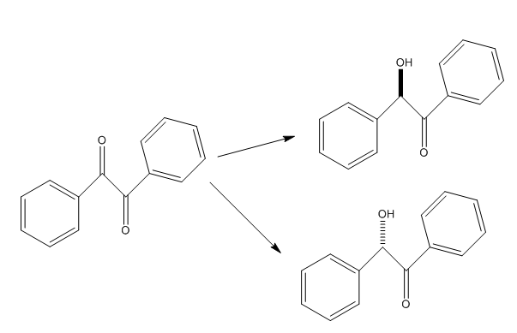
Reaction Mechanisms
Reduction 1

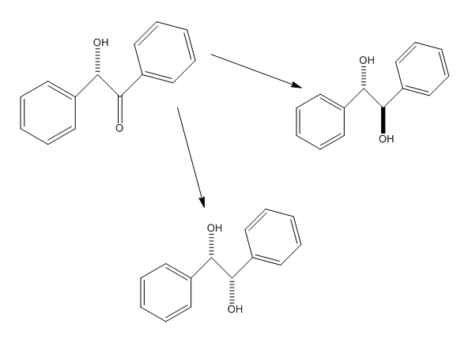
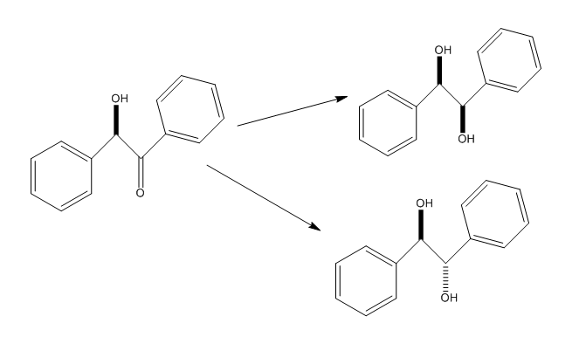
Reduction 2: Work-Up

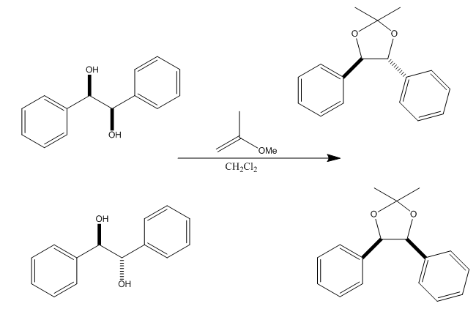
Diastereomers Anti

Syn

Procedure and Observations
(Refer to Organic Chemistry I – CHM 1321 – Lab Manual)
- Accurately measure 1g of benzyl by using a folded sheet and place the compound in a 50 mL Erlenmeyer flask.
- Carefully place the stir bar in the flask
- Add +/- 10mL of ethanol. Clamp flask over magnetic stir plate. Place and fill an ice bath with ice and cold water under the flask. Stir for 5 minutes.
- Add 0.2g of sodium borohydride in 3 equal portions to the flask, 2 minutes in between each. Stir for 10 minutes, during which the mixture should lose its yellow coloration.
- Remove the ice bath and stir solvent for 5 minutes in order to allow it to warm to room temperature.
- Take a TLC plate to see if the reaction is complete. Use benzil as a reference and 2:8 EtOAc:Hexanes as an eluent.
- While running the reaction in step 5, warm 50mL of water
- Once TLC shows a complete reaction, add 10mL of warm water the reaction flask and transfer the reaction flask to the hotplate. Stir and heat: the solution should now be pale and yellow. Continue stirring until the intense bubbling stops.
- Add another 20mL of hot water to the reaction mixture. Stir and heat for about 10 minutes, during which the mixture should gently boil.
- Remove the flask and allow it to cool to room temperature.
- Collect crystals using suction filtration. Rinse the crystals in small amount of cold water and maintain suction for about five minutes to allow crystals to dry.
- Determine the mass of the product and percent yield. Perform TLC of final product (which is 2:8 EtOAc:Hexanes). Use a small amount of crystals dissolved in acetone to spot the TLC plate.
- Place about 600mg (0.6g) of your diol product (obtained crystals) in a 25mL round-bottom flask. Add 25mL of CH2Cl2 to make a solution. After having dissolved this compound, add a stirring bar to the flask.
- Add 1.0mL of 2-methoxypropene and 50mg (0.05g) of p-toluenesulfonic acid. Stir this mixture at room temperature for approximately 30 minutes.
- After 30 minutes have passed, take a TLC of your reaction. Use the diol product for reference lane (2:8 EtOAc:Hexanes as eluent).
- If step 15 shows you have a complete reaction, prepare two more TLC plates and spot the reaction mixture onto each. Use one TLC plate to reference syn acetonide and the other to reference trans acetonide.
- Reference both plates using 2:8 EtOAc:Hexanes as the eluent and proceed to determine which stereoisomer (s) of hydrobenzoin are in your product.
Observations
- Stirred solvent by hand to speed up reaction time
- Solvent was pale and liquid when heated from room temperature and had a more opaque solidified texture when cooled by letting it sit or ice bath
- Crystals were soft (noticed when measuring 0.6g for part B with a spatula)
- White foam-like substance was released from under the filter during the suction filtration process
- Solution turned dark-red instantly after adding 2-methoxypropene and p-toluenesulfonic acid.
Measurements:
Filter= 16.21g
Crystals + Filter= 16.93g
Crystals= 16.93-16.21= 0.72 g
Theoretical mass: 1.0 g
Percent Yield: (actual yield/theoretical yield) x 100%
(0.72/1.0) x 100% = 72 % yield.

Discussion
During this experiment we have observed different reduction steps and the impact they have on the purity of a compound, the way it shows up on a TLC plate, the different stereoisomers possible from the reductions and how we can identify an unknown diol product by comparing the results. We have witnessed first-hand that sequential reductions produce Diastereomers, and that those can be matched up with unknown compounds to identify major and minor compositions. Our TLC plates have a slightly irregular appearance: this can be explained by sources of error during our lab such as insufficient time for proper dissolution, spotting error and especially the time constraint which made for more rushed measurements and less concrete results. The first TLC plates were successful, but the final TLC measurements suffered because of what seems to be a slightly incomplete reaction. However, I suspect that our diol product was the anti compound because of the alignment of spots on the product TLC with the anti acetonide TLC plate and a more similar amount of spots we see compared to the syn reference plate. The percent yield could have been affected by the same error sources as the spots on the TLC plates, especially the lack of time for the final mixture to stir, therefore lowering result accuracy.

Conclusion
The first TLC plate depicted a successful reduction of the carbonyl group. Due to lack of time, the last TLC plate did not show results conclusive enough to make a definite affirmation regarding the nature of the obtained diol product. The mass of crystals obtained was 0.72g, resulting in a 72% yield.
Questions
1. (At minimum amount of solvent = 100℃)
Starting Mass A + B : 3.5g + 10 = 13.5 g
A in mL: (3.5g) (100mL/16g) = 21.88 mL
B in mL: (10g) (100mL/16g) = 62.5 mL
62.5 mL is the minimum amount of solvent required.
Transfer into grams:
(62.5mL) (1g/100mL) = 0.625g is each compound of mother liquor
Mass compound A: 3.5g – 0.625g = 2.875g
Mass compound B: 10g – 0.625g = 9.375
Total A+B = 12.25g
Percent yield: (actual value/theoretical value) x100%
(12.25g/13.5g) x100% = 90.8% yield
2. Assuming sample is at 20℃
Mass of mother liquor: 100mL = 1g
Mass compound A: 3.5g – 1g = 2.5 g
Mass Compound B: 10 g – 1 g = 9 g
Total A + B = 11.5 g
Remembering that starting mass was 13.5g,
% Yield = (actual value/theoretical value) x100%
(11.5 g / 13.5 g ) x100% = 85.2% yield
3. The recovery was poor because temperature factors were neglected. The first error was attempting to dissolve the crude product in methanol at 25℃: methanol has a boiling point of 64.7℃ (almost three times higher than the temperature used by the student), which did not allow proper dissolution of the crude product. The second error was the sudden temperature drop with regards to the ice bath: gradual temperature changes result in more accurate crystal collection and boiling the methanol properly would ensure a more thorough removal of the impurities. Another suggestion would be to rinse the crystals with cold water as opposed to ice-cold methanol.
4. a) Sodium borohydride (NaBH₄₎ is not a powerful enough reducing agent to reduce a carboxylic acid. The bubbling is caused by the decomposition of the reducing agent: the acid protons from butanoic acid reacting with the basic hydrides in NaBH_{4.}
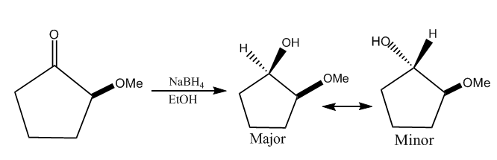
b) Sodium borohydride adds an H in the reaction, reducing the carboxylic acid into an aldehyde (more specifically butanal). The end products are likely to be hydrogen gas, boron trihydride and sodium formate.
5.

Reagent and Product TLCs
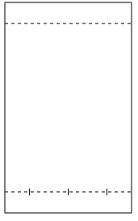
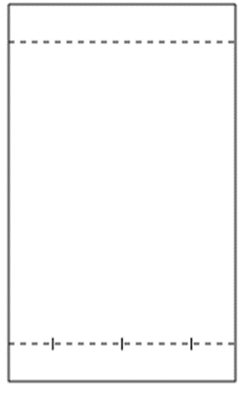

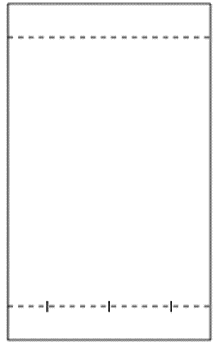
Syn and Anti Acetonide Reference TLCs

