What is Anthropology?
- A humanistic discipline that studies the diversity of human kind in its cultural manifestations (focuses on meanings rather than measurements, texture of everyday life rather than generalizations)

- Started with a focus on small-scale societies, uncovering details of peoples lives though sustained contact known as participant observation, which is conducted during fieldwork.
- Going to faraway places is linked to the discipline's history and intellectual premises as well as to the anthropologists' own history and interests.

- Many anthropologists now study closer to home or at home as the reasons for choosing a field site have changed and the site itself may feed into the topic and theoretical questions that one selects.

Let's listen to Dr. Deborah Gewertz, professor of Anthropology, Amherst College and Dr. Frederic Errington, professor of anthropology, Trinity College, Connecticut, tell us how they became anthropologists, and why they decided to carry out research in Papua New Guinea, a country located in the Southwest Pacific, north of Australia.
Anthropology-cultral anthropology social prehistoric archaeology, physical anthropology
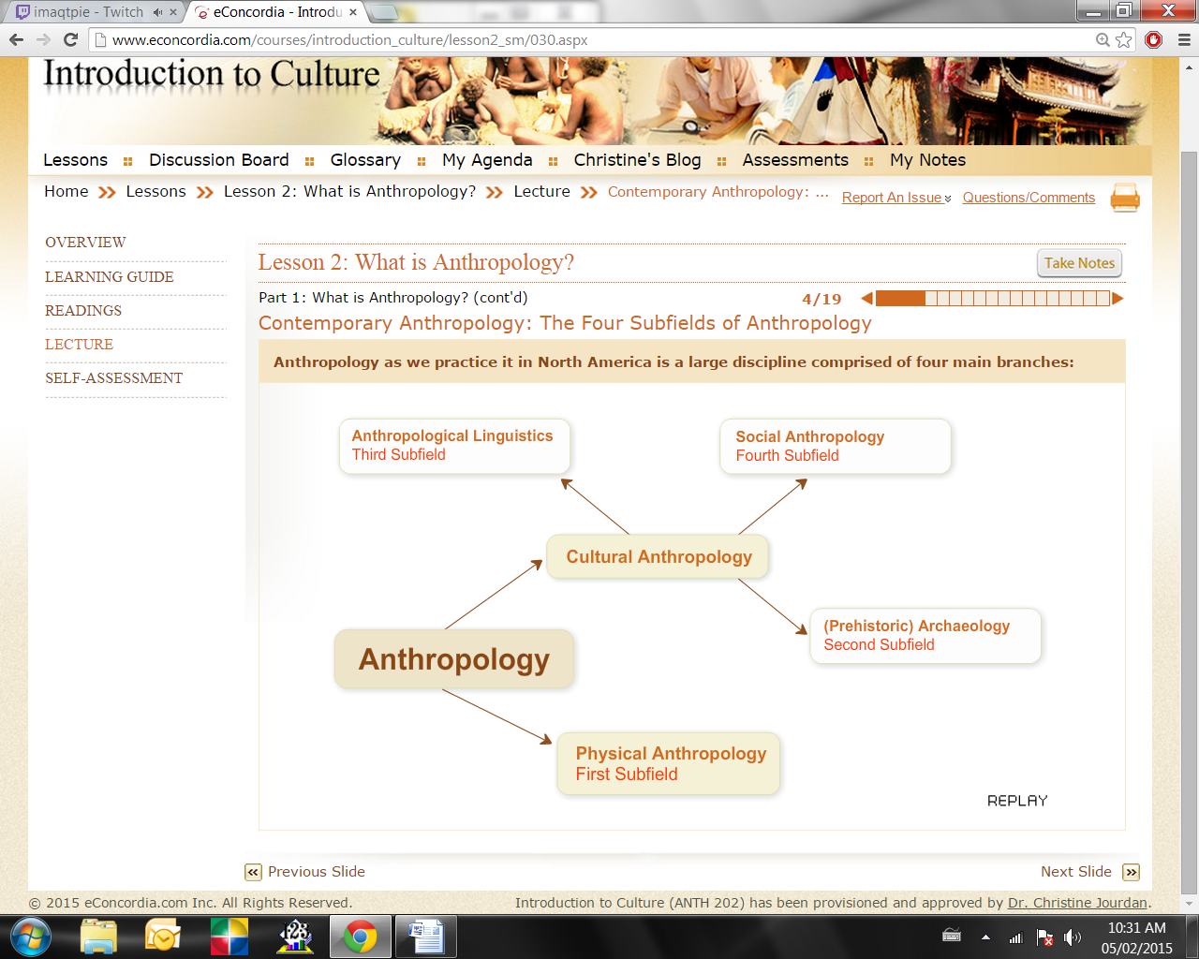

Physical Anthropology: First Subfield
Click on Play to listen to the MP3.

Physical anthropologists (first subfield) study the physical dimension of human beings; divided into paleontologists and primatologists.
- Paleontologists study human evolution (paleontology) => how pre-human creatures became human beings, the ancestry of Homo Sapiens. A famous example is the discovery in Ethiopia in 1974 of Lucy,; a young female whose fossil remains date back 3.2 million years, classified as an Australopithecus Afarensis.
- Primatologists study the social life and behaviour of non-human primates, like chimpanzees (with whom we share 99% of our body chemistry) and gorillas, in the wild and captive, and experiment in animal psychology and ape language. An example of a well-known case is that of Jane Goodall and her studies of chimpanzees in east Africa.
Some physical anthropologists also study the genome of social groups in the hopes of providing clues on origins, migration and group identity of populations.
We will talk about animal communication later in the course, but in the meantime you can read more on big apes and language in this article " Great Ape Language" from Science Daily.
7 million years before
Hominina speciate from the ancestors of the chimpanzees. The latest common ancestor is Sahelanthropus tchadensis (ca. 7 Ma). The earliest known human ancestor post-dating the separation of the human and the chimpanzee lines is Orrorin tugenensis (Millennium Man, Kenya; ca. 6 Ma). Both chimpanzees and humans have a larynx that repositions during the first two years of life to a spot between the pharynx and the lungs, indicating that the common ancestors have this feature, a precursor of

4.4 million years before
Ardipithecus ramidus ramidus (Next: Australopithecus afarensis in 4.4 Ma)
Some Australopithecus afarensis leave footprints on volcanic ash in Laetoli, Kenya (Northern Tanzania). Strong evidence of bipedalism.

3.5 MA
Kenyanthropus platyops, a possible ancestor of Homo, emerges from the Australopithecus genus.

3 MA
The bipedal australopithecines (a genus of the Hominina subtribe) evolve in the savannas of Africa while being hunted by Dinofelis. Loss of body hair takes place in the period 3-2 Ma, in parallel with the development of full bipedalism.

2.5 MA
Appearance of Homo. Homo habilis is thought to be the ancestor of the lankier and more sophisticated Homo ergaster. Lives side by side the Homo erectus until at least 1.44 Ma, making it highly unlikely that Homo erectus directly evolved out of Homo habilis. First stone tools, beginning of the Lower Paleolithic.

1.8 MA
Homo erectus evolves in Africa. Homo erectus would bear a striking resemblance to modern humans, but had a brain about 74 percent of the size of modern man. Its forehead is less sloping and its teeth are smaller. It is believed to be an ancestor of modern humans (with Homo heidelbergensis usually treated as an intermediary step).

1.5 MA
Homo georgicus (Dmanisi man), with Homo erectus and Homo habilis characteristics, arrives in Georgia. Control of fire by early humans is achieved. Evolution of dark skin, which is linked to the loss of body hair in human ancestors, is complete by 1.2 Ma.

516 KA
Homo antecessor, the common genetic ancestor of humans and Neanderthals. At present estimate, humans have approximately 20,000–25,000 genes and share 99% of their DNA with the now extinct Neanderthals and 95% of their DNA with their closest living evolutionary relative, the chimpanzee.

355 KA
Three 1.5 m (5 ft) tall Homo heidelbergensis left footprints in powdery volcanic ash solidified in Italy. Homo heidelbergensis is the common ancestor of both Homo neanderthalensis and Homo sapiens. It is morphologically very similar to Homo erectus but Homo heidelbergensis had a larger brain-case, about 93% the size of that of Homo sapiens. The species was tall, 1.8 m (6 ft) on average, and more muscular than modern humans. Beginning of the Middle Paleolithic.

195 KA
Omo1, Omo2 (Ethiopia, Omo river) are the earliest fossil evidence for archaic Homo sapiens, evolved from Homo heidelbergensis.

160 KA
Homo sapiens (Homo sapiens idaltu) in Ethiopia, Awash River, Herto village, practice mortuary rituals and butcher hippos.

150 KA
Mitochondrial Eve lives in East Africa. She is the most recent female ancestor common to all mitochondrial lineages in humans alive today.

70 KA
Appearance of mitochondrial haplogroup L2. Behavioral modernity. The human variant of the FOXP2 gene (associated with the development of speech) appears in this period.

60 KA
Y-chromosomal Adam lives in Africa. He is the most recent common ancestor from whom all male human Y chromosomes are descended. Appearance of mitochondrial haplogroups M and N, which participate in the migration out of Africa.

50 KA
Migration to South Asia. M168 mutation (carried by all non-African males). Beginning of the Upper Paleolithic. mt-haplogroups U, K.

40 KA
Migration to Australia and Europe (Cro-Magnon).

25 KA
Neanderthals die out. Y-Haplogroup R2; mt-haplogroups J, X.

12 KA
Beginning of the Mesolithic/Holocene. Y-Haplogroup R1a; mt-haplogroups V, T. Evolution of light skin in Europeans (SLC24A5). First domestication of the dog. There is genetic evidence for a much earlier split between dog/wolf lineages. Homo floresiensis dies out, leaving Homo
sapiens as the only living species of the genus Homo

10000 BCE
Beginning of the Neolithic/Holocene. The invention of farming in the Fertile Crescent occurs during this time.

Archaeology: Second Subfield
Archaeologists (second subfield) are interested in finding objects (bones, fire) and artifacts (pottery, ornaments, etc.) because of what they can tell about the social life that once existed - revealing ways of life, presence of sacred rituals, etc., and not just housing layouts.

Pre-historic vs. Historic Archaeology:
Pre-historic archaeology studies societies that never left written records, whereas historic archaeology studies societies that did leave a written record.

Linguistic Anthropology: Third Subfield
Linguistic anthropologists (third subfield) are trained in linguistics and anthropology and study the relationship between language and the rest of culture => how speech and language are used to signal identity or status, express thoughts and knowledge, label the world around them, etc.
- Through comparative methods, this can provide information on migration and how people without writing systems were related in the past.
- Also interested in birth and death of languages, language and gender/nationalism/ethnicity/social class, ethnography of communication, how the context of communication affects the choice of language in any speech community => what is said to who, when it is said and how it is said.

Cultural or Social Anthropology: Fourth Subfield
Cultural and social anthropologists (called ethnology in Europe) (fourth subfield) often study contemporary societies anywhere in the world and the specialization in particular dimensions of social life (arts, economy, political life, religion) has caused fragmentation.
Topics vary greatly, even at Concordia University, and all can be studied from different theoretical perspectives, but all cultural anthropologists obtain their data firsthand through research in the field.

Anthropology is Holistic
Anthropology’s interest in the whole of the human condition lends to its four sub-disciplines, studying the diversity and transformations of human beings and their cultures. Each is an interpretive subfield aiming to understand human life from a holistic perspective and are thus taught in many anthropology departments in North America.
This is not however, standard in all anthropology traditions
– British anthropology is essentially social anthropology, while French anthropology is divided into three forms:
- physical anthropology (referred to as anthropology)
- archaeology
- ethnology (social and linguistic anthropology). They are taught autonomously.

Myth of Origin Story from the Solomon Islands
Here is an excerpt of the creole language of the Solomon Islands. It is called Pijin and is now spoken throughout the country. The grammar is very similar to that of the local languages, but 80% the vocabulary comes from English.
Listen to a local myth of origin told to me by Cecilia Saako, a 57-year-old woman from the Solomon Islands. Cecilia is from one of the Polynesian outliers in the Solomons. Pijin is a second language for her. She can neither read nor write.

Cecilia is a widow: those of us who know her culture can tell that she is a widow because her hair is short and her clothes are old and dirty, as is required by tradition. In brief, she is in mourning.

As you listen to Cecilia, read the text of the story and see if you can understand some of it before looking at the translation.

Listen to your professor explain the
"history of the discipline".
- Chapter 1 in the textbook provides a brief summary of how anthropology appeared and evolved, founded in 19th-century Europe when evolutionary social theory was an important scientific paradigm.
- It was believed that societies developed in easily observed stages; this false assumption put Western societies ahead of all others– serving as justification for many acts of decimation or forced social transformations and the colonization of much of the world by European countries.
- Ethnocentrism: the belief that the moral standards, belief systems, arts, etc. of one's own society are superior to those of other societies.
- Common to some extent, a measure of ethnocentrism can be proof of successful socialization and enculturation of the individual and contentment. An extreme presence is rejected by anthropology and leads to intolerance.
Cultural Relativism
- Franz Boas's work best represents the beginning of American anthropology and the reaction to evolutionary anthropology at the beginning of the 20th century.
- Due to colonialism's destruction of many societies, Boas and students like Margaret Mead and Ruth Benedict thought to record human cultures before they disappeared. This became known as salvage anthropology.
- Cultural relativism understands societies in terms of their own logic rather than ranking or judging them by outside standards, but this idea must be examined carefully.

Let's listen to Dr. Sally Cole, Department of Sociology and Anthropology, Concordia University, discuss Franz Boas and cultural relativism.

Listen to your professor explain
"how anthropology works."
- Participant observation: Living alongside your participants (the people you are studying) is a crucial part of your fieldwork as well as taking notes of all your observations.
- Interviews are also an important part of the research process, allowing further understanding through in-depth questions with individuals and are thus an important tool for eliciting information.
- Archives can also be helpful for finding information on the history and background of the area as well as demographics and statistics.
- Use of tools such as recorders, camcorders and cameras in the process of gathering audio and visual material allows interviews to be easily captured and transferred.

Participant Observation in Honiara
Because part of the research involves the transmission of linguistic knowledge in families, it is important that I live with families and see how this is done.
During my last two field trips in Honiara in 2007-2008, I lived with two different families: the Furau and the Wame. In the case of the Furau, three generations lived in the household, plus other members of the extended families.
All told we were 14 people. You can see pictures of some members of this family. While living with them, I shared their life, helping them with cooking, shopping, taking care of the children, cleaning, participating in family activities on the weekend and in the evenings, and attending church or other events.

Fieldwork

- Fieldwork is not an easy process and success depends on the acumen (insight/wisdom) and industriousness of the researcher, the soundness of the research project and on personal qualities.
- Fieldwork often takes anthropologists away from loved ones and/or in to cultural contexts that require adjustment to new ways of being, talking and etiquette and new timetables, forcing them out of their comfort zones.

- When researchers are brought into worlds so different from their own they can experience culture shock accompanied by frustration and difficulties adjusting. It is important to be able to recognize this as it can occur unexpectedly.
- Success in research depends on acceptance and on participants and their desire to help us (age, gender and class and can help or hinder the research).
- Chapter 2 explains that many anthropologists now work at home or in Western societies.

Ethics
- The relationship created with the people anthropologists work with (establishing rapport) is important. A relationship of mutual respect and trust aids in productive research.
- The relationship depends on the anthropologists’ people skills and traits (intellectual honesty, patience, tact, humour, independence, care).
- Anthropologists have moral obligations towards the people they study and these are detailed in a code of ethics; we have obligations as both fellow humans and as scientists.
- Intellectual honesty and quality publications are two very important obligations anthropologists have towards their participants.
- A third obligation (less mentioned) is the return of data and results of the research to people who have participated (by sending copies of interviews, transcriptions and pictures to individuals, groups, archives and museums or sending copies of the articles or books published).

Question
1. Which of the following is not a subfield of anthropology?

a) Physical anthropology
b) Linguistic anthropology
c) Sociocultural anthropology
d) Paleontology
e) Archaeology

Question
2. "Armchair anthropology" differs from "verandah anthropology" in that:

a) Armchair anthropologists traveled to colonized countries where they conducted research but did not live with the people they were studying. Verandah anthropologists stayed home and studied cultures from afar.
b) Verandah anthropologists traveled to colonized countries where they conducted research but did not live with the people they were studying. Armchair anthropologists studied cultures from afar.
c) Armchair anthropologists were functionalists whereas verandah anthropologists were strict evolutionary anthropologists.
d) Verandah anthropologists pioneered participant observations, while armchair anthropologists relied on the written accounts of explorers and missionaries.
e) Verandah anthropologists were strict functionalists while armchair anthropologists were evolutionary anthropologists.
3. Informed consent:

a) is used solely by hospitals or medical professionals to obtain the consent of clients prior to any medical procedure.
b) requires that all research participants sign an informed consent form to ensure ethical research.
c) requires that the researcher acquire the written consent of government officials prior to conducting research.
d) obliges the researcher to sign a consent form specifying that he or she will act ethically in the field.
e) requires the researcher to inform participants of the intent, benefits and possible effects of the study and obtain their consent either in writing or orally.

Question
4. The kula is:

a) a spiritual force that permeates all of existence.
b) a trading network linking many islands of the Pacific.
c) a highly valued bracelet used for trade in the Trobriand Islands.
d) a trading network whereby women traded bundles of dried banana leaves and beautifully decorated fibrous skirts.
e) a high-status individual in the Trobriand Islands who achieved status through trade.
5. Rapport is:

a) the trusting relationship that must be gained with a gatekeeper before access to the field is obtained.
b) the sacred relationship between community members in the Trobriand Islands.
c) trust gained through gift giving.
d) a trusting relationship between the researcher and the study population.
e) also known as "going native" or the researcher integrating herself or himself completely in the community under study.

Question
6. A young and unmarried female researcher is likely to face more difficulties than a young and unmarried male researcher because:

a) people in most cultures consider a young unmarried female on her own extremely unusual.
b) she is at greater physical risk than her male counterpart.
c) women in the community where she is studying may react to her with suspicion and jealousy.
d) it will be impossible for her to conduct research in any male-dominated field or community such as the male gay community.
e) she will be limited to studying a smaller number of topics, for example the geishas of Japan.
7. Reverse culture shock:

a) is a condition that obliges many anthropologists to abandon their former homes and go live in their research community.
b) is the stress felt by immigrants as they migrate to a new country.
c) is the stress and feelings of discomfort that an anthropologist may experience returning home from the field.
d) is the cultural shock that anthropologists from Asia, Africa or Latin America may experience conducting fieldwork in Canada, the United States or Europe.
e) occurs when an individual who has become completely assimilated into another culture must return to his country of origin.
8. Participant observation:

a) is no different than "hanging out" in a research community.
b) requires the anthropologist to adopt the lifestyle of the people being studied.
c) is rendered impossible when the Hawthorne effect is present when the fieldworker is conducting research.
d) requires reflexivity and subjectivity while carefully observing and writing about what has been observed in the field.
e) has been abandoned by contemporary anthropologists who now privilege interviews and questionnaires.
9. Triangulation:

a) involves using multiple methods and sources when conducting research to ensure greater perspective.
b) requires the use of both qualitative and quantitative methods.
c) involves both inductive and deductive approaches to research to ensure greater validity.
d) requires that teams of researchers conduct ethnographic fieldwork in a common research project.
e) involves the use of statistics to ensure that research conforms to scientific standards and acceptable margins of error.
10. Collaborative research:

a) is an approach to learning about cultures that involves the anthropologist working with researchers from other disciplines as partners and teammates rather than competing researchers.
b) is an approach to learning about cultures that involves the anthropologist working as a consultant hired by a given population to conduct research on their culture.
c) is an approach whereby the researcher trains local community members to conduct research on their own culture.
d) is an approach whereby researchers work with local researchers as teammates and collaborate as coauthors in publishing accounts of the research.
e) is an approach to learning about culture that involves the anthropologist working with members of the study population as partners and teammates rather than strictly as subjects.
11. According to your text, the four subfields of anthropology are archaeology, physical anthropology, classical archaeology and anthropological linguistics.

a) True
b) False
12. Primatology is the study of primitive cultures and mores.

a) True
b) False
13. Ethnology is another word for cultural anthropology.

a) True
b) False
14. The use of anthropological data to offer practical solutions to contemporary problems within society is called applied anthropology.

a) True
b) False
15. A testable proposition concerning the relationship between a particular set of variables is called:

a) paradigm
b) hypothesis
c) theory
d) deduction
16. The species to which we all belong is called:

a) Homo sapiens
b) Homo Economicus
c) Genus Homo
d) Homo neanderthalensis
17. The greatest distinction of anthropology is that it is global and _____________ in its approach.

a) restrictive
b) comparative
c) general
d) true
18. In the late 19th century, professional linguistics existed.

a) True
b) False
19. The most important anthropological paradigm used in 19th century Europe was:

a) Ecological anthropology
b) Evolutionary anthropology
c) Structural anthropology
d) Symbolic anthropology
20. Boas’ thought that anthropology as a science should:

a) describe all societies of the world before they disappeared
b) analyze kinship systems around the world
c) understand evolutionism
d) prevent social change from taking place

Definitions of Culture

What do anthropologists mean by culture?
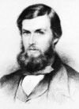 | A classic definition was proposed by Edward Tylor, a 19th-century British anthropologidy, who wrote in 1871 that:  ‘Culture or civilization… is that complex whole which includes knowledge, belief, art, law, morals, customs, and any other capabilities and habits acquired by man as a member of a society.’  Left: Edward Burnett Tylor (Source: Encyclopaedia Britannica online)
Let’s note that early definitions of culture focused on the aggregation of events, things and systems of thoughts that encompassed and guided human behaviour.
Needless to say, not all segments of Edward Tylor's definition have withstood the test of time. Anthropologists today are still considering cultures as complex wholes, but they would probably not refer to ‘man’ but to ‘humans’, they would probably not equate ‘culture’ with ‘civilization’ as this word connotes particular cultural traits (such as writing systems, centralized states, etc) that are not found in all societies.
It is fair to say that the dominant definition of culture has changed throughout the history of anthropology and that not all anthropologists agree on what it is. There are many ways of understanding this concept.
Various definitions of ‘culture’ by different scholars:
- ‘The learned behaviors and symbols that allow people to live in groups. The primary means by which humans adapt to their environments. The way of life characteristic of a particular human society.’ (Serena Nanda and Richard Warms, 2002: 412)
- ‘The learned system of beliefs, feelings, and rules for living around which a group of people organize their life.’ (Richley Crapo, 2002: 492)
- ‘Distinctively human; transmitted through learning; traditions and customs that govern behavior and belief. (Conrad Kottak, 2002: 501)
- ‘The system of knowledge more or less shared by members of a society.’ (Roger Keesing, 1981: 509)

Various Approaches
The range that exists in the definitions of culture is obviously large. But do not be mistaken. It is not that anthropologists disagree fundamentally on what culture is. Far from it. But their ‘take’ on it varies with the theoretical approaches they prefer. For instance, those anthropologists called ‘interpretive’ will focus on the symbols and thoughts of a cultural group. Others, such those called ‘materialists’ will focus on the learned behaviours and lifestyles of peoples. However different their approaches may be, all anthropologists agree that culture refers to learned (and somewhat shared) patterns of behaviour and thought.
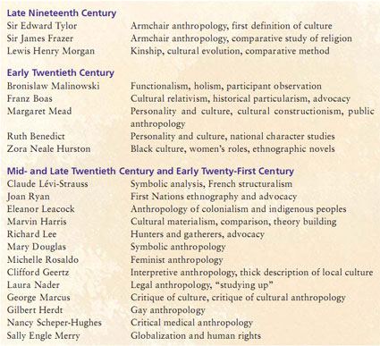

How did Culture Begin?
- Culture emerged through group formations and the development of language and the ability to use symbols.
- Culture as a means of addressing natural/social needs through a system of rules.
- Human needs are diverse and complex and accordingly, so is culture.

Culture is Learned

Culture is Shared
- Sharing of culture reflected in the socialization of members in ways that contribute to understanding of common rules, meanings and behaviours.
- Culture as shared allows for mutual interpretations, symbolic meanings, messages and intentions to flow.

One Society, Different Values
People in the same cultural group can have very different opinions and ways of understanding the world. People have different tastes, different expectations, different outlooks on things. Within the same cultural group, people will have different values, goals and systems of meanings.
To learn more about the debate over religious culture courses in Quebec primary schools, check out these suggested links.
For example:
For the longest time in Quebec, religion was taught in school and was mandatory in primary schools. When the government opted to make the course optional and to offer a course in ethics and morals for the children who did not want to take the religion course, many people were outraged, while others applauded.
In the wake of the ‘reasonable accommodation’ debate that took over the province in 2007-2008, the Quebec government opted to replace the course on ethics and religion with a course on comparative religious culture.
Some parents objected that the course gives the same importance to all religions and therefore undermines their own in the minds of the children.
Something to think about
How can you explain that this would happen in the same province with only 6 million people who share the same space, go through the same education system, have the same government, speak the same languages, and so on?

Social Cultural Diversity

Class, gender, race, ethnicity and indigenous peoples
In all societies, basic distinctions exist between individuals in terms of age and gender.
Often, what people can or cannot do, may or may not do, may or may not say, is linked to their memberships into social groups defined by their gender and their age.
In multicultural societies, other factors such as race, ethnicity and indigeneity have provided additional ways of ‘classifying’ people according to their skin colour, ethnic origin and native status.
We shall cover these issues in detail in a later lesson.

Subcultures
Clearly, when people are part of a cultural group they are not passive recipients of prepackaged systems of meanings, behaviour and thought.
As individuals, they develop their own opinions and ideas. Individuals in a culture engage the dominant culture according to gender, class, experience, age, etc. And this process is often what leads them to have different visions of what their culture is.
Right: Female break dancers
(Source: Flickr photo by Delmo-Baggins)
Some fully approve of the dominant model and embrace it while others reject it. It is the engagement with culture that leads to socio-cultural change.
When groups of people recognize themselves as having different ways of engaging the cultural world in which they live, we talk of subcultures.

Youth Culture
In some societies, young people have modes of expressions, behaviour and values that may be significantly different from those of their adult counterparts: they dress differently from their parents, they listen to different kinds of music, they use different words, and so on. This observation has led anthropologists such as Vered Amit to talk about youth culture. Yet however different some youth wish to be, they also engage with the rest of society.
This is true of many of the subcultures that comprise societies: subcultures organized around age, around leisure activities, around religions, around economic means, and so on.

Listen to Dr. Vered Amit from Concordia University explain what she means by youth culture and how youth culture intersects with the rest of the society, legally, socially and culturally.

A Subculture Example: Hip Hop Music
Stylistic origins | Funk, disco, soul, dub, toasting, performance poetry, spoken word, signifying, the dozens, scat singing, talking blues
Cultural origins | 1970s, the Bronx, New York City
Typical instruments | Turntable, synthesizer, vocals, drum machine, sampler, guitar, piano
Mainstream popularity | High worldwide since the late 1980s

Culture change

Core Cultural Elements and Cultural Change
- Change in the mid-1940s: anthropologists studying cultural change, particularly from the point of view of acculturation studies, posited that not all areas of culture changed at the same pace.
- American scholars such as Herskovitz or Linton, for example, proposed that there were core elements in all cultures that were more resistant to change than others.

Read what Professor Pierre Beaucage has to say about cultural change (preceded by your professor's question to him).

Changes Not Linked to Technology

Case Study: Dancing in a Polynesian Settlement

On Easter Sunday 2007, your professor was invited to spend the day at the Lord Howe settlement in Honiara and witness/participate in the celebrations. There was to be music, food and a competition of dances. Your professor took her movie camera along.
On that day, a dance competition took place: groups of women and young boys belonging to different associations presented their dances. It was a long-drawn-out affair lasting many hours.
As you watch some segments of the video that your professor shot that day, pay attention to the dances of the women, their attire, the music they dance to, the use of perfume and the flower decorations they wear. Contrast that with the dances of the young boys and their attire.
The Lord Howe settlement is located at the mouth of the Mataniko River, by the seaside. It is inhabited exclusively by people from the Lord Howe Islands, a Polynesian outlier located north of the Solomon Islands, also known as Otong Java. In the settlement, people have running water but no sewage facilities, and housing runs from makeshift shelters to concrete houses.

Issues of Identity Amidst Change
- When external cultural markers are changed drastically, is the cultural group or individual identity any less authentic?
- Opposing concepts such as "traditional" and "modern" tend to oversimplify the complexities of cultural change.

Four Models of Cultural Interaction
- The most important forms of change are often associated with contact with outside groups.
- Anthropologists have identified four models of cultural interaction: clash of civilizations; McDonaldization; Hybridization; and Localization. You can read the description of each in the textbook.
- Amongst the various forms that contact has taken, colonialism (part of the clash of civilizations model), has brought about the biggest changes.

Four Models of Cultural Interaction
1 | Clash of civilizations | Conflict model
2 | McDonaldization | Takeover and homogenization model
3 | Hybridization | Blending model
4 | Localization | Local cultural remaking and transformation of global culture

Colonization
The word ‘colonization’ usually refers to European expansion into the non-Western world (from the 17th to 20th centuries), but has existed throughout history in various forms.
- European colonization has produced the most dramatic social changes in recent human history.
- Most empires had an agricultural mode of subsistence.

Check out these maps
Egyptian Empire | Alexander's Empire | Mongol Empire | Aztec Empire

European Colonization
Papua New Guinea is a country in the Western Pacific that comprises the eastern part of the large Island of New Guinea, the Bismark Archipelago, and the Island of Bougainville. Part of it was colonized by the Germans at the end of the 19th century, and subsequently by the Australians under a protectorate. It became independent in 1975.

Colonization and People’s Lives

Post-Colonial Politics
Colonization has not only affected individual groups located within former states, but it has also created new countries by amalgamating different ethnic groups and cultural groups into one geopolitical entity.
Think, for instance, of the countries of West Africa, such as Ivory Coast, Nigeria, the Congo, Rwanda, Ethiopia, the Sudan, etc., which were created by the Briitish, the Belgians and the French, and are now, after iIndependence, fraught with ethnic tensions. Again, the political crises that are shaking the Melanesian countries of Papua New Guinea, the Solomon Islands, Vanuatu and Fiji, are cases in point.

Colonialism and Modernity

For quite some time after they became independent, post-colonial states throughout the world have also been economically weak, and very often remained dependent on the economies of the former colonial powers. Even after independence, many former colonies had retained a form of economy that supplied raw commodities to the former colonial powers (coffee, sugar, cocoa, minerals, etc.) and served as a market for the sale of manufactured goods.
This observation led economists such as André Gunder-Frank to propose that under-development was maintained by the former colonial powers, and was in fact necessary for their own economic development. This thesis is questioned, particularly in light of the economic success stories of Brazil and South Korea, as well as other countries. Your professor asks Pierre Beaucage to clarify this point.

Part 3: Globalization
Professor Beaucage’s view (from the previous slide) is very political and not all people will agree with it. Yet, as anthropologists have observed, dramatic types of change take place when, in the context of economic globalization, powerful international corporations, with the help of advertising campaigns, aim at changing people’s lifestyles and consumption patterns so as to market their ware.

Globalization and Social Change
1. In addition to the four traditional fields of anthropology, which of the following has been proposed as a fifth field of anthropology?

a) applied
b) forensic
c) social
d) evolutionary
e) paleolithic
2. Symbols are arbitrary, conventional and prescribed, but some people are also emotionally attached to them.

a) True
b) False
. The "Garbage Project" conducted by archaeologists excavating a landfill can be applied by policy makers as the research:

a) proved that rapid decomposition of waste produced large quantities of methane, a greenhouse gas.
b) highlighted the sheer volume of polystyrene and plastics in landfills.
c) demonstrated to the dismay of planners that paper by its sheer volume was a major culprit in the filling up of landfills.
d) demonstrated that newsprint that decomposes in landfills could be used as compost.
e) demonstrated that diapers and plastics were releasing toxins into underground aquifers.
4. Descriptive linguistics is:

a) the study of the structure of languages.
b) the study of non-verbal language.
c) the study of language change over time.
d) the study of the relation between language and sentence.
e) the study of language phonetics.
5. What was the purpose of Miner's description of the Nacirema culture?

a) He wanted to make the familiar strange.
b) He was conducting "salvage" ethnography to record the culture of a people threatened with assimilation and cultural extinction.
c) He wanted to make the strange familiar.
d) He was writing an ethnographic account of a remote people located in the tropical jungle of Amazonia.
e) He wanted to demonstrate how cultures evolved over time.
6. Which of the following pairings is not correct?

a) Franz Boas, personality and culture
b) Sir Edward Tylor, armchair anthropology
c) Bronislaw Malinowski, participant observation
d) Marvin Harris, cultural materialism
e) Claude Lévi-Strauss, structuralism
7. Franz Boas promoted the detailed study of individual cultures within their own historical contexts. This approach is called:

a) historical functionalism
b) cultural relativism
c) functionalism
d) historical particularism
e) structural functionalism
8. Franz Boas' research on the height, weight and head size of 17,000 immigrants:

a) demonstrated that some migrant groups were innately inferior.
b) is an example of evolutionary anthropology.
c) conclusively showed that body size and shape can change quickly.
d) revealed minimal change between generations, even those born in the United States.
e) conclusively demonstrated that African Americans were racially superior.
9. How would cultural materialists analyze the practice of elimination in villages in India?

a) They would study the ecological advantages that village practices provide and how social norms enforce advantageous practices.
b) They would analyze the symbolic significance of clean and unclean.
c) They would study class conflict and how practices of elimination enforce social hegemony.
d) They would seek out the underlying social structures.
e) They would seek to deconstruct power-knowledge relations.
10. Hybridization is also called:

a) cultural crossover
b) McDonaldization
c) localization
d) global assimilation
e) Marxism
11. People who do not share all life-style characteristics with the rest of society are said to be in a:

a) group culture
b) holistic culture
c) sub culture
d) coop culture
12. Sir Edward Tylordefined culture as consisting of patterns of acting as well as patterns of:

a) behaviour
b) instinct
c) thought
d) social behaviour
13. Failure to comprehend the role enculturation plays in maintaining each group’s patterns of behavior and thought lies at the heart ofthe phenomenon known as:

a) ethocentrism
b) sexism
c) subordination
d) the relativity of truth
14. Which is not an example of diffusion?

a) Cereal eating in the United States of America
b) The use of paper on which to write
c) The invention of the light bulb by Thomas Edison
d) The use of the English language in Australia
15. The method which involves living for extended periods among a peopole and participating in their daily round of activities is named:

a) participation
b) practicing observation
c) careful observation
d) participant observation
16. Culture is unique to human beings, while other types of animals may live in groups of societies.

a) True
b) False
17. Symbols are arbitrary meaningful units or models we use to represent reality.

a) True
b) False
18. Cultural understandings are shared equally by all members of a particular society.

a) True
b) False
19. ‘Man, those people sure do some stupid, immoral things. I’am glad our culture has devised superior methods of dealing with that problem’. This is an example of:

a) ethnocentrism
b) clear, logical reasoning
c) cultural relativism
d) comparative normativism
e) multicultural mores
20. The standards by which members of a society define what is good or bad, desirable or undesirable, holy or unholy, and beautiful or ugly are called:

a) values
b) norms
c) mores
d) folkways
e) set by instinct

Part 1: The Origin of Language

What is Language?
Language is a code for communication consisting of a set of symbols and a set of rules for constructing messages => these symbols are arbitrary and conventional, used by peoples in societies and passed from generation to generation, and they can be oral, written or signed (like sign language).

Language as a Tool for Communication
- As a tool for communication, language is central to culture. Think of everyday activities that need language to be accomplished.
- The importance of language in anthropology was brought about by the works of Franz Boas and led to the creation of linguistics as a subfield (focusing on the relationship of language and culture.)
- Linguistic anthropologists look at social interactions and meanings through the study of discourse and speech.
- Speech is language in action (different from language), and by studying speech, we can know language and the role it plays in social relationships.
How did Language Begin
Language began as:
(1) | The result of divine or supernatural intervention (God gave people language, i.e. Adam and Eve).
(2) | Language is part of the ontology of the world => language exists because humans exist. (particular conception/theory of the relationship of language to things in particular and to the world in general).
(3) | Language is an inherent part of the human species and is part of its evolution (language developed in relation to human evolution). This is the accepted belief.

How did Language Begin? (cont'd)
(1)  The result of divine or supernatural intervention.  Biblical story of the Tower of Babel.    The Tower of Babel by Pieter Brueghel the Elder (1563) (Source: Kunsthistorisches Museum, Austria) | (2)  Language is part of the ontology of the world.  The relationship of language to particular things.  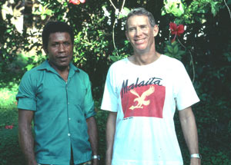  Mae’eadi and Anthropolgist Roger Keesing in Honiara, Solomon Islands, 1991 (Source: C. Jourdan)

(3)
Language is an inherent part of the human species and is part of its evolution.
The development of language in relation to human evolution.
All anthropologists believe that this third point is correct as it puts the development of language in relation to human evolution. Let’s see how in the next slide.
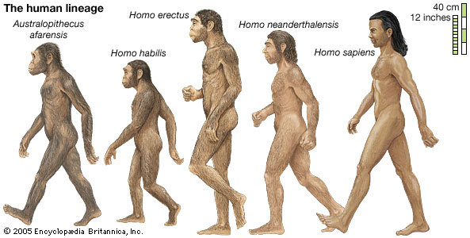

The Origin of Language
Physical anthropologists and paleontologists looking at evolution can help in uncovering the origin of language. The key to understanding how language appeared is to examine its functions: communication between people, store knowledge, think, and express emotions.

If language is linked to evolution, then:  - What point in the history of human evolution were physical (human physical traits like cognitive abilities and larynx) and social (communication through language advantageous) conditions favourable for the development of language?  - How important is the development of language for human evolution? Language was such an adaptive advantage that it put humans ahead on the evolution track, more distant than other humanoids like Neanderthalians. | 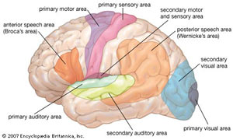  (Click on image to enlarge)
Paleontological records show that the combination appeared 1.6 million years ago at the time of the Homo Erectus. However, language took a long time to develop, and is believed to have only appeared in the last 100,000 years. It is associated with the physical and neurological characteristics of the modern Homo Sapiens

The Development of Communications
The commucations diagram below explains the relationship between the development of language, needs for precise communication, development of the brain, and socialization (Source: S. Nanda)
- Language did not just appear with Homo Sapiens, although the how and why will never be known for certain. Nor is it known why vocal-based symbols were chosen over visual ones.
- Language was most likely the last step in human biological evolution, separating us from animals => Scupin remarked that human history began with cultural evolution (Scupin, 2000: 96).
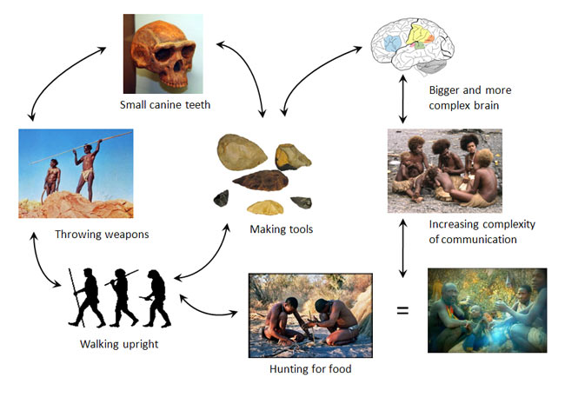

However simplistic this diagram is, it has the merit of proposing a theory of communication that seeks to integrate purely physical considerations with cognitive and social ones. It explains that language did not appear once Homo Sapiens appeared and physical evolution was over. We will never know how language began for sure, and we will never know the time at which it became more beneficial to communicate through a voice-based system of symbols rather than through a visual system of symbols and signs.
But one thing is certain: the capacity for language, which distinguishes humans from all other animals, was probably the last step in our biological evolution, and as Scupin remarks, since that time human history has been marked by cultural rather than biological evolution (Scupin, 2000: 96). In any case, explorations from several directions have greatly reduced the dimensions of our ignorance.

Part 2: What is Language?

Let's leave the topic of the origin of language and move on to the study of language itself. The easiest way to start this study is to ask ourselves the following question:

What do We Know When we Know a Language?
- We know the sounds that belong to our language and those that do not.
- We also know the place of some combinations of sounds.
- Finally, we know how to combine sounds in the right order in order to produce meaning.

What Do We Know about Language?
Building blocks of language:
- Phonology: sound systems
- Morphology: how words are put together
- Lexicon: the vocabulary
- Syntax: the grammar

The Main Characteristics of Human Language
Human language displays four main characteristics: arbitrariness, conventionality, productivity and displacement (the first two we share with non-human primates).
- Arbitrariness means that the relationship between sound and meaning is irrelevant (all languages would use the same words otherwise) => words are symbols: their meanings are defined by culture, not label.
- Conventionality and arbitrariness combined allow us to create new words, assign them meaning, change meaning as needed, and so on.
- Productivity allows us to communicate different messages by combining various elements of language. Thus we can modify and refine the meanings of sentences to fit the context (situation) in which they are spoken (tone, volume used to indicate urgency, etc.)
- Displacement allows us, through language, to talk about the past or future; permitting us to enter a world of abstraction since we cannot see the past or future.
Human language is thus a communication system that is open while those of animals are closed.

Part 3: Language and Culture

Language Socialization
- Language is the repository (bank) of meaning and is a tool used to communicate meaning. How it is used and what the use signals about human relationships is what is important to anthropologists.
- American linguist Noam Chomsky has shown that humans are predisposed for language learning. For example, children can understand and produce complex sentences without having been exposed to the data necessary for the production of such sentences.
- The key to language acquisition is in socialization (the social process associated with learning how to become a member of one’s own society), just like culture.
- Bambi Schieffelin and Elinor Ochs show in their research that language socialization involves two different activities: socialization to use language (language acquisition by children in the context of family life) and socialization through language (socialization of children into culture through language)

Why do Languages Change?
Schieffelin and Ochs (from the previous slide) make it clear that language socialization is the key to cultural socialization, and that language is central to culture and is fed by culture. In anthropology, the debate is whether language is the motor of culture or a mirror of it.
Languages change (like culture):
- Passage of time: each generation influences language in the ways they use it. Expressions change, along with grammar.
- Cultural contact and borrowing from other languages (sometimes this is forgotten through history).
- Migration and subsequent isolation and development of local culture (Quebec French Vs. France French).
- Identity creation.
Visit the KryssTal website and review many of the English words that have come from contact with other languages: http://www.krysstal.com/borrow.html.
These lists are not complete, but they will provide you with a good indication of the process of borrowing.

Language Families

Let's listen to Dr. Kevin Tuite from the Universite de Montreal explain to us how the method of lexicostatistics functions.
Watch the video
(Length 03:41)
Dramatic changes can lead a language to be unrecognizable to its relatives over time. Historical linguists help us to understand how languages are related though lexicostatistics: comparing patterns of sound changes between languages. They compare words likely to be found in each language because they encode elements of everyday life shared by all societies.
- The initial list of 100 words (body parts, intimate family members, basic colours, basic physical environment elements) called the "Core Vocabulary" was compiled by linguist Morris Swadesh.
- Lexicostatistics has been criticized, but has allowed historical linguists to group languages into large families.

Check out
- Ethnologue: Languages of the World, where you can access maps of the different language families from around the world at http://www.ethnologue.com/.
- List of core vocabulary used for lexicostatistics comparison (Source: Language, Culture, and Society: An Introduction to Linguistic Anthropology, by Zdenek Salzmann, Westview Press; 4th ed. (July 31 2006).
- Language Families: Austronesian Languages
Austronesian Language Tree and Full Tree Figure of Austronesian Languages (Click on images to enlarge)
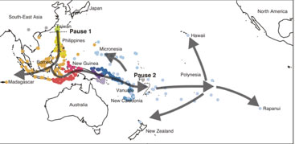 | 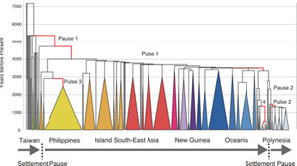
Copyright: The Austronesian Basic Vocabulary Database: Simon Greenhill, Robert Blust & Russell Gray

- Common Words in Six Austronesian Languages
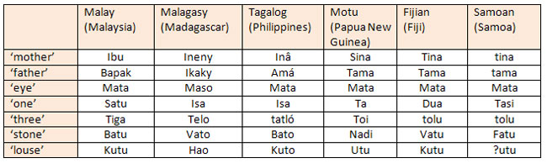

Why Do We Need to Know How Languages are Related?
Knowing how languages are related to each other is important to archaeologists or anthropologists who need to understand the geographical origins of a given group of people.
For instance, for a very long time the origin of Pacific Islanders was an object of conjecture and debate. A nagging question was: Given the cultural traits that are found on both sides of the Pacific Ocean, (pan pipes, tapas, stone or earth ovens, sweet potatoes) it was not clear whether Pacific Islanders had migrated into the Pacific from the Americas or from Asia.
So linguists started to do a comparative study of the languages of the Pacific using the lexicostatistics method. And what results did they get? Well, that that these languages could be grouped into two families: the Papuan languages and the Austronesian languages.

The subsequent comparison of the Austronesian languages of the Pacific with languages of Southeast Asia and South America was done to test the hypothesis of the origin of Pacific Islanders. The idea was that if scholars could find resemblances between the languages of the Pacific with languages found on either side of the Pacific Ocean, then we could determine the geographical origins of Pacific Islanders.

Origins of Pacific Islanders
Knowing how languages are related is important to anthropologists and archaeologists when attempting to understand the geographical origins of a given group => examining whether two groups with similar cultural traits may have originated from the same peoples.
For example: Pacific Islanders may or may not have migrated from the Americas or Asia. Using lexicostatistics, the languages could be grouped into two families: Papuan and Austronesian languages. Austronesian languages of the Pacific were then compared to those of Southeast Asia and South America in order to discover the existence of similarities or not.

How Language Changes

Listen to your professor explain how languages change.
- Language changes reflect a healthy culture where new generations spout new ideas and ways of being appear and push language in different directions.
- Languages have disappeared when their speakers and cultures have come under attack throughout history (i.e. colonization of the world by Europe has left its mark; Tasmania, an island off Australia, had its last aboriginal speakers decimated by British settlers).
- Globalization of popular culture through English is having a similar effect elsewhere. TV programs, songs and print media give more prominence to one language. English has become a lingua franca (a language of universal communication used to overcome linguistic gaps that exist in multilingual encounters).
- Socioeconomic value is being associated with the dominant language and people give in to this and move away from their own language. It is when whole communities shift that ancestral languages become obsolete and disappear.
- National education systems that teach in one "national" language are responsible for many disappearances, for the government is giving social legitimacy to one language and forcing speakers of other languages to learn it.
- Language death is when a language disappears, which entails a process of endangerment stages.
- How Language Changes (cont'd)
- There are 6000 languages present today and, while diversity is high, the forces of colonization, globalization and education threaten them. Linguist Richard Krauss estimates that in 100 years 90% of these languages will be gone or spoken only by the older generations.
- However, new languages may appear when sociolinguistic situations allow them to develop, like the pidgin and creole languages of Jamaica or Haiti. They are created by the contacts between diverse populations speaking different languages and in social circumstances where learning the other languages is impossible. They are also linked to the early slave trade of the Atlantic between Africa and the Americas and in labour trade in the Pacific between Melanesian Islands and the Australian northern state Queensland.
- Malayo-Polynesian Family of Languages
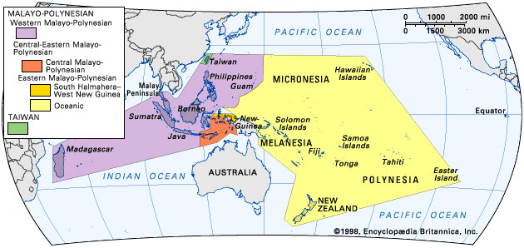
"Before European colonial expansion, Malayo-Polynesian had the widest territorial extent of any language family. A primary genetic division in the family separates the Austronesian languages of Taiwan from the remaining languages, which are divided into Western and Central-Eastern Malayo–Polynesian. Western Malayo-Polynesian includes Javanese, which is spoken by about 76 million people-more than a third of all Austronesian speakers." (Source: Austronesian languages, Encyclopedia Britannica)

The Genesis of Melanesian Pidgin

Listen again to a sample of Solomons Pijin, a version of Melanesian pidgin as it is used by your professor's friend Janet in the Kastom story she is recounting.
In the second part of the 19th century labourers, on sugar plantations who were recruited from their home islands in Melanesia had no access to learn the language of the plantation overseers, nor that of fellow diverse workers.
Thus, a new language developed that retained some grammatical features of the Melanesian languages and borrowed English vocabulary.
For a language with an unpromising start that did not exist 150 years ago, it is now spoken in Papua New Guinea, Solomon Islands and Vanuatu and serves as a national language.

Other New Languages
New languages also appear within particular social groups: Verlan, the language of young people in the housing projects of the suburbs of Paris, is a case in point.
What is Verlan?
Verlan is a form of French slang that plays with syllables and sounds and typically reverses the order of syllables as they are being heard (not written). Most famous examples are words such as Verlan (means: reverse) and ripou (a corrupt police officer).
Let’s see how they are built:

l'envers... l'en vers... vers l'en... versl'en... verslen... verlen... verlan pourri... pou rri... rri pou... rripou... ripou
You can read more about Verlan and see other examples of verlan words at: http://french.about.com/library/vocab/bl-verlan.htm?

Language and Identity

Listen to your professor explain the association between language and identity.
- Social jargons like Verlan or new languages are created not only as a means of communication but as a symbol of identity as well.
- Verlan was originally used to keep information away from those in authority, and it spread as a language of resistance to authority and identity (now used by disenfranchised youths).
- There is a strong association between language and identity and it is fraught with emotional considerations. Does your ability (or lack thereof) to speak Greek affect your identity as a Greek person?
- The association between language and identity has led governments to create language legislation.
  - For example: Bill 101 made French the official language of Quebec and made children not born to English-speaking parents attend French schools, thus implying that French is the language of Quebecers and to ensure the continuation of French as a strong cultural language on the North American continent. Some believed that Quebec culture could only survive in French.

The Sapir-Whorf Hypothesis
The debate revolves around two particular approaches:  - Is language such a powerful tool that it creates grooves of expression that predispose us to see the world in a particular way?  - Or, rather, is language a mirror of culture, reflecting cultural beliefs and preoccupations about the world? | 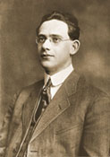  Edward Sapir, 1913(Source: Canadian Museum of Civilization) | 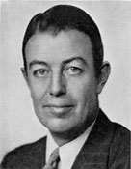  Benjamin Lee Whorf(Source: Manuscripts & Archives, Yale University)

Language as a Mirror
Anthropologists agree that there is a relationship between language and thought, but not one where language determines thought. Rather, they see it as an influence on the speaker's thinking and worldview (weak reading of the hypothesis).
Languages also develop vocabularies that reflect local cultural realities and preoccupations: military vocabulary is prominent in countries where the army is important and the whole vocabulary of cooking in English can be borrowed from French => sauté, julienne, etc.

1. A meaningful sound is a:

a) phone
b) phoneme
c) morpheme
d) vowel
e) consonant
2. _________ refers to the ability to refer to events and issues beyond the immediate present.

a) displacement
b) productivity
c) call system
d) semantics
e) phonetics
3. Human language has _________, or the ability to create an infinite range of understandable expressions from a finite set of rules.

a) flexibility
b) elasticity
c) productivity
d) proclivity
e) universality
4. _________ refers to the study of the meaning of words, phrases and sentences

a) linguistics
b) phonetics
c) morphetics
d) semantics
e) sociolinguistics
5. The term _________ refers to social inequality in access to new and emerging information technology, especially access to up-to-date computers, the Internet and training related to their use.

a) electronic curtain
b) digital divide
c) digital marginalization
d) digital chasm
e) divide
6. Which of the following would be an example of observer's paradox?

a) children under study stop talking about "boogers" when the principal walks into the classroom.
b) while having lunch at a research participant's home, she changes the topic of conversation when her husband walks in to the room.
c) an hour into an interview, a research participant relaxes and starts talking much more informally, using some profanity and colloquialisms.
d) while doing research, a researcher seeks to speak informally, adopting local idioms.
e) during an interview, a research participant refrains from swearing.
7. The Sapir-Whorf hypothesis:

a) says that a people's language affects how a person thinks and sees the world.
b) says that a population's reality shapes its language.
c) says that intelligence can be measured using language mastery.
d) says that new words cannot be learned without experiencing the reality they represent.
e) says that humans can understand reality even if they do not have the words to describe that reality.
8. Tag questions are:

a) questions that prod the listener to speak.
b) rhetorical questions used by the speaker to solicit an emotional reaction.
c) questions seeking negation placed at the start of a sentence.
d) questions seeking affirmation placed at the end of sentences.
e) questions using the "five W's."
9. All early writing systems use _________, symbols that convey meaning through a form or picture resembling that to which it refers.

a) ideagraphs
b) logographs
c) ideagrams
d) glyphs
e) pictographs
10. The best example of language shift is:

a) Cree children learning the Cree language at school.
b) an immigrant living in Vancouver learning English in an ESL class.
c) a French speaker who speaks his language with great difficulty after living in New York for 30 years.
d) the child of Guatemalan refugees who only speaks English as his parents refused to speak Spanish in his presence.
e) a global language displacing indigenous languages.
1. Which language has a superior ability to project images of the future?

a) English
b) Hungarian
c) Cantonese
d) None of the above
12. In English, certain obligatory categories seem to reflect a social bias in favor of:

a) whites
b) males
c) females
d) administrators
13. The fact that the Hungarian and Finnish languages were once the same indicates that they belong to the same.

a) dialect
b) language
c) family
d) genetic stock
14. The sounds that native speakers perceive as being distinct are:

a) morphemes
b) allophones
c) telephones
d) phonemes
15. Human languages are inherently flexible and creative and not closed systems. This human language trait is called productivity.

a) True
b) False
16. The English word ‘dogs’ contains one free morpheme and one bound morpheme.

a) True
b) False
17. Modern anthropologists think that language determines thought.

a) True
b) False
18. Scientific attemps to teach apes to spe4ak human languages have been extremely successful, especially with chimpanzees.

a) True
b) False

Question
19. Words in human languages seldom have any necessary connection with the concrete objects or abstract symbols they represent. This human language trait is called:

a) displacement
b) productivity
c) clarity
d) arbitrariness
20. Linguistic differences in pronunciation, vocabulary, or syntax that may differ within a single language are known as:

a) honorifics
b) dialects
c) glottos
d) sublanguages

