- WHAT IS JOB PERFORMANCE?
  - Behaviour
  - Quality and quantity of the employees’ performance
  - Under employees’ control but not at all times
  - External factors also contribute to one’s job performance.
  - Contributes positively or negatively
  - To accomplish organizational goals
- DETERMINANTS OF JOB PERFORMANCE
- Task performance
  - Behaviours that are directly involved (technical) in the transformation of resources into goods or services.
  - Included in a job description.
  - Routine task performance: Well-know or habitual responses by employees to predictable task demands.
  - Adaptive task performance: Thoughtful responses by and employee to unique or unusual task demands. How an employee handles unpredicted situations.
  - Creative task performance: Ideals or physical outcomes that are both novel and useful.
    - Ex. Proposing ideas.
  - Many organizations identify task performance behaviours by conducting a job analysis.
    - Job analysis: A process by which an organization determines requirements of specific jobs.
- Organizational Citizenship Behaviours.
  - Voluntary activities that contribute to the organization by improving the work setting.
  - Interpersonal
    - Helping
    - Courtesy
    - Sportsmanship.
  - Organizational
    - Voice
    - Civic virtue
    - Boosterism.
- Counterproductive Work Behaviours.
  - Behaviours that intentionally hinder organizational goal accomplishment.
  - Negative or undesirable attitudes.
  - Interpersonal
  - Organizational
  - Types of Counterproductive Behaviours
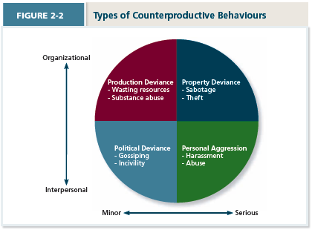

WHAT IS ORGANIZATIONAL BEHAVIOUR?

Organizational Behaviour: A field of study devoted to understanding, explaining and ultimately improving the attitudes and behaviours of individuals and groups in organizations.
  - Human Resources Management: Field of study that focuses on the implications of OB theories and principles in organizations.
  - Strategic Management: Field of study devoted to exploring the product choices and industry characteristics that affect an organization’s profitability.
- Management
  - Management is the art of science getting things accomplished in organizations through others.
  - There is a difference between leadership and managers.
  - Leaders go beyond management.

- EARLY PRESCRIPTIONS CONCERNING MANAGEMENT
- The Classical View
  - Classical studies tends to adopt the pessimistic view of human nature. Bureaucracy is Max Weber’s ideal type of organization that includes:
    - Strict chain of command.
    - Technical competence.
    - Detailed rules, regulations, and procedures.
    - High specialization.
    - Centralization of power.
  - Scientific Management: Using scientific methods to design optimal and efficient work processes and tasks.
- Human Relations View
  - The human relations movement called attention to certain dysfunctional aspects of classical management and bureaucracy:
    - Employee alienation.
    - Limits innovation and adaptation.
    - Resistance to change.
    - Minimum acceptable level of performance.
    - Employees lose sight of the overall goals of the organization.
  - HRM establishes personal relationships.
  - Recognizes that the psychology attributes of individual workers and social forces within work groups have important effect on work behaviours.
- Contingency Management: The Contingency Approach
  - Dependencies are called contingencies.
  - The contingency approach to management recognizes that there is no one best way to manage.
  - Situational approach. Whichever suits the organization best.

- INTEGRATIVE MODEL OF ORGANIZATIONAL BEHAVIOUR
- 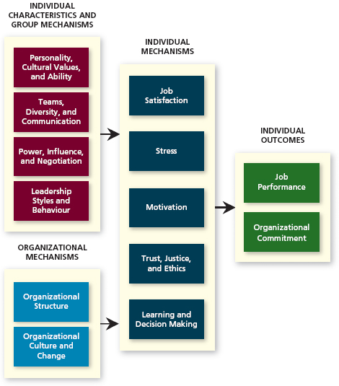

- WHAT DO MANAGERS DO? 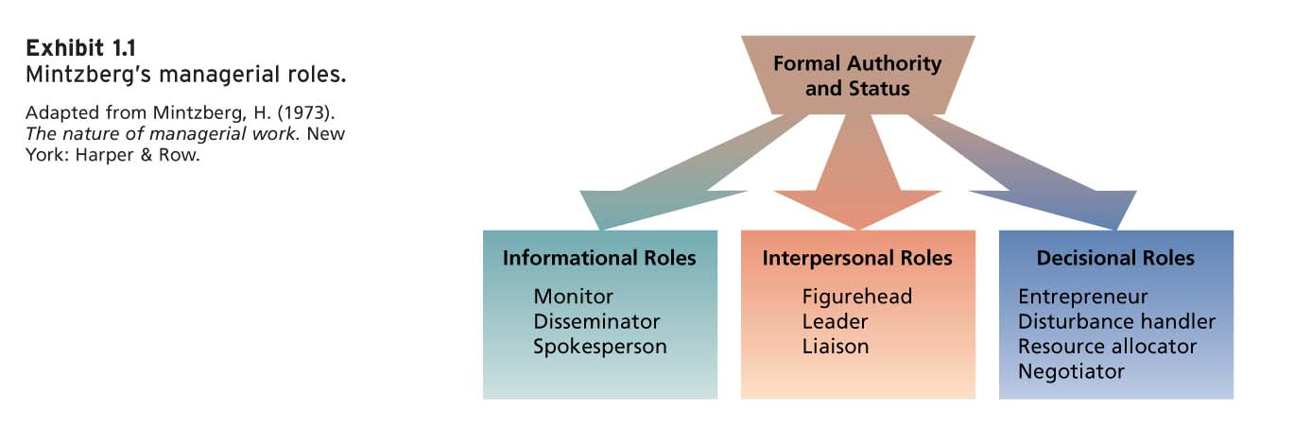

- SUMMARY OF MANAGERIAL ACTIVITIES
- 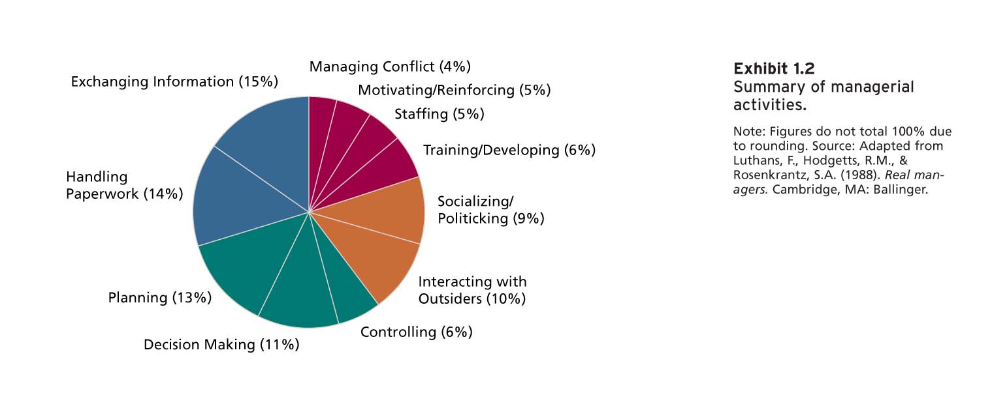

- MANAGERIAL MINDS
- Experienced managers use intuition to guide many of their actions:
  - To sense that a problem exists.
  - To perform well-learned mental tacks rapidly.
  - To synthesize isolated pieces of information and data.
  - To double-check more formal or mechanical analyses.
  - GRIP
    - Game plan.
    - Relationship goals.
    - Esteem goals (Self goals)
    - Procedure.
- Manager Skills
  - Knowledge competence
  - Sensitivity competence
  - Skills: Analyze organizational situations and propose ideas.
  - Value: Ethical and legal obligations.

- International Managers
  - National culture is one of the most important contingency variables in organizational behavior.
  - The management style and emphasis given to various activities varies greatly across cultures.
  - Cultural variations in values affect both managers’ and employees’ expectations about interpersonal interaction.

- MANAGEMENT PRACTICES OF THE BEST COMPANIES TO WORK FOR IN CANADA
  - Flexible work schedules.
  - Stock-options, profit-sharing, and bonuses.
  - Training and development programs.
  - Family assistance programs.
  - Career development programs.
  - Wellness and stress reduction programs.
  - Employee recognition and reward programs.

- Organizational Commitment
  - The desire to remain a member of the organization 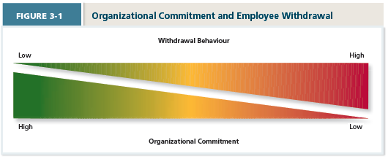
  - Withdrawal Behavior: Employee actions that are intended to avoid work situations.
- Three Forms of Organizational Commitment
  - Focus of Commitment: Refers to the various people, places, and things that can inspire a desire to remain a member of an organization.
- 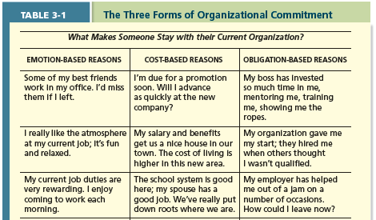
  - Affective Commitment (Emotion-based): An employee’s desire to remain a member of an organization due to a feeling of attachment.
    - Erosion Model: A model that suggests that employees with fewer bonds with co-workers are more likely to quit the organization.
    - Social Influence Model: A model that suggests that employees with direct linkages to co-workers who leave the organization will themselves become more likely to leave.
  - Continuance Commitment (Cost-based): An employee’s desire to remain a member of an organization due to an awareness of the costs of leaving.
    - Benefit associated with staying and a cost associated with leaving.
    - Lack of employment alternatives increases continuance commitment.
    - Embeddedness: An employee’s connection to and sense of fit in the organization and community.
      - Provides more reasons why a person needs to stay with their current position.
- 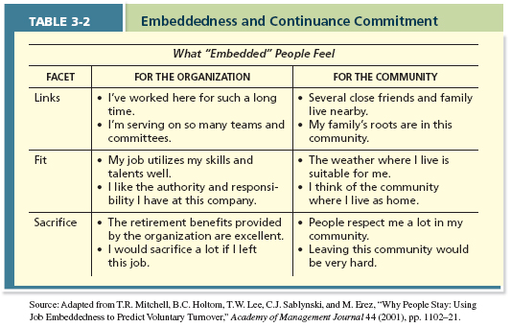
  - Normative Commitment (Obligation based): An employee’s desire to remain a member of an organization due to a feeling or obligation.
    - Feeling of obligation to remain loyal.
    - Staying because you ought to.
    - Organization’s investment in employees.

- Reactions to Difficult Situations
- High Commitment
  - Voice: A response, often in reaction to a negative work event, in which an employee offers constructive suggestions for change.
  - Loyalty: A passive response to a negative work event in which one publicly supports the situation but privately hopes for improvement.
- Low commitment
  - Neglect: A passive, destructive response to a negative work event in which one’s interest and effort in work decline
  - Exit: A response to a negative work event in which one becomes often absent from work or voluntarily leaves the organization.

- Types of Employees
- Stars
  - Ideal employees.
  - Good job performers.
  - Commitment is high.
  - Role models of the organization.
- Citizens
  - Employees are commitment.
  - Not as superior as stars.
  - Shows willingness to grow.
  - Shows loyalty
  - Civic values
- Lone Wolves

- Apethetic
  - Neglects their responsibilities
  - Not willing to learn
  - No sense of connection
- Withdrawal Behaviour
- 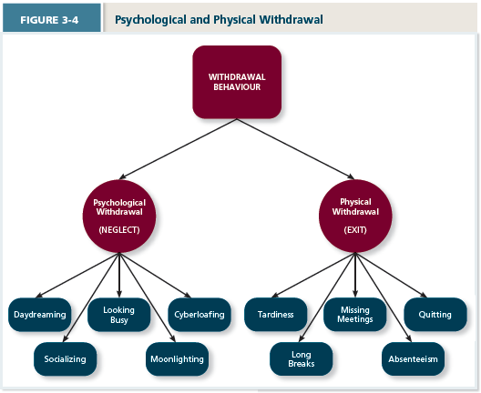
  - Psychological Withdrawal: Mentally escaping the work environment.
  - Physical Withdrawal: Physical Escape from the work environment.
  - Independent Forms Model: A model that predicts that the various withdrawal behaviours are uncorrelated, so that engaging in one type of withdrawal has little bearing on engaging in other types.
  - Compensatory Forms Model: A model indicating that the various withdrawal behaviours are negatively correlated, so that engaging in one type of withdrawal makes one less likely to engage in other types.
  - Progression Model: A model indicating that various withdrawal behaviours are positively correlated, so that engaging in one type of withdrawal makes on more likely to engage in other types.

- Commitment and Employment Relationships
- Psychological contract: what to expect. Employee beliefs about what employees owe the organization and what the organization owes them.
- Two forms of psychological contracts:
  - Relational Contracts: Focus on a broad set of open-ended and subjective obligations.
  - Transactional Contracts: Focus on a narrow set of specific monetary obligations.

- What is Job Satisfaction?
  - A collection of attitudes that workers have about their jobs.
  - Determinations of Job Satisfaction:
    - Discrepancy
    - Fairness
    - Disposition
    - Mood and emotion

Why Are Some Employees More Satisfied than Others?
  - Employees are satisfied when their job provides the things they value.
  - Value: Things that people consciously or unconsciously want to seek or attain.
- Facets of Satisfaction
  - Pay: Feelings towards the compensation for their jobs.
  - Promotions: Feelings about how the company handles promotions.
  - Supervisors: Feelings about their boss, including his or her competency, communication, and personality.
  - Coworkers: Feelings about their co-workers, including abilities and personalities.
  - Work tasks (work itself): Feelings about their actual work tasks.
    - Meaningfulness of Work: A psychological state indicating the degree to which work tasks are viewed as something that counts in the employee’s system of philosophies and beliefs.
    - Responsibility for Outcomes: The degree to which employees feel they are key drivers of the quality of work output.
    - Knowledge of Results: The extent to which employees are aware of how well or how poorly they are doing.
    - Job Characteristics Theory: A theory that argues that five core characteristics combine to result in high levels of satisfaction with the work itself.
      - Variety, Identity, Significance, Autonomy, Feedback.
- 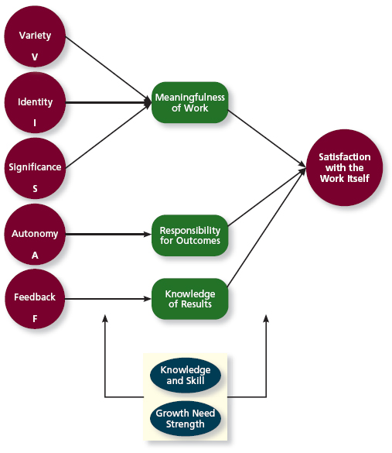
Variety: Job requires different activities and skills.
Identity: Job offers completion of a whole identifiable piece of work.
Significance: Job really matters and impacts society as a whole.
Autonomy: Job allows individual freedom and discretion regarding how the work is to be done.
Feedback: Job itself provides information about how well the job holder is doing.

Knowledge and Skill: Employees have the aptitude and competence needed to succeed on their job.
Growth Need Strength:
Employees desire to develop themselves further.

- 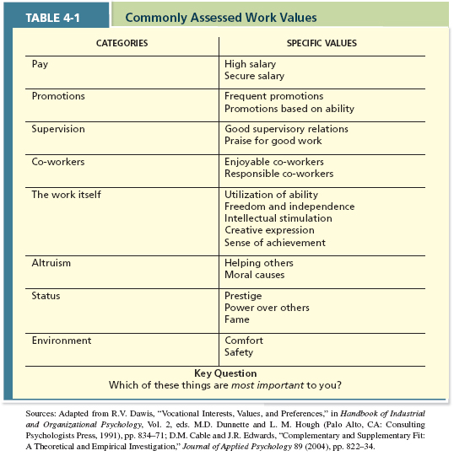

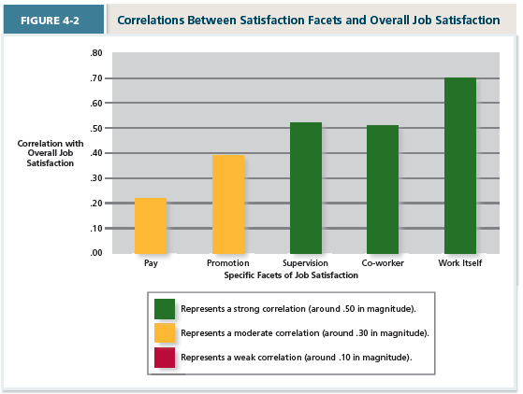
- Key Contributors to Job Satisfaction
  - Mentally challenging work
  - Adequate compensation
  - Career opportunities.
  - People

- Job Enrichment: When job duties and responsibilities are expanded to provide increased levels of core job characteristics.

What Determines Job Satisfaction?

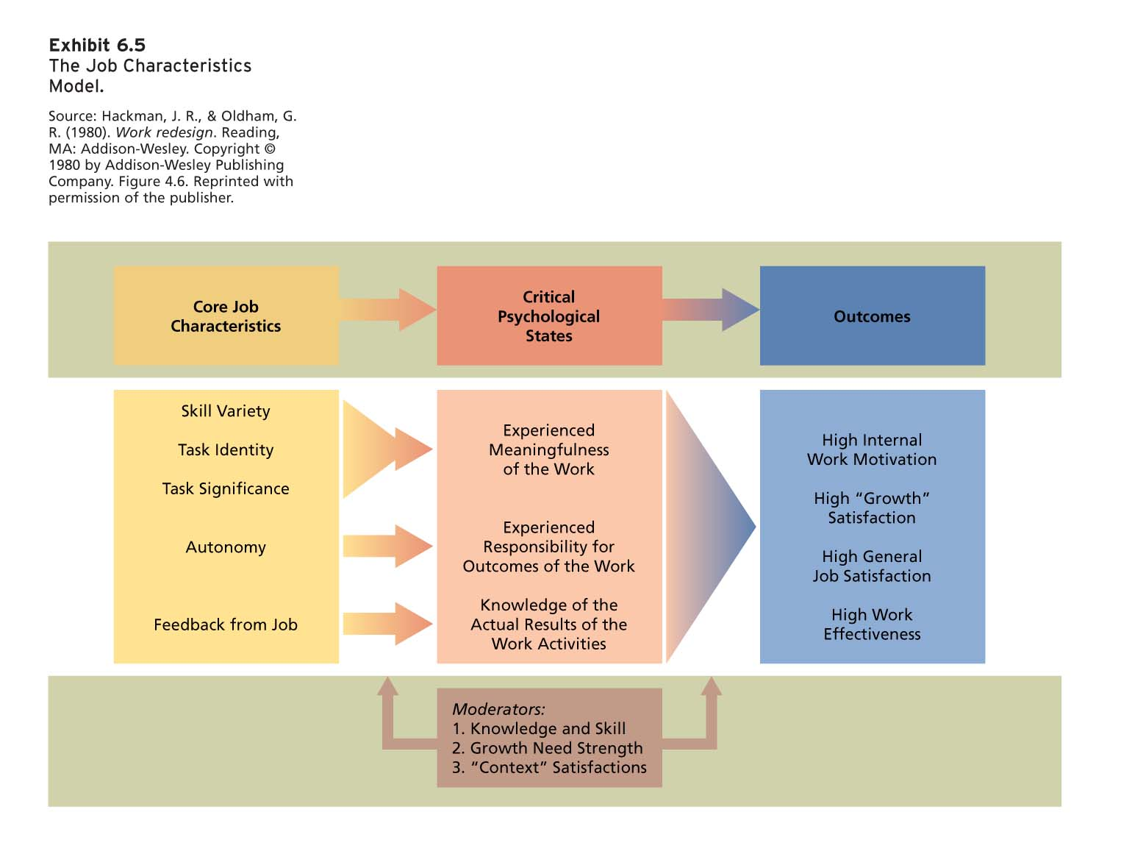

  - Disposition
  - Value Fulfillment (“Value-percept theory”): A theory that argues that job satisfaction depends on whether the employee perceives that his or her job supplies those things that he or she values.

- Consequences of Job Satisfaction
- Job Satisfaction has a number of consequences:
  - Absence from work
  - Turnover
  - Performance
  - Organizational Citizenship behaviour
  - Customer satisfaction and profit.

- Moods and Emotions
  - Moods and emotions differ
    - Length of time
    - Intensity
    - Whether they have a target
  - Both can vary over the course of a day
  - Both can influence one’s job satisfaction (e.g. on a given day).
  - Emotional Labour: The management of their emotions that employees must do to complete their job duties successfully.
    - Should organizations require emotional labour?
  - Emotional Contagion: The idea that emotions can be transferred from one person to another.
- Changing Attitudes
  - Goldstein and Sorcher recommend three techniques for teaching new behaviours.
    - Modeling of correct behaviors.
    - Role-playing of correct behaviours.
    - Social reinforcement.

- Stress: The psychological response to demands when there is something at stake for the individual, when coping with these demands would tax of exceed the individual’s capacity or resources.
- Stressors: Demands that cause the stress response
- Strains: Negative consequences of the stress response

- The Stress Process

Transactional Theory of Stress: How stressful demands are perceived and appraised, as well as how people respond to the perceptions of appraisals.

Primary Appraisal: Evaluation of whether a demand is stressful and, if it is, the implications of the stressor in terms of personal goals and well-being.

Benign Job Demands: Job demands that are not appraised as being stressful.
- 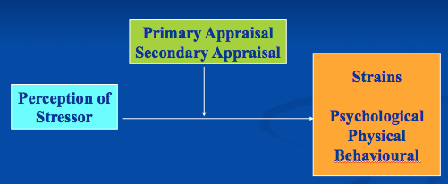

- Model of a Stress Episode
- 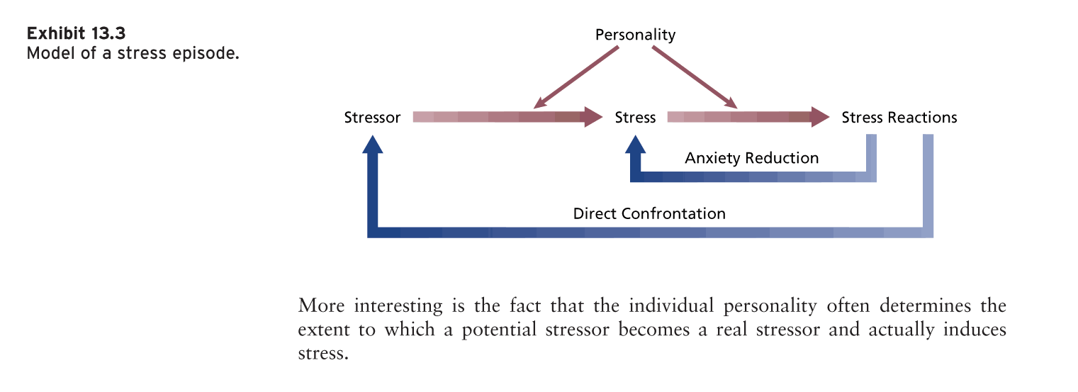

Sources of Stress at Various Points in the Organization

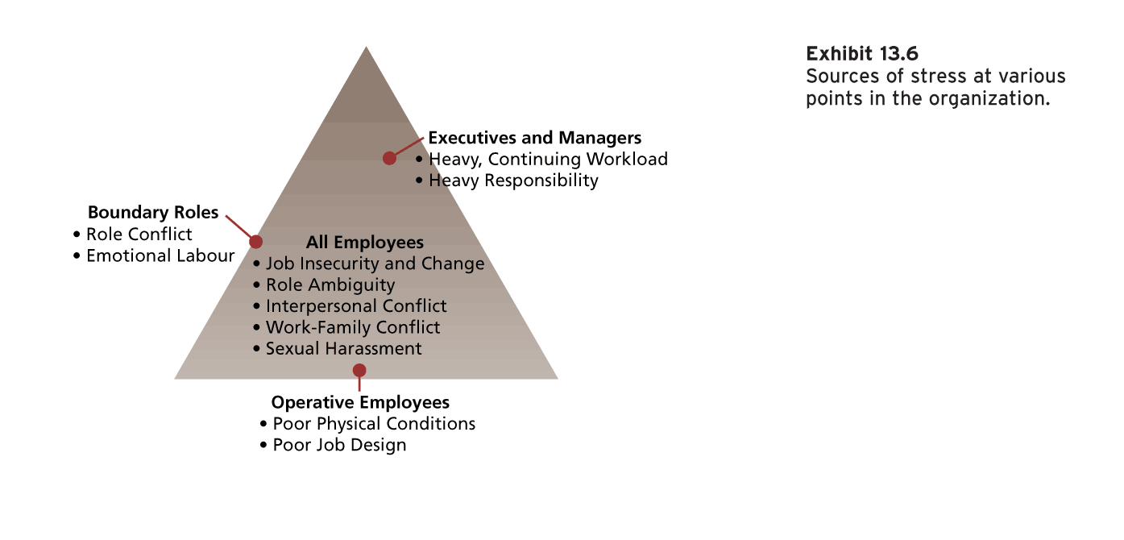

TYPES OF STRESSORS
- Hindrance Stressors: Stressful demands that are perceived as hindering progress toward personal accomplishments or goal attainment.
  - Role Conflict: Others’ having differing expectations of what an individual needs to do in a role.
  - Role Ambiguity: Lack of direction and information about what needs to be done in a role.
  - Role Overload: An excess of demands on an employee preventing him or her from working effectively.
  - Daily Hassles: Minor day-to-day demands that interfere with work accomplishment.
  - Work Conditions
  - Interpersonal conflict
  - Sexual and psychological harassment
  - Triggers negative emotions like anxiety and anger.
- Challenge Stressors: Stressors that tend to be appraised as opportunities for growth and achievement.
  - Time Pressure: Sense that the amount of time allocated to do a job is not quite enough.
  - Work Complexity: The degree to which job requirements tax or just exceed employee capabilities.
  - Work Responsibility: The number and importance of the obligations that an employee has to others.
- Non-Work Hindrance Stressors:
  - Work-Family Conflict: A form of role conflict in which the demands of a work role hinder fulfillment of the demands in a family role (or vice versa).
  - Negative Life Events: Events such as a divorce or death of a family member that tend to be appraised as a hindrance.
  - Financial Uncertainty: Uncertainties with regard to the potential for loss of livelihood, savings, or the ability to pay expenses.
  - Types of Work Life Conflict:
    - Time-based
    - Strain-Based
    - Behaviour-Based
- Non-Work Challenge Stressors:
  - Family Time Demands: The amount of time committed to fulfilling family responsibilities.
  - Personal Development: Participation in activities outside of work that foster growth and learning.
  - Positive Life Events: Events such as marriage or the birth of a child that tend to be appraised as a challenge.

- How People Cope With Stress
  - Secondary Appraisal: When people determine how to cope with the various stressors they face.
  - Coping: Behaviors and thoughts used to manage stressful demands and the emotions associated with the stressful demands.
  - Behavioural Coping: Physical activities used to deal with a stressful situation.
  - Cognitive Coping: Thoughts used to deal with a stressful situation.
  - Problem-Focused Coping: Behaviours and cognitions of an individual intended to manage the stressful situation itself.
  - Emotion-Focused Coping: Behaviours and cognitions of an individual intended to help manage emotional reactions to the stressful demands.
- Reacting to Stress
  - Strain: The reactions of people who experience organizational stress.
    - Behavioural Reactions.
    - Psychological Reactions
    - Physiological Reactions.
- 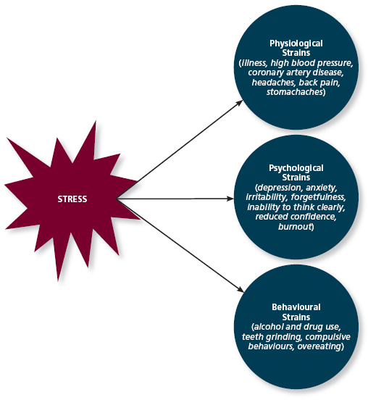
  - Physiological Strains: Reactions from stressors that harm the human body.
    - Dizziness
    - Headache
    - Pounding hearts
    - Stomach distress
    - Difficulty sleeping
    - Illness and death.
  - Psychological: Negative psychological reactions from stressors such as depression, anxiety and anger.
    - Burnout: Emotional, mental and physical exhaustion from coping with stressful demands on a continuing basis.
  - Behavioural: Patterns of negative behaviours that are associated with other strains.
    - Accidents at work.
    - Performance changes.
    - Substance abuse (including smoking)
    - Absenteeism and Turnover
    - Aggression (Retaliation.
    - Counterproductive work behaviours.

- Reducing and Managing Stress
  - Stress Audit: An assessment of the sources of stress in the workplace.
  - Work Planning (Family-Friendly Policies)
    - Decreased/Compressed Workweek.
    - Personal Days.
    - Job sharing/Part-time work.
    - Flextime.
    - Flexplace/Telecommuting.
  - Other Practices
    - Employee Assistance Programs (EAP)
      - Stress management
      - Time Management
      - Rehabilitation
    - On-site daycares or daycare subsides
    - Gym memberships.
    - Connections to health specialists

- Five Steps to Emotional Stability

- Self-Monitoring

- Motivation and Work
  - Motivation: A set of energetic forces that determine the direction, intensity, and persistence of an employee’s work effort.
  - The extent to which persistent effort is directed toward a goal.
  - The basic characteristics of motivation:
    - Direction
    - Intensity
    - Persistence of Effort
    - Goals.
  - Engagement: A widely used term in contemporary workplaces that has different meanings depending on the context; most often refers to motivation, but it can refer to affective environment.
    - Employees who are “engaged” completely invest themselves and their energies into their jobs.
    - Outwardly, engaged employees devote a lot of energy to their jobs, striving hard as they can to take initiative and get the job done.
    - Inwardly, engaged employees focus a great deal of attention and concentration on their work, sometimes becoming so absorbed, involved and interested in their tasks that they lose track of time.

- Prominent Need Theories of Motivation
  - Maslow’s Hierarchy of Needs
  - Alderfer’s ERG Theory
  - McClelland’s Theory of Needs

Process Theories of Work Motivation
  - Motivation theories that specify the details of how motivation occurs.
  - Expectant Theory: A theory that describes the cognitive process employees go through to make choices among different voluntary responses.
    - Employee behavior is directed toward pleasure and away from pain or, more generally, toward outcomes and away from others.
    - Choices depend on three specific beliefs that are based in out part learning and experience.
    - Expectancy: The belief that exerting a high level of effot will result in successful performance on some task.
      - Self-Efficacy: The belief that a person has the capabilities needed to perform the behaviours required on some task.
    - Instrumentality: The belief that successful performance will result in some outcome or outcomes.
    - Valance: The anticipated value of the outcome(s) associated with successful person.
      - Needs: Groupings or clusters of outcomes viewed as having critical psychological or physiological consequences.
      - Extrinsic and Intrinsic Motivation
      - Meaning of Money: The idea that money can have symbolic value (e.g., achievement, respect, freedom) in addition to economic value.
    - Motivational Force: The direction of effort is dictated by three beliefs:
      - Expectancy: (E P)
      - Instrumentality: (P O)
      - Valance (V)

Motivational Force = (EP) X [E((PO)XV)]
      - E in the equation signifies that instrumentalities and valances are judged with various outcome in mind, and motivation increases as successful performance is linked to more and more attractive outcomes.
      - Motivational force equals zero is and of the three beliefs equals zero.
  - Equity Theory: A theory that suggests that employees create a mental ledger of the outcomes they receive for their job inputs, relative to some comparison other.
    - Comparison Other: Another person who provides a frame of reference for judging equity.
    - Equity Distress: An internal tension that results from being overrewarded or underrewarded relative to some comparison other.
    - Cognitive Distortion: A reevaluation of the inputs an employee brings to a job, often occurring in response to equity distress.
    - Internal Comparison: Comparing oneself to someone in your same company.
    - External Comparison: Comparing oneself to someone in a different company.
  - Goal Setting Theory: A theory that views goals as the primary drivers of intensity and persistence of effort.
    - Specific and Difficult goals: Goals that stretch an employee to perform at his or her maximum level while still staying within the boundaries of his or her ability.
    - Self-Set Goals: The internalized goals that people use to monitor their own progress.
    - Feedback: In goal setting theory, it refers to progress updates on work goals.
    - Task Complexity: The degree to which the information and actions needed to complete a task are complicated.
    - Goal Commitment: The degree to which a person is determined to reach the goal.
    - S.M.A.R.T. Goals: Specific Measurable Achievable Results-Based Time-Sensitive goals.
  - Psychological Empowerment: An energy rooted in the belief that tasks are contributing to some larger purpose.
    - Meaningfulness: A psychological state reflecting one’s feelings about work tasks, goals, and purposes, and the degree to which they contribute to society and fulfill one’s ideals and passions.
    - Self-Determination: A sense of choice in the initiation and continuation of work tasks.
    - Competence: The capability to perform work tasks successfully.
    - Impact: The sense that a person’s actions “make a difference”-that progress is being made toward fulfilling some important purpose.

- 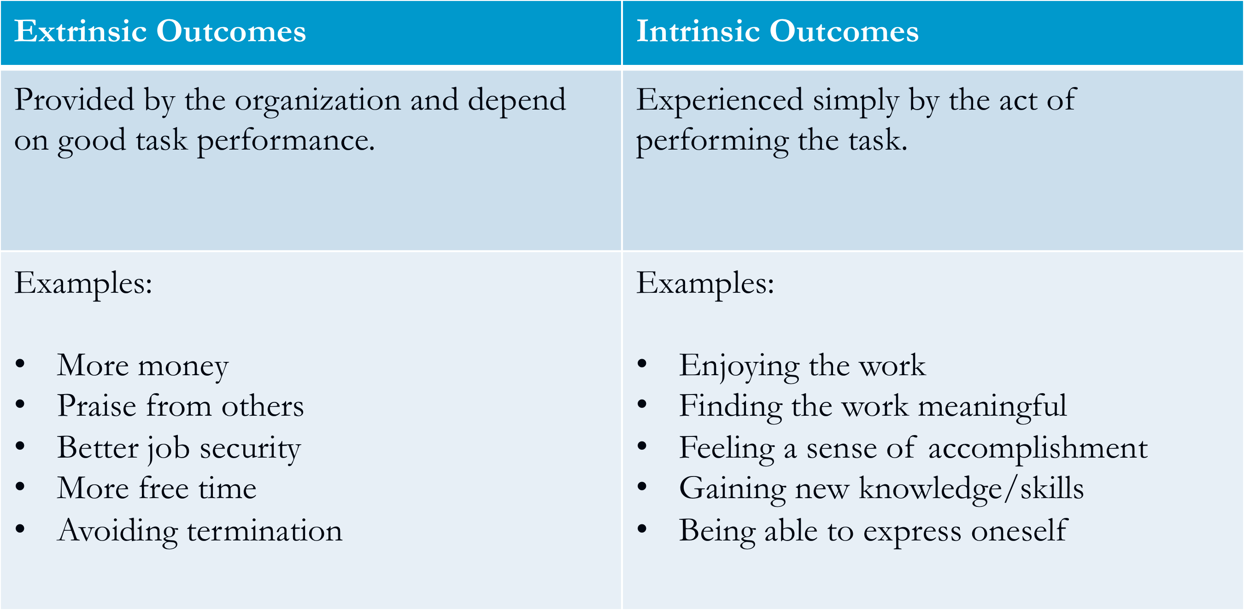
  - Extrinsic Outcomes: Related to the Expectancy Theory, the desire to put forth work effort due to some contingency that depends on task performance.
  - Intrinsic Motivation: Desire to put forth work effort due to the sense that task performance serves as its own reward.

- Few Factors That Effect Motivation in Work Places
  - Achievement/Recognition
  - Work itself
  - Responsibility
  - Advancement/Growth
  - Supervision
  - Company Policy
  - Working Conditions
  - Salary
  - Peer Relationship
  - Security

- Few Suggestions for Motivating the Employees
  - Recognize individual differences
  - Match people to jobs
  - Practical and realistic goals.
  - Individualize rewards
  - Link rewards to performance
  - Check the system for equity
  - Materialistic incentives.

- How to Motivate: Managerial Principles
  - Employees want to see clear relationships between Effort, Performance and Desirable (extrinsic) Outcomes.
  - Employees want jobs that provide psychological empowerment.
  - Employees need goals.
  - Employees want to be treated fairly.

- Money as a Motivator
  - Financial incentives and pay-for-performance plans have been found to increase performance and lower turnover.
  - Compensation:
    - Piece-rate
    - Wage incentive plans
    - Merit pay
    - Lump sum bonus
  - Pay plans to motivate teamwork:
    - Profit sharing
    - ESOPs
    - Gain sharing
    - Skill-based pay

- Job Enrichment Procedures
  - Think about Job Characteristics Model
  - Many job enrichment schemes include the following:
    - Combining tasks
    - Establishing external client relationships.
    - Establishing internal client relationships.
    - Reducing supervision or reliance on others.
    - Forming work teams.
    - Making feedback more direct.

- Management by Objectives
  - An elaborate, systematic, ongoing program designed to facilitate goal establishment, goal accomplishment, and employee development.

- Alternative Working Schedules
  - Flex-time
  - Compressed workweek
  - Job sharing
  - Telecommuting

- Motivation Practices in Perspective
  - The balanced motivational systems used by an motivational systems used by an organization should fit the strategic goals of the organization.

- Effects of Motivation on Performance and Commitment
- 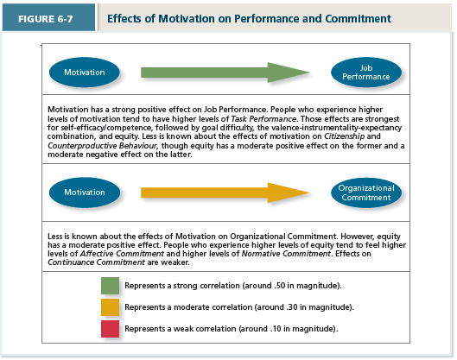

- Trust: The willingness to be vulnerable based on positive expectations that the other party has good intensions and actions.
- Justice: The perceived fairness of an authority’s decision making.
- Ethics: The degree to which the behaviours of an authority are in accordance with generally accepted moral norms.

- Factors That Influence Trust Levels
- 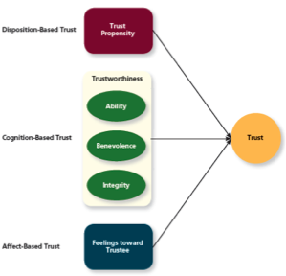

- Types of Trust Over Time
- 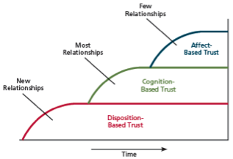
  - Disposition-Based Trust: Trust that is rooted in one’s own personality, as opposed to a careful assessment of the trustee’s trustworthiness.
    - Trust Propensity: A general expectation that the words, promises, and statements of individuals can be relied upon.
  - Cognition-Based Trust: Trust that is rooted in a rational assessment of the authority’s trustworthiness.
    - Trustworthiness: Characteristics or attributes of a person that inspire trust, including competence, character, and benevolence.
    - Ability: The skills, competencies, and areas of expertise that enable an authority to be successful in some specific area.
    - Benevolence: The belief that an authority wants to do good for a trustor, apart from any selfish or profit-centered motives.
    - Integrity: The perception that an authority adheres to set of values and principles that the trustor finds acceptance.
  - Affect-Based Trust: Trust that depends on feelings toward the authority that go beyond any rational assessment of trustworthiness.

- Justice
  - Employees want to be treated fairly by authorites.
  - Four justice considerations.
    - Distributive: The perceived fairness of decision-making outcomes.
    - Procedural: The perceived fairness of decision-making processes.
    - Interpersonal: Perceived fairness of the interpersonal treatment received by employees from authorities.
    - Informational: Perceived fairness of the communications provided to employees from authorities.
- Rules of Fair Process
  - Voice
  - Correctability
  - Consistency
  - Bias Suppression
  - Representativeness
  - Accuracy.

- Justice Trust
  - The more author figures (managers) treat employees in a just manner, the more they will be perceived by their employees as trustworthy.
  - Thus, justice is important for trust building in organizations.

- Ethics in Organizations (Occupation Specific)
  - Moral consequences can be framed in terms of the potential to harm any stakeholders in the decision.
  - Nature of ethical dilemmas:
    - Conflicts of interest.
    - Questionable gift giving
    - Sexual harassment
    - Workplace fraud
    - Favouritism/nepotism
    - Unfair competition
    - Disrespect for employee legislation.
  - Whistle-Blowing: Employees’ exposing illegal or immoral actions by their employer.

- The Four-Component Model of Ethical Decision Making
  - A model that argues that ethical behaviours result from the multistage sequence of moral awareness, moral judgment, moral intent, and ethical behaviour.
- 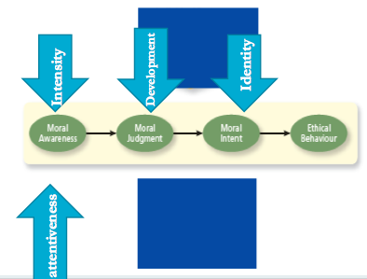
- 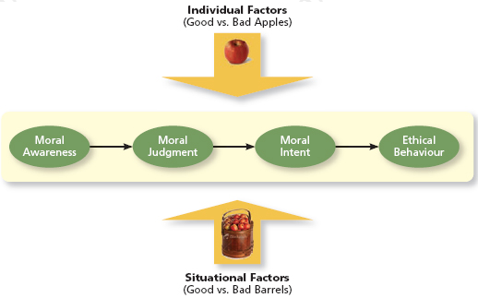

  - Moral Awareness: Recognition by an authority that a moral issue exists in a situation.
    - Moral Intensity: The degree to which an issue has ethical urgency.
    - Moral Attentiveness: The degree to which people chronically perceive and consider issues of morality during their experiences.
  - Moral Judgment: When an authority can accurately identify the “right” course of action.
    - Cognition Moral Development: As people age and mature, they move through several states of moral development, each more mature and sophisticated than the prior one.
    - Moral Principles: Perspective guides for making moral judgments.
  - Moral Intent: An authority’s degree of commitment to the moral course of action.
    - Moral Identity: The degree to which a person views himself or herself as a moral person.

- Bringing it all Together 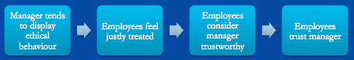

- Causes of Unethical Behaviour
  - Anticipation of healthy reinforcement or gain
  - Role/Value conflict
  - Stiff competition for scarce resources
  - Personality and level of awareness
  - Culture of an organization

- Employing Ethical Guidelines
  - Identify the effects of the decision made
  - Identify the costs and benefits of decision alternative to the stakeholders.
  - Consider the moral expectations that surround a particular decision.
  - Be familiar with common ethical dilemmas in your organizational role or profession
  - Discuss ethical matters with decision stakeholders and others.
  - Convert your ethical judgments into appropriate action.
  - Training and education in ethics is also important.

- Corporate Social Responsibility: A perspective that acknowledges that the responsibility of a business encompasses the economic, legal, ethical and citizenship expectations of society.

- PBS Documentary McWane
  - Tyler Pipe (McWane’s largest Plant)
  - Repeat violator of safety rules.
  - Workers experienced burns, amputations, and violent industrial accidents.
  - Unguarded machinery.
  - Just do work and don’t care about works. Safety is sacrificed to increase productivity.
  - Company expands. Annual revenues 2 Billion. Increases their profitability through “Disciplined management practices”.
    - Meant reducing work force by two thirds.
  - Employee died while working at Tyler Piping.
  - Company denied that it was their fault.
  - No injuries legitimate
  - Productivity increases so does the number of accidents.
  - Turnover heightened then they began to employee ex-convicts.
  - Enviable for being very profitable and commercial success.
  - Unenviable for their business practices (most dangerous workplaces in America).
  - How can we apply the 4-Component Model to McWane senior management
    - Moral Intensity: Proximity is low
    - Moral Judgment: Senior management put an emphasis on production over the safety of people (and the environment)
    - Moral Intent: None
    - Moral Behaviour: None (until culture change)
  - How can we apply the 4 component model to Robert rester
    - Whistleblower
      - Personal Costs > Personal Benefits.
      - Organizational Costs < Organizational Benefits (arguably)
    - Moved through all components of model to speak out against the organization but the organizational pressures prevented him from doing the right thing earlier.

- What is Learning?
  - A relatively permanent change in knowledge, skill or behaviour that occurs due to practice or experience.
  - Expertise: The knowledge and skills that distinguish experts from novices.

Types of Knowledge
  - Explicit Knowledge: Knowledge that is easily communicated and available to everyone.
  - Tacit: Knowledge that employee can only learn through experience.

- What do Employees Learn?
  - Practical skills
  - Intrapersonal skills
    - Emotional and psychological skills.
    - How to be able to propose ideas and making decisions.
    - Processing information.
    - Introverts vs. Extroverts
  - Interpersonal skills
    - Between individuals and groups.
    - Social relationships.
    - Communication skills.
  - Cultural Values

- How do Employees Learn?
  - Operant Learning:
- 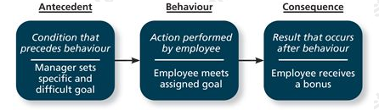
  - The “consequences”
  - Reinforcement: The process by which consequences strengthen behaviours.
  - Contingencies of Reinforcement: Four specific consequences used by organizations to modify employee behaviour.
    - Increases desired behaviours:
      - Positive Reinforcement: A reinforcement contingency in which a positive outcome follows a desired behaviour.
      - Negative Reinforcement: A reinforcement contingency in which an unwanted outcome is removed following a desired behaviour.
        - Not always encouragement (**Exam Q*)
    - Decreases unwanted behaviours
      - Extinction: Removal of a positive outcome following an unwanted behaviour to decrease its reputation.
      - Punishment: Imposing an unpleasant outcome following an unwanted behaviour to decrease its reputation.

- Using Punishment Effectively
  - Provide an acceptable alternative for the punished response.
  - Limit the emotions involved in punishment.
  - Make sure the chosen punishment is truly aversive.
  - Punish immediately or reinstate the circumstances surrounding the problem behaviour at a more appropriate time.
  - Do not reward unwanted behaviours before or after punishment.

- Social Cognitive Theory
  - Social learning involves:
    - Observing the behaviour of others.
    - Seeing what consequences they experience.
    - Thinking about what might happen if we act the same way.
    - Observational Learning
      - When employees observe the actions of others, learn from when they observe, and then repeat the observed behaviour.
    - Self-efficacy
    - Self-management/self-regulation are part of social learning theory.

- Goal Orientation
  - Learning Orientation: A predisposition or attitude according to which building competence is deemed more important by an employee than demonstrating competence.
  - Performance-Proven Orientation: A predisposition or attitude by which employees focus on demonstrating their competence so that others will think favourably of them.
  - Performance-Avoid Orientation: A predisposition or attitude by which employees focus on demonstrating their competence so that others will not think poorly of them.

- Organizational Learning Practices
  - Organizational behaviour modification.
  - Employee recognition programs.
  - Training and formal learning
  - Informal learning
  - Career development.

- What is Decision Making?
  - The process of generating and choosing from a set of alternatives to solve a problem.

- Decision Making in Known Situations
  - Programmed Decisions Intuition
  - Programmed Decisions: Decisions that are somewhat automatic because the decision maker’s allows him or her to recognize the situation and the course or action to be taken.
  - Intuition: An emotion judgment based on quick unconscious gut feelings.
  - Crisis Situation: A change – sudden or evolving – that results in an urgent problem that must be addressed immediately.

- Decision Making in Novel Situations
  - Non-programmed decisions Rational Decision-Making Model
  - Non-Programmed Decisions: Decisions made by employees when a problem is new, complex, or not recognized.
  - Rational Decision-Making Model: A step-by-step approach to making decisions that is designed to maximize outcomes by examining all available alternatives.
- 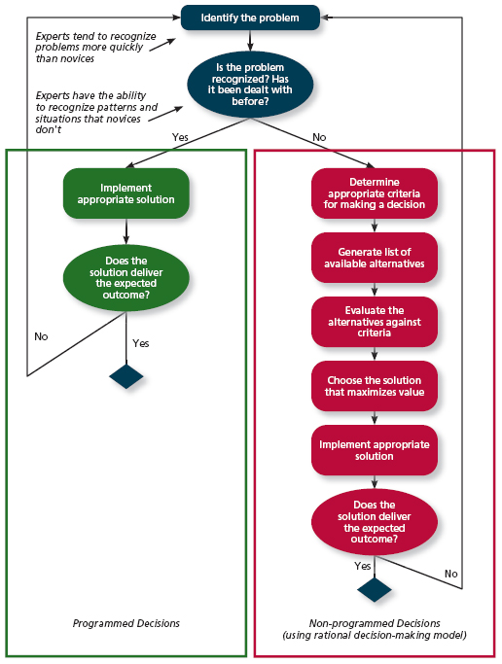

- Decision-Making Problems
  - We are rarely rational decision-makers
    - Limited Information
      - Bounded Rationality: The notion that people do not have the ability or resources to process all available information and alternatives when making a decision.
      - Satisficing: What a decision maker is doing who chooses the acceptable alternative considered.
    - Faulty perceptions
      - Heuristics (rules of thumb): Simple and efficient rules of thumb that allow one to make decisions more easily.
        - Guide or principle based on experience or practice rather than theory.
      - Selective perception: The tendency for people to see their environment only as it affects them and as it is consistent with their expectations.
      - Availability Bias: The tendency for people to base their judgments on information that is easier to recall.
      - Projection bias: The faulty perception by decisions makers that others think, feel, and act as they do.
      - Social Identity theory: A theory that people identify themselves according to the various groups which they belong and judge others according to the groups they associate with.
      - Stereotyping: Assumptions made about others based on their social group membership.
      - Contrast effect: The tendency to judge things erroneously on the basis of a reference that is near to them.
      - Primary and recency effects: Tendency to weight recent events more than earlier events.
    - Faulty attributes: How we explain others’ actions or outcomes.
      - Dispositional: Actions/outcomes cause by the person’s particular motives, skills and/or knowledge.
      - Situational: Actions/outcomes caused by the situation.
      - Fundamental attribution error: The tendency for people to judge others’ behaviours as being due to internal factors such as ability, motivation, or attitudes.
      - Self-serving bias: When one attributes one’s own failures to external factors and success to internal factors.
    - Escalation of commitment: A common decision-making error, which the decision maker continues to follow a failing course of action.
    - Advice discounting.

- Effects of Learning on Performance and Commitment
- 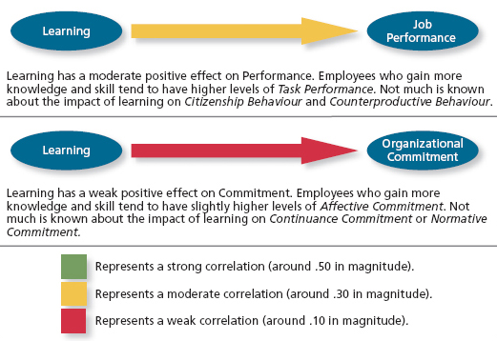

- Improve Learning to Boost Decision Making
  - Training: A systematic effort by organizations to facilitate the learning of job-related knowledge and behaviour.
  - Knowledge Transfer: Exchange of knowledge between employees.
  - Behaviour Modeling Training: When employees observe the actions of others, learn from what they observe, and then repeat the observed behaviour.
  - Communities of Practice: Groups of employees who learn from one another through collaboration over an extended period of time.
  - Transfer of Training: Occurs when employees retain and demonstrate the knowledge, skills, and behaviours required for their job after training.
  - Climate for Transfer: An organizational environment that supports the use of new skills.

- Personality and Organizational Behaviour
  - The structures and propensities inside a person that explain his or her characteristic patterns of thought, emotion, and behaviour; personality reflects what people are like and creates their social reputation.
  - The role of personality in organizational behaviour has often been debated in what is known as the “person-situation debate”.
  - This has led to three approaches
    - The dispositional approach
      - Personality is responsible for their own behaviour.
    - Situational Approach
      - No control over behaviour.
      - External factors effect behaviour.
      - Ex. Working conditions
    - Interactionist approach (Organizational development)

Personality and the Situation
  - Personality has the strongest effect in weak situations.
    - Uncertainty and ambiguity in their roles.
    - Must apply personality/cultural knowledge to accomplish goals.
  - Personality has less of an impact in strong situations.
    - Roles clearly defined.
    - “Going by the book”

- The Five-Factor Model of Personality (*Midterm and Exam*)
- Five basic but general dimensions that describe personality:
  - Extraversion: Social, talkative vs. withdrawn, shy
    - Those with communication skills can be dominant.
    - Zero Acquaintance Situations: Situations in which two people have just met.
    - Status Striving: A strong desire to obtain power and influence within a social structure as a means of expressing one’s personality.
    - Positive Affectivity: A dispositional tendency to experience pleasant, engaging moods such as enthusiasm, excitement, and elation.
  - Emotional stability/neuroticism: Stable and confident vs. Depressed and anxious.
    - Negative Affectivity: A dispositional tendency to experience unpleasant moods such as hostility, nervousness, and annoyance.
    - Locus of Control: Related to Neuroticism. One’s tendency to view the cause of events and personal outcomes as internals or externally controlled.
  - Agreeableness: Tolerant, cooperative vs. cold, rude
    - Communion Striving: A strong desire to obtain acceptance in personal relationships as a means of expressing one’s personality.
  - Conscientiousness: Dependable, responsible vs. careless, impulsive.
    - Accomplishment Striving: A strong desire to accomplish task-related goals as a means of expressing one’s personality.
  - Openness to Experience: Curious, original vs. dull unimaginative

- Emotional Ability (or Emotional Intelligence)
  - Cognitive Ability: Capabilities related to the use of knowledge to make decisions and solve problems.
  - Managing emotions
    - Identify
    - Self Awareness
    - Self Monitoring
    - Managing emotion
    - Have empathy
  - Emotion Perception: Ability to identify one’s own emotion’s and others’ emotions.
  - Understand Emotion: Understanding how emotions evolve over time, how they differ from each other, and which are more appropriate in given contact.
  - Emotion Regulation: Skill involving the capacity to consciously induce and maintain a positive affective state.
- Model of Emotional Intelligence
- 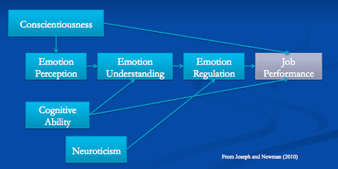

- The Big-Five Matters
  - Task performance
    - Conscientiousness (Direct)
    - Extraversion (Direct)
    - Agreeableness (Direct)
    - Neuroticism
      - Weak correlation
  - Organizational Citizenship Behaviours
    - Conscientiousness
      - Offering help and support
  - Counterproductive Work Behaviours
    - Conscientiousness
      - Negative impact
  - Training Proficiency
    - Openness to Experience
    - Extraversion
    - Conscientiousness

- Additional Personality Characteristics
  - Locus of Control: Tendency to view the cause of events and personal outcomes as internally or externally controlled.
    - Blaming responsibilities elsewhere.
    - Internal: Taking responsibilities for their actions.
      - Perform better.
    - External: Do not take responsibilities.
      - Blaming others.
  - Self-Monitoring: Individuals who monitor their own and other’s behaviour.
    - Ability to observe.
  - Self-Esteem: Positive self-concept/evaluation.
  - Competitiveness: Competing with oneself and looking at accomplishments and goals.
  - Type A and B
    - A: More organized and judgmental. Structure. No flexibility. Rational.
    - B: More relaxed. Flexibility.

Recent Development in Personality and Organizational Behaviour
  - Five new personality variable that have been found to be important for organizational behaviour:
    - Positive and negative affectivity
      - Positive: Optimistic
      - Negative: Passive
      - Both have an effect to job performance.
    - Proactive personality
    - General self-efficacy: Successfully performing a task.
      - Relation to work itself.
    - Core self-evaluations: Image of our self worth. How we think of ourselves.

- Values and Attitudes
  - Culture: The shared values, beliefs, motives, identities, and interpretations that result from common experiences of members of a society and are transmitted across generations.
  - Values: Enduring and long lasting beliefs/preferences/principles about what is worthwhile and desirable.
  - Attitudes: A fairly stable evaluative tendency to respond consistency to some specific object, situation, person, or category or people.
  - If you want to change someone’s behaviour, you must take into consideration their values (likes and dislikes)

- Work Centrality
  - Values in their jobs itself.

- Hofstede’s Five Cultural Dimensions
  - Discovered five basic dimensions along which work-related values differed across cultures:
    - Power distance: The degree to which a culture prefers equal power distribution (low power distance) or an unequal power distribution (high power distance).
    - Uncertainty avoidance: The degree to which a culture tolerates ambiguous situations (low certainty avoidance) or feels threatened by them (high uncertainty avoidance).
    - Masculinity/Femininity: The degree to which a culture values stereotypically male traits (masculinity) or stereotypically female traits (femininity).
    - Individualism/Collectivism: The degree to which a culture has a loosely knit framework (individualism) or tight social framework (collectivism).
    - Time Orientation
      - Polychronic (Type B) vs. Monochronic (Type A)
  - Ethnocentrism: One who views his or her cultural values as “right” and values of other cultures as “wrong”.

- Take-Aways:
  - Personality, values, and intelligence are highly stable human characteristics.
    - Difficult but not impossible to change.
  - Each is related to job performance.
  - Each can be easily measured and used as hiring criteria.

- Team: Two or more people who work interdependently over some time period to accomplish common goals related to some task-oriented purpose.

- Stages of Team Development
- 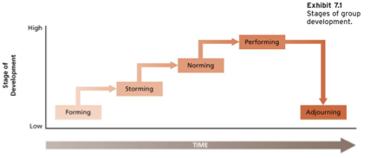
  - Forming
  - Storming
  - Norming
  - Performing
  - Adjourning
    - Task is finished, so the team separates.

- Alternative Developmental Process
- 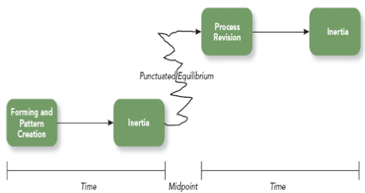
  - ^ Read page 270**
  - Teams will reach the midpoint and realize that they need to progress.
    - A change happens, could be negative or positive.
  - How teams work: Idle model.
  - Teams need sufficient time.
  - If team is dysfunctional, they will need a leader.
    - Leader needs to constantly monitor team.

- Types of Team Interdependence
  - Dependent on each other.
  - Interdependence of
    - Goal
    - Outcome
      - Each member matters when it comes to the outcome of the task to ensure quality.
    - Task

- Task Interdependence
  - Task Interdependence: The degree to which team members interact with and rely on other team members for information, materials, and resources needed to accomplish work for the team.
  - Pooled Interdependence
    - Each member is an expert on each task.
    - Group projects where the task is split up and given to the member who specializes in a part.
    - Not much back and forth communication.
- 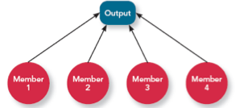
  - Sequential Interdependence
    - An output of one member is the input of the next member.
    - Member 2 cannot do their part until member 1 is done with their part.
    - When all members are done with their parts, in the end you will see the quality.
- 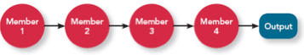
  - Reciprocal Interdependence
    - Dependency.
    - Teams within teams.
    - Too many people working on a task, there will be subgroups.
    - Internal communication within subgroups.
- 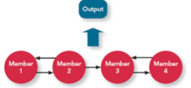
  - Comprehensive
    - All members are important in every single step of the project.
    - “Brain storming session”
    - All communicating
    - Tasks can be split up, but everyone’s input is placed in each part.
    - Everyone is involved. No specific responsibility.
- 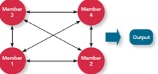
  - Must know which team would better suit a task.

- Team Composition
  - The mix of the various characteristics that describe the individuals who work in the team.
  - Dimensions that are important in each team.
  - Member Personality (Ideal Personalities)
    - Conscientiousness
    - Agreeableness
    - Extraversion
  - Member Ability and Tasks
    - Disjunctive Task: One member with great ability = Team Success
      - Success depends on the strongest member in the team.
    - Conjunctive Task: One member with poor ability = team failure
      - No matter how strong all the members are, if there is one ember who is weak, it can ruin the outcome of the task.
      - Depends on the weak performer for success.
    - Additive Task: More members with great ability = team success.
      - All team members matter.
      - Does not depend on one performer (weak or strong).
  - Team Size and Tasks
    - Size of the group depends on the type of task.
    - Simple tasks: smaller group.
    - Complex tasks: larger groups and screening people with good skills.
    - Disjunctive Task: Larger size = greater team success
    - Conjunctive Task: Larger size = weaker team success
      - More people with weak skills are not ideal.
    - Additive task: Larger size = greater team success.
  - Team Diversity
    - Can enhance performance when innovation is required and when members can and want to understand and integrate ideas.
    - Surface level diversity
      - Race, gender, ethnicity
      - Negative effects on team performance weaken over time.
    - Deep level diversity
      - Values, personality, personal goals.
      - Negative effects on team performance strengthen over time.
  - Norms, Roles, and Status
    - Norms: Codes of conduct for the group or shared expectations.
    - Roles: The behaviours a person is expected to display in a given context.
    - Status: Rank, social position, or prestige.
    - Established in order to provide regularity and predictability.
  - Team Cohesion
    - The bond between members.
    - Team members need to care about one another.
    - With no team cohesion, it could result in groupthink.

- Groupthink
  - Support of conformity and team harmony at the expense of other priorities, such as goal accomplishment.
  - Some common symptoms:
    - Illusion of invulnerability
    - Rationalization
    - Illusion of morality
    - Stereotyping of outsiders
    - Self-censorship
    - Illusion of unanimity
    - Mindguards.
  - Good way to avoid: Share the role of being the Devil’s Advocate.

Team Process
  - Process Gain:
  - Process Loss:
    - Getting less than expected from the team.
      - Coordination loss: loss of time and energy due to integration efforts.
      - Motivation loss: Loss in productivity because one or more members are not as productive as they could be.
        - Also called social loafing.

- Maintaining Effective Teams
  - Clarify mission or goals.
  - Establish rules of conduct.
  - Keep the size of the team small or appropriate size.
  - Team selection criteria
  - Appropriate technical and interpersonal skills.
  - Emphasize positive interdependence.
  - Ensure accountability and Tie awards with performance.
  - Appropriate autonomy.
  - Organize regular meetings and updated information.
  - Team celebrations.

- Communication
  - Thinking
  - Encoding
  - Transmitting
  - Perceiving
  - Decoding
  - Understanding
  - Noise
  - Feedback

- Barriers to Effective Communication
  - Language
  - Misreading non-verbal forms of communication
  - Noisy Transmission
  - Perceptual Biases/Assumptions/Differences
  - Interpersonal Relationships.
  - Cultural Differences

- The Verbal and Nonverbal Language of Work
  - Nonverbal Communication: Refers to the transmission of messages by some medium other than speech or writing.
  - Differences in nonverbal communication across cultures include:
    - Facial expressions.
    - Gestures.
    - Gaze
    - Touch
    - Use of space.

Gender Differences in Communication
  - Differences in male and female communication styles and rituals:
    - Getting credit.
    - Confidence and boasting
    - Asking questions
    - Apologies
    - Feedback
    - Compliments
    - Ritual Opposition
    - Managing up and down
    - Indirectness

- Cross-Cultural Communication
  - Communication is better between individuals who share similarcultural values.
  - Cross-cultural communication problems can be understood in terms of:
    - Language differences
    - Nonverbal communication
    - Etiquette and politeness
    - Social conventions
    - Cultural context.

Communication Media and Information Richness
  - Criteria to measure the richness of communication
    - Amount of feedback
    - Number of cues.
    - Variety of languages used
    - Potential for expressing emotions and feelings.

- Personal Approaches to Improving Communication Competency
  - Empathetic listening and appropriate eye contact
  - Using first-person singular pronouns
  - State you position openly; be specific, not global
  - Make you message congruent and appropriate to individual receiver’s frame of reference.
  - Be descriptive not evaluative
  - Use multiple techniques to fully comprehend
  - Give timely and specific feedback
  - Don’t react to emotional words, but interpret their purpose.
  - Communicate your feelings but don’t act on them.
  - In work situations take notes and decide on specific follow-up.
  - Acknowledge cultural differences.

- Organizational Approaches to Improving Communication
  - 360 degree feedback
  - Employee survey
  - Suggestion systems
  - Query systems
  - Telephone/TV networks
  - Formal and informal training

- Power and Influence – Defined
  - Power: The capacity to influence the behaviour of others.
  - Influence: The process by which people successfully persuade others to follow their advice, suggestions, or orders.

- Types of Power:
- 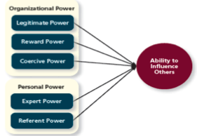
  - Legitimate Power: A form of organizational power based on authority or position.
    - Comes from status, position and role. Use position and title to influence others.
  - Reward Power: Based on the control of resources and benefits.
    - Exchange power. When you have something to offer. Ability to give rewards or consequences.
  - Coercive Power: Based on ability to hand out punishment.
    - Worst type of power. One imposing it’s will.
      - Because of their control, or knowledge. Use to manipulate others.
      - Resistance
  - Expert Power: Knowledge, expertise. Ability to influence behaviour.
    - Specialty in an area.
  - Information Power:
  - Referent Power: Not that influential. How people can link and bond with you.

- How Do People Obtain Power?
  - Personality and knowledge
  - Involvement in visible activities
  - Informal relationships with right people
  - Empowerment
  - Influential tactics

- Power and Influence: Contingency Factors:
  - Substitutability: The degree to which people have alternatives in accessing the resources that a leader controls.
  - Centrality: How important a person’s job is and how many people depend on that person to accomplish heir tasks.
  - Discretion: Managers have the right to make decisions on their own.
  - Visibility: How aware others are of a leader and the resources that leader can provide.

- Responses to Influence
- 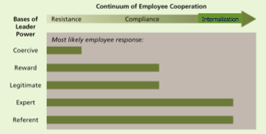
- Resistance: When a target refuses to perform a request and puts forth an effort to avoid having to do it.
- Compliance: When targets of influence are willing to do what the leader asks but do it with a degree of ambivalence.
  - People accept your power.
- Internalization: A response to influence tactics where the target agrees with and becomes committed to the request.
  - People will understand where your power is coming from.
  - Credibility.
  - Easier to persuade people.

- Influence Styles
  - Assertive Persuasion
    - Reasoning
    - Debating
    - Presenting ideas, proposals and suggestions that involve facts and logic.
  - Reward and punishment
    - Stating expectations.
    - Using incentives and pressures.
    - Evaluating.
    - Demanding
    - Bargaining.
  - Participation and Trust:
    - Understanding
    - Involving and supporting others.
    - Personal Disclosure.
    - Active Listening.
  - Common Vision
    - Inspiring
    - Visioning
    - Finding common ground
    - Aligning

- Designing Your Influence Strategy
  - Identify:
    - Your objectives
    - Whose cooperation is needed
    - What awards they like and why they might resist.
    - Your current and future type of relationship with those whose cooperation is needed.
    - Your sources of power and influence.
    - Your values and attitudes toward possible strategies (Can you live with the outcome?)

- Empower to Gain Power
  - Power is paradoxical in that the more a leader empowers others, the more power he or she receives.

Conflict Resolution

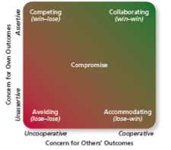
  - Competing: A conflict resolution style by which one party attempts to get his or her own goals met without concern for the other party’s results.
    - Ex. “Do it my way or the high way”.
    - Use it if you have all the facts.
  - Avoiding: Conflict resolution style by which one party wants to remain neutral, stay away from conflict, or postpone the conflict to gather information or let things cool down.
    - Not the ideal situation.
    - Go with avoiding style is emotions are too high. Or the situation that is not important.
    - Lacking information or not prepared. Or if the person is too hostile.
  - Accommodating: A conflict resolution style by which one party gives in to the other and acts in a completely unselfish way.
    - Establishing a goodwill, if the outcome is not that important and important to the other party.
  - Collaborating (Best way): Conflict resolution style whereby both parties work together to maximize outcomes.
  - Compromise: A conflict resolution style by which conflict us resolved through give-and-take concessions.
    - Good bargaining styles.

- Negotiation: A process in which two or more interdependent individuals discuss and attempt to reach agreement about their differences.

- Negotiation Strategies
  - Distributive: Negotiation strategy in which one person gains and the other person loses.
    - Win-lose approach.
    - Fixed amount of resources.
    - Short term focus on relationship.
  - Integrative: Negotiation strategy that achieved an outcome that is satisfying both parties.
    - Win-win approach
    - Not a zero-sum game.
    - Long0term focus on relationship.

- Principled Negotiation (How to get to yes)
  - Separate the people from the problem
  - Focus on interests, not positions.
  - Invert options for mutual gain.
  - Insist on objective criteria.
  - BATNA: A negotiator’s best alternative to a negotiated agreement.

- Negotiation Stages
  - Preperation
  - Exchaning information
  - Bargaining
  - Closing and commitment

- Rules for Negotiation
  - Do not think of a negotiation as a game.
  - Be prepared
  - Know yourself and your counterpart
  - Always look for common ground and common goals.
  - Follow basic communication rules.
  - Maintain emotional stability, personal integrity, and trust.
  - Know when you continue and when to walk away.
  - Negotiate with someone who has the authority to commit.
  - Ask for a written agreement.

- Common Mistakes in Negotiation
  - Making assumptions.
  - Overestimating or underestimating.
  - Too optimistic or pessimistic goals without factual data.
  - Letting counterparts know your time deadline.
  - Accepting the very first offer.
  - Focusing on what the other party gets.
  - Not saying no in an acceptable manner.

- Alternative Dispute Resolution
  - A process by which two parties resolve conflicts through the use of a specially trained, neutral third party.
  - Mediation: A process by which a third party facilitates a dispute resolution process but with no formal authority to dedicate a solution.
  - Arbitration: A process by which third party determines a binding settlement to a dispute between two parties.

- Leadership: The use of power and influence to direct the activities of followers toward goal achievement.
- Leader-member exchange theory: A theory describing how leader-member relationships develop over time on a dyadic basis.
  - Role Taking: The phase in a leader-follower relationship when a leader provides an employee with job expectations and the follower tries to meet those expectations.
  - Role Making: The phase in a leader-follower relationship when a follower voices his or her own expectations for the relationship, resulting in a free-flowing exchange of opportunities and resources for activities and effort.

- Leadership Attributes
- What Effective Leaders Need to Be, Know, and Do.
  - Set Directions
    - Understand external events
    - Focus on the future.
    - Turn vision into action.
  - Demonstrate Personal Character
    - Live and values of the firm.
    - Create a positive self-image.
    - Display cognitive ability and personal claim.
  - Build Organizational Capability
    - Build infrastructure
    - Leverage diversity
    - Build teams
    - Manage change
    - Design human resource systems.
  - Mobilize Individual Commitment
    - Direct emotions
    - Manage attention
    - Share power and authority
    - Build collaborative relationships.

- History of Leadership Theory
  - The trait era: Late 1800s to mid 1940s
  - Behavioural Era: Mid 1940s to early 1970s
  - The contingency Era: Early 1960s to present.

- Trait Theory (Great Man Theory)
  - “Leaders are born, not made”.
  - Traits are more predictive of who becomes a leader in the first place (Leader emergence) than they are how well people actually do in a leadership role (leader effectiveness).
    - Leader Emergence: The process of becoming a leader in the first place.
    - Leader Effectiveness: The degree to which the leader’s actions result in the achievement of the unit’s goals, and continued commitment of the unit’s employees, and the development of mutual trust, respect, and obligation in leader-member dyads.
- 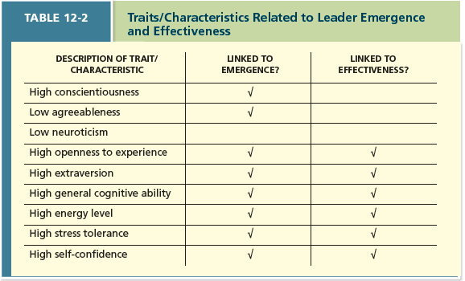

- The Behavioural Approach
- How do leaders make decisions?
- 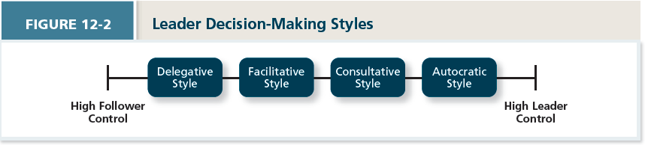
  - Autocratic style: A leadership style where the leader makes the decision alone without asking for opinions or suggestions of the employees in the work unit.
  - Consultative Style: A leadership style in which the leader presents the problem to employees asking for their opinions and suggestions before ultimately making the decision their selves.
  - Facilitative Style: A leadership style in which the leader presents the problem to a group of employees and seeks consensus on a solution, making sure his or her own opinion received no more weight than anyone else’s.
  - Delegative Style: A leadership style where the leader gives the employee the responsibility for making decisions within some set of specified boundary conditions.

- Time – Driven Model of Leadership: A model that suggests that seven factors, including the importance of the decision, the expertise of the leader, and the competence of the followers, combine to make some decision-making styles more effective than others in a given situation.
  - Decision Significance – Is the decision significant to the success of the project or the organization?
  - Importance of commitment – Is it important that employees “buy in” to the decision?
  - Leader expertise – does the leader have significant knowledge regarding the problem?
  - Likelihood of commitment – How likely is it that employees will trust the leader’s decision and commit to it?
  - Shared objective – Do employees share and support the same objectives, or do they have an agenda of their own?
  - Employee expertise – Do the employees have significant knowledge or expertise regarding the problem?
  - Teamwork skills – Do the employees have the ability to work together to solve the problem, or will they struggle with conflicts or inefficiencies.
- Life Cycle Theory of Leadership
  - When to initiate structure?
    - Initiating Structure: A pattern of behaviour where the leader defines and structures the roles of employees in pursuit of goal attainment.
  - When to be considerate?
    - Consideration: A pattern of behaviour where the leader creates job relationships characterized by mutual trust, respect for employee ideas, and consideration of employee feelings.
  - Life Cycle Theory of Leadership: The theory stating that the optimal combination of initiating structure and consideration depends on the readiness of the employees in the work unit.
    - Readiness: The degree to which employees have the ability and the willingness to accomplish their specific tasks.
    - Telling: When the leader provides specific instructions and closely supervises performance.
    - Selling: When the leader explains key issues and provides opportunities for clarification.
    - Participating: Leader behaviour in which leader shares ideas and tries to help the group conduct its affairs.
    - Delegating: Leader behaviour in which the leader turns responsibility for key behaviours over to employees.

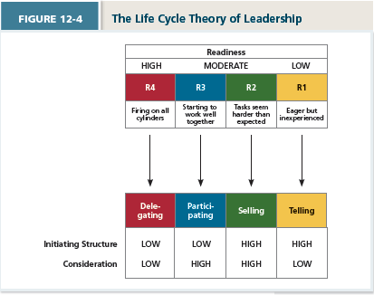

- Contingency Theory
  - Fiedler’s Contingency theory (leader-match theory)
    - Leadership orientation is measures by having a leader describe their least preferred co-worker (LPC).
      - High LPC score Relationship orientated.
      - Low LPC score Task orientated.
  - Factors that affect favourableness, in order of importance
    - Leader-member relations
    - Task structure
    - Position power
  - House’s Path-Goal Theory (Concerned with leader behaviours)
    - Subordinates, Path, Goal Define goals, Clarifies paths, removes obstacles, provides support.
    - Specific kinds of leader behaviour:
      - Directive
      - Supportive
      - Participative
      - Achievement-orientated.

- Transformational Leadership: The pattern of behaviour in which the leader inspires followers to commit to a shared vision that provides meaning to their work while also serving as a role model who helps followers develop their own potential and view problems from new perspectives.
  - Laissez-Faire Leadership: When the leader avoids leadership duties altogether.
- Transactional Leadership: A pattern of behaviour in which the leader rewards or disciplines the follower on the basis of performance.
  - Passive Management-By-Exception: A type of transactional leadership in which the leader waits around for mistakes and errors, then takes corrective action as necessary.
  - Active Management-By-Exception: A type of transactional leadership in which the leader arranges to monitor mistakes and errors actively, and takes corrective action when required.
  - Contingent Reward: A more active and effective type of transactional leadership, in which leader attains follower agreement on what needs to be done using rewards in exchange for adequate performance.
  - Idealized Influence: The power held by a leader who behaves in ways that earn admiration, trust, and respect of followers, causing followers to want to identify and emulate the leader.
  - Inspirational Motivation: A type of influence in which the leader behaves in ways that foster an enthusiasm for and commitment to a shared vision of the future.
  - Intellectual Stimulation: A type of influence in which the leader behaves in ways that challenge followers to be innovative and creative by questioning assumptions and reframing old situations in new ways.
  - Individualized Consideration: A type of influence in which the leader behaves in ways that help followers achieve their potential through coaching, developing, and mentoring.

- Organizational Structure: How tasks are formally divided, grouped and coordinated between individuals and groups within the company.
  - Two basic dimensions:
    - Vertical flows:
      - Downward, from the top to the bottom of the organization through different levels of managers (e.g., directives, instructions, goal setting).
      - Upward, from the bottom to the top of the organization (e.g., employee suggestions for empowerment).
    - Horizontal flows:
      - Between cross-functional teams or between departments at the same level.

- Organizational Design
  - The process of creating, selecting, or changing the structure of an organization.
  - Business Environment: The outside environment, including customers, competitors, suppliers, and distributors, which all have an impact on organizational design.
  - Company Strategy: An organization’s objectives and goals and hot it tries to capitalize on its assets to make money.
  - Technology: The method by which an organization transforms inputs to outputs.
  - Company Size: The number of employees in a company.

- Departmentation
  - The assignment of jobs to departments is called departmentation. There are several methods of departmentation.
    - Functional departmentation: An organizational form in which employees are grouped by the functions they perform for the organization.

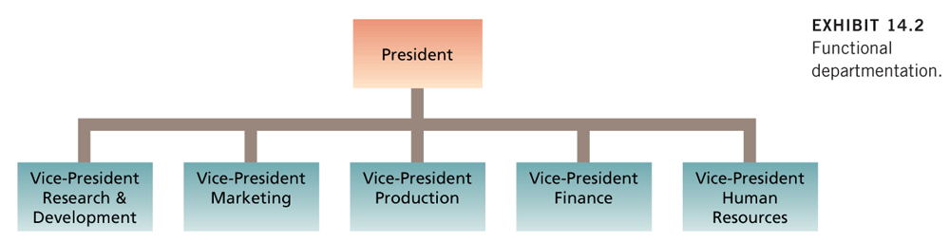
    - Product departmentation

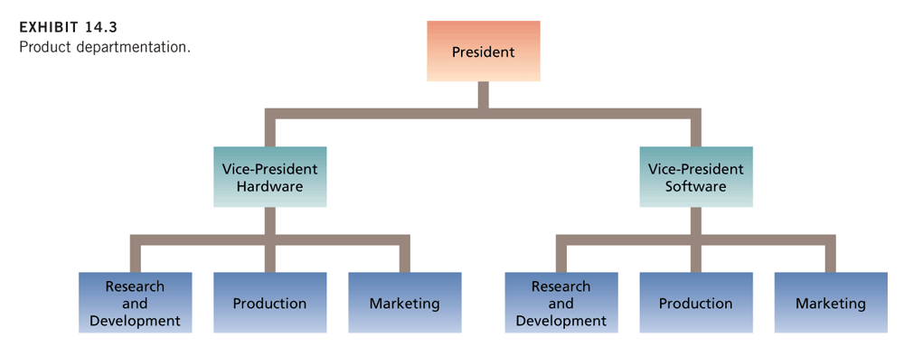
    - Matrix departmentation: Complex form of organizational structure that combines a functional and multidivisional grouping.
      - Multidivisional Grouping: Form in which employees are grouped by product, geography or client.
        - Product structure: Organizational form in which employees are grouped around different products that the company produces.

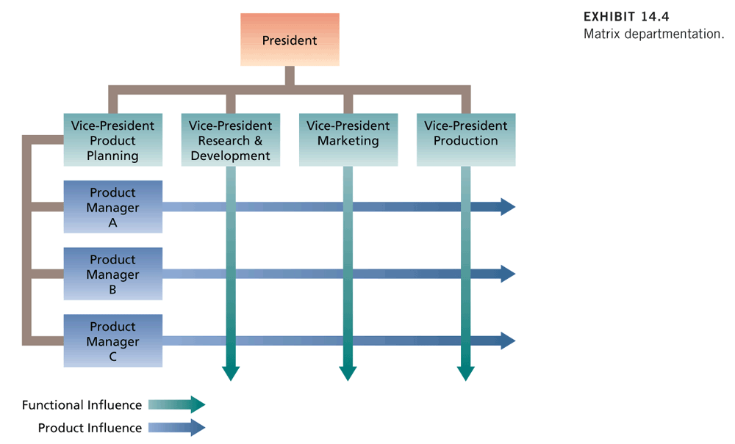
    - Geographic departmentation: Organizational form in which employees are grouped around different locations where the company does business.

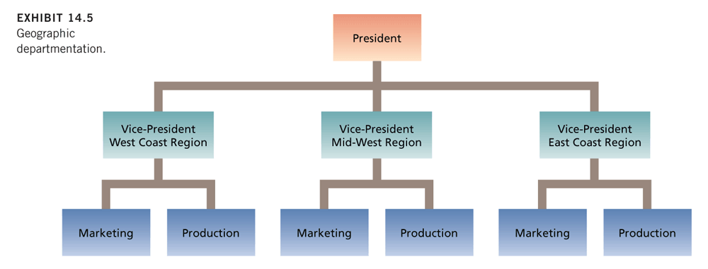
    - Customer departmentation: Employees are organized around serving customers.

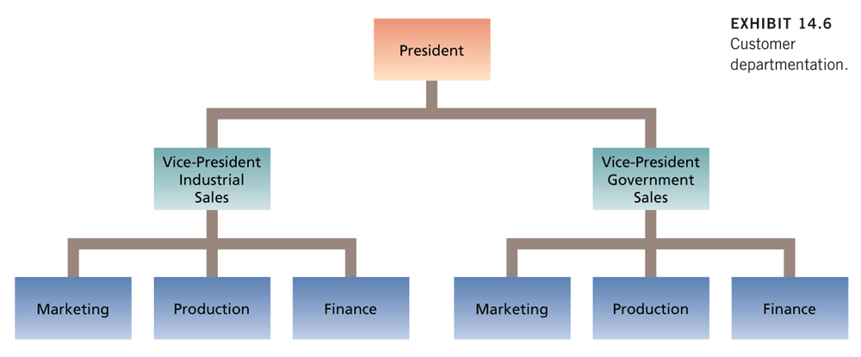
    - Hybrid departmentation

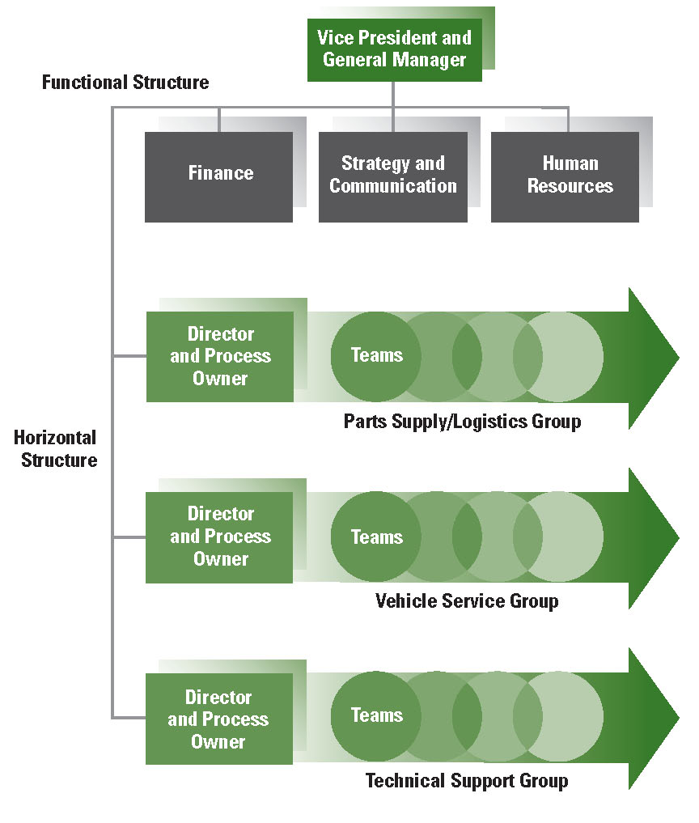

Traditional Structural Characteristics (Elements of Organizational Structure)
  - There are a number of characteristics that summarize the structure of organizations:
    - Work specialization: The degree to which tasks in an organization are divided into separate jobs.
    - Chain of command: Answers the question of “who reports to whom?” and signifies formal authority relationships.
    - Span of control: Represents how many employees each manager in the organization has responsibility for.
    - Formalization: The degree to which rules and procedures are used to standardize behaviours and decisions in an organization.
    - Centralization: Refers to where decisions are formally made in organization.
    - Complexity
    - Flat versus tall organization

- Mechanistic and Organic Structures
  - Mechanistic Organization: Efficient, rigid, predictable, and standardized organizations that thrive in stable environments.
    - High levels of formalization, degrees of work specialization, centralization of decision making.
    - Rigid and hierarchal chain of command, and narrow spans of control.
  - Organic Organizations: Flexible, adaptive, outward-focused organizations that thrive in dynamic environments.
    - Wide span of control.
    - Low levels of formalization
    - Weak or multiple chains of command
    - Low Levels of work specialization.

- Contemporary Organic Structures
  - The removal of unnecessary bureaucracy and the decentralization of decision-making result in a more adaptable organization.
  - Some contemporary organic organizational
    - The Ambidextrous Organization
    - Network and Virtual organizations
    - The Modular organization
    - The Boundary-less organization

- Symptoms of Structural Problems
  - Bad job design
  - The right hand does not know what the left is doing
  - Persistent Conflict between departments
  - Slow response times
  - Decision with incomplete information
  - A proliferation of committees.

- Organizational Culture: A shared social knowledge within an organization regarding the rules, norms and values that shape the attitudes and behaviours of its employees.
- 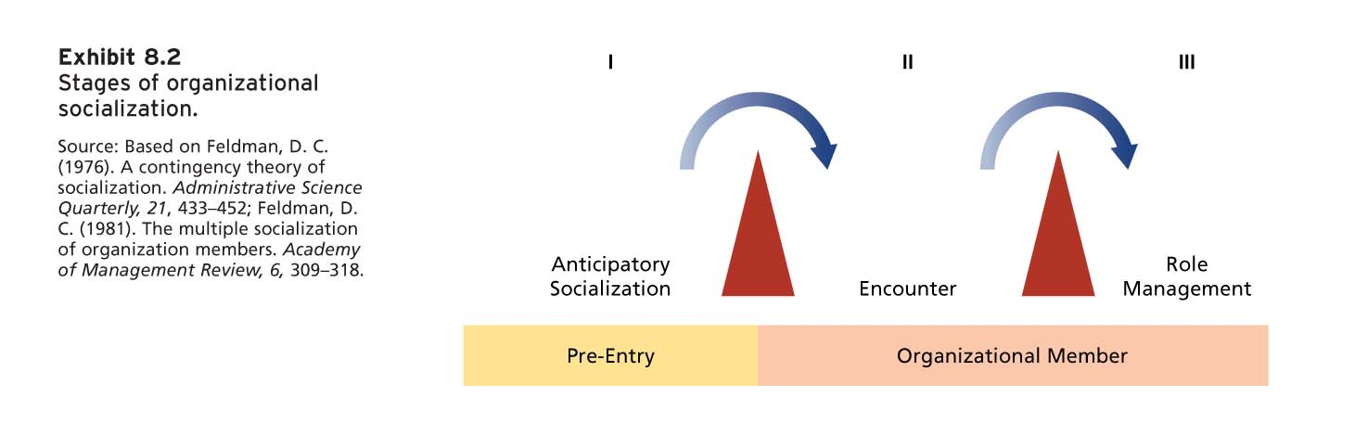
  - Anticipatory Socialization: A stage of socialization that begins as soon as the potential employee develops an image of what it would be like to work for a company.
    - Things that we assume and learn.
  - Encounter: A socialization beginning the day an employee starts work, during which the employee compares the information as an outside to the information learned as an insider.
    - Employees are selected for the particular position. Orientation session.
      - Varies through organizations.
      - Learn basic rules and history.
  - Role Management (Mastery in):

- Three Components of Organizational Culture
  - Observable Artifacts: Aspects of an organization’s culture that employees and outsiders can easily see or talk about.
    - Symbols: The images an organization uses, which generally convey messages.
    - Physical Structures: The organization’s buildings and internal office designs.
    - Language: The jargon, slang, and slogans used within an organization.
    - Stories: Anecdotes, accounts, legends, and myths passed down from cohort to cohort within an organization.
    - Rituals: The daily or weekly planned routines that occur in an organization.
    - Ceremonies: Formal events, generally performed in front of an audience or organizational members.
  - Exposed Values: The beliefs, philosophies, and norms that a company explicitly states.
  - Basic Underlying Assumptions: The ingrained beliefs and philosophies of employees.

- Social Domains
  - Performance proficiency
    - Make sure your employees understand their position.
      - Boundaries
      - Helping them perform more efficiently
  - Role Clarity
    - Make sure there is no ambiguity.
    - Create a relationship with employees
  - History and Value
    - Collective likes and dislikes.
    - Implicit rules and regulation
  - Language/Jargon
  - Politics
  - People/Social Integration
    - Help consider employees to socialize outside work.

- Why is Socialization Important?
  - To remove any ambiguity with the positions and culture in the organization.
  - Psychological Contracts
  - Unrealistic Expectations
  - Sources of unrealistic expectations of the employers or organization.
    - Media
    - Occupational Stereotypes
    - Recruiters

- Socialization Methods
  - Realistic Job Previews: The process of ensuring that a prospective employee understands both the positive and the negative aspects of the job.
  - Employee Orientation Programs: A common form of training during which new hires learn more about the organization.
  - Mentoring: The process by which a junior-level employee develops a deep and long-lasting relationship with a more senior-level employee within the organization.

- Proactive Socialization:
  - Few tactics
    - General socializing
    - Boss relationship building
    - Networking/Observations
    - Feedback-seeking/Information-seeking
    - Behavioural self-management
    - Relationship building
    - Job change negotiation
    - Involvement in work-related activities
    - Informal mentor relationships.

- Organizational Culture and Subcultures
  - The shared values, beliefs, and assumptions considered to be the appropriate way to think and act within an organization.
  - Culture Strength: The degree to which employee agree about how things should happen within the organization and behave.
  - Subculture: A culture created within a small subset of the organization’s employees.
  - Counterculture: A subculture whose values do not match those of the organization.
  - CULTURE NORMS BEHAVIOUR
  - Contributors to the culture
    - Organization’s founder
    - Top management
      - Creates vision.
    - Nature of the socialization process
    - Consistency among different steps.

- Shein’s Levels of Culture (Diagnosing a Culture)
- 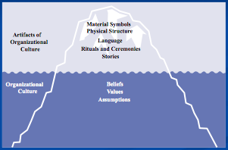
  - Some executives are particularly skilled at using symbols consciously to reinforce cultural values
  - Rites, rituals, and ceremonies can convey the essence of a culture
  - The folklore of organizations – stories about past organizational events – is a common aspect of culture that often reflects its uniqueness.

- The “Strong Culture” Concept
  - An organizational culture with intense and pervasive beliefs, values, and assumptions.
  - Weak cultures are fragmented and have less impact on organizational members.
- 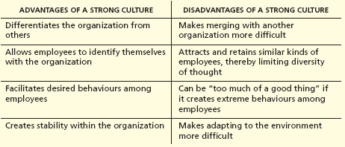

- Organizational Targets for Change
  - Change is a must for survival.
  - Goals and strategies
  - Process and Tasks
  - Structure
  - Culture
  - People
  - Technology

- Forced for Change
  - External vs. Internal Forces.
  - Internal: Employees.
  - Workforce
  - Technology
  - Economic Shocks
  - Competition
  - Social Trends
  - World Politics

What is Change Management?
  - Defining and instilling new value, attitudes, norms and behaviours within an organization that support new ways of doing work and overcome resistance to change.
  - Forms of Change:
    - Radical Change
      - Also known as frame-breaking change, drastic change.
      - Change that results in a major overhaul of the organization or its component systems.
      - May have to change the structure.
      - Anything that requires people to break out of their comfort zone.
    - Incremental Change
      - Also known as frame-bending change.
      - Change that is part of the organization’s natural evolution.
      - Adjusting, improving, keeping the same framework.
  - Types of Organizational Change:
    - Planned Change: The result of specific efforts by a change agent.
      - Planning, strategizing and implementation that requires intensive research.
    - Unplanned Change: Occurs spontaneously or randomly.
      - On the spot decisions.

- Organizational Change Process
- 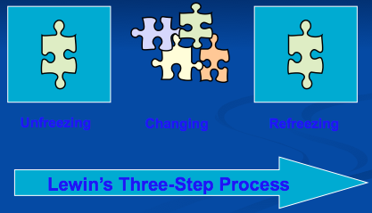
  - Unfreezing: When the organization comes to some realization that the status quo is unacceptable.
    - Needs credibility as to why change needs to be made.
  - Changing: Plan and implement the change initiative.
  - Refreezing: The newly developed attitudes and behaviours need to harden up, becoming entrenched as new norms, values, and shared understanding.

- Common Change Strategies Used in Organizational
  - Force-coercion strategy
    - Demanding change.
    - Used when Dealing with people with resistance to change.
  - Rational Persuasion Strategy (Ideal)
    - Educating and persuading people.
    - Giving an explanation as to why change is being made.
  - Shared Power Strategy
    - Democratic
    - Involving everyone in the plan.
    - Could result in time sensitive issues.

- Resistance to Change
  - Unwillingness to change or support change.
    - Passive
    - Active
    - Aggressive
  - Politics and self interest
  - Low tolerance for change
  - Lack of trust
  - Different assessment of a situation
  - Organizational culture

How to deal with Resistance
  - Education and communication
  - Participation and Involvement
  - Facilitation and support
  - Negotiation and agreement
  - Explicit and implicit coercion.

