CHAPTER 10: GETTING FUNDING OR FINANCING
THE IMPORTANCE OF GETTING FINANCING/FUNDING
Why Most New Ventures Need Funding
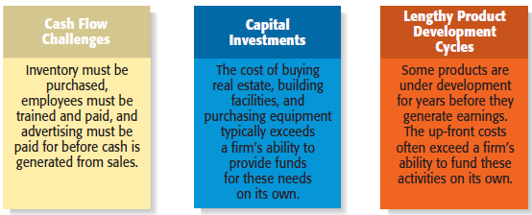

Sources of personal financing (3):
- Personal Funds: The vast majority of founders contribute personal funds, along with sweat equity, to their ventures. (Sweat equity represents the value of the time and effort that a founder puts into a new venture.)
- Friends and Family: second source of funds for many new ventures.
- Bootstrapping: Finding ways to avoid the need for external financing or funding through creativity, ingenuity, thriftiness, cost cutting, or any means necessary. EXAMPLES:
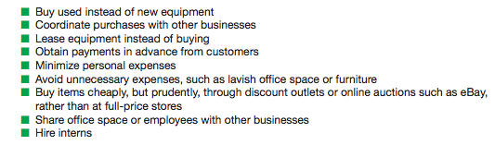
Preparing to raise debt or equity financing
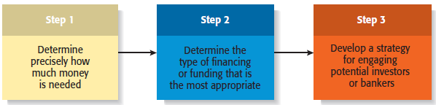
- Step 1: Constructing and analysing documented cash flow statements and projection for capital expenditures. Knowing exactly how much money to ask is important because:
  - A. Don’t want to be caught short & don’t want to pay capital if not needed
  - B. Poor impression if uncertain
- Sept 2:
  - Equity financing: Exchanging partial ownership in a firm, usually in the form of stock, for funding
  - Debt financing: Getting a loan
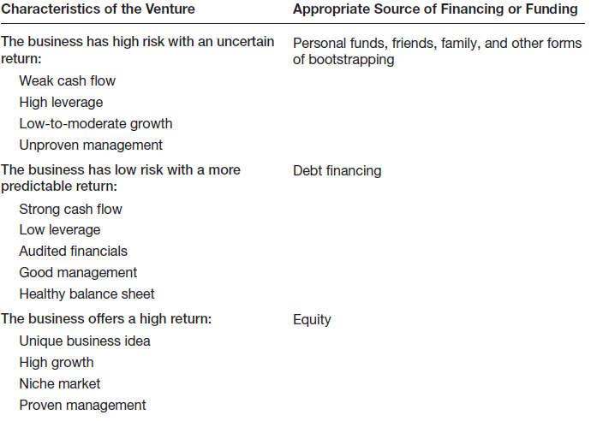

- Step 3: Elevator speech (pitch) is a brief, carefully constructed statement that outlines the merits of a business opportunity. 45 seconds to 2 mins

Sources of Equity Funding (3):
- Business Angels: Are individuals who invest their personal capital directly in start-ups.
The prototypical business angel is about 50 years old, has high income and wealth, is well educated, has succeeded as an entrepreneur, and is interested in the start-up process.
The number of angel investors in the U.S. has increased dramatically over the past decade.
Business angels are valuable because of their willingness to make relatively small investments.
These investors generally invest between $10,000 and $500,000 in a single company.
Are looking for companies that have the potential to grow between 30% to 40% per year.
Business angels are difficult to find.

- Venture Capital: Is money that is invested by venture capital firms in start-ups and small businesses with exceptional growth potential.
There are about 800 venture capital firms in the U.S.
Venture capital firms are limited partnerships of money managers who raise money in “funds” to invest in start-ups and growing firms.
The funds, or pool of money, are raised from wealthy individuals, pension plans, university endowments, foreign investors, and similar sources.
The investors who invest in venture capital funds are called limited partners. The venture capitalists are called general partners.
Venture capital firms fund very few entrepreneurial firms in comparison to business angels.
Many entrepreneurs get discouraged when they are repeatedly rejected for venture capital funding, even though they may have an excellent business plan.
Venture capitalists are looking for the “home run” and so reject the majority of the proposals they consider.
Venture capitalists fund between 3,000 and 4,000 companies per year, compared to about 62,000 per year for business angels.
An important part of obtaining venture capital funding is going through the due diligence process.
Venture capitalists invest money in start-ups in “stages,” meaning that not all the money that is invested is disbursed at the same time.
Some venture capitalists also specialize in certain “stages” of funding.

- Initial Public Offerings (IPO): is a company’s first sale of stock to the public. When a company goes public, its stock is traded on one of the major stock exchanges.
Most entrepreneurial firms that go public trade on the NASDAQ, which is weighted heavily toward technology, biotech, and small-company stocks.
An IPO is an important milestone for a firm. Typically, a firm is not able to go public until it has demonstrated that it is viable and has a bright future.
Reasons that motivate firms to go public:
- Way to raise equity capital to fund current and future operations
- Raises a firm’s public profile, making it easier to attract high-quality customers and business partners
- Liquidity event that provides a means for a company’s investors to recoup their investments
- Creates a form of currency that can be used to grow the company via acquisitions

Sources of Debt financing (2):
- Commercial Banks: Historically, commercial banks have not been viewed as a practical source of financing for start-up firms. This sentiment is not a knock against banks; it is just that banks are risk averse, and financing start-ups is a risky business.
Banks are interested in firms that have a strong cash flow, low leverage, audited financials, good management, and a healthy balance sheet.

- SBA guaranteed loans: Approximately 50% of the 9,000 banks in the U.S. participate in the SBA Guaranteed Loan Program. The program operates through private-sector lenders who provide loans that are guaranteed by the SBA. The loans are for small businesses that are not able to obtain credit elsewhere.

