Chapter 1
Claim: A claim is the major conclusion of a piece of writing that the author is trying to persuade you to accept
- Unproblematic claims
  - Consistent with our own experiences and observations
  - Facts independent of interpretation
  - Agreement among experts or strongly supported general claims that are common sense
  - Technical or mathematical claims
- Contestable claims
  - Not commonly accepted knowledge
  - Often introduce new ideas that awaken curiosity
  - Sometimes presented as if it were a fact
  - Cannot stand on their own
Chandler’s Theory
- Managerial enterprise refers to large industrial concerns in which operating and investment decisions are made by a hierarchy of salaried managers governed by a board of directors.
- Economies of scale
  - Cost per unit drops as the volume of output rises
- Economies of scope
  - Using many of the same raw and semi-finished materials and intermediate production processes to make a variety of different products.
- These potential cost advantages can be fully realized if the flow of materials is kept constant to assure capacity utilization
- To capitalize on manufacturing investments, entrepreneurs must invest heavily in:
  - National and international marketing and distribution organizations
  - Recruit teams of managers: lower and middle managers
    - Coordinate flow of goods through production and distribution
  - Top managers
    - Coordinate and monitor operations, plan and allocate resources for future activities
- Entrepreneurs who make these investments are called First Movers
  - Engage in research and development to improve their production; through better sources of supply, and distribution; more effective marketing services
  - Differentiate their products
  - Move quickly into growing markets and out of declining ones
  - Once the opportunity to be a first mover is lost it is very difficult to regain

Chapter 2
Evidence: Any statement that is a response to the question
- Precision
  - Numbers and direct quotations = good and should be provided
  - Precision creates the impression of accuracy
- Sufficiency
  - How much evidence?
  - Misleading notion of hasty generalization
- Representative
  - Variety in the sources of evidence should match the variety in the population
    - If company X is a bad place to work, this should come out for all workers: quitters/fired and those still employed
- Authority
  - Training, credentials, experience
  - Classics or current writing
  - Context-dependent (business arguments should ideally come from business experts, legal ones from legal experts, etc.)
    - Fallacy of false appeal to authority
    - Fallacy of argumentation ad populum (‘bandwagon’)
- Clarity of expression
  - Quantitative data should be interpreted
  - Direct quotation should also be interpreted
Greiner’s Theory
- Organizations move through a series of developmental phases over time.
- Each phase begins with a period of evolution which are characterized by steady growth and stability
- Each phase ends with a revolutionary period of substantial organization turmoil and change
  - Exhibit a serious upheaval of management practices
  - The resolution of every revolutionary period determines whether or not a company will move forward into its next stage.
- Age of the Organization
  - History shows that the same organizational practices are not maintained throughout a long life span.
  - Management problems and principles are rooted in time
- Size of the Organization
  - A company’s problems and solutions change as the number of employees and sales volumes increase
  - Coordination and communication magnify, levels in the management hierarchy multiply, jobs become interrelated
- Growth rate of the industry is the speed at which organizations experience phases of evolution and revolution and is related to the market environment

Phase 1: Creativity
  - Birth stage of the organization, emphasis on creating both product and market
  - Absorbed entirely by making and selling a new product
  - Long hours of work are rewarded by modest salaries and promise of ownership
  - Communication among employees is informal and infrequent
  - Dislike management activities
- As the company grows, larger productions require efficiencies of manufacturing
- Increased number of employees cannot be managed through infrequent and informal communication
- Additional capital must be secured and new accounting processes must be adopted for financial control
- Founders find themselves burdened with unwanted management activities and a crisis of leadership is introduced
Phase 2: Direction
  - Functional organizational structure is introduced to separate manufacturing from marketing activities
  - Jobs assignments become specialized
  - Accounting processed for inventory and purchasing are introduced
  - Incentives, budgets and work standards are adopted
  - Communication is formal and impersonal
  - New managers and supervisors assume most of the responsibility for instituting direction
- Although the new directives channel employees efficiently into growth, they eventually become inappropriate for complex organizations
- Lower level employees who possess direct knowledge about markets and machinery find themselves restricted by the hierarchy, torn between following procedures and taking initiative on their own
- Lower-level supervisors are treated as functional specialists rather than decision making managers and this leads to a crisis of autonomy
Phase 3: Delegation
  - Application of a decentralized organizational structure.
  - Greater responsibilities are delegated to managers of plants and market territories
  - Profit centers and bonuses are used to motivate employees
  - Top-level executives limit themselves to managing by exception based on periodic reports from the field and their communication is infrequent
- This phase allows companies to expand by means of heightened motivation from managers at lower levels
- Managers are able to penetrate larger markets, respond faster to consumers and develop new products
- Problems occur when top-level managers feel like they are losing control over field operations and lower-level managers run their own show without coordinating plans, money, technology or personnel with the rest of the organization. This is a crisis of control
Phase 4: Coordination
  - Characterized by the use of formal systems for achieving greater coordination
  - Decentralized units are merged into product groups, formal planning procedures are established and reviewed
  - New staff is hired and located at headquarters to initiate companywide programs of control and review
  - Capital expenditures are carefully weighed and spread across the organization
  - Each product group is treated as an investment center where return on investment capital is used to allocate funds
  - Technical functions are centralized at headquarters while daily operating decision remain decentralized
  - Stock options and companywide profit sharing are used to encourage employees to identify with the organization as a whole
- Although these managers have decision making power, they must justify their decisions to a “watch dog” at headquarters
- Lack of confidence begins to build between line and staff and we move to the red-tape crisis
Phase 5: Collaboration
  - Emphasizes spontaneity in management action through teams and skillful confrontation of interpersonal differences
  - Social control and self-discipline replace formal control
  - Solving problems quickly through teamwork and combinations of different teams across functions
  - Top-level managers are reduced at the headquarters and reassigned into teams that consult with line workers.
  - Educational programs used to train managers in behavioral skills for achieving better teamwork and conflict resolution
  - Real-time information systems are integrated
  - Economic rewards are geared towards team performance rather than individual achievements
  - Experimenting with new practices is encouraged throughout the organization
ORGANIZATIONS SHOULD NOT TRY AND SKIP PHASES*

Chapter 3
Tannenbaum and Schmidt’s Theory
- Modern managers often find themselves torn between exerting “strong” leadership (authoritarian) and “permissive” leadership (democratic)
- The Continuum of Leadership behavior illustrates different patterns of leadership managers can choose from in relating themselves to their subordinates
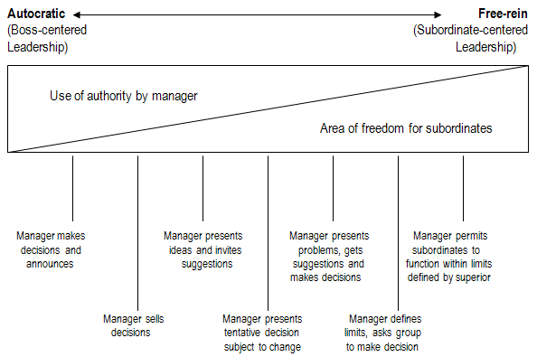
- The manager makes a decision and announces it
  - The manager identifies a problem, considers alternative solutions, chooses one and reports it to his subordinates for implementation. No opportunity for subordinates to influence the decision making process. Coercion may or may not be used
- The manager “sells” his decision
  - The manager identifies a problem, considers alternative solutions, chooses one and rather than announcing it for implementation, he tries to persuade his subordinates to accept it, thus reducing any resistance or opposition to his final decision
- The manager presents his idea, invites questions
  - The manager has arrived at a decision and seeks acceptance of his decision. Provides his subordinates with a fuller explanation of his though process and intentions. After presenting his ideas, he invites questions to clarify any misunderstandings. This process allows for a deeper exploration of the implications of the decision
- The manager presents a tentative decision subject to change
  - This kind of behavior permits subordinates to have some influence on the decision. The manager identifies and diagnoses the problem, prior to meeting with his staff he arrives at a tentative decision. Before finalizing it, he presents his solution for the reaction of those who will be affected by it. This manager likes to hear what other have to say
- The manager presents the problem, get suggestions, and then makes his decision
  - The manager identifies the problem and rather than defining his own solution he goes straight to his subordinates for suggestions, thus allowing him to expand his repertory of solutions to the problem. The purpose of this is to get the most out of the knowledge and experience of those working the “front line.” The manager then makes an informed decision that he regards as “most promising.”
- The manager defines the limits and requests the group to make a decision
  - The manager now appoints the group the right to make decision (may include himself as a member). Before doing so, he defines the problem and boundaries within which the decision must be made. The manager has decided that the decision should be made by the people directly involved
- The manager permits the group to make decisions within limits defined by a superior
  - This represents an extreme degree of group freedom. Here the group undertakes the identification and diagnosis of the problem, develops alternative procedures for solving it and decides on one of these solutions. The only limits directly imposed on the group are that of their immediate superior. If the boss participates in the decision making process, he does so with no more authority that any other member, he is committed to the decision of the group

- How to lead
  - Forces in the manager: The manager’s behavior is greatly influenced by his personality. He will perceive his leadership problems based on his background, knowledge, and experience
    - Value system: How strong does he feel that individuals should have a share in making the decisions? How convinced his he that the official who is paid to assume responsibility should personally carry the burden of decision making?
    - His confidence in subordinates: Who is best qualified to deal with this problem? He may, justifiably or not, have more confidence in his own ability to make the decision than that of his subordinates
    - His own leadership inclinations: Some managers function more comfortably as highly directive leaders; confident in their own abilities, while others are more comfortable in a team role; continually sharing many of their functions with subordinates
    - His feelings of security in an uncertain situation: Some managers have a greater need for predictability and stability (their own decisions) while others do not
  - Forces in the subordinate: What affects the subordinate’s behavior? What are their personality variables that affect their decision making process? What are the subordinate’s expectations of how the boss should react in relation to them?
  - Managers will permit greater freedom to his subordinates if:
    - Subordinate’s need for independence
      - People differ greatly in the amount of direction they desire
    - Subordinate’s readiness to assume responsibility for making decisions
      - Some people see additional responsibility as a tribute to their abilities while others see it as “passing the buck”
    - Subordinate’s tolerance for ambiguity
      - Some people prefer clear-cut directives while others prefer a wider area of freedom
    - Subordinate’s interest and degree of importance placed on the problem
    - Subordinate’s understanding of the organizational goals and whether they identify themselves with the organization
    - Subordinate’s necessary knowledge and experience to deal with the problem
    - Subordinate’s ability to share in the decision making
      - People who have come to expect strong leadership and then are suddenly expected to share in the decision making process are often upset by this new experience; contrarily, people who have enjoyed considerable amounts of freedom are upset when the boss begins to make all the decisions
  - Forces in the situation: Certain characteristics in the general situation; pressures from the organization, the work group, nature of the problem, and pressures of time
    - Type of organization: Values and traditions of the organization that influence the employees. Employee participation is also influenced by the size of the working units, geographical distribution, and the degree of inter/intra-organizational security required to attain company goals
    - Group effectiveness: Before delegating tasks to subordinates, the manager must decide whether or not they can work effectively as a unit. Long-lasting groups work better together than new ones. Similarly, groups with closely related backgrounds have developed habits on how to work together at in a timely and efficient manner. The degree of confidence, cohesiveness, permissiveness, mutual acceptance and commonality of purpose will also exert influence on the group’s functioning
    - The problem itself: Is the problem better solved with manager’s knowledge or that of the subordinates? Some problems require first-hand knowledge of specialists from many different fields
    - The pressures of time: The more a manager feels the need for immediate decisions, the more difficult it is to involve other individuals.
    - Long- run strategy: Decisions made based on the “bigger picture.” Thinking about the future of the decisions made today
    - Attaining objectives: Depends on what the manager wants to accomplish. Most modern managers shift their attention from immediate assignments to:
      - Raise the level of employee motivation
      - Increase subordinate’s readiness to accept change
      - Improve quality of all managerial decisions
      - Develop teamwork and morale
      - Further the individual development of employees

Chapter 4
Underlying assumptions: Logical link that fills the gap between the evidence and the claim
- Implicit or explicit principles that form the bases of our beliefs & reasoning
- Tell us whether evidence provided for a claim is relevant
- Reality assumptions: our beliefs about reality; about the way things are
- Value assumptions: our ideals, our standards of right and wrong, the way things ought to be
Collins and Porras’ Theory
- Companies that enjoy enduring success have core values and a core purpose that remain fixed while their business strategies and practices endlessly adapt to the changing world
- Truly great companies understand the difference between what should never change and what should be open for change, how to manage continuity and change simultaneously
- Company vision: Provides guidance about what core to preserve and what future to stimulate progress towards. A well-conceived vision consists of two major components:
Core ideology: (What we stand for and why?) Enduring character of an organization – a consistent identity that transcends product or market life cycles, technological breakthroughs, management fads, and individual leaders. Most lasting and significant part of visionary companies
- Core ideology provides the glue that holds an organization together as it grows, decentralizes, diversifies, expands globally, and develops workplace diversity. A source of guidance and inspiration
  - More important to know who you are than where you are going, for where you are going will change as the world around you changes
- Core ideology is not created by external factors; it is discovered by looking inside. It has to be authentic. Attracts company people whose personal values align with the company’s ideology and repels those people who are incompatible
  - Core values: A small set of timeless guiding principles, core values require no external justification; they have intrinsic value and importance to those inside the organization
    - Core values might be a competitive advantage to a company and would hold even if they proved to be a competitive disadvantage to a company
  - Core purpose: The organization’s reason for being. An effective purpose reflects people’s idealistic motivations for doing the company’s work
    - Core purpose itself does not change; however, it does inspire change. A core purpose can never be fully realized therefore an organization can never stop stimulating change and progress towards it
      - Not to be confused with goals or business strategies

Envisioned future: A vivid description of what it will be like to achieve goals. It conveys concreteness – something visible, vivid, and real; on the other hand, it involves a time yet unrealized with its dreams, hopes, and aspirations
- BHAG (Big Hairy Audacious Goals): A huge, intimidating challenge – clear and compelling, it serves as a unifying focal point of efforts, and acts as a catalyst for team spirit (a way to stimulate progress)
  - Requires 10 to 30 years of efforts to complete. Setting a BHAG that far into the future requires thinking beyond current capabilities of the organization and the current environment (visionary)
- Vivid description: A vibrant, engaging, and specific description of what it will be like to achieve the BHAG
  - Creates an image of utopia that people can carry around in their heads
  - Passion, emotion, and conviction are essential parts of vivid description

Chapter 5
- Causal explanation: author’s interpretation of cause and effect relationships
- Rival causes: The same evidence can be consistent with different interpretations
- Three (3) types of rival causes related to:
  - Differences between groups
  - Association of characteristics
    - Reverse causation?
    - Effect of 3rd variable?
  - The post hoc, ergo propter hoc fallacy

Social Power
- Reward Power: based on one’s perception that other has the ability to mediate rewards for him
- Coercive Power: based on one’s perception that the other has the ability to mediate punishments on him
- Legitimate Power: based on one’s perception that the other has a legitimate right to prescribe behaviour for him
- Referent Power: based on one’s identification with the other
- Expert Power: based on one’s perception that the other has some special knowledge or expertise

Mintzberg’s Theory
Folklore: The manager is a reflective, systematic planner
- Fact: Study after study has shown that managers work at an unrelenting pace, that their activities are characterized by brevity, variety, and discontinuity, and that they are strongly oriented to action and dislike reflective activities
  - Managers must respond to the pressures of the job, because of this there is little time for rest and reflection
    - When managers plan, they do so implicitly in the context of daily actions, not in some abstract process reserved for two weeks at a retreat
  - Managers want to encourage the flow of current information and respond to stimuli, they prefer “live” to delayed action
    - Constantly plagued by the possibilities of what might be done and what must be done
Folklore: The effective manager has no regular duties to perform
- Fact: Managerial work involves performing a number of regular duties, including ritual and ceremony, negotiations, and processing of soft information that links the organization with its environment
  - Important for managers to interact with customers, assuming the manager wishes to keep these customers
Folklore: The senior manager needs aggregated information, which formal management information system best provides
- Fact: Managers strongly favor verbal media, telephone calls and meetings, over documents
  - Written documents don’t provide live, current information
  - Managers cherish “soft” information (gossip)
    - Today’s gossip may be tomorrow’s fact
  - The manager becomes his own director of central intelligence
    - Verbal information and strategic data of the organization is stored in the minds of the managers
  - Extensive use of verbal media explains why managers are reluctant to delegate tasks
    - Managers must take the time to “dump memory” onto subordinates; may be tedious and timely, and because of this managers may find it more efficient to do the task themselves
    - To do too much or to delegate to subordinates with inadequate briefing?
Folklore: Management is, or at least is quickly becoming, a science and a profession
- Fact: The managers’ programs – to schedule time, process information, make decisions, and so on – remain locked deep inside their brains
  - The information they need differs, but they seek it in the same way – by word of mouth, and is stored in their minds
  - Managers are overburdened with obligations and cannot easily delegate their tasks
    - Driven to overwork and forced to do many tasks superficially
      - Not much time to analyze and quantify information
    - Brevity, fragmentation, and verbal communication characterize their work
  - Before managers needed to respond only to owners and directors, now they find that subordinates with democratic norms continually reduce their freedom to issue unexplained orders, and a growing number of outside influences demand attention
The manager’s roles
- Managers have various interpersonal relations which give them access to a lot of information. Information, in turn, enables managers to make decisions and strategies for the unit
- Interpersonal roles
  - Figurehead role: Duties that involve interpersonal roles may sometimes be routine (ceremonial duties), involving little serious communication and no important decision making. Important to smooth functioning of an organization and cannot be ignored
  - Leader role: The influence of managers is most clearly seen in the leader role. Duties that involve motivating and encouraging employees, as well as reconciling their individual needs with the goals of the organization
  - Liaison role: Duties that involve making contacts outside the vertical chain of command
- Informational roles
- By virtue of interpersonal contacts, with subordinates and network contacts, the manager has a powerful database of information. The manager may not know everything but typically knows more than subordinates do
  - Monitor: Duties that involve perpetually scanning the environment for information, interrogating liaison contacts and subordinates, and receiving unsolicited information (gossip, hearsay, and speculation)
  - Disseminator: Duties that involve passing privileged information directly to subordinates, who would otherwise have no access to it (when subordinates lack easy contact with one another)
  - Spokesperson: Duties that involve sending information to people outside the unit – every manager must inform and satisfy the influential people who control the organizational unit
- Decisional roles
  - Entrepreneur: Duties that involve improving the unit, to adapt it to changing conditions in the environment
  - Disturbance handler: Duties that involve involuntarily responding to pressures. Change is beyond the manager’s control and too severe to be ignored
  - Resource allocator: Duties that involve deciding which units get what, designing unit’s structure, the pattern of formal relationships and how work is to be divided. Authorizes the important decisions of the unit before they are implemented
  - Negotiator: Duties that involve negotiating are an integral part of the manager’s job, he/she has the authority to commit organizational resources in “real time” and the nerve-center information that important negotiations require
Effective management
- The manager’s effectiveness is significantly influenced by their insight into their own work. Performance depends on how well a manager understands and responds to the pressures and dilemmas of the job
- The manager is challenged to find systematic ways to share privileged information
  - There are great dangers in centralizing the organization’s data bank in the minds of its managers
  - Managers must have regular debriefing sessions with key subordinates to “dump” information
- Managers are challenged to deal consciously with the pressures of superficiality by giving serious attention to the issues that require it, by stepping back in order to see a broad picture, and by making use of analytical inputs
  - Managers have the information and the authority; analysts have the time and the technology. Managers must share information with analysts so their findings can be adjusted and they can work cohesively
- Managers are challenged to gain control of their own time by turning obligations into advantages and by turning those things he/she wishes to do into obligations
  - A speech is a chance to lobby for a cause; a meeting is a chance to reorganize a weak department; a visit to an important customer is a chance to exchange trade info

Chapter 6
Barney’s Theory
- A firm will have sustained competitive advantages if its resources and capabilities are valuable, rare, inimitable and organized in a way that allows to exploit potential opportunities
- Competitive advantage occurs when an organization acquires or develops an attribute or combination of attributes that allows it to outperform its competitors
- SWOT analysis: Relationships between a firm’s environmental opportunities and threats, and a firm’s internal strengths and weaknesses
  - Firms that use their internal strengths in exploiting environmental opportunities and neutralizing environmental threats, while avoiding internal weaknesses, are more likely to gain a competitive advantage over other firms
- A firm’s resources and capabilities include all of the financial, physical, human, and organizational assets used by a firm to develop, manufacture, and deliver products and services to its customers
  - Resources: physical, human, organizational assets used by the firm to develop, manufacture and deliver products and services to its customers
  - Financial: debt, equity, retained earnings
  - Physical: machines, manufacturing facilities, buildings
  - Human: experience, knowledge, judgment, wisdom
  - Organizational: history, culture, formal reporting structure, patents
- Managers must address four important questions about their resources and capabilities:
  - The question of value: Do a firm’s resources and capabilities add value by enabling it to exploit opportunities and/or neutralize threats?
    - Resources include specific technological skills and creative organizational cultures that enable firms to respond to, and even create, new environmental opportunities
    - Changes over time in customer tastes, industry structure, or technology can render some resources and capabilities less valuable in the future
    - Most important responsibility of strategic managers is to constantly evaluate the firm’s resources and capabilities to see whether or not they still add value
    - By answering the question of value, managers link the analysis of internal resources with that of the environmental opportunities and threats
    - Resources are only valuable when they exploit opportunities and/or neutralize threats
  - The question of rareness: How many competing firms already possess these valuable resources and capabilities?
    - If a particular resource is controlled by numerous competing firms, then that resource is unlikely to be a competitive advantage
    - Valuable but common resources give firms a competitive parity. These resources are still essential to a firm’s survival
    - Valuable but rare resources give firms a temporary competitive advantage
  - The question of imitability: Do firms without a resource or capability face a cost disadvantage in obtaining it compared to firms that already possess it?
    - Imitation can occur in two ways: duplication and substitution
    - Duplication occurs when an imitating firm builds the same kinds of resources as the firm it is imitating
    - Substitution occurs when substitute resources have the same strategic implications and are no more costly to develop (leads to competitive parity)
    - Three reasons why these internal attributes of firms are costly to imitate:
    - The importance of history: As a firm evolves, it picks up skills, abilities, and resources that are unique to it, reflecting its particular path through history. These resources and capabilities reflect the unique personalities, experiences, and relationships that exist in only a single firm
    - The importance of numerous “small decisions” in developing, nurturing, and exploiting resources: Depends upon literally hundreds of thousands of decisions made each day by employees. Small decisions are essentially invisible to firms seeking to imitate another firm’s resources. Success does not depend on doing a few big things right, but on doing lots of little things right
    - The importance of socially complex resources: Cost disadvantage in imitating resources and capabilities through physical resources that may be complex to acquire. On the other hand, organizational phenomena like reputation, trust, friendship, teamwork and culture are difficult to imitate
If resources and capabilities are valuable, rare, and socially complex: sustained competitive advantage
Summary of VRIO, Competitive Implications, and Economic Implications
Valuable? | Rare? | Costly to Imitate? | Organized Properly? | Competitive Implications | Economic Implications
No | No | No | No | Disadvantage | Below
Yes | No | No | No | Parity
Yes | Yes | No | No | Temporary Advantage | Above (for some amount of time)
Yes | Yes | Yes | Yes | Sustained Advantage | Above

  - The questions of organization: Is a firm organized to exploit the full competitive potential of its resources and capabilities?
    - Formal reporting structure, explicit management control systems, and its compensation policies (complementary resources)
    - Limited ability to generate a competitive advantage alone but when combined with other resources and capabilities, they can enable a firm to realize its full competitive advantage
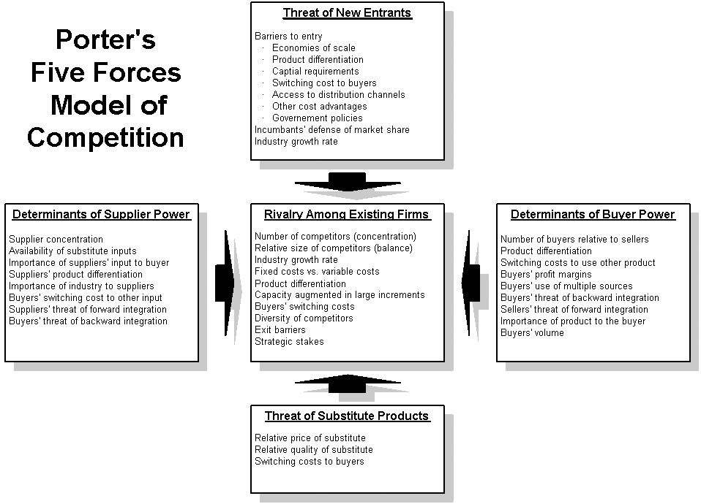
Chapter 7
Kaplan & Norton’s Theory
- What you measure is what you get. An organization’s measurement system strongly affects the behavior of managers and employees.
- No single measure can provide a clear performance target or focus attention on the critical areas of the business. There must be a balanced presentation of both financial and operational measures
  - Cannot rely on one set of measures to the exclusion of the other
- Balanced scorecard: a setoff measure that give top managers a fast but comprehensive view of the business. The balanced scorecard includes financial measures that tell the results of actions already taken. And it complements financial measures with operational measures on customer satisfaction, internal processes, and the organization’s innovative and improvement activities
- The scorecard brings together in a single management report, the company’s competitive agenda: becoming customer oriented, shortening response time, improving quality, emphasizing teamwork, reducing new product launch times, and managing for the long term. Shows whether improvement in one area has been achieved at the expense of the other
- Customer’s perspective: How do customers see us?
  - Time: Lead time measures the time required for the company to meet it’s customer’s needs
  - Quality: Measures the defect level of the incoming products as perceived by the customer. Could also measure on-time delivery, accuracy of the company’s delivery forecast
  - Performance and service: How the company’s products or services contribute to creating value for its customers
- Internal perspective: What must we excel at?
  - Translates to what the company must do internally to meet its customers’ needs; derives from prom processes, decisions, and actions occurring throughout an organization
  - Factors that affect cycle time, quality, employee skills, and productivity
  - Companies should try and identify core competencies, the critical technologies needed to ensure market leadership
- Innovation and learning perspective: Can we continue to improve and create value?
  - Intense global competition requires that companies make continual improvements to their existing products and processes and have the ability to introduce entirely new products with expanded capabilities
- Financial perspective: How do we look to shareholders?
  - Have to do with profitability, growth and shareholder value
- The balanced scorecard can only translate a company’s strategy into specific measurable objectives. Must convert operational performance into improved financial performance

Chapter 8
Handy’s Theory
- By the time you know where you ought to go, it’s too late to go there, or, more dramatically, if you keep on going the way you are, you will miss the road to the future
- The world keeps changing. One of the paradoxes of success is that the things and the ways which got you where you are are seldom those that keep you there.
- The Sigmoid curve tells the story of life itself. We start slowly, experimentally, and falteringly; we grow and then we decline.
  - The secret to constant growth is to start a new sigmoid curve before the first one starts to decline. Point A is the right place to begin the second curve where time, resources and energy to get the new curve through its initial explorations are prime before the first curve begins to dip downward
  - The real energy for change comes only when you are looking disaster in the face, at point B on the first curve

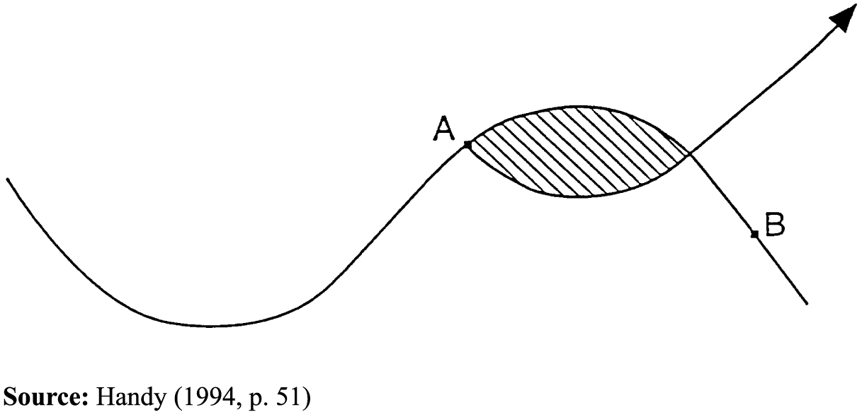
- Building a new future while maintaining the present will ensure the renewal and continued growth of any organization.
  - Original leaders have a responsibility to keep the first curve going long enough to support the early stages of the second curve
- The second curve can be a new product, new way of operating, new strategy, or new culture. It have to be noticeably different from the old curve
- The shaded area is a time of great confusion. Two, or more, groups of people and two sets of ideas are competing for the future
- The discipline of the second curve:
  - Requires that you always assume that you are near the peak of the first curve (point A)
  - Follows the four stage cycle of discovery:
    - Questions start it off (If we did not exist, would we reinvent ourselves, if so how?)
    - The questions give rise to ideas, possibilities, hypotheses
    - The best of these must be tested, tentatively and experimentally
    - The results of the experiments are reviewed
  - The discipline of the second curve means that you do not reinvent the same life because that would merely perpetuate the first curve
- Curvilinear logic means starting like over again, something that gets harder as one gets older
- Kaizen = continuous improvement

Chapter 9
Herzberg’s Theory
- The things that make people satisfied and motivated on the job are different in kind from the things that make them dissatisfied
- People are motivated by interesting work, challenge, and increasing responsibility
  - Intrinsic factors for people’s deep-seated need for growth and achievement
“Motivating” with KITA
- The most sures, simplest and most direct way of getting people to do something is to administer a “Kick In The Arse”
- Negative Physical KITA
  - In-elegant,
  - Contradicts the precious image of benevolence that most organizations cherish
  - Since it is a physical attack it stimulates the autonomic nervous system and often produces negative feedback
- Negative Psychological KITA
  - Cruelty is not visible; the bleeding is internal and comes much later
  - Since the number of psychological pain a person can feel is infinite, the direction and possibility of the KITA is increased many times
  - The person administering the kick can manage to be above it all and let the system accomplish the dirty work
  - Those who practice it receive an ego satisfaction
  - If the employee does complain, he or she can be accused of being paranoid; there is no tangible evidence of an actual attack
  - Negative KITA does not lead to motivation, but to movement
- Positive KITA
  - KITA, although it may be positive, is not motivation
    - Ex.: I can charge a person’s battery and the recharge it, and recharge it again. But it is only when one has a generator of one’s own that we can talk about motivation. One then needs no outside stimulation. One wants to do it
  - Positive KITA personnel practices:
    - Reduce time spent at work – Motivated people seek more hours of work, not fewer
    - Spiraling wages – If rising wages don’t or won’t do the job, reducing them will
    - Fringe benefits – These benefits are no longer rewards, they are rights
    - Human relations training – The failure of human relations training to produce motivation led to the conclusion that supervisors and managers themselves were not psychologically true to themselves in their practice of interpersonal decency
    - Sensitivity training – Temporary gains from comfort, economic and interpersonal KITA, personnel managers concluded that the fault lay not in what they were doing but in the employee’s failure to appreciate what they were doing
    - Communications – Management must listen to what employees have to say
    - Two-way communication – Management ordered morale surveys, suggestion plans, and group participation programs
    - Job participation – The goal is to provide a sense of achievement rather than a substantive achievement in the task
    - Employee counseling – Helps employees unburden themselves by talking to someone about their problems
Hygiene vs. Motivators
- The opposite of job satisfaction is not job dissatisfaction but, rather, no job satisfaction; and similarly, the opposite of job dissatisfaction is not job satisfaction, nut no job dissatisfaction
- The growth or motivator factors that are intrinsic to the job are: achievement, recognition for achievement, the work itself, responsibility, and growth or advancement
- The dissatisfaction-avoidance or hygiene (KITA) factors that are extrinsic to the job include: company policy and administration, supervision, interpersonal relationships, working conditions, salary, status, and security
- The motivation-hygiene theory suggests that work be enriched to bring about effective utilization of personnel
  - Job enrichment provides the opportunity for the employee’s psychological growth, while job enlargement merely makes a job structurally bigger
- Job loading
  - Horizontal job loading merely enlarges the meaninglessness of the job
    - Challenging the employee by increasing the amount of production expected
    - Adding another meaningless task to the existing one, usually some routine clerical activity
    - Rotating the assignment of a number of jobs that need to be enriched
    - Removing the most difficult parts of the assignment in order to free the worker to accomplish more of the less challenging assignments
  - Vertical job loading motivates employees to reach high levels of responsibility, recognition, personal achievement, growth and learning
    - Removing some controls while retaining accountability
    - Increasing the accountability of individuals for own work
    - Giving a person a complete natural unity of work
    - Granting additional authority to employees in their activity; job freedom
    - Making periodic reports directly available to the workers themselves rather than to supervisors
    - Introducing new and more difficult tasks not previously handled
    - Assigning individuals specific or specialized tasks, enabling them to become experts
Eternal Triangle
- There are three general philosophies of personnel management
  - Organizational Theory
    - Believe that human needs are either so irrational or so varied and adjustable to specific situations that the major function of personnel management is to be as pragmatic as the occasion demands
  - Industrial Engineering
    - Believe that humankind is mechanically oriented and economically motivated and that human needs are best met by attuning the individual to the most efficient work process. The goal of personnel management therefore should be to concoct the most appropriate incentive system and to design the specific working conditions in a way that facilitates the most efficient operation, engineers believe they can obtain the optimal organization of work and the proper work attitudes
  - Behavioral Science
    - Believe that focus on group sentiments, attitudes of individual employees, and the organization’s social and psychological climate. The approach to personnel management is generally to emphasize some form of human relations education, in the hope of instilling healthy employee attitudes and an organizational climate that is considered to be felicitous to human values. The belief is that proper attitudes will lead to efficient job and organizational structure
Job Enrichment
- Select those jobs in which the investment in industrial engineering does not make changes too costly, attitudes are poor, hygiene is becoming very costly and motivation will make a difference in performance
- Approach these jobs with conviction that they can be changed
- Brainstorm a list of changes that may enrich the jobs, without concern for their practicality
- Screen the list to eliminate suggestions that involve hygiene, rather than actual motivation
- Screen the list for generalities, such as “give them more responsibility” that are rarely in practice
- Screen the list to eliminate any horizontal loading suggestions
- Avoid direct participation by the employees whose jobs are to be enriched
- In the initial attempts at job enrichment, set up a controlled experiment
- Be prepared for a drop in performance in the experimental group the first few weeks
- Expect your first-line supervisors to experience some anxiety and hostility over changes you are making. It stems from their fear that the changes will result in pooer performance for their unit
- Job enrichment will not be a onetime proposition but a continuous management function
  - The changes should bring the job up to the level of challenge commensurate with the skill that was hired
  - Those who have still more ability eventually will be able to demonstrate it better and win promotion to high level job
  - The very nature of motivators, as opposed to hygiene factors, is that they have a much longer-term effect on employees’ attitudes. It is possible that they job will have to be enriched again, but this will not occur as frequently as the need for hygiene

