Anatomy of the Muscular System
Gross Anatomy of a Skeletal Muscle:
Muscle fiber is the name of a single muscle tissue cell.
Several different levels of CT wrapping
- Endomysium: fine layer of CT that surrounds each muscle fiber (cell)
- Perimysium: sheath around a fascicle.
- Epimysium: dense, fibrous CT that surrounds and holds together a group of fascicles
  - Outside layer of a single muscle.
- Deep Fascia: still coarser layer of dense CT that binds muscles into functional groups.
  - Ex. Hamstrings vs. Quadriceps
Muscle Attachments:
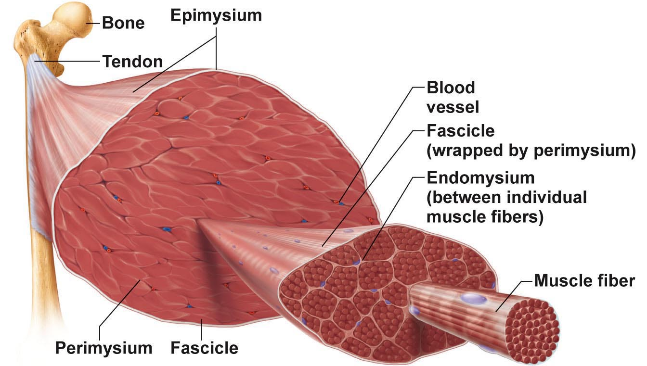
- Most muscles span joints
- Most muscles are attached to bones in at least 2 places
Origin:
Insertion:
Most attachments are indirect attachments involving either a tendon or an aponeurosis.

Arrangement of Fascicles:
- All skeletal muscles have fascicles.
4 Basic Patterns:
- Parallel:
  - can be straplike (Sartorius)
  - Fusiform (biceps, brachii)
- Pennate:
  - Unipennate: Ex. extensor digitorum longus
  - Bipennate: Ex. rector femoris.
  - Multipennate: Ex. deltoid.
- Convergent: muscle is triangular or fan-shaped
  - Ex. pectoralis major
- Circular: concentric rings surround external openings and contract to close opening (Ex. orbicularis oris)
Interactions of Skeletal Muscles:
- Muscles can work together or in opposition.
4 Functional groups:
- Prime movers
- Antagonists
- Synergists
- Fixators.
Prime Mover:
Ex. biceps brachii, and elbow flexion.
Antagonist:
- Can provide resistance to prevent overshoot or control rate of movement.
- A single muscle can be a prime mover for one action and an atangonist for another action.
- Ex. Biceps brachii and triceps brachii.
Synergists:
- Muscles that help the prime mover by:
  - Promoting the same movement
  - Reducing undesirable movements (ex. finger flexor muscles cross both wrist and phalangeal joints).
Fixators:
- Immobilize a bone.
- Ex. muscles involved in posture.
Naming Skeletal Muscles:
- Location of Muscle: bone or body region: Ex. temporalis, intercostal.
- Shape of Muscle: Ex. deltoid (triangular), right and left trapezius muscles form a trapezoid.
- Relative Size of Muscle: maximus, minimus, longus, brevis. Ex. gluteus maximus and gluteus minimus.
- Direction of Muscle Fiber: Ex. rectus = straight, parallel to midline (rectus femoris). Also transversus abdominis, oblique.
- Number of Origins: biceps, triceps, quadriceps. Ex. biceps brachii.
- Location of Muscle’s Origin and/or Insertion: if both indicated, origin always indicated first.
  - Ex. sternoceidomastoid (neck region – dual origin on sternum and clavicle and insertion on mastoid process of temporal bone)
- Action of the Muscle: Flexor, extensor, adductor
  - Ex. adductor longus for thigh adduction and supinator muscle in forearm.
Extensor carpi radialis longus:

Muscles of the Head – Facial Expression:
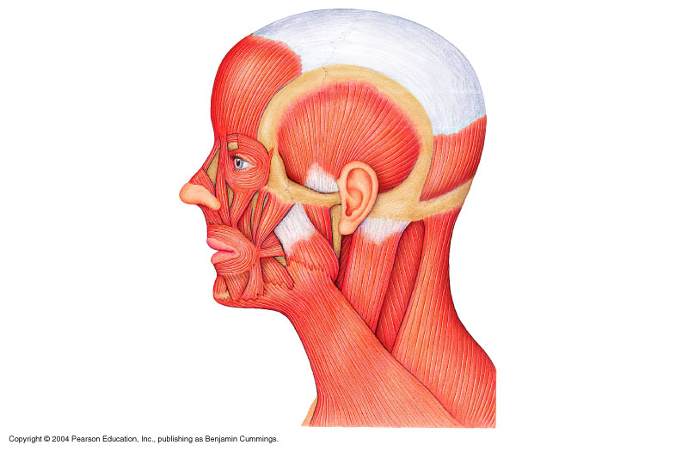
- Insert into skin or other muscles, not bones; innervated by the facial nerve.
Epicranius: Main muscle of scalp – consists of
- Frontalis: raises eyebrows, wrinkles forehead
- Occipitalis: pulls scalp posteriorly.
Orbicularis oculi:
- surrounds rim of orbit
- Protects eyes from light/injury – blinking, squinting, also draws eyebrows down.
Zygomaticus (cheek to corner of mouth): smiling muscle.
Orbicularis Oris:
- lips, multi-layered
- closes, purses, protrudes lips.
Mentalis: (mandible to chin)
- V-shaped pair – portudes lower lip: wrinkles chin. Buccinator: (mandible/maxilla to orb oris):
- Deep to masseter – whistling, sucking
- Hold food in place when chewing: especially in nursing infants.
Platysma: (fascia of chest to mandible):
- Helps depress mandible; tenses skin of neck.
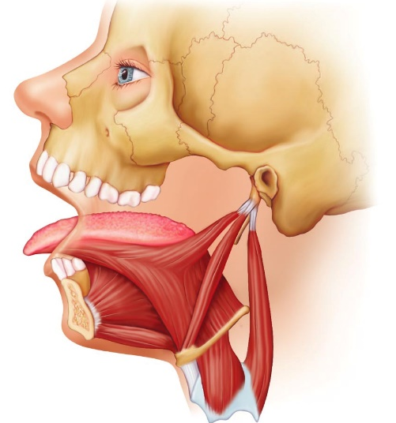
Muscles that Move the Tongue:
Genioglossus: (mandible to inferior tongue and hyoid bone): prime mover of tongue protrusion, anchors tongue to prevent obstruction of respiration.
Hypoglossus: (hyoid bone to inferolateral tongue): depresses tongue, especially lateral margins.
Styloglossus: (styloid process of temporal bone to inferolateral tongue): retracts and elevates tongue.

Muscles of the Head: Mastication, etc.
4 pairs involved in chewing, all innervated by mandibular division of cranial nerve V.
- Masseter: (zygomatic to mandible): prime mover of jaw closure (powerfully)
- Temporalis: (temporal to mandible): elevates and retracts mandible (closes jaw); maintain closed jaw at rest.
- Medial and Lateral Pterygoid: (sphenoid to mandible): both two-headed; additional jaw movements (ex. side-to-side grinding movements).
- Buccinator: (mandible/maxilla to orbicularis oris):
  - helps keep food between grinding surfaces of teeth during chewing. 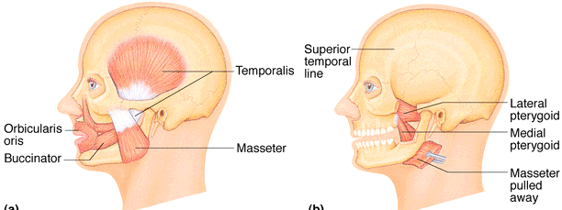

Muscles of the Neck and Vertebral Column: Head and Trunk Movements.
- Head moved by muscles originating from axial skeleton.
Sternocleidomastoid: (manubrium/clavicle to mastoid process of temporal):
- 2-headed; deep to platysma: prime mover (both muscles) of head flexion;
- Individual muscle action for head rotation to side; head tilts.
Scalenes: (cervical vertebrae to 1st 2 ribs):
- More laterally and deep to platysma and sternocleidomastoid – elevate first 2 ribs; role in coughing, flex and rotate neck.
Splenius: (vertebrae to mastoid process of temporal):
- Superficial; “bandage muscle”, head extension (both sides) or rotation tilts.
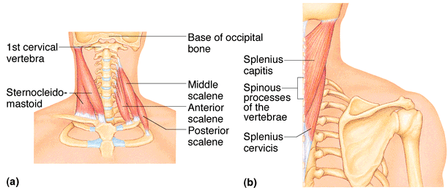

Muscles of the Neck and Vertebral Column: Head and Trunk Movements
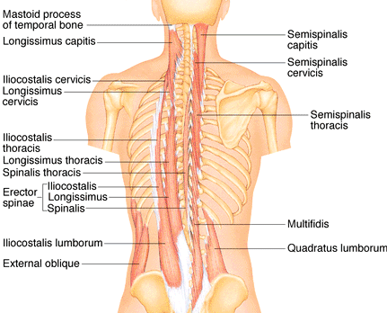
Erector spinae: prime mover of back extension: consists of 3 columns of muscles. (illiocostalis, longissimus, spinalis): resistance to bending forward.
Semispinalis: deeper, composite muscle from thoracic region to head;
- Extends vertebral column and head: rotation of head, synergistic with sternocleidomastoid muscles of opposite side.
Quadratus lumborum: (iliac crest to lumbar vertebrae):
- Individual muscles flex vertebral column laterally: jointly to extend lumbar spine and fix 12th rib.
- Maintain upright posture.
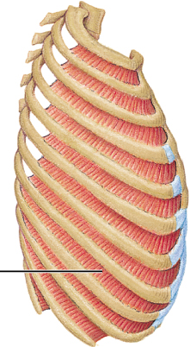
Muscles of Respiration:
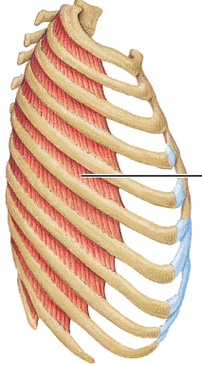
External intercostals: 11 pairs between ribs; oblique; pull ribs together to elevate rib cage
- (inspiration; 1st ribs fixed by scalene muscles)
Internal Intercostals: 11 pairs, between ribs: external intercostals; draw ribs together to depress rib cage
- (expiration; 12th ribs fixd by quadratus lumborum)
Diaphragm: dome-shaped when relaxed; prime mover of inspiration.
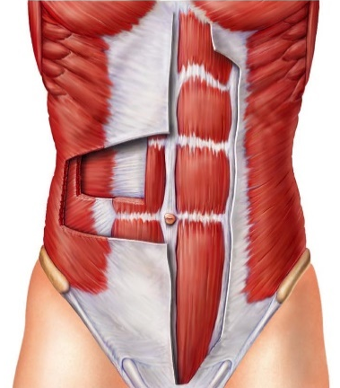
Muscles of the Abdominal Wall:
Rectus abdominis: medial superficial; pubis to rib cage:
Lumbar rotation fix and depress ribs, stabilize pelvis during walking;
External Oblique: largest and most superficial lateral muscle:
- Together increase ab pressure, flex vertebral column
- Individual rotation
Internal Oblique: deeper, but same actions as ext obliques.
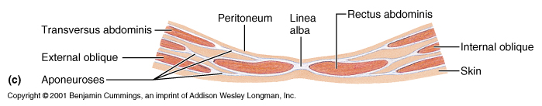
Transversus abdominis – deepest; compresses abdominal contents.

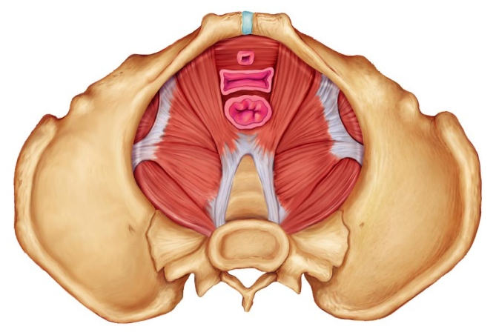
Muscles of the Pelvic Floor and Perineum:
Levator ani: (pubis to inner coccyx): supports pelvic viscera and forms supportive sling at anorectal junction and vagina.
- Resists increases in intra-abdominal pressure.
Coccygeus: (spine of ischium to sacrum and coccyx): supports pelvic viscera and coccyx.
Urogenital Diaphragm: supports pelvic viscera and constricts urethra.
Superficial Muscles of Thorax: Arm Movements
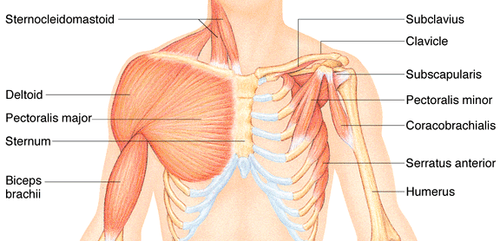
Pectoralis major: (sternum/rib cartilages to humerus):
- Prime mover of arm flexion; rotates arm medially; adducts arm; climbing, throwing, pushing.
Lattisimus dorsi: (vertebrae to humerus): broad, flat back muscle; prime mover of arm extension; arm adductor, rotates arms at shoulder, rowing, swimming
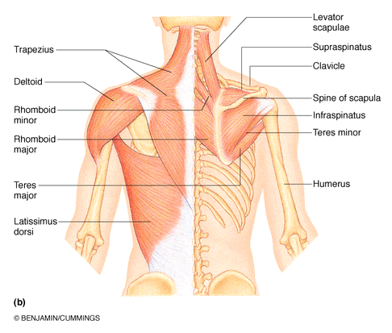
Deltoid: (clavicle/scapula to humerus): thick, rounded, site of IM injection, prime mover of arm abduction (all fibers)
- Also lateral and medial rotations, flexion or extensions if only some fibers used, swinging arm when walking.
Trapezius: (occipital and vertebrae to scapula): superficial, stabilizes, raises, retracts, rotates scapula.
Rhomboids: (vertebrae to scapula): deep to trapezius: aid in scapula movements (ex. Squaring shoulders, rotation when lowering arm).

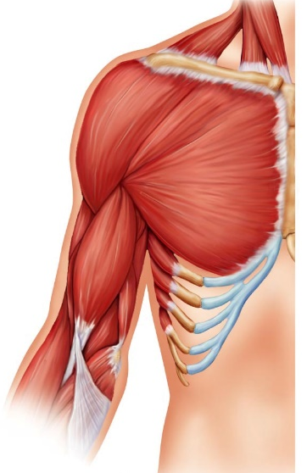
Muscles Crossing the Shoulder and Elbow Joints:
Triceps brachii: (scapula/humerus to ulna):
Only muscle of posterior compartment of arm; powerful forearm extensor, may help stabilize shoulder joint.
Biceps brachii: (shoulder to radius):
Anterior, flexes elbow joint and supinates forearm; weak flexor of arm at shoulder.
Brachialis: (humerus to ulna):
Immediately deep to biceps brachii; major forearm flexor (strong) – lifts ulna as biceps lift radius.
Brachioradialis: (humerus to radius):
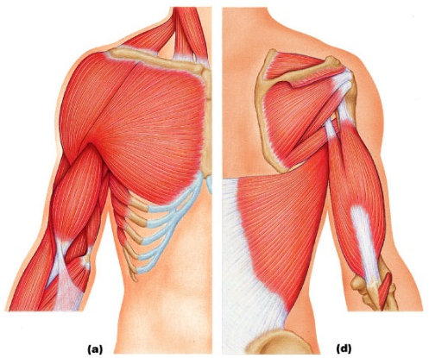
Superficial; from distal humerus to distal forearm; synergist in forearm flexion.

Muscles of the Forearm: Movements of the Wrist, Hand and Fingers:
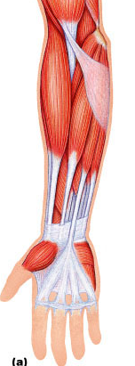
2 functional groups allow for movements of
- The wrist
- The fingers and thumb
Pronator teres: (humerus/ulna to lateral radius): Pronates forearm, weak flexor of elbow.
Flexor carpi radialis: (humerus to metacarpals): Diagonally across forearm, powerful flexor of wrist; abducts hand.
Flexor carpi ulnaris: (humerus/ulna to metacarpals): Powerful flexor of wrist; also adducts hand in concert with extensor carpi ulnaris; stabilizes wrist during finger extension.
Flexor digitorum superficialis: (humerus/ulna to phalanges):
- 2-headed, deeper; flexes wrist and middle phalanges of fingers 2-5

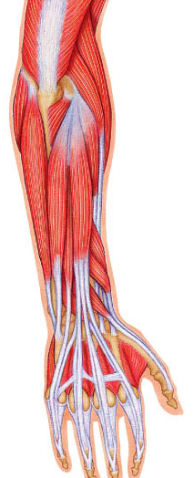
Extensor carpi radialis longus/brevis: (humerus to metacarpals): extends and abducts wrist.
Extensor Digitorum: (humerus to phalanges): prime mover of finger extension; extends wrist, can abduct fingers.
Supinator: (humerus to radius): deep; assists biceps brachii to supinate forearm.
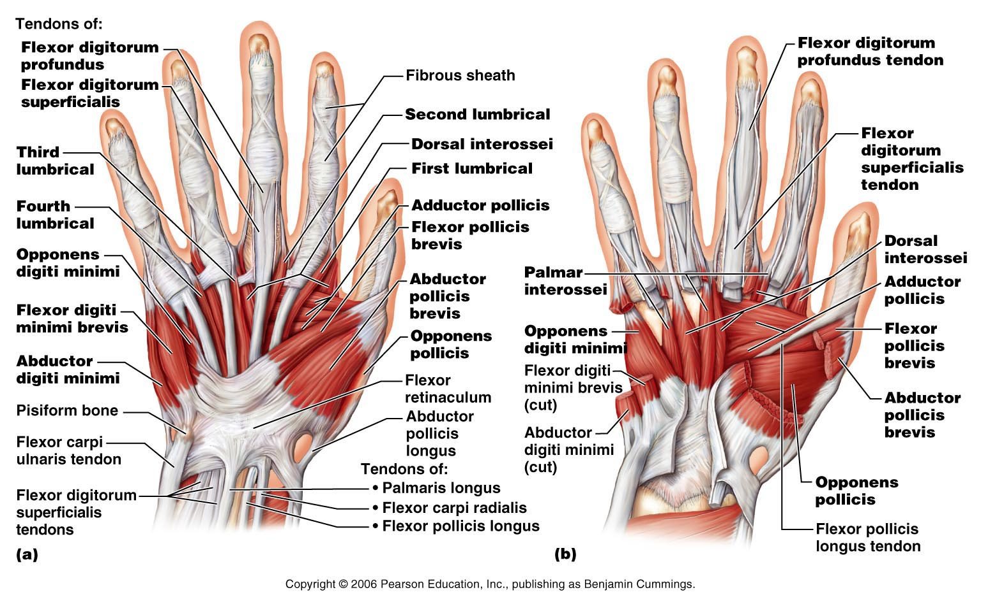

Muscles of Hip, Thigh and Leg:
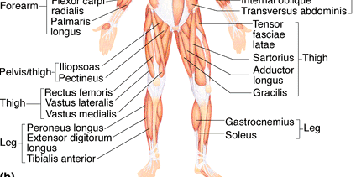
Iliopsoas: (iliac crest and lumbar vertebrae to femur): composite of 2 muscles; prime mover of hip flexion.
Sartorius: (iliac spine to medial tibia): strap-like; longest muscle; flexes and laterally rotates thigh; weak knee flexor.
Adductors (magnus, longus, brevis): (pubis to femur): all adductors flex, medially rotate thigh.
Ex. riding a horse, walking, fixing hip when knee flexed.
Pectinus: (pubis to femur): adducts, flexes and medially rotates thigh
Gracilis: (pubis to medial tibia): adducts thigh, medially rotates leg (walking)
Rectus Femoris: (iliac spine to patella and tibia): extends knee, flexes thigh at hip.
Vastus (lateralis, medialis, intermedius): all extend the knee.
Tibialis anterior: (tibia to tarsals): prime mover of dorsiflexion; inverts foot.
Extensor Digitorum longus: (tibia to phalanges): dorsiflexes foot; prime mover of toe extension.
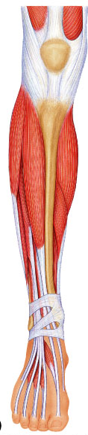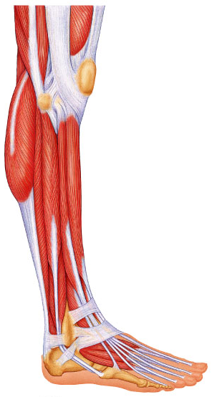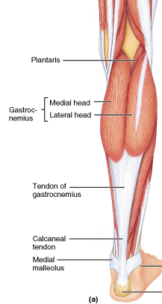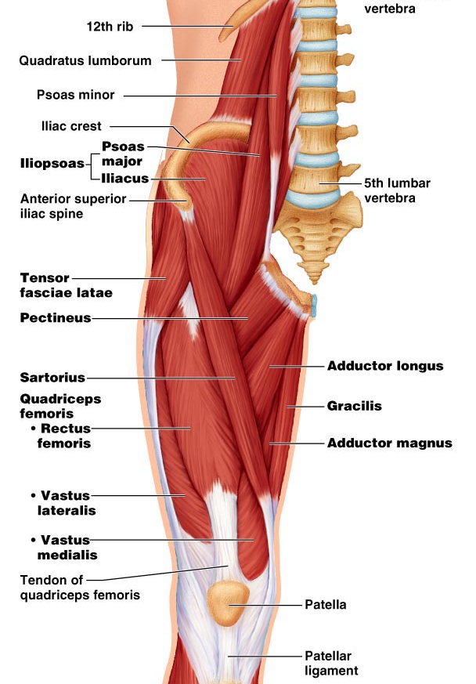
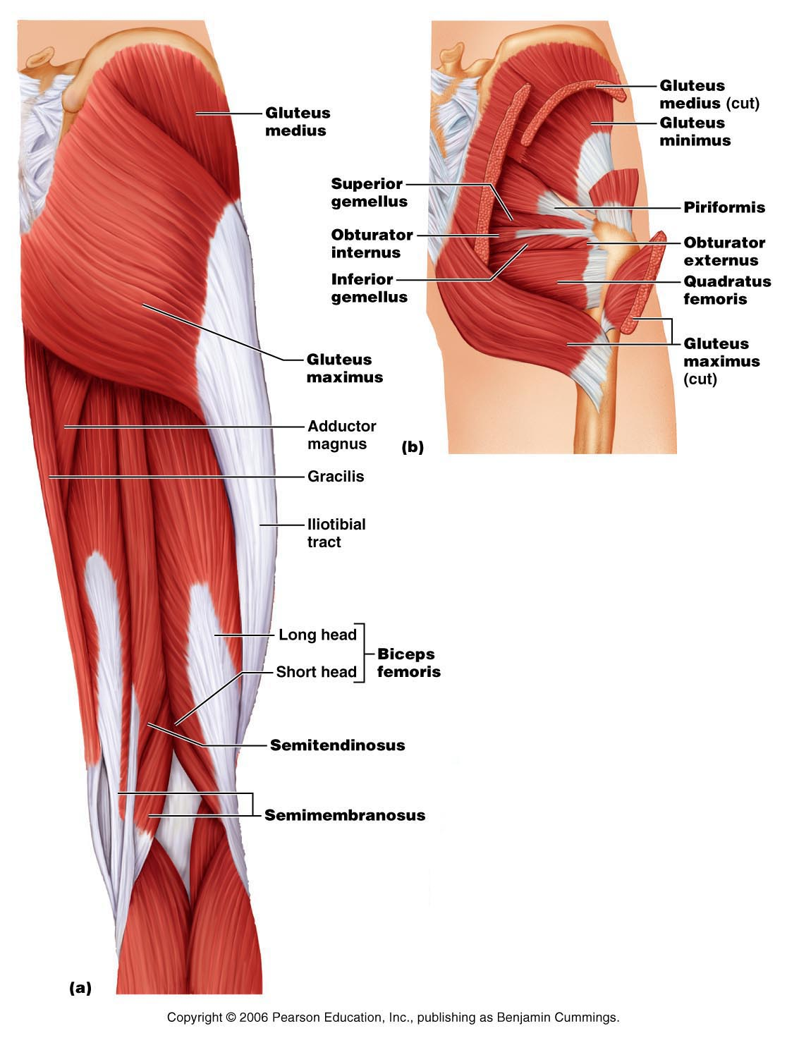
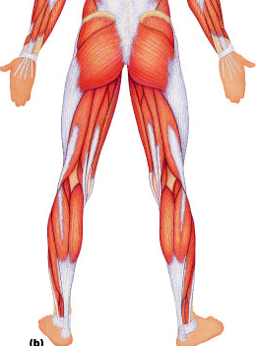
Gluteus Maximus: (ilium/sacrum to femur): largest and most superficial buttock muscle; major thigh extensor – climbing stairs, running (im injection)
Gluteus Medius: (iilium to femur): abducts and medially rotates thigh; especially during walking (im injections).
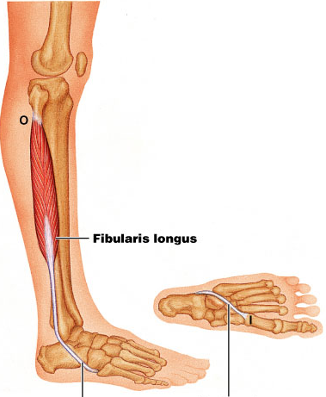
Hamstrings: (ischial tuberosity to tibia/fibula): 3 muscles; all extend thigh and flex knee.

Gastrocnemius: (femur to calcaneal tendon): plantar flexes foot when knee extended; flex knee if foot dorsiflexed.
Soleus: (proximal tibia/fibula to calcaneus): deeper, plantar flexes ankle: walking, running, dancing.
Fibularis (peroneus) Longus: (fibula under foot to 1st metatarsal): plantar flexes and everts foot: helps keep foot flat on ground.
Calcaneal (Achilles Tendon): largest tendon in body (G and S)



