CHAPTER 5: INDUSTRY AND COMPETITOR ANALYSIS
Industry: A group of firms producing a similar product or service, such as airlines, fitness drinks, furniture, or electronic games.
Industry Analysis: Is business research that focuses on the potential of an industry. Helps a firm determine if the niche or target markets it identified during its feasibility analysis are accessible and which ones represent the best point of entry for the new firm.

What is the fundamental nature, characteristics, drivers, makes it work or the business. Who are the competitors, ratios, Gathers information about something you don’t know. You want to know what you’re getting into.

Competitor analysis: detailed evaluation of a firm’s competitors. Once a firm enters an industry, it must understand its competitive environment.

Three Key Questions
Is the industry accessible—in other words, is it is realistic place for a new venture to enter?
Does the industry contain markets that are ripe for innovation or are underserved?
Are there positions in the industry that avoid some of the negative attributes of the industry as a whole?

Industry trends: Strength of an industry depends on if environmental trends shift in favor or against the products or services sold by firms in the industry. (its not because managers didn’t do well their job)
- Environmental Trends
  - Include economic trends, social trends, technological advances, and political and regulatory changes.
  - For example, industries that sell products to seniors are benefiting by the aging of the population.
- Business Trends
  - Other trends that impact an industry.
  - For example, are profit margins in the industry increasing or falling? Is innovation accelerating or waning? Are input costs going up or down?

Five Forces Model: To determine the industry profitability.
Each of the five forces impacts the average rate of return for the firms in an industry by applying pressure on industry profitability. Well managed firms try to position their firms in a way that avoids or diminishes these forces—in an attempt to beat the average rate of return of the industry.
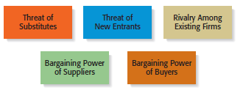

Threat of substitutes:
  - The price that consumers are willing to pay for a product depends in part on the availability of substitute products.
  - For example, there are few if any substitutes for prescription medicines, which is one of the reasons the pharmaceutical industry is so profitable.
  - In contrast, when close substitutes for a product exist, industry profitability is suppressed, because consumers will opt out if the price gets too high.
- Elasticity of demand: If a price of a product goes up too high, people will look to alternative, other opportunities.
- Switching costs: the costs to switch,
- ALWAYS important variables
- Framework: help us to get through maze of knowledge, that’s why we use concept maps, models,
- Industry is more attractive when this threat is low, meaning that product and services from other industries cant easily serves as substitutes for the products and services being made and sold in the focal (center, main point of interest) firm’s industry. Very acute if the substitute is free.
- EX: airplanes tickets a are too high, business people will use videoconference, skype etc
- UPS, mailing becomes too expensive people will attach documents in emails

  - The extent to which substitutes suppress the profitability of an industry depends on the propensity for buyers to substitute between alternatives.
  - This is why firms in an industry often offer their customers amenities to reduce the likelihood that they will switch to a substitute product, even in light of a price increase.

Threat of new entrants
  - If the firms in an industry are highly profitable, the industry becomes a magnet to new entrants.
  - Unless something is done to stop this, the competition in the industry will increase, and average industry profitability will decline.
  - Firms in an industry try to keep the number of new entrants low by erecting barriers to entry.
    - A barrier to entry is a condition that creates a disincentive for a new firm to enter an industry.
- More attractive when threat of new entrants is low. Competitors cannot easily enter the industry to copy what other businesses are doing.

BARRIERS TO ENTRY:
Economies of Scale: Industries that are characterized by large economies of scale are difficult for new firms to enter, unless they are willing to accept a cost disadvantage. Occurs when mass-producing a product results in lower average cost. (ex producing vast quantities of things thereby reducing the average cost of one single thing)

Product differentiation: Industries such as the soft drink industry that are characterized by firms with strong brands are difficult to break into without spending heavily on advertising.

Capital requirements: The need to invest large amounts of money to gain entrance to an industry is another barrier to entry.

Cost advantages independent of size: Existing firms may have cost advantages not related to size. For example, the existing firms in an industry may have purchased land when it was less expensive than it is today. (Others company have bought land and equipment years ago when it was cheaper than what new entrants have to pay for the same assets at the time of their entry.)

Access to distribution channels : Distribution channels are often hard to crack. This is particularly true in crowded markets, such as the convenience store market. (Ex for a new sport drink to be placed in a convenience store, it has to displace an already existing product to get shelf space.)
Some industries, such as broadcasting, require the granting of a license by a public authority to compete. (Patents, copyrights, trademark, wich prevents anther firm from duplicating what the start-up is doing. )

NON TRADITIONAL BARRIERS TO ENTRY :
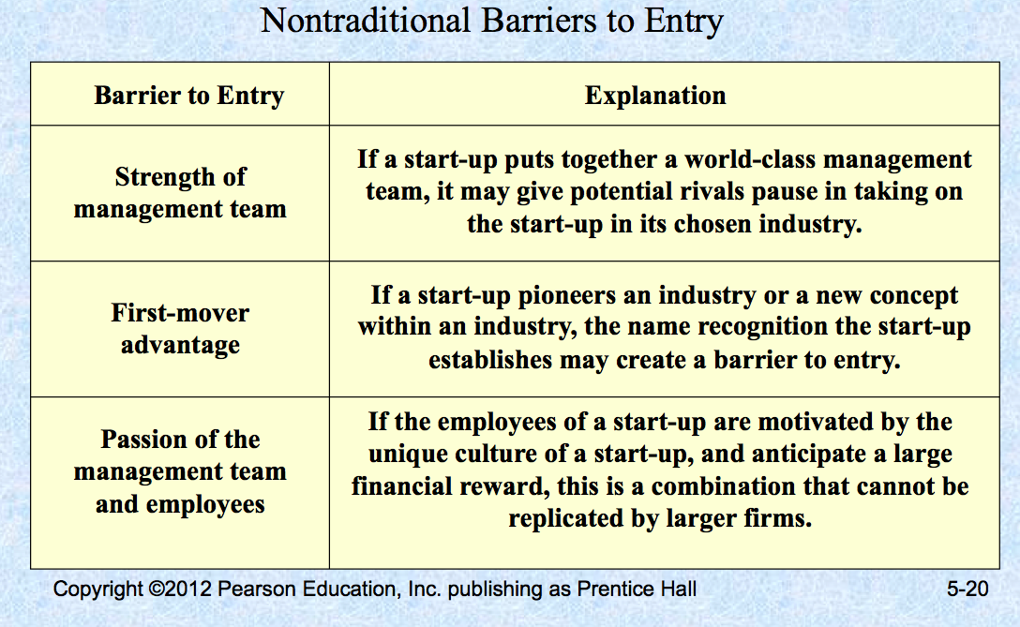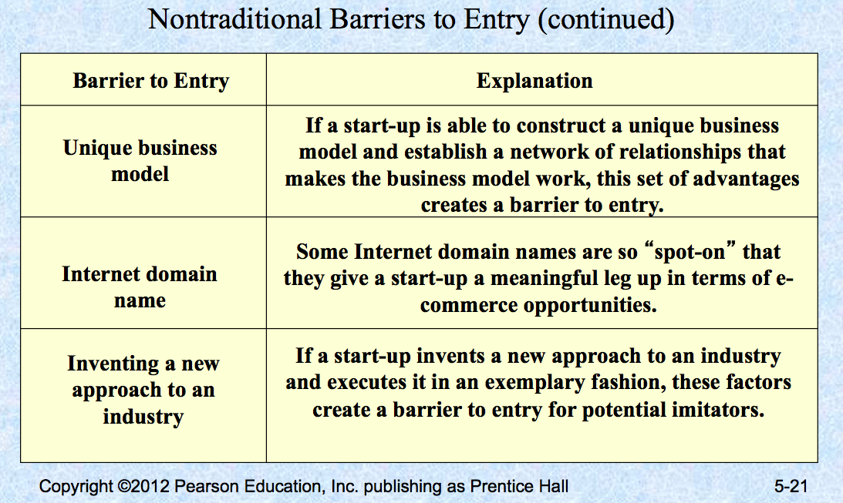

Rivalry Among Existing Firms: The major determinant of industry profitability is the level of competition among existing firms.
  - Some industries are fiercely competitive, to the point where prices are pushed below the level of costs, and industry-wide losses occur.
  - In other industries, competition is much less intense and price competition is subdued.
Factors :
Number and balance of competitors: The more competitors there are, the more likely it is that one or more will try to gain customers by cutting its price.

Degree of difference between products: The degree to which products differ from one product to another affects industry rivalry. (2. Paper product industry have to compete on price because there is no meaningful difference between one manufacturer’s product and another’s.)
Growth rate of an industry: The competition among firms in a slow-growth industry is stronger than among those in fast-growth industries. slow-growth like insurance must fight for market share. Thus the cut their prices and increase service quality. But in fast growing like pharmaceutical there’s enough customers to satisfy most firms production capacity.

Level of fixed costs: Firms that have high fixed costs must sell a higher volume of their product to reach the break-even point than firms with low fixed costs.

Bargaining Power of Suppliers
  - Suppliers can suppress the profitability of the industries to which they sell by raising prices or reducing the quality of the components they provide.
  - If a supplier reduces the quality of the components it supplies, the quality of the finished product will suffer, and the manufacturer will eventually have to lower its price.
If the suppliers are powerful relative to the firms in the industry to which they sell, industry profitability can suffer
Suppliers can raise their prices and lower the quality which will have an impact on the finished good and companies will have to sell cheaper.

Factors:
Supplier concentration: When there are only a few suppliers that supply a critical product to a large number of buyers, the supplier has an advantage.

Switching costs: Switching costs are the fixed costs that buyers encounter when switching or changing from one supplier to another. If switching costs are high, a buyer will be less likely to switch suppliers.

Attractiveness of substitutes: Supplier power is enhanced if there are no attractive substitutes for the product or services the supplier offers.

Threat of forward integration: The power of a supplier is enhanced if there is a credible possibility that the supplier might enter the buyer’s industry.

Bargaining Power of Buyers
  - Buyers can suppress the profitability of the industries from which they purchase by demanding price concessions or increases in quality.
  - For example, the automobile industry is dominated by a handful of large companies that buy products from thousands of suppliers in different industries. This allows the automakers to suppress the profitability of the industries from which they buy by demanding price reductions.

Buyer group concentration: If there are only a few large buyers, and they buy from a large number of suppliers, they can pressure the suppliers to lower costs and thus affect the profitability of the industries from which they buy.
Buyer’s costs: The greater the importance of an item is to a buyer, the more sensitive the buyer will be to the price it pays.
Degree of standardization of supplier’s products: The degree to which a supplier’s product differs from its competitors affects the buyer’s bargaining power.
Threat of backward integration: The power of buyers is enhanced if there is a credible threat that the buyer might enter the supplier’s industry.

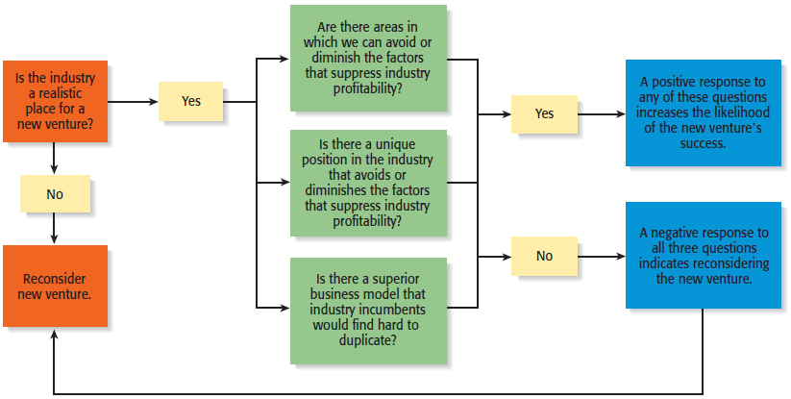

Industry types:

Emerging Industries
  - Industries in which standard operating procedures have yet to be developed.
    - Opportunity: First-mover advantage (firm that take the leadership of an emerging industry, first company to establish a significant position in a new market)
Fragmented Industries
  - Industries that are characterized by a large number of firms of approximately equal size.
    - Opportunity: Consolidation (consolidate the industry through a geographic roll up strategy (one firm starts acquiring similar firms that are located in different geographic areas.)
Mature Industries
  - Industries that are experiencing slow or no increase in demand.
    - Opportunities: Process innovation and after-sale service innovation
Declining Industries
  - Industries that are experiencing a reduction in demand.
    - Opportunities: Leadership, establishing a niche market, and pursuing a cost reduction strategy
Global Industries
  - Industries that are experiencing significant international sales.
    - Opportunities: Multidomestic and global strategies

Competitor Analysis: A detailed analysis of a firm’s competition.
  - It helps a firm understand the positions of its major competitors and the opportunities that are available to obtain competitive advantages.
  - A competitive analysis grid is a tool for organizing the information a firm collects about its competitors.
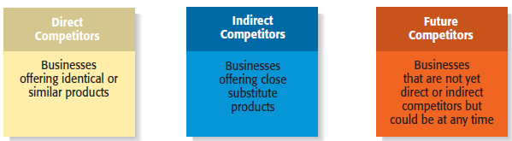

First step= determine how the competition is.
Ex 1800flowers = flower industry & gift industry = broader sets of competitor and opportunities to consider,
Direct: competitors are going for the same costumers as the new firms.
Indirect: target the same basic need
Future: always concerned about strong competitor going into their market.

Sources of Competitive Intelligence
- Attend conferences and trade shows.
- Purchase competitors’ products.
- Study competitors’ Web sites.
- Set up Google and Yahoo! e-mail alerts.
- Read industry-related books, magazines, and Web sites.
- Talk to customers about what motivated them to buy your
product as opposed to your competitor’s product.

Competitive Analysis Grid
  - A tool for organizing the information a firm collects about its competitors
  - A competitive analysis grid can help a firm see how it stacks up against its competitors, provide ideas for markets to pursue, and identify its primary sources of competitive advantage.



