ADM 2337 Human Resource Management
Midterm1-Saturday October 4th, 1-230, DMS 1140-1150

Chapter One
Human Resources come from:
HRM
Scientific Management (Production)

+

Human Relations Movement: Concern for people
(Adding value to a company)
Responsibility of HR departments:
-Analyzing + Designing Jobs
-Recruiting + Hiring
-Training and Development
-Managing Performance
-Total Rewards
-Employee and Labor relations
-HR Policies
-Legal Compliance

Example: Small businesses have their own supervisors carry out HR functions.
-They help with defining jobs, interviewing, training, coach and developing employees, appraisal, communicating policies and motivation.

HR divisions use strategic choices in the workplace:
-Work Flows: Efficiency vs. Innovation
-Compensation: Fixed vs. variable (plus other types like financial, intangible)
-Employee Rights: Discipline or Prevention. The policy is used as guideline. It can be described as progressive.
-Staffing: Internal vs. External

Types of Human Capabilities (adding value)
Training, Intelligence, Judgment
Relationships, Experience, Insight

HRM Organizational Performance
(Main Goal)
Quality, Profitability, Customer, Satisfaction

Behavior of Human Capabilities
Motivation, Effort.
Overall Framework

HR uses external and internal forces and issues to work labor force. It puts pressure on them 24/7. The concerns of the employees revolves a lot around “knowing the social contract.”

Challenges HR Employee Concerns
Changes in market and the economy | Planning | Job Security
Globalization | Recruitment | Health Care
Technology | Staffing | Age and gender work issues
Costs | Job Design | Gender
Leveraging employees | Appraisal | Rights
 |  | Privacy

Top Challenges

Responding Strategically (keeping future in mind) to changes in the Market
HR managers need to understand:
-Total Quality Management: Making sure quality is overall successful throughout issue/project.
-Re-Engineering/restructuring: Changing focus if strategies being used.
-Six Sigma: Doing things right the first time around
-Changing Management: Reactive/Proactive (finding new ways to doing thing)

Competing, Recruiting and Staffing Globally
-Globalization: 70-85% of Canadian economy today is affected by international competition.
-Impact of Globalization: “Anything, anytime, anywhere” markets, partnerships with foreign firms. Meaning lower trade and tariff barriers.

Setting and Achieving C.S.R and sustainability goals
-CSR affects people and communities
-Sustainability is closely related to CSR. It refers to a company’s ability to produce a good or service without damaging the environment or depleting sources

Advancing Human Resource Management with technology
-Collaborative software that allows workers to interface and share info with each other have changes how and where people do business.
-From touch labor to knowledge workers.

Containing costs while retaining top talent and Maximizing Productivity
Organizations take approaches to lower costs:
-Benefits, Downsizing, Furloughing employees, Outsourcing, Offshoring, Employee leasing
Responding to the demographics and diversity challenges of the workforce
Demographic changes: diverse workers, aging, more educated workers
Managing Diversity: Being aware of characteristics common to emmployees, while also managing employees as individuals

Adapting to educational and cultural shifts affecting the workplace
-Cultural and societal changes affecting the workforce.
-Employee Rights
-Privacy Concerns of the Employees
-Changing Attitudes towards Work
-Balancing work and family

Partnership of HR departments and line managers
Tasks of HR managers: advice and control, service, policy formulation, advocacy

Competencies of HR Managers: Business mastery, HR mastery, Change mastery, Personal credibility.

Chapter 2 Strategy and Human Resources Planning

Strategic Planning: It is a proactive process that involves procedure for making decisions about the organization’s long-term goals and strategies.

Human Resource Planning (HRP): Process of anticipation and providing for the movement of people into, within and out of an organization.

Strategy can be described as targeting future goals using the things you have now. There is a linkage between strategic planning and H.R.P

Overview of Human Resource Planning Process

Forecasts of Labor demanded Forecasts of Labor Supply
Option | Speed of Result | Suffering Caused
Downsizing | Fast | High
Pay Reductions | Fast | High
Demotions | Fast | High
Transfers | Fast | High
Work-sharing | Fast | High
Hiring Freeze | Slow | Low
Natural Attn | Slow | Low
Early Retirement | Slow | Low
Re-Training | Slow | Low

Forecast of Labor Shortage/Surplus

Goal Setting and S.P

Program Implementation and evaluation

HR Strategies-Strategies for addressing shortage/surplus

Reducing Surplus (for Economic Reasons)
Ex: University in 2002-early retirements

Avoiding a Shortage
Option | Speed Of Result | Suffering Caused
Overtime | Fast | High
Temporary employment | Fast | High
Outsourcing | Fast | High
Retrained Transfers | Low | High
Turnover Reductions | Low | Moderate
External Hires | Low | Low
Tech Innovation | Low | Low
How to Implement an HR strategy

- Mission, Vision and Values
-Mission: Basic purpose for an organization and the scope of an organization.
-Strategic Vision: Statement about where the company is going and what it can become in the future; clarifies the long term direction of the company and it’s strategic intent
-Core Values: Strong and enduring beliefs and principles that the company uses as a foundation for its decisions.

2. Environmental Analysis
Porter’s Five Forces Models
NEW ENTRANTS

SUPPLIERS RIVAL FIRMS CUSTOMERS

SUBSITUTES

3. Internal Analysis- Culture, Composition and Capabilities
Forecasting is a critical element of planning and strategizing.
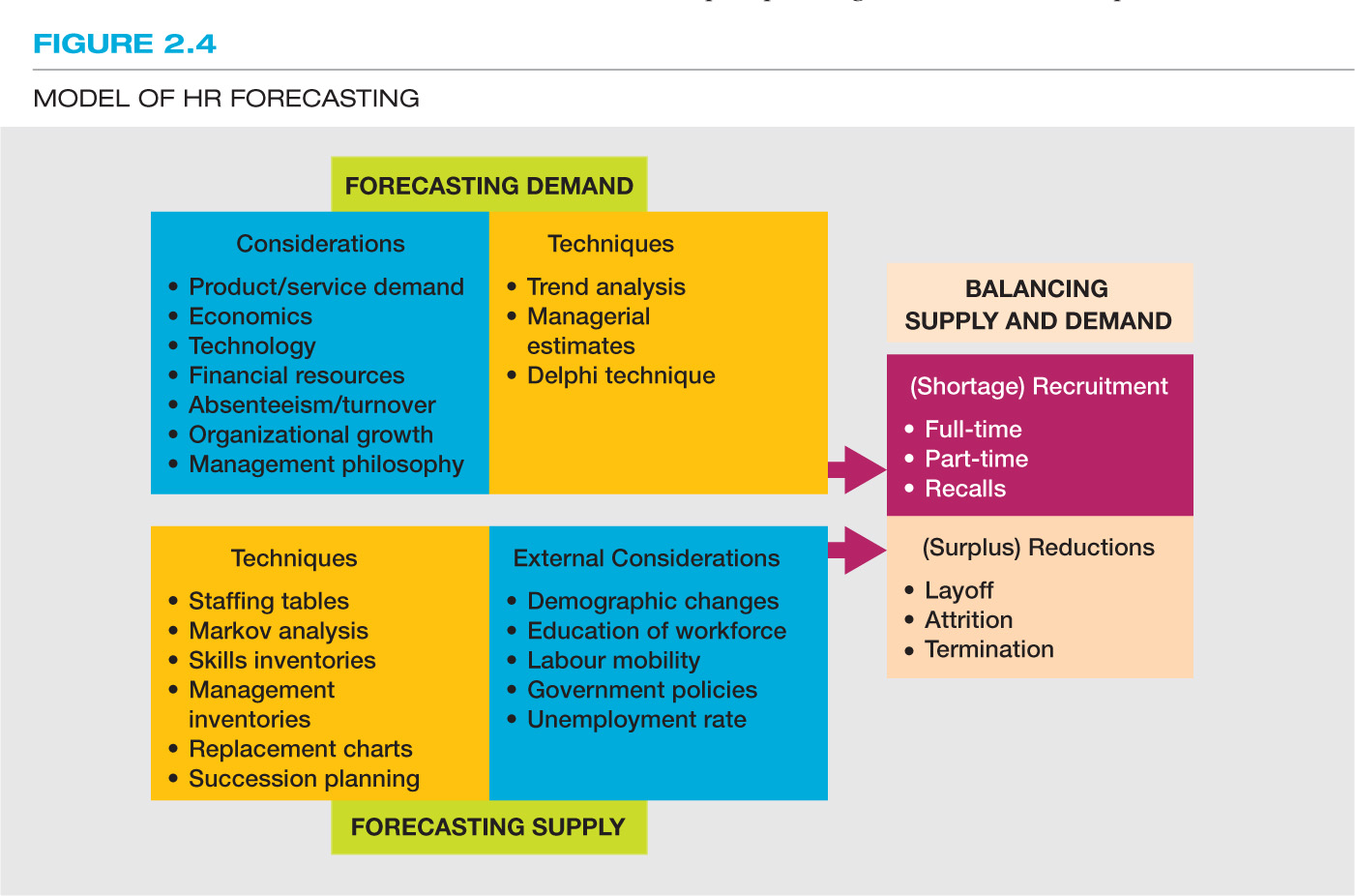

Forecasting a firm’s demand for employees:
QUANTITATIVE METHODS FORECASTING DEMANDSQUALITITATIVE METHODS

Quantitative Approach: Trend Analysis-Forecasting labor demand is based on an organizational index

Internal Labor Supply:
Skill Inventories: Files of personnel education, experience, interests, skills etc that allows managers to quickly match job openings with employee backgrounds to quickly match job openings with.
Replacement Charts: Listing of current jobholders and people who are potential replacements if an opening occurs.
Succession Planning: Process of identifying, developing and tracking key individuals for executive position.
Markov Analysis: Flow and probability of employee working internally through using historical benchmarks
Staffing Tables: Info for employees

4. Formulating Strategies

Growth and Diversification Mergers and Acquisition

CORPORATE STRATEGY

Strategic Alliances and Joint Ventures

Business Strategy: Value of Creation. What the firm adds to a product or service by virtue of making it, the amount of benefits provided by the product or service once the costs of making it are subtracted. (Value=benefits-costs). Strategies that are known around the business world, especially in HR departments, are:

-Defender Strategy: Low cost strategy
-Innovation/Differentiation Strategy
-Analyzer Strategy: abit of both

5. Strategy Implementation
-Taking Action: Reconciling Supply + Demand
-Balancing demand and supply consideration
-Forecasting business activities (trends)
-Locating Applicants
-Organizational downsizing, outsourcing and offshoring-reducing headcount.
-Making Layoff decisions
-Seniority vs. Performance
-Collective Agreements

6.Evaluation and Assesment
Issues:
-Benchmarking: the process of computing the organization;s processes and practices to those of other companies.
-Human Capital Metrics: Assesses aspects of the workforce
-HR Metrics: Assesses performance of the HR function itself.
Measuring A Firm’s Strategic Alignment.
Balancing Scorecard (BSC): A measurement framework that helps manager’s translate strategic goals into operational objectives. It evolves mainly around Finances, Customers, Processes and Learning.

Ensuring Strategic Flexibility for the Future
-Organizational capabilities: Capacity of the organization to act and change in pursuit of sustainable competitive advantage.
-Coordinator Flexibility: Ability to rapidly reallocate resources to a new or changing needs.
-Resource Flexibility: HR who do a lot of different things in many ways.

Chapter 3- Equity and Diversity in Human Resource Management

Legal Framework for HRM
Federally Regulated (10%):
-Federal Agencies, Canada Post, Banks, TV&Radio stations

Provincially Regulated (90%):
-All other businesses

Legislation in Canada
-Charter of Rights and Freedoms
-The Canadian Human Rights Act
-Employment Standards Legislation
-Employment Act Equity
-Pay Equity Act
-Official Languages Act
-Personal Information Protection and Electronic Documents Act (PIPEDA)

Prohibited Grounds of Discrimination by Canadian Human Rights

Pardoned Convictions Race/Color -National or Ethnic origin
C.H.R.A

Disability Religion

Morital Status Sex/Sexual Orientation Age

Equality in Employment Opportunity
Discrimination: Unfair Treatment due to personal attributes.
Direct Discrimination: Discriminating on purpose, knowing that it is discrimination
Indirect Discrimination: Discriminated someone without knowing. People’s neglicence and poor analysis can lead to this. HR policies can accidentally discriminate. “Point of Undue Hardship”

Enforcement of Provincial Human Rights Law
1.Files a written complaint
2.Investigation and submission of report
3.IF complaint is sustained, settlement would be reached.
4.If there is no agreement, then a tribunal would ensue.

Employer’s Role
The employer’s role is key in the workplace. Their role is a bonafide occupational requirement/qualification. They have a duty to accommodate, as well as a duty to prevent harassment.
Harassment: Physical assault, physical contact, verbal abuse/threats, unwelcome invitations, remarks, jokes, leering-pornographic photos, practical jokes (condescension).
-The role also revolves around valuing diversity.

Remedies for Human Rights Violation
-Compensation for: Cost wages, general damages and expenses, pain and humiliation.
-Restoration of rights denied
-Written letter of apology
-Mandatory Training Sessions
-Required employment equity program

Employment Equity Program Implementation Steps
1.Obtaining Senior Management commitment and support
2.Data Collection and Analysis
3.Employment Systems Review
4.Plan Development
5. Implementation
6.Monotoring, Evaluation, Revising

Employee Rights
The right to Know
About known or foreseeable hazards in the workplace

The right to Participate
In identifying + resolving job-related safety and health problems.

The right to Refuse
Dangerous Work

Occupational Health and Safety
-Internal Responsibility System
-Workplace Health and Safety committees
-Bill C-45 (westray Bill)

Diversity Management
It’s a broader/more inclusive then employment equity; it a set of activities designed to:
-Integrate all employees in multicultural workforce
-Use diversity to enhance organization’s effectiveness.

Business reasons for Diversity Management:
-Better utilization of talent
-Increased Marketplace understanding
-Enhanced creativity
-Increased quality of team problem solving
-Greater understanding in Leadership positions

Characteristics of effective Diversity Programs
Celebrate Diversity
Diversity Training
Top Management commitment
Support Groups/Mentoring Programs
Diversity Audits
-Management Responsibility and Accountability
-Inclusive and representative communications

Chapter 4-Analyzing Work & Designing Jobs

Work Flow Analysis

Raw Inputs
Info, Materials, data needed

Equipment
Special equipment, facilities and system are needed Activity Output

Human Resources
Competencies, Knowledge, skills, abilities
and other characteristics are needed

Activity: What tasks are required in the production of the output

Output: What product, info, or service is provided? How is output measured?

Job Analysis
Process of getting detailed information about jobs. Knowledge is needed for:
-Staffing, training, performance appraisal, other HR functions
You can gather job information from interviews, Questionnaires, Observations, Diaries

Sources of Job Information
Incumbents: People who currently hold that position in the organization, and they also provide accurate estimates of time.
Observers: Supervisors should review the information provided by incumbents- they identify importance of job duties.
Government: National Occupational Classification (NOC) provides standardized information about jobs.

TDR: Task, duties, responsibilities
Workflow: Overall
Job Analysis: Specific Jobs

Job Analysis Methods
Position Analysis Questionnaire: One of the broadest and most researched instruments for analyzing jobs. It draws a lot on skills like tech, social aspects. It evaluates:
-Information input and mental Processes
-Work output
-Relationship with other people
-Job context and other characteristics

Task Analysis Inventory
Focuses on the tasks performed in a particular job.

Critical Incident method (observational method)
Involves the identification of job tasks that are essential for job success. It documents a specific employee and observes them. It is one of the oldest methods out there.

Functional Job Analysis
Responsibility for people data, things. 7 elements to this: people, data, work process, linguistics and mathematical. This method identifies performance standards and training requirements for a job.

Occupational Analysis inventory (OAI)
Contains 617 “work elements”

Common Metrics Questionnaire
Targetted toward both exempt and non-exempt jobs. Competency Based Approach: a job can be meaningful degined in a term of tasks, dutues, processes and skills necessary for job success.

Steps in Job Analysis
- Identify what the info will be used for
- Review relevant background information
- Select representative positions/jobs to be analyzed
- Analyze Jobs
- Review Analysis with incumbent/supervisor
- Develop job description/specification

Uses of Job Analysis Info
Analysis
Description Specifications

-HR planning -Recruitment/Selection -Wage/Salary -Performance Appraisal
-Labor relation -Training, Development and career management -Job Design

Trends in Job Analysis: Flexibility, Adaptability, Competency-based approaches, De-jobbing, Team-based/project-based structures.

Approaches to Job Design

Design for efficiency

Design for Mental Capacity: Design for Motivation:
Job
-Filtering info -Job enlargement
-Clear displays/instruction -Job enrichment
-Memory aids -Teamwork/flexibility
Design for safety and health
Job Design: An outgrowth of job analysis that improves jobs through technological and human considerations to enhance organizational efficiency and employee job satisfaction.

Job Descriptions vs Specifications
Job description: List of tasks, duties and responsibility (TDR’s) that a particular job entails. Focuses on activities

Job specifications: List of the competencies that an individual must have to perform a particular job. It looks at the required qualities of the person who will perform the work.

Elements of a Job Description
Identification Information: Job title, location, and source of job analysis information
Job Summary: Short statement summarizing the responsibilities of the positions in the organizational structure.
Job Duties and Responsibilities: Job’s top 3-5 responsibilities in a greater detail
Specifications: Knowledge and skills required to carry out the job’s duties and responsibilities.
Minimum Qualifications: Basic standards to be met in order to be successful in the position, such as education, certification and years of experience.

Writing Job Specifications: Human Traits, Experience, Skill, Effort, and Working Conditions.

Problems with Job Descriptions
1.If they are poorly written, using vague rather than specific terms, they provide little guidance to the jobholder
2.They are sometimes not updated as job duties or specifications change.
3. They may violate the law by containing specifications not related to job success.
4.They can limit the scope of activities of the job holder, reducing organizational flexibility.

Behavioral Concerns- An outgrowth of job analysis that improves jobs through technological and human considerations to enhance organization efficiency and employee job satisfaction.

Job Characteristics Model-Jobs that motivates employees

Job Characteristics Psychological States
-Skill variety -Meaningfulness of work performed
-Task identity -Responsibility for work outcomes
-Task significance -Knowledge of the results of the work performed
-Autonomy
-Feed Back

JOB OUTCOMES: Improved work performance, Increased internal motivation, lower Absenteeism and turnover
Designing Work For Groups/Teams
Employee Involvement Groups (ET’s)
-Groups of employees who meet to resolve problems or offer suggestions for organizational improvement.
-Also known as quality circles (GC’s)
-Success with ET’s requires: comprehensive training group members, Recognition of the group’s contributions, continuing input and encouragement by management, and the use of a participate/democratic leadership style.

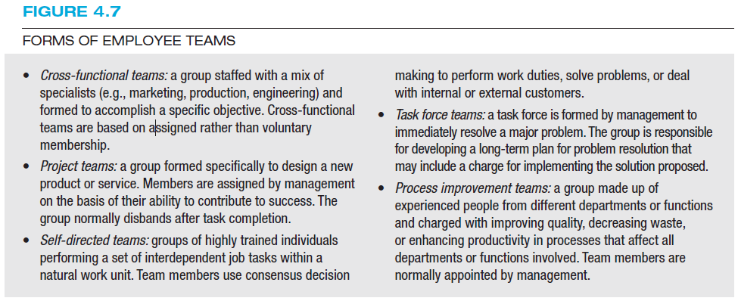

Characteristics of a Successful Team
-A commitment to shared goals and objectives
-Motivated and energetic team members
-Open and honest communication
-Shared Leadership
-Clear role assignments
-A climate of cooperation, collaboration, trust, and accountability
-The recognition of conflict and it’s positive resolution

Flexible work schedules consists of:
1.Compressed workweek
2.Flextime
3. Job Sharing
4. Telecommuting
-

Chapter 5-Branding the Talent Pool: Recruitment and Careers Employee Selection
Recruiting Human Resources

Identify Job openings Specify Job requirement Select Methods of recruitment Generate pool of qualified applicants

Human Resource Policies
-Internal vs. External recruiting: “Promote from within” policies makes an organization more attractive
-Lead-the-market pay strategies: Meeting or exceeding the market rate of pay to compete for applicants
-Recruitment Branding & Image AdvertisingUsing Marketing techniques to become an “employer of choice”, generating a favorable image.

Recruitment Sources
-Internal recruiting (current employees)
-Direct Applicants (walk-ins, write-ins)
-Employee referals
-Former employees
-HRSDC (Job Bank)
-Social Media
-Advertisements/job posting
-Employment Agencies
-Executive search firms
-Educational job fairs
-Customers

Which Recruitment method to use
Decisions should really be base on:
-How long employees recruited from different sources stay with the organization
-Recruits who have the most knowledge about the organization before being hired will stay the longest
-Also something to look at is the cost-effectiveness of the source. Meaning doe t he quality of the candidate justify it’s cost?

Who Should Do the Recruiting?
HR recruiters or generalists (large firms) VS Managers/Supervisors (Smaller firms)
-Works Teams
-Recruiting Process Outsourcing (RPO)

Global Labor Markets
Why recruit Globally? To develop better products via global workforce and to attract the best talent wherever it may be.

International Recruiting Issues:
-Local, national, international laws
-Different Labor costs
-Different pre-employment and compensation practices
-Cultural Difference
-Security
-Work Visas

Recruitment Traits and Behaviors
Characteristics of a Recruiter:
-Warm and informative, provides the right info, Realistic Job Previews

Enhancing Recruiter’s impact:
Training (Feedback, avoid offensive behavior)
Recruit in teams, i.e. include job experts

