Lecture 1 – Introduction
What is CAM*?
- "a group of diverse medical, and health care systems, practices and products that are not presently considered to be part of conventional medicine"

  - *National Centre for Complementary & Alternative Medicine (NCCAM)
  - Western perspective of naturally sourced medicine

National Center for Complementary and Alternative Medicine (NCCAM), NIH
4 Domains | Description | Examples
Mind-body interventions | Mind's capacity to affect body functions | Support group Meditation, Prayer, ARt, Music, Dance
Biologically-based therapies | Substances from nature, herbs, food, vitamins | Herbal products, supplements
Manipulative and body-based methods | Manipulation and movement of part of body | Chiropractic, massage
Energy Therapies | Biofield: affect body's Energy  EM therapy | Qi gong, Reiki, Therapeutic touch Magnet therapy

Examples of CAM Systems:
- Naturopathic Medicine - healing as a whole instead of symptoms, basically a doctor without using drugs
- Traditional Chinese Medicine
- Ayurvedic Medicine - India, uses herbal topically
- Kampo Medicine - Japanese medicine
- Traditional Native Healing - first nation healers; you must be born with and be selected
CAM Terminology
- Complementary medicine - Used together with conventional medicine
- Alternative Medicine - Used in place of conventional medicine
- Integrative medicine - combines treatments from conventional medicine and CAM for which there is evidence of safety and effectiveness
- Future - Comprehensive medicine. Patient-centered, evidence-based, shared treatment
"Unique" Characteristics of CAM:
- Self-healing mechanisms (enhance your own ability to get rid of a bug, --> improving your immune system)

  - innate to human body
  - therapy stimulate natural healing
- Holistic - physical, emotional, mental, psychosocial, diet, lifestyle - considered in treatment
- Achieving well-being v.s. curing a disease
- Treat causes rather than symptoms of health problems
- Validate subjective experience v.s. objective measure
- Efficacy based on personal anecdotes (although clinical study data are available in some areas)

Popularity of CAM
- Canadians spent > 3.8 billion on CAM
- >50% of Canadians use CAM

  - Higher in specific groups
- HIV/AIDs is 88%
- Cancer Patients
- 17% of Canadian use Herbal therapy
Most Common Therapies
1 | Natural Products | 18%
2 | Deep Breathing | 13%
3 | Meditation | 9%
4 | Chiropractic | 9%
5 | Massage | 8%
6 | Yoga | 6%
7 | Diet based therapies | 4%
8 | Progressive relaxation | 3%
9 | Guided imagery | 2%
10 | Homeopathic therapies  -->dilutions from a disease of a healthy person | 2%

Economics Impact
- 2007 survey in US: 38% of adults used CAM
- 83 millions spent $ out of pocket $33.9 billion
- $11.9 billion on practitioner visits and $14.8 billion on non-vitamin, non-metals natural products
- CAM costs: 1.5% totally health care cost
- Australians spend > 3.5 billion annually n CAM for management of chronic disease and improve/health and wellness

  - total: $100 billion
- 2009 National instutute of CAM of Australia commissioned a series of cost effectiveness studies of selected CAM interventions with established efficacy and safety
- Yes - acupuncture for chronic low back pain as a complement to standard care
- Not - as a replacement
- Yes - St. John's wort for mild to moderate depression (lower unit cost, save $50 million/year)
- Yes - Fish oil as adjunctive treatment of coronary heart disease

  - no in reducing NSAID use in RA
- Yes - Phytodolor, a herbal medicine, in managing OA Osteoarthritis (pain, inflammation) compared with NSAID (could save 178$ million/year)
Characteristics of user:
- Higher in women
- Aged 50 or older
- Higher education and income
- Higher in the West, lower in Quebec/Atlantic Canada
- 80% to prevent disease and maintain well-being
- Use conventional treatment concurrently and do not inform doctor

Why the increase in popularity?
- Emotional comfort
- Placebo effect
- Cyclic nature of chronic diseases
- Prevalence of chronic diseases
- Access to health information
- Sense of entitlement to quality of life
- Question scientific breakthrough on disease treatment
- Interest in spiritualism
- Adverse effects and cost of conventional treatment
CAM in the context of Communication between physicians and patients:
- A substantial proportion of patients do not tell their physicians that they use CAM, this is because

  - Their physician does not ask about CAM use
  - They believe their physician:

    - will disapprove and that this will have an impact on their care
    - will not know anything about CAM
    - has no time to listen and to understand their CAM use
    - They may have limited knowledge about

      - safety, efficacy and intended purposes of CAM therapies, about regulation and licensing of CAM practices
      - about provincial college policies and guidelines regarding referral to CAM practitioners
  - This is because

    - many physicians have not received training about CAM
    - many physicians do no know where to look for information about CAM

If physicians do not know whether a patient is using CAM, they may miss potential risks for patients, including:
- Mis-attribution of benefits/harms to conventional treatment
- Potential for interactions
- Use of harmful treatments
- CAM use may indicate dissatisfaction with care that can be resolved
Take home message:
- CAM: 4 domains
- Commonly used therapy
- Characteristics of CAM practices and users
- Reasons for popularity
- Impact on health care and cost
- Challenges of integration into main stream medicine

Lecture 2 – Introduction to TCM
Herbal medicine & TCM

1. Definitions of herbal medicine
2. Historical and cultural perspective
3. Current usage in N. America
4. Traditional Chinese Medicines
- Basic theories in TCM
- Property of Chinese Herbs
- Medicinal formula
- Comparison with pharmaceuticals
- Approaches in product development
Natural Sourced Medicines

Derived from:
Botanical sources (herbal medicines)
- Herbs
  - Herbaceous plants,
  - Bark, roots, leaves, seeds, flowers, fruits of trees, shrubs, woody vines.
- Animal sources: bone, cartilage, gall bladder; insects, aquatic organism.
- Minerals

Historical and Cultural perspectives of Herbal Medicine
North America:
- Use of herbal medicines declined substantially after WWI. Emergence in popularity in the 1990s
Europe:
- Remained a prominent part of health care in Europe.
- Physicians in Germany prescribe both conventional drugs and herbal medicines

China: Traditional Chinese Medicine has long history of use
- Based on herbal medicines, acupuncture, and therapeutic massage
- Predominated by Western medicine until recent re-modernization of TCM
- Practice of integrative medicine

Herbal Medicines
- Used by 75% of the world population
- As traditional medicines
- Used for health promotion and disease prevention (as self-care in some cases)
  - Balance and harmonize body functions
  - Enhance the body’s own healing potentials, cope with stress
    - e.g. stimulate immune function
- Conventional medicine emphasizes treatment of diseases
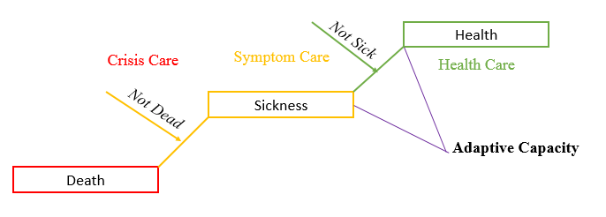

Usage in North America
- In Canada, > 50% of Canadians consume Natural Health Products regularly
- > $ 4.3 billion sale
- 40,000-50,000 products:
  - (50% vitamins; 30% herbs)

Top Ten Natural Products in 2007
- Chondrotherapy: Glucosamine with or without Chondroitin Sulfate
- Osteroarthritis
- Calcium with or without Magnesium and Vitamin D
- Osteoporosis Prevention
- Echinacea
- Colds
- St. John’s Wort
- Depression
- Vitamin E (with or without Co-Enzyme Q10)
- Fat soluble nutrient
- Black Cohosh, other phytoestrogens
- Menopausal symptoms
- Essential Fatty Acids: Omega 3-6-9
- Vitamin C: Ascorbic acid
- Garlic
- Saw Palmetto
- Benign prostate hyperplasy

Most Common Natural Products
- Fish Oil (Omeaa 3 fatty acids)
- Glucosamine/Chonroitin
- Echinacea
- Flaxseed oil
- Ginseng
- Black cohosh
- Ginkgo
- Milk Thistle
- Garlic Supplements
- Conezyme Q-10
- St John’s wort
Reasons for Increase in Popularity
- Access to health information; Sense of self-control of one’s health
- Prevention of diseases and maintenance of good health
- Consumers have lost confidence in the “medical establishment”
  - especially chronic health conditions
  - Frustrated with side effects of drugs, lack of effectiveness, expensive
- Regarded as being safe because they are “natural” – (myth)
- Convenience, do not require a prescription; cheaper

Different types of Herbal Products
- Supervised by health care practitioners.
- As self-care products, self-directed use (NHPs regulations)

Availability in The Market
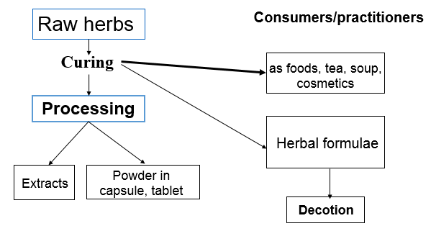

Traditional Medicines of the World
Traditional Chinese Medicine
Ayurvedic Medicine
Kampo Medicine
Traditional Native Healing
Others

Traditional Chinese Medicine
- 5000 years of history
- Distinctive & comprehensive medical system
- Holistic
- Variety of treatment modalities
- Herbology
- Massage
- Acupuncture
- Exercise: Qi Gong, Tai Chi
- Diet (herbs as foods...life style)
A Centrist Model for Chinese Medicine

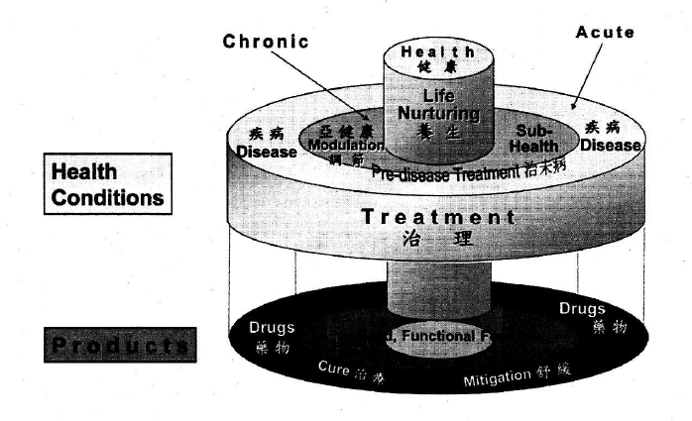
In the center core is health, extending out is illness
Capacity to cope with stress.
Use of nutritive foods, functional (health) foods, and medicinal herbs

Modernization of Traditional Chinese Medicines

- Ying Yang Theory
- The world results from the mutual action of two complementary but opposite material forces. Originated from observation of the cycle of day and night
- Night/Day, Shade/Light, Cold/Hot, Descending/Rising, Female/Male, Liver/Gall Bladder, Kidneys/Bladder
Yin | Yang
Sleepiness, low energy | Restlessness, hyper
Pale face/tongue | Red face/tongue
Slow Pulse | Rapid pulse
Weak voice | Loud voice
Loose stool | Constipation
- Signs and Symptoms with Yin and Yang medicine
- Consequences of disruption of yin-yang relationship
- 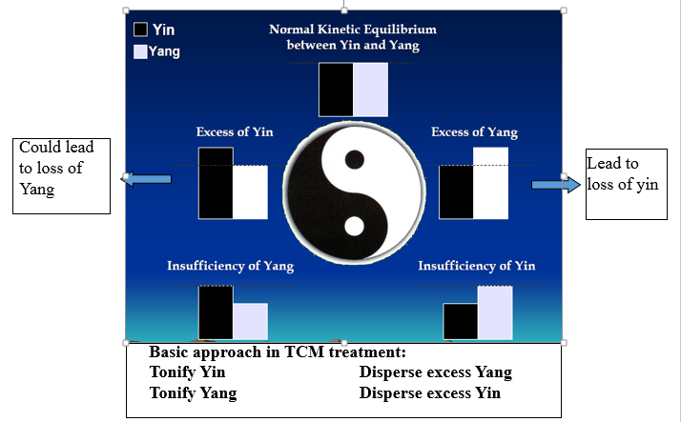
- In practice, strategies may be combined, for example, disperse excess yin and tonify yang
- Opposite but complementary
- Dynamic Changes (not absolute)

- 5 Elements Theory
- Five elements essential to life
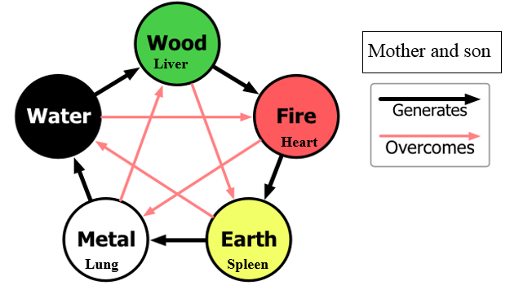
Water | Kidney
Metal | Lung
Earth | Spleen
Fire | Heart
Wood | Liver

- Etiology
  - External pathogens:
    - wind, cold, heat, dampness, dryness, fire
  - Internal causes: seven emotions
    - Joy, anger, melancholy, anxiety, grief, fear, terror
  - Others:
    - improper diet, over strain (mental, physical, sexual), trauma

TCM approach to Patients
- Health differentiation
  - Identify the patient’s body constitution
- Disease Differentiation
  - Identify the ailment
- Diagnostic Differentiation
  - Identify the phases of the ailment

Differentiations: Collection and assessment of sensory detectable syndromes with 4 diagnoses
(Observation, listening, smelling, query and palpation)

Tongue Diagnosis: surface of the tongue corresponded to the viscera
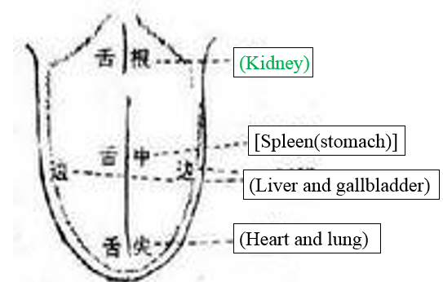

Pulse Diagnosis

Pulse type | Left Hand | Right Hand
Cun | The Heart | The Lung and Thorax
Guan | The Liver and Gallbladder | The Spleen and Stomach
Chi | The Kidney and Lower Abdomen | The Kidney and Lower Abdomen
Treatment Principles (Primary tenet)

Look for the primary causation
Restore balance (yin and yang)
- Tonify deficiency
- Reduce excess
- Warm cold
- Clear heat

Regulate qi
- Replenish deficient qi
- Move stagnate qi
- Subdue rebellious qi
- Raise sinking qi

Regulate zang fu organ function

Chinese Herbal Medicines and Formulas/Prescription
- Includes herbs, minerals, and animal parts
- They have their own
- Natural property: Cold, Hot, Warm, and Cool
- Flavour: Pungent, Sweet, Bitter, Sour, Salty
- Energy tendency: Rising, Lowering, Floating, Sinking

Functional Aspects
Examples
- Hot or warm herbs : to tonify “yang” and strengthen “fire”, and dispel cold and warm the body
  - (eg. Dried ginger and Cinnamon bark)
- Cold or cool herbs: -to clear heat, purge fire and reduce toxin.
  - (eg. Rhubarb and peppermint)
- Pungent: -Move Qi and blood in the body to treat Qi and blood stagnation
  - (eg. immature tangeraine peel)
- Sweet: Tonify Qi (eg. ginseng) and blood (eg Chinese angelica root)
- Sour: Astringent agent, holding fluid and Qi of the body to treat diarrhea, seminal emission

TCM Formulas
- Complex mixture recipes of inter-related substances (4 up to 20’s herbs)
- Every medicinal substance has its strengths and short comings
- Components of a formula are balanced to accentuate the strength and reduce the side effects
- Composition and the four ranks of ingredients

1. Principal herb:
- The most important ingredient;
- Treats the causes of the main symptoms of a disease
2. Associate herb:
- Strengthens the effect of the principal herb,
- Treats accompanying symptoms
3. Assistant herb:
- Assists the principal and associate herbs, strengthen their effects
- Treats less important symptoms
- Reduces toxicity of principal and associate herbs
- Suppress vomiting

4. Guiding herb:
- Focuses the action of the formula on certain channel or area of the body
- Harmonizes and integrates the action of the other ingredients

Example of a classical Formula (Ma huang tang) for asthma
- Ephedra: (principal herb)
Pungent in flavor and warm in nature;
inducing diaphoresis, expelling cold and facilitating the flow of lung Qi.
- Cinnamon twig: (Associate herb)
Pungent in flavor, sweet in taste and warm in nature;
-expel cold and enhance ephedra’s action to induce diaphoresis;
-warms channels to facilitate the flow of yang-Qi to reduce headache and body ache.
- Bitter apricot kernel: (assistant herb)
Bitter taste and warm nature,
- lowers the adverse flow of the lung-Qi and strengthen the asthma-reducing effect of ephedra
- Liquorice root: (guiding herb)
Sweet taste and mild nature;
-coordinates the effects of the other ingredients; reduces the dry and drastic actions of ephedra and cinnamon twig

Characteristics of Chinese medicines: challenges and advantages as compared to pharmaceuticals

Multiple components in a herb | Single component
Multiple herbs in a formula | A few cocktails
Poorly defined | Highly purified
Product quality questionable | Consistent
Multiple targets | Highly specific–silver bullet
Synergistic interactions | None
Low toxicity  - Toxic adulterated products  - Toxic components used for acute treatment | Lower margin of safety  - account for hospital admission, fatality

Korean Traditional Medicine
- Constitutional typing: outward appearances: personality and temperament

Type | Taeyang-in Marcro-yang type | Taeum-in Macro-yin Type | Soyang-in Micro-yang type | Soum-in Micro-yin type
 | 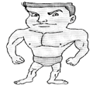 | 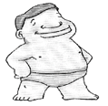 | 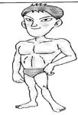 | 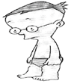
Type of Illness | Hepatic | Cardio  respiratory | Renal | Digestive
Function of Internal Organs | Liver: Weak | Liver: Strong | Kidney: Weak | Kidney: Strong
Function of Internal Organs | Lung: Strong | Lung: Weak | Spleen: Strong | Spleen: Weak

Differences in:

  - Recommendation for life styles
  - Disease risk is different
  - Food intolerance is different
To Know:
- Source of natural medicines and their usage
- History of use
- Health and wellness model and role of natural products
- List of top 10 selling products
- TCM
  - Basic principles in health and wellness
  - Diagnosis and treatment
  - Herbal medicines

Lecture 3 – Worldwide traditional medicine
Traditional medicine use Worldwide
- In Europe and North America over 50% of the population have used complementary or alternative medicine at least once (70% in Canada)
- In asia, herbal medicine account for 30%-50% of total medicine consumption
- a 60$ billion market in herbal medicines exists worldwide
- WHO estimates that traditional medicine provides 80% of health care products in the developing world
- WHO Traditional Medicine Strategy 2014-2023 aims to integrate traditional medicine into national health care systems
Traditional knowledge in urbanized organized societies: Ancient medical Sciences
- The medicinal knowledge of major civilizations is: codified and recorded medicinal knowledge (written traditions), systemic knowledge of the natural world, influenced by major world religions

  - Traditional chinese medicine (TCM)
  - Traditional Korean medicine
  - Traditional Mongolian medicine
  - Traditional Tibeatan medicine
  - Kampo medicine in Japan
  - Ayurvedic and Siddha medicine of India, Nepal, and Sri Lanka
  - Arabic medicinal knowledge (Unani among others)
  - European traditional herbal medicine
Ayurvedic Medicine
- 6000 year old tradition native to the Indian subcontinent, wide practiced throughout India, Nepal, Sri Lanka, and some parts of Pakistan
- Hindu traditional medicine of the Vedic tradition, in part based on classic Sanskirt texts

  - Not all knowledge is based on text, there is also oral passing of knowledge
  - however, the fundamental basis is based off these Sanskirt text

    - not all knowledge is based on text, there is oral
    - Fundamental basic is based on these Sanskirt texts
- Health Canada NNHPD has monographs for some Ayurvedic herbs, Recognized by the WHO. Recognized by the The National Health Institutes. Center for Complementary and Alternative Medicine (NIH/NCCAM) in the USA

  - There is evidence to back up this type of medicine
  - Note: A complied data set that tells you about specific herb - type of information that you'd read about any drug. Complied and recognized by government
Ayurveda (Science of Life)
- The science of eight components/branches
- The balance of the Doshas, three elemtnal substances that each human is made of (Vatha, Pitha, and Kaptha)

  - Each person is a individual because f the ratio they have of these 3
- 20 characteristics/qualities (gunas), arranged in pair of antonyms, are inherent to all substances

  - heavy/light
  - cold/hot
  - unctuous/dry
  - dull/sharp
  - stable/mobile
  - soft/hard
  - non-slimy/slimy
  - smooth/coarse
  - minute/gross
  - viscous/liquid
- Heavy will be balanced by light (paired in antonyms)
- Can define all natural or unnatural substances
- Over 5000 signs and symptoms described in Madhav Nidan (~800AD)

The science of eight components
- Internal Medicine (Kaya-Chikitsa), which focuses on doshic imbalance, metabolic function, and digestion

  - Balance of the 3 elemental substances)
- Surgery (Shalya Chikitsa)
- Ear, Eye, Nose, and throat (Salakya Chikitsa)
- Obstetrics/Gynecology (Prasuti and Stri-Rog)
- Pediatrics (Bala Chikitsa/Kaumarbhritya)
- Psychology and Psychiatry (Bhuta-vidya or Graha-Chikitsa), which includes spirituality
- Toxicology (Agadha-tantra) which focuses on poisons ranging from insect bites to heavy metals and plants
- Rejuvenation/Geriatrics (Rasayana) and Vilification/Sexology (Vajikaran)

  - Healthy aging
The 3 Doshas

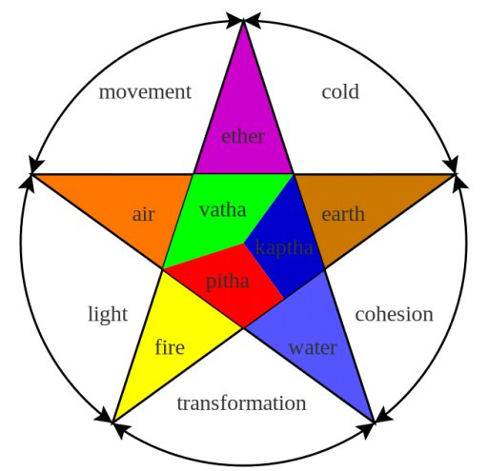

Ayurvedic Diagnosis

- 8 ways of diagnosis:

  - Nadi (pulse) - complicated, many types of pulse
  - Mootra (Urine)
  - Mala (stool)
  - Jihva (tongue)
  - Shabda (speech)
  - Sparsha (touch)
  - Druk (vision)
  - Aakruti (Appearance) - how you hold yourself
- The five senses are used to inform diagnosis

Ayurvedic Treatment paradigm

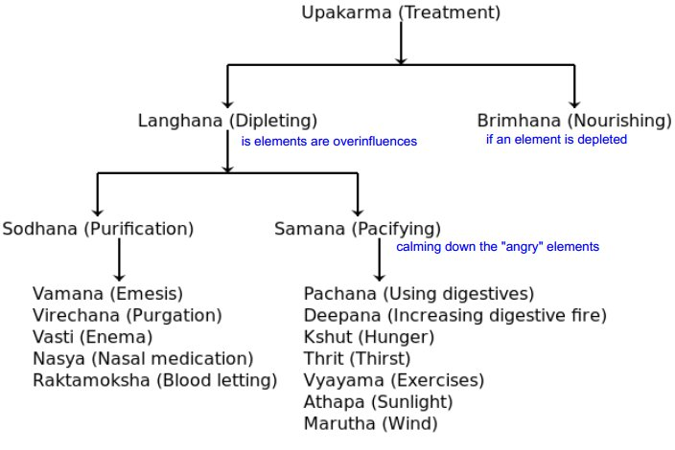

Ayurvedic Practice
- Pranayama - Breathing exercises, practicing pranayama helps you feel calm
- Abhyanga - rubbing the skin with herbal oil to increase blood circulation and draw toxins out of the body through the skin
- Rasayana - using mantras (repeated words or phrases duing meditation combined with certain herbs to rejuvenate a person
- Yoga - Combining pranayama, movement, and meditation. Yoga has been shown to improve circulation and digestion, and to reduce blood pressure, cholesterol levels, anxiety and chronic pain
- Pancha karma - cleansing the body to purify it and reduce cholesterol. Practitioners use methods that cause sweat, bowel movements and even vomit to cleanse the body of toxins
- Herbal medicine - prescribing herbs to restore dosha balance
Ayurvedic herbs
- Over 700 medicinal plants and 6000 formulations detailed in 3 classic Sanskrit texts
- Plants drugs are classified as per their pharmacogical and curative properties (up to 50 groups)
Traditional Knowledge in indigenous societies
- Local knowledge/unique to a specific culture
- Knowledge acquired over time
- Passed on by "oral tradition"
- It is alive
- It is a scientific method based on observation but also has a cultural basis (for example: the doctrine of signatures)
Traditional medicinal knowledge in indigenous societies
- In traditional societies without access to outside resources, traditional healers remember and pass down by oral tradition to family members (~200 species of medicines)
- A culture can maintains knowledge of 800-1000 species through specialists: ex women (dye plants, cures for infants), men (hunting, construction, primary forest habitats), midwives, and shamanistic healers with ritual and secret knowledge
- Indigenous peoples often have a cosmocentric world-view (man as a part of nature, nature as sacred) based on traditional animist religions, which influences the way they perceive health and disease
Biodiversity and Cultural Diversity are Linked
Biodiversity - the total diversity of living things, at genetic species and ecosystem levels | Cultural Diversity - the total diversity of human cultures at different scales of similarity and difference
Biosphere - The entre area of the earth, (land, water, and air) - inhabited by living things | Ethnosphere - the sum total of human thought, language, beliefs and institutions made manifest by the myriad of world cultures

Preservation of Cultural and Biological Diversity
- J. McNeely, former chief scientist at IUCN, argues that preservation of indigenous cultures and biological diversity go together

  - the double helix of conservation
- Natural alliances between conservation groups and indigenous cultures can provide protection of rights of vulnerable people, preservation and stewardship of biodiversity and tropical forest
- Local people gain income, medicines, construction materials, preservation of cultural heritage and language
- For developed countries conservation and "ecosystem services" are achieved
Traditional Knowledge and tropical biodiversity
- 68% of plant biodiversity is tropical, therefore tropical medicinal plant knowledge is relevant focus for conservation
- WHO estimates >80% people in tropics rely on traditional medicine
How do we study traditional medicinal knowledge?
- Ethnobiology: the scientific study of dynamic relationships among peoples, biota, and environments

  - Ethnobotany
  - Ethnopharmacology
Ethnobotany?
- The study of the direct interrelations between humans and plants
- The dynamic interactions of human needs and thought with botanical nature in a cultural context
- How people use plants medicinally, technologically, nutritionally and spiritually
- In the past, often dismissed as a descriptive survey of interesting but dying and irrelevant traditions
Ethnobotany is the study of traditional knowledge of plants
- Traditional Botanical knowledge (TBK)
- Indigenous Agricultural Knowledge (IAK)
- Traditional Ecological knowledge (TEK)

What is Ethnopharmacology?
- The study of biological activity of traditionally used drugs
- The relation between traditional science and modern science
Non-human primate origins of ethnobotanyL Zoopharmacognosy
- Use of medicinal plants by chimpanzees, other primates and animals
- Chimps display self-medication behaviours that ay represent early evolution of traditional medicine
- Bitter pith chewing, and whole lead swallowing are non-nutritive and expel parasites
- At most chimps used 2-3 species of plants

Chimp swallowing Aspilia mossambicensis leaf whole
- The leaves have barbs that collect parasites in the intestines
- proves that they realize they're sick and do something about it

Chimpanzees are observed eating Veronia amygdalina leave while sick. These leaves are not part of their normal diet. Pharmacological studies revealed antiparasitic steroid glycsides (upper row) and sesquiterpene lactones (lower row)
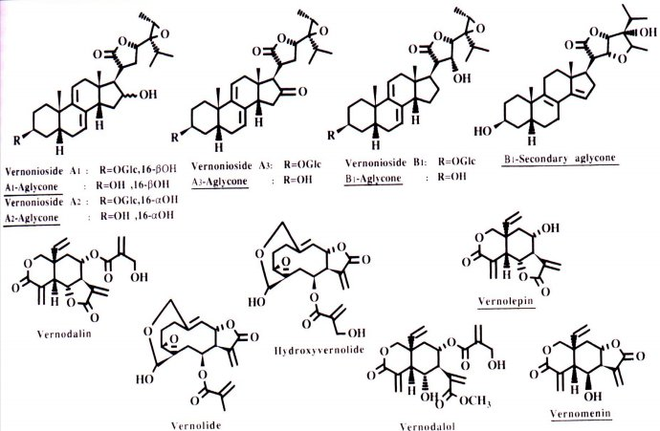

Classical Ethnobotany
- Richard Evans Schultes was a Harvard Ethnobotanist who's work on the ritual and religious use of plants in the Amcericas Laid the Foundations for modern ethnobotanical research
- His is most well known for his work on hallucinogenic snuffs, ayahuasca, coca (leaf of cocaine, no addiction shown), magic mushrooms, and peyote cactus
Ayahuasca
- Orally administered hallucinogen used for ritual healing and religious use
- Used in Western Amazon by numerous independent indigenous peoples
- Their mythology speaks of a time when men lost the ability to talk to the gods
- Ayahuasca restores this ability and allows the healer and the patient to travel to the spirit world and invoke the spirits to remove the disease
The two botanical components of the binary hallucinogen Ayahuasca (Caapi, & Yage)
- Banasteriopsis caaapi (Malphigiaceae)
- Psychotria spp (Coffee family)

DMT derivates occur in several hallucinogenic snuffs as well as in the Psychotria component of Ayahuasca
- Harmine alkaloids occur in Banasteriopsis of Ayahuasca
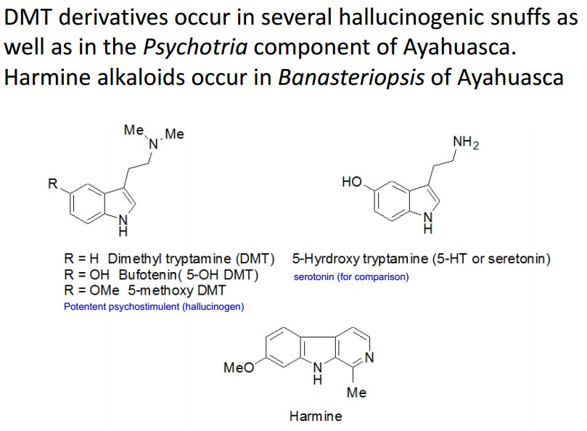

Pharmacology of Ayahuasca
- DMTs induces psychedelic hallucination by binding to 5-HT receptors (7 known) and in particular deeply alters perception of space and time, allowing perception of flight
- DMT is destroyed by monoamine oxidase (MOA) in the stomach but can be absorbed through nasal mucus membranes when taken as snuff
- Harmine in AYahuasca is a potent MAO inhibitor allows oral uptakes of DMTs
Decriptive Ethnobotanies: "use categories"
- Most ethnobotanists now categorize plants according to major use categories: repiratory, circulatory, dermatological, gastrointestinal, reproductive use etc
- Specific uses within each major use caetgory are also described. For example, respiratory uses includ flu, colds, coughs, bronchitis, asthma etc
- Traditional cultures do not recognize many conditions known in allopathic medicine, such as cancer, and may have unique disease concepts, such as the Maya concept "susto" (culture cound syndromes)
- Use categories are based on those described by Cook
Ethnobotanical Notes
- Identification of the plant drug (voucher specimen required)
- Collection methods and storage by healers
- Preparation of the drug
- Drug therapy
- Sociocultural context: origin of disease, ratonale for treatment, ceremonies, spiritual context
- Disease frequency from local health authorities
- Accessories (photo of healers, processing, sample collections of locally prepared drug)
Common preparation methods
- Decoctions (boiled and concentrated), infusion (teat) for drinking or bathing
- Sweat bath
- Eat appropriate plant tissue ex. inner bark vs outer bark
- Squeeze juice into affect area
- Place poultice on affected area
- Smoke the plant or use as incense, snuffs
- Ritual preparation, ceremonial administration and prayers of the healer may be as important or more important than the pharmacology of the plant
Quantitative Ethnobotany
- Move from descriptive to quantitative science: for original field studies or literatire reviews
- Ethnobotanical and ethnopharmacological journals are no longer willing to accept anecdotal or medicinal :plant list" data, especially from a small number of informants
- Indices based on a large number of individuals provide broader population view of cultural knowledge
- Statistical analysis allowed identification of significant features of traditional knowledge
- Quantitative data enables the statiscal evaluation of the connection between traditional knowledge and modern scientific knowledge

  - Defines limited of scientific vs cultural/spiritual view
  - Assists indigenous groups seeking validation and respect for TK
  - Assists policy makers in assessing co-management strategy
Ethnobotanical use categories - Help Define areas of Expertise

Eastern Canadian First Nation use of Medicinal plants by treatment category

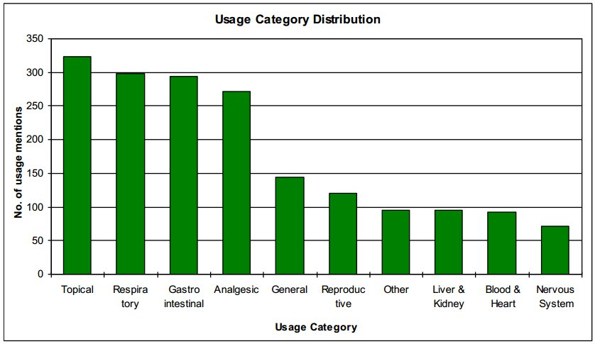

Quantitative ethnobotanical metrics
- Frequency of use of a medicinal plant
- Fuse = Number of healers using the plant / total number of healers
- Immunomodulatory medicinal plants used by the Q’eqchi’ Maya of Belize
  - High frequency of use for most plant
  - 52% of species were used by all healers

Quantitative ethnobotanical metrics: Syndromic Importance Value (SIV)
- Developed to rank medicinal plants used by the Cree of Eeyou Istchee in northern Quebec in the treatment of diabetes and its associated symptoms (Leduc et al, 2006)
  - There was a rating for each diabetic symptom, not all symptoms are caused just by diabetes (sweet urine is always an indicatory)
  - Diabetes was not a widely recognized traditional medicine concept, and high blood sugar not detected by traditional healers
  - However, healers recognize diabetic symptoms and treat them effectively
  - Takes into account 3 ethnobotanical parameters:
(1) number of different symptoms (15) for which the plant was cited
(2) frequency of citation by different traditional healers (consensus)
(3) relative importance of symptoms for which the plant was cited
  - Allows us to rank plants; what symptoms are being covered
Syndromic Importance value (SIV)
Where,
- w is the weight of the symptom,
- s the symptom contribution for the species,
- f the frequency of citation for the species,
- S the total number of symptoms used for this survey,
- F is the total number of interviews in the survey.

Top 8 boreal forest plants used by the Cree of Eeyou Istchee in the treatment of diabetes and its associated symptoms (based on SIV ethnobotanical rankings)
Rhododendron groenlandicum  Labrador Tea Kachichepukw  (Leaves) | Larix laracenia  Tamarack  Watnagan  (Inner bark) | Abies balsamea  Balsam fir  Inaasht  (Inner bark) | Picea mariana  Black spruce  Inaahtkw  (Cones)
Sorbus decora  Mountain ash Muskuannanatuk  (Inner bark) | Alnus incana  Speckled alder  Atushpi  (Inner bark) | Sarracenia purpurea  Pitcher plant  Ayigadash  (Whole plant) | Pinus banksiana  Jack pine  Ushchishk  (Cones)

Ethnobotany and ethnopharmacology outcomes
• Basic studies: folk taxonomy, cultural ecology, pharmacological basis of traditional medicine, etc.
• Biodiversity and cultural conservation
• International development and primary health care, first nations health care
• Complementary and alternative medicine
• Phytochemical and drug discovery
• Novel pharmacological targets and treatments
• Toxicology (pharmacokinetics and drug interactions)
• Medicinal plant development
• Regulatory issues

Lecture 4 – Discovering Traditional medicines

Learning Objectives:
- Role of natural sourced medicine in medicine and health care
- Sourcing of NHPs
- Challenges in quality issues
Finding New Medicines:
- Uses of Medicinal Herbs in
- Therapeutics Development
New drugs approved between 1983 and 1994 by the US FDA
Synthetic | Semi-Synthetic | Natural | Biological
289 - 56% | 173 - 33% | 30 - 6% | 28 - 5%
- Semi-synthetic: when you start with a precursor from plant and then modify it

- Search of novel molecules from plants (how to find new molecules in plants)
- High-throughput random acquisition and screening program
- Need 20,000 candidate compounds to obtain one clinical useful drug
  - Takes millions of dollars to screen through compounds to get it to clinical trial (it might not even be useful)
- Ethnobotanical Approach
- Consult local herbalists/Traditional healers
- Literature on folk medicine
- Only plants with historical use in medicine are tested

- Chemosytemics Approach
- Based on knowledge on phytochemical composition of certain species, genus, or family to evaluate related species for comparable compounds with better therapeutic index or selectivity
- The approach for new drug development: from Chinese herbal medicines
- Diversity of Chinese herbs and classical herbal formulae provide great resources for new therapeutic products development
- Combining the principles of TCM with modern science and technology to develop innovative Chinese medicines while keeping the characteristics and formulation principles of TCM shows good promise but has challenges
How can we modify these components to make it more effective?

Pharmacognosy: Isolation of bioactive compounds from single herbs and evaluate for development into drugs by systematic screening.
Establishment of chemical libraries
Compound: Artemisinin | Vincristine | Taxol
Plant: Qinghao | Periwinkle | Yew Tree

Current Drug Development Model
- Rational drug design (highly specific single compound)
- Chemistry
  - Preclinical studies
  - Clinical studies (phase I – IV)
Huge time and cost involved

Reverse Research Strategies
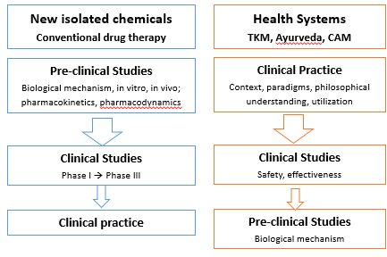

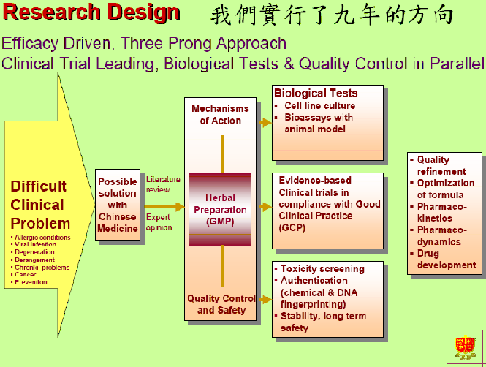
- Problems drugs don't do well with:

  - Neurodegeneration
  - aging
  - viral infections
  - loss of cognition
PHY906 by PhytoCeutica
- A TCM formulation with 4 herbs with a history of > 1800 years
- Activities: anticancer and antiviral activity, immunological stimulation, analgesic activity, liver protection, and appetite improvement.

  - He wanted to minimize the side effects of chemotherapy
  - The product actually had anti-cancer properties
- Formula traditionally used to treat GI symptoms (diarrhea, abdominal spasms, fever, headache, vomiting, nausea, thirst) which are also toxicities from chemotherapeutic treatment.
- Originally targeted for reduction of side effect of chemotherapy
- Now as adjuvant for cancer chemotherapy
- Clinical trials in progress

Process single herb to obtain an pharmacologically-active “extract”

- Dr Peter Lipsky, NIAMS, NIH
- “Thundergod vine: from the countryside to the bedside to the bench” at the NA Research Conference on Complementary and Integrative Medicine, 2006
- Multiple chemical components with potent anti-inflammatory and immunosuppressive activities, with no glucocorticoid-like side effects.
- Anti-inflammatory components isolated from Tripterygium Wilfordii Hook F (Thundergod vine)

New Innovation
- Component Chinese Medicine (CCM): Modern Chinese medicinal products that are formulated with active components or fractions of TCM but following the formulation principles and theories of TCM

  - Collect Extracts from components of herbal formula
  - Identify the active components
  - Design or mixing based on computer based optimization

Systems biology approach for multi-component and multi-action herbal products
- Administer product to test animals
- Isolate serum, urine, or tissue samples to determine metabolomic changes
- Correlate with pharmacological activities
- Data mining – bioinformatics to identify:
Bioactives;
Interaction among components
Mechanisms of action

Development of traditional medicines
- Affordable to developing countries
- As an example, in Tanzania, WHO, in collaboration with China, is providing technical support to the government for the production of antimalarials derived from the Chinese herb Artemisia annua.
- Discovery of bioactives from the plants
- Cultivation of plants using bioactives as markers
- Local production of the medicine brings the price of one dose down from US $6 or $7 to a more affordable $2.

OGIRC Objective Resourcing High Quality NA Ginseng Plants and Products
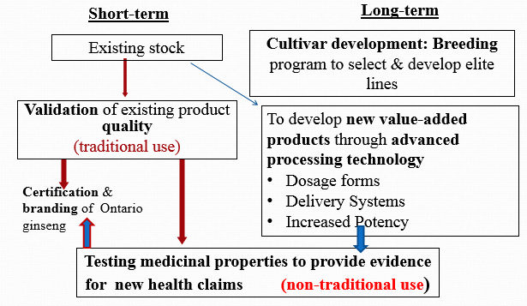

Approach in New Natural Product Development by Industry in Canada
- Product concept (considering market, consumer and health/illness trends, innovative new ingredients or products)
- Theoretical product formula (source ingredients, consider cost, delivery form, evidence for ingredients, safety, taste etc)
- Manufacturing (ingredient sourcing, testing, timeline, machines needed, test batch produced, finished product testing, then full product run, NHPD application submission, clinical trial implementation)
- Marketing and Sales (advertising: magazines, newspapers, web, commercials, radio, TV, sales team training and sell sell sell)

Is there an evidence base for NHPs to support use in this regard?

Research in CAM
- 6500 + controlled trials (Cochrane CM Field)
- ~ 1000 systematic reviews
- 908 RCTs of CAM
- 1500 + new Medline indexed articles per year ²

Systematic review of evidence underlying CAM practices
- 4000+ papers across 207 condition-treatment pairs
  - 58% of the pairs have been studied with 1 or more RCTs
  - 23% of the pairs have been studied with 1 or more meta-analyses
  - 18% have no identifiable supporting studies
- On going searches

Do we have evidence for products?
- Depends on who’s asking
  - NHPD wears a regulatory hat in this regard, not a scientific one
    - Their job is to protect the public and make sure the manufacturers are supplying safe products with accurate information and reasonable health claims
- Manufacturer perspective:
  - Yes → There are many products with adequate evidence depending on the claim level applied for
  - No → An idea may look good, but when we look for the evidence it may not be there
  - BUT → May change claims to fit with the evidence out there

Hierarchy of Evidence (Efficacy)
- Animal research and In vitro studies
- Historical/Traditional Evidence, Clinical observation
- Regulatory Autority Reports, post marketing surveillance
- Case series, case studies
- Observational studies (Case-control/Cohort Studies)
- Controlled Clinical Trials (N of 1 trials)
- Randomized controlled trials
- Systematic reviews / Meta analyses
Sourcing of Herbal products – for drugs, NHPs, traditional medicines, nutritional foods
- Good raw materials. How to judge for high quality?
- From what sources?
- Grown in the wild
- Geo-herb concept (Herbs grown in natural environment are best)
- Sustainability (When collected from the wild, will it continue to survive)
- Seed banks

- Cultivation (This approach to not deplete the natural resource)
- Wild-crafted
- Farm-cultivated
- Different cultivation methods: hydroponics, aeroponics…
- Bioreactor-based production

Quality of Natural Products: challenges
1. Correct identity of the herbs
2. Product purity - free from contamination, adulterants.
3. Strength & consistency

Quality deficiency related to:
- Raw herbs: Sourcing, collection, cultivation
- Basic processing:
- Manufacturing: Advanced processing, production
- R & D issues?

Some basic framework about product quality
1. Botanical identity and identification
One of the most frequently ignored aspects of botanical quality. This applies mostly to raw materials.
Techniques used:
- a) Organoleptic (sensory) evaluation of appearance, taste and smell
- b) Microscopic examination of diagnostic histological characteristics (lect 6)
- c) Chemical and genetic techniques (lect 7)

2. Purity (contamination, substitution, adulteration)

- Contamination
(accidental/unintentional inclusion of undeclared substances other than intended materials) by:

  - Other botanicals (including wrong part of the plant/herb
  - Toxic botanicals:
Anise seed → Poison hemlock
Burdock root → Deadly nightshade
  - Foreign materials- dirts
  - Microbes (bacterial and fungal): due to improper drying or storage of plant materials.

Consequences:

  - Risk of clinical infections in immuno-compromised consumers
  - Change the chemical composition of plant materials making them in some cases more toxic and less pharmacologically less active.
  - Examples of highly toxic fungal or bacterial metabolites : E.coli endotoxin, C. botulinum toxin, aflatoxin from Aspergillus sp.
  - Pesticides: most commonly cited consumer concerns.
- Most herbal products on the current market are not considered as organic.
- Some European studies showed the presence of pesticide residues that exceeded allowable limits. e.g. aldrin and dieldrin
- Some Ontario grown ginsengs are known to contain DDT
  - Heavy metals: lead, arsenic, mercury, and cadmium.
- Sources of heavy metal contamination;
  - Naturally or if grown near mines
  - Some herbs have higher affinity
- Uptake of heavy metals by plants;
- Recommended maximum acceptable levels. Valid? Chemical species taken into consideration
  - Radioactive residues:
- European herbs originated from the former eastern block countries are known to have radioactive contamination.
- Since the Chernobyl incident, cases of significant contamination have been reported
- Substitution
- A complete exchange of the declared herbs present
- Intentional- with cheaper and inferior species (adulteration).
- Unintentional- due to lack of expertise or experience in botanical identification
- Adulteration
- Intentional addition of undeclared substances
- Fillers for raw herbs to increase weight for the sale of exhausted botanicals
  - inert organdies, such as starch, flour, baking soda;
  - inert inorganic, such as brick dust, dirts, and chalk)
- Other herbs to increase profit margin.
  - The most commonly adulterated herbs are those that command the highest market value.
Examples of commonly adulterated herbs:
- Devil’s claw
- Echinacea sp.
- Ginseng
- Goldenseal
- Kava kava
- St.John’s wort
Note: it is difficult to ascertain whether or not the inclusion is intentional.
- Addition of pharmaceuticals – for fortification
- Adding undeclared substances to increase the pharmacological effect of the product
  - e.g. Diet/weight-loss, performance-enhancing, and purported aphrodisiac products may be spiked with: stimulants -- caffeine, ephedrine, amphetamines, hormonally-active substances...
  - Asian patent medicines (usually contains multiple components: herbs, animal parts, and minerals may contain: prescription drugs, heavy metals, and other ingredients that may or may not be listed on the label.
- Addition of Organic compounds as markers for intended herbs
- Most (spiking) cases were related to addition of pure marker compounds (available through chemical supply companies), for the purpose of passing off poor quality or exhausted botanicals.
- Other approach involves the blending in material from other plant species rich in the same marker compound.
How to control product variability?

1. Sourcing
- Good Agricultural Practice (GAP)
- Two aspects:
-General → deal with farm operation, safety, hazards, record keeping, trackability.
-Specific → more scientifically based, breeding program, genetics and phytochemical based.
- Challenges:
  - Administration of GAP in economically depressed regions, involving workers with limited education is difficult
  - Require research support
  - Difficult to apply to crops which need long term commitment

2. Manufacturing, production
- Good manufacture practice (GMP) (also see NHPs regulations)
i). Product specifications:
-identify and purity of products
-methods for product testing
-approval from a quality assurance person
ii) Premises: conditions – sanitary and avoid contamination during processing and storage
iii) Equipment
iv) Personnel –appropriate qualifications
v) Operation- record keeping, ability to recall lots or batches of products
vi) Quality assurance – require person responsible for assuring quality of products and the ingredients (including approval of manufacturing and processing methodologies), and record keeping.
vii) Stability of products
viii) Record keeping

R&D and Design Issues
- Undeclared "Schedule F" drugs, e.g. phenylbutazone, chloramphenicol
- Use toxic substances to treat diseases and symptoms for a short period of time
- Toxic substances neutralize each others during preparation and/or decoction

Need to know:
- Describe 4 approaches in searching for potential drug candidates from plants
- Outline the basis for several approaches in developing medicines from TCM, traditional medicines, and NHPs.
- Define quality of natural products.
- Describe what factors may contribute to poor quality?
- Differentiate contamination, substitution and adulteration, and provide examples.
- Explain what may be introduced to control quality in the sourcing and manufacturing process.
- When given the resources, describe how you may develop a novel and sustainable NHP for the Canadian market.

Lecture 5 – Plants as a Source of Medicines
Plants as Sources of Medicines
- Linnaeus 1753, borrowing from Casper Bauhin 150 years earlier, used binomials in his Species Plantarum
- Linnaeus did not come up with either binomials or the complete “Linnaean hierarchy” that we use today, but he did systematically apply binomial nomenclature and a consistent hierarchy to his encyclopedic compendia of known organisms
- The complete naturalist: a life of Linnaeus (QH44.B54 1971)
The Linnaean Hierarchy (we now use 3 domains of life)
- Dumb kings play chess on fine green sods [or make up your own memory device]
- Domain, Kingdom, Phylum, Class, Order, Family, Genus, species [subspecies/variety, f.sp.]
- The singular of species is species
- The plural of genus is genera
- The plural of phylum is phyla
Taxon Names
The names of many groups above genera have common (diagnostic) endings, depending on the group of organisms

Taxon/Suffix | Fungi | Algae | Plants
Phylum | -mycota | -phyta | -phyta
Class | -mycetes | -phyceae | -opsida
Order | -ales | -ales | -ales
Family | -aceae | -aceae | -aceae

Outline of the evolutionary relations among land plants
- Most of the major diversification of plants had occurred before the end of the dinosaurs (end of the Cretaceous period), BUT most dinosaurs did not feed primarily on Angiosperms (flowering plants), as we do.
- The bryophytes are ancient, non-vascular plants reproducing by spores: mosses, liverworts, and hornworts. Because they are non-vascular, they cannot live far from free water. Oldest
  - Ex. Marchantia, liverwort (wort means it has medical uses, liver, means its use for liveres)
- Lycophytes (club mosses and relatives) are vascular plants that reproduce by spores and do not have true leaves. They were very important in the Coal Age (Carboniferous period).
  - Ex. Club mosses (used to be huge, now are not)
- Ferns and horsetails are vascular plants that reproduce by spores but have true leaves. Some, especially horsetails, were also very important in the Carboniferous.
  - Almost nothing eats ferns
- Gymnosperms are seed-bearing vascular plants, but they do not have ovaries or flowers - seeds are borne naked on modified leaves. Gymnosperms are less diverse than Angiosperms (flowering plants), but some are used in medicines.
  - Ex. Cycas siamensis; Ginkgo biloba (living fossil); Ephedra; Microsporangiate strobili; Pinus Longaeva
  - Instead of sending off spores off on their own, surviving the environment and finding the other half Seeds - pollen fertizilizes the plant and is formed on the parent (root, stem and first leaves) before it's sent off; These are “naked” seeds places on leaves
- Angiosperms are vascular plants that produce their seeds (ovules) inside ovaries, which are found in flowers. They are the most diverse group of plants, and the most important in food and medicine
  - Ex. Maize (monocot); Hepatica Americana (eudicot)

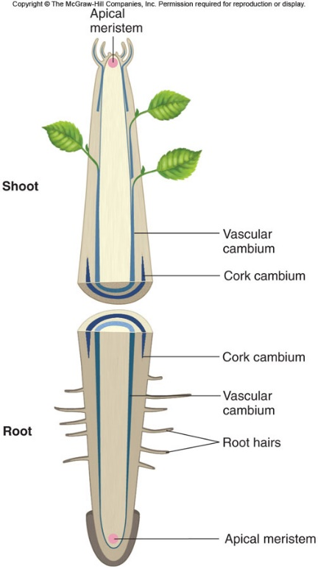
The Body of a flowering plant (usually) has 4 sets of organs:
- Root, stem, leaves, and flower/fruit

Apical meristems lead to primary growth = height growth
Some plants have two other types of lateral meristematic tissues, vascular cambium and cork cambium, which produce secondary growth = diameter growth
Meristems produce three types of tissues: dermal, ground, and vascular tissues.
Tissue Type | Cell Type | Function
Dermal
Epidermis | Epidermal cells | Protection
Periderm | Cork Cells | Protection
Ground
Parenchyma | Parenchyma cells  - Evenly thin walls  - Large volume in cell  - Stores foods or toxins | Storage, photosynthesis
Collenchyma | Collenchyma cells  - Thickened corners of the cell  - Less volume | Support
Sclerenchyma | Sclereids, fibres  - Small volume in cell  - Rigid for support | Support, protection
Vascular
Xylem | Tracheids, vessel elements, fibres, parenchyma | Water conduction, support
Phloem | Sieve tube members, companion cells, fibres, parenchyma | Food transport

Xylem (Water)

- Tracheids: in all woods (and the only conducting cells in Gymnosperms). Long, tapering, with spiral thickening, ad with simple or bordered pits.
- Vessel elements: only in (most) Angiosperms. Shorter, wider than tracheids, stacked to form a tube (= vessel). End walls are perforated, or lacking at maturity.
- Fibers: in all woods. Slender, tapering, with thickened (lignified) walls. Strength/support
- Parenchyma: in all woods. Thin-walled, ~undifferentiated living cells. Storage, or radial transport (in rays)
Phloem (Food)
- Sieve tube members: Living, but with degenerate nucleus. Cylindrical, somewhat thick-walled, with porous and oblique end walls (= sieve plates). Stacked to form a tube (conduction).
- Companion cells: Thin-walled, with enlarged nucleus that runs the adjacent s.t.m.
Roots
- Fibrous (wide spread of equal diameter)
- Taproot (Main root with smaller branches off → better protected inside plant, because eating the top of the root would kill the plants
Plant Organs: Stems
- Monocot stem
- monocot vascular bundle
- dicot stem
- dicot vascular bundle.
The “fiber cap” consists of scerlinkama cells
Cross-section of a 3 year old woody stem of a cork oak tree, showing annual rings of xylem
“Bark” is everything outside the vascular cambium;
inner bark = Phloem and outer bark = Cork

Wood is secondary xylem, produced in Gymnosperms (softwoods, above) and Angiosperms (hardwoods). The youngest growth ring is outside, next to the vascular cambium that produced it.
Anatomy of Lily Flower
- Petal (modified leaf)
- Pedicel (stem)
- Receptical (top of the stem)
- Sepal
- Flower bud
- Anther (package of pollen) on the end of a filament
- Style ( Female receptacle for pollen)
- Stigma (where the pollen sticks on the style)
Summary
- Modern plant classification goes back to Linnaeus and has been advanced by DNA sequences.
- Bryophytes (nonvascular, spore-bearing), lycophytes and ferns (vascular, spore-bearing) and gymnosperms (seeds without ovaries) are minor in # species and economic/medicinal value.
- Magnoliophytes (flowering plants) are most important in # species and economic/medicinal value.
- 4 plant organ systems: roots, stems, leaves & flowers
- 3 tissue types: dermal, ground & vascular
- Where do plant-derived medicines come from? (all 4 organ systems and all 3 tissue types, but predominantly parenchyma cells because it’s used for storage)

Lecture 6 – Canadian Regulations for NPHs

Canadian Regulations for Natural Health Products
CHFA:
- Is Canada’s largest trade association dedicated to natural
health and organic products
- Is the voice of the Natural Health Industry in Canada
- Represents 1,000+ member companies across Canada, including manufacturers, retailers, wholesalers, distributors, and importers of natural and organic products. These can include foods, vitamin and mineral supplements, herbal products, homeopathics, sports nutrition products, health and beauty aids and more
Session Outline – NHPs
- Canadian Regulations
  - Consumer Health Products
  - Natural Health Products (NHPs)
- NHP Claims
  - Marketing Claims
  - Health Claims
    - Traditional Claims
    - Modern Claims
- NHP Licencing Requirements
  - Safety and Efficacy
  - Quality

Learning objectives:
- Define a NHP
- The diagnosis, treatment, mitigation or prevention of disease, disorder or abnormal physical state or its symptoms in humans
- Restoring or correcting organic functions in humans
- Modifying organic functions in humans, such as modifying those functions in a manner that maintains or promotes health
- Understand types of NHP ingredients
- An NHP substance is defined as the medicinal ingredient responsible for a physiological effect,
as outlined in Schedule 1 of the Natural Health Products Regulation

- Schedule 1 NHP Subtances
Category 1: A plant, plant material, algae, bacterium, fungus or non-human animal material.
Category 2: An extract or isolate of a substance described in item 1, the primary molecular structure of which is identical to that which it had prior to its extraction or isolation;
Category 3: Vitamins
Category 4: Amino Acids
Category 5: Essential Fatty Acids
Category 6: Synthetic Duplicates [of Category 2-5]
Category 7: Minerals
Category 8: Probiotics

- Schedule 2 of the NHPR (Non-NPH substances)
1. A substance that is administered by puncturing the dermis;
2. A substance regulated under the Tobacco Act;
3. A substance set out in Schedule C to the Act (i.e., radiopharmaceuticals);
4. A substance set out in any of Schedules I to V of the Controlled Drugs and Substances Act
- List types of NHP dosage forms
- Capsules, Tablets, Grandules, liquids, lotions, extracts, tinctures, powders
- NO needles, or transdermal patches
- Describe the differences between marketing claims and health claims
- In order to attain approval for a product licence application, a NHP must have a recommended use/
purpose (expressed via its health claim)
- This health claim must have a health context in order to be issued a Natural Product Number
- a health claim is considered to be “any representation in labelling and advertising that states, suggests or implies that a relation exists between the consumption of (pro duct or product constituents) and health”
  - Codex is an international standard
- Health claims can be stated or implied through graphic representa@on on a food product label or via product advertising
- NHP Claim Categories:
  - Compendial
Traditional
Non-Traditional Claim
Homeopathic
TPD Category IV/ Labeling Standard
Homeopathic DIN
Transitional DIN
- List what types of Health Products the Consumer Health Products framework proposed to govern
- Pre-Processing: Compliance with the Natural Health Product Regulations is enforced by the Health Products and Food Branch Inspectorate [HPFBI]
- Post-market: Marketed Health Products Directorate (MHPD)

Lecture 7 – Efficacy
Efficacy Assessments for RCTs

How do we prove that a treatment is effective?
- Subjecting a drug to scientific rigor
- Comparing to nothing, or other standard of care treatment
- Using well conducted studies (high quality, large sample size, multiple studies with similar conclusions)
What is the highest quality study of these choices?
A - Case series
B - Randomized study (Higher quality, adjust for bias)
C - Cohort study (start with patients)

Levels of Evidence
- Meta-analysis of RCTs
- Randomized controlled trial (RCT)
- Prospective cohort (outcome hasn’t occurred yet)
- Retrospective cohort (People have the disease or have died and you look at their life before)
- Case control study
- Case series or case report

Data from large RCTs or meta-analyses may be far more believable than a case series
- You need to know compared to what
- Placebo effect
- There isn’t selection bias
- Publication bias (if publication is negative, it’s less likely to be published)

Trial Quality
- Randomized (yes or no, how what it done, better to do offsite)
- Controlled – another agent, placebo
- Blinded
- Intent to treat – once randomized always analyzed (once you’re placed in a category, you are assumed that you had the treatment)
- Drop outs accounted for

Randomization
- Equal chance of being allocated to whatever group if it is a 1:1 randomization scheme
- It is done to eliminate bias
- In a large trial there is a good chance for confounders both known and unknown to be distributed equally amongst the groups
- Neither investigator or subject can determine a priori which treatment subject will be allocated to
- Thus even day vs odd day allocation is not randomization
- Randomization needs to be stated and how it was done – random number generation, balanced blocks, central or local
- Central randomization is better – no way for the site to interfere with allocation
If Randomization works:
- Baseline characteristics are equal
- This implies that both known and unknown factors that may be associated with the outcome of interest are equally distributed between the random groups

Controlled
- There are comparisons
- Comparisons could be standard of care, other care, placebo
- Uncontrolled studies are not randomized controlled trials, they are intervention or treatment studies that do not allow for estimation of the true effect of the treatment
Blinding
- Blinding means masking the treatment
- Blinding the subject
- Blinding the investigator
- Blinding the outcome assessor if different from investigator
- Blinding all of the trial personnel
- Placebo or comparator should look, taste and seem identical to active agent
- Single blinding – someone is blinded, who?
- Investigator, subject, outcome assessor
- Double blinding
- Needs to state who is blinded
- ‘double dummy double masked’

Intent to Treat (ITT)
- If the subject is randomized (not just consents), they are analyzed
- Some trials state that they are modified ITT,
  - ie only if participant receives at least one dose of study drug
- If a subject is enrolled to a treatment (A) then drops out and receives the other treatment (B), which treatment are they analyzed as having received?

Analysis
- You can analyze drop outs in various ways
  - Assume the worst – ie treatment failure, death
  - Last observation carried forward (LOCF)
    - LOCF can assume patient drops out when doing poorly or having a side effect
    - Treatment may not have had time to work
    - It can introduce bias, often as there is differential drop out
    - If on active drug, you may drop out doing well but with side effects, vs placebo – drop out due to lack of effect
Drop outs
- If a trial has many drop outs (a large proportion of participants), it may no longer be considered randomized
- Drop out may be different between the treatment groups being studied (different rates, different reasons)
- Loss to follow up – a good study can account for every person enrolled
Statistical Analysis
- The best is a between groups comparison not a pre and post treatment comparison in each treatment group
- Ex RCT in HTN (hypertension)
- BP Group A Group B Group C
- Baseline 160/100 156/96 144/82
- End 140/80 150/92 138/78
Group A → Largest Change in BP
Group C → Lowest Final BP
WE DON’T KNOW → not enough information

Which treatment is the likely the best at lowering blood pressure? What if the drop out was a lot different
- BP Group A Group B Group C
- N baseline 100 103 99
- N end 50 100 99
- Baseline 160/100 156/96 144/82
- End 140/80 150/92 138/78

Bias
- Sources of bias are obvious sometimes, but not always
- In general, whoever funds the study finds the results they were looking for
- This is not cheating, but more stacking the deck (magnifying small differences, minimizing side effects, etc)
There are trial quality scores
- This can help a reader interpret the results (ie sort out how likely the results are to be truth and not just random results)
Levels of evidence
- Systematic Reviews
- Plausibility increases if several studies show the same results (consistency)
- The results make biological sense
- Different study designs or different populations show similar results
- There is a dose response

Value of N of 1
- Prescribe only what is working, stop if treatment is not effective
- Stop if the treatment is causing side effect reproducibly
- N of 1 can’t be done in asymptomatic disease
  - (ie no outcome to measure or in treatment that takes a long time to work and or has a long washout time)
Conclusions
- Trial quality is important for the conduct of trials in order to have the best chance of finding the true answer
- RCTs still have limitations
- RCTs can often only answer one question well
- N of 1 trials can be small (each patient is a single trial) and are cheaper and can demonstrate if within an individual something is effective or causing a side effect

Lecture 8 – Phytochemical Evaluation of Plant Medicines
Plant metabolism: All plant metabolites are organic compounds which are produced by primary or secondary metabolic pathways
- Primary metabolites – Compounds which control basic functions in all plants (nutrition, growth, development)
  - E.g. pathways in carbohydrate, protein, and fat biosynthesis
- Secondary metabolites – Compounds which have evolved to participate in ecological interactions between the plant and its environment (plant-pollinator, plant-pathogen, plant-herbivore, plant-climate)
Characteristics of secondary metabolites
- Unique chemotaxonomic distribution
- Phytochemicals are diverse (every species different) and redundant (analogs)
- Many secondary metabolites are biologically active as these compounds interact with the environment
- Stored in special structures: glands, resin ducts and vacuoles where they are produced in large amounts

Examples of distinct distributions
• Glucoscinolates (mustard oils)
• Sesquiterpene lactones (Bitter substances)
• Furanocoumarins (phototoxins)
• Betalaines (red alkaloids)
• Brassicaceae Mustard family
• Asteraceae Daisy family
• Apiaceae Carrot family
• Centrospermae (beets)
harmane alkaloids> 12 families
phenolic acids > 100 families
Major secondary metabolites in plants
Main types: | Derived from:
Phenolics  Alkaloids  Terpenoids | Phenylalanine  Amino acids  Isoprene
Also in Fungi and Bacteria: POLYKETIDES, derived from the ACETATE pathway
Minor secondary metabolites
Type: | Derived from:
• Acetylene  • glucoscinolate  • amides  • non-protein amino acids  • cyanogens  • Many others | • Fatty acids  • amino acids  • fatty acids  • amino acids  • amino acids

Diversity of secondary metabolites
Role of secondary metabolites:
- Floral colour (e.g., anthocyanins)
- pollinator attraction (e.g., monoterpenes)
- UV protection (e.g., flavonoids)
- herbivore deterrence (e.g., tannins, phenolics, alkaloids)
- defense against pathogens (e.g., flavonoids, terpenoids)
- adaptation to water stress
- adaptation to cold
- cell-cell signaling (e.g., flavonoids, phenolics)
Numbers of secondary metabolites:
• Phenolics - 8000
• Alkaloids - 12000
• Terpenoids - 25000
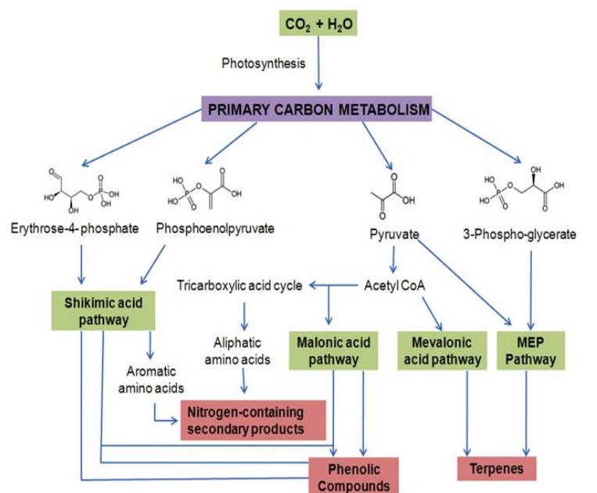

Phenolics: Important antioxidants
- eg. Gallic acid, resveratrol, quercetin, catechin, apigenin, naringenin
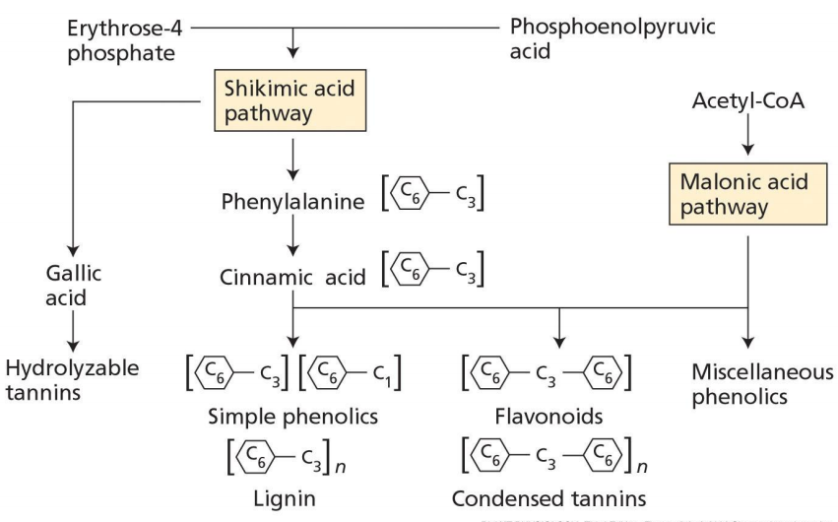
Alkaloids are biologically active compounds with heterocylic rings containing N
- eg. Cocaine, Nicotine, Morphine, Caffeine
Alkaloid pathways evolved separately from different amino acid precursors
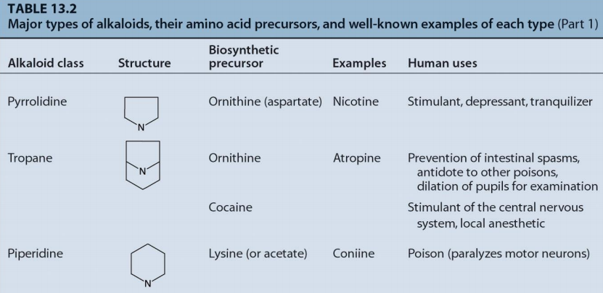
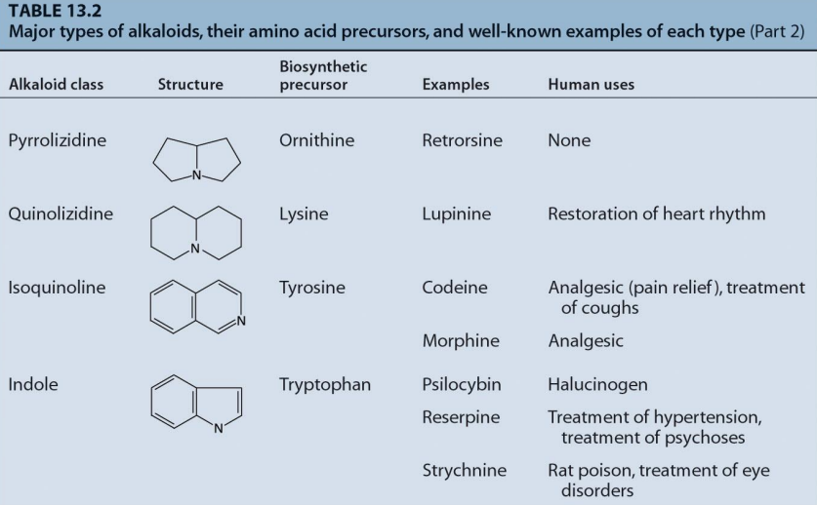

Terpenes are saturated compounds made from C5 “isoprene” units: Two pathways lead to C5 units
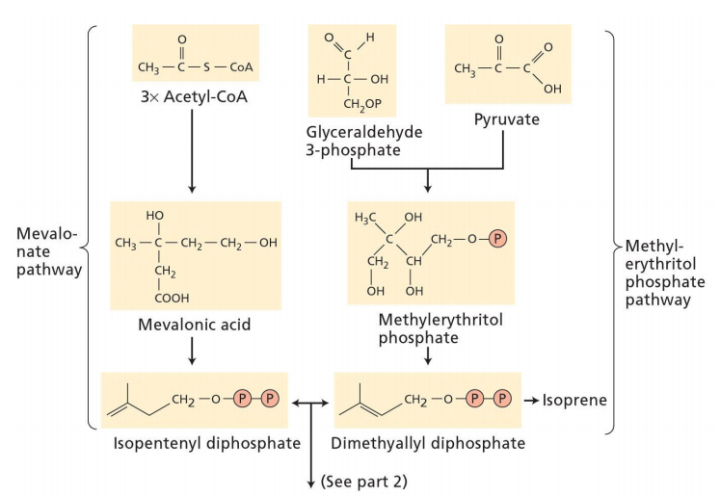

Terpene synthesis leads to C10 (monoterpenes), C15(sesquiterpenes), C20 (diterpenes), C30 (triterpenes), C40 (tetraterpenes), etc…
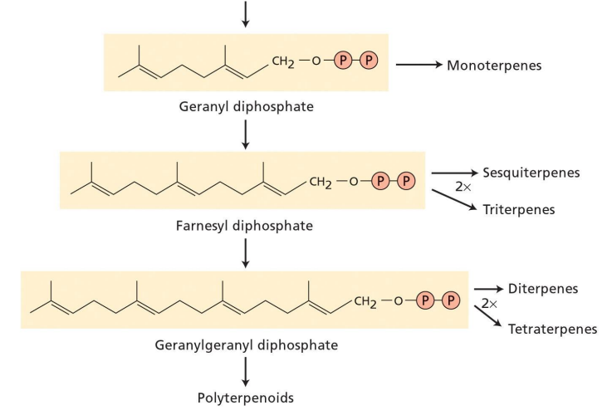

Terpene diversity
- menthol, parthenolide sesquiterpene (C15), Taxol Diterpene backbone (C20), Ginsenoside Rg1 Titerpene backbone (C30)

Phytochemical analysis
- Medicinal plants, herbal products, and plant derived drugs require methods to identify and quantify their chemical constituents
- This analysis is important in the discovery of the active principles of medicinal plants as well as in the standardization of their products to ensure consistent quality
How do we identify and quantify the chemical constituents of medicinal plants?
- Gas chromatography (GC)
- High performance liquid chromatography (HPLC)
- Mass spectrometry (MS)
- Nuclear magnetic resonance (NMR)
- High performance liquid
- chromatography (HPLC)
Separation based on polarity:
- Due to a variety of chemical interactions between the mobile phase (liquid) and the stationary phase (solid), the components pass through the column at different rates and eluted at different time (retention time ).
- Sample components with stronger interactions with the stationary phase than with the
mobile phase will elute from the column less quickly, and thus have a longer retention time

Normal phase vs Reverse phase
Normal phase chromatography
Stationary phase: high polar rigid silica
Mobile phases: relatively nonpolar organic solvent
The least polar component is eluted first
Reverse phase chromatography
Stationary phase: hydrophobic, C18
Mobile phase: polar aqueous based
Polar component eluted first
HPLC-DAD (Diode array detector)
- Diode array detector : A UV detector of variable wavelength. The UV absorption of the effluent is continuously measured at single or multiple wavelengths. These are by far the most popular detectors for HPLC.
- Compounds identification : Compare the retention time and UV spectrum of an authenticated standard to unknown peaks within a chromatogram.
- Chromatographic profile of a black spruce ( Picea mariana ) fraction at 210 nm
- UV spectrum of peak found at 5.5 min overlapped with spectrum of taxifolin standard
HPLC-DAD chemical profile or fingerprint
Mass spectrometry
- In order to measure the characteristics of individual molecules, a mass spectrometer converts them to ions so that they can be moved about and manipulated by external electric and magnetic fields. The three essential functions of a mass spectrometer, and the associated components, are:
- The ion source : A small sample is ionized, usually to cations, by loss of an electron.
- The mass analyzer : The ions are sorted and separated according to their mass and charge (M/Z ratio).
- The detector : The separated ions are then measured, and the results displayed on a chart.

Tandem mass spectrometry (MS-MS) is used to produce structural information about a compound by fragmenting specific sample ions inside the mass spectrometer and identifying the resulting fragment ions. This information can then be pieced together to generate structural information regarding the intact molecule, or to differentiate structurally similar molecules.
MS Time of Flight (TOF) Detector
An MS-TOF detector produces highly accurate molecular weight measurements
by timing how long it takes a given ion to “fly” a known distance
Two different molecules but same mass ?
- An MS-TOF can measure mass to several decimal places (exact mass)!
Non-targeted metabolic profiling and multivariate analysis
- MS techniques allow for the generation of very large amount of ionic data for all metabolites (primary and secondary) found within an extract. When looking for differences between extracts, principal component analysis can take all this information into account and can separate extract types based on their principal components and the clustering of samples along these axes. Can also be done with NMR data.
Alcoholic extract from 5 different farms
Aqueous extract from 5 different farms
Preparative scale HPLC
• Very large scale automated prep scale HPLC for fractionation of extracts and fractions
• The chromatographic profile of the extract or fraction can be used to guide the fractionation or subfractionation of active fractions
Novel Phytochemical identification: Structure Elucidation
- Once a pure active is Found, a natural product Chemistry group uses correlative NMR Like COSY and HMBCOR to determine Structures X-ray analysis isPossible when crystals Are available
Biological evaluation and bioassays
- Examples of bioassays for assessment of biological activity and mode of action
• Antimicrobial assays
• Antiparasitic assays
• Immunomodulatory assays
• Anticancer
• Behavioral assays
• DNA array, gene deletion arrays etc.
Antimicrobial-disc diffusion
• Sterile discs are saturated with 20 or 100 ug plant extract for the antibacterial assay, or 2mg for the antifungal assay.
• Agar plates are innoculated with E. coli, S. aureus , or S. cerevisiae in 0.1 mL medium
• Spread with “hockey stick”
• Discs are placed on the plate and zones of inhibition are measured at 24 and 48 hours.
• More advanced assays- serial dilution to “MIC” minimal inhibitory concentration
• Use of “Pannels” of antibiotic strains resistant
ELISA for cytokine TNF alpha quantitation in rat macrophages stimulated by ginseng
DNA expression-based assays
macrophages Echinacea extracts(polysaccharides)
Activated macrophages
m-RNA, c DNA
DNA array analysis or quantitative-PCR
Gene deletion arrays (GDA)
• GDA analysis uses an array of yeast mutant strains, each strain having a single gene knocked out
• 4700 (of ~6000) genes that can be deleted without affecting the viability
• each mutant strain is transferred from a master plate of gene knock-out strains to a plate containing a concentration of the plant extract
• Any significant growth reduction of a specific mutant colony on the plate containing the target plant extract is scored as a potential hit

Herbal product standardization
- American herbal products association definition Standardization refers to the body of information and controls necessary to produce material of reasonable consistency. This is achieved through minimizing the inherent variation of natural product composition through quality assurance practices applied to agriculture and manufacturing processes.
• Phytochemical standardization
• Biological (activity) standardization

Phytochemical standardization of plant derived medicines
- Through co-evolution with its environment, a unique collection of “ secondary metabolites” or “phytochemicals” is found in each species of medicinal plant
- Secondary metabolites are suitable “ phytochemical markers ” for standardization (quality assurance)
- The phytochemical marker is much more relevant if it is also an “ active principle” responsible for the medicinal action of the herbal product
- Because of phytochemical diversity, a “ profile” of several secondary metabolites is often recommended

Phytochemical standardization – Industry perspective
- Crude drugs and extracts are manufactured to contain a defined amount of constituent(s)
ex. Opium = 10.0%<[morphine]<10.5%
- Batch to batch reproducibility of constituents is an
important aspect of standardization.
- Standardization is not merely identification of the concentration of constituents but requires careful control of material quality and manufacturing

Raw herbal material and phytochemical variability
- Quality of Raw Herbs depends on:
- Soil conditions
- Seasonal effects
- Environmental conditions
- Harvesting and production methods
- Storage conditions
- Microbial & chemical contaminants
Regulation
- Canada, Natural health products directorate guidelines:
- Specifies need for identification of medicinal ingredients, but no detailed requirements indicated
- evidence of standardization of phytochemical markers is needed only if label claims there is standardization
- Currently, only a small percentage of NHPs are phytochemically standardized
The ‘ideal’ phytochemical marker compound
- Species specific
- Found in relatively consistent levels
- It is either the active ingredient or a principal and characteristic component of a mixture
- It is easily and quantitatively measured
- Many peoples mistakenly assume that the marker compound chosen is the active ingredient, this is not always the case
Short-comings of phytochemical standardization
- May not translate into a functional correlate of medicinal potency if inappropriate chemical markers were used (few chemical components identified as significant contributors to a plant’s medicinal effect!)
- Do not apply to chemical components bioactivated or deactivated following oral ingestion
- Quantitative analysis of a single chemical or class of chemical, with no pharmacological activity relevant to the expected therapeutic effect
  - Useful for only quality control purpose
  - Need to develop bioassays (functional markers) that
    - correlate with the pharmacological action of NHPs
    - relevant to the effect (health claim)
Biological standardization
Objectives:
- Determine potency: dose related pharmacological, therapeutic effect
- Relative potency: two samples or product bioequivalent?

Applications:
- to standardize quality of NHP:
- to ensure consistent therapeutic (medicinal) effect by using appropriate biological/pharmacological parameters as standard
- Use of biologically standardized products in clinical study is recommended but are seldom available
- Use for generic products as surrogate to clinical study to support their efficacy (therapeutic equivalence)
Pharmacological Standardization :
Quantitative pharmacological analysis – study strategy
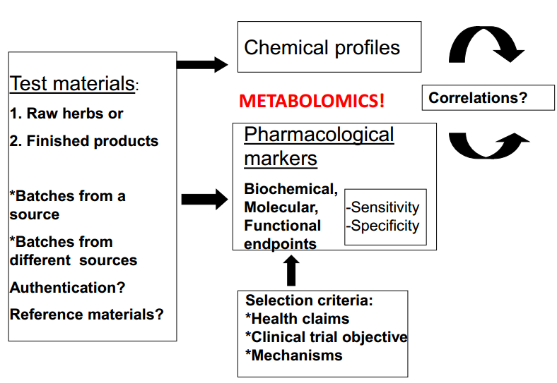
Pharmacological standardization :
- Challenges and issues to consider
- Test materials from authenticated products or herbs? Reference materials?
- What to use in a biological test? Solubility in bioassay (culture media, bioavailability in animals)?
- Multiple parameters may be needed, depending on the mechanisms of action and nature of the health claim.
METABOLOMICS!
- Sensitivity? Detect consistent (reproducible) changes at nontoxic levels of exposure.
- Dose-dependency, specificity, to generate IC50 or ED50 values
Challenges and issues to consider continued:
- Many NHPs have poorly defined effects or mechanism of action
- Parallel chemical analysis: known active ingredients? (usually not known or contain multiple components that act synergistically to produce the desired treatment outcome.
METABOLOMICS!
• How to examine correlations between pharmacological potency and chemical profile (fingerprint)?
METABOLOMICS AND MULTIVARIATE ANALYSIS!
• Additional challenge for some traditional medicines:
• Unconventional theory about disease and treatment.

Lecture 9 – Adverse Effects
Potential adverse effects of NHPs
Indirect effects:
- Use of NHPs reduces the opportunity of treatment by conventional therapy
  - e.g. cancer patients. Particularly when the alternative treatment is ineffective.
- Interact with other agents.
  - eg. Drugs
Direct effect:
- Intrinsic property of products

1991-95 by the Medical Toxicology Unit at Hospitals, London, England.
Methods:
1. Evaluate reports to the National Poisons Information Service (medical professionals and poisons centres around the world)
2. Follow-up questionnaire
Clinical consultation
Toxicological analysis/identification of samples

Evaluation criteria:
1. Temporal association between exposure and effect.
2. Disappearance of effect after cessation of exposure.
3. Reappearance of the effect with re-challenge.
4. Other medical history, including co-exposure to other agents.
5. Biological plausibility.

Traditional Chinese Medicine
- Common symptoms:
  - GI (liver, abdominal pain);
  - CV (cardiomopathy);
  - Skin (allergy)
- Hepatotoxicity of TCM used for skin diseases. ....idiosyncratic reaction?
- Complex problem of TCM
  - Individualized nature of a prescription,
  - Multiple components (up to 26 herbs).
  - Quality control: 10-25% with doubtful authenticity.
  - Toxicity due to use of incorrect or substitute herbs
Note: TCM is important because largest source of crude herbal drugs in the world.
Conclusion:
Overall risk to public health is low but cases potentially serious adverse effects are of concern
Note: The relatively low frequency of adverse health effect due to the relatively good health of the consumers of NHP.

Safety Issues
- Systemic reviews of risk-benefit profile of commonly-used products
  - Ginkgo biloba ($151 million)
    - Dementia and Claudication
  - St. John’s wort ($140 million)
    - Mild depression
  - Ginseng ($96 million)
    - “Fatigue and debility”
  - Echinacea ($70 million)
    - Adaptogen
  - Saw palmetto ($32 million
    - BPH*
  - Ephedra
    - Weight loss → CV risk. Banned
  - Kava kava ($17 million) Acute anxiety
    - Cases of hepatotoxicity (Banned in Canada)

Rate of adverse health effects – Low (much lower than drugs)
Underestimated?
- Consumers: consider these products as natural and therefore safe
- Some physicians consider NHPs are placebos. ...thus reduces the likelihood of associating any adverse reaction with any NHP usage.
- Patients are embarrassed to admit the actual amount used when there is an adverse reaction
- Report of adverse reactions to NHPs by health-care professionals via Can Adverse Drug Reaction Monitoring Program
- Case report : difficult to establish causal relationship

Safety: To broker any conflicts between a patient’s choice of CAM and risk considerations.
- Committed CAM users may believe that many published concerns over safety are:
  - unfounded,
  - fear mongering from medical profession and pharmaceutical industry
Problems related to the use of herbal products
- Lack of scientific evidence for efficacy and safety
- Lack of regulatory oversight
- Lack of quality control
- Public misinformation
- Lack of knowledge about herb-drug interactions by patients and health care providers
Safety
- Adverse side effects induced by drugs in in-patients in China -1990s
- 5% (50,000,000)
- 7.9% of affected patients had fatal outcome
- Herbal medicines 1980-1990:
- 2747 cases of medium/severe side-effects and 132 fatal cases.

Potential Adverse effects of NHPs
Direct effect:
- Intrinsic property of products
- Product Factors
- Lack of Quality Control
a)- Contaminations - Bacteria and fungi, Pesticides, Heavy metals, Radioactive residues
b)- Wrong substitution........Wrong herb being incriminated
For example, *Siberian ginseng and neonatal androgenization. Real culprit was the substitute: Chinese silk vine
c) - Adulterants:
eg. Asian Patent Medicines
* Usually contain multiple components
* Contains prescriptions drugs, heavy metals, and other ingredients that may or may not be listed on the label.
Case Example
- Renal injury- fibrotic interstitial nephritis
- In 1991-2 two women in Belgium on slimming program, followed by 7 other patients
- >100 cases have been reported secondary to intake of Chinese herbs in China, Taiwan, UK.
  - All have hypocellular interstitial fibrosis and atrophy of renal tubules
- Due to aristolochic acid
- Found in Aristocholochia manshuriensis, a. fangchi, a. contorta, caulis aristolochiae, radix aristolochiae
- Inappropriate Processing: Processing can affect the toxicity of herbs
- E.g. Aconite contains highly toxic alkaloids, which are removed by boiling.
- Consumption of incorrectly prepared aconite can be fatal
- Modification of dosage form:
- Use of extracts instead of the whole plant:
- Increase potency because of concentration.
- Removal of certain components of a plant render the extract more toxic.
- Implication: create uncertainty if the evidence of safe cultural use is based on the whole plant.
- Consumer Factor: Inappropriate use by consumer
  - Misconceptions and Over-dosing
    - All natural health products are “safe” and “more is better” ----> consume excessive doses.
      - e.g. Mis-use of weight loss and energy/tonic products
    - May contain diuretics, laxatives and caffeine, ephedrine and amphetamines.
    - Chronic use -----> overdose and toxicity.
    - e.g. Cu 30 mg/day for 3 year and 60 mg/day for 1 year------> liver cirrhosis, hepatic failure.
    - Multiple products exposure.
    - e.g. Zn overdose and leukocyte aplasia from 5 different products:
      - vitamins,
      - minerals,
      - fish oils/linoleic acid,
      - amino acids and
      - enzymes------>
    - a total Zn of 36 mg/day-over twice recommended dose.
  - Self-treatment (possible inaccurate self-diagnosis)
    - (In Europe NHPs are usually prescribed by health-care practitioners).
    - Low risk: using a bitter to trigger upper digestive function, like taking aspirin for a headache.
    - But risky to take proven immunostimulant or anti-oxidant substances without appropriate medical diagnosis
    - Contraindications
      - Long-term Echinacea …immunosuppression
      - Immunostimulants in MS
    - Cross-cultural use of products without supervision may pose a problem.
    - For example, according to the theory of TCM, Chinese medicinals can be classified on the basis of:
      - Their flavour (pungent, sweet, bitter...),
      - Natural property (rising, lowering...)
      - Energy tendency to balance the body energy and function.
- Patho-physological status
- Pregnancy: effect is poorly understood.
  - (Recommended to avoid them during pregnancy and lactation period)
- Relative safe NHPs for normal consumption may pose significant risk. e.g:
  - Uterine vasoconstrictors. eg. ephedra vulgaris, xanthium.
  - Uterine vasodilators. eg. Dong Quai, Black Cohosh.
  - Oxytocin synergists. eg. Blue Cohosh

What you Need to Know:
- Describe the direct and indirect adverse effects of herbal medicines on health
- List the evaluation criteria for the adverse health effects of herbal medicines and explain why it is difficult to establish causal relationship?
- Describe the issues with use of herbal products in US and Canada; and explain why the reported incidence is lower than that of drugs?
- Outline factors relating to products that may contribute to adverse outcomes and strategy to minimize it.
- Outline factors relating to consumers that may contribute to adverse outcomes and discuss what could done to reduce the incidence.
- For consumer out-reach, make a list of to do and not to do.

Lecture 10 - Herb-Drug Interactions
Objectives:
- How serious is the problem? Incidence?
- Sources of evidence and their reliability?
- Critical aspect: clinical significance?
- Who is at risk?
- What types of NHPs and drugs are involved?
  - according to mechanisms of interactions
  - SJW as an example
- Case study- right to self-administration
- Challenges
- Information resources

Typical Case Report
- Middle age woman on warfarin and digoxin
- Stabilized blood clotting showed decrease
- Questioning revealed recent intake of dong quai for menopausal symptoms
- Dong quai contains cumarins and ferulic acid, known inhibitors of blood clotting
- Many plants contain these chemicals, therefore potential to interact with anticoagulants
- Quantitative and qualitative variability in chemical constituents makes prediction difficulty

Limitations of Case Reports
- Causal relationship not established
  - Alternative explanations not been excluded
  - Temporal relationship?
  - No re-challenge
  - Complex composition, multiple herbs
  - Quality of product not known; contaminants, adulterants may be involved
- Well-documented case reports only serve as a critical warning system

Levels of Evidence
- Case report:- published individual responses
- Clinical studies: healthy subjects/patients
- Meta-analysis: systemic review
- Animal studies: extrapolate to humans
- In vitro studies: extrapolate to in vivo
Purpose:
- Pharmacological plausibility
- Mechanisms of interaction
- Theoretical/pharmacological consideration

Who may be at risk to H-D Interactions?
- Most peoples who use NHPs also take drugs at the same time; and do not tell their physician about it.
- Chronic conditions or life-threatening prognoses: cancer, HIV, Alzheimer’s disease, irritable bowel syndrome, chronic fatigue syndrome
- Frustrated with conventional medications:
  - patients from rheumatology, hemodialysis, organ transplant.
Examples of clinically significant interactions, according to mechanisms:
- Pharmacokinetic interactions: herb alters the pharmacological effects/toxicity by modifying the plasma concentration of the drug via changes in: -
    - absorption
    - distribution
    - excretion
    - metabolism
- Pharmcodynamic interactions: herb alters the response of the drug target without changing the drug plasma concentration
- Effect on clinical lab test

St. John’s Wort
- Indications: German Commission E
  - Mild to moderate depression (first line therapy; used as often as SSRI’s)
- Mechanism: similar to SSRIs
- Good Clinical evidence

Drug interaction w/ St. John’s Wort
- A middle-age male with recent kidney transplant
- Stablized on Cyclosporine, an immunosuppressive agent
- Over a period of 10 days, signs of organ rejection
- Patient revealed the regular use of St John’s wort over a week for mild depression

Basis of Interaction
- Induction of intestinal/hepatic CYP3A4 and P-glycoprotein Pump
- What may be the consequences?
- systematic bioavailability of
  - substrate of 3A4
  - substrate of the pump
Other Examples of St. John’s Wort interactions
- Clinical study- Reduce AUC of:
  - Indinavir (57%)
  - Midazolam (52%)
  - Digoxin (25%)
  - Amitriptyline (22%)
  - Simvastatin active metabolite (62%)
  - Irinotecan active metabolite (42%) 3A4 Inactive
    - Increase 3A4…decrease iriontecan availability to be bioactivated
    - Therefore therapeutic failure

Characteristics of St. John’s Wort action
- Induction of 3A4
- Duration of treatment 3-14 days
- One day treatment no effect
- Dose 600 mg – 900 mg
- Reversible
- Intestinal enzyme >> liver enzyme
- Less effect on other P-450

Summary of Mechanism underlying drug interaction involving St. John’s Wort
1. Induce CYP3A4- increase deactivation of a number of drug substrates- decrease bioavailability
2. Induce multi-drug resistance gene 1 (MDR1) - up regulate p-glycoprotein drug transporter-- decrease uptake from intestinal tract and increase renal excretion.

Pharmacokinetic interactions involving other herbs
inhibitors | Drug Substrates | Consequence
Black/Long Pepper | Phenytoin  Propranolol  Rifampicin | Increased AUC (inhibits metabolism)
Licorice root | Prednisolone | Increased AUC 49%

Pharmacodynamic Interactions – Warfarin (most cited drug involved)
INR – International Normalized Ratio

Increased INR in case reports of
Dong quai | Bruising  Inhibit platelet aggregation
Danshen | Bleeding complications.
Garlic bulb | Inhibit platelet aggregation.
Ginkgo leaf | Bleeding reaction  No effect in Clin Study
Wintergreen oil (Topical) | Bleeding reactions. High methyl salicylate?
Decreased INR by:
Asian ginseng | No effect in animal studies
Green tea lead | High vitamin K

Unusual interaction: Supplement/Drug Interactions with Glucosamine
- Acetaminophen: acetaminophen clearance requires sulfate
- Decrease in serum sulfate will reduce effectiveness of glucosamine.
- Acetaminophen: reduced analgesic effect due to increased clearance.

How to minimize risk of H-D interactions?
- Taking herbs at least 1½ hrs apart from taking drugs is a very good idea. …preferably taking the drugs first
- When the drug therapy is already addressing a particular therapeutic goal, avoid adding a potent herbal therapy with the same goal.
- avoid mixing herbs or supplements and drugs that have similar actions or have opposite actions
Summary
- Herbs could modify drug response and may have significant adverse clinical outcome
- Pharmaco-kinetic and dynamic interactions
- Incidence is under-estimated
- Clinical evidence is not strong
- Require better education and communication, reporting mechanism and research
- Note: herb-drug interaction could have beneficial outcomes!

Benefits of using herbal medicines concurrently with drugs
- To reduce the adverse side effects of chemo- and radiation-therapy with medicinal mushroom extracts.
  - e.g. PSP or afterwards?
- Product quality is an issue
- PHy 906 in GI cancer. Clinical trials. Enhance efficacy and reduce toxicity of Irinotecan

Need to Know:
- 1. Describe the basic mechanisms and give key examples (be familiar with herbs that are known show interactions)
- 2. Challenges in evaluating the clinical significance
- 3. Explain the ethical issues in conducting clinical study, and how they be overcome
- 4. List those who may be at risk and explain how the risk may be reduced.
- 5. Explain with examples how intended herb-drug interactions could be beneficial?

Lecture 11 - Anti-oxidant and anti-inflammatory NHPs

Reactive Oxygen Species (ROS)
- ROS = Reactive oxygen species are highly reactive molecules, free radicals and pro-oxidant non-radicals containing one or more oxygen atoms
- Free radicals = Atoms or molecules with one or more unpaired electrons
- Under normal conditions ROS play essential signalling and regulatory roles in many pathways
- Under pathological conditions, excess (or insufficient) ROS can lead to cellular dysfunction and death via multiple pathways.
ROS function
Physiological role
- Cellular signaling: mediators of signal transduction and in the activation of proteins such as tyrosine kinase
- Redox regulation: protein phosphorylation, ion channels, and transcription factors and in part mediated by redox reactions
- Biosynthetic processes: thyroid hormone production and cross linking of extracellular matrix for example
Role in growth and development
- Regulates cell cycling
- Regulates embryogenesis: controls differentiation of embryonic cell lines into cardiomyocytes for example
Low, Normal, and High levels of ROS in the population
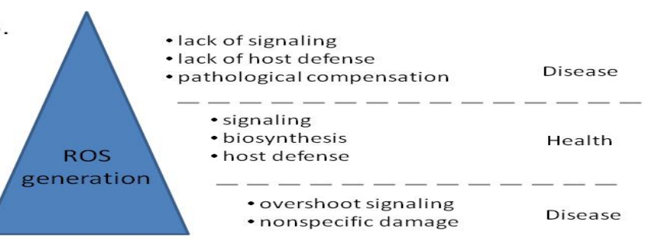
Reactive Oxygen Species (ROS) And Reactive Nitrogen Species (RNS)
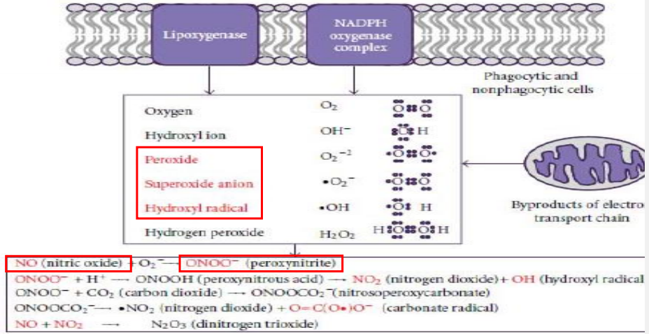
Nitric oxide, peroxynitrite

3 Main Sources of ROS2) NADPH Oxidase (NOX)
- Mitochondria
  - Oxidative phosphorylation, the generation of ATP in the mitochondria, involves the electron transport chain. Electrons are passed through a series of proteins via oxidation-reduction reactions.
  - 90-95% of O2 completely reduced by mitochondrial cytochrome oxidase to form H2O.
  - 5-10% of O2 undergo univalent reduction to form ROS.
  - Oxygen Superoxide Hydrogen Peroxide Hydroxyl Radical Water
  - P2 O₂₋* H₂O₂ OH* H₂O
- NADPH Oxidase (NOX)
- Respiratory (oxidative) burst: Phagocytic immune cells (neutrophils and macrophages) produce superoxide anion, hydrogen peroxide and peroxynitrite to destroy internalized bacteria or fungi.
- NOX in non-phagocytic cells respond to a variety of stimuli, including integrin signaling, growth factors, immunological and hormonal mediators, and hypoxia
- 5-Lipoxygenase (5-LOX)
  - 5-LOX responds to a variety of stimuli, including integrin signaling, growth factors, immunological and hormonal mediators, and hypoxia
- Other enzymes
  - NAD(P)H dependent oxido-reductases
    - E.g. Xanthine oxidase (XO)
  - XO catalyzes the oxidation of hypoxanthine to xanthine to uric acid
  - With formation of H2O2 and in some cases O2-
  - Enzyme plays an important role in the catabolism of purines
  - Is a target in the treatment of gout (“rich man’s disease”), a buildup of uric acid crystals

Endogenous defences against ROS
Antioxidant enzyme systems:
- Superoxide dismutase (SODs) and superoxide reductase (SORs)
- Catalase and heme peroxidases
- Glutathione peroxidase and the glutathione system
Redox homeostasis
Under normal healthy conditions there is an absence of redox-dependent responses
Cells under physiological conditions:
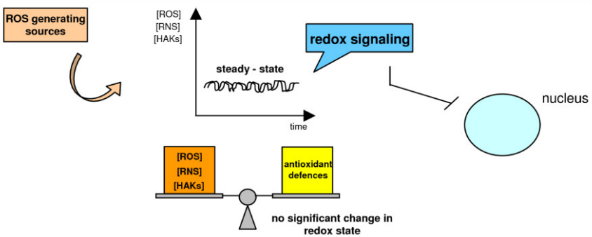
Cells in which a significant level of intracellular ROS generation occurs as a moderate and transient change in redox state

Oxidative stress or anti-oxidative response Antioxidant defences
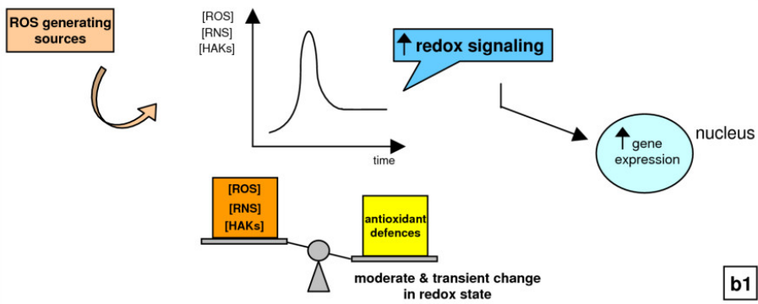
Cells in which a significant level of intracellular ROS generation occurs as a severe and irreversible change leading to cell death
Induction of cell death
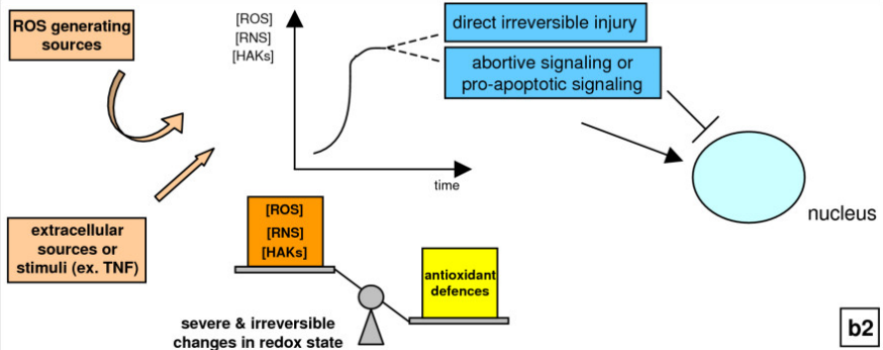

Cells in which a significant level of intracellular ROS generation occurs as a chronic shift in redox state
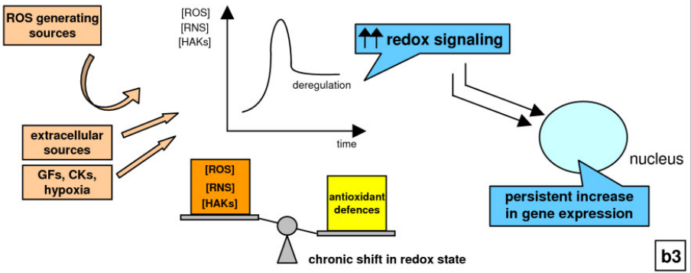
Up-regulation of different patterns of gene expression Pathological conditions
Cellular targets of ROS

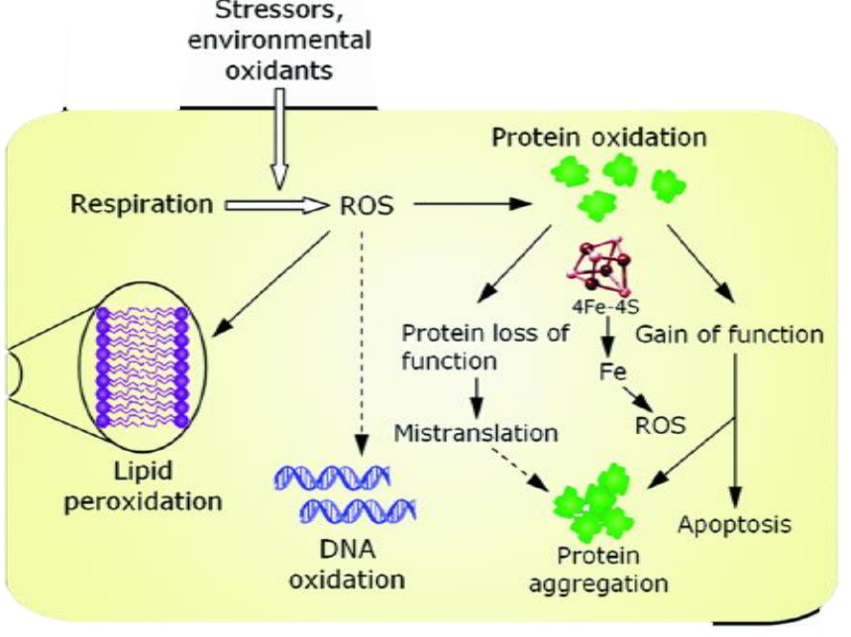
Protein as target:
- Oxidation of proteins may lead to the formation of insoluble protein aggregates
  - As found in neurodegenerative pathologies for example
- ROS involved in the formation of advanced glycation endproducts (AGEs), which is an irreversible molecular change typically seen in glycosylated cell surface proteins.
DNA as target:
- ROS are capable of inducing single and double stranded breaks in DNA
- ROS can induce structural and chemical changes of both pyrimidine and purine bases as well as 2’- deoxyribose
- As such, cells may undergo a series of cumulative mutations, which in turn may disrupt cell homeostasis with the end result of cancer development
- Mitochondrial DNA - more sensitive to oxidative stress-induced mutations because it lacks DNA repair enzymes
Lipid as target:
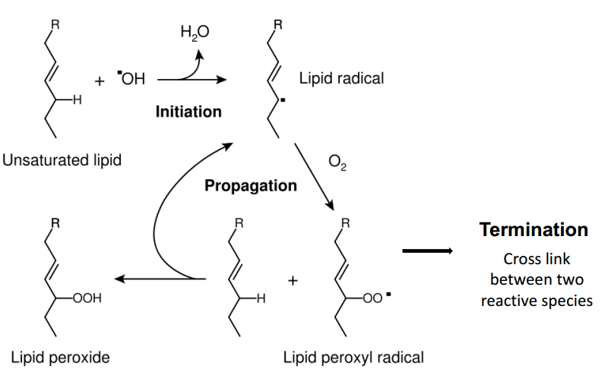
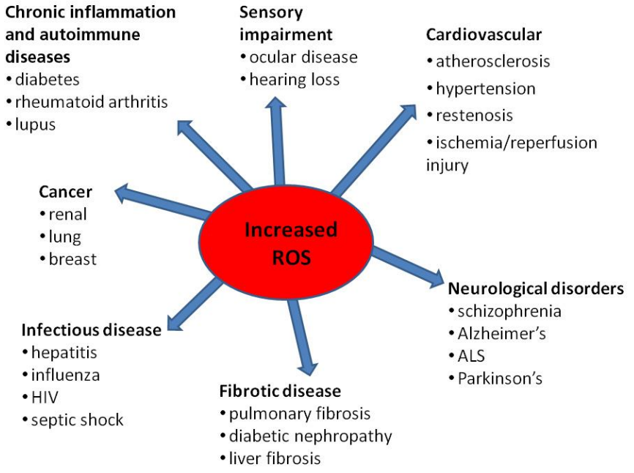
Antioxidants general mode of action
• Oxidant Stress = Production >> Detoxification
• Reduce ROS by
- reduce formation
- increase removal by
- scavenging of ROS (direct)
- upregulating anti-oxidative enzyme (indirect)
- alter activity by modifying co-factors
- alter availability of selenium or Zn, which are required
- for anti-oxidant enzyme activity
- de novo synthesis of antioxidant small molecules

Different types of antioxidants according to lipid solubility
- Hydrophobic: act on cell membrane and protect against lipid peroxidation
- Hydrophilic: react with ROS in cytosol and blood plasma
- Synergistic interaction among them

Ascorbic acid (Vitamin C)
- Not synthesized in humans
- Participates in redox reaction
- Reducing agent, reduces H2O2
- Intracellularly it exists in a reduced state, conversion by GSH
Radical scavenging
- Ascrobic Acid (vitamin C) will donate a hydrogen atom (H-, electron) to the oxidised radical to neutralise it
Tocopherols (Vit E)
- Alpha-tocopherol best known
- Lipid-soluble
- Undergoes redox cycling , coupledwith ascorbate
Engineering vitamin E (alpha tocopherol) into soybean oil
- Vitamin E is an important dietary antioxidant reducing lipid peroxidation due to ROS
- 4 Arabodopsis biosynthetic genes now identified, VTE1, VTE2, VTE3 and VTE4
- Transformation of soya with VTE3 leads to gamma tocopherol only
- With VTE3 and VTE4 transformation, alpha tocopherol now formed in quantity
Melatonin
- Lipid soluble, cross BBB
- Found in animals, plants, fungi and bacteria
- Terminal antioxidant, does not undergo redox cycling, but converted to a stable product.

Resveratrol (a stilbene phenolic)
- Effect on life extension, cancer prevention, athletic performance, radiation, neurodegeneration
- Found to Improve Health, But Not Longevity in aging Mice on Standard Diet
- The mechanisms of effects on life extension, appear to mimic several of the biochemical effects of calorie restriction
- Resveratrol activates Sirtuin 1 (SIRT1) and PGC-1α and improve functioning of mitochondria
Condensed tannins (phenolics)
- Tannins complex and inactivate digestive enzymes
- Give “oaky” flavour to wine
- Potent antioxidant
- But also suspect carcinogen in esophogeal cancer of Mediterranean Countries
Catechins (Phenolics)
- Green tea catechins are potent antioxidants
- Catechins in green tea lose some of their activity when fermented to black tea
In this clinical study, tea lowered biochemical markers of oxidation
- MDA is a measure of lipid peroxides
- 8-oh-dG is a measure of nucleic acid oxidation (hydroxy-deoxyguanosine)
Anthocyanins (phenolics)
- Coloured pigments of berries and flowers
- Dark skinned berries are among the most potent antioxidants
Lignan and lignin (phenolics)
- Lignans are produced as dimers of phenyl propanoids (C6C3) by attachment of middle carbon of C3 side chain. For example, pcoumaryl alcohol-free radical coupling reaction.
- Lignins are high molecular weight wood compound formed by free radical induced polymerization of p-coumaryl alcohol by enzyme laccase.
Flax, a major nutraceutical crop in Canada
- Contains PUFAs and lignans
- Main lignan in flax is compound 1, while 2 is human metabolite
Benefits of Antioxidants
- Antioxidants reduces cell-damaging effects of free radicals.
- People who eat fruits and vegetables, which are good sources of antioxidants, have a lower risk of heart disease and some neurological diseases, cancers.
- These observations suggested that antioxidants might help prevent these conditions.
- But no studies in humans show any cause-effect relationship between antioxidant vitamins and CV Diseases
Five best antioxidant-rich foods
- Berries
- Broccoli: high in Vit C, sulforphane, lutein (lipidsoluble)
- Garlic: Vit A, B, C, selenium, Zn; allicin, diallyl sulphides
- Green tea: Catechin polyphenols
- Tomatoes: Lycopene (fat soluble)
Challenging in efficacy evaluation in humans: Paradoxical effects of ROS
- The human population is heterogeneous, including levels of ROS
- People who over-generate ROS are at high risk for developing cancer, cardiovascular diseases, cataracts and other degenerative diseases because of the oxidative damage to cell constituents
- Antioxidants protect people with a high level of ROS: Responsive population
- Whereas antioxidants might be detrimental in people with a low level of ROS
By further decreasing the activity of ROS-dependent protective mechanisms:
- People with a low level of ROS might be in danger of harboring low activity of highly important protective reactions.
- These include
- apoptosis, which deletes precancerous, cancer, virus infected and other cells threatening human healt
- phagocytosis, which fights infectious microorganisms
- cytochrome P-450 -detoxification reactions provided by complexes.

ROS are essential triggers and mediators of all these protective reactions. Consequently, a low ROS level limits the activity of these protective reactions: Non-responsive population
Therapeutic potential of antioxidants
- For diseases caused by a surplus of ROS, antioxidant supplementation has proven largely ineffective in clinical studies, most probably because their action is too late, too little, and too non-specific.
- Specific inhibition of ROS-producing enzymes is an approach more promising of clinical efficacy.
Inflammation and Immunomodulation
- Innate and Adaptive immune systems
- Inflammation is a complex set of interactions among a variety of cell types and soluble factors, in response to a wide range of internal and external stimuli
- Immunomodulation is managed by many integrated Pro- and Anti-inflammatory pathways
- Inflammation can be acute, chronic, localized or generalized
Inflammation
Characteristic Process
Mediators
- -Prostaglandins Vasodilation
- -NO
- -Histamine Cap. permeability
- -Leukotrienes Pain receptor
- Activation of:
- Neutrophils lysosomal Tissue injury
- Macrophages oxidant stress
- Lymphocytes cytokines

Immunomodulation and disease
- Inflammation has been linked to a wide variety of disorders
- Inflammation can cause disease
- Inflammation can contribute to the pathology of a disorder
- Inflammation remains one of the main therapeutic targets in many debilitating diseases

Inflammation
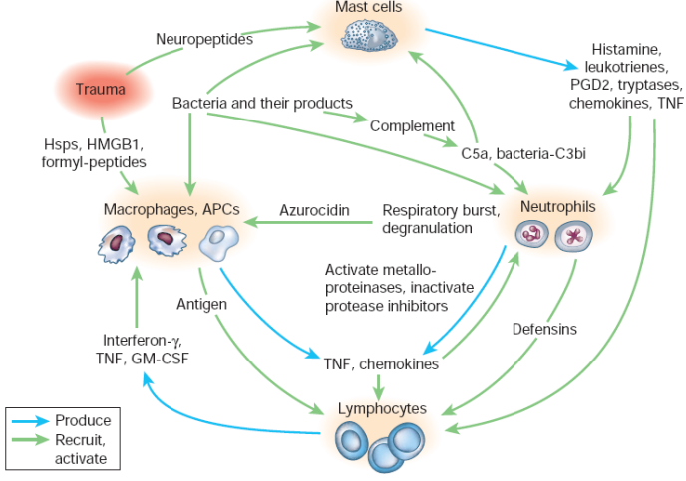
COX and LOX
NF-κB
- NF-κB is a family of transcription factors involved in the expression of numerous immunomodulatory proteins
- An important proinflammatory pathway

Cytokines
- Signal molecules, predominantly glycoproteins, which play an essential role in cell-to-cell communication, and can be produced by a variety of cell types
- Cytokines are most commonly associated with immunomodulation, however they are also implicated in several other cellular functions
- Traditionally, they are classified as possessing antiinflammatory/inhibitory or proinflammatory/stimulatory characteristics
- Pleiotropy and redundancy
- Net immunomodulatory effect dependent on a multitude of factors

Mechanisms of action of steroidal and non-steroidal anti-inflammatory drugs
A. NSAIDs
- Cyclooxygenase inhibitors
  - Arachidonic acid--------------------→ PGE2, PGI2 (Prostoglandins)
COX
COX: 2 forms:
COX-1 (all Tissues) | Consequence of inhibition
Gastric mucosa | Ulceration
Renal function | Acute renal failure
Promote Platelet aggregation | Bleeding tendencies

COX-2 (tissue injury sites, brain) Anti-inflammatory
- Inducible
- *First-generation NSAIDs: non-selective inhibitors of COX-1 and -2
  - Salicylates: Aspirin- irreversible inhibitor
  - Propionic acids: Ibuprofen, Naproxen
  - Others: Indomethacin, Prioxicam

- *Second-generation NSAIDs: COX-2 inhibitors
  - Celecoxib (Celebrex), Rofecoxib (Vioxx)

B. Steroidal anti-inflammatory: glucocortcoids
- (eg. cortisone, prednisolone, betamethasone)
- Pharmacological actions:
- Anti-inflammatory and immunosuppressant effects:
  - -inhibit synthesis of mediators
  - -inhibit phagocytes infiltration
  - -Inhibit proliferation of lymphocytes
- Note: Adverse effects of long-term use: Adrenal insufficiency, osteoporosis, glucose intolerance, myopathy, fluid and electrolyte imbalance, growth retardation, infection, psychologic disturbances, cataracts and glaucoma, peptic ulcer.
Echincaea alkylamides – Anti-inflammatory
Colchicine
- A traditional treatment for gout (arthritis)
- Gout is a painful inflammation caused by deposition of uric acid in joints
- Deposits lead to attack by leukocytes which causes inflammation
- Inhibits leukocyte proliferation of at the site of inflammation
- Acts by inhibiting spindle formation (doubles chromosome number)
- Provides pain relief

Case study: Feverfew
- Feverfew, Tanacetum chrysanthemum is used as an anti-inflammatory and treatment of migraines in European herbal medicine.
- active principle is the sesquiterpene lactone parthenolide
- parthenolide is known to alkylate (covalently bind) proteins through michael addition reaction (using exocylic methylene), but target protein unknown
- Parthenolide alkylation of proteins by “Michael addition” reaction
Kwok et al 2001 undertook semisynthesis of derivatives to work out
Anti-inflammatory activity in rat ears:
- Reduced parthenolide is inactive
- TNF activates and parthenolide inhibits NF-kb phosphorylation
- Reporter gene induction by TNF and inhibition by parthenolide

Fishing out the molecular target
- A biotin-parthenolide (BP) conjugate was prepared synthetically (active)
- TNF stimulated HeLa cells were treated with BP conjugate, then lysed
- biotin binding resin (streptavidin) used to catch and purify BP conjugates and their protein receptor in extracts
- BP was found attached to cell kinase IKKb

IKK activity (KA:GST) is inhibited by parthenolide in wild type HeLa cells but not site directed cys 179A mutant
Feverfew as a prophylactic treatment for migraine: a double blind placebo controlled study
- D. Palevitch et al., 1997, Phytotherapy Research 11: 508-511
- Daily dose: 1 capsule 50 mg powdered dried leaf with 0.2% parthenolide content, 57 patients
- significant reduction in pain intensity compared to placebo
- profound reduction in migraine associated symptoms: vomiting, nausea, sensitivity to noise and light
Feverfew mode of action
- Migraine is associated with release of large amounts of serotonin into the brain
- Parthenolide is a serotonin release inhibitor.
- A convenient assay for serotonin release can be undertaken with platelets, loaded with C14 seretonin, then stimulated by PAF or other activating agent
- Parthenolide inhibits release of C14 into extracellular medium
- Parthenolide has lower IC50 for serotonin release than other sesquiterpene lactones tested

[Parthenolide] predicts activity across all feverfew varieties
This and significant clinical trial led to granting of licence for feverfew with 0.2% parthenolide

