1.1 STAGES
1. Ante-mortem inspection. Antemortem means before death - so this is the inspection of the live animal. The inspector will be looking for animals which are crippled and cannot walk properly. These will be slaughtered separately because they will not be able to negotiate the raceways in the abattoir. The inspector will look for animals with signs of a fever or abnormal behaviour (particularly animals which might have a central nervous system disease). These will be separated and treated specially. For example, this is where outbreaks of very serious diseases like hoof and mouth would first be detected and the panic button activated.
2. Stunning. The animal must be rendered unconscious before it can be killed by exsanguination (except where there are religious exemptions). The method of stunning varies considerably, although concussion is the most widely used method. Hand-operated captive-bolt pistols with a .22 blank cartridge are common, but pneumatic concussion systems or electrical stunning may be used in very large abattoirs.
3. Exsanguination (sticking or bleeding). While unconscious, a sticking knife is used to open the thick hide at the base of the animal's neck. A second knife is used (the first is now dirty) to penetrate the clean tissues under the hide and to sever the major blood vessels from the heart to the head. Care is needed because bacteria may be carried into the animal (veins may have negative pressure) from where the bacteria may rapidly contaminate the meat deep in the carcass.
4. Skinning (removal of hide). Most beef hides are used for leather production. Thus, they are valuable and must not be damaged by cuts as the hide is removed from the carcass. Cuts are made along the medial (inside) faces of the limbs and along the animal's belly to facilitate the removal of whole hides with as little loss as possible. The apparatus used varies with the size of the abattoir. Large abattoirs will have a hide puller which pulls off the whole hide (like skinning a rabbit). Small abattoirs may use an air knife (two counter-oscillating circular blades) which reduce the risk of cutting through the hide. At a local level, a skinning knife may be used - but this will be a lengthy operation.
5. Evisceration (removal of guts). The viscera are removed from posterior to anterior (from the rear of the animal to the front), starting in the abdominal cavity and finishing in the thoracic cavity. The udder or penis are first to be removed, together with any cod fat in the region between the animal's hindlimbs. This opening then allows removal of the bladder and uterus (if a female), followed by large and small intestines. Great care is taken in the removal of the anus and rectum, which are first closed off with a plastic bag to prevent faecal contamination of the carcass. Similarly, the oesophagus is tied off at the other end of the gut to prevent contamination of the throat of the carcass. After the intestines, the rumen is removed, followed by the liver and diaphragm. The diaphragm separates abdominal and thoracic cavities and must be cut away from the rib cage. The muscular part of the diaphragm remains on the carcass (it is composed of edible red meat). The lungs, heart and trachea are removed together - these items are called the "plucks".
6. Post-mortem inspection. This is a search for parasites, infected lymph nodes and signs of disease in the viscera removed from the carcass. Key components to be inspected are usually spread out on a large tray.
7. Final carcass preparation. This includes trimming (bruises and tags of inappropriate tissues remaining on the carcass), washing and weighing. Washing frequently includes a rinse with fluids such as lactic acid which have antibacterial properties.
8. Chilling. Meat is NEVER frozen straight off the kill floor, but must be cooled as rapidly as possible to reduce surface bacterial spoilage. The first meat cooler is around zero degrees centigrade with a high air speed and a high humidity. It takes all day to cool down a large mass of meat. The day after slaughter, carcasses are moved to a less severe environment (high air speed would dry the carcass too much, while a high humidity would encourage spoilage by surface moulds). Despite the importance of reducing meat spoilage, the carcass must not be cooled too rapidly or else the muscles will shorten (COLD SHORTENING) and the meat will become very tough. The rule of thumb for beef is not to get below 10 C within 10 hours of slaughter.

Preparation for slaughter
The optimum amount of rest required by meat animals before they are slaughtered depends on the climate, the distance they have travelled, their method of transport and their general health. In some countries, where animals are auctioned at stock yards before they are taken to an abattoir, the rest periods are sometimes inadequate. This creates a commercial problem that is difficult to evaluate. On one hand, animals lose weight during transport and in holding pens, and it is undesirable to use pens and labour to prolong a rest period that confers no immediately obvious commercial advantage. On the other hand, stressed or weary animals sometimes produce meat with an unacceptable appearance or water holding capacity, and this may create economic losses later on. Animals lose about 0.2% per hour of their live weight once feeding has ceased, but this is very variable. For beef cattle, losses in 48 hours of fasting may range from less than 1% to 8%. About half the live weight loss shows up as a loss in carcass weight. However, improvements may be gained by electrolyte therapy, allowing animal’s free access to drink electrolytes during lairage.
In some situations, a rest period of one day for cattle and two or three days for pigs is considered to be optimum. However, such rest periods may be counterproductive if the animals fight among themselves. Animals are not fed in the 24 hour period prior to slaughter.
1.2 ANTIMORTEN INSPECTION
1. Disease. A zoonosis is a disease of animals which may be secondarily transmitted to man. The plural is zoonoses.
2. Drugs. It is difficult to detect animals which have been given drugs then slaughtered without an adequate clearance time - but every effort is made to look for signs of this. Obviously, animals still containing veterinary-grade drugs pose a health risk to consumers.
3. Accommodation. The meat inspector is responsible for ensuring the lairage (the pen where the animal rests) and animal holding standards meet the legal rquirements for the humane treatment of animals.
4. Humane slaughter . The meat inspector is responsible for ensuring the animal feels no pain when slaughtered. Thus, the animal must first be rendered unconscious before it is killed by exsanguination.
5. Separate sick animals. The meat inspector is in charge of ensuring sick or crippled animals are separated from the group for special attention. Animals may be healthy and walking normally when they board their transport, but their condition may change during the journey.

1.3 STUNNING, EXANGUINATION, EVISCERATION

Stunning methods

There are several criteria for a good slaughter method:
(1) animals must not be treated cruelly,
(2) animals must not be unnecessarily stressed,
(3) exsanguination must be as rapid and as complete as possible,
(4) damage to the carcass must be minimal, and the method of slaughter must be
(5) hygienic,
(6) economical and
(7) safe for abattoir workers.
To avoid the risk of cruelty, animals must be stunned or rendered unconscious before they are exsanguinated. When religious reasons do not allow stunning, extra care is needed to ensure that exsanguination causes the minimum of distress to the animal. In the Kosher method of killing, conscious cattle are suspended with the head stretched back, and then the throat and its major blood vessels are severed. Drugs cannot be used in the meat industry to induce unconsciousness in animals for slaughter since unacceptable residues would remain in the meat.
Animals can be effectively stunned by concussion. Concussion may be induced by a bullet or a bolt that penetrates the cranium, or by the impact of a fast-moving knocker on the surface of the cranium. In modern abattoirs, the primitive pole-axe has been replaced by devices which use expanding gas, either from an air-compressor or from a blank ammunition cartridge. First, the animal is restrained in a narrow pen or knocking box in order to minimize its head movements. The concussion instrument is then accurately located at a point on the midline of the skull, above the level of the brow ridges of the eye sockets. Concussion stunning should not be applied on the neck or posterior part of the skull.
The knocker is a heavy instrument held with both hands. There is a safety catch on the handle, but the actual trigger protrudes from the head of the knocker and is activated as the knocker is tapped against the animal's head. The captive bolt pistol resembles a heavy hand gun, but a blank cartridge is used to propel a cylindrical bolt rather than a bullet into the skull. After penetration, the bolt is withdrawn into the barrel of the pistol and the pistol is reloaded. Steers, heifers and cows are normally stunned with a knocker or a heavy captive bolt pistol, but bulls and boars which have massive skulls are sometimes shot with a rifle bullet. Pigs and lambs may be stunned with a light-weight captive bolt pistol.
Exsanguination
Cattle and pigs are usually exsanguinated by a puncture wound which opens the major blood vessels at the base of the neck, not far from the heart. The trade name for this process is sticking. In sheep, lambs and small calves, the major blood vessels may be severed by a transverse cut across the throat, near to the head. Poultry can be exsanguinated with a diagonal cut from the corner of the jaw towards the ear on the other side, or by a knife thrust through the roof of the mouth to severe the brain and its major blood vessels. For poultry, the cut may be made on the side of the head if the head is later to be removed automatically by machine.
If the sticking wound is inaccurately placed, exsanguination may be too slow, and it may be almost halted by the formation of large blood clots. The formation of blood clots is accelerated when large areas of tissue are damaged by repeated inaccurate punctures. If the trachea is severed by the sticking wound, blood may be drawn into the lungs as the animal breathes. Later in the slaughter procedure, this may necessitate the trimming of blood clots from the pleural membranes after they have been inspected. If the oesophagus is severed, the vascular system may be contaminated by the entry of food particles into the venous system. If the connective tissues of the shoulder are opened, blood may seep into the shoulder region to form blood clots between the muscles.
Incomplete exsanguination increases the amount of residual blood in the carcass. The lean meat may then appear unduly dark and the fat may become streaked with blood. On the surface of incompletely exsanguinated poultry, the skin may appear dark and bloody over the breast, neck, shoulders and wings. The microscopic tissue damage that may later be caused by the freezing and thawing of poultry enables residual blood to leak from skin capillaries. Thus, the results of incomplete exsanguination are often more noticeable to the consumer than to the producer.
The exsanguination or sticking of meat animals in an abattoir is usually performed by severing the carotid arteries and the jugular vein at the base of the neck. In poultry, these vessels may be cut only on one side of the neck. The sticking knife must be kept clean otherwise bacteria might be introduced into the venous system and spread through the otherwise relatively sterile muscles of the carcass. Once exsanguination has started, the pulse and mean blood pressure rapidly decline because of the reduced stroke volume of the heart. Blood pressure changes are monitored physiologically by baroreceptors in the carotid sinuses. During exsanguination, respiratory movements of the thorax may be stimulated, and neurogenic and hormonal mechanisms attempt to restore the blood pressure by increasing the peripheral resistance by vasoconstriction. The heart keeps beating for some time after the major blood vessels are emptied, but rapidly stops if exposed and cooled. Electrical stunning of pigs may terminate cardiac activity so that, at the start of exsanguination, the blood escapes by gravity rather than being pumped out. In pigs, cardiac arrest does not affect the rate and extent of exsanguination. After exsanguination has started, the heart usually re-starts and attempts to pump, until it runs out of energy. Thus, in many cases, there is no reason why animals such as pigs and sheep cannot be killed by electrocution rather than being merely electrically stunned. In cattle stunned by concussion, more or less complete exsanguination may be obtained without ventricular pumping. Similarly, normal exsanguination is obtained in poultry that have been killed by electrocution rather than by being electrically stunned. In meat animals, "head to back" stunning may be used to stop the heart.
Blood loss as a percentage of body weight differs between species: cows, 4.2 to 5.7%; calves, 4.4 to 6.7%; sheep, 4.4 to 7.6%; and pigs, 1.5 to 5.8%. Blood content as a percentage of live weight may decrease in heavier animals since the growth of blood volume does not keep pace with growth of live weight. Approximately 60% of blood is lost at sticking, 20-25% remains in the viscera, while a maximum of 10% may remain in carcass muscles. Different stunning methods may modify the physiological conditions at the start of exsanguination and, also, the neural responses to exsanguination. Electrically stunned sheep lose more blood than those stunned with a captive bolt, but they also have more blood splashes in their carcasses.
Reduction of blood flow to the kidneys causes the release of a proteolytic enzyme, renin, which acts on a plasma protein to produce a polypeptide, angiotensin I. This polypeptide is converted enzymatically to angiotensin II which then causes widespread vasoconstriction. Vasoconstriction is important because it decreases the retention of blood in meat. Angiotensin II vasoconstriction is operative in both conscious and anaesthetized animals. Catecholamines and antidiuretic hormone (ADH) may also enhance vasoconstriction during exsanguination. Speed of exsanguination may modify the balance between neural and hormonal vasoconstrictive mechanisms, with hormonal vasoconstriction predominating in rapid exsanguination. However, asphyxia prior to exsanguination may result in vasoconstriction due to the activity of the sympathetic nervous system.
It is traditionally maintained that poor bleeding leads to dark meat with poor keeping qualities due to microbial spoilage and rancidity. However, there is little scientific evidence in support of this view, and it may be false, even in animals which retain massive amounts of blood in their carcasses. Delayed exsanguination of cattle may lead to a slight reduction in the amount of blood removed so that the carcass and spleen are slightly heavier. The effects on meat quality, however, are negligible. I am certainly not proposing that poor exsanguination is a good thing, but should it occur, it is not such a disaster as some meat inspectors suppose.
Factors that regulate the balance between extracellular and intracellular fluid compartments in meat are poorly understood. Fluid is delivered to living muscles by arteries, but it may return to the heart by either of two routes, in the venous system or in the lymphatic system. The route taken by intercellular fluid depends primarily on the extent to which fluid is taken up by capillaries and then passed to the venous system. In living animals, the venous return is far greater than the lymphatic return. The lymphatic capillaries which drain skeletal muscles are mostly located in the connective tissue around bundles of muscle fibres. The small amount of lymph that drains from muscles is increased after neural stimulation, and its lactate dehydrogenase content (LDH - an enzyme from within the muscle fibre) increases dramatically following muscle damage. In sheep, the flow of lymph from lymph nodes increases within 15 minutes of stress due to pain. Haemorrhage may or may not cause absorption of intercellular fluid into the blood stream, depending on the degree of vasoconstriction and consequent hydrostatic pressure in the vasculature.

Blood to the brain
Arterial blood to the brain is evenly distributed by a circular pattern of arteries called the circle of Willis. The circle of Willis receives blood from the intracranial carotid rete (a rete is a meshwork of blood vessels). In sheep, the external carotid arteries supply the intracranial carotid rete, via the internal maxillary arteries since the internal carotid arteries are absent in adults. However, blood may also reach the intracranial carotid rete from vertebral arteries via the occipito-vertebral anastomosis (an anastomosis is a communicating link between two vessels). The situation in cattle is similar, but with an additional supply to the intracranial carotid rete from vertebral and occipital arteries. The extent to which intact vertebral arteries might prolong a supply of oxygenated blood to the brain once an animal's throat has been cut is difficult to assess. In sheep, consciousness may persist for 65 to 85 seconds. In pigs, the delay between exsanguination and termination of electroencephalographic (EEG) activity is approximately 20 seconds following proper stunning. However, anoxia causes the dilation of cerebral blood vessels so that their storage capacity may be increased. An important point to bear in mind in considering studies on this topic is the difference between severing the carotid arteries (as in the Jewish Shechita method) and in ligation of the carotids (as in experiments attempting to simulate Shechita conditions). In the former case there is a rapid loss of blood supply to the brain whereas, in the latter case, the blood supply may be maintained.

Utilization of blood
The recovery of animal blood for utilization in food products for human consumption should be attempted. The main problems are to prevent the contamination of collected blood by bacteria from the skin, and to keep the blood of different animals separate until their carcasses have passed veterinary inspection for human consumption. Blood may be collected hygienically with a hollow knife. Coagulation of the blood can be prevented by the addition of anticoagulants such as citric acid or sodium citrate. Alternatively, the fibrin which binds blood clots together can be removed by stirring with a paddle. When utilized for human food or pet food, blood contains easily assimilated iron. Blood proteins have a high nutritional value and a high water binding capacity in processed products. The red blood cells burst if water is added to blood. If they are kept intact, red blood cells can be removed by centrifugation in order to prepare plasma. Plasma is a yellow liquid, rather like egg-white, and it may be dried to a powder for use in human food. If blood is discharged into the abattoir effluent instead of being utilized, it increases the biological oxygen demand (BOD) of the effluent. Chemical oxygen demand is another index of the pollution load of the abattoir effluent: it can be measured in several hours rather than in the several days required for BOD determinations.

Evisceration
A method for eviscerating, cleaning and trimming a beef animal to produce a dressed carcass is described below. In this case, the carcass has already been suspended on an overhead rail in a manner that enables the removal of the distal parts of the hindlimbs.
(1) skin the head and remove the skull and lower jaw, leaving the whole of the neck and the skin of the head hanging on the carcass,
(2) remove each foot and the distal part of each limb by cutting through the joint immediately proximal to the long cannon bone,
(3) make a long incision through the hide in the midline of the chest and abdomen, and continue the incision along the medial face of each of the limbs,
(4) remove the hide altogether if suitable equipment is available, or just remove it from the ventral part of the body and leave it temporarily hanging from the animal's back,
(5) open the thoracic cavity with a midventral saw-cut through the breast bone or sternum,
(6) open the abdomen with a long mid-ventral incision, and remove the penis or udder tissue, and any loose fat in the abdominal cavity,
(7) split the pelvic girdle with a mid-ventral knife-cut or saw-cut through the cartilage that separates the pelvic bones in the midline,
(8) cut around the anus and close it off with a plastic bag,
(9) skin out the tail (if this was not done earlier),
(10) separate the esophagus (which takes food to the stomach) from the trachea (which takes air to the lungs), by pulling the esophagus through a metal ring; close off the esophagus by knotting it,
(11) eviscerate the carcass by pulling out the bladder (and uterus if present),intestines and mesenteries,rumen and other parts of the stomach,liver; after cutting through the diaphragm, remove the plucks (heart, lungs and trachea),
(12) separate the left and right sides of the carcass by sawing down the midline of the carcass, through the vertebral column,
(13) trim and weigh the carcass to obtain its HOT WEIGHT,
(14) wash the carcass and pin a shroud over it to smooth the subcutaneous fat.
The other species of meat animals are treated in a corresponding manner, except for the head, feet and hide. With calves, the skin may be left on until the eviscerated carcass has been chilled. Beef carcasses are first shackled with a chain around the foot, but before the feet are removed, the carcasses are re-suspended from a hook under the Achilles tendon at each hock. However, the feet are usually left on pork carcasses. After being shackled during exsanguination, usually by one hindlimb, pork carcasses are re-suspended from a hooked bar or gambrel. This is inserted beneath tendons that have been freed underneath the hind-feet. When pigs are shackled by one hindlimb during exsanguination, differences in meat tenderness may be created between left and right hams. In some abattoirs, carcasses are skinned while they are on a metal cradle which holds them off the floor.
Washing of the dressed carcass is more complex than it might first appear. Apart from considerations relating to water purity and waste treatment, consideration must be given to sanitizing factors such as chlorine, organic acids and high temperature. Sanitizing agents may greatly reduce the levels of surface bacteria when the carcass is washed, but at the risk of hiding poor sanitation at earlier stages of processing. There is much to commend the philosophy of preventing initial contamination rather then removing it once it is present.
Composition of 550 kg steer
60.0% carcass
10.0% fill (gut contents, etc)
7.3% hide
7.2% inedible organs
6.0% head,tail & feet
2.4% diaphragm and internal (visceral) fat
1.4 POSTMORTEM INSPECTION
The retropharyngeal, submandibular and carotid lymph nodes of the head are inspected and a search is made for evidence of parasitic infections
1.5 EDIBLE ORGANS
Several edible organs are obtained on the kill floor:-
1. tongue,
2. tail,
3. liver,
4. sweetbreads (thymus gland),
5. hanging tender (thick diaphragm muscle),
6. kidneys, and
7. heart.
1.6 DEFINITION OF CARCASS
The carcass is defined by law as the animal minus the following:-
1. hide,
2. head and tail,
3. shanks of fore and hind legs,
4. spinal cord,
5. internal organs and their contents,
6. internal fats,
7. external cod fat (in pubic region), and
8. udder fat (if present).

Dressing percentage
Dressing percentage = carcass weight / live weight %
The dressing percentage is a measure of the carcass yield but is influenced by a number of extraneous factors. If the animal is caked in dried mud or has a high content of gut fill, the dressing percentage will be decreased. If a large amount of visceral fat is removed, the dressing percentage will be decreased. If the animal has massive bones, the dressing percentage will be increased - even though bones contribute no edible part of the carcass. Thus, dressing percentage is a useful measure of yield - but must be viewed critically.

1.7 DIGESTIVE SYSTEM

The structure of the mouth and teeth will be considered later in Lab 5.
Here we will consider the following parts of the alimentary tract:-
1. oesophagus,
2. reticulum,
3. rumen,
4. omasum,
5. abomasum,
6. small intestine,
7. caecum, and
8. large intestine.
As well as the following organs:-
1. liver,
2. pancreas, and
3. spleen.

1.8 CARCASS LYMPH NODES

ischiatic
2. scrotal
3. deep inguinal
4. internal iliac
5. external iliac
6. lumbars
7. renal
8. intercostals
9. sternals
10. anterior sternal
11. prepectoral
12. popliteal
13. precrural
14. prescapular

Lymphatic system
Blood is brought to the body tissues in arteries and is removed by veins. However, interstitial fluid from between the cells of a tissue also is removed by the lymphatic system. Lymph vessels have extremely thin walls, and the lymph fluid they contain is wafted along by body movements that massage the lymph vessels. A system of flap-like valves prevents backward movement of the lymph. As well as fluids, the lymphatic system also recycles proteins that leak from the vascular system. This is an important factor in the determination of the osmotic balance between the interstitial fluid and the blood. In starved animals, the scarcity of blood proteins unbalances the system and leads to the accumulation of interstitial fluid (edema).
If body tissues are invaded by disease-forming bacteria, some of the bacteria drift into the lymphatic system. The lymphatic system is arranged like a system of rivers leading to an estuary. The final opening of the system is called the right thoracic duct, and this returns the lymph to the vascular system at a point where the main veins of the body enter the heart. Lymph nodes with a gland-like appearance are located at regular intervals throughout the lymphatic system (Figure 1-27). Their function is to filter and destroy invading bacteria. When lymph nodes are successful, they prevent the spread of disease from the region of tissue that has been invaded. The activated lymphocytes of the lymphatic system may play a major role in attacking and destroying invading bacteria.
The lymph nodes that guard healthy tissues are compact in structure and pale brown in color. They become swollen and discolored when they are activated by invading bacteria. The meat inspector systematically examines the lymph nodes of the viscera and the dressed carcass. Lymph nodes that appear to be abnormal are sliced open for inspection. Knives must be re-sterilized once they have been used to open an infected lymph node. Once alerted to the presence of diseased tissue, the inspector determines the type and severity of the disease. The whole of the carcass or just the diseased parts may be condemned. It is essential, therefore, that any offals that have already been removed from the carcass can all be traced back to the carcass from which they originated. This also includes any blood which may have been collected as an ingredient for processed meat products. Blood for human consumption is usually collected with a hollow knife in order to minimize contamination from the surface of the carcass.
LAB 2: Pork Slaughter and Digestive System
2.1 STAGES OF SLAUGHTER OPERATION
*mostly the same as cattle with a few exceptions in yello
1. Ante-mortem inspection. Antemortem means before death - so this is the inspection of the live animal. The inspector will be looking for animals which are crippled and cannot walk properly. These will be slaughtered separately because they will not be able to negotiate the raceways in the abattoir. The inspector will look for animals with signs of a fever or abnormal behaviour (particularly animals which might have a central nervous system disease). These will be separated and treated specially. For example, this is where outbreaks of very serious diseases like hoof and mouth would first be detected and the panic button activated.
2. Stunning. The animal must be rendered unconscious before it can be killed by exsanguination (except where there are religoius exemptions). The method of stunning varies considerably. Hand-operated captive-bolt pistols with a .22 blank cartridge are common in small abattoirs, but electrical stunning or carbon dioxide stunning are used in large abattoirs. Electrical stunning uses an alternating current to induce unconsciousness. It may be applied with electrodes transversely across the head or, alternatively, longitudinally from the head to the back (anterior to posterior). For carbon dioxide stunning the pigs travel down into a pit (carbon dioxide is much heavier than air) where they become unconscious.
3. Exsanguination (sticking or bleeding). While unconscious, a sticking knife is used to open the thick skin at the base of the pigs's neck. A second knife is used (the first is now dirty) to penetrate the clean tissues and sever the major blood vessels near the heart. Thus, the puncture wound for pigs is much deeper into the thoracic cavity than for cattle. Care is needed to avoid damaging tissues around the trachea, otherwise blood enters the pleural space and forms clots on the inside of the thoracic cavity. Care is needed because bacteria may be carried into the animal (veins may have negative pressure) from where the bacteria may rapidly contaminate the meat deep in the carcass.
4. Hair removal. Although some abattoirs have a hide puller which pulls off the whole hide (like skinning a rabbit) for use in making pigskin leather (for gloves and hush-puppy shoes), most abattoirs remove the hair but leave the skin on the carcass. The skin is removed when the carcass is butchered (usually the day after slaughter) and is used for the manufacture of food-grade gelatin.
5. Evisceration (removal of guts). The viscera are removed from posterior to anterior (from the rear of the animal to the front), starting in the abdominal cavity and finsihing in the thoracic cavity. The mammary glands or penis are first to be removed. This opening then allows removal of the bladder and uterus (if a female), followed by large and small intestines. Great care is taken in the removal of the anus and rectum, which are first closed off with a plastic bag to prevent faecal contamination of the carcass. Similarly, the oesophagus is tied off at the other end of the gut to prevent contamination of the throat of the carcass. After the intestines, the stomach is removed, followed by the liver and diaphragm. The diaphragm separates abdominal and thoracic cavities and must be cut away from the rib cage. The muscular part of the diaphragm remains on the carcass (it is composed of edible red meat). The lungs, heart and trachea are removed togther - these items are called the "plucks".
6. Post-mortem inspection. This is a search for parasites, infected lymph nodes and signs of disease in the viscera removed from the carcass. Key components to be inspected are usually spread out on a large tray.
7. Final carcass preparation. This includes trimming (bruises and tags of inappropriate tissues remaining on the carcass), washing and weighing. Was
8. Chilling. Meat is NEVER frozen straight off the kill floor, but must be cooled as rapidly as possible to reduce surface bacterial spoilage. The first meat cooler is around zero degrees centigrade with a high air speed and a high humidity. It takes all day to cool down a large mass of meat. The day after slaughter, carcasses are moved to a less severe environment (high air speed would dry the carcass too much, while a high humidity would encourage spoilage by surface moulds). Cold shortening can occur in pork, but is seldom a commercial problem because the pork carcass retains its skin and subcutaneous fat - so cooling is quite slow.

2.2
Same as above

2.3 STUNNING, EXSANGUINATION, EVISCERATION

Stunning methods
Animals may be stunned by passing an alternating electric current through the brain. The method is widely used for stunning pigs and poultry. Unconsciousness is induced by a wide range of voltages, from about seventy volts to several hundred volts. The length of time that the current is passed through the brain may be reduced to only one or two seconds if abattoir workers are waiting to shackle the pig's hindlimb with a chain, and then to exsanguinate the animal immediately. With a simple, hand-held electric stunner, the current is applied to the pig's head with two electrodes that protrude from an insulated handle. The electrodes must be cleaned at frequent intervals to ensure good electrical contact with the pig. The transformer which supplies the current is usually mounted on a nearby wall. However, large automated stunning systems are used in most commercial abattoirs and these may have one of a variety of different patterns of electrodes. Some designs have a current flow through the chest to stop the heart (although the heart starts to beat again when the pig is hoisted up on a shackling chain). High voltage head to back stunning intended to stop the heart may cause vertebral fractures and blood splashes in the meat if the system is not carefully operated and monitored. Essentially, if the rear electrode is moved forward there is less damage to the carcass, but also a reduced probability of stopping the heart. High frequency electrical stunning of pig may be used to reduce carcass damage.
Pigs may be stunned by placing them in an atmosphere which contains 65% carbon dioxide. Carbon dioxide is heavier than air and is trapped in a pit or deep tunnel into which the pigs are conveyed. After about one minute, the pigs are withdrawn in a cage or on a conveyer belt, and are then exsanguinated as rapidly as possible. Carbon dioxide stunning requires some major features in the architecture of the abattoir which make it difficult to retro-fit whereas automated electrical stunning apparatus is simple to incorporate because it does not require pits or tunnels. Modern carbon dioxide stunning apparatus is very effective because carbon dioxide concentration can be accurately controlled by solid-state gas sensors. In older system the gas levels were not accurately controlled.

Exsanguination

if the sticking wound is inaccurately placed, exsanguination may be too slow, and it may be almost halted by the formation of large blood clots. The formation of blood clots is accelerated when large areas of tissue are damaged by repeated inaccurate punctures. If the trachea is severed by the sticking wound, blood may be drawn into the lungs as the animal breathes. Later in the slaughter procedure, this may necessitate the trimming of blood clots from the pleural membranes after they have been inspected. If the oesophagus is severed, the vascular system may be contaminated by the entry of food particles into the venous system. If the connective tissues of the shoulder are opened, blood may seep into the shoulder region to form blood clots between the muscles.
Incomplete exsanguination increases the amount of residual blood in the carcass. The lean meat may then appear unduly dark and the fat may become streaked with blood.
The sticking knife must be kept clean otherwise bacteria might be introduced into the venous system and spread through the otherwise relatively sterile muscles of the carcass. Once exsanguination has started, the pulse and mean blood pressure rapidly decline because of the reduced stroke volume of the heart. Blood pressure changes are monitored physiologically by baroreceptors in the carotid sinuses. During exsanguination, respiratory movements of the thorax may be stimulated, and neurogenic and hormonal mechanisms attempt to restore the blood pressure by increasing the peripheral resistance by vasoconstriction. The heart keeps beating for some time after the major blood vessels are emptied, but rapidly stops if exposed and cooled. Electrical stunning of pigs may terminate cardiac activity so that, at the start of exsanguination, the blood escapes by gravity rather than being pumped out. In pigs, cardiac arrest does not affect the rate and extent of exsanguination. After exsanguination has started, the heart usually re-starts and attempts to pump, until it runs out of energy.
Blood loss as a percentage of body weight differs between species: cows, 4.2 to 5.7%; calves, 4.4 to 6.7%; sheep, 4.4 to 7.6%; and pigs, 1.5 to 5.8%. Blood content as a percentage of live weight may decrease in heavier animals since the growth of blood volume does not keep pace with growth of live weight. Approximately 60% of blood is lost at sticking, 20-25% remains in the viscera, while a maximum of 10% may remain in carcass muscles. Different stunning methods may modify the physiological conditions at the start of exsanguination and, also, the neural responses to exsanguination
Reduction of blood flow to the kidneys causes the release of a proteolytic enzyme, renin, which acts on a plasma protein to produce a polypeptide, angiotensin I. This polypeptide is converted enzymatically to angiotensin II which then causes widespread vasoconstriction. Vasoconstriction is important because it decreases the retention of blood in meat. Angiotensin II vasoconstriction is operative in both conscious and anaesthetized animals. Catecholamines and antidiuretic hormone (ADH) may also enhance vasoconstriction during exsanguination. Speed of exsanguination may modify the balance between neural and hormonal vasoconstrictive mechanisms, with hormonal vasoconstriction predominating in rapid exsanguination. However, asphyxia prior to exsanguination may result in vasoconstriction due to the activity of the sympathetic nervous system.
Factors that regulate the balance between extracellular and intracellular fluid compartments in meat are poorly understood. Fluid is delivered to living muscles by arteries, but it may return to the heart by either of two routes, in the venous system or in the lymphatic system. The route taken by intercellular fluid depends primarily on the extent to which fluid is taken up by capillaries and then passed to the venous system. In living animals, the venous return is far greater than the lymphatic return. The lymphatic capillaries which drain skeletal muscles are mostly located in the connective tissue around bundles of muscle fibres. The small amount of lymph that drains from muscles is increased after neural stimulation, and its lactate dehydrogenase content (LDH - an enzyme from within the muscle fibre) increases dramatically following muscle damage. In sheep, the flow of lymph from lymph nodes increases within 15 minutes of stress due to pain. Haemorrhage may or may not cause absorption of intercellular fluid into the blood stream, depending on the degree of vasoconstriction and consequent hydrostatic pressure in the vasculature.

Utilization of blood
The recovery of animal blood for utilization in food products for human consumption should be attempted. The main problems are to prevent the contamination of collected blood by bacteria from the skin, and to keep the blood of different animals separate until their carcasses have passed veterinary inspection for human consumption. Blood may be collected hygienically with a hollow knife. Coagulation of the blood can be prevented by the addition of anticoagulants such as citric acid or sodium citrate. Alternatively, the fibrin which binds blood clots together can be removed by stirring with a paddle. When utilized for human food or pet food, blood contains easily assimilated iron. Blood proteins have a high nutritional value and a high water binding capacity in processed products. The red blood cells burst if water is added to blood. If they are kept intact, red blood cells can be removed by centrifugation in order to prepare plasma. Plasma is a yellow liquid, rather like egg-white, and it may be dried to a powder for use in human food. If blood is discharged into the abattoir effluent instead of being utilized, it increases the biological oxygen demand (BOD) of the effluent. Chemical oxygen demand is another index of the pollution load of the abattoir effluent: it can be measured in several hours rather than in the several days required for BOD determinations.

Evisceration

The viscera are removed from posterior to anterior - first the viscera from the abdominal cavity, then removal of the diaphragm, then the plucks (trachea, heart + lungs).
2.4 POSTMORTEM INSPECTION
1. Inspection of submaxillary gland.
2. Inspection of carcass.
3. Inspection of abdominal viscera and lymph nodes.
2.5 EDIBLE ORGANS AND CARCASS
1. Liver
2. Heart
3. Tongue
4. Kidneys
5. Tail
6. Feet
7. Head

Carcass = entire body of the hog excluding all the internal organs apart from the kidneys.

Head, feet, leaf-lard, kidneys and tail are part of the hot carcass weight and are only removed after the hot carcass weight is known.

Typical dressing percentage (hot carcass weight / live weight) is 75-80%.
2.6 DIGESTIVE SYSTEM
1. Oesophagus. The red muscle nearest the mouth is where swallowing is initiated by voluntary muscle. Thereafter, the bolus of food is moved down the oesophagus by smooth muscle peristalsis.

2. There is a simple stomach (pig is monogastric) with one main chamber.

Gland regions are defined histologically but are not evident from an outside view.
1. cardiac gland region
2. oesophageal gland region
3. fundic gland region
4. pyloric gland region
3. Small intestine (duodenum, jejunum & ileum)

3. The small intestine is important for the absorption of digested food.
Villus - small projections into the lumen (hollow cavity) of the small intestine
Lacteal - collects lymph fluid with digested fat
Lymph vessel - collects lymph from lacteals
Cisterna chyli - collects all the lymph from intestines and remainder of body
Right thoracic duct - empties lymph into main blood stream of the posterior vena cava

4. Caecum - dead-end, like the human appendix only much larger.

5. Large intestine

6. Look for mesenteric lymph nodes.

7. The pig liver has four large lobes plus a small caudate lobe.

Hepatic Artery - brings arterial blood to the corners of the lobule.
Hepatic Portal Vein - brings blood with dissolved nutrients from the small intestine.
Hepatic Vein - located centrally and removes blood processed by the liver lobule.
Branch of Bile Duct - collects bile at the corners of the lobule

Natural Casings.
These are important by-products of the abattoir. After extensive cleaning and preservation in salt they are used as sausage skins (natural casings).

Rounds - Small Intestine - Beef, Pork, Lamb
Runners - Small Intestine - Beef
Middles - Large Intestine - Beef, Pork
Beef Bungs - Caecum - Beef
Hog Bungs - Large & Small Intestine - Pork
Caps - Caecum - Pork
Weasand - Oesophagus - Beef
Bladder - Bladder - Beef, Pork
Lab 3: Heart, Lungs, and Kidney
The right ventricle pumps blood through the semilunar valves and into the pulmonary arteries and then to the lungs.
Oxygenated blood returns to the left atrium in the pulmonary veins, through the bicuspid valve.
- The atrium fills the left ventricle, and oxygenated blood is then pumped through the aorta to the body tissues.
- The aorta branches to form the major arteries. These branch again many times and eventually give rise to arterioles and, finally, to capillaries.
- Blood is collected from the body tissues by the venous system, and eventually returns to the right atrium via the anterior vena cava and the posterior vena cava for another cycle through the lungs. Thus, relative to other arteries, the pulmonary artery is unusual because it contains de-oxygenated blood. And, relative to other veins, the pulmonary vein is unusual because it contains oxygenated blood.
- In the arterial system of meat animals, the aorta bends to the LEFT side of the body, and then runs posteriorly in the midline, ventral to the vertebral column. It supplies arterial blood to all the body except the lungs.
- In the arterial system of poultry, the aorta swings to the RIGHT side of the body after leaving the heart .
- If poultry develop heavy muscling, the thin-walled right ventricle may be unable to cope with the increased cardiovascular demands and the ventricular wall may thicken as it adapts to the situation. But this may prevent the atrioventricular valve from functioning properly and the back pressure to the liver may cause ascites, an accumulation of fluid in the abdomen that may kill the bird.
- The venous system of meat animals is dominated by the anterior and posterior vena cava.
- The venous system of poultry is distinguished by a loop in the neck created by the jugular anastomosis and a loop around the kidneys.

Cardiac muscle fibres. There are three different types of muscle tissue in the body -smooth, cardiac and skeletal. Smooth muscle occurs in the digestive and reproductive tracts, cardiac muscle is only found in the heart, while skeletal muscle forms all the meat of the commercial carcass. Most cardiac muscle cells are mononucleate. They are arranged in rows to form branching fibers, but individual cells are separated by intercalated discs. Cardiac muscles have a striated appearance due to the precise alignment of sliding filaments in their contractile fibrils, but skeletal muscles also are striated.

Action potentials. Cardiac muscle cells are continuously pumping out sodium ions through their membranes. This causes the inside of the cell to have an electrical charge of approximately -90 mV with respect to the outside of the cell. This is called a resting potential. Extrinsic factors such as electrical activity (ionic movements) in adjacent cells may decrease the resting potential towards zero. When it reaches a value of approximately -65 mV, the threshold potential, the decrease in electrical potential accelerates, and it shoots past the zero value so that for a brief instant (about one tenth of a second) the membrane potential is positive. This sudden reversal of electrical charges is called an action potential. Action potentials are propogated into the interior of cardiac muscle cells by transverse tubules. In each cell, the transverse tubular system is an extensive series of finger-like indentations of the surface membrane.

Cardiac contraction. This is the same as the contraction of skeletal muscle - which is described in LEC 11. The arrival of an action potential in the interior of the cardiac muscle cell causes the release of calcium ions from the sarcoplasmic reticulum. The sarcoplasmic reticulum is a series of membrane-bounded vesicles in the interior of the cell. Unlike the transverse tubular system, the sarcoplasmic reticulum does not open to the surface of the muscle cell. Units of the sarcoplasmic reticulum surround the contractile fibrils in the interior of cardiac muscle cells. The sarcoplasmic reticulum sequesters and stores calcium ions, but it releases them again when prompted to do so by the transverse tubular system. Calcium ions activate the system of sliding protein filaments which is responsible for muscle contraction.

Intrinsic rhythm. The intrinsic rhythm of heart contraction originates from a group of cells at the sinu-atrial node. The membranes of these cells behave as if they had a sodium ion leak. Thus, at regular intervals their resting potentials drop to their threshold values, and they initiate action potentials. Action potentials then spread in a coordinated wave through right and left atria. The atria then contract and pump blood into the ventricles. However, the ventricles also are capable of filling themselves as they expand after pumping out their previous fill of blood. Under normal conditions, atrial contraction contributes to the overall cardiovascular efficiency, but its contribution may become vital when the heart is weakened by disease. In the medial wall of the heart, at the junction between the atria and ventricles, is a sensitive group of cells forming the atrioventricular node. This node is connected to a conduction system called the bundle of His that runs down the medial wall separating left and right ventricles. The atrioventricular node is activated by contraction of the atrial cells, and the bundle of His conducts the action potential wave to the base of the ventricles. From this point, a wave of contraction spreads upwards through the ventricles so that the the blood that has just filled the ventricles is now pumped out of the heart. The intrinsic heart rate is determined by the rate at which the sinu-atrial cells "leak" or depolarize, by the value of their threshold potentials, and by their resting potential. The flow of blood through the heart is directed by the heart valves. Mitral and tricuspid valves make a "lub" sound and the semilunar valves make a "dup" sound.
Electrocardiogram (ECG). Coordinated electrical activity of cardiac muscle cells generates an electrical signal that may be detected on the surface of the fore flank as an electrocardiogram.
- The P wave is due to atrial excitation,
- PQ is the delay as the action potential passes down the bundle of His,
- QRS is due to ventricular contraction or systole, and
- T is caused by repolarization of the ventricles.
Control of heart rate. Activity of the heart is greatly influenced by its ionic environment. Isotonic sodium chloride plus calcium ions tend to stop the heart in systole (contracted) while isotonic sodium chloride plus potassium ions tend to stop the heart in diastole (relaxed).
The nervous system also has an effect on heart rate. The thoracic nerve of the sympathetic nervous system releases catecholamines that increase the heart rate (tachycardia) while the vagus nerve of the parasympathetic nervous system releases acetylcholine that slows the heart (bradycardia). The neural regulation of cardiac activity is a reflex response to inputs from blood pressure receptors or baroreceptors, and from chemoreceptors that monitor the concentration of carbon dioxide in the blood. When the heart contracts, it works against the resistance to blood flow created by the peripheral blood vessels in the body tissues. Thus, if the peripheral blood vessels decrease their diameter (vasoconstriction), the blood pressure tends to rise. Conversely, if peripheral blood vessels are dilated (vasodilation), the blood pressure tends to drop.

7.2 RESPIRATORY SYSTEM
- The nasal cavity opens into the pharynx (shared with the alimentary canal), and then opens into the larynx.
- The larynx has a cartilagenous skeleton with muscles that support and stretch the vocal cords. In poultry, however, sound is produced by a separate organ, the syrinx, which is located farther down the respiratory system.
- The epiglottis is a spout-shaped cartilage that protects the entrance to the larynx.
- The larynx leads to the trachea or windpipe.

Trachea

The trachea is a flexible tube held open by rings of cartilage, rather like a vacuum-cleaner hose, as shown above. If it was not held open, it would collapse when the animal tried to breath in. The continuity of each ring of cartilage is broken by a small dorsal gap.
The trachea divides into two bronchi at a "Y" fork

Bronchus
The bronchi connect with the right and left lungs, where they branch into progressively smaller ducts called bronchioles.

Epithelium
The trachea, bronchi and bronchioles are lined with ciliated epithelium and mucous glands, as seen in the image above which is a transverse section through the wall of the trachea. The cilia seen in a row across the top of the cells in tha image above (facing into the lumen of the trachea) are extremely fine whip-like hairs on the lumenal surfaces of cells. A complex system of mobile protein strands along the length of each cilium provides the motive power for movements that appear whip-like. Millions of cilia beat in a coordinated manner so that they can propel a continuous stream of mucus from the lungs to the nasal cavity. Thus, any small particles that have entered the lungs, despite the protective filtering of incoming air by the turbinate bones, can be removed.

Gaseous exchange
- This occurs between inhaled air and the blood in the lungs, and takes place across the moist surfaces of ALVEOLI or alveolar sacs.
- In mammals, the alveoli are the final blind-ending branches of the air duct system.
- Beneath the moist epithelium which lines each alveolus is an extensive meshwork of lung capillaries.
- Oxygen is taken up by the blood in a loose combination with the hemoglobin of red blood cells or erythrocytes.
- There are three ways in which carbon dioxide may be carried in the blood; (1) in solution, (2) combined with blood proteins, or (3) as bicarbonate.
- Carbon dioxide is more soluble and diffuses faster than oxygen. The ratio of bicarbonate to carbonic acid determines the pH or acidity of the blood. This ratio is regulated by the rate of escape of carbon dioxide from the blood in the lungs: loss of carbon dioxide increases pH (decreases acidity).
- Gaseous exchange does not occur across the walls of the major air ducts that lead into the lungs. Thus, the last fraction of air that is inhaled becomes the first fraction to be exhaled, and the oxygen it contains is not utilized.
- Typical resting rates of respiration are 12 to 18 breaths per minute in cattle, 12 to 20 in sheep and 10 to 18 in pigs.The rate of respiration is controlled by the medulla oblongata in the posterior part of the brain. The medulla responds primarily to the pH and the carbon dioxide content of the blood; it increases the rate of respiration if the blood becomes acidic with a high level of carbon dioxide.
Pork Lung
Pleural membranes. When the lungs are removed from the body, slippery pleural membranes may be seen covering both the inner surface of the thoracic cavity and the lung surface. Pleural membranes prevent friction between the lungs and the body wall.
Inspiration and expiration. Caused by movements of the intercostal muscles, the ribs, the diaphragm and, sometimes, the abdominal muscles.
Diaphragm. The diaphragm resembles a strong drumskin that divides the thoracic and abdominal cavities, but it is thickened by muscle where it joins the body wall. In a dressed carcass, the muscular part of the diaphragm remains as a flap of muscle running diagonally across the inside of the ribcage.
By-products. The proteins of the lungs (as well as those of the rumen and spleen), may be recovered by alkaline extraction followed by reacidification. Protein may be isolated as a powder or texturized to form fibers. Lungs also may be processed to isolate heparin, an anticoagulant for medical use
3.3 EXCRETORY SYSTEM
In mammals, the kidneys are ventral to the vertebral column in the anterior lumbar region. The kidneys of pigs and sheep are oval in shape while the kidneys of cattle are each divided into approximately 20 lobules, as shown below.
In healthy well-fed animals, the kidneys are usually surrounded by perirenal fat, which is called leaf fat in the pork carcass.
each kidney has a depression or hilum where the renal artery enters the kidney, and where the renal vein and ureter leave the kidney. The ureter from each kidney carries urine to the bladder
Although sometimes difficult to see, when a kidney is cut open, a pale inner medulla may be seen surrounded by a dark red cortex. The wide entrance to the ureter is called the pelvis of the kidney. Running through the medulla, towards the pelvis of the kidney, are many small collecting tubules. Each of these terminates at a small conical mound called the pyramid, so that the pyramids project into the pelvis of the kidney. Urine is produced from the blood by a functional unit of the kidney called a nephron. There are large numbers of nephrons in each kidney. Urine leaves the bladder in a single tube, the urethra, that runs to the penis or to the vagina.
In the diagram of the nephron above, the renal capillary (1) enter the Bowman's capsule (2) to form the gomerulus (3). Parts 2 +3 are also called a Malpighain corpsucle. The proximal convioluted tubule (5) leads through the loop of Henle (6) and distal convoluted tubule (7) to the collecting tubule (8).
Lab 3: Reproductive System
3.1 Male Reproductive System
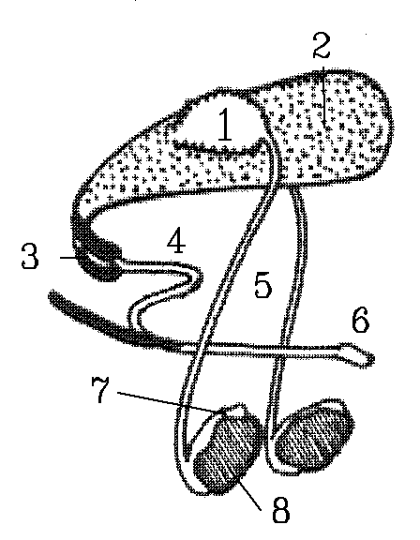 side view of a bull
1. Seminal vesicle
2. Bladder
3. Cavernosus muscles
4. Sigmoid flexure
5. Vas deferens
6. Penis
7. Epididymis
8. Testes

Major difference in animals for the extent of penis tissue that can be pumped up with blood pressure (very large eg. stallion, small eg. boar)
Types of Penis’s
1) Lacking in rigid structure and blown up by blood pressure
2) sturucture maintaining integrity and do not increase in length or width
-Testes- lots and lots of tubing within that hold the sperm transferred by the vas deferens
-boars bulbourethal glands are related to “boar taint” caused by androstenone (pheromone/hormone that is transmitted from boar to sow when wanting to copulate)
- The paired testes of male farm mammals are located in a muscular bag called the scrotum where they can be maintained several degrees below body temperature for the efficient production of spermatozoa or sperm
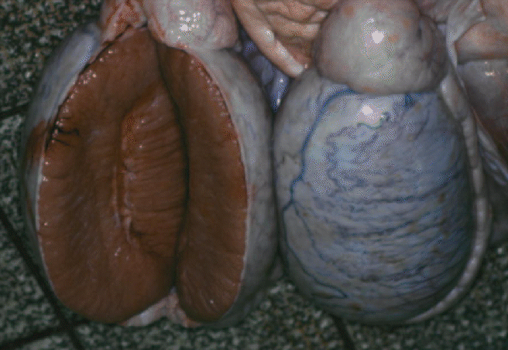
- Each testis can be raised by the cremaster externus muscle.{Evidence of cremaster muscles may appear in carcasses of sows and gilts and so cannot be used to identify male carcasses!}.
- The connective tissue round the testis is called the tunica albugenia: it is white with a good blood supply.
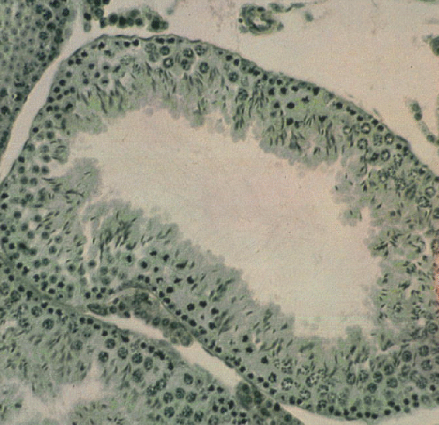
Spermatozoa cells
Sperm tails
- Spermatozoa are produced in seminiferous tubules tightly packed into the oval shape of the testis. The image above shows one tubule under the microscope. The higher power image below shows part of the tubule (lumen downwards) with meiotic divisions leading to the formation of spermatozoa. The tails can be seen in the center
- The many seminiferous tubules in each testis open into a labyrinth of tubes called the rete testis. Immature spermatozoa from the rete testis pass in a number of efferent ducts to a further tubular system, the epididymis, located on the surface of the testis, as shown in the image below
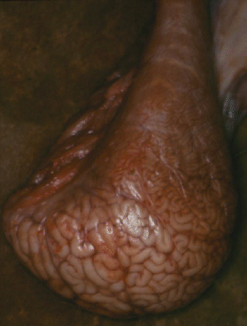
- Spermatozoa mature during storage in the epididymis and are carried to the urethra during mating by peristalsis of the vas deferens.
- The urethra is located ventrally in the penis.
- Seminal fluid to carry the spermatozoa is produced by the paired seminal vesicles, by the prostate gland, and by the paired bulbo-urethral glands (= Cowper's glands). The glands are located along the urethra, near to the bladder. The image below shows the seminal vesicles of a boar.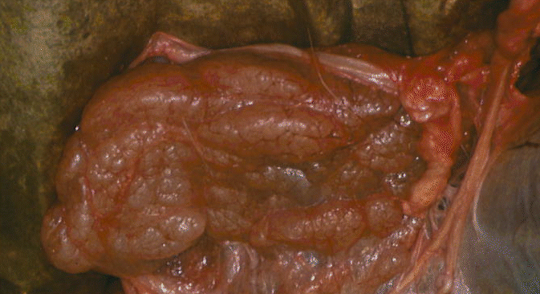
- The penis has a sigmoid flexure or S-shaped bend along its length. The sigmoid flexure is straightened out when the penis is extended for mating. This occurs when a pair of muscles, the ischio-cavernosus muscles, compress the veins which drain the blood from the penis. Arterial blood pressure then expands the volume of vascular tissue in the penis.
- The ischio-cavernosus muscles are attached to the ischium and the trimmed stump of the muscle may be seen on dressed sides of beef as a pizzle eye. The pizzle eye is poorly developed in steer carcasses and is larger and darker in bull carcasses.
- During the embryonic development of both mammals and birds, the testes are formed from tissue located near to the kidneys. In male mammals, the testes normally move to the scrotum outside the body cavity, and they pass through the body wall in the inguinal canal. The testes are attached to the inside of the scrotum by the gubernaculum which is contractile in fetal animals and is responsible for pulling the testis through the inguinal canal.
- The layers of connective tissue that cover each testis are the (1) tunica vaginalis communis and (2) the inner layer formed by the tunica vaginalis propria. Both layers are derived from modified layers of peritoneum gathered by the testes during their migration. The inner layer supports the blood vessels and nerves to the testis.
- In cryptorchid pigs or ridgelings, movement of the testes along the inguinal canal is incomplete and they do not reach the scrotum. This abnormality causes infertility, but an older cryptorchid pig may still develop boar taint like a normal boar. The cause of the condition is not fully known but the normal mechanism of testicular movement appears to involve the action of testosterone on the genito-femoral nerve which then produces a peptide that activates the gubernaculum.
3.2 Female Reproductive System
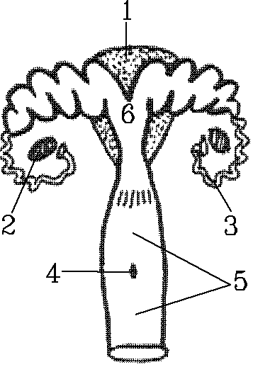
1. Bladder
2. Ovary
3. Oviduct/fallopian tube
4. Opening of urethra
5. Vagina

- Female mammals have a pair of ovaries located posteriorly and dorsally in the abdominal cavity Figure 1-21c.The image below shows one ovary of a cow
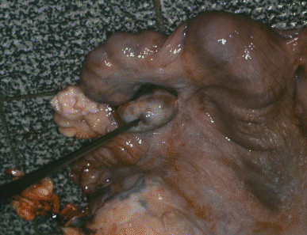

- Ova develop in the cortex (outer layer) of the ovary. Each ripe ovum is enclosed in a fluid-filled follicle, as shown in the histological image below. At estrus, ova are released into a ciliated funnel or infundibulum at the end of each oviduct (fallopian tube).
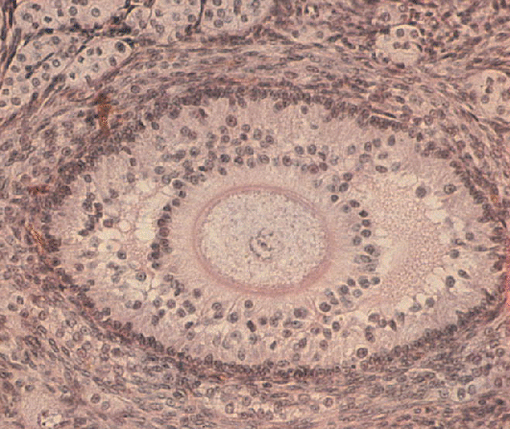
- The oviduct on each side leads into a horn of the uterus where embryonic development takes place. The image below shows one horn of the uterus of a cow.
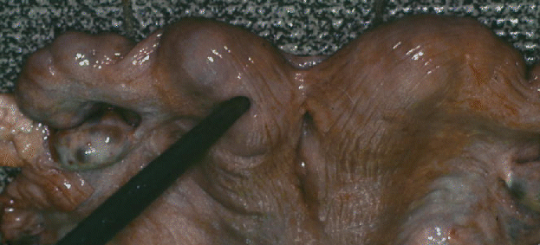
- At birth, the offspring emerge through the dilated cervix and vagina.The image below shows an undilated cervix of a cow
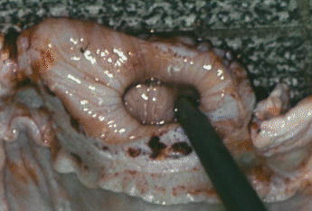
- Mammary glands are derived from highly modified sweat glands of the skin. The udders of sheep and goats are divided into right and left halves, each with a teat. The cow's udder has four quarters so that there are two teats on each side. Most sows have seven pairs of mammary glands and a total of 14 teats. Milk is produced in glandular alveoli, and it collects in the cistern of the teat. The bovine udder is supported by medial and lateral suspensory ligaments which are dominated by elastin and collagen fibers, respectively.

