- Key words:
- Acquisition获得物
- ARPANET阿帕网络
- Business model
- Cloud computing云计算
- Conversion转变
- GPS(global positioning system)
- Hosting
- HTML(hypertext markup language)
- Infrastructure stack基础设施堆积
- Retention保留
- Scalability可扩展性
- Server
- SaaS(software as a service)软件即服务
- Telecommunications
- Web 2.0
- Web 3.0
- Web services网络服务

Origin of the internet date-1957, when Russia launched the sputnik satellite.

Envision “intergalactic星际间的 network” -> share computer resources, exchange ideas, and cooperate on scientific objects. The ARPANET enabled human communication in a time-and distance-independent manner that was completely new and that remains the core legacy of this military system. 如果战争让其中一台主机报销，其他的主机也可以正常使用

Mosaic was 8ntruduced as the first graphical browser in 1993, he ordinary computer user could move around the web in point-and-click mode instead of having to learn cumbersome search terms.
- 4 misconceptions that led to the bursting of the dot-com bubble
- it is ok to sell products for less than what they cost you, because that will bring you lots of customers.
- internet-based companies are immune to economic cycles.
- internet companies cannot spend too much on advertising
- internet companies that carry no inventory are infinitely profitable.

- Web 2.0 – second generation, like facebook, sabre.
- characteristics Web 2.0 products:
- Services, not packaged software, with cost-effective scalability. (cloud computing)
- Control over unique, hard-to-recreate data sources that get richer as more people use them (chp 4)
- Trusting user as co-developers. Ex. The firefox browser.(chp 9)
- Harnessing治理 collective集体的 intelligence. Ex. Blog and wikis
- Leveraging the long tail through customer self-service. Long tail-niche markets只要顾客能帮忙保持价格低廉，market就会特别有利润
- Software above the level of a single device. Apps. (chp 11,16)
- Lightweight user interfaces, development models, and business models. –applications are easy to use, flexible. (chp 3)

Business improvements attributed to social business software:

Increases:
- Communication with customers
- Employee connectedness
- Project collaboration and productivity
- Ideas generated inside the firm
- New business win rate

Decreases:
- Time to find info and experts
- # of customer support calls
- #of emails sent
- time needed for meeting
- need for travel

Web 3.0 – semantic语义的 and personal

Semantic – internet can understand user intent and makes it easier to find info. (google’s instant preview tool)
- Personal – bookmarking services. Ex. Firefox and Delicious bookmark.
- Web 3.0 characteristics:
- Real-time. Tweets. What is going on at this moment.
- Semantic. Make web activities easier.
- Open communication. Find info without reference to where it originally resided.
- Mobile and geography. GPS. Location-based marketing.

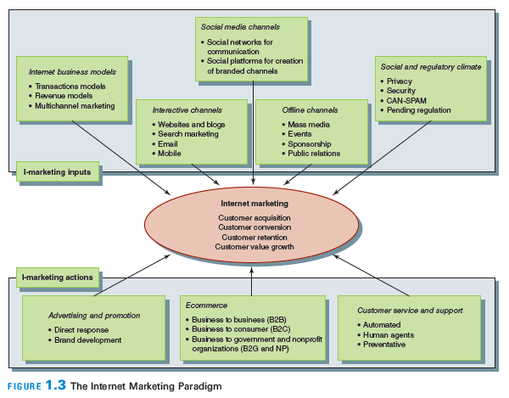
- Marketers attempt to achieve 4 distinct generic goals:
- Customer acquisition. Attract new customers.
- Customer conversion转变. Persuade visitors, shoppers to become actual customers.
- Customer retention保留. Turn newly found customer into a loyal one. It’s cheaper to remain the customers rather than acquire them.
- Growth in customer value.

Internet marketing inputs:

Business models
- -transactions汇报 models
- -revenue models
- -multichannel marketing. Affect customer acquisition. This requires both offline and online channels.
- Interactive channels
- -website and blogs. Channels for communication. B2B
- -search marketing. SEO &PPC drive customer to company’s website
- -email marketing. (customer acquisition -> customer retention)
- -mobile marketing
- -other interactive channels and activities. Ex. Kiosks and events. (customer acquisition)
- Social media channels (personal expression)
- -social networks for communication
- -social platforms for creation of branded channels
- Offline channels (integrated communications process)
- -mass media
- -event
- -sponsorship
- -public relations
- Social and regulatory climate
- -private
- -security
- -CAN-SPAM
- -pending regulation

- Internet marketing actions
- -Online advertising and promotion
- -Ecommerce
- -Customer service and support

- The internet infrastructure stack:
- Computing in the cloud (fee for services)
- ->computing and data storage now take place “in the cloud”
- ->ex. Salesforce.com
- connect and sell
- service and engagement
- collaboration
- automate and extend
- social marketing
- listen and analyze
- products and partners
- Applications service provider (web services)
- ->SaaS (software as a service)
- ->从网页操作application (data warehousing/personalization)
- ->buy software and annual update yourself
- ->web services solutions involve making codes available to developers so they can develop functions on the website that makes use of sophisticated proprietary software.
- ->Amazon Web Services (developers page)
- Website operations (load balancing, security, caching)
- ->day-to-day work of keeping the system running and of fine-tuning it to provide a high level of uptime and fast and dependable downloading of pages to users.
- ->purely technical to maintain and operate a website
- Internet hardware and software (servers, routers, web/application/database servers)
- ->outsource website hosting
- ->hardware: specific software to connect to the internet and to run the specific applications programs that drive the functionality of the site
- Website hosting (internal and external)
- ->a website must be housed on a server, an operation
- ->server who host the site must be connected to the network to perform the operation functions
- -> ex. blogging
- Telecommunications carrier (connection to internet)
- ->backbone主心骨 –a series of networks run by various carriers.
- ->invisible

- A profile of the internet and its users
- The size and scope of the internet
- Technical measurements (size of the internet) – numbers of systems, number of servers, speed of networks, etc.

- World internet penetration渗透 rate:
- 1. north America
- 2. Australia
- 3. Europe
- 4. Latin America/Caribbean
- 5. middle east
- 6. world, avg.

7. Asia

8. Africa

large population -> huge growth rate

Who use the internet, for what: consumers

Demographic

-gender is not a factor

-younger generation, high income, high education level tent to use internet more.

Behaviors
- send or read email
- use a search engine
- get news online
- buy a product online
- social network sites

introducing the digital lifestyles

influencers: the internet is an integral part of my life手机是生活的一部分

communicators: I love talking and expressing myself (message, email)

knowledge-seekers: use internet to gain knowledge, info and education

networkers: internet is important to establish and maintain relationships

aspirers: want to create a personal space online (new to internet)

functionals: internet is a functional tool (email, checking news) ->older

Who use the internet, for what: business

Business use internet to attract new customers, to sell products and services, to retain existing customers, and to deliver customer support and service.

10 drivers of the internet economy因特网经济
- information creates the greatest added value for products.
- Size and distance do not matter in many types of communications
- Speed and flexibility are f the essence.
- People are the key assets in internet enterprises
- Growth in the network causes exponential increase in value
- Marketers can deal with customers on a one-to-one basis
- Demand can be predicted with greater accuracy
- Cost patterns change as transaction and coordination costs shrink for businesses and consumers recognize that switching costs are low.
- Customers have power in for-rich channels

10.An info economy is characterized by choice and abundance.

Basic requirements of successful marketing – to acquire, convert, retain and increase the value of customers.

- Key words:
- Advertising model
- Affiliate加入 model
- Brokerage回扣,中间人 model
- Business model
- Community model
- Ecommerce电子商务
- Extranet外联网
- Infomediary信息中介
- Infomediary model
- Intranet内部联网
- Manufacturer (direct) model
- Merchant商人 model
- P2P (peer-to-peer)点对点技术
- Predictive可预见得 modeling
- Proprietary私人拥有的 system
- Subscription订阅 model
- Utility实用 model
- Value proposition价值定位

Business model: how an entity sustains itself; how it makes money; how it achieves its revenue objectives.

Michael Rappa: Business model is the method of doing business by which a company can sustain itself-that is, generate revenue. The business model spells out how a company makes money by specifying where it is positioned in the value chain.

Ethriraj, Guler, and Singh: a unique configuration of elements comprising the organization’s goals, strategies, processes, technologies, and structure, conceived to create value for the customers and thus compete successfully in a particular market.

Ecommerce: most common type of revenue production on the internet and refers to an economic exchange.

Ecommerce is ubiquitous普遍存在的 in B2C, B2B, governmental, and nonprofit markets.

Functions of a business model:
- Articulate深层表达value proposition, the value created for users
- identify market segment
- define the structure of the value chain
- estimate the cost structure
- describe the position of the firm
- formulate the competitive strategy

9 key elements of preparing a business model:
- who are your customer segments?
- What is your value proposition?
- What is the customer relationship?
- What are your revenue streams, how much do they generate?
- What are your key resources?
- What are your key activities?
- Who are your key partners?
- What is your cost structure?
- What are your distribution channels?

Business model focuses on creating value for the customer and delivering that value to the customer to a clearly defined market segment

Business value (shareholders)->economic value (technological section)

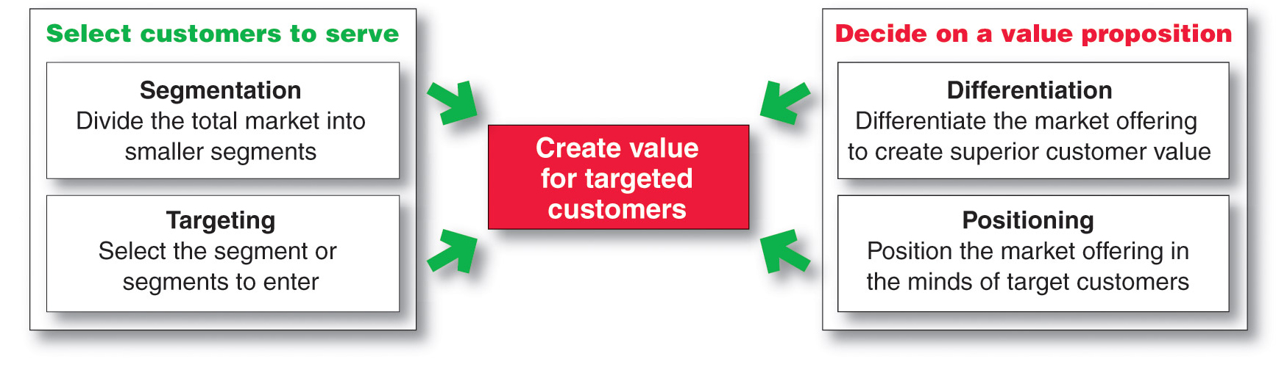

Economic value=the vale of ownership and use – the cost of the item

Value proposition: the value delivered by the firm to a specific, targeted customer segment.

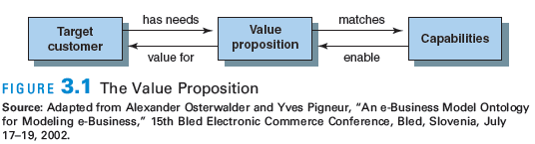

Identifying business models

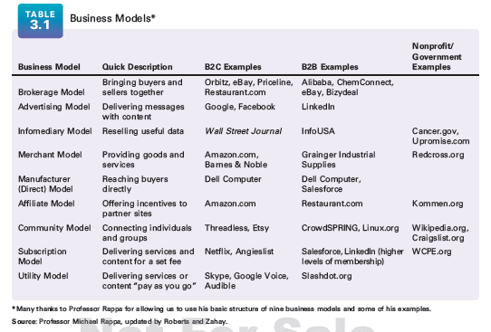
- Brokerage model: bringing buyers and sellers together
- Marketplace exchanges (alibaba)
- Demand collection systems (priceline)
- Auction brokers (ebay)
- Transaction broker (paypal)
- Virtual marketplaces (amazon.com)
- Coupon promotion sites (groupon)
- Advertising model: delivering messages with content

Traditional media broadcast model

Email, messaging, blogs

Categories of the advertising model
  - Portal入口 (yahoo!)
  - Classified (monster.com)
  - Query疑问-based paid placement (google)
- Infomediary model: reselling useful data
- Advertising networks (google)
- Audience measurement service (nielsen)
- Incentive marketing (mypoints)
- B2B informediaries (infoUSA)
- Metamediaries (edmunds) provide comprehensive info to buyers from sellers
- Merchant model: provicing goods and services
- Virtual merchant (amazon.com)
- Catalog merchant – mail order business. 看产品名字，发邮件打电话order
- Bit vendor (apple itunes music store) digital products
- Click and mortar,aka multichannel/bricks n clicks (best buy)有网店有实体店
- Aggregator – selection, organization, price, convenience, matching, fulfillment
- Manufacturer (direct) model: reaching buyers directly
- Direct selling (dell)
- Syndication企业联合组织 or licensing of content (new york times)
- Software-based services 卖软件给公司
- Affiliate附属 model: offering incentives to partner sites
- Banner标语 exchange
- Pay-per-click
- Revenue sharing
- Community model: connecting individuals and groups

Create a business based on user loyalty and repeat engagement

P2P application allow for file sharing from one computer to another.

Intranets host busy traffic in files moving around the world

Extranets link corporate info resources to those of stragegic partners and suppliers.
- Open source (firefox)
- Open content (wikipedia)
- Crowdsourcing (threadless) members to design and vote to produce the product.
- Fund-raising (American red cross)
- Social networking service (fb)
- Subscription model: delivering services and content for a set fee

Users are charged a periodic fee to subscribe to a service
- Content services (netflix)
- Person-to-person networking services (classmates) user-submitted info
- Trust services (TRUSTe) membership association
- Membership organizations (WCPE) services are free but encourage to contribute
- Application services providers ASP (adobe) software applications
- Utility model (on-demand): delivering services or content “pay as you go” (metering测量 usage)
- Metered usage (skype)
- Metered subscriptions (slashdot) 买书读 读多少页卖多少钱

- Key words:
- A/B split
- Back end
- CLV (customer lifetime value)
- Customer service
- Customization
- Data
- Data mining
- Database
- Front end
- Fulfillment
- Information
- Interactive
- NPV (net present value)
- Personalization
- Predictive model
- Profile
- Sales promotion
- Testing

- key words:
- ad format
- brand
- brand equity品牌价值
- brand image
- brand recognition/brand awareness
- branded content
- content marketing
- high involvement
- low involvement
- roadblock路障
- video marketing

- DVDs, digital video, pay-per-view, video streaming goes up
- Radio, newspapers, magazines goes down

Electronic roadblocks are the most cost efficient, and can produce significant daily reach. TV can deliver twice reach than roadblocks

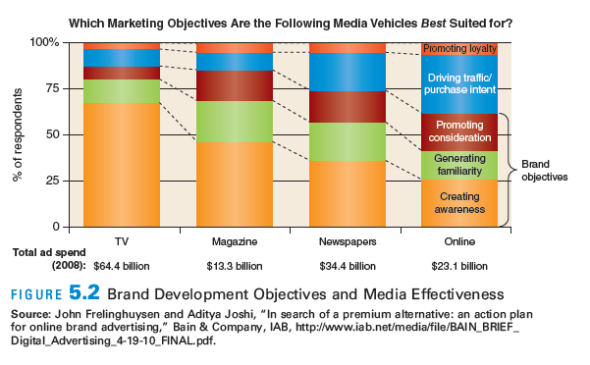

Engaging ad formats广告形式 will not be optimally effective unless marketers develop strategies that have impact at the appropriate stage in the brand development process.

Marketer options also depend on consumer stage

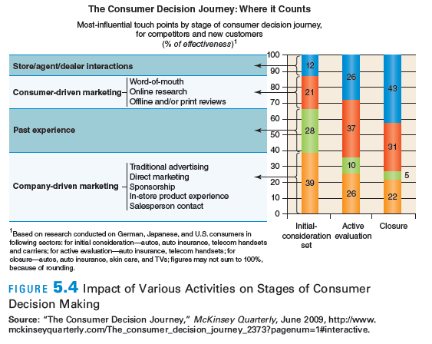

Media choice by brand objective

TV best for generating awareness

Print best for creating familiarity – good for promoting consideration

Online best for promoting consideration and driving purchase intent

All have a role in promoting loyalty – TV least effective

Building internet brands
- Brand equity and brand image

Brand equity: the set of associations that allow it to earn greater volume and margins & have sustainable, differentiated advantage over competitors.

Brand awareness:
- Brand recognition (consumers remember seeing/hearing about a brand)
- Recall (be able to remember info about the product or brand.)

Brand image: favorability, strength, uniqueness

High involvement products: can be equated with high risk purchases whatever the price.

Low involvement products: requires less effort and involvement on the part of the customer who may take action on the basis of awareness alone.
- Creating a strong brand on the internet

Brand building process

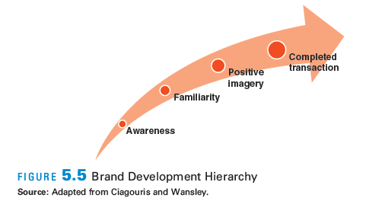

- Traditional brand building has been done in the mass media, where the maintenance and deepening of relationships is difficult because of the inability to these media to address consumers based on their stage of relationship development.

- Strong brand development
- The best brand building on the internet will fuse the attention-getting power of the web’s interactive environment with the targeted relationship techniques of information-driven direct marketing.
- Interactivity (attention and engagement)
- Targeted marketing (information-driven marketing programs)

Integrated with offline brand-building

- Building and developing an online brand

Brand building activities:
- Ensure the best possible product and customer experience
- Learn about your targeted audience
- Set branding objectives
- Establish your message. Give your brand a voice and personality
- Develop the necessary creative elements to convey the desired message and personality
- Balance online and offline media mix
- Create relevant content and distribute it across the web
- Engage with customers and prospects
- Monitor online conversations and use of your brand to protect its integrity
- Continue to grow and evolve发展进化 the brand

Brand community
- - A “specialized, non-geographically bound community, based on a structured set of social relations among admirers of a brand.”
- Every contact/interaction/touchpoint with customer must be viewed as an event in the brand development process: advertising/email/video

Many types of videos:
- Slideshows
- Product demonstrations
- How-to and tutorials
- Case studies and testimonials
- Social videos (promote viewer sharing)
- Vignettes or series
- Scribing /RSA (animated storytelling)
- Branching videos (links embedded in videos)

Branded content – content that is obviously produced by the brand buy what is not overtly promotional in nature. It needs to be entertaining and that often suggests professional production quality.

Video marketing strategy

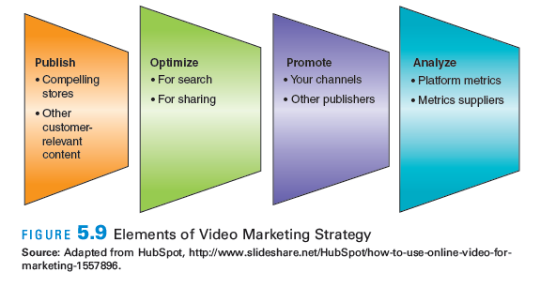

step 1:

Publishing compelling引人注目的, customer-relevant video material.

Video should tell a story that shows the benefits of the product to the customers.

Step 2:

Optimize优化 the video on the channel that goes to targeted audience, for both searching and sharing.

Step 3:

Promote the video by using business channels, partners and who value your content.

Step 4:

The effort should be productive by analyzing the metrics度量 produced by the channels and platforms or with metrics provided by 3rd party suppliers.

Blogs are both informative and engaging.

One way to increase engagement is to embed videos in blog posts.

Publishing

Types of videos and places them in a 3-stage buying process
- Awareness stage. Video sharing by friends
- Consideration stage. Video convey传达 knowledge about the product and benefits.
- Close stage. Encourage bloggers to write comments about the video

Developing customer-relevant and stories

Advices of one video marketer:
- Decide which types of content you are going to use to deploy your video
- Establish your marketing objectives (call to action)
- Identify your targeted audience
- Make the content relevant to your audience – engaging, unexpected, memorable, entertaining, or informative.
- Integrate your content across multiple social media marketing channels.
- Tell a simple, engaging story to your target audience
- Show them, don’t tell them. (tangible benefits)
- Establish objectives and then demonstrate the presentation.
- The only perspective that matters is the customer’s perspective.

Optimizing for search and sharing

Things need to do to optimize the videos for search:
- Study relevant keywords and use them in all the other optimization activities
- Include text when posting
- Tag key words and description with the video link where cannot attach a video
- Have a short, catchy title
- Optimize video and page URLs
- Encourage user ratings
- Post video on youtube
- Use platform that submit your video to many channels
- Keep your video brief

Promote
- post video on the marketer’s own channel.

Post/link your video to every one of your other content channels.

Feature a link or embed the video on the site’s home pagr for a reasonable time.

Archive it to a product or another relevant page

Write a blog post and embed the video

Post it on the fb page and tweet it

Post it on video-sharing sites other than youtube
- post video on the channels of other publishers

reach out the influencer by email, informing them about the video, encouraging them to feature it prominently in their content.

Release include links to relevant corporate or product videos

Post video to social bookmarking sites

Post on sites have influence to the audience

Be social

Analyze

Common metrics:
- placements, the number of videos associated with the campaign, measured by the number of videos with a unique URL
- collection and analysis of comments and rating posted by viewers
- engagement, measured by individual metrics

video marketing is part of a content marketing strategy, content marketing is only one aspect of the overall internet marketing strategy.

Video marketing for small business
- create a video channel
- invest in video advertising

- show your product in action
- give instructions and advice
- let your customers become fans by viewing and sharing yours
- post your videos on your website and video-sharing platform
- study the analytics provided by the platform

best way to do video marketing
- set social goals, not financial ones
- have a marketing plan
- have a social media presence
- include sharing options in your video posts
- encourage commentary and respond as needed
- measure results
- look at video as a relationship building tool
- monitor what people say about the campaign in other channels
- have a formal debriefing at the end of the formal campaign like we will make it better
- key words:
- bounce rate网站跳出率 点进网页以后没有继续点别的页面就跳出了
- CAN-SPAM Act
- Click-through rate点击率
- Confirmed opt-in
- Double opt-in双重选择加入 输入邮箱地址后会发出确认加入的邮件 再确认
- Email marketing
- Hard bounce
- Open rate打开邮件的数量／发给人的数量
- Opt-in选择性加入 给我发打折邮件
- Opt-out不要给我发打折邮件
- Permission许可
- Soft bounce软性弹回 邮件无法送达
- Spam

Email marketing was the top area of business budget growth for marketers

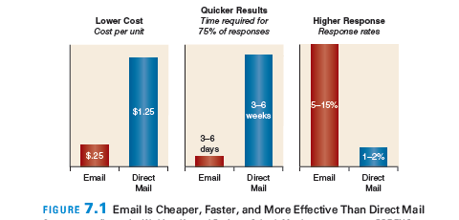

email has a strong return on investment ROI

emails are so cost-effective that they have the ability to drive ROI 2 or 3 times higher than other forms of direct marketing.

Email can be used by any marketers who has an acceptable way to acquire an email list of potential customers.

Email is highly measurable and database-driven

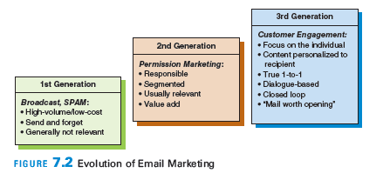

evolve 发展

Permission marketing: the concept of permission that holds true today.
- Anticipate: people expect to receive your emails
- Personal: email is sent to that person only
- Relevant: content pertains to the recipient’s interests

Integrating email and social media

Types of emails
- Newsletters
- Customer service announcements
- New product announcements
- Alerts and reminders
- Promotion and advertisings

- Levels of permission

- Opt-out: the visitor did not refuse to receive further communications from the marketers. – minimum acceptable standard
- Opt-in: visitors agree to receive further communications.
- Double opt-in: visitors agree to receive further communications then sent an email asking them to confirm their consent by replying to the email
- Confirmed opt-in: visitors actively acquiesce to receiving email, again probably by checking a box. Sent a follow-up email confirming the permission but no reply is required.

Developing an email marketing campaign

The basics of email marketing:
- Gather customer data
- Derive customer insight – needs, wants, value, feedback
- Suggest proactive有前瞻性的 action
- Evaluate response – track click-through and open rate…

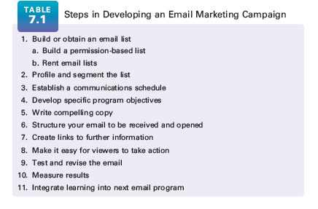

Email design

Ways to improve the message

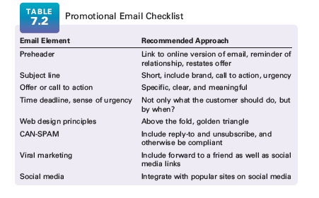

open rates – email subject line.

The email itself should clearly state the offer – and only including one offer is best.

Can-spam – people have a valid reply-to address and a valid opt-out or unsubscribe feature.

Advantages of email service providers
- Help get emails delivered through ISPs
- Aid in tracking, measurement
- Provide database integration
- Manage content dynamically
- Integrate with social marketing, other campaign

Tracking emails

Hard bounce – email address is bad or truly undeliverable

Soft bounce – email could mot ne delivered at that particular time, perhaps because of a system problem.

Bounce rate – undeliverable addresses as percent of total

Open rate – number of email offers opened divided by number delivered

Click-through rate – number of email offers clicked on divided by number opened

Click to purchase rate – number of purchases on divided by number opened.

Targeting, personalization and customization
- Targeting refers to directing marketing communications to individuals or businesses that have been identified as valid prospects for acquisition or retention for the good or service.
- Personalization involves the creation of specialized content for a prospect/customer with a known profile
- Customization is the creation of new content, services, or even products based on the needs and wants of an individual

Golden Rs of email marketing
- Relevance: applicable to readers’ needs
- Respect: sender needs to guard the data
- Recipient control: what content he wants to receive and how often he wants to receive it

CAN-SPAM Act
- It bans false or misleading header info
- It prohibits deceptive subject lines
- It requires that your email give recipients and opt-out method
- It requires that commercial email be identified as an advertisement and include the sender’s valid physical postal address

另句话来说：
- Applies to Acquisitional or Promotional Emails
- Valid ‘from’ email address, valid reply
- Physical postal (street) address
- Unsubscribe (opt-out)
- Label as ‘advertising’

Key words:

Broad match

CPC (cost-per-click) 每个行动所付出的成本

CPM (cost-per-thousand)每千人次收费

Directory姓名地址录

Display URL

Domain name authority

Exact match

Index server

Keyword

Keyword density

Local search

Meta tag元标记

Negative match

Page rank

Paid search

Phrase match

Search engine

Search engine algorithm

SEM (search engine marketing)

SEO (search engine optimization)

Spiders

Title tag

Universal search

User intent意图

Search engines – websites that work to help users to find the things they wanted to find on the internet

Web marketers use search for branding, online sales, lead generation for both manufacturers and dealers, driving traffic to websites, and simply to provide content.

Directory – create a list of sites that are usually arranged y category and each directory has a search function. (Yahoo!)

In reality, the most important aspect in being able to be found on the internet is to be indexed by the major search engines, which usually requires submitting the website to these engines.

Search engine marketing SEM:

->The entire process of getting listed on search engines so consumers can find you.

->”a form of internet marketing that seeks to promote website by increasing their visibility in search engine result pages”

2 basic aspects of SEM:
- search engine optimization SEO – the process of designing a site and its content whereby search engines find the site without being paid to do so. “the process of editing a web site’s content and code in order to improve visibility within one or more search engines”

free SEM – natural search, organic search, algorithmic search
- pay-per-click PPC – text ads targeted to keyword search results on search engines, through programs are sometimes referred to as PPC advertising and cost-per-click CPC advertising.

Paid SEM – paid search

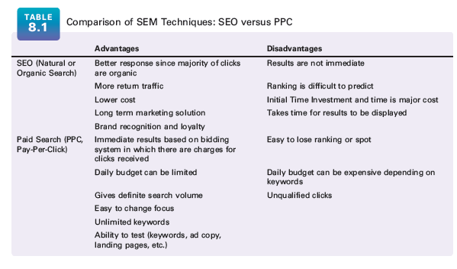

page rank = search result – a mathematical algorithm name to indicate how important a page is on the web

Organic search
- Keywords– Words or phrases selected when making a search (can also be used in other contexts)
- Meta name– Also known as meta tag or meta element and is in the header portion of a site’s HTML code
- Algorithm –Displays the search engine’s ‘best guess’ as to which pages are most relevant
- Title Tag–Title in blue bar at top of web page; important for SEO Rankings

Search engines:
- Universal search – search results from multiple content sources such as videos, images, news, maps, books, and websites into one set of research results
- Index server – stores info on previously categorized websites as a best fit to certain keywords.
- Spider – programs that crawl the web and follow every link or piece of data that they see and bring this info back to be stored.
- Search engine algorithm – the search engine’s “best guess” at which pages are most relevant to the user’s search and in which order they should be shown

Some items that are usually used for inclusion in the rankings are:
- The location and frequency of keywords on the page
- The HTHL title tag
- Site content, including quality and relevance
- The number of other sites that link to the page
- The number of click-throughs generated by searches to that page
- Recency of mention and number of social mentions

Optimizing organic search

A good suggested process for beginning an SEO campaign is as follows:
- Define the target market
- Find out what they search for
- Develop a search strategy: find keywords and phrases
- Redesign site with those keywords in mind
- Register the site with search engines
- Implement a paid search campaign to complement or inform the organic search campaign

Common problems in organic search
- Search engine spiders unable to navigate the website
- No site map on website
- Nonoptimized navigation structure
- Diluted稀释的 link popularity of key category/product pages

Basic approach to search engine optimization

Domain name authority – the extent to which that domain name is considered to be a reputable website in a particular category.

Organic SEO influencers:
- Link building: volume, diversity, trust factor
- On-page factors: architecture, tagging, content
- Domain name authority: age, mentions, brand influence
- Overall website traffic: click-throughs, bounce rate
- Social footprint: mentions, syndication

It’s useful to use paid search terms where the site is not showing up as strongly in the organic search ranking as was hoped.

Organic and paid search should work together

A good process for paid search campaigns is as follows:
- Investigate broad search categories and trends
- Narrow down keywords
- Determine traffic and cost
- Select terms and match criteria
- Design ads
- Run campaigns
- Measure and refine

Broad match searches all volumes for that keyword idea, including synonyms and related words

Phrase match must include that entire phrase. (exact sequence)

Exact match will return the search volume for that particular keyword

Negative match is a term that you do not want to be considered

Local search: ads targeted to geographic areas.

Display URL: may or may not be the same as the actual site URL

CPM: the pricing for site targeting is based on CPM (click per thousand)

The relationship between search and social media (use social media to enhance SEO)

