Reading (Communication: Principles for a Lifetime)
Self Concept Components
Self | Sum total of a person is; person’s central inner force
Self-concept | Person’s subjective description of who he/she is
Sef-image | The way a person views themselves in a particular situations (differs from situation to situation)
Attitude | Learned predisposition to respond favourably or unfavourably towards smt  Like-Dislikes  Ex. Like ice cream and tennis
Belief | The way which you structure your understanding of reality  True-False  Ex. You believe your parents love you
Value | Enduring concept of what is right and wrong  Good-Bad  Ex. Value honesty and trust
One or Many Selves
Material Self | Your concept of self reflected in all tangible things you own (body, clothes, car, home)
Social Self | Concept of self developing through your personal, social interactions with others.  Multifaceted: different selves when talking to different people  Ex. With friendinformal, with professorsformal
Spiritual Self | Concept of self upon your thoughts of introspection about your values and moral standards  “why am I here?”
How the Self-Concept Develops
Communication with Others | Our self-concept develops as we communicate with others, receive their feedback, make sense out of it, and internalize or reject part of it.  Ex. Someone told you that you have a good sense of humor but how would you know that without others laughing at the humorous things you say or do?  1902-Charles Horton Cooley said we learn who we are by interacting with others, much like looking into a mirror  George Herbert Mead believed our sense of who we are was bc of relationships with others  Development begins at birth-mostly family influences the way we view ourselves and as we grow up it becomes friends and co-workers. Media has indirect influence but not as much as people in our lives
Association with Groups | Self-concept develops partly bc of and through our identifications with groups and organizations  Ex. Canadian, soccer player, liberal  Peer pressure is powerful force as even adults ask themselves what people might think of certain actions
Assumed Roles | Self concept affected by roles we assume  Ex. Son, daughter, employee, parent, student, spouse  Especially in relation to person’s sex and gender: men go for giftedness, power and invulnerability. Women view themselves through likeability and morality.
Self labels | Terms we use to describe our attitudes, beliefs, values, and actions play a role in shaping our self-concept  Through self-reflexiveness, we can talk to ourselves about ourselves and determine what labels we want to be known for  Ex. When you were young, maybe you wanted to be a rocker or movie star, and everyone said you were talented so you labeled yourself as that. As you grow up, however, you may assume new labels as you observe yourself more critically and discover new strengths
Factors Affecting Self Esteem
Gender Differences | In male dominated cultures, females tend to suffer from self esteem issues more than males since boys feel better able to do things than girls
Social Comparisons | Judgment on how well or poorly you perform compared to other can be self defeating and cause self esteem issues
Self-Expectations | Your estimation on how well you perform compared to your own goals has a profound impact on self esteem
Self Fulfilling prophecies | What you believe about yourself often comes true bc you expect it to come true

HSS2102B-Principles of Communication (pages 88-96)-Sept. 8, 2014
Human Communication
Basic Assumptions | - Process  - Transactional  - Multidimensional  - Balance between content and relationship
Challenges to Communication | - Age, gender, culture, education, socioeconomic status, motivation/intention, life experiences, values/moral code/philosophy
5 Fundamental Principles of Communication | 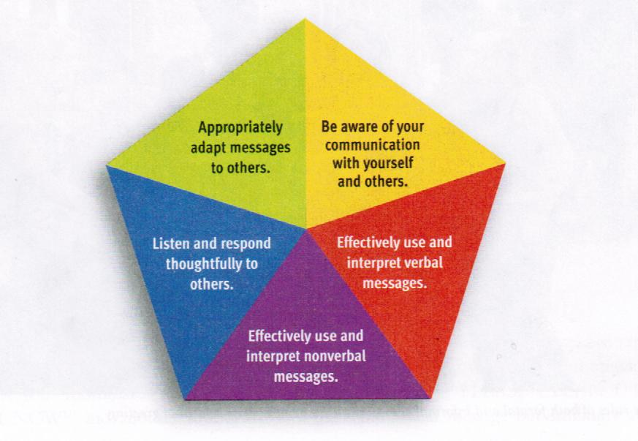
Self awareness of Self-Concept
Self Concept | - Self concept: who you think you are (subjective view)
William James’: Three Components of “Self” | - Material: tangible elements  - Social: personal and social interactions  - Spiritual: values, morals, beliefs
The Perception Process | - Step 1-Attention and Selecting: what you notice and choose to focus on in your environment (could be within a range of stimuli  - Step 2-Organizing: convert info into patterns you can understand so you can make sense of what we observed  - Step 3-Interpreting: Give meaning to what we observe, step back as third person and be aware
Perpetual Factors | - Self –Fulfilling Prophecy: make a prediction and act like it’s true  - Primacy-Recency: Primacyrecall first chunk of info, Recencyrecall last chunk of info absorbed. No recollection of intermediate stages  - Consistency: reinforce existing plan/theory, if thinks happen all the time then you expect it to happen  - Attributions: try to explain another’s motivation for their behaviour
How do you improve perceptual skills? | - Be genuine and tactful (sensitive, considering other feelings)  - Give benefit of the doubt  - Describe feelings rather than evaluate others  - Solve problems rather than control others  - Be flexible rather than rigid toward others  - Present yourself as equal
Reminders | - Like you’re talking to a friend  - Not sure? Just listen or ask  - Speak your essence but be respectful  - Assertive and truthful

Readings: Processes of Perception
Personality Assumptions
Halo effect | If you believe a person has positive qualities, you then assume that they have other positive personalities (reverse halo effect is opposite) ex. Positive perspective on doctors, then start noticing all positive side of doctors
The Self-Fulfilling Prophecy
What is it? | Make prediction that comes true bc you act on it as if it were true
What are the steps? | - Make a prediction (ex. Shaq is friendly in interpersonal encounters)  - Act towards person or situation as if prediction were true (ex. Act as if Shaw were a friendly person)  - Bc you act as if it were true, it becomes true (ex. Bc of way you acted towards Shaq, he becomes comfortable and friendly)  - Observe your effect on the person or situation; it strengthens your belief (ex. You observe Shaq’s friendliness and this solidifies your belief of the fact that he’s friendly
Pygmalion effect | Teachers were told of students expected to do exceptionally well (when they were actually chosen at random) and kids actually did well bc teachers gave the appropriate attention to do well
How can self-fulfilling prophecies distort an individuals view on things? | Short circuits critical thinking and influences behavior to conform to the prophecy. Individual then sees what was predicted rather than what’s really there.
Primacy and Recency
Primacy | Influenced by what comes first
Recency | Influenced by what is more recent
Consistency | Tendency to maintain balance with perceptions or attitudes  Expect certain things to go together and not  Ex. I expect a person I like to LIKE me. (not dislike) This is intuitively satisfying.  Uncritically assuming an individual’s consistency can lead you to a distortion of the person as a whole.  Halo and reverse halo effect apply here
Stereotyping | Can be sociological or psychological fixed impression of a group of people  A schema: conception that is common to all members of a class or group  Leads people to see others in certain way  Prevent you from seeing individual, see member of group instead  Lead people to ignore other’s unique characteristics and fail to benefit from special contributions of each individual
Explaining Motivation | Attribution: explain motivation for a person’s behavior  Ask ourselves if person was in control of behavior  Ex. Person failed history exam and lost car to dealership. Sympathetic if exam was unfair and she lost her car bc she has no money since she lost her job due to discrimination. Not sympathetic if she went to a party instead of studying and gambled her car money away.  Dislike if in control of negative behaviours  Sympathetic is not in control of negative e behaviours  Attribution of causality leads to major barriers:  Self serving biastake credit for the positive and deny responsibility for negative (ex. Poor performance evaluation bc supervisor is unfair or good performance eval bc I work hard)  Overattributionsingle out one or two obvious characteristics and attribute everything person does to those characteristics (sally has difficulty working in a team bc her parents are alcoholics)  Fundamental attribution errortendency to think that people do what they do bc that’s the people they are, instead of looking at the situation (external factors). This is not universal, differs by culture

HSS2102B-Principles of Communication (Class video)-Sept. 10, 2014
When are we happy? | When needs are met
When are we upset? | When needs are not met
Why do we expect? | When young our needs were always met and we keep looking for that
Why are needs not met? | Person does not know what the other wants  - person does not want to meet needs. Wants the other person to pay up first. Sense of indebtedness (eye for an eye)  - person simply cannot meet needs and does not have internal resources to meet needs
What are the primary emotions? | Pleasure, pain (not getting needs met, boundaries crossed without permission), comfort, discomfort, happiness (you can only understand what happiness is once you’ve felt sadness), sadness
Secondary emotions? | Anger (remembered pain), guilt (pain turned inwards), depression (depletion of energy), fear (projected pain)
What are the 7 biological responses? | Fight or flight  Reactive  Restful awareness (transition from external reference point to internal): I’m in this world but I’m not of this world, pay attention to spaces between actions, breaths and thoughts, I’m the silent presence of my experiences  Intuitive: start to listen to inner voice, quiet impulse guiding to greater evolutionary awareness and joy, I’m responsible for my life, I decide how I feel, listening to internal dialogue  Creative: taking same raw material that’s always been there but use it to make something immerse that wasn’t there before, creating new relationships just like when you have the same painting materials but make art out of it, how do I deal with same raw material but use it so that something new can emerge, try something different to have different outcome  Visionary: don’t feel too powerful and cocky that it begins to bring you down as a person, analogies and comparisons with things you’re not too familiar with, looking more at the big picture and system rather than the detail  Sacred: internal reference point has shifted from ego to spirit, what do I get out of it for me? How can I help? (ego finds what makes people different, judgment), spirit sees passed this and looks at hard center. It’s a wave thinking of itself as an ocean instead of just a wave, seeing that it’s a temporary extension of something bigger and deeper. Everything is unified.

HSS2102B-Non-Verbal Communication- Sept. 15, 2014
What are the different characteristics of Non-verbal communication? | Tone, pitch, tempo: how loud? High and low? How fast?  Gestures, movements, physical expressions: eye contact, dress, space
What are the different aspects of verbal communication? | Spoken words  Written words
What is the difference between non-verbal and verbal comm.? | Complexity: non verbal is complex and can be taken in many way  Flow: non verbal is always happening, non stop  Clarity: non verbal is very clear, you can watch what you say but it’s harder to watch your non verbal  Impact:  Intentionality: never fully there on non verbal
What social functions does it affect? | Identity management: other people react to the status of someone  Relationships
What are the functions of non-verbal communication? | Repeating  Substituting  Complementing  Accenting  Regulating  Contradicting  Deceiving: not exactly a bad thing, practiced but subconsciously
What are the types of non-verbal communication? | Posture and Gesture: kenisicsare you open or are you closed? Body movement, posture, and gesture. Manipulators: fidgeting  Face and Eyes: 6 basic emotions fear, surprise, anger, disgust, happiness, sadness  Voice (paralanguage): non-verbal, vocal messagestone, speed, pitch, length of pausedisfluencies: umm, ahh, likesarcasm  Touch: kinesthetic people, overcome barriers  Physical Attractiveness  Clothing: changes with culture  Distance (proxemics)  Time: chronemics (how punctual you are  Territoriality  Environment

Reading: Non-Verbal Communication
Non-Verbal Communication
Definition: oral and non-oral messages expressed by other than linguistic means. (excludes: sign language and written words)(includes: sighs and laughs)
- Vocal: by mouth, auditory means
- Verbal: through content and language

Characteristics of Non-Verbal Communication
 | Vocal Communication | Non-Vocal Communication
Verbal Communication | Spoken words | Written words
Non-Verbal Communication | Tone of voice, sighs, screams, vocal qualities (loudness, pitch) | Gestures, movements, appearance, facial expression
Non-Verbal Behaviour Has Communicative Value
- Virtually impossible to NOT communicate non-verbally
- Can be intentional or non-intentional (ex. Stammering, sweating, blushing)
- People are not always conscious of non-verbal behaviors
- Important to tune in to non-verbal to be more aware of others feelings and what they’re thinking allows you to better respond
Non-Verbal Communication is Primarily Relational
- Social Functions
  - Identity management: create image of ourselves as we want others to view us (ex. Go to a party and instead of saying “Hi, I’m attractive, friendly and easy going” you’ll dress nicely, smile a lot, and strike a relaxed pose)
  - Define the kind of relationship we want with others: way you behave when greeting someone (ex. Wave, shake hands, nod, smile, clap the other person on the back, hug or avoid all contact)
  - Conveying emotions: cue about the way people feel (ex. Bored, attracted, nervous)
Non-Verbal Communication is Ambiguous
- Some easier to decode than others
  - In lab experiments, subjects were better at identifying positive facial expressions than negative ones
  - Better senders are better receivers
  - Decoding improves with age and training but there are still differences in personality and occupation
  - Women better non verbal decoders than men
- Consider several factors (or clues)
  - Context (smiling at a joke vs. smiling at bad news)
  - History of relationship with sender (friendly, hostile)
  - Mood
  - Feelings (when insecure, almost anything is a threat)
Non-Verbal Communication is Different from Verbal Communication
 | Verbal Communication | Non-Verbal Communication
Complexity | One dimension (words) | Multiple dimensions (voice, posture, gesture, distance)
Flow | Intermittent (speaking and silence alternate) | Continuous (can’t avoid)
Clarity | Less likely to misinterpret | More ambiguous
Impact | Less impact when verbal and non-verbal are contradictory | More impact when verbal and non-verbal are contradictory
Intentionality | Intentional | Unintentional
Non-Verbal Skills are Important
- Social scientists call “emotional intelligence”

Influences on Non-Verbal Communication
- Non-verbal communication is universal, however, there are some notable differences in the way people use and understand non-verbal behavior.
Culture
- Non-verbal behaviors heavily influence by cultural display rules and social context
- Less obvious cross-cultural differences can damage relationship without parties ever recognizing
- Various cultures had different NV rules
- Although certain NV expressions are universal, the way they are used varies around the world (ex. Some cultures discourage obvious expression of feelings like happiness or sadness)
Gender
- Obvious differences: physiological (height, depth and volume of voice), social (female better at NV expression)
- Social factors have more influence than biology (ex. Women historically have less powerful social status, those in subordinate have better decoding skills)
- Men and women have more similar NV characteristics than different (ex. We both have similar ways of eye contact, posture and gesture)

Function of Non-Verbal Communication
- V and NV relate and operate together
Repeating
- Emblem: NV behavior with precise meaning everyone in particular culture group knows (ex. Nod=yes, shake head=no)
- People remember words reinforced by gestures better
Substituting
- Emblems can replace rather than enhance
- Important when people are reluctant to express feelings in words
Complementing
- NV match content of verbal message
- Illustrators: NV behaviors that accompany and support verbal messages (ex. Apologizing with sincere NV cue rather than snarky expression)
Accenting
- Emphasize oral (ex. Pointing accusing finger, stressing certain words)
- Comparable to italics in text
Regulating
- Controls flow of verbal communication (ex. Tone of voice when wanting to speak and when trying to get someone else to)
Contradicting
- Simultaneous expression of different messages in NV and V behaviours (ex. Red bulging face person yelling, “Anger? No, I’m not angry!”
- NV message carries more weight
- Avoid awkwardness of telling someone that you’re uninterested in what they’re saying by acting uninterested and responding “uh-huh/ no kidding”
Deceiving
- Deception occurs when messages exchanged are not truthful (ex. White lie when you try your friend’s cooking and respond “mm that’s so good. You’ll have to give me the recipe” to avoid offending)
- Some people are better at hiding it than other, mostly women as they age and people who are high self-monitors (ex. Lawyers, sales people, actors)
- Better at catching lies from sidelines than when participating actively in conversation
- No sure fire way of picking out NV behaviours from deceiver but there are always clues “stammer, false start, blinking of eyes”
- Motivation to lie and preparedness influence whether lie appears more believable or not
- Range of effectiveness in uncovering deceptive messages: 45-75%
- Women are better at uncovering lies, but ability declines when they get intimate with a person (men too)
Types of non-Verbal Communication
- Various forms of NV communication that include bodies, artifacts, environment and the use of time
Posture and Gesture
- Kinesics: study of body movement, posture and gesture
- Communicate vulnerability (read/interpreted by rapists when looking to spot a victim)
- Manipulators: movements in which one part of the body grooms massages, rubs, hold, pinches, picks or otherwise manipulates another part
  - Viewed as dishonesty and person is more likely to be liar, but this is not for sure
Face and Eyes
- Complicated channel of expression
  - Number of expressions one can produce
  - Speed of change
  - Different emotions show more clearly in different part of the face
    - Ex. Happiness and surprise in eyes and lower face, anger in lower face and brows and forehead, fear and sadness in eyes, disgust in lower face
- Ekman and Friesen identified 6 basic emotions in face
  - Surprise, fear, anger, disgust, happiness, sadness
  - Affect blends: combination of two or more expressions, each showing a different emotion (ex. Fearful and surprised, disgusted and angry)
- People accurate at reading face, especially when they know the person or context
- Eye contact: meeting glance signal involvement, looking away signals avoidance
Voice
- Paralanguage: non-linguistic means of vocal expression (rate, pitch, tone)
- Disfluencies: non-linguistic verbilizations (um, er, ah)
- People more likely to comply or have positive attitude towards person speaking at the same rate as them
Touch (or haptics)
- Essential to healthy development
- Research from dying infants found it was bc the babies weren’t being touched enough
- Not being touched enough as infant can lead to skin complications
- Improves IQ
- Touch factors:
  - Part of body touching
  - Part of body touched
  - Length of time
  - Pressure
  - Movement after contact
  - presence of anyone else
  - situation
  - relationship between people
Physical attractiveness
- Attractive people are usually more liked and maintain an upper hand in most life situations
- Ways to improve attractiveness w/o plastic surgery: posture, gestures, facial expressions, exercise, the way we dress
Clothing
- Effective in the early stages of a relationship, clothing does not matter as much once you get to know the person
Distance
- Proxemics: study of how people and animals use space
- Edward T. Hall defined 4 types of distance used in our mainstream culture depending on how we feel towards person, given time, context of conversation, personal goals
  - Intimate distance: skin contact to 45 cm
    - Loved one, doctor, dentist, hairdresser, athlete
    - Sign of trust
  - Personal distance: 45 cm to 1.2 m
    - Relational partners
    - Uncomfortable if smn moves in without invitation
  - Social distance: 1.2 m to 3.6 m
    - Business, formale, impersonal situation
    - Range we sit form the boss
  - Public distance: 3.5 m +
    - Classroom instructors
    - Anyone who has option but chooses to stay out of range is not interested in talking
Time
- Chronemics: study of how humans use and structure time
- Waiting=important person worth their time
- Important people should not wait
- Depends on culture
Territoriality
- Territory: fixed space that individual assumed some right to occupy
- More important=more right to space
Environment
- A room or space can communicate designers personality and type of interaction that takes place inside
- People work harder in more attractive environment
- Layout can be therapeutic (ex. Encourage conversation by placing chairs at a comfortable distance from each other)
- Placing doors in certain location is important for interaction and privacy level (ex. In an apartment)
- How people react to environment shows whether they want to be left alone or not (ex. Choosing seat with most distance away from other readers in library)

HSS2102B-Health Communication Models-Sept. 17, 2014
What does noise mean? | External/inner voice, what you’re thinking AND what you’re saying
What are the moels? | Action, interaction, transaction
What is action? | Message transfer
What is interaction? | Response to message sent by source
What is transaction? | Constant rxn to what is being said in communication

Readings: Foundations of Human Communication

Foundations of Human Communication
- Importance and pervasiveness of effective human communication demonstrated through 5 principles:
- Aware of communication with yourself and others
- Use and interpret verbal messages
- Use and interpret non-verbal messages
- Listen and Respond thoughtfully
- Appropriately adapt messages to others
- Discusses effective strategies that serve in 3 prevalent communication situations
  - Interpersonal interactions
  - Group and team communication
  - Presentational speaking

Communication Defined
- Communication: the process of acting on information (ex. Someone does/says smt, others think/do smt in response to the action/words as they understand them
- Focus on human communication: people communicating with other people
- Method of communication is just as important as content bc it creates meaning for the person (ex. Prof puts syllabus up on website and expects all students to know bc he through info out there)
- Human communication: process of making sense out of the world and sharing with others by creating meaning through verbal/non-verbal messages
- Everyone interprets and understands messages differently
- Effective and proper communication should be other oriented (makes sense in the perspective of the other person, not just creator) must consider needs, background, and culture of receiver
Communication Competence
- Goals of communication serve as measures of competent communication through 3 criteria
- Message should be understood as communicator intended it to be understood
- Should achieve effect communicator intended to achieve
- Should be ethical
The Message Should Be Understood
- Primary goal of effective communication is to develop common understanding of both sender and receiver’s POVs
The Message Should Achieve Its Intended Effect
- Make sure intent (purpose) of message is achieved
- Have a goal in communication (ex. Make a deal, tell a joke, get a date)
The Message Should Be Ethical
- Ethics: beliefs, values, and moral principles by which we determine what is right and wrong
- Many principles can be universal
- Ethical communication (1999 National Communication Association’s Credo for Communication Ethics): fundamental to reasonable thinking, decision making, and development of relationships and communities within contexts , cultures, channels and media. Moreover, ethical communication enhances human worth and dignity by promoting truthfulness, fairness, responsibility, personal integrity, and respect for self and others.
- Gives people choices rather than forcing them and keeping private such info as others wish to keep private (so they are able to keep dignity/integrity)
- Ethical probes: certain situations in which we challenge whether they are ethical or not
Why Study Communication?
- Promoted within business, maintain employment, make good leaders
- Canadian Association of Student Activity Advisors (CASAA) host conferences to highlight skills such as self awareness, public speaking listening and overall effective communication in SA, AB, BC, YK, NT.
- Canadian Public Health Association’s National Literacy and Health program provide workshops for youth highlighting literacy issues, work on listening (types of language, stereotypes, body language, preparedness), paraphrasing, asking questions to clarify, 5 W’s (who, what, when, where, why)
To Improve Your Employability
- Employers want effective communication, info management, positive attitude, responsible, teamwork
- 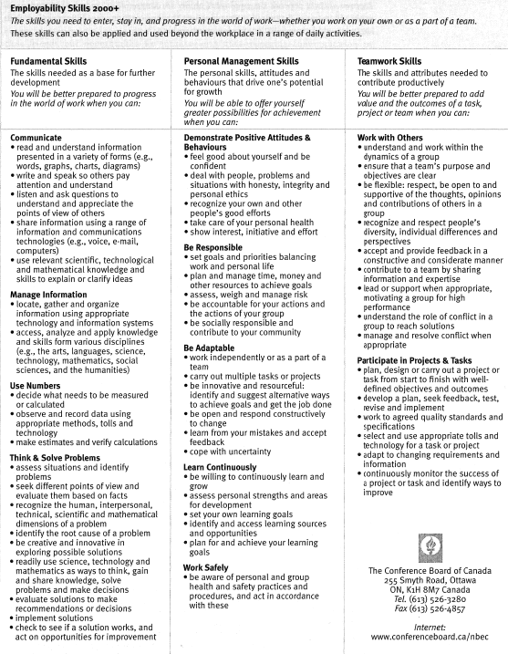
To Improve Your Relationships
- Virginia Satir (pioneer in family enrichment) family communication: largest single factor determining the kinds of relationship (we make) with others”
- Early communication with parents develops self concept and self-worth (people are “made” by families)
To Improve Physical and Emotional Health
- Relationships improve health and quality of life
Communication Models
- Meaning is created simultaneously among people
Communication as Action: Message Transfer
- Message is sent and received. Period.
- Harold Lasswell in 1949 described procees:
- Who (sender) to whom (receiver)
- Says what (message)with what
- In what channel?
- Source: originator of thought or emotion, puts into code that can be understood by receiver (transmitter)
  - Encoding: translating ideas, feelings, and thoughts into a code (ex. Vocalizing words, gesturing, eye contact
  - Decoding: interpreting ideas, feelings, and thoughts that have been translated into a code
- Receiver: person who decodes message, tries to makes sense out of what the source encoded (filters past experiences, attitudes, biases, values, prejudice)
- Message: written, spoken, and unspoken elements of communication to which people assign meaning
- Channel: Pathway through which messages are sent (can be thorough phone, fax, visual, auditory, olfactory, tactile channel)
- Noise: info, either literal or psychological, that interferes with accurate encoding or decoding of message (lawn mower, worrying thoughts)
- Encoding: Translation of ideas, feelings, and thoughts into a code
- Decoding: Interpretation of ideas, feelings, and thoughts that have been translated into code
- In communication: what we put in is not what we get out (others cannot automatically know what you mean just bc you know what you mean
Communication as Interaction: Message Exchange
- 1950s, feedback and context were added to “communication as interaction” action models
- For every action there is a reaction
- Context: Physical and psychological communication environment
- Feedback: verbal and nonverbal responses to message
  - Intentional (applause to good performance) or unintentional (yawn to boring story)
  - Verbal (repeating what someone says to confirm “that’s two burger and fries, right?”) or non-verbal (blushing before being asked on a date)
- In many communication situations, source and receiver send and receive messages at the same time
Communication as Transaction: Message Creation
- 1960s, all interaction are simultaneous
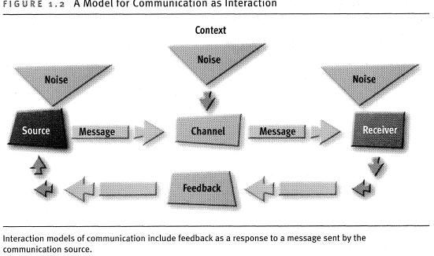
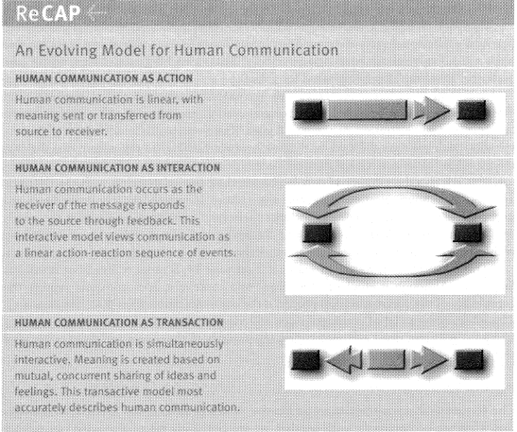
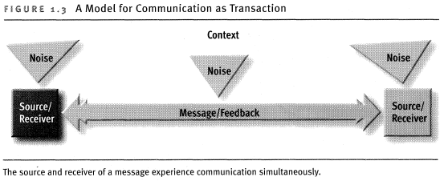
- monitor to degree to which each person understands a message
- only sender and receiver of messages can determine whether one episode (of “coordinated management of meaning” ends and another begins
Communication Characteristics
- Communication is inescapable, irreversible, and complicated; it emphasizes content and relationships; and it is governed by rules
Communication is Inescapable
- Experts agree: Communication with others plays an ever-present role in our life
- People judge you by behavior, not your intent
Communication is Irreversible
- Russian proverb: Once a word goes out of your mouth, you can never swallow it again
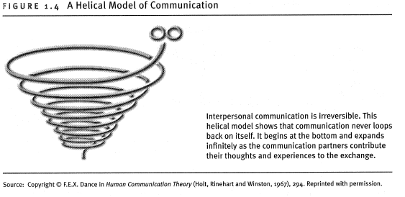
- Complicated bc of the number of variables and unknown factors involved when people interact
- Dean Barnlaud says whenever we communicate with other people, there are 6 people involved
- Who you think you are
- Who you think the other person is
- Who you think the other person thinks you are
- Who the other person thinks they are
- Who the other person thinks you are
- Who the other person thinks you think they are
- Osmo Wiio (Scandinavian communication scholar) points out challenges of communicating with others
- If communication can fail, it will
- If messages can be understood in different ways, it will be understood in just that way that does the most harm
- There is always somebody who knows what you meant by your message better than you
- The more communication there is, the more difficult it is to succeed
Communication Emphasizes Content and Relationships
- Content: part of a message that focuses on new info, ideas or suggested actions that a communicator wishes to share (what is said)
- Relationship: offer cue about emotion, attitudes, amount of power, and control the speaker directs toward others (how smt is said)
Communication is Governed by Rules
- Imbedded in culture or discussed verbally rather than written in rulebook
- Definition according to Susan ShimanoffRule: followable prescription that indicates what behavior is expected/preferred as well as prohibited in a specific situation
  - Explicit (ex. written out in syllabus) and implicit (basic lessons learnt that do not need going over)
Communication Principles For a Lifetime
- Be aware of your communication with yourself and others
  - Being conscious about everything
  - Intrapersonal communication: occurs within yourself, includes thoughts and emotions
  - Good: make choices about communication. Bad: on default and just react to thoughts
- Use/interpret verbal
  - Language: system of symbols (words) structured by rules (grammar) what makes it possible for people to understand one another
- Use/interpret nonverbal
  - Nonverbal is more believable in contradictory situations (when verbal doesn’t match nonverbal)
  - Continuous
- Listen/respond thoughtfully
  - Internal and external noise act as barriers
  - Other oriented: consider needs, motives, desire, and goals your communicating partners while still maintaining your own integrity
- Appropriately adapt messages to others
  - Important to adapt your response appropriately: adjust what is communicated/how a message is communicated; make choices about how to formulate message and respond to others to achieve your communication goals
  - Use info about others to shape responses and delivery to them
Communicating With Others, Three Situations
- Interpersonal communication: occurs simultaneously with another person in attempt to mutually influence each other for relationship managing purposes
  - Impersonal: treats people as objects, responds to their roles rather than who they are
- Group communication
  - Group: 3-15 people who have common goal, sense of belonging, influence others
  - Small-group communication: transactive process of creating meaning among 3-15 people who share common goal, sense of belonging, exert influence on one another
  - Dyad: 2 person interaction
  - Team: coordinated small group organized to work together to achieve a common goal. Assigned roles, and they are focused on their goal.
- Presentational communication: context of communication that occurs when speaker addresses a large audience in person
  - Rhetoric: using symbols to influence or persuade others

HSS2102B-Group dynamics (small group communication)-Sept. 22
What is the difference between small groups and large groups in terms of interactions within the group? | Large: specialized and refine but disconnects you from the mission of the company or corporation  Small: close knit and personal but members have to be more flexible since the numbers are there
What is the optimum number of effectiveness for people communicating in a group? | 5-7
What determines whether a group works effectively or not? | Process
What is another word for code of conduct? | Acceptable behavior
Overt norms | Verbally agreed upon
Covert norms | not verbally acknowledged, but known nonetheless
What are the five stages of phases of a group? | - orientation: do I belong here?  - Conflict: control issues, not always bad, when you don’t necessarily like someone but you’ll put up with them temporarily for the sake of professionalism  - Cohesion: establishing unity  - Working: time, energy, depth in disclosure  - Termination: closure
Goblet issues | Things you talk about to break the ice or start conversation
“In or out” discussion | Choose whether you want to stick around
“Top or bottom” discussion | Ex. You’re a laissez faire type person but you could be the leader, it just doesn’t show
“Close or far” discussion | How well do I want them to know me? How close do I want to get to this person?

MIDTERM #1 CHECKPOINT

HSS2102B-Interprofessional Communication (Health Care Relationships)-Sept. 24, 2014

Model of Health Communication (Northouse & Northouse)
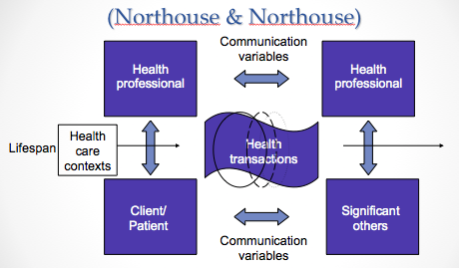

Professional-Patient Relationships
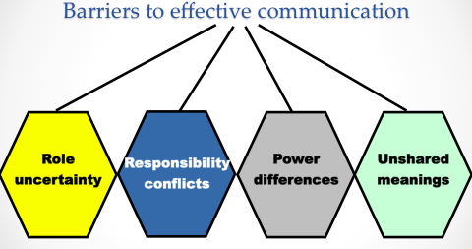
- What are the 4 barriers to effective communication?
  - Role uncertainty
  - Responsibility conflicts
  - Power differences (Leary’s model)
  - Unshared meanings
- What factor is involved in role uncertainty? What does it reinforce?
  - Hesitation; only express physical concerns
  - Reinforces traditional communication
- What is role uncertainty based on?
  - person’s psychology
- What are the two factors of responsibility conlficts?
  - Responsibility for disease
  - Responsibility for cure
- Describe the power differences between HCP and patient.
  - HCP=dominant
  - Patient=submissive
- What’s an example of a flaw with power differences made by the physician?
  - Not disclosing things that you may not think are appropriate when they really are
- What are the two different state of unshared meanings? How is this solved?
  - Person-minded, not word-minded
  - Paraphrase; use many communicating methods

Professional-Professional Relationships
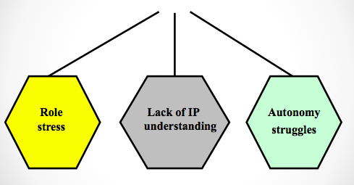
- What are the 3 barriers to effective communication?
  - Role stress
  - Lack of interprofessional understanding
  - Autonomy struggles
- What does role stress include?
  - Role conflict
  - role overload
- What counts as lack of IP understanding?
  - HCPs not fully understanding roles of other HCPs they work alongside with
- What does it cause?
  - Role confusion and territorial dispute
- Why do HCPs know so little about another’s role?
  - Professional education isolation from other health disciplines
- What is another factor that contributes to a lack of awareness of the various professional roles?
  - Limited amount of contact between HCPs on a daily basis
- How does lack of knowledge of one another’s roles contribute to the problems in professional-professional relationships?
  - HCP make demands on other professional that are not compatibleleads to conflict
  - Increase in territorial disputes-whose job is whose
- What are the several ways the system has tried to deal with lack of awareness of another’s professional roles?
  - Spending a week with HCP
  - Increase contact during clinical rotations
  - Interdisciplinary seminars to increase role knowledge among HCPs
- What are the 3 factors that determine autonomy struggles?
  - Scope of practice (governing laws)
  - Ability to access facilities
  - Ability to gain reimbursement

Professional-Family Member Relationships
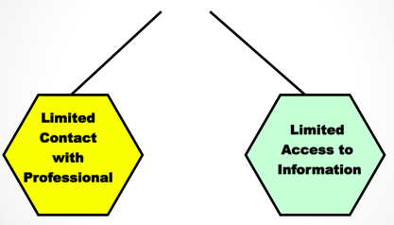
- What are the 2 barriers to effective communication?
  - Limited contact with professional
  - Limited access to information
- What factors affect limited contact with professionals?
- What are the two levels of limit to access to information?
  - Privileged: available to family but not to patient
  - Filtered: family receives after patient or third party

Patient – Family Member Relationships
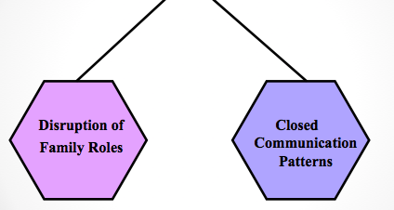
- What are the 2 barriers to effective communication?
  - Disruption of family member roles
  - Closed communication patterns
- What factors are included in disruptions of family member roles when it comes to role adaptation?
  - Ambiguity – too loose
  - Rigidity – too constricted
- What’s an example of loose ambiguity?
  - Too much of a friend, not serious and parent has no authority over child, the parent is like the child
- What perpetuates closed communication patterns? How are rules handled?
  - Perpetuated by family rules/protectiveness
  - Define rules; rules need discarding?; new rules needed?

HSS2102B-Culturally Sensitive Communication-Sept 29, 2014

(note: “gender content not covered in slides)

- High/Low Contexts: Where Different Cultures Fall on the Scale
  - Low-Context Cultures: info provided explicitly, usually with words
  - High-Context Cultures: much info drawn from surroundings
  - How does low context do with nonverbal? Background info? Compartmentalization? Info control? Direction form someone? Knowledge?
    - Less aware of nonverbal
    - Need detailed background info
    - Tend to segment and compartmentalize info
    - Controlingo on a “need to know” basis
    - Prefer explicit and careful directions form someone who “knows”
    - Knowledge is important
  - How does high-context deal with nonverbal cue? Info flow? Physical context? Environment and gestures? Info networks?
    - Nonverbal important
    - Info flows freely
    - Physical context relied upon for info
    - Environment, situation, gestures, mood all taken into account
    - Maintain extensive info networks
- Cultural Values
  - What are the masculine traits?
    - Achievement, assertiveness, heroism, material wealth, and traditional sex roles
  - What countries exemplify this?
    - Japan, Australia, Venezuela, Italy, Switzerland, Mexico
  - What are the feminine traits?
    - Relationships, caring for less fortunate, overall quality of life, and less traditional sex roles
  - What countries show this to be common?
    - Sweden, Norway, Denmark, Chile, Portugal, Thailand
  - How do people with certainty feel about ambiguity and security?
    - Do not like ambiguity
    - Value feeling secure
  - What countries are proponents of this?
    - Greece, Portugal, Belgium, Japan, Peru, France
  - How do people with uncertainty deal with ambiguity?
    - Comfortable with ambiguity
  - What countries show this?
    - Singapore, Jamaica, GB, India, Hong Kong, USA
  - How would you describe a centralized community?
    - Power in hands of smaller # of people
  - How would you describe a decentralized society?
    - Favour equality and even distribution of power
  - Individualistic: accomplishment of individual achievement
  - Collectivist: group and team collaboration
  - What do individualistic (low context) cultures emphasize? Give exmaples of countries?
    - Independence, spontaneity, autonomy in decision making
    - Ex. Canada, US, Western Europe
  - What do collectivist (high context) cultures emphasize? Give example countries.
    - Group harmony and cooperation
    - Concencus in HC decision
    - More effort addressing others especially authority
    - Emotions: to facilitate group cohesion
    - Face-saving strategies
    - Japan, Pakistan, Thailand, South America
- Barriers to Bridging Differences and Adapting to Others
  - What are the barriers?
    - Ethnocentrism: assuming superiority
    - Assuming similarity
    - Stereotyping and prejudice
    - Different communication codes: language, nonverbal cues
- Adapting to Others Who Are Different From You
  - What are the three ways you can achieve this?
    - Develop knowledge
    - Develop motivation
    - Develop skill
  - How do you develop knowledge?
    - Seek info
    - Listen and ask questions
  - How do you develop motivation?
    - Tolerate ambiguity
    - Develop mindfulness: self-talk, mindful
  - How do you develop skill?
    - Become other oriented: social decentering, empathy
    - Listen and respond appropriately
- Improving Intercultural Communication
  - What are the different things one must do to improve intercultural communication?
    - Recognize and reduce ethnocentrism
    - Be minful
    - Face fears
    - Avoid overattribution
    - Identify uncertainty and ambiguity
    - Recognize differences
    - Recognize meaning differences in verbal and nonverbal messages
    - Adjust your communication
    - Recognize culture shock
  - How do you recognize and reduce ethnocentrism?
    - Self-awareness
  - What are the 4 types of mindfulness?
    - Unconsciously incompetent
    - Consciously incompetent
    - Consciously competent
    - Unconsciously competent
  - How would one face their fears in this context?
    - Your well-being, well-being of others
  - You want to avoid attribution. What is this?
    - Tendency cuased by person’s cultural identification
    - view person as a spokesperson for given group
  - How do you identify uncertainty and ambiguity?
    - Active listening and perception checking (seek feedback)
  - What kind of differences is one looking to recognize?
    - Between you and culturally-different people: values, beliefs
    - Within the culturally-different group: one but not the same
  - How would one react to recognize meaning differences in verbal and nonverbal messages?
    - Use straightforward language and speak slowly and clearly
  - How would one adjust their communication?
    - Accommodate different system of symbols and communication styles
  - Why does culture shock occur?
    - Common psychological reaction
- Dimensions of Cultural Differences
  - What are the different dimensions?
    - Materialism vs. concern for others
    - Formality vs. informality
    - Acceptance of power and authority
    - Individualism vs. collectivism
    - Urgent vs. casual time orientation
    - High context vs. low context
    - Work vs. leisure orientation
- Barriers to Effective Intercultural Communication
  - What are the different barriers here?
    - Perceptual expectations
    - Stereotypes, prejudice and discrimination
    - Ethnocentrism
    - Different norms and codes of conduct: microinequities
  - What’s the difference between stereotypes and prejudice?
    - Stereotype: associating different things to a culture
    - Prejudice: how that changes your view about a person or react to non verbal cues
- Understanding Culture: Key Concepts
  - What are the 4 key concepts?
    - Enculturation
    - Prejudice
    - Ethnocentrism
    - Acculturation
  - Enculturation: learning ways of your culture through family, peers, schools, faith-based organizations, government, media
  - Prejudice: judgment made about others based on previous decisions or experiences
  - Ethnocentrism: Evaluating values, beliefs and behaviours of your own culture as better than another
  - Acculturation: person’s culture is modified through direct contact with or exposure to another culture
- Improving Intercultural Communication and Fostering Understanding
  - What are the 5 ways to improve this?
    - Develop cultural sensitivity and cultural intelligence
    - Focus on individuals rather than groups
    - Respect all cultures
    - Value cultural differences
    - Minimize cultural bloopers
- How do you overcome cross-cultural communication barriers?
- Be alert to cultural differences in customs and behaviours
- Use straightforward language: speak slow and clear
- Speak in language of the people from other culture (when appropriate)
- Observe cultural differences in etiquette
- Be sensitive to differences in nonverbal communication
- DO not be diverted by style, accent, grammar or a personal appearance
- Listen for understanding, not agreement
- Be attentive to difference in appearance
- Effect of Cultural Barriers (Bowen, 2001)
  - What are the effects of cultural barriers?
    - Increase in hospital re-admission
    - Increase in possibility of errors
    - Decrease in patient satisfaction
    - Decrease in understanding of condition
    - Decrease access to mental health and counseling
    - Decrease in representation of minorities in clinical and health research
    - Decrease in staff satisfaction and effectiveness
    - Increase risk of liability
    - Increase in health cost
    - Decrease in compliance
    - Decrease in adequate management of chronic illnesses
    - Decrease in quality of care
    - Decrease in informed consent
- Traditional vs. Culturally Competent Approach to Care
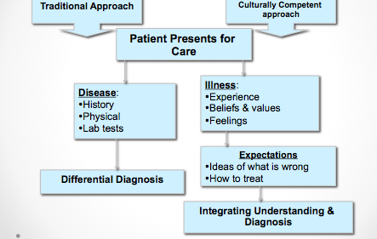

HSS2102-Conflict-Oct. 27, 2014
- Conflict is synonymous with miscommunication
Why so much conflict existts
- Competition for limited resources
  - Rewards; ex. Med school
- Personality clashed
  - Interdependence, struggle
- Aggressive personalities: bullying
  - Weren’t taught how to react and have insight
- Culturally diverse teams and factional groups (perceived incompatibility)
- Microinequities
  - Subtle stratification or discrimination
- Harassment: ex. Sexual
- Competing life (work, family) demands
The good and bad sides of conflict
- Positive sides of interpersonal conflict
  - Talents and abilities emerge
    - Everyone must collaborate to work at full capacity
  - Needs satisfaction=good feelings
    - How do we do it so that everybody wins
  - Unity (after conflict)
    - Comes from doing the right thing
    - May have to compromise to get on same level as everyone else
      - Depends if you’re used to autonomy
      - Conflict can be productive as long as it’s constructive
  - Reduces likelihood of premature agreement and poor decisions (group think)
- Negative sides of interpersonal conflict
  - Poor well-being
  - Wasted resources (money, time, energy)
  - Emotional costs and fatigue
  - Self-interests, dominated all
  - Can lead to violence at workplace
  - How can the these negative sides be alleviated in a employer-employee situation?
    - Employer may demand several little things of employee and employee obeys bc employer is higher authority. Employer may change task to get a rxn out of employee but employee shows indifference and employer does not expect this. If issue that matters arises, however, employee will speak up for what’s right and express concern
2 kinds of Conflict
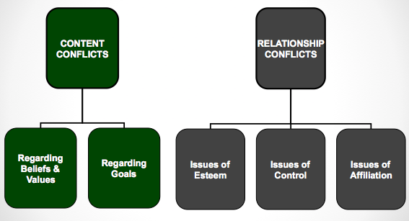
- What are the two conflict types on the content level and what do these kind of conflicts include?
- Regarding values and beliefs (religious, cultural, professional)
- Regarding goals
  - Procedural: the “how”
  - Substantive: the “what”
- What are the 3 types of conflicts on the relational level? Provide examples.
  - Esteem: worth, respect
  - Control: power struggles
  - Affiliation: inclusion, affection
Levels of conflict
- What are the 4 levels of conflict?
  - Personal (self doubt, questioning self)
  - Interpersonal (one on one challenge)
  - Intragroup (within the group)
  - Intergroup (between groups)
- What is interpersonal conflict?
  - Disagreement between or among connected individuals
  - Content conflict vs. relationship conflicts
  - Online conflicts (ex. Say something and let it spiral out of control)
- What are the characteristics of interpersonal conflict?
  - Negatives and positives consequences
  - Culture and gender
  - Conflict styles have consequences
    - Competing: I win, you lose
    - Avoiding: I love, you lose
    - Accommodating: I lose, you win
    - Compromising: I win and lose, you win and lose
    - Collaborating: I win, you win
  - 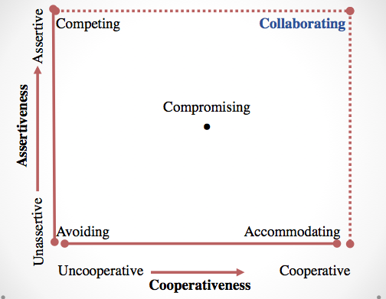
  - List some of the positive and negative consequences.
    - Positive: talents emerge, need satisfaction, unity after conflict, prevents premature disagreement
    - Negative: poor well-being, wasted time
    - Final and emotional costs
    - Fatigue
    - Self interest domincate
    - Workspace violence

Steps in Win-Win Problem Solving
- What are the steps in win-win problem solving?
- Identify your problem and unmet needs
- Make a date
- Describe your problem and needs
- Partner checks back (this is how I feel, now I want you to check how you feel)
- Solicit partner’s needs
- Check your understanding of partner’s needs
- Negotiate a solution
  - Identify and define the conflict
  - Generate a number of possible solutions
  - Evaluate the alternative solutions
  - Decide on the best solution
- Follow up on the solution
Ways to manage Conflict
- Avoidance (non-negotiation) and fighting actively
- Force and talk
- Defensiveness vs. supportiveness
  - Evaluation, Control
  - Strategy: manipulation vs. spontaneity
  - Neutrality, superiority
  - Certainty: closed-mindedness vs. provisionalism
- Face detracting and face enhancing
- Blame and empathy
  - Buying time to control reflex and know how you really feel about a situation
- Silencers and facilitating open expression
- Gunnysacking and present focus
  - Gunnysacking=holding things in, store and carry it with you (sooner or later it’s going to come out more intense than it was stored and possibly to wrong person)
- Fighting below and above the belt: belittling
  - You know sth about that person and use it to hurt them
- Verbal aggressiveness and argumentiveness
  - Can be positive if constructive
  - Objectivity, avoid attacking,, avoid interrupting, express interest, avoid being overemotional, alow for face saving
Techniques for resolving Conflicts with Others
- Confrontation and problem solving (win-win)
  - Respect
- Disarm the opposition
  - Get smn to not get their barriers up, demonstrate empathy and respect to bring walls down
- Cognitive restructuring
  - Get on same level as smn; ‘given my knowledge of you I can understand where you’re coming from, but have you thought about (blank)”; ‘hearing you bc I’m feeling empathetic and I’m paraphrasing to demonstrate that I’m listening but I think you’re wrong and bc of the situation be should do it this way”
- Appeal to third party
  - Ex. Mediators; used when no resolution coming up without
- Negotiation and bargaining tactics
  - Create positive negotiation climate
  - Allow room for compromise but be reasonable
  - Focus on interests, not positions
  - Make a last and final offer
  - Allow for face-saving
- Use a mediator
  - Formal method to address conflict; objective third party
  - The ultimate goal: finding a solution that both sides can agree to while still maintaining their goals
A Model for Resolving Conflicts: 5 steps
- Define the conflict
  - Define both content and relationship issues (in specific terms)
  - Empathize
  - Avoid mind-reading (don’t project; makes sense that if we have experience then specific situation will trigger that experience and make you react in certain way)
- Examine possible solutions
  - Express opinion while not offending
- Test a solution
- Evaluate the solution
- Accept or reject the solution
  - Accept: out
  - Reject: back to steps 1,2, OR 3
Styles of Expressing Conflict
- Non assertion (same thing as being passive)
  - Put smn else’s well being before theirs; rather not be argumentative or
- Direct Aggression (just aggression)
  - Passive Aggression (form of hostility, not as sharp or prominent, they don’t feel like they can directly
- Indirect Aggression (same as passive but not as apparent)
- Assertion
- Ex: Art student friend asks which elective they should take. Friend suggests microbiology class.
  - Non assertive: “yeah well maybe I will, I don’t know, sounds like a good class”
  - Direct: “hey wanna go to the movies tonight”
“No I’m busy doing microbiology tonight no thanks to you!”
- Passive: “hey movies tonight?”
“no I’m stuck doing microbiology tonight.”
- Indirect: “hey what class should I take?”
“probably this one since it wouldn’t as time consuming as others”

Developing Assertiveness
- Assertive: clearly and honestly stating what you think or howyou feel in a fortright manner, without being abusive, abrasive or obnoxious
- Nonassertive: not overtly participating in sharing their thoughts, not letting their feelings be known
- Aggressive: overbearing, step on others to get what they want in a situation
- Becoming less shy
- How can you become more assertive in social situations?
  - Set a goal
  - appear warm and friendly, use body language
  - conduct anonymous conversations
  - greet strangers
  - practice decisiveness

Characteristics of an Assertive Message
- What are the characteristics of an assertive message?
- Behavioral description: non judgmental
- Interpretation of other person’s behavior: Perception check (paraphrasing)
- Describing feelings (not attacking them as a person)
- Description of the consequences
  - You
  - Person being addressed
  - Others
- A statement of your intentions
  - Your stance on an issue
  - Requests of others
  - Descriptions of how you plan to act in the future

HSS2102B-Ethics- Oct. 28, 2014

Scenario
- Physiotherapist
- Treating dislocated shoulder from abuse
- Advise patient to seek counseling
- Patient declines and says they want your counsel bc they have high level of trust and comfort with you (will not open up to any other health care pro)
- What do you do?
  - Say you are also qualified as a counselor
  - They don’t want to change environment
  - Could say come on your own time (if it is a private business)
  - If part of a corporation (like a hospital) you have no choice but to move on bc the schedule is crazy and you can only concentrate on the intervention at hand
Health Care Ethics
- What is the common health care dilemma?
  - Conflict that requires careful consideration of all possible solutions to identify the that balances the interests of all involved
- Ethics
  - Set of moral principle that serve as guiding philosophy for behavior
  - Code of ethics, in each health care profession
  - Function: education, policy, consultation (deal with facts and emotional issues
- What are the 4 ethical principles?
- Autonomy (client makes decisions)
- Beneficience (paternalism, professional decides what’s best)
- Nonmaleficience (do no harm)
- Justice (resources distributed responsible)
- What are the characteristics of autonomy? What needs to be addressed?
  - self determination
  - built on trust, respect, truthfulness, sharing, and confidentiality
  - adult, sound mind, written consent
  - following needs to be addressed
- language (appropriate)
- all risks and benefits must be outlined
- any and a alternatives must be discussed
- client must sign statement that indicates understanding and acceptance of treatment
- How should a HCP explain a diagnosis and communicate to a patientin terms of informed consent?
  - How much info is enough?
    - Impossible to provide info in all of its detail
    - Do patients truly understand “pros and cons” from a medical perspective?
  - Information overkill=more stress to patients?
    - Did patient feel pressure to make a decision
  - HCP must address the unique condition
  - Family members can be gatekeepers
- Explain beneficence and nonmaleficience.
  - To do good and to provide benefit, do no harm
  - If harm is unavoidable, must be minimized
  - Benefits must outweigh the risks
- How is justice viewed?
  - Ethical obligation to be fair
  - Rights-based, legal, distributive
- What are the approaches to Truth Telling in terms of patient and professional relationship?
- Strict paternalism
  - Blatant deception by the HCP for the patient’s best interest
- Benevolent deception
  - HCP withholds some of the truth from the patient
- Contractual honesty
  - HCP discloses as much info as the patient desires
- Unmitigated honesty
  - HCP tells all, even if patient does not want to hear the truth

HSS2102-Therapeutic Communication-Oct. 29, 2014

- Existential factors: learning from others and life
- Altruism: when one realizes they can assist another despite their own difficulties
- Corrective recapitulation: transference (familiarity) getting to somewhere comfortable that you haven’t felt in a while; safe place
- Catharsis: learning to express (release) feelings
- Universality: the human condition (hope, unity)
- What do HCP focus on?
  - Patient’s most important concern
  - Patient’s perception
  - Facilitating the expression of emotion
  - Guiding towards a course of action
  - Management of illness, coping with crisis
- How much control would a HCP when you give patients sense of empowerment?
  - Perception individuals have about how they are connected to others
  - Degree to which they feel able to influence the nature and development of relationship
  - Complementary and symmetrical
  - Restore control to patient when HCP shares control
- How do you define trust?
  - We trust when we see people act in a positive, consistent, reliable manner
  - HCP needs to be competent, sincere, and caring
  - Trust=patient feels valued as a person
  - Recognize the mistake of “thinging” (lose human touch, feel like a number)
    - Ex. Heart specialist, the MS clinic, hip replacement on Ward B
- How does confirmation build on trust?
  - Uncovering meaning in life
  - How one chooses to respond to life (man search for meaning
  - Patients desire the feeling of acceptance
  - Cyclical process of disconfirming communication
- HCP disconfirmed
- HCP less attentive to client
- HCP disconfirms client
- Client feels disconfirmed
- Client is less responsive to HCP
- Client disconfirms HCP
- Back to stage 1
- How do we define empathy? What are the barriers between the HCP and patient?
  - Feeling “with” client, while not losing objective
  - Patients become empowered and have positive perception of health care
  - Associate with better outcomes (assists with coping and resilience)
  - HCP inexperience, lack of motivation (caring), distractions, fatigue (burnout)
  - Patient: lack of openness (bad past experiences), fear and rejection (scared of being judged), language barrier
- What factors influence self-disclosure?
  - Who you are (your experiences)
  - Your culture (varies)
  - Your gender (men tend to not be as expressive as women)
  - Your listeners the dyadic effect (when in an intimate situation, more likely that self disclosure will happen; smaller the environmentmore self disclosure)
  - Your topic (how you carry yourself)
- What are the rewards of self-disclosure?
  - Self knowledge (self acceptance: more positive self concept)
  - Communication and relationship effectiveness
  - Physiological health (release that comes from catharsis)
- What are the dangers of self-disclosure?
  - Personal risks (ostracizing: alienating smn; “why are you telling me this?”; rejection by family and friends
  - Relationship risks decreased trust
  - Professional risks (be sensitive; check with person; leveling: don’t make assumptions; “I probably don’t understand fully but I might have an experience that’s kind of the same thing”)
- What are the Guidelines for self-disclosure?
  - Define motivation behind the self disclosure
  - How appropriate is the self-disclosure, and in what atmosphere is it occurring (location, how many ppl are around)
  - Is there reciprocal disclosure (analogous to idea of symmetry; confidence and trust, is it happening both way?)
  - Will self-disclosure impose burdens
- What are the Guidelines for Facilitating and Responding to Disclosure?
  - Practice skills of effective and active listening: empathetic, open minded, understanding of feelings
  - Support disclosure: practice affirmation (through your disclosure, I know where you’re coming from)
  - Be willing to reciprocate with disclosure
  - Maintain confidentiality
- How do you increase listening effectiveness?
  - Empathy and objective listening
    - View other as equal
    - Empathy: ability to put yourself in the position of the other person
    - An attitude, a skill
    - Understanding thoughts and feelings, as opposed to a reflection
  - Non judgmental and critical listening
    - With an open minded (question your own assumptions, listen for facts)
    - Be more tentative about what we think we know
    - Don’t be afraid of being wrong
    - Be aware of leveling
  - Surface and depth listening
    - Most message have more than one meaning: literal and hidden
      - Ex. Do you like my shirt?-->can be serious or joking
      - Meaningful contact=awareness of the multiple levels of meaning
      - Content vs. relational aspect of message (use of nonverbal cues)
      - What is being said, why is it being said

HSS2102B-Interviewing and Counselling-Nov. 3, 2014

Phases in the Interview Process
- What are he different phases in the interview process?
  - Preparation
    - Planning for the first meeting
    - Self awareness of strengths and limitations
  - Initiation
    - First contact; establishing therapeutic climate
    - Clarification of the interview’s purpose
    - Formulating a contract and establishing mutual goals
  - Exploration
    - Client’s determination of their problems, and subsequent management of their feelings
    - Development of coping skills
  - Termination
    - Must plan for the interview’s closure
    - Summarization of issues and accomplishments
    - Discussion of the termination, and how it makes the clients feel
Communication Technique in Interviews
- What are the various communication techniques in interviews?
  - Questions
  - Silence
  - Restatement
  - Reflection
  - Clarification
  - Interpretation
Questions
- Explore the two techniques of questions. What are the advantages?
  - Open: intended to facilitate disclosure
    - Time consuming, stimulates discussion, more complex answers
    - How, what, describe, explain
    - Ex. Tell me about your son’s problems in school?
  - Closed: for clarification and facts
    - Does not allow for explanation of emotions; limits response (yes/no)
    - Who, where, when
    - Ex. Was your work stressful today?
  - 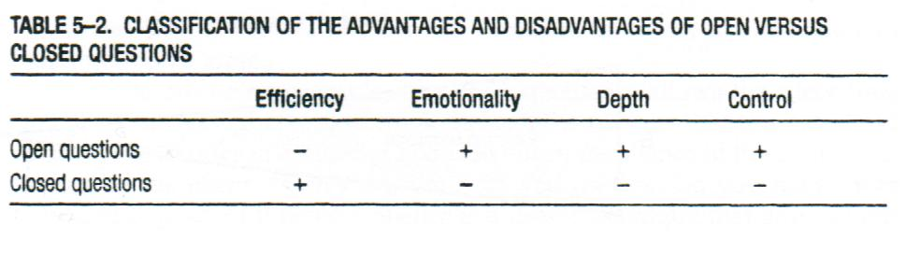
Silence
- When used effectively, what can silence do in a therapeutic environment?
  - Encourages client disclosure (possibly catharsis)
  - Allow the clinician to collect thoughts
  - Difficulty of giving expression
  - Appropriate and therapeutic (avoid overuse)
Restatement (Paraphrasing)
- What does restatement demonstrate?
  - “What” (content) is being said
  - Without adding personal thoughts/feelings
    - Ex. “I hear you saying”, “it sounds like”
  - Show “active listening” and acts as feedback
  - Confirming and validating the client
Reflection (of Feeling)
- What does reflection depend on?
  - “how” things are expressed
- Is it more or less difficult than restatement? Why?
  - More difficult
  - Requires picking out the emotional aspect
- What is it used for?
  - Check accuracy if understanding (HCP correctly understood patients
- When shouldn’t you use it?
  - Too soon or too frequently
Clarification
- How is it done?
  - Form broad to more focused topics
- How does it help?
  - Helps clinicians determine what issue is the most pressing
- What does it allow for?
  - Better understanding of client’s thoughts and feelings
- What might it required
  - Closed-ended questions and client to provide specific examples
Interpretation
- What does the clinician offer?
  - Explanation, new frame of reference or way of looking at things
- What is it designed to connect?
  - Meaning to a feeling
- What should the client have control over?
  - Control over accepting or rejection clinician’s interpretation
- What are some suggestion for effective interpretation
  - Use same language as client
  - Prelude (introduce) that you are offering ideas; ask for feedback
Using the narrative Model
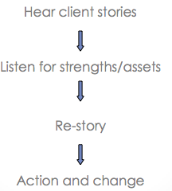

Contrast with illness-centered medicine
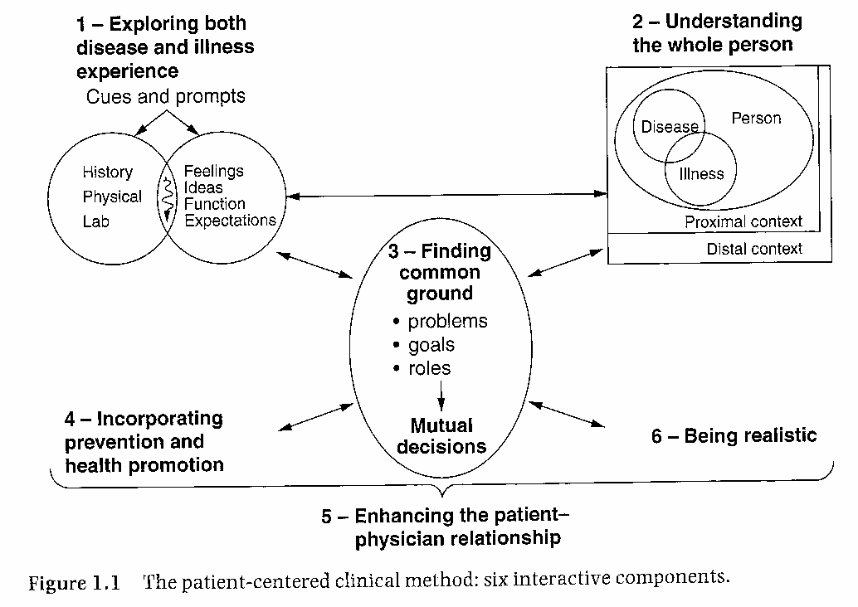

The Nature and Types of Interviews
- What are the types of interviews?
  - Information-gathering
  - Appraisal
  - Problem-solving
  - Persuasion
  - Job
Interview Structure
- What does it consist of?
  - Opening
  - Body (asking questions)
  - Conclusion
- What are the questions types you can ask in the Body of the interview?
  - Open and closed
  - Probing questions
  - Hypothetical questions
- What are the two types of funnel sequences used for question asking?
  - Funnel sequence
  - Inverted funnel sequence
- What would the diagram of the funnel sequence look like? Provide an example of how one would approach this.
  - 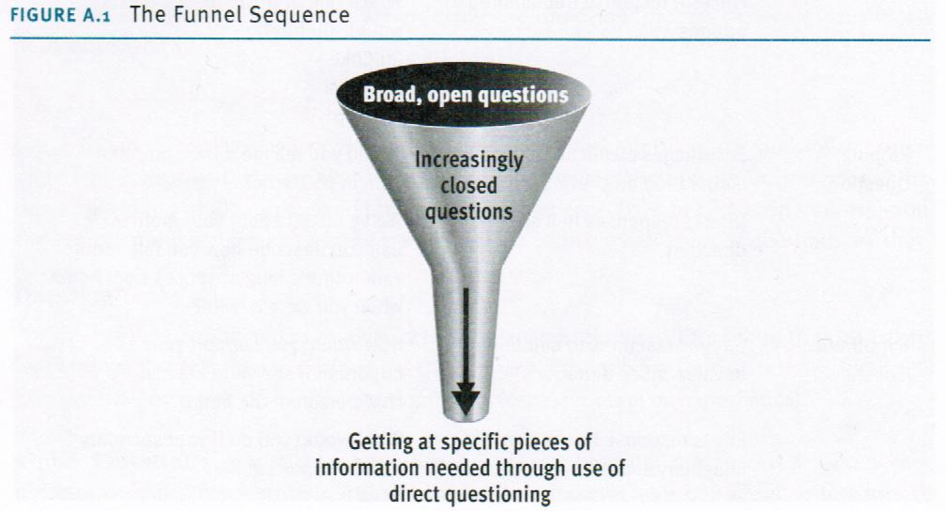
  - Example:
    - Why do you find communication interesting?
    - What is your primary interest in the study of communication?
    - How long have you studied intercultural communication
    - Why do you think intercultural communication theory is useful?
    - What would you do to test intercultural communication theory?
- Now show an inverted funnel sequence and provide examples for that.
  - 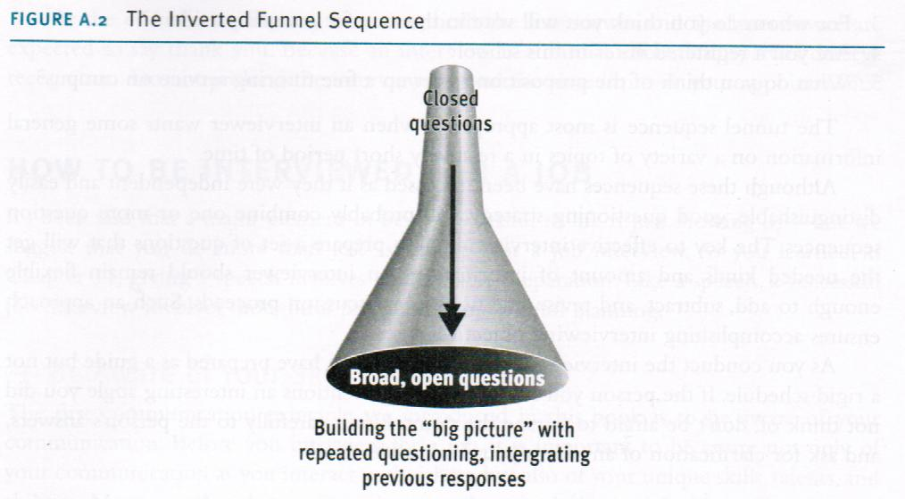
  - Example:
    - Do you believe that your supervisor wants to fire you?
    - What makes you think you will be fired soon?
    - What do you think caused this problem?
    - How has this problem developed?
    - How would you describe the working climate in your department?
Undergoing a job interview
- What should you be aware of?
  - Your skills and abilities
- How do you prepare your resume?
  - Personal info, career objective, education, experience, honours and special accomplishments, select optional info, and references
- What else should you do to prepare?
  - Identify and anticipate your employer’s needs
- What should you do be doing during the interview?
  - Listening responding, and asking appropriate questions
- What should you do after the interview?
  - Follow up
Undergoing an Information-Gathering Interview
- How should you initially approach this?
  - Prepare for the interview
- What should you do during?
  - Listen effectively
  - Respond appropriately
Responsibilities of the Interviewer
- What are the responsibilities?
  - Awareness of biases and prejudices
  - Adapting to an interviewee’s behavior
  - Dealing wisely with sensitive content
  - Listening effectively
  - Recording info
  - Asking appropriate questions
Summary: Principles of Interviewing
- Awareness of your communication with yourself and others
- Effective use and interpretation of verbal messages
- Effective use and interpretation of nonverbal messages
- Listening and responding thoughtfully to others
- Appropriately adapting messages to others

HSS 2102-Gender, Aging and Communication-Nov. 17, 2014

Gender and Communication
- What does the importance of gender in culture include?
    - Sex based expectations and conditioning from birth
    - Results on development as adults: relationships, career
- Which gender is represented my instrumental orientation and expressive orientation?
    - Instrumental men
    - Expressive women
- Which gender tends to disclose more?
    - Women, especially in same sex dyads, intimate info (even more when relationship becomes more intimate)
    - Equal in negative disclosure
- Listening and Gender (as a function of socialization)
  - When talking…
    - Men are superior, women are non-expert
  - What kind of listening style do women take part in?
    - People oriented
  - What type of listening do men have?
    - Time-oriented
  - When communicating, how do men and women compare?
    - Similar fashion
  - How do men and women approach socialization?
    - men: knowledge=respect
    - women: seek to be liked, express interest, send more nonverbal cues, less pure silence, proximity and body posture
- Gender Differences in Communication Style
- List communication styles found in women.
    - Use communication for rapport building
    - Want empathy, not solutions
    - Use gentle expletives (“oh dear”)
- List communication styles for men.
    - Prefer to use talk to preserve independence and status (via knowledge and skill)
    - More directive and less apologetic
    - More intimidating when facing differences
    - Attention to accomplishment and hogging recognition
- What are some polar differences?
    - Men want to solve problems alone, women want to discuss
    - Men more directive and less apologetic, women more apologetic and polite
    - Interruption used differently
- Gender and conflict style (due to socialization)
  - List some common traits of women in this context.
    - More likely to use indirect strategy instead of confronting head on (harmony)
    - Logical reasoning and arganing during competition
  - List some common traits of me in this context.
    - Direct aggression
    - Withdraw if uncomfortable or don’t get their way
    - Aggression can be part of friendship
    - More cooperative with other women than other men
  - What are we finding about these differences as society develops?
    - Differences less pronounced as sex role stereotyping is diminishing
- What does the demand-withdraw dynamic entail?
  - Criticizer complains and demands for something while other withdraws and avoids confrontation
  - Reflected as women as complainer and man as withdrawer
- Ageism
  - External Ageism: discrimination on basis of age
  - What is involved in external ageism?
    - Assumptions about capacity
    - Removes decision-making process
    - Ignores person’s wishes
    - Treats person as child
  - Internal Ageism: person doesn’t believe they can do something because of their age
  - What does society need to do?
    - Develop and foster new attitudes
    - Materials and services, sensitive to needs
    - Keep up with evolution of population
- Communication Approach to Aging
  - Why is communication central to figuring out the roles of elder people in society?
    - Reflects and shapes understanding of aging
      - Perceptions of aging
    - Shapes experience of aging
      - What message do people receive when they age
    - Age group memberships fundamentally important to our sense of “self”
      - Our social identify
    - Age group memberships influence communication phenomena
      - Styles and content of communication
  - Give an example of an ageist situation and evaluate passive, aggressive, assertive and humourous response and how the older person is evaluated in terms of that response.
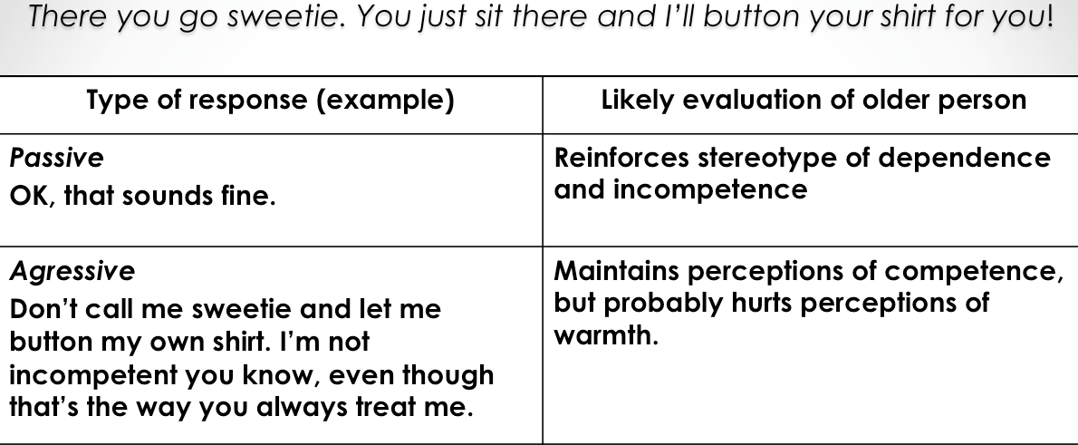
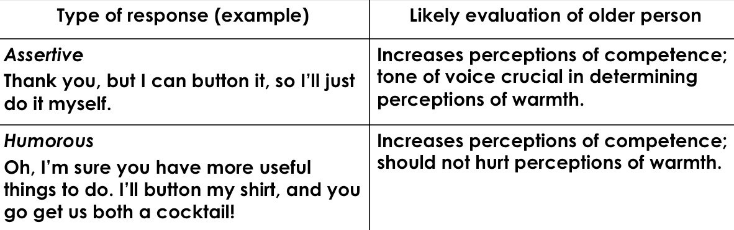

Communication Enhancement Model
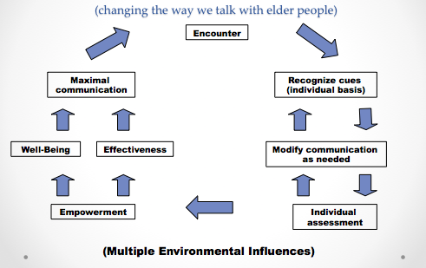

HSS 2102A – Health Promotion Messaging – Nov. 26, 2014

A Look at Three Communication Theories
- Activation Model (Sensation seeking targeting)
  - How does the Activation Model make an impact?
    - Stimulation and sensation seeking
    - Messages with high sensation value (creative, intense, explicit)
    - Sex and drug use and other high risk behaviours
- Extended Parallel Process Model (EPPM)
  - How are people affected by the EPPM?
    - Fear appeal and scare tactics
    - Threat appraisal: severity and susceptibility
    - Efficacy appraisal
  - What makes up efficacy appraisal?
    - Self-efficacy (confidence) and response efficacy (make a difference?); both need to be high for fear appeal to work
- Fisher’s Narrative Theory
  - What does this theory entail?
    - People are storytellers
    - Involves personal story, history, culture
    - Truthfulness and consistency

