Week 3:
Lecture 5
Case Study Discussion 1
- United Breaks Guitars:
- How could UAL have handled this crisis better? What types of strategies and tactics are recommended for other companies?
- Better deal with people and get across that there is a protocol in place
- Why did Dave Carroll’s song video go viral? What does it take for something to become successful viral content?
- Huge customer base
- Look at it from two hats: from consumer and manager
Social Media Crisis
Management Introduction
- Social Media Crisis:
- A crises issue that arises in or is amplified by social media, and results in negative mainstream media coverage, a change in business process, or financial loss.
- Characteristics:
- Technology helps create a negative buzz around a brand, product, or service.
- Ground-up phenomenon that is largely out of the control of the business being affected.
- Powered through emergent events:
- small low-level events, such as the interactions between a few consumers, can give rise to higher-level intensity, such as the development of new disparaging multimedia content and negative campaigns.
Additional Facts About the Case
- Extensive & Deliberated Use of Social Media:
- Carroll’s friend, Ryan Moore, posted the video to YouTube at about 10 p.m. on Monday, July 6.
    - A small team of friends used Twitter to introduce their followers to the video.
    - They also tweeted to those on Twitter who had themselves tweeted about bad experiences with United Airlines, and to members of the media including Jay Leno, Jimmy Fallon, and Perez Hilton.
    - They posted the story to Digg and other social news sites to which people could submit stories and vote them up or down
- What else worked in Dave’s favor:
- Dave Carroll’s video was immediately picked up by Consumerist.com, a website affiliated with Consumers Union, America’s leading not-for-profit consumer advocacy organization and the publisher of Consumer Reports magazine.
- What the event did for Dave:
- Became famous ... Increased sales... etc.
- The New York Times labelled Dave Carroll as “the Everyman symbol of the aggrieved traveler”.
- Dave Carroll formed many new business relationships with manufacturers like Taylor Guitars and Calton Cases, and service providers such as Mariner Partners and RightNow Technologies (customer experience software providers).

Additional Facts about the Case: Response and Selected Tweets from UAL
- United’s first tweets on July 7, 2009:
- “This has struck a chord w/us and we've contacted him directly to make it right.”
- “We have called him and the person who answered his phone scheduled a call for tomorrow morning.”
- On July 8th, United offered Dave an apology and $1200 in repair costs and $1200 in airline vouchers:
- The offer was declined, and United made a $3000 donation to a music school.
- Public Taunting continues on July 8 with no response from United:
- “Why'd you guys have to go and break his guitar? http://bit.ly/rI2ef Stop being a bully and fess up!”
- “You can say creatively that this has struck a chord with you but lets be real how do you plan on changing?”
- “And since I'm on a roll, shame on you for taking over a year to bother . . . Too much truth in your bar?
Web 2.0 Attitudes
- Groundswell, “…spontaneous movement of people using online tools to connect, take charge of their own experience and get what they need – information, support, ideas, products, and bargaining power – from each other.”
  - An event happens, and then from that ground up event, thru social media you get what you want
- New way of thinking is captured in a list of 95 statements called the Cluetrain Manifesto (page 105)
    - Markets are conversations.
    - These networked conversations are enabling powerful new forms of social organization and knowledge exchange to emerge.
    - As a result, markets are getting smarter, more informed, more organized. Participation in a networked market changes people fundamentally.
    - People in networked markets have figured out that they get far better information and support from one another than from vendors.
Commercial Aspects of Web 2.0 Attitudes
WEB 2.0 on EXAM
Goal is to try and build relationships – Cluetrain Manifesto: markets are relationships
- Viral (Word-of-Mouth) Marketing
    - Viral blogging
Viral marketing done by bloggers
- Classified Ads, Job Listings, and Recruitment
- Special Advertising Campaigns – Companies cater to the needs of specific groups
- Mobile advertising increased sales can come from harnessing techniques based on personal preferences such as collaborative filtering
Lecture 2 – Steps of a Social Media Strategy
- Discover
  - Target Audience
  - Objectives
  - Capacity
  - How to Operationalize
- Strategize
  - Listening
  - Answering
  - Social Tools and Interactions
  - Strategy for Managing Content
- Manage
  - Data Collection, analytics
  - Measure results vs. goals (lecture 7)
  - Refine –adjust and test
  - Repeat Steps 1-3
Job Roles of a Social Media Strategist
- Work closely with your already existing marketing staff to understand your marketing strategy and goals.
- Research the most appropriate social media channels for your business.
- Determine with the best tools to manage your business and train internal staff how to manage those accounts using the tools.
- Develop metrics and institute tracking devices to gauge return on investment.
- Advise on how to deliver promotional content and campaigns through the channels.
- Monitor changes in social media technology, channels, and tools and make adjustments and provide training.
->Lecture 3 – innovation, value, customer experience, excitement
Innovative Marketing
- https://www.youtube.com/watch?v=XNic4wf8AYg
- Jay-Z and Bing
- Fresh way of thinking – using the physical objects for marketing
- Good marketing for sub-products as well
Web 2.0 Definition and Applications (Examples)
- Extract from a Long Definition:
- Software as a continually-updated service that gets better the more people use it, consuming and remixing data from multiple sources, including individual users, while providing their own data and services in a form that allows remixing by others, creating network effects through an architecture of participation
- Salient Features of Web 2.0:
- The Web as a Technology Platform in itself
- Information Sharing, Collaboration and Interactive Functionality of the web:
    - Interconnectivity and Interactivity of web-delivered content !
- Architecture based on Participation
- Popular Examples of Web 2.0 based Applications:
- Social Networking Sites, Video Sharing Sites, Wikis, Blogs, and Folksonomies.
- Mashups and APIs (Application Programming Interfaces).
What is Web 2.0? (Page 100)
How is it different from Web 1.0?
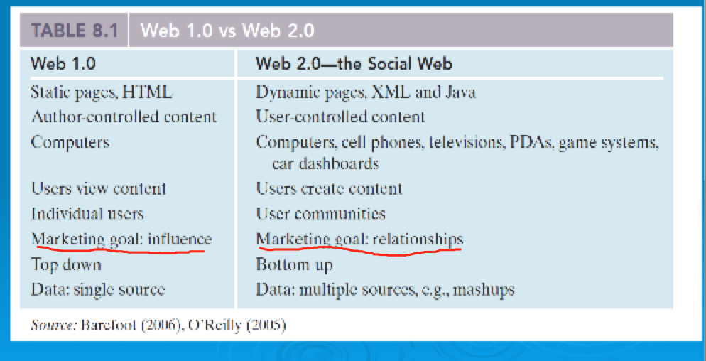
Web 2.0 Components – RSS feeds (page 102)
- RSS (Really Simple Syndication): used to publish frequently updated content such as blog entries and news headlines
- Informing
- Supply chain of information
- An RSS feed (i.e., document) contains either a summary of content from a website or the full text
- RSS enables people to keep up with their favorite websites in an automated manner
- RSS content is read using software called "feed reader" or "aggregator"
- The user subscribes to a feed by entering the feed's link into the reader
- The reader checks the user's subscribed feeds regularly for new content, downloading any updates it finds
Web 2.0 Components – Mashups (102-103)
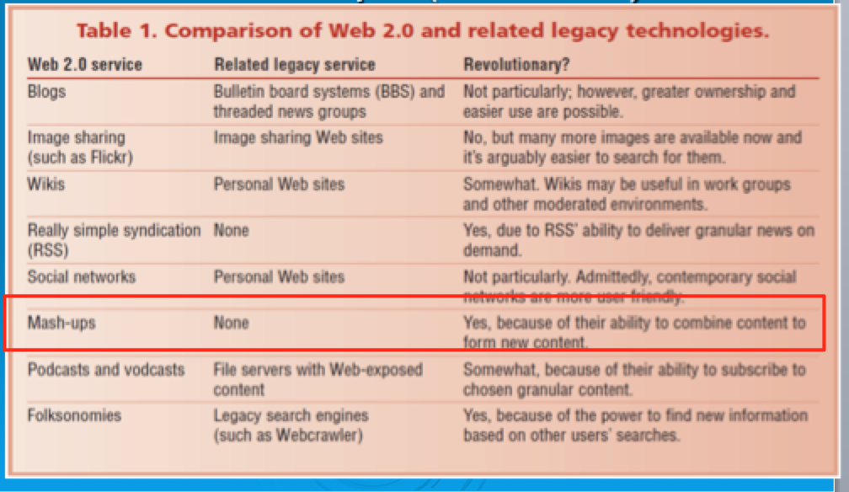
What are Mashups
- A mashup is a web application that combines data or functionality from more than one source into a single integrated interface or tool:
- Applications or interfaces generated by combining content, presentation, or application functionality from disparate sources.
- Content used in mashups is typically sourced from a third party via a public interface or API (Application Programming Interface):
  - API (Application Programming Interface):
    - an abstraction that defines and describes an interface for interaction with a set of functions used by components of a software system.
    - Abstraction is the process of taking away or hiding or removing characteristics from an object in order to reduce it to a set of essential characteristics.
    - For the consumer or user, abstraction helps focus on the essential elements with unwanted detail omitted.
- The word “Mashup” originated in the music industry, where a mashup was a combination of two or more songs to create a new experience:
  - Typically, the vocal track of one song was combined with the instrumental background of another in this process.
- The technology industry extended this definition to encompass a new class of applications that described the combination of two or more sources into an integrated application.
- Mashups are applications generated by combining content, presentation, or application functionality from disparate sources.
  - A mashup is typically created from several data sources and services, mashing up (combining, stitching together) the sources and services to create something new, or add value in some way.
- But…not all Mashups are Composite Applications:
  - Mashups may also be used to access a single resource to mine data or migrate content (re-purpose existing data and information according to your needs)
Mashups and Web 2.0
- Mashups have been regarded as a Disruptive Technology:
  - “Mashups will be a major force in the next few years, with vendors such as IBM, Serena Software and Microsoft leading the way. The disruptiveness comes in the end-user environment, where business users with little technical ability will be able to create their own mashups and assemble them in dashboards. This will introduce security and privacy challenges for the IT industry.”
    - Gartner Research
Social Media and Business Disruption
- One of the biggest forces changing business is the Internet (remember – it is the basis for all other flatteners)
- Organizations must be able to transform as markets, economic environments, and technologies change
- Focusing on the unexpected allows an organization to capitalize on the opportunity for new business growth from a disruptive technology
Social Media as an Industry Disruptor
- Industry and Market Disruptors
- Disruptors
Companies that introduce a significant change in their industries thus cause disruption in the way business is done
Checklist of questions to help identify disruptors
    - Is the service or product simpler, cheaper, or more accessible?
    - Does the disruptor change the basis of competition with the current suppliers?
    - Does the disruptor have a different business model?
    - Does the product or service fit with what customers value and pay for?
Disruptors in Business
Disruptor is technology that enters a market and takes over
- The Internet has completely disrupted the way businesses operate, employees communicate, and products are developed and sold. Here are a few examples:
- Travel site Expedia.com is now the biggest leisure-travel agency, with higher profit margins then even American Express.
- $ 7-8 billion in annual online music downloads have wrecked the traditional music business.
- Dell increases profit margins while cutting prices by using the Internet to link suppliers and customers.
- EBay is one of the nation’s top 15 retailers.
One of the biggest forces changing business is the Internet (remember – it is the basis for all other flatteners)
What is Social Networking
- It Involves relationships defined as: An extended group of people with similar interests or concerns who interact and remain in informal contact for mutual assistance or support. A logical or natural association between two or more things: connection, correlation, interconnection, interdependence, interrelationship, link, linkage, relation, tie-in.
- It Involves building “Social Capital”.
- Social networking is achieved through social network services (page 108)
What is Social Capital
- Social capital is a core concept in business, economics, organizational behavior, political science, and sociology, defined as the advantage created by a person's location in a structure of relationships. It explains how some people gain more success in a particular setting through their superior connections to other people.
- Remember business is about building relationships of all sorts to create “Social Capital.” – these relationships can be with customers, suppliers, media etc.
Information into Capital
- Knowing that Facebook has a billion users isn’t helpful on its own
- The business challenge is analyzing and shaping the information to be meaningful from a business perspective and to be able to reach out to those billion users
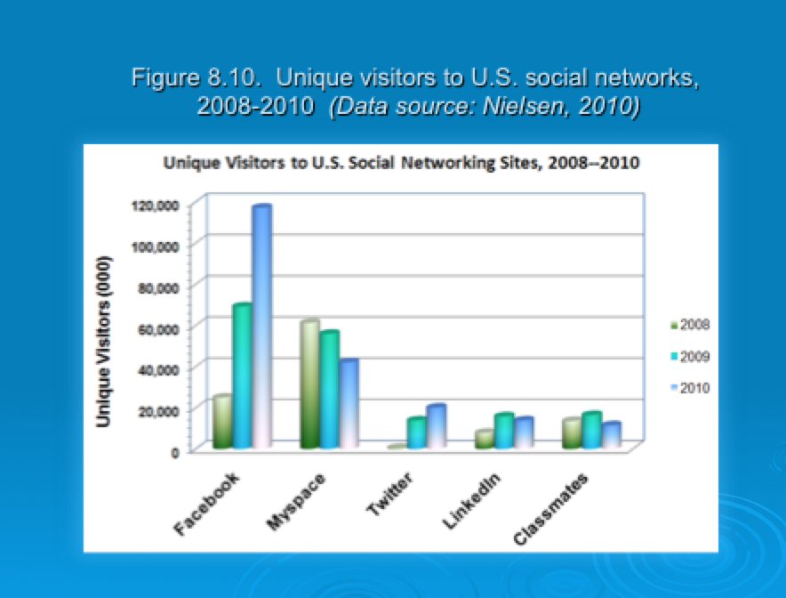
Social Network Analysis (SNA)
- SNA is the mapping and measuring of relationships and flows between people, groups, organizations, computers, or other information or knowledge processing entities
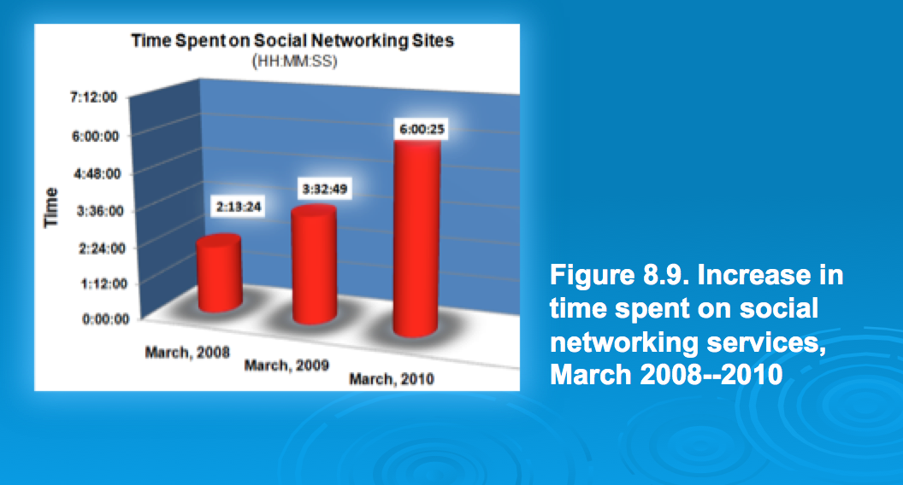

- How do we classify people and identify new Business Models?
- Social network analysis (SNA software)
The mapping and measuring of relationships and information flows among people, groups, organizations, computers, and other information- or knowledge-processing entities. The nodes in the network are the people and groups, whereas the links show relationships or flows between the nodes. SNAs provide both visual and mathematical analyses of relationships
Examples of Network Classification
- Aggregators: Linkedin, Facebook, Xing, Ecademy etc. etc..
- Geographic: “Link to” sites: Chicago, Charlotte, Nashville, New York etc. etc..
- Industry : Wireless Factors, Wine & Spirits, Motor Sports, Entrepreneurs etc. etc..
- Topical: Politics, Music, Sports Investments, etc etc..
Digital Economy Business Models
- Based on who is involved
  - Business-to-consumer (B2C)
  - Business-to-business (B2B)
  - Consumer-to-consumer (C2C)
- Based on the medium
  - Mobile commerce (m-commerce)
  - Location commerce (l-commerce)
Internet Business Models – Different Models
- Virtual Storefront
- Sells products directly to consumers (B2C) or businesses (B2B)
- www.chapters.ca
- Information Broker
- Provides product, pricing, and availability information to individuals and businesses
- Revenue from advertising or from directing buyers to sellers
- http://www.ehealthinsurance.com
- Transaction Broker
- Saves users time and money by processing online sales transactions
- Fee paid per transaction
- http://www.baystreet.ca/
- Online Marketplace
- Buyers and sellers meet, search for products, display products and establish prices
- Revenue from transaction fees
- www.ebay.ca (C2C)
- http://www.chemconnect.com (B2B)
- Content Provider
- Provides digital content
- Customer pays for access
- Advertising can also provide revenue
- www.britannica.com
- Online Service Provider
- Provides a service
- Revenue from transaction fees, advertising, or by collecting marketing info from users
- http://www.xdrive.com
- Virtual Community
- Provides chat room, online meeting place, etc. for people of similar interests
- www.KidsHelp.sympatico.ca
- Portal
- Provides initial point of entry to the web, specialized content, services
- www.msn.ca

