Week 2
Lecture 3
Innovative Connectivity
- Social media tools connect people to processes and information
- Apps are simply the means of doing that to help prevent information indigestion
- Business processes gain new perspectives – people and businesses become more productive
- It accelerates the data to information cycle (class 1) to make information usage more efficient
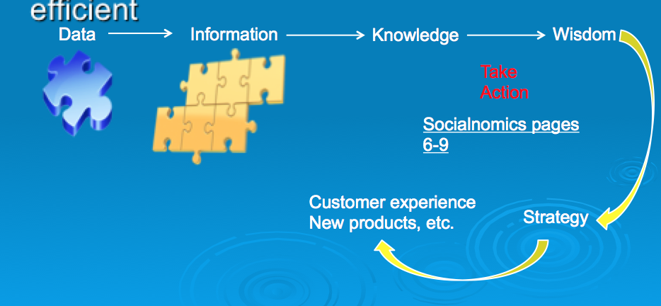
Digitization
- Basically means the replacement of physical tasks by digital means – Facebook is social digitization
- Significant business relationships have been digitally enabled
- Supply chains are a good business example – we used to design products face to face but now we often do it piece by piece in different locations
Digital Goods
    - Goods that can be delivered over a digital network
          - E.g., Music tracks, video, software, newspapers, books
    - Industries with digital goods are undergoing revolutionary changes (publishers, record labels, etc.) – pages 14-26 of Socialnomics chpt
    - These changes may impact many other processes (i.e. recruitment, marketing) – go back to slide 18 from last class

Changes to Business Processes
- ‘Offline’ avenues are also impacted by digital goods - i.e. social clubs, education, tv channels (Socialnomics, page 13)
- Offline business (i.e. postal service) become online
- http://www.cbc.ca/news/canada/ottawa/canada-post-to-phase-out-urban-home-mail-delivery-1.2459618
Other Digitization Impacts
- Last Class - Bit Torrents & P2P (i.e. Napster) changed how we access products (i.e. movies and music) and required new laws to be created because of technology enabled business
- Online banking – new security standards
Eight Key Differences in the Digital Economy
Reach or expansiveness, Communication, Richness, and Technology
1. Ubiquity (Reach)
    - Internet/Web technology available everywhere: work, home, etc., anytime.
    - Effect:
- Marketplace removed from temporal, geographic locations to become “marketspace”
- Enhanced customer convenience and reduced shopping costs
2. Global reach
    - The technology reaches across national boundaries, around Earth
    - Effect:
- Commerce enabled across cultural and national boundaries seamlessly and without modification
- Marketspace includes, potentially, billions of consumers and millions of businesses worldwide
3. Universal standards
    - One set of technology standards: Internet standards
    - Effect:
- Disparate computer systems easily communicate with each other
- Lower market entry costs—costs merchants must pay to bring goods to market
- Lower consumers’ search costs—effort required to find suitable products

4. Richness
    - Supports video, audio, and text messages
    - Effect:
- Possible to deliver rich messages with text, audio, and video simultaneously to large numbers of people
- Video, audio, and text marketing messages can be integrated into single marketing message and consumer experience
5. Interactivity
    - The technology works through interaction with the user
    - Effect:
- Consumers engaged in dialog that dynamically adjusts experience to the individual
- Consumer becomes co-participant in process of delivering goods to market
6. Information density
    - Large increases in information density—the total amount and quality of information available to all market participants
    - Effect:
- Greater price transparency
- Greater cost transparency
- Enables merchants to engage in price discrimination
7. Personalization/Customization
    - Technology permits modification of messages, goods
    - Effect
- Personalized messages can be sent to individuals as well as groups
- Products and services can be customized to individual preferences
8. Social technology
    - The technology promotes user content generation and social networking
    - Effect
- New Internet social and business models enable user content creation and distribution, and support social networks
Competitive Advantage
- To survive and thrive an organization must create a competitive advantage
- Competitive advantage – a product or service that an organization’s customers place a greater value on than similar offerings from a competitor
- First-mover advantage – occurs when an organization can significantly impact its market share by being first to market with a competitive advantage
THE FIVE FORCES MODEL – Evaluating Business Processes and Strategy
- Porter’s Five Forces Model determines the relative attractiveness of an industry
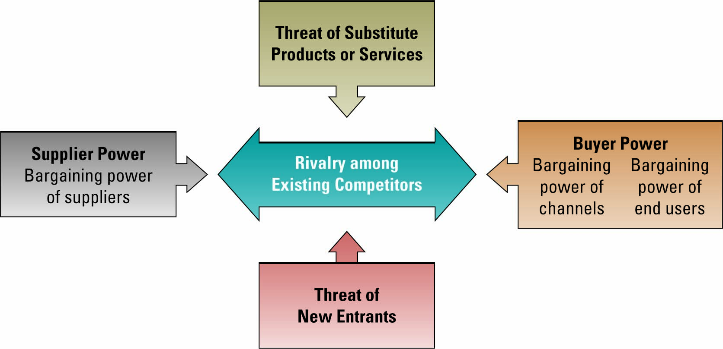
Porter’s 5 Forces Model
- Buyer power - high when buyers have many choices of whom to buy from and low when their choices are few
- Use IT to reduce buyer power (thus creating a competitive advantage) through loyalty programs
- Loyalty program rewards customers based on the amount of business they do with a particular organization (frequent flyer programs, Shopper’s optimum, coffee shops where you get your 10th cup of coffee free, etc.)
‘Long tail’ of social networking provides access to previously inaccessible market niches and customers
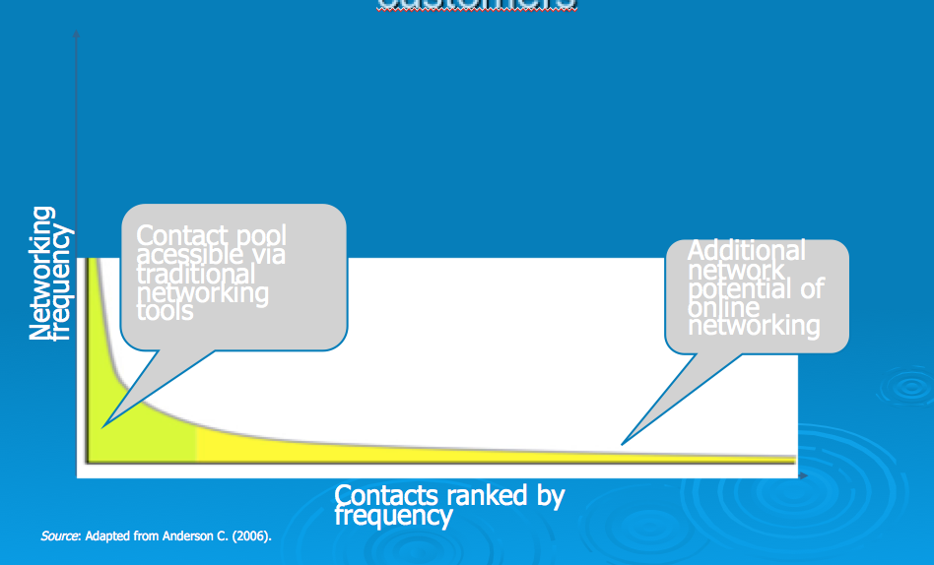
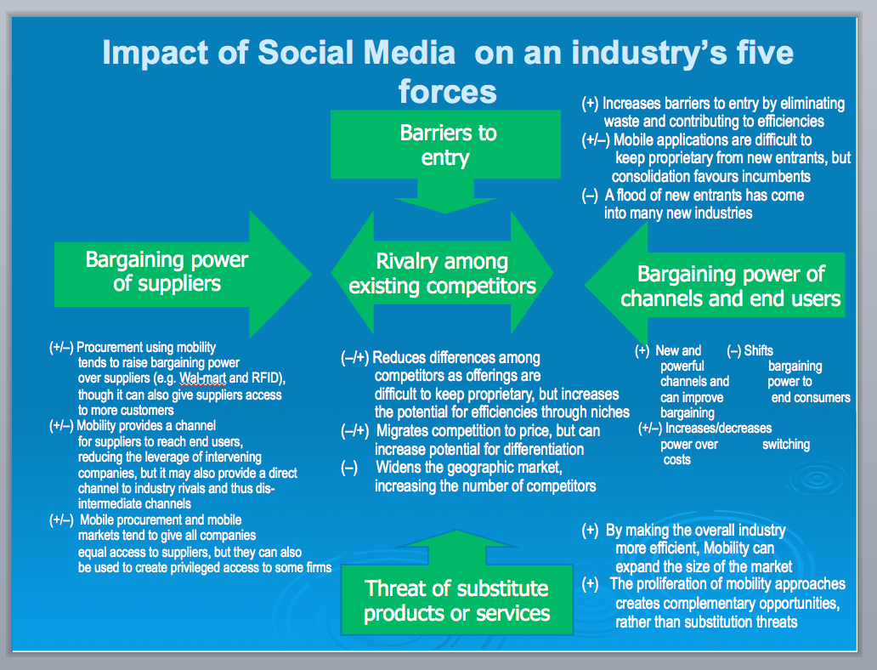
Takeaway: in dealing with theses five forces, there are benefits and detrimental aspects of using Social Media
How Does Social Media Work
- http://www.youtube.com/watch?v=MpIOClX1jPE&feature=channel
Right Tool for the Job
- All social media tools are not the same but rather you need the right tool to ensure you achieve your objectives
Social Media for Business
  - Google -cloud computing everything from anywhere with an Internet connection
  - LinkedIn-build and foster professional network and employee engagement
  - Facebook Pages-talk with loyal customers build new ones, create employee page, long term relationship building
  - Twitter- Initial connection, brief communication with employees and customers (i.e. 1PM sale), short term/initial relationship building
  - You tube – Marketing, education
  - Location based networking to identify and manage situations
  - Foursquare- Presence, have employees check-in to geographic location
Honeycomb of Social Media (Functionality & Implications)
(Kietzmann et al., 2011)
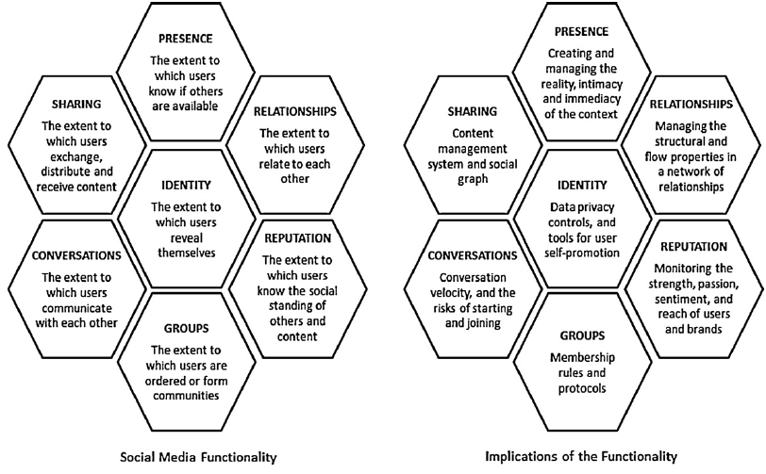

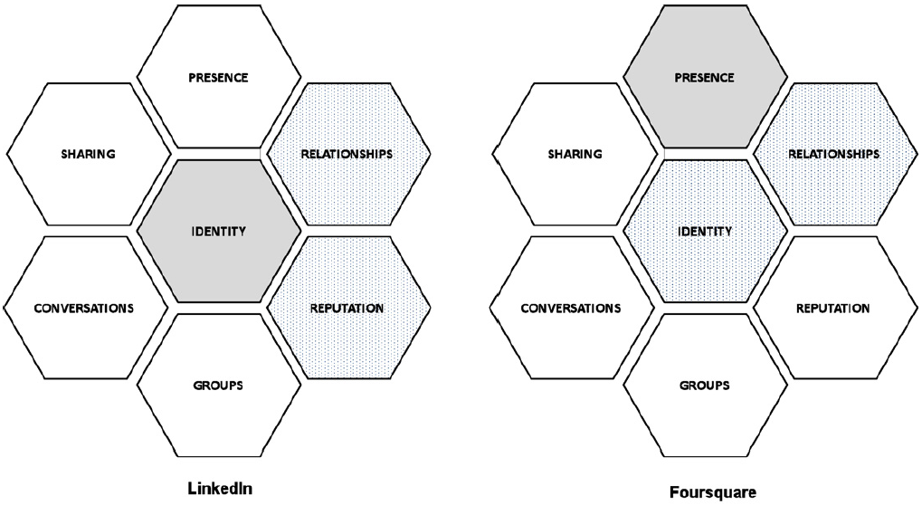
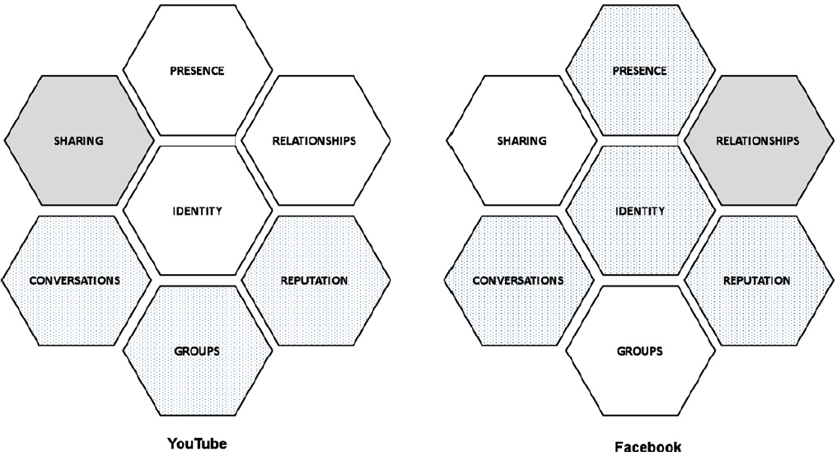
Why Is It Important to Align Social Media and Business Strategy
- Failure to do so may result in surprising outcomes
- http://www.businessinsider.com/mcdonalds-twitter-campaign-goes-horribly-wrong-mcdstories-2012-1
- http://www.businessinsider.com/the-top-10-corporate-social-media-disasters-2013-11
- http://www.socialmediatoday.com/content/7-social-media-campaign-disasters-what-were-they-thinking
- http://www.inc.com/geoffrey-james/top-8-brand-disasters-of-2014.html

Economics of Digital Goods
Cost of producing first unit is almost the entire cost of the product: marginal cost of producing 2nd unit is almost zero
- Costs of delivery over the Internet are very low
- Marketing costs remain the same
- Consumer costs are also reduced

How to make money using Web 2.0
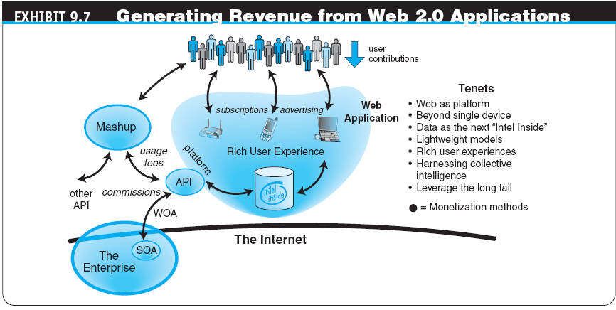

How Does YouTube Make Money
- The Business and Revenue Models
- Advertisements were launched on the site beginning in March 2006
- In April 2006, YouTube started using Google AdSense
- Recently, YouTube began ad revenue splitting with copyright holders
- Given its traffic levels, video streams, and page views, YouTube’s potential revenues is millions per month
Social Networks and E-Commerce
Other Revenue Generation Strategies in Social Networks
- Offer premium service for monthly or per service fee
- Organizations partner with the social networks, paying them a monthly service fee
- Some social networks have a network of thousands of local physical venues where members can meet; these venues may pay a fee to be associated with the network
There are six basic strategies for generating revenue from Web 2.0 applications:
  - Advertising
  - Sales
  - Subscription
  - Free/Freemium
  - Transaction Fee
  - Affiliate
Amazon Affiliates
Micro Revenue
- Page 30 Socialnomics
- Information is the facilitator of most services
- M-Revenue enables us to generate large dollars from many small contributions
- Threadless T-Shirts http://p2pfoundation.net/Threadless_-_Business_Model

Lecture 4
Wikis
- “wiki wiki” means “quick" in the Hawaiian language
- A wiki is a website or similar online resource which allows users to add and edit content collectively
- Example: www.wikipedia.com
Wiki
- Collectively share and edit a body of knowledge
- Ongoing process of creation and collaboration
- Knowledge Management – e.g. Wikipedia, Enterprise wikis
- Wikis are collaboration tools
- Blogs and chats are more turned towards conversation
- Wikis are intended to maintain a series of unique documents as their content evolves
- Wikis have built-in version control
- No changes can be made without creating a record of who made those changes
- Reversion to an earlier version is always possible
Watch this: http://www.youtube.com/watch?v=-dnL00TdmLY
Flattening from Friedman (Module 1 – Unit 2)
The Overall Idea
- The global economic playing field has been leveled
- Competition is worldwide (benefit and burden from class 2)
- Few jobs or markets are constrained by geographic boundaries
- Successful managers must be able to leverage technology to be successful in this world
Organizational/ Behavioural Impacts
- Note that:
- IT broadens the distribution of timely information
- Increases the speed of decision-making
- Empowers lower-level employees
- Increases management span of control
- Flattening organizations, more virtual firms, increasing flexibility
Behavioral Impacts- Flattening Organizations
- IT facilitates flattening of hierarchies by:
  - Distributing information to empower lower-level employees and increase management efficiency less number of middle managers
- Information systems can reduce the number of levels in an organization by providing managers with information to supervise larger numbers of workers and by giving lower-level employees more decision-making authority.
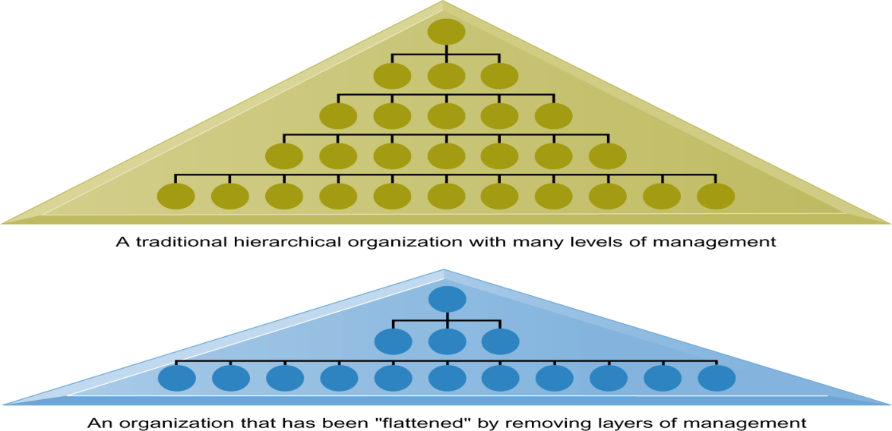
Thomas Friedman’s “The World is Flat”” Stages of Globalization
- Globalization 1.0 (from 1492 to 1800):
  - Agent of Change: Globalization 1.0 focused on countries.
- Globalization 2.0 (from 1800 to 2000):
  - Agent of Change: Agent of Change: Globalization 2.0 focused on cities.
- Globalization 3.0 (from 2000 to the present):
  - Agent of Change: Globalization 3.0 focused on groups and individuals.
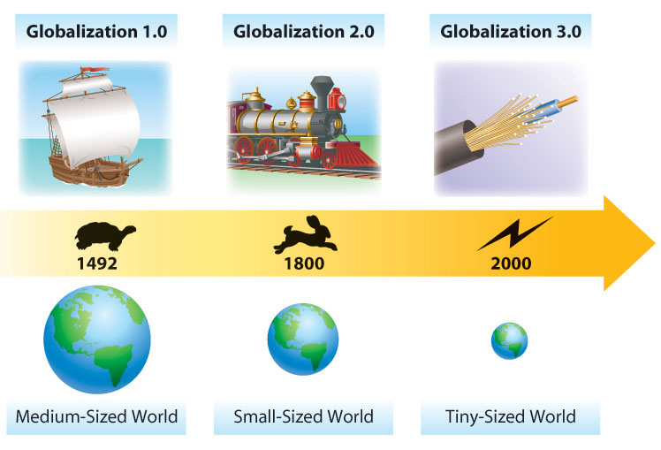
- Globalization 3.0 created a new world that is characterized by:
  - Worldwide communication
  - Worldwide collaboration without barriers (right area on long tail)
  - In Globalization 3.0, individuals and small groups play important roles as individuals who:
    - Command more information,
    - Have more options,
    - Exchange information more conveniently,
    - Coordinate actions,
    - Influence (peers, companies, governments)
Studying about the “Flatteners”
- Relate the flatteners back to the topics from classes 2-3 (connectivity, niche markets, customer controlled information, etc.)
- Geography, in various forms- physical, cultural, or informational, limits competition by enabling cost-advantaged relationships between sellers and buyers who are located close to one another
- Flattening the world reduces geographical barriers but does not reduce the need for relationships
- Reshapes customer supply relationships into hexagons
Customer- Supplier Reshaping
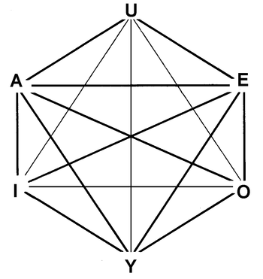

Thomas Friedman’s “The World is Flat”:
Ten Flatteners
- Fall of the Berlin Wall (represented a crumbling of a physical and symbolic wall that blocked the flow of information, goods, and services – similar to people getting access to the internet)
- Netscape goes public
  - August 9, 1995
  - First mainstream browser
  - Gave individuals access to the Internet – i.e. mass connectivity
- Development of workflow software
- Uploading/open sourcing
  - Self-Organizing Collaborative Communities.
  - Individuals as consumers and producers of content.
  - Fast dissemination of information, news and events.
  - Collaboration on open-source & free software
  - Social Media & User-Generated Content:
  - Social Media:
  - Social Media is a group of Internet-based applications that build on the ideological and technological foundations of Web 2.0, and that allow the creation and exchange of User Generated Content.
  - User-Generated Content (i.e. You Tube)
    - Term popularized in 2005
    - Various forms of media content that are publicly available and created by end-users.
    - 3 basic requirements for UGC: (OECD, 2007)
      - Needs to be published either on a publicly accessible website or on a social networking site accessible to a selected group of people
      - Needs to show a certain amount of creative effort
      - Needs to have been created outside of professional routines and practices
  - Collective Intelligence:
  - People and computers who are connected and act collectively more intelligently than individuals, groups, or computers have ever done before (i.e. crowdsourcing)
  - Ideation Communities:
  - Platforms where customers can post news, stories, ideas, case studies etc. and other people can rate, vote for the best ideas, comment and share ideas etc.
- Outsourcing
- Offshoring
- Supply Chaining
- In-sourcing
- In-forming
  - Individuals and small groups are globalizing
  - What are the drivers of Globalization 3.0?
  - Fast changes
  - Emergence of new industries
- In-forming is the ability to build and deploy your own supply chain of information, knowledge and entertainment (individual niche from lectures 2-3)
- It is the antithesis of being told or taught. It is about self-empowering; empowering individuals to do what they think best with the information they have (customer control from lecture 3)
- The opportunity for people to have private, semiprivate, or public gatherings on the Internet regardless of geography and time
- Search Engines
  - “Informing is the individual’s personal analog to uploading, outsourcing, insourcing, supply-chaining and off shoring.” (Friedman, p. 178)
  - Google, Yahoo, and MSN Web Search
  - “The easier and more accurate searching becomes the more global Google’s user base becomes and the more powerful a flattener it becomes. (Larry Page, Google Cofounder)” (Friedman, p. 179)
- Better Search Engines
  - “Google now employs scores of mathematicians working on its search algorithms, in an effort to always keep them one step more relevant that the competition”
  - (Friedman, p.180)
  - Data -> Information (lecture 1) – this is the premise of the Big data craze
- The Steroids
  - The new technologies that are amplifying and turbo-charging all other flatteners.
    - Computing speed and capacity
    - Instant messaging
    - Videoconferencing
    - Computer graphics
    - Wireless technologies and devices
- Personal digital devices like mobile phones, iPods, iPhones, Android phones, instant messaging, and voice over Internet Protocol (VoIP).
- Digital, Moble, Personal and Virtual –
- all analog content and processes (from entertainment to photography to word processing) can be digitized and therefore shaped, manipulated and transmitted;
  - Virtual - these processes can be done at high speed with total ease;
  - Mobile - can be done anywhere, anytime by anyone;
  - Personal - can be done by you.
- Better Search Engines
  - “Google now employs scores of mathematicians working on its search algorithms, in an effort to always keep them one step more relevant that the competition”
  - (Friedman, p.180)
  - Data -> Information (lecture 1) – this is the premise of the Big data craze
- Flattener #10: The Steroids:
  - Flatteners converging and getting turbo-charged through these enablers.
  - Keywords: digital, mobile, personal, virtual.
- What were the three specific examples of Digital Steroids cited by Friedman?
- 1: Computing Speed / Storage / Portability ;
- 2: Peer-to-Peer Features (IM, File Sharing);
- 3: Voice over IP (e.g. Skype)

- In this course, we will discuss flatteners #4, #9, #10
within the context of Web 2.0 technologies

Thomas Friedman’s “The World is Flat”: Triple Convergence
- Up until the year 2000, the ten flatteners were semi-independent from one another.
- Around the year 2000, all the flatteners converged with one another.
  - This convergence could be compared to complementary goods, in that each flattener enhanced the other flatteners; the more one flattener developed, the more leveled the global playing field became.
- After the emergence of the ten flatteners, a new business model was required to succeed.
  - While the flatteners alone were significant, they would not enhance productivity without people being able to use them together.
  - We are in a convergence of three powerful, technological forces:
    - Cheap and ubiquitous computing devices
    - Low-cost, high bandwidth
    - Open standards
- The creation of a global, Web-enabled playing field allows for multiple forms of collaboration – the sharing of knowledge and work – in real time, without regard to geography, or, in the near future, even language.

Business Implications of Flattening
- Dot Com misconception—Hard work not necessary
- Strategies must be aligned and be appropriate with tools
- China and India took advantage of the flat economy leading to steady erosion of US engineering, math and science
- Must be innovative and creative – i.e. Steve Jobs and Jeff Bezos
Impact of Flattening on Business
- Opportunities to alter how business processes are conducted (e.g. process efficiency)
- New opportunities for building brands and developing customer relationships (e.g. CRM)
- Companies that are better at using IS in general and social media in particular do a better job of dealing with Porter’s 5 threats
  - Dell, Wal-Mart, eBay, etc.
- Substitute products or services
  - New substitutes emerge (e.g., online music lowers the value of record stores)
- Customers’ bargaining power
  - Customers have access to info on products & pricing, thus can bargain
- Suppliers’ bargaining power
  - Suppliers have more options to sell their products
- Threat of new entrants
  - The Internet reduces barriers to entry, such as physical location and changes the business environment (e.g. Blockbuster & www.netflix.ca)
- Rivalry among existing competitors
  - The Internet widens geographic market, increasing the number of competitors, pressure to lower prices
Challenges of Operating in the Digital World
- Globalization has created a set of unprecedented challenges:
  - Governmental challenges
  - Geoeconomical challenges
  - Demographic challenges
  - Cultural challenges
Flattening and IS Strategies
- Multidomestic Business Strategy
  - Lower degree of global integration
  - Higher degree of local responsiveness
- Global Business Strategy
  - Higher degree of global integration
  - Lower degree of local responsiveness
- Transnational Business Strategy
  - Some operations centralized
  - Others decentralized

- Business/ Information Systems Strategies


