Lecture 1: ADM1370
Applications of Information Technology for Business
- What is an Information System?
  - Purpose: To provide accurate, timely and useful information
    - Each element must be present and all of the elements must work together
  - An Information System consists of FIVE PARTS, including:
    - People,
    - Procedures,
    - Software,
    - Hardware, and
    - Data
  - Information system (IS) = IT plus procedures, and people that produce & utilize information.
    - IT = hardware + software + data
      - Products
      - Methods
      - Inventions
      - Standards
  - Avoid a common mistake:
    - Do not try to buy an IS; you cannot do it. That is because you cannot buy people or processes
  - However you can buy IT:
    - Buy or lease hardware, license programs and databases, even obtain predesigned procedures. Ultimately, people execute those procedures to employ that new IT.
  - Any new system requires training tasks, overcoming employees’ resistance to change, and managing employees as they utilize new system.
- Social Media and Business
  - Allow people to get social online by sharing opinions, news, content, photos, etc.
- Digital Persona and Business
  - One of the biggest challenges (but ways of being innovative) is defining the digital persona of social media mediated business
  - This is the ultimate objective that businesses face
- Substance Over Norm
  - The biggest challenge is figuring out how to use social media to drive business strategy
- Information Systems Elements
  - Hardware
    - Monitor
    - Keyboard
    - Printers
  - Software
    - OS
    - Application Software
    - Custom Software
  - Procedures
    - User manuals
    - Data entry procedures
    - Step by step guides
    - Guidelines
  - Data
    - Data: raw facts/ usually with no inherent meaning. Not useful in decision making process
    - Information: processed data that conveys meaning and is useful to people/ in the decision making process
  - People
    - ICL: Knowledge, skills, and abilities
    - Training and certification
    - Requirements
  - Information Systems Elements: Data and Information
    - Information System:
      - Set of interrelated components
      - Collect, process, store, and distribute information
      - Support decision-making, coordination, and control
    - Data versus Information
      - Data are streams of raw facts
      - Information is data shaped into meaningful form
        - Example: raw data from a supermarket checkout counter can be processed and organized to produce meaningful information, such as the total unit sales of dish detergent or the total sales revenue from dish detergent for a specific store or sales territory

- A Systems Perspective of IS
  - Three core activities of information systems
    - Input: Captures raw data from organization or external environment
    - Processing: Converts raw data into meaningful form
    - Output: Transfers processed information to people or activities that use it
  - Advanced information systems also incorporate one additional functionality:
    - Feedback:
      - Output returned to appropriate members of organization to help evaluate or correct input stage
  - It is important to remember that these functionalities are not limited to technologies:
    - Can you think of these activities in a management context
- Socio-Technical View of Information Systems
    - Includes issues and insights contributed from technical and behavioral disciplines.
  - Technical Approach:
    - Emphasizes mathematically based models)
    - Computer science, management science, operations research
  - Behavioral Approach:
    - Behavioral issues (strategic business integration, implementation, etc.)
    - Psychology, Economics, Sociology
- Why Study Information Systems
  - Benefits of an IS education for a management student:
    - In today’s workplace, it is imperative that IS work effectively and reliably.
    - IS managers DO NOT only work with the IT dept.:
      - IS will be part of your job in other business functions such as Marketing, Operations, HR, Finance, Accounting etc.
  - As an IS manager for your business function, you will play a vital role in the implementation and administration of technology within your divisions and for the benefit of your organization.
    - You will plan, coordinate, and direct research on the computer-related activities of firms.
    - You will consult with other managers, help determine the goals of an organization and then implement technology to meet those goals.
    - You will coordinate with pertinent people about the technical aspects such as software development, network security, and Internet operations.
- Remember:
  - Digital firms use information systems to enable the seamless flow of information between different parts of the organization as well as between the organization and its suppliers and customers
  - Conducting business electronically enables new levels of efficiency, competitiveness, and profitability (i.e. strategy) – ‘Digital Persona’
  - As you read the course material think of examples of information and computing systems and how they can be used in business. Marketing, HR, Finance - how do they contribute to making the business more competitive?
Class 2
E-Business 101
- Consumers
- Producers
- Information
- Connectivity
Changing Face of Business
- Blockbuster and Roger’s video are shuttered
- Iconic stores like ‘Sam the Record Man’ are extinct
- Travel agencies are a dying entity
- BestBuy is teetering on bankruptcy: http://www.dailyfinance.com/on/5-reasons-why-best-buy-is-going-down-in-2014/
- Target and Sony stores closing now
Digital Ecosystem
- Mobile tools (i.e. smartphones) are changing the way we do business
- Subsequently the way we market products, design products, find customers, interact with customers etc. is also different
Mobile Thinking
- http://mobithinking.com/mobile-marketing-tools/latest-mobile-stats
- Mobile tool usage and online consumer behavior is changing
Disintermediation
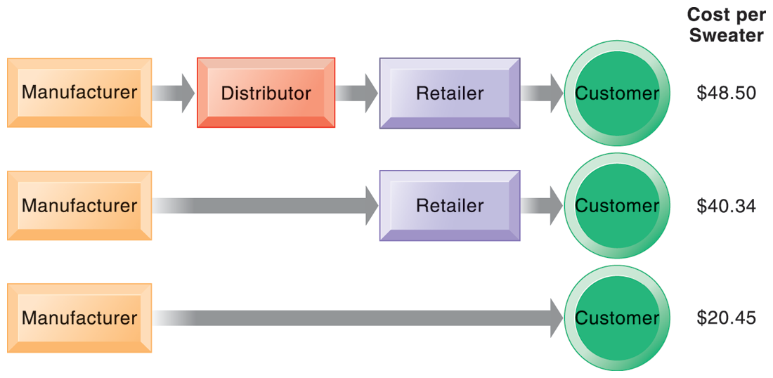
Digital Ecosystem and Business
- Wikis, Social Networking Applications – i.e. Facebook, Twitter, have changed how we access and use information
- They also change how people socialize and how they shop
- But…..these tools are the means to doing things and not the ends
- As business managers we need to know how to leverage their potential to achieve strategic advantage
Digital Persona of Business
- How businesses, customers, suppliers etc. interact in the digital era
- Often changes the landscape of how business processes are done
- Impacts many things including marketing, branding, communicating and relationship building
Digital Persona: Changing How We Do Things – Peer 2 Peer Exchange
- P2P (e.g. Napster) changed how we access music. It put the sharing into social media
- It reshaped businesses (e.g. put Sam the Record Man out of business) and required new laws to be created because of the technology
- It ultimately changed the landscape of the music business
What is Social Media
- Social Media:
  - Social Media is a group of Internet-based applications that build on the ideological and technological foundations of Web 2.0, and that allow the creation and exchange of User Generated Content.
(Kaplan & Haenlein, 2010)
- Types of Social Media:
  - Social Networks:
    - Facebook, LinkedIn, Friendster
  - Blogs:
    - Blogger, Wordpress, Tumblr
  - Microblogs:
    - Twitter, Jaiku, FriendFeed
  - Discussion Forums:
    - OffTopic.com, IGN Boards
  - Multimedia Sharing:
    - Youtube, Slideshare
  - Content Aggregators:
    - Digg, Reddit
  - Social/Collaborative
Bookmarking & Tagging:
    - StumbleUpon, Diigo
Business Uses of Social Media
- Can you think of uses of social media for specific business functions?
  - Marketing & Sales
  - Public Relations
  - Research & Development
  - Human Resources
  - etc.
Old Wine in New Bottles
- Social media does not change the business processes we do…
- …rather, it changes how we do the processes
- It increases the value of information (but does not necessarily change the information itself)
- It also increases nc – coefficient of connectivity - this is what connects people, information and processes
Categories of Social Media
- We can broadly categorize social media based upon functionality
  - World Wide Web (1991)
  - Internet Relay Chat (1983)
  - Media Sharing (P2P) – (1999)
  - Social Networking (1997)
  - Blogs (1996)
  - Real time location based networking – i.e. Foursquare (2008)
Steps of a social media strategy
- 1. Discover
  - Target Audience
  - Objectives
  - Capacity
  - How to Operationalize
- 2. Strategize
  - Listening
  - Answering
  - Social Tools and Interactions
  - Strategy for Managing Content
- 3. Manage
  - Data Collection, Analytics
  - Measure Results vs. Goals (lecture 7)
  - Refine – Adjust and Test
  - Repeat Steps 1-3
Overview of Socialnomics
- “Socialnomics: How Social Media Transforms the way we live and do business” by Erik Qualman.
- Book is about:
  - impact of social media on businesses and consumers.
  - implications for business & suggestions to improve
performance in various business functional areas.
  - Chapter 1 Discussion:
    - Definition: World of Mouth
      - an advancement of Word of Mouth:
      - it disseminates the information quickly and globally;
      - its digital aspect allows the original integrity of the
message to remain intact; and
      - it is traceable to an original source
World of Mouth
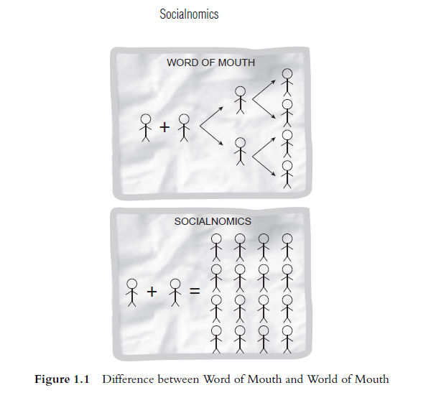

What is Socialommerce
- Transactional, search and marketing components of social media
- “people value the opinion of other people” (Socialnomics, Chapter 5, pg. 89)
- 76% rely on word of mouth
- Only 15% rely on ads

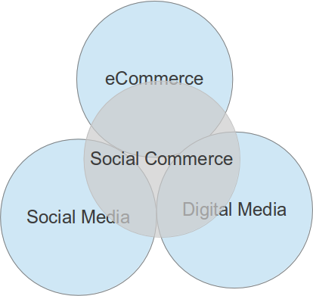
Overview of Socialnomics
- Chapter 1 Discussions:
- Spending time on social media makes you more “productive”.
  - How? Personal & Professional Examples?
  - Does it make businesses more productive?
- Implications of social media on business:
  - Business models need to shift.
  - Industry Examples?
Overview of Socialnomics
- Chapter 1 Discussion:
- Social media also drives activity in the offline world:
  - Examples?
- Social media is an “and” thing rather than an “or” thing:
  - Examples?
Offline Revenue
- “Social Media can drive offline revenue and new forms as well.” (Chapter 5, pg. 103)
Page 4- Mas Markets to Mass Niches
- Maslow’s hierarchy of needs in the context of consumers (individual satisfaction and acceptance and social integration)
- Information distribution (television, newspapers etc.) used to be one to many
- Chris Anderson’s long tail describes how niche information access is the new normal
Long Tail and Social Media
- “The Long Tail: Why the Future of Business Is Selling Less of More”
by Chris Anderson:
  - Applicable to online businesses:
  - Distribution and inventory costs of businesses successfully applying this strategy allow them to realize significant profit out of selling small volumes of hard-to-find items to many customers instead of only selling large volumes of a reduced number of popular items. The total sales of this large number of “non-hit items” are called "the long tail".
Don’t Underestimate Niche Demand
- On Average Barnes and Nobles stores carries 130,000 book titles
- Amazon.com has approximately 2.3 million books
- About 20% of Amazon’s sales come from outside it’s top 130,000 sales
Supermarket and Airline Delay
- Sally Supermarket story on page 6-7
- JetBlue Twitter story on pages 8-9
- Commonality between the two stories?
Examples of the Power of the Internet
- Patient traveling for chemotherapy gets bumped by airline: http://www.cbc.ca/news/canada/thunder-bay/porter-airlines-bumped-chemotherapy-patient-gets-compensation-1.2886799
Other Socialnomics Impacts on Business
- Page 14 – role of middleman is diminished – decline of print news (also pp 16-17)
- Microblogging and other forms of blog driven information are more common – leads to less demand for traditional news sources, even propriety online sources - http://www.niemanlab.org/2014/04/american-newspaper-revenue-is-still-dropping-just-not-quite-as-much-as-before/
- People consulting online reviews before making purchase
The Systems Perspective of IS
- Remember that environmental actors, such as customers, suppliers, competitors, stockholders, and regulatory agencies, interact with the organization and its information systems.
Business Strategy and IT
- Business Processes and how IT supports these processes
- Changing paradigm of information and communication technologies
- How to leverage #2 to better do #1
Business Processes
- Business processes
- Manner in which work is organized, coordinated, and focused to produce a valuable product or service
- Concrete work flows of material, information, and knowledge – sets of activities
- Unique ways to coordinate work, information, and knowledge
- Ways in which management coordinates work
Examples of Business Processes
- Manufacturing and production:
  - Assembling product, checking quality, producing bills of materials
- Sales and marketing:
  - Identifying customers, creating customer awareness, selling
- Cross-Functional Business Processes:
  - Transcend boundary between sales, marketing, manufacturing, and research and development
    - Group employees from different functional specialties to a complete piece of work
    - Example: Order Fulfillment Process
Business Processes Information Systems and Complementary Assets
- But….Investing in information technology does not guarantee good returns - Considerable variation exists in the returns firms receive from systems investments
- Variations are caused by influencing factors Including:
  - Adopting the right business model
  - Investing in complementary assets (organizational and management capital):
    - Assets required to derive value from a primary investment
    - Complementary assets include:
      - Organizational assets, e.g. Appropriate business model ; Efficient business processes
      - Managerial assets, e.g. Incentives for management innovation ; Teamwork and collaborative work environments
      - Social assets, e.g. Internet and telecommunications infrastructure ; Technology standards
Apple- iPod, iPhone, iTunes, iPads- Merging Technology, Business and Entertainment
- Apple has significant challenges in early-mid 1990’s– losing market share to Windows
- Shifted focus to digital music – creation and playing/storage
- Launched iPod in 2001 and then expanded to include numerous iPod accessories
- Public image of Apple shifted dramatically including PCs
Questions to Think About from Apple’s Success
- What might have happened to Apple if its top executives had not supported investment in iPods?
- Did Apple gain a competitive advantage from its decision to invest in an online music business?
- How did Apple gain a competitive advantage through its introduction of the iPod?

