January 14, 2015
Chapter 1: Scientific Theory & The Big Bang

- Introduction
- We will learn that the foundation of science is scientific theory
- One of the most complex of science theories is the Big Bang Theory
  - Leading theory of how the Universe originated

- The Scientific Method

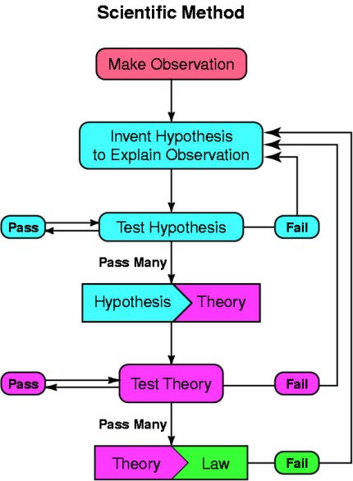
Fig 1.1 The Scientific Method

2.1 Hypothesis
- Hypothesis: an educated guess based upon observation
  - Can be supported OR rejected through experimentation and/or more observation
  - Though supported or rejected, it CANNOT be proven to be true

2.2 Theory
- Scientific Theory: summarizes a hypothesis/hypotheses that’s supported by repeated testing & observation
  - Theory is valid as long as there’s no firm evidence to threaten it
    - “Innocent until proven guilty”
  - LIKE A HYPOTHESIS, theories can be supported OR rejected
- If evidence supports a hypothesis, it’s accepted as a good explanation & becomes a theory
  - Theory isn’t guaranteed true; it’s the best we can formulate based on current evidence
- Hypotheses & Theories attempt to explain the ‘why’ of some action
  - But theories are better formulated & tested (compared to hypotheses)

2.3 Law
- Law: explains a body of observations
  - Scientific laws explain thing, NOT describe them
- Theory VS Law
  - Theory if the statement explains WHY something happens
  - Law if the statement explains HOW something happens

EX. of the scientific method
- Observation → Every Canadian I’ve met this year loves cheese
- Hypothesis → All Canadians must love cheese
- Experiment/Test → A random sampling of Canadians from around the country produces only cheese lovers
- Publication of my hypothesis →”My national research has indicated that Canadians always have a predilection for cheese, wherever they are found”.
- Further testing → Every Canadian citizen any other scientist has ever observed in any country has always been partial to cheese
- Theory → All Canadians love cheese
- Prediction: The next Canadian I meet will be a cheese fan

- The Big Bang
3.1 The Theory
- The BBT is an effort to explain what happened in the beginning of the Universe.
- Figure 1.2 = an attempt to illustrate how things progressed from the BBT to the Universe of today
- Before BBT, the Universe didn’t exist
  - At the birth of the Universe, time & space were created in a gigantic expansion that spread from a ‘singularity’

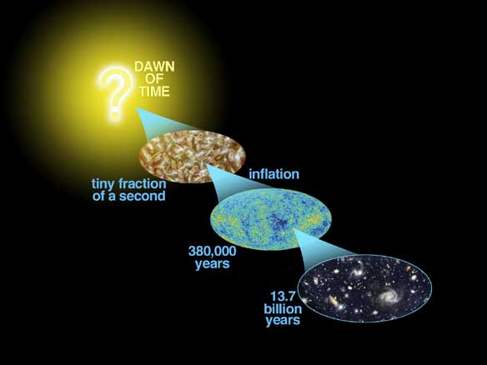
Fig. 1.2

What is a singularity?
- An area in space-time where gravitational force is so high that the laws of physics break down & don’t apply
- There is no “readily understood definition”

What is a gigantic expansion?
- To have an explosion there has to already be space into which the explosion spreads
- The Big Bang created space & time; like a balloon, it expands in the tiniest fraction of time and continues to expand – in this tiny instant, time & space had a finite beginning (well… inside the balloon)
- It can be true that there was nothing (no space, time or energy) until the BBT

3.2 The Observations (the Evidence)
- Three Pillars of Proof evidence that support the Big Bang Theory
- Recession of stars / galaxies (as described by Hubble’s Law)
- The characteristics of cosmic microwave background radiation
3) The abundance of light elements

- Hubble’s Law
- Edwin Hubble (1889 – 1953)
  - He demonstrated that there were many galaxies (as described by Hubble’s Law)
  - He proved that the Universe is expanding
  - He showed us how to measure distances in space

- Hubble fought for the recognition of astronomy in the subject of physics
- After death, the Nobel Prize Committee officially made this recognition
- 1990, NASA scientists installed a telescope into Earth’s orbit, naming it Hubble Space Telescope

4.1 Light’s Redshift & Hubble’s Law
- Sound VS Light
- When an object (ex. train horn) is coming toward you makes a sound sound waves are compressed & shortened
- When an object is leaving sound waves are stretched & lengthened
- This apparent change in sound is known as the Doppler Shift / Effect
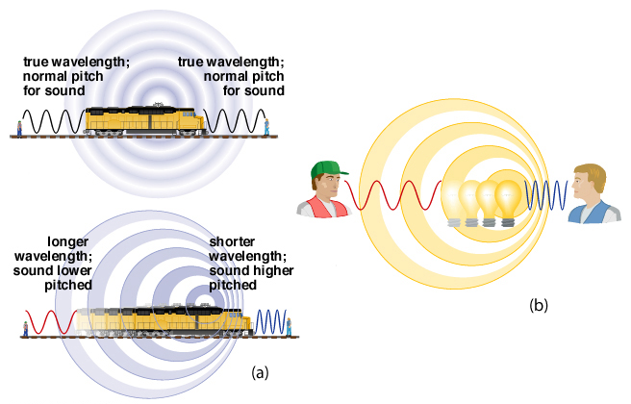
Fig. 1.4 Doppler Shift

- Hubble knew light would behave somewhat like the waves of sound when the light source is moving towards/away from the observer
  - If the light source is moving TOWARD the observer, the light wavelength appears to shorten (ex. to move into the blue spectrum, aka “blue-shifted”
  - If the light is moving AWAY from the observer, the light wavelength appears to lengthen (ex. to move into the red spectrum, or “red-shifted”)
- The faster the light emitting object was moving, the greater the shift

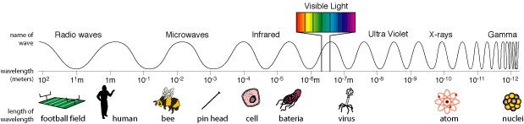
Fig. 1.5 The Electromagnetic Spectrum

- The speed of light is fixed, it CANNOT change
  - Hubble concluded that this means the stars had to be moving away from Earth
  - This applied to everything he could see – the Universe had to be expanding, and light waves moved with it
  - The more distant a galaxy is, the longer its light takes to arrive
    - More “red-shifted” it appears when it finally arrives
    - Basically the amount of red-shift can be used as a measure of a star or galaxy’s distance from Earth
- From these observations, Hubble formulated an equation known as the Hubble Law….
v = H_{o}d
  - v → the speed expressed in kilometres per second
  - d → the distance of the star/galaxy away from Earth in parsecs
    - 1 parsec = 3.26 times the distance light travels in one year
  - H_{o} → the Hubble constant: the speed of expansion of the Universe
- You can calculate how far from Earth an object is by dividing its velocity (obtained from the amount of redshift) by the expansion factor
- Your calculation assumes that H_{o} (the expansion factor) is a constant
  - If the expansion of the Universe has changed over time, your calculation will be inaccurate (more about this later)

5.0 Cosmic Microwave Background Radiation
- It’s estimated it was super hot in the first seconds of the Universe, and as it expanded, it cooled
- The hot light photons have lost energy & dropped from the visible light energy range into the microwave energy range
  - This constitutes the Cosmic Microwave Background (CMB) that we can still see today
- Scientists figure CMB can be seen anywhere in the Universe because it comes from all directions with the same intensity

- CMB was first found in 1965 as ‘noise’ in a sensitive microwave radio reciver

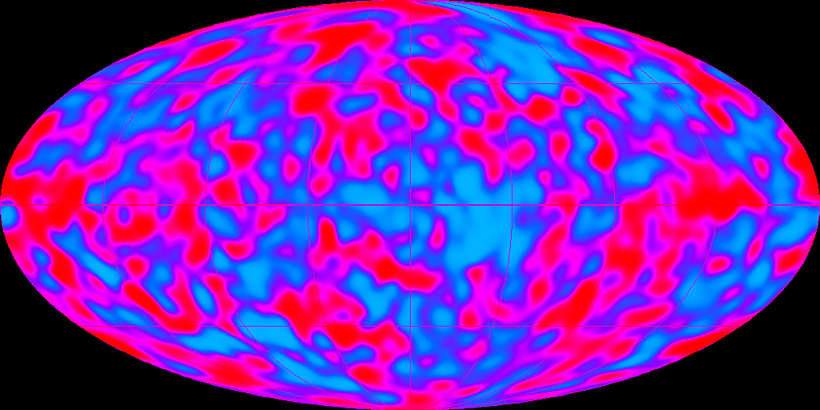
Fig. 1.6 Cosmic Microwave Background

- As seen in the map (where the signal converted to temperature), it shows the same pattern of distribution from all parts of the Universe
- CMB represents the very last remnants of the light/heat energy of the Big Bang’s initial expansion

- Abundance of Light Elements
- The Third Pillar Of Proof has to do with the ratio of all the various atoms in the 3 lightest elements:
- Hydrogen (75%)
- Helium (25%)
- Lithium (trace)
- The observed abundance of all the different atoms of those elements can be explained ONLY if they originated from one single ratio of the 1st subatomic particles of matter that can be formed from a super-hot environment

- Shape of the Universe
- Important Question: How will the Universe end?
  - There are 3 unique shapes (& some mixes, but we’ll just look at the unique ones)

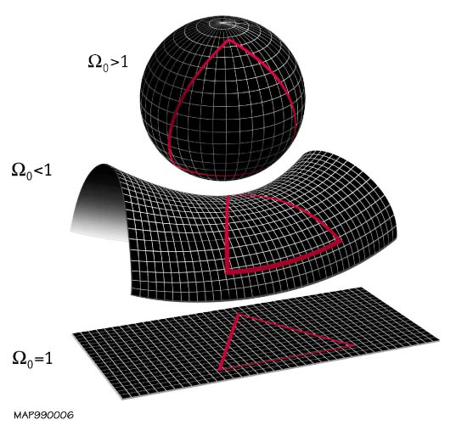
Fig. 1.7 Shape of the Universe

- Like the ‘balloon’ used to illustrate BBT, the Universe has a positive curvature like a sphere (Figure 1.7 top)
  - AKA a “closed” universe – the Universe would be finite in size, but without a boundary (like a balloon)
  - In a closed universe, you can, in principle, fly a spaceship in one direction and eventually arrive back where you started
  - Closed universes = closed in time they eventually stop expanding, and then contract in a “Big Crunch”
    - Like tossing a ball in the air, energy of your throw keeps the distance between you and the ball expanding, but when energy fades, the ball gets pulled back by gravity
- Another possibility is that the Universe might be “open” (negative curvature)
  - Such universes are kinda saddle-shaped (Figure 1.7 middle)
  - They are infinite & unbounded; Parallel lines eventually diverge
  - Open universes expand forever
    - The ball you tossed in the air just kept going and going
- Final possibility is that the Universe is flat (Figure 1.7 bottom)
  - They are infinite in spatial extent & unbounded; Parallel lines are always parallel
  - Like #2, they can expand forever, but the expansion rate approaches 0
    - The ball goes and goes, but eventually just appears to hang there

- Density parameter is critical to all 3 of our models
- If space has a NEGATIVE curvature, there isn’t enough matter around to allow gravity to act and stop the expansion
  - Let’s say the density parameter is less than one (in Fig. 1.7, that’s signified by Ωo<1)
- If space has a POSITIVE curvature, there’s more than enough matter to allow gravity to pull everything back together (can be expressed as Ωo>1)
- If space is FLAT, we can say there’s the ‘critical’ value of matter around that prevents the Universe from pulling back together OR from expanding indefinitely (Ωo=1)

- What out there affects gravity?
- There is conventional matter stars, planets, asteroids, comets, etc. but that’s >5% of the Universe (Fig. 1.8)
- Since that is definitely not enough, some years ago something was hypothesized: dark matter
  - Matter no one has seen because it gives off no (electromagnetic) energy, but we know it exists because we can detect its gravitational attraction to conventional matter

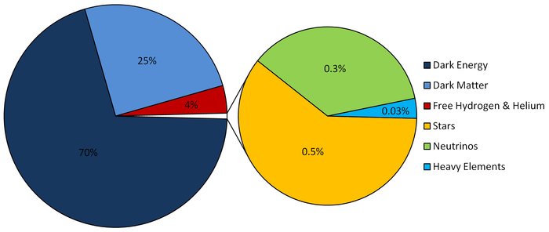
Figure 1.8 Cosmological Composition

- Dark matter is approx. 27% of the matter of the Universe
- If dark matter is the only thing out there, it would be enough to slow the expansion of the Universe
- BUT scientists recently detected the expansion is increasing instead of decreasing
- WHY!?
  - There’s probably a mysterious force out there (around 70% of the Universe) that acts in opposition to gravity: it repels matter (aka dark energy)
- Dark energy is the force that controls the expansion of space
  - Counterbalances the kinetic energy of the Big Bang expansion
- Since the expansion is increasing, we’re basically accepting that the Universe is ALMOST perfectly flat (with the slightest negative curvature)

8.0 Age of the Universe
8.1 Radioactivity
- Certain elements have components that are radioactive
  - They breakdown to form other components and give off energy in the process
- We use radioactivity to interpret the age of rocks – meaning we can determine the age of the Universe by:
  - Observing the compositions of gases around old stars
  - Knowing the exactly radioactive processes required to produce these gas compositions from the very first elements created in the Big Bang
  - Knowing all the time factors involved in breaking down one component to yield others
- This information gives us Universe age estimating between 11.5-17.5 billion years (though there is a star from 2006 that was found and dated at 13.2 billion years so the Universe has to be older than that)

8.2 Hubble’s Expansion Constant
- To connect redshift with distance/velocity of light sources in the Universe, Hubble had to propose a ‘constant’ for the expansion rate (H_{o})
- In any ‘rate’ expression, there’s a time factor so its possible to use Hubble’s equation to find the age of the most distant light sources we can find
- In 2002, the Hubble Space Telescope found white dwarf stars that were between 12-13 billion years
  - The age of the Universe had to fall between 13-14 billion years because it would’ve taken something less than 1 billion years for the stars to cool (cause its dead now)

8.3 Cosmic Microwave Background Radiation
- ^ Offer the most accurate view (to date) of conditions in the early Universe
- Based on the best physics available, a sophisticated model of the Universe was produced
- Assuming the right model has been developed (only an assumption), the Universe is 13.80 ± 0.04 billion years

Appendix: What Banged?
- According to a mathematical physicist, Neil Turok, the BB was big, but not unique – there has been and we will have many more
- He suggests that the BB is one in an infinitely repeated cycle of expansion and contraction
  - Neither time or universe has a beginning or end
- Turok proposes the universe holding 2 infinitely extensive sheets, separated by a thing layer of (dark?) energy a sandwich model
  - Once in a while, the intermediate layer becomes unstable and gravity starts pulling things together, & layers bounce together… from the point of contact, sufficient energy is generated to produce another Big Bang

