- BMOS Exam #2 Review:
- Exam Location:
- Student Service Center
- Last Name:

- Testable material:
  - Training and Appraising Employees
  - Introduction to Marketing and the Marketing Environment
  - Consumer Behavior I
- 52 can be answered from lecture
- 18 from textbook
- Training and Appraising 28 Q’s
- Introduction to Marketing and the Marketing Environment 27 Q’s
- Consumer Behavior I 15 Q’s

Training and Developing Employees – (132-149, 167-190)
(Part ½)

Training:
  - Consists of an organization’s planned efforts to help employees acquire job related skills, knowledge, abilities, and behaviors.
  - Can be either one-on-one mentoring or formal classes.
  - Low use of previous work experiences.
  - Can be on site or off site.
  - Training is required; because:
    - Some jobs require specific training.
    - Job or organizational changes.
    - Commitment, job satisfaction
    - Difficulty in selection
    - Legislatively Mandated
    - Reward
Stages of Instructional Design:
5 Stages:
Needs Assessment
Readiness of Training
Planning:
- Objective
- Trainer
- Method
Implementation
Evaluate

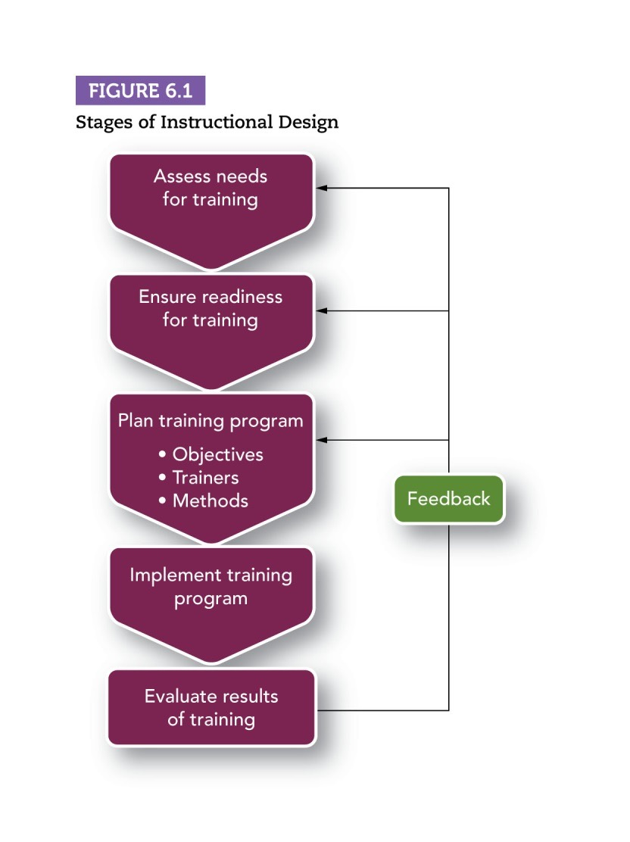

Instructional Design:
  - Process of systematically developing training to meet specific needs.
Development:
Employee development: A combination of formal education, job experiences, relationships, and the assessment of personality and abilities.
  - Helps individuals prepare for the future of their careers.
  - High use of previous work experiences.
  - Not required. (Not mandatory)

- Rapid change in technology requires employees to constantly be learning new skills.
- Employee development in working with a diverse group of people is essential for international business and the growing diversity within the Canadian economy.
- The amount go money spent on learning and development within companies has dropped 40% since the early 1990’s.

IMD is the International Institute for Management Development

LMS (Learning Management Systems):
  - A computer application that automates the administration, development, and delivery of training and development programs.

Needs Assessment:
  - The process of evaluating the organization, individual employees, and employee tasks to determine what types of training are necessary.
  - Factors that prompt a Needs Assessment are:
    - Decisions to produce new products.
    - Decisions to apply new technology.
    - Designing new jobs.
    - Outside forces that prompt a Needs Assessment:
      - Customer requests.
      - Legal requirements.
  - The three areas a Needs Assessment answers are:
    - 1. Organization - What is the context in which the training wills occur/is it appropriate?
    - 2. Person - Who needs training?
    - 3. Task - What topics should the training cover?

Organization Analysis:
  - A process for determining the appropriateness of training by evaluating the characteristics of the organization.
  - Looks at the training needs in light of the organization’s strategy, resources available for training, and management’s support for training activities.
  - Training needs will vary depending on the organizations strategy of whether they want to grow or shrink their workforce.

Person Analysis:
  - A process for determining individuals’ needs and readiness for training.
  - Involves several questions such as:
    - Do performance deficiencies result from a competency gap — that is, a lack of knowledge, skill, or ability? (If so, training is appropriate; is not, other solutions are more relevant.)
    - Who needs training?
    - Are these employees ready for training?

Task Analysis:
  - The process of identifying the tasks and competencies that training should emphasize.
  - Usually conducted along with Person Analysis.
  - Analyst who performs a task analysis validates the lists of tasks performed in a specific job by showing it to employees, supervisors, and other field experts and also asks them to complete a survey on the importance, frequency, and difficulty of the tasks.

Readiness for training:
  - A combination of employee characteristics such as cognitive ability (able) and Motivation (willing). And a positive work environment that permit training.

Self-efficacy:
  - A sense of personal control and being able to master one’s environment.
  - Factors that affect self-efficacy are: performance in similar situations, observing others perform, verbal persuasion, and emotional arousal.

Work Environment:
  - Situational Constraints: the limits on training’s effectiveness that arise from the situation or the conditions within the organization. (eg. a lack or money for training, lack of time for training/practicing, the failure to provide proper tools or materials for training.)
  - Social support: the ways that the organizations people encourage training.

Request For Proposal (RFP):
  - A document outlining the type of service needed, the number of employees to be trained, the date, which should receive proposals.

Planning and Designing a Training Program:
Training objectives:
    - A statement of what the employee is expected to do, acceptable level of performance, and conditions.
    - Measurable performance standards.
    - Resources needed to carry out the desired performance.

Fidelity:
  - In developing training programs, it is important to consider physical fidelity and psychological fidelity.
  - Physical Fidelity: Extent to which the training tasks mirror the physical features of the tasks to be performed on the job.
  - Psychological Fidelity: Extent to which the training tasks develop the same knowledge, skills, and abilities that are required to perform the job.

Training Methods:
  - Instructor-led (classroom) (58%)
  - Self-paced (online) (14%)
  - Collaborative (face to face) (11%)
  - Instructor-led (online) (6%)
  - Instructor-led (blended) (5%)
  - Self-paced (non-computer based) (3%)
  - Self-Paced (computer-aided, offline) (2%)
  - Collaborative (online) (2%)
  - Other (1%)

Types of training:
  - Audiovisual training:
    - Using Course material prepared in presentations, podcasts, videos, or workbooks.
  - Computer based training:
    - Method of training that utilizes computer technology to enhance acquisition of knowledge and skills.
    - E Learning: Receiving Training via the Internet or the organization’s intranet.
    - EPSS (Electronic Performance Support System)
  - On-The-Job training:
    - Apprenticeships: A work-study training method that teaches job skills though a combination of on-the-job training and technical training.
    - Internships: On-the-job learning sponsored by an educational institution as a component of an academic program.
    - Cooperative education: a plan of higher education that incorporates paid work experience as an integral part of academic studies.
  - Simulations:
    - A training method that represents a real-life situation, with trainees making decisions resulting in outcomes that mirror what would happen on the job.

MUST HAVE HIGH FIDELITY
    - Avatars: Computer depiction of trainees, which the trainees manipulate in an online role-play.
    - Virtual Reality: a computer based technology that provides an interactive, three-dimensional learning experience.
  - Business Games and Case Studies:
    - The method of learning through trainees discussing and analyzing a detailed situation. This helps to develop and exercise higher-order thinking skills.
  - Behavior Modeling:
    - A method of training in which the trainee will observe other people demonstrating the desired behavior.
  - Experiential Programs:
    - Training programs in which participants learn concepts and apply them by simulating behaviors involved and analyzing the activity, connecting it with real-life situations.
    - Adventure Learning: A teamwork and leadership training program based on the use of challenging, structured outdoor activities.
  - Team Training:
    - Cross training: Team training in which team members understand and practice each other’s skills so that they are prepared to step in and take another member’s place.
    - Coordination training: Team training that teaches the team how to share information and make decisions to obtain the best team performance.
  - Action Learning:
    - Training in which teams get an actual problem, work on solving it, commit to an action plan, and are accountable for carrying it out.

Implementing and Evaluating the Training Program:

Principles of Learning:
  - To understand and fully remember the content of the training employees need a chance to demonstrate what they have learned.
  - Readability: The difficulty level of written materials.

Ways that Training Helps Employees Learn:

Training Activity: | Ways to Provide Training Activity:
Communicate the learning objective. | - Demonstrate the performance to be expected.  - Give examples of questions to be answered.
Use distinctive, attention-getting messages. | - Emphasize key points.  - Use picture, not just words.
Limit the content of training. | - Group lengthy material into chunks.  - Provide a visual image of the course material.  - Provide opportunities to repeat and practice material.
Guide trainees as they learn. | - Use words as reminders about sequence of activities.  - Use words and pictures to relate concepts to one another and to their context.
Elaborate on the subject. | - Present the material in different contexts and settings.  - Relate new ideas to previously learned concepts.  - Practice in a variety of contexts and settings.
Provide memory cues. | - Suggest memory aids.  - Use familiar sounds of rhymes as memory cues.
Transfer course content to the workplace. | - Design the learning environment so that it has elements in common with the workplace.  - Require learners to develop action plans that apply training content to their jobs.  - Use words that link the course to the workplace.
Provide feedback about performance. | - Tell trainees how accurately and quickly they are performing their new skill.  - Show how trainees have met the objectives of the training.

Massed vs. Distributed Practice:
  - Distributed practice: training material presented in small chunks.
  - Massed practice: training material presented all at once.

Measuring Results of Training:
  - Evaluation of training (depending on the objective of training) can be measured using any of the following:
    - Reaction: Satisfaction with the program. (Feelings about the training that they received)
    - Learning: Knowledge and skills gained.
    - Behavior: Behavior changes. (Transfer or training) (Changes in behavior performance exhibited on job due to training)
    - Results: Improvements in individual and organizational performance. (Economic value that is gained through new behaviors performed on the job.)

Evaluation methods:
  - Transfer of training: On-the-job use of knowledge, skills, and behaviors learned in training.
    - Measured by 3 questions:
      - 1. Do you perform the task?
      - 2. How many times do you perform the task?
      - 3. To what extent do you perform difficult and challenging learned tasks?
  - Assessment of training should also evaluate training outcomes.
    - Training outcomes: if anything has changes as a result of the training.

Orientation of New Employees—Onboarding:
  - Orientation: Training designed to prepare employees to perform their jobs effectively, learn about their organization, and establish work relationships.
    - This method is used because of the “shock factor” that some individuals face while starting a new job.
  - Onboarding: Another term for Employee Orientation

Diversity Training:
  - Training designed to change employee attitudes about diversity and/or develop new skills needed to work with a diverse workforce.

Protean Career:
  - A career that frequently changes based on the changes in a person’s interests, abilities, and values, and in the work environment.

Managing Employees’ Performance: (PART 2/2)

Performance Management:
  - A process in which managers ensure those employees’ activities and outputs contribute to the organization’s goals.
  - This process requires knowing what activities and outputs are desired, seeing if they occur, and providing feedback in order to aid employees with meeting expectations.
(Stages: Specify Aspects of Performance, Appraise Performance, and Provide Performance Feedback (Problem Solving/Rewards))
The Process of Performance Management:
  - Performance Appraisal: an annual meeting at which an individual in a managerial position will analyze and critique the employee’s behavior and apparent attitudes from the past year.
  - Performance management can deliver many potential benefits such as:
    - Allowing top performers to know they are valued
    - Encourage communication between managers and their employees
    - Establish uniform standards for evaluating employees
    - Help the organization recognize its strongest performers (and weakest = termination)

The Purpose of Performance Management:
  - Strategic Purpose: Effective performance management helps the organization achieve its business objectives.
  - Administrative Purpose: Refers to how organizations use the system to provide information for day-to-day decisions about salary, benefits, and recognition programs. Also refers to hiring/layoffs.
  - Developmental Purpose: serves as a basis for developing employees’ knowledge and skills. Effective performance feedback allows employees to become aware of their strengths and what they have to work on.

EPM (Electronic Performance Monitoring):
  - Use of electronic devices to collect, store, and report employee performance.

Criteria for Effective Performance Management:
  - Fit with strategy: A performance management system should aim at achieving employee behavior and attitudes that support the organization’s strategy, goals, and culture. (Ex. is a company emphasizes customer service. Performance appraisals should measure whether employees are engaging in those behaviors.
  - Validity: The extent to which a measurement tool actually measures what it is intended to measure. In the case of a performance appraisal, validity refers to whether the appraisal measures all the relevant aspects of performance and omits irrelevant aspects of performance.
  - Reliability: Describes the consistence of the results that a performance measure will deliver.
Interrater Reliability: Consistency of results when more than one person measures the performance.
Test-retest reliability: Consistency of results over time.
  - Acceptability: Whether or not a measure is valid and reliable.
  - Specific feedback: A performance measure should specifically tell employees what is expected of them and how they can meet those expectations.

Making Comparisons: (How is Performance Measured?)
  - Simple ranking: Requires managers to rank employees in their group from the highest performer to the lowest performer.
    - Alternation ranking: Manager decides which employee is the highest performer, then selects the lowest performer, then the second highest performer, then the second lowest performer, then the third highest performer… etc.
  - Forced-distribution method: Assigns a certain percentage of employees to each category in a set of categories.
  - Paired-comparison method: This method involves comparing each employee with each other employee
  - Relative percentile method: Employees are compared on performance dimensions identified through job analysis.

How performance is measured:

Approach: | Fit With Strategy: | Validity: | Reliability: | Acceptability: | Specificity:
Comparative | Poor, unless manager takes some time to make link. | Can be high if ratings are done carefully. | Depends on ratter, but usually no measure of agreement used. | Moderate; easy to develop and use but resistant to normative standard. | Very Low
Attribute | Usually low; requires manager to make link. | Usually low; can be fine if developed carefully. | Usually low; can be improved by specific definitions of attributes. | High; easy to develop and use. | Very Low
Behavioural | Can be quite high. | Usually high; minimizes contamination and deficiency. | Usually high. | Moderate; difficult to develop, but accepted well for use. | Very High
Results | Very High | Usually high; can be both contaminated and deficient. | High; main problem can be test-retest— depends on timing of measure. | High; usually developed with input from those to be evaluated. | High regarding results, but low regarding behaviours necessary to achieve them.

Rating Attributes:
    - Graphic Rating Scale: Method of performance measurement that lists attributes and provides a rating scale for each attribute; the employer uses the scale to indicate the extent to which an employee displays each attribute.
    - Mixed-Standard Scales: Method of performance measurement that uses several statements describing each attribute to produce a final score for the attribute.

*Attribute based performance methods are easy to develop and can be applies to a wide variety of jobs and organizations.

Rating Behaviors:
  - Critical-incident method: Method of performance measurement based on managers’ records of specific examples of the employee behaving in ways that are either effective or ineffective. (This involves managers to keep a record of specific examples of the employee behaving in certain ways.) (Behaviors that result in good or poor job performance.)
  - BARS (Behaviorally Anchored Rating Scale): Method of Performance measurement that rates behavior in terms of a scale showing specific statements of behavior that describe different levels or performance.
  - BOS (Behavioral Observation Scale): A variation of BARS, which uses all behaviors necessary for effective performance to rate performance at a task. Raters rate employee based on the frequency of critical incidents.
  - OBM (Organizational Behavior Modification): A plan for managing the behavior of employees through a formal system of feedback and reinforcement. There are four main components.
    - 1. Define a set of key behaviors necessary for job performance.
    - 2. Use a measurement system to assess whether the employee exhibits the key behaviors.
    - 3. Inform employees of the key behaviors, perhaps in terms of goals for how often to exhibit the behaviors.
    - 4. Provide feedback and reinforcement

Measuring Results:
  - MBO (Management by Objectives): A system in which people at each level of the organization set goals in a process that flows from top to bottom, so employees at all levels are contributing to the organization’s overall goals; these goals become the standards for evaluating each employee’s performance. MBOs have 3 components
    - 1. Goals are specific, difficult, and objective.
    - 2. Managers and their employees work together to set the goals.
    - 3. The manager gives objective feedback through the rating period to monitor progress toward the goals.
  - Studies show that 68 of 70 MBO have conducted resulted in an improved productivity.

Balanced Scorecard: an organizational approach to performance management that integrates strategic perspectives including financial, customer, internal business process, and learning and growth.

Sources of Performance Information:
  - Chosen individual to collect data must have an understanding of the job requirements and the opportunity to see the employee doing the job.
  - 360-degree performance appraisal: also called multi-rater is a performance measurement that combines information from the employee’s managers, peers, direct reports, self, and customers.
    - Managers: Most used source of performance information.
    - Peers: Good source for performance information because provides insight for when managers are unable to observe.
    - Direct Reports: Used for evaluating the performance of managers, direct reporting is the employee reporting to a manager. Works to see how manager treats employees.
    - Self: Self-avocation. Rarely used alone. Managers will ask employees about their performance.
    - Customers: Customers are often the only people who directly observe the employee. Customer evaluations are used to rank employee performance.

Using multiple raters:
  - Advantages:
    - Ability to observe various job facets.
    - Reliability
    - Fairness
    - Rate acceptance
    - Improved defensibility

Errors in Performance Measurement:

Types of Rating Errors:
  - Similar-to-me error: Rating error of giving a higher evaluation to people who seem similar to oneself.
  - Contrast error: Rating Error caused by comparing employee’s performance to co-workers rather than to an objective standard.
  - Errors in Distribution:
    - Leniency error: Rating error of assigning inaccurately high ratings to all employees.
    - Strictness error: Rating error of giving low ratings to all employees, holding them to unreasonably high standards.
    - Central tendency: Incorrectly rating all employees at or near the middle of a rating scale.
  - Recency Emphasis: Rating error that occurs when an annual rating is based only on most recent work performed.
  - Focus on activities: Rating error when employees are assessed on how busy they appear rather than how effective they are in achieving results.
  - Halo error: Rating error that occurs when the rater reacts to one positive performance aspect by rating the employee positively in all areas of performance.
  - Horns error: Rating error that occurs when the rater responds to one negative aspect by rating an employee low in other aspects.

Calibration Session:
- Meeting at which managers discuss employee performance ratings and provide evidence supporting their ratings with the goal of eliminating the influence of rating errors.

Performance Improvement:
  - This happens after the feedback session (session in which managers speak to employees about their performance).
  - The action taken on this step depends on what is missing:
    - Lack of ability: When a motivated employee lacks knowledge, skills, or abilities in some area. Manager may offer training.
    - Lack of motivation: Managers with an unmotivated employee can explore ways to demonstrate that the employee is being treated fairly and rewarded adequately.
    - Lack of both: Employees whose performance is below expectations because they have neither motivation nor the ability to perform the job may not be a good fit for the position.
  - Performance improvement plan: Summary of performance gaps and includes an action plan mutually agreed to by the employee ad supervisor with specific dates to review progress.

Legal Requirements for Performance Management:
  - Many times people dispute their job termination and sue organizations for allegations that said organization discriminated against the employee on the basis of one of the protected grounds in the human rights legislation.

Marketing & The Marketing Environment – (200-217, 226-246)

- Consumer Purchase Decision Process
- Problem recognition
- Information search
- Evaluation of alternatives
- Purchase decision
- Post-purchase behavior

- Customer value - unique combination of benefits revived by targeted consumers (quality, price, convenience, delivery)
- Goods and services with added value over competitive offerings
- Elements of marketing mix: product, price, place and promotion (4 P’s)
- Value added to products through: product design, pricing strategies, service elements
- Better to target a select group of people than to try to target everyone

- Target market - specific group of existing and potential customers to which marketers direct their marketing efforts
- Success of marketing depends on customer needs and customer value
- Product - attributes that make up a good, service or idea
- Price - Regular retail or sale price for product
- Place - distribution channels
- Promotion - communication tools needed to inform a customer about a product

- Marketing process - process of first identifying consumer needs, secondly managing marketing mix to meet these needs and thirdly realizing profits
- Throughout this process, marketers manage the success
- Marketing is described as the process of planning and managing goods, services or ideas to meet consumer needs and organizational objectives
- Exchange is the trade of things of value between buyers and sellers so that each benefits
- Exchange is often more complex than a simple trade - involves all benefits received on both ends
- Product encompasses goods, services and ideas
- Good - product you can touch and own
- Service - intangible product you cannot touch
- Idea - concept that looks for support
- Many marketers today launch products with layers of goods, services and ideas
- Market - potential consumers who have both the willingness and ability to buy a product
- Sometimes target market and consumers are different people i.e. market for Froot Loops is parents with children while the consumers is the children

- Evolution of Business Philosophies
- Production orientation - stage business’ were in up until the 1930’s which focused on manufacturing
- Sales orientation - stage from the 1930’s-1960’s - focused on selling as many products as possible
- Marketing orientation - focusing organizational efforts to collect and use information about customers needs to create customer value
- Marketing concept - stage that focuses on idea that an organization should strive to satisfy the needs of consumers while trying to achieve an organizations goals
- Relationship marketing - when organizations create long-term links with their customers, employees and suppliers to increase loyalty and customer relations - started in the 1990’s
- Social media has added to relationship marketing making it more engaging and interactive
- Social media can be used in four ways:
- Marketers use social media to engage and connect with consumers
- Marketers use social media to monitor real-time consumer engagement
- To measure impact of specific promotional programs
- To identify informal brand advocates

- Customer Relationship Management - overall process of building and maintaining profitable customer relationships by delivering superior customer value and satisfaction
- Less expensive to service and maintain current customers than to promote new ones
- Use of CRM loyalty programs to keep customers
- Targets these customers based on passed purchases and what stage in life they're in and targets marketing in specific ways towards these customers

- Corporate Social Responsibility (CSR) - When organizations voluntarily consider the well being of society by taking responsibility for how their businesses impact consumers, customers, suppliers, and the environment…
- CSR usually involves one of the three:
- Sponsorship/spearheading of community programs
- Sponsorship/involvement in fundraising for charitable organizations
- As a business in full that ends up positively impacting the community

- Societal marketing concept - marketing programs that focus on the consumer and the well being of society
- Marketing has moved from meeting short term needs to developing a long term customer base and long term viability
- Customer relationship management and corporate social responsibility with an emphasis on:
- Digital marketing - display advertising; affiliate marketing, search engine marketing, and search engine optimization, pay per click advertising…
- Experiential marketing - marketers create opportunities for consumer to interact directly with brand and spread the word to others i.e. shopping center hosting live events associated
- Partnership marketing - creation of formal associations between brands that will result in incremental business for both brands that could not have been achieved separately
- Metrics - Measures and monitors business performance through the collection and usage of data used to evaluate marketing programs
- Strategic alliance - another form of partnership marketing - alliances with companies with similar values and objectives that are long term
- Promotional partnerships - simple short-term promotional offers between brands
- The Copyright Modernization Act, Bill C-32 - consumers be permitted to make one copy per device of a digital download
- The Canadian Marketing Association (CMA) - professional body for marketing industry that responds to legislative issues and sets guidelines
- Accurate representation
- Truthfulness
- Price Claims
- Privacy
- Marketing to children
- Direct marketing approaches

- Marketers scan marketing environment and review six key areas of focus:
- Demographic forces
- Socio-cultural forces
- Economic forces
- Technological forces
- Competitive forces
- Regulatory forces
- Marketing Environmental Scan - process of continually acquiring information on events occurring outside an organization to identify trends, opportunities and threats

- SWOT Analysis:
Strengths, Weaknesses, Opportunities and Threats - assesses how well a company is servicing its company and consumers by looking at internal and external strengths, weaknesses/opportunities.
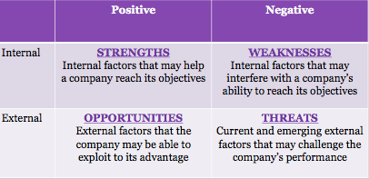
Demographics - Statistical study of populations
- Demographic forces - the statistical data on population according to characteristics such as gender, age, ethnicity, income, education, and occupation
- i.e. Canadian census indicates population is growing older, contains diverse generations, is settling in the suburbs of large cities
- i.e. Jack Layton tried to reach younger voters by using QR codes on print ads as well as social media
- Census shows Canadian population is aging - marketers address this with new products and services focused on this group
- Marketers note 4 main generational groups of consumers:
- Baby Boomers - main reason for greying of NA - average of 4 children per family - now accounts for about 60% of expenditure
- Generation X - born between 1965 and 1974 - 12% of population - not as brand loyal as baby boomers, more educated
- Generation Y (Millennial) - born between 1975 and 1991 - 27.5% of CDN population
- Generation Z (Net Generation) - born between 1992 and 2010 - considered most disruptive of the generations - aka net generation
- Suburbs growing faster than the cities in Canada
- In Canada visible minorities make up 50% of population in large urban areas
- Growth being shown in underdeveloped areas

- Socio Cultural Forces - cultural values, ideas and attitudes as well as society’s morals and beliefs
- Canada’s aging population, shrinking household size, and high incidence of dual income is impacting food consumption patterns
- Increased focus on healthy living with Canadian Government Agencies, Medical Professionals, media… - marketers respond with healthier products
- Canadians showing keen interest in global warming and being less wasteful
- One of Canada’s most notable socio-cultural changes is the switch in roles of women and men in society
- Economy - the collective income, expenditures, and resources that affect the cost of running a business or household

- Economic Forces - collective income, expenditures, and resources that affect the cost of running a business or household
- Car purchases go down heavily during recession
- Some things like flour purchases go up during recession
- Macroeconomic forces - state of countries economy as a whole
- A countries key economic indicators are:
- Inflation rate - inflation is a period when the cost to produce and buy products and services gets higher as prices rise
- Unemployment rate
- Economic growth rate
- Recession - time of slow economic activity
- Organization for Economic Co-operation and Development (OECD) - looks at Canadian economic growth
- Microeconomic forces - the supply and demand of goods and services and how this is impacted by individual, household, and company decisions to purchase
- Gross income - total amount of money made in one year by a person, household or family
- Disposable income - after-tax income that consumers have left for spending and savings
- Discretionary income - after-tax income a consumer has after paying for necessities

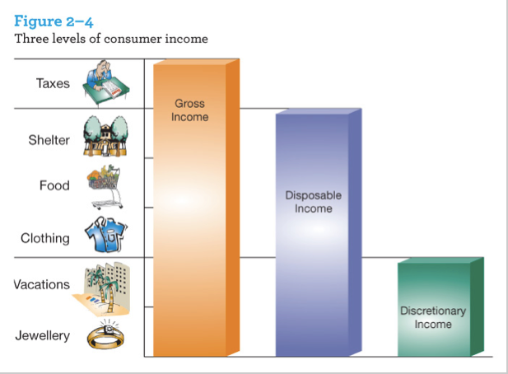

- Technological forces - inventions or innovations that stem from scientific or engineering research
- Electronic messaging is reducing need for traditional mail delivery

- Competitive forces - alternative products that can satisfy a specific markets needs
- Direct competitors - similar products sold in the same category
- Indirect competitors - products competing for the same buying dollar in a slightly different but related category
- Monopoly - when only one company sells in a particular market
- Oligopoly - type of competition when a few companies control a market
- Monopolistic competition - type of competition where a large number of sellers compete, offering consumers similar or substitute products
- Perfect competition - type of competition where there are many sellers with nearly identical products. (Price Matching usually ex. Gas stations)

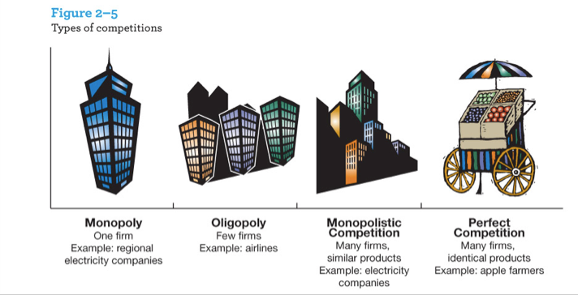
- Regulatory Forces - restrictions placed on marketing practices by government and industry associations
- Regulations - restrictions placed on marketing practices by government and industry associations

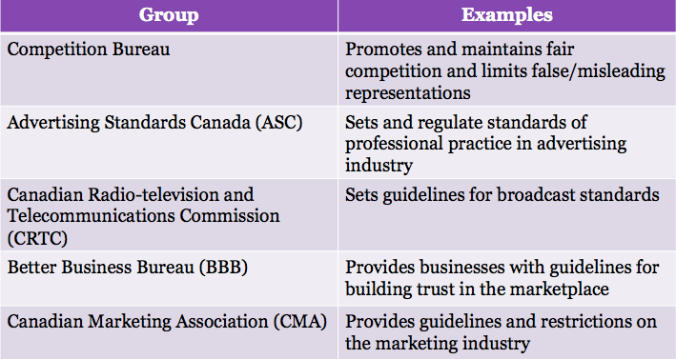

Groups that regulate marketing practices in Canada:
- Competition bureau - responsible for administration and enforcement of several acts as well as to promote and maintain fair competition
- Advertising Standards Canada (ASC) - self regulatory non-government association run by marketing professionals with purpose of regulating standards - guidelines are the Canadian Code of Advertising Standards
- Canadian Radio-television and Telecommunications Commission (CRTC) - government agency that sets guidelines - administers Broadcasting Act and Telecommunications Act
- Better Business Bureau (BBB) - voluntary alliance of businesses
- Canadian Marketing Association (CMA) - backbone of marketing industry in Canada - provides guidelines through its Code of Ethics and Standards of Practice
- Bait and switch advertising - advertising low priced product (bait), luring them into store and then selling them high priced items (switch)
- Do Not Call List (DNCL) - gives ability to consumers to not receive telemarketing calls
- CRTC restricts TV advertising to :
- 12 minutes per hour on specialty channels
- No advertising on PPV, VOD…
- No limits on FM/AM
- No limits on regular TV stations
- No advertising on CBC
- Personal Information Protection and Electronic Documents Act (PIPEDA) - provides businesses with guidelines on what information can be collected, shared and distributed
- Spam - dissemination of unsolicited electronic messages to recipients
- Promotional contests are widely used in Canada to encourage consumers to purchase products
- Quebec’s Consumer Protection Act - prohibits advertising to children under the age of 13
- Criminal Code - prohibits lotteries where winnings are based purely on chance unless for a government lottery or charity
- Competition Act - prohibits lotteries unless there is a fair disclosure of rules, prizes, odds…

Consumer Behavior I – (251-257)

Purchase Decision Process:
- Customer is not necessarily aware.
- The stages that a buyer passes through while making choices about which products or services to buy.
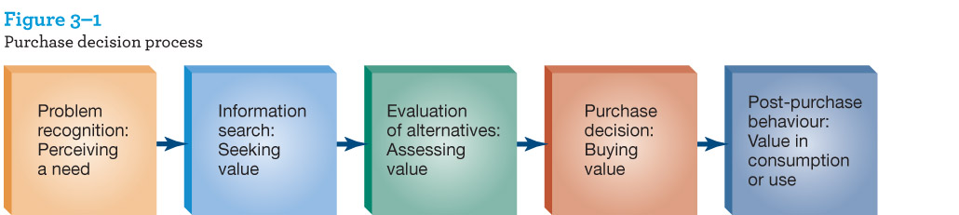

5 Stages:
- Problem recognition: Recognizing a Need
  - Something I want/Something I need — how to solve it
- Information search: Seeking Value
  - Internal search - scan memory for previous experience
  - External search - something more expensive, gathering information for options
    - Personal search – primary sources of external info from relatives etc.
    - Public search – Google, consumer reports, or government agencies.
- Evaluation of alternatives: Assessing Value
  - Evaluative criteria - objective and subjective attributes that one considers to compare different products and brands.
  - Suggested set - group of brands that a consumer would consider acceptable from among all brands.
- Purchase Decision: Buying Value
Three Choices:
- Chosen brand
- From whom to buy
- When to buy
  - When to buy may depend on:
    - Sales
    - Store atmosphere
    - Pleasantness of shopping experience
    - Salesperson persuasiveness
    - Time pressure
    - Finances
- Post-Purchase Behavior: Value in Consumption or Use
  - After buying a product, the consumer compares it with his/her expectations and is either satisfied or dissatisfied.
  - Dissatisfied customers tell approx. 9 others
  - Satisfied customers tell approx. 3 others
    - Dissonance:
  - May occur when a decision is made between two or more objects or actions.
    - Dissonant:
  - Incompatible or Inconsistent
    - Cognitive dissonance:
- Post purchase psychological tension or anxiety.

Dissonance (buyers remorse) is greater when the decision is important.
Dissonance can be reduced by:
- Decreasing the perceived attractiveness of the alternative that was not chosen.
- Increase the perceived attractiveness of what I did choose.
- Increasing the perceived similarity of the alternatives.

Involvement & Problem Solving Variations:
- There are Personal, Social, and Economic consequences of a purchase for the consumer.
- High involvement:
  - Expensive, bought infrequently, could reflect ones social image. (Luxury Goods)
- Low involvement:
  - Ex) Milk, salt, vegetables

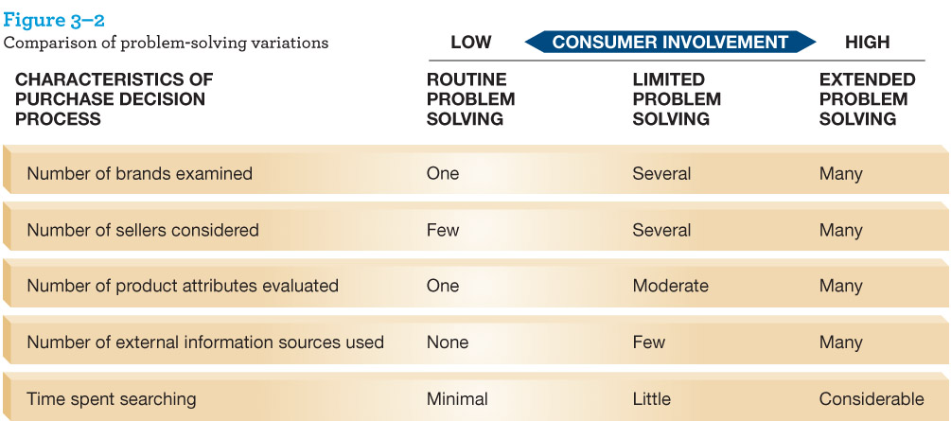
Three different kinds of Problem Solving:
- Routine Problem Solving:
  - Typically low involvement decision-making and frequently purchased goods.
- Limited Problem Solving:
  - Consumers rely on past experience more than external information but pay more attention to new services/goods.
- Extended Problem Solving:
  - Each of the 5 stages of Consumer purchase decision process is used in the purchase. The consumer involvement is very high.

*The graph above highlights the different characteristics of purchase decisions and consumer involvement in making those decisions.

Choice (*NOTE not in textbook readings):
- Choice can be a good thing or a bad thing.
- The Paradox of Choice: (The problem with choice)
  - Too much choice creates problems. (Creates demotivation)
  - We also do not like having no choice.
- Choice overload hypothesis:
- Extensive choices:
    - Could be seen as desirable initially but can be demotivating in the end.
    - Results in fewer purchases.
    - Preferred by people who were sure in their decisions. (Problem Solving/Involvement is high)
- Limited Choices:
  - Had a more enjoyable decision making process.
- Meta-analysis conclusion:
  - A systematic method of evaluating statistical data based on results of several independent studies of the same problem.
  - Told us that the choice overload hypothesis does not hold over every situation, only in certain situations it may work.

Situational Influences: (*Shown in bottom box)
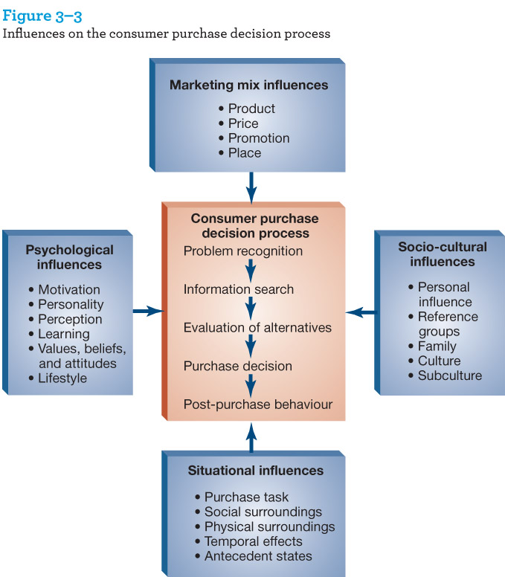

Situational Influences are the background factors of a purchase situation, beyond the person and the product.
    - Ex) smells, sights, sensory etc.
Purchase task.
    - What you are going to buy.
Social surroundings:
- Other people present when decision is made.
Physical surroundings:
- Decor, music, crowding
Temporal effects:
- Time of day purchase is made/ amount of time available.
Antecedent states:
- Mood, Amount of cash on hand, mood before purchase setting.

Sensory Marketing:
- Marketing that engages your senses
  - Ex) Music, odors, visuals in a purchase setting.

Congruence:
- A match between the consumer feeling and the environment.
- Sensory marketing appropriate for demographic of clientele.
The Power of Audition:
- Music helps viewers of an advertisement better process the message.
- People spend more time browsing in a store when slow vs. fast music is played (as long as its congruent)
The Power of Smell:
- The learned view of odor preference suggests that we perceive some scents as pleasant vs. unpleasant.
- Based on the concept of associative learning - we associate certain experiences with feelings.
- Associative learning is relevant to marketers because it suggests that emotions can be elicited in customers based on presence or absence of certain scents. (Ex. Hollister, keeps away an “older kind” of client)
- Ambient Scents - are present in the background of a setting and are usually fainter, spread over a wide area.
  - Pleasant ambient scents may increase spending (when no music is playing) and decrease perceptions of passage of time

