Chapter 1
The Purpose and Use of Financial Statements

Users and Uses of Accounting
Accounting is the information system that identifies and records the economic events of an organization, and then communicates with them to a wide variety of interested users.
Internal Users
- Plan, organize, and run companies
- Financial directors, marketing managers, human resource personnel, production supervisors, and company officers

External Users
- Customers, employees, labour unions, taxing authorities and regulators
- Investors to make decisions to buy, hold, or sell their ownership interest
- Lenders to evaluate the risks of lending money
- Creditors to decide whether or not to grant credit
Form of Business Organization
Proprietorships
- Owned by one person
- Simple to set up
- Owner has control over business
- Unlimited liability(owner receives any profits, suffers any losses)
- Life of the proprietorship is limited to the life of the owner
- The business profits are reported as self-employment income and taxed on the owners personal income tax return

Partnerships
- Similar to proprietorship except owned by more than one person
- Formalized in a written agreement
  - Formation of the partnership/partnership contributions
  - Partnership liquidation
  - How profits/losses are shared
- Each partner has unlimited liability
- Business profits are reported as self-employment income and taxed on each partner’s personal income tax return

Corporations
- Separate legal entity owned by shareholders (owners of shares)
- Indefinite life
- Owners enjoy limited liability
- Pay income tax as separate legal entities on any corporate profits
- Public Corporations distribute their financial statements to investors, lenders, other creditors, other interested parties and the general public
- Private Corporations issue shares but they do not make them available to the general public. They almost never distribute their financial statements publicly.

Business Activities

Financing Activities
- Obtaining (and repaying) funds to finance the operations of the business
  - Borrowing money or repaying loans (debt financing)
  - Selling or repurchasing shares (equity financing)
- Forms of Debt
  - Bank Indebtedness: pre-arranged bank loan, company draws more money than cash on hand
  - Bank Loans: Money borrowed from the bank
  - Noncurrent debt such as mortgages, bonds and leases

Investing Activities
- Purchase or sale of long-lived assets needed to operate the company
- Examples:
  - Purchase or sale of long term investments
  - Purchase or sale of long-lived assets such as property, plant and equipment and intangible assets (assets are resources that a company owns or controls)

Operating Activities
- The main day-to-day activities of business
- Examples:
  - Revenue
  - Expenses
  - Related accounts such as accounts receivable and account payable

Financial Statements
Income Statement – Reports revenue and expenses to show how successfully a company performed during a period of time
Revenue: Arise from the sale of a product or service – resulting in an inflow of assets
Expenses: Cost of assets consumers or services used to generate revenue

Profit = Revenues – Expenses

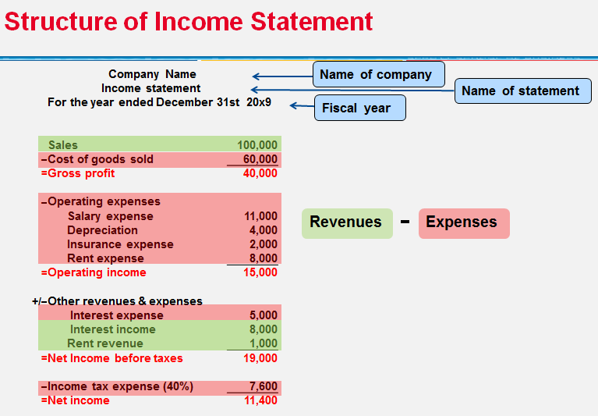

Statement of Changes in Equity – Shows the changes in each component of shareholders’ equity, as well as total equity, during a period of time

Share Capital: Amount contributed by shareholders
Retained Earnings: Cumulative profit retained in the corporation
Deficit: Negative Retained Earnings

How to Find Statement of Changes in Equity:
Share Equity + Issues of Share + Profit – Dividends = Ending Shareholders Equity
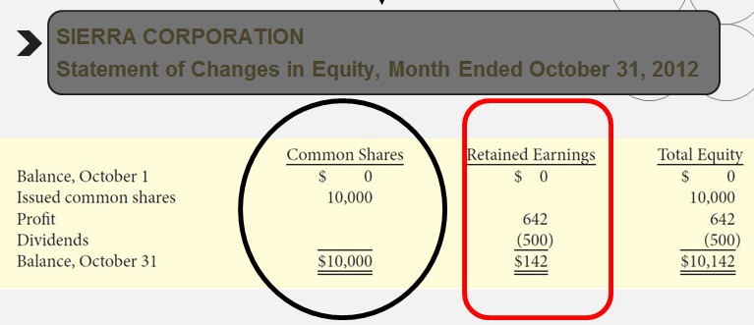

Statement of Financial Position – Also known as a balance sheet, presents a picture of what a company owns (assets), what it owns (its liabilities), and its net worth (shareholders equity) at a specific point in time

Assets = Liabilities + Shareholders Equity

Assets: Resources owned by a business
Liabilities: Obligations of the business (outsider claims)
Shareholders’ Equity: Shared capital and retained earnings (insider claims of a business)

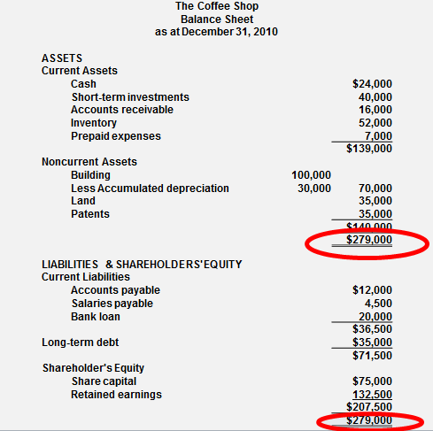

Statement of Cash Flows – Shows where the company obtained cash during a period of time and how that cash was used

Reports the effect on cash of the company’s operating, investing and financing activities. Shows net increase or decrease in cash for the period

Relationships between the Statements:
- Profit from income statement is reported in the statement of changes in equity
- Ending balance of shareholder’s equity is reported in both statements of financial position and changes in equity
- Statement of cash flows is related to the statement of financial position
Chapter 2
A Further Look at Financial Statements

Statement of Financial Position (Balance Sheet)

Assets
Current Assets
Investments
Property, Plan and Equipment
Goodwill
Liabilities and Shareholders Equity
Current Liabilities
Non-Current Liabilities
Share Capital
Retained Earnings

Assets
- Assets expected to be converted to cash or used in the business within one year or one operating cycle
  - Operating cycle: The average time it takes to go from cash to cash in producing revenue
- Usually listed in order of liquidity

Types of Current Assets
- Cash
- Short-Term Investments
- Accounts Receivable (Amount owed to the company by customers)
- Accrued Receivable (Amount owed to the company for interest, sales tax, rent)
- Notes Receivable (Amount owed to a company supported by a promise to repay
- Inventory (Goods held for sale to customer)
- Supplies (Consumable Items)
- Prepaid Expenses (Paid in advance)

Non-Current Assets
- Assets not expected to be converted to cash or used in the business within one year or one operating cycle

Types of Non-Current Assets
- Investments (long term investments such as loans, mortgages and bonds)
- Properly Plant and Equipment (Tangible assets with long useful lives)
- Intangible Assets and Goodwill (Assets that do not have a physical substance)

Liabilities
- Obligations that are to be paid within the coming year or one operating cycle

Types of Current Liabilities
- Bank Indebtedness (Short-term loan from a bank such as a line of credit)
- Accounts Payable (Amounts owed by the company to supplies for purchases made on credit
- Accrued Liabilities (Amounts owed by the company salaries, rent, sales tax)
- Notes Payable (Amounts owed supported by a promise to repay)
- Current Maturities of Long-Term Debt (Portion of the payment due within the current year)

Types of Non-Current Liabilities
- Notes Payable (Bank loans, mortgages and bonds payable)
- Lease Obligations (Amounts to be paid in the future on long-term rental contracts)
- Deferred Income Tax Liabilities (Income tax that is expected to be payable later)

Shareholders’ Equity
Share Capital
- Investment of cash (or other assets) in the company by shareholders in exchange for preferred or common shares

Retained Earnings
- Cumulative profits kept for use in the company

Using the Statement of Financial Position

Liquidity
- Measure a company’s short-term ability of to pay its obligations that will come due within the next year

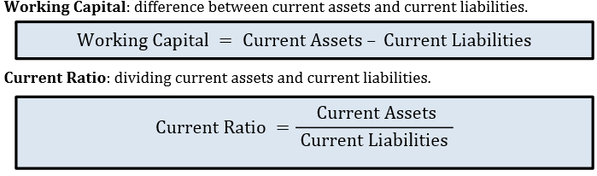
Solvency
- Measure a company’s ability to survive over a long period of time
  - The higher the percentage of debt to total assets, the greater risk that debt cannot be repaid when they are percentage of assets

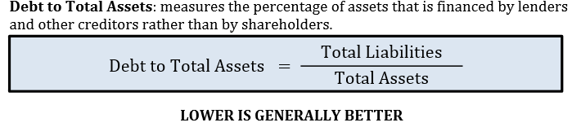

Using the Income Statement
Profitability
- Measures a company’s operating success for a given period of time

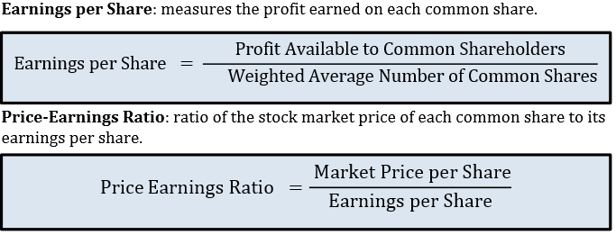

Framework for the Preparation and Presentation of Financial Statements
Conceptual Framework for Financial Reporting
Objective of Financial Reporting
- To provide financial information that is useful to existing and potential investors, lenders and other creditors
- Who are making decisions about providing resources to a company:
  - Buying, selling, holding equity and debt
  - Providing or settling loans or other credit
- Financial information is provided by general purpose financial statements using accrual accounting

Chapter 3
The Accounting Information System

Accounting Information System
- The system of collecting and process transaction data and communicating financial information
- Can vary widely based on factors such as:
  - Type of business and its transactions
  - Size of company
  - Amount of data
  - Information requirements
- An accounting transaction occurs when assets, liabilities or shareholders’ equity items change as a result of some economic event

Analyzing Transactions
- Transactions analysis determines impact on the accounting equation
  - Assets= Liabilities + Shareholders’ Equity
- The accounting equation must always balance
  - Therefore, each transaction has a dual (double-sided) effect on the equation

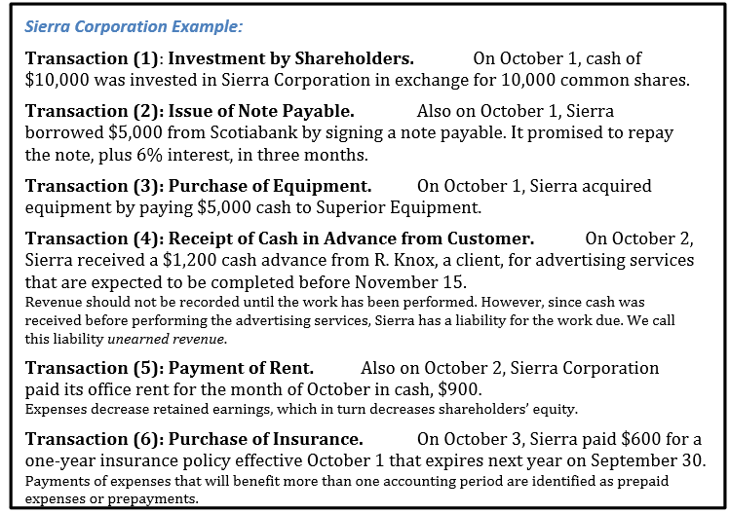
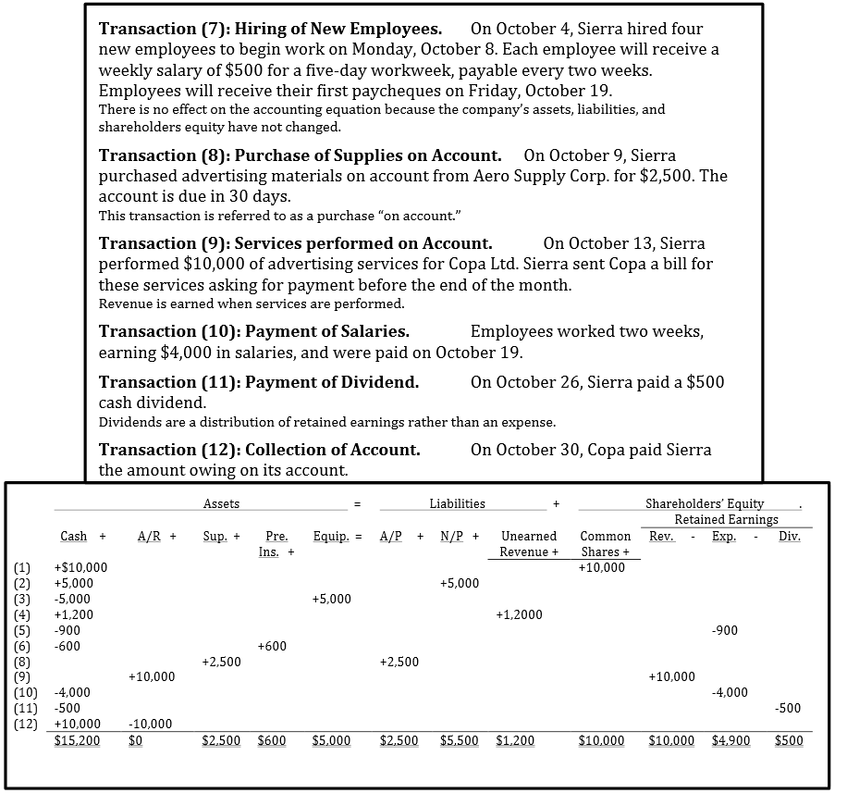

The Account
- An individual accounting record of increases and decreases in a specific asset, liability, or shareholders’ equity item
- Three parts:
  - The title of the account
  - A left or debit side
  - A right or credit side

Debits and Credits
- Describes where the entries are made in the account
  - Debit is on the left column
  - Credit is on the right column
- Add up each side:
  - If the greater sum is on the left, the account has a debit balance
  - If the greater sum is on the right, the account has a credit balance

Normal Balances

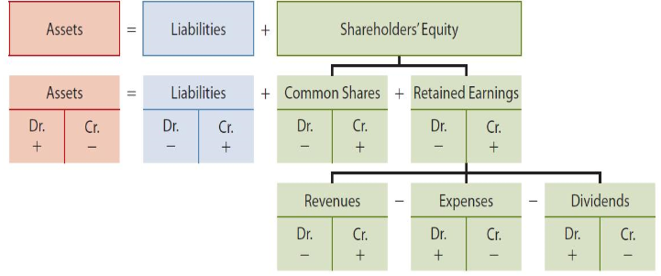

Steps in the Recording Process
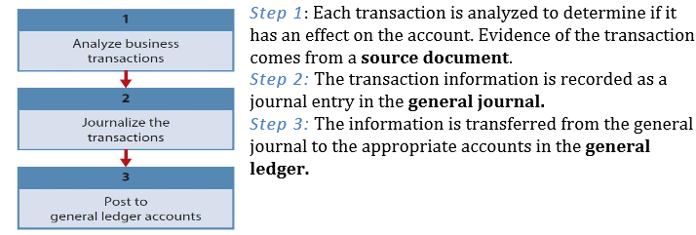
The Journal
- Transactions are recorded in chronological order in the journal and then transferred to the accounts
- For each transaction, the journal shows the debit and credit effects on specific accounts
- The general journal makes several contributions to the recording process:
  - It discloses the complete effect of a transaction in one place, including an explanation and, where applicable, identification of the source document
  - It provides a chronological record of transactions
  - It helps to prevent and locate error, because the debit and credit amounts for each entry can be quickly compared

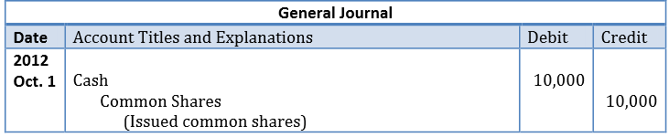

Note the following features of the journal entry:
- The date of the transaction is entered in the date column
- The account to be debited is entered first at the left. The account to be credited is then entered on the next line, indented under the line above. The indentation differentiates debits from credits and decreases the chance of switching the debit and credit amounts by mistake
- The amounts for the debits are recorded in the debit (left) column, and the amounts for the credits are recorded in the credit (right) column
- A brief explanation of the transaction is given

The Ledger
- Entire group of accounts maintained by a company
  - List of accounts is called a chart of accounts
- Contains all the asset, liability and shareholders’ equity accounts
- Posting is the process of transferring information from the general journal to the general ledger accounts

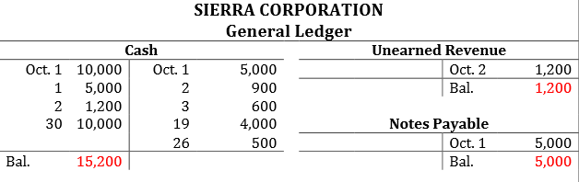
Trial Balance
- List of all the accounts and their balances at a specific time
- Serves to prove the mathematical equality of debits and credits after posting
  - Sum of debits = sum of credits
- Aids in the preparation of financial statements

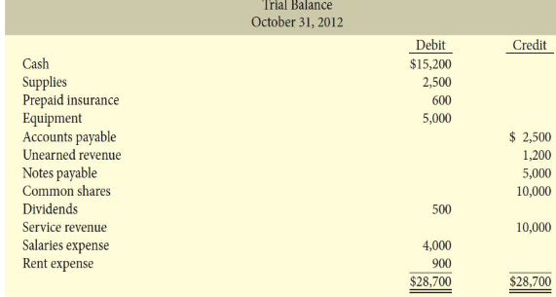

The Procedure for preparing a trial balance:
- List the account titles and their balances in the same order as the chart of accounts. Debit balances should be entered in the debit column and credit in the credit column
- Total the debit columns and the credit columns
- Ensure that the debit and credit column totals are equal

Chapter 4
Accrual Accounting Concepts

Timing Issues
- Companies need immediate feedback on how well they are doing
- Accounting divides the economic life of a business into artificial time periods
  - Month, quarter, year
  - Many transactions affect more than one time period

Revenue Recognition
- Revenue is recognized when:
  - Sales or performance effort is substantially complete
  - Amount is determinable (measurable)
  - Collection is reasonably assured
- In merchandising company:
  - When merchandise is sold (point of sale)
- In a service company:
  - When the service is performed

Expense Recognition
- Expenses are recognized when:
  - Due to ordinary activity, a decrease in future economic benefits occurs
    - Related to a decrease in an asset or an increase in a liability
  - It can be measured reliably
- Tied to changes in assets and liabilities
- Often (but not always) coincides with revenue recognition

Accrual Versus Cash Basis of Accounting
Accrual
- Transactions affecting a company’s financial statements are recorded in the period of the events office, rather than when cash is received or paid
  - Revenue is recorded when earned, rather than when cash is received
  - Expenses are recorded when goods or services are consumed, rather than when cash is paid

Cash
- Revenue is only recorded when cash is received
- Expenses are recorded only when cash is paid
- Can lead to misleading financial statements:
  - Revenue and expenses can be manipulated by timing the receipt and payment of cash
  - Can increase or decrease profit

The Basics of Adjusting Entries
- Adjusting entries are made to adjust or update accounts at the end of the accounting period
- Required because the trial balance may contain complete and up-to-date data
  - Some items are not recorded daily
  - Some costs are not recorded during the accounting period, as they expire due to the passage of time
  - Some items may be unrecorded

Types of Adjusting Entries
Prepayments
- Prepaid expenses: expenses paid in cash and recorded as assets before they are used or consumed
- Unearned revenues: cash received and recorded as liabilities before revenue is earned
Accruals
- Transactions affecting a company’s financial statements are recorded in the period the events occur; rather than when cash is received or paid
  - Accrued revenues: revenues earned but not yet received in cash or recorded
    - Adjusting entry results in an increase to both an asset and a revenue account
  - Accrued expenses: expenses incurred but not yet paid in cash or recorded
    - Adjusting entry results in an increase to both an expense and a liability account
- Accruals have not been recognized at all until an adjustment is made

Adjusting Entries for Prepayments
- Prepayments increase current assets such as prepaid expenses and certain types of non-current assets
- Adjusting entries for prepayments allocate a cost from an asset or liability account to an expense or revenue account

Prepayments made:
- The adjusting entry records the expense that applies to the current period and reduces the asset account that was originally recorded

Prepayments received:
- The adjusting entry records the revenue earned in the period and reduces the liability account where the unearned revenue was originally recorded

Prepaid Expenses
- Costs that are paid for in cash before they are used
  - When the cost is incurred, an asset (prepaid) is increased (to show the future service or benefit) and cash is decreased
- Expire with the passage of time or through use
  - Not practical to record this expiration on a daily basis – it is done when statements are prepared
- Adjusting entry increases an expense account and decreases the asset (prepaid) account

Depreciation
- The process of allocating the cost of a long-lived asset or non-current asset to expense over its useful life
  - Depreciation: normally used in relation to property, plant and equipment
  - Amortization: used in relation to intangible assets
  - Depletion: used in relation to natural resources
- Depreciation is an allocation concept, not a valuation concept
  - We depreciate an asset to allocate its cost to the periods over which we use it
  - Not recording a change in the actual value of the asset
- Calculation of depreciation:
  - Straight-line method of depreciation: divide the cost of the asset by its useful life
  - At the time an asset is acquired, its useful life is not known with any certainty
    - It must be estimated
    - Depreciation is an estimate rather than a factual measurement of the cost that has expired

Unearned Revenue
- Cash that has been received before revenue is earned
  - When the cash is received, a liability account (Unearned revenue) is increased and cash is increased
- The opposite of prepaid expenses
- Adjusting entry decreases the liability (unearned revenue) account and increases a revenue account
  - Reflect the amount of revenue earned in the period and the remaining liability at the end of the period

Adjusting Entries for Accruals
- Accruals have not been recognized at all until an adjustment is made
- Revenues that have been earned, but not received in cash (accrued revenues)
  - Adjusting entry results in an increase to both an asset and a revenue account
- Expenses that have been incurred, but not yet paid or recorded (accrued expenses)
  - Adjusting entry results in an increase to both an expense and a liability account

Accrued Revenues
- Accrued revenues may accumulate (accrue) with the passing of time, as in the case of interest revenues
- They may result from services that have been performed but not yet billed or collected, such as fees
- An adjusting entry is required for two purposes:
  - To show the receivable that exists at the statement of financial position date
  - To record the revenue that has been earned during the period

Accrued Expenses
- Interest, rent, salaries, property tax, and income tax are common examples
- Accrued expenses result from the same factors as accrued revenues
- Adjustments for accrued expenses are necessary to:
  - Record obligations that exist at the statement of financial position date
  - Recognize the expenses that apply to the current accounting period

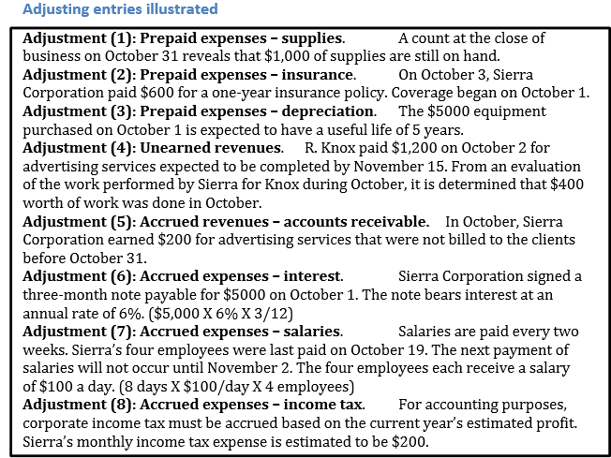

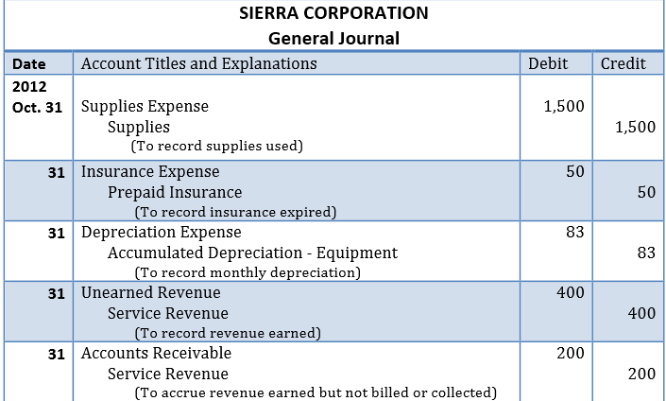
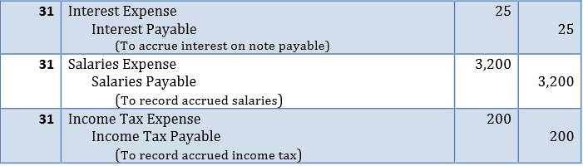

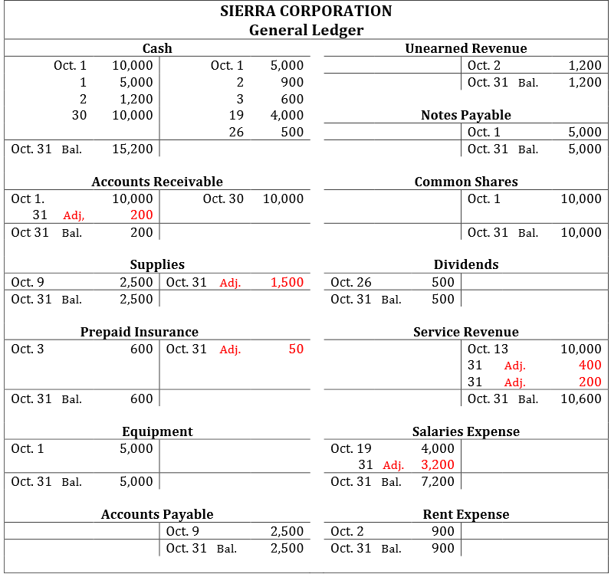

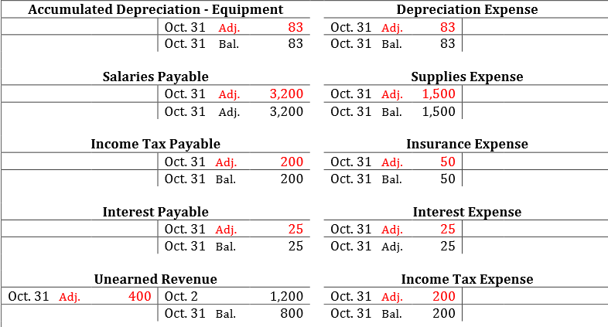
Adjusted Trial Balance
- Prepared after all adjusting entries have been journalized and posted
- Shows the balances of all accounts at the end of the accounting period
  - Including those accounts that have been adjusted
- Proves the equality of total debit balances and total credit balances after adjusting entries that have been made
- The main source for preparation of financial statements

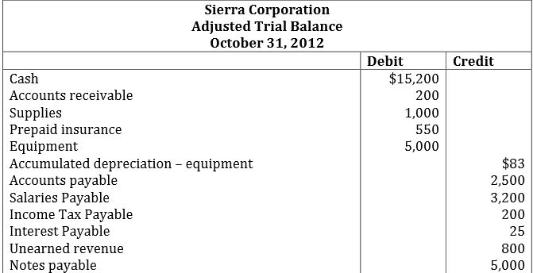
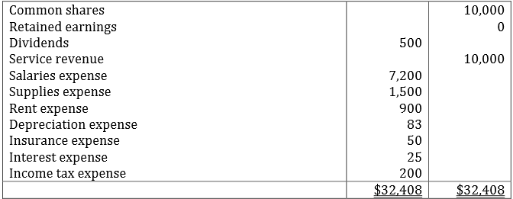

Closing the Books
- Revenue and expense accounts are subdivisions of retained earnings
  - Considered to be temporary accounts
- Statement of financial position accounts carry forward into the future
  - Considered to be permanent accounts
- Closing entries
  - Temporary account balances are transferred to retained earnings
  - Produce a zero balance in the temporary accounts to prepare them for the next periods activity

Temporary and Permanent Accounts:
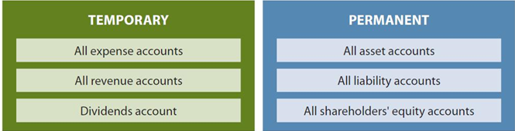

Preparing Closing Entries (The Closing Process)
- Close revenue accounts:
  - Debit each revenue account for its balance and credit income summary
- Close expense accounts:
  - Debit income summary and credit each expense amount for its balance
- Close income summary:
  - Debit (or credit) income summary for the balance in the account and credit (debit) retained earnings
- Close dividends account:
  - Debit retained earnings and credit dividends account for the balance

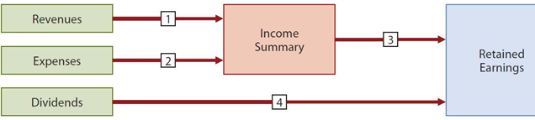

Other Comprehensive Income and Accumulated Other Comprehensive Income
- For companies reporting under IFRS only
  - Companies reporting under ASPE do not recognize OCI
- May have complex items that determine OCI rather than profit
  - Similar to revenues and expenses
- Items in OCI plus profit = comprehensive income

Preparing a Post-Closing Trial Balance

- List all permanent accounts and their balances
  - After all closing entries are journalized and posted
- Proves the equality of total debit balances and total credit balances after the closing entries have been made

Summary of the Accounting Cycle
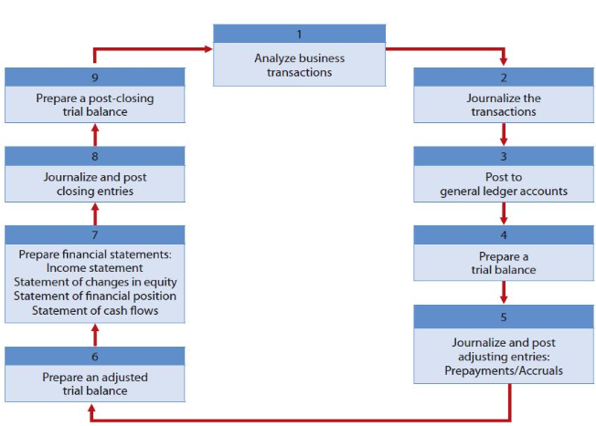

Chapter 5
Merchandising Operations

Merchandising
- Involves purchasing products (inventory) to resell to customers
  - Retailers sell to customers
  - Wholesalers sell to other companies
  - Manufacturers produce goods for sale

Operating Cycles
- The time it takes to go from cash to cash in producing revenues
- Usually longer or a merchandising company than it is for a service company
  - Merchandise must first be purchasd before it can be sold
  - Adds an additional step to the cycle

Income Measurement Process
Expenses for a merchandising company are divided into two categories:
- Cost of Goods Sold: Total cost of the merchandise that was sold during the period
- Operating Expenses: Expenses that are incurred in the process of earning sales revenue

Gross Profit = Sales revenue less cost of goods sold

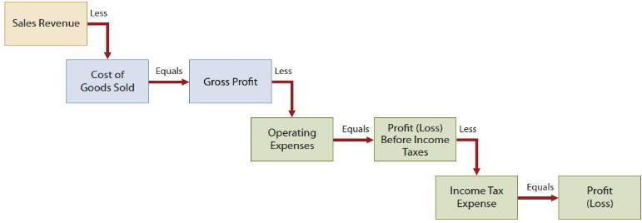

Inventory Systems
- Flow of costs for a merchandising company:
  - Beginning inventory and purchases = Cost of goods avaibale for sale
  - Once sold, these costs are assigned to cost of goods sold
  - Goods left over are ending inventory
- One of these two systems is used to account for inventory (statement of financial position) and costs of goods sold (income statement)
  - Perpetual inventory system
  - Periodic inventory system

Perpetual Inventory System
- Detailed records are kept for the cost of each product bought and sold
- These records are updated constantly for purchasing and sales
- A physical count is done at least once a year to adjust perpetual records to actual
- This system enables the effected control of inventory which is an important asset
- The cost god goods sold and the reduction in inventory – both its quantity and cost are recorded each time a sale occurs

Perpetual Inventory System: Purchases of Merchandise
- Purchases are recorded in the merchandise inventory account
- Includes all costs to get merchandise to place of business and ready for resale:
  - Includes freight and applicable taxes
  - Less purchase returns, allowances and discounts
- Credit purchases are supported by a purchase order

Periodic Inventory System
- Detailed records of merchandise are not kept throughout the period
- Cost of goods sold is only determined at the end of the accounting period:
  - Once inventory is counted
  - Cost of goods sold = beginning inventory and cost of purchases less ending inventory

The follow steps are necessary:
- Beginning Inventory: Determine the costs of goods on hand at the beginning of the accounting period
- Cost of Goods Available for Sale: Add the cost of goods purchased to the beginning inventory. The total is the cost of goods available for sale during the period
- Ending Inventory: Determine the cost of goods on hand at the end of the accounting period from the physical inventory count
  - Subtract the ending inventory from the cost of goods available for sale; the resale is the costs of goods sold

Recording Purchases of Merchandise

Purchases
- Purchases are recorded in the Merchandise Inventory account
- Includes all costs to get merchandise to place of business are ready for resale:
  - Includes freight and applicable taxes
  - Less purchase returns, allowances, discounts
- Credit purchases are supported by a purchase order

Sales Taxes
- Most merchandising and service companies collect sales taxes on the goods they sell and services they provide
- Merchandising companies pay GST or HST on the cost of the goods they purchase
- GST and HST paid does not form part of cost of goods (refunded)

Freight Costs
- The invoice should indicate whether the seller or the buyer must pay the cost of transporting the goods
- Freight paid by the buyer is part of the cost of the merchandise purchased
- FOB (Free on Board) – refers to where title or ownership of goods transfers:
  - FOB shipping point: seller’s place of business
    - Ownership of the goods passes from the seller to the buyer as soon as the goods are shipped
  - FOB destination: buyer’s place of business
    - Ownership of the goods does not pass from the seller to the buyer until the goods are received by the buyer (i.e. destination point)

Purchase Returns and Allowances
- A purchaser returns the goods to the seller and receives a cash refund or credit
- The buyer may choose to keep the merchandise if the seller is willing to give an allowance (deduction) from the purchase price
- In both cases, the result is a decrease to Merchandise Inventory (the cost of goods purchased)

Discounts
- A quantity discount gives a price reduction according to the volume of the purchase:
  - Not recorded separately – discounted price is recorded as cost of purchase
- A purchase discount is offered to encourage early payments of a balance due.
  - Example: 2/10, n/30:
    - 2% cash discount may be taken on the invoice price if the payment is made within 10 days. Otherwise, the invoice price is due in 30 days
    - Recorded separately when payment made. Results in a decrease to Merchandise Inventory account

Recording Sales of Merchandise

Sales
- Two journal entries are required to record each sale in a perpetual inventory system
  - First entry records sales revenue
  - Second entry records the cost of the merchandise sold

Sales Tax
- When a company collects sales taxes from selling a product or service, these sales taxes are not recorded as revenue
- Sales taxes that are collected from selling a product or service are recorded as liability until they are paid to the government

Freight Costs
- FOB destination – the seller assumes the responsibility
- Freight costs incurred by the seller on outgoing merchandise are an operating expense to the seller
- Debited to the account ‘freight out’ or ‘delivery expense’

Sales Returns and Allowances
- Also requires two separate entries
  - The first entry records a debit to the sales returns and allowances account and a credit to the accounts receivable/cash account
  - The second journal entry debits the Merchandise Inventory account and credits the Cost of Goods Sold account
- Sales taxes are not recorded as revenue
- When freight is FOB destination, seller records cost of freight as an expense
- Sales returns and allowances are a contra revenue account to sales
- Sales discounts are also a contra revenue account to Sales
- If the merchandise is not resalable and is discarded, a second entry is not made

Discounts
- No separate entry is made to record a quantity discount
- Sakes are recorded at the invoice price
- The account ‘sales discounts’ is added to record sales discounts
  - Contra revenue accounts to sales – normal debit balance

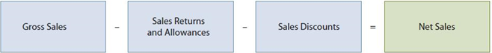

Summary of Merchandising Entries

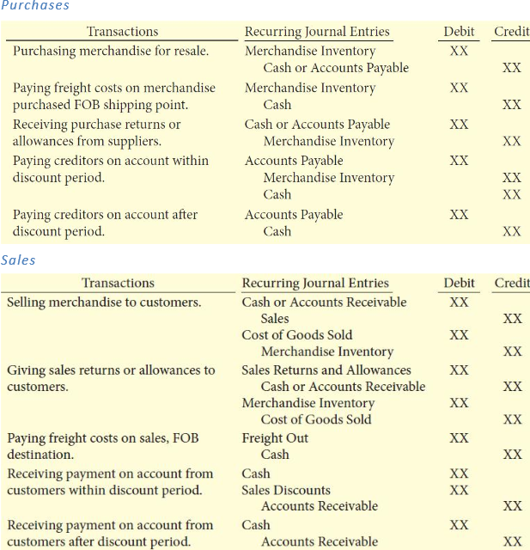

Income Statement Presentation

Single-Step Income Statement
- All data is classified into revenue or expenses
- Income tax expense is usually disclosed separately from the other expenses
- Cost of goods sold, interest expense and income tax expense must be separately reported
- The remaining expenses can be included directly in the income statement, or can be summarize into one or more lines

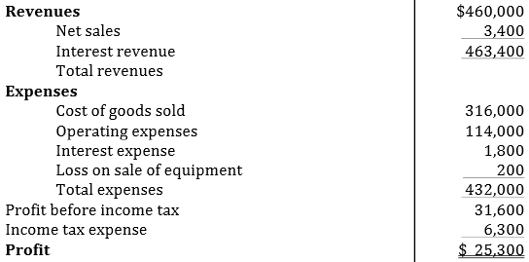

Multi-Step Income Statement
- Net Sales: Sales returns and allowances and sales discounts are subtracted from gross sales to determine net sales
- Gross Profit: Cost of goods sold is subtracted from net sales to determine gross profit
- Profit from Operations: Operating expenses are deducted from gross profit to determine profit from organizations
- Non-Operating Activities: The results of activities that are not related to operations added(as other revenues and gains) or subtracted(as other expenses and losses) to determine profit before income tax
- Profit: Income tax expense is subtracted from profit before income tax to determine profit (loss)

Net Sales
- Begins by presenting sales revenue
- The two contra revenue accounts, sales returns and allowances and sales discounts are deducted rom gross sales in the income statement to arrive at net sales
Gross Profit
- Cost of goods sold is deducted from net sales to determine gross profit
- Gross profit represents the merchandising profit of a company
Profit from Operations
- Calculated by subtracting operating expenses from gross profit
Non-Operating Activities
- Consists of other revenues and gains, as well as other expenses and losses that are unrelated to the company’s main operations
Profit
- The final outcome of all the company’s operating and non-operating activities

Example:
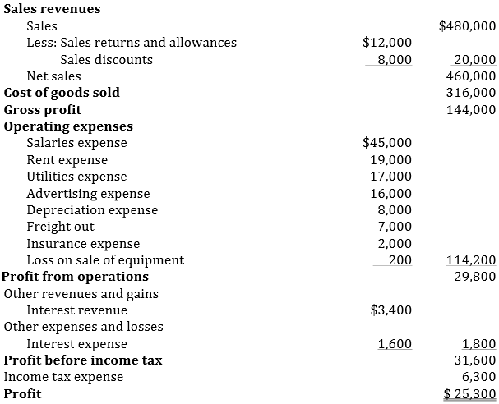
Evaluating Profitability:



