- Human Resource Management (HRM)
- The process of managing human talent to achieve an organizations objectives.
  - Human Capital; The knowledge, skills and capabilities of individuals that have economic value to an organization.

- Why Study HRM?
  - Having a good understanding of HRM is important for managers and entrepreneurs of all types- not just HR personnel.
  - All managers are responsible for at least some of the activities that fall into the category of HRM.
  - Managers play a key role in selecting, training, and motivating, appraising and promoting employees.
  - Great business plans and products and services can easily be coped by competitors. Great personnel cannot; their knowledge and abilities are among the most distinctive and renewable resources upon which a company can draw.

- Human Capital and HRM
  - Human capital is intangible and cannot be managed the way organizations manage jobs, products, and technologies.
  - One reason is because employees, not the organization, own their own human capital. (If a valued employee were to leave the company, they take their human capital with them and any investments that the company has made in training and developing these people is lost.)
  - To build human capital in organizations, mangers must continue to develop superior knowledge, skills and experience within their workforces and retain and promote top performers.
  - Beyond the need to invest in employees, organizations also have to find ways to better utilize the knowledge of their workers. (Too often employees have knowledge that goes unused.)

- Explain how human resource managers can help their organizations gain a sustainable competitive advantage through the strategic utilization of people
  - HR managers who have a good understanding of their firm’s business can help it achieve its strategies through utilization of people and their talents.
  - An organization’s success increasingly depends on the knowledge, skills and abilities of its employees.
  - To “compete through people”, organizations have to do a good job at managing human capital.
  - Managers must develop strategies for identifying, recruiting and hiring the best talent available; developing these employees in ways that are firm specific helping them generate new ideas and generalize them throughout the company; encouraging information sharing and rewarding collaboration and teamwork among employees.

- Competitive Challenges and HRM

- Major Challenges Facing HRM
- Responding Strategically to Changes in the Marketplace

Terms:
    - Six Sigma; A set of principles and practices whose core ideas include understanding customers needs, doing things right the first time, and striving for continuous improvement.
    - Reengineering; The fundamental rethinking and radical redesign of business processes to achieve dramatic improvements in cost, quality, service and speed.
    - Downsizing; Planned elimination of jobs.
    - Change Management; Change management is a systematic way of bringing about and managing both organizational changes and changes on the individual level.
    - Reactive Change; Changes that occurs after external forces have already affected performance
    - Proactive Changes; Changes initiated to take advantage of targeted opportunities

- Competing, Recruiting and Staffing Globally

Explain how globalization is influencing HRM
      - Globalization has become pervasive the number of kinds of jobs that are available and requires that organizations balance a complicated set of issues related to managing people working under different business conditions in different geographies, cultures and legal environments.
      - HR strategies and functions have to be adjusted to take into account these differences.

- Setting and Achieving Corporate Social Responsibilities and Sustainability Goals
    - CSR; The responsibility of the firm to act in the best interest of the people and communities affected by its activities
    - Sustainability; Closely related to CSR, it refers to a company’s ability to produce a good or service without damaging the environment or draining a resource.

Explain how good HR practices can help firms achieve its corporate social responsibility and sustainability goals
    - The face pace of globalization and corporate scandals over the years have led to anew focus on corporate social responsibility (good citizenship) and sustainability.
    - Companies are finding out that having a good reputation of pursuing these efforts can enhance their revenues and improve the capability of talent they are able to attract.
    - One of HR’s leadership roles is to spearhead the development and implementation of corporate citizenship throughout their organizations, especially the fair treatment of workers.

- Advancing HRM with Technology
    - Collaborative Software; Software that allows workers to interface and share information with one another electronically.
    - Knowledge Workers; Workers whose responsibilities extend beyond the physical execution of work to include planning , decision making and problem solving
    - Human Resource Information System (HRIS); A computerized system that provides current and accurate data for purposes of control and decision making

Describe how technology can improve how people perform and are managed
    - Technology has tended to reduce the number of jobs that require little skill and to increase the number of jobs that require considerable skill, a shift we refer to as moving from touch labor to knowledge work.
    - This displaces some employees and requires that others be retrained.
    - In addition, information technology has influenced HRM through HRISs that streamline HR processes, making information more readily available to managers and employees and enable HR departments to focus on the firm’s strategies.
    - The internet and social media are also affecting how employees are hired, work and are managed.

- Containing Cost while Retaining Top Talent and Maximizing Productivity
    - Approaches to lowering labor related cost:
      - Downsizing
      - Outsourcing
      - Offshoring; The business practice of sending jobs to other countries
      - Near-shoring; The process of moving jobs closer to one’s home country
      - Furloughing; A situation in which an organization asks or requires employees to take time off for either no pay or reduced pay
      - Employee Leasing; The process of diminishing employees who are then hired by a leasing company (which handles all HR related activities) and contacting with that company to lease back the employees.
      - Productivity Enhancement

Discuss how cost pressures affect HRM policies
    - To contain cost, organizations have shoring, furloughing and leasing employees, as well as enhancing productivity.
    - HR’s role is not only to implement these programs but also to consider the pros and cons of programs such as these and how they might affect a company’s ability to compete, especially if they lead to the loss of talented staff members.

- Responding to the Demographic and Diversity Challenges of the Workplace
    - Demographic Changes
    - The Diversity/Immigration Challenge
    - Age Distribution of Employees
    - Gender Distribution of the Workforce

Discuss how firms can leverage employee differences to their strategic advantage
    - The workforce is becoming increasingly diverse, and organizations are doing more to address employee concerns and to maximize the benefit of different kinds of employees.
    - But to benefit from those differences, managers need to look past the obvious differences between employees and see not so obvious differences, such as how they think, learn, work, solve problems, manage their time, and deal with other people.
    - By first seeing the differences, exploring them, and then discovering how they can provide value to the organization, HR managers can leverage those differences.

- Adapting to Educational and Cultural Shifts Affecting the Workplace
    - Education of the Workforce
    - Cultural Changes
    - Employee Rights
    - Concern for Privacy
    - The Changing Nature of the Job
    - Changing Attitudes toward Work
    - Balancing Work and Family

Explain how educational and cultural changes in the workforce are affect HRM
    - HR managers must keep up-to-date of the educational abilities of the talent available to their organization.
    - Despite the fact that the educational attainment of the labor force has risen in general, many firms are finding it difficult to find workers with the basic skills they need.
    - As a baby boomer retire, HR departments may have to offer higher compensation packages to attract qualified candidates, and recruiting and selection system will have to function much more competitively.
    - Employee rights, privacy concerns, attitudes toward work, and efforts to balance work and family are becoming more important to workers as the cultural dynamics of the labor force shifts.
    - Companies are finding that accommodating employees’ individual needs as a result of these shifts is a powerful way to attract and retain top- quality people.

- The Partnership of Line Managers and HR Departments
  - Line Mangers; Non-HR managers who are responsible for overseeing the work of other employees.

- Responsibilities of the HR Manager
- The major activities for which an HR Manager is typically responsible for is as follows:
- Advice and Counsel (Serve as an in-house consultant to supervisors, managers and executives given their knowledge on internal employment issues.)
- Service (Perform a host of service activities such as recruiting, selecting, testing, planning and conducting training programs, and hearing employee concerns and complaints.)
- Policy Formulation and Implementation (Propose and draft new policies or policy revisions.)
- Employee Advocacy (Listening to employee’s concerns and representing their needs to managers- to ensure that the interest of employees and the interest of the organization are aligned with one another.)

- Competencies of the HR Manager
- Business Mastery (Need to know the business of their organization thoroughly.)
- HR Mastery (Organization’s behavioral science experts.)
- Change Mastery (Must be able to manage change processes so that their firms’ HR activities are effectively merged with business needs of their organization.)
- Personal Credibility (Must establish personal creditability in the eyes of their internal and external customers.- personal relationships w/customers, demonstrating the values of the firm, standing up for one’s own beliefs, and being fair-minded when dealing with others.)
- 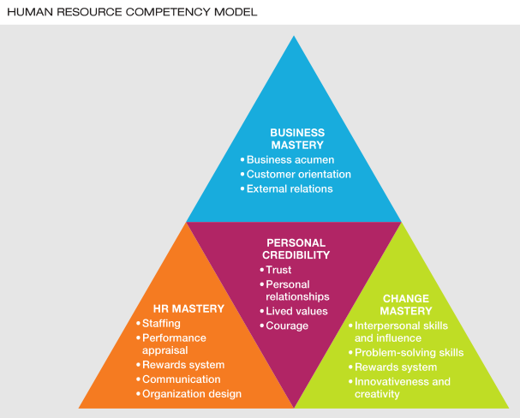

- Provide examples of the roles and competencies of today’s HR managers.
  - In working with line managers to address their organization’s challenges, HR managers play a number of important roles;
    - They are called on for strategic advice and ethics counsel,
    - Various service activities,
    - Policy formulation and implementation,
    - And employee advocacy.
  - To perform these roles effectively, HR managers mist have a deep understanding of their firm’s operational, financial, and personal capabilities.
  - HR managers who do and are creative and innovative can help shape a firm’s strategies so as the respond successfully changes in the marketplace.
  - Ultimately, managing people is rarely the excusive responsibility of the HR function.
  - Every manager’s job involves managing people.
  - Consequently, successful companies combine the expertise of HR Specialists with the experience of line managers and executives to develop and use the talents of employees to their greatest potential.

- Strategic Planning
  - Procedures for making decisions about the organizations long-term goals and strategies
- Human Resource Planning (HRP)
  - Process of anticipation and providing for the movement of people into, within, and out of the organization.

- Step 3 Internal Analysis
- The 3 C’s
  - Capabilities
    - People that distinguish an organization from its competitors
    - The resources must be:
      - Valuables
      - Rare
      - Difficult to imitate
      - Organized
  - Culture
    - Cultural Audits
      - Audits of the culture and quality of work life in an organization (values, assumptions, beliefs, and expectations VABEs)
  - Composition
    - Value- Able to accomplish the organization’s goals
    - Unique- How difficult is it to imitate their skills

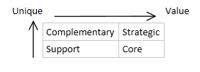

- Model of HR Forecasting

- 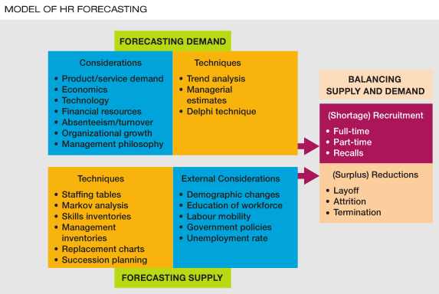

  - Involves:
    - Forecasting the demand for labor
    - Forecasting the supply of labor
    - Balancing Supply and Demand

- Forecasting the Demand for Labor
- Demand Techniques
  - Quantitative
    - Trend Analysis
      - A quantitative approach to forecasting labor demand based on an organizational index such as sales.
  - And/or Qualitative
    - Managerial Estimates
    - Delphi Techniques
      - Decreases the subjectivity of forecast by soliciting and summarizing judgments of preselected groups of individuals
        - A group of decision making tools

- Demand Considerations
  - Product/Service Demands
  - Economics
  - Technology
  - Financial Resources
  - Absenteeism/ Turnover
  - Organizational Growth
  - Management Philosophy

- Forecasting the Supply of Labor
- Supply Techniques
  - Staffing Tables
    - Graphic representation of all jobs organizational jobs, along with the number of employees currently occupying these jobs and future (monthly or yearly) employment requirements.
  - Markov Analysis
    - A method for tracking the pattern of employee movements through various jobs- % of people who remain, transfer, quit or are promoted.
  - Skills Inventories
    - Files of personnel education, experience, interests, skills, etc. that allow managers to quickly match job openings with employee backgrounds
  - Management Inventories
  - Replacement Charts
    - Listing of current jobholders and people who are potential replacements if an opening occurs.
  - Succession Planning
    - The process of identifying, developing, and tracking key individuals for executives positions.

- External Supply Considerations
  - Demographic Changes
  - Education of Workforce
  - Labor Mobility
  - Government Policies
  - Unemployment rate

- Balancing Supply and Demand
  - Shortage (Recruitment)
    - Full-time
    - Part-time
    - Recalls
  - Surplus (Reductions)
    - Layoff
    - Attrition
      - A natural departure of employees from organizations through quits, retirements, and deaths.
    - Termination
      - Practice initiated by an employer to separate an employee form the organization permanently.

- Terms:
  - Strategic Planning
    - Procedures for making decisions about the organization’s long-term goals and strategies
  - Human Resource Planning (HRP)
    - The process of anticipating and providing for the movement of people into, within, and out of an organization.
  - Strategic Human Resources Management (SHRM)
    - The pattern of human resources deployments and activities that enable an organization to achieve its strategic goals

- 1. Identify the advantages of integrating HR planning and strategic planning
  - SHRM integrates strategic planning and HRP.
  - HRP and strategies become especially critical when organizations consider global strategies, including mergers, joint ventures offshoring, the relocation of plants, product innovations, and down-sizing or when dramatic shifts occur in the composition of the labor and type of people needed to meet organizational objectives.

- 2. Understand how an organization’s competitive environment influences its strategic planning
  - Analyzing the firm’s competitive environment is central to strategic planning.
  - The competitive environment includes the specific organizations with which the firm interacts.
  - Firms analyze the competitive environment to adapt to or influence the nature of composition.

- 3. Understand why it is so important for an organization to do an internal resource analysis
  - Conducting an internal analysis to gauge the firm’s strengths and weaknesses involves looking at a firm’s “Three C’s”- its Capabilities, Composition, and culture.
  - An internal analysis enables strategic decision makers to inventory the organization’s skills and resources as well as employee’s performances levels.
  - An organization’s success increasingly depends on the knowledge, skills, and abilities of employees, particularly as they help establish a set of core capabilities that distinguish an organization from its competitors.
  - When employees’ talents are valuable, rare, difficult to imitate, and organized, a firm can achieve a sustained competitive advantage through its people.

- 4. Describe the basic tools used for human resource forecasting
  - HRP is a systematic process that involves forecasting the demand for labor, performing supply analysis, and balancing supply and demand considerations.
  - Forecasting demand requires using either quantitative or qualitative methods to identify the number by HR functions. ( Supply analysis involves determining whether sufficient employees are available within the organization to meet demand and whether potential employees are available on the job market.)

- 5. Explain the linkages between competitive strategies and human resources
  - As organizations plan for their future, top management and strategic planers must recognize that strategic planning decisions affect- and are affected by- HR functions.
  - On the one hand, HRP plays a reactive role in ensuring that the right number and type of employees are available to implement a chosen business plan.
  - On the other hand, HRP can proactively identify and initiate programs needed to develop organizational capabilities on which future strategies can be built.
  - HRP and strategic planning tend to be most effective when there is a reciprocal relationship between two process.

- 6. Understand what is required for a firm to successfully implement a strategy
  - Formulating a HR strategy is only half of the HR battle; the strategy must also be implemented.
  - Employment forecasts must be reconciled against the internal and the external supplies of labor the firm faces.
  - This can include having current employees work overtime or hiring full-time, or contract employees.
  - Id there is an employee surplus, the organization can consider layoffs, attrition and termination strategies.

- 7. Recognize the methods for assessing and measuring the effectiveness of a firm’s strategy
  - Firms need to establish a set of parameters that focus on the “desired outcomes” of strategic planning, as erll as the metrics they will use to monitor how well the firm delivers against those outcomes.
  - Issues of measurement, benchmarking, alignment, fit, and flexibility are central to the evaluation process.
  - Firms use benchmarking, strategy mapping, and the balanced scoreboard(BSC) as tools to gauge their outcomes.

- Employee Equity
  - The employment of individuals in a fair and nonbiased manner.

- Major Forms of Employment Legislation
  - Employment standards legislation
  - Human rights codes
  - Legislation to advance the employment circumstances of designated groups
    - Employment Equity
    - Pay Equity

- Disparate/ Adverse Impact
  - Griggs VS. Duke Power (1971)

  - Is it ok to ask a candidate is married when you are just curious and have no intention to discriminate?
  - Is it ok to ask a candidate for his/her age because if the candidate is hired this information will be needed to fill out forms?

- Prima Facie
- The supreme court that in proving prima facie case of discrimination, Griggs did not have to show that Duke Power intend to discriminate against blacks, but simply that the policies of the company had an adverse impact on them.
- You don’t have to prove it, the company have to prove that they did not discriminate.

- Systematic VS. Intentional
  - Systematic; Employment criteria that have the effect of discriminating on prohibited grounds but are not used with the intent to discriminate. (E.g. Height requirement)
  - Intentional; Deliberate use of race, religion, or other prohibited criteria in employment decisions.

- Equity in the Workplace***
  - Employment Equity
    - Federal employment equity act
    - Federal contractors program (reverse discrimination)
  - Pay and Equity
    - Equal pay for equal work
    - Equal pay for work of equal value
  - Systematic Discrimination
    - The exclusion of members of certain groups through the application of employment policies or practices based on criteria that are not job related.

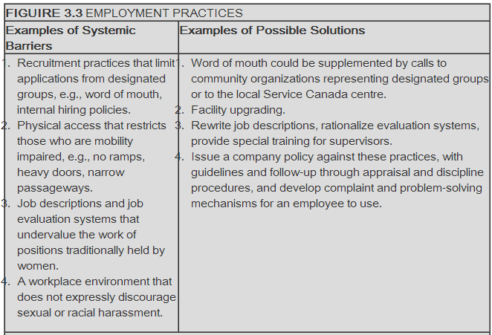
  - Reasonable Accommodation
    - Adjustments in job content and working conditions that an employer may be expected to make in order to accommodate a person protected by human rights provisions.
    - (Attempts by employers to adjust the working conditions or schedules of employees with disabilities or religious preferences.)
  - Employment Equity: Designated Groups
    - Women
    - Visible Minority
    - People with disabilities
    - Aboriginals

- Bona Fide Occupational Requirement/ Qualifications
  - A justified business reason for discriminating against a member of a protected class based on business reasons of safety or effectiveness.

- What is Sexual Harassment?
- The Federal government’s Equal Employment Opportunity Commission’s guidelines define sexual harassment as:
  - “Unwelcome sexual advances, request for sexual favors, and other physical and verbal contact of a sexual nature when it affects the terms of employment under one or more of the following conditions: such an activity is a condition for employment such an activity is a condition of employment consequences such as promotions, dismissal, or salary increase; such an activity creates a hostile working environment.”

- 1. Explain the reasons for equity legislations
  - Employment equity refers to the employment of individuals in a fair and nonbiased matter.
  - Four groups in Canada- women, visible minorities, Aboriginals people, and persons with disabilities- tend to be concentrated in a few occupations that are accorded lower status and pay.

- 2. Identify the legal framework, including the charter and human rights legislation
  - The Canadian Human Rights Act applies to all federally governed departments and agencies and all organizations incorporated under federal jurisdiction.
  - The act prohibits discrimination on the basis of groups such as race, religion, sex, age, national or ethic origin, physical handicap, and marital status.
  - The charter of Rights and Freedom guarantees some fundamental rights every Canadian, including freedom from discrimination.
  - The Canadian Human Rights Commission (CHRC) enforce the act through a formal complaint procedure.

- 3. Describe pay equity and strategies to implementing it
  - Pay equity is an amendment to the Canadian Human Rights Act that makes it illegal for employers to discriminate against individuals on the basis of job content.
  - By definition pay equity means equal pay for work of equal value.

- 4. Discuss the Employee Equity Act with respect to its origins, its purpose, and its continued enforcements
  - The Employment Equity Act requires all federally regulated employers to prepare an employment equity plan that identifies areas in which members are the designated groups are over- or underrepresented and established plans to promote an equitable workplace.

- 5. Describe how employment equity is implemented in organizations
  - The implementation of employment equity involves six steps:
- Senior Management Support
- Data Collection and Analysis
- An Employment Systems Review
- Establishment of a Work plan
- Implementation
- Follow up Process (includes monitoring, reviewing and revision)

- 6. Discuss sexual harassment as an employment equity issue
  - Sexual harassment is an employment equity issue undergoing continued debate.

- 7. Explain and give examples of diversity management
  - Managing diversity does more than incorporate employment equity.
  - The goal of diversity management is to optimize the utilization of an organization’s multicultural workforce with the goals of realizing strategic advantage.

- Does anything surprise you about the case?
- - It was in 1993, which was not very long ago
- If you were Denny’s would you admit guilt? Why or Why not?
- Admit it because it was wrong, and it was too obvious to fighting to be innocent.
- Potential law suits

- As a consultant, what would you recommend Denny’s do in the short term and long term?
- Having someone accountable
- Increase Public Relation
- Hiring new diverse staff
- Advertising can be more diverse in people
- Sensibility training
- Public apology (ASAP)- the CEO+ Staff (team apology instead of a single apology)
- Review Hiring Policies
- Audit

- - Denny’s chose to acknowledge that they had a serious problem. Through a series of diversity initiatives to ensure the company’s survivals to change the public’s perception.
- - Provided intensive diversity training to all employees, starting with front line employees.
- - Fired people who refused to participate in training programs.
- - Trained new recruits before being allowed to assume their position.
- - Featured African-American and other minorities in their advertising.
- -Set up a customer complaint hotline and investigation procedure.
- - Hired a Chief of Diversity
- - Retained an African-American to the board of directors
- - Donated over million dollars to civil rights associations and organizations.
- - Extended diversity initiatives to customers as well.

Job Design; The Process of systematically organizing work into task required to perform a job.
  - An outgrowth of job analysis that improves jobs through technological and human considerations to enhance organization efficiency and employee job satisfaction.

- Job Design Considerations
  - Job Specialization (Industrial Engineering)
    - Work Implications
    - A field of study concerned with analyzing work methods and establishing time standards.
  - Behavioral Aspects
    - Job enlargement, job ration, job enrichment, team based job design.
  - Ergonomic Aspects
    - Psychical needs of workers
    - An interdisciplinary approach to designing equipment and systems that can be easily and efficiently used by human beings.
  - Increasing Job Flexibility
    - Compressed workweeks (4 days a week, longer hours)
    - Flextime (Start at different times, example 10-6 instead of 9-5)
    - job-sharing (Two part time jobs instead of one full time)
    - telecommuting (Working from home)

- Motivating Potential Score (MPS)
  - Job Enrichment involves increasing the motivating potential of jobs
  - MPS=Variety+Identity+Significance X Autonomy X Feedback

Skill Task Task

3

- The Nature of Job Analysis
  - Procedure of determining tasks, duties, and responsibilities of each job and the human attributes (knowledge, skills, abilities, others- KSAO) required to perform it.

- Job Analysis Tool
  - Position Analysis Questionnaire (PAQ)
    - Very structured job analysis questionnaire which contains 194 items.
  - Competency Based
    - Describing a job in terms of the measurable, observerable behavioral competencies an employee must exhibit to do a job well, instead of a list of specific duties.

Job Description VS. Specifications

Job Description is a list of the tasks, duties, and responsibly that a particular job entails. Focuses on activities.
  - A format of job descriptions varies widely often reflecting the needs of the organization and the expertise of the writer.
  - At a minimum, job descriptions should contain a job title, a job section, and a job duties, or essential functions, section.
  - A job specification may also be included.
  - Job descriptions should be written in clear and specific terms with considerations given to their legal implications.

Job Specifications is a list of competencies that an individual must have to perform a particular task. Focuses of KSAOs required to do the job.

- Technique Questions

How does one conduct a job analysis? (the steps)

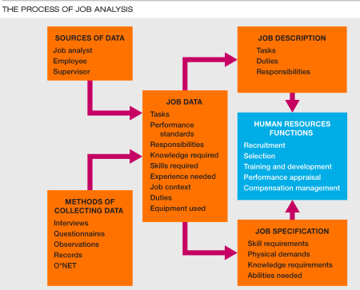
  - Job analysis data may be gathered using several collection methods;
    - Interviews
    - Questionaries’
    - Observations
    - Diaries
  - More Quantities approaches include;
    - PAQ system
      - A questionnaire covering 194 different task that, by means of a 5-point scale, seeks to determine the degree to which different tasks are involved in performing a particular job.
    - Critical Incident Method
      - A job analysis method by which important job task are identified for job success.
    - Task Inventory Analysis
      - An organization-specific list of task and their descriptions used as a basis to identify components of jobs.
    - Competency-Based Analysis

  - It is the prevailing opinion of the courts that HRM decisions on employment, performance appraisals, and promotions must be based on specific criteria that are job related.
  - Theses criteria can be determined objectively only my analyzing the requirements of each job.

- How does one “design” or “redesign” a job? (the considerations needed to be taken into account)
- 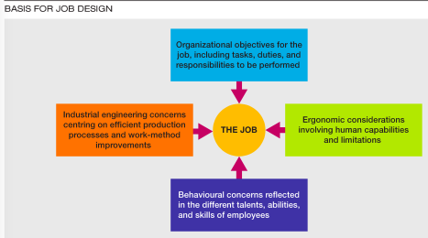
  - Job design is a combination of 4 basic organizational considerations;

1. Industrial Engineering Concerns of Analyzing Work Methods

2. Establishing Time Standards
    - 3. Ergonomics Considerations;
      - which accommodates human capabilities and limitations to job task

4. Employee Contributions.

  - The process of searching out and attracting qualified job applicants which begins with the identification of a position that requires staffing and is completed when applications are received from an adequate number of applicants.

- The Recruitment Process

- Recruiting Within the Organization (Internal): Advantages
  - Employees see that competence is rewarded thus enhancing commitment, morale and performance
  - Insiders are less likely to leave
  - More accurate assessment of person’s skills and performance level
  - Inside candidates require less orientation

- Recruiting Within the Organization (Internal): Disadvantages
  - Discontent of unsuccessful candidates.
  - Time consuming to post and interview all candidates if one is already preferred
  - Employees dissatisfaction with insider as new boss
  - Possibility of “inbreeding”

- Recruiting Outside the Organization (External): Advantages
  - Larger pool of qualified candidates
  - More diverse applicant pool
  - Acquisition of skills or knowledge not currently available within the organization
  - Elimination of employee rivalry and competition
  - Cost savings resulting from hiring individuals who already have the skills, rather than providing training

- Recruiting Outside the Organization (External): Disadvantages
  - Unknown entities
  - Resentment from current staff
  - Selection process costly
  - Takes time to “learn the ropes”

- Formal Definition
  - A job interview is a process in which a potential employee is evaluated by an employer for prospective employment in their company or organization. During this process, the employer hopes to determine whether or not the applicant is suitable for the role.

- Securing the Interview
- Reflect on your personal brand
  - Branding; The marketing practice of creating a name or an image that identifies and differentiates a product from other products
  - In this case the product is you!
    - What benefits do you offer?
    - What qualities do you want your audience to associate with you?
    - Who are you?
    - Why are you different?
    - What is your “brand promise”?
    - Why should an employer choose you?
  - You need to be able to identify and eventually articulate how you meet the employer’s needs.

- Creating a solid marketing package
  - A winning resume and cover letter
    - Attend workshops/ use online resources
  - A professional online presence
    - LinkedIn, Twitter, Website, blogs, etc..

- Use active job search techniques
  - Join student and professional association
  - Attend multiple networking events
  - Set up information meetings
  - Use social media
  - Volunteer

- The Preparation Process
  - Research the company
    - Mandate/focus/services/clients/news
  - Understand the job you are applying for
    - Key responsibilities/qualifications/traits
  - Know yourself and what you have to offer
    - Reflect on your skills and experience
  - Review you resume and know its content
    - Be prepared to elaborate and provide examples
  - Anticipate questions and practice answers
    - Family, friends, Career Centre: Practice Interview
  - Prepare any documentations you want to bring
    - Portfolio, letters of reference, transcripts, projects
  - Plan your route/map out your day
    - Directions, timeframe, leave room for error/ traffic
  - Give yourself a pep talk.

- Interview Etiquette
  - Listen carefully, ask questions and take time to reflect when needed.
  - Be cool and confident without coming across as being arrogant
  - Don’t bring up salary, benefits or holidays at the first interview
  - Thanks the interviewer for their time.

- Types of Interview Questions
  - Traditional/General
    - Getting to know you questions, icebreakers, understanding your personality questions.
    - Success depends on your responses as well as on the report you build with the interviewer.
  - Behavioral
    - Based on the premise that past behavior is the nest predictor of future behavior
    - Success depends on the relevance of the example you choose and you ability to clear describe the;
      - Situation
      - Task
      - Action
      - Result
        - Provide a STAR answer!
  - Situational
    - The interviewer gives you a hypothetical situation and ask how you would react
    - Success depends on the appropriateness of your anticipated actions (in connection with company values) and on your ability to articulate your thought process and you problem solving skills
    - You can draw parallels from your past experiences

- Types of Interviews
  - Phone Interview Tips
    - Keep paper and pens, a copy of your resume, and a list of the jobs you have recently applied for near the phone.
    - Be conscious of your tone of voice and try to avoid long pauses (let them know if you need a minute to think- remember they can’t see you)
  - Skype Interview Tips
    - Dress professionally and prepare your surroundings, as employers will be paying attention to the details that are available.
    - Practice the process with someone in advance
    - Use active listening cues in your conversation
    - Address technical problems immediately
  - Panel Interview Tops
    - Focus primarily on the person who asked you the question; however, you also need to make eye contact with the other interviewers.
    - Try not to be intimidated by the number of people (this is probably their way of speeding up the process)
  - Group Interview Tips
    - Try to stand out from the crowd without stealing the spotlight and over powering the group
    - Be conscious of how you are interacting with the other members of the group
  - Stress Interview Tips
    - Try to stay focused and calm (they want to see how you react under pressure)
  - Case Interviews
    - The employer wants to see how you approach a problem and how you break down a complex situation into logical components
    - There are be more than one answer to the case
    - Your objective is to demonstrate an understanding of the main issue, to structure your thinking effectively, to use data and calculations appropriately, and to communicate you recommendations clearly.

- Tips for Making a Good Impression
  - Your interview actually starts before you meet
  - Be prepared: practice out loud beforehand
  - Be yourself/natural; talking vs. scripting
  - Stay focused, take your time, avoid umm…
  - Try to use different examples
  - Be confident and enthusiastic

- Final Steps
  - Ask about “next steps” or “the process” at the end of your interview
  - Thank the interviewers and ask for their cards
  - Send a follow-up thank you letter (24-48 hours)
  - Be patient; however, keep track of where you are in the process.
  - Reflect on how you did/ areas to improve

- Chapter 1- The World of HRM
  - 7 Competitive Challenges and HRM (p. 5-25)

- Changes in the marketplace and economy
- Globalization
- Corporate Social Responsibility and Sustainability
- Technology
- Containing Cost while Maintaining Productivity
- Demographic changes
- Educational and Cultural shifts

- Chapter 2- Strategy and HRP
  - Figure 2.4 Model of HR Forecasting
    - Forecasting Demand
    - Forecasting Supply
    - Balancing Supply and Demand

- Chapter 3- Equity and Diversity in HRM
  - Make sure you understand the key terms in the presentation. For example;
    - Protected groups
    - Designated groups
    - Adverse impact
    - Systematic Discrimination
    - Prima Facie
    - Reasonable Accommodation
    - Bona Fide Occupational Qualification (or Requirement)
    - Employment Equity

- Chapter 4- Job Analysis and Work Design
  - Understand the difference between job analysis and job (work) design
  - Understand the difference between a job specification and job description
  - Technique Questions
    - How does one conduct a job analysis? (the steps)
    - How does one “design” or “redesign” a job? (the considerations needed to be taken into account)

- Chapter 5- Recruitment
  - Be able to discuss the different types of interviews and interview formats (see Marion Lajoie’s presentation)
  - See PowerPoint slides for recruitment

In General…
  - Only answer what is asked…more is often less
  - Make sure you answer all parts of the question
  - Look at the way points are allocated- this often gives you a clue as to what answers are expected
  - Remember that the grader will be grading 200 exams—make his job easy.
- Overview of the Selection Process
  - Selection
    - The process of choosing individuals who have relevant qualifications to fill existing or projected job openings
  - Selection Considerations
    - Person-job fit
    - Person-organization fit

- Begin with a Job Analysis
  - Results of a job analysis:
    - Job Description
    - Job Specifications

- Must accurately measure KSAOs

- Reliability and Validity ***( on midterm #2)
  - Reliability
    - The extent to which a measurement generates consistent results i.e. free from random error.
  - Validity
    - The extent to which performance on a measure (e.g. test score) is related to what the measure is designed to assess (such as job performance)

- Often uses correlation coefficients.

- Measuring Validity***
- 1. Criterion-Related Validity
  - Substantial correlation between test scores and job performance scores
    - Predictive validation; if I hire you today in the future I will look at the test you took 5 years ago and compare it to your current job performance.
    - Concurrent validation; good workers should have good test scores and vise versa, test is taken and compare when given at that time.

- 2. Content Validity
  - Consistency between the test items and situations that occur on-the-job

3. Construct Validity
  - Establishing that test measure intelligence, leadership, or other such constructs, and NOT something else.

- Bulls Eye methods
- Unreliable
- Invalid
- (hitting everywhere else but the bulls eye and outside the target, therefore invalid)

- Reliable
- Invalid
- (Focusing on one part of the target only and not the bulls eye therefore still invalid)

- Reliable
- Valid
- (Hitting the bulls eye on the target therefore valid.)

- Selection Tools
  - Some tools are better than others (IQ Test is better than an Personality Test)
  - Some tools cost more than others (Assessment Centers)
  - The more tools you have, the better the decision.

Validity

Tools

  - Each tool adds some value

- Background Information
- - Resumes and Job Applications
- - Biographical Information Blanks or Bio data
  - how much did you enjoy high school?
  - if you were to go through university again, what major would you choose?
  - when you have a problem on your job, to whom do you turn for assistance?
  - how many jobs have you held in the past five years?
  - how would you describe your life at home while growing up?

- Employee Tests
  - Cognitive Ability Test
    - “g” general mental ability
  - Physical Ability Test
  - Personality Test
  - Job Knowledge Test
    - Asking HOW the job should be done
  - Work Sample Test
    - Asking candidates to do the job.

- Honesty (Integrity) Tests
- Overt Test Questions
- 1. What % of people take more than $5.00/week (in cash and supplies) from their employers?
- 2. Do you think most people would cheat if they get away with it?

- Veiled Purpose Questions
- 1. Are you more sensible than adventurous?

2. Do you almost always make your bed?

3. How often do you blush?

Beating a Lie Detector Test
  - Prepare, study, and anticipate questions
  - Do math in your head
  - Thinking about something exciting or frightening
  - Bite you tongue
  - Insert a small tack in your show

- Hand Writing Test
  - Judging a type of person based on their hand writing.

- Emotional Intelligence Test
  - An individual’s ability to be self aware, detect emotions in others and manage emotional cues and information.

