Econ 330 January Midterm Prep

One Period Model

Production Possibility Frontier
- Define: A curve depicting all maximum output possibilities for two or more goods given a set of inputs (resources, labor, etc.). The PPF assumes that all inputs are used efficiently.
- As indicated on the chart below, points A, B and C represent the points at which production of Good A and Good B is most efficient. Point X demonstrates the point at which resources are not being used efficiently in the production of both goods; point Y demonstrates an output that is not attainable with the given inputs.
- Among others, factors such as labor, capital and technology will affect where the production possibility frontier lies. The PPF is also known as the production possibility or transformation curve.
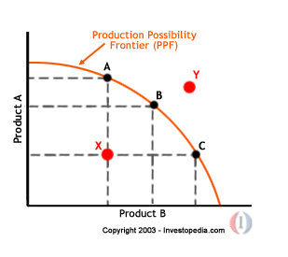

Competitive Equilibrium
- Define: An equilibrium condition where the interaction of profit-maximizing producers and utility-maximizing consumers in competitive markets with freely determined prices will give rise to an equilibrium price. At this equilibrium price, the quantity supplied is equal to the quantity demanded.
- While the basic supply and demand model is based on individual consumer and firm behavior, the competitive equilibrium model is based on the behavior of aggregate consumers and firms in competitive markets. It can be used to predict the equilibrium price and total quantity in the market, as well as the quantity consumed by each individual and output per firm.
- Equation: ?????????

Pareto Optimality
- Define Pareto Optimality
- Characterize the solution to the planners problem
- Why do we analyze the problem of a fictitious planner

Laffer Curve
- Show the curve
- Explain how you can find two tax rates (low and high)
- Show the equilibrium
- Explain the economic intuition and how this affects policy decisions

Search and Unemployment

Matching Function
- Using the CRS property of the matching fiunction, express the job finding probability in terms of labour market tightness

Labour market tightness
- Define
- Explain relationship between firms probability of finding a worker and the market tightness

Wage
- Define how it is determined
- Explain how you define the equilibrium

Growth Models

Malthusian Model
- Explain two steady state equations
- What happens in the long run with factor productivity increases?

Solow Model
- From a numerical model, determine: (In the steady state)
  - Capital per worker
  - Income per capita
  - Consumption per capita
- And again, determine when [s] changes
- Plot as a function of the 3 savings rate and comment on it

