Contents
1.1 What is Health? 4
Paradigms of Health 4
The Reductionist Pathway 4
The Holistic Pathway 4
1.2 Definition of Health, Wellness, Illness, and Disease 5
Dimensions of Health 5
Preventing Illness 6
Sex Differences 6
Improving your Health 6
Health Promotion: Helping You Stay Healthy 7
Quality and Length of Life 7
Are Canadians Healthier Now? 7
1.3 Population Health Models 8
Social Ecology Theory 8
The CIAR Model (Evans and Stoddard)* 8
Lalonde Model* 9
Layered Influences on Health (Dahlgren and Whitehead)* 9
Hamilton and Bhatti Integrated Framework for Population Health Promotion 10
The University of Ottawa Population Health Institute Model 10
Etches Model 11
2.1 Chronic Diseases 11
Cardiovascular Disease (CVD) 11
Types of CVD 11
Controlling Your Risks for CVD 12
Surgery and Medications for HD 13
Cancer 13
Incidence and Mortality 13
What Causes Cancer? 14
Risks for Cancer 14
Types of Cancer 14
Facing Cancer 15
Diabetes 15
2.2 Infectious and Non-infectious Diseases 16
Risk Factors 17
Types of Pathogens 17
Pathogen Route of Invasion 17
Host Defences 17
Vaccinations 18
Acquired Immune Deficiency Syndrome (AIDS) 18
How HIV is transmitted 18
Symptoms 18
Non-infectious Diseases 18
Respiratory Disorders 18
Neurological Disorders 19
Sex-related disorders 19
Digestion-Related Disorders 19
Musculoskeletal Diseases 20
Other Maladies 21
2.3 The Aging Process 21
Age-Related Characteristics 21
What is Normal Aging? 21
Theories on Aging 21
Health Challenges of Older Canadians 21
The Process of Dying 22
Social Death 22
Near-death experiences 22
Coping with loss 22
What is “Normal” Grief? 22
Quasi-Death Experiences 23
Life and Death Decision Making 23
2.4 Nutrition 23
Canada’s Food Guide 23
The Digestive Process 23
Caloric Values of Energy Nutrients 24
Obtaining Essential Nutrients 24
Sexual Differences in Nutritional Needs 25
Vegetarianism 25
Eating Well as a Student 25
Food Safety Concerns 26

Module 1: The Science of Health

1.1 What is Health?
Health is often related to physical well-being and states of disease-free living however, there is a wide array of factors that lead to positive health status.

Paradigms of Health
There are two different types of paradigms of health: reductionism and holism. The path to wellbeing is achieve though both paradigms of health.

The Reductionist Pathway
- The breakdown of an entity to its most fundamental parts or systems
  - Macroscopic to microscopic
  - E.g. neurology, microbiology, immunology, pathology, physiology
- Rationale: understanding these mechanisms will allow us to heal the body when one or more of these systems deviate from the norm (disease or illness in the body)
  - Evidence in biotechnology, advanced surgical methods, pharmaceutical intervention
  - Tertiary health
  - Invasive – works on a specific system
  - Deals with the symptoms – but what about the origins of the disease?
- The Challenge: the individual loses the sense of having autonomy of their body and well-being

The Holistic Pathway
- Holism entails the synthesis of the entire entity, including the environment in which it interacts
  - Microscopic to macroscopic
- Treatment of illness and diseases – unified approach
  - Nutrients, human movement, recover and regeneration, cognitive and emotional balance
    - Naturopathic medicine
    - Practical and non-invasive (affects many systems at once)
    - Primary health – focus on prevention
- Rationale: Synergy – health is created through the harmony of all systems
- The Challenge: many variables in question, therefore research on the paradigm is difficult
Parallel Pathways
- The path towards health is achieve through both paradigms of health.
- Holistic health focuses on the balance of basic tenants of living

  - Healthy diet
  - Exercise
  - Sleep
  - Meaningful service
  - Enjoyment
  - Stress management

- Biomedical intervention should be used when severe life-threatening illness and disease need to be treated immediately
  - Should be used in conjunction with holistic approach to health

1.2 Definition of Health, Wellness, Illness, and Disease
The World Health Organization (WHO) has defined health as the complete physical, mental, social well-being, not merely the absence of disease or infirmity.
Health and well-being is manifested through both length and quality of life. The focus of health and wellness is on personal attitudes and behaviours to achieve optimal well-being within a realistic framework of the individual potential with a continuum between illness and wellbeing.
Wellness – an active process of becoming aware of and making choices towards a healthy and fulfilling life. Achieving high level in each dimension of life
Illness – experience and perception of disease within sociocultural context
Disease – biological and/or physiological malfunctioning
The health and wellness continuum includes:

- Social health
- Intellectual health
- Emotional health
- Occupational health
- Environmental health
- Spiritual health
- Physical health

An important factor to remember is that adaptability or the ability to successfully cope is also important in measuring one’s health (Rene Dubos).

Dimensions of Health
Physical Health
- Includes physical characteristics
  - Body size and shape
  - Sensory acuity
  - Susceptibility to disease
  - Body functioning
  - Recuperative ability
- Ability to perform functions of daily living
- Need for PA, adequate diet and sleep, lowered alcohol consumption, no smoking, and good health care
Social Health
- Capacity for satisfying interpersonal relationships
- Communication skills
- Ability to adapt to various social situations
Intellectual Health
- The ability to think clearly, reason objectively, analyze critically
- Learning from successes and failures
- Making responsible decisions
Occupational Health
- Satisfaction a person gets from his or her career or stage of career development
- Involves maintaining and attaining a satisfying balance between work and leisure
Emotional Health
- Level of self-efficacy, self-esteem, self-confidence, trust, and love
- The ability to effectively and appropriately express feelings
Environmental Health
- Appreciation of external environment and the role individuals play in maintaining, preserving, protecting, and improving it
Spiritual Health
- Meaning, purpose, transcendence, connectedness, and energy
- May or may not include a supreme being or specified way of living by a particular religion

Preventing Illness
There are three levels of prevention: 1º, 2º, and 3º.
- Primary prevention is designed to stop health problems before they start.
  - Using sunblock
- Secondary prevention includes taking action to intervene early in the development of a health problem to reduce symptoms or halt its progression
  - Investigating a change in a mole
- Tertiary prevention is treatment or rehabilitation efforts aimed at limiting the effects of the disease
  - Cancer treatment

Sex Differences
Although women make up roughly half the population, a limiting factor to optimal health for women is the sex biases in medical research. These sex biases arise from androcentricity, overgeneralization, sex insensitivity, and double standards. In addition, researchers must take into account the menstrual cycles of research participants.

Improving your Health
First and foremost many state that we should eat properly, have adequate amounts of rest, and exercise in order to improve health. However, it was established that health transcends the physical to the emotional, spiritual, occupational, environmental, intellectual, and social wellbeing. Despite this, diseases of the heart and malignant neoplasms are amongst the leading causes of death in Canada helping us establish the importance of proper nutrition and exercise.
Each of us must work on focusing on our positive attributes whenever possible, changing the negative aspects, and learning to recognize and manage aspects we cannot change. Emphasis is placed on integrating the mind, body, and spirit to achieve optimal health for the holistic approach of health.
Benefits of achieving optimal health include

- Improved health status and longer life
- Improved quality of life
- Greater energy levels
- Stronger immune system
- Improved self-confidence
- Enhanced relationships
- Improved ability to control stress
- Reduced reliance on health-care system
- Improved CV system
- Increased fitness
- More positive look on life
- Improved environmental sensitivity
- Enhanced levels of spiritual health

Health Promotion: Helping You Stay Healthy
Health promotion refers to all efforts made to encourage healthy behaviours with the goal of improving health of an individual or population (WHO). In order to achieve this we require educational, organizational, environmental, political and financial support to health build positive attitudes and behaviours and to change negative ones.

Quality and Length of Life
Health and overall well-being is manifested through both quality and quantity of life. Mortality statistics measure the number of years a person lives. Another consideration is how a person lives those years.
The trend is moving upwards. In the Roman Empire the average life expectancy was 25 years and in the 20th century the life expectancy was 50. Today the life expectancy in Canada is 81 years on average.

Are Canadians Healthier Now?
Instead of being constantly ill Canadians live most of their lives relatively healthily. However there is an increase in diseases such as heart disease and stroke, as well as, cancer.
It is true that people are living longer but many are living with degenerative diseases. Life span has increased but quality of life is low as we reach older age.
Aside:
How much sleep do you really need?
Age | Sleep Needs
Newborns (0 – 2 months) | 12- 18 hours
Infants (3 to 11 months) | 14 to 15 hours
Toddlers (1 – 3 years) | 12 to 14 hours
Preschoolers (3 -5 years) | 11 to 13 hours
School-age children (5 to 10 years) | 10 to 11 hours
Teens (10 – 17) | 8.5 to 9.25 hours
Adults | 7 to 9 hours

1.3 Population Health Models
Health is a state of complete physical, mental, and social well-being and not the mere absence of disease or infirmity
Population health is an approach to health that aims to improve the health of the entire population and to reduce health inequities among population groups
Health inequity are the avoidable inequalities in health between groups of people within countries and between countries
Social determinants of health – born, grow up, live, work, and age and the systems put in place to deal with illness

Social Ecology Theory
- Assumes that appropriate changes in the social environment will produce changes in the individual
- SET shows that multiple levels of influence are important for understanding tobacco initiation and interventions to prevent uptake and the development of dependency
- Recognised micro and macro-level factors that operate in a synergistic fashion at the level of individuals, groups, organizations, communities, and populations
- Accommodates factors that influence individuals through the socio-physical environment

The CIAR Model (Evans and Stoddard)*
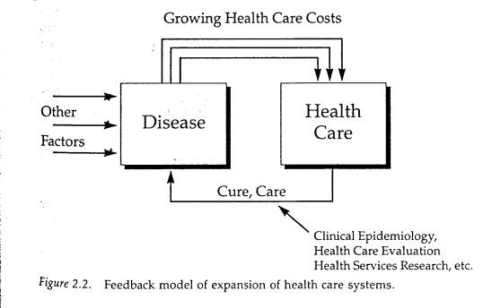

Lalonde Model*
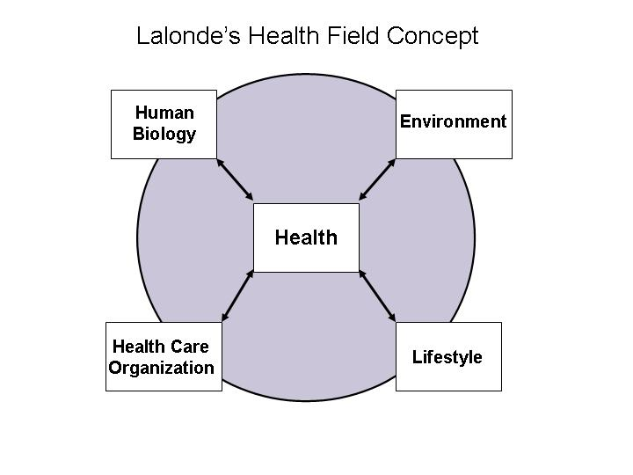

Layered Influences on Health (Dahlgren and Whitehead)*
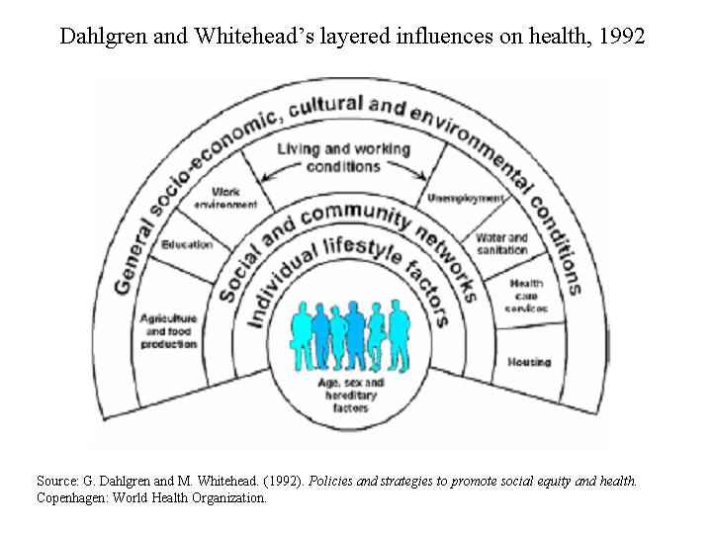

Hamilton and Bhatti Integrated Framework for Population Health Promotion
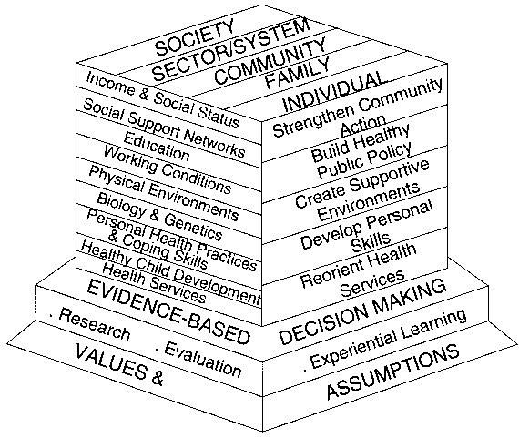

The University of Ottawa Population Health Institute Model
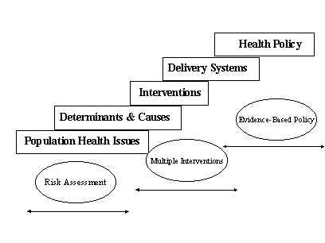

Etches Model
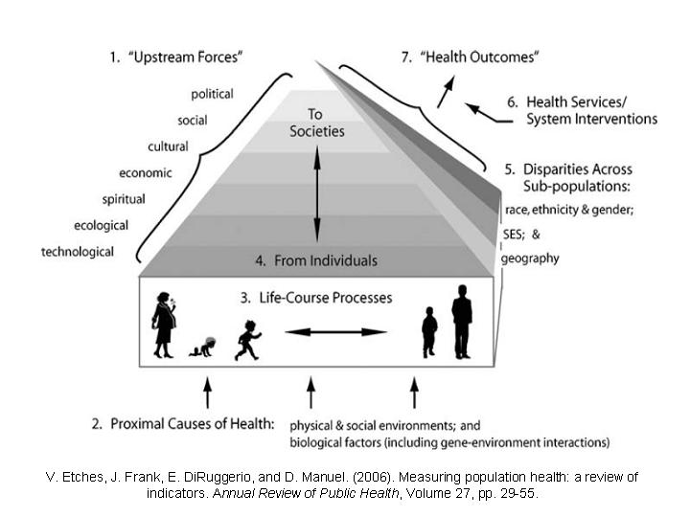

Module 2: Biological and Genetic Determinants

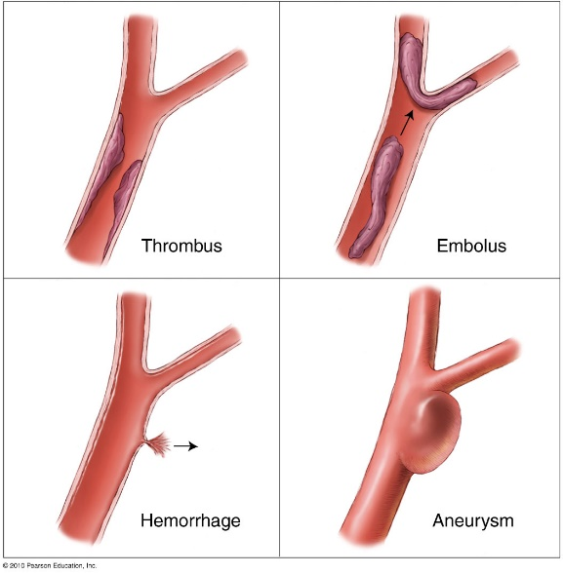
2.1 Chronic Diseases

Cardiovascular Disease (CVD)
- Leading cause of death WW
- 80% of premature deaths prevented through
  - Healthy dietary intake
  - Physical activity
  - Avoiding tobacco
  - Maintaining weight

Types of CVD
- Atherosclerosis
  - Type of arteriosclerosis – narrowed, hardened arteries
  - Plaque lines the arteries
    - Partial or total block
  - Affected by
    - Fluctuations in blood pressure
    - Elevated blood cholesterol, TG, and glucose
    - Smoking
- CHD
  - Coronary thrombosis – blood flow impeded
  - Collateral circulation – damaged heart may heal
  - Ischemia – insufficient blood flow, decreased oxygen
  - Angina pectoris – severe chest pain from reduced O2
  - Myocardial infarction (MI) – heart attack
- Stroke
  - Blood to brain severely reduced or cut-off
  - Causes of stroke
    - Thrombus
    - Embolus
    - Aneurysm
  - Transient Ischemic attack
- Hypertension
  - Risk factor for CHD and stroke
  - 140/90 mmHg or higher
  - Essential or secondary HT
- Arrhythmia – irregular heart beat
- Congestive Heart Failure – damaged and overworked heart
- Congenital heart disease
- Rheumatic heart disease – strep infection

Controlling Your Risks for CVD
- Controllable risks  - Blood pressure  - Fat and cholesterol levels in blood  - Smoking  - Physical inactivity  - Obesity  - Diabetes  - Individual response to stress | - Uncontrollable risks  - Heredity  - Sex  - Age  - Ethnicity

Women and CVD
- Premenopausal women – unlikely except with RF

  - Diabetes
  - High BP
  - Kidney disease
  - Genetic predisposition to high cholesterol
  - Family history
  - Oral contraceptive use
  - Smoking

- Postmenopausal – risks increase rapidly

Recognizing HD in women
Symptoms  - Chest discomfort rather than pain  - Pain in neck, jaw, or arms  - Heaviness in shoulders, back, stomach  - Out of breath, tired, sweating, nausea | Reasons symptoms may be overlooked  - Symptoms are more vague  - Sex-bias in health care delivery  - Women decline procedures > men  - Less aggressive treatment after heart attack  - Older age

Surgery and Medications for HD
- Angioplasty vs. Bypass
  - Bypass – invasive treatment – move around arteries
  - Angioplasty – fewer risks but may need repeating – balloon to make artery bigger
  - Drugs – beta blockers, calcium channel blockers, cholesterol-lowering medications, aspirin
- Thrombolysis
  - Injection – dissolves clots and restores blood flow

Cancer
Cancer is an uncontrolled growth or spread of abnormal cells. When cells malfunction during the replication phase malignant and benign tumors can arise. Malignant tumors have the ability to metastasize (spread from one place to another) thus affecting more organs. They also continue to divide to no end without treatment. Benign tumours eventually stop growing and only pose a problem if they are blocking arteries or in a major organ. Doctors can biopsy tissues to see if there are any abnormalities.

Incidence and Mortality
- 186 400 new cases in Canada
- 24% women and 29% men
- Mortality declining for all under the age of 70
- Lung cancer – leading cause of death among cancers
- Influence – age, sex, ethnicity, socioeconomics, lifestyle
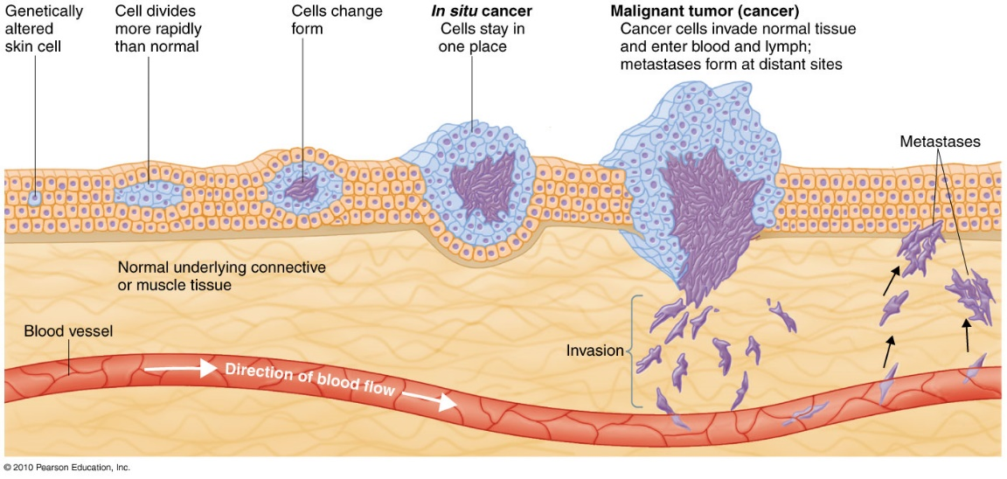

What Causes Cancer?
The majority of cancers are preventable through lifestyle and environment. External factors that cause cancer include tobacco, chemicals, radiation, or infection. Internal factors include inherited mutations (oncogenes), hormones, immune conditions, and mutations that occur from metabolism. These causal factors may act in sequence or together to initiate or promote carcinogenesis.
Cancer is treated by surgery, radiation, chemotherapy, hormones, and immunotherapy.

Risks for Cancer
- Lifestyle
  - Most of those who suffer from cancer are above 55
  - Smoking – leading cause of preventable death (WW 1 in 5 deaths)
  - Diet
  - Exercise
- Obesity – risk increases as BMI increases
- Biological factors
  - Genetic predisposition (oncogenes)
- Environmental and occupational factors
  - Workplace carcinogens
- Social and psychological factors
  - Negative emotions, stress, poor sleep, poor diet, depression
- Chemicals in food – pesticides and herbicides
- Infectious diseases
  - Chronic inflammation, suppressed immunity, chronic stimulation
  - HBV, HCV -> liver cancer
  - HPV -> cervical cancer
- Medical factors
  - HRT (estrogen)
  - Chemotherapy – increase risk of certain cancers

Types of Cancer
- Carcinomas – epithelial tissues
  - Breast, lung, intestines, skin, mouth
- Sarcomas – mesodermal layer tissues
  - Bones, muscles, and CT
  - Lymphomas
  - Leukemia
- Lung Cancer (most prominent cancer)
  - Symptoms: persistent cough, chest pain, recurrent pneumonia or bronchitis
  - Only 15% live 5 years beyond diagnosis
  - Prevention
    - Avoid exposure to smoke, industrial substances, radiation
    - 90% avoided by not smoking
- Breast Cancer
  - 1 in 9 women; risk increases with age
  - Warning signs: persistent breast changes
    - Lumps, thickening, swelling, changed shape or size, redness
  - Prevention
    - PA, regular self-examination, mammography
  - Treatment
    - Mastectomies, lumpectomy, chemotherapy, radiation
- Colorectal Cancer
  - Warning: bloody rectum, stool, bowel changes
  - Higher risk: people over 40 with family history
    - Inflammatory bowel problems
- Prostate cancer
  - Most common in men; risk increases with age
  - Warning: weak, interrupted urine flow
- Skin Cancer
  - Most do not die
  - Malignant melanoma = major killer of young women
  - Linked to sun exposure
  - Symptoms: unusual skin conditions, ABCDE warning signs of melanoma

Facing Cancer
Cancer’s 7 Warning Signals

- Changes in bowel or bladder habits
- A sore that does not heal
- Unusual bleeding
- Lump in breast or elsewhere
- Indigestion or difficulty swallowing
- Distinct change in mole or wart
- Nagging couch or hoarseness

New Hope in Cancer Treatments
- Surgical removal of tumours
- Radiation
- Chemotherapy
- Attention: psychological needs of patients and families
Life after Cancer
- Heightened public awareness and improved prognosis
- Less threat and isolation
- Assistance is more readily available
- Research improvements

Diabetes
T1DM – insulin dependent and autoimmune disease
T1DM – non-insulin dependent, 90% of all cases
Gestational D – during pregnancy, increases risk of developing t2DM within 5-10 yrs of giving birth
May require insulin injections or other medications.

Development of T2DM
- Pancreatic insulin-producing cells overworked
- Overabundance of fa
- Pre-diabetes -> T2DM
  - Plays a role in metabolic syndrome (MetS)
  - Linked to overweight and obesity

Risk Factors
- Non-modifiable
  - Increased age, ethnicity, genetic and biological factors
- Modifiable
  - Body weight, diet, physical activity, sleep
  - Level of stress
  - BMI >25
  - Waistline: 102 cm + males, 89 cm + females

Blood Tests to Diagnose and Monitor Diabetes
- Fasting Plasma Glucose Test (FPG)
  - Overnight fast, blood tested for glucose level
- Oral glucose tolerance test (OGTT)
  - Drink liquid of concentrated glucose
  - Test blood glucose 2 hours later

Complications Associated with Diabetes

- CVD
- Kidney Disease
- Amputations
- Eye disease and blindness
- Flu and pneumonia-related deaths
- Pregnancy complications

Lifestyle Changes to Improve Glucose Levels
- Weight loss – 5-10% of current weight
- Diet – Whole grains, high fibre, fatty fish
- Exercise – 30 min CD, 5 days a week

2.2 Infectious and Non-infectious Diseases
Pathogen – disease-causing agent
Epidemic – disease outbreak in a community Pandemic – global epidemic
- Most diseases are multifactorial
- Conditions for disease to occur:
  - Susceptible host, transmitting agent, hospital environment

Risk Factors
- Non-Modifiable
  - Heredity, aging, environmental conditions
- Modifiable
  - Stress and poor nutrition
  - PA
  - Sleep
  - Hygiene
  - High risk behaviours (sex and drugs)

Types of Pathogens
Bacteria  - Staph and strep  - Pneumonia  - Tb  - Periodontal | Viruses  - MMR  - Chicken pox  - Influenza  - Mononucleosis  - Hepatitis

Pathogen Route of Invasion
- Transmission
  - Direct or indirect contact
  - Autoinoculation
  - Airborne, foodborne, animal-borne, waterborne

Host Defences
- Physical and Chemical
  - Skin; enzymes
  - Slight elevations in body temperature
  - Linings of the body e.g mucous membranes
  - Secretions e.g. tears and saliva
  - Immune system
- Humoral
  - Antibodies made in response to antigens
- Cell-mediated
  - Leukocytes, macrophages, neutrophils
- Fever
  - Destroys some pathogens
  - Stimulates WBC production
- Pain
  - Response to injury – stops action, prevent further injury
  - Direct or referred pain – often accompanied by inflammation

Vaccinations
- Increase immunity
- Inoculation with killed or weakened pathogens
- May contribute to acquired immunity

Acquired Immune Deficiency Syndrome (AIDS)
- Progressed from HIV
- Global health problem
  - >21 million have died of AIDS
  - 57 million infected in Canada
    - With higher rates in black and aboriginal Canadians

How HIV is transmitted
- Engaging in high risk behaviours
- Exchange of bodily fluids
- Receiving blood transfusion prior to 1986
- Injecting drugs
- Mother to infant transmission (perinatal)

Symptoms
- Incubation time varies greatly
- Infants and newborns at high risk
- HIV+ adults develop AIDS within 8-10 years
  - With no treatment

Non-infectious Diseases
- Chronic diseases – pain, suffering, disability
  - Normally do not result in death
- Not transmitted by pathogens or personal contact
- Develops over a long period of time
- Lifestyle and personal health
- Prevention and control to minimize effects

Respiratory Disorders
Allergy Induced Problems
- Body’s defences overreact to harmless antigen
- Ab trigger the release of histamines
  - Dilating vessels, increasing mucous secretions
Hay Fever
- Chronic respiratory disorder to ragweed and flowers
- Sneezing, itchy, watery eyes and nose

Asthma
- Wheezing, shortness of breath, coughing spasms
- Majority children under 10
- Dust, pollen, dander, stress, exercise
Emphysema
- Gradual destruction of alveoli
- Difficulty exhaling and inhaling
- Cause is uncertain; effects irreversible
- Associated with long-term cigarette smoking and air pollution
Chronic Bronchitis
- Smoker’s cough
- Inflamed bronchial tubes
- Symptoms: productive cough and shortness of breath

Neurological Disorders
Headaches
- Tension, migraine, secondary, psychological
Seizure
- Epilepsy
- Grand mal, petit mal, psychomotor, Jacksonian

Sex-related disorders
Fibrocystic Breast Disease
- Common, non-cancerous problem
- Small lump to large masses (tissue)
- Progressively worse with age
Premenstrual Syndrome (PMS)
- Depression, irritability, headaches, cramps
- Hormonal imbalance

Digestion-Related Disorders
Ulcerative Colitis
- Inflammation of the mucous membranes of the colon
- Symptoms: bloody diarrhea, cramps, weight loss, nausea, sweating, fever
- Unknown cause – linked to stress and food
- Treatment – focus on alleviating symptoms
Irritable Bowel Syndrome
- Nausea, pain, gas, diarrhea
- Symptoms vary week to week
- Caused by certain foods or stress
- Stress management and healthy habits
Diverticulosis
- Bulges in the walls of the intestines resulting in irritation and infection
- Bulges may fill with feces
- Bleeding and chronic obstruction may occur
Peptic Ulcers
- Damage to stomach or intestinal lining
- Common cause: bacterial infection
- Treatment: Antibiotics
- More prevalent in the highly stressed
- Associated with high fat foods and excessive alcohol
Gallbladder Disease
- Gallbladder irritated by chemicals, infections, overuse
- Reduced ability to digest fats
- Pain in upper right portion of abdomen after eating fatty foods
- Treatment: medication, altering diet, surgical removal

Musculoskeletal Diseases
Arthritis
- OA
  - progressive deterioration of bone
  - Wear and tear
  - Treatments: anti-inflammatory drugs, joint replacement
- RA
  - Autoimmune disorder
  - Destruction of bony ends of joints
  - More prevalent in women; cause UNK
Fibromyalgia
- Chronic and painful
- Array of symptoms
  - Widespread pain, stiffness, tender points, depression
  - Swelling, coldness, numbness, tingling, headaches
- UNK cause
  - Sleep and stress possible links
Lower back pain
- Risk factors: age, body type, poor posture, psychological and occupational factors
- Prevention
  - Good posture, mattress and shoes, PA, ergonomics

Other Maladies
Chronic Fatigue Syndrome
- Chronic headaches, tiredness, and sore throat
- Psychological roots
Job-related disorders
- Carpal Tunnel – irritation of the median nerve.

2.3 The Aging Process

Age-Related Characteristics
- Biological age
- Psychological age
- Social age
- Legal age and chronological age
- Functional age

What is Normal Aging?
- Definition of old
  - 60-69 = young old
  - 70-79 = middle old
  - 80-89 = old old
- Older people are a product of lifelong experiences
  - Happiness, heartbreak, day to day experiences
- Physical changes
  - Skin, bones, joints, head, UT, heart and lungs, eye sight
  - 6 senses, mobility, sexual changes and body comfort
- Mental changes
  - Intelligence, memory, adaptability, depression, dementia, Alzheimer’s disease

Theories on Aging
- Biologic Theories
  - Wear and tear, cellular, autoimmune, genetic mutation
- Psychosocial theories
  - Progress through critical stages in lifetime
    - Middle to old age = stressful period
  - Develop coping methods early
  - Successful aging – emotional, physical well-being

Health Challenges of Older Canadians
- Alcohol use and abuse
  - 5 x more in men than women
- Prescription drug use
  - Addiction to drugs
- OTC remedies
  - ASA and laxatives
- PA
  - Sarcopenia – decline in muscle tissue mass
  - 150 min of mod intensity exercise each week
- Gender issues
  - Women live longer and more often alone
  - Women have higher comorbidity as a result of living longer
  - Poverty and health problems

The Process of Dying
Coping Emotionally with Death
- Denial
- Anger
- Bargaining
- Depression
- Acceptance

Social Death
- Loss of value, appreciation by other
- Not treated as a member of society
  - Avoided, isolated, and excluded

Near-death experiences
- Three phases
  - Resistance, life review and transcendence

Coping with loss
- Bereavement
- Disenfranchised grief
- Grief
- Mourning

What is “Normal” Grief?
- Responses vary widely, and may include:
  - Distress and tightness in throat
  - Choking, shortness of breath
  - Frequent need to sigh; feeling emptiness
  - Muscular weakness
  - Intense anxiety
- Coping with Grief
  - Grief work – integrating new reality to life
- Model of grieving tasks (Worden)
  - Accept reality of loss
  - Work through the pain of grief
  - Adjust to the new environment
  - Emotionally relocate deceased
- When an infant or child dies
  - Bereaved siblings have difficulty due to lack of coping skills
  - Children not comfortable discussing death
    - Difficulty understanding death
  - Less social support for kids
    - Feeling emotionally abandoned

Quasi-Death Experiences
- Losses that resemble death
  - Child abduction
  - Divorce, loss of romance
  - Job termination or retirement
  - Ending an athletic career
- Involves: separation, termination, loss, changed self-perception

Life and Death Decision Making
- Palliative care
  - Pain, symptom management (facility, in-home)
  - Social, psychological, and spiritual support
  - Dyathanasia – passive “mercy killing”
    - Treatment withheld allowing a person to die
  - Euthanasia – active mercy killing

2.4 Nutrition
Hunger: physiological need to eat
Appetite: psychological desire to eat
Healthy eating – Mediterranean, Asian, and Western focus

Canada’s Food Guide
- For ages 2+
- Age and sex-specific
  - Variety of foods
  - Balanced intake
  - Moderation of caloric intake

The Digestive Process
- Mouth – chew food, saliva, enzymes
- Esophagus – move food to stomach
- Stomach – mix food, add acid and enzymes
- Small intestine – 8 m tube; duodenum, jejunum, ileum
  - Received enzymes from liver and pancreas
  - Receives enzymes from the liver and pancreas
  - Nutrients go into bloodstream
- After absorption liver distributes most nutrients
- Large intestine – processes digestive waste
- Digestive process takes approximately 24 hours

Caloric Values of Energy Nutrients
- CHO – 4 kcal/g
- Fat – 9 kcal/g
- Protein (amino acids) – 4 kcal/g
- Alcohol (ethanol) – 7 kcal/g

Obtaining Essential Nutrients
- Water
  - Dehydration – abnormal depletion of bodily fluids
  - 50-60% of body weight
  - DRI: Males 3 L, Females 2.2 L
- Proteins 4 kcal/g
  - Functions: tissue development and repair
    - Protection, regulation, transportation, and balance
  - Meat, milk and alternatives
  - Composed of aa
  - Complete proteins – contain all essential aa
  - Incomplete proteins
  - Plant sources of protein – IC
    - Legumes
    - Nuts and seeds
    - Grain products
- CHO 9 kcal/g
  - Circulates as glucose in body
  - Simple CHO
    - Fruits, veggies, sugar
    - WHO recommends <10% cal from added sugars
  - Complex CHO
    - Starches: breads, potatoes, beans, grains, cereals
    - Glycogen
      - How the body stores glucose
    - Popular diets
      - Atkins and Zone
- Fibre
  - Aids digestion and decreases risk – cancer, HD, diabetes, obesity
  - DRI : 38 g for men, 25 g women
  - Selected whole grains, fruits and vegetables, legumes
- Fats 9 kcal/g
  - TG, cholesterol, phospholipids
  - Excess consumption increases risk of HD
  - Eat less saturated and trans-fats
    - Animal sources and process foods
  - Eat adequate unsaturated fats
- Vitamins
  - Fat soluble – A, D, E, K
  - Water soluble – B, C
  - Antioxidants – protect against cell and tissue damage
  - Vitamin D
    - Reduce risk of cancer, immune-related diseases
    - Canadians at risk of deficiency
- Minerals
  - Macro-minerals needed in large amounts
  - Trace minerals are needed in small amounts
  - Sodium – regulate blood and bodily fluids
  - Calcium – bone health
    - Carbonated drinks may cause excretion of calcium
    - Vitamin D increases absorption of Ca
    - Milk products, green veggies
  - Iron
    - Anemia causes fatigue

Sexual Differences in Nutritional Needs
- Woman’s need vary e.g. pregnancy, lactation
- Men eating too much meat
  - Increased risk of colorectal and prostate cancer
- Increased fruit and vegetable intakes
  - Decreases risk of lung, esophageal cancer, and stroke

Vegetarianism

- Vegans – risk of vitB12 deficiency
- Lacto-vegetarians (dairy)
- Ovo-vegetarians (eggs)
- Lacto-ovo-vegetarians
- Pesco-vegetarians (seafood, dairy, eggs)
- Semi-vegetarians (poultry, seafood, dairy and eggs)

Eating Well as a Student
- Fast foods
  - Ask for nutrition advice
  - Limit mayo, sauces, and add-ons
  - Order salad and limit dressing
  - Limit fired foods
  - Water not soft drinks
- Nutrition and Health Claims
  - Reduced – at least 25% less
  - Light – reduced fat/calories
- When funds are short
  - Avoid shopping when hungry
  - Coupons and specials and shop at discount food chains
  - Plan ahead and cook large meals and store portions

Food Safety Concerns
- Food borne illness
  - 10 000 reported cases per year
  - Symptoms
    - Cramping, nausea, vomiting, diarrhea
  - Minimizing risk
    - Perishables at end of shopping
    - Clean salad bars; meat and seafood counters
    - Eat meat, seafood, poultry within 1 -2 days
    - Eat leftovers within 3 days
    - Keep appropriate T of food
    - Ensure food is cooked properly
    - Refrigerate cooked food within two hours
    - Thaw food in fridge
    - Clean hands, utensils, when handling foods
    - Contain juices of raw foods
- Food additives
  - Reduce risks of food-borne illness
  - Prevent spoilage
  - Enhance look and taste
  - Enhance nutrient value
- Food allergies
  - Food intolerance may imitate allergy symptoms but does not involve IS
  - Body overreacts to harmless proteins
    - Hives, rash, itchiness, diarrhea, nausea and death
  - Most common allergens
    - Soybeans, legumes, nuts, shellfish, eggs, wheat and milk
- Organic food
  - More expensive but health impacts are unclear
- GMO
  - Enhanced production
  - Improve colour and appearance
Factors to Keep in Mind
- Frequency
- Quantity
- Quality

