Chapter 1-11, 14, 15
Chapters 1-4 - "History and Overview of Macroeconomics"

Economic History
1920s - The roaring twenties left many behind
-Paradigm was the classical model
1930s -The great depression
-Paradigm became the Keynesian model
1940s -WWII
1950s-1960s -The "good old days"
-Unprecedented economic growth and rising living standards
-Paradigm was still the Keynesian model
1970s -Stagnation + inflation = stagflation
-Keynesian paradigm begins to lose favour
1980s -Steep recession followed by strong recovery
1990s -Low inflation and pretty high unemployment until 1995
2000 Return of the "good old days" as far as macroeconomy is concerned
-->"The Great Moderation" with one notable exception
-->The financial sectors of the USA and UK got out of control
2008-2009 -A financial meltdown causes the "great recession"
-->Not as severe in Canada as in the USA
-->Economists are currently trying to develop a more suitable paradigm that hopefully will take into account what occurred
-Macroeconomic theory over the past 90 years has tended to evolve with the actual macroeconomic performance
-->Has led to changes in these models over time, which is not the case for microeconomics
-->Drafting a new paradigm is always a work in progress

Mea Culpa
-In the mid-2000s, financial economists (not all economists) screwed up in the absolute extreme
-While the profession can retrospectively explain the terrible economic phenomena which occurred, it lacks a unified, overarching model of how the macroeconomy works
-Real estate and financial bubbles are extremely dangerous for the macroeconomy

What is Macroeconomics All About?
-It is more or less the same approach as micro, with some of the same concepts, such as an equilibrium and supply or demand pressures
-The scope is quite different however
-This term we study choices or tradeoffs in the Aggregate, such as aggregate employment rather than employment in a certain firm or occupation
-->Deficit reduction in exchange for lower interest rates
-->Lower inflation in exchange for higher interest rates
-In both micro and macro, the analysis is based on a market economy, in which scarce resources (land, labour, and capital) are allocated among alternate uses via Supply and Demand Forces
-->This analytic tool always generates P's and Q's (Equilibrium Price and Quantity

Three Primary Markets of Macroeconomics
1) Output Markets for goods and services
2) Money Markets
3) Employment Markets
-These three markets are inextricably linked, and we will study the relationships between them (a disturbance in one market has repercussions in another)

Output Markets For Goods and Services
-Part of the real economy
-->Consists of concrete, tangible goods and services (as opposed to the money economy)
-Q is GDP
-->Gross domestic product, the $ value of all final goods and services produced over a given interval
-P is the composite price level

Employment Market
-Also part of the real economy
-Q is employment
-->Unemployment rate is one measure of employment conditions
-P is the wage level
-->Wage inflation rate measures the change in the wage level over time

Money Market
-Not part of the real economy
-->Money is just a medium of exchange
-Q is the quantity of money circulating in the macroeconomy
-->Includes currency, deposits, and credit
-P is the interest rate and the foreign exchange rate

More on the Output Market
-GDP: the total market value of all final goods and services produced during a year
-A growth rate = change in the level / level
-->Always expressed as a %
-->A ratio quantity = level / level (units are crucial)
-Real GDP growth over time is used as an indicator of economic activity
-->When growth is negative, the economy is shrinking (Recession)
-->When GDP exceeds 2% unemployment should fall, otherwise it will rise
-Real GDP levels are a measure of economic well-being, or living standards
-Currently economy is operating at about 4 % below its estimated capacity

More on the Money Market
-The P variables are the interest rate and the exchange rate for the dollar
-Why are interest rates and exchange rates so volatile?
-->Current rates are very low by historical standards
-Supply and Demand for loanable funds, especially the former
-->Uncertainty causes Supply to fall, pushing up the interest rate
-->Since late 2008, central banks have been expanding the supply of money like never before
-Why is the Canadian $ so strong after being so weak?
-->From 61.5 US cents to parity and beyond in a little over 6 years
-->During the period of weakness, low demand relative to supply
- We are perceived as a resource intensive economy, and most of those markets were weak
- Weak $ required for Canadian made goods to be competitive with those of our trading partners
- Not perceived to be safe when haven during uncertain times, but the US $ was
-->During period of strength, higher demand relative to supply
- We are perceived as a resource intensive economy, and most of those markets are strong and international in scope
- HUGE budget and current account deficits (to be defined) in the US are undermining investor confidence in the greenback
- Higher interest rates are paid in Canada relative to the US, making assets denominated in Canadian $ relatively more attractive

Getting Statistics Online
www.statcan.gc.ca
-Click on "latest indicators"
-See browse by subject on the home page

Chapter 5 - "Measuring A Nation's Income"

Circular Flow Model
-Gives the structure, or the skeleton, of the macroeconomy
-A flow quantity is an amount per unit of time, like a current of water passing through a tube
-A stock quantity is an amount observed at a point in time, like the volume of water in a tank or a balance in a bank account
-Value of stock at time t = value of stock at time t - 1 + value of inflow - value of outflow
-->Leakages and injections are both flow quantities
-An injection is any addition to the circular flow
-->Investment, exports, and government spending
-A leakage is any withdrawal (drainage) from the circular flow
-->taxes, imports, savings

Basic Concept
-Flows of expenditures and incomes circulating through the markets that comprise the macroeconomy
-->Similar to the cardiovascular system of blood circulating through the human body

The Concept of Twos
-Two by two by two is simplest version, which is what the textbook does
-Two types of markets
-->Factor markets (inputs)
-->Goods and services markets (outputs)
-Two types of actors
-->Households
-->Producers (firms, businesses)
-Two types of economic activity (Flows)
-->Income flows from services rendered
-->Expenditure flows from G&S produced
-In the diagram coming up:
-->The green arrows denote financial flows
-->The red arrows denote the REAL flows of either factors being rendered or goods and services being exchanged
The Structure of the Circular-Flow Model
-In the factor market (on bottom)
-->Households are the sellers and earn income
-->Firms are the buyers and spend
-In the goods and services market (on top)
-->Households are the buyers and spend
-->Firms are the sellers and earn income
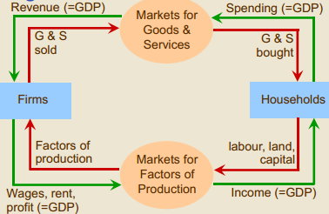
Key Point
-Expenditure for one actor is income for another within each of the 2 markets
-->Every dollar which circulates is both income and expenditure
-->Every dollar has a double identity
-->As a result, total (aggregate) expenditure = total (aggregate) income

Complication
-Add a money market to the model
-Savings leak out of G&S market to enter the money market, which transforms them into investment spending, and they are injected back into the G&S market
-The foreign sector and the government sector are parts of the G&S market, and would appear on top

National Accounting
-The objective is to measure GDP
-The circular flow model gave the structure or the anatomy, which is the relationship of the flows. Now we want to discover the size of them
-Similar to accounting at a firm level
-->The idea is to track and measure economic activity
-Two major approaches:
-->Expenditure approach
-->Income approach
-Recall income and expenditure are distinct flows within the macroeconomy, and are equal in aggregate

Expenditure Approach (Table 5.1)
-Expenditure approach is the easiest. All spending activity is broken down as:
-->Consumption spending (C)
-->Investment spending (I)
-->Net export spending (X)
- Exports - Imports
-->Government spending (G)
GDP = C + I + G + X
-->These % figures are for the year 2011
-->C is relatively stable but has declined in relative terms in recent decades (about 57% of GDP)
-->I is unstable and is the hardest to model (about 23% of GDP)
-->G refers only to government purchases, and does not reflect transfer payments
- It has grown in relative terms in recent decades to about 21% of GDP
All of the following pertains to the foreign sector of the economy:
-Imports reflect Canadian spending on foreign goods - the spending leaks from the circular flow
-->About 32% of GDP
-Exports reflect foreigner's spending on Canadian goods - the spending is injected into the circular flow
-->About 31% of GDP
-NX = X - IM is net exports (net exports = exports - imports)
-->minus 1% of GDP

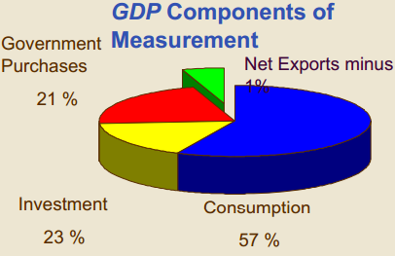
-Injections enter with + signs
-->Government spending
-->Investment spending
-->Export spending
-Leakages enter with - signs
-->Imports
-->Savings and taxes are leakages, but since they are not expenditures, they don't appear in this equation

Savings and Taxes
-Savings (S) is consumption spending (C) postponed into the future
-In the current accounting period, think of S as a transformation of consumption spending into investment spending
-Think of taxes (T) as a transformation of private consumption spending into public spending (G) and investment spending (I)

Three Types of Investment Activity, or Capital Spending
1) Residential investment (new housing)
2) Plant and equipment (for factories/producers)
3) Inventory accumulation (is a flow)
-->Inventory levels are a stock value
-It is possible for one economic agent to contribute to C, I, Im, G spending simultaneously (i.e. I am a consumer, an investor, and an importer)
-Therefore, in order to classify as C, I, G, X, or Im, it is not the identity of the spender that matters, but rather the nature of the good or service being purchased
Factor Incomes Approach (Table 5.2)
-This time, the focus on income earning activity, not on spending activity. The question now is "How was this dollar earned?"
-Y (aggregate income, same value as GDP) broken down into three components:
-->Factor payments
-->Indirect taxes
-->Depreciation
-In 2011, it amounted to about $50,000 per capita
-NDP (net domestic production) = Factor incomes + indirect taxes
-GDP (same value as Y) = NDP + depreciation (capital consumption allowance)
-Factor payments include:
-->About 52% of GDP in 2011
-Rent to landlords and landladies
-Interest and dividends to investors
-->About 4% of GDP in 2011
-Profit to entrepreneurs
-->About 12% of GDP in 2011
-->The difference between these last 2 items is not always clear
-These quantities give income at factor cost. This is not total income at market prices
-Indirect taxes fill this gap
-->PST, GST, HST excise taxes
-->Incurred only upon act of purchase
-Depreciation refers to what is required in order to maintain the capital stock in its existing condition
-It is possible for one economic agent to earn income from land, labour, and/or capital simultaneously
-Therefore, it is not the identity of the earner that matters, but rather the manner in which the income is earned

Apogee (Climax)
-GDP, as calculated by the expenditure approach, should equal Y, as calculated by the factor income approach
-->Statscan does it both ways
-->The 'bottom line' in Table 5.1 is consistent with the 'bottom line' in Table 5.2
-GDP = Y, or gross domestic product = national income
-->This equality is consistent with the circular flow model
Real vs. Nominal GDP
-Real GDP is nominal GDP adjusted for inflation
-The objective is often to measure changes in the volume of economic activity, as economic well-being depends on the quantity of G&S produced but...
-GDP has to be measured by value, not physical volume, and value depends on both volume and prices
-->Nominal GDP increases because prices rise
-->Nominal GDP also increases because production (real GDP) increases
-Have to find a way to disentangle changes in volume from changes in prices
-A price deflator (index) is a time series of numbers that measures inflation
-->Think of it like a two-column matrix that gives a one-to-one correspondence between time and the level of prices
-They are used to deflate nominal quantities into real ones (strip the inflation)
-To this end, deflators account for the inflation that is embodied in nominal quantities
-% change nominal = % change real + inflation rate
-->No inflation means real value = nominal value
-Real GDP = (Nominal GDP/deflator) x100
-->Takes logs of both sides and differentiate this in order to obtain the expression above

How Good a Measure of Economic Welfare is GDP?
-In some ways, it underestimates it, so actual economic welfare is higher than the official numbers indicate
-->The underground economy: activity is not reported (all untaxed, but not all illegal)
-->Non-market activities: Activity might be reported, but is not traded and not valued
-->It does not reflect time allocated to leisure
-In some ways it overestimates it, so economic welfare is actually lower than the official numbers indicate
-->Economic bads: by-products of economic activity, especially pollution and congestion
- The economic activity which generates the pollution is included in GDP, but the pollution is not accounted for
-->The value of some activities which do not promote economic welfare are included in GDP, such as criminal justice, national defence, and environmental cleanup
- i.e. The value of spending to address "necessary evils" IS included in the official GDP figures
-No single statistic will resolve this issue
-->Alternative index developed by two researchers whom I know well is discussed in case study on page 115
-Economic well-being and the value of GDP growth are somewhat subjective
-->'Left-wing' types stress distributional issues: What good is GDP growth if the lion's share goes to capital (read 'the rich') rather than labour?
-->'Right-wing' types say 'plenty', because 'the rich' are the geese that lays the golden egg for all of us, and 'the poor' would be even 'poorer' if 'the rich' were not so rich
-Interesting figures in Table 5.4 on international comparisons (2009 data)
-->On average it is estimated that GDP per capita adjusted for local prices is about 83% in Canada of what it is in the USA
- We are slightly better off than the Japanese, the French, the Germans, and the British
-->Canada has a more equal distribution of income than most post-industrial economies
-->Life expectancy in Canada is 3 years longer than it is in the USA

Recession: two consecutive quarters of negative growth in real GDP
Depression: extended severe recession

Chapter 6 "Measuring the Cost of Living"

Two Types of Deflators
-Consumer price index (CPI)
-->Used to measure evolution in the cost of living
-GDP deflator
-->Has a much broader base
-->Supposed to reflect the prices of all goods that are produced domestically
-Learning how to use and interpret the deflators is more important than learning how to calculate their values
-Figure 6.2 in the textbook shows the evolution (i.e. the changes over time) of both of these deflators from 1965 to 2011
-->They tend to move together
-->Since early 1990s, very moderate inflation

Illustration of GDP Deflator
-Take the following figures as given
-->Year 1, 100 (the base year)
-->Year 7, 118.1
-->Year 8, 121.9
-->Year 9, 125.1
-->Year 10, 1.1% inflation
-Year 8 and 7, (121.9/118.1 - 1) x 100 = 3.2% annual inflation rate
-Year 9 and 8, (125.1/121.9 - 1) x 100 = 2.6% annual inflation rate
-What about this minus one business?
-->Inflation between years t and t-1 = (Pt - Pt-1) / Pt-1 = Pt / Pt-1 - 1
-->Multiply by 100 in order to convert to a percentage
-Working in the other direction:
-->(x / 125.1 - 1) x 100 = 1.1
-->x / 125.1 = 1.011 or x = 126.5 for the index in year 10
-Working over a longer period:
-->In year 1, the base year, index = 100
-->The cumulative inflation over the 9 year period is(125.1 / 100 - 1) x 100 = 25.1%
-These types of calculations will be expected from you
-Some real figures for Consumer Price Index (CPI)
-->Consider the following information:
- November 2012 CPI = 121.9
- October 2013 CPI = 123
- November 2013 CPI = 123
- 2002 CPI = 100 (the base year)
- Based on buying habits, 2009
-->From those figures, we can determine that:
- Prices in November 2013 are 23% higher now compared to 2002
- The annual rate of inflation from November 2012-November 2013 = +0.9%
- The rate of inflation from November 2013 to October 2013 = 0%
- If that annual rate (+0.9%) were to continue for 10 years, this would translate into ((1.009^10 -1) x 100) - ((1.009 - 1) x 100) = 9.37%
-->Although in this case multiplying 0.9% by 10 gives an approximation of 9% for the true value of 9.4%, the appropriate operation is exponential because price charges are compounded on each other

Example of Compounding
-Suppose an interest rate of 10% per year and a time period of 12 years
-->With compounding, $1 would grow to $3.13 for an increase of 213%
- ((1 + 0.1)^12 - 1) x 100 = 213% or $2.13 total interest paid
-->Without compounding, the interest is applied only to the initial value of $1, and the total amount would be $2.20 for an increase of 120%
- (( + 0.1 x 12) - 1) x 100 = 120% or $1.20 total interest paid
-Core inflation = CPI stripped of the prices of those goods and services with the most volatile prices, esp. energy (designed to reflect longer-term trends)

Construction of CPI
-The approximate weights for the CPI are:
-->Food: 16.1%
-->Shelter: 27.5%
-->Household operations and furniture: 11.8%
-->Clothes/shoes: 5.6%
-->Transport: 19.3%
-->Health, personal care: 5%
-->Recreational, education, reading: 11.8%
-->Tobacco, alcohol: 3%
-Each of these weights is attached to its corresponding price level in order to calculate the overall deflator, which measures the price level for a synthesized, composite good
-->Then the inflation rate is calculated as before
-Every year (for whatever time period) has a value for real GDP (or whatever series one is deflating) in constant dollars of the base year
-->Year in which the deflator = 100
-Every year (or whatever time period) also has a value for nominal GDP (or whatever series one is deflating) denominated in current dollars for the year in question

More on Interpretation of Deflators
-Deflators in 2002 = 100 (choice of the base year arbitrary, but use the same year throughout your analysis)
-->In the base year, nominal GDP = real GDP
-Based on 2009 'basket content', which refers to buying habits
-Since there has been continuous inflation since the 1930's, the deflator rises every year
-->i.e. Rising deflator indicates rising prices, falling deflator indicates falling prices
-If a deflator for a given year > 100, prices in that year are higher than they were in 2002
-->So nominal GDP for that year in current dollars > real GDP in constant, 2002 dollars
-->Illustration: if prices in 2006 are higher than they were in 2002, nominal GDP experienced in 2006 denominated in 2006 current dollars > real GDP experienced in 2006 denominated in 2002 constant dollars as 2002 dollars are worth more than 2006 dollars
-If a deflator for a given year < 100, price level in that year is lower than it was in 2002
-->So nominal GDP in current dollars for that year < real GDP in constant, 2002 dollars
-->Illustration: if prices in 2002 are higher than they were in 1980, nominal GDP in 1980 in 1980 current dollars < real GDP in 1980 in 2002 constant dollars as 1980 dollars are worth more than 2002 dollars

Why are Deflators Useful?
-Good application on pages 130 and 131
-->Show that between 1957 and 2011, the price of gasoline rose more than the overall rate of inflation
- In other words, its price in constant dollars (or the 'real price') increased
-->Show that the most popular movie of all time was "Gone With the Wild" as measured by real revenue in constant dollars

Reminder (Very Important)
-(ΔY / Δ time) is the rate of change of Y. This is not a percentage, and has the same units as Y
-( ΔY / Y) / (Δ time) is the growth rate of Y. This is a percentage, and has no units

Current Economic Issue
-GDP deflator and CPI probably overstate inflation
-->Substitution bias means that consumers react to price changes by buying less of the good whose price has increased
- By omitting it we overstate inflation
-->Introduction of the new G&S is temporarily omitted from the CPI
-->Quality changes are not always accounted for
- Since quality is usually improved, this will cause inflation to be overstated
-Why does this matter?
-->Pensions like the CPP and many wage contracts are indexed for inflation according to CPI
-->Hot political issues that pits workers against retirees

Real vs. Nominal Interest Rates
-Real interest rates = nominal interest rate - the inflation rate
-->Was negative in late 1970s
-->About 0% now for small savers
-->About 2% for corporate borrowers
-->Note that all financial intermediaries make their living on this spread
-->See figure 6.3 in text
- Real state = 3-month corporate bond rate - inflation rate as measured by the CPI
-Why is this important?
-->Lending and borrowing decisions are typically made on the basis of expected real interest rates
-Most loan contracts are arranged according to an expected real interest rate
-->If inflation turns out to be higher than expected, borrowers win and lenders lose because the real interest rate falls
-->If inflation turns out to be lower than expected, borrowers lose and lenders win because the real interest rate rises
-A negative real interest rate encourages borrowing and discourages saving/lending as loans are repaid in deflated dollars

Chapter 7 "Production and Growth"

Basic Theme
-Long-term performance of economic growth
-->Level of real GDP is a good (but far from perfect) gauge of economic prosperity
-->Growth of real GDP is a good gauge of economic progress
-What are the long-run determinants?

Economic Growth Around the World
-Living standards measured by real GDP per capita
-Table 7.1 shows values for the years 1990 and 2006 for selected countries, and calculates the average rate of growth over this period
-Canada is slightly richer than most of Europe, including the UK, but at least 15% poorer than the USA (on average only)
-The message in these figures is that a lot can happen in 100 years
-->A poor country that grows rapidly can gain a lot of ground
- "tigers" (a country that used to be poor, but now has made incredible gains and is rich) include, or included, Japan, S. Korea, Ireland, Hong Kong
- The 1990s were terrible for Japan, and the next decade was not much better
- Brazil and Mexico have done well according to these figures
-->A rich country that grows slowly can lose a lot of ground
- Britain, Argentina
-->A country with negative growth is in big trouble
-So what's the big deal between a growth rate of 1% and one of 2% per year?
-->If real GDP grows at 1% per year, the size of the economy will double in about 70 years
-->If real GDP grows at 2% per year, the size of the economy will double in about 35 years
-->Such is the nature of compounding growth over a long period of time

Primary Causes of Economic Growth and Prosperity
-The endowments of land, labour, and capital
-That one critical item that tends to be ignored in elections. It is not sexy, but it is of the utmost importance (not usually talked about)

Productivity
-"How efficient we are utilizing the inputs in order to produce output"
-It is highly desirable that it starts growing again in Canada, as it has been stagnant for the past 4-5 years
-Principle #8, chapter 1

Definition of Productivity
-"Producing smarter" (more efficiently)
-Production = product = output
-Productivity = output / input
-->Often measured in terms of output per hour of labour inputted
-->Think of using resources as efficiently as possible
-Our living standards and prosperity depend on this more than anything else
-To see why, imagine a firm's labour force that becomes more productive or efficient. They can receive higher wages without the price of the product or service increasing, which would increase their gains
-During of periods of productivity growth, real wages grow (1962-1973, 1983-1988, 1991-2000)
-->Productivity growth is uneven
-->Upcoming graph is quite dated yet still relevant and revealing
Real GDP per Hour of Work
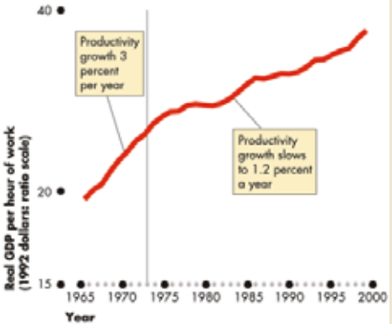
Determinants of Productivity
-Physical capital
-Human capital (knowledge, skills, and aptitude embodied in workers)
-->Obtained through education, training, experience
-Natural resources
-Technological Knowledge (the state of technology)

Natural Resources (land)
-Canada and Australia are very endowed with this, which contributes to GDP growth
-It is not a necessary condition for prosperity
-->Japan and Hong Kong are poorly endowed
-It is not a sufficient condition for prosperity
-->Russia and Brazil are well endowed
-->We definitely cannot rely on these, 'hewing wood' and 'drawing water'

Economic Growth and Public Policy
-Public policy means what can the government do about it?
-->Plenty (see list below)
-->Politicians tend to have other pre-occupations

-Savings and investments
-Avoid diminishing returns
-Attract FDI (Foreign Direct Investment - on your own)
-Develop human capital (education)
-Property rights and Political Stability
-Free trade
-Research and development

1) Saving and Investment
-Forgoing present consumption through saving in order to produce more capital goods through investment spending, which augments the capital stock
-Empirical evidence shows that countries that allocated the most of their GDP to investment spending tended to grow the fastest between 1960-1991

2) Diminishing Returns and the Catch-up Effect
-Capital, like labour, is thought to exhibit diminishing returns
-Capital formation leads to higher real GDP, but additional increments of capital yield declining yet still positive increments to real GDP
-->The rate of GDP growth falls (but should still be positive)
-->Like when Gray experienced diminishing returns to training and exercise
-The catch-up effect is related to diminishing returns
-Some countries like South Korea grew very rapidly because they started from a very low capital stock, and had "nowhere to go but up"
-Other countries like Canada started from a much higher capital stock, invested a fair amount, and grew more slowly
-Developing countries have the potential to grow very rapidly for awhile

The Production Function & Diminishing Returns (Figure 7.1)
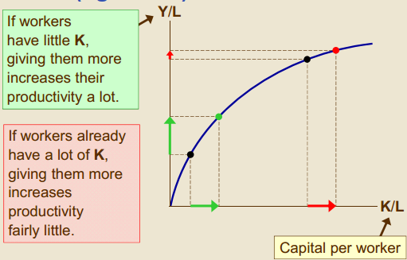
The Catch-up Effect
The property whereby poor countries tend to grow more rapidly than rich ones
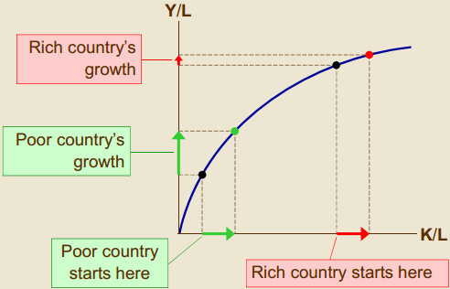
3) Education (Human capital)
-Critical at all levels of training and education, including vocational, university level, and professional
-Especially important to be able to offer meaningful and useful training to laid off workers
-Not just the level of formal education is important, but also the actual levels of general numeracy, literacy, and computer literacy

4) Clearly Enforced Property Rights and Political Stability
-Property rights: the ability of people to determine the use of the resources that they own
-The basic idea is that these institutional arrangements encourage economic agents to be productive and are thus conducive to productive activity
-"Economic prosperity depends in part on political prosperity" (page 156)
-->Political stability is very good for living standards

5) Free Trade
-Most economists believe that open economies are more productive than closed ones, and there is plenty of supporting evidence
-Many other social scientists do not believe this

6) Technological Change and Innovation
-E.g. internal combustion engine (rather than beasts of burden), computers, internet, telecommunications
-It has to be diffused as well as invested
-It creates jobs as well as destroying them
-->The 'luddites' (people against advances in technology in 1700's) were wrong
-It can contravene the onset of diminishing returns to capital

Chapter 8 "Saving, Investment, and the Financial System"
-->Deals with Money Market
Introduction
-Read 'FYI' box on page 171 and the definitions on pages 168-173
-Until now, all that we have covered is deals with goods and services market
-There are two other types of markets (money markets and input markets)

Money Market
-While the goods and services market and the input market consist of real (concrete) economic activity, money markets do not
-Money serves as an accessory to concrete, real economic activity, meaning that exchanging money is not an end in and of itself (but rather a means to the end to producing output)
-->Think of GDP as a pie, some get more than others, but we all eat the pie
-Events in money markets influence real economic activity through three channels, and vice versa
1) Exchange rates
2) Interest rates (only deal with this factor in this chapter)
3) Price level in the output market
-By far the largest component of the money supply that circulates in the Canadian economy is comprised of credit, not cash
-The structure of the financial system:
-->Savers who supply loanable funds
-->Borrowers who demand loanable funds
-->Financial intermediaries (middlemen of this market) who broker deals between these two sets of actors
-The ultimate destination of much of the loanable funds is for investment spending, which in turn is directed toward capital spending, which hopefully maintains and augments the productive capacity of the macroeconomy

Financial Institutions in the Canadian Economy
-Many, many different instruments within financial markets, as saving and lending activities are very specialized
-Canadian financial markets are among the deepest, or most developed, in the world
-->Lots of credit available, and many different types of credit available
-->In very good condition relative to those of just about any other country
Bond Market
def: a loan or an IOU that is marketable or transferable from one individual to another
-->This means that the price is determined by supply and demand forces
-Characteristics:
-->The coupon rate of interest (the rate of interest when the bond was issued)
-->The face value (the initial amount of the bond)
-->The term to maturity (pay-off period before bond matures-->whoever issued it is liable for paying out the face value)
-->Credit risk (reliability of borrower)

Stock Market
-Read the box on how to read the newspaper's stock tables
-Stocks are also called equities
-Like bonds, they are totally marketable, and therefore the price is determined by supply and demand forces
-Stockholders in theory own the enterprise, and have claim on its profits
-Potentially high risk, potentially high return
-The textbook mentions two types of intermediaries
-->Banks
-->Mutual funds
- Ideal way for small investors to 'play the stock market' by diversifying their risk, which means avoiding placing all of one's eggs in one basket

Saving and Investment in the National Income Accounts
-Back to the framework of chapter 5
-->Name of the game was to assign every $ of spending into one of 5 types of spending (an exercise in taxonomy or classification)
-->That is not what we are doing now
-We do the equation Y = C + I + G + NX
-Assume a closed economy
-->The absence of trade is called autarky
-->Opposite is called an open economy, which is what we have in Canada
-->Therefore, NX = 0
-Y = C + I + G
-->Y - C - G = I
-->Define national savings, S = Y - C - G
-This yields S = I, i.e. national savings = investment spending
-Since S = Y - C - G, then S = (Y - T - C) + (T - G)
-->Total S is thus decomposed into private savings (on the left) and public saving (on the right)
-->(Y - T) is called disposable income (like take-home pay), and whatever remains after consumption spending is private saving
- If T - G > 0, it runs a surplus, like (until recently) the federal government of Canada
- If T - G < 0, it runs a deficit, like the federal government of the USA and the province of Ontario
-Punch-line: for the aggregate economy, S = I (always)
-->Only applies in the aggregate
-->The money market, whose institutions and players I have presented, works to bring about this equally

The Market for Loanable Funds
-It is the savers who supply the loanable funds
-It is the investors who demand the loanable funds
-->Does not include the government's demand for funds
-The price of loanable funds is the interest rate
-Figure 8.1 in the textbook
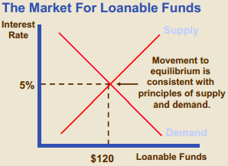
-The law of demand applies to the D for loanable funds
-->As the interest rate goes up (down), the quantity demanded for them goes down (up)
-The law of supply applies to the S for loanable funds
-->As the interest rate goes up (down), the quantity supplied for them goes up (down)
-We say that the interest rates adjusts to equilibrate the market
-->When loanable funds are relatively scarce (plentiful), we will have high (low) interest rates
-What types of policies can be implemented to encourage saving, a goal which most economists favor?
-->Lower taxes on the returns to saving and instead shift the incidence of taxation to consumption
- Idea behind the GST, HST
- Most economists think that it would have been better to cut income taxes rather than the GST because with income taxes, you are taxing individuals according to what they put into the economy as opposed to what they take out of it
-->Increase tax shelters for retirement saving (RRSP)
-->Illustrated in figure 8.2
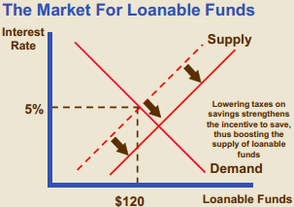
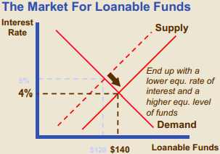
-What types of policies can be implemented to encourage investment, a goal which most economists favor?
-->Investment tax credit
-->Illustrated in figure 8.3
-->'Right-wingers' favour this
-->Current policy debate surrounds further cuts to be the corporate income (profit, not revenue) tax rate
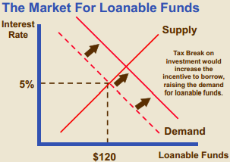
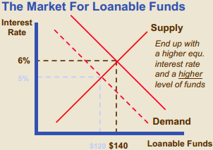
-What about the government's most important intervention in the money market: its deficit or surplus?
-->Running a deficit results in the 'crowding out' effect, which I call the 'government credit hog' effect
-->Illustrated in figure 8.4
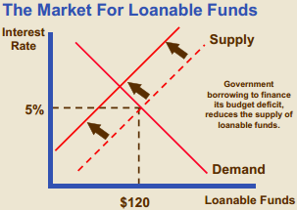
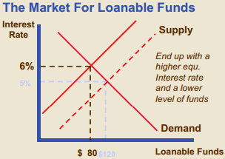
-The public borrowing crowds out the private borrowing, thus reducing private investment spending and capital formation
-Textbook makes the important distinction between debt and deficits
-->Deficit is the flow of (T - G) over a time period
-->Debt is the stock of money that the government owes, and is the cumulative deficit or surplus
-Vicious circle on next page
-->Self-reinforcing
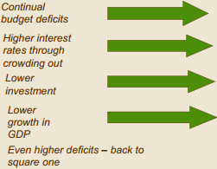
-->Process in reverse order is a virtuous circle

Canadian Case
-Involves the vicious circle from 1975-1997 and the virtuous circle until 2008
-->See figure 8.5
-->The switch (called austerity) required enormous political courage and was painful
-->Have to consider both federal debt and provincial debt
-->Page 182 reiterates the lesson: "when the government reduces national saving by running a budget deficit, the interest rate rises, and investment falls. Because investment is important for long-run economic growth, government budget deficits reduce the economy's growth rate"
-->Old policy debate was whether deficits were desirable or not
- 'Left-wingers' were in favour of them, and 'right-wingers' were not
New policy debate is over how soon the fiscal stimulus, which was brought on to fight the recession, should be removed
'Left-wingers' tend to favour higher social spending, and 'right-wingers' tend to favour tax cuts and debt repayment

Chapter 9 "Unemployment and Its Natural Rate"
-->Deals with Labour Market
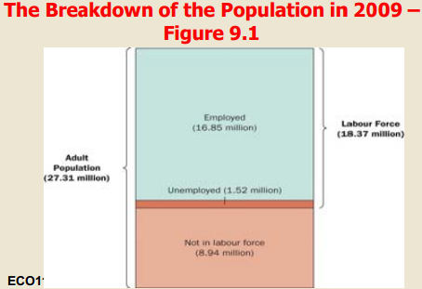
Measuring Labour Market Performance
-Who's considered to be officially unemployed?
-->Without work and 'actively' seeking work
-->On layoff expecting recall
-->Hired, but waiting to start work within a month
-Several labour market indicators show different things
-->LF = U + E = 1.5 + 16.9 = 18.4 million
-->UR = U / LF * 100 = 1.5 / 18.4 = 8.2%
-->LFPR = LF / Working Age Pop. * 100 = 18.4 / 27.3 = 67.3%
- Labour force participation ratio
-->Employment to Population Ratio = E / Working Age Pop. * 100 = 16.8 / 27.3 = 61.5%
-->Figures for 2009 in these slides characterise an unhealthy labour market
-Figures for Jan 2013
-->Employment = 17.6 million
-->Unemployment = 1.3 million
-->Labour force = 19 million
-->Adult, working age population = 28.5 million
-Two major patterns for the unemployment rates
-->Men have higher unemployment rates than women
-->Youth workers have higher UR than prime-age workers, who in turn have higher UR than older workers
Canada and Regional Unemployment Rates (Figure 9.2)
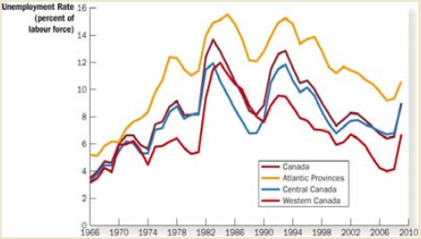
Labour-Force Participation Rates for Men and Women since 1951 (Figure 9.1)
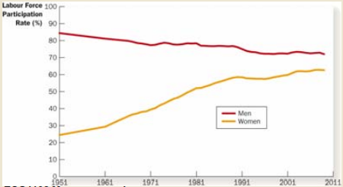
-Why bother with these different indicators? They capture different aspects of a multi-faceted labour market
-->In particular, if the UR is declining, is it due to job creation of people going NLF?
-Measured UR has been lower in the USA (7.8%) than in Canada (7.0%) until fairly recently
-->In part because some workers who report that they are unemployed in Canada would report that they are NLF in the USA
-->In the past there were slightly fewer jobs available relative to the population in Canada compared to the USA
How Accurate an Indicator is the UR?
-Biggest and most controversial issue in determining the degree to which the official unemployment actually measures labour market performance: among the jobless, who is actively seeking work?
-Discouraged workers are jobless workers who are not considered to be unemployed because they are not "actively" seeking work
-->If they were considered as unemployed, the measured UR would be much higher
-->In USA, while the 'official' UR is 6.5%, the 'unofficial' UR is thought to be almost double that figure

Illustration of Massaging the UR
-Suppose that LF = 100 and U = 7
-->Then UR = 7%
-Now suppose that 4 prisoners are up for parole
-->If they are released, they are bound to be jobless, and if they are deemed to be actively seeking work, UR = (7 + 4) / (100 + 4) = 10.6%
-->If they are not released, they remain NLF, and UR does not change (still 7%)
-->In either case, the true state of labour market is unchanged, but the official unemployment rates diverge

Anatomy of Unemployment
-Flows into unemployment
-->Job losers
- Largest source, very counter-cyclical
- Even during good times, many layoffs occur
-->Quitters
- Cyclical (high during good times, low during bad times)
-->Entrants and re-entrants into the LF
- Cyclical
-Flows out of unemployment
-->Employment (finding work)
- Even during bad times, people are hired
-->NLF
-The duration of unemployment
-->Extremely variable, as some of the jobless are out of work for years while others find work within days
-->Very little long-term unemployment in Canada (defined as out of work for more than a year)
Main Point
-The static view of unemployment - that the stock of unemployed workers has all been unemployed since the recession began, and they won't find work until it ends - is invalid
-Truth: The labour market is more Dynamic, with workers constantly flowing in and out of unemployment
-->During good times, some workers are laid off
-->During bad times, some workers are hired
-->Recent data from the USA:
- For every 100 people employed in October of 2010, 95 are still employed in November, 2 have lost jobs, and 3 are NLF
- For every 100 people unemployed in October of 2010, 17 found jobs in November, 64 are still unemployed, and 19 are NLF
-Different demographic groups and different skill/education groups have very different unemployment experiences

Types of Unemployment
-Frictional
-->Has a positive economic function
-Structural
-->Very economically harmful and difficult to remedy
-Cyclical or demand deficient
-->Generally occurs in recessions
-->This is what we are now experiencing
-Frictional unemployment: associated with normal turnover as good labour market matches take time to form
-->A 3% rate of frictional unemployment is thought to be desirable
-Structural unemployment: pool of jobless workers ill-suited for jobs that are available
-->Poor job training and education
-->Low geographic mobility
-->Somewhat of a problem in Canada (especially now)
-Cyclical unemployment: a global shortage of jobs in the labour market
-->That is the big problem now
-The natural rate of unemployment is the one that exists when the economy is near its capacity (at the top of the business cycle)
-->Cyclical unemployment is zero, and all unemployment can be characterized as either structural or frictional
-->It is notional, and can only be estimated
-->A synonym is the 'NAIRU' - the non accelerating inflation rate of unemployment
-The only sustainable UR is the natural rate of unemployment
-->If the actual rate dips below the natural rate, inflation takes off
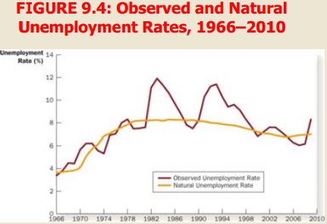
Big Controversy - How High is 'Natural' Unemployment?
-5% or lower, if it exists at all, according to "left-wing" groups
-->Almost all of the current level of unemployment is cyclical
- This view was valid during the great depression and depths of recession
- They find the very notion offensive
-7-8%, many "right-wing" analysts used to say
-->Much of the existing level of unemployment is structural
- That view is valid in continental Europe
- They have been proven wrong, since we reached 5.8 % without provoking inflation
-It can definitely change as a result of government policy, albeit gradually

Explanations of Unemployment (Underlying Causes)
-Job search
-Minimum wages
-Unions
-Efficiency wages
-->Most of this analysis is right-wing in perspective

1) Job search
-Already mentioned in the context of frictional unemployment
-Matching the right worker with the right job is time consuming and resource consuming
-A lot of sectoral change in the economy causes "churning", which means that jobs are created and destroyed simultaneously, necessitating much job search
-Basic idea: the better and the faster the matching process, the more efficient the labour market
-There is a long passage on Employment Insurance
-->Most economists believe that it aggravates the level of unemployment by reducing the incentive to search for new work (subsidizing leisure) and, by greatly increasing the incomes of seasonal workers, increases their number (and hance the degree of seasonal unemployment)
-->There is plenty of empirical evidence to suggest that firms and workers alter their employment behaviour in response to Employment Insurance program
- Called 'gaming the system
-->Must read page 205 in the fifth edition VERY carefully, as they mention the name of a famous economist

2) Minimum wage laws
-"If the wage is kept above equilibrium level for any reason, the result is unemployment" (pg. 205)
-The authors have structural unemployment in mind
-Applies to only low-skilled workers
-An extremely emotive issue
-Empirical evidence suggests that it does reduce the growth in employment

Unemployment from a Wage Above Equilibrium Level (figure 9.5)
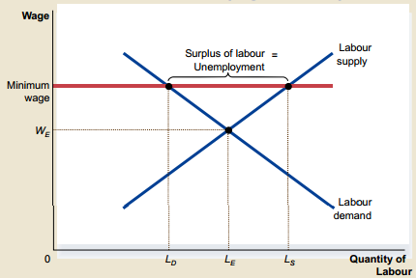

3) Unions and Collective Bargaining
-Learn institutional details on your own
-Model works just like the minimum wage, with a going wage above the equilibrium level, that can contribute to structural unemployment
-Textbook briefly goes over the pros and the cons
-->Also an extremely emotive issue towards which views tend to be subjective

4) Efficiency wages
-Like the case of the minimum wage and the union wage, the going wage exceeds the equilibrium level, which contributes to structural unemployment
-Unlike the previous two cases, the employer pays this wage voluntarily
-Various rational reasons why he/she might pay more than the going wage, but the level of employment is likely to be lower than what would otherwise be the case

Chapter 10 "The Monetary System
-->Deals with the money market

Three Distinct Functions of Money
1) Medium of exchange
-Avoids the very cumbersome process of barter, which stems from the double coincidence of wants (Person A wants what Person B has to offer and vice-versa)
2) Unit of account
-Used as a common denominator for the value and the relative value of goods and services or credits/debits (compare value of good X with value of good Y)
-->A candy bar might be worth 3 lollypops and a trip to France might be worth 2 trips to the Canadian Rockies: wouldn't it be easier to compare the value of all of these terms of $?
-Think of it as a measuring device ('yardstick')
3) Store of value
-Brings in the dimension of time (with deferred payments)
-Usually production and exchange are not simultaneous activities, especially with investment activity
-Money should allow a claim on goods and services in the future
-->In other words, it has to hold most of its value over time (low inflation)
*Caution: it is very easy to confuse the latter two functions of money, this is why it is a candidate for an exam question*

History of Money
-Challenge has always been to give money a relatively stable value
-->It always has to be supported by something
-Commodity or metallic money
-->Gold and silver were the recognizable benchmark, or base commodities, which had intrinsic value in addition to the exchange value
-->One could redeem (convert) paper currency for gold
-Paper money developed as a more portable form
-Now almost all money is Fiat money
-->Intrinsically worthless, so it cannot be converted
-->Is it valuable because the government says that it is a legal tender? NO!
- The signature means nothing - there's a signature on worthless currencies
-What gives Fiat money value?
-->People's faith that they can exchange it for concrete goods and services
-Confidence in the value of the currency now and in the future is crucial. Without it, chaos
-->Ensured by reasonably low inflation and adequate levels of economic activity
-->Hyperinflation leads to economic and social and political catastrophe

Monetary Aggregates
-There are several definitions of the money supply. In decreasing order of liquidity
-->M1 = currency + DD (demand deposits)
- M1 is more liquid than M2
-->M2 = M1 + TD (term deposits) + savings deposits
- M2 is more in value than M1
-These are stock quantities, and hence cannot be compared to GDP figures, which are flow quantities

Banking System Structure
-2 major types of actors
-->The central bank (the Bank of Canada)
-->Depository institution: any organization that serves as a liaison between savers and borrowers
- Chartered banks
- Trust companies
- Financial co-ops
-Functions of the central bank
-->Issue currency
-->Act as the bankers' bank
-->Act as banker for the federal government
-->Regulate the supply of money through monetary policy
-Monetary policy: deliberate, purposeful action by the Bank of Canada to regulate the supply of money

Fractional Reserve System
-Fractional reserves are a critical element of our financial system
-If the commercial banks were to hold 100% of their deposits for safe-keeping, and did not issue any loans, the money supply would be unaffected...
-But they DO make loans, big time!
-The loans outstanding are very highly leveraged
-->Leverage means lending Peter's money to Paul, so there are multiple claims on the initial money involved
-->The loans are illiquid; only a small fraction of the outstanding loans are convertible into cash
- Liquid assets can be converted into cash immediately at very little cost
- For a bank, liquid assets are its government bonds and commercial bills
-To meet the liquidity needs of depositors, banks hold reserves in the form of cash
-->On a typical day, only a very small fraction of their deposits will be redeemed
-Holding these reserves has its benefits and its costs (they cannot be lent to borrowers) so...
-...Banks face a tradeoff between maintaining confidence in the financial integrity of their institution (solvency) and earning profits by making loans
-In the past, there were regulations for required reserves. Now there are only targets for reserves
-->A desired ratio of reserves to total deposits
-Any reserves in excess of these targets are called excess reserves
-It is from these excess reserves that money can be created by expanding Credit

Money Creation
-In order for the supply of money to expand (contract), there must be a net injection (withdrawal) of funds from outside (inside) the financial system
-Illustration:
-->Suppose that there is a net increase of $100,000 to the Canadian banking system
-->Suppose that a bank has a target reserve ratio of 25%
-->In round one, $25,000 is kept on reserve, and $75,000 is loaned out to borrowers
-->In round two, this new $75,000 loan is deposited elsewhere by the borrower. and $18,750 is kept on reserve, $56,250 is loaned out again, etc.
-We have a series of loans which turn into deposits...
-->Which in turn are transformed into loans after setting aside reserves...
-->Which in turn are transformed into deposits...
-->etc. (page 229 in textbook)
-At each round, the total amount of credit (loans) expands by a factor of 75% of the loan made during the preceding round

The Multiple Creation of Bank Deposits
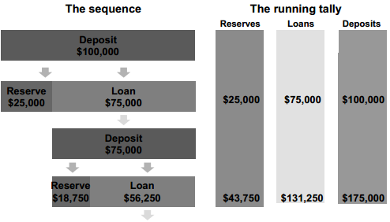
The Multiple Creation of Bank Deposits
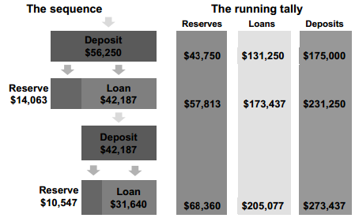
-At each round, 25% of this new loan leaks out of circulation in the form of reserves
-At the end of this Multiplier process, total loans increase by $300,000, total reserves increase by $100,000, and total deposits increase by their sum
-This is the multiplier process for money markets
-It stops when Δ total reserves withdrawn from circulation and withheld in the form of reserves = amount of original reserves injected into the banking system
-Multiplier = Δ cumulative deposits / Δ original deposits (true by definition)
-->Δ original deposits = Δ reserves at the end of the process
-Value of the multiplier = 1 / desired reserve ratio
-->Assuming that no excess reserves and no cash are held
-Back to the illustration:
-->Cumulative change in deposits = 400,000
-->Initial change in deposits = 100,000
-->Desired reserve ratio = 0.25
-->Multiplier = 1 / desired reserve ratio = 1 / 0.25 = 4 = 400,000 / 100,000
-Money is destroyed by going in the opposite direction
-->A withdrawal of reserves from the banking system sets off the process in reverse
-->When reserves are insufficient, banks call back loans
-Essence of this process: Excess Reserves are loaned out
-->The more (fewer) excess reserves, the more (less) credit can be generated

Monetary Policy
-How does the central bank affect the money supply, and hence interest rates?
-It has a lot less power than it used to have, given the integration of world financial markets
-->With mobile capital, investors search for the highest rate of return
-It can influence short-term interest rates
-Long-term interest rates are determined in world capital markets
-It cannot control the demand for money - only the supply of money

Objectives of Monetary Policy
-Objective used to be to achieve low interest rates during the recession (the recessionary gap) and high interest rates during booms (the inflationary gap)
-->'Loosening or tightening of the monetary screws' (when the economy is booming, the central bank has to intervene and cool off the economy by raising interest rates, and vice versa)
-Current objective is primarily to achieve "price stability", including 'asset price stability'
-->Anti-inflation

Primary Instruments of Monetary Policy
-Open market operations is a potent instrument
-Changes in the 'bank rate' that it charges on the loans that it makes
-->It also targets the 'overnight rate', which refers to the interest rate that a commercial bank pays when it borrows money from another one

Open Market Operations
-To increase (decrease) the money supply, the central bank has to inject (withdraw) new reserves into (from) the financial system from (to) outside of it
-The bank of Canada can trade in either bonds or foreign currency
-->The latter are called foreign exchange market operations
-The central bank can buy bonds
-->New reserves are injected into the financial system
-->Commercial banks have excess reserves, placing them in a position to expand credit
-->The money creation process (with the multiplier) commences
-The central bank can sell bonds
-->Reserves are withdrawn from the financial system
-->Commercial banks desire more reserves, forced to contract credit
-->They call back loans, the money destruction process (with the multiplier) commences

Other Instrument of Monetary Policy
-Changing the overnight or the bank rate
-->Raising those rates that they charge to commercial banks makes it more expensive for them to expand credit, so the quantity of reserves available for lending, as does the supply of money contracts
-->Cutting those rates that they charge to commercial banks makes it less expensive for them to expand credit, so the quantity of reserves available for lending rises, as does the supply of money
-Changes in these rates of interest are viewed as the indicator for short-term interest rates throughout the money market

Chapter 11 "Money Growth and Inflation"

The Classical Theory of Inflation
-Applies in the long run only
-Thus far we have thought of price as the money value of a basket of goods, and have compared it over points in time
-Now turn this conception around and think of the value of money in terms of how many goods and services it can buy
-->'Value of money' as opposed to 'money value' of items
-This means that the value of money is inversely related to the composite price level, meaning that as inflation occurs, the value of money diminishes, and as deflation occurs, the opposite applies
-->$1 = 1 / P
-->In this context, we are not talking about interest rates at all
-In the long run, the composite price level, and thus the rate of inflation, adjusts to the level where the demand for money = the supply of money
-->This framework for the supply and demand for money is quite different from the framework presented in chapter 8, which consisted of the S and D for loanable funds

Quantity Theory of Money
-The basic idea is that what matters for inflation in the long run is the growth in the quantity of money circulating relative to the availability of real goods and services on which it is to be spent
-It is the phenomenon of "too many $ chasing too few goods" that causes the price inflation
-The opposite is possible as well: "too few $ chasing too many goods" that causes price deflation

The Classical Dichotomy
-It is the real and the money sectors of economy that are dichotomous, which means separate and isolated from each other
-->What occurs in one has no effect in the other
-An implication of this dichotomy is that money is neutral
Diversion to Some Reminders
-Recall distinction between real and nominal variables
-Nominal variables are measured in monetary units
-Real variables reflect volumes, and are measured in either physical units or constant dollars
-Prices as we normally consider them are nominal variables
-Relative prices, or prices compared to each other, are the real variables
-The real economy consists of the real variables
-The money economy consists only of nominal variables
Back to the Neutrality of Money
-A change in the money supply, a totally nominal variable, will affect the price level (another nominal variable), but it will not affect any real variable
Example: If there is price inflation caused by growth in the money supply, wages will adjust along the prices so that the real wage will remain unchanged, and there will be no changes in the real labour market
-->No changes in employment, unemployment, etc

The Quantity Equation
Definition: the velocity of money is the number of times per year that a $ circulates
V = (P * Y) / M (identity)
-P is the composite price level
-Y is the real GDP
-P * Y is nominal GDP
-M is the money supply
M * V = P * Y
-What is the significance of this?
-->If M increases by a lot, either...
- P must rise
- or Y must rise
- or V must fall
-->V is thought to be pretty stable over time
-->In the long run, Y (real GDP) increases, but only due to increasing factor endowments or productivity
-->So P is forced to rise, which means inflation

The Inflation Tax
-Is an application of the quantity equation
-If a government faces a big budget deficit, it can do 3 things:
-->Raise taxes
-->Borrow the shortfall by issuing bonds (and potentially cause crowding out)
-->Print money to pay its creditors. That is the inflation tax
-If the government adopts the last option to any degree, major price inflation will emerge, which is a tax on savers and anyone who holds onto money balances
-See figure 11.4

The Fisher Effect
-Long run only
-The nominal interest rate adjusts such that the real interest rate is relatively constant
-If the inflation rate increases (decreases), the nominal interest rate will increase (decrease) in tandem
-Recall that the real interest rate is a real variable, so that the neutrality of money applies
-See figure 11.5

Summary of This Chapter So Far
-ONE factor that contributes to inflation or deflation is the rate of growth of the money supply
-->Especially for large increases or decreases
-->There are other factors
-The quantity theory of money is the classical view of the macroeconomy, and is closely tied to the neutrality of money
-->The quantity equation is the key element of it
-If there is rapid growth (shrinkage) in the money supply without a commensurate increase (decrease) in REAL output, then there will be high inflation (deflation), as there are too many (few) $ chasing too little (much) output
-->That is principle #9 in the textbook, page 14
-The growth rate in the money supply should not greatly exceed the growth rate in real production, as the production of additional consumable goods and services are required in order to soak up the newly circulating $
-->That is not controversial
-Hyperinflation can also be caused by a normal growth rate in the money supply coupled with a collapse in real output
-->Political turmoil and civil war will cause this

The Costs of Non Hyper-Inflation
-Often incomes are indexed to inflation, which mean that wages and pensions often adjust to price inflation
-Does this mean that inflation is not dangerous from an economics perspective? NO!
-->It does have important short-run effects in the real economy
-Inflation DOES have an impact on the real economy. How? Textbook gives 6 ways, of which I review 4
-->Show leather costs
-->Relative price variability and mis-allocation of resources
-->Tax distortions
-->Unexpected inflation causes arbitrary redistributions of income and wealth
-Shoe leather costs occur when economic actors try to outrun inflation by unloading their money balances before they lose a lot of their value
-->Inflation is so high that money no longer functions as a store of value
-->Either spend the balance immediately or convert it into something that holds value better than money
-Relative price variability and mis-allocation of resources
-->We have experienced this in Canada
-->Again the idea is running a race against inflation
-->It can distort investment decisions in particular when it becomes more profitable to invest in speculative activities (inflation hedges) rather than in capital goods and structures, which are productive activities
- This type of economic behaviour is sometimes called hedging
-->Case in point is the high inflation during the mid 2000s in the US housing market, which was the epicenter for the economic crisis that the fully developed world now faces
- A very excessive amount of the land, labour, and capital resources were allocated to housing
-Tax distortions are compounded by inflation
-->If income taxes are applied to nominal interest earnings rather than real interest earnings, savers are irrational
- See table 11.1
-->If income taxes are applied to nominal wage increases rather than real wage increases, governments gain and workers lose
-Unexpected inflation causes arbitrary redistributions of income and wealth
-->Unanticipated inflation is more harmful
-->When inflation is higher (lower) than expected, creditors lose (win) and debtors win (lose) as the debts are paid back in deflated (inflated) $
- Unless the loan contract can be renegotiated
-Read the case study at the end of the chapter

Chapter 14 "Aggregate Demand and Aggregate Supply"
*Back to the Output Market*

Purpose of this Chapter
-In this chapter we return to the market for goods and services
-Real GDP fluctuates, usually growing but at uneven rates
-->Occasionally falling
-The AD-AS model determines equilibrium real GDP and explains its fluctuations

3 Key Facts Regarding Economic Fluctuations
-#1 real GDP has its ups and downs that comprise the business cycle, but this cycle is not regular (like the seasons)
-->We had experienced about 15 straight years of growth in real GDP in Canada
- That streak ended in 2008
- It resumed half-way through 2010, albeit more slowly than we would like
-Recession = period of contracting real GDP and rising unemployment
-Depression = a very severe recession
-#2 many macroeconomic aggregates move together, although not necessarily by the same magnitude
-#3 as real GDP falls even slightly, unemployment skyrockets
-->By mid-2009, the economy had shrunk about 3.5% points from its peak, but by mid-2009, the unemployment rate was over 2% points higher than its trough
Figure 14.1 Fact #1: Economic fluctuations are irregular and unpredictable
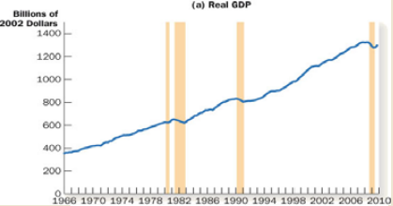

Fact #2: Most macroeconomic quantities fluctuate together
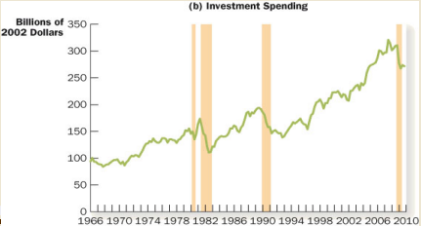
Fact #3: As output falls, unemployment rises big time
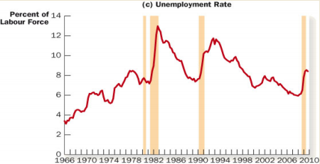
Model of Aggregate Demand (AD) and Aggregate Supply (AS)
-Designed to explain short-run fluctuations in equilibrium real GDP
-Long-run real GDP determined by levels of inputs and productivity
-->Treated in chapter 7
-->The short-run changes around that trend in long-run real GDP is the focus of this model
-->Quite a different approach than the classical approach
- Dichotomy of the real versus the money sector
- Neutrality of money
Figure 14.2: Aggregate Demand and Aggregate Supply
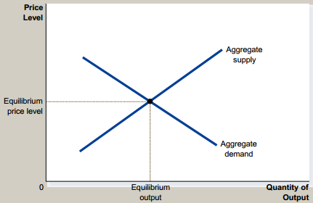
-Note that it does generate an equilibrium value for the composite price level P and the aggregate output level - real GDP
-Somewhat analogous to supply and demand model at the microeconomic level, but the foundations are different
-The aggregate demand curve really ought to be called the aggregate expenditure curve

Why Does the AD Curve Have a Negative Slope? (Hard)
-There are 3 different reasons
-If price increases (decreases)
-->Nothing happens to real GDP, as it is already adjusted for inflation
-->Real wealth decreases (increases)
-->Consumption spending decreases (increases)
-->GDP = C + I + G + NX decreases (increases)
-Where did we start and end this process?
-->If P increases, real GDP decreases
-->If P decreases, real GDP increases
-->There is the negative slope
-This shows two points on the AD curve
-->Figure 14.3
-This is called the wealth effect
-->There is a strong negative wealth effect occurring right now in the US economy, as house prices plummet, so does consumer wealth, and so does consumption spending
-Now for another reason
-If price increases or decreases
-->Real exchange rate appreciates (depreciates)
-->Net export spending decreases (increases)
-->GDP = C + I + G + NX decreases (increases)
-->This is the real exchange rate effect
-Interest rate effect mentioned in the text is hard
Figure 15.2 The Aggregate-Demand Curve
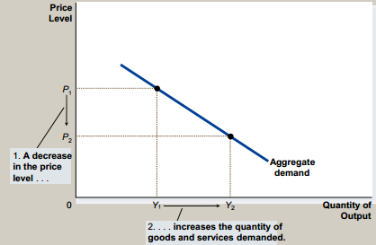
Interpretation of AD Curve
-AD gives the functional relationship between P and real GDP
-->This relationship is negative
-->All of the points are hypothetical
-->Tells NOTHING about Y (REAL GDP) that actually prevails

Shifts in the AD Curve
-Any factor except price which causes an increase in expenditure (I,X,G,C increases) will shift AD to the right
-->These are increases in injections
-Any factor except price which causes a decrease in expenditure (I,X,G,C decreases) will shift AD to the left
-->These are decreases in injections
-Any factor except price which causes (negative) expenditure to decrease Im,T,S decreases) will shift AD to the right
-->These are decreases in withdrawals
-Any factor except price which causes (negative) expenditure to increase (Im,T,S increases) will shift AD to the left
-->These are increases in withdrawals
-Interpretation of shifts
-->If an injection increases or a withdrawal decreases
- At each possible price level, there is a higher level of expenditure than before
-->If an injection decreases or a withdrawal increases
- At each possible price level, there is a lower level of expenditure than before
-Any change in P means move along the AD curve

Aggregate Supply
-2 types
-->Short-run (SRAS)
-->Long-run (LRAS)
-This distinction is HARD!
-The interpretation of this curve: the set of all combinations of P and GDP that firms are willing to produce
Figure 14.6 The Short-Run Aggregate-Supply Curve
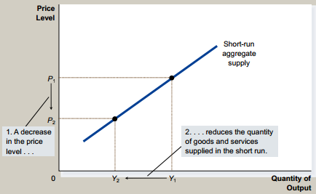
Why the SRAS Curve Has an Upward Slope (Hard)
-Just focus on the 'sticky-wage' theory
-Along any short-run aggregate supply curve, physical productivity and input prices are held fixed
-As P increases (decreases), it's more (less) profitable to produce, so GDP increases (decreases)
-There is a direct relationship between P and GDP (+ slope)
-I think that the textbook's treatment on pages 343-345 is MUCH more complicated than necessary
-Warning: Do not ever shift an AS curve due to a change in P

Shifts in SRAS Curve
-If productivity falls, and/or if input levels fall, and/or input prices rise, shift SRAS to the left
-If productivity rises, and/or input levels rise, and/or input prices fall, shift SRAS to the right
-Do NOT shift the SRAS curve due to a change in composite price

Long-run AS
-Is vertical in P-GDP space at "the natural rate" of output where production factors are fully employed
-The vertical form implies that there is no mathematical relationship between the two variables
Figure 14.4 The Long-Run Aggregate-Supply Curve
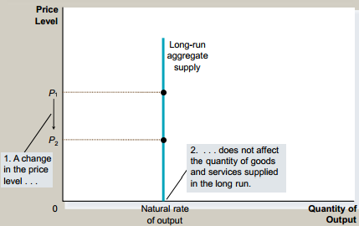
Why is the LRAS Vertical?
-The long-run equilibrium level for real GDP depends on the factor endowments of land, labour, capital, and the technology of production, which have nothing to do with the price level
-->Same thing as the neutrality of money theory, which is essentially the same thing as the classical dichotomy
-Mathematically, this means no relationship between P and the natural rate of output

Shifts in the LRAS Curve
-Natural rate of output also called potential GDP
-This is thought to be the long-run equilibrium for real GDP
-Same factors cause the LRAS to shift as the SRAS, except for changes in wages
-Do NOT shift the LRAS curve due to a change in composite price
-LRAS will expand (contract) , and the curve will shift to the right (left), if there is an increase (decrease) in any of the endowments of the factors of production, or if there is an improvement (deterioration) in the technology of production
-This thankfully, is exactly what occurs in Canada almost every year
-->The productive capacity of the economy expands
-->See figure 14.5

Equilibrium
-In equilibrium AD=SRAS, which means that the planned expenditures of consumers, investors, etc. are consistent with the production plans of firms at the equilibrium price (exam question - "explain what this means in economic terms")
-->Anywhere else and there is an imbalance, and we would expect a price adjustment
-The intersection of the 2 curves

Short-Run Equilibrium
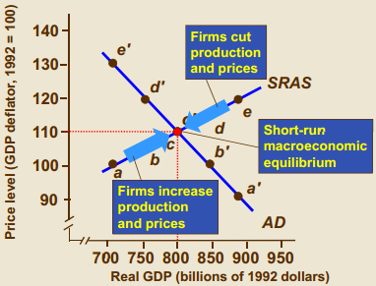

Figure 14.7 The Long-Run Equilibrium
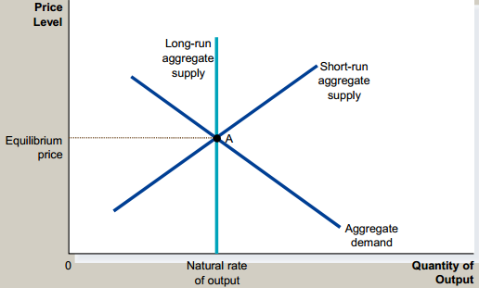

Applications of AD-AS Model: Macroeconomic Shocks (outcome will be good)
-Each time we will start at LR equilibrium, which means potential GDP
-AD shocks take the form of shifts in AD curve
-AS shocks take the form of shifts in SRAS curve
Case of a Negative Shock to AD (outcome will be bad)
-Suppose a contraction in AD, due to a stock market crash or a major terrorist attack
-->In 2008 and part of 2009, a HUGE negative shock to AD caused by a clogged-up, dysfunctional credit markets
-At each possible price level, spending goes down, so AD shifts to the left
-Leads to a lower equilibrium price and lower equilibrium quantity
-Economy enters a recession

Figure 14.8 A Contraction in Aggregate Demand
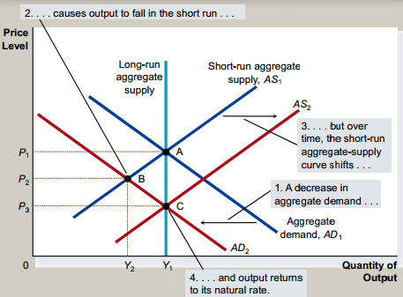
-Due to hard times, after a long adjustment period, there is downward pressure on wages
-This cause SRAS to shift to the right
-Equilibrium price decreases and equilibrium quantity increases
-Eventually, the recession ends, and real GDP grows back to its natural rate
-Read pages 354-357 (or 361-265), which covers a case study and is good stuff

Case of a Negative Shock to AS
-Suppose a contraction of SRAS, due to an energy shock price
-->2008 in the US
-->Japanese earthquake
-->9/11
-At each possible price, production costs rise, causing SRAS to shift to the left
-Equilibrium prices increase and equilibrium quantities decrease
-Called stagflation

Figure 14.10 An Adverse Shift in Aggregate Supply
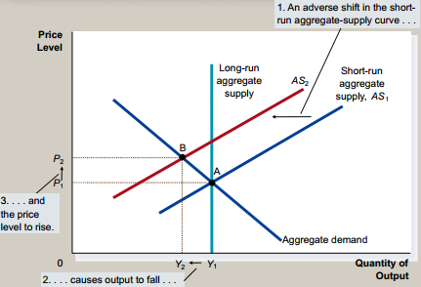
-One way to remedy the situation is for the government to cause an increase in AD
-AD shifts to the right
-Equilibrium price increase and equilibrium quantity decreases
-End up with even higher prices than before, but the economy is back to its natural rate of output
-Read case study pages 358-360

Figure 14.11 Accommodating an Adverse Shift in Aggregate Supply
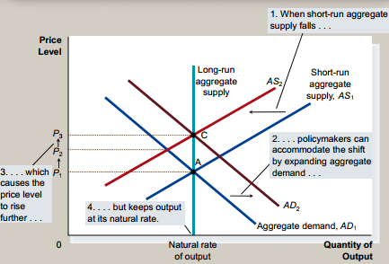

Chapter 15 "The Influence of Monetary and Fiscal Policy on Aggregate Demand"

What is Stabilisation Policy?
-Deliberate, conscious effort of the government to intervene in the macroeconomy with an eye toward influencing the course of Equilibrium P or Q (real GDP)
-Fiscal policy is carried out by finance departments, and involves changing T and/or G
-->www.fin.gc.ca
-->www.fin.gov.on.ca
-Monetary policy is executed by the Bank of Canada
-Both of them operate through shifts in the AD curve

The Money Market Revisited
-Back to the money market, with the supply and demand for money holdings
-The theory of liquidity preference is related to the money demand curve
-NOT to be confused with the market for loanable funds in chapter 8
-->There the central decision was how much of nation income FLOWS go to saving and investment as opposed to consumption spending
-Now the decision is in what form to hold the STOCK of wealth
-->In a liquid form (cash) or in an illiquid form (bonds)
-This is sort of like the depiction of the money market presented in chapter 11
-->There the equilibrium variable is the composite price level P
-This time we are after the equilibrium rate of interest
Figure 15.1 The Supply of Money
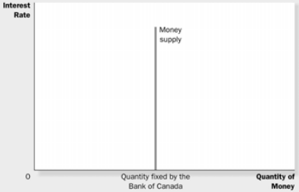
-The money supply is determined entirely by the Bank of Canada, and its magnitude depends on its monetary policy and not the interest rate
-Since there is no relationship between the interest rate and the supply of money, the money supply curve is vertical in interest rate-quantity of money space
Figure 15.2 The Demand for Money
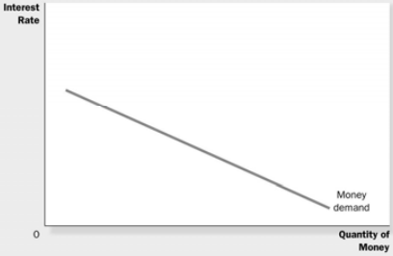
-The demand for money is thought to depend on the interest rate more than anything else
-There is a negative relationship, so the slope of money demand is negative
-->The opportunity cost of holding money is the interest that you could have earned by placing it in an illiquid asset. Holding cash pays nothing
-->As this cost (which is the interest rate) increases, the quantity demanded of money decreases, and vice versa
-->In other words, when interest rates are very low, you do not lose much by holding most of your portfolio in cash
-->When interest rates are high, you do lose a lot by holding most of your portfolio in cash, and you are tempted to place as much of it in interest bearing assets as possible
-The money demand curve shifts to the right if there is either an increase in P or an increase in real GDP
-->Either of these changes mean that people want to hold more money in liquid form at each possible interest rate because they need to finance a higher level of purchases than before
-If shifts to the left given a decrease in P or a decrease in real GDP

Final Exam*Depict the money market, the version with the liquidity something schedule and the money supply, explain how an equilibrium is reached-->DO NOT SHIFT CURVE unless there is an increase/decrease in composite price level or real GDP. Instead, move along the curve*

Figure 15.3 Equilibrium in the Money Market
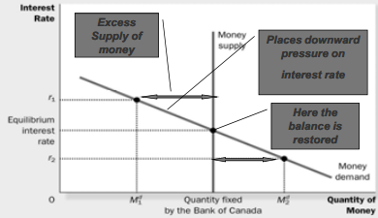
-Equilibrium occurs at the interest rate where the quantity demanded = quantity supplied
-If the interest rate is higher (like r1), then there is excess supply of money, downward pressure on interest rates, causing the quantity demanded of money to rise, moving it back toward equilibrium quantity supplied
-If there interest rate is lower (like r2), then there is excess demand for money, upward pressure on interest rates, causing the quantity demanded of money to fall, moving it back toward equilibrium quantity supplied

Impact of Monetary Policy on the Macroeconomy
-Like figure 15.6
-If the goal is to stimulate the macroeconomy:
-->Buy bonds, expand quantity of money which circulates, MS shifts right, equilibrium rate of interest falls
- Not all in the money market
-->Now the transmission to the G&S market: I and C spending increase, AD shifts right, equilibrium P and GDP increase
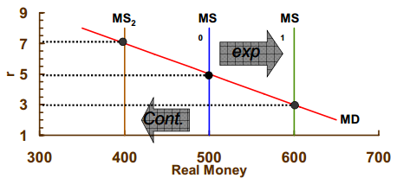
Cont = contraction and Exp = expansion
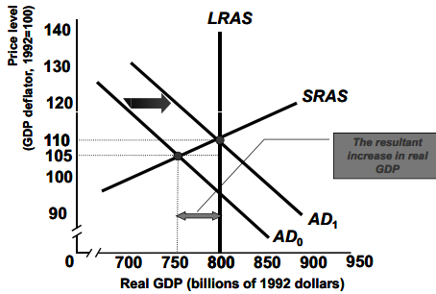
-->This is "loose money" in action (popular and current)
-If the central bank deems that inflation is a risk, it will implement a restrictive monetary policy
-->Sell bonds, contract quantity of money which circulates, MS shifts left, equilibrium rate of interest rises
-->Now the transmission to the G & S market: I and C spending decrease, AD shifts left, equilibrium P (we experience a deflation) and GDP decrease
-->This is "tight money" in action, which is very unpopular

Monetary Policy in the Open Economy
-->We now also consider imports and exports
-HARD
-Figure 15.7
-->The textbook's treatment is more complicated than necessary
-If MS goes up, interest rate goes down
-Due to the lower interest rate, financial capital flows out
-Canadian dollar depreciates
-NX rise (when the Canadian dollar is weak, exports go up, and imports go down)
-AD shifts to the right
-So AD expands for two reasons:
-->Lower interest rates cause I and C to rise (Domestic channel)
-->Lower interest rates cause a weaker Canadian dollar, which in turn causes NX to rise (International trade channel)

History of Monetary Policy
-1988-1992; early 1980's very tight money
-->Contraction in money supply
-->High interest rates (expensive credit)
-->Lower I and C spending, high unemployment
-->Disinflation (a lower rate of inflation)
-->Extremely unpopular
- People were hanging effigies of John Crow
-Late 1960's, early 1970's, first half of 2000's easy money, 2009 until now
-->Expand money supply
-->Low interest rates (cheap credit)
-->Now coined "quantitative easing"
-->Higher I and C spending, low unemployment
-->Possible breeding ground for inflation
-->Extremely popular
- Extended political life of Richard Nixon (President of the USA)

Recap of How Policy Works
-The interest rate is the link between activity in the money market and activity in the market for goods and services
-What happens on Bay Street (the money market) affects what happens on Main Street (the G&S market)
-2 channels which you should know
-->From the money market to I and C to AD
-->From the money market to the XR to NX and AD
-Money supply expands, r goes down, I increases, AD shifts to the right, Y increases, P increases
-->Monetary expansion causes...
-->Positive AD shock
-Money supply contracts, r goes up, I decreases, AD shifts to the left, Y decreases, P decreases
-->Monetary contraction causes...
-->Negative AD shock
-r goes up, demand for financial assets (stocks, bonds, etc) denominated in CN$ shifts right, the loonie appreciates, X fall, IM rise, AD shifts to the left
-r goes down, demand for financial assets (stocks, bonds, etc) denominated in CN$ shifts left, the loonie depreciates, X rise, IM fall, AD shifts to the right
-The two transmission mechanisms always work in the same direction
-->A fall in the interest rate is always expansionary
-->An increase in the interest rate is always contractionary
-For both transmission mechanisms, do synthesize, do conceptualize, don't memorize

Fiscal Policy
-To stimulate AD, the government either increases G and/or cuts taxes
-->Causes AD to shift to the right
-To contract AD, the government either decreases G and/or raises taxes
-->Causes AD to shift to the left

