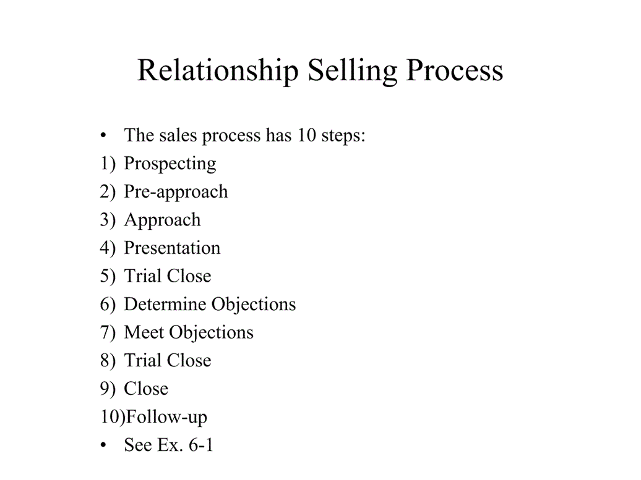
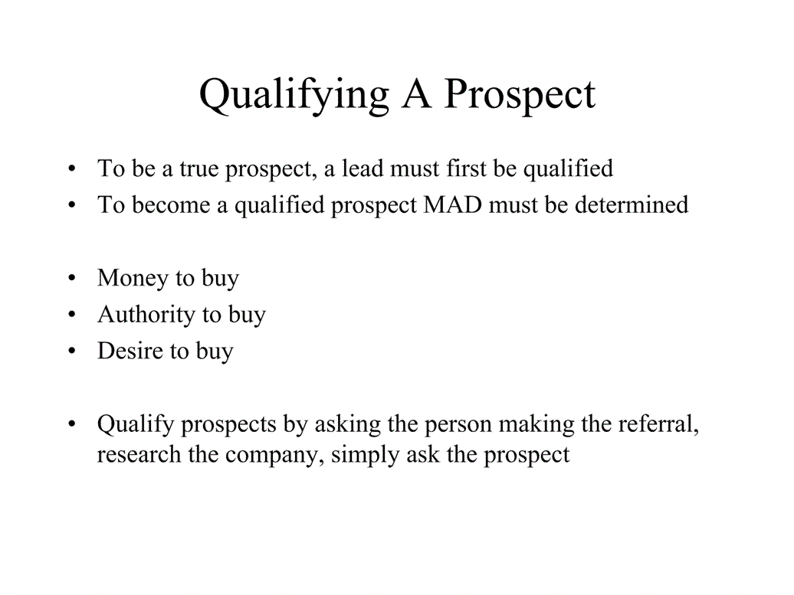
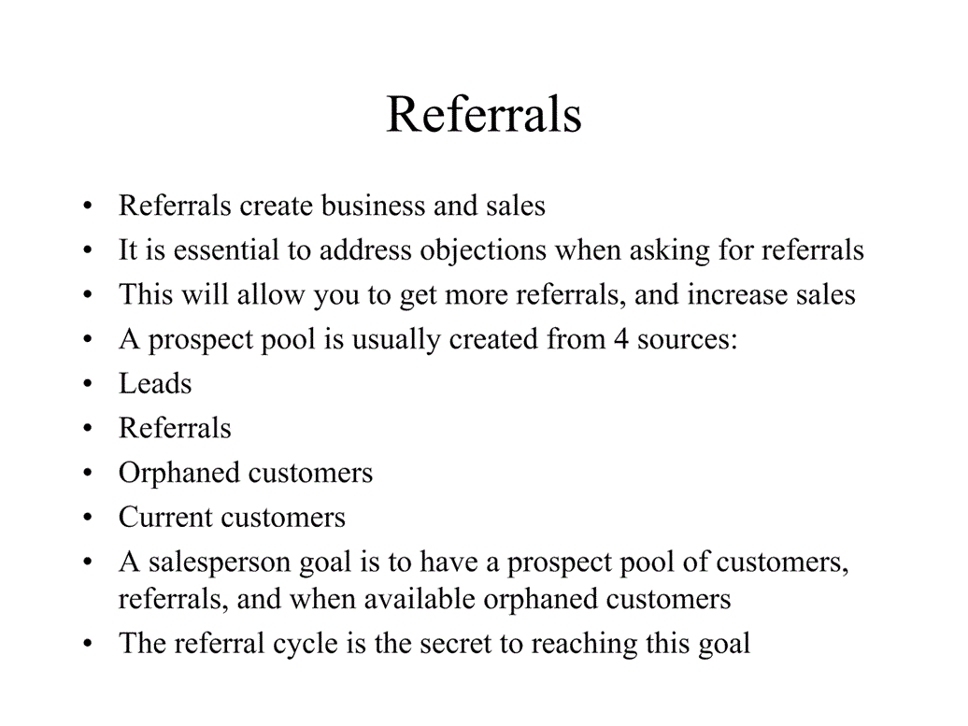
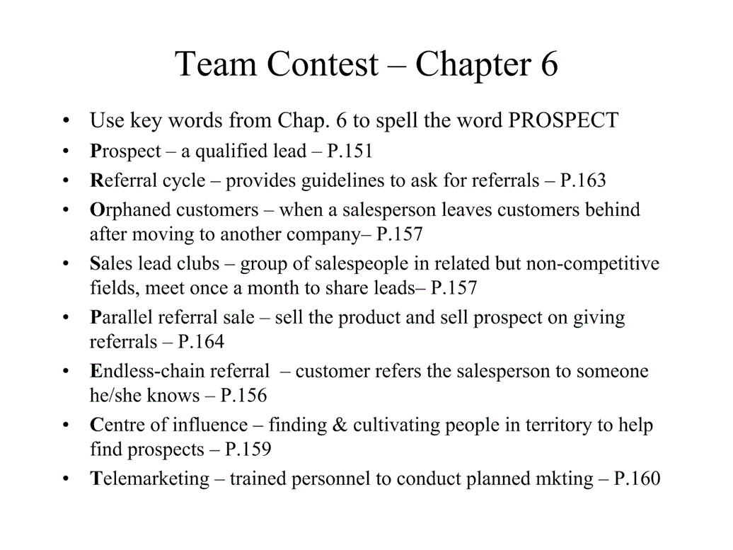
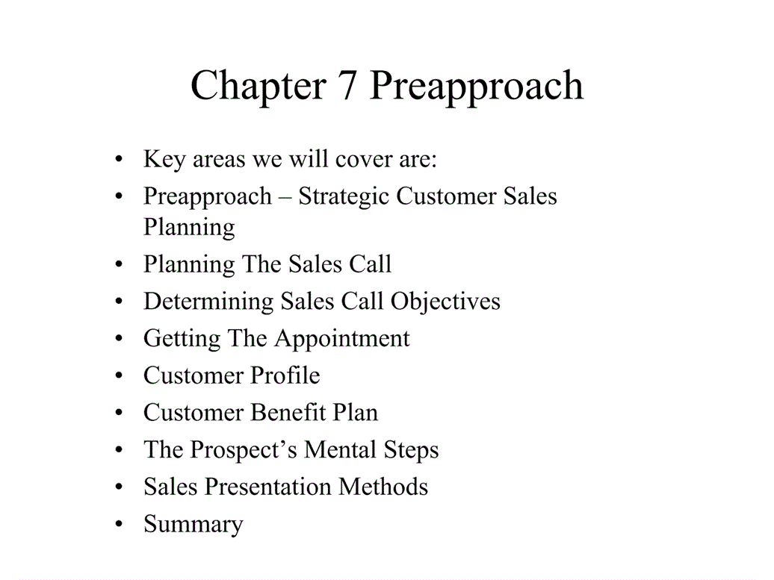
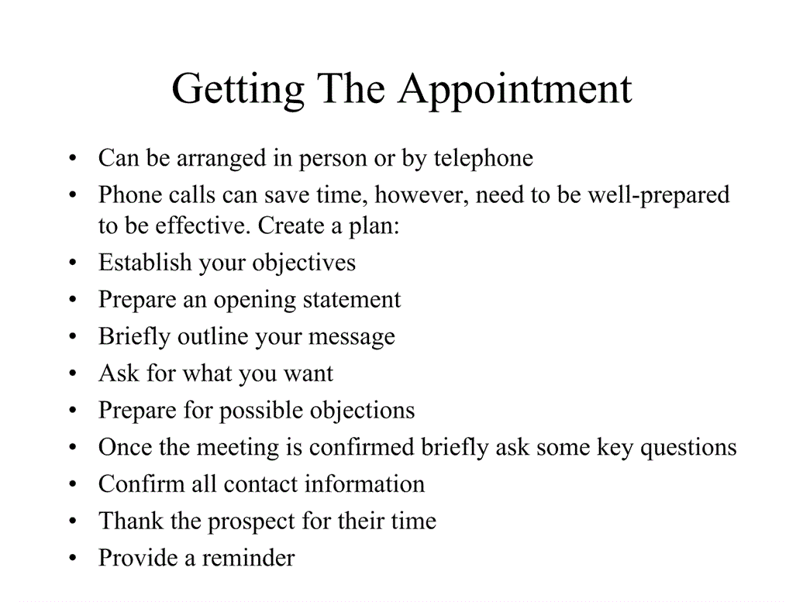
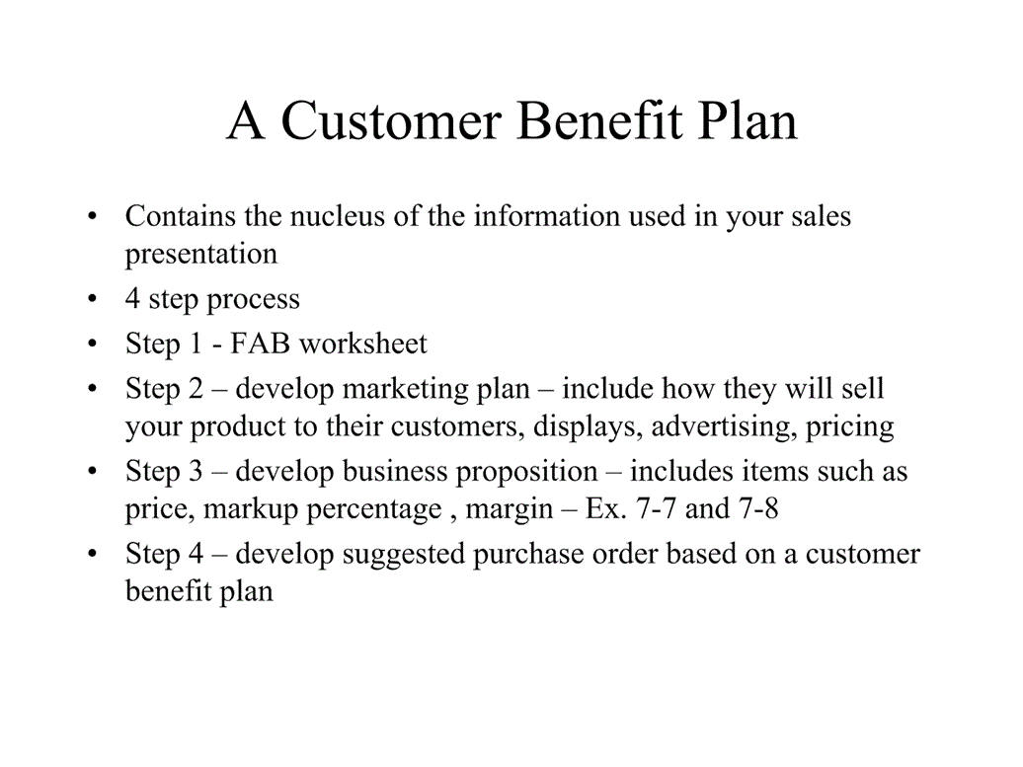
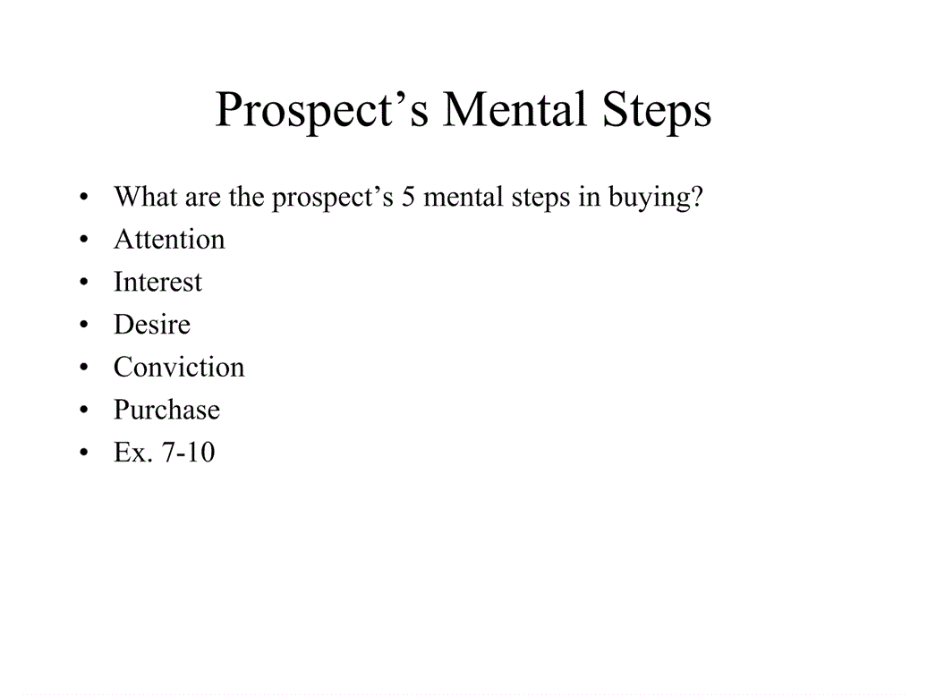
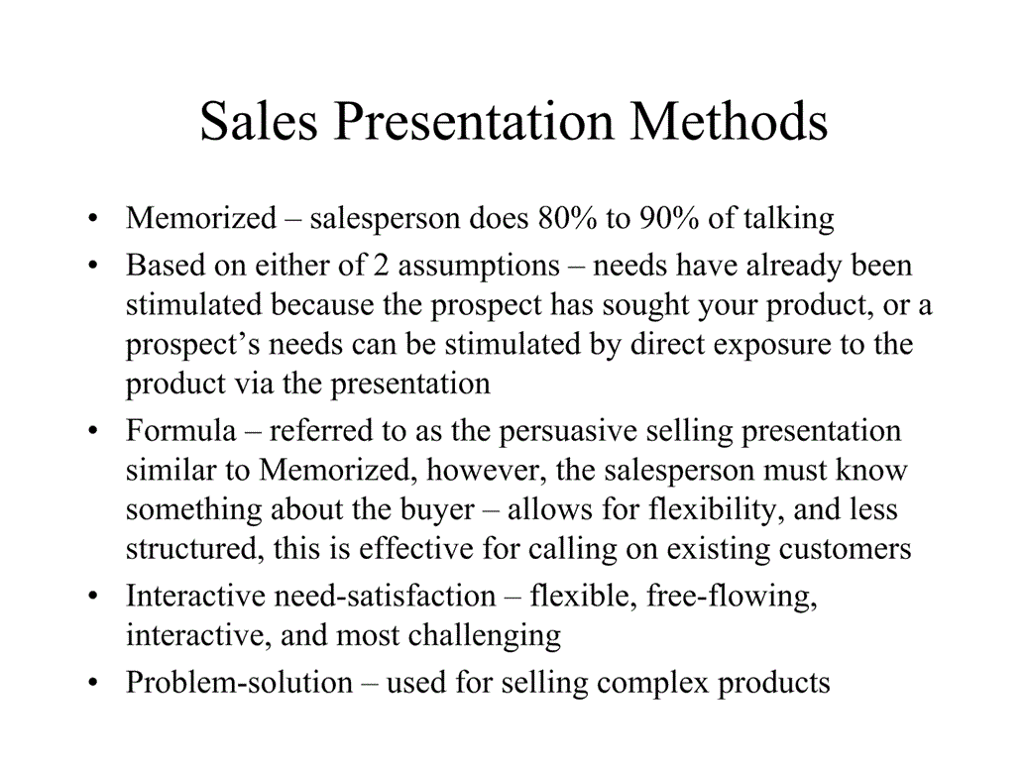
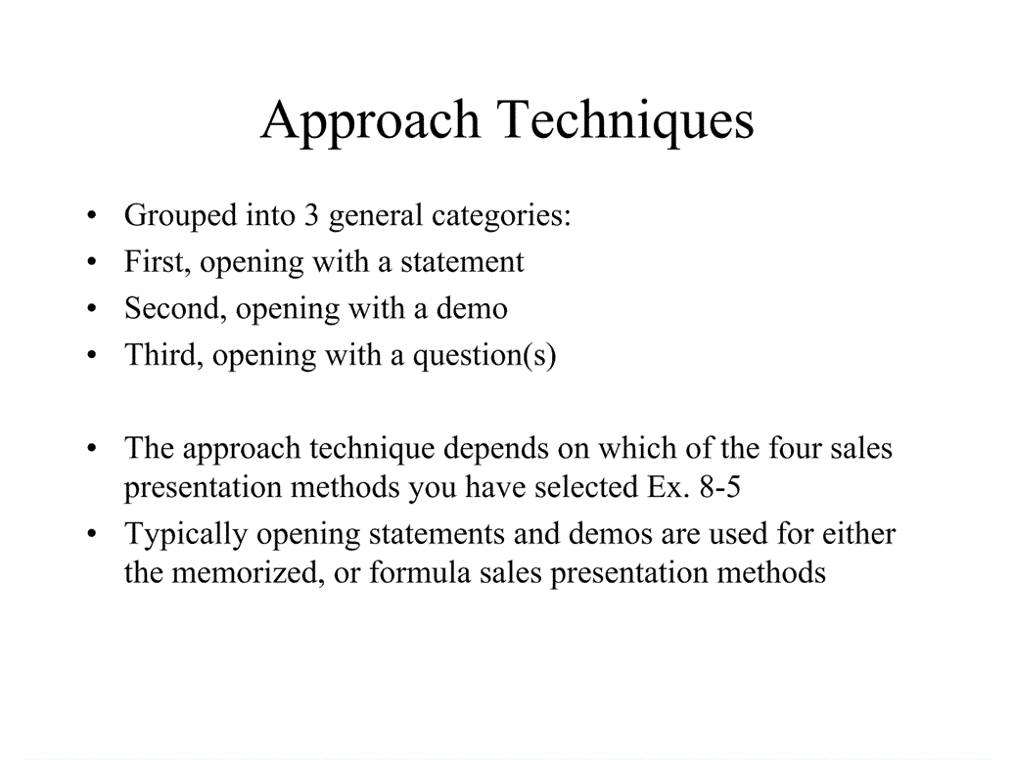
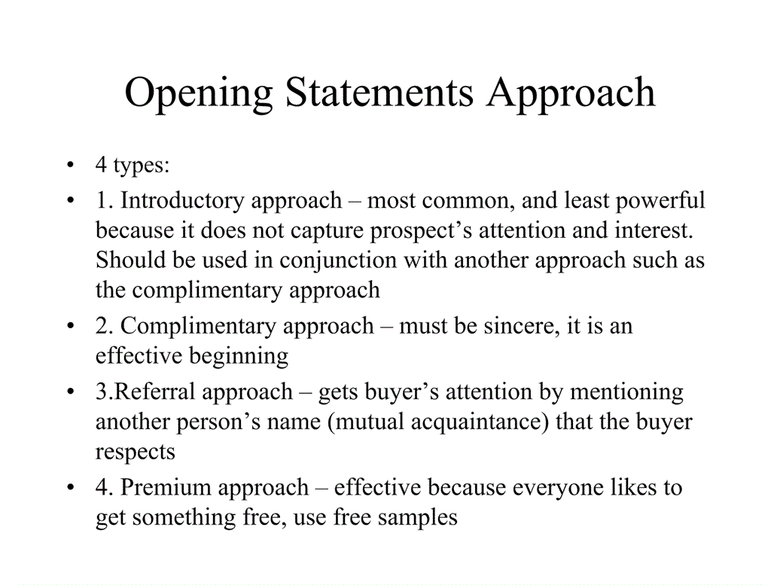
Question approaches can be: customer benefit approach, curiosity approach and opinion & shock approach (asking for customers opinion)
Direct, open ended, rephrasing and redirect questions
Use questions that are easy to answer, pause so the ca answer and listen

5 purposes of presentation = knowledge, beliefs, desire, attitude and conviction
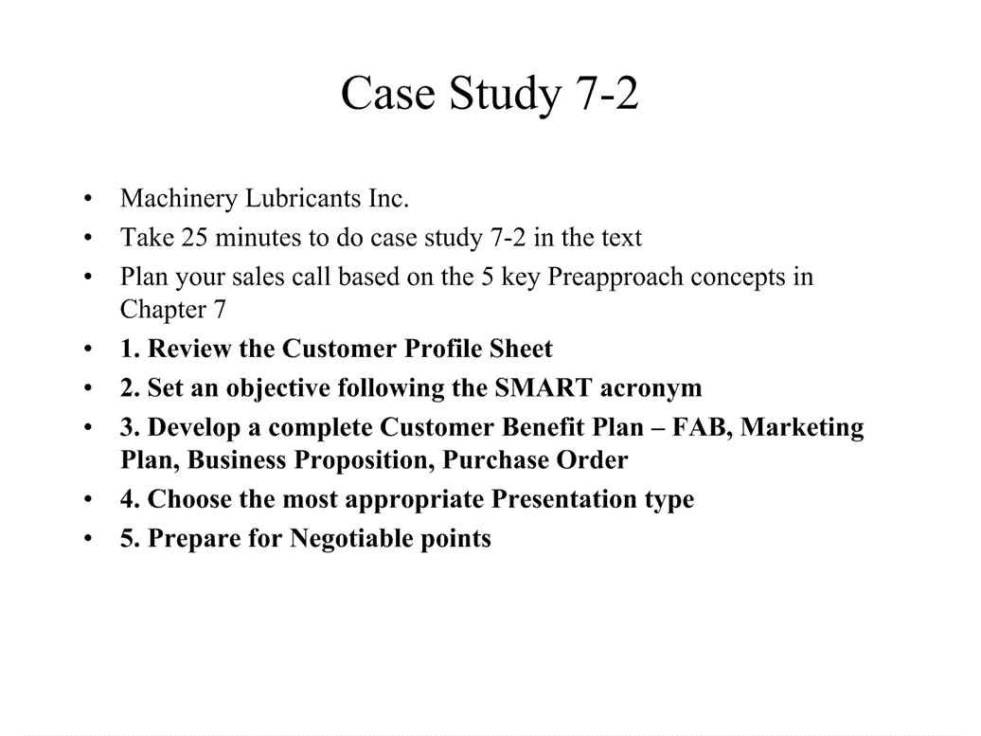
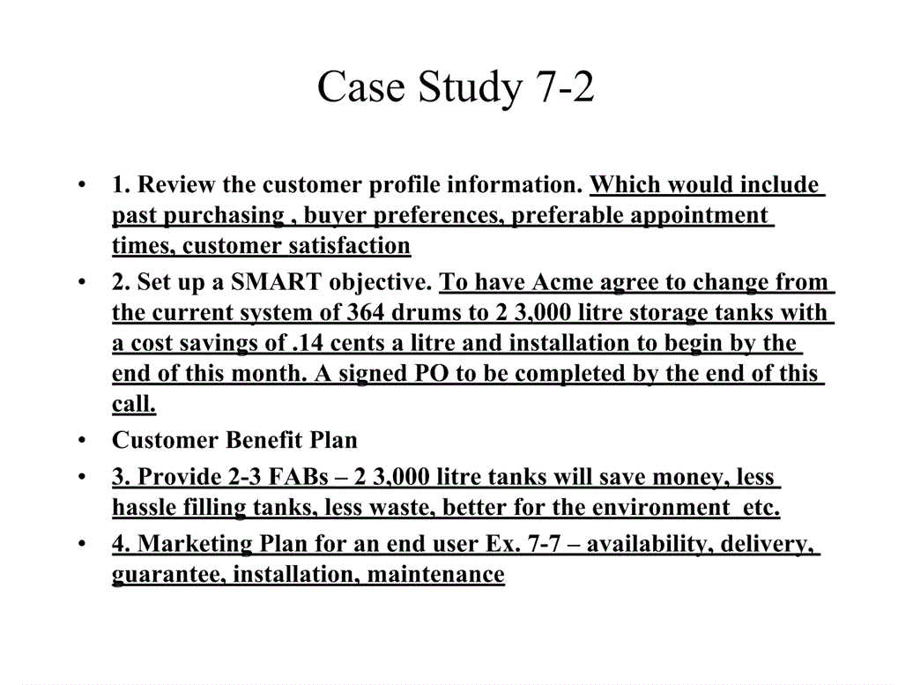
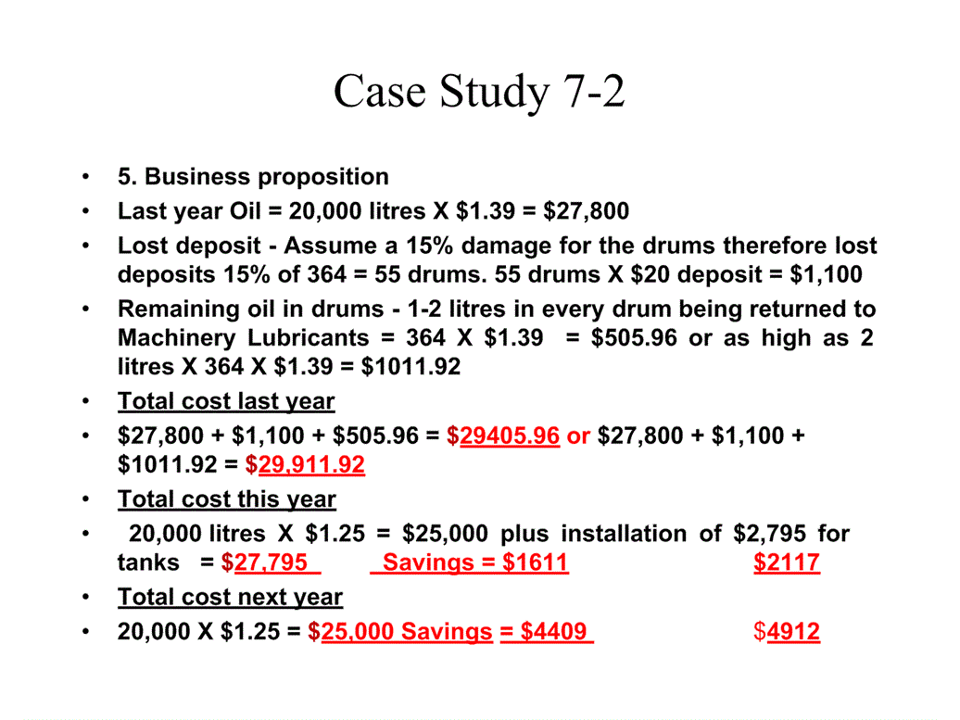
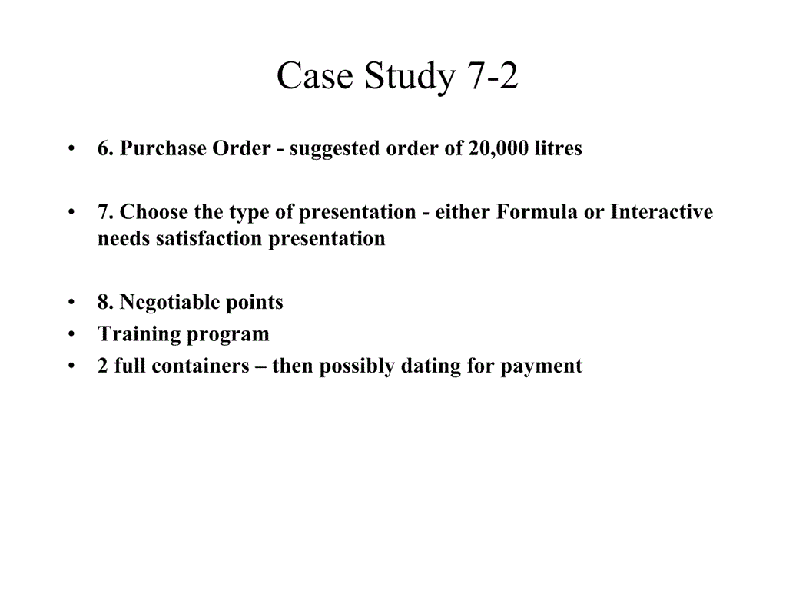
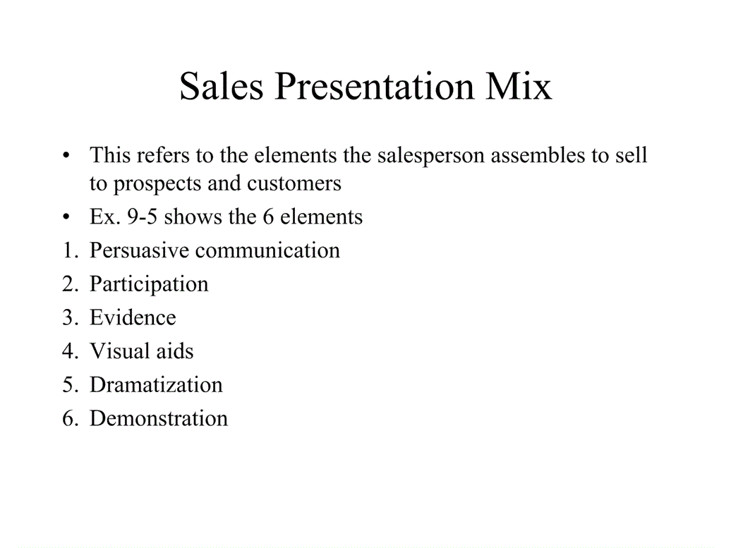
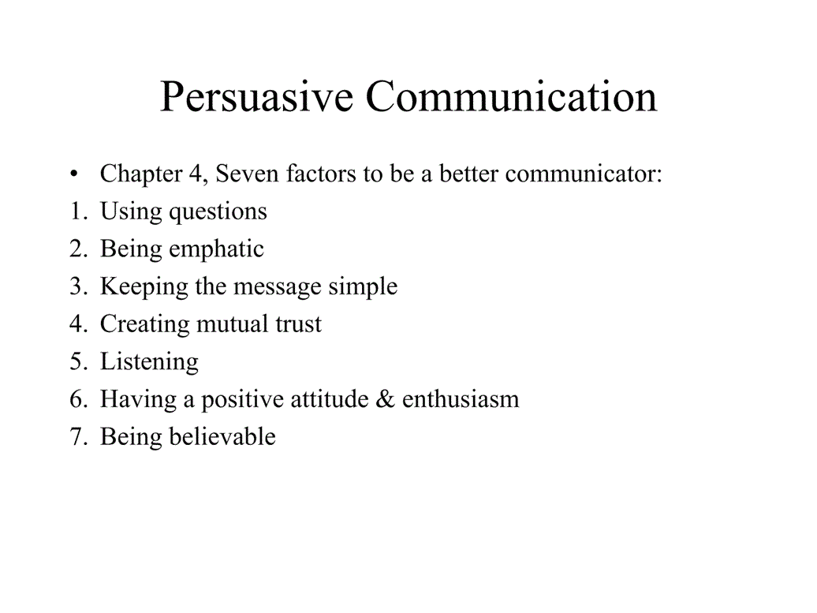
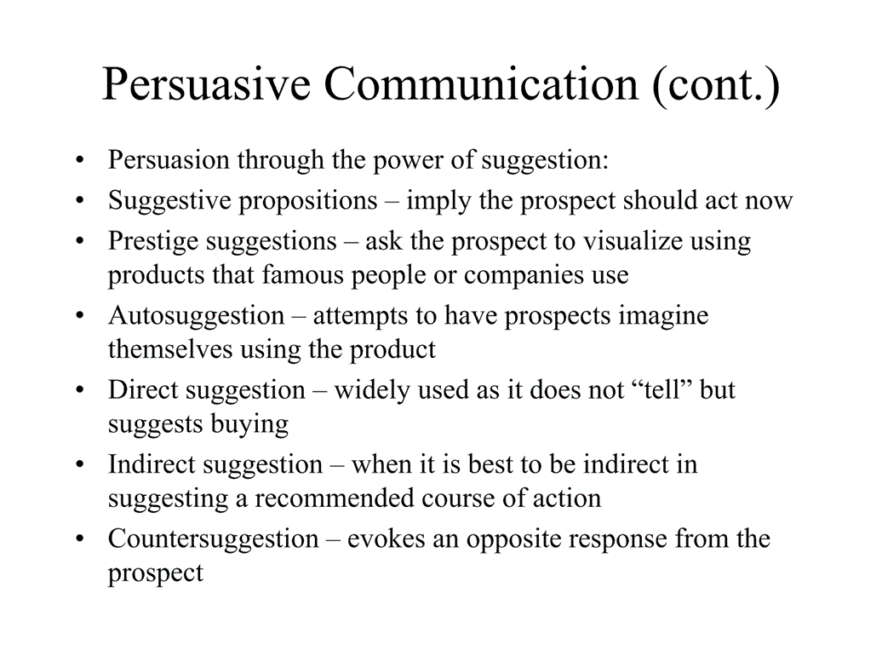
Use evidence statements: Testimonials, company’s past history, independent research results a guarentee
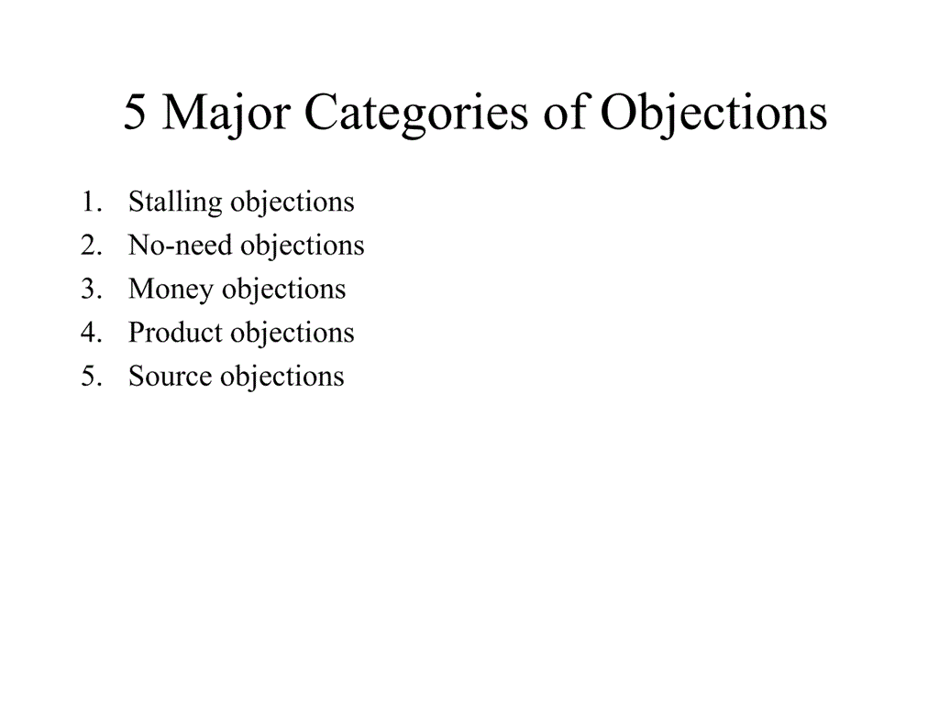
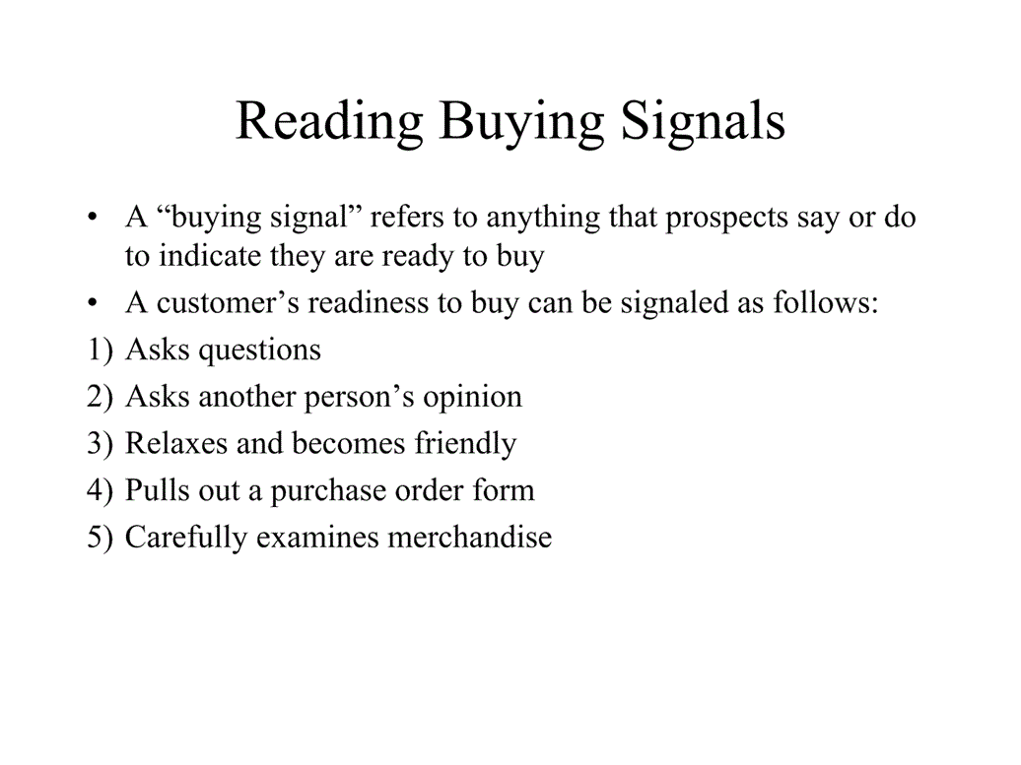
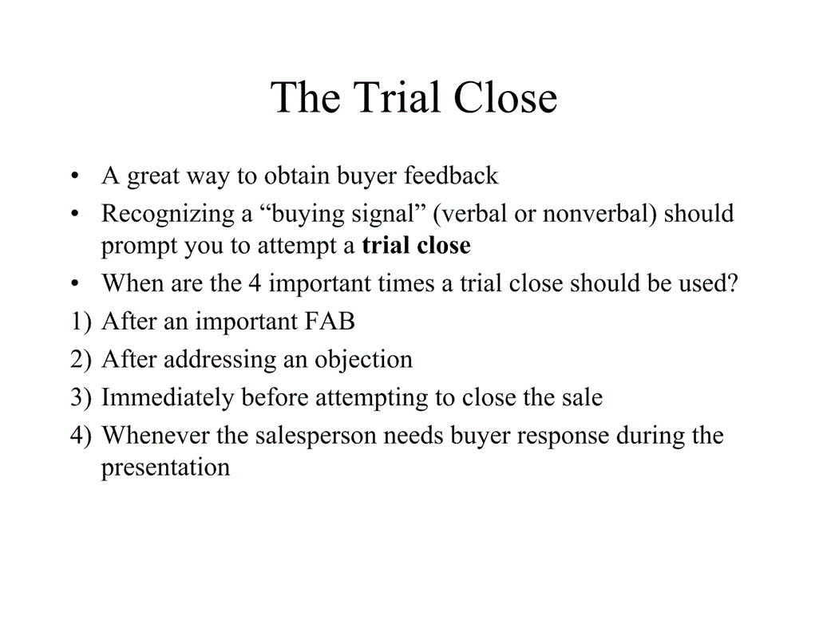
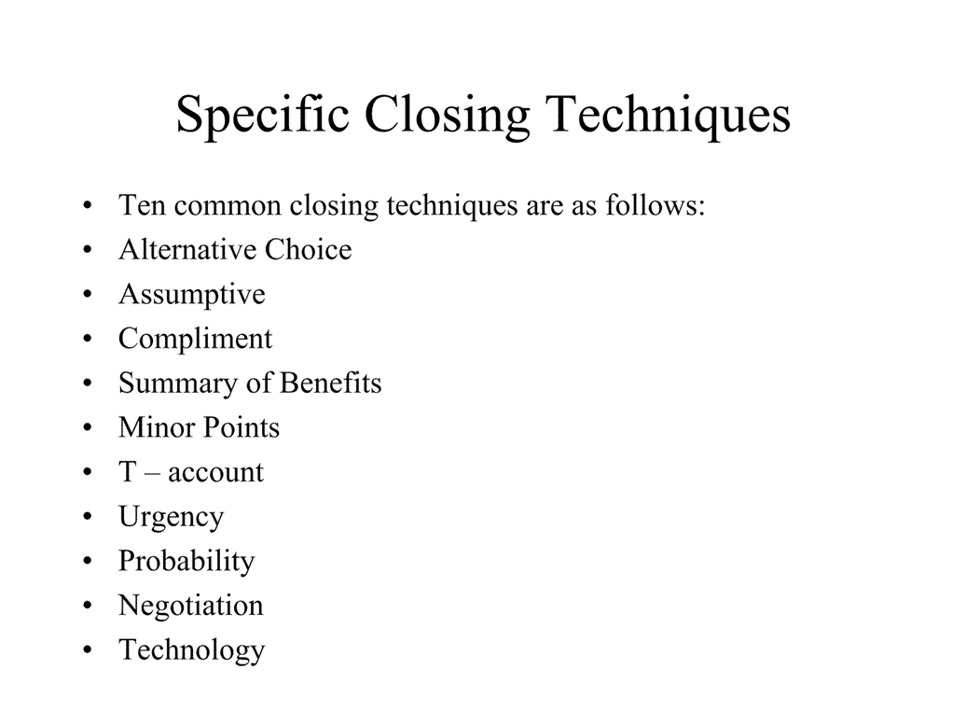
For analytical buyer always provide pros aswell as cons. Lots of research. Do you agree with our facts and figures? Do you want me to clarify any details. Only talk factual business related.
Feeler presentation: chat until they que the start of the presentation. Try to meet informally coffee/lunch. Use emotional terms like “im excited.” Start with something carried over from previous presentations. Keep the presentation on a personal note. Push the decision, force the close.

Approaches: statements; introductory, complimentary, referral, premium. Questions; customer benefit, curiosity, opinion, shock, multiple question


