BIO 1A03 Applied Lecture #2 – Cystic Fibrosis

Importance of protein folding analogy:

- Animation of a robot “transforming” into car, the whole point is that every part of a protein has to fold correctly to occur

What is Cystic Fibrosis?

- The most common fatal disease (1/3600 children born in Canada)
- Many effects, but mainly gastrointestinal and respiratory
Symptoms:
- Peristent cough
- Thick mucus production (causes obstruction, hard to clear pathogens)
- Wheezing, shortness of breath
- Chest infections/Pneumonia
- Bowel Disturbances (e.g obstruction of pancreas/liver leading to malabsorption)
- Salty “tasting” sweat
- This chronic persistence of symptoms and bacterial infections leads to the destruction of the lungs (most prevalent cause of death)
- Current life expectancy ~40
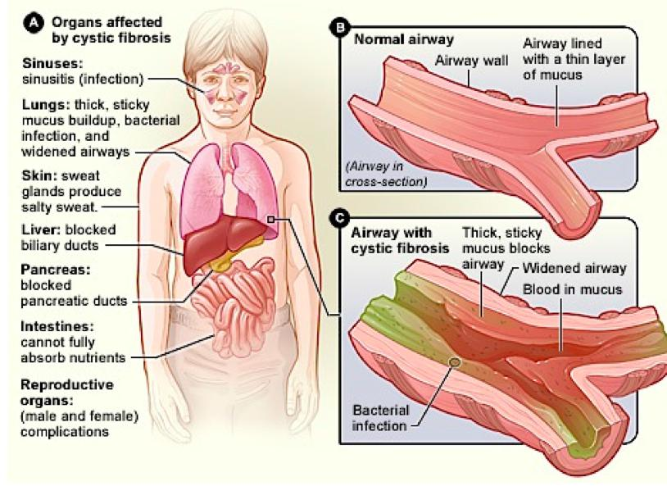

Mucus clearance is essential for respiratory health:

- Two main cells, ciliated cells and goblet cells
- Normally there is an airway surface liquid on top of these layers
- This allows the cilia on the ciliated cells to beat away the mucus that is created by the goblet cells
- This mucus has dust particles/bacteria
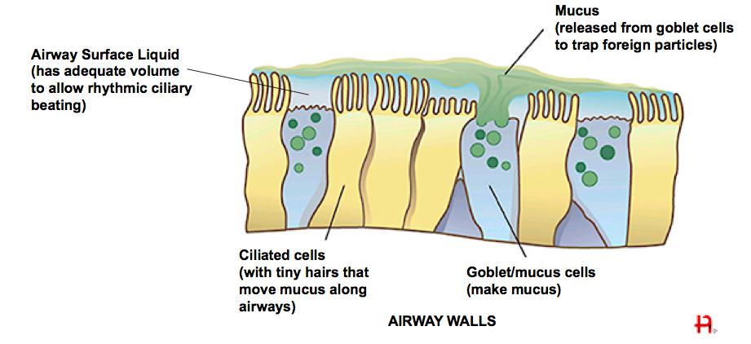
Mucus clearance is essential for respiratory health:

- Airway surface liquid should have adequate volume to allow rhythmic ciliary beating and allow for mucociliary transport
- (High resolution microscopy with illumination animation showing this autonomic rhythmic beating)

Cystic fibrosis transmembrane conductance regulator (CFTR):

- A mutation of this gene is responsible for Cystic Fibrosis and is expressed on the long (q) arm of chromosome 7
- Basically normally the gene gets transcribed, sent out as mRNA, and translated via ER-bound ribosome, also folds with chaperone assistance
- Protein transported to the apical membrane of cells lining airway
- It then facilitates the transport of Cl- ions across the epithelial membranes to the lumen
- Airway surface liquid height and mucus hydration mediated by a balance between Na+ (sodium) and Cl- (Chloride) transport across the apical (surface facing the lumen of a tube like structure) of epithelial cells
- Normally water tends to accompany

CFTR channels are important for airway clearance:

- Mucus transport is the primary lung defense mechanism and it fails in patients with cystic fibrosis
- Chloride excretion is not working in CF but Na+ is constantly up taking sodium (Na+) and water follows
- Water is following because the inside of the cells become hypertonic (hyperabsorption of water)

Mutations of CFTR gene leads to cystic fibrosis:

- Over 1900 disease associated mutations
- Deletion of phenylalanine at amino acid residue 508
- Most common mutation accounting for over 2/3rds of patients
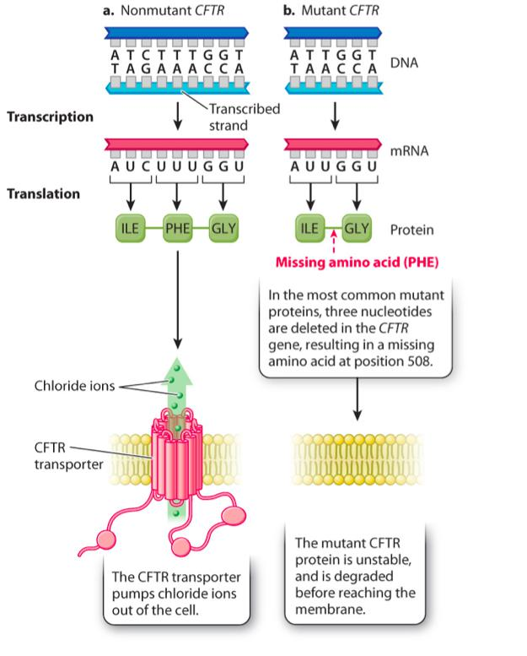

Understanding cystic fibrosis:

- CFTR mutations that cause cystic fibrosis can affect the number and function of CFTR channels at the channel surface

Outcomes of mutations in the CFTR gene:

- CFTR is normally synthesized in the rough ER, modified in the Golgi apparatus and is embedded in the cell membrane
Outcome:
- CFTR is degraded intracellularly (no protein transported to the cell membrane, most severe form of disease)
- Abnormal protein is processed and is embedded in the cell membrane but functions abnormally

Mutations in CFTR gene result in mucus buildup:

- Reduced quantity and/or reduced function of CFTR in apical membrane leads to hyperabsorption of Na+ and H2O

(Gene Therapy Video):

- Video discusses the case of a young girl who is suffering from CF who two weeks later died. And Discusses the general idea of using gene therapy to treat CF as it is the CFTR gene which is directly effected

Pharmacological Intervention:

- Some drugs work similarly to chaperones to fold and locate CFTR to cell surface (this is not perfect and it is frequently seen that the drug-treated CFTR is not anchoring well on the membrane)
- Others improve CFTR’s Cl- transport function
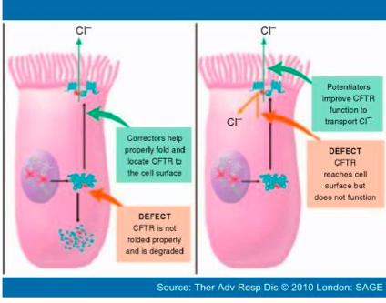

McMaster Research:

- Dr. Michael Surette investigating microbial interactions
- Sees that bacteria is typically considered to be good when located in the nose and throat and become hazardous for CF patients when combined with bad bacteria in the lower areas in the lower airways

