ECON 1050 Final Exam Review: Chapters 3-8, 10-17
Chapter 3 - Demand and Supply
Markets and Prices
- Markets have two sides: buyers and sellers ○ A competitive market is a market with many buyers and sellers, so no single buyer can influence the price
- - Money price is the number of dollars that must be given in exchange for an object
- - Relative price is the ratio of one price to another
  - ○ Relative price is an opportunity cost
  - ○ Supply and demand model uses relative price in relation to the average price of other goods and services Demand
- Demand:
○
If you demand something, then you:
▪ Want it
▪ Can afford it
▪ Plan to buy it ○
○
is the amount that consumers plan to buy at a given price, and refers to a point on the demand curve/the quantity demanded at a particular price
▪ Does not necessarily mean the actual amount bought, as the quantity supplied might not equal the quantity demanded
Demand is the entire relationship between the price and the quantity demanded of a good
The quantity demanded
- - Law of demand states "other things remaining the same, the higher the price of a good, the smaller the quantity demanded; and the lower the price of a good, the greater the is the quantity demanded"
  - ○ Substitution effect: when the price of a good rises, its relative price (OC) rises because consumers can switch to cheaper substitutes
  - ○ Income effect: When a price rises, the price rises relative to income
- - Change in demand occurs when any factor that influences buying plans, except the price of the good, changes ▪ The prices of related goods ▪ Expected future prices ▪ Income
  - □ Normal goods - demand increases as income increases
  - □ Inferior goods - demand decreases as income increases ▪ Expected future income and credit ▪ Population ▪ Preferences
  - ○ A shift right is an increase in demand
  - ○ A shift left is a decrease in demand
- - Substitutes are goods that can be used in place of another good
- - Complements are goods that are used in conjunction with another good Supply
- Supply:
○
○ ○
○
a good, the smaller is the quantity supplied"
- Change in supply occurs when any factor that influences selling plans, other than the price of the good, changes
- ▪ The prices of factors of production
- ▪ The prices of related goods produced
- ▪ Expected future prices
- ▪ The number of suppliers Screen clipping taken: 17/10/2013 12:27 AM
- ▪ Technology
- ▪ The state of nature
If a firm supplies a good or service, the firm: ▪ Has the resources and technology to produce it ▪ Can profit from producing it ▪ Plans to produce and sell it
is the amount of a good that producers plan to sell at a particular price, and refers to a point on the supply curve ▪ Not necessarily the same as the amount sold, as the quantity supplied is not always equal to the amount demanded
Supply is the entire relationship between the price of a good and the quantity supplied
The quantity supplied
The supply curve can be interpreted as a minimum-supply-price curve - Law of supply states "other things remaining the same, the higher the price of a good, the greater is the quantity supplied; and the lower the price of
ECON 1050 Final Exam Review Chapters 3-8, 10-17 Page 1
- ○ A shift right is an increase in supply
- ○ A shift left is a decrease in supply Market Equilibrium
- 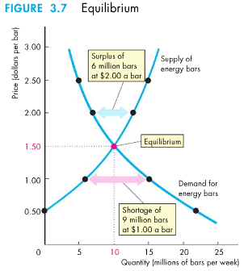
- Prices shift towards equilibrium
- ○ A shortage (Qd>Qs) increase the price
- ○ A surplus (Qd<Qs) decreases the price Chapter 4 - Elasticity
- Elasticity is a units-free measure of the responsiveness of the quantity demanded of a good to a change in its price, when all other influences are the same
- ○ Elasticity > 1, elastic
- ○ Elasticity = 1, unit elastic (at middle of curve)
- ○ Elasticity < 1, inelastic
- 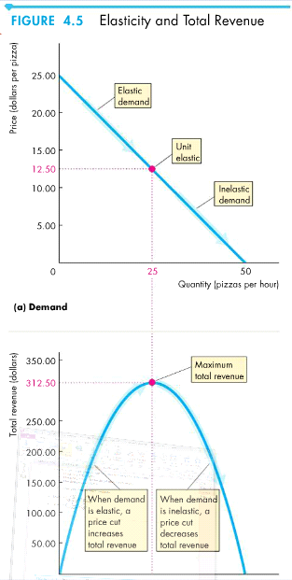
○ Steeper slope = more inelastic Price Elasticity of Demand
ECON 1050 Final Exam Review Chapters 3-8, 10-17 Page 2
Price Elasticity of Demand
- -
- - If a price cut increases total revenue, demand is elastic
- - If a price cut decreases total revenue, demand is inelastic
- - If a price cut leaves total revenue unchanged, demand in unit elastic
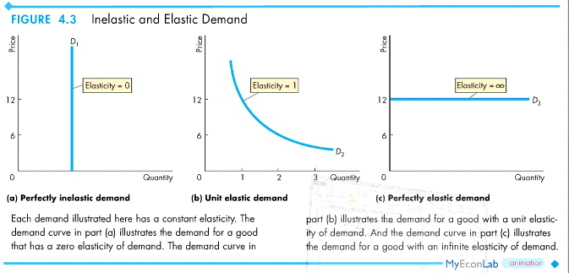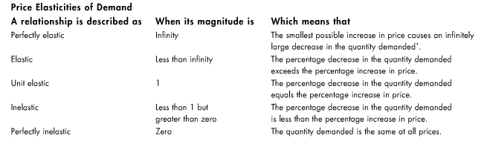
Price Elasticity of Supply
-
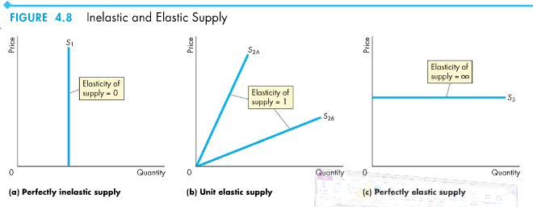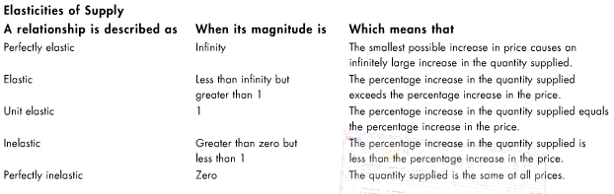
Cross Elasticity of Demand
ECON 1050 Final Exam Review Chapters 3-8, 10-17 Page 3
-
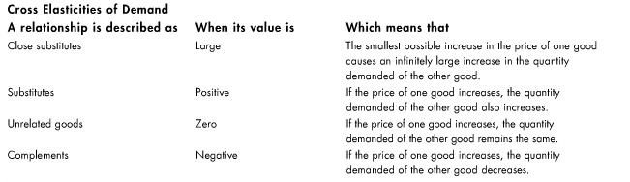
Income Elasticity of Demand
-
Chapter 5 - Efficiency and Equity
Resource Allocation Methods
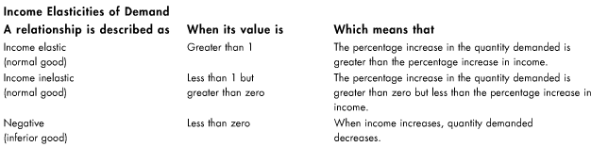
-
Resources are allocated by:
- ○ Market price ▪ People who are willing and able to pay that price get the resource
- ○ Command ▪ Allocation by someone in authority
- ○ Majority rule ▪ Allocation by voters choice
- ○ Contest ▪ Allocates sources to a winner (or group of winners)
- ○ First-come, first-served ▪ Allocates to those who are first in line
- ○ Lottery ▪ Allocates to those who pick the winning number, draw the lucky card, etc.
- ○ Personal characteristics ▪ Allocates to those with the "right" characteristics
- ○ Force There is a distinction between value and price
-
- -
○ ○
○
Value is what we get Price is what we pay
is the relationship between the price of a good and the quantity demanded by one person is a relation between the price of a good and the quantity demanded by all buyers
The horizontal sum of all the individual demand curves
Individual demand
Market demand
ECON 1050 Final Exam Review Chapters 3-8, 10-17 Page 4
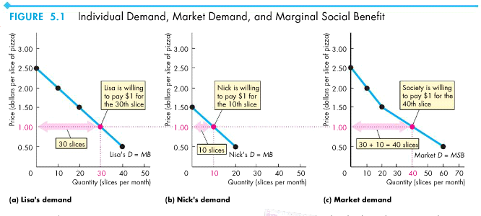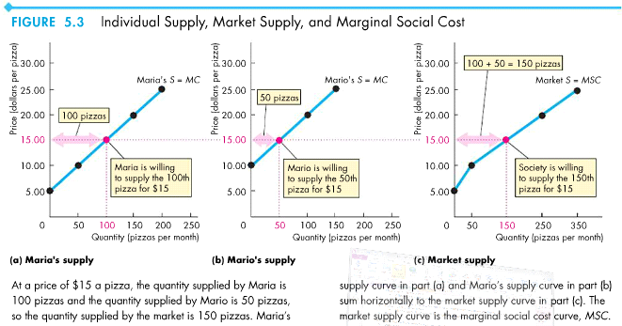
Benefit, Cost, and Surplus
- Producer surplus is the excess amount received from the sale of a good or service over the cost of producing it (profit) ○ The difference between price and supply
- Consumer surplus is the excess of the benefit received from a good over the amount paid for it ○ The difference between price and demand
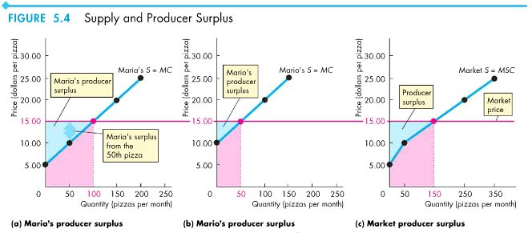
ECON 1050 Final Exam Review Chapters 3-8, 10-17 Page 5
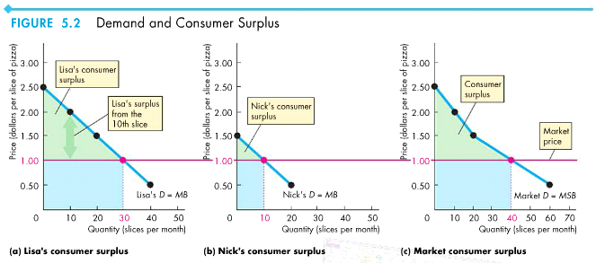
- As stated before, ○
Is the Competitive Market Efficient?
- Total surplus is the sum of consumer surplus and producer surplus ○ Total surplus is maximized when an efficient quantity is produced (equilibrium)
- Market failure occurs when when there is an inefficient outcome to a market
- ○ This happens when there is either overproduction or underproduction
- ○ The scale of inefficiency is measured by the deadweight loss
- ○ Sources of market failure: ▪ Price and quantity regulations
□ Price caps and limits
▪ Tax and subsidies ▪ Externalities
□ A cost or benefit that affects someone other than the seller or buyer ▪ Public goods and common resources
□ Good or service consumed by everyone even if they don't pay for it ▪ Monopoly
□ Sole provider of a good or service ▪ High transactions costs
□ The costs of the services that enable a market Is the Competitive Market Fair?
- - Competitive market fairness:
  - ○ It's not fair if the result isn't fair
  - ○ It's not fair if the rules aren't fair ▪ Symmetry principle: the requirement that people in similar situations be treated similarily
- - Utilitarianism is a principle that states that we should strive to achieve "the greatest happiness for the greatest number"
○ Income must be transferred from rich to poor so that there are no rich or poor
equilibrium
occurs when MC=MB
Production is efficient at equilibrium
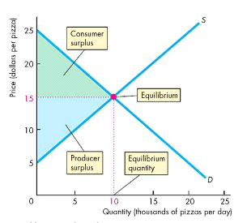
ECON 1050 Final Exam Review Chapters 3-8, 10-17 Page 6
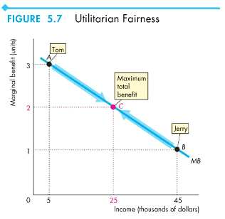
- The big tradeoff is a tradeoff between efficiency and fairness Chapter 6 - Government Actions in Markets
A Housing Market with a Rent Ceiling
- Price ceilings or price caps: a government regulation that makes it illegal to charge a price higher than a specified level ○ Only when it is set below the equilibrium price does it have an effect
- Rent ceiling is a price ceiling applied to the housing market
○ If set below the equilibrium: ▪ Housing shortage
▪ Increased search activity (OC rises) ▪ Black market (illegal market where price is above ceiling at equilibrium) ▪ Results in an inefficient underproduction of housing services
□ MB exceeds MC, creates deadweight loss
▪ Allocation during a shortage occurs by:
- □ A lottery
- □ First come, first serve
- □ Discrimination
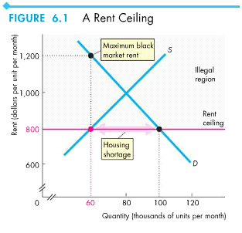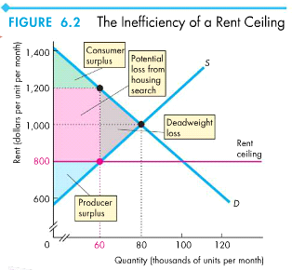
ECON 1050 Final Exam Review Chapters 3-8, 10-17 Page 7
A Labour Market with a Minimum Wage
- - Price floor: a government regulation that makes it illegal to charge a price lower than a specified level
- - Minimum wage is a price floor applied to the labour market
○ Only has an effect when set above the equilibrium amount - creates unemployment ▪ Is inefficient because MB exceeds MC
Taxes
- Tax incidence is the division of the burden of a tax between buyers and sellers
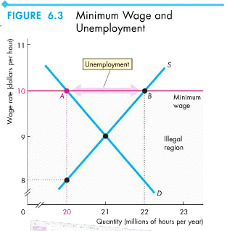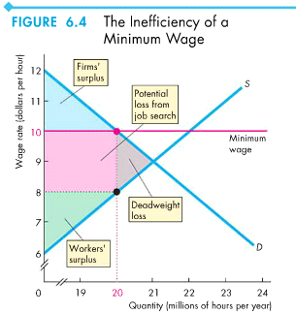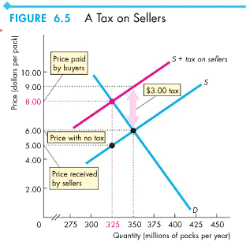
ECON 1050 Final Exam Review Chapters 3-8, 10-17 Page 8
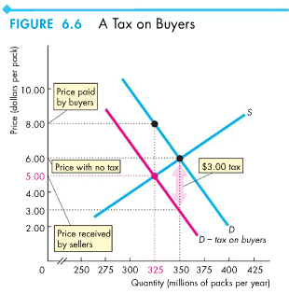
- - The more inelastic (steeper slope), the more of the tax is paid by buyers
- - Perfectly inelastic demand: buyers pay
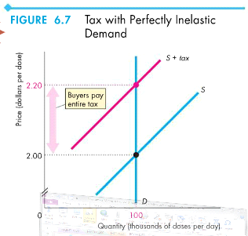
- Perfectly elastic demand: sellers pay
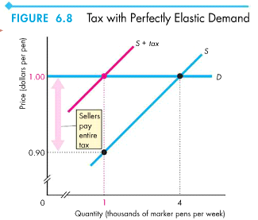
- Taxes create an inefficient underproduction: ○ MB exceeds MC, creates DWL
ECON 1050 Final Exam Review Chapters 3-8, 10-17 Page 9
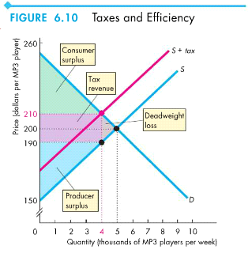
- Fairness to a tax system has been proposed two conflicting principles:
- ○ The benefits principle: people should pay taxes equal to the benefits they receive from the government
- ○ The ability-to-pay principle: people should pay taxes according to how easily they can bear the burden of tax/rich people pay more, poor people pay less Production Quotas and Subsidies
- - Production quota is an upper limit to the quantity of a good that may be produced in a specific period
  - ○ Set above the equilibrium price has no effect
  - ○ Set below the equilibrium price results in: ▪ Decrease in supply ▪ Rise in price ▪ Decrease in MC ▪ Inefficient production ▪ Incentive to cheat and overproduce
- - Subsidy is a payment made by the government to a producer
  - ○ Increase in supply
  - ○ Fall in price and increase in quantity produced
  - ○ Increase in MC
  - ○ Payments by government to farmers
  - ○ Inefficient overproduction
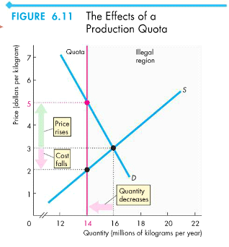
ECON 1050 Final Exam Review Chapters 3-8, 10-17 Page 10
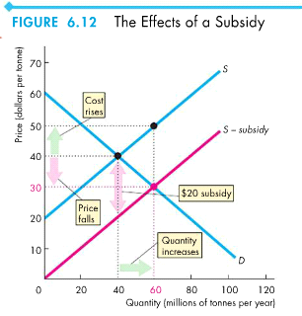
Chapter 7 - Global Markets in Action
How Global Markets Work
- - Imports: goods and services bought from other countries
- - Exports: goods and services sold to other countries
- - International trade is driven by comparative advantage
- - When world price is: ○ ▪  ▪ Increases CS, decreases PS, increases TS
Below equilibrium:
Import
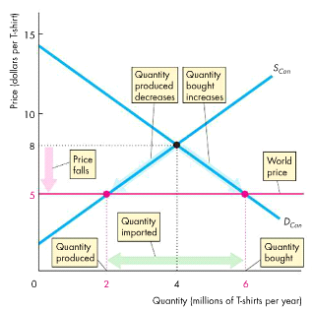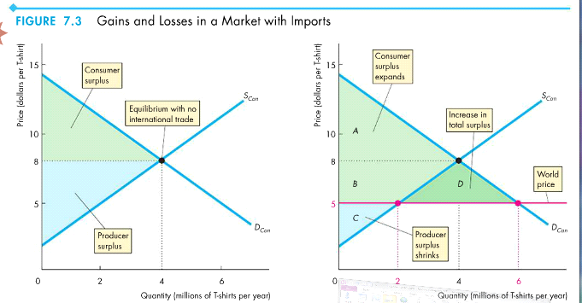
○
Above equilibrium:
▪ 
Export
ECON 1050 Final Exam Review Chapters 3-8, 10-17 Page 11
Export
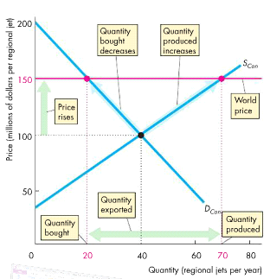
▪ Decreases CS, increases PS, increases TS
International Trade Restrictions
- - Governments use these tools to protect domestic industries from foreign competition: - - - -
- - Tariffs are taxes on a good that is imposed by the importing country when an imported good crosses its international boundary
  - ○ Buyers must pay price plus tariff
  - ○ CS decreases, PS increases, DWL arises ▪ CS decreases more than PS increases though ○ Causes: ▪ Rise in price ▪ Decrease in quantity demanded ▪ Increase in domestic production ▪ Decrease in imports ▪ Tariff revenue
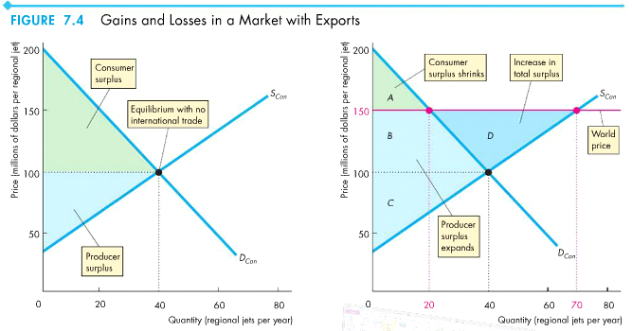
Tariffs
Import quotas
Other import barriers
Export subsidies
ECON 1050 Final Exam Review Chapters 3-8, 10-17 Page 12
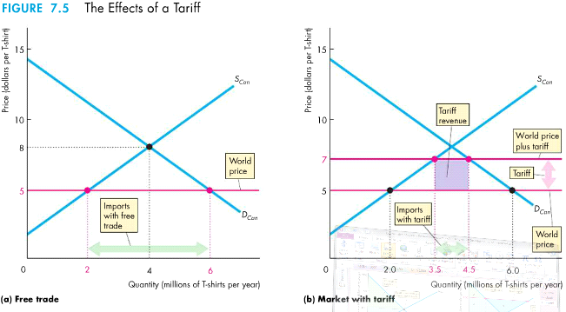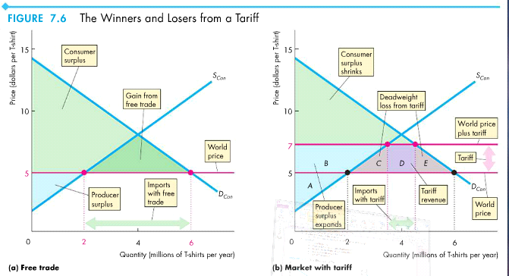
- Import quota is a restriction that limits that maximum quantity of a good that may be imported in a given period ○ CS decreases, PS increases, DWL arises ○ Causes:
▪ Rise in price ▪ Decrease in quantity demanded ▪ Increase in domestic production
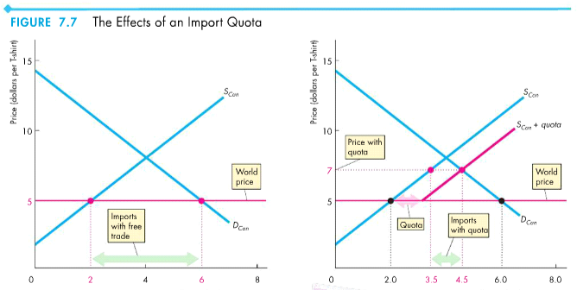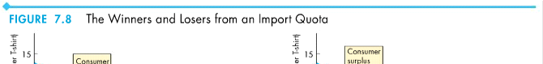
ECON 1050 Final Exam Review Chapters 3-8, 10-17 Page 13
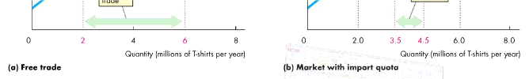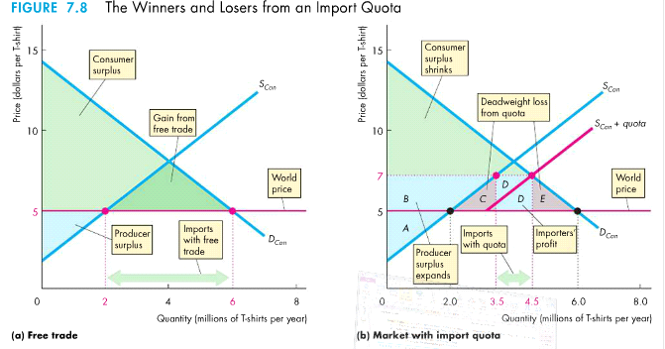
- Export subsidy is a payment by the government to the producer of an exported good
- ○ Increases domestic production
- ○ PS increases
- ○ Results in inefficient underproduction in the rest of world and creates a DWL The Case Against Protection
- - Countries debate whether free international trade is good, or whether they should protect themselves from foreign competition
- - Two classical arguments for restricting international trade:
  - ○ Infant-industry argument ▪ It is necessary to protect a new industry so that it can mature and then compete in world markets
  - ○ Dumping argument ▪ Dumping occurs when a foreign firm sells its exports at a lower price than its cost of production ▪ Causes domestic firms out of business - a monopoly, then raises prices Chapter 8 - Utility and Demand
• Consumption choices are influenced by: ○ Consumption possibilities ○ Preferences
• A budget line marks the consumption possibilities (boundary between the combination of goods and services that one can afford)
- ○ Consumption possibilities change when income or prices change
- ○ A change in price changes the slope of the line
- - Utility is the benefit or satisfaction that a person gets from the consumption of a good (happiness level)
- - Total benefit is called Total Utility
○ More consumption usually gives more total utility
- Marginal utility is the change in total utility from the consumption of one more good or service ○ People exhibit diminishing marginal utility - marginal utility decreases as consumption increases
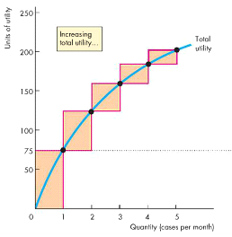
ECON 1050 Final Exam Review Chapters 3-8, 10-17 Page 14
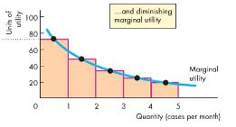
- - Consumer equilibrium is the situation where consumers have allocated all of their income in a way that maximizes total utility
- - Marginal utility per dollar is the marginal utility from a good by spending one more dollar
○ Calculated by: -
- - Utility-Maximizing Rule: total utility is maximized when
  - ○ All available income is spent
  - ○ Marginal utility per dollar is equal for all goods
- - When the price of a good changes, the marginal utility per dollar changes as well - therefore changing buying demand
○ If the price halves, the MUd doubles
- - When income levels change, the amount bought changes (that constraint changes)
- - The paradox of value is that the price of essential goods are low, while the price of non-essential goods are high
○ This is because of the difference in total and marginal utility
▪ Total utility of essential goods is huge, while the marginal utility is low ▪ Total utility of non-essential goods is low, while the total utility is high
- Behaviour economics studies the way people make decisions ○ People are limited from making rational decisions by:
▪ Bounded rational (rational limited by the computing power of the brain) ▪ Bounded willpower (knowing regret) ▪ Bounded self-interest (limited self-interest - helping others) ▪ The endowment effect (people value things higher when they own it)
- Neuroeconomics is the study of the activity of the brain when a person makes an economics decision Chapter 10 - Organizing Production
- - A firm is an institution that hires factors of production and organizes those factors to produce and sell goods and services
- - Each firm organizes the production of goods using two systems and solve the principle-agent problem (induce an agent to act in the best interest of a principal):
  - ○ Command system ▪ Managerial hierarchy
  - ○ Incentive system ▪ Market-like mechanism inside firm - compensation scheme to get workers to work
- - A firm's goal is to maximize profit
- - Economic profit is total revenue minus total cost ○
- - Normal profit is the average profit that is earned ECON 1050 Final Exam Review Chapters 3-8, 10-17 Page 15
To maximize utility/find consumer equilibrium: find the situation where maximum utility per dollar is equal for both goods, a nd is within income
constraint
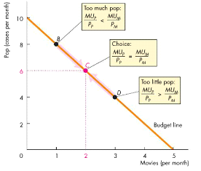
- Normal profit is the average profit that is earned
- - To achieve maximum economic profit, a firm must make 5 decision:
  - ○ What to produce and in what quantities
  - ○ How to produce
  - ○ How to organize and compensate its managers and workers
  - ○ How to market and price its products
  - ○ What to produce itself and buy from others
- - Three constraints limit a firms ability to maximize profit:
  - ○ Technology constraints
  - ○ Information constraints
  - ○ Market constraints
- - An opportunity cost is incurred when it uses capital
○ Implicit rental rate is the opportunity cost
▪ 2 parts: economic depreciation, forgone interest
- - Economic depreciation is the fall in market value of a firm's capital
- - Forgone interest is the funds that could have been used for some other purpose to create interest
- - Technological efficiency occurs when the firm produces a given output by using the least amount of inputs
- - Economic efficiency occurs when the firm produces a given output at the least cost
- - Types of businesses: ○ Sole-proprietorship ▪ Single owner with unlimited liability ○ Partnership ▪ Two or more partners with unlimited liability ○ Corporation ▪ One or more limited liability stockholders
- - Perfect competition occurs when there are many firms, they each sell an identical product, there are many buyers, and there are no restrictions on the entry of new firms
- - Monopolistic competition is a market structure where a large number of firms compete by making slightly different products (product differentiation)
- - Oligopoly is a market structure where a small number of firms compete
- - Monopoly is a market structure where only one firm produces a good or service, and there is a barrier to entry
- - Four-firm concentration ratio is the percentage of the value of sales by the four largest firms in an industry
- - Herfindahl Hirschman Index (HHI) is the percentage of the market share of the 50 largest firms in a market squared
- - Firms are more efficient than markets as co-ordinators of economic activity because they can achieve
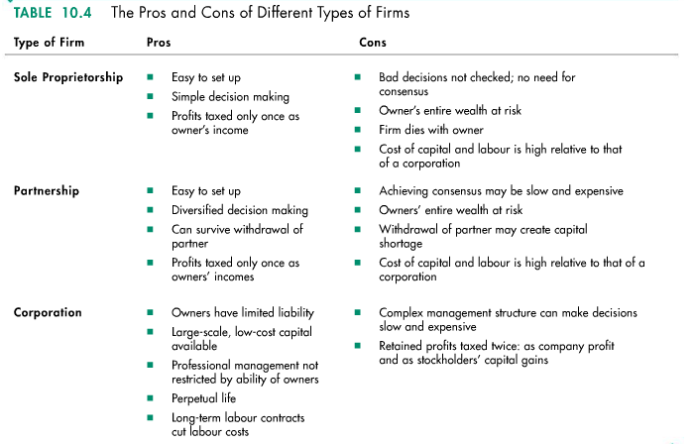
ECON 1050 Final Exam Review Chapters 3-8, 10-17 Page 16
- Firms are more efficient than markets as co-ordinators of economic activity because they can achieve
- ○ Lower transaction costs (costs that arise from aspects of an exchange - e.g. finding business)
- ○ Economies of scale (when the cost of producing a unit of good falls as its output rate increases)
- ○ Economies of scope (when a firm specializes its resources)
- ○ Economies of team production (when groups specialize in tasks) Chapter 11 - Output and Costs
- - Two time frames that distinguish decisions
  - ○ Short run
    - ▪ A time frame where the quantity of at least one factor of production is fixed - called plants (e.g. sometimes capital, land, entrepreneurship)
    - ▪ To increase output in the short run, the firm must increase the quantity of variable factors of production (labour)
  - ○ Long run ▪ A time frame where the quantity of all factors of production can be varied (can change its plant) ▪ To increase output in the long run, the firm can change its plant as well as the quantity of labour ▪ Long run decisions are not easily reversed, called sunk costs
- - The relationship between output and the quantity of labour are displaying three ways:
  - ○ Total product ▪ The maximum output that a given quantity of labour can produce ▪ Increase in employment increases total product ▪ Total product curve is shown by total product at each labour
  - ○ Marginal product
    - ▪ The increase in total product from a one-unit increase in the quantity of labour
    - ▪ Every production process has initial increasing marginal returns (marginal product is increasing), then diminishing marginal returns (marginal product is decreasing)
    - ▪ The law of diminishing returns states that the marginal product of the variable of production eventually diminishes
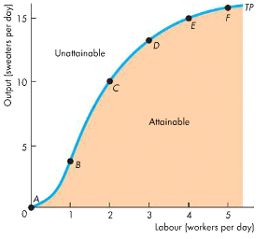
ECON 1050 Final Exam Review Chapters 3-8, 10-17 Page 17
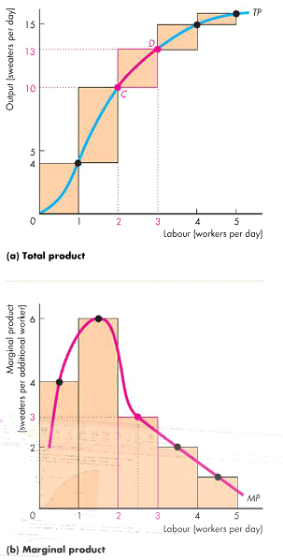
○ Average product ▪ Average productivity
▪ 
- In the short run, a firm must increase its costs to increase production - this relationship of output and cost can be shown three ways: ○ Total cost
▪ (TC) is the cost of all factors of production ▪ Split into total fixed cost and total variable cost
□ is the cost of the firm's fixed factors - same at all quantities (e.g. machines)
□ is the cost of the firm's variable factors - changes as output changes (e.g. labour) ▪ 
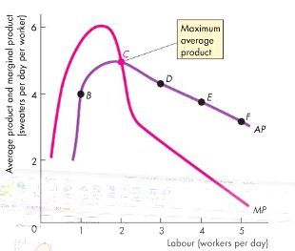
Total fixed cost
Total variable cost
ECON 1050 Final Exam Review Chapters 3-8, 10-17 Page 18
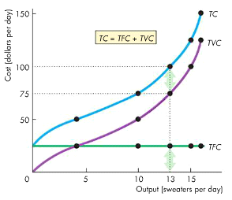
○ Marginal cost
- ▪ (MC) is the increase in total cost from a one-unit increase in production
- ▪ At small outputs MC decreases due to specialization and division of labour , but at larger outputs MC increases because of th e law of diminishing returns
- ▪ A firm's MC curve is the short term supply curve ○: ▪ 
□ (AFC) is the total fixed cost per unit of output ▪ Average variable cost
□ (AVC) is the total variable cost per unit of output ▪ Average total cost
□ (ATC) is the total cost per unit of output □
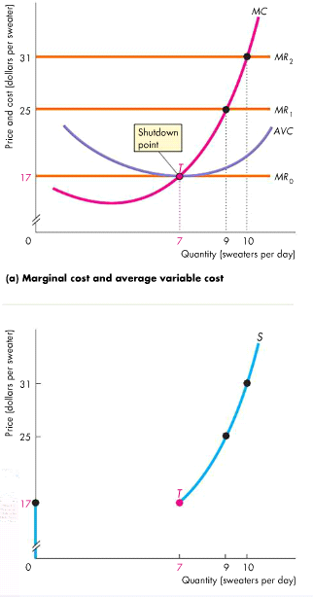
Average cost
Average fixed cost
ECON 1050 Final Exam Review Chapters 3-8, 10-17 Page 19
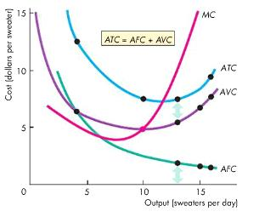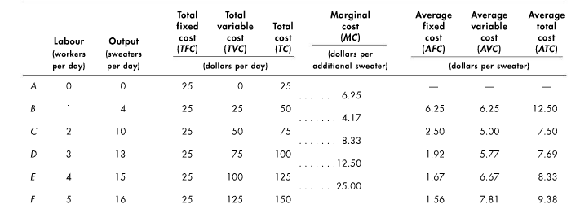
- In the short run, the short run cost curve is MC - its position depends on two factors:
- ○ Technology (increase in technology increases marginal and average product of labour)
- ○ Prices of factors of production (increase in price increases the firm's costs)
ECON 1050 Final Exam Review Chapters 3-8, 10-17 Page 20
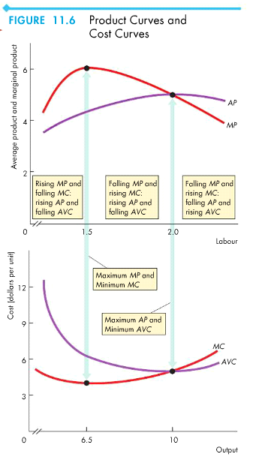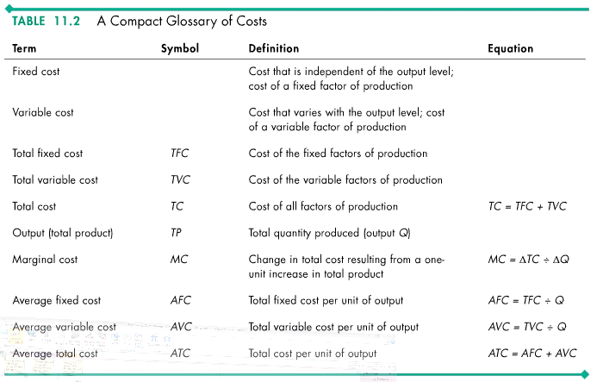
- In the long run, the LRAC (long run average cost) curve is made up by taking the lowest point on the SRAC curve for each point ○ The lowest point on the LRAC curve is a firm's minimum efficient scale
ECON 1050 Final Exam Review Chapters 3-8, 10-17 Page 21
○
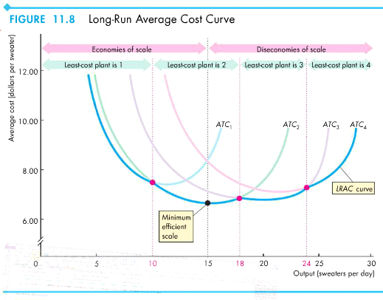
Chapter 12 - Perfect Competition
- - Perfect competition is a market in which:
  - ○ Many firms sell identical products to many buyers
  - ○ There are no restrictions on entry to the market
  - ○ Established firms have no advantage over new ones
  - ○ Sellers and buyers are well informed about prices
- - Perfect competition arises when the minimum efficient scale of a single producer is small relative to the demand
- - Firms in perfect competition are price takers - a single firm cannot influence market price
- - A firm's goal is to maximize profit (Total Revenue -Total Cost) ○
○ Marginal revenue is the change in total revenue that results from a one-unit increase in the quantity sold ▪ Half the horizontal distance of total revenue
- - Profit is maximized at the point where MR=MC
- - A firm will temporarily shutdown if it sells at, or below, its shutdown point (where MC =AVC)
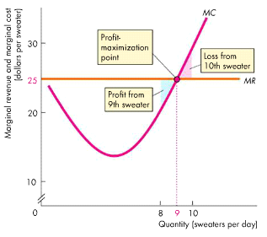
ECON 1050 Final Exam Review Chapters 3-8, 10-17 Page 22
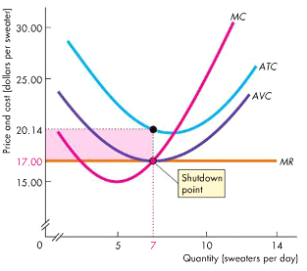
-
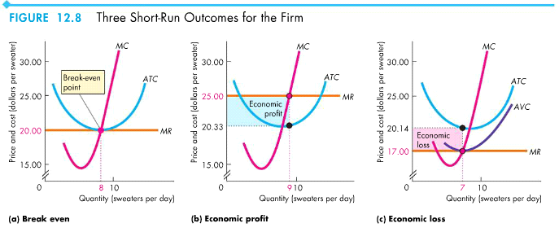
- - In the long run, price depends on:
  - ○ External economies - factors beyond the firm's control that lower costs as market output increases
  - ○ External diseconomies - factors beyond the firm's control that raises costs as market output increases
- - In the long run, the quantity produced and price sold at is where Supply = Demand
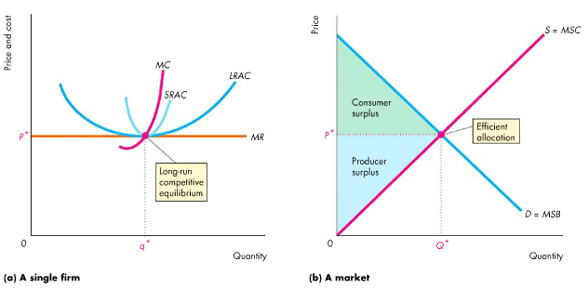
Chapter 13 - Monopoly
- A monopoly is a market with a single firm that produces a good or service ○ Arises from no close substitutes and barrier to entry
▪ 3 barriers to entry: □ Natural
 Natural monopoly - a market in which one firm can supplies the entire market at the lowest cost □ Ownership
ECON 1050 Final Exam Review Chapters 3-8, 10-17 Page 23
□ Ownership
-  One firm owns a significant part of a key resource □ Legal
-  Legal monopoly - a market in which competition and entry are restricted by legalities (e.g. book)
- A monopoly creates its own price, which creates two pricing strategy situations:
- ○ Single price ▪ Same price to all customers
- ○ Price discrimination ▪ Different units of a good or service for different prices -
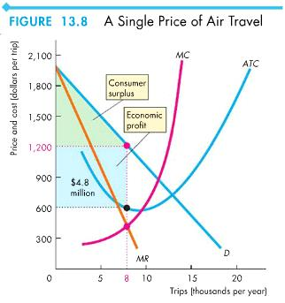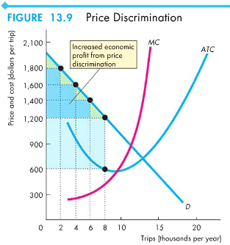
A monopoly is not a price taker, so they choose a price and quantity that maximizes profit | MR=MC
ECON 1050 Final Exam Review Chapters 3-8, 10-17 Page 24
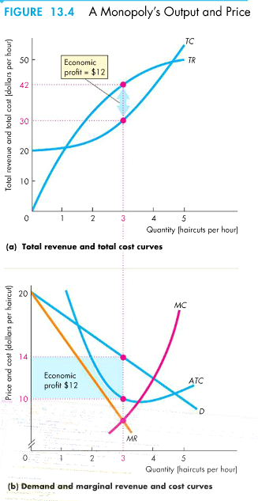
-
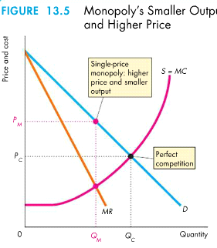
ECON 1050 Final Exam Review Chapters 3-8, 10-17 Page 25
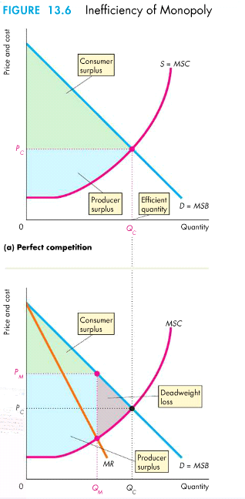
- Economic rent is any surplus, and the pursuit of capturing economic rent is called rent seeking ○ Rent seekers pursue their goals by buying a monopoly, or creating one
- Perfect price discrimination occurs when a firm sells each unit of output for the highest price anyone is willing to pay for it ○ Eliminates consumer surplus
- - Monopolies are in self-interest, not social interest; to regulate monopolies:
  - ○ Regulation - rules administered by a government to influence price, quantities, etc.
  - ○ Deregulation - process of removing regulation
- - Monopolies are regulated to follow one of the rules:
○ Marginal cost pricing rule - sell where MC = MB so that marginal cost = marginal benefit
Average cost pricing rule - sell where ATC = MB so there is no economic profit ECON 1050 Final Exam Review Chapters 3-8, 10-17 Page 26
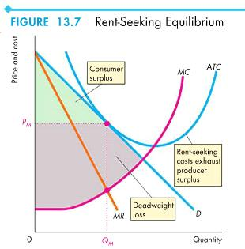
○ Average cost pricing rule - sell where ATC = MB so there is no economic profit ○
Formula Overview So Far:
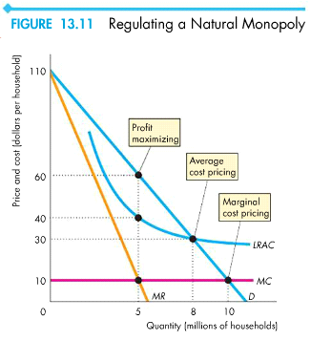
Chapter 14 - Monopolistic Competition
- - Monopolistic competition is a market structure in which:
  - ○ A large number of firms compete
  - ○ Each firm produces a differentiated product
  - ○ Firms compete on product quality, price, and marketing
  - ○ Firms are free to enter and exit the industry
- - A firm in monopolistic competition:
  - ○ Has small market share ▪ Due to many firms
  - ○ Ignores other firms ▪ No individual firm can dictate market conditions
  - ○ Cannot collude ▪ Coordination to collude a high price is impossible because of number of firms
- - Product differentiation: making a product slightly different from the product of a competing firm
○ These products are close substitutes but not perfect substitutes for products of the other firms
- - Product differentiation enables a firm to compete with other firms in three areas: ○ Quality ○ Price ○ Marketing
- - In the short run, a monopolistic competitive firm makes its output and price decision like a monopoly - which could result in either economic profit or loss
○ Where MR=MC
ECON 1050 Final Exam Review Chapters 3-8, 10-17 Page 27
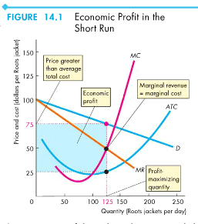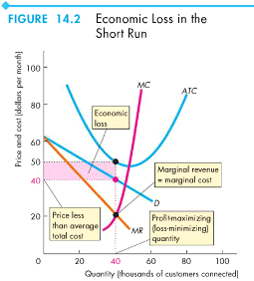
- - In the long run, a monopolistic competitive firm makes zero economic profit - because other firms will enter the market
- - There are two key differences between monopolistic competition and perfect competition:
  - Excess capacity - the firm is producing below its efficient scale, where ATC is minimum
  - Markup - the amount by which price exceeds marginal cost
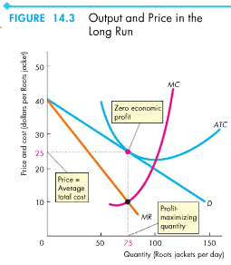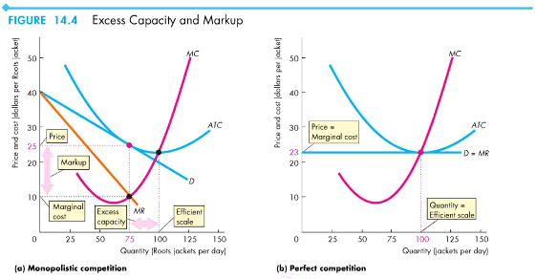
ECON 1050 Final Exam Review Chapters 3-8, 10-17 Page 28
Chapter 15 - Oligopoly
- - Oligopoly is a market structure in which:
  - ○ Natural or legal barriers prevent the entry of new firms.
  - ○ A small number firms compete.
- - Economies of scale and demand form a natural barrier that can create a natural oligopoly
- - Duopoly: An oligopoly market with two firms
- - Because oligopolies consists of a small number of firms, each has a large share of the market. This causes: ○ Interdependence
○ Temptation to Cooperate ▪ A cartel is a group of firms acting together
- - Economists think about oligopoly as a game between two or a few players, and to study oligopoly markets they use game theory
- - Game theory: A set of tools for studying strategic behavior – behavior that takes into account the expected behavior of others and the recognition of mutual interdependence
○ Game theory seeks to understand oligopoly as well as other forms of economic, political, social, and even biological rivalries by using a method of analysis specifically designed to understand games of all types
- All games share for common features: ○ Rules
○ Strategies ▪ All the possible actions of each player
○ Payoffs ▪ A payoff matrix is a table that shows the payoff for every possible action by each player for every possible action by each o ther player
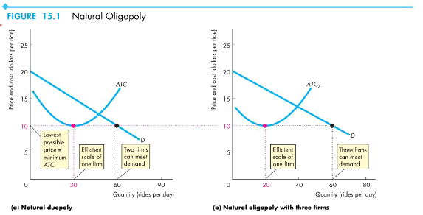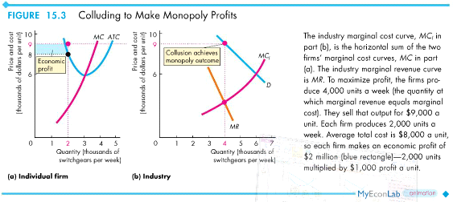
ECON 1050 Final Exam Review Chapters 3-8, 10-17 Page 29
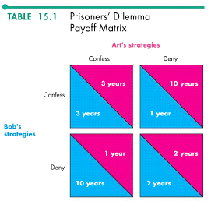
○ Outcome
- - Dominant-strategy equilibrium: an equilibrium in which the best strategy is to cheat (confess) regardless of the strategy of the other player
- - Anti-combine law: the law that regulates oligopolies and prevents them from becoming monopolies or behaving like monopolies Chapter 16 - Externalities
- - Externality: a cost or benefit that arises from production and falls on someone other than the producer, or a cost or benefit that arises from consumption and falls on someone other than the consumer
  - ○ A negative externality is an externality that imposes a cost
  - ○ A positive externality is an externality that provides a benefit
- - There are four types of externalities:
  - ○ Negative production externalities ▪ The most costly sources are congestion, pollution, and carbon emission
  - ○ Negative consumption externalities ▪ A source of irritation for most of us - e.g. smoking in a confined space
  - ○ Positive production externalities
  - ○ Positive consumption externalities
- - Marginal private cost (MC): the cost of producing an additional unit of a good or service that is borne by its producer
- - Marginal external cost: the cost of producing an additional unit of a good or service that falls on people other than the producer
- - Marginal social cost: the marginal cost incurred by the producer and by society ○
- - Property rights: legally established titles to the ownership, use, and disposal of factors of production and goods and services that are enfor ceable in the courts
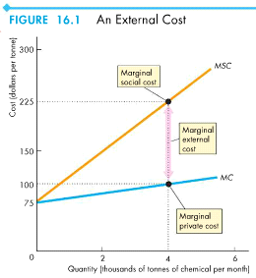
ECON 1050 Final Exam Review Chapters 3-8, 10-17 Page 30
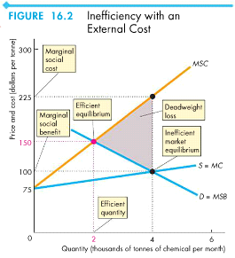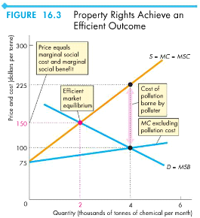
- - Coase theorem: the proposition that if property rights exist, if only a small number of parties are involved, and if transactions costs (the opportunity cost of conducting a transaction) are low, then private transactions are efficient
- - The three main methods governments use to cope with external costs are: ○ Taxes ▪ Pigovian taxes: using taxes as an incentive for producers to cut back the pollution they create
○ Emission charges
○ Cap-and-trade ▪ Assigned a tradable permitted pollution license
- - Marginal private benefit (MB): the benefit that the consumer of a good or service receives from an additional unit of it
- - Marginal external benefit: the benefit from an additional unit of a good or service that people other than its consumer enjoy
- - Marginal social benefit (MSB): the marginal benefit enjoyed by society ○
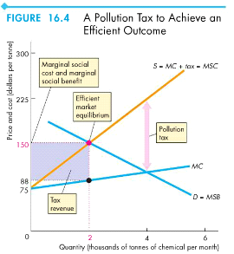
ECON 1050 Final Exam Review Chapters 3-8, 10-17 Page 31
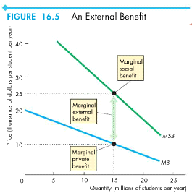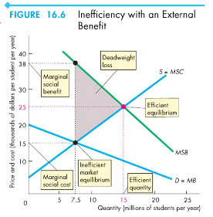
- Governments can use four devices to achieve a more efficient allocation of resources in the presence of external benefits:
- ○ Public production: a good or service is produced by a public authority that receives its revenue from the government (e.g. public school)
- ○ Private subsidies: a payment that the government makes to private producers
- ○ Vouchers: a token that the government provides to households, which they can use to buy specified goods or services
- ○ Patents and copyrights: a government-sanctioned exclusive right granted to the investor of a good, service, or productive process to produce, use, and sell the invention for a given number of years
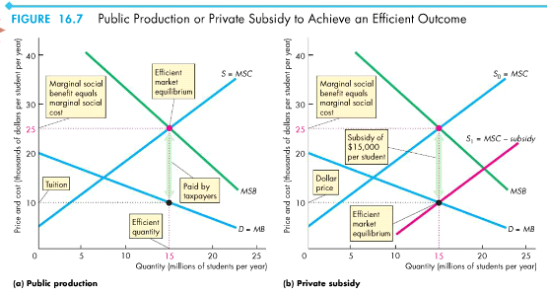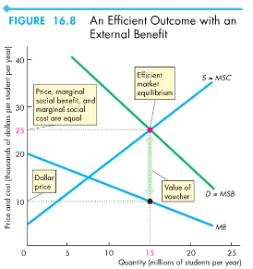
ECON 1050 Final Exam Review Chapters 3-8, 10-17 Page 32
use, and sell the invention for a given number of years
Chapter 17 - Public Goods and Common Resources
- - A good is excludable if it is possible to prevent someone from enjoy its benefits
- - A good is if it is impossible (or extremely costly) to prevent anyone from benefiting from it
- - A good is rival if one person's use of it decreases the quantity available for someone else
- - A good is if one person's use of it does not decrease the quantity available for someone else
- - Private good: a good that is both rival and excludable
- - Public good: a good that is both non-rival and non-excludable
- - Common resources: a good that is rival and non-excludable
- - Natural monopoly good: a good that is non-rival and excludable
- - Free rider: a person who enjoys the benefits of a good or service without paying for it
- - : the market would provide an inefficiently small quantity of a public good ○ No one has an incentive to pay for the public good because no one can be excluded
non- | excludable
non- | rival
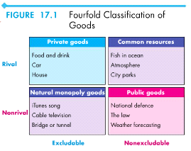
Free- | rider problem
ECON 1050 Final Exam Review Chapters 3-8, 10-17 Page 33
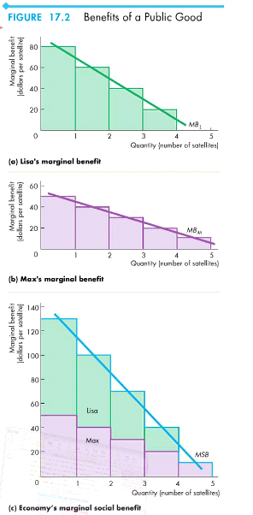
- - The efficient quantity of a public good is when MSC=MSB
- - Principle of minimum differentiation: the tendency for competitors to make themselves similar to appeal to the maximum number of clients or voters
- - Bureaucrats want to maximize their department's budget because a bigger budget brings greater status and power, therefore they overproduce
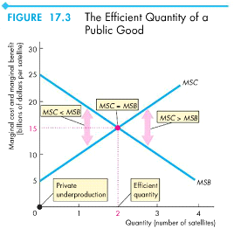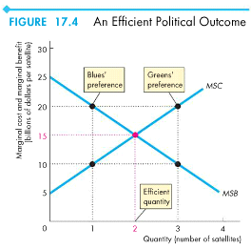
ECON 1050 Final Exam Review Chapters 3-8, 10-17 Page 34
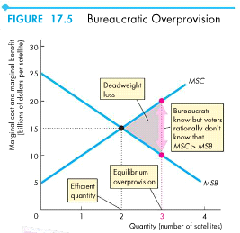
- - Rational ignorance: the decision not to acquire information because the cost of doing so exceeds the expected benefit
- - There are two types of political equilibrium:
  - ○ Social interest theory: governments make choices the achieve an efficient provision of public goods ▪ Occurs when voters are fully informed
  - ○ Public choice theory: governments make choices that result in efficient overprovision of public goods ▪ Occurs when voters are rationally ignorant
- - Government growth is because of:
  - ○ Voter preferences
  - ○ Inefficient overprovision
- - Tragedy of the commons: the overuse of a common resource that arises when its users have no incentive to conserve it and use it sustainably
- - Overfishing occurs because the crew is already out on the sea, and they want to catch the amount in which their marginal private costs are covered (MC=MSB)
- - The three main methods that might be used to achieve the efficient use of a common resource are:
○ Property rights
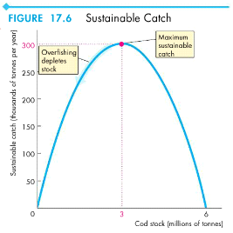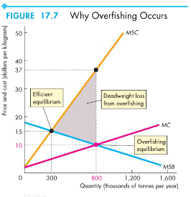
ECON 1050 Final Exam Review Chapters 3-8, 10-17 Page 35
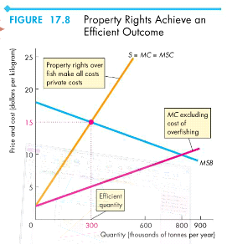
○ Production quotas
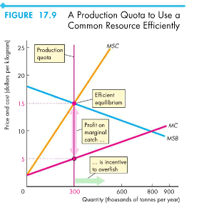
○ Individual transferable quotas (ITQs)
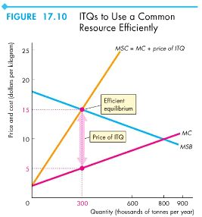
ECON 1050 Final Exam Review Chapters 3-8, 10-17 Page 36

