Chapter 1
  - Financial and personal satisfaction are the result of an organized process that is commonly referred to as personal money management or personal financial planning
Personal Financial Planning is the process of managing your money to achieve personal economic satisfaction
  - It allows you to control your financial situation
Advantages of personal financial planning:
  - Increased effectiveness in obtaining, using, and protecting your financial resources throughout your lifetime
  - Increased control of your financial affairs by avoiding excessive debt, bankruptcy, and dependence on others for economic security
  - Improved personal relationships resulting from well-planned and effectively communicated financial decisions
  - A sense of freedom from financial worries obtained by looking to the future, anticipating expenses, and achieving your personal economic goals
Six-Step Procedure of the Financial Planning Process
- Determining your current financial situation
- Developing financial goals
- Identifying alternative courses of action
- Evaluating alternatives
- Creating and implementing a financial action plan
- Re-evaluating and revising the plan
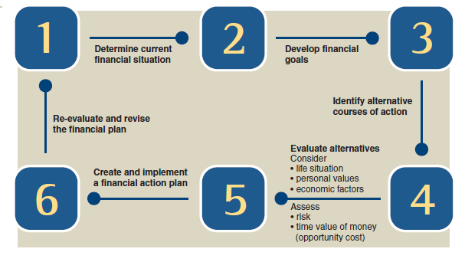

(Explained)
- Determine current financial situation regarding income, savings, living expenses, and debts. Preparing a list gives you a foundation for financial planning activities.
- Periodically analyze financial values and attitude toward money. Analyzing your values involves identifying what beliefs you hold with respect to money and how these beliefs lead you to act in certain ways. Being aware of your values, attitude toward money, and financial decision-making process will help you differentiate your needs from your wants and will lead you to a clearer definition of your financial goals.
- Continue the same course of action. Expand the current situation. Change the current situation. Take a new course of action. = developed alternatives/possible courses of action.
- Every decision closes off alternatives; ex. a decision to invest in stocks could mean you can’t go on vacation. Opportunity Cost is what you give up by making a choice. This cost (a tradeoff) cannot always be measured in dollars. Financial opportunity costs include interest, liquidity, and safety of investments. It is measured in terms of the time value of money, the increases in an amount of money as a result of interest earned.
- Develop an action plan. Choose ways to achieve your goals. As you achieve your immediate or short-term goals, the goals next in priority will come into focus. You may need assistance from others to implement your financial action plan. (Ex. an insurance agent)
- You need to regularly assess your financial decisions. (Each year you should review your finances).
Developing Personal Financial Goals
Two main factors as to why Canadians have money problems: poor planning, and weak money management habits; and extensive advertising, selling efforts, and product availability.
Many factors influence your financial aspirations for the future: the time frame you would like to achieve your goals, the type of financial need that drives your goals, and your life situation.
Timing:
  - Short-term goals are to be achieved within the next year or so (ex. saving for a vacation)
  - Immediate goals = 2-5 years
  - Long-term goals involve financial plans that are 5+ years (ex. retirement savings)
Should be planned in coordination with short- and medium-term ones
Goals for Different Financial Needs:
  - Consumable-product goals usually occur on a periodic basis and involve items that are used up quickly. Ex. food, clothing, entertainment (if made unwisely, can have negative effect on financial situation)
  - Durable-product goals involve infrequently purchased expensive items. Ex. appliances, cars, etc.
  - In contrast ^ many people over look intangible-purchase goals – Ex. personal relationships, health, education, etc.
Life Situation:
  - Personal factors (age, income, personal beliefs) influence spending/saving patterns
  - Adult life cycle – the stages in the family situation and financial needs of an adult – an important influence on your financial activities and decisions
  - Life cycle approach – the average person goes through the four basic stages in personal financial management (LCA) to financial planning
Goal-Setting Guidelines:
  - Goal setting is central to financial decision making
  - Your financial goals should be stated to take the following factors into account:
Financial goals should be realistic
Financial goals should be stated in specific, measurable terms
Financial goals should have a time frame
Financial goals should indicate the type of action to be taken
  - Be SMART (specific, measureable, attainable, realistic, timely)
The Influence of Economic Factors on Personal Financial Planning
Economics is the study of how wealth is created and distributed. It includes various institutions, principally business, labour, and government, that must work together to satisfy our needs and wants.
Market Forces:
  - Prices of goods and services are generally determined by supply and demand
Financial Institutions:
  - Banks, trust companies, credit unions, insurance companies, and investment companies are the financial institutions with which most people do business
  - They facilitate financial activities in our economy
  - The Bank of Canada, our nation’s central bank, has significant responsibility in our economy
  - ^concerned with maintaining an adequate money supply (achieved by influencing borrowing, interest rates, and buying/selling government securities
Global Influences:
  - Our economy is affected by financial activities of foreign investors and competition from foreign companies
  - When the export level of Canadian-made goods is lower than the level of imported goods, more Canadian dollars leave the country than the dollar value of foreign currency coming into Canada
Economic Conditions
  - Newspapers and business periodicals regularly publish current economic statistics
  - Your personal financial decisions are most heavily influenced by consumer prices, consumer spending, and interest rates
Consumer Prices
  - Inflation is a rise in the general level of prices
  - In times of inflation, the buying power of the dollar decreases (Ex. if prices increased 5% during last year, items that cost $100 now cost $105, meaning it takes more money to buy same amount of goods and services.
  - ^Main reason is an increase in demand without comparable increase in supply
  - Inflation is most harmful for people living on fixed incomes (ex. retirees)
  - The consumer price index (CPI) (published by Statistics Canada) is a measure of the average change in the prices urban consumers pay for a fixed “basket” of goods and services

Consumer Spending
  - As consumer purchasing increases, the financial resources of current and prospective employees expand
  - Reduced spending causes unemployment
Interest Rates
  - When consumer saving and investing increase the supply of money, interest rates tend to decrease
  - As consumer, business, government, and foreign borrowing increase, the demand for money, interest rates tend to rise
  - Risk is also a factor in the interest rate you pay as a borrower
  - People with poor credit ratings pay a higher interest rate than people with good credit ratings
Opportunity Costs and the Time Value of Money
In every financial decision, you sacrifice one thing to obtain another that you consider more desirable.
Personal Opportunity Costs
  - Time used for one activity cannot be used for other activities
  - Allocating time should be viewed like any decision (select use of your time to meet your needs, achieve goals, and satisfy personal values)
  - Other personal OC’s relate to health Ex. poor sleep/bad eating habits = illness = less time spent working
  - Your personal resources require careful management
Financial Opportunity Costs
  - In making choices, you must consider time value of money, the increases in an amount of money as a result of interest earned
  - Saving. investing a dollar instead of spending it today results in a future amount greater than a dollar
  - The OC of the time value of money is present in these financial decisions:
Setting aside funds in a savings plan with little/no risk has the OC of potentially higher returns form an investment with greater risk
Having extra $$ withheld from your paycheque in order to receive a tax refund has the OC of the lost interest the money could earn in a savings account
Making annual deposits in a retirement account can help avoid the OC of having inadequate funds later in life
Purchasing a new automobile or home appliance has potential benefit of saving you $ on future maintenance and energy costs
Interest Calculations
Three amounts are used to calculate the time value of money for savings in the form of interest earned:
  - The amount of savings (AKA the principal)
  - The annual interest rate
  - The length of time the money is on deposit
Two methods: simple interest and compound interest
Simple Interest: I = P x R x T
(P amount in savings) x (R annual interest rate) x (T time period) = (I interest)
Ex. $500 on a deposit at a 6% annual interest rate for 2 years = $60 ($500 x 0.06 x 2)

Compounding refers to interest that is earned on previously earned interest. Each time interest is added to the principal, the next interest amount is computed on the new balance.
Ex. the $500 on a deposit at 6% annual interest rate for 2 years will earn:
$61.80 ($500 x 0.06 = $30 the first year, and [$500 + $30] x 0.06 = $31.80 the second year - $31.80 + $30 = $61.80)
The total amount of compounding is greater than what you would earn under simple interest. You can calculate the increased value of your money from interest earned in two ways:
  - Calculate the total amount that will be available later (future value)
  - Determine the current value of an amount desired in the future (present value)
Future Value of a Single Amount
Future Value is the amount to which current savings will increase on the basis of a certain interest rate and a certain time period. They typically involve compounding. Compounding allows the future value of a deposit to grow faster than it would if interest were paid only on the original deposit.
Ex. $100 deposited in a 6% account for 2 years will grow to $112.36. It’s computed as follows:
Original Amount in Savings
Amount of Interest Earned

Future value (year 1) = $100 + ($100 x 0.06 x 1 year) = $106
Future value (year 2) = $106 + ($106 x 0.06 x 1 year) = $112.36

The same process can be continued for a third, fourth, and fifth year, but computations are time-consuming. Tables simplify the process. To use a future value table, multiply the amount deposited by the factor for the desired interest rate and time period.
Ex. $650 at 8% for 10 years has a future value of $1,403.35 ($650 x 2.159).
Found in Table

Most investment opportunities specify shorter (than one year as used in examples) compounding intervals. This is called intra-period compounding = compounding frequency is more than once a year. Ex. semi-annually, quarterly, monthly, etc.

Returning to the example of $100 deposited in a 6% account for two years, now compounded semi-annually:
m = number of compounding periods in a year = 2
i = interest rate per period = 6 ÷ 2 = 3%
Future Value (after 6 months) = $100 + ($100 x 0.03 x 1 period) = $103
Future Value (after 1 year) = $103 + ($103 x 0.03 x 1 period) = $106.09
Future Value (after 1.5 years) = $106.09 + ($106.09 x 0.03 x 1 period) = $109.27
Future Value (after 2 years) = $109.27 + (109.27 x 0.03 x 1 period) = $112.55
The value grows from $112.36 to $112.55 due to increased frequency in compounding each year.
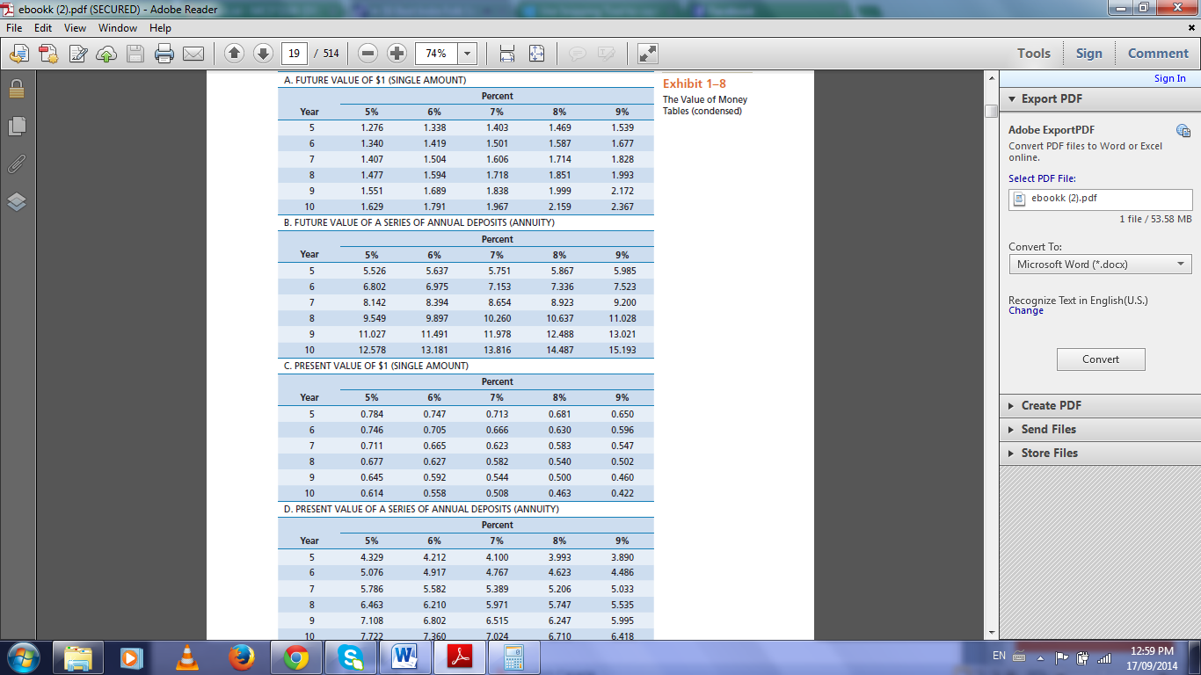

Future Value of a Series of Deposits
  - An annuity is a series of equal amounts (deposits or withdrawals) made at regular time intervals
  - To determine the future value of equal yearly savings deposits, use the table ^. To use it, the deposits must earn a constant interest rate.
Ex. If you deposit $50 a year at 7% for 6 years, starting at the end of the first year, you will have $357.65 immediately after the last deposit ($50 x 7.153).
Present Value of a Single Amount
  - Present value is the current value for a future amount based on a certain interest rate and a certain time period
  - Present value computations (AKA discounting) allows you to determine how much to deposit now to reach a desired total in the future.
Ex. if you want $1000 5 years from now and you earn 5% on your savings, you need to deposit $784 ($1000 x 0.784)
Present Value of a Series of Deposits
  - You can use present value computations to determine how much you need to deposit so you can withdraw a certain amount from the account for a desired number of years
Ex. if you want to take $400 out of an investment account each year for 9 years and your money is earning an annual rate of 8%, you can see that you need to make a current deposit of $2,498.90 ($400 x 6.247).
Achieving Financial Goals
By using the eight major areas of personal financial planning to organize your financial activities, you can avoid many common money mistakes
Components of Personal Financial Planning
  - To achieve a successful financial situation, you must coordinate these components through an organized plan and wise decision making:
(Obtaining, Planning, Saving, Borrowing, Spending, Managing Risk, Investing, Retirement & Estate Planning)
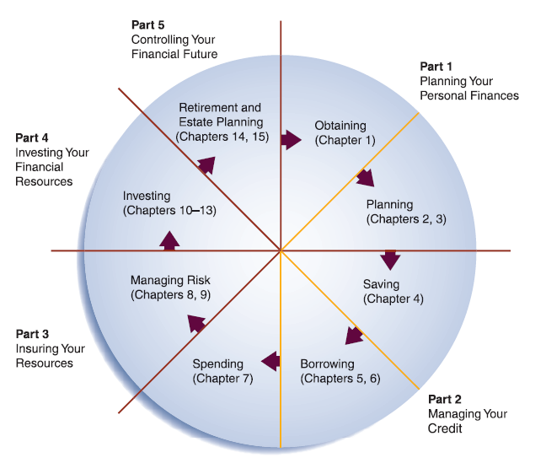
Obtaining (Ch. 1): You obtain financial resources from employment, investments, or ownership of a business
Planning (Ch. 2, 3): Planned spending through budgeting is the key to achieving goals and future financial security
Saving (Ch. 4): Long-term financial security starts with regular savings plan for emergencies, unexpected bills, replacing major items, and purchasing special goods and services (higher education, a boat, etc.) Liquidity = the ability to readily convert financial resources into cash without a loss in value]
Borrowing (Ch. 5, 6): Maintaining control over your credit-buying habits contributes to your financial goals. [Bankruptcy is a set of federal laws that allow you to either restructure your debts or remove certain debts]
Spending (Ch. 7) Financial planning is designed not to prevent you from enjoying life but to help you obtain the things you want
Managing Risk (Ch. 8, 9): Adequate insurance coverage is another component of personal financial planning
Investing (Ch. 10-13): While many types of investment vehicles are available, people invest for two primary reasons. Current interest seekers select investments that pay regular dividends or interest VS. investors who desire long-term growth choose stocks, real estate, etc.
Retirement and Estate Planning (Ch. 14, 15): Most people want financial security upon completion of full-time employment.

Developing a Flexible Financial Plan
  - A Financial Plan is a formalized report that summarizes your current financial situation, analyzes your financial needs, and recommends future financial activities
Implementing your Financial Plan
  - The most important strategy for success is the development of financial habits that contribute to both short-term satisfaction and long-term financial security, including:
    - Using a well-conceived spending plan helps you stay within your income while you save and invest for the future. The main source of financial difficulties is over spending.
    - Having appropriate insurance protection helps you prevent financial disasters
    - Becoming informed about tax and investment alternatives helps you expand your financial resources
  - Achieving your financial objectives requires two things: 1. Commitment and willingness to learn. 2. Appropriate information sources.



