Biology 2290F Final Exam Notes 2013

Final Exam: Wednesday, December 11th, 9:00 a.m., 2.5 hr. Bring your Western ID card. Thames Hall Gym.

PROGRAMMABLE CALCULATORS MAY NOT BE USED IN THE BIOLOGY 2290F/G FINAL EXAMINATION.

If you have health or compassionate conflicts with this date, please see the academic counsellors in the Dean's Office to arrange a Special Exam. (Get document signed by I. Krajnyk). Special Final Exams may have a different format than the regularly scheduled Final Exam. Please confirm with I. Krajnyk any arrangements you have made with the Student Development Office.

Exam Review Session: Tuesday, December 10th, 12:00 noon NCB, Room 113.
Laboratory teaching faculty will respond to questions.

Exam Format and Content
The Final Exam has been designed to determine the degree to which individual students can independently demonstrate a command of a set of Final Exam Course Objectives appropriate for the content of the current offering of the course. For this term, the Final Exam Objectives are outlined below.
A total of 30% of the Final Mark is available (Dean, Krajnyk and Zabulionis Units (10% each)). Since the course has been substantially reorganized relative to previous offerings, we will not discuss questions from previous exams.
Sample questions will be available on the OWL (Sakai) site to illustrate some possible question formats.

Take note that most of these objectives involve skilful application, rather than simple recall, of knowledge acquired in the course.
Each student has had a different experience passing through the different units of this course. The Final Exam may take this into account by asking questions that involve:
i) material that everyone has encountered, either in a particular Unit
(e.g. spectrophotometry) or during a given rotation (e.g. creating a table)
ii) material relating only to your personal experience
(e.g. Briefly describe the importance of controls in your genetics experiment.)
iii) novel situations that no one has encountered in the course
(e.g. How might you test the hypothesis that Victoria Park squirrels prefer to nest in oaks?)

Study Tips
Since the philosophy and structure of Biology 2290 are unique among the Core Courses, you should not assume that study techniques that are successful in other courses will necessarily be successful in Biology 2290. Your studying should prepare you to think and “work with" rather than just "remember" the concepts covered in the course. Review any material that you found difficult (e.g. dilutions?) as well as anything that was delegated to another group member. Look over your individual experiments with the intent to defend your methods, analyses and conclusions. Review the poster Guidelines. Practice calculations. Get help. Sleep!

*Overall Course Objectives Relevant to the Final Exam*

1. Communication

1. Communication

Write clear, concise and accurate explanations of the physical/chemical/biological principles underlying the various experiments that you have performed….

Define relevant biological terms:
absolute/obligate parasite: parasites requiring host organism to complete part/all life cycle. (ie. Bacteriophages)
aim: general statement on investigated topic
aliquot: portion of sample
caption: brief heading describing overall what a figure is presenting. Placed above figures when doing ppt (never use both legend & caption for figure).
continuous data: data from continuum that would have fractional increments (ie. Measurements made daily for 3 weeks)
-data joined w/ line on graph.
discrete data: integer data values where no intermediate values possible (ie. Different concentration of solution)
-data not joined w/ line on graph
F-test in Anova: a variance ratio (calculated) where mean square between treatments is divided by mean square within treatments (named after Sir Ronald Fisher, British statistician).
Flow chart: diagram w/ steps of process. Shown w/ various boxes connected w/ arrows. Info in each box = action needs to be performed in each step. Step1=title
footnote: used for tables, not figures. To explain an abbreviation/ meaning of term or symbol in table.
germination: start of growth of seed/spore that was dormant.
*hypothesis: simple statements/explanation designed to provide possible answers to scientist(s) posed question/measured (or observed) phenomena in nature.
Before designing/implementing an experiment, 2 basic hypotheses are always stated:
- Null H₀: hypothesis of no difference/change/effect. Assumes experiments manipulated/independent variable had no effect on variable measured (dependent variable) or that no difference between observed/expected results.
- Alternate/Experimental H_{a}/H₁/H_{A}: hypothesis of difference/change/effect. Indicates that manipulated treatment (indep.) had effect on measured (dep.), or difference between the observed expected results.
incubation: 1) Growth/maintenance of microbiological culture @ controlled conditions.
2) Period between infection & appearance of disease symptoms
3) Birds sitting on eggs until hatch.
insignificant: never used in written/oral form when presenting results of statistical data.
key: explanation to symbols used in figure. Can be placed within figure frame. If symbol used same treatment in multiple graphs in one figure, then can be incorporated as second sentence in legend.
legend: placed below fig. self-explanatory & incorporating relevant elements in figure.
*lysogenic cycle: virus life cycle where virus integrates into chromosome host infected cell, often remaining essentially dormant (inactive) for some time.
*lytic cycle: virus life cycle where virus replicates within host cell, releasing new gen. viruses when host lyses.
*MIC: Min. Inhibitory Concentration = min [antimicrobial agent] (eg. Amp).
*MOI: Multiplicity of Infection = $\frac{phage}{cell}$ ratio. MOI of ≥3 required to have 95% infected cells by phage since they are randomly distributed over bacteria.
manuscript: book/article/doc/other work of author, prepared + submitted for publication. All info in script is always double spaced for submission (to the publisher) purposes.
non-parametric data: Data with non-normal distribution/distribution is unknown.
note: always placed below table to explain outcome of stat. results presented in table. In a figure, note is incorporated as second sentence in legend.
objective: statement of intent providing specific and succinct details about experiment being done to examine all/part of topic investigated.
parametric data: data w/ normal distribution.
*pfu: after overnight growth, plaques visible on plate. Each plaque has arisen from single phage & termed plaque forming unit (pfu). Using dilution of phage, titre (viable phage concentration) can be determined (pfu/mL).
*plaque: visible cleared zone of bacterial lawn caused by repeated cycles of infection/lysis through single infectious phage.
prediction: specific directional statement predicting outcome of exp. Follows hypothesis logically & cannot appear w/out stated hypothesis. Can be 1+ predictions depending on experiment. If prediction agrees w/ data, then supports hypothesis.
primary article: articles that present new data & experimenters’ personal interpretation/explanation of results.
protocol: Always numbered, sequentially detailed account of experiment.
replicate: each of repetitions in treatment.
replication: repetition of all treatments within experimental study.
*SD (standard deviation): a descriptive statistic measuring dispersion of a population around mean.
*SE (standard error): a descriptive statistic measuring deviation of sample means from population mean.
sample: small part/quantity taken from population.
secondary article (review paper): articles derived from primary lit., such that data is previously published. May or may not reflect experimenters’ views.
strain: species sub-type.
strand: string of nucleotides. (RNA) or half a double-stranded DNA.
*temperate phage: phages that can undergo both modes of replication: lytic & lysogenic cycles (eg. Lambda phage). This phage reproduced w/out killing host cell.
title: for table, title should be placed above. Should be self-explanatory, with elements relevant to what is presented.
title case: first word of each word uppercase (except for and, the, of, on etc.).
top/soft agar: liquid nutrient agar for working with bacteriophages. Bacteria & phage mixed in top of agar, poured onto agar plate w/ bacteria growth medium, allowed to solidify & grow overnight so that plaques are visible.
various: Different.
varying: Changing.
*virulent phage: bacteriophages that reproduce only using lytic cycle. Kills host.

2. Experimental Design

2. Experimental Design

Explain the components of the "Scientific Method". (pg. 129-132)

Scientific Method
- Logical, orderly arranged approach/process to study nature and gain new knowledge; scientific info is gathered by asking/answering questions; Scientists revolve around: 1) Observation, 2) Experimentation & 3) Communication.

Observation
  - The first step in scientific method: to make observations about nature.
  - Enables scientist to formulate questions raised from either learning something new or something that triggered scientist’s imagination.

Experimentation: planned investigation to obtain new scientific info using logical structure to test a hypothesis.

Objective: statement of intent providing specific & concise detail about experiment being done to examine all/part of an investigated topic.
    - Every experiment requires clear statement study objective(s).

Hypothesis: simple statements designed to provide possible answers to question.
    - Statements of H₀ and H_{a} made prior to design and implementation of experiment.
    - Experiment may have 1+ set of hypotheses or 1+ H_{a} (alternate) depending on nature of exp.

Predictions: specific directional statements predicting outcome of experiment.
    - Must follow logically from hypothesis & cannot appear without hypothesis.
    - Depending on nature of experiment, there can be more than one prediction.
    - If prediction agrees w/ data, hypothesis is supported.

Experimental design/protocol: Clearly outlines structure of experiment, materials, methods, and choice of statistical technique for data analysis
    - Always written in lab notebook.
    - Three important principles:
      - Control: no treatment given to exp. unit; baseline of comparison for manipulated treatments; as a treatment
      - Replication: repeat of treatments (condition applied to test organism); Reduced experimental error.
      - There is a minimum, but no max # of replications… Min = (# of treatments) + (1)
      - Randomization: not intentional; every individual (from population) has equal chance of being represented in experiment.
    - Scientist also need to think about sample size, choice of organism (or exp. unit), treatments (what is changed or indep. variable), what is measured (or dep. Variable), appropriate experimental parameters, number and frequency of observations, duration of exp., solutions, and all apparatus & material.
    - Appropriate statistical technique
      - By planning statistical technique, scientist can decide on:
        - Number of observations required (data points)
        - Type of data collected (discrete or continuous)

Implementing experiment & collecting data
    - Conducting experiment/collecting data on prescribed basis to use in statistical analyses.
      - Data recorded in an organized (Table/Figure) manner.
    - Scientists may need to account for experimental error due to:
      - Micro-environmental variability in growth chamber, greenhouse, field, etc.
      - Variability amount co-workers (e.g. Students).

Statistical analysis: analysis and interpretation of data w/ view towards objective evaluation of reliability of conclusions based on the data.
  - Used to: (1) obtain objective interpretation of results (2) explain biological sig. of organism w/ respect to objectives.
  - Descriptive statistics: 1st step after data collection to organize & summarize data.
    - Significance level (α): probability level below which we reject null. In most, significance level α = 0.05.
- Provides objective criterion for accepting/supporting or rejecting/disproving H₀.
    - DF: Degrees of freedom = n-1, where n = # of observation.
    - Sum of squares (SS): used to eliminate signs of deviation from mean.
    - Mean square (MS): variance resulted by dividing group sum of squares by respective DF.
    - Test statistic and P values: F value, as in Anova, is calculated from analysis of variance table (P<0.001, P=0.005).
- P value purposes (2): 1) if P < α, then reject H₀ in Anova, 2) if P>0.001, evidence H₀ can be rejected even at 1% significance level.
Provides:
- Results: Once exp. complete, statistical technique is employed and scientist is then able to obtain results by accepting/rejecting H₀.
- Discussion: Scientist can objectively interpret data by evaluating if results were similar to other studies, had practical application, new findings, or expected to see results.
- Conclusion: Statistical inference allows scientist to make conclusions. Comparison of conclusions is always made w/ scientist’s hypothesis (ie. Do results support hypothesis? If yes, how and why? If not, then why not?)

Communication: final step is to communicate findings to scientific community. Three forms:

Scientific paper for peer review journal (predominant form)

Oral presentation

Poster presentation

Identify questions, hypotheses, or predictions that could be investigated with given resources. (pg. 131; Quiz 1 & 2 - K-Unit)

2. Experimental Design (pg. 2)

- Question/Objective: statement of intent providing specific & concise detail about experiment being done to examine all/part of an investigated topic.
- Hypothesis: simple statements designed to provide possible answers to question
  - Statements of H₀ and H_{a} always made prior to design and implementation of experiment.
    - H₀: hypothesis of no difference/change/effect; assumes manipulated treatment (indep.) had no effect on variable measured (dep.) or no dif. between observed + expected results. Always tested because hypothesis can never be proven, only supported/disproved. Careful when making conclusion, for someone in future may find a case where hypothesis is not true (new observation may conflict w/ long-standing results.
    - H_{a}: hypothesis showing difference/change/effect. Indicates that in exp., manipulated treatment (indep.) had some effect on measured variable (dep.), or was a dif. between observed + expected results.
  - Experiment may have 1+ set of hypotheses or 1+ H_{a} (alternate) depending on nature of exp.
- Prediction(s): specific directional statements predicting outcome of experiment.
  - ‘Direction’ for experimental design and statistical analysis steps.
  - Must follow logically from hypothesis & cannot appear without hypothesis.
  - Depending on nature of experiment, there can be more than one prediction.
  - If prediction agrees w/ data, hypothesis is supported.
Example:
Cakile edentula var. lacusris is an annual plant that grows on beaches and foredunes along Lake Huron. Plants of C. edentula var. lacutris are prone to various levels and types of herbivory by insects, rodents, and white-tailed deer. Loss of leaves lowers the capacity of the plant to capture sunlight and manufacture food. Some of the deleterious effects include reduced growth and flowering and lower plant biomass. Continued herbivory eventually kills the plant. Thus, it is important to determine the effects of herbivory on plants.
- Objective: To examine the ability of Cakile edentula var. lacustris to tolerate herbivory.
- Hypotheses
  - H₀: Defoliation (or artificial herbivory) had no affect on total plant biomass and plant height of Cakile edentula var. lacustris.
  - H_{a}: Defoliation (or artificial herbivory) affected total plant biomass and plant height of Cakile edentula var. lacustris.
- Prediction: Cakile edentula var. lacustris plants would be lighter in weight and shorter in stature with an increase in herbivory intensity.

Design an experimental study to test a given hypothesis (ex. 106-107; Quiz 2 - K-Unit)
- See Example above (ie. This question is continued)…
- Method: Forty plants of C. edentula var. lacustris having same height and number of leaves (n=4) were chosen for this experiment. Defoliation treatments consisted of control (no leaves removed), 25% defoliation (one out of four leaves removed), 50% defoliation (two out of four leaves removed). Each defoliation treatment was replicated eight times.
Following the defoliation treatments, plants of C. edentula var. lacustris were allowed to recover and grow for 8 weeks. At the end of the experiment plant height (cm) was recorded followed by drying of plants and recording individual total plant biomass (g). The raw (or experimental) data for this experiment are presented in Table 1.
- Randomization: randomly removed bacteria from plate (every bacteria (from population) has equal chance of being represented in experiment).
Total biomass (g) |  |  |  |  |  | Plant height (g)
Replicates | 0% | 25% | 50% | 75% | 100% | Replicates | 0% | 25% | 50% | 75% | 100%
r1 | # | # | # | # | # | r1 | # | # | # | # | #
r2 | # | # | # | # | # | r2 | # | # | # | # | #
r3 | # | # | # | # | # | r3 | # | # | # | # | #
r4 | # | # | # | # | # | r4 | # | # | # | # | #
r5 | # | # | # | # | # | r5 | # | # | # | # | #
r6 | # | # | # | # | # | r6 | # | # | # | # | #
r7 | # | # | # | # | # | r7 | # | # | # | # | #
r8 | # | # | # | # | # | r8 | # | # | # | # | #
Table 1. Total plant biomass (g) and height (cm) of C. edentula var. lacustris exposed to various levels of defoliation.

Identify appropriate treatment and control conditions. Identify appropriate replicates. (Pg.139-140; Quiz 2 – K-Unit; 113-114)
- Continued…
  - (Control: no treatment given to exp. unit; baseline of comparison for manipulated treatments; as a treatment)
  - (Treatment: what is changed or independent variable)
- Replicate: one of the eight identical plants subjected to one of the 5 treatments.
- Treatment and Control conditions:
  - Control: 0%.

  - Treatment(s): 25%, 50%, 75%, 100%.

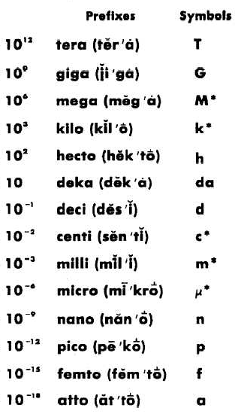
3. NumeracyManipulate SI units of measure and exponents. (pg. 62; 67-68)

3. Numeracy
- m = mass (g)
- MM = molar mass (g/mol)
- n = mol
- c = concentration (mol/L)
- V = Volume (L)

Calculate concentrations, molarities and dilutions. (Pg.61-67)
Suspensions, solutions, concentrations and dilutions
- All cellular reactions occur in aqueous environment.
  - In vitro: artificial environment.
- Suspensions: non-homogeneous = mix of substances that eventually separate into components (oil + water)
- Solutions: homogeneous = mix of substances that remain stable indefinitely.
  - Solvent: does dissolving (liquid; millilitres – mL)
  - Solute: is dissolved (solid; grams – g)
Percent Concentration
- Solute/Solvent = g/mL or mL/mL
  - 10% (w/v) 10g/100mL, etc.
  - 90% (v/v) 90mL/100mL, etc.
- Variant of % concentration: parts per hundred (pph), parts per thousand (ppt), etc.
Molar concentration
- Gram molecular weight = molecular weight
- 1 mole = 6.02 x 10²³ molecules
- See triangle diagram representing equations to calculate molar related quantities
Dilutions: making less concentrated solutions from more concentrated solutions through adding more solvent.
- Stock
  - $Dilution factor=\frac{Final volume}{Original volume}$
  - $C_{1}V_{1}=C_{2}V_{2}$
    - $\frac{Original concentration}{x mL}=final concentration$
    - $Required volume=\frac{Stock+Solvent}{division}, Solvent=\frac{x mL-1mL}{Division}, Stock=Division$
- Serial
  - $\left[\frac{Original Vol}{{Total}_{1}+Original Vol}\right]x Original Concentration={New Concentration}_{1}$
  - ${New Concentration}_{1} x\left[\frac{ new vol}{{Total}_{2}+new Vol}\right]={New Concentration}_{2}$

- $Example:if 0.25 ml of 0.2 M solution is added to 9.75mL of water, and 1.0mL of this diluted solution is added to 5.0 mL of water, what is the final molarity?$

$$Original Vol=0.25 mL, {Total}_{1}=5.0 mL, {Total}_{2}=5.0 mL, Original Concentration=0.2 M, New Vol=0.1 mL$$

$$\left[\frac{0.25 mL}{0.25 mL+9.75 mL}x 0.2 M\right]x \left[\frac{1 mL}{1 mL+5.0 mL}\right]=8.33 x {10}^{-4} M$$

Identify and interpret appropriate statistical analyses. Plot and interpret graphical/tabular data. (K-unit Quiz 2; 139-140)
- Anova (one-way analysis of variance): used when experiment has three or more treatments.
  - Looks at differences between means of three or more treatments
  - H₀ (null): µ_{A} = µ_{B} = µ_{C} … µ_{i}, where µ_{i} is the population mean in treatment ‘i’. (no sig. difference)
  - H_{a} (alternate hypothesis): is that means are not all equal.
- Multiple comparisions procedure) Tukey test (HSD: honesty significant difference test): if anova rejects null, treatment means are not all equal and have significant differences. Then we proceed to determine where specifically significant differences exist between means. Tukey test examines all pair wise comparisons of treatment means and considers H₀: µ_{A} = µ_{B} vs. H_{a}: µA ≠ µB.

- If P less than significance level (α) then we reject H₀ in Anova.
- If P>0.01 provides evidence that null can be rejected even at 1% significance level.

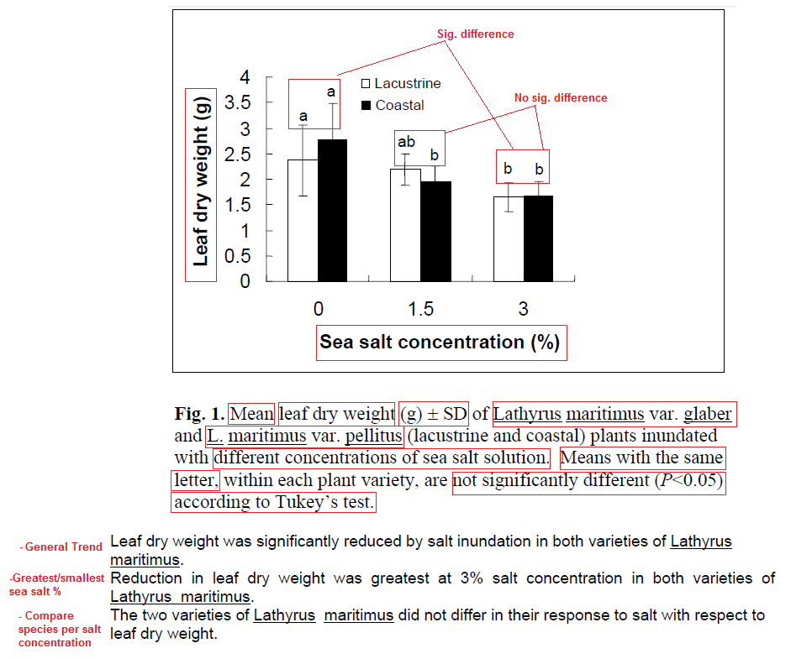
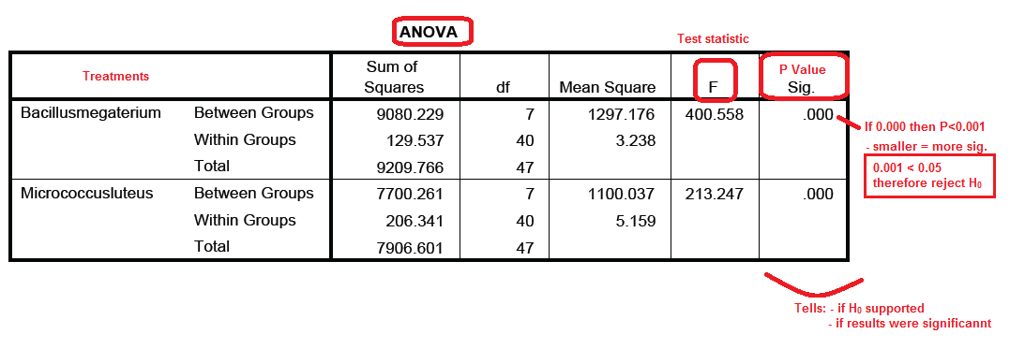
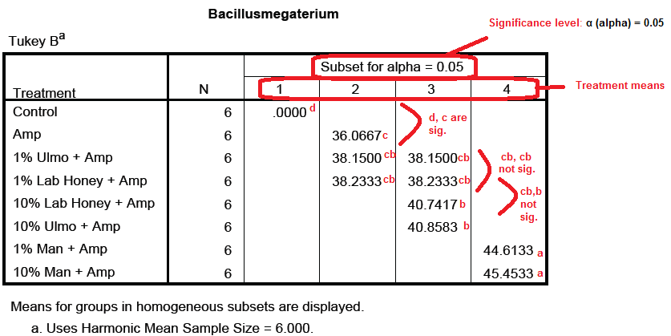
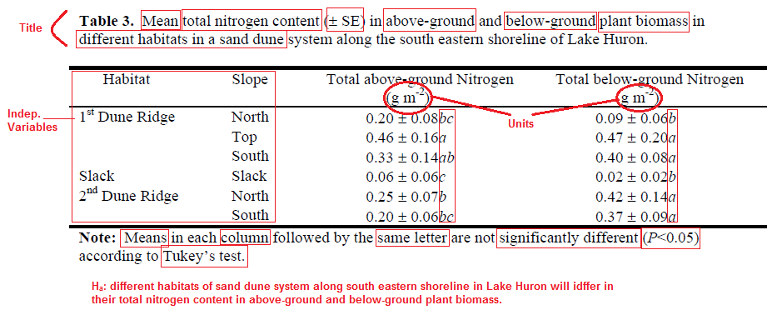
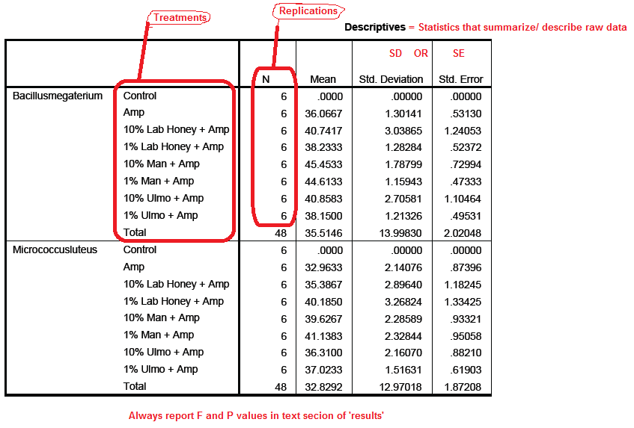

Dean Unit
- Radiant energy of wavelengths 340 – 900m is supplied by tungsten lamp. Light focused onto diffraction grating (like glass prism) splits light into component wavelengths.
- Wavelengths selected by position of diffraction grating so light of very narrow range passes through exit slit before reaching sample.
- Light transmitted reaches phototube that transduces the light energy to an electric current. Current measured by amp meter calibrated in terms of both how much light of a given wavelength sample transmits and absorbs. Meter on Spectronic 20 gives % transmittance and absorbance. Spec. does NOT measure absorbance, but the amount of light transmitted by sample which is compared to “blank” to determine absorbance.

Diagram the Spectronic 20 optical system. Explain how the instrument works.
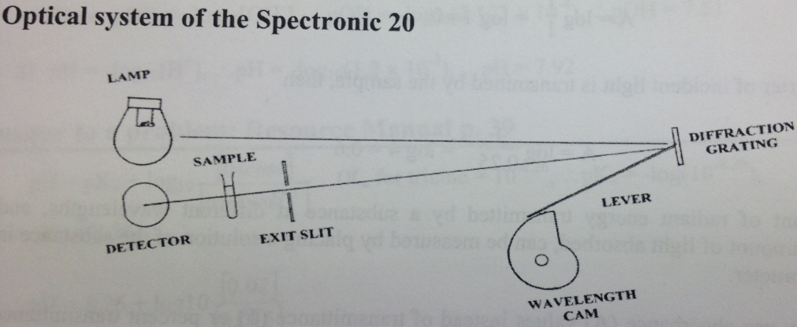

Describe transmittance and absorbance. Convert transmittance values to absorbance values. (57-58)
- Transmittance (T): fraction of the incident light that passes through (transmitted by) sample.
$$T=\frac{I}{I_{0}}$$
$$where I_{0}=radient power of incident light and I=radient power of light passing through sample$$
- Absorbance (A): amount of light absorbed by sample.
  - Lambert’s Law (for thin layer of sample): same proportion of light is absorbed regardless of the radiant power of the incident light (I₀).
I₀ | ½ | ¼ | 1/8 | 1/16 | 1/32
  - $A= log\frac{1}{T}=log \frac{I}{I_{O}}$

State Lambert's Law and Beer's Law in words. Apply A = E.c.l. (pg.57-58)
- Lambert’s Law (for thin layer of sample): same proportion of light is absorbed regardless of the radiant power of the incident light (I₀).
  - $A= log\frac{1}{T}=log \frac{I}{I_{O}}$
- Beer’s Law: absorbance is proportional to number of absorbing particles (concentration).
  - $A = E x l c$
    - Where A = absorbance (no units)
    - E = absorption (or extinction) coefficient (L/mol/cm) = measure of probability a type of photon will be absorbed by a given type of molecule (varies w/ wavelength and solvent).
    - c = concentration (mol/L)
    - l = path length through spectrophotometer tube (usually 1 cm)

Identify an appropriate "blank" to zero the spectrophotometer for a given experiment. (pg.60)
- Before absorbance is read, must adjust spec. for a reference blank.
  - Contains all of the substances in sample except for the material whose absorbance you wish to measure. Blank placed in holder and meter adjusted to 100% Transmittance (control). This step compensates for any absorbance by the solvent in which sample is dissolved and for the reflection of light from the surface of the tube. Once instrument adjusted for 100% T with the blank, any change in absorbance detected when sample is read due only to material being measured.

Give examples of the principal uses of the spectrophotometer. (Dean lab notes p. 16)
- To produce absorption spectra that can be used to characterize or identify compounds in solution.
- To make quantitative determinations of the concentration of materials in solution by reference to your own standard curves.
- To study the rate at which (bio)chemical reactions proceed.

Describe how to prepare absorption spectra and how they are used. (D-Unit Lab 1, pg.57-60)
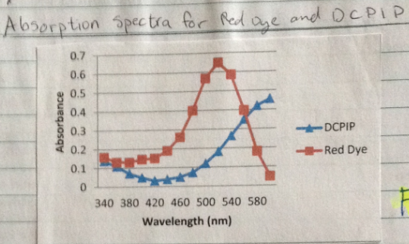
- Spectrophotometry can be used to identify or characterize compounds in solution by producing an absorption spectrum. An absorption spectrum is a graph of the absorbance values of a chemical compound in solution measured at a series of different wavelengths.
- Set up Spectronic 20
  - Turn on (power switch); allow to warm for ~15min
  - Select wavelength (wavelength control)
  - W/ sample holder empty and cover closed, set meter to 0% transmittance (zero control)
  - Adjust spectrophotometer for reference blank (see reference blank question above)
  - Place sample tube in sample holder, close lip and read absorbance directly from the meter.
  - If other samples are to be read at same wavelength, don’t adjust for blank each time
- Record the absorbance value for each solution at increments over the range of λ min to λ max.
- Plot all of the data on one graph and note the wavelength at which absorbance is maximal (the λ max) for each solution.
- Example for Red Dye and DCPIP:

Describe how to prepare and use a standard curve of Absorbance vs. concentration. Interpret ∆A values
- Make a dilution series by diluting x fold every step.
- Read the absorbance (A) of each diluted solution at set wavelength.
- Graph Absorbance vs. Concentration
  - (line should pass through the origin because at zero concentration absorbance will be zero)
  - (This graph, a standard curve, exemplifies Beer’s Law (i.e. up to a concentration limit, absorption is linearly related to the concentration of the absorbing compound in solution) (A = E l c A $∝$ c).
  - Spectrophotometer can therefore be used to determine an unknown solution concentration if you first prepare a standard curve of known concentrations of that substance vs. absorbance.
    - Absorption coefficient (E) for can be calculated from the slope of the standard curve (A = E l c )

Use ∆A values to calculate reaction rates (D-Unit Lab 2 & 3)
- Using ∆A values at set Time increments of a reaction (ie.$\frac{∆A}{min})$, we can calculate $\frac{∆c}{min}$ by Beer’s law (A = E l c).
  - So $c=\frac{A}{El}$ ${∆c}/{min}=\frac{{∆A}/{min}}{El}=\frac{{mol}/{litre}}{min}=rate of reaction$

  - Now if you are using 5.0 mL of DCPIP solution plus 50 µL of reducing agent, the actual amount of DCPIP reduced in 1 minute is calculated by:
    - ${∆c}/{min} x \left(5.0x{10}^{-3}L+50x{10}^{-6}L\right)= moles of DCPIP reduced/minute (average rate).$
  - To get rate in terms of moles of DCPIP reduced/minute/µg of chlorophyll:
    - $\frac{\left(moles of DCPIP reduced\right)}{minute}÷ \# µg chlorophyll added to mixture = DCPIP reduced/minute/µg of chlorophyll$
- Example:
- ∆A @ 2min (control) = 0.035 mol/min
- ∆A @ 2min (Tube 2) = 0.285 mol/min
  - Subtract ∆A control from Tube 2
  - The corrected ∆A @ 2min is now 0.25 mol/min
    - Divide by 2 to get ∆A/min = .125
      - Now use E value (calculated above)
= 15,000L/mol/cm
      - Now find ∆c/min
∆c/min = (∆A₆₀₀/min) / (E)
∆c/min = (0.125) / (15,000)
∆c/min = 8.33 x 10⁻⁶mol/L/min
      - Multiply ∆c/min x (total volume rxn mixture) / (1000ml/L)
8.33 x 10⁻⁶mol/L/min x ((5.02ml)/1000ml/L))
= 4.18 x 10⁻⁸ moles reduced/min
      - Divide by 20 micrograms of chlorophyll
(4.18 x 10⁻⁸ moles reduced/min) / (20 microg)
= 2.09 x 10⁻⁹ mol/min/microg of chlorophyll

Summary of Rate calculation:
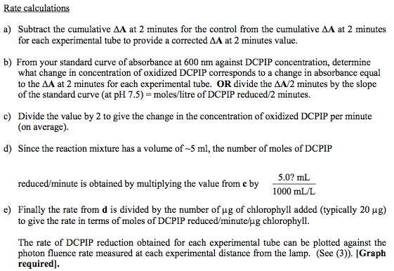

Explain the meaning of resolution in microscopy and the theoretical limit to resolution by reference to Abbe’s equation. (Resource Manual, pp. 47–49)
- Resolution in microscopy:
  - Resolution (d): smallest distance 2 objects must be separated in be distinguished as 2 objects.
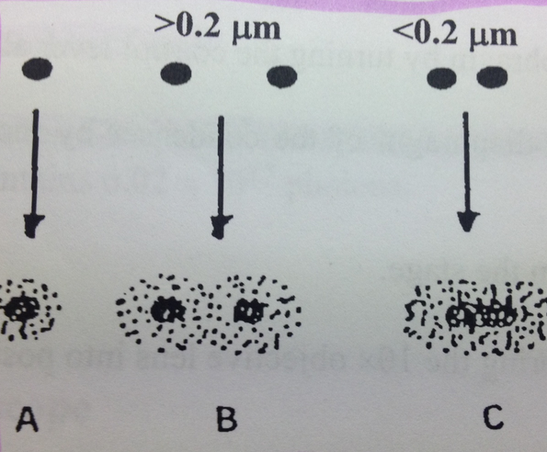
- When particle is examined w/ light microscope, periphery appears blurry at high magnification due to diffraction.
- 2 particles are separated by ~0.2 µm, images will overlap but individual character still seen (Can be resolved).
- 2 particles are separated by less than 0.2 µm, images fuse. Same image appears if particle was actually single structure (Cannot be resolved)
- Theoretical limit to resolution in an optical system (reference to Abbe’s equation):
  - (Diagram shows path of light rays through a specimen (beneath a coverslip on a slide) and into the objective lens)
Abbe’s equation
  - d = limit of resolution
  - 0.612 = constant derived of diffraction at plane of specimen
  - λ = wavelength of image-forming light
  - n sin α = numerical aperture of lens, measure of lens light gathering capacity.
$$d=\frac{0.612 λ}{n sin α}$$

  - Aperture angle (α): angle subtended by optical axis and the outermost rays that enter the objective lens.
  - Refractive index (n): Refractive index of the medium filling the space between the cover slip and lens.
    - Air n=1 (ignored).
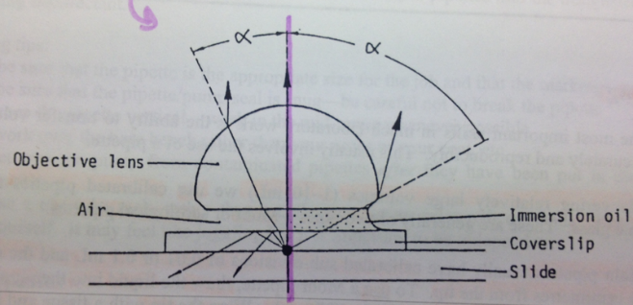
    - Immersion oil n=1.515
      - *Usage can produce considerable gain in numerical aperture.
  - To attain max resolution (min d):
    - λ minimized by using near 400 nm (violet light) (ie. Shortest visible wavelength).
      - In practice we use yellow-green (520-580 nm) since eye most sensitive to this part of spectrum.
    - n sin(α) maximized by:
      - n: increased as far as possible beyond air (n=1) using immersion lens or oil.
      - sin (α): α must be as close to 90º as possible, although cannot since specimen must be placed at some distance from lens.

Explain how to estimate the number of cells/mL with: i) a haemacytometer and ii) a spectrophotometer where the # cells/mL = “A400”/slope of standard curve. (D-Unit Lab 5)

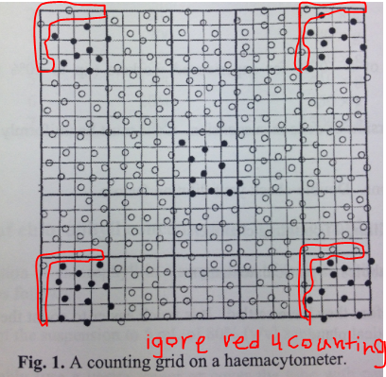
Haemacytometer: thick glass with lines etched precisely on the surface to form 2 counting grids
  - Counting
    - At the center of each grid is a 1mm x 1mm square
      - Then divided into 25 smaller squares by triple lines
        - Each smaller square is divided into 16 smaller squares
          - When cover is on 0.1 mm space between cover and surface
      - Count middle and 4 corners of counting grid.
        - Cells on Top left or left boundary are NOT counted
      - Do same process for second grid and calculate avg. cell of total 10 squares.
  - Calculation:
    - ${Number of cells}/{mL=} (Avg. Cell count per square) x \left(250,000\right)$

Spectrophotometer:
  - See question 8…
    - Instead of using Beer’s law (A = Elc) to find ∆c/min, we use Beer’s law and slope of standard curve graph of (Absorbance vs. Number of cells/mL) (ie. E value) to find ∆c (cells/ml).
    - $Number of cells/mL =(Measured absorbance of medium at A_{400}) ÷(Slope of standard curve graph)$
      - ie. c = A/El

Describe the meaning, and give the units, of photon fluence rate (Manual, p. 45)
- In photosynthesis, direct relationship between number of molecules photochemically altered & number of photon energy.
  - Essential to know number of photons impinge upon surface, rather than energy delivered.
    - Preferred measurement of Photosynthetically Active Radiation (PAR) is photosynthetic photon flux.
      - Flux = rate of flow of particles
      - Photosynthetic photon flux = number of photons in 380-700 nm range per unit of time on unit surface.
        - Measured by quantum sensor
        - Photon flux = μmoless⁻¹m⁻²

Know and use the following pH-related equations (pg.34-39):
- [H⁺][OH⁻] = 1 x 10⁻¹⁴
- pH = -log[H⁺]
*See Quizzes
  - [H+] = 10^{-pH}
- pOH = -log[OH⁻]
  - [OH]=10^{-pOH}
- pH + pOH =14
- $pH = pKa + log\frac{[acid]}{[base]}$

Describe how to make a buffer solution, how it minimizes change in pH (pg.39-42)

- How Buffers Minimize Changes in pH (Probably wrote too much here too lazy to summarize):
- Buffer solution maintains fairly constant pH when small acids/alkali are added.
- Weak acids (HA) dissociate into ions when dissolved in water. In solution, weak acid is in equilibrium with conj. Base (A⁻) and protons (H⁺).
  - Ha <--> A⁻ + H⁺
- Three common examples:
  - Tris H⁺ <-> Tris + H⁺
  - Phosphate⁻ <-> Phosphate²⁻ + H⁺
  - Acetic acid CH₃COOH <-> CH₃COO + H⁺
- Acetic acid act as buffer that resists pH change when H⁺ or OH⁻ ions are added.
  - When H⁺ added, eq. shifts left.
  - When OH added, eq. shifts right.
- When pH = pKa, buffering capacity of sodium is at greatest. Range in which buffer is most effective lies between one pH unit on either side of the pKa value.
- Biological reactions = extremely pH sensitive.
  - Experimental reactions run w/ buffer to maintain pH.
- Tris H⁺ <-> Tris + H⁺
  - When sodium hydroxide is added, (OH⁻) ions combine with H⁺ to form water. Driving equilibrium right
    - As you add more Tris H⁺ and Tris become more equal and buffering capacity increases (if [Tris H⁺] = [Tris], pH = pKa
      - Greatest capacity.
    - We will not reach this point because pKa for tricine is 8.26 and you will add only enough to bring to pH = 7.5., pH of your solution is within 1.0 pH unit of the pKa for tricine so it will be an effective buffer.

- How to Make Buffer:
- We will be making a buffer of volume 50 mL with
  - 250mM tricine
  - 500mM sorbitol (maintain osmosis)
  - 100mM KCl
  - 25mM MgCl₂●6H₂O
- To make 50mL of chloroplast buffer you ...
  - First need to calculate the weight of each component to be added
    - m = c x V x MM (see 3. Numeracy – “Manipulate SI units of measure and exponents”)
      - Tricine = (179.2 MM) x (0.50 M) x (0.05 L) = 4.48g
Molar Masses Given:
Tricine = 179.2
Sorbital = 182.17
KCl = 74.55
MgCl₂●6H₂O = 203.3
      - Sorbital = (182.17 MM) x (0.1 M) x (0.05 L) = 0.91g
      - KCl = (74.55 MM) x (0.1 M) x (0.05 L) = 0.37g
      - MgCl₂●6H₂O =(203.3 MM) x (0.025 M) x (0.05 L) = 0.25g
  - MgCl very hygroscopic (absorbs water from air)
    - Need to add an extra mL to compensate
    - Addition of 1.0mL of 1.25 M MgCl to buffer
      - When diluted 50 mL, will produce needed concentration.
  - Sorbitol dissolves slowly so provided with 40mL of solution @ that will change to 500 mM when diluted to 50mL.
  - Dissolve Tris and KCl in 40mL sorbitol solution.
  - Add the 1.0mL of MgCl
  - When dissolved, place gently cleaned pH electrode into solution and add sodium hydroxide (NaOH) until buffer reaches 7.5 pH.
  - Put solution into measuring cylinder and bring volume up to 50 mL.
    - Will use this solution at 1/5 of present concentration by diluting 5 fold (i.e. 1:4).

Be aware of factors to consider when selecting a buffer solution for a specific experimental context
- Factors that affect choice of buffer solution to use in specific biological context:
  - pH of use for the buffer should lie within 1.0 pH unit on either some of the pKa for that buffer.
    - In this range, buffering capacity of the solution is at its greatest
  - All components should be compatible.
    - Ex. If you need magnesium ion in mixture, would not use a phosphate buffer because these two ions react and precipitate as magnesium phosphate.
  - Should not affect the biological system of interest.
    - Ex. Don’t use phosphate buffers to study phosphatase enzymes (they competitively inhibit these enzymes).
    - Ex. Buffers w/ Tris are not usually used in measuring rates of electron transport through chloroplasts because it damages oxy-evolving complex of photosystem II.
  - Effect of dilution on pH depends on the buffering system.
    - If weak acid = positively charged (e.g. tricine H⁺), it decreases in pH with dilution.
    - If weak acid = negatively charged (e.g. phosphate) or uncharged (e.g. acetic acid), it increases in pH with dilution.
    - Degree of change with dilution depends on buffer. If buffer is sensitive to dilution, stock buffers are made at pH that will change to the required pH when diluted or adjust for pH after dilution.
  - pH of the majority of buffers decrease w/ increase in temperature.
    - Magnitude of this is buffer specific.
    - Buffers are usually prepared at the temperature at which they are to be used.
  - If additional salts are included in buffer solution, these should be added before pH and volume are adjusted.
    - Ex. tricine buffer contains MgCl2 and KCl.

Krajnyk Unit

Explain and outline the steps in the scientific method (pp. 129–131).

See #2 Experimental Design)

Define terms (e.g. descriptive statistics, null/alternate hypotheses, prediction, replication, treatment, control, randomization, scientific method, protocol, experiment, significance level, flow chart) (pp. 92–93, 97, 108, 129–132, lecture notes)

- Scientific Method, Randomization, Replication, Prediction, Treatment, Control, Significance Level, Null/Alternate Hypotheses, Experiment, Descriptive Statistics:
  - See Experimental Design
- Hypothesis contains:

  - Scientific name of organism
  - Part of organism (if applicable)
  - Stage in life cycle (if app.)
  - Independent variable
  - Dependent (response) variable

- Protocol (p.92): sequentially detailed account of experiment; (written in lab book); easy to draw flow chart and write `methods’ after.
  - Title: specifically reflecting nature of experiment
  - Numbering steps.
  - Very concise: incorporate diagrams, photos, labelling, even references.
  - Checklist:

    - Latin name of organism w/ authority, common name, additional info:
      - Age, size, strain, culture, location, perennial, part, state in life cycle, etc.
    - Material used (state brand name where applicable)
    - Apparatus, set ups, calibrations, methods of operations, etc.
    - Explain controls, treatments, replications, dependent and independent variables.
    - Sample size (+ how this was obtained)
    - Duration of experiment
    - Experimental parameters e.g. cm, g, mL, M, %, etc.
    - How solutions were made (dilutions, calculations, etc.), storage req., etc.

    - Indicate potential hazards, safety req., etc.
    - List: measured variables, how data was collected, frequency of data collection, specify any qualitative observations, reasons for collecting data at specific time of day/year, etc.
    - If field work (outside lab), then consider additional elements (e.g. map, GPS, environmental variables, etc.)
    - How data will be handled e.g. calculations, statistical tests, etc.; names of statistical techniques used to analyse data and citations for these techniques.
    - Prepare data sheet(s)/graph(s) (Table or Figure) into which you will enter data.

- Flowchart (pg.94): diagram of the separate steps of a process in sequential order
  - First step = title
  - Start end
  - Step, Start/End, Decision (with branches for If True/False).
  - Like protocol but very concise.

Explain the importance of randomization, controls, replications, significance level, and statistical analyses (pp. 97, 104, 108, lecture notes).

See Experimental Design

Explain when Anova and Tukey tests are used and what they do. Reasons for testing H0 (pp. 106-112, 131)

(See: 3. Numeracy (Identify and interpret appropriate statistical analyses)

3 basic assumptions to be considered if application of the parametric analysis of variane (Anova) is to be valid:

Data obtained randomly from normal population. (Normality)

Sampled populations have equal variances (Homoscedasticity).

Unequal sample variances are referred to as hetreoscedastic.

It is assumed that treatment effects are additive (linear). (Additivity)
- Given an example of an experimental study, state objectives, hypotheses, prediction. Identify replications, controls, dependent (response) and independent variables and units of measure. (Quiz 1 & 2; 130, 139-140,)
- See above.
- Present descriptive statistics in Tables and/or Figures and indicate with letters results of statistical analyses (pp. 113–114, 139–140
- See Numeracy
- Given Tables and/or Figures, write text for a “Results” section (pp. 139–140, lecture handout for text, lecture notes).
  - See 2. Experimental Design and 3. Numeracy.
- De-and re-construct (paraphrasing) information from selected passages of a primary article (Assignment #1)

Given summarized data, create effective Tables and/or Figures. Write effective titles/legends (pp. 99(SD/SE), 113–114, 139–140, lecture notes)

See 3.Numeracy

SD: square root of variance; is a measure of dispersion of the population around the mean. Used when wish to describe population that has been sampled.

SE: does not imply mistakes are made, Standard error of the mean measures the deviates of the sample means from the population mean. Used when wish to describe the precision of estimation of the population mean (not for individual data points, but sample means)

Table Title: Self-explanatory, above table, no vertical lines, minimize horizontal lines

Dependent (response) variable

Descriptive statistic of dependent

Statistical dispersion (SE or SD)

Name of organism (if many, general term)

Independent variable

Description of independent variable

Trends:

Independent variable

Dependent (response) variable

Significant differences

Points to mention

Indep. Variable

Dep. Variable

Significant Differences

Direction of significance

Test statistic (F) & P value

Comparison to control

Compare to other major results

Reference to Table and/or Figure.

What kind of information—in terms of content—is presented in the various sections of a poster? (pp. 133-135)
- Brief summary of research
- Abstract never on poster.
- Tense: past for your work, present for other work
- Title (3 Parts): Essence of exp. (informative, concise, specific, sentence case), Authors (title case), Affiliation (title case)
- Intro (6 points): Issue/aim/phenomenon/concept, importance of it, mention organism, objective, hypotheses (H_{a}), prediction(s).
- Methods (past tense): Brief and concise.
  - Key points: Control, Indep. (treatments), Replications, Randomization, Dep. (response) variable.
- Results (past tense):
  - Tables/Figures:

    - Summarized & clear data
    - Self exp. Title for table
    - Self exp. Legend for figure.

  - Text: Scientific story

    - Important summarized findings.
    - Data not repeated.
    - Major findings/results present (general trends/patterns & major differences).
    - Implications not discussed.
    - Test statistic (F) and P value reported.
    - Refers to ever table/figure.

- Discussion:
  - Major focus: interpret meaning & importance of findings
  - Interpret results in context of: objectives or hypothesis + prediction(s), support all statements.
  - Two primary articles paraphrased
  - Original thoughts/ideas
  - Facts vs. speculation
  - Unusual/unexpected results
    - Biology not apology.
  - Conclusion: few statements, usually last paragraph.
- References:
  - Journal: full
  - Poster: no title in references.
- Acknowledgements.

Zabulionis Unit

Explain the biology/chemistry underlying the various steps of plasmid transformation. (i.e. explain the function of reagents such as calcium chloride, etc.) (Lab book + pg.69, 10-13)
- Terms:
- Transferring techniques (13): Read page 13 Resource manual.
- Aseptic Technique (11-12): To ensure experimental microbial systems are controlled and contained at all times. See pages 11-12.
- Pouring Plates (12-13): Process of making agar plate (pg. 12-13)
- Adhesion Zone: Area in the cell membrane where the plasmid is able to enter the bacteria under the correct condition
  - It seems to be the part where the bacterial membrane where the inner and outer membrane are fused to pores in the membrane
- Antibiotics: compounds produced by some bacteria/fungi that inhibit other cells.
  - Most antibiotics function by 1 of 4 mechanisms:
    - Inhibition of cell wall synthesis
    - Alteration of membrane permeability
    - Inhibition of protein synthesis
    - Inhibition of nucleic acid synthesis.
- Ampicillin: antibiotic derived from penicillin which is bactericidal (kills bacteria) and interferes w/ cell wall biosynthesis (fiber cross-linking).
  - Transpeptidase enzyme for crosslinking new peptidoglycan chains in growing cell wall is irreversibly inactivated by ampicillin binding.
  - Only actively growing cells affects (ie. Ampicillin blocks new cell wall synthesis), not dormant.
  - Amp^{r} (ampicillin resistance gene) codes for enzyme that degrades antibiotic.
- Text explanation (pg. 69):
  - Few bacteria have mechanism for taking up DNA (transformation). E. coli must be artificially induced to become “competent” for transformation by subjecting them to incubation in cold calcium chloride followed by brief heat pulse 42ºC.
  - Mechanism: large DNA molecules (- by phosphate) move through adhesion zones where inner and outer membranes are fused to pores in the bacterial call wall. Chilling calls likely stabilizes lipid membrane, while (+) calcium chloride shield (-) DNA backbone. Heat pulse creates thermal imbalance across membrane, physically pumping DNA through adhesion zones.
    - Once inside, DNA must be replicated to be stably inherited by daughter cells. DNA w/ replication origin can replicate independently of the host chromosome. Molecules lacking replication origin might be incorporated by recombination (cross over) or transposition (“jumping genes”).
    - Genes carried into cell by transformation may confer a new trait (antibiotic resistance) after transcription and translation. Time required for expression = “phenotypic lag.”
- In class explanation:
  - The cold calcium chloride has two functions:
    - The coldness basically freezes the lipopolysaccharide fibers on the outer cell membrane. This stabilizes the negative charges and makes it easier for the plasmid to enter the bacteria and transform it since LPs are usually waving around preventing plasmid from entering cell.
    - The Calcium chloride dissociates in the bacterial solution. The positive calcium ions will neutralize the negative charges on the LPS on the outer membrane (and other membrane components) as well as the negative charges on the plasmid (plasmid is made of negatively charged DNA, due to the presence of phosphate groups)
  - The heat pulse treatment, when moving the bacterial solutions from ice bath to the 45C water bath, has three functions that may contribute to the transformation of the bacterial cells:
    - Thermal Expansion: The membrane expands when subjected to heat. However, the outer membrane expands at a quicker rate than the inner membrane, which produces a physical push that brings the plasmid inside the cell
    - Fluidity: At higher temperatures (45C water bath) it would be easier for the plasmid to slip through the membrane which is more fluid than the rigid membrane at freezing temperatures
    - Electrical attraction: Bacterial maintain a negative resting membrane potential by constantly pumping out positive hydrogen ions from inside the cell. At freezing temperatures, the pump ceases to work, and there is a buildup of positive charge inside the cell. This is attractive to the negatively charged plasmids, and it becomes easy for them to enter the cell
  - The 37C incubation period for 15 minutes serves as the 37C lag incubation period in which the cell needs time to accept the plasmid (and the ampr) gene before it can start transcribing, translating, and replicating it.
  - The LB broth is nutritious, and allows the cells to divide efficiently
  - The TE buffer is used to dissolve DNA (therefore, we place the pGreen plasmid in 10 uL of TE buffer)
- Watch video: http://education-portal.com/academy/lesson/bacterial-transformation-definition-process-and-genetic-engineering-of-e-coli.html#lesson

Explain the biology underlying transformation, satellite colonies, antibiotic action and resistance of ampicillin, plasmid structure and apply to unique situations. (pg. 10-13, 69, lab book, class notes)
- Transformation: see question 1.
- Transformants: Bacteria that were able to acquire the plasmid (i.e. pGreen) and start growing and dividing on the plate
  - Transformation is a very very rare event: In 100 uL of cells, there are 100 million cells (we always assume in this course that 1uL of cells contain 1 million cells). However, in the entire cell population, only a few dozen obtain this plasmid. We only need a few because bacteria grow fast + antibiotics eradicate non transformants
  - The transformants look like dark circles on our plates (they basically stand out).
- Satellite colonies: dormant bacterial cells that start growing on the ampicillin-free LB media (which is nutritious), and living through the support of being around transformants that kill of antibiotics (ie. Transformants protect satellite colonies).
  - Bacteria that has transformed into amp^{r} synthesize the protein coded by the pGreen plasmid.
    - The protein is an ampicillin resistant protein that is exported OUT of the cell and breaks down a ring of ampicillin around the transformed cell
    - The ampicillin-free ring around the plasmid allow for smaller bacterial colonies to grow around it (ie. Satellite colonies).
    - So satellite colonies are dormant bacterial cells that start growing on the ampicillin-free LB media (which is nutritious)
    - As a result, satellite colonies have a delayed appearance they appear much later on the plate than the transformants. These have a few implications in research… in that we can isolate and purify the transformant cells because they are much easier to work with than with satellite colonies
      - We can take the plate out of the 37C incubator before the satellite colonies appear
      - We can add even more ampicillin to the plate (this is an expensive method). This method will keep only the transformant cells on the plate
- Antibiotic action: See Question 1 terms, etc.
- Resistance of ampicillin: See Question 1 terms, etc.
- Plasmin structure: See Amr notes below…
- Unique situations:
  - Why would one transformant have less satellite colonies than others?
    - Less production of amp^{r}.
    - Less nutrients available.
  - EDTA and CaCl₂ are added to transformation experiment. EDTA is a chelating agent for divalent cations. Why was transformation not successful?
    - EDTA, a chelating agent for divalent cations, will disable the affect normally done by CaCl₂ cations that shield the plasmid from the forces preventing entrance to the cell – thus limiting plasmid transformation and decreasing number of transformant.

Micropipette usage from Resource Manual and Notes. (pg. 49-51, notes)
- Pipetting:
  - For delivering volumes (1-10ml) use calibrated pipettes of borosilicate glass. Two types:
    - Mohr pipettes: calibrated sub-divisions of 0.01 or 0.1 mL and markings end a few cm from tip.
      - Usage:
        - Draw liquid into pipette w/ pipette filler to a level about 2cm above “0” mark.
        - Wipe tip w/ tissue and lower liquid level until meniscus is sitting on zero line (@ eye level)
        - Deliver & remove last drip from tip by touching it to inside of receiving container.
        - Called TD (to deliver) pipettes because the invended volume is delivered without emptying pipette.
    - Serological pipettes: resemble Mohr, except are graduated downward to tip itself.
      - Usage:
        - Same way as Mohr except all solution must be forced out.
        - After tube emptied, wait ~15sec to allow liquid to drain.
        - Last drop is then blown out using pipette filler pressure.
    - Sterile glass/plastic 1mL and 10mL pipettes.
      - Hold pipette close to end when inserting pump, otherwise can break.
  - Selection of correct size is important: use smallest practical pipette.
    - Why? Diameters differ, therefore cross sectional areas differ, so if meniscus is 1mm above zero larger error.
- Micropipettes: models used = Eppandorf and Gilson digital micropipettes.
  - Select micropipette of the appropriate volume range (look at the plunger label).
  - Keep pipette tip box closed whenever you do not need them.
  - When needed, open the box, and place the pipette into the tip (meaning, don’t grab the tip with your fingers because they are sterile).
  - Push the plunger until its first natural stop, and THEN place it into the solution.
  - Slowly let go of the plunger to suck up the solution.
  - To deliver the pipette solution out, put the pipette tip against the side wall of the tube, push the plunger until the first natural stop. Take the pipette tip out of the solution, but keep it pressed against the wall. Wait 1-2 seconds, then depress the plunger to the second natural stop.
  - Take pipette out of the solution slowly, and allow pipette tip to return to up position.
  - Eject the tip into the biohazard container (Eppendorf = third stop, Gilson = white plunger on back).
  - Never touch pipette tip.

Determine stock solution, final and working concentrations (pg. 61-68)
- See NumeracyDilutions

Estimate the number of cells/mL in overnight cultures (D-Unit lab notes pg. 17, RS 17-19)
- # Colonies in Volume after x dilution. Number of cells per mL before dilution?
$$Number of cells before Dilution=\frac{\# Colonies}{Volume (mL)}x {Dilution (mL)}^{-1}$$

Interpret data to develop a prediction, conclusion and propose models to explain trends.
- Mehhhhhhhhhhhhhhhhhhhhhhh

Additional Zab Notes. Courtesy of Amr Alsabbagh:
How to Plate:
- Pipette 100uL of bacteria solution onto the center of the plate
- Place the spreader in ethanol, then run it through a flame to sanitize it
- Open the lid of the plate slightly (just enough for the spreader)
- Tap the spreader on the lid to cool it down.
- Before touching the bacterial solution, tap the spreader on the LB media in the plate (make sure there is no sizzling sound)
- With the lid just barely above the plate, use the spreader to spread the solution using long, gentle strokes. Rotate the plate as you are spreading
- Incubate the plates upside down, to prevent condensation from dripping onto the bacteria.
- Label the plates themselves (not the lid)
Protocol for transformation of E. Coli JM101 with pGreen (ampr):
- Scraped a line (about 4 cm) of E. Coli JM101 from agar plate, using a sterile toothpick. The bacteria was placed into an Eppendorf tube.
- 500 microliters of cold CaCl2 (100mM) and vortexed until the solution was cloudy
- Place the solution into the ice bath for 5 minutes
- Vortex sample again. Transfer 250 uL of the solution into separate tubes.
- To one tube (control) add only 10uL of TE buffer. To the experimental tube, add 10uL of the pGreen plasmid in TE buffer.
- Samples were both vortexed and placed in an ice bath for 5 minutes again
- Heat pulse treatment both samples were placed in a 45C water bath for 100 seconds.
- Samples were vortexed again, and placed in an ice bath for 2 minutes
- 250uL of lysogeny broth (LB) was added to each tube.
- The tubes were vortexed and incubated in a 37C water bath for 15 minutes
- The samples were vortexed again to be ready to be spread .
- 100uL from each sample was placed into each of the following plates: LB plate and LB+amp plate (100ug/mL)
- Plates were labelled and incubated at 37C overnight
Notes on Transformation Experiment:
- E. Coli is the species. JM101 is the strain
- TE buffer dissolves DNA
- Amp^{r} = ampicillin resistant
Notes on personal Experiment:
- See Transformation
Growth Types:
- Confluent growth: Most common growth pattern. Individual colonies cannot be distinguished from one another Kira calls this growth “Lawn growth”
- Colonial growth: Individual colonies can be distinguished from one another
R-Plasmids:
- R-Plasmids are Resistance Plasmids
- They are small, circular clumps of DNA that do not get incorporated into bacterial chromosomes
- pGreen is ~3.9kb in size. In comparison, the E. Coli chromosome has 4000kb (roughly 1000 times bigger than the plasmid)
- pGreen contains a few genes:
  - the ampr gene 900 bp
  - Green fluorescent protein (GFP) allows the plasmid to glow green below UV light
  - Has an origin of replication (ori)
- Plasmids have no introns
- Ori
  - E. Coli bacteria have a stringent ori: The ori is tightly controlled, and makes it difficult for polymerase to bind and replicate the plasmid. As a result, only 5 to 6 copies of the plasmid are made
  - Scientists mutated the ori to make it a relaxed ori. This is not tightly controlled, and allows for 100s of copies of the plasmid per cell
Spot test:
- This is used to save plates. Instead of spreading the bacteria all over the plate: put 10uL of bacteria on the plate, and don’t spread it
- You can put numerous drops on the whole plate.
- Does not work for all experiment types

Acquiring a plasmid:

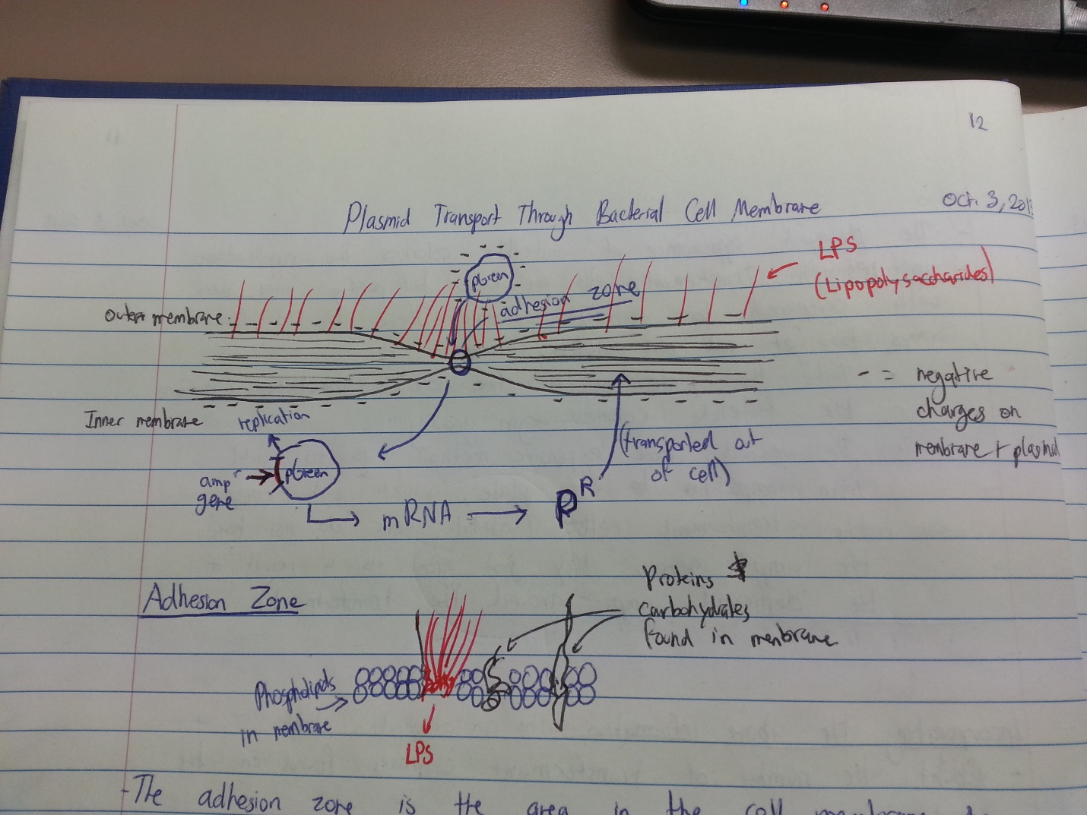
- Lipopolysaccharides (LPS) are found on the outer membrane of the bacteria. They are found in highest concentration around the adhesion zone. There are approx. 600,000 of them on the membrane of each cell
- LPS wave around fluidly at the incubation temperature of 37C
- When placed in an ice bath, the LPS fibres freeze
  - This makes it easier for the plasmid to get through the membrane because it stabilizes the negative charges
- DNA has a negative charge (due to the presence of phosphate groups). The lipid membrane ALSO has a negative charge.
  - Since the plasmid is made of negatively charged DNA, it cannot enter the cell under normal charge conditions
  - THEREFORE, we add calcium chloride (CaCl2). In the bacterial solution, it dissociates and the Ca2+ helps to neutralize the negative charges so that the plasmid can go through the membrane
Control Types:
- Negative control
  - Hoping to see no growth in the control plate
  - For example: We can put E. Coli that have not been transformed (do not contain the ampr plasmid) onto an LB+amp plate. If no growth is observed, we can conclude that the bacterial population will not become resistant to ampicillin without the actual plasmid.
  - In other words, negative control is used to make sure that cells don’t get those rare random mutations that can make them resistant to our treatments. Beneficial muations in the transformation experiment may be due to the ice bath or the CaCl2 or something.
  - The beneficial mutations are very rare, but there are million of cells in our sample, so there is a slim chance of the ampr phenotype arising
- Positive Control
  - AKA vitality control
  - This is our experimental sample We WANT to see growth
  - Positive control is used to see if our cell sample survived our protocol
- Experimental Control
  - This is highest level of control (hierarchically higher than positive and negative controls)
  - We are trying to see how the organism “works” and find out if there are better ways we can perform the experiment
  - Example: we may find that subjecting the cell to heat shock for 200 seconds instead of 100 seconds may allow more growth on the plates, and this can be used as a baseline instead.
Observation Table:
- There are a few things that we should observe when performing our experiment, and should go onto our data table:
  - The number of transformant colonies (one transformant colony = 1 transformed cell)
  - Ratio of satellite colonies to transformant colonies
    - Some transformants will have larger satellite colonies around them than others, depending on how much ampr protein the produce and export
- So in our experiment we mentioned 2 things:
  - The number of transformants
  - The size of the satellite colonies
- Sample calculations are placed below the table
- Title above the table the table title will be similar to the protocol tile, except you are adding what you are measuring
  - Table 1. Mention what you are measuring, the experiment, the bacteria type, and the plasmid type
    - Table 1. Observed number of transformed E. Coli JM101 colonies containing the pGreen plasmid (amp^{r})
Other Information:
- Plasmids get replicated in the cell so that daughter cells can have a copy
- The plasmid (and the ampr gene) gets transcribed and translated before it can get transported as a protein to (and out of) the cell wall
- Incubation lag: there is a small period of time that cells must be incubated at 37C in order for them to accept the plasmid (and the ampr gene) in order to become resistant to amp. This incubation lag period allows the cells to transcribe, translate, and replicate the plasmids to produce enough ampicillin-resistant protein in order to survive the amp plates
- Competent Cells: Cells that are readily able to take up a plasmid
- Established cells: Cells that have took up the plasmid, and are able to transcribe, translate, and replicate it
  - You can have a competent cell that is not established, but in order for the cell to survive, it has to be competent AND established.

