Chapter 12—Attraction, Love, and Communication
Relationships usually progress, starting with attraction, intimacy, and then love, and the continuous requirement of communication throughout the process

Attraction
- Proximity and timing are crucial to meet people we are attracted to
- Tend to be more attracted to people that we have had contact with several times
- Mere-Exposure Effect: tendency to like a person more if we have been exposed to him or her repeatedly
- We tend to like people who are similar to us (age, ethnicity, background, economic and social status)
- Homophily: tendency to have contact with people who are equal in social status
- Tendency for ethnic homophily have to do with ethnocultural minorities tend to live in socially and economically separate communities
- Matching Phenomenon: tendency for men and women to choose as partners people who match them, that is, who are similar in attitudes, intelligence, attractiveness
- Similarity is attitudes are important for relationships but personality, not so much
- If given a choice, people will always go for the more attractive choice
- Young men and women rate physical attractiveness as most important
- Light skin is rated as more attractive (to African Americans)
- Physical attractiveness is most important to males rating females
- Women’s worth tends to be based on her beauty, while men’s is based on their success
- How desirable a man is judged to be depends on the woman’s sense of her own worth
- Status seems to be the least important factor of attractiveness
- Four social forces make online dating popular:
  - Growing population of single people
  - Career and time pressures lead people to seek more efficient ways to look
  - Single people are highly mobile
  - Workplace romance is not very acceptable (harassment)
- Online dating allows minorities to seek other partners
- Attract people for dating that do not have the time or taste for single bars
- Imagination can strongly influence online meetings and fuel attractiveness
- A major disadvantage is the risk of dishonesty (catfish)
- Reinforcement Theory Byrne’s Law of Attraction
  - We tend to like people who give us rewards/reinforcements
  - Tend to dislike people who give us punishments
  - Attraction to another person is proportionate to the number of reinforcements that person gives us relative to the total number of reinforcements plus punishments that person gives us
  - People like others who are similar to them because the interaction is rewarding
  - We prefer attractive partners due to the high value we know society places on them
  - We believe others will have a higher opinion of us if we have a good-looking partner
  - We are attracted to similar people because it activates positive views about ourselves
- Sociobiology Sexual Strategies Theory
  - View in evolutionary perspective (heterocentric)
  - Function of mating has been about reproduction
  - Men have to choose reproductively valuable women (youthful and fertile and healthy looking)
  - Women make a greater personal investment when reproducing
  - Want mates who are reproductively valuable and good investments
  - Having a healthy child who develops normally is very reinforcing
  - Use our sexual strategies to obtain this
  - This theory is not a good model for same-sex relationships/attraction

Intimacy
- Features of intimacy include openness, honesty, mutual self-disclosure, caring, warmth, protecting, helping, devotion, commitment, attentive, emotional
- Intimate interactions include intimate experiences and intimate behaviours
- Intimate Experiences: meaning a person gives to their interaction with another person
- Example: meeting your partner’s parents, this is a positive experience because he wants to include you in the family
- Most common form of intimate behaviour is verbal self disclosure
- Intimate Relationship: relationship in which intimate interactions occur on a regular and predictable basis. A relationship characterized by affection and between partners, mutual trust, and cohesiveness
- Intimacy can also be define as closeness and sharing, and partner responsiveness, which has three dimensions: affective, cognitive, and physical
- Self-disclosure leads to reciprocity
- Self disclosure makes us like and trust a person more, modeling causes use to reciprocate as well, and norms of equity
- More self-disclosure = more likely to stay together
- Scale for measuring intimacy Personal Assessment of Intimacy in Relationships (PAIR) Inventory
  - Measures emotional intimacy in a relationship based on certain questions
- We are unlikely to self disclose unless we trust our partner

Love
- Have a triangular relationship between sex/hook ups, romantic love, and passionate love
- Sternberg Triangular theory of Love
  - Love has 3 fundamental components
  - Intimacy, passion, commitment
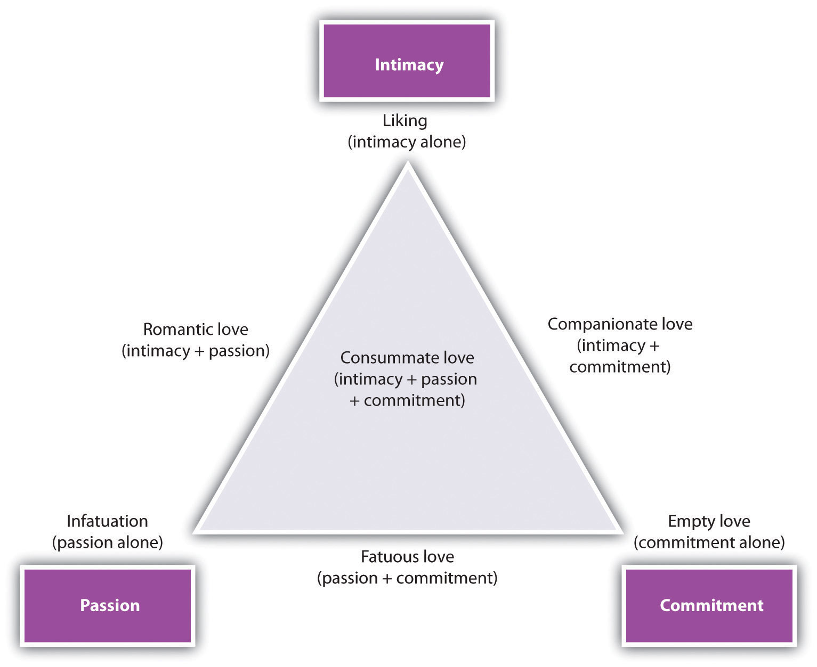
  - Intimacy is the emotional component, can be found between friends, siblings, not just lovers
  - Passion is motivational component for love, physical attraction and sex drive
  - In long term relationships, passion is what fades first
  - Commitment is the cognitive component, two aspects to this:
    - Short term: decision that one loves the other person
    - Long term: decision to commit to the relationship
  - People who have high levels of all components consummate love
- Sternberg also developed questionnaire about triangle
  - Sternberg Triangle Love Scale (STLS) to measure 3 components
  - Was good at predicting how relationships will progress
- Attachment Theory of Love
  - Quality of early attachment in infant-parent bond, whether secure or insecure, profoundly affects us for the rest of our lives, primarily on our capacity to form loving attachments to others in adulthood
  - 4 different attachment styles
  - Attachment styles based on our perceptions of ourselves as well as our expectations of how others will respond to us
  - If we view ourselves in a positive way worthy of love, self-confident, see people as trustworthy and available
  - View ourselves in a negative way unworthy of love, anxious about relationships, see people unreliable and rejecting
  - Secure positive self image and others model, other people are accepting and responsive
  - Preoccupied low sense of their own lovability, but positive evaluation of other people. Try to gain self-acceptance through the acceptance from other people. Want to get close to a lover but too scared of rejection.
  - Fearful lovers negative outlook on self and other people. Expect to be rejected by others so avoid relationships. Feel uncomfortable feeling close to others.
  - Dismissive feel they are worthy of love but have negative outlook on others. Avoid disappointment by avoiding relationships, remaining mostly independent
  - Dismissing and fearful are both similar by avoiding intimacy
  - Fearful and preoccupied are similar by both depending on acceptance from others to feel good about themselves
  - Separation due to divorce or death is not related to attachment styles
  - Quality of parent and peer relationships both affect adult attachment styles
  - People who have insecure attachment with their parents can have secure attachment with a partner
  - Conflicts in relationships can be caused by mismatches in style
  - Gives some explanation for jealousy
  - Also helps to explain high risk sexual behaviour
- It doesn’t just matter our interactions with our loved ones, it matters how we interpret them
- Theory of Love as a story
  - Need someone who fits our love story (what we think love should be like)
  - People make up their own love stories and are attracted to them unconsciously
  - Common component in stories:
    - Objectification-threat (partner is unpredictable/strange
    - Nurturing-caring (shared moments, nurture is important)
    - Pornography (like to use weird sexual techniques, do what partner wants)
    - Pragmatism (recipe for success, I am following the rules)
- Fourth theory differentiates between passionate love and companionate love
  - Passionate Love: state of intense longing for union with our other person and of intense physiological arousal
  - Passionate love contains three components:
    - Cognitive (preoccupation and idealization of the person)
    - Emotional (physiological arousal, sexual attraction, desire for union)
    - Behavioural (taking care of each other, maintaining closeness)
  - Passionate love can be overwhelming, obsessive, all consuming
  - Companionate Love: feeling of deep attachment and commitment with someone you have an intimate relationship with
  - Passionate love is the first stage of a romantic relationship
  - Sexual desire and romantic love are different agendas
  - Sexual desire = passion, attractiveness, high status
  - Romantic love = attachment and commitment
  - Evolutionary perspective desire to mate, pairing, parenting
  - Each has its own reward pathways in the brain
  - Dopamine levels rise during mating, dopamine is linked to euphoria and craving
  - Frequent presence of a loved one causes hormone release of prolactin and oxytocin
  - MRI study shown pictures of their lover and parts of the brain rich in dopamine lit up (mesolimbic dopamine pathway?) Operational Definition: defining some concept or term by how it is measure—example, defining intelligence as those abilities that are measured by IQ tests
- Operational Definition: defining a concept/term by how it is measured—example, defining intelligence as those abilities that are measured by IQ tests
- Two Component Theory of Love: two conditions must exist simultaneously for passionate love to occur: physiological arousal and attaching a cognitive label (i.e. love) to the feeling
- Misattribution of Arousal: when a person is a stage of physiological arousal (from exercising or something scary) and attributes the feelings to love or attraction
- This theory also explains why people have a tendency to associate love with sex
- Also explain the confusion between love and lust
- Two dimensions where cultures vary
  - Individualism VS collectivism
    - Canadians get married on a basis of passionate love, while collectivist culture society marriages are often arranged and family status is usually the basis of marriage
  - Independence VS Interdependence
    - For other cultures the self is defined in relation to others
- All cultures have intelligence, kindness, and understanding rated as the top characteristics a partner must have
- Western culture might see falling in love a component in order to marry
- Eastern culture sees marriage happening first and then you fall in love with that person

Communication
- Distressed couples usually have communication deficits
- Sexual orientation does not influence communication skills or deficits for couples
- Couples with sexual problems have poorer communication (about everything)
- 4 types of negative messages we send our partners:
  - Criticism: attacking partner’s personality or character
  - Contempt: intentionally insulting or orally abusing the other person
  - Defensiveness: denying responsibility, making excuses, replying with a complaint, or self-protective responses instead of addressing the problem
  - Withdrawal: responding with silence, turning TV on, walking out of the room
- Sexual Self Disclosure: telling person sexual things about yourself such as your sexual likes and dislikes
- Majority of Canadians feel they can disclose their sexual likes/dislikes
- Sexual disclosure leads to satisfaction in two ways
  - Increases intimacy between partners
  - Sharing likes and dislikes helps our partner learn about our sexual preferences, causing mutually enjoyable sexual reactions
- Very important in long term relationships, during a new relationship sex is exciting and feel satisfying without knowing your full needs
- Important that when communicating the message’s intent and impact are the same
- Intent: how you meant it
- Impact: how it was interpreted
- Using “I” statements helps to make emotions softer and communication not as insulting to the other person
- Avoid the use of mind-reading making assumptions about what your partner thinks or feels
- Documenting is an important component of communicating well
- Documenting: giving specific examples of the issue being discussed
- Next step give suggestion of what could be improved
- Levelling: telling your partner what you are feeling by stating your thoughts clearly, simply and honestly (usually the hardest part)
- When you level with your partner you also have to do some editing
- Editing: censoring or not saying things that would be deliberately hurtful to your partner or that are irrelevant
- It is important to be an active listener, and be a non-defensive listener
- Next it is important to give feedback to indicate you are listening
- Good to paraphrase saying in your own words what you think they meant
- Non-Verbal Communication: communication not through words, but through the body (eye, tone of voice, touching)
- Distressed couples tend to have worse non-verbal communication than verbal
- Also tend to be negative listeners
- Validation: telling your partner that, given his or her point of view, you can see why he or she thinks a certain way (good form of communication)
- Important to give partner positive feedback when they do something right
- Inevitable that you and your partner will get into fights, important that you have a set of rules for fighting fair make arguments constructive instead of destructive
- Edit what you say (no sarcasm, insults)
- Do not bring up old partners
- Do not play amateur psychologist
- No dumping (storing up anger and dumping it all out at once)
- Don’t hit and run (bring up something negative when there is no time to discuss it)
- Do not focus on who’s to blame, focus on the solutions
- Homosexual couples are more likely to initiate sex using non-verbal communication

