PHILOSOPHY – UNIVERSITY – NOTES

CLASS 2 CHAPTER 1

Critical thinking – most complicated term -
Good reasoning is tricky after simple logic
What does reasonable mean? – Charter of rights and freedoms, law any right listed in it is subject to reasonable limitations. – How well they evaluate their argument to make it true.
What is a good argument? – Anonymous. We want to know whether the claim being made is true or plausible.
Evaluating a claim – does their claim have anything to back it up? Does the evidence that backs it up seem strong how much does it back it up?
Meta – thinking about thinking
Most general approach figuring out what is true in this world. No wishy washy – everything depends on it.
We want to know as best as we can what’s really going on. Internet makes it more difficult – packed with misinformation. Ability to think critically is more important than ever.
Come up with Beliefs that are closer to the truth. Doomed in society if no one tries to find good reasoning.
The news – business has become more mediated. They keep their stories specific to “juicy” news. It is damaging our critical thinking. Ecochains. We have to ask ourselves “is this true’. Actively do it to ourselves. Not wait for the news to do it for us. Must look for evidence that we are wrong. “I hold this belief tentatively” only thing not tentative is logic. Belief is always tentative. Learn more by doing this. Dogmatic, no longer question anything. It withers away when not used. Make sure you’re keeping your brain awake – whole life.
Extremely valuable – no rich idiots wanted.
Textbook – claim; assert that something is the case. Claim that something is true. You have a proposition about the world. A proposition states something about the world that we can understand as a fact. A fact of the matter. What is truth? We know when a proposition is made without knowing if its true or not. Claim does not come in clear form always, must determine what the claim is. What is the conclusion of their argument? Objective is always true of false answer whether we know it or not.
Subject of opinion: Everything is true or false there is a god or not a god. Based on what people might feel. Questions of faith are a classic example. Only true is this class in love with Justin bieber if half of this class is in love with Justin bieber. Depends on what people are feeling or not. Changes acc
ording to feelings. True if they feel it. Subjective opinion. Just because someone tells you their feeling something doesn’t mean they are. They can/do lie.
Claim is a part of an issue. Call a claim into question – you turn it into an issue.
What is going to count as evidence that our issue is going to count as evidence to make it true or false?
Philosophy- why should we believe something?
Proving a good argument from a bad argument is easy. Proving error is easier than proving true.
Kinds of truth - Wenkenstein. He changed his mind on the 30 pages he wrote. He said he was wrong and figured out he was wrong. Tried to write another book and gave up. He thought he had come up with what makes things true or not. – Was a logical structure that was extremely complicated? – “The world is everything that is the case” The world is made up of facts not claims. The fact that he decides he is incorrect, shows that problems are difficult to solve. Almost like science – metascience. Scientific truth is not the only truth that there is. These claims are rather frequent. Ex: if you just believe then you will be successful. If you fail you didn’t believe enough. No way to prove it true or false. It is logically impossible to prove it true or false. Have to be rejected form the get go.
“What evidence could we have that god didn’t create the earth this morning?” – Wenkenstiens teacher.
Have to find the evidence that could’ve proven it false. Claim – issue- evidence – argument.
Any individual piece of evidence is called a premise.
For a premise to prove something true must be true itself. That premise can itself become an issue with its own argument. Go back infinitely.
Go back into an argument until both people believe something is true. Try to determine the consequence of believing that thing we believe. The premise must be relevant to the conclusion. Making imprints from the premise to the conclusion.
The difference between argument and an explanation: Explanation is why something is the case. Argument about whether the story is correct. Just the story about why something is the case is not an argument. They explain the conditions of the argument. How do you figure out what is being argued.
Trying to persuade someone and trying to produce a reasonable argument are two different things. Rational arguments are not emotional.
We know what the right thing to do is but we don’t do it = persuasion. Reason doesn’t have a lot of power. More important to hang on to that little bit that we have. When unreason has so much power even in ourselves we know we must reason even more.

These biases are a product of our impulses. We tend to give more weight to evidence we already believe. Even thinking we like something will produce a cognitive bias. Your prejudice will produce a confirmation bias and could be based on any error.
Be tentative about who you are. Stop worrying about who you are. You are always in a growing process. Must break out of bad habits and cognitive bias – chocolate experience.
Peer pressure. Bandwagon – if someone likes something because someone else likes something but they might be doing the same thing.

Chapter Reading
The purpose of thinking critically is to come to correct conclusions.
Concluding involves believing.
A belief and a claim are propositional, which means it can be expressed in a declarative sentence – a sentence that is either true or false.
Objective claim: has this characteristic: whether it is true or false is independent of whether people think it is true or false.
Subjective claim: whether a subjective claim is true or false is not independent of whether people think it is true or false.
Fact and opinion: factual opinions are not all true.
Factual opinion/belief/claim = objective opinion/belief/claim = opinion/belief/claim whose truth is independent of whether anyone thinks it is true.
Relativism is the idea that truth is relative to the standards of a given culture. Relativism holds that if your culture and some other culture have different standards of truth or evidence, there is no independent “god’s-eye-view” by which one culture’s standards can be seen to be more correct than the others.
Moral subjectivism: the idea that what is right and wrong is merely a matter of subjective opinion, that thinking something is right or wrong makes it right or wrong for that individual.
Moral subjectivism: There is nothing good or bad but that thinking makes it so.
An issue is a question. An issue can be subjective or objective.
An argument presents a consideration for accepting a claim.
An argument is an attempt to support or prove a contention (conclusion) by providing reason to accept it.
A premise is the claim or claims in an argument thought to support or demonstrate a conclusion.
A conclusion of an argument is what the premise supposedly supports or demonstrates.

CLASS 3

Being aware of biases - first step to being a critical thinker
Attitude- doubt – want to know stuff – naturally halfway there
Tendency to spot what we believe
Bad mood = bad stuff happens good mood = good stuff happens
Hard to go against what we believe
Counter evidence - negativity bias: tend to be very focused on stuff that we are worried about (dangerous) - blow up the level of danger in our heads “better be careful”
Loss aversion – far more rash to get something back if we’ve lost something
In-group bias – we are more disposed to people we think we share something with, it doesn’t have to be the case but it doesn’t have to be true. (Think we have a connection but we don’t)
Robert cave experiment – group of boys at a summer camp, having a good time, competing w each other, playing tricks on each other, competitive, after a few days they are told that there is another camp nearby with a different set of boys, attitude towards other changes, feel the need to give the camps names, feeling bonded as a group because of the existence of the other group, immediately play tricks on the other camp, increases to intense and borderline activities, not really sharing anything, arbitrary, other half of the experiment , have to come together to fix a problem, immediately starts dissolving the in group bias, must recognize that we want to bind ourselves to our group and look favorably towards our own group

Carl Schmitt – you want to be a successful politician? Convince people that you have something in common/common enemy.

If you want power you must protect people from the danger.
First step to get over them is to know they’re there
UOttawa vs Carleton –all students
Lacking something therefore must acquire it to become part of the group ex: apple
It is easier to build dislike then to build like.
Obedience to authority

Stan milligram experiment- “I’m running a psychology test, paid,” administer shocks to test subjects, professor “press this button it will give a shock to the other student” ramp up the shock- extreme pain – life threatening – disturbing number of students kept administering the shock because someone in authority was telling them to do – do nasty shit if someone in authority tells you to do it

Tendency to believe those who claim authority
We are over confident about stuff we don’t know much about – the more we learnt the less confident we are about the subject even though we are becoming wiser

Chapter Reading
Cognitive bias: a psychological factor that unconsciously affects belief information.
Belief bias: the tendency to evaluate reasoning by the believability of its conclusion.
Confirmation bias: the tendency to attach more weight to evidence that supports our viewpoint.
Heuristics: general rules we unconsciously follow in estimating probabilities.
Availability heuristics: unconsciously assigning a probability to a type of event on the basis of how often one thinks of events of that type.
False consensus effect: the inclination we may have to assume that our attitudes and those held by people around us are shared by people at large.
Bandwagon effect: an unconscious tendency to align one’s thinking with that of other people.
Negativity bias: attaching more weight to negative information than to positive information.
Loss aversion: being more strongly motivated to avoid a loss than to accrue a gain.
In-group bias: a set of cognitive biases that makes us view people who belong to our group differently from people who don’t.
Fundamental attribution error: having one understanding of the behavior of people in the in-group and another for people not in the in-group.
Obedience to authority: a tendency to comply with instructions form and authority.
Overconfidence effect: a cognitive bias that leads us to overestimate what percentages of our answer on a subject are correct.
Better-than-average illusion: a self-deception cognitive bias that leads us to over estimate our own abilities relative to those of others.
Truth: a claim is true if it is free from error.
Knowledge: if you believe something, have an argument beyond reasonable doubt that it is so, and have no reason to think that you are mistaken, you can claim you know it.

CHAPTER 2

How do we find the pieces of an argument?
Argument different then an explanation
- Explanation tells us a plausible story about why something happened – a happened because of b
- An explanation of an event is not an argument
- The causes of the event do not prove that it happened – they just made it happen
- Arguments need explaining in them a is true because of b
- Why is the case? Explanation
- How is it the case? Argument

Explanation can be turned into an argument
Find point of agreement and moving back and fourth to find agreement
Recognize conclusions – indicator – conclusion indicator – understand clearly what has been said
Possible conclusion indicators: therefore – I conclude – this shows that – hence - it follows that – this entails that – here are some of the reasons why x is the truth
Premise indicator – since – for – in view of – because
Just because they are used does not mean they are indicators
Ex: She will fail this class since she only attended 60% of classes
Since the accident teddy has become more humorous
One word one meaning? Is that possible? Later winkenstein to find answer
Context will show us if word is used as an indicator or not

Two different kinds of arguments:

1.Deductive argument – give certainty – if the premises are true the conclusion is true – even if the premises are not true the conclusion follows the perspective of the premise – valid premise necessarily follows conclusion – want to see if premise leads to the conclusion
*Arguments generally leave premises unstable – implicit argument
ex: Andy McDonald lives in northern Ontario therefore lives in Canada – Premise: northern Ontario is in Canada
Must figure out if it is valid before checking if it’s true
- If the premises are true the argument is sound

2.Inductive argument – never have certainty – premise is support but do not guarantee the conclusion – make it more likely – better or worse – stronger or weaker - new evidence will change the case
Ex: Andy McDonald lives in northern Ontario therefore Andy uses mosquito repellent
Unstated Premise: There are mosquitoes in northern Ontario – Andy doesn’t like mosquitoes
These premises do not guarantee but make it more likely
Ex: -- Andy does not own bug spray
-- Counter evidence: allergic to spray but more allergic to mosquitoes
SCIENTIFIC KNOWLEDGE IS INDUCTIVE – ex: just because you’ve had 10 hot days in a row doesn’t mean the 11th day will be the same
Knowledge comes from experience: does experience give you knowledge?

Empiricist and rationalist
HUME-empiricist
We will never perceive a real circle – all circles will be irregular but we can deduce that a circle is a circle without experience
PLATO-rationalist
Cannot see a circle without having an idea of what a circle is

Chapter Reading
An argument consists of two parts. The premise is intended to provide a reason from accepting the second part, the conclusion.
Conclusions used as premises: the same statement can be the conclusion of one argument and the premise in another argument.
Unstated premises and conclusions: arguments can contain unstated premises.
Conclusion indicators: Thus – consequently – so – therefore – hence – accordingly – this shows that – this implies that – this suggests that – this proves that
Premise indicators: since – for – in view of – this is implied by – that’s a good reason.
Two kinds of arguments: deductive and inductive.
Deductive argument: an argument intended to prove or demonstrate, rather than merely support, a conclusion. An argument is valid if it isn’t impossible for the premise (or premises) to be true and the conclusion false. When the premise of a valid argument is true, the argument is sound.
Inductive argument: the premise of a good inductive argument doesn’t demonstrate its conclusion; it supports it.
Example of valid deductive argument: Juan lives on the equator. Therefore, Juan lives midway between the north and the south poles.
Example of a relatively strong deductive argument: Juan lives on the equator. Therefore, Juan lives in a humid climate.
Balance of considerations reasoning: Trying to determine which considerations, both for and against thinking or doing something, carry the most weight.
Inference to the best explanation: an argument whose conclusion explains the cause of something.
PICTURES ARE NOT PREMISES, CONCLUSIONS, OR ARGUMENTS.
If… then… sentences cannot be arguments because it could be a premise or a conclusion.
Lists of facts are not arguments.
A because B can be a cause or evidence.

CLASS 4

In deductive arguments they have a claim called universal.
Universal: talks about every member of a group.
Usually unstated premise that is universal.
Ex: “That dog is a pit-bull its mean for sure.” – missing premise: all pit-bulls are mean
Ex: “Andy McDonald is an English teacher, therefore he must be liberal.” Not a deductive argument because it’s a bigger stretch – inductive argument.
Inductive indicators: words that suggest probability, plausible or implausible, likely, unlikely
Deductive indicators: it is certain that, absolutely, definitely.
Deductive arguments can be mathematical in form. Depend on agreement of definition.
Inductive arguments can be predictions and can be analogy. Inductive arguments are inferred and **
How do you gain knowledge from a metaphor?
What is the most likely reason this happened given the circumstance?

Explanation and arguments:
-Starts by explaining the occurrence
-Doesn’t conflict with established knowledge
-Involves the fewest possible conflict with knowledge

Occuns razor:
- Do not add information that is not needed.
- A good argument does not needlessly add conditions.
- Shaving off the unimportant information

“The selling of human organs, such as a heart, kidneys, and corneas, should be outlawed. Allowing human organs to be sold will inevitably lead to a situation in which only the rich will be able to afford transplants. This is so because whenever something scarce is bought or sold as a commodity, the price always goes up. The law of supply and demand requires it.”

Numbering the parts:
“(1) [The selling of human organs, such as a heart, kidneys, and corneas, should be outlawed. (Conclusion)] (2) [Allowing human organs to be sold will inevitably lead to a situation in which only the rich will be able to afford transplants. (Premise)] This is so because (3) [whenever something scarce is bought or sold as a commodity, the price always goes up. (Premise)] (4) [The law of supply and demand requires it.” (Premise)]

Order of diagram: 4 – 3 – 2 – 1

4: because of the law of supply and demand
3: whenever something scarce is bought or sold as commodity, the price always goes up.
2: allowing human organs to be sold will inevitably lead to a situation in which only the rich will be able to afford transplants
1: [Therefore,] the selling of human organs, such as a heart, kidneys, and corneas, should be outlawed.

“The selling of organs such as hearts, kidneys, and corneas, should be outlawed. If this practice is allowed to get a foothold, people in desperate financial straits will start selling their own organs to pay the bills. Alternately, those with a criminal bent will take to killing healthy young people and selling their organs on the black market. In the final analysis, the buying and selling of human organs comes just too close to the buying and selling of life itself.”

Numbering the parts:
“(1) The selling of organs such as hearts, kidneys, and corneas, should be outlawed. If this practice is allowed to get a foothold, (2) people in desperate financial straits will start selling their own organs to pay the bills. Alternately, (3) those with a criminal bent will take to killing healthy young people and selling their organs on the black market. In the final analysis, (4) the buying and selling of human organs comes just too close to the buying and selling of life itself.”

2 3 4 – 1

“Getting poor people off the welfare rolls requires that we modify their behavior patterns. The vast majority of people on drugs are high school dropouts, single parents, or people who abuse alcohol and drugs. These behavior patterns frustrate any desire poor people may have to get a job and improve their condition in life.”

Numbering the parts:
“(1) [Getting poor people off the welfare rolls require that we modify their behavior patterns. (Conclusion)] (2) [The vast majority of people on drugs are high school dropouts, single parents, or people who abuse alcohol and drugs. (Premise)] (3) [These behavior patterns frustrate any desire poor people may have to get a job and improve their condition in life. (Premise)]”

2+3= 1

Must attack argument depending on the structure of the diagram.

Exercise 2-18 #3
If you want to see the best version of The Three Musketeers, try the 1948 version. Lana Turner is luscious; Vincent Price is dastardly; Angela Lansbury is exquisitely regal; and nobody ever has or ever will portray D’Artagnan with grace, athleticism, or skill or Gene Kelly. Download it. It’s a must.

2 3 4 5 - 1 – 6

Chapter Reading
A word or phrase is vague if we cannot say with certainty what it includes and what it excludes.
A word, phrase, or sentence is said to be ambiguous when it has more then one meaning.
The most obvious way is probably by containing an ambiguous word or phrase, which produces a case of semantic ambiguity.
There is a special kind of semantic ambiguity, called grouping ambiguity, which results when it is not clear whether a word is being used to refer to a group collectively or to members of the group individually.
Syntactic ambiguity occurs when a claim is open to two or more interpretations because of its structure-that is, its syntax.
Ambiguous pronoun references occur when it is not clear to what or whom a pronoun is supposed to refer.
Generality is a lack of specificity.
The first and main purpose of definitions is to tell us what a word means.
Words in the dictionary are given lexical definitions; they tell us what the word ordinarily means.
Definitions that make a term more precise or that stipulate new or different meanings for them are often referred to as précising definitions or stipulation definitions.
Definitions can also be used to persuade; such use is often labeled the persuasive or rhetorical use of definition.
Rhetorical uses of definitions frequently make use of emotive meaning or rhetorical force of words. This meaning consists of the positive or negative association of a word.
Definition by example (ostensive definition): Pointing to, naming, or otherwise identifying one or more examples of the sort of the thing to which the term applies: “By ‘scripture’, I mean writings like the Bible and the Koran.”
Definition by synonym: Giving another word or phrase that means the same as the term being defined. “Fastidious means the same as fussy.”
Analytical definition: Specifying the features that a thing must possess in order for the term being defined to apply to it. – Almost all dictionary definitions, often said to be lexical definitions, are of the analytical variety.

CLASS 5

Vagueness:
To get at how we argue we have to get at how we understand the world. We understand the world in one way by making classes of things.
Proof is a class of thing. Create a concept that fits a whole bunch of objects into one class. Ex: fish, crazy idiots
In certain classes there is a border where it is unclear whether certain things fit in a certain class or not.
When are you bald? – How many hairs do you have to have to be considered bald?
When are you officially greedy? - How much can you ask for to become greedy?
When do you become mature? – When do you become an adult?

The more detail you get about a class, the easier it is to distinguish whether something fits in the class or not.
One of the most important classes is the class of reasonable decisions.
Ambiguity:
When a word or a phrase can have more than one meaning.
Is a source of many jokes.
More problematic humor - The person must quickly understand both meanings.
Problematic for arguing.
Semantic ambiguity – when a word or phrase has two meanings. Ex: light beer
- More of a sarcastic tone
Grouping ambiguity:
- When it is unclear whether the term refers to the group individually or collectively.
Syntactical ambiguity:
- When the structure of the phrase creates ambiguity.
- How you break down what is being said is based on the structure of the sentence.
- People who protest, often get arrested.
- People who protest often, get arrested.
Ambiguous pronoun:
- What does the pronoun refer to in the sentence?

Generality:
- Claims that are general
- Claims that are so broad, the borderline is hard to make

Can I make a good decision without knowing more?
Do I have a good reason?

Defining our terms more efficiently:
Abortion is the murder of unborn children. – defining the term in the statement therefore you can argue whether or not abortion is bad.
Definition is something everyone can agree on. We can only have a word if people agree on it. Mechanism of communication is language therefore the people that you are speaking to must understand what you are saying.
How do words become meaningful?
Before we can define a word we need to determine the purpose.

Lexical definitions:
What people ordinarily understand the word to mean?

Technical definitions:
The definition provided by dictionaries and scientists.
Can be different then lexical definitions

10% tax on importing vegetables – guy brings tomatoes through the border – tomatoes are fruit – should he pay the taxes?
Is riding a horse home drunk, drunk driving?
Something as important as a law can have ambiguity in it, which could change the outcome of someone’s case.

Stipular definition:
The people who make a stipular definition have the authority to do so. (authority figures)

Essentialist definitions:
Trying to determine the definition of justice –

Definition by example: (Ostensive)
Refine definitions by adding example.
A guitar is this and this and this.

Labeling things with names – How do we lean what pointing means? This means this. How do you determine what “this” is?

Chapter Reading
There are two arenas in which we assess credibility: the first is that of claims themselves; the second is the claims sources.
Does the claim conflict with our personal observation? – It is hard to believe a claim that comes into conflict with other observations we’ve made.
Does the claim conflict with our background information? – Reports must always be evaluated against our background information – that immense body of justified beliefs that consists of facts we learn from our own direct observations and facts we learn from others.
Initial plausibility: a rough assessment of how credible a claim seems to us.
A person who stains to gain from our belief in a claim is know as an interested party, and interested parties must be viewed with much more suspicion than disinterested parties, who have no stake in our belief one way or another.
Physical and other characteristics: cannot judge if a person is trust worthy according to their looks or behavior because con artist can fool people easily.
Expertise: we might doubt a source’s actual knowledge of an issue in question.

CLASS 6

Definition by synonym: when we say: “this thing that were looking at is like another thing”
Only works if were comfortable with the other words we use. Similarity=synonym

Could you learn a language if someone gave you a dictionary of that language?
The dictionary is a circular argument. Need someone from that country to show you what the words mean. (“Showing” is illusive because the pointing definition wouldn’t work completely either.)
Sometimes there are no perfect synonyms, which is problematic for definitions by synonyms.
How do you define the meaning of a word?

Analytical definition: specify the features to describe a term. This is how we get deductive arguments. More general categories then more specific categories are used to group types of objects. Ex: species: Cats – Siamese
Is the category you’re using to define your term specific enough?

Language requires agreement and acceptance for it to work. You can’t make up language on your own.
You need background knowledge to solve the ambiguity.

3-9:
2. As a group.
3. As a group.
5. As a group.
6. As a group.
8. Individual.
9. As a group.

CHAPTER 4

Is the information I am receiving credible?
How does this fit with the truths that I know about the world?
Two separate grounds for suspicion.
- Content of claim: How unusual is this claim?
- Source of claim: Where does this information come from?

The more background you have the better you are at protecting yourself.

Source:
Do they stand to gain something? Do they want something out of it? Follow the money.
Is the party an interested party? Does the source profit from the claim? Do they gain power from the claim? Are they consistent?

George bush went to Russia. He said: “I looked him in the eye and I found him to be very straightforward and trust worthy. I trust his soul.” – not a good test for credibility

Content:
We assess the degree with all the rest of the stuff we know.
What is subject to our memory? We need to be careful with our memory.
Our later experiences warp our memories. We have a limited amount of memory that we can bring to the world. Our attention is selectively directed. What had epistemological relevance that makes you care about it?
Your emotional state can change what you see and don’t see; remember and don’t remember. Tend to see the stuff that goes with what we already believe.
Do not be too concerned with yourself will help you become more perceptive. Becoming perceptive is a skill that can help you make good arguments.
-Credible source = reputable source
-The level of plausibility depends on the level of background information in your life.

Chapter Readings
-Claims lack credibility to the extent they conflict with our observations, experience, or background information, or come from sources that lack credibility.
-The less initial plausibility a claim has, the more extraordinary it seems; and the less it fits with our background information, the more suspicious we should be.
-Interested parties should always be viewed with more suspicion than disinterested parties.
-Doubts about sources generally fall into two categories: doubts about the source’s knowledge or expertise and doubts about the source’s veracity, objectivity, and accuracy.
-We can form reasonably reliable judgments about a person’s knowledge by considering his or her education, experience, accomplishments, reputation, and position.
-Claims made by experts, those with special in a subject, are the most reliable, but the claims must pertain to the area of expertise and must not conflict with claims made by other experts in the same area.
-Major metropolitan newspapers, national newsmagazines, and network news shows are generally credible sources of news, but it is necessary to keep an open mind about what we learn from them.
-Governments have been known to influence and even to manipulate the news.
-Sources like Wikipedia, institutional websites, and news organizations can be helpful, but skepticism is the order of the day when we obtain information from unknown Internet sources or advocacy TV/.
-Advertising assaults us at every turn, attempting to sell us goods, services, beliefs, and attitudes. Because substantial talent and resources are employed in this effort, we need to ask ourselves constantly whether the products in question will really make the differences in our lives that their advertising claims or hints they will make. Advertisers are always more concerned with selling you something than with improving your life. They are concerned with improving their own lives.
-What goes for advocacy television also goes for talk radio.

CLASS 7

The credibility is the plausibility of the claim.
The more knowledge you have the better you can judge the credibility.
Exercise 4-1
- light, distance, time, distractions
- mood, pain, caffeine
What is the first thing that comes to mind about finding a source?
You go to an expert.
How do I know that someone is an expert?
-Have they had experience in this field?
BUT it might not be enough. – They could be bad at what they do.
We need to look for formal degrees, diplomas, and accreditation. Some schools are more respected then others.
Look for the reputation of the institution. Are the people that graduated from the school doing well?
Look at how good the professors are. See if other experts agree that they’re an expert.
There’s never a final answer, it’s all inductive.
The more experts that agree that a person is an expert is a good sign that they might be a real expert.
Is the expert an interested party?
----- Credibility and the media.
There are fewer and fewer credible news outlets.
Get your information from more then one source.
What are they actually arguing?
Most of the information we get comes from businesses. The fact that they are a business may distort what they are trying to tell us. May be a one sided view.
It’s hard to know this because the larger corporations tend to keep out of the picture. Six corporations own/control 90% of the media.
-Time Warner, general electric, Disney, news corp., clear channel,
They brand smaller companies to make them look local.
This is hard for us to get reputable sources because we only have one point of view; a business point of view.
It makes it more important for you to pay attention to what you’re listening to.
Gannett is the largest magazine company – they own 600 magazines and 23 television channels.
You also have to worry about government. The government previews news stories.
Bias in the media: Define what it means to be left or right.

RIGHT MIDDLE LEFT
No regulation 50% gov’t 100% gov’t
Of business controlled controlled
No gov’t business business
Pro-life pro-choice

There is no link between government and pro-life or pro-choice. You don’t have to be right or left winged for everything.
You can find the middle until you know the ends.

Chapter Readings
Words and expressions have what is known as emotive meaning or rhetoric force.
Rhetorical devices I: The first group of rhetorical devices is usually single words or short phrases designed to give a statement a positive or negative slant (sometimes called slanters).
A euphemism is a neutral or positive expression used in place of one that carries negative associations.
A dysphemism is used to produce a negative effect on someone’s attitude about something, or to tone down the positive associations it may have.
When inserted into a claim, weaslers help protect it from criticism by watering it down somewhat, weakening it, and giving the claim’s author a way out in case the claim is challenged.
Downplayers attempt to make someone or something look less important or less significant.
Rhetorical devices II
A stereotype is a cultural belief or idea about a social group’s attributes, usually simplified or exaggerated. It can be positive or negative.
Innuendo uses the power of suggestion to disparage (say something bad about) someone or something.
A loaded question, like innuendo, is used to imply something without coming out and saying it.
Rhetorical devices III
Also known as the horselaugh, this device includes ridicule and vicious humor of all kinds.
Hyperbole is extravagant over statement, or exaggeration.

CLASS 8

Would an unbiased media present every idea equally?
We tend to emphasize the theories that we think have the most evidence.
We try to determine what is truer then other truths.
Politicians will turn what they are saying into something we will believe.
Believe a politician that claims to do unpopular things.
It’s crucial to a healthy democracy to let the citizens know what’s going on.
If people don’t know what’s going on then it is dangerous to vote.
The media helps us hold governments to account.
The job of the media should always be to be critical to whoever is in power.
A media that is virtuous is biased to criticizing the power.
You have to know what’s going on before you can evaluate it.
Who did this media support for the last election? – Globe and mail, Stephen Harper
As a student you should consider: best knowledge on this subject
Selectivity can produce bias
You have to be wrong before you can be right.
You have to improve your way of thinking to be wiser and smarter.
You want to know you’re really wrong so you can be really right.
Advertising: its everywhere.
Being smart about advertising is a good start
By hook or by crook is to convince that you need/want something.
They want to manipulate us by using our emotions and our subconscious.
You have to ask yourself what do you have to do to evaluate product and element?
What will this product really help in my life? Will it help it at all?
Will it make us happier? You need to know the meaning life. You have to have thought about life in the most basic state. How should I live? What is a worthwhile life?
Our needs are met but how do we produce a rich life?

Chapter Readings
Rhetorical devices IV
Rhetorical definitions employ rhetorically charged language to express or elicit an attitude about something.
Rhetorical explanations use language of standard explanations to disguise their real purpose, which is to express or elicit an attitude.
A rhetorical analogy likens two or more things to make one of them appear better or worse than another.
Questions to keep in mind when considering comparisons:
- Is the comparison vague?
- Is important information missing?
- Is the same standard of comparison used?
- Are the items comparable?
- Is the comparison expressed as an average?

CLASS 9
Chapter 5 – Rhetorical devices

A way of talking or writing that uses those biases to psychologically manipulate us.
An attempt to load an argument with psychological force.
Trying to manipulate us via our emotional power.
It boils down to performing experiments on animals is wrong – why? Because it brings pain
> Causing animals pain is wrong
A euphemism is an attempt to sugar coat. – Make something look less horrible
Example: killed – passed away, fired – let go
Dysphemism – make something seem worse then it is. Ex: freedom fighter – terrorist
Load the definition using a rhetorical definition.
You don’t have a right for the government doing something but you do have a right if the government isn’t doing something.
Stereotypes: where a generalization is unfounded – Can’t judge a stereotype unless you’ve looked at the evidence. – It’s only a stereotype if it’s based on little evidence. – Inductive argument ex: Nationalism, make rules to keep people apart, most human thing we can do to create a bond is making a group.
Companionship: sharing bread
What’s the evidence about the generality of this group?
Innuendo: someone covering their ass in an argument – don’t want to say something out loud – taking a stand without really taking a stand
Reasons: weaken an argument
Weaslers: deliberately used to escape hatches – try to hide something by comparing it to something worse – ex: ecstasy should be used instead of heroin, up to 50% in a store
Downplayers: brings an argument into to play that downplays the opposite argument
ex: self- appointed, quotation marks
Context can help sort these things out – they only one 10 games so far, how many games have they played?
Loaded questions: already contains claims that themselves need to be justified, which are relevant to the issue in the debate – often have negative characteristics ex: when will you guys start studying? Even when one rejects the more extreme claim, you might have already been dragged in the opposite way that you want to argue.
Proof surrogate: suggesting that there’s some type of evidence

Chapter Readings

Argumentum ad hominem – attempting to dismiss a source’s position by discussing the source rather than the positions.
Straw man – attempting to dismiss a source’s position by misinterpreting it
False dilemma – attempting to establish a point by pretending it is the only alternative to something we will find unacceptable, unattainable, or implausible
Misplacing the burden of proof – attempting to place the burden of proof on the wrong side of an issue
Begging the question – attempting to “support” a contention by offering as “evidence” what amounts to a repackaging of the very contention in question
Appeal to emotion – attempting to “support” a contention by playing on our emotions rather than by producing a real argument
Irrelevant conclusion – relevance fallacies that do not fit into the previous categories

CLASS 11

Chapter 6
Fallacies: they are on the surface of arguments that seem to be good. These are bad arguments that at first glance seem like good arguments. Have fooled people regularly. They are so cla ssic that people have given them names.
Formal fallacies: more strictly logical mistakes
Informal fallacies: using a rhetorical device can produce fallacies
While fallacies can use rhetorical devices they aren’t just used to emotionally fool people.
Relevance: where the premises are not relevant to the conclusion.
What does it mean for a premise to be relevant or not to conclusion?
There is a factor for every case.
General question: What in this argument makes this premise relevant or not to this conclusion?
Ways we are fooled into thinking premises are relevant to the conclusion.
AD HOMINEM:
- Instead of actually criticizing the argument you criticize the person making the argument.
- Irrelevant to the truth of the premise even if you don’t like the person
- It just means they didn’t use the right evidence but the claim still stands
- “You’ve changed your mind on this therefore you are using an ad hominem”-flip flop
- Need to know what made them change their mind
- We want the premises to back up the conclusion
U2 –
- “You should do something but they never do it”
- We can make a moral judgment- “you’re not living up to your claims”
- Says nothing about the actual claim, doesn’t discredit the claim that they don’t live by (hypocrisy)
- Distinguishing the claim from the right to follow the argument
- Just because they don’t live up to the claim doesn’t mean the claim is wrong
Poisoning the well
- Attack the circumstance the argument is in
- It may be a question to doubt credibility
- “Rob ford hangs out with criminals therefore we should discredit his taxation policy”
- Sometimes this variation of an ad hominem attacks other things in the claim which are irrelevant as well

None of this undoes what we’ve learned about credibility but it leads us to questions about credibility but should not lead us to question the truth of the claim.

Straw man: if you are critiquing a position you need to present that position in the strongest way. You cannot attack their weakest argument but their strongest because it will make it easier to make your critiques more credible. You want to present the theory as best as possible by using the strong links.

False dilemma: ignoring other alternatives. Either you do it our way or you do it no way at all. Perhaps there is a middle road

The perfectionist fallacy: It’s a version of the false dilemma. Unless we go all the way we cant do anything at all. We can’t solve the whole problem so we shouldn’t try at all.

Line drawn fallacy: We reject the position because we can’t draw the exact boundary point where that position is applied.

Chapter Readings

Hasty generalization – generalization from too few cases or from samples that are too small
Generalizing from exceptional cases – generalizing from cases that are exceptional or from samples that are biased (skewed)
Accident – applying a general statement to an exceptional case
Weak analogy – offering an argument based on debatable similarities between two or more things
Fallacious appeal to authority – attempting to support a claim by citing a source that is not really an authority
Fallacious appeal to popularity – treating an issue that cannot be settled by public opinion as if it could
Post hoc, ergo propter hoc – thinking that a temporal succession between two variables, in and of itself, establishes a cause-and-effect connection between them
Cum hoc, ergo propter hoc – thinking that simultaneity between two variables, in and of itself, establishes a cause-and-effect connection between them
Slippery slope – offering an argument resting on an unsupported warning that something will progress by degrees to an undesirable outcome
Untestable explanation – an argument based on an untestable explanation

CLASS 12

Misplaced burden of poof: When the person making the claim suggests it is the critics’ responsibility to prove the claim wrong. However, it is the person making the claim who has the responsibility to defend the claim. The burden of proof is on the side of those who want to take the action.

3 grounds for placing the burden of proof
-Initial plausibility: the less plausible the claim is, the more the burden of proof lies on the person making the claim. If it’s a very plausible claim then the burden can lie on the person who’s denying the claim. Ex: going to war
-On the person making the claim: Argues that the person suggesting things should be changed has the burden of proof. How long does something have to be around for it to be changed or kept?
-Special circumstances: judicial system in general is an example. The burden of proof is always on the people trying to prove someone guilty. “You are innocent until you are proven guilty.” Attempt to regress the balance of power. The danger of falsely convicting is far worse then falsely getting off.

The appeal to ignorance: variation of misplaced burden of proof. You commit this fallacy when you prove something to be true by not disproving it.
*The absence of disproving leaves the question open.
*The more knowledge you have the more able you are to assess plausibility and you are less likely to be fooled.

Circular Reason: This occurs when the premises of the argument presuppose the conclusion. I can’t accept the premise unless I already accept the conclusion. Trick you into believing the conclusion before proving the argument. Premise = conclusion Basically, there is no argument. “Because the conclusion, the conclusion.” The premise and the conclusion were phrased differently enough that they appear different but truly they are not. Ex: the existence of god

Emotional fallacies:
Persuasion rather than logical errors

Outrage: instead of presenting a strong argument they simply present stronger and stronger emotions. The amount of anger one shows can convince someone to believe this argument. “If they’re that mad, something must be wrong.” OR someone makes you mad at someone and then they move to something else so you accept the argument that they gave you even if you wouldn’t normally agree with them.

Slanted emotional terms: setting us up to be angry. Ex: protests

Scapegoating: It works as a sub variant of outrage. We are already mad so we get manipulated. “This is a terrible thing and you know what? It’s their fault.” Ex: the Germans blaming the Jews in WW2
Scare tactics: make people afraid. Scaring is like being mad.
*Many of these fallacies use psychological biases

Argument for pity: make you feel sorry for someone and claims about him or her are true because you pity them. P.194

Argument from envy: smuggling information in because you envy someone.

Someone butters you up. Praise can hinder your judgment.
Guilt trip: someone makes you feel guilty about something and then tries to sneak in some argument to convince you to do something.

Peer pressure or grouping: someone that forces you to do something. Large-scale peer pressure.

Chapter Readings

Affirming the consequent – affirming the consequent of an “if…then…” claim and attempting to infer its antecedent
Denying the antecedent – denying the antecedent of an “if… then...” claim and attempting to infer the denial of its consequent
Undistributed middle – assuming that two things that are related to a third thing must be related to each other
Equivocation – the use of claims as premises and/or conclusions that contain words or phrases that are interpreted in more than one way
Amphiboly - the use of claims as premises and/or conclusions that contain words or phrases that are interpreted in more than one way
Composition – assuming that what is true of a group of things taken individually must also be true of those same things taken collectively; or assuming that what is true of the parts of a thing must be true of the thing itself

CLASS 13

Hasty generalization: Overestimate the strength of an argument based on an inappropriate sample. Ex: when someone appeals to anecdotal evidence.
Venkenstein: p.26
Generalization from exceptional incident: we need to know if the incident is exceptional. Ex: Hitler coming into power
Scare tactics used to get Hitler into power: bombing in German parliament
Fear makes you make choices that are less wise. Context could be fear inducing.
Poll: designed to capture all types of people without a choice. It is very hard to do.
Fallacy of accident: a general rule is applied to a specific case. Ex: return property
Weak analogy: are crucial in thinking as humans. Compares instances that are not exactly alike but the instances are close enough that we can determine something else that is alike. Depends on how relevant arguments 1,2,3 are to 4. 4 will also be shared if those first three have a bearing on the fourth. Inductive.

CLASS 14

Do not dismiss a claim because it has a fallacy in it. Make sure you evaluate the whole claim.
RE’s of understanding: Authority figure: to what degree is any particular authority justified in speaking on any issue? How credible is a thinker on any point? Must have expertise in the subject. Recognized by other experts in their field.
Truth is not a question of democracy.
What appeals to most people are the easy and the general.
Is what people think of moral, moral? Is there another way to determine such a thing?
We want to belong so we mark ourselves as belonging to a group. Ex: beards, selling people stuff
*Subjectivist fallacy: things are not made true because you think they are.
More technical fallacies: Fallacies about cause and effect
One way that we come to evidence about something
Misapplying scientific methods: inductive facts about the world.
Method of agreement: ex: 5 people eat dinner at the restaurant – all 5 get sick later, these people ordered an assortment of items from the menu. How do we figure out what made them sick? Do they all have the same symptoms? They all got food poisoning. Is there something in common that was in each dish? Was it something they all ate? Did they have kiwi desert?
- Correlation does not equal causation
Must find candidates that might have caused the problem. Must not forget the fact that there might be a better candidate.
Post hop ergo propterhoc: just because this thing preceded this further thing does not mean the original thing caused the second thing. Just because an event preceded another event this does not mean that it caused the second event.
Superstition is based on this fallacy
Fallacy does not prove that there is no argument.
Difference between absences of proof
Cum hoc proptorhoc: Just because this thing happened with this other thing doesn’t mean it caused it. The claim that caused because it happened with another claim – they were related ex: should tuition go up if the number of students go up?
They fail because they don’t account for other possibilities:
-Whether there was random variation

Checklist:
Was it coincidental? Did A and B happen at the same time
Could there be an underlying cause? Did A cause B
Was the causation going in the right direction? Perhaps B caused A instead of A caused B

Slippery Slope: if X happens then Y is going to happen and then Z is going to happen and Z is terrible. Z is a far more troubling version then Y ex: drugs, soft drugs to hard drugs.
Is there a slippery slope when using drugs?
How slippery is the slope? There may be a tendency for people to do soft drugs then harder drugs

Chapter Readings

Division – assuming that what is true of a group of things taken collectively must also be true of those same things taken individually; or assuming that what is true of a while is also true of its parts
Confusing explanations and excuses – presuming that, because someone is explaining how or why some event came to pass, he or she is attempting to excuse or justify that event
Confusing contraries or contradictories – fail to notice that two conflicting claims can be either contraries (cannot both be true but can both be false) or contradictories (cannot both be true and cannot both be false)
Consistency and inconsistency – Consistency in one’s beliefs is a requirement of rationality, but the inconsistency of a person (in changing from one belief to another inconsistent with the first) does not impugn either the previously held belief or the current one
Gambler’s fallacy – believing that the past performance of independent events will have an effect on a further independent event
Overlooking prior probabilities – failing to take into consideration the likelihood of an event all other things being equal; that is, its likelihood apart from any outside influences
Overlooking false positives – when deriving the proportion of X’s that are Y’s from the proportion of Y’s that are X’s failing to take into consideration the proportion of non-Y’s that are X’s.

CLASS 15

Informal fallacies- deductive
The way we talk about things changes the argument
Modus Pones
We need to be able to convert arguments (separate parts of claim) into their structural form
The first sentence is an “if than” statement
A > B
The A part is called the anticy
1. P > Q
2. P
__________
C. Q
** C stands for conclusion
Denying the anticy
~ means that it is not true
1. P > Q
2. ~P
____________
C. ~Q
Our language is logical
All of something is all something
1. All sharks are fish
2. All salmon are fish
______________________
C. All salmon are sharks
This is clearly untrue
P.225
The pun fallacy- argument is based on a pun

Chapter Readings

The four types of categorical logic as discussed in this chapter:
-The four types of categorical claims include A, E, I, and O
-There are Venn diagrams for the four types of claims
-Ordinary English claims can be translated into standard-form categorical claims. Some rules of thumb for such translations are as follows:
-“only” introduces predicate term of A-claim
-“the only” introduces subject term of A-claim
-“whenever” means times or occasions
-“wherever” means places or locations
-claims about individuals are treated as A-claims or E-claims
-The square of opposition displays contradiction, contrariety, and subcontrariety among corresponding standard-form claims
-Conversion, obversion, and contraposition are three relations that result from operations performed on standard-form claims; some are equivalent to the original, are some are not.
-Categorical syllogisms are standardized deductive arguments; we can test them for validity by the Venn diagram method or by the rules method – the latter relies on the notions of distribution and the affirmative and negative qualities of the claims involved

CLASS 16

Contradictories: Cannot both be true
Contrary: Could both be true or both be false

Gamblers fallacies: that coin came up 10 times it heads it must be heads the next time
-Overlooking prior probability: something has to be likely only because we haven’t really examined the conditions
- Overlooking false positivist: what needs to be clear about the circumstances so it can be clear on what is causing the effect, something may seem the case but we might have overlooked other factors that seem unlikely
Miscalculating probability fallacy:
Fallacy of composition: just because it was this way your whole life it could change later on

CLASS 17

Categories: make categories and add predicates
Categorical claims: made up of subject and predicate
A claim: All wolves are mammals
E claim: No lizards are mammals
I claim: Some sea creatures are mammals
O claim: Some mammals are not sea creatures

You have to be clear on what the subject is and what the predicate is
Copula: not
Quantifier: All
Universal claims are about all of the members of the group
Particular claims are about some of the members of the group

The first blank is the subject term (s) and the second blank is the predicate term (p)
The subject term is always a group of something. That is, it is always a noun.
Arguments can have categorical claims in them
Venn diagrams are composed of overlapping circles. Each circle represents a characteristic. We overlap these to show relations between the two

Note: there are two types here:
Affirmative: something is something (A/I)
Negative: something isn’t something (E/O)

Something that is a member of both groups goes in the middle
**One must shade where there is nothing
A group of something
Things in both groups
A group of something

The only – subject
Only – predicate
Mass terms (nouns): air; there is no one air or one water
Whenever you get mass terms you add example of water and then you add your predicate
Aristotle: anybody that is identical to Aristotle then can be predicated; all Aristotle’s are ancient Greece
A and E claims are universal because they talk about the entirety of the class
I and O claims are nothing in particular
The square of opposition: from claims you can deduce other claims
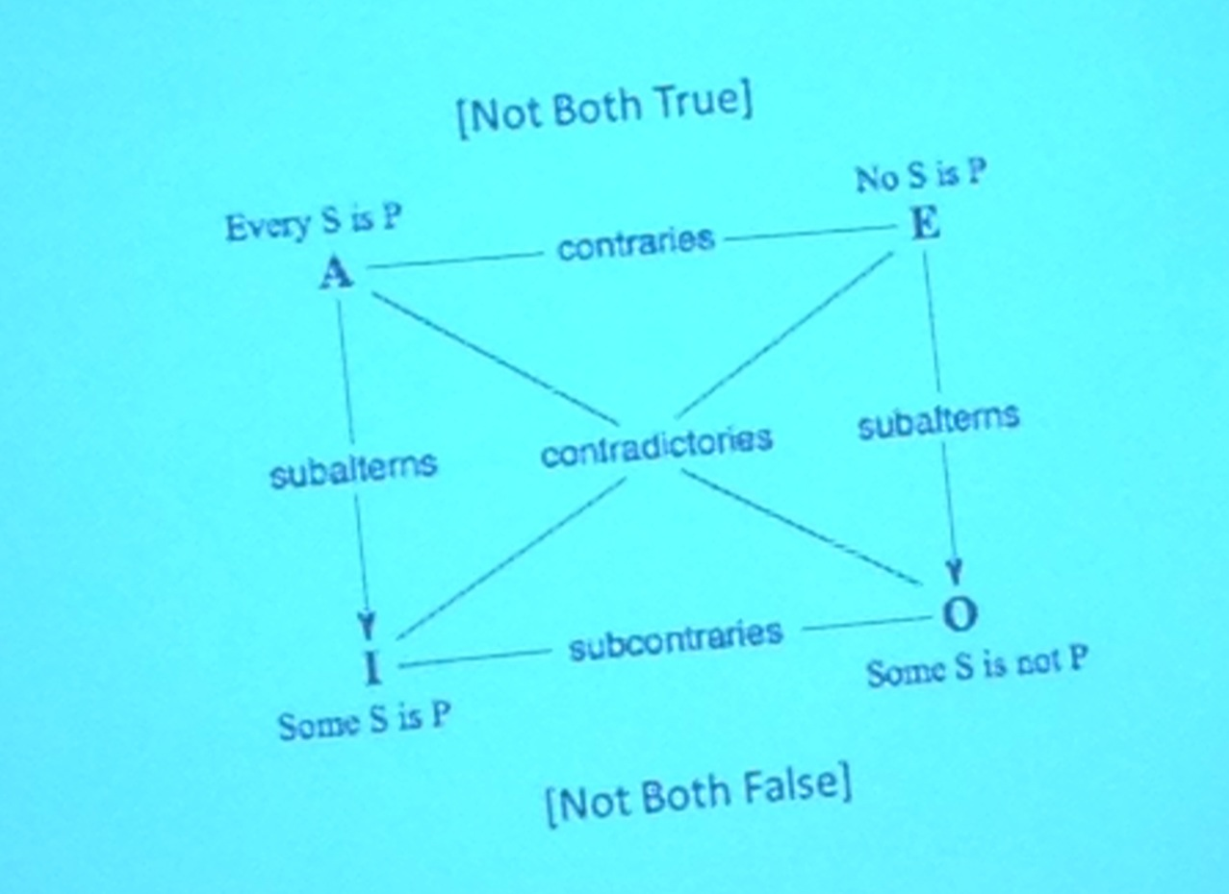
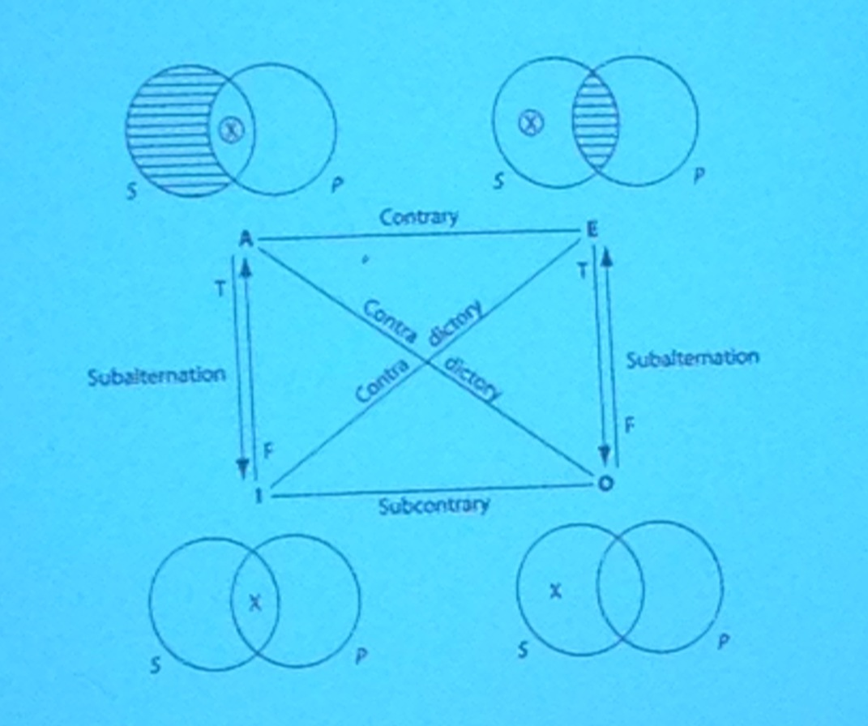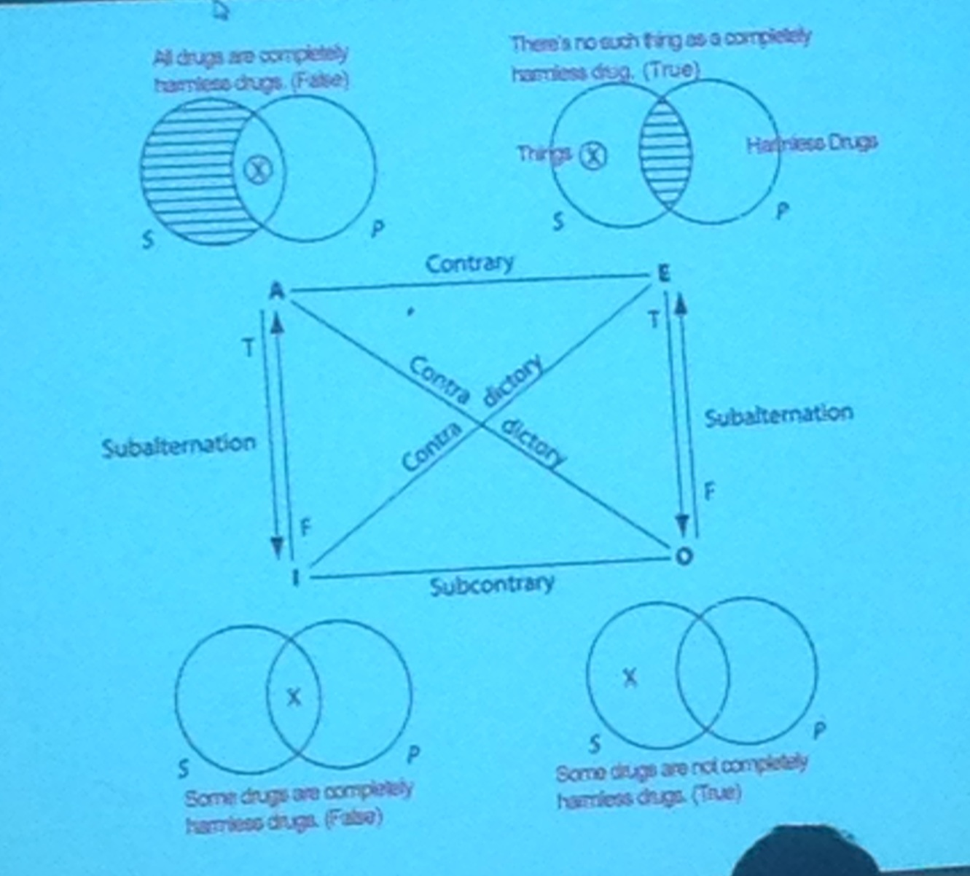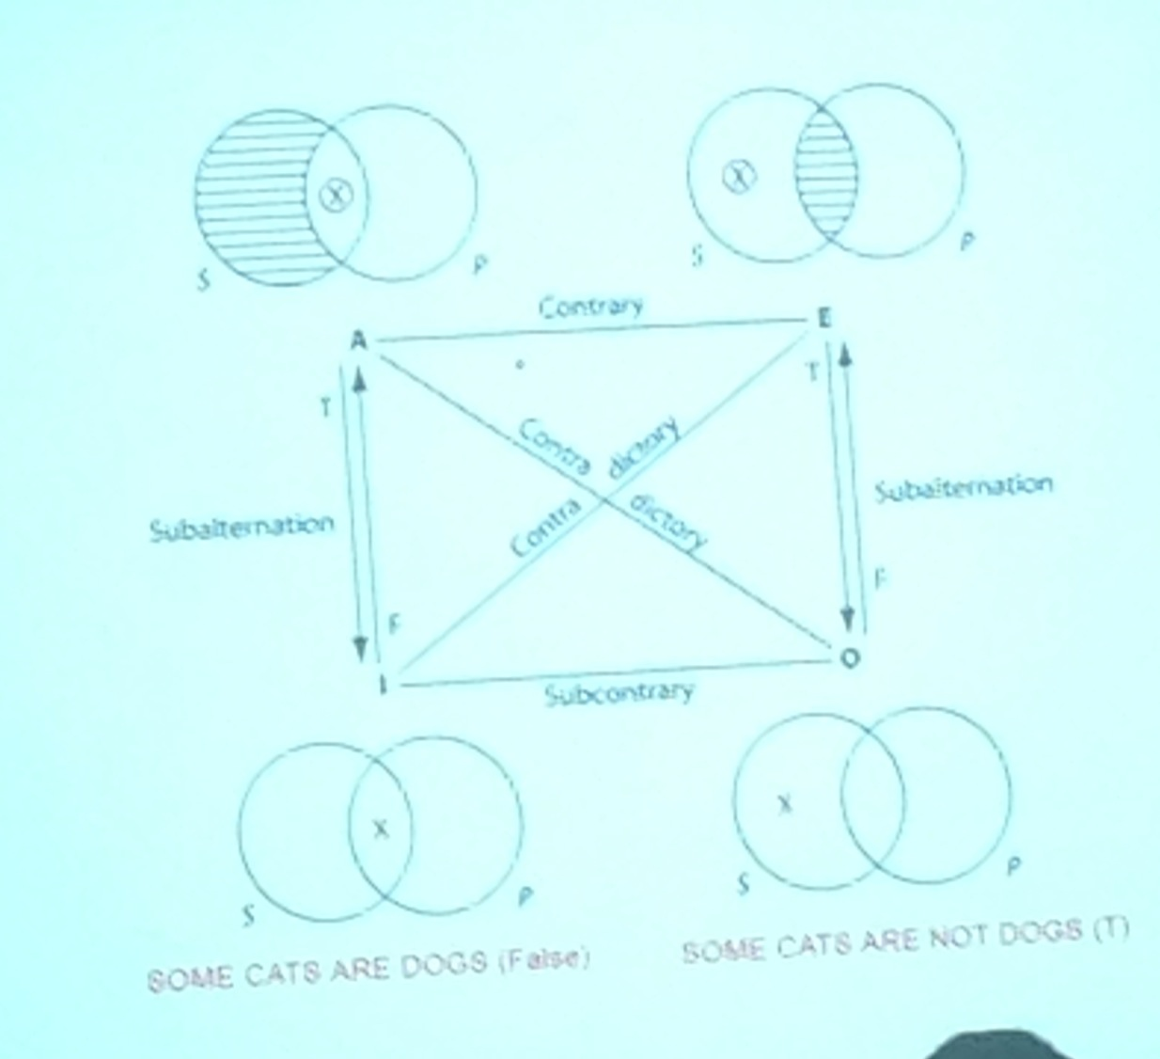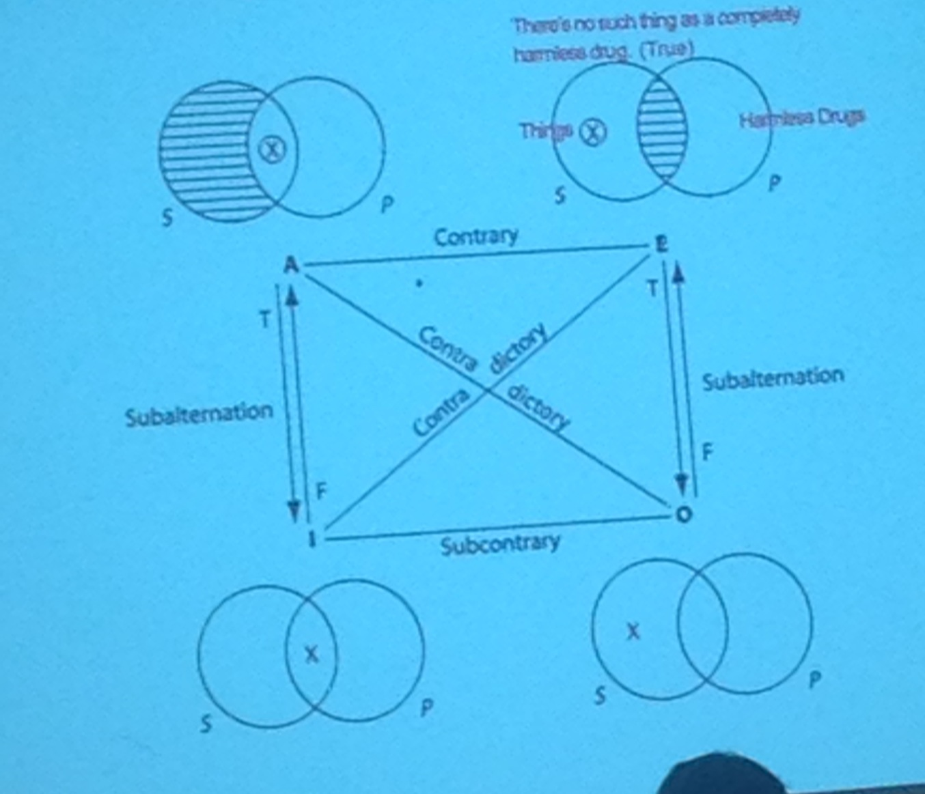

CLASS 18

Categorical syllogism:
- two premises and a conclusion;
- there are three terms: subject predicate, middle term

- All soldiers are patriots
- No traitors are patriots
- ( c ) Therefore no traitors are soldiers

(S) Minor term: first term of the conclusion (traitors) (subject)
(P) Major term: second term of the conclusion (soldiers) (predicate)
(M) Middle term: the term that is in both the predicate and the subject (patriots)

If they are both universal you do them both in order
If there is only one universal claim, do the universal claim first
If there’s two options for a premise put it on the line

All is often written as whoever anyone never whenever
Some: a few, not every not all some, some are not, there is, there are
If then = all or no

CLASS 20
Chapter 10 * not doing the whole chapter

Simplifying real world arguments down to structural forms.
Reduced the term of the claims down to a letter. The letter stood for a class of things.
Propositions = full statements
We will be working with full statements rather then classes.
Propositions are held together by operators/connectors.
In categorical logic we had a quantifier. The operators are the elements of our language that tie things together: and, or, neither, if, if then. Now the letter is going to stand for the entire claim.
Use upper case letters as a matter of standard from. Distinguishing between a single statement and a compound statement. Compound statement = made of two claims. Single statement = made of one claim.

- The most basic kind of logical claim we make is to say that its not the case. It is not the case = ~ R; always in front of the letter
- Class and half full = C & H or C . H
- Either/ or = V (wedge)
- If … Then = / sideways horseshoe / >

Conjunction, disjunction, condition
Examining the truth-value of these forms intercept

Conjunction

P = claim
------------
T
F

P Q
--------------
T T
T F
F T
F F

You put all the T’s and F’s in both lines*
For every additional letter you double the amount of letters/ lines
In the first line, you put the T’s then F’s together in the P line, and you alternate T’s and F’s in the Q line.

P ~P
---------------
T F
F T

Rolex does not make computers.

P Q P&Q
-----------------------------------
T T T
T F F
F T F
F F F

A conjunction is only true if both of the claims are true. Subtler version of and : but, why, even though, however.
Disjunction – give us a story about how it happened
The logic of a disjunction
A disjunction is true when both the first two elements are true.
“You’re either going to get a 1000$ or 10000$” and you get 10000 the claim is still true
If you get two possibilities and one of them is true then the disjunction is true.
The raw disjunction doesn’t get either or.
Not absolute options.

P Q P v Q
----------------------------
T T T
T F T
F T T
F F F

If both the options are false then the disjunction is false.
Either you can ski at mont tremblant or mont blanc
You can ski at mont tremblant and mont blanc
Unless mont tremblant allows skiing mont blanc does.
Unless mont blanc allows skiing mont tremblant does.
How does the exclusive version work?
We use EITHER OR instead or either/ or.
Representation of EITHER OR
~ (P v Q) ~ S v (P v Q)
(on v off) &~ (on and off)
(P v Q) & ~ (P & Q)
------------------------------

P Q P Q
-----------------------------
T T T
T F F
F T T
F F T

If the first claim is false then the rest of the claim can be true. This is true because when its false it disconnects itself from the rest of the claim.

The first claim is the antecedent the second claim is the consequent.

If the university of Ottawa raises tuition then Carleton will raise the tuition.
The university of Carleton will raise tuition only if the university of Ottawa raises tuition.

~ (P Q)

A & B v C
(A & B) v C
A & (B v C)

Prozac relieves depression and Allegra combats allergies, or Tums reduces stomach acid.
(P & A) v T

Prozac relieves depression, and Allegra combats allergies or Tums reduces stomach acid.
P & (A v T)

Either Prozac relieves depression and Allegra combats allergies or Tums reduces stomach acid.
(P & A) v T

P and if Q then R
If P and Q then R

P = Paula goes to work
Q = Quincey – double shift
~P Q

P Q ~P ~P Q
-----------------------------------------
T T F T
T F F T
F T T T
F F T F

Double negation rule: two false make a true

Contraries
Two claims can be consistent – not equivalent of contradictory if there is one line that they turn out to be true on one claim
If they are consistent then this means that one line is true which could make the whole claim true.
If they are inconsistent then this means that there is no possibility that the claim is true and no lines are true.

CLASS 21
How to turn a language into a
If: always introduces the antecedent of a claim
Only if: introduces the consequent of a claim

IF o s
ONLY IF means logically speaking, doesn’t mean everyone will get elected, ET
IF AND ONLY IF, makes both an antecedent and a consequent (PQ) & (QP) different than only if
S W
X Y
D A
A A+
Unless = or (v)
R v B = ~ R B

Valid argument patterns: determine whether or not a real world argument is valid or not.

Modus Ponens: [MP]
- P Q
- P
C. Q

N=noble prize
W=writer
- N W
- N
---------------------------
C. W

1. (P v Q) R
2. (P v Q)
---------------------------
C. R (P v Q)

2. Modus Tollens [MT]
1. P Q
2. ~Q
------------------
C. ~P

C=cares
S= stop killing
- C S
- ~S
C. ~C
O=Born in Ottawa
C=Canadian
- OC
- ~C
C. ~O

- (P&Q) R
- S S ~R
- S ~R S
C. ~(P&Q) C. ~R
4. ~R 2,3 MP
5. ~ (P&Q) 1,4 MT
VALID

P. 318

3. Disjunctive argument = [DA]
1. P v Q
2. ~P
---------------------------
C. Q

- P v Q
- 2. ~Q
---------------------------
C. P

I= infinite jest
T = trial
- I v T
- ~I
---------------------------
C. T

4. Chain argument (hypothetical syllogism) = [CA]
1. P Q
2. Q R
---------------------------
C. P R

Simplification [SIM]
- P & Q
- P
- P & Q
- Q

Conjunction [CONJ]
- P
- Q
---------------------------
C. P & Q

Addition [ADD]
- P Q
----------------------
C. P v Q

Invalid
- G v R
- G
C. ~R

CLASS 22

Constructive Dilemma (CD)
1.(PQ) & (RS)
2.P v R
______________
C. Q
*Like 2 cases of modus pones

Ex: Mexico = M, Ottawa = O, Bake = B, Freeze = F
1.(MB) & (O F)
2.M v O
_________________________
C. B v F
Denying the Antecedent
1.P Q
2.~P
_____________
C. ~ Q
Invalid – Condition only shows us one outcome, when really there is multiple

Destructive Dilemma (DD)
1.(P Q) & (R S)
2.~Q v ~ S
__________________________
C. ~P v ~R
*Like 2 cases of modus tollens

Eg.) M = Mexico, O = Ottawa, B = Bake, F = Freeze
1.(M B) & (OF)
2.~B v ~F
_________________________
C. ~M v ~O

•(~)M – not the same as ~M

L = Witness Lied, B = Bob is guilty
1.L v B
2.~L
____________
C. B

T= Witness told truth, B = Bob is guilty
1.~T v B
2.T
_____________
C. B

Double Negotiation
P = ~~P
1.~T v B
2.~~T
______________
C. B

P v Q Q v P = (COM)
~~P = DN

= Logically equivalent

1.(B~M) & (C ~J)
2.H v J
____________________________
C. ~B v ~C

1.M v S
2.~S
____________
C. M

Implication
(P Q) (~P v Q)
(P Q) R ~(P v Q) v R

Contraposition (CONTR)
(P Q) (~Q P)

Demorgan’s Law (DEM)
-Only effects disjunctive and conductive
1. ~(P&Q) (~P v ~Q)
2. ~ (P v Q) (~P v ~Q)

1.S (T&U)
2.S (~T v ~U)

1. ~A
2. ~B
3. ~A & ~B

CLASS 23

- P Q
- ~P S
- ~Q
---------------------
- ~P 1,3 MT
- S 2,4 MP
Conclusion: /Therefore S ------ VALID

- ~PS
- ~P
--------------------------
C. S

- (PvQ) R
- Q
--------------------------
- P v Q 2, ADD
- R 1,3 MP
Conclusion /Therefore R
VALID

- P
- P v Q (valid)
- P&Q (invalid)

- F G
- F v H
- ~G
- H (GI)
Conclusion /Therefore F I
- ~F 1,3 MT ~F from 1 and 3 by MT
- H 2,5 DA Next you obtain H by DA
- G I 4,6 MP Next G I by MP
- F I 1,7 CA Finally F I by chain A
VALID
p. 248

CHAPTER 11

One set of evidence gives you a 1% chance that something is going to happen
Another set of evidence gives you a 1.5% chance that something is going to happen

Entity A has attributes B, C, and D, …2
Entity B has attributes B, C, and D, …2

CLASS 24

Statistical generalization
Want the sample size to be correct.
Analogy = analogs
Sample group should be diversified. That sample group represents all the differences in the sample group
Error margin = statistical amount of error calculated relative to the group sample.
p.343
The larger the group the larger the sample
Once you get to a certain point the improvement of sampling declines rapidly.
Be cautious and be questioning about everything

