BIOL/FNH 436 examples of types of exam questions

1. George found a pseudogene in a region of the elephant genome that he is studying. What are two possible features that would make it a pseudogene?

-non-functional, unable to produce functional protein
-reading frame disrupted, or promoter stop codon, not expressed

2. Rebecca is studying methylation in the bHLH transcription factor in tomatoes. How can she determine which cytosines are methylated?

-bisulfite sequencing: convert methylated cytosine into thymine then use PCR and sequencing
-southern blots using methylation sensitive and insensitive enzymes (enzymes with same recognition site but differ in methylation sensitivity)

3. How can DNA methylation lead to histone deacetylation?

-methyl C binding protein (MECP2) binds to methylated DNA and then recruit histone deacetylases -> histone deacetylation

4. Robert is identifying transposable elements in the horse genome. He has found a TE with an endonuclease gene. What kind of TE is it?

-RNA elements class 1 transposons -> non-LTR retroelements -> LINES (long interspersed nuclear elements)

5. What are two ways in which TEs that have inserted into genic regions can cause epigenetic regulation of the gene?

- If the TE inserted into the 3’UTR, transcription of it would make antisense transcripts that would pair with transcripts from the gene, causing transcript degradation and down-regulation of the gene.
- If the TE inserted into the regulatory region, methylation of it could prevent expression of the gene

6. Lisa is studying mutation rates in microsatellites within the dog genome.
a. What are three factors that influence the mutation rate in the microsatellites?

-number of repeats
-unit repeat length
-sequence composition
-genome location
-secondary structure of repeats

b. She finds a microsatellite that has expanded from 11 repeats to 13 repeats. Explain a mechanism for how the microsatellite likely expanded.

-as a result of replication slippage, the newly replicated strands form a looping region as a result of misalignment after dissociation and rehybridization. Thus, the newly formed strand is in different length as template strand.
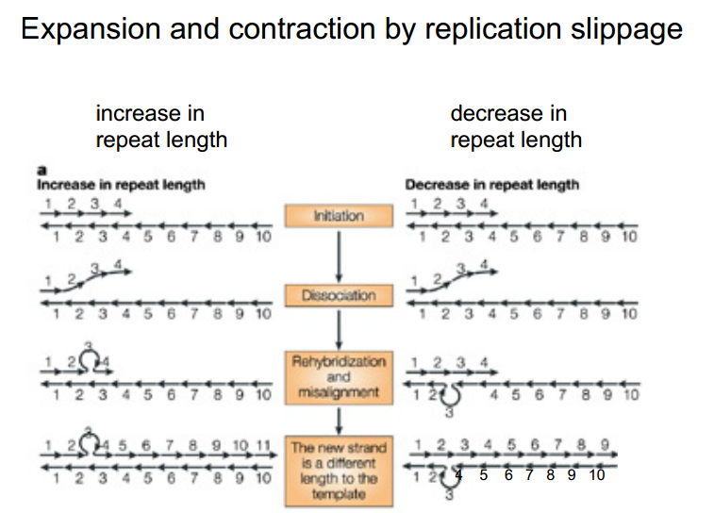

7. Charles has sequenced and assembled a portion of the centromere from a zebrafish chromosome.
a. He is analyzing the satellite repeats. Describe in words or draw how the satellite repeats are organized.

-satellite repeats are arranged in 1-6 bp repeat units, usually 6-30 repeats long.
-usually present in non-coding regions: 5’LTR, 3’LTR, regulatory regions
i.e. GTGACGTGTCAGTGACTCGTG

b. Charles finds a 400 kb insertion of DNA from another chromosome in the centromere. Would he expect it to disrupt the function of the centromere? Why or why not?

No. Because centromere involve rapid rate of sequence evolution, with satellite repeats including tandem repeats within inner region. Thus the exact sequence not important for function, and large scale change typically do not disrupt centromere function.

8. How do the ancient and added regions on the X chromosome compare with those in the Y in humans?

- Ancient region on the X is large and takes up almost all of the long arm, whereas the ancient region on the Y is in two small sections, 1 on each arm.
- Added region on the X is larger than on the Y and it has multiple layers
- Both the X and Y contain the pseudoautosomal region in the added region

9. How does Xist RNA function in X chromosome inactivation?

-Xist RNA spread out to chromosome arms and coats chromosomes
->induce epigenetic changes and histone hypoacetylation
->heterochromatin forming
-> formation of Barr body
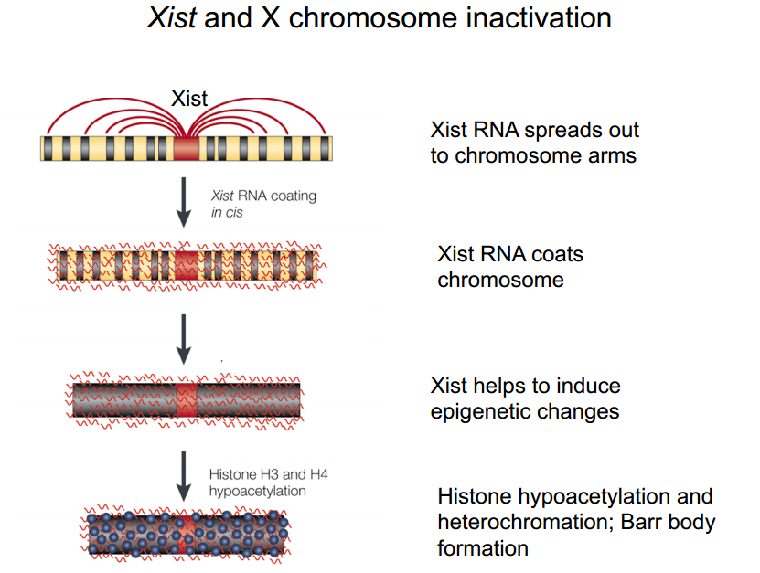

10. Shown below are two sections of a GenBank record from the alcohol dehydrogenase gene in Drosophila miranda
How many introns are present and what is the location(s) of the intron(s)?
4 introns: 1-898, 992-1073, 1478-1537, 1805-3461
What is the 5’UTR region - start and stop? 1-898
What is the 3’UTR region – start and stop? 1805-3461

