ASTRONOMY- final review

CHAPTER 5

Spectra lines
- Dark lines interrupting the solar spectrum. Scientists realized these spectral lines were related to the presence of various types of atoms in the suns atmosphere.
- Spectral line: a line in a spectrum at a specific wavelength produced by the absorption or emission of light by certain atoms
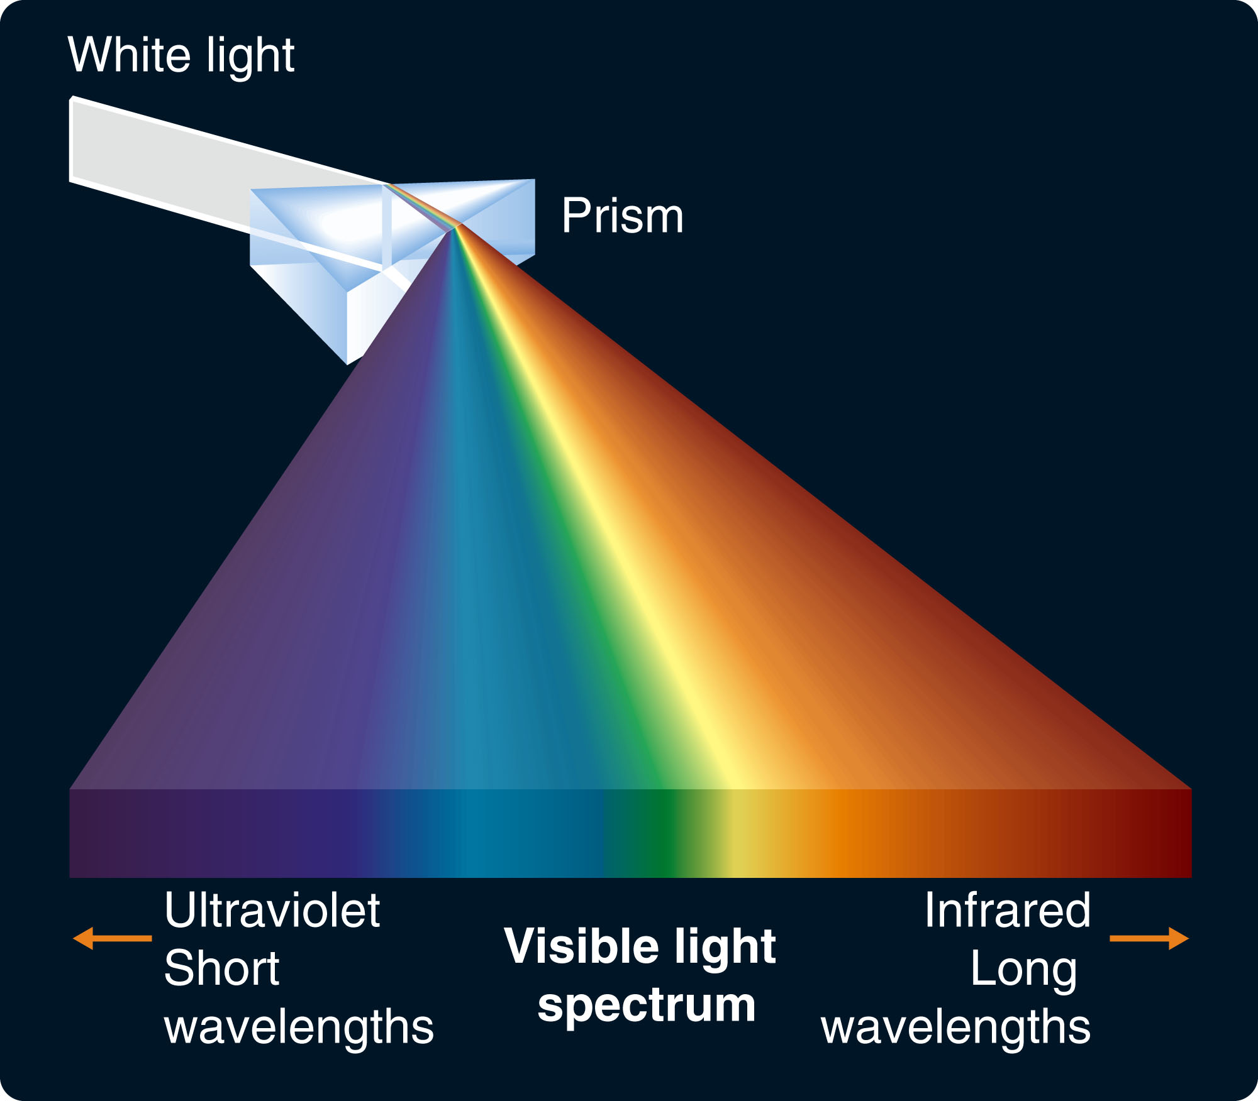
Spectroscopy: breaking light from an object into its different wavelengths, and comparing the amounts of light emitted at different wavelengths

Three Basic Types of Spectra
1. Continuous (thermal, or black body): produced by a hot, dense object. Contains all wavelengths, but relative amount of each depends on temperature. Ex. a standard incandescent light bulb, the sun, a glowing heating coil on the stove, a human body...
2. Emission Spectrum (line): low-density gas excited by a source of energy emits only particular wavelengths, which depend on the type of atom or molecule.
3. Absorption Spectrum (line): low-density gas lit from behind absorbs particular wavelengths depending on the type of atom.
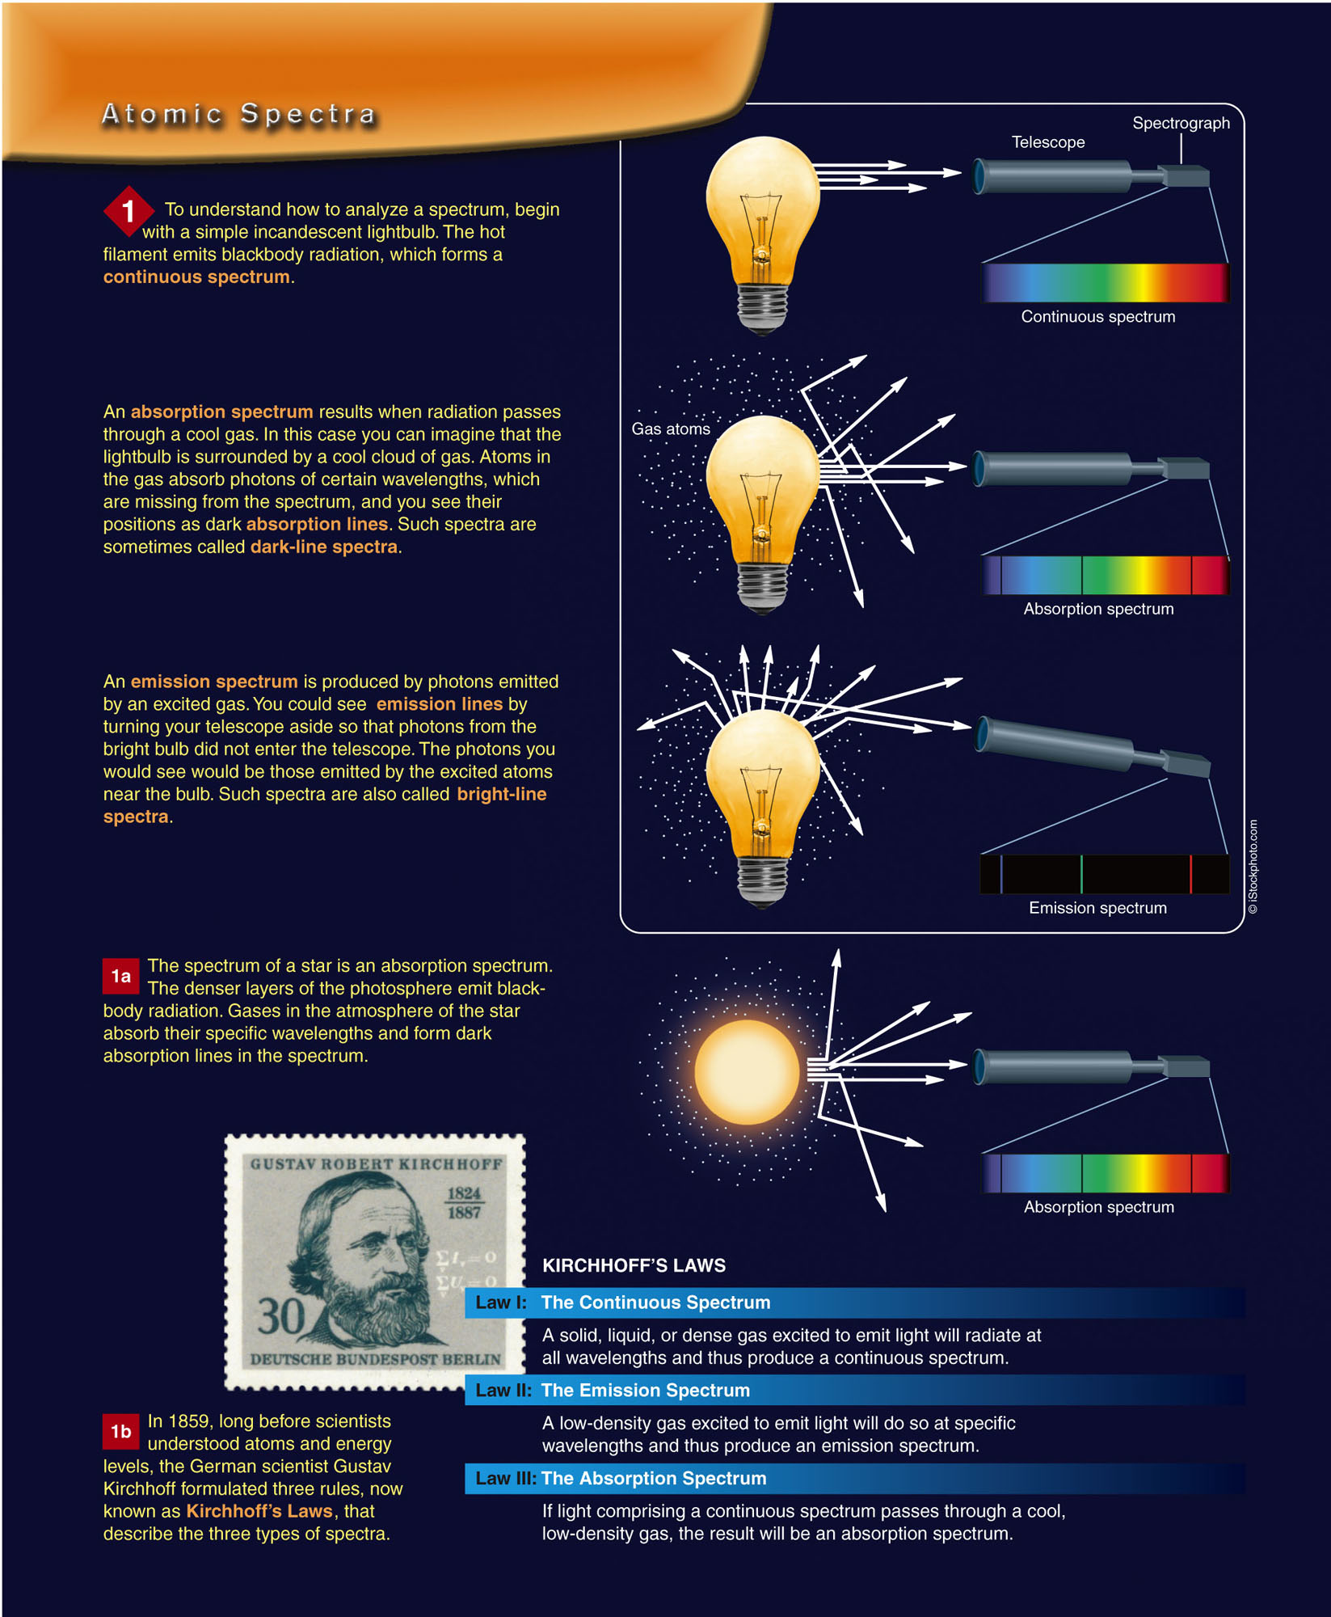
1. Hot filament emits blackbody radiation, forms continuous spectrum
2. Absorption spectrum results when radiation passes through cool gas. Imagine light bulb surrounded by cool cloud of gas. Atoms in the gas absorb photons of certain wavelengths, which are missing from the spectrum, and you see their positions as dark absorption lines. Such spectra are sometimes called dark-line spectra.
3. An emission spectrum is produced by photons emitted by an excited gas. You could see emission lines by turning your telescope aside so that photons you would see would be those emitted by the excited atoms near the bulb. Such spectra are also called bright-line spectra.

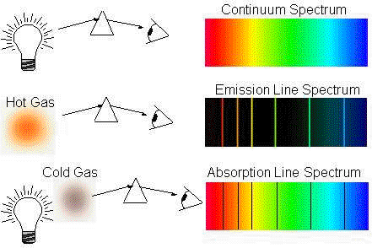
Types of Spectra and What They Tell Us
Continuous: tells about an objects temperature.
- Hotter objects emit more light overall, and more of that light is at shorter wavelengths/ higher frequencies. This means that we can figure out the temperature of a star by looking at its thermal spectrum.
- Betelgeuse is redder in colour than Rigel: it is a cooler star.
- Objects at temperatures around room temperature or body temperature emit mostly infrared light.
Line: (emission and absorption) tells us about chemical composition, and provide a reference point for the Doppler effect.
Physics of atoms and lights
- Electrons in an atom can only orbit in specific orbits with particular energies. Can only absorb or emit energies by moving levels
- Spends most of time in ‘ground state’. If a photon with the right energy comes along, the electron can absorb the energy and bounce up to an excited (higher-energy) state.
- The energy is emitted again as the atom falls back to the ground state.
- Each type of atom has particular energies of photons that it is able to absorb or emit. These photon energies correspond to particular transitions between energy levels of that atom.
- The set of all these energies (and corresponding light frequencies) form a kind of “chemical fingerprint” for that atom.
- Molecules often have more complicated spectral fingerprints than single atoms.
The Doppler Effect
- Wavelengths emitted by an object moving away from us (we see a redshift, lower frequencies) or towards us (we a blueshift, higher frequencies)
- This is useful when we look at a known spectrum line- we know what frequency would be if it came from a stationary source. So the Doppler effect can tell us about radical velocity (toward or away from us) but not about transverse (sideways velocity).
- Without a reference spectrum, you won't know for sure which star is moving, but there are several possibilities.

CHAPTER 12
Parts of the Solar System
- The sun
- Planets: Mercury, Venus, Earth, Mars, Jupiter, Saturn, Uranus, Neptune
- Terrestrial planets (the inner four): small and rocky, mercury, venus, earth, and mars
- Jovian planets (the outer four): more moons, larger, richer in hydrogen, helium,have rings, “ices” (water, ammonia, methane).
- Asteroid belt: small rocky objects between mars and jupiters orbit. Includes dwarf planet ceres.
- Kuiper belt: small, icy bodies beyond Neptune's orbit. Includes some comets, some dwarf planets like pluto.
- Oort cloud: comets and similar small objects at the farthest edges of the solar system
Solar Nebula Hypothesis:
- Currently the most widely accepted view of how the solar system formed.
- Sun together with the planets formed from a collapsing cloud of gas and dust
- Cloud’s spin flattens it into a disc as it collapses
- Planets, asteroids, etc. form from material in the outer part of the disc, through the sticking together of small pieces first into planetesimals and then protoplanets.
- Formation of planets stops when the sun turns on, and solar wind drives away the remaining gas and dust .
Key Facts Explained by Solar Nebula Hypothesis
- Most objects in the solar system orbit in the same plane, in the same direction. (from the original spin of the collapsing disc)
- Different sizes and chemical composition of inner vs. outer solar system objects: when the planets were forming, inner solar system was too hot for water and similar substances to solidify. This meant more material and more types of material available for the outer planets. Only rocks and metals were solid in the inner solar system.
- Everything in the solar system formed at nearly the same time. (before the sun turned on)
Solar Nebula Hypothesis
- Another positive sign: disc-shaped clouds are observed near newly forming stars, for example in orion.
- Some uncertainties: we don’t know for sure how typical our solar system is.
- Not fully explained: how did the planets end up with more angular momentum than the sun?
- There are still big questions about how Jupiter and Saturn got as big as they did before the sun turned on.
Detecting Extrasolar Planets
- Two main methods for detecting planets around other stars: Doppler method and transit method. (others include astrometry and direct imagery)
- Doppler method: use the Doppler effect to detect the small wobble of a star as a planet’s gravity tugs on it.
- Transit method: detect dimming of the star as the planet moves in front of it
Extra solar Planets:
- Most of the planets found so far are large and close to their stars (“hot jupiters”)
- According to solar nebula hypothesis, these types of planets should be rare.
- But our methods of finding planets are biased—planets that are large and close to their stars are easiest to find. So it could be that we are only finding the unusual cases so far.
- Some planets of more earth-like size have been detected, and some in the “habitable zone” where liquid water could exist.

CHAPTER 13

The Terrestrial planets:
- Mostly rock and metal, since these were the solid materials available when the planets were forming.
- Note that mercury contains more iron and less silicon than the others—metals solidified sooner at mercury’s orbit.
- All show some signs of geological activity in the past, but only earth has currently active plate tectonics
- Older surfaces show craters form impacts of meteorites and late planetesmials.
Atmospheres of the Terrestrial Planets:
- Mercury: no significant atmosphere—too small and hot.
- Venus: much thicker than earth’s. Carbon dioxide with some sulfur dioxide and sulfuric acid. Very hot.
- Earth: heavily influenced by life. Mostly nitrogen, oxygen, smaller amounts of carbon dioxide, water vapour, etc.
- Mars: much thinner, colder than earth’s. mostly carbon dioxide.
Atmospheres in general
- Both size and temperature have an influence
- Larger and colder bodies hold onto an atmosphere more easily than smaller, hotter ones.
- Lighter gases (like hydrogen, helium) escape more easily than heavier ones. Only the jovian planets retain large amounts of these.

CHAPTER 14

The Jovian Planets
- Larger size, lower average density compared to the terrestrial planets.
- More hydrogen, helium, water, ammonia, methane compared to the terrestrial planets.
- All have rings, and many moons.
- More solid material was available in the outer solar system when they were forming, so they grew larger more quickly than the terrestrial planets.
- Grew large enough to begin pulling in and holding onto gases like hydrogen, helium.
- Jupiter and Saturn are both mostly hydrogen and helium
- Uranus and Neptune also include large amounts of water and other “ices”
Moons of the Jovian Planets
- There are a lot
- A few are lager than mercury
- Jupiter’s Galilean satellites: lo, Europa, Ganymede, callisto
- Lo: volcanically active. (heated by tidal forces)
- Europa: liquid water ocean below an icy surface
- Saturns moon titan: thick hazy atmosphere, lakes of liquid methane/ethane.
- Because of the tidal heating, many of the Jovian moons show much more geological activity than you would otherwise expect for such small objects

CHAPTER 1
Planet orbiting star solar system galaxy cluster supercluster walls/filaments/voids universe
Solar systemgalaxycluster (superclusters, filaments, voids and walls)universe
Relative Size
- Jupiter is 10x bigger than the earth
- Sun is 10 x bigger than Jupiter
- Therefore sun is 100x bigger than earth
Units
- AU astronomical unit= distance between earth and sun (distance inside solar system)
- LY light year= how far light travels in a year (between stars and galaxies)
- Scientific notation= 650000= 6.5 x 10⁵ , 0.0065= 6.5 x 10⁻³
Approximate Size
- Nearest star= few LY away
- Nearest galaxy= few million LY away
- Milky way size= almost 100 000 LY (100 billion stars), larger but not largest
- Farthest visible= 14 billion LY away (100 billion galaxies)
- Earth= smallish NOT smallest
- Sun= medium sized star

CHAPTER 2

Constellations
- 88 regions in sky, well-defined boundaries. Every star is in one constellation.
- Ex. Ursa major, orion, Taurus
Asterisms
- Patterns or visible groups of stars. May include stars from more than one constellation. Ex. Big dipper
*stars with same constellation or asterism appear to be close to eachother, but might actually be at very distances away

Locating Things In The Sky
- Constellations – 88 region in the sky with official boundaries (a star belongs to only one)
- Asterisms – recognizable groups of patterns of stars (landmark – stars can belong to more than one)
- Stars may not be physically close, just lie in the same direction from Earth
- Angular Distance – angle formed by lines extending from the observer to two locations in the sky
Celestial Sphere – relative to stars
- Celestial Sphere – imaginary sphere surrounding Earth, Sun, and planets (East to West)
- Celestial N/S Pole – point on celestial pole directly above Earth’s N/S poles
- Celestial Equator – circle around celestial sphere directly above Earth’s equator
Daily Cycles of The Sky
- Earth rotates W to E so CS appears to rotate E to W
- Sun rises in the E and sets in the W
Yearly Cycles
- Seasons: Tilt
- Summer Solstice: N hemisphere tilted toward the Sun, 23.5ºN of CE = declination
- Ecliptic is farthest N (or time of year Sun is at this point)
- Winter Solstice: N hemisphere tilted away from Sun, 23.5ºN = -declination
- Ecliptic is farthest S (or time of year when Sun is at this point)
- Vernal Equinox: point on CS where ecliptic crosses the CE from S to N
- Autumnal Equinox: point where ecliptic crosses CE from N to S
Monthly Cycles
- New Moon: dark, close to Sun, not visible at night
- Waxing Crescent: more than half lit, E of sun, visible in W after sunset
- 1st Quarter: W (right) half lit, visible near meridian at sunset, sets around midnight
- Waxing Gibbous: less than half lit, visible in the E after sunset, sets after midnight
- Full Moon: opposite to Sun, rises near sunset and visible all night
- Waning Gibbous: less than half lit, rises between sunset and midnight
- Last (3rd) Quarter: eastern (left) half lit, rises around midnight
- Waning Crescent: W of Sun, visible before sunrise
- Sidereal Period: complete moon orbit
- Synodic Period: time taken to return to phase
Eclipses (Sun Appears To Move Eastward)
- Moon must be on a nodal point where its orbit crosses the ecliptic
- Solar Eclipses
- Only at a New Moon
- Umbra: region of complete shadow where Sun is completely blocked
- Penumbra: region of partial shadow where part of Sun is blocked
- Annular Eclipse: Moons angular diameter is smaller than Sun
- Lunar Eclipse
- Darkening of Moon passing through Earth’s shadow
- Only happens at Full Moon
Naming of Stars
- Derives from Ancient Greek, Arabic, Latin – descriptive or related to mythology
- Sirius = glowing, Aldeberan = follower, Vega = landing, Spica = ear of wheat or Virgo
- Or Greek letter and Latin possessive form of constellation (letters in order of brightness)
- Alpha Centaura (brightest in Centaura), 2 names: Betelgeuse also Alpha Orionis
Declination
- Angular distance from CE (+N, -S) = latitude (-90 – + 90)
Right Ascension
- Angle measured eastward from Vernal Equinox = longitude (0 – 24 hrs) 15º = 1hr
Point of View
- Zenith – point overheard
- Horizon – all points 90º away from Zenith
- Meridian – line passing through Zenith
- Altitude – angular distance from Horizon
- Azimuth – direction in angles (usually from S)
Precession
- The slow change in orientation of Earth’s axis of rotation caused by the Moon and Suns uneven gravitational pull on Earth equational bulge
- Makes poles and equator wobble relative to ecliptic
- Meaning equinoxes move relative to stars

CHAPTER 3

Geocentric vs. Heliocentric model
- Geocentric (Ptolemaic): earth-centered. Retrograde motion explained through epicycles.
  - Mars, Jupiter, Saturn: Ptolemy- planets move backwards on the inner part of their epicycles.
  - Mercury and Venus: Ptolemy- their epicycles are fixed along a line between the earth and the sun.
- Heliocentric (Copernican): sun-centered. Kept idea of circular orbits. Retrograde motion explained through different speeds of planets.
  - Mars, Jupiter, Saturn: Copernicus and kepler- earth orbits the sun faster than the outer planets—when it catches up, they appear to move backwards.
  - Mercury and Venus: Copernicus and kepler- mercury and venus orbit the sun inside our orbit.
Kepler- Ellipses
- Abandoned circular orbits for ellipses.
- Made heliocentric model more accurate.
- Keplers laws
  - Orbits of planets are ellipses with the sun at one focus
  - A line between a planet and the sun sweeps out equal areas in equal times. (means that the planet travels faster when it is closer to the sun)
  - A planet’s orbital period squared is proportional to its average distance from the sun cubed (P²=a³) (That means planets farther out take longer to finish an orbit).
How Different Models explain
- Mars, Jupiter, Saturn
- Ptolemy- planets move backwards on the inner part of their epicycles.
- Copernicus and kepler- earth orbits the sun faster than the outer planets—when it catches up, they appear to move backwards.
- Mercury and Venus
- Ptolemy- their epicycles are fixed along a line between the earth and the sun.
- Copernicus and kepler- mercury and venus orbit the sun inside our orbit.
Galileo
- Telescope observations helped overcome objections to heliocentric model.
Newton’s Laws
- Universal laws explain motion of planets the same way as motion on earth. Explained kepler’s laws using universal gravitation and laws of motion.
  - I. an object at rest remains at rest unless a force acts on it; an object in motion continues in a straight line at constant velocity unless a force acts on it
  - II. A body’s change of motion (acceleration) is proportional to the force acting on it, and is in the direction of the force.
  - III. When one body exerts a force on a second, the second body exerts an equal and opposite force on the first.

- Any two objects attract each other with a force proportional to the product of their masses and inversely proportional to the square of the distance between their centers
- Inverse square law: if the same 2 bodies are moved twice as far apart, the force is ¼ as big. If they’re moved 3 times as far apart, the force is 1/9 as big, etc.
- One consequence: an orbiting plane experiences a larger force a perihelion, smaller at aphelion

CHAPTER 4

Main Parts of a Telescope
- Objective/primary – does the main job of focusing and concentrating light
- Eyepiece – magnifies the image produced by the objective, making it visible
Types of Telescopes
- Refracting – the objective is a lens (focuses light by refraction)
- Reflecting – objective is a curved mirror (focuses light by reflection)
Powers of a Telescope: How Telescopes Extend Our Vision
- Light-gathering power: ability to concentrate light and make faint objects visible, depends on the width of the objective (wider = better)
- Resolving power: ability to distinguish fine detail, limited by diffraction, imperfections in the lenses or mirrors, and atmospheric distortion
- Magnifying power: ability to make small details appear bigger, depends on the eyepiece (specifically the ratio of the eyepiece focal length to the objective focal length)
- Magnifying an image doesn’t necessarily make it sharper (different from resolving power)
Limitations of Resolving Power
- Diffraction: the spreading of waves as they pass through an opening, depends on the ration of wavelengths in aperture size (short wavelengths or large aperture both improve resolution)
- Can also improve resolution using interferometry
- Chromatic Aberration: a problem with lenses (not mirror) where different colours of light focus at different points
- Not a problem with reflecting telescopes
- Atmospheric Distortion/Seeing: irregular bending of light as it passes through layers of the atmosphere, causes stars to twinkle and causes blurred images
- Ways to improve this: observe from mountains and dry locations or space or adaptive optics
Advantages of Reflecting Telescops
- No chromatic aberration
- Mirrors can be supported from behind, not just as the edges – less sagging
- Easier to polish a single surface than to ty to make a lens free of defects all the way through
- Because of these advantages modern research telescopes are almost all reflecting
Advantages of Larger Telescopes
- Greater light-gathering power
- Better angular resolution
Advantages of Placing Telescopes In Space
- Eliminates atmospheric distortion
- Allows you to see the wavelengths that get absorbed by the atmosphere (gamma rays, far IR, etc.)
Some Special Techniques
- Interferometry: linking multiple telescopes together to reduce diffraction effects and improve angular resolution, it’s like having a telescope as wade as the distance between the individual telescopes, mostly used for radio telescopes but some visible light telescopes as well
- Adaptive optics: using a computer-controlled deformable mirror to partly compensate for atmosphere distortion, improves the seeing for ground-based telescopes
Types of Light: Electromagnetic Spectrum



