Alfred Chandler: The Enduring Logic of Industrial Success

The Concepts:

- Logic of Managerial Enterprise: The dynamic growth and competition that drives modern industrial capitalism

- Economies of scale: Large plants can produce products at a much lower cost than small ones because the cost per unit drops as the volume of output rises

- Economies of scope: Large plants can use many of the same raw and semi-finished materials and intermediate production processes to make a variety of different products

- Management hierarchy:
- lower and middle managers: coordinate products though production and distribution
- top managers: coordinate and monitor current operations and to plan and allocate resources for future activities

- First movers & challengers: companies that quickly dominated their industries by making large investments and gaining competitive advantage (high market share)
- created national and international marketing distribution organizations
- recruited teams of managers
- They engaged in systematic R&D to improve their products and processes, they differentiated as well. They captured markets and others may not want to compete.
- “Those who made these large investments [manufacturing economies of scale and scope, marketing and management] – the companies I call first movers – quickly dominated their industries…” (Chandler, 1990, 132)
- “It is important to distinguish first movers from the inventors of a product…and from the pioneers who first commercialize an innovation…it was IBMs massive investments in the production, distribution, and management of the System 360 that made it the industry’s first mover.” (Chandler, 1990, 132)

- Research & development: to improve products and processes. Innovation and strategy is more important than price.
- Related & unrelated diversification:
- Unrelated diversification: when managers acquire businesses in which they have few if any organizational capabilities to give them a competitive edge (ignore logic of managerial enterprise)
- Related Diversification: Expanding in your field of knowledge

This leads to…

- Separation of top vs middle managers:
- Top managers have little knowledge of or experience with the technological processes and markets of the new acquisitions
- Overload in decision making at the corporate office

- Stock market pressures: loose profits and market share if:
- Entrepreneurial enterprises fail to become managerial enterprises
- Managerial enterprises fail to maintain their competitive capabilities- Short‐term thinking: making a quick buck and trying to gain competitive edge through unrelated diversification

- Short-term thinking: making a quick buck and trying to gain competitive edge through unrelated diversification

Chandler’s Major Claims:

-Logic of Managerial Enterprise: Successful firms capitalize on economies of scale & scope, create management structures and invest in research & development
-Once a firm loses the opportunity to be a first mover, it is difficult to regain competitive advantage
-For firms to benefit from economies of scale or scope:
- Flow of materials must be kept constant
- National (and international) marketing and distribution functions must be created
- Teams of lower and middle managers need to be recruited

Chandler’s Secondary Claims:

- Growth through unrelated diversification is a poor corporate strategy
- Business ownership patterns have diminished the likelihood of many firms’ long-term success
- In competitive battles Research/innovation and strategy are more powerful weapons than price.

Side Notes:
-Continuing growth: Companies grew horizontally (combining with competitors) and vertically (moving backward to control materials and forward to control outlets)

Larry Greiner: Evolution and Revolution as Organizations Grow

-A theory of organizational life cycles, with a focus on growth

Greiner’s Major Claims:

• Organizational growth is characterized as a series of developmental phases
• Management practices that work well in one phase bring on a crisis in the next

Concept list:

-Evolution & Revolution: Phases begin with a period of evolution (steady growth and stability) and ends with a revolutionary period (turmoil and change)
- If the revolutionary period is resolved, the company can move to next stage of evolution
-How organizations develop:
- Age of the organization: The same organizational practices are not maintained throughout a long life span. Management problems and principles are routed in time.
- Size of the organization: Problems and solutions tend to change with increased employees and sales revenue.
- Stages of evolution: As organizations grow, different evolutionary period emerge.
- Stages of revolution: Practices become outdated; companies that do not change will fold of cease to grow. Solution for one crisis becomes a major problem in the next.
- Growth rate of the industry: Speed of stages are related to the speed of the growth of the industry

Evolutionary and Revolutionary phases:

1. Creativity: Birth stage of organization. Frequent, informal communication, long work hours and modest salaries as well as promise of ownership benefits, decisions and motivations are highly sensitive to market feedback.
- “Crisis of Leadership”: Informal communication becomes infeasible, additional functions must be implemented. Need a strong business manager.
2. Direction: Functional organizational structure. Different departments, formal communication, more employees, increased efficiency, need of systems (accounting, inventory...)
- “Crisis of Autonomy”: Impersonal environment. Lower level employees have more knowledge about markets and machinery than management; want to take initiatives on their own.
Need a decentralized hierarchy of management.
3. Delegation: Decentralized organizational structure. More responsibility given to lower management, bonuses is used to motivate employees, diversification of products.
- “Crisis of Control”: Lower level management begins to run their own show without coordinating with the rest of the organization. Management must focus on control.
4. Coordination: Strategic business units are formed. Top level management takes responsibility for the initiation and administration of the new system.
- “Red Tape Crisis”: Procedures take precedence over problem solving. Company has become too large and too complex to me managed though formal programs and rigid systems.
Conflict between like and staff; line managers resent direction from those who are not familiar with local conditions. Management must promote interpersonal collaboration.
5. Collaboration: Strong interpersonal collaboration. Social control and self-discipline replace formal control; rewards are geared for team performance.
- “? Crisis”: Psychological saturation of employees who grow exhausted from the intensity of teamwork and innovation. May perhaps be solved though new structures and programs that allow employees to periodically rest, reflect and revitalize themselves.

-Management style:
- Managers need to know where they stand in the phases of development.
- Must know when it’s time to change and be able to activate it.
- Cannot skip phases, must go with the flow.
- Must be able to persuade ideas to other managers.

-Advantages of large, bureaucratic organizations:
- Hierarchical Authority: Promises, control and responsibility
- Specialization of sub-units: Promises accountability, control and expertise
- Management by Rules: Promises control and consistency
Being IMPERSONAL promises objectivity, consistency and equality

Greiner’s Secondary Claims:

-Organizations should not try to skip phases of growth
-Top managers whose style is no longer appropriate should remove themselves (As growing and developing managers should give up position to someone more suitable)
-Growth is not inevitable
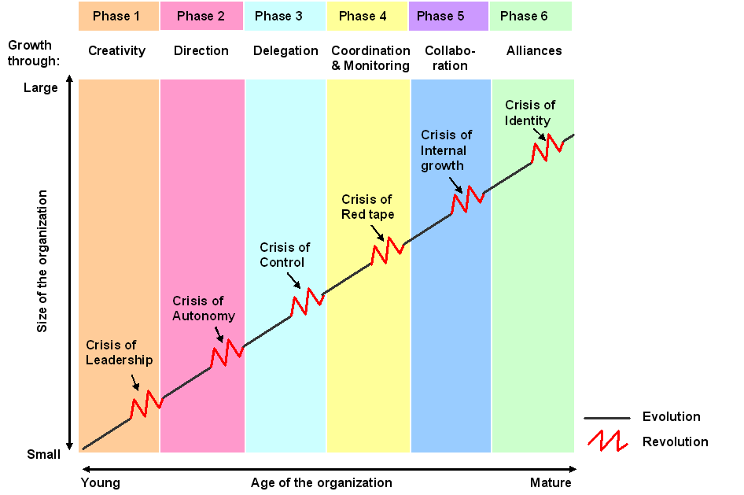

**Chandler says you must grow and Greiner says you don’t have to BUT Chandler has evidence and Greiner does not.

Tannenbaum and Schmidt: How to choose a leadership pattern

Background: Classic ideas about leadership:
-Trait leadership theories
- Are there “born leaders?” What traits are important?
-Behaviour leadership theories
- Do successful leaders behave in certain ways? Can these behaviours be learned?
-Contingency/Situational leadership theories
- What does successful leadership depend on?

Answering the need:
-Old Problem: How to lead followers?
-New Problem: When should a decision is made by the leader? When should employees be consulted? And to which extent?
“... The purpose of this article is suggesting a framework which managers may find useful in grappling with this dilemma…”

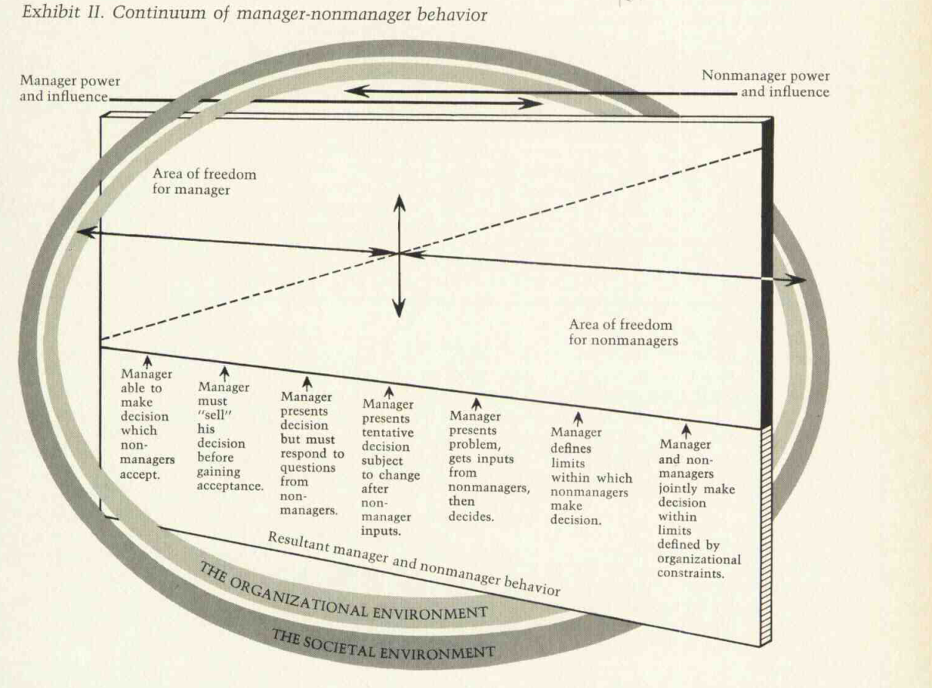

1. Leader makes decision and announces it
- Subordinates have no say in the decision making, managers weigh the options and make the decision.
2. Leader “sells” decision
- Manager will explain the decision and the benefits of the decision to the subordinates.
3. Leader presents ideas and invites questions
- Manager will then decide to allow subordinates to discuss and question his decision in order to better understand it.
4. Leader presents tentative decision subject to change
- Manager will then consider the inputs from the subordinates and re-evaluate his decision (subordinates will have an influence on the final decision).
5. Leader presents problem, gets suggestions, and makes decision
- Manager will pick the best solution to the given problem, this is often done when the team has more experience and knowledge on the subject matter than the manager.
6. Leader defends limits, asks group to make decision
- Manager will now give power to the subordinates with clear limits set by him. This only happens when subordinates have gained enough knowledge and experience to deal with a problem efficiently.
7. Leader permits subordinates to function within limits, defended by their superior
- Manager lets subordinates to identify possible solutions, allowing them to take the necessary course of action while staying within the limits set by him. Manager will defend the decisions of the subordinates thus granting them the same level of authority in decision making.

-If the subordinates make the decision, is the manager responsible?
-What role should managers play?
-Member or authority figure
-Should subordinates be able to tell what style manager is using?
-How do you measure a manager’s “democracy”?
How to lead:

-3 Forces Impact:
Forces in the Manager
- Value system
- Confidence in the subordinate
- Own Leadership inclinations
- Feelings of security
Forces in the Subordinate
- High need for independence
- Readiness to assume responsibility
- High tolerance for ambiguity
- Identify with the organization’s problems and goals
- Have knowledge and experience
- Learned to be part of decision making
Forces in the Situation
- Type of organization
- Group effectiveness
- Nature of the problem
- Time pressures
- Long-run strategy
- Objectives to be attained

-Successful leaders are insightful, flexible, and are keenly aware of the factors or forces which are most relevant to their own behavior at any given time. They also understand their subordinates well enough to give responsibility to the people who are best suited to the tasks required of them.

Zaleznik: Managers and Leaders: Are they different?

Leaders | Managers
Shapes ideas – not reactive | Goals are given – impersonal
Seeks risks | Conservative
Open to new options for problems | Limits choices to coordinate differences
“Twice-born” | “Once-born”
Feeling of separateness | Harmony with one’s environment
Seek opportunities for change | Maintain the existing balance
Prefer to work with ideas | Prefer to work with people
Focus on what decisions mean to participants | Focus on how things get done
Intensive relationships | Moderate relationships

“Organizations need both leaders and managers to succeed…” (Zaleznik, 2004, 74)

Freedom, Power, and Influence

Leaders
Decisions affect entire company (strategy, assets, finances, employees).
-Long term.

Managers
Decisions affect part of the company (some assets, finances, employees).
-Medium term.

Supervisors
Decisions affect some employees and some assets.
-Short term.

Zaleznik Major Claim:
“Managers embrace process, seek stability and control, and instinctively try to resolve problems quickly….. Leaders, in contrast, tolerate chaos and lack of structure and are willing to delay closure in order to understand the issue more fully.” (Zaleznik, 2004, 74)

Zaleznik Secondary Claims:

-“…business leaders have much more in common with artists, scientists, and other creative thinkers than they do with managers.” (Zaleznik, 2004, 74)

-“Organizations need both managers and leaders to succeed…” (Zaleznik, 2004, 74)

-“Leaders work in the opposite direction. Where managers act to limit choices, leaders develop fresh approaches to long-standing problems and open issues to new options.” (Zaleznik, 2004, 77)

-“Leaders work from high risk positions…” (Zaleznik, 2004, 77)

-“For those who become managers, a survival instinct dominates the need for risk, and with that instinct comes an ability to tolerate mundane, practical work.” (Zaleznik, 2004, 77)

-“Managerial personalities form moderate and widely distributed attachments. Leaders, on the other hand, establish, and also break off, intensive one-to-one relationships.” (Zaleznik, 2004, 77)

James C. Collins and Jerry I. Porras: Building your Company’s Vision

-“Companies that enjoy enduring success have core values and a core purpose that remain fixed while their business strategies and practices endlessly adapt to a changing world”

-Core ideology: Enduring character; glue that holds the organization together as it grows, decentralizes and expands globally. Captures what you stand for and why you exist (consists of core values & core purpose). Core ideology is a consistent identity that transcends product or market life cycles, technological breakthroughs, management fads and individual leaders.

-Core values: Beliefs about what is important in the long-term. Timeless guiding principles, rarely if ever change. Intrinsic values inside the organization, excludes anything external. A company should never change its core values; they must always remain true to them.
– Core purpose: Inspiration for people who work there. It is not just about making profits, it’s about finding a reason why you come in to work every day and produce. It is the reason why people enjoy innovating and not just working for a paycheck. Reflects people’s idealistic motivation for doing the company’s work. Why are we here? A group of people get together so they are capable to accomplish something collectively that they could not accomplish separately.

-Discovering your Core Ideology:
- Must be authentic.
- You do not create or set core ideology
- Description of what actually exists, not just what we wish existed
- Needs to be meaningful and inspirational only to people inside the organization
- Find people who are predisposed to share the organization’s core values and purpose
- Once established, everything else that is not part of the core ideology should change and adapt to market changes.
- Core ideology should not change in response to market changes.
- Getting people to share the core ideology.
  - Sony’s ideology: We shall welcome technical difficulties and focus on highly sophisticated technical products that have great usefulness for society regardless of the quantity involves: we shall place our main emphasis on ability, performance, and personal character so that each individual can show the best ability and skill.
** Don’t confuse core ideology with the concept of core competence. Core competence is a strategic concept that defines your organization’s capabilities- what you are particularly good at whereas core ideology captures what you stand for and why you exist

-Envisioned future: BHAGs (big hairy audacious goal)
- Audacious, vivid goals stimulate progress
- 10 to 30 year audacious goal plus vivid descriptions of what it would be like to achieve the goal.
- Powerful way to stimulate progress
- Clear & compelling; serves as unifying focal point of effort; acts as a catalyst for team spirit
- Inventing such a goal forces and executive team to be visionary rather than strategic or tactical.
- Difficult but not impossible to achieve
- Companies need to build a strong organization with people capable of achieving the goals
- Avoid the “We have arrived” syndrome which is an organization who achieved their BHAG but failed to replace it with another.

-Vision Level
- Companies often use a bold mission called BHAG
- There’s a difference with having a goal and setting yourself a huge challenge like climbing Mount Everest
- It means thinking beyond the current capability
- Successful companies preserve the core ideology and stimulate progress through a vivid and audacious envisioned future.

-Vivid Description
- A vibrant, engaging and specific description of what it will be like to achieve that BHAG
- Creating an image that people could carry on in their head.
- Passion, emotion and conviction are essential parts.

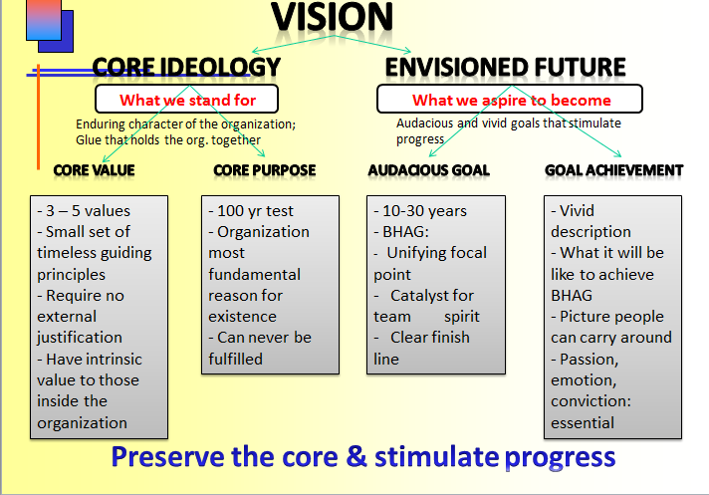

Mintzberg: Manager’s job: Folklore and fact

Common beliefs:
1. Managers are reflective, systematic planners
2. The effective manager has no regular duties
3. Senior managers need aggregated information
4. Management is a science and a profession

Myth: “Managers are reflective, systematic planners”
Fact: -Managers work at an unrelenting pace
-Activities are brief, varied, action-oriented and discontinuous

Myth: “The effective manager has no regular duties”
Fact: -Numerous regular duties, including ceremonies and negotiations
-Process “soft information” that links organization with its environment

Myth: “Senior managers need aggregated information, which are best provided by formal management information systems”
Fact: Managers favor verbal media, telephone calls, and meetings over documents

Myth: “Management is, or at least is quickly becoming, a science and a profession”
Fact: -It is hardly known what procedures managers use
-Managers’ programs – to process information, make decisions, etc. – are locked deep
inside their brain

INTERPERSONAL ROLES

-The Figurehead Role
- Duties of a ceremonial nature.
- Routine.
- Involving little serious communications.
- No important decision making.
- However, they are important to the smooth functioning of an organization and cannot be neglected by the manager

-The Leader Role
- Manager is responsible for the work of its people.
- Two kinds of leader roles:
  - Direct leadership
  - Indirect leadership
- Leadership decides in large part how much of it the manager will realize.

-The Liaison Role
- The manager makes contacts outside his vertical chain of command.
- The liaison role is devoted to building up the manager’s own external information system: informal, private, verbal and effective.
- INFORMATIONAL ROLES
- The Monitor Role
- The manager continuously scans his environment for information, interrogating his liaison contacts and his subordinates and receives unsolicited information.

-The Disseminator Role
- The manager passes some of his privileged information directly to his subordinates, who would otherwise have no access to it.

-The Spokesman Role
- The manager sends information to people outside of his unit. ii) Also inform and satisfy the influential people who control the organizational unit.

DECISIONAL ROLES

-Entrepreneur
- -Voluntary initiator of change
- -Improving the unit, to adapt it to changing conditions in the environment.

-Disturbance handler
- Describes the manager involuntarily responding to pressures.
- Change is beyond the manager’s control.
- Every manager must spend a good part of his time responding to high-pressure disturbances.
- Resource Allocator
- Responsible of deciding who will get what in his organizational unit.
- The manager designs his unit’s structure and authorizes the important decisions of his unit before they are implemented.

-Negotiator
- Managers spend considerable time in negotiations.
- Leonard Sayles: negotiations are a “Way of Life’’ for the sophisticated manager.
- These negotiations are duties of the manager’s job. Sometimes routine but they are an integral part of his job.

-The ten roles just described are indivisible, a manager has to fulfill with all of them. But different managers stress on different roles: ex: Sales managers: interpersonal role, Production managers: decisional role. Nevertheless all roles remain inseparable.

-Authors research indicates that managers:
- work at an unrelenting pace on various brief activities
- perform regular duties
- favor verbal communication

-Schools need to:
- identify managerial skills
- put students in situations to develop skills

-“Management schools will begin the serious training of manager when skill training takes a serious place next to cognitive learning.” (Mintzberg, 1990, p 15)

-“My description of managerial work suggests a number of important managerial skills – developing peer relationships, carrying out negotiations, motivating subordinates, resolving conflicts, establishing informational networks and subsequently disseminating information, making decisions in conditions of extreme ambiguity, and allocating resources.” (Mintzberg, 1990, p15)

Above everything, the Manager has to deal with its insight. The more he understands and responds to dilemmas of the job, the more he will be effective.

3 Areas of Concern:

-About Dilemma of delegation:
1. Mintzberg figured out that the information should be shared between the manager and the close subordinates.
2. In order to respond quickly to numerous and various problems, the manager should use the management scientist: Managers have information and authority, Scientist have time and technology.
3. Gain time: two factors:
a. First, he has to turn obligations to his own advantages.
b. Second, he has to free his time and forced obligations into his schedule

-Can we educate our Managers?
Our managements schools need to: identify the skills managers’ use, select student who show potential in these skills, put the students into situations where these skills can be practiced and then give them systematic feedback on their performance. We can also enhance the entrepreneurial skills by designing programs that encourage sensible risk taking and innovation.
Above all, the Manager needs to be introspective about his work so that he may continue to learn on the job.

French and Raven: Bases of Social Power

Reward Power: based on one’s perception that other has the ability to mediate rewards for him
- One of the main reasons we work is for the money we need to conduct our lives. There are many more forms of reward -- in fact anything we find desirable can be a reward, from a million dollar yacht to a pat on the back.
- Reward power is thus the ability to give other people what they want, and hence ask them to do things for you in exchange.
- Rewards can also be used to punish, such as when they are withheld. The promise is essentially the same: do this and you will get that.
Coercive Power: based on one’s perception that the other has the ability to mediate punishments on him
- This is the power to force someone to do something against their will. It is often physical although other threats may be used. It is the power of dictators, despots and bullies. Coercion can result in physical harm, although its principal goal is compliance. Demonstrations of harm are often used to illustrate what will happen if compliance is not gained.
- Coercion is also the ultimate power of all governments. Although it is often seen as negative, it is also used to keep the peace. Parents coerce young children who know no better. A person holds back their friend who is about to step out in front of a car.
- Other forms of power can also be used in coercive ways, such as when a reward or expertise is withheld or referent power is used to threaten social exclusion.

Legitimate Power: based on one’s perception that the other has a legitimate right to prescribe behaviour for him
- Legitimate power is that which is invested in a role. Kings, policemen and managers all have legitimate power. The legitimacy may come from a higher power, often one with coercive power. Legitimate power can often thus be the acceptable face of raw power.
- A common trap that people in such roles can fall into is to forget that people are obeying the position, not them. When they either fall from power or move onto other things, it can be a puzzling surprise that people who used to fawn at your feet no long do so.

Referent Power: based on one’s identification with the other
- This is the power from another person liking you or wanting to be like you. It is the power of charisma and fame and is wielded by all celebrities (by definition) as well as more local social leaders. In wanting to be like these people, we stand near them, hoping some of the charisma will rub off onto us.
- Those with referent power can also use it for coercion. One of the things we fear most is social exclusion, and all it takes is a word from a social leader for us to be shunned by others in the group.

Expert Power: based on one’s perception that the other has some special knowledge or expertise
- When I have knowledge and skill that someone else requires, then I have Expert power. This is a very common form of power and is the basis for a very large proportion of human collaboration, including most companies where the principle of specialization allows large and complex enterprises to be undertaken.
- Expert power is that which is used by Trades Unions when they encourage their members to strike for better pay or working conditions. It is also the power of the specialist R&D Engineer when they threaten to leave unless they get an exorbitant pay rise or a seat by the window.

*Information Power: based on controlling the information needed by others in order to reach an important goal

Ideas:
-The Five Bases of Social Power theory starts from the premise that power and influence involve relations between at least two agents, and theorizes that the reaction of the recipient agent is the more useful focus for explaining the phenomena of social influence and power.
-French and Raven examined the effect of power derived from the various bases of attraction (the recipient's sentiment towards the agent who uses power) and resistance to the use of power. They conclude that the use of power from the various bases has different consequences.
-For example, coercive power typically decreases attraction and causes high resistance, whereas reward power increases attraction and creates minimal levels of resistance.
-French and Raven also concluded that "the more legitimate the coercion [is perceived to be], the less it will produce resistance and decreased attention".

Jay Barney: Looking Inside for a Competitive Advantage

A theory of sustained competitive advantage

Barney’s Key Concepts:
-Sustained competitive advantage:
- Valuable resources and capabilities
- Rare resources and capabilities
- Hard to imitate resources and capabilities
- Resources and capabilities organized to be exploited

-Barney says there are a lot of tools to focus on a company like SWOT.
-Socially complex resources are organizational phenomena like reputation, trust, friendship, teamwork and culture.
-Sustained competitive advantage cannot be created simply by evaluating environmental opportunities and threats, and then conducting business only in high-opportunity, low-threat environments. Rather, creating sustained competitive advantage depends on the unique resources and capabilities that a firm brings to competition in its environment.

Barney’s Major Claims:
- The most careful and complete analysis of firms’ competitive environments cannot, by itself, explain their success
- Strategists also need to analyze the competitive implications of firms’ internal strengths and weaknesses.
- Financial, physical, human, organizational assets used by the firm to develop, manufacture and deliver products and services to its customers.

-A Firm’s Resources and Capabilities
- Financial: debt, equity, retained earnings, etc…
- Physical: machines, manufacturing facilities, buildings.
- Human: experience, knowledge, judgment, wisdom, etc…
- Organizational: history, relationships, trust, culture, formal reporting structure.

Four Important Questions about Resources and Capabilities (VRIO):

Question of Value: Does firm’s resources and capabilities enable it to exploit opportunities and/or neutralize threats?
- Sony’s and 3M’s resources-including their specific technological skills and their creative organization cultures- made it possible for these firms to respond to, and even create, new environmental opportunities.
- Changes in a firm’s environment may reduce the value of a firm’s resources in their current use, while leaving the value of those resources in other uses unchanged.
- Rolex and Timex exploit very different valuable resources. Rolex emphasises on quality and a high-status reputation while Timex emphasises on high-volume and low-costs.
Questions of Rarity: How many competing firms already possess these valuables resources and capabilities?
- If a firm’s resources are valuable and rare, those resources may enable a firm to gain at least a temporary competitive advantage.
- Wal-Mart gained a competitive advantage over K-Mart because of their Just-on-Time principle to control inventory. This point-of-purchase inventory control system was rare.
Question of Imitability: Do firms without resources or capability face a cost disadvantage in obtaining it compared to firms that already possess it?
- Imitation can occur either through substitution or duplication
- If these substitution resources have the same strategic implications and are no more costly to develop, then imitation through substitution will lead to competitive parity in the long-run.
History: Valuable and rare resources acquired or developed through unique historical circumstances can be a source of sustained competitive advantage

Small decisions: A firm’s competitive advantage seems to depend on numerous “small decisions” (rather than big ones) through which a firm’s resources and capabilities are developed and exploited in developing, nurturing and exploiting resources

Socially complex resources: Reputation, trust, friendship teamwork and culture, while not patentable are much more difficult to imitate

Question of Organization: Is a firm organized to exploit the full competitive potential of its resources and capabilities? (Rolex v. Timex)
- Wal-Mart’s continuing competitive advantage in the discount retailing industry can be attributed to its early entry into rural markets in the US.
  - Not valuable Competitive Disadvantage
  - Valuable, but not rare Comparative equality
  - Valuable and Rare Competitive advantage
  - Valuable, Rare, but not costly to imitate Temporary competitive advantage
  - Valuable, rare, and costly to imitate Sustained competitive advantage

Kaplan and Norton: The Balanced Scorecard

- The “bottom line” is not enough
- The traditional financial performance measures worked well for the industrial era but not anymore
- A stakeholder is anyone who has invested interest in a company and stockholders are company owners, employees, etc.
- Four perspectives for a balanced scorecard
-Customer perspective:
- What matters most to customers? How do customers see us? (Specific measures, includes numbers, that reflect the factors that really matter to customers) To achieve our vision, how should we appear to customers?
-Internal business perspective:
- How can we produce to meet customer expectations? What must we excel at? (Internal operations that enable them to satisfy customer needs) To satisfy our shareholders and customers, what business processes must we excel at?
-Innovation & learning perspective:
- How can we make continual improvements? Can we continue to improve and create value? (Improve existing products, launch new ones, and create more value for customers.....)To achieve our vision, how will we sustain our ability to change and improve?
-Financial perspective:
- How can we ensure profitability for shareholders? How do we look to them? To succeed financially, how should we appear to our shareholders?

Handy: The Sigmoid Curve

The Sigmoid Curve:
- It is the story of a product’s life cycle and of many a corporation’s rise and fall
- There is life beyond the curve. The secret to constant growth is to start a new sigmoid curve before the first one peters out.
- The real energy for change comes only when you are looking disaster in the face, at point B on the first curve. At this point it is going to require mighty effort to drag oneself up to where, by now, one should be on the second curve. At point B, resources are depleted and energies are low. For an individual, an event like being laid off typically takes place at point B,
- If a company is left at point B, only new people will have the credibility and the vision to lift the place back onto the second curve.
- It is wise for a company to start their second curve at point A and to ensure renewal and the continued growth of their organization.
- Maintaining traditional business strategies and never adapting to new markets (think of Blockbuster) will never be able to reach the second curve and will eventually die.
- The Discipline of the Second Curve:
- You will only know for sure where you are on the curve when you look back.
- The discipline of the second curve follows the traditional four-stage cycle of discovery (questioning, ideas, possibilities, and hypotheses). The first two stages cost nothing except for the time for imagination.
- The second curve is always different, although it builds on and grows out of the first.
- Climbing the first curve is when a company is expanding or growing, but to reach the second curve the company must to something really different like launch a new product. (Megabus was still on their first curve, all they did was add wi-fi, new routes, and more busses)
-Curvilinear Logic:
- Logic that everything has its ups and downs and nothing lasts forever.
- Curvilinear Logic means starting life over again, something that gets harder as one gets older.
- Coca-Cola is an exception to this general rule**
- Kaizen means continuous improvement
- Fertilizing the Second Curve:
- Second-curve thinking will come most naturally from the second generation, those who will inherit the future.
- Include some thoughts and recommendations on how the organization should adapt to the changes they might foresee for their industry and their world around them

- We can also relate this curve to Collin’s Company Vision

Key Points:
-“We start slowly, experimentally, and falteringly; we wax and then we wane.” (Handy, 1994, 50)
-“The secret to constant growth is to start a new sigmoid curve before the first one peters out.” (Handy, 1994, 51)
-“…the real energy for change comes only when you are looking disaster in the face, at point B on the curve.” (Handy, 1994, 52)

The Paradox of Time:
-By the time you know where you ought to go, it’s too late to go there
-If you keep on going the way you are, you will miss the road to the future
-Because it is easy to explain things looking backward, we think that we can predict them forward.

The S-shaped curve:
-Empires, Corporations, Product life cycle, Love and relationships, Personal career, etc..
-The 2curves: When to start the 2nd curve
-Who should lead the 2nd curve?
-Time of great confusion

Fertilizing the 2nd curve:
-Seniors: Permission + Encouragement
-New ideas can co-exist with old

Frederick Herzberg: One More Time: How do you Motivate Employees?

Motivating with KITA:
1. Negative KITA: fear of what will happen if something is not done. Will never lead to motivation.
- Negative physical KITA It is a physical attack; it directly stimulates the autonomic nervous system and usually leads to negative feedback from employees.
- Negative psychological KITA this has more advantages over physical KITA because the cruelty is not visible (the hurting is internal). Those who use this type of KITA like managers receive ego satisfaction. If the employee complains, he or she can be accused of being paranoid because there is no tangible evidence of an attack.
2. Positive KITA: rewards, incentives, seduction to get and employee to “move” or “jump”.
“Do this for me or the company, and in return I will give you a reward, an incentive, more status, a promotion, all the quid pro quos that exist in the industrial organization”

**KITA is NOT motivation because we are kicking our employees each time to do something. For motivation, one needs no outside stimulation because one WANTS to do it. KITA results only in short-term movement

3. Hygiene factors: These factors are extrinsic and do NOT provide job satisfaction. Hygiene factors are what employers do to get their employees to move. Hygiene factors are tied in with the KITA concepts. Hygiene factors include company policy, supervision, salary, status, working conditions, etc.
4. Motivator or Growth factors: This is the primary cause to job satisfaction. The growth or motivator factors that are intrinsic to the job are achievement, recognition for achievement, the work itself, responsibility, and growth or advancement.
5. Dissatisfiers (mentioned above)
6. Satisfiers (mentioned above)
7. Horizontal job loading: reducing personal contribution of employees rather than giving them opportunities for growth in their accustomed jobs in order to enrich certain job. Job loading enlarges the meaningless of a job. Examples of job loading include:
- Increasing the quota of hamburgers that need to be produced without extra time given
- Asking a dishwasher to mop the floors as well in his shift (adding another meaningless task)
- Removing the most difficult parts of the job to free the worker to accomplish more less challenging tasks.
8. Vertical job loading: Has internal motivators involved. Examples include:
- Introducing new difficult tasks not previously handled (growth and learning)
- Removing some controls while retaining accountability (responsibility and achievement)
9. Job enlargement: No change in challenges.
10. Job enrichment: a systematic attempt to motivate employees by manipulating the motivational factors.

Vertical job loading (providing motivator factors)

What might you do to ‘improve’ a job?
- Remove some controls while retaining accountability
- Increase accountability of individuals for own work
- Give person a complete natural unit of work
- Grant additional authority; job freedom
- Make periodic reports directly available to workers themselves rather than supervisors
- Introduce new, more difficult tasks
- Assign workers to specialized tasks, enabling them to become experts

Steps for JOB ENRICHMENT (instilling motivators)
- How might you go about improving a job?
- Select jobs, approaching them with the conviction that they can be changed
- Brainstorm possible changes
- Remove hygiene & horizontal loading issues
- Avoid direct participation by the employees whose jobs are to be enriched
- Be prepared for an initial drop in performance
- Expect first‐line supervisors to experience some anxiety
- Not all jobs can or need to be enriched.
- Ultimate reward in motivation is personal growth

Hygiene Factors:
To avoid job dissatisfaction
- Company Policy and administration
- Supervision
- Interpersonal Relationships
- Working Conditions
- Salary
- Status
- Security
Motivation Factors:
To increase job satisfaction
- Achievement
- Recognition
- Work itself
- Responsibility
- Advancement
- Growth

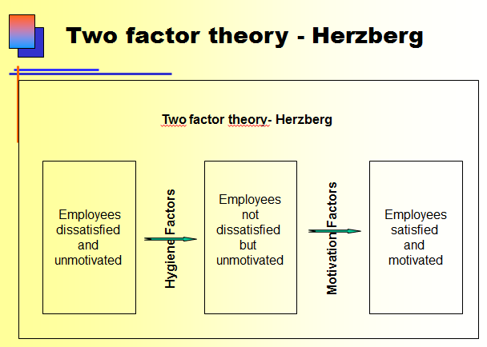

Liker and Choi: Building Deep Supplier Relationships

-Businesses are increasingly relying on their suppliers to reduce costs, improve quality, and develop new processes and products faster than their rivals can.
-Supplier Keirestsu: Close-knit networks of vendors that continuously learn improve and prosper along with their parent companies. (Japanese supplier-partnering model)
-Toyota and Honda believe they can create the foundations for partnerships only if they know as much about their vender as the vendors know about themselves
-Neither Toyota nor Honda depends on a single source for anything: both develop two to three suppliers for every component or raw material they buy. If Toyota doesn’t approve of the performance of their suppliers, they simply give the contract to this supplier’s competition.
-Toyota and Honda don’t source from low-wage countries much; their suppliers’ innovation capabilities are more important than their wage costs.
-Understand how your suppliers work:
- Learn about suppliers’ business
- Go see how suppliers work
- Respect suppliers’ capabilities
- Commit to coprosperity
-Turn supplier rivalry into opportunity:
- Source each component from two or three vendors
- Create compatible production philosophies and systems
- Set up joint ventures with existing suppliers to transfer knowledge and maintain control
-Supervise your suppliers:
- Send monthly report cards to core suppliers
- Provide immediate and constant feedback
- Get senior managers involved in solving problems
-Develop suppliers’ technical capabilities:
- Build suppliers’ problem-solving skills
- Develop a common lexicon
- Hone core suppliers’ innovation capabilities
-Share information intensively but selectively:
- Set specific times, places, and agendas for meetings
- Use rigid formats for sharing information
- Insist on accurate data collection
- Share information in a structured fashion
-Conduct joint improvement activities:
- Exchange best practices with suppliers
- Initiate kaizen projects as suppliers’ facilities
- Set up supplier study groups

Critical Thinking by Linda Dyer

Critical Thinking: Analyzing the validity of arguments in a text.
- Identify the author’s major conclusions
- Describe and evaluate supporting evidence
- Uncover assumptions and values
- Determine soundness of causal logic and deconstruct use of persuasive language

What is a claim?
- Main thesis or conclusion of a text that the author is trying to persuade you to accept.
- Easiest claims to find are towards the beginning or end of a text.
- Cue words are indicators that the claim is about to come (eg. Data shows that, in summary, in fact, therefore, etc.)
- Unproblematic Claims: Consistent with our own experiences and observations, facts independent of interpretation, agreement among experts or strongly supported general claims that are common sense, technical or mathematical claims. (Quebec is larger than Nova Scotia)

Contestable Claims: Not commonly accepted knowledge, often introduce new ideas that awaken curiosity, sometimes presented as if it were a fact, cannot stand on its own. Needs good evidence to support it.

How can one identify it?
- Explicit or implicit?
- Often found in the very beginning or end of a text
  - Explicit: very obvious and clear
  - Implicit: idea that summarizes what the author is trying to say

What is an example of an unproblematic claim (uncontestable)?
- I do not juggle fire on Sundays.
- You are bigger now than when you were born.

How about a contestable claim?
- Art students make poor entrepreneurs.

Presenting Your Claim: We make a concept map or concept list. It has to be a fair summary of your main ideas.

Evidence:
- Evidence is any statement that is a response to the question: Why is it true. It may consist of statistics, details of past events, anecdotes, etc.
- Evaluate the supporting evidence
- Why is this true?

Finding the evidence:
- Indicator words. (Because, as a result...)
- Logical sequence of reasons

A claim (persuasion to accept) and evidence (details to support claim) = Argument

Good evidence:
Accuracy: Evidence has to be true (do your own research). Look for errors.
Precision: Evidence can`t be vague, it has to be as specific as possible. Overuse of ambiguous words such as many, often, usually, high probability, etc, are indicators of low precision.
Sufficiency: You need enough evidence to support the claim.
Representativeness: The evidence they provide must be representative to all Canadians (let`s say). Should represent everyone from the group you wish to target.
Authority: Expert, valid source
Clarity of expression: Clear, paragraphs, etc.

Underlying Assumptions
- Underlying assumptions: Implicit or explicit principles that form the bases of our beliefs & reasoning. Logical link that fills the gap between the evidence and the claim. Different people have different assumptions reflecting different values.
- They tell us whether evidence provided for a claim is relevant
  - Reality assumptions: our beliefs about what events have taken place, what exists or how things work in the world.
  - Value assumptions: our ideals, our standards of right and wrong, the way things out to be. Can be recognized though the use of words like ought, should, desirable....
- Challenging underlying assumptions:
  - To challenge reality assumptions we must present information showing that the author`s notions of reality and how the world works are debatable or just plain wrong.
  - Challenging value assumptions are difficult as values develop early in life and are quite resistant to change.

Causal claims
- Causal explanation: Author’s interpretation of cause & effect relationships. May be multiple causes
- Rival causes: The same evidence can be consistent with different interpretations. Can we think of plausible rival causal explanations that would account for exactly the same events?
- Three types of rival causes:
  - Differences between groups: When an author says that an outcome is caused by a specific difference between groups, we must pause and think: Are there any other differences between these groups that may be relevant? If we can think of some other relevant factors that differ between the groups, we have a plausible rival cause.
- Association of characteristics: A correlation between two factors might be explained by one of three causal links. There may be a direct causal relationship, a reverse causal relationship or no relationship save though the effect of a third factors.

- Post hoc, ergo propter hoc (After this therefore because of this): Just because an event was followed by another even, it does not necessarily means that the first event caused the second.

Techniques of persuasion:
- Anticipate objections based on
  - negative evidence ( show that it is misleading)
  - alternative/rival causes (same evidence can be consistent with different interpretations)
  - conflicting assumptions (If you know that there are reality assumptions that your audience might feel are debatable or wrong, you must provide explicit data to back up your assumptions)
- Counter‐argue objections
- Limit claims you cannot rebut
  - Acknowledging limitations makes your writing MORE persuasive
- Rhetoric – Use of language & form:
  - Detail, be complete (evidence and assumptions)
  - Tone (scholarly vs. narrative)
  - Vividness (being concrete draws attention); bring evidence to life, attracting attention to your points and making them memorable for your readers.

