Chapter 3
4 legal sources affecting Canadian emp practices
- Constitutional law; supreme law of Canada
- It has a pervasive impact on employment practices, as it does on all spheres of Canadian Society (influence all practice of HRM)
- Section 15 of the Canadian Charter of Rights and Freedoms
- Human rights legislation; prohibits discrimination in employment n the provision of good/service
- Legislation generally establishes human rights commissions or tribunals to deal with complaints, including those involving employment discrimination
- Section 8 of the Canadian Human Rights Act refers to a “a prohibited ground of discrimination.” EX Race, national or ethnic origin, colour, religion, age, sex (including pregnancy and childbirth), marital status, family status, mental or physical disability, pardoned conviction, sexual orientation
- Employment equity; program establish in many organization
- Employment equity (EE);
  - the elimination of discriminatory practices that prevent the entry or retention of members from designated groups in the workplace,
  - and the elimination of unequal treatment in the workplace related to membership in a designated group (e.g., women, visible minorities, Aboriginal peoples, and people with disabilities)
- Dev/implement EE plan (6)
  - Obtain support of senior management for the EE effort
  - Conduct a survey to determine the present representation of designated groups in the organization’s internal work force
  - Set future representation targets for designated groups based on availability of qualified workers in the labour market
  - Remove systemic employment barriers to increase representation for designated groups in the internal work force
  - Monitor the changing composition of the internal work force over time
  - Make necessary changes to the EE intervention to bring designated group representation up to future targets
- Benefits
  - A work force representative of Canadian culture and diversity
  - An increase in global competitiveness and productivity
  - High employee morale and decreased absenteeism
  - Amicable relationships with customers and clients
  - Enhanced corporate reputation
  - Increased profitability and a better bottom line
- Labour law, employment standards, and related legislation; grant employment right, impose responsibility n obligation

Employment standards: federal/provincial laws to regulate minimum age of employment, hours of work, minimum wages, statutory holidays, vacations, work leaves, and termination of employment
Direct discrimination: occurs where an employer adopts a practice or rule that, on its face, discriminates on a prohibited ground
Indirect discrimination: occurs when an employer, in good faith, adopts a policy or practice for sound economic, or business reasons, but when it is applied to all employees it has an unintended, negative impact on members
Protected groups: those who have attributes that are defined as “prohibited grounds” for discrimination under the human rights act that applies to the employing organization
Adverse impact: occurs when the selection rate for a protected group is lower than that for the relevant comparison group
Bona fide occupational requirement (BFOR): requirement(s) that a person must possess to perform the essential components of a job in a safe, efficient, and reliable manner
Accommodation: the duty of an employer to put in place modifications to discriminatory employment practices or procedures to meet the needs of members of a protected group being affected by the employment practice or procedure
Undue hardship: the limit beyond which employers and service providers are not expected to accommodate a member of a protected group
Sufficient risk: an employer may argue that an occupational requirement that discriminates against a protected group is reasonably necessary to ensure that work will be performed successfully and in a manner that will not pose harm or danger to employees or the public. (i.e. pilots)
Adverse effect discrimination: a situation where an employer, in good faith, adopts a policy or practice that has an unintended, negative impact on members of a protected group
Outreach recruiting: the employing organization makes a determined and persistent effort to make potential job applicants, including designated group members, aware of available positions within the employing organizations

R&S Notebook 3.5
InEffective Practices for Non-discriminatory Recruiting
  - Permit receptionists and recruiters in employment offices to “pre-screen” applicants on the basis of informal criteria (e.g., appearance, dress)
  - Categorize and stream job applicants based on stereotyped assumptions about protected or designated group membership (e.g., that women are not physically strong enough for certain work)
  - Rely solely on seniority when promoting employees without regard for meeting the qualifications need for the position
  - Rely on word-of-mouth advertising
  - Post job advertisements only in-house
effective Practices for Non-discriminatory Recruiting
- Set and advertise objectively determined selection criteria for the job
  - Advertise job openings in media that are read, viewed, or listened to by protected or designated group members
  - Train employment clerical staff and recruitment officers in outreach recruiting
  - Base selection criteria on bona fide occupational requirements
  - Use opportunities to visually present protected or designated group members in positive employment roles
  - Establish networks with community groups from which protected or designated group members are drawn
  - Post complete, objective, and specific information on all available jobs in a conspicuous spot

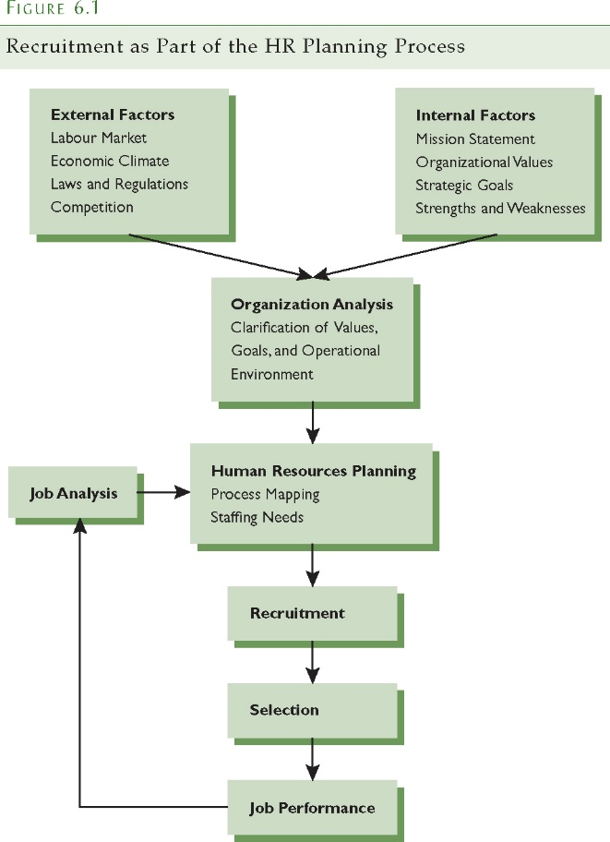
Chapter 6
Attracting Job Applicants
Recruitment: the generation of an applicant pool for a position or job in order to provide the required number of qualified candidates for a subsequent selection or promotion process
Applicant pool: the set of potential candidates who may be interested in, and who are likely to apply for, a specific job
Self-selecting out: occurs during the recruitment and selection process when candidates form the opinion that they do not want to work in the organization for which they are being recruited
The Original Context
Interests and values: an individual’s likes and dislikes and the importance or priorities attached to those likes and dislikes
Job search: the strategies, techniques, and practices an individual uses in looking for a job
Corporate Image n Applicant Attraction
- Reputation of an organization is an important concern to job applicants (better the image= org attractive, especially important in tight markets)
- Corporate image predicts the likelihood of interest on the part of a job seeker
- Familiarity with the company (give more info bout org)
- Competitive compensation package
Image advertising: advertising designed to raise an organization’s profile in a positive manner in order to attract job seekers’ interest
The Person-Org fit (they look at both)
Person-job fit: when a job candidate has the knowledge, skills, abilities, or other attributes and competencies required by the job in question (work experience/background)
Person-organization fit: when a job candidate fits the organization’s values and culture and has the contextual attributes desired by the organization (work experience/extracurricular act)
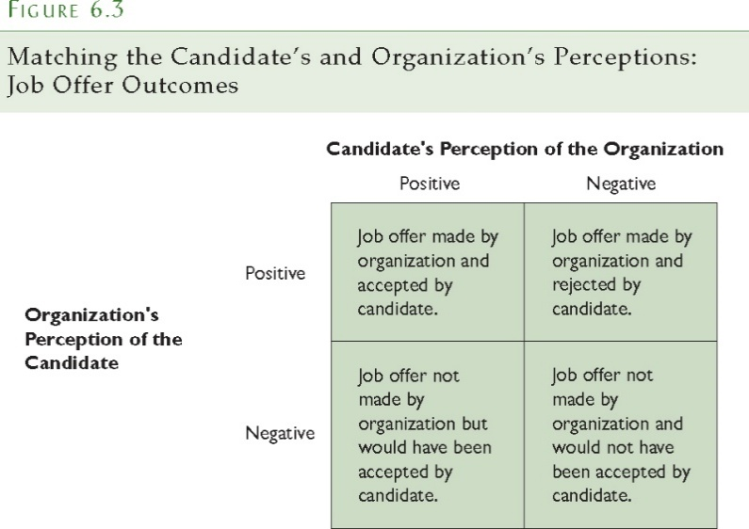

- Perception based on from the recruitment process
- Both might misrepresent their attributes/charac
- Candidates tend dev overly + perception bout orga

Realistic job preview: a procedure designed to reduce turnover and increase satisfaction among newcomers to an organization by providing job candidates with accurate information about the job and the organization

Recruitment strategy
External Factors: The Labour Market
  - Labour markets and recruiting; labour market/econo conditions impose diff constraint (i.e. broaden R in unfavorable market)
  - Part-time labour markets and recruiting; hiring best part-time worker brings unique probs (i.e. not feel as committed, some usu unskilled/uneducated)
  - Outsourcing (contracting with an outside agent to take over specified HR functions); EX comp turn to emp agency (especially find part-time worker), payroll
  - The Legal Environment; comply w/ legal…
  - Systemic Discrimination; intentional/unintentional exclusion of members of groups…
  - Diversity Recruitment; …diversity makes good business sense
Internal Factors
  - Business Plan; addresses aspect of external factor, it also influences degree org fills vacancies in/external applicants
  - Job Level and Type; type of occupation/nature of industry may influence org R strat (done in particular way)
  - Describing the Job; duties n r3sponsibility n skills required for the job

HR planning
The process of anticipating and providing for the movement of employees into, within, and out of an organization

R action plan
Timing of recruitment initiatives
- Recruiting occurs in response to need; an employee leaves for one reason or another and, if the position is retained, must be replaced either through internal or external hiring.
- Pattern occurs in large organizations which recruit from college/university graduates.
- The timing of the recruiting process can extend over a considerable period of time.
Locating and targeting the applicant pool
Target recruiting efforts on a specific pool of job applicants who have the appropriate knowledge, skills, abilities, and competencies in order to perform the job. This applicant pool may be concentrated in one geographic area or spread throughout the country (HR responsible known where to find them). Allows org to tailor their message to that specific group
R sources for internal candidates
- Internal Job Postings
- Replacement Charts (expect vacancies, dev succession plan to fill them)
- Human Resources Information Systems (computerize database contains job analysis on each position)
- Nominations (usu supervisor nominates)
“” External
- Job Advertisements, Newspapers, Professional Periodicals and Trade Journals, Radio and Television, Public Displays, Direct Mail, special R events, job fair, emp referral networking, walk ins, emp agencies…
Internet recruiting: the use of the Internet to match candidates to jobs through electronic databases that store information on jobs and job candidates
Social networks: Internet sites that allow users to post a profile with a certain amount of information that is visible to the public

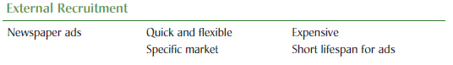

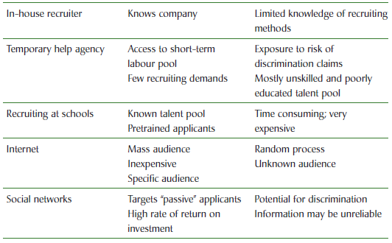

R&S today 6.5
- Attitudinal measures
  - Job satisfaction
  - Job involvement
  - Satisfaction with supervisor
  - Commitment to organization
  - Perceived accuracy of job descriptions

- Behavioural measures
  - Turnover
    - Within 6 months
    - Within 12 months
    - Within 24 months
  - Absenteeism
- Performance measures
  - Performance ratings
  - Sales quotas
  - Performance potential

*diff measure that evaluate recruiting efforts
Chapter 2
R&S process
An employer’s goal is to hire an applicant who possesses the knowledge, skills, abilities, or other attributes (KSAOs) required to perform the job
R&S Today 2.1

EX
Selection Process for Winnipeg Police Constables: Minimum Qualifications
  - Age 18 years or older
  - Education (Manitoba Grade 12 or equivalency– e.g. GED)
    - Foreign credentials require assessment by Manitoba Labour and Immigration prior to application
    - Valid Full Class 5 driver’s licence with no more than four demerits on Driver’s abstract as assessed by the Winnipeg Police Service
  - Canadian citizen or landed immigrant
  - No involvement in any criminal activity within the last two years (including illegal drugs)
  - No criminal record for which a pardon has not been granted
  - Must meet current Winnipeg Police Service vision standards
  - Successful completion of job-related physical test
Selecting new recruits
  - must provide evidence that they meet the vision standards needed to do the job
  - only those candidates who pass the written examination are invited to a short, behavioural-based screening interview conducted by a panel
  - a three hour background interview is completed
  - candidates who are considered for employment undergo psychological and medical examinations, including testing for drug use
  - a selection panel compares all of the qualified candidates and decides on whom to offer employment
Building a foundation (reliability n validity)
Reliability: the degree to which observed scores are free from random measurement errors; an indication of the stability or dependability of a set of measurements over repeated applications of the measurement procedure (test should provide about same info each time)
EX time clock, stamps time everyday day for emps 855, 856 n 857, if the clock report time 5 min fast (900, 901, 902), still reliable, but not valid (systematic error)
Factors Affecting Reliability
- Temporary Individual Characteristics: factors such as health, motivation, fatigue, and emotional state introduce temporary, unsystematic errors into the measurement process.
- Lack of Standardization: changing the conditions under which measurements are made introduces error into the measurement process.
- Chance: factors unique to a specific procedure introduce error into the set of measurements.
Methods of Estimating Reliability
Use 2 diff, but parallel, measures of characteristic or attributes, use same set of ppl, both measure should report the same score for each indiv
- Test and Retest: the identical measurement procedure is used to assess the same characteristic over the same group of people on two different occasions.
- Alternate Forms: having a person take the same interview twice may lead to a false estimate of the reliability of the interview process. To prevent the intrusion of effects from the first interview, the manager asks the applicants alternate questions during the second interview; the correlation between both experience scores again estimates reliability, with high correlations once more indicating strong reliability.
- Internal Consistency: consider any two questions in the interview to be an example of a test-retest situation, and determine the correlation between scores given to each item in that pair; logic behind establishing reliability through internal consistency. Rather than select any particular pair of items, the correlations between the scores of all possible pairs of items are calculated and then averaged; this average estimates the internal consistency, the degree to which all the questions in the set are measuring the same thing.
- Inter-Rater Reliability: measurement in personnel selection is often based on the subjective assessment, or rating, of one individual by another.
- Choosing an Index of Reliability: have to estimate the degree of variability in a set of scores that is caused by measurement error; obtain this estimate by Index of Reliability; the HR specialist chooses an appropriate index of reliability and determines the level of reliability that is acceptable for use of a specific measure.
- The HR Specialist must consider the consequences of the decisions based on the measure; the need for accuracy increases with the seriousness of the consequences for the employee.
Validity: the legitimacy or correctness of the inferences that are drawn from a set of measurements or other specified procedures; the degree to which accumulated evidence and theory support specific interpretations of test scores in the context of the test’s proposed use
Validity Strategies
- Construct and content validity: validation strategies that provide evidence based on test content
- Criterion validity: related validity provides evidence based on relationships to other variables
Bias: systematic errors in measurement, or inferences made from those measurements, that are related to different identifiable group membership characteristic such as age, sex, or race
Fairness: the value judgments people make about the decisions or outcomes that are based on measurements
  - Principle that every test taker should be assessed in an equitable manner

