FINAL REVIEW – COMM 223
CHAPTERS 1, 2, 3, 4, 5, 6, 8, 9, 10, 11, 12, 14, 15, 16, 17, 19

CHAPTER 1
Marketing is the process by which companies create value for customers and build strong customer relationships in order to capture value from customers in return.
5 Steps in the Marketing Process:
- Marketers need to understand the market place and customer needs and wants
- Marketers design a customer driven marketing strategy with the goal of getting, keeping, and growing target customers.
- Marketers construct a marketing program that actually delivers superior value
- Building profitable customer relationships and creating customer delight
- The company reaps the reward of strong customer relationships by capturing value from customers
In the marketing process, the first four steps are designed to “create value for customers and build customer relationships” and the last step is designed to “capture value from customers in return”.
The importance of understanding customers (needs, wants, and demands) and the marketplace: This understanding helps them design want-satisfying market offerings and value-laden customer relationships which help them capture customer lifetime value and greater share of customer. The result is long term increased customer equity.
Customer lifetime value Share of customer Customer Equity (long term)
5 Core Marketing Concepts:
- Needs, wants, and demands
- Market offerings (products, services, and experiences)
- Value and satisfaction
- Exchange and relationships
- Markets
Wants are formed by human needs. Wants backed by buying power = demand. With a value proposition (a set of benefits promised to the customer by the company which would satisfy their needs), companies address customer needs. Value proposition is fulfilled through a market offering, which delivers customer value and satisfaction, resulting in long-term exchange relationships with customers.
Customer Driven Marketing Strategy: The company decides who it will serve by dividing the market into segments of customers (market segmentation) and selecting which market segments they will target (target marketing) Next, they decide how they will serve the targeted customers (differentiating and positioning themselves in the marketplace).
Marketing Management Concepts:
- Production concept: management’s task is to improve production efficiency and bring down prices.
- Product concept: customers favor products that offer the most in quality, performance, and innovative features; thus little promotional effort is required.
- Selling concept: consumers will not buy enough of organizations products unless it undertakes a large scale promotion effort.
- Marketing concept: achieving organizational goals depends on determining the needs and wants of target markets and delivering the desired satisfaction more effectively and efficiently than competitors do.
- Societal marketing concept: generating customer satisfaction and long-run societal well-being through sustainable marketing strategies are key to both achieving the companies goals & fulfilling responsibilities.
Customer relationship management (CRM) defined as the process of building and maintaining profitable customer relationships by delivering superior customer value and satisfaction. The goal of CRM is to produce high customer equity (the total combined customer lifetime values of all of the company’s customers). Creating superior customer value and satisfaction is the key to building successful long term relationships.
Strategies for creating value for customers and capturing value from customers (profits and customer equity): Marketers aim to build the right relationships with the right customers. Companies try to acquire profitable customers while building relationships with customers that help grow “share of customer”. Companies and good marketers eventually realize that they can’t do it alone. They must also be good at partner relationship management.
Share of customer – The portion of the customers purchasing that a company gets in its product categories.
Customer equity – The total combined customer lifetime values of all of the company’s current and potential customers.
CHAPTER 2
Strategic planning (4 steps):
- Defining the company’s mission (market oriented, realistic, specific, motivating, consistent with the market environment)
- Setting objectives and goals
- Designing a business portfolio
- Developing functional plans (detailed marketing plans in line with the companywide plan)
Business portfolio – the collection of businesses and products that make up the company, guided by the company’s mission statement, objectives, and management plans. To create a business portfolio that best fits the company’s strengths, weaknesses, and opportunities, it must analyze and adjust its current business portfolio and develop growth and downsizing strategies for adjusting the future portfolio. Nowadays, companies are designing portfolios that are customized and unique and better suit their situations.

Marketing’s role in strategic planning – Companies departments: marketing, finance, accounting, purchasing operations, information systems, human resources, and others. Marketing plays a key role in the company’s strategic planning by providing a marketing concept philosophy and inputs regarding attractive marketing opportunities. In individual business units, marketing designs strategies for reaching the unit’s objectives and helps to carry them out profitably. By marketers practicing partner relationship management, they work closely with partners in other departments in order to form an effective value chain that serves the customer. By effectively partnering with other companies, they form a superior value delivery network.

At the center of marketing strategy and programs are customer value and relationships. Through marketing segmentation, targeting, differentiation, and positioning, the company divides the total market into smaller segments, selects segments it can best serve, and decides how it wants to bring value to them. Also, designing an integrated marketing mix helps to produce the wants in the target market. Marketing mix = price, products, place, promotion.

To find the best marketing mix and plan, and put them into action, a company must engage in market analysis, planning, implementation, and control.
Marketing Plan:
- Executive summary
- Current marketing situation
- Threats and opportunities
- Objectives and issues
- Marketing strategies
- Action programs
- Budgets
- Controls

Marketing departments:
- Functional marketing organization
- Geographic organization
- Product management organization
- Market management organization

Boston Consulting Group Growth-share matrix
Stars – High-Growth, high-share businesses or products. Often need heavy investments to finance their rapid growth. Eventually their growth will slow down and they will turn into cash cows.
Cash Cows – Low-growth, high-share businesses or products. These established and successful SBU’s need less investment to hold their market share. Thus, they produce a lot of the cash that the company uses to pay its bills and support other SBU’s that need investment.
Question Marks – low-share business units in high-growth markets. They require a lot of cash to hold their share, let alone increase it. Management has to think hard about which question marks it should try to build into stars and which should be phased out.
Dogs – low-growth, low-share businesses and products. They may generate enough cash to maintain themselves but do not promise to be large sources of cash.
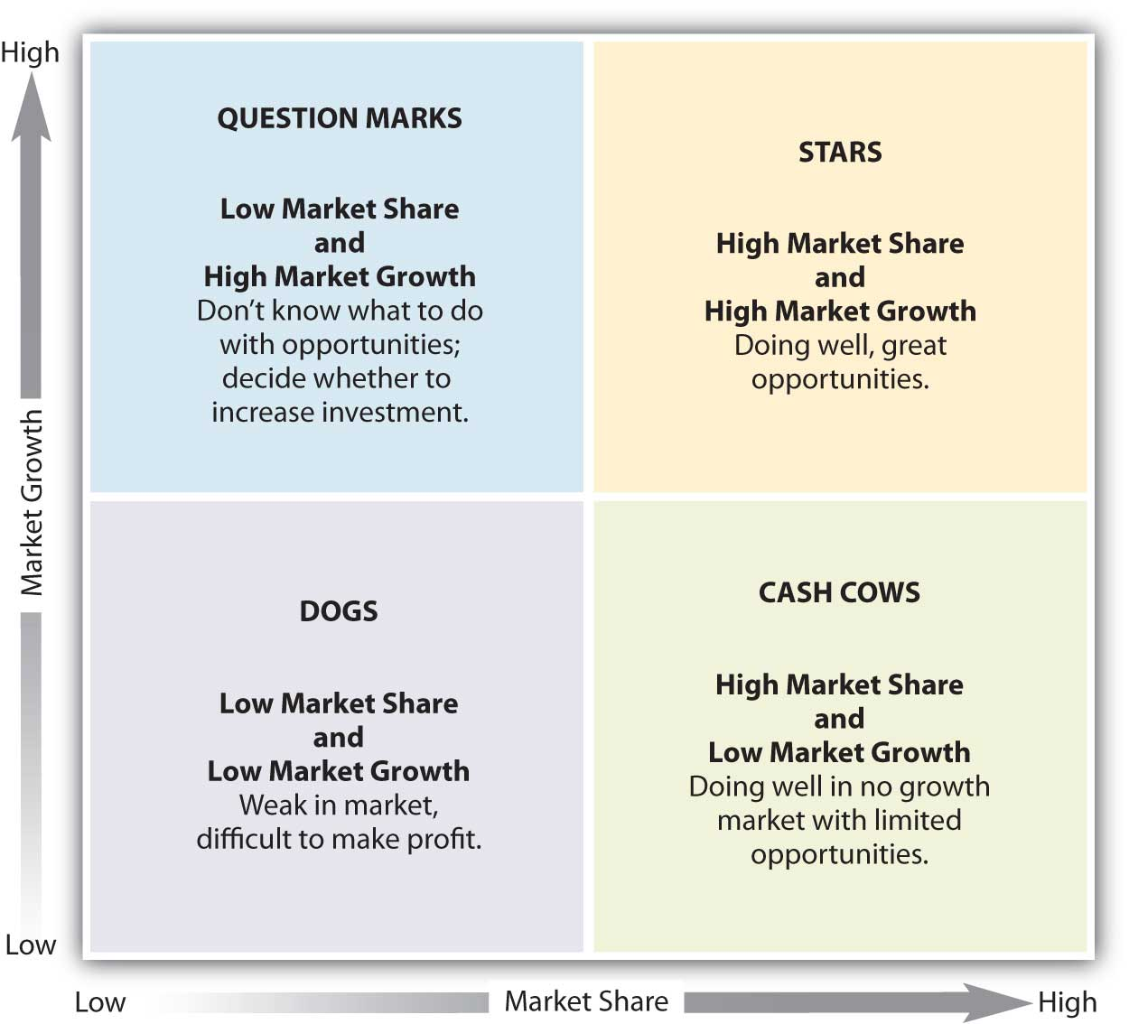
3
4
1
2
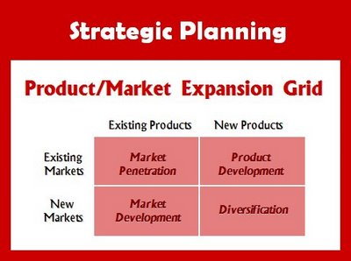
Dentist offices
Toothpaste industry
Smell Eliminate / Fridge
Baking soda / Fridge
CHAPTER 3
Micro-environment: Directly related to products/markets – company, suppliers, marketing intermediaries, markets, competitors, relative “publics”. Consists of actors close to the company that combine to form its value delivery network or that affect its ability to serve its customers. It includes the company’s internal environment (departments and management levels) as it influences marketing decision making. Marketing channel firms are suppliers and marketing intermediaries, including resellers, physical distribution firms, market service agencies, and financial intermediaries that cooperate to create customer value.
Macro-environment: Larger societal forces that affect the entire microenvironment. Broader/long-term effects – Social/cultural, demographic, political/legal, economic, natural, technological. These forces shape opportunities and pose threats to the company.

MACROENVIRONMENT

Demographics and Economics:
Demographic environment – changing age structure, shifting family profiles, geographic population shifts, better educated/more professional population, increasing diversity. Ex: 1) The changing age structure of the population – Baby boomers, generation x, generation y, the millennials. 2) The changing Canadian household - “crowded nest” syndrome where people are living at home for way longer. 3) Geographic shifts in population – highest population growth in Nunavut, Alberta, Yukon, PEI, British Colombia, Saskatchewan. 4) Better educated and more professional population – increases demand for quality products, books, travel, computers and internet services. 5) Increasing diversity – leads companies to create products, ads, and promotions that are designed to target there various diverse groups.
Economic environment – factors that affect buying power and patterns. Characterized by more frugal customers who are seeking greater value – the right combination of good quality and service at a fair price. 1) Changes in consumer spending – economic factors that either increase or decrease spending. Consumers are either spending freely or frugally depending on the current economic situation. 2) Income distribution – the rich are getting richer and the poor are getting poorer.
Distribution of income has also shifted – rich becoming richer, poor becoming poorer and middle class is shrinking tiered market.
Natural and Technological Environments
Natural Environment: Natural resources that are needed as inputs by marketers or that are affected by marketing activities. Environmental concerns create marketing opportunities for alert companies.
- Short-ages of certain raw materials
- Higher pollution levels
- More government intervention in natural resource management
Environmental sustainability – Developing strategies and practices that create a world economy that the planet can support indefinitely.
Technological Environment: Creates opportunities and challenges because companies that fail to keep up with technology changes will miss out on new products and marketing opportunities.
Political and Cultural Environments:
Political Environment: laws, agencies, and groups that influence or limit marketing actions. This environment has undergone three changes that affect marketing worldwide: increasing legislation regulating business, strong government agency enforcement, and greater emphasis on ethics and socially responsible actions. 1) Legislation that regulates business – can either be good or bad. 2) Increased emphasis on ethics and socially responsible actions: Socially responsible behavior where companies encourage their managers to look beyond what the regulatory system allows and simply “do the right thing”, and cause-related marketing where companies exercise social responsibility and build a more positive image by selling pink things for breast cancer or “TOMS” one for one policy.
Cultural Environments: institutions and forces that affect a society’s values, perceptions, preferences, and behaviors. The environment shows trends toward “cocooning”, a lessening trust of institutions, increasing patriotism, greater appreciation of nature, a changing spiritualism, and the search for more meaningful enduring values. 1) The persistence of cultural values – core beliefs are passed on from parents to children and are reinforces by schools, churches, business, and government. Secondary beliefs are more learned by comparing to others like believing in getting married early or later (easier to change these). 2) Shifts in secondary cultural values – people’s views of themselves, people’s views of others, people’s views of organizations, people’s views of society, people’s views of nature, people’s views of the universe.
Companies can react to the changing marketing environment by accepting that it is an uncontrollable element to which they must adapt, avoiding threats and taking advantage of opportunities as they arise. They can also take the proactive stance which they would work to change the environment rather than simply reacting to it. Important: companies should try to be proactive rather than reactive.

DEFINITIONS:
Baby boomers: 9.8 Million Canadians born during the baby boom following WWII and lasting until the mid 1960s.
Generation X: 7 Million Canadians born between 1967 and 1976 in the “birth dearth” following the baby boom.
Millenials (Gen Y): The 10.4 Million children of the Canadian baby boomers, born between 1977 and 2000.
CHAPTER 4
Environmentalism – An organized movement of concerned citizens, businesses, and government agencies to protect and improve people’s current and future living environment.
Sense-of-mission marketing – A principle of sustainable marketing that holds that a company should define its mission in broad social terms rather than in narrow product terms.
Societal Marketing – A principle of sustainable marketing that holds that a company should make marketing decisions by considering consumers’ wants, the company’s requirements, consumers’ long-run interests, and society’s long-run interest.
Deficient Products – Products that have neither immediate appeal nor long-run benefits. Ex: bad tasting & ineffective medicine.
Pleasing Products – Products that have high immediate satisfaction but may hurt consumers in the long-run. Ex: cigarettes ad junk-food.
Salutary Products – Products that have low immediate appeal but may benefit consumers in the long run. Ex: bicycle helmets and some insurance products.
Desirable Products – Products that give both high immediate satisfaction and high long-run benefits. Ex: tasty and nutritious breakfast food.
Major Social Criticisms of Marketing:
Marketing’s impact on individual consumer welfare has been criticized for its high prices, deceptive practices; high-pressure selling, shoddy or unsafe products, planned obsolescence, and poor service to disadvantaged consumers. Marketing’s impact on society has been criticized for creating false wants and too much materialism, too few social goods, and cultural pollution. Critics have also denounced marketing’s impact on other businesses for harming competitors and reducing competition through acquisitions, practices that create barriers to entry, and unfair competitive marketing practices. Some of these concerns are justified and some are not.
The Roles of Ethics in Marketing:
Increasingly, companies are responding to the needs to provide company policies and guidelines to help their manager’s deal with questions of marketing ethics. Of course, even the best guidelines cannot resolve all of the difficult ethical decisions that individuals and firms must make. But there are some principles from which marketers can choose. One principle states that the free market and the legal system should decide such issues. A second and more enlightened principle puts responsibility not on the system but in the hands of individual companies and managers. Each firm and marketing manager must work out a philosophy of socially responsible and ethical behavior. Under the sustainable marketing concept, managers must look beyond what is legal and allowable and develop standards based on personal integrity, corporate conscience, and long-term customer welfare.
CHAPTER 5
Information & gaining insight about the marketplace and customers – Since the marketing process begins with an understanding of the marketplace and consumer needs and wants, a company needs sound info to produce superior value & satisfaction for customers. Companies also require info on competitors, resellers, and other forces and actors in the marketplace. Now, marketers are viewing info not only as an input for making better decision but also as an important strategic asset and marketing tool.

Marketing information system (MIS) – consists of people and procedure for assessing information needs, developing the needed information. And helping decision makers use the information to generate and validate actionable customer and market insights. A well designed MIS begins and ends with users.
- Assesses information needs – serves the company’s marketing and other managers but also provide info to external partners.
- Develops information – from internal databases (provide information on the company’s own operations and departments), marketing intelligence activities (supply everyday information about developments in the external marketing environment), and marketing research (consists of collecting information relevant to a specific marketing problem faced by the company).
- Help users analyze and use the information to develop customer insights, make marketing decisions, and manage customer relationships.

Marketing Research Process:
- Defining the problem and setting the research objectives through exploratory, descriptive, or causal research.
- Developing a research plan for collecting data from primary and secondary sources.
- Implementing the marketing research plan by gathering, processing, and analyzing the information.
- Interpreting and reporting the findings

Internal and external secondary data sources often provide info more quickly and at a lower cost than primary data sources, and they an sometimes yield information that a company cannot collect by itself. Primary (observation/survey/experiment) and Secondary data must nevertheless be relevant, accurate, current, and impartial.

How companies analyze and market information:
CRM (analyze individual customer data) which integrates, analyzes, and applies the mountains of individual customer data contained in their databases.
Marketing information has no value until it is used to make better marketing decisions… Thus, MIS must make the information available to managers and other who make marketing decisions or deal with customers. In other cases, this means providing regular reports and updates & making non-routine info available for on the spot decision. Many firms use intranets and extranets to make this process easier. Also, thanks to modern technology, today’s marketing managers can gain access to marketing information at any time and from virtually any location.

Issues Marketing Researchers face:
Conducting research in small business, not-for-profit, or international situations leads marketers to facing problems. Problems can stem from funding, although small business and NFP tend not to have this problem. International and domestic research face more and different problems. Nevertheless, all organizations need to act responsibly to major public policy and ethical issues surrounding marketing research, including issues of intrusion on consumer privacy and misuse of research findings.
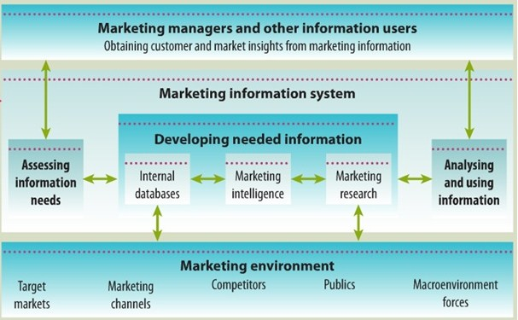
CHAPTER 6
Consumer market – consists of all individuals and households who buy or acquire goods and services for personal consumption.
Consumer behavior – defined as an ongoing process which starts long before the consumer purchases a product or service and continues long after he or she consumes it. This extended definition of consumer behavior means that marketers must always remain aware of a number of issues before, during, and after purchase in order to build brand loyalty and lasting relationships with their customers.
Maslow’s Hierarchy of Needs
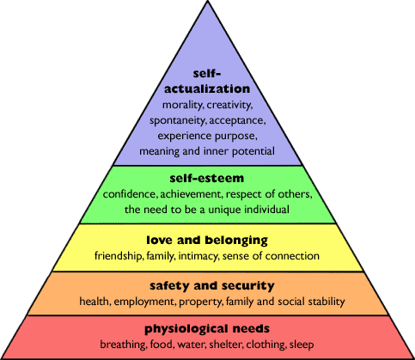
4 Factors that influence Consumer Buyer Behavior –
- Cultural – most basic determinant of a person’s wants and behaviors. Subcultures are cultures within cultures that have distinct values and lifestyles and can be based on anything from age to ethnicity.
Culture – Subculture – Social Class
Culture: The set of basic values, perceptions, wants, and behaviours learned by a member of society from family and other important institutions.
Subculture – A group of people with shared value systems based on common life experiences and situations. Ex: regional subcultures (in Canada – Atlantic provinces, Quebec, Central Canada, the Prairies, and British Columbia) and founding nations (in Canada – Aboriginal peoples, the English, and the French), and mature consumers.
Social Class – Relatively permanent and ordered divisions in a society whose members share similar values, interests, and behaviours. Measured as a combination of occupation, income, education, wealth, etc…
- Social – reference groups: family, friends, social networks, and personal associations, all affect product and brand choices.
Groups and Social Networks – Broken down into groups, opinion leaders, and online social networks. Groups can be described as classifications of people that influence one’s behavior such as membership groups, reference groups, and aspirational groups. Opinion leaders are considered to be a person within a reference group who, because of special skills, knowledge, personality, or other characteristics, exerts social influence on others. Online social networks are online social communities where people socialize or exchange information or opinions. This is a new form of consumer-to-consumer and business-to-consumer marketing and it has big implications for marketers.
Family – The most important consumer buying organization in society and can strongly influence buyer behavior. This includes the roles and influence of the husband, wife, and children on the purchase of different products and services.
Roles and Status – A person’s position in groups such as: family, clubs, organizations, and online communities.
- Personal – lifestyles, buyer’s age, life-cycle stage, occupation, economic circumstances, personality, and others influence personal buying decisions.
Age and Life-Cycle Stage – The stage through which families might pass as they mature over time, ex: marriage, having children, purchasing a home, divorce, children going to university, changes in personal income, moving out of the house, and retirement.
Occupation – Dictates the amount of money a person makes and the goods and services they will buy depending on their income level. Ex: Blue collar workers tend to buy more rugged work clothes and white collar workers spend more money on looking dapper.
Economic Situation – Marketers watch trends in personal income, savings, and interest rates. Companies takes steps to redesign, reposition and reprice their products, especially after a recession.
Lifestyle – A person’s pattern of living as expressed in his or her psychographics. Measures activities (work, hobbies, sports, shopping, social events), interests (food, family, fashion, recreation), and opinions (about themselves, social issues, business, products).
Personality and Self-Concept – Personality is the unique psychological characteristics that distinguish a person or group, and is usually described in terms of traits such as self-confidence, dominance, sociability, autonomy, defensiveness, adaptability, and aggressiveness. Consumers are likely to choose brand that they can identify with which leads to the term brand personality which is the specific mix of human traits that may be attributed to a particular brand.
- Psychological – motivation, perception, learning, and beliefs/attitudes affects consumers decision making process.
Motivation – The need that is sufficiently pressing to direct the person to seek satisfaction of the need. The two main theories of motivation are those of Sigmund Freud and Abraham Maslow.
Perception – The process by which people select, organize, and interpret information to form a meaningful picture of the world. This affects businesses and marketing efforts in terms of how consumers will perceive their ads and offers.
Learning – Defined as changes in an individual’s behaviours arising from experience. Learning occurs through the interplay of drives, stimuli, cues, responses, and reinforcement. A drive is a strong internal stimulus that calls for action; an drive becomes a motive when it is directed towards a particular stimulus object. After a person is satisfied with a purchase, they consider the experience is rewarding therefore the more and more they use their purchase, their response is reinforced.
Beliefs and Attitudes – Beliefs are a descriptive thought that a person has about something, and attitude is a person’s relatively consistent favourable or unfavourable evaluations, feelings, and tendencies toward and object or idea.

Types of Buying Decision Behavior
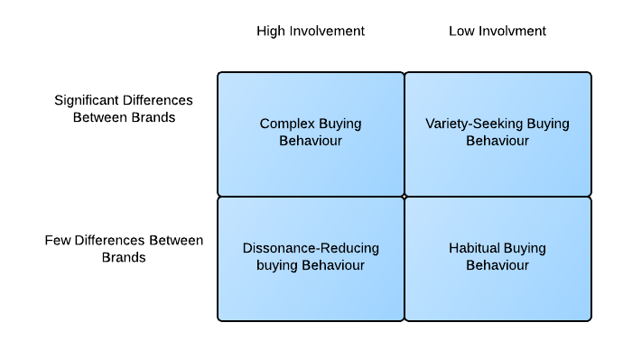
Ex: Camera, Car
Ex: Salt
Ex: Cookies
Ex: Carpet
Buyer Decision Process:
- Need Recognition – consumer recognizes a problem or need that could be satisfied by a product or service on the market.
- Information Search – Once need is recognized, the consumer is aroused to seek more information on the products.
- Evaluation of Alternative – With information in hand, the consumer now uses the info to evaluate brands in the choice set.
- Purchase Decision – Actually buys the product.
- Post purchase Decision – Consumer takes action based on satisfaction or dissatisfaction.

Adoption and Diffusion for a New Product –
Adoption Process:
- Awareness
- Interest
- Evaluation
- Trial
- Adoption

Diffusion:
- Innovators
- Early Adopters (marketers often try to bring their new products to their attention first)
- Early Majority
- Late Majority
- Laggards
Characteristics that Affect Rate of Adoption:
- Relative advantage
- Compatibility
- Complexity
- Divisibility
- Communicability

DEFINITIONS:
Perception: The processes by which people select, organize, and interpret information to form a meaningful picture of the world.
Cognitive Dissonance: Buyer discomfort caused by postpurchase conflict.

CHAPTER 8
Designing a customer-driven marketing strategy:
- Market Segmentation – the act of dividing a market into distinct segments of buyers with different needs, characteristics, or behaviors who may require separate products or marketing mixes.
- Market Targeting – designing strategies to build the right relationships with the right customers.
- Differentiation – actually differentiating the market offering to create superior customer value.
- Positioning – positioning the market offerings in the minds of target customers.

Consumer Marketing Segmentation:
- Geographic – the market is divided into different geographical units, such as nations, regions, provinces, countries, cities, or even neighborhoods.
- Demographic – the market is divided into groups based on demographic variables, including age, gender, family size, family life cycle, income, occupation, education, religion, race, generation, and nationality.
- Psychographic – the market is divided into different groups based on social class, lifestyle, or personality characteristics.
- Behavioural – the market is divided into groups based on consumers’ knowledge, attitudes, uses, or responses to a product.
In business markets, segments can also be by business demographics (industry, company size), operating characteristics, purchasing approaches, situational factors, and personal characteristics.
The effectiveness of segmentation analysis depends on finding segments that are measurable, accessible, substantial, differentiable, and actionable.
Target Marketing Strategies
How companies identify attractive markets and choose a market-targeting strategy?
To target the best market segments, a company evaluates each segments size and growth characteristics, structural attractiveness, and compatibility with company objectives and resources. It then chooses one of four market-targeting strategies – ranging from very broad to very narrow targeting.
- The seller can ignore segment differences and target more broadly instead, using undifferentiated (or mass) marketing. This involves mass producing, mass distributing, and mass promoting about the same product in about the same way to all consumers.
- The seller can also adopt differentiated marketing instead – developing different market offers for several segments.
- Concentrated marketing (or niche marketing) involves focusing on one or a few market segments only.
- Finally micromarketing is the practice of tailoring products and marketing programs to suit the tastes of specific individuals and locations. Micromarketing includes local marketing and individual marketing.
Which targeting strategy is best depends on a company resources, product availability, the product life-cycle stage, market variability, and competitive marketing strategies.
Companies differentiate and position their products for maximum competitive advantage…
- Identifying a set of possible differentiations that create competitive advantage
- Choosing advantages on which to build a position
- Selecting overall positioning strategy
Value Proposition – The brands full positioning or the full miz of benefits on which the brand is positioned.
5 winning value propositions:
- More for more
- More for the same
- The same for less
- Less for much less
- More for less

Market Segmentation
- Identify bases for segmenting the market
- Develop segment profiles
Target Marketing
- Develop measure of segment attractiveness
- Select target markets
Market Positioning
- Develop positioning for target segments
- Develop a marketing mix for each segment

Market Segmentation – Dividing market into distinct groups with distinct needs, characteristics, or behaviours, who might require separate products or marketing mixes.
Target Marketing – Selecting one or more target markets which you will target your product towards.
Market Positioning – Creating a clear, distinctive, and desirable position in the consumer’s mind, relative to competition.
Bases for segmentation:
- Consumer Descriptive Variables
  - Demographics
  - Geographic
  - Psychographic
- Consumer Behavioural Variables
  - Use Occasions
  - Benefits (Toothpaste: clean breath, white teeth)
  - User Status (current vs. new user)
  - Usage Rate (heavy users, large package sizes)
  - Loyalty (Or brand switchers)
  - Attitude towards product (food just commodity, no name brand)

CHAPTER 9
Product: Anything that can be offered to a market for attention, acquisition, use, or consumption that might satisfy a need or want. Includes cars, computers, cellphones as well as services, events, persons, places, organizations, ideas, or a mixture of these. Key element in market offering.
Services: An activity, benefit, or satisfaction offered for sale that is essentially intangible and does not result in the ownership of anything. Examples: banking, hotel services, airline travel, retail, wireless communication, and home repair services.
LEVELS OF PRODUCTS/SERVICES
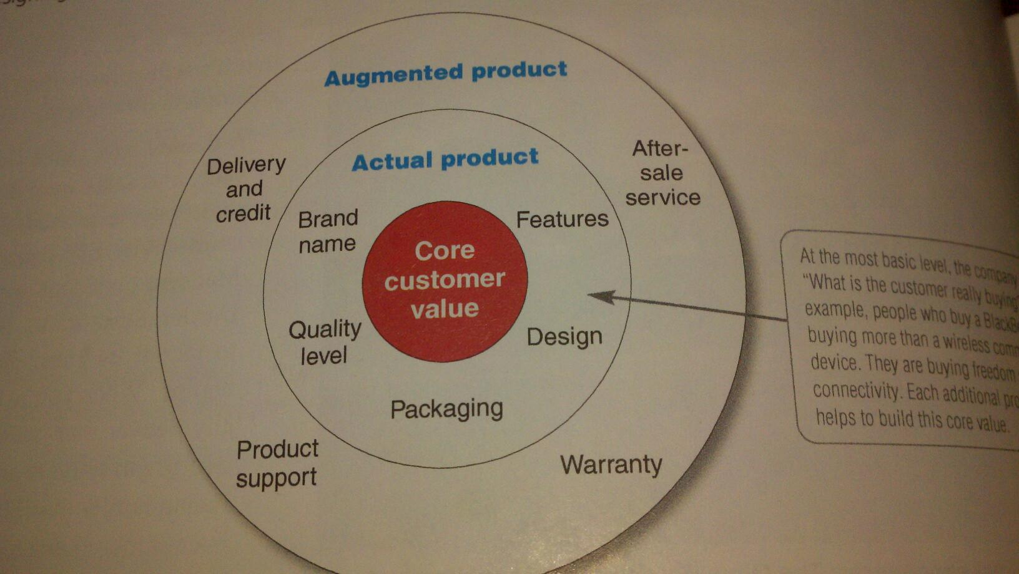

Consumer product: A product or service bought by final consumers for personal consumption. These products include convenience products, shopping products, specialty products, and unsought products.
Convenience products: bought frequently, immediately, and with minimal comparison or buying effort.
Shopping products: consumer usually compares attributes such as suitability, quality, price, and style.
Specialty products: unique characteristic or brand identification which significant groups of buyers are willing to make a special purchase effort.
Unsought product: either the consumer does not know about this product or know about it but does not normally consider buying it.

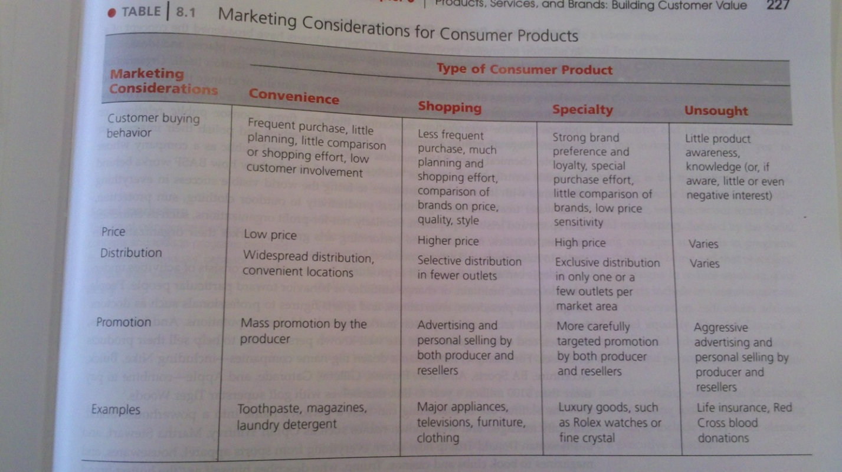
Business product: a product bought by individuals and organizations for further processing or for use in conducting a business. Example: buying a lawn mower for a landscaping company.
- Materials and parts: raw and manufactured materials and parts
- Capital items: business products that aid in the buyers production or operations
- Supplies and services: supplies – operating supplies and repair maintenance items. Services – maintenance and repair services and business advisory services.
Individual Product Decisions
Product Attributes Branding Packaging Labelling Product Support Services
Product Quality – The characteristics of a product of service that bear on its ability to satisfy stated or implied customer needs.
Brand – A name, term, sign, symbol, or design, or a combination of these, that identifies the products or services of one seller or group of sellers and differentiates them from those competitors.
Packaging – The activities of designing and producing the container or wrapper of a product.
Labelling – simple tags or complex graphics attached to products that identify and describe the product at hand.
Product line – A group of products that are closely related because they function in a similar manner, are sold to the same customer groups, are marketed through the same types of outlets, or fall within given price ranges. Example: Campbell’s soup sells healthy beverages, baked snacks, and simple meals (soups).
Product Mix – The set of all product lines and items that a particular seller offers for sale. Also known as a product portfolio. Example: Campbell’s product line has a mission or “product mix” of “nourishing people’s lives everywhere, everyday.”
Services Marketing
Nature and Characteristics –
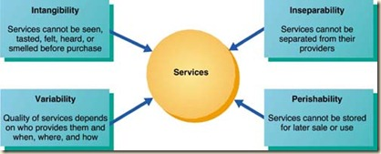

Service Profit Chain – the chain that links service firm profits with employee and customer satisfaction.
Marketing strategies for service firms –
Internal Marketing – Orienting and motivating customer-contact employees and supporting service people to work as a team to provide customer satisfaction.
Interactive Marketing – Training service employees in the fine art of interacting with customers to satisfy their needs.
Interactive Marketing
Internal Marketing
External Marketing
Service Management –
Differentiation – develop a differentiated offer, delivery, and image.
Quality – consistently deliver higher quality than competitors.
Productivity – train employees to work harder and more skillfully considering firms are under great pressure to increase service productivity while costs rise rapidly.
Branding Strategies –
Brand Equity – The differential effect that knowing the brand name has on customer response to the product and its marketing.
Building Strong Brands – Brand Strategy Decisions:

Managing Brands – Brand positioning must be continuously communicated to others thru advertising campaigns that create name recognition, brand knowledge, and some brand preference. More importantly, brands are maintained by customers’ brand experiences. Therefore, a company must put as much care into managing the brand experiences (advertising, personal experience with the brand, word of mouth, company webpages, etc.) as it does into producing its ads.
CHAPTER 10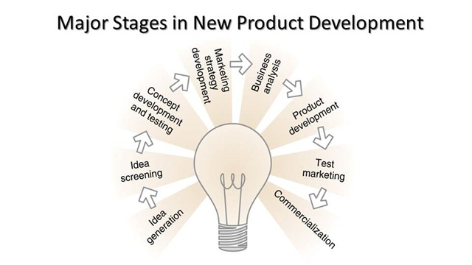
1) Idea Generation – “The systematic search for new-product ideas”. A company typically generates hundreds of ideas, even thousands, to find a few good ones. Major sources of new product ideas are internal sources (R&D and executives, salespeople, scientists, engineers, and manufacturing staff) and external sources such as customers, competitors, distributors, suppliers, and others.
2) Idea Screening – The purpose of this step is to reduce the large number of idea previously generated. This step helps spot good ideas and drop poor ones considering it is only beneficial for the company to go forward with the products that will be the most profitable.
3) Concept Development and Testing – In this stage, is it first very important to create a product concept which is a detailed version of the idea stated in meaningful customer terms. Next is it important to test this concept ‘symbolically’ or ‘physically’ with groups of target customers. Generally, companies are more successful with a concrete, physical presentation of the concept to potential consumers.
4) Marketing Strategy Development – This step involves designing an initial marketing strategy for a new product based on the product concept. In the development of a marketing strategy, it is important to describe 1) the target market; the planned VP; and the sales, market share, and profit goals, 2)the product’s planned price, distribution, and marketing budget, 3) the planned long-run sales, profit goals, and marketing mix strategy.
5) Business Analysis – In this stage take place the review of the sales, costs, and profit projections for a new product to find out whether there factors satisfy the company’s objectives. If all of these objectives are satisfied, then the product can move onto the product development stage.
6) Product Development – This step involves developing the product concept into a physical product to ensure that the product idea can be turned into a workable market offering. This is the first step that requires a huge jump in investment. The R&D department in this case will develop and test the physical version of the product (prototype). Rigorous test are carried out in this stage in order to guarantee a safe and effective product to consumers.
7) Test Marketing – At this point in NPD, the product and its proposed marketing program are tested in realistic market settings. This step allows the company to get a taste of how the product will perform once released although without going to the full expense of the full introduction of the product. Also allows the company to test the entire marketing program – targeting and positioning strategy, advertising, distribution, pricing, branding, packaging, and budget levels.
8) Commercialization – This step involves the full introduction of a new product into the market. With the introduction of the product into the market, however, high costs are incurred. The company may possibly spend hundreds of millions of dollars on advertising, sales promotion, and other marketing efforts within the first year.
Product Life Cycle
PLC Strategies: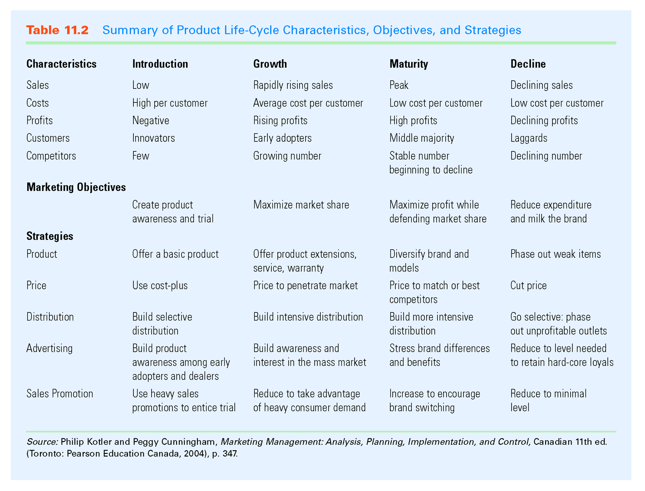
CHAPTER 11
Major Pricing Strategies
Customer Value-Based Pricing – Setting a price based on buyers’ perceptions of value rather than on the seller’s cost.
Good-Value Pricing – Offering the right combination of quality and good service at a fair price. This process involves introducing less expensive versions of established, brand-name products. Armani Armani Exchange, MacDonald’s Value Menu (Dollar Menu).
Value-Added Pricing – Attaching value-added features and services to differentiate a company’s offers and charging higher prices. An example would be movie theaters (AMC). Instead of lowering prices in order to attract more customers, they add amenities instead; more comfortable leather seating with prime sound systems, and chair side catered meals offered with the option of alcoholic beverages.
Cost-Based Pricing – Setting prices based on the costs for producing, distributing, and selling the product plus a fair rate of return for effort and risk.
Types of Costs:
- Fixed costs – aka ‘overhead costs’, costs that do not vary with production or sales level.
- Variable costs – Costs that vary directly with the level of production.
- Total costs – The sum of the fixed and variable costs for any given level of production.
Costs at Different Levels of Production – Higher costs for lower levels of production and vise-versa; lower costs for high production volumes. This also leads companies to practicing more efficient means of production.
Costs as a Function of Production Experience – As company’s gain experience in production, they learn how to do it better. Shortcuts are learned and employees become more familiar with equipment. With more practice, work is better organized, better equipment and production processes are introduced, companies become more efficient and gain economies of scale. The Experience Curve is the drop in the average per-unit production cost that comes with accumulated production experience.
Cost-Plus Pricing – Can be defined as adding a standard markup to the cost of the product. An example would be construction companies who submit job bids by estimating the cost of the job and adding a standard markup for profit.
Break-Even Pricing – Defined as setting price to break even on the costs of making and marketing a product or setting price to make a target return. Generally, a breakeven chart is used in order to demonstrate the total cost and total revenue expected at different sales volume levels. Example: at $20, a company must sell 30,000 units in order to break even and for total revenue to cover total costs.
Competition Based Pricing – Involves setting prices based on competitors’ strategies, costs, prices, and market offerings. In this case, consumers will base their judgments of a product’s value on the prices that the competitors charge for similar products.
New Product Pricing Strategies –
Market-Skimming Pricing – Involves setting a high price for a new products to skim maximum revenues layer by layer from the segments willing to pay the high price; the company makes fewer but more profitable sales. Example: Apple setting the starting price for the iPhone at $599, then lowering it to $499, then $399, then $99; constantly attracting the market segments with more money, looking for the newest gadget on the market, then lowering the price to enable almost everyone to buy the product.
Market-Penetration Pricing - Involves setting a low price for a new product to attract a large number of buyers and a large market share. This strategy means setting a low initial price to penetrate the market quickly and deeply – to attract a large number of buyers quickly and win a large market share.
Internal Factors that influence pricing is the company’s overall marketing strategy, objectives and marketing mix, as well as organizational considerations. Price is only one element of the company’s broader marketing strategy. If the company has selected its target market and positioning carefully, then its marketing mix strategy, including price, will be fairly straightforward. Some companies position their products on price and then tailor other marketing mix decisions to the price that they want to charge. Other companies deemphasize price and use other marketing mix tools to create non-price positions.
External Factors that influence pricing include the nature of the market and demand and environmental factors such as the economy, reseller needs, and government actions. The seller’s pricing freedom varies with different types of markets. Ultimately, the customer decides whether the price is right or not. It is the customer that weigh the price with the perceived values of using the product: if the price exceeds the sum of the values, consumers will not buy the product. So, the company must understand concepts such as the demand curve, and price elasticity.
CHAPTER 12
Explain why companies use marketing channels and discuss the functions these channels perform. In creating customer value, a company can’t do it alone. It must work within an entire network of partners – a value delivery network – to accomplish this task. Individual companies and brands don’t compete, their entire value delivery networks do.
Most producers use intermediaries to bring their products to market. The forge a marketing channel ( or distribution channel) – a set of interdependent organizations involved in the process of making a product or service available for use or consumption by the consumer or business user. Through their contacts, experience, specialization, and scale of operation, intermediaries usually offer the firm more than it can achieve on its own.
Marketing channels perform many key functions. Some help to complete transactions by gathering and distributing information needed for planning and aiding exchange, developing and spreading persuasive communications about an offer, performing contact work (finding and communicating with prospective buyers), matching (shaping and fitting the offer to the buyer’s needs) , and entering into negotiation to reach an agreement on price and other terms of the offer so that ownership can be transferred. Other functions help to fulfill the completed transactions by offering physical distribution (transporting and storing goods), financing (acquiring and using funds to cover the costs of the channel work), and risk taking (assuming the risks of carrying out the channel work).
Channel alternatives for companies: Channel alternatives vary from direct selling to using one, two, three, or more intermediary channel levels. Marketing channels face continuous and sometimes dramatic change. Three of the most important trends are the growth of horizontal, vertical, and multichannel marketing systems. These trends affect channel cooperation, conflict, and competition. Channel design begins with assessing customer channel service needs and company channel objectives and constraints. The company then identifies the major channel alternatives in terms of the types of intermediaries, the number of intermediaries, and the channel responsibilities of each. Each channel alternative must be evaluated according to economic, control, and adaptive criteria. Channel management calls for selecting qualified intermediaries and motivating them. Individual channel members must be evaluated regularly. 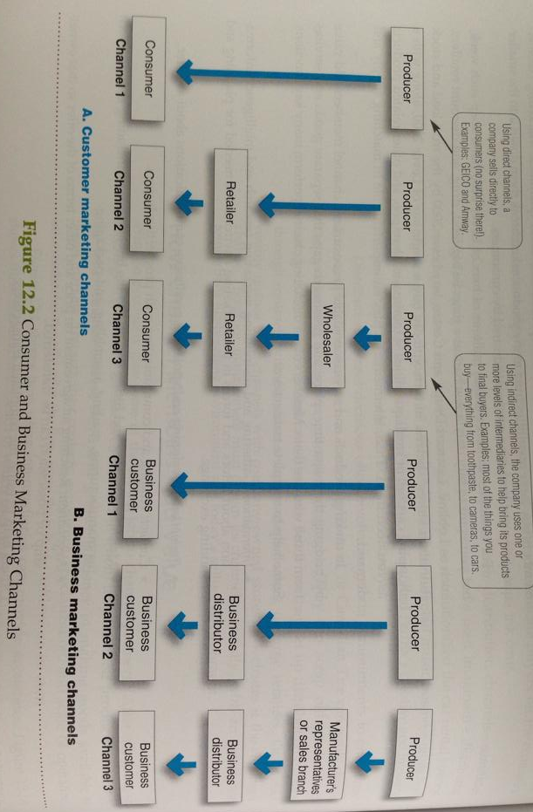
Value delivery network – a network composed of the company, suppliers, distributors, and ultimately the consumers who “partner” with each other to improve the performance of the entire system in delivering customer value.
Direct marketing channel – no intermediary levels
Indirect marketing channel – containing one of more intermediary levels
Channel conflict – disagreement among marketing channel memebers on goals, roles, and rewards – who should do what and for what rewards.
Vertical marketing system – a distribution channel structure in which producers, wholesalers, and retailers act as a unified system. One channel member owns the others, has contracts with them, or has so much power that they all cooperate.
Corporate VMS – a vertical marketing system that combines successive stages of production and distribution under single ownership; channel leadership is established through common ownership.
Contractual VMS – a vertical marketing system in which independent firms at different levels of production and distribution join together through contracts.
Administered VMS – a vertical marketing system that coordinates successive stages of production and distribution though the size and power of one of the parties.
Horizontal Marketing System - a channel arrangements when two or more companies join at one level to follow a new marketing opportunity.
Multichannel distribution system – when a single firm sets up two or more marketing channels to reach one or more customer segments.
Disintermediation – cutting out marketing channel intermediaries by product or service producers ro the displacement of traditional resellers by radical new types of intermediaries.
Intensive Distribution – stocking the product in as many outlets as possible.
Exclusive distribution – Giving a limited number of dealers the exclusive right to distribute the company’s products in their territories.
Selective Distribution – The use of more than one, but fewer that all of the intermediaries who are willing to carry the company’s products.
Physical Distribution (or marketing logistics) – Planning, implementing, and controlling the physical flow or goods, services, and related information from point of origin to points of consumption to meet customer requirements at a profit.
Supply chain management – managing upstream and downstream value-added flows of materials, final goods, and relted information among suppliers, the company, resellers, and final consumers.
CHAPTER 14
The Promotion Mix (or marketing communications mix)–
Advertising - Any paid form of non-personal presentation and promotion of ideas, goods, or services by an intentional sponsor. Includes broadcast, print, internet, outdoor, and other forms.
Sales Promotion - Short-term incentives to encourage the purchase or sale of a product or service. Includes discounts, coupons, displays, and demonstrations.
Personal Selling – Personal presentation by the firm’s sale’s force for the purpose of making sales and building customers relationships. Includes sales presentations, trade shows, and incentive programs.
Public Relations – Building good relationships with the company’s various publics by obtaining favourable publicity, building a good corporate image, and handling or heading off unfavourable rumors, stories, and events. Includes press releases, sponsorships, special events, and webpages.
Direct Marketing – Direct connections with carefully targeted individual consumers to both obtain an immediate response and cultivate lasting customer relationships. Includes catalogues, telephone marketing, kiosks, the internet, mobile marketing and more.
NEW MARKETING COMMUNICATIONS MODEL – Less broadcasting and more narrowcasting!
- Consumers are changing. They are now more informed and more communications involved. They now use the internet and other technologies to find information on their own instead of using marketing marketer-supplier information. The also connect more easily with other consumers and create their own marketing messages.
- Marketing strategies are also changing. Focused marketing programs are being developed more and more as marketers are now shifting away from mass marketing. These focused marketing programs build closer customer relationships in more narrowly defined micro-markets.
- Communication technology is also becoming more advanced by intensively changing the way that companies and customers communicate with each other. New communication tools now include smartphones, iPads, iPods, satellite and cable television systems , and the internet (email, social networks, blogs, brand websites, and so much more).
The Communication Process –
The communication process involves 9 elements: two major parties (sender, receiver), two communication tools (message, media), four communication functions (encoding, decoding, response, and feedback), and noise. To communicate effectively, marketers must understand how these elements combine to communicate value to target customers.

Developing Effective Marketing Communications –
- In preparing marketing communications, the communicator’s first task is to identify the target audience and its characteristics.
- Next the communicator has to determine the communication objectives and define the response sought, whether it be awareness, knowledge, liking, preference, conviction, or purchase.
- Then a message should be constructed with an effective content and structure. Media must be selected, both for personal and non-personal communication. The communicator must find highly credible sources to deliver messages.
- Finally, the communicator must collect feedback by watching how much of the market becomes aware, tries the product, and is satisfied in the process.
CHAPTER 15
5 Major Advertising Decisions:
- Objectives Setting
  - Communication Objectives
  - Sales Objectives
- Budget Decisions:
  - Affordable Approach
  - Percentage of Sales
  - Competitive Parity
  - Objectives and Tasks
- Message Decisions
  - Planning a message strategy
  - Executing the message effectively
- Media Decisions
Most Important!
  - Defining reach, frequency, and impact goals
  - Choosing major media types
  - Selecting media vehicles
  - Deciding on media timing
- Advertising Evaluation
  - Communication Impact
  - Sales and Profits Impact
  - Return on Advertising
Functions of Public Relations –
- Press relations of press agency: Creating and placing newsworthy information in the news media to attract attention to a person, product, or service.
- Public publicity: Publicizing specific products.
- Public affairs: Building and maintaining national or local community relationships.
- Lobbying: building and maintaining relationships with legislators and government officials to influence legislation and regulation.
- Investor relations: Maintaining relationships with shareholders and others in the financial community.
- Development: Working with donors or members of not-for-profit organizations to gain financial or volunteer support.
Tools of Public Relations –
- News: PR professionals find or create favourable news about the company and its products or people. Sometimes the stories occur naturally or sometimes the PR person suggests activities or activities that would create news.
- Speeches: This could build or hurt the company’s image as executives are usually either fielding questions from the media or giving talks and gaining publicity at trade associations or sales meetings.
- Special Events: Ranging from news conferences, press tours, grand openings, and fireworks displays to laser light shows, hot air balloon releases, multimedia presentations, or educational programs designed to reach and interest target publics.
- Written Materials: Meant to reach and influence target markets. Includes annual reports, brochures, articles, and company newsletters and magazines.
- Audiovisual materials: Slide and sounds programs, DVDs, and online videos.
- Corporate Identity materials: logo’s, stationery, brochures, signs, business forms, business cards, buildings, uniforms, and company cars and trucks.
- Public service activities: contributing money and time to public service activities improves public goodwill.
CHAPTER 16
Personal Selling – involves interpersonal interactions between salespeople and individual customers whether it be face-to-face, by telephone, via email, through video or web conferences, or by other means. In personal selling, salespeople can probe customers to learn more about their problems and then adjust the marketing offer and presentation to fit the special needs of each customer.
ROLE of PS:
- Companies that sell only online or through catalogues or companies that sell through manufacturer’s reps. Sales agents, or brokers, have no need for personal selling/salespeople
- Companies that sell business products and services (such as IBM, DuPont, and Boeing) work directly with customers therefore salespeople and personal selling play a major role.
- Companies who sell consumer products (such as P&G and Nike) often use salespeople to gain the support of wholesalers, and retailers, and to help them be more effective in selling the company’s products.
Steps in the Selling Process –
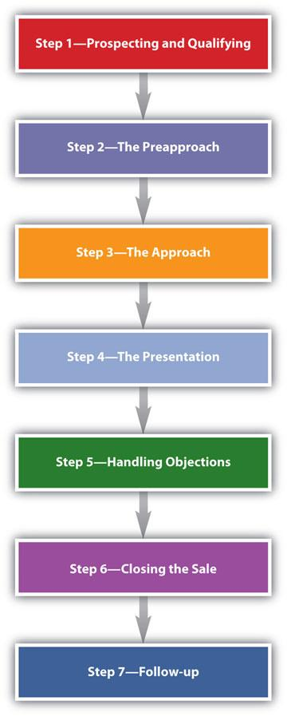
Prospecting – A salesperson or company identifies qualified potential customers.
Pre-approach – A salesperson learns as much as possible about a prospective customer before making a sales call.
Approach – A salesperson meets the customer for the first time.
Presentation – A salesperson tells the “value story” to the buyer, showing how the company’s offer involves the customer’s problems.
Handling Objections – A salesperson seeks out, clarifies, and overcomes any customer objections to buying.
Closing – A salesperson asks the customer for an order.
Follow-up – A salesperson follows up after the sale to ensure customer satisfaction and repeat business.

How do salespeople create value and build customer relationships?
Most companies use salespeople, and any companies assign them an important role in the marketing mix. For companies selling business products, the firm’s sales force works directly with customers. Often, the sales force is the customer’s only direct contact with the company and therefore may be viewed by customers as representing the company itself. In contrast, for consumer-product companies that sell through intermediaries, consumers usually to not meet salespeople or even know about them. The sales force works behind the scenes, dealers with wholesalers and retailers to obtain their support and helping them become more effective in selling the firm’s products.
As an element of the promotion mix, the sales force is very effective in achieving certain marketing objectives and carrying out such activities as prospecting, communicating, selling and servicing, and information gathering. But with companies becoming more market oriented, a customer-focused sales force also works to produce both customer satisfaction and company profit. The sales force plays a key role in developing and managing profitable customer relationships.
Design & Use of Sales Promotion Campaigns
Sales promotion campaigns call for setting sales promotions objectives (sales promotion is customer relationship building), selecting tools; and developing and implementing the sales promotion program by using consumer promotion tools (from coupons, refunds, premiums, and point-of-purchase promotions to contests, sweepstakes, and events), trade promotion tools (from discounts and allowances to free goods and push money), and business promotion tools (conventions, trade shows, and sales contests), as well as determining such things as the size of the incentive, the conditions for participation, how to promote and distribute the promotion package, and the length of the promotion. After this process is completed, the company must evaluate its sales promotion results.
Major Sales Promotion Categories and Tools:
Consumer Promotions – Used to boost short-term customer buying and involvement or enhance long-term customer relationships…
Trade Promotions – Used to persuade resellers to carry a brand, give it shelf space, promote it in advertising, and push it to customers…
Business Promotions – Used to generate business leads, stimulate purchases, reward customers, and motivate salespeople…
CHAPTER 17
Direct Marketing & its Benefits –
Direct Marketing - consists of all direct connections with carefully targeted segments or individual consumers. Beyond brand and relationship building, direct marketers usually seek a direct, immediate, and measurable consumer response. Using detailed databases, direct marketers tailor their offers and communications to the needs of narrowly defined segments or even individual buyers.
Benefits – For buyers, direct marketing is convenient, easy to use, and private. It gives buyers ready access to wealth of products and information, at home and around the globe. Direct marketing is also immediate and interactive, allowing buyers to create exactly the configuration of information, products, or services they desire and then order them on the spot. For sellers, direct marketing is a powerful tool for building customer relationships. Using database marketing, today’s marketers can target small groups or individual customers, tailor offers to individual needs, and promote these offers through personalized communications. It also offers them a low-cost, efficient alternative for reaching their markets. As a results of these advantages to both buyers and sellers, direct marketing has become the fastest-growing form of marketing.
Major Forms of Direct Marketing –
- Personal Selling - involves interpersonal interactions between salespeople and individual customers whether it be face-to-face, by telephone, via email, through video or web conferences, or by other means. In personal selling, salespeople can probe customers to learn more about their problems and then adjust the marketing offer and presentation to fit the special needs of each customer.
- Direct-mail Marketing – This is the largest form of direct marketing that consists of the company sending and offer, announcement, reminder, or other item to a person at a specific address. New forms of this marketing are called email and mobile marketing.
- Catalogue Marketing – selling through catalogues to a set list of customers, made available in stores or accessible on the web.
- Telephone Marketing – Using the telephone to sell directly to customers.
- DRTV Marketing – Two forms: direct-response advertising (or infomercials) and home shopping channels.
- Kiosk Marketing – Information and ordering machines that direct marketers place in stores, airports, hotels, and other locations.
- Online Marketing – Online channels that digitally link sellers with consumers.
- Digital Direct Marketing – mobile marketing, podcasts, vodcasts, and interactive TV.

How companies have responded to the internet and other powerful new technologies with online marketing strategies?
Online marketing is the fastest-growing form of direct marketing. The Internet enables consumers and companies to access and share huge amounts of information with just a few mouse clicks. In turn, the internet has given marketers a whole new way to create value for customers and build customer relationships. It’s hard to find a company today that doesn’t have a substantial web marketing presence.
Online consumer buying continues to grow at a healthy rate. Most Canadian online users now use the internet to shop. Perhaps more importantly, the internet influences off-line shopping. Thus, smart marketers are employing integrated multichannel strategies that use the web to drive sales to other marketing channels.
Nowadays, there are companies online that are considered click-only companies that operate online only. In addition, many brick-and-mortar companies have added online marketing operations, transforming themselves into click-and-mortar companies. Many click-and-mortar companies are now having more online success that their click-only companies.
CHAPTER 19
The Global Marketing Environment –
The International Trade System:
Barriers to International Trade:
- Tariffs: Tax levied by foreign country against imported products
  - Revenue vs. Protective Tariffs
  - About 20-50% (decreasing)
  - Problems? Protecting companies that are inefficient and it isn’t good for the economy because the fact of paying more makes us buy less and it’s not good for the economy.
- Quotas: Limit on volume of particular good
- Embargo: Total import ban on particular good (ex: Europe not allowing importing of Ice Wine from Canada)
- Exchange Control: Foreign exchange & exchange rate against other currencies
- Non-tariff Barriers
Economic Environment:
- Populations are not all “customers”
- Subsistence Economies (5% elite, 95% struggling)
  - Market potential for mainly expensive luxury goods
- Raw-material Exporting economies (South American countries – diamonds)
  - Market potential for heavy equipment for mining (caterpillar), some luxury but mostly low priced (aluminum pots and pans)
- Industrializing Economies (huge and growing markets)
  - Market potential for low priced goods, mature products (washing machines), but also planes. Example: VW beetle stops being sold in Germany but still huge factory in Mexico so VW Beetle becomes popular in Mexico.
- Industrial economies (g7 and g12 – US, CAN)
  - Market potential for expensive, high priced products

Political-Legal Environment:
- Export potential of country depends on favorableness of its political-legal environment re foreign trade
- At least 4 key factors:
- Gov’t Attitude towards international buying / relationships
- Political Stability
- Monetary Regulations
- Sometimes “countertrade”
- Gov’t Bureaucracy

Cultural Environment:
- Cultural traditions, preferences and taboos must be carefully studied
  - Effect?
    - White – pure
    - Black – evil
    - Cannot use VS ad in middle eastern countries because they’re not appropriate in their culture

Major Decisions in International Marketing:
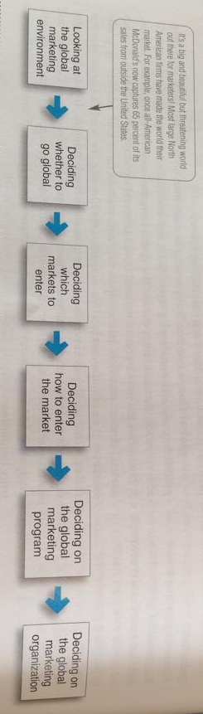
Exporting: Entering a foreign market by selling goods produced in the company’s home country, often with little modification.
Joint Venturing: Entering foreign markets by joining with foreign companies to produce or market products or services.
Standardized Global Marketing: An international marketing strategy that basically uses the same marketing strategy and mix in all of the company’s international markets.
Adapted Global Marketing: An international marketing strategy that adjusts the marketing strategy and mix elements to each international target market, bearing cost but hoping for a larger market share and return.
Straight Product Extension: Marketing a product in a foreign market without any change.
Product Adaptation: Adapting a product to meet local conditions or wants in foreign markets.
Product Invention: Creating new products or services for foreign markets.
Communication Adaptation: A global communication strategy of fully adapting advertising messages to local markets.

