Respiratory System Final Exam Notes:
Introduction
- major function of respiratory system is to apply 02 and dispose of CO2
- 4 distinct processes:

  - Respiratory system

    - pulmonary ventilation: movement of air in and out of the lungs
    - external respiration: exchange of gases between blood and air of alveoli
  - Cardiovascular system
  - 3. transport system: role of blood in transport of gases between lungs and tissues of body
  - 4. internal respiration: at the level of tissues, exchange of gasses between blood in systemic capillaries and tissue cells
- respiratory zone (site of gas exchange)

    - composed of respiratory bronchioles, alveolar ducts and alveoli (microscopic)
- conducting zone (passagways)

    - nose, nasal cavity, pharynx, larynx, tarchea, bronchi, bronchioles, terminal bronchioles
    - as well as providing a passageway, conducting zone organs also cleanse, humidify and warm incoming air
- Nose

  - Functions:

    - airway for respiration
    - moistens and warms incoming air
    - filters and cleans inspired air
    - resonating chamber for speech
    - olfactory (smell receptors)

  - structure of external nose: differences in nose size/ shape due to differences in nasal cartilages
  - skin covering dorsal/lateral aspects of nose is thin; contains many sebaceous glands
  - air enters nasal cavity via external nares (nostrils)divided by midline nasal septum (cartilage,bone)
  - air then goes via internal nares to nasopharynx
  - roof of nasal cavity formed by ethmoid and sphenoid bones of skull
  - floor of nasal cavity formed by palate (anterior is hard, posterior is soft)
  - vibrissae are the hairs to filter course particles
  - nasal cavity lined by 2 types of mucosa

    - olfactory mucosa- contains receptors for sense of smell
    - respiratory mucosa-

        - pseudostraitified ciliated columnar epithelium
        - lamina propria has mucous and serous glands (1L/ day sticky mucus containing lysozyme)
  - respiratory mucosa move contaminated mucus posteriorly to pharynx where it is swallowed and digested
  - cold air slows down cilia, allowing mucus to accumulate in the nasal cavity and dribble out the nostrils=runny nose
  - thin walled veins under nasal epithelium and warm incoming air, cold air engorges the vascular plexus with blood resulting in nose bleeds

- Paranasal Sinuses

  - surround nasal cavity
  - located in frontal, sphenoid, ethmoid, maxillary bones
  - lighten skull, producee mucus, also warm and moisteen air
  - the nasal mucosa is continuous with the respiratory tract, thus spreading infections easy
  - sinus headache: passageways connecting sinuses to nasal cavity blocked; air in sinus gets blocked, partial vacuum
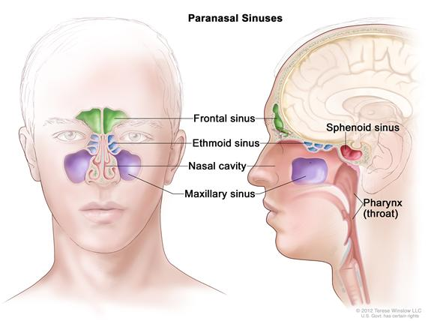
- Pharynx (the throat)

  - common pathway for food and air
  - wall composed of skeletal muscle throughout 13cm length
  - 3 parts: nasopharynx, oropharynx, laryngopharyx

- Nasopharynx

  - below sphenoid bone, above soft palate
  - serves only as an air passageway
  - when swallowing the uvula move superiorly, an action that closes off the nasopharynx and prevents food from entering the nasal cavity
  - pseudostratified ciliated epithelium
  - pharyngeal tonsils (adenoids) traps and destroys pathogens entering the nasopharynx in air
  - pharyngotympanic (auditory) tubes drain from middle ear

- Oropharynx

  - fauces connects oral covaity with oropharynx
  - from soft palate to epiglotties (air AND food)
  - epithelium becomes stratified squamous so it can accomodate the increased friction and chemical trauma (hot/spicy foods) accompanying food passage
  - palatine tonsils + lingual tonsils

- Laryngopharynx

  - also both for food and air
  - straitified squamous
  - from epiglotties to larynx- then respiratory and GI pathways diverge
  - during swallowing, food has "right of way"
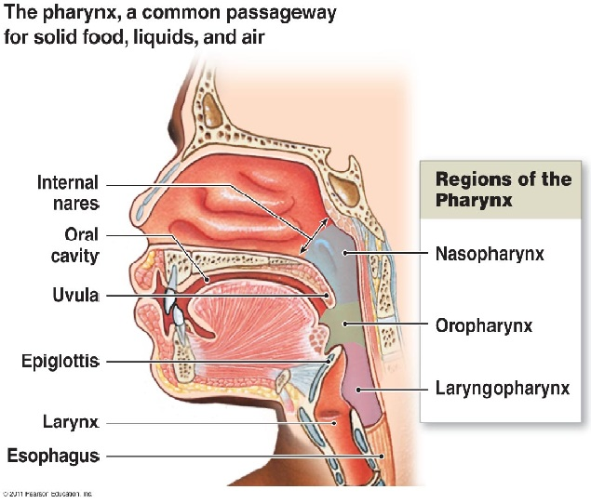
- Larynx

  - attached to hyoid bone (above); continuous with trachea (below)
  - 3 functions

    - open, 2-directional airway
    - switching: food vs air
    - voice production
  - 9 cartilages in total
  - thyroid cartilage - large, shield shaped cartilage in front (adam's apple)
  - arytenoid cartilage- lateral, pyramid-shaped, anchor vocal cords
  - 9th cartilage is epiglottis - elastic cartilage, anchored to anterior rim of thyroid cartilage and extends up to base of tongue
  - true vocal cords - white (avascular), vibrate in response to air movement from lungs

- Voice production

  - speech is the intermittent release of expired air opening and closing of glottis
  - length of vocal cords and size of glottis altered by by action of laryngeal muscles that move arytenoid cartilages
  - male voice at puberty- vocal cords become longer and thicker forcing them to vibrate more slowly producing a deeper voice
  - loudness of voice- the force of air across vocal cords
  - laryngitis- inflammation of vocal cords= vibration impaired
- Sphincter Functions

  - epiglottis closes respiratory tract during swallowing
  - vasalva manuevre: the glottis closes to prevent exhalation and the abdominal muscles contract, this helps empty the rectum and stabilize the body trunk


