Topic 1: Basic Cellular Physiology and the Anatomy and Physiology of the Cardiovascular, Lymphatic and Respiratory Systems
1.1 The Structural Organization of the Human Body (p. 3-4)
- Atom: smallest particle of an element with all of the properties of that element; consists of protons, neutrons and electrons
- Molecule: the smallest amount of a substance that can exist alone = a combination of atoms
- Organelle: molecules associate in specific ways to from organelles = basic components of living cells
ex. mitochondria, lysosomes, ribosomes, RER, GA
- Cell: fundamental structural and functional unit of a living thing; cells vary widely in size and shape, reflecting unique functions in the body
- Tissue: a group of similar cells that have a common function
- Organ: structure composed of at least 2 (but usually 4) tissue types that performs a specific function for the body
ex. Stomach - epithelial tissues line digestive tract produce digestive tissues, CT reinforces soft muscular walls, nervous tissue increase digestive activity by stimulation, muscle tissues make up bulk of stomach wall
- Organ system: organs that work closely with one another to accomplish a common purpose
ex. digestive system uses stomach, LI, SI

1.2 Major Organelles and Structures in Cells (p. 83-95)
Organelle | Structure and Function
Plasma membrane | - Membrane made of a double layer of lipids within which proteins are embedded. Proteins may extend entirely through the lipid bilayer or protrude on only one face. Externally facing proteins and some lipids have attached sugar groups.  - Serves as an external cell barrier, and acts in transport of substances into or out of the cell. Maintains a resting potential that is essential for functioning of excitable cells. Externally facing proteins act as receptors and in cell-to-cell recognition.
Mitochondria | - Rodlike, double-membrane structures; inner membrane folded into projections called cristae.  - Site of ATP synthesis, powerhouse of the cell.
Ribosomes | - Dense particles consisting of 2 subunits, each composed of ribosomal RNA and protein. Free or attached to RER.  - The sites of protein synthesis.
Rough endoplasmic reticulum | - Membrane system enclosing a cavity, the cisterna and coiling through the cytoplasm. Externally studded with ribosomes.  - Sugar groups are attached to proteins within the cisternae. Proteins are bound in vesicles for transport to the GA and other sites. External face synthesizes phospholipids.
Smooth endoplasmic reticulum | - Membranous system of sacs and tubules; free of ribosomes.  - Site of lipid and steroid (cholesterol) synthesis, lipid metabolism and drug detoxification.
Golgi apparatus | - A stack of smooth membrane sacs and associated vesicles close to the nucleus.  - Packages, modifies and segregates proteins for secretion from the cell, inclusion in lysosomes and incorporation into the plasma membrane.
Lysosomes | - Membranous sacs containing acid hydrolases.  - Sites of intracellular digestion.
Peroxisomes | - Membranous sacs of oxidase enzymes.  - The enzymes detoxify a number of toxic substances. The most important enzyme, catalase, breaks down hydrogen peroxide.
Microtubules | - Cylindrical structures made of tubulin proteins.  - Support the cell and give it shape. Onvolved in intracellular and cellular movements. Form centrioles. cilia and flagella, if present.
Microfilaments | - Fine filaments composed of the protein actin.  - Involved in muscle contraction and other types of intracellular movement, help for the cell's cytoskeleton.
Intermediate filaments | - Protein fibres; composition varies.  - The stable cytoskeletal elements; resist mechanical forces acting on the cell.
Centriole | - Paired, cylindrical bodies, each composed of nine triplets of microtubules.  - Organise a microtubule network during mitosis to form the spindle and asters. Form the bases of cilia and flagella.
Cilia | - Short cell-surface projection; each cilium composed of nine pairs of microtubules surrounding a central pair.  - Coordinated movement creates a unidirectional current that propels substances across cell surfaces.
Flagella | - Like a cilium, but longer; only example in humans is the sperm tail.  - Propel the cell.
Microvilli | - Tubular extensions of the PM; contain a bundle of actin filaments.  - Increase surface area for absorption.
Nucleus | - Largest organelle. Surrounded by the nuclear envelope; contains fluid nucleoplasm, nucleoli and chromatin
Nuclear membrane | - Double-membrane structure pierced by pores. Outer membrane continuous with ER.  - Separates the nucleoplasm from the cytoplasm and regulates passage of substances to and from the nucleus.
Nucleoli | - Dense spherical (non-membrane-bounded) bodies, composed of rRNA and proteins.  - Site of ribosome unit manufacture.
Chromatin | - Granular, threadlike material composed of DNA and histone proteins.  - DNA constitutes the genes.

1.4 Different Tissues of the Human Body (Ch 4)
1.4.1 Define tissue and demonstrate how the organization of cells into tissues contributes to overall homeostasis.
- Histology: study of tissues and their cellular organization
- Tissue: groups of structurally similar cells that perform common/related function
- Individual body cells specialized; division of labour
- At organ level, cooperation for organ to work as a whole

1.4.2 List the 4 primary types of tissues.
- Epithelial: covering
- Connective: support
- Muscle: movement:
- Nervous: control (regulation)

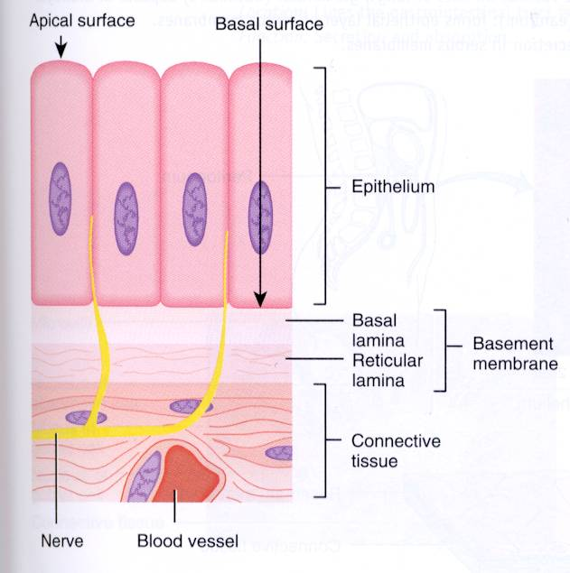
1.4.3 List and demonstrate your understanding of 7 special structural characteristics of epithelial tissue.
- Epithelial tissue: a sheet of cells that covers a body surface or lines a body cavity
- Covering and lining epithelium (creates boundaries); ex.
- Glandular epithelium
- Functions of various epithelia:
- Protection (mechanical, chemical, infectious) - skin
- Absorption - GI tract
- Filtration - kidney
- Excretion - kidney
- Secretion - glands
- Sensory reception - taste buds, olfactory membranes, etc.
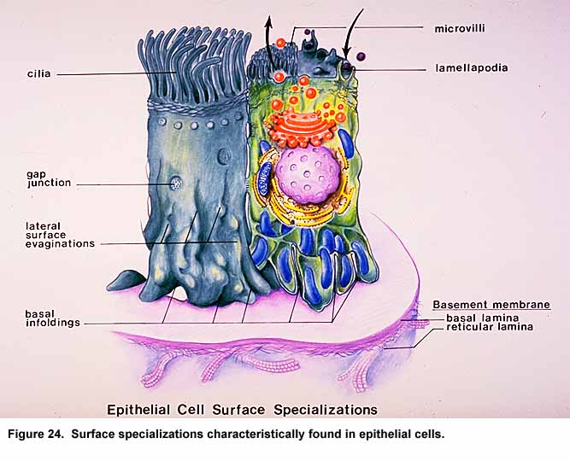
1.4.4 List and demonstrate your understanding of 7 special structural characteristics of epithelial tissue.
- Cellularity: tissues are cell-dense
- Specialized contacts: tight junctions and desmosomes
- Tight junctions: where membranes fuse to prevent materials from entering
- Desmosomes: help hold cell membranes strongly together
- Polarity: apical and basal surfaces; apical surface often specialised such as having microvilli or cilia
- Basal lamina: noncellular, underlying supportive sheet of primarily glycoproteins
- Attachment site for epithelial cells
- Filtration role
- Supported by connective tissue: basement membrane = basal lamina + reticular lamina [underlying reticular connective tissues (CT)]
- An important feature of cancerous epithelial cells is failure to respect the boundary imposed by the basement membrane
- Innervated but avascular: nourished by diffusion through blood vessels
- Regeneration: high regenerative capacity for places like lining of stomach and skin

1.4.5 Indicate the 2 criteria used to classify epithelial cells.
Cell Shapes Layers
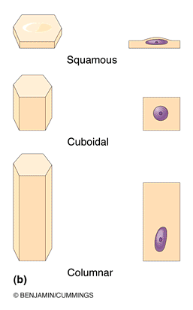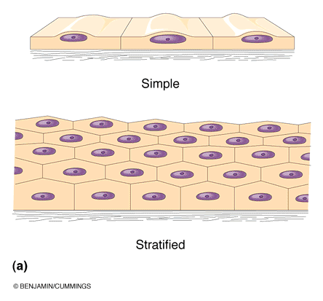

1.4.6 List the 4 types of simple epithelial; indicate primary function associated with each and sample body locations.
- Simple squamous epithelium: thin and permeable for filtration, diffusion
ex. endothelium and in kidney, lungs (alveoli), lines the inside of mouth
- Simple cuboidal epithelium: secretion and absorption
ex. kidney tubules, small glands
- Simple columnar epithelium: also digestion and secretion
ex. digestive tract, lines stomach and most of intestines
- Pseudostratified (ciliated) columnar epithelium: a single layer
ex. respiratory tract where cilia and mucus secretion are local specializations
- Transitional epithelium: lines the bladder, an organ that has to fill - the basal layers are columnar to cuboidal and the apical layers become increasingly flattened and squamous-like as filling occurs
- Stratified squamous: lines the inside of the mouth

1.4.7 Describe the structure of stratified squamous epithelium and give a sample body location.
- Protective role; basal cells cuboidal and undergo mitosis to keep regenerating the layer from below
- Most common example is skin
- The apical layer of cells are flattened at atrophied

1.3.8 Define: gland, endocrine gland, exocrine gland
- Gland: one or more cells that make and secrete a particular product
- Endocrine: do not have ducts; release product (hormones) into intercellular space
- Exocrine: have ducts; secrete products on surface or into a system of ducts
ex. mucus, sweat, oil/salivary glands, liver, pancreas, etc.
a. Unicellular: no glands because unicellular; really just goblet cells (produce mucus in digestive and respiratory tracts)
b. Multicellular: epithelium-derived duct and secretory cells; surrounded by supportive CT which brings blood vessels and nerves
- Secretory method:
- Merocrine/eccrine: secretes product continuously by exocytosis (most common type)
ex. pancreas, salivary glands, most sweat glands
- Holocrine: cell rupture; only in sebaceous glands (produce oil in skin)
- Apocrine: cell apex pinches off with secretory product (ex. mammary glands, but may be merocrine)
1.3.9 List the 5 type of CT; list the 4 main functions associated with CTs
- 5 major types: mesenchyme (embryonic), CT proper, cartilage, bone and blood
- Main functions:
- Binding or support; ex. cartilage and bone
- Protection; ex. bone, blood, adipose tissue
- Insulation; ex. adipose tissue
- Transportation; ex. blood

1.3.10 Describe the structural organization of CT in general; distinguish between collagen, elastic and reticular fibres; distinguish between "blast" and "cyte" types of CT cells
1. Structural Elements of CT
- Ground substance: interstitial fluid + cell adhesion proteins and proteoglycans - molecular sieve
- Fibronectin, laminin - help cells attach to CT elements
- Proteoglycans
- Fibres:
- Collagen fibres: high tensile strength
- Elastic fibres: elastin has coiled structure to allow stretch + recoil
- Reticular fibres: thin collagen protein; fine network to support blood vessels, soft tissues
- Cells: immature ("blast") forms vs. mature ("cyte") forms
- "Blasts" are actively dividing/synthesizing cells during growth and repair
- "Cytes" primarily provide a level of maintenance
Tissue Type | "Blast" | "Cyte"
CT proper | Fibroblast | Fibrocyte
Cartilage | Chondroblast | Chondrocyte
Bone | Osteoblast | Osteocyte
Blood | Hemocytoblast | RBCs, WBCs, platelets
2. Types of CT
- Mesenchyme: first tissue formed from mesoderm germ layer - mesenchymal cells + fluid ground substance and fine fibrils are the source of all other CTs
- CT proper:
- Loose CT (areolar, adipose, reticular): not as many fibrils nor as sturdy
- Dense CT (dense regular, dense irregular, elastic)

1.3.11 List and briefly describe the 3 types of loose CT; include key functions for each type as well as sample body locations
- Areolar CT: gel-like matrix with all 3 fibre types; cells = fibroblasts, macrophages, mast cells and some WBCs
- Description: loose arrangement of fibres; reservoir of water and salts but is also a prime site of edema during inflammatory reaction
- Location: widely distributed under epithelia of body
ex. In the walls of the epithelium
- Function: cushioning of organs, immunity (macrophages) and inflammation; fluid reservoir
- Adipose tissue: areolar CT modified to store nutrients; adipocytes
- Description: fat-filled adipocytes with displaced nuclei; do not reproduce; scanty matrix
- Location: under skin, around kidneys and eyeballs in bones and within abdomen, in breasts; 18% of average wt (15% for men; 22% for women)
- Function: fuel reservoir, insulation, supports and protects organs
- Reticular CT: like areolar CT, but only reticular fibres
- Location: lymphoid organs (lymph nodes, bone marrow, spleen)
- Function: fibres form soft internal skeleton that supports free blood cells

1.3.12 List and briefly describe the 3 types of dense CT (fibres are the predominant element)
- Dense regular CT: bundles of collagen fibres running parallel to direction of pull; white flexible tissue with great resistance to tension
- Location: tendons (muscle to bone), ligaments (bone to bone) at joints, also aponeuroses (sheet rather than ropelike structure)
- Function: attachment with strength
- Dense irregular CT: same as regular, but collagen bundles thicker and arranged irregularly
- Location: dermis, submucosa of digestible tract, fibrous capsules of organs and joints
- Function: withstand tension exerted in many directions; strength
- Elastic CT: like regular CT, but a very high content of elastic fibres; found in some very elastic ligaments

1.3.13 List the other remaining types of connective tissue
- Cartilage: features between dense CT and bone (tough but flexible)
- Avascular (explains why it takes a long time to heal when damaged), devoid of nerve fibres
- Ground substance contains lots of the GAGs (glyocoaminoglycan) chondroitin sulfate and hyaluronic acid - also chondronectine (adhesive protein)
- Collagen fibres (can have some elastic fibres)
- Up to 80% water
- Bone: calcium salts give hardness and strength for support/protection of softer tissues; cavities for fat storage and synthesis of blood cells
- Osteoblasts: make bone
- Osteocytes: maintain bone
- Osteoclasts: chew up bone when we need calcium
- Blood: classified as a CT because it consists of cells (RBCs, WBCs) and is surrounded by a nonliving fluid matrix (blood plasma)
- "Fibre" components are soluble protein molecules - only visible during clotting

