ANP 1106 – Midterm1

1: ANATOMICAL TERMS

Standard Anatomical Position
-initial reference point,
-direction from POV of subject (ie patient, cadaver)
-body erect, feet apart, palms face forward and thumbs away from body

Divisions of the Body
Axial: head, neck, and trunk
Appendicular: appendages/limbs attached to axis

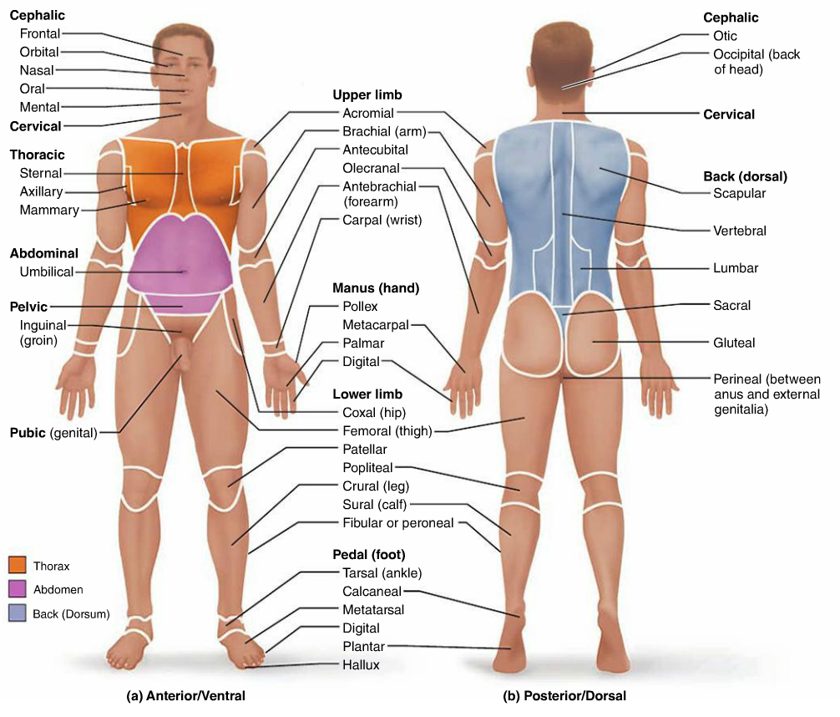

Planes and Sections
Sagittal Plane: divides body into L and R parts
--Median Plane/Midsagittal Plane: sagittal plane that is exactly in the midline
--Parasagittal Plane: all other sagittal planes offset from the midline
Frontal (Coronal) Plane: divides body into anterior and posterior parts
Transverse (Horizontal) Plane: divides body into superior and inferior parts
Transverse section=cross section
Oblique Section: cuts made diagonally between the horizontal and vertical planes
Term | Definition
Superior (Cranial) | Toward the head end or upper part of a structure or the body; above
Inferior (Caudal) | Away from the head end or toward the lower part of a structure or the body; below
Ventral (Anterior) | Toward the front end of the body; in front of
Dorsal (Posterior) | Toward the back end of the body, behind
Medial | Toward or at the midline of the body; on the inner side of
Lateral | Away from the midline of the body; on the outer side of
Intermediate | Between a more medial and a more lateral structure
Proximal | Closer to the origin of the body part of the point of attachment
Distal | Father from the origin of the body part of the point of attachment
Superficial | Toward or at the body surface
Deep | Away from the body surface; more internal

Dorsal Body Cavity
Cranial Cavity: enclosed by the skull and houses the brain
Vertebral (Spinal) Cavity: enclosed by the vertebral column and houses the spinal cord
-both cavities are continuous and well protected

Ventral Body Cavity
-larger, houses the viscera (internal organs)
Thoracic Cavity: 2 lateral pleural cavities (house lungs) + central pericardial cavity (houses the heart)
Abdominopelvic Cavity: superior abdominal cavity (stomach, intestines, spleen, liver) + inferior pelvic cavity (bladder, some reproductive organs, rectum) **nothing separating abdo + pelv (pelv tips away)
-diaphragm separates the two main cavities
-abdominopelvic region not supported by bone (only muscle) and most susceptible to trauma

Abdominopelvic Quadrants
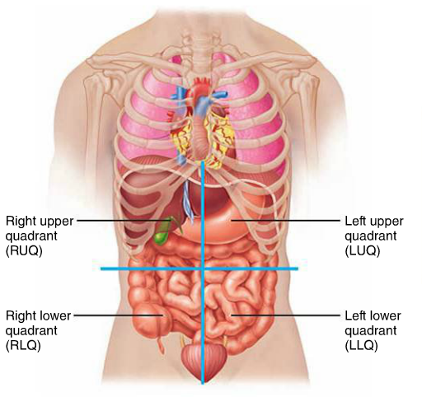

Transverse + median planes intersect at the umbilicus
Abdominopelvic Regions
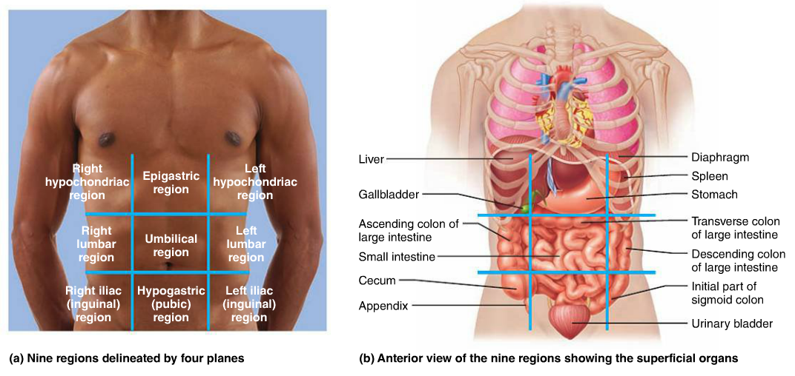

2: INTEGUMENTARY SYSTEM

Skin’s Regions
Epidermis: epithelial layer, thick, keratinized stratified squamous epithelium
Dermis: bulk of skin, fibrous CT

Epidermal Cells
Keratinocytes: produce keratin (fibrous protein) as a protective agent, new epidermis every 25-45 days
Melanocytes: produce pigment melanin; found in deepest layer of epidermis; branching processes transfer to adjacent cells so granules can accumulate and form pigment shield (prevents UV radiation from damaging nucleus)
Dendritic (Langerhans’): star shaped; migrate to epidermis from bone marrow; macrophages activate immune system
Tactile (Merkel): at epidermal-dermal junction; disc-like sensory nerve ending used as touch receptors

Epidermal Layers
-“thick skin” covers high-abrasion areas + includes all 5 strata
-“thin skin” is missing stratum lucidum and all other strata are thinner
Stratum Corneum: most superficial; 20-30 layers of dead cells, essentially flat membranous sacs of keratin, glycolipids in ECF
Stratum Lucidum: 2-3 rows of clear, flat, dead keratinocytes
Stratum Granulosum: 5 layers of flattened cells, organelles deteriorating; cytoplasm full of lamellar granules (release lipids) and keratohyaline granules
Stratum Spinosum: many keratinocyte layers unified by desmosomes; cells contain thick pre-keratin bundles (melanin granules and dendritic cells most abundant here)
Stratum Basale: deepest; one row of stem cells; some newly formed cells become more superifical layers (occasional melanocytes and dendritic)

Dermis
-cell types typical of CT: fibroblasts, macrophages, some mast cells, WBCs, semi-fluid matrix heavily embedded with collagen, elastin and reticular fibers richly supplied with nerve fibers, blood and lymphatic vessels, hair follicles, sweat and oil glands

Papillary Layer of Dermis
-thin, superficial
-areolar CT fibers interspersed w/ blood vessels
-dermal papillae (contain capillaries or nerve endings for touch, pain) indent overlying epidermis, keeps dermis and epidermis from separating
-dermal papillae overlie dermal ridges on palms of hands, soles of feet to give us epidermal ridges known as friction ridges

Reticular Layer of Dermis
-thick, deeper
-dense irregular CT (thick bundles of collagen fibers parallel to skin surface)
-source of lines of cleavage/tension lines
-collagen fibers give strength+resiliency + maintain skin hydration
-elastic fibers provide stretch+recoil
-surgeons cut along these lines for better recovery
Flexure Lines: dermal folds that occur at or near joints where dermis is tightly secured to deep structures (ie palms, wrists, fingers, soles, toes)
Striae: “stretch marks” extreme stretching of the skin
Blister: fluid filled pocket that separates the epidermal and dermal layers

Hypodermis
-superficial fascia, subcutaneous tissue FATTY
-areolar CT + blood vessels & adipose tissue
-anchors skin to underlying structures w/ ability to slide
-shock absorber, insulator, fat storage (can be drawn upon when nutrients low)

Skin Colour Pigments
Melanin: only one made in the skin; different forms (yellow, rust, black, brown); skin colour dependent on type and relative amount and keratinocyte retention of the pigment
-people close to equator have more melanin
Carotene: yellow/orange in plant products [eg carrots; deposits in keratinocytes (esp stratum corneum) + hypodermis]
Hemoglobin: from capillary circulation + gives skin a pinkish hue
---Cyanosis: poorly oxygenated Hb causes blood and skin of Caucasians to appear blue

Hair and Hair Follicles
-functions: sense insects, protection against trauma/heat loss/sunlight, shield eyes, filter air in nose
-hard keratin = more durable, doesn’t flake
Hair Shaft: shape determines curliness of hair; medulla (large cells partially separated by air spaces, absent in fine hair), cortex (many layers of flattened keratinocytes, pigment is here), and cuticle (single layer of overlapping cells)
-split ends are cuticle abrasion at tip of hair
-grey hair has diluted pigment and more air space
Hair Root: part embedded in skin (w/in hair follicle)
Bulb: expanded deep end of follicle – has papilla and root hair plexus
Follicle: outer CT root sheath + inner epithelial root sheath; hair matrix
Arrector Pili Muscle: 1/follicle; contract to pull hair up and dimple skin
Sebaceous Gland: holocrine gland that secretes sebum (oily lubrication and waterproofing; bactericidal)
Whitehead: accumulated sebum blocks sebaceous gland duct
Blackhead: oxidation of sebum material
Acne: bacterial infection of sebaceous gland
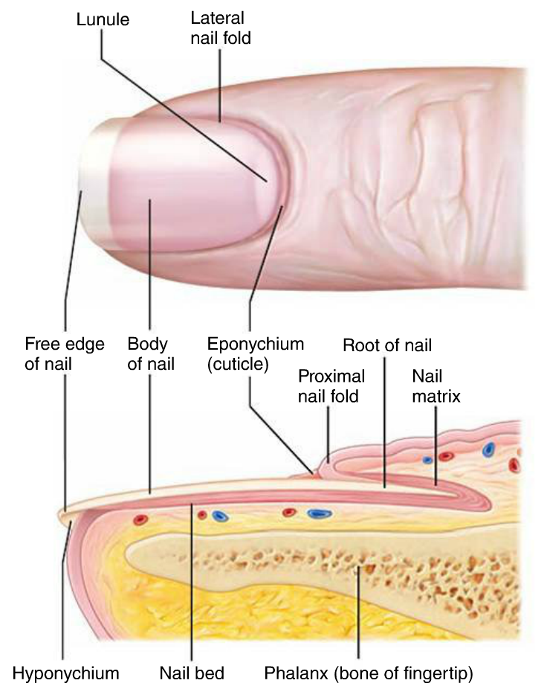
Hair Thinning and Baldness
Vellus Hair: thin
Terminal Hair: thick
-hair growth affected by hormones (DHT) and nutrition
Hirsutism: excessive hair growth in F due to extra testosterone
-hair grows ~2.5mm/week
-active phase then resting phase
Alopecia: loss of hair/baldness
Male Pattern Baldness: shortened growth phase (no DHT)
Nails
-scale like modification of epidermis, protective + useful
Lunula: growing end of nail (more cells, less blood vessels)
-2 lateral and one proximal nail fold
-4 specialized epithelia (proximal nail fold, nail matrix, nail bed + hyponychium)
-yellow tinged and thickened nails indicate a fungal infection
-yellow tinged can also indicate a serious respiratory or thyroid gland disorder
-spoon nail = iron deficiency
-Beau’s (horizontal) lines = malnutrition (sporadic stoppage of matrix growth)

Sweat Glands
-all over skin surface (except nipples and external genitalia)
->2.5 million/person
Merocrine:
-more common
-esp. palms, soles, forehead
-simple coiled tubular glands with pores at surface
-thermoreg
-secretes sweat (hypotonic filtrate of blood, 99% water w/ solutes, pH 4-6)
Apocrine:
-axillary + anogenital areas; larger
-ducts empty into hair follicles
-same as sweat (but fatty substances and proteins too); odourless until decomposed by skin bacteria “BO”
-function? (not thermoreg) maybe sexual scent glands
-activated by SNS when stressed
Modified Sweat Glands:
-ceruminous secrete wax (cerumen) in external ear canal
-mammary secrete milk

Functions of the Skin
1) Protection
-chemical barrier (secretions, melanin)
-physical barrier (trauma, bacterial invasion, waterproof)
-biological barrier (Langerhans cells of epidermis and macrophages in dermis)
-permeable to gases, fat-soluble vitamins and steroids, plant oleoresins, organic solvents, heavy metal salts, penetration enhancers (drug admin)
2) Body Temperature
-sweat 0.5-12 L/day
-vasoconstriction
3) Cutaneous Sensation
-pressure, temperature, pain, wet/dry, texture
4) Metabolic Functions
-vit D, carcinogens, topically applied cortisone hydrocortisone
5) Blood Reservoir
6) Excretion
-ammonia, urea, and uric acid in sweat
-salts

Burns
-heat, electricity, radiation, chemicals
-first concern is dehydration, then infection
First Degree: only epidermis (ex sunburn)
Second Degree: epidermis + upper dermis (blisters)
Third Degree: entire thickness of skin (epidermis and all of dermis) (grey-white, cherry red, or black)
-skin cannot repair itself after 3rd degree but might be able to skin graft

Rule of Nines
-the following are indications of SA% per section of body (Ant, Full)
Head/Neck (4.5%, 9%)
Upper Limbs (9%, 18%) *ant rt arm = 4.5%
Trunk (18%, 36%)
Lower Limbs (18%, 36%) *ant rt leg = 9%
Perineum (1%)

3A: ANATOMY OF THE SKELETAL SYSTEM – BONY TISSUES

Functions of Bone
- Support: keep body upright
- Protection: skull, ribcage, vertebral column
- Movement: muscle attachment, appendages, digits (large and fine movements)
- Mineral Storage: calcium, phosphate
- Blood Cell Formation: red bone marrow
- Fat Storage: yellow bone marrow (E reserve)
- Hormone Production: osteocalcin (made by osteoclasts) stimulates bone deposition, insulin

Cartilage
-tough, but flexible
-avascular, no nerves
-ground substance = GAGs + adhesive proteins
-collagen fibers (some elastic)
-80% water
Perichondrium: outer CT membrane covering cartilage
-poor vascularization = bad repair, ossification with age
Chondroblasts: immature, form cartilage
Chondrocytes: mature, maintain cartilage
Lacunae: localized clusters of chondrocytes

Types of Cartilage
Hyaline Cartilage
--Loc: ends of long bones, nose, trachea, larynx, costal cart. of ribs
--Fcn: support (collagen), resists stress
Elastic Cartilage
--Loc: external ear, epiglottis
--Fcn: maintain shape, flexible (elastic)
Fibrocartilage
--Loc: intervertebral discs, pubic symphis, knee
--Fcn: tensile strength, absorb compressive shock (alt rows of chondrocytes and collagen)

Bone
-Ca+2 salts = hardness, strength, support, protection
-cavities for storage, synthesis of blood cells
Osteoblasts: immature, forms bone
Osteoclasts: mature, maintains bone
Osteocytes: breaks down bone (Ca+2 to blood)
Periosteum: covers outer surface of compact bone (contains osteoblasts and osteoclasts)
--outer fibrous layer and inner osteogenic layer
Endosteum: covers trabeculae of spongy bone + lines canals of compact bone (delicate layer of CT w/ osteoblasts and osteoclasts)

Bone Classification
Axial Skeleton: skull, vertebral column, rib cage
Appendicular Skeleton: limbs and girdles
Compact Bone: smooth, dense outer layer
Spongy Bone: honeycomb of trabeculae (bone marrow can reside in spaces here)
Long Bones: shaft and 2 ends, compact bone with hollow centre (marrow cavity) ex. femur
Short Bones: cube-shaped, spongy bone + thin outer layer of compact ex. sesamoid bones, wrist, ankle
Flat Bones: thin + flat (sometimes curved) ex. skull, ribs, breastbone
Irregular Bones: complicated shape, spongy bone + thin covering layer of compact bone ex. vertebrae, hip

Structure of Typical Long Bone
Diaphysis: tubular shaft of long bone (medullary cavity here)
Epiphysis: end of long bone, hyaline cartilage cushions joint
Epiphyseal Line: between diaphysis and each epiphysis, remnant of epiphyseal plate

Microscopic Structure of Compact Bone
Osteon: functional unit of compact bone, an elongated cylinder parallel to the long axis of bone, group of hollow tubes of bone matrix, tiny weight-bearing pillars
Lamella: single matrix tube
-all of the collagen fibers in a lamella run in one direction but the collagen fibers of an adjacent lamella run in different directions
Haversian (Central) Canal: runs through the core of each osteon
Volkmann’s (Perforating) Canal: right angle to long axis connecting blood and nerve supply between medullary cavity and central canals
Canaliculi: small canals that connect the lacunae with each other and to central canal
Interstitial Lamellae: fill gaps between forming osteons or are leftover osteons (partially destroyed by remodeling)
Circumferential Lamellae: sheets of bone located just deep to periosteum; extend around entire circumference of shaft

Microscopic Structure of Spongy Bone
-contains trabeculae, lamellarly arranged osteocytes and canaliculi
-trabeculae arranged along lines of stress; helps bone resist stress
-trabeculae only few cell layers thick; contain irregularly arranged lamellae and osteocytes interconnected by canaliculi
-no osteons
-nutrients diffuse through canaliculi from the marrow spaces between the trabeculae to reach osteocytes

Bone Formation
Intramembranous Ossification: bone develops from fibrous CT membrane containing mesenchymal cells; begins at 8 weeks of embryonic development (ex. skull, clavicle)
Endochondral Ossification: bone develops via the replacement of hyaline cartilage; begins at 2nd month of development (ex. all bones below skull)
-endochondral more complex because old bone and cartilage must be removed (add vessels, nerves)
-short bones have one ossification centre, long bones have many
-when secondary ossification is complete, hyaline cartilage remains on the epiphyseal surfaces and epiphyseal plate
Interstitial Growth: at epiphyseal plates
-epiphyseal plate same size when growing (child, adolescent) because rate of cartilage growth on the epiphysis facing side is balanced by replacement with bony tissue on the diaphysis facing side
-eventual epiphyseal plate closure (18 F, 21 M)
Appositional Growth: bone thickens
-layers of bone laid down one on top of another
-osteoblasts on periosteal side secrete bone matrix
-osteoclasts on endosteal side remove bone matrix
*unequal rate produces a thicker, stronger bone (but not too heavy)
Parathyroid Hormone: stimulates osteoclasts to resorb bone, releasing Ca+2 into blood

Osteoporosis
-bone resorption outpaces bone formation = porous bone
-spine, neck, femur especially vulnerable
-estrogen and testosterone promote bone health by restraining osteoclast activity and promoting bone deposition
-other factors include: calcium and protein poor diet, insufficient exercise, abnormal vit D receptors, smoking (reduces estrogen levels)

3B: ANATOMY OF THE SKELETAL SYSTEM … **DIAGRAMS IN TEXTBOOK**

Table 6.1 Bone Markings
Name of Bone Marking | Description
Projections That Are Sites of Muscle and Ligament Attachment
Tuberosity | Large rounded projection; may be roughened
Crest | Narrow ridge of bone; usually prominent
Trochanter | Very large, blunt, irregularly shaped process (only on femur)
Line | Narrow ridge of bone; less prominent
Tubercle | Small rounded projection or process
Epicondyle | Raised area on or above a condyle
Spine | Sharp, slender, often pointed projection
Process | Any bony prominence
Projections That Help To Form Joints
Head | Bony expansion carried on a narrow neck
Facet | Smooth, nearly flat articular surface
Condyle | Rounded articular projection
Ramus | Armlike bar of bone
Depressions and Openings (For Passage of Blood Vessels and Nerves)
Groove | Furrow
Fissure | Narrow, slitlike opening
Foramen | Round or oval opening through a bone
Notch | Indentation at the edge of a structure
Depressions and Openings (Others)
Meatus | Canal-like passageway
Sinus | Cavity within a bone, filled with air and lined with mucous membrane
Fossa | Shallow, basinlike depression in a bone, often serving as an articular surface

The Skull
Vault: superior, lateral and posterior aspects + forehead
Base: inferior aspect
-3 distinct fossae on cranial base: anterior, middle, posterior

Cranium
-surrounds and protects brain
-bones are self bracing bc curved (thin but strong)
Frontal Bone: dome-shaped, forms roof of orbits and anterior cranial fossa
-supraorbital margin, supraorbital foramen, glabella
-frontal sinuses
Parietal Bones: bulk of cranial vault
Occipital Bone: base of skull, walls of postcranial fossa
-Foramen Magnum: large hole at base for spinal cord passage
-Occipital Condlyes: articulate with C1
-External Occipital Protuberance: projection at back of skull
Temporal Bones: 3 areas/regions
-Squamous Region: flattened, zygomatic bone and mandibular fossa
-Tympanic Region: surrounds external acoustic meatus
-Petrous Region: internal aspect that contributes to cranial base and houses ear cavities, mastoid process
Sphenoid Bone: articulates with all other cranial bones, base of MCF + ACF, contains sphenoid sinuses
-Greater and Lesser Wings: orbits, MCF, ACF
-Pterygoid Processes: attach chewing muscles
-Optic Foramina: for optic nerves
Ethmoid Bone: cube deep between orbits and nasal cavities
-Cririform Plate: roof of nasal cavity + floor of ACF
-Olfactory Foramina: tiny holes transmitting olfactory nerves
-Perpendicular Plate: projects inferiorly (nasal septum)
-Crista Galli: projects superiorly to attach to dura mater of brain

Cranial Sutures
Coronal Suture: 2 parietal + frontal
Squamous Suture: parietal + temporal
Lambdoid Suture: 2 parietal + occipital
Sagittal Suture: parietal + parietal
Sutural Bones: tiny irregular bones can occur w/in cranial suture

Facial Bones
-framework, contain cavities for sensory organs, provide openings for air/food, secure teeth, and anchor facial muscles
Mandible: lower jaw, strongest + largest facial bone
-Mandibular Notch:
-Coronoid Process: insertion of temporalis muscle
-Mandibular Condyle:
-Alveolar Margin: contains tooth sockets
-Mandibular Foramina: nerves to teeth in lower jaw
-Mental Foramina: blood vessels + nerves to chin + lower lip
Maxillary Bones: fused medially, has maxillary sinus (these are the ones that get infected)
-Alveolar Margins: hold teeth
-Palatine Processes: form hard palate
-Frontal and Zygomatic Processes:
Zygomatic Bones: =cheekbones (articulate with maxilla’s zygomatic processes)
Nasal Bones: 2 tiny, fused medially
Lacrimal Bones: 2 fingernail shaped bones
-Lacrimal Fossa: for lacrimal sac (crying and stuffed nose)
Palatine Bones: 2 L-shaped bones
-horizontal plates form hard palate, vertical plates form nasal cavity + orbit
Vomer: single thin bone forms nasal septum
Inferior Nasal Conchae: thin, curved bones projected medially (largest of 3 pairs of conchae)

Bones That Form An Orbit
Zygomatic, Frontal, Maxilla, Ethmoid, Lacrimal, Sphenoid, Palatine (orbital process)

Hyoid Bone: only bone that does not articulate with any other bone, supports tongue + gives attachment to muscles for swallowing + speech, horseshoe shaped w/ 2 horns

Vertebral Column
-weight bearing, anchor muscles, protect spinal cord
-curves = resiliency + flexibility
-cervical (7) + lumbar (5) are concave, thoracic (12) and sacral are convex

Supporting Elements of Vertebral Column
Anterior Longitudinal Ligament: strongly attached to vertebrae + discs
Posterior Longitudinal Ligament: narrow, weaker, attached only to discs (prevents hyperflexion of spine)
Intervertebral Discs: absorb shock, circular, thickest in lumbar/cervical
-Nucleus Pulposus: elasticity + compressibility
-Annulus Fibrosis: holds together successive vertebrae and resists tension

A Typical Vertebra
-increases in size further down the column
Vertebral Arch: 2 pedicles (w/ notches) + 2 laminae
-1 spinous process: muscle attachement
-2 transverse processes: 1 per side for muscle attachment
-paired superior and inferior articular processes: link vertebrae, articulation
Vertebral Foramen: arch and body enclose, spinal cord passage
Vertebral Canal: formed from stacked vertebrae
Intervertebral Foramina: spinal nerve passage

Regional Characteristics of Vertebrae
Characteristic | Cervical (3-7) | Thoracic | Lumbar
Body | Small, wide | Large, heart-shaped, 2 costal facets | Massive, kidney shaped
Spinous Process | Short, projects posterior | Long, sharp, projects inferiorly | Short, blunt, rectangular, projects posteriorly
Vertebral Foramen | Triangular | Circular | Circular
Transverse Process | Contain foramina | Bear facets for ribs | Thin and tapered
Superior Articular Process | Facets directed superoposteriorly | Facets directed posteriorly | Facets directed medially
Inferior Articular Process | Facets directed inferoanteriorly | Facets directed anteriorly | Facets directed laterally
Movements Allowed | Greatest range of movement | Mainly rotation (ribs restrict) | Flexion and extension (rotation prevented)

Atlas: no body, no spinous process, neural arches, articulation with brain and with C2 (also occipital condyles)
Axis: dens = pivot
Sacral Vertebrae: 5 fuse to form sacrum
-Sacroiliac Joint, Sacral Promontory, Transverse Lines, Sacral Foramina, Sacral Crest, Sacral Canal, Sacral Hiatus
Coccygeal Vertebrae: ¾ fused to form coccyx (mainly useless)

Thoracic Cage
Sternum: manubrium, body, xiphoid process
-Jugular Notch: indentation at top of manubrium
-Sternal Angle: hinge btw manubrium and body
-Xiphisternal Joint: fusion of body and xiphoid process
Ribs: 7 true, 5 false (2 floating)
-Costal Groove: on inner surface that lodges intercostal nerves and blood vessels
-2 facets, one articulates with demi-facet of corresponding vertebra, other with superior vertebra
-tubercle articulates with transverse process of corresponding vertebra

Pectoral Girdle
-clavicles + scapulae
-scapulae only attached laterally = free movement
-glenoid cavity is shallow + poorly reinforced = movement not restricted
-clavicles s-shaped (outward fracture)
-scapulae’s acromion (articulates w/ acromial end of clavicle) and coracoid process (biceps muscle)

Humerus
-only “bone of arm”
-head, neck, greater + lesser tubercles, intertubercular sulcus
-Trochlea: articulates w/ ulna
-Capitulum: articulates w/ radius
-Ulnar Nerve: behind medial epicondyle

Ulna
-longer than radius
-olecranon and coranoid process
-radial notch (on coranoid process)
-styloid process (has ligament to wrist)

Radius
-distal end is wider with medial ulnar notch and lateral styloid process
**connected to ulna by interosseous membrane

Hand
-“Pollex” = thumb
-8 carpels
-scaphoid, lunate (articulate with radius)
-also triquetrum, pisiform, hamate, capitate, trapezoid, trapezium
-metacarpels numbered 1-5 from thumb
-phalanges (same numbering) and proximal, middle, distal (except thumb doesn’t have middle)

Pelvic Girdle
-os coxae = ilium, ischium and pubis
-acetabulum is hip socket
-female is wider

Thigh
-femur
-fovia capitis (ligament to acetabulum)
-lat + med condyles (art w/ tibia)
-lat + med epicondyles (muscle attachment)
-patellar surface (btw condyles)
-greater and lesser trochanters (muscle attachment)

Tibia
-transfers weight from femur to foot
-condyles, ant crest, tibial tuberosity (patellar ligament)

Fibula
-head and lateral malleolus

Foot
-tarsus (ankle bone)
-7 tarsal bones (calcaneous, talus)
-5 metatarsus 1-5
-big toe = hallux
-phalanges 3 (proximal, middle distal) except big toe

4: INTRODUCTION TO JOINTS

Joint: 2+ bones meet
-classified by structure (fibrous, cartilaginous, synovial) and function (synarthroses, amphiarthroses, diarthroses)

Fibrous Joints
-fibrous CT, no joint cavity
Sutures: overlapping/interlocking 2 bones (btw bones of skull)
Syndesmoses: ligament or sheath of CT (interossous membrane)
Gomphoses: peg-in-socket (tooth)

Cartilaginous Joints
-united by cartilage, no cavity
Synchondroses: areas of growth (epiphyseal plates, btw ribs, sternum)
Symphysis: articular surfaces covered by hyaline cartilages, linking plate of fibro cartilage, strength w/ flexibility (pubic symphysis, intervertebral joints)

Synovial Joints
-most joints, lots of movement
5 Characteristics:
--articular cartilage
--joint cavity (filled w/ fluid)
--articular capsule (double layered)
--synovial fluid (reduces friction)
--reinforcing ligaments
*some have fatty pads or articular discs

Bursae + Tendon Sheaths
Bursa: sac lined with synovial membrane + contains a thin film of synovial fluid; found where ligaments, muscles, skin or tendons overlie/rub against bone
Tendon Sheath: elongates bursa that wraps around a tendon

Factors Influencing Joint Stability
Articular Surface: deep ball-and-socket joints have good shape for stability
Ligaments: more=more strength, ligaments can only stretch about 6% before breaking (stretched ligaments stay stretched)
Muscle Tone: tendons of muscles crossing joints usually most important stabilizing factor (kept taught by muscle tone) esp. shoulder, knee, arches of foot

Common Joint Injuries
Sprains: partially torn ligaments repair themselves (slowly, poorly vascularized), completely torn = surgery
Cartilage Injuries: usually knee (cartilage avascular, cannot repair itself), pieces break off/interfere w/ joint function arthroscopic surgery
Dislocation: bones forces out of their normal positions at a joint; need to be reduced repeat dislocations common because ligaments get stretched

Movements Allowed by Synovial Joints
Angular Movements: flexion, extension, (hyperextension), gliding, dorsiflexion, plantar flexion, abduction, adduction
Rotations: pronation, supination, eversion, inversion, circumduction, lateral rotation, medial rotation
Special Movements: protraction, retraction, elevation, depression, opposition

Joints
Plane Joint: 2 flat opposing surfaces = gliding (ex intercarpal joints)
Hinge Joint: cylinder into trough = flexion/extension, uniaxial (ex elbow)
Pivot Joint: insertion into a ring or sleeve = rotation, uniaxial (ex atlas and dens of axis)
Condylar Joint: “knuckle like” both articulating surfaces oval = flex/ext, abd/add, biaxial (ex phalange + metacarpal)
Saddle Joint: saddle shape permits more freedom than condylar = flex/ext, abd/add, biaxial (ex metacarpal + carpal)
Ball and Socket Joint: = flex/ext, abd/add, rotation, multiaxial (ex shoulder, hip)

MIDTERM:

Know up to ball and socket joint
60 marks (44MC 16 matching, FITB diagram)
Anatomical terms, skin, bone, skeleton, joints
Diagrams from textbook

