GEO1111
Lecture 2: Scientific and Geologic Theories
Science: the intellect and practical activity encompassing the systematic study of the structure and behaviour of the physical and natural world through observation and experiment.
Geology: science that pursues an understanding of planet Earth.

Nature of scientific inquiry | Nature of geologic inquiry
Assumes the world is consistent and predictable | Deals with large spatial scales and complex systems therefore controlled experiments are difficult and sometimes impossible
Scientists collect facts through observation and measurements, but facts are secondary to understanding | Deals with time scales that are immense compared to human lives therefore it is impossible to observe entire processes directly
Goal of science is to discover patterns in nature and use the knowledge to make predictions | Geological evidence is fragmented and incomplete therefore conclusions and models may be non-unique and dependent on intuition and experience, testing multiple approaches and looking at processes that are responsible for the geological events
Predictions made using models often lead to new unforeseen uses (generalize observations) | Geological theories often use rocks and minerals

Principle of uniformitarianism: geological processes and natural laws that operate today have acted throughout geologic time
Earth systems react on many time scales:
- Oldest continental rock = 4.5 billion years old
- Extinction of dinosaurs = 65 million years ago
- Evolution of Homo sapiens = 0.5 million years ago
- Last glacial maximum = 15,000 years ago
- Duration of average earthquake = about 10 seconds
Explanation of theories by using inductive method (early stages and searching) and deductive method (later stages and focused)
Inductive (Baconian) method:
- Collection of data and making observations without regard to theory
- Expect explanation will become apparent from organization and synthesis of large data sets
Deductive (Darwinian) method:
- Devised models account for sets of observations and used to make predictions about nature
- Iterative
- Collection of scientific data
- Dinosaurs, plankton and other organisms extinct 65 million years ago
- Extinction was FAST
- Corresponds to unique geochemical anomalies in rock records
- Spike in Iridium (platinum metal group) which corresponds to meteorites, comets, and cosmic dust
- Spike in sulfur, sulfur derived from bolide impact and volcanism
- Large spike in carbon
- Development of one or more working hypotheses to explain the data
- Comet or asteroid impact created the geochemical anomalies
- Testable: craters, dust cloud and fireball created nuclear winter = instant death
- Development of observations and experiments to test the hypotheses
- Identify crater: chicxulub crater is 65 million years old
- Identify lava eruptions
- Test and confirm abrupt end to dinosaurs and plankton
- Acceptance, modification or rejection of the hypotheses
- Accept asteroid theory
- No large lava eruptions present, Deccan traps are in India
- Dinosaurs extinct when asteroid caused catastrophic changes to the Earth’s System
Hypothesis: a tentative or untested explanation. Must be testable.
Theory: a well-tested and widely accepted view that the scientific community agrees best explains certain observable facts.
Law: high degree of confidence in such theory.
Minerals and Rocks
Minerals: building blocks of rocks
- Naturally occurring
- Solid (no liquids or gases)
- Definite chemical composition of elements expressed by a chemical formula and has a crystal structure

Composition:
- Ionic bonding
- Atoms gain or lose valence electrons to form ions
- Ionic compounds consist of an orderly arrangement of oppositely charged ions and are therefore neutral and stable
- Covalent bonding
- Atoms share electrons to achieve electrical neutrality
- Covalent compounds are generally stronger than ionic bonds (ex: diamonds)
- Metallic bonding
- Clound of valence electrons are free to migrate among atoms
- Metals are conductors
- Weaker and less common than ionic or covalent bonds
- Van der walls forces
- Weak electrostatic forces
- Very weak (ex: graphite)
Ionic radius also plays a part, small space requires atoms to compete for space in a crystallizing liquid BUT atoms with similar radii can be substituted into compounds without problem causing a change in chemistry but not structure.
Polymorph: same chemistry, different structure (ex: diamonds and graphite are both pure carbon)
Elements: form of matter that cannot be broken down into simpler form by heating, cooling, or chemical reaction. Most abundant in Earth my weight = oxygen.
Abundance of available elements in Earth’s crust:
- Oxygen = 45 %
- Silicon = 27%
- Aluminum = 8%
- Iron = 5%
- Calcium, Magnesium, Sodium, Potassium = less than 5%
Compound: combination of one or more elements in specific proportions. Atoms bond to form minerals in regular geometric shapes
- Temperature and pressure at the time of formation controls structural growth of the crystal
Atoms: smallest particles of an element that retains all of the elements chemical properties

Lecture 3: The Solar System and the Origin of Earth
Solar system:
- Consists of our star, the sun, the planets, their satellites, and asteroids
- Located on one arm of the Milky Way galaxy
Geocentric Perspective:
Proposed by Aristotle (384-322 BCE)
- Geocentric universe deeply entrenched in church doctrine
Challenged by Aristarchus (312-230 BCE)
- Simple spheres containing the planets and the sun revolving around Earth did not explain the retrograde motion of planets
Ptolemy (150 CE)
- Proposed that planets also follow a smaller circular orbit (epicycles)
- Predictable periods of retrograde motion
Copernicus (11473-1543)
- Suggested that because Mars has a larger retrograde motion that it is the closest to Earth while Saturn, having the smallest retrograde motion, is the furthest from Earth
- Proposed that the Earth spins on its axis leading to sunrise
- Kepler (1571-1630)
- Law of ellipses: the orbit of each planet is an ellipse with sun at one focus
- Law of orbital harmony: For any planet, the square of the orbital period (years) is proportional to the cube of the planet’s average distance from the sun
- Law of equal areas: A line drawn from a planet to the sun sweeps out equal areas in equal time although the orbital velocity changes
Age of our solar system:
- Meteorites are approx. 4.53 – 4.58 billion years old
- Mars is 4.2 billion years old
- Moon rocks are 4.4 – 4.5 billion years old
- Oldest rock on Earth is 4.1 billion years old (Acasta Gneiss)
- Oldest mineral on Earth is zircon in Australia at 4.4 billion years old
Solar Nebula Theory:
- Solar nubula, cloud of He, H some heavier dust from stars and supernova
- 4.6-4.4 billion years ago, gravitational contraction, cloud initiates rotation
- Gravitational collapse increases temperature, light elements driven towards outermost edges of disk
- Planets result from accretion of dust, planetisimals
- Sun originates from concentration of mass at the centre
Some observations:
- All planets revolve around the sun in the same direction
- All planets revolve within the same plane expect for Pluto (not even a planet anymore)
- Nearly all planets revolve counter clockwise on their axes (but Venus is clockwise and Uranus is severely tilted)
- Sun also revolves counter clockwise on its axis
- Axes of rotation of sun and planets are nearly all perpendicular to the ecliptic
- Terrestrial planets have high densities (4-5.5 g/cm³), rocky surfaces and metallic cores
- Jovian planets have a low density (0.6-1.8 g/cm³), composed of H, He, NH₃, CH₃
Questions of theory:
- Venus rotates clockwise, contrary to the majority of planets
- Origin of the asteroid belt (between Mars and Jupiter) destruction of an early planet by collision? Or failed accretion of planetisimals?
- Rotation speed of Sun is too slow given its position at the centre of the disk
Mercury:
- Diameter= 4,880 km
- Density = 5.4 g/cm³
- 0 satellites
- 70% metallic and 30% silicate composition
- Internally layered
- Largest temperature range (-170 to 475 ºC)
Venus:
- Diameter = 12,104 km
- Density = 5.24 g/cm³
- 0 satellites
- Earths twin in the sense that it has volcanoes and tectonics
- Tick and deadly atmosphere inhibits telescope observation
Earth:
- Diameter = 12,760 km
- Density = 5.52 g/cm³
- 1 satellite = moon
Moon:
- Diameter = 3475 km
- Density = 3.3 g/cm³
- Theories of formation:
- Collision with mars sized protoplanet during initial spiralling nebula
- Captured from space
- Formed with earth during accretion of other planets
- Highlands = 90% plagioclase feldspar and “foam” on magma ocean
- Maria = flood basalts
- Moon evolution:
  - Formation of crust
  - Lunar highlands
  - Maria basins
  - Rayed craters

Mars:
- Diameter = 6,787 km
- Density = 3.96 g/cm³
- Polar ice at both poles
- 2 satellites
- Ancient volcanoes and tectonics
- Internally layered
- Crust = basalt
- Volcano the size of Arizona
- Evidence of flowing water and erosion present on surface
Jupiter:
- Diameter = 143,000 km
- Density = 1.33 g/cm³
- 63 satellites and moonlets
- Core region is surrounded by dense metallic hydrogen which extends outward to about 78% of the radius of the planet
- Surface is liquid hydrogen
- Layered atmosphere creates giants storms
Io, one of the 4 Galilean satellites:
- Currently volcanically active
- Fountains of lava gush to 160 km in height
Saturn:
- Diameter = 121,000 km
- Density = 0.69 g/cm³
- 56 satellite and moonlets
- Rings = approx. 100 km thick
- Core similar to Earth surrounded by a deep layer of metallic hydrogen, an intermediate layer of liquid hydrogen and liquid helium and an outer gaseous layer
- Has a magnetic field
Uranus:
- Diameter = 51,000 km
- Density = 1.27 g/cm³
- 27 satellites
- “twins” with Neptune

Neptune:
- Diameter = 49,500 km
- Density = 1.76 g/cm³
- 13 satellites
- Satellite Triton contains cryovolcanism (water and ammonia lavas rather than liquid rock)
Pluto:
- Demoted
- Diameter = 2,300 km
- Density = 2.3 g/cm³
- Largest member of a distinct population of rock, metals, and ices called the Kuiper belt (dwarf planets, moons, planetisimals)
Planet composition:
Terrestrial Venus, Mercury, Earth, Mars, Moon? | Jovian Jupiter, Saturn, Uranus, Neptune
Hard silicate rocky surfaces | Very large outer planets
Close to the sun | Turbulent
Larger ones have atmospheres | Composed of gases such as H, He, NH₃
Dense metallic cores | Very low density
Few satellites | Many satellites

Space junk:
- Asteroids: left over planet fragments
- Comets: dirty snowballs
- Meteoroids: shooting stars made of iron
- Can cause collisions with other space junk or planets
Key concepts in Earth systems:
- Earth is part of the Solar System within a Galaxy
- The sun and stars are the source of our elements. Fusion is an important process.
- Solar nebula theory describes origins of the solar system
- Kepler’s Law describes elliptical planetary orbits, not circular – sense of immense scale of solar system
- Different composition of terrestrial and jovian planets – similar geologic processes operating on other planets
Lecture 4
Geochronology: geologic time. Which occurred first? Are they the same age? How old is it?
- Relative dating – compare 2 or more entities to determine which is older
- Principle of uniformitarianism: the same processes act throughout time (but possibly at different rates), therefore the present is key to the past.
- Ongoing processes can be more influential than catastrophes such as hurricanes and floods
- General rules apply such that rivers flow downhill and volcanoes erupt lava but the composition of river water and lava has not always been the same. Still useful to determine how rocks are positioned
- Law of superposition: most sediments settle from water and wind
- young rock material sediment) is deposited on top of earlier and older deposits
- Principle of horizontality: layers of sediment and lava are generally deposited in a horizontal position
- Ripple marks and mudcracks help us to identify the surface of rocks
- Principle of cross-cutting relationships: intrusive formations and fault must be younger than the rock it cuts across
- Matching of rocks of similar ages in different regions is known as correlation and often relies upon fossils (remains of ancient organisms or other evidence of their existence that became preserved in a rock)
- Relative age of fossils is determined by using superposition and horizontality to determine the age of the rock and the fossil within it
- William Smith noted that sedimentary strata in widely separated areas could be identified and correlated by their distinct fossil content
- Lithostratigraphic: matching up continuous rock sequences
- Chronostratigraphic: matching up rock of the same age, usually done with fossils using biostratigraphy
Principle of fossil succession:
- Fossil organisms succeed one another in a definite and determinable order, and therefore any time period can be recognized by its fossil content
- Short lived, widespread organisms are most useful, called index fossils
Correlation of rock layers:
- Conformable sequences: layers of rock deposited without interruption
- Unconformity: a gar or break in the rock record produced by erosion or non-deposition of rock units, could imply tectonic movements since the environment changed from deposition to no deposition
- Types of unconformity:
  - Nonconformity: metamorphic or igneous rocks in contact with sedimentary strata
  - Angular unconformity: tilted or folded rocks are overlain by flat lying rocks
  - Disconformity: strata either side of the unconformity are parallel but the ages differ a lot (determined by composition change, deposition style change, ancient soil, colour change etc)
- Numerical dating – specifying the actual number of years (+/-) years that have passed since an event occurred (aka absolute age dating)
- Relies on the rate of decay of radioactive isotopes with in minerals
- Radioactivity: spontaneous changes (decay) in the structure of the atomic nuclei
- Rutherford-Soddy law: number of radioactive atoms decaying at any time (t) is proportional to the number (n) of atoms present. N(t) = N (t=0) e ^{[0.693/T1/2*time]}
- Decay produces a new nucleus with changed number or protons or neutrons through emission or capture of subatomic particles
- We do not know when the individual atom will convert but we do know the probability that it will occur in the next time interval
- Principle of radioactive dating: percentage of radioactive atoms that decay during one half life is always 50%, however, actual number of atoms that decay continually decreases
- Definitions:
  - Parent – an unstable (decaying) radioactive isotope (eg: U²³⁸, K⁴⁰, Rb⁸⁷)
  - Daughter – the isotopes resulting from the decay of a parent (eg: Pb²⁰⁶, Ar⁴⁰, Sr⁸⁷)
  - Half-life – the time required for one half of the radioactive nuclei in a sample to decay
  - Decay constant – define as (0.693/T_{1/2}) – lambda is different for each isotope
- Isotopes used in geochronology and produced by supernova explosions before our solar system formed (explosive nucleosynthesis)
Law of radioactive decay:
N(t) = N (t=0) e ^{(ln2/T1/2 * time)}
- The Earth was much more radioactive when it formed than today
Types of radioactive decay:
- Alpha emission
- Alpha particle = 2 protons and 2 neutrons (He)
- Nucleus decays, expulsion of alpha particle
- Mass number reduced by 4
- Atomic number lowered by 2
- Beta emission
- Beta particle = electrons
- Originate from breakdown of neutron in nucleus
- Neutron forms electron and proton, proton stays, therefore increase in number of protons
- Increase in atomic number since the number of protons increases
- Electron capture
- Nucleus steal electron from atom’s own orbiting cloud
- Creates new neutron, decreases atomic number
General equation for dating:
Only 2 measurements are needed – parent:daughter (measured with mass spectrometer) and known decay constant (lambda) measure previously
t=[ln(P+D)/P]/lambda
Assumptions in radioactive dating:
- The half-life has been measured and does not vary through time
- The system is closed (no loss of daughter after mineral forms)
- The radiometric clock in minerals starts when daughter product begins to be trapped in mineral (usually controlled thermally)
Other chronometers:
- Varve chronology (layered lake sediments)
- Dendrochronology (tree rings)
- Lichenometry (lichen diameters)
- Carter impact density (surfaces of planets)
- Surface exposure age dating (intergalactic cosmic-ray bombardment of Earth’s surface)
- C¹⁴ dating (bones, wood, paper, cloth)
C¹⁴ dating:
- Carbon-14 is produced by cosmic ray bombardment of Nitrogen-14 in the atmosphere, dating is useful for about 10 half-lives or 57,00 years
- Carbon-14 occurs naturally in organic remains rather than minerals
- It is absorbed by all living organisms from the atmosphere or the food that they eat
- Clock is “set” when an organism dies
- Carbon is extracted from the buried sample
- C¹⁴:C¹² ratio is measured by AMS
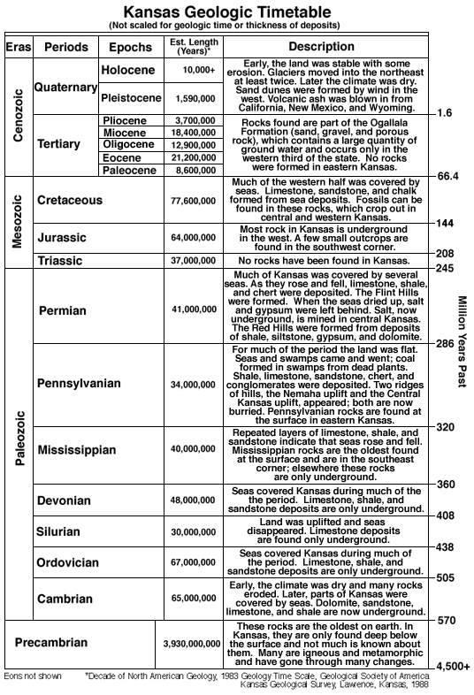
Lecture 5: Plate Tectonics
λ = ln(2)/t_{1/2}
t_{1/2} = half life, measured experimentally and different for every isotope
Calculating age: need 3 things
- Half-life: can be found in published literature
- Number of atoms of parent (decaying isotope) in the sample of the unknown age: measured by mass spectroscopy
- Number of atoms at time=0: must be estimated or we can use atoms at time zero = parent + decay product
Carbon-14 dating:
- C-14 occurs in organic remains rather than in minerals
- It is absorbed by all living organisms from the atmosphere of the food they eat
- The clock is set when an organism dies (t=0)
- The C-14 atoms decay with a half-life of 5730 +/- 40 years
- Carbon is extracted from the buried sample in the ARC buildings or other research facilities
- C-14:C-12 ratio is measured by accelerator mass spectroscopy
- Ages are calculated from the ratio of C-14:C-12 in the sample compared to the initial C-14:C-12 in the atmosphere
Using the Law of Radioactive Decay:
N(t)= N (t=0) e ^{[ln(2)T1/2 * time]}
To solve for time: t = T1/2 / ln(2) * ln(N_{t}/N_{t=0})
We chose isotopes based on the age of the item we are dating as all isotopes have different half-lives. For example, U-238 has a half-life of 4.5 billion years and C-14 has a half-life of 5,730 years.

Plate tectonics:

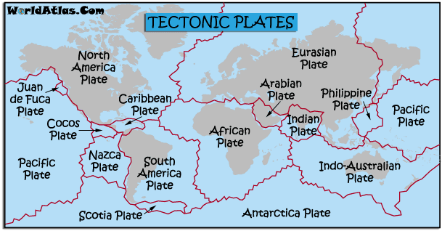
- Early Earth was hot and is cooling through time
- Geologists thought that cooling = shrinking and mountains were the result of contraction
- Other geologic phenomena were random catastrophes like flooding and meteorite impact
Continental Drift:
Alfred Wegner (1915) proposed a theory:
- 200 million years ago, there existed a single super continent: Pangea
- Single large ocean: Panthalassa
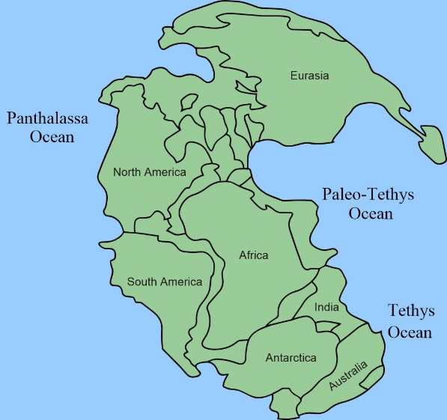
Evidence of Wegner’s Theory:
- Fit of continents
- Puzzle-piece fit of coast lines of Africa and South America has long been known
- Pangea later separated into Laurasia and Gondwanaland
- Laurasia: northern continent containing North America and Asia without India
- Gondwanaland: Southern continent containing South America, Africa, India, Antarctica and Australia
- Fossil Evidence
- Mesozoic fossil Mesosaurus (crocodile) found in South America and South Africa
- Paleozoic fossil Glossopteris (subpolar fern) found in Africa, Australia, India and South America
- All line up in the rock stratas that may have been joined together
- Rock types and structure
- Correlation of strata across the Atlantic
- Appalachian mountains (North America) and Caledonides (British Isles and Scandinavia)
- Ages of rocks that were consistent with certain periods of time on different continents
- Paleoclimatic Evidence
- Synchronous glaciation in south hemisphere and tropical conditions present in North America and Eurasia
- Explained when these continents are put together in one mass
Drift hypothesis was REJECTED: Wegner did not provide mechanisms or driving force to move the continents on the Earth’s surface. Centrifugal force and tidal flow are insufficient to plow continents across the Sea Floor and continents do not simply drift.
Arthur Holmes (1937) proposed a new theory:
- Proposed convection in the mantle as a driving force for continental drift
- 50 years for theory to be ACCEPTED
Evidence for Holmes’s theory:
- Rock magnetism
- Paleomagnetism uses mineral magnetic alignment direction and dip angle to determine the direction and distance to the magnetic pole
- Steeper dip angles indicate rocks formed closer to the northern magnetic pole
- Minerals line up when they are magnetized, the angles are preserved
- Dip angles are flatter are the equator and steeper towards the poles, the angles point in opposite directions at opposite poles
- Polar wandering and paleomagnetism
- Polar wandering curves for North America and Europe have similar paths, but are separated by about 24º of longitude
- Differences between the paths can be reconciled if the continents are placed next to one another
- Age of sediments
- Age of ocean crust changes systematically on both sides of the mid ocean ridge
- Ocean sediments are formed by volcanic activity and spread out from the mid-oceanic ridge and therefore are not formed at a constant rate throughout the ocean floor
- Gradient in age can be seen
- Magnetic reversals
- Marine sediments magnetic anomalies are bands of normal and reversed magnetic field signatures
- Parallel mid-ocean ridges
- Symmetric bar-code anomaly patter reflects plate motion away from ridge coupled with magnetic field reversals
- Looking at lava eruptions can help us identify magnetic field reversals, therefore we can see the stripes in the sea floor spreading as the poles reverse
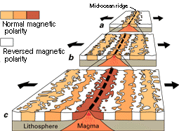
Seafloor Spreading: Harry Hess (1962)
- Hot mantle rock rises away from the mid-ocean ridge
- Seafloor moves away from the mid-oceanic ridge due to mantle convection
- Seafloor rocks and mantle rocks beneath them cool and become more dense with distance from the mid-oceanic ridge
- Convection is circulation driven by rising hot material and/or shrinking cooler material

Sea floor Spreading and Subduction:
- Sea floor rocks are young (less than 200 million years old) so there must be a process created the rick and a process decaying and eliminating it or we would see much older rocks present. Young rock is present in the middle of the ocean at the oceanic ridge
- Ridge elevation have high heat flow
- There is an abundant basaltic volcanism on ocean ridges (Hawaiian islands)
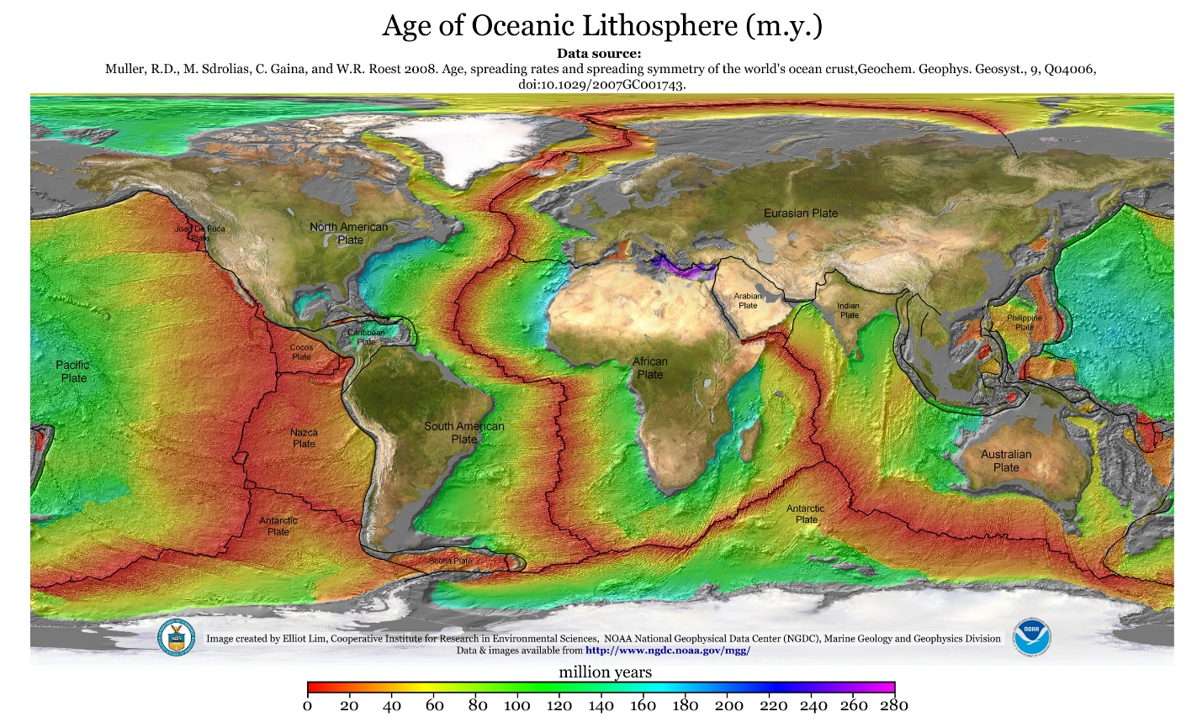
Plate Tectonics Theory:
- Ocean crust tis moved away from spreading centres
- Ocean crust cools and becomes more dense
- These rocks may sink back into the mantle at subduction zones (collision between tectonic plates and continental plates, created a trench)
Implications of sea floor spreading:
- Earthquakes
- Mountains and faults
- Volcanoes, more volcanic activity at mid oceanic ridges and around the edge of the Pacific ocean
- Tsunamis caused by high intensity earthquakes beneath the sea floor
- Mineral composition rock type is influenced by this process too
- Climate changes due to things like mountain belts
- Big ten = things that help geologists explain the Earth’s processes
Lecture 6: Plate tectonics 2
January 28, 2015
Plate tectonic theory continued:
- Oceanic crust is far more dense than continental crust
- Oceanic crust = about 7km thick
- Continental crust = about 30-50 km thick
Two models of convection:
- Whole-mantle convection
- One single system circulating between the lower and upper mantle
- Stratified convection
- 2 systems
- 1 circulation system in lower mantle
- 1 circulation system in the upper mantle
Causes of convection and plate motion:
- New crust is created but the Earth is not getting larger, new ocean crust is therefore getting destroyed as well as being created
- Mantle convection may be the cause or an effect of circulation set up by:
  - Slab pull: pulling of crust into mantle by down-going slab during subduction (like cooler denser water sinking in the ocean)
  - Slab push: pushing of crust resulting from elevated position of oceanic ridge system, causing crust to gravitationally slide down flanks of ridge
- Faulting at subduction zones = earthquakes
- As the oceanic crust is moved under the continental crust, mountains are formed, friction builds, and earthquakes are created when the pressure is released
J.Tuzo Wilson’s Plate Model (1965)
- tectonic plates are composed of the relatively rigid, brittle lithosphere
- Plate “float” upon ductile asthenosphere
- plates interact at their boundaries, which are classified by relative plate motion
- they move apart at divergent boundaries
- they slide past one another at transform boundaries
- they move together at convergent boundaries
- 7 major plates and many minor plates
Divergent Margins (Type 1 Margin)
- Plates move away from each other
- Can occur within the ocean or within continent but always lead to the creation of an ocean basin
- Marked by rifting, volcanism, and uplift
  - Crust is stretched and thinned
  - Normal fault mark rift zones
  - Decompression causes melting
  - Hot rocks are thermally buoyant
- Examples of rift valleys: Gulfs (Gulf of Suez, Gulf of California)
Transform Plate Margins (Type 2 Margin)
- Plates move in different directions
- Plates slide horizontally past one another (shear)
- No igneous or metamorphic activity
- Occurs in 3 areas:
  - Two offset segments of mid-oceanic ridge
  - A mid-oceanic ridge and a trench
  - Two trenches part of the ocean deeper than 7km)
- Not as much heat due to lack of pressure build up, therefore no rock build up
- Explains heavy earthquake activity near California
- Example: San Andreas Transform Margin – pacific plate is going north, north American plate is going south
Convergent Margins (Type 3 Margin)
- Plates move toward each other
- Collisional zones: compression/crustal thickening, mountains. Igneous and metamorphic activity
- Nature of boundary depends on plates involved (oceanic vs continental)
- 3 types of collisions:
  - Ocean to ocean: marked by deep ocean trench and volcanic island arc (subduction zone). Plates move towards each other and cause thickening, mountains etc. Australian + Eurasian plate = Philippines. Denser (older) plate is sub ducted
  - Continent to ocean: marked by ocean trench, volcanic arc, and mountain belt (subduction zone). Causes moderate metamorphism, voluminous igneous activity, moderate crustal shortening and water to be sub ducted as well (geysers). Nazca plate + South American plate = Andes Mountains
  - Continent to continent: Crust is destroyed at these margins. Marked by mountain belts and thrust faults, high grade metamorphism and some igneous activity. Extensive folding and crustal shortening. Indian-Australian plate + Eurasian plate = Himalayas.

- These boundaries change over geologic time
- Note: North America is not at a plate boundary and therefore does not receive many earthquakes, but historically:
  - Late Proterozoic era: Laurasia (North America) begins to move away from Gondwana created an ocean
  - Avalonia created due to tectonic collisions
  - Eventually created the Maritimes and Nova-Scotia
  - As Gondwana is pushed below Laurentia, the Appalachian mountains were formed
  - Mountains were created as Pangea was formed
  - As the Pangea breaks up, the Atlantic was formed
  - This area (east coast of North America) has now been relatively inactive for millions of year
Tectonic Cycle:
- A continent rifts when it breaks up
- As spreading continues, an ocean opens, passive margin cools and sediments accumulates
- Convergence begins, an oceanic plate sub ducts, volcanic chain forms at an active margin
- Terrain accretion-form the sedimentary wedge welds material to continent
- As two continents collide, orogeny thickens the crust and builds mountains
- The continent erodes, thinning the crust
Lecture 7
Feb 2, 2015
Layers of the Earth:
Crust: oceanic and continental. Solid, strong, rigid, 30-70 km thick.
Mantle: solid, weak, ductile, 2900 km thick.
Core: outer (liquid) and inner (solid), 3470 km thick.
Physical cores:
- Lithosphere = crust and upper mantle (~100 km)
- Asthenosphere = below the lithosphere (~140 km)
- Core = below the asthenosphere
How do we look inside the earth?
- Earthquakes
  - Vibration of earth produced by the rapid release of energy stored in rock subjected to stress
  - Plates rubbing past each other = energy released radiates in all directions from its source in the form of waves
  - 2 types of waves = Primary (propagating out and expanding in its direction and capable of reflecting back to its source) and Secondary (produced on the surface of an object and capable of reflecting back to its source)
    - Velocity is proportional to density and elasticity
    - Velocity increases with depth
    - P-waves propagate through solids and liquids and S-waves will only propagate through solids
    - P-waves travel faster than S-waves
    - Waves are refracted as the cross boundaries (bends)
    - Waves can also reflect off of boundaries
    - Law of reflection: the angle at which the wave is incident on the surface equals the angle at which it is reflected
  - Create an x-ray image of Earth
- Volcanoes
- Meteorites: craters give us an idea of what the Earth looked like before evolution
- Drilling (not successful)
Discovering Earth’s Major Boundaries:
- Crust-mantle boundary: aka (Mohorovicic Discontinuity MOHO)
  - Discovered by A. Mohorovicic (1909)
  - Based on the observation that the seismic velocities are slower in the crust (6 km/s) than the mantly (8km/s)
- Core mantle boundary:
  - Discovered by B. Gutenberg (1914)
  - Based on the observation that P waves die out at 105 degrees from the earthquake and reappear at about 140 degrees (P wave shadow zone)
- Core:
- I. Lehmann (1936) proved seismic waves travel in and out of the core
- Characterized by refracting the P waves
- The fact that S waves do not travel through the core provides evidence for the existence of a liquid layer beneath the rocky mantle (S wave shadow zone)
Seismic waves and Earth’s Structure:
- Abrupt changes in seismic wave velocities that occur at particular depths helped seismologists conclude that Earth must be composed of distinct shells
- Earth’s interior is not homogenous
- Density sorting during an early period of partial melting
- Layers are defined by composition/chemistry and mechanics/physics
Temperature and Pressure Effects:
- Competing pressure and temperature forces complicate things
- Increase depth = increase temperature = melting
- Increase depth = increase pressure = increase rock strength
Layers defined by physical properties:
- Depending on the temperature and depth, a particular Earth material may behave like a brittle solid, deform plastically, or melt and become liquid
- Main layers of Earth’s interior are based on physical properties and hence mechanical strength
Lithosphere: cool and strong
Athenosphere: partially melted, ductile.
Mesosphere: strong and hot.
Core: outer is liquid and metallic. Inner is solid.
Earth’s internal Heat Engine:
- Earth’s temperature gradually increases with an increase in depth at a rate known as the geothermal gradient
- Varies considerably from place to place
- Averages between 10 and 20 degrees Celsius/km
- The rate of increase is much less in the mantle and core
- Contributions to Earth’s internal heat:
- Heat emitted by radioactive decay of isotopes of U, Th, K
- Heat released as Fe crystallizes to form the solid inner core (releases heat)
- Latent heat released by colliding particles during the formation of Earth
Dissipating Earth’s internal Heat:
- Heat flow in the crust (conduction), rates vary
- Mantle convection: no large change in temperature with depth in the mantle, must have an effective method of transmitting heat from the core outward
Earth’s magnetic field:
- Must be composed of material that conducts electricity and is mobile
- Structure of core:
  - Liquid outer shell convecting around solid inner shell
  - Inner core rotates faster than the Earth’s surface
  - The axis of rotation is offset about 10 degrees from the Earth’s poles
- Magnetic field has a North and South pole
- Magnetic field allows use of a compass
- Occasionally flips
Lecture 8
Feb 4, 2015
The rock cycle:
Igneous rock + weathering and erosion = sediment + lithification = sedimentary rock + metamorphism + metamorphic rock + rock in mantle + partial melting = magma + solidification = Igneous rock
This is the main view. Note also that sedimentary rock and metamorphic rock can be transformed into sediment and igneous rock can be transformed directly into metamorphic rocks.
Rocks and minerals are important to study as they give information about:
- Precious rocks present
- Foundation for infrastructure
- Earthquakes
- What types are formed there and previous climate changes
Tectonic plates are part of the lithosphere which is made of rocks, which are made of minerals, enriched in some elements.
The continental crust is enriched in silica, aluminum, potassium, sodium, and calcium. These rocks are termed Silicic or Felsic (sialic)
The antheoshpere and ocean crust are rock enriched in other elements such as magnesium and iron. These rocks are termed (ultra) Mafic or Basic.
Minerals:
- Building blocks of rocks
- Naturally occurring
- Solid
- Definite chemical composition of elements expressed by a chemical formula and has a characteristic crustal structure (ex = quartz)
- Atoms bond to form minerals in regular geometric shapes called crystals
- They are chemical compounds – combination of 1 or more elements in specific proportions and are classified based on composition (ex = ice is a mineral)
Combination of elements to form minerals depends mainly on 3 characteristics of atoms of that element. To form a mineral:
- Abundance of available elements within crust
- Big 8 = oxygen (45%), Silicon (27%), aluminum (8%), iron (5%), calcium, magnesium, sodium, potassium
- Temperature and pressure at time of formation controls structural growth of crystal, different temperatures and pressures create polymorphs
- Size and charge of atoms and ions
Silicates: Big 7 = quartz, mica, potassium feldspar, plagioclase feldspar, pyroxene, olivine are most abundant.
Other minerals = nonsilicates. Major groups:
- Oxides
- Sulfides
- Sulfates
- Native elements
- Carbonates
Biominerals: biological materials can form minerals
- Tooth enamel
- Bones of vertebrates
- Stones in urinary tract
- Shells of molluscs and other invertebrates
Processes to create rocks and minerals:
- Solidification of magma
- Magma is molten rock and contains crystals and gases within the Earth
- Melt is generally only the liquid portion of the process
- Lava is molten rock and contains crystals and gases at the surface of the Earth
- Cooling magma slowly creates larger crystals than cooling it quickly
- Creates igneous rocks
- Formation of magma
- High temperature = radioactive decay within earth,early earth was produced during the big bang
- High temperature = Frictional heat of tectonic plates and convergent margins = crustal thickening
- Formed within volcanic arcs
- Hi pressure results in higher temperatures to melt solid (bonds are closer together therefore stronger)
- If pressure is release quickly, the solid will melt
- Crustal decompression occurs at divergent margins
Nature of magma consists of 3 components:
- Liquids composed of mobile ions
- Solids – generally silicates
- Gases – volatile and generally water vapour, carbon dioxide, and sulfur dioxide
- Formation of igneous rock
- Before minerals form, liquid magma has random atoms suspended in non-crystalline structure
- During magma cooling, atomic vibrations slow and bonds begin to form compounds and eventually a crystalline structure
- After cooling, igneous rock forms from rock which has cooled and crystallized directly from molten material at or near the surface
- 2 categories: at surface (extrusive and volcanic rock) and subsurface (intrusive and plutonic rock)
- Formation of volcanic rock
- Erupt and flow, or explode at the earth’s surface
- Cooling times range from seconds to years
- May have no crystals (glass) or small and large crystals (phenocrysts)
- Basalt is the archetype composed of very fine grained minerals (pyroxene and plagioclase feldspar) form mostly on the ocean floor
- Formation of plutonic rock
- Intrude at depths of 0.1-10 km within the crust
- Mm-cm scale crystals are generally evident
- Can form huge masses (plutons and batholiths) that likely cool over a million years
- Granite is the archetype – composed of potassium and sodium feldspar and quartz, commonly found on the continents
- Local plutons throughout the Canadian shield just north and west of Ottawa
Bowen’s series crystallization:
- An explanation for the diversity of igneous rock types that appear to have evolved from a single magma source
- As they slowly cool in deep reservoirs (magma chambers) different minerals achieve saturation at different temperatures
- Crystallization of the minerals changes the chemical composition of the magma
- Occurs in 2 ways:
- Discontinuous – Fe and Mg minerals crystallize one after another in specific sequence, composition and structure change from simple to complex
- Ca-plagioclase preferentially crystallizes early (hi temperature), gradually as magma cools, Na ions continuously replace Ca in crystal which causes little structural change
Bowen’s reaction series assumes:
- Closed system
- Early minerals would remain in contact with magma, reacting to form new minerals
- Demonstrates that a full range of igneous rocks could be produced from the same mafic (basaltic) magma
But in reality:
- Crystals settle to bottom of magma chamber or get stuck on chamber walls = fraction crystallization and magmatic differentiation
- Assimilation of wall rock material
- Magma mixing: involves 2 bodies of magma intruding one another and 2 chemically distinct magmas may produce a composition quite different from either original magma
Mafic:
- Igneous rocks in which silicates dominate
- Dark (ferromagnesian) silicates
- Olivine, pyroxene, amphibole, biotite mica
- 45-55% quartz
Felsic:
- Light (nonferromagnesian) silicates
- Quartz, muscovite mica, feldspars
- 65% + quartz
Intermediate (andesitic) composition:
- Contains 55-65% quartz
- Associated with explosive volcanic activity
Ultramafic (komatiite) composition:
- Less than 45% quartz
- Not found on surface of earth today
- Rare composition that is composed of olivine and pyroxene
Rock Textures:
Texture is used to describe the overall appearance of a rock based on the size, shape, and arrangements of interlocking minerals
Factors affecting crystal size:
- Rate of cooling: slow = large, fast = small, very fast = glass
- Amount of silica present
- Amount of dissolved gases
Phaneritic:
- Coarse grained
- Crystals can be seen without a microscope
Aphantitic:
- Fine grained
- Microscopic crystals
- May contain vesicles – holes from gas bubbles
Porophyritic:
- Large (phenocrysts) and small (groundmass) crystals
Glassy:
- No crystals visible
- Silica = obsidian and foamy = pumice
Pyroclastic:
- Fragments ejected during a violent volcanic eruption
- Often appears to be layered or composed of shattered rocks
Pegmatitic:
- Exceptionally coarse grained
- Form in late stages of crystallization of granitic magmas with high volatile content

