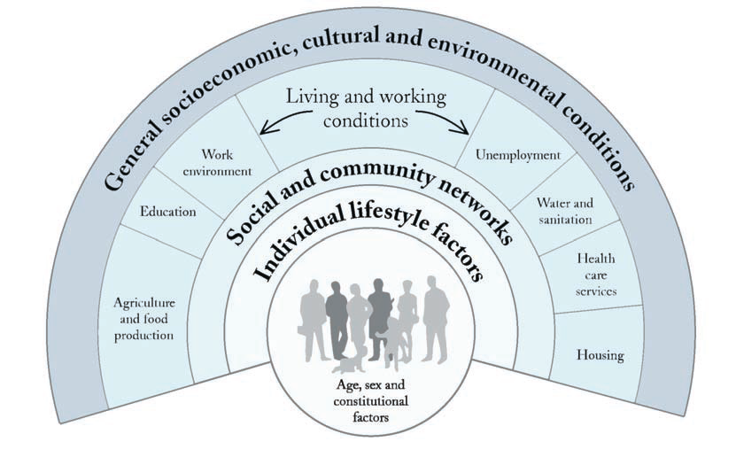
Income and Income Distribution
-Clear link between income and socio-economic status and health outcomes.
-More equal income distribution is one of the best predictors of better overall health of society.
-Wealthier people tend to live longer than those who are poor.
-Near double the suicide rates in the lower income level.
-Things that can reduce the issue are: Increasing the minimum wage, progressive taxation to improve wealth, or a greater degree of unionized workplaces to reduce wealth inequalities.

Education
-Leads to better health.
-Allows citizens to participate in the political process.
-Increases overall literacy.
-About 50% of the population has post-secondary education; children whose parents do not, perform worse than those who do.
-Ways to reduce the issue: Funding the Canadian education system, Controlling the post-secondary tuition fees.

Unemployment and Job Security
-Employment provides income, identity, and helps structure a life.
-Unemployment leads to stress, health threatening coping behaviours, and material/social deprivation.
-Only half working aged Canadians have had a full time job for 6+ months.
-Women are over-represented in precarious forms of work.
-Canada ranked 26/28 in employment protection and benefits.
-Ways to resolve the issue: Set basic standards of employment and work for everyone; reduce the power inequalities between employers/employees; supply unemployed people with income, training, and employment opportunities.

Employment and Working Conditions
-Work dimensions that influence health: Employment security, work conditions, pace, hours, ability to self-express.
-Many workers feel stressed, feel like their employment puts their health/safety at risk, and work too much.
-Ways to fix the issue: Balance hours and rewards, improve high-strain low-income jobs, unionize to balance power, allow employees to influence their environment.
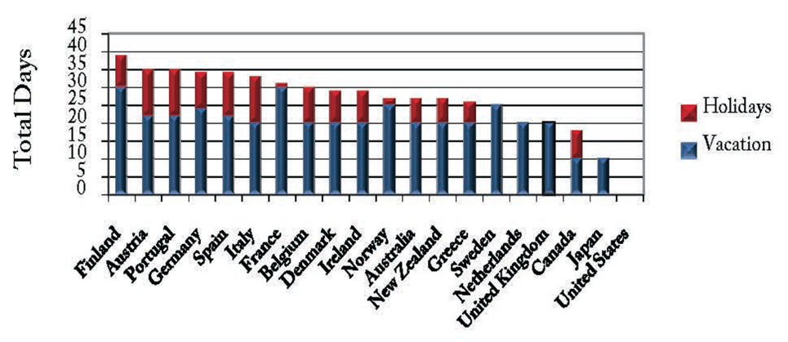
Early Childhood Development
-Early events have strong/immediate effects on all round health (Biological, Psychological, Social).
-Biological: Low birthweight babies are more susceptible to health problems.
-Psychological: “Pathway effects”
-Social: Cumulative effects.
-Canada spends close to the lowest on early childhood education. 15% live in poverty.
-Ways to fix the issue: Quality and affordable childcare must be guaranteed, families should get support and benefits, children should get higher wages and social assistance.

Food Insecurity
-Being unable to have an adequate diet in terms of quality/quantity.
-A barrier to proper nutritional intake.
-People with food insecurity eat less fruits, vegetables, dairy products, and vitamins.
-9% of Canadians.
-Due to another mouth to feed, loss of employment, change in work hours.
-Most have a diet related problem (Diabetes, HBP, allergies).
-Ways to solve issue: Increase minimum wage/social assistance, assure healthy foods are affordable, make housing and childcare affordable, help employ mothers.

Housing
-Poor housing/homeless is a threat.
-Canada has agreed to provide shelter, but has yet to do that.
-Overcrowding allow the transmission of illness.
-Canada is experiencing a housing crisis, rent has increased well past the cost of living.
-Some tenants spend upwards of 50% of total income on housing.
-Ways to resolve it: Make affordable housing available, support mixed housing, link housing policy to all other ones.

Social Exclusion
-Specific groups being denied the chance to participate in Canadian life.
-Non-healthy, coloured, or disabled people are more likely to be excluded.
-Denied participation in civil affairs, social goods, involvement in social production, chance in the economy.
-Ways to resolve this: Revise laws and regulations allowing new Canadians to practice their profession, Enforce laws that protect the rights of minority groups, direct attention to health needs of immigrants.

Social Safety Net
-range of benefits/support that protects citizens from life changes that can affect their health. (allowances, unemployment insurance, retirement pensions, etc.)
-Canada’s protection and supports are nearly the worst.
-Ways to solve it: Strengthen the social safety net, reevaluate the need of government intervention to maintain health, have strong political/social movements.

Health Services
-The Canada Health Act (1984) made requirements that must be met by public health care insurance: Public administration, Comprehensiveness, Universality, Portability, Accessibility.
-The “single payer” concept: health care administration by a public authority.
-Top 1/3 of Canadians still have much better access to health services.
-Medicare only covers 70% of healthcare costs.
-Ways to solve it: Strengthen the Medicare system, provide dental coverage, implement pharmacare (nursing home cost coverage), controlling the use of ineffective treatment.

Aboriginal Status
-2007 UN Declaration of the Rights of Indigenous Peoples was implemented to improve health and living conditions; Canada was against it.
-Clear that Aboriginals still have much worse living conditions.
-Recommendations to make it better: Recognize and Implement an Aboriginal government, make living situations better, make an aboriginal university.

Gender
-Woman have to deal with children/housework, discrimination in the workplace, and fulltime jobs. This has a negative impact on women.
-Men dominated jobs pay more, especially in Canada.
-Solve it: Enforce pay equality, affordable high quality child care, employment insurance for part time.

Race
-Most immigrants are minority groups in Canada that are racialized.
-Increases in low-income status affected all immigrants.
-Recent immigrants of colour are experiencing more mental health problems and insecurities.
-To stop it: We must recognize the racism, make people aware, allow foreign trained people to practice in Canada, strongly enforce anti-discrimination, government must improve their living conditions.

Disability
-Canada’s levels of benefits/support to those with disabilities are very low.
-Disabled people are less likely to be employed, many rely on social assistance benefits.
-Over 10% of the population has a disability.
-Canada spends next to the least on disabled people.
-What do we do: Assist disabled with support costs, enhance transportation, study poverty/disability.

