Creating value for customers and building customer relationships is a key concern to marketing managers. Present the 5-step model of the marketing process that marketing managers use. In your response, ensure that you give rationale for each step in the marketing process.
Page 6, Figure 1.1 (p.33 for expanded model 1.5 figure)

The 5 steps to the marketing process which marketing managers use are:
- Understanding the marketplace and customer needs and wants.
  - You need to research your consumers and the marketplace
  - Manage marketing information and costumer data.

- Design a customer-driven marketing strategy.
  - Select customers to serve; target a specific market: marketing segmentation and targeting
  - Decide on a value proposition; which are the benefits and values your product delivers: differentiation and positioning

- Construct a marketing program that delivers superior value.
  - Transforming your strategy into action by implementing the 4 P’s; Product (building strong brands), Price (creating value), Promotion (communicating the value proposition), and Place (managing the supply chains, demand and distribution)

- Build profitable relationships and create customer delight.
  - Customer Relationship Management: must build strong relationships with chosen customers
  - Partner Relationship Management: building strong relationships with marketing partners.

- Capture value from customers to create profits and customer equity.
  - Create satisfied, loyal customers
  - Capture customer lifetime value
  - Increase share of market and share of customer.

There are several general concepts under which organizations design and carry out their marketing strategies. Please explain and contrast the selling concept and the marketing concept.
Page 11, Figure 1.3 Selling & Marketing Concepts Contrasted

- The selling concept focuses on the company’s existing products and undertakes a large-scale selling and promotion to obtain profitable sales. They focus more on sale transactions rather than on building long-term profitable customer relationships

- The marketing concept starts with a well-define market; focuses on customer needs and integrates all marketing activities that affect customers. They generate profit by creating lasting relationships with the right customers based on customer value and satisfaction.

Strategic planning sets the stage for the rest of planning in the firm. Please present the steps in the strategic planning and present your ideas with examples to illustrate your understanding of this activity. 1 example.
Page 43, Figure 2.1 Steps in Strategic Planning. Read p. 42-48.

A company starts the strategic planning process by defining the overall purpose and mission. This clearly states their desired accomplishments. The mission is then translated into detailed supporting goals and objectives that guide the entire company. Next, the company decides what portfolio businesses and products are best for them and how much support to give each one. Each business and product develops detailed marketing and other departmental plans that support the company wide plan. Marketing planning occurs to support company strategic planning with more detailed plans for specific marketing opportunities. For example, strategic planning is broken down into mission, goal, objectives and strategies; a university student’s mission is to be successful in his future, his goal is to graduate with a degree in order to reach success, his objectives are to achieve good grades and finally his strategy to achieve these grades would be to study and complete all assignments.

Business portfolio analysis is a major activity in strategic planning. The best-known portfolio planning method was developed by Boston Consulting Group. Please explain the growth share matrix developed by BCG. Please give examples in your answer. Are there any problems associated with BCG matrix? If so, please explain.
Page 48, Figure 2.2 BCG Growth Share Matrix

This is a portfolio planning method that evaluates a company’s SBUs (strategic business units) in terms of its market growth rate (need for cash), which provides a measure of market attractiveness and a relative market share (ability to generate cash) that measures of company strength in the market.

- High growth rate = high need for cash
- Low growth rate = low need for cash
- High market share = generating lots of cash
- Low market share = not generating lots of cash

Stars are high in the market growth rate and have a high share of businesses and products. Meaning they need to be generating lots of cash to cover their rapidly growing investments. Over time, their growth will slow down and they will turn into cash cows.

Cash cows are low in growth rate but have a high market share. This means they are well-established companies who need little investment to finance because they are successful and produce a lot of cash.

Question marks have low market shares but have a high growth rate. It’s difficult for managers to decide whether they put time and effort into building them into stars or phase them out. Not generating much cash and need money.

Dogs are low growth share, which means they have a low need for cash, and a low market share meaning they aren’t generating much cash. This will not be a large source of cash but it may have enough to stay in business.

- Problems:
  - Difficult to define SBU’s and measure market share and growth rate
  - Time consuming
  - Costly to implement

One useful device for identifying growth opportunities is the product market expansion grid. Please explain hat it represents and provide example to illustrate your understanding of this grid.
Page 50, Figure 2.3 Product Market Expansion Grid. Read p. 49-50.

A portfolio-planning tool for identifying company growth opportunities through market penetration, market development, product development and diversification.

- Market penetration: this focuses on company growth by increasing sales of current products to current market. They do so through improvements in advertising, prices, service, menu selection and store design. For example, Starbucks has added 300 new stores each year and remodelled many of their current stores to better meet the customer demands

- Market development: this identifies and develops new market segments for current company products either demographically or geographically. For example, Starbucks is aiming to promote more products to senior or their aim to expand over to new regions such as Japan and China.

- Product development: This offers modified or new products to current markets. For example, Starbucks has introduced a new light roast coffee blend to meet a particular market segment that prefers light-medium coffee blends. They also created a new beverage with fruit juice and green coffee extract to fulfill the needs of the energy drinking market.

- Diversification: this is the starting up or buying process of businesses beyond its current products and markets. Starbucks has expanded their merchandise by selling categories ranging from coffee and tea brewing equipment to music and books.

The marketing mix is the set of tactical marketing tools that companies integrate to respond to the requirements of a specific target market. Please explain the components of the marketing mix in enough details to illustrate your understanding of this tactical tool. Use examples by mentioning components of each.
Page 58, Figure 2.4, 4 P’s of the Marketing Mix. Read p. 58.

These tools help the firm produce and achieve the response it wants in the target market.
- Product goods and services combination the company offers to the target market; variety, design, quality, features, packaging, brand name and services.

- Price the amount of money customers must pay to obtain the product; list price, discounts, trade-in allowances, credit terms and payment period.

- Place includes company activities that make the product available to target consumers; channels, coverage, locations, inventory and transportation

- Promotion activities that communicate the merits/qualities of the product and persuade target customers to buy it; advertising, personal selling, sales promotion and PR.

Please explain the rationale for a company to use a swot analysis. What are the inherent features of a SWOT analysis? Please use examples in your answer.
Page 59, Figure 2.7 Swot Analysis

Managing the marketing functions begins with a complete analysis of the company’s current situation. Marketers conduct a SWOT analysis to evaluate the company’s overall strengths, weaknesses, opportunities and threats. The goal is to match the company’s strengths to attractive opportunities in the environment, while eliminating or overcoming weaknesses and minimizing threats.

- Strengths include internal capabilities, resources and positive situational factors that may help the company reach its objective (serve customers, achieve objectives). For example, in an Apple store, the sales associates are highly trained and educated about the merchandise and therefore generate a large scale of sales and profit.

- Weaknesses include internal limitations and negative situational factors that may interfere with a company’s ability to achieve its objectives. For example, a company may be lacking the resources and money to properly advertise and promote the product to targeted markets.

- Opportunities are favorable factors or trends in the external environment that the company may be able to exploit to its advantage. For example, new locations available for potential expansion of company.

- Threats are current and emerging external factors that may challenge the company’s performance. For example, competitive companies upselling similar products to the same targeted market.

You are the marketing manager of a company intending to manufacture, distribute and make available for sale a line of ___________ (product) in _____________ (location). What macro-environmental concerns must you consider before undertaking your enterprise?
Page 76, Figure 3.2 Microenvironment

- Demographics study of human population in terms of; size, density, location, age, gender, race, occupation. 3 of Canada’s largest generation populations are Baby Boomers (post world war 2 1947-1966, 9.8 million babies), Generation X (1967-1976, 7 million babies) and Generation Y/technology (1977-2000, 10.4 million babies).

- Economic factors that affect consumer purchasing power and spending patterns. Trends, income distribution (rich remain rich, poor become poorer and middle class stagnates), changes in consumer spending (financial cautiousness after recession)

- Natural environment natural resources that are needed as inputs by marketers or that are affected by marketing activities; air and water pollution (growing shortage of raw material), global warming (renewable resources, eco friendly, biodegradable), environmental sustainability. What is available to manufacture product.

- Technological force that create new technologies. Creating new product and material opportunities. Wonders; antibiotics, Internet, smartphones, Horrors; nuclear missiles, chemical weapons. The manufacturers capabilities.

- Political laws, regulations, government agencies, pressure groups that influence or limit various organizations and individuals in a given society: competition act, pricing, advertising, labelling, motor vehicle act, food and drug acts, policies, currency restrictions and quotas.

- Cultural institutions and other forces affect a society’s basic values, perceptions, preferences and behaviours. People’s views of themselves, others, society, universe (religion)

Factors Influencing Consumer Behavior – page 185 F.6.2

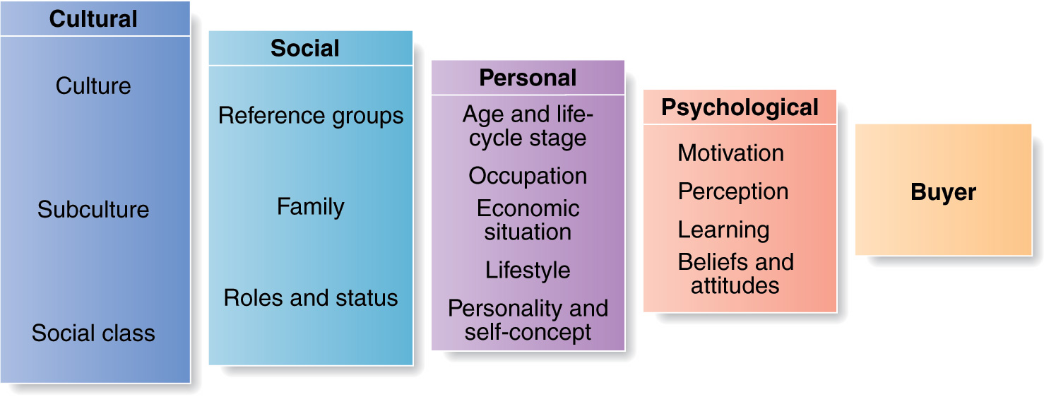
Cultural

- Culture
  - Definition: The set of basic values (achievement, equality, freedom, respect), perceptions, wants, and behaviors learned by a member of society from family and other institutions
  - Marketers need to understand the role played by the buyer’s culture, subculture and social class
  - International marketers must understand the culture in each international market and adapt their marketing strategies accordingly
  - Cultural shift
    - e.g. cultural shift toward greater concern about health and fitness

- Subculture
  - Definition: Each culture contains smaller subcultures or groups of people with shared value systems based on common life experiences and situations
  - Based on differences in nationalities, religions, racial groups, and geographic regions
  - 4 important subcultures:

    - Regional subcultures (Canada)
    - Founding nations (Canada has 3: aboriginals, English and French)
    - Ethnic subcultures (1 in 5 Canadians could be a member of minority 2017)
    - Mature consumers (different age cohorts)

- Social class
  - Definition: Relatively permanent and ordered divisions in a society whose members share similar values, interests, and behavior
  - Can be determined by a combination of occupation, income, education, and wealth. *Must satisfy all these conditions (for example, a “gangster” is not high class (wealth) because we have to consider occupation, education)

Social:
A consumer’s behavior is also influenced by social factors: smaller groups, family, social roles and status.
- Reference Groups
  - Membership group: Groups that have a direct influence and to which a person belongs
    - Primary membership group: Members interact continuously and informally: Family, Neighbors, Friends
    - Secondary membership group: More formal and less continuous interaction: Religious or professional groups
  - Reference group: Groups that serve as direct or indirect points of comparison in forming a person’s attitude or behavior.
  - Aspirational group: Groups to which the individual wishes to belong: CEOs, doctors or athletes (young hockey player hopes to someday be like Sidney Crosby and play in the NHL)
  - Marketers try to identify the reference group of their markets: word of mouth, opinion of leaders, knowledge, personality, and online social networks.
  - The importance of group influence varies across products and brands depending on the visibility to others

- Family
  - This is the most important consumer buying organization in society, marketers are interested in the roles and influences of the husband and wife and children on the purchase of different products and services: mother-> food, household products, clothing… Children-> food, clothing
  - Children’s influence on family buying decisions

- Social roles and status
  - This is the person’s position in a group.
  - Role consists of the activities people are expected to perform according to the people around them.
  - Each role carries a status reflecting the general appreciation given to it by society (working mother – she’s the brand manager… at home – she’s a mother and wife… and sporting events – she’s a fan --- she will purchase products based on each role and status)

Personal
Influences by personal characteristics: age, life cycle stage, occupation, economic situations, personality and lifestyle.

- Age & Life-Cycle Stage
  - Buyers change their preferences in good and services many times as they age.
  - Tastes in food, clothing are often age related or through different life stages like marriage or having children, divorce.

- Occupation
  - This affects the goods and services bought. Marketers try to identify the occupational group that have an above-average interest in their products and services
- Economic situation
  - Marketers watch trends in personal income, savings, and interest rates. Following the recession, most companies have taken steps to redesign, reposition and reprice products.
  - The type of work performed may necessitate different consumption patterns, such as blue collar versus white collar
  - Will also indirectly affect how much income is available

- Lifestyle
  - A person’s pattern of living as expressed by their activities (work, hobbies), interests (food, fashion), and opinions (themselves, social issues)
  - Number of different lifestyle or psychographic classification systems

- Personality and self-concept (or self-image)
  - A person’s unique psychological characteristics that distinguish a person or group. Personality traits can include: self-confidence, dominance, sociability, autonomy.
  - A brand personality is the specific mix of human traits that may be attributed to a particular brand.
  - That lead to relatively consistent and lasting responses to his/her own environment
  - A reflection of self-image, people’s possessions that contribute and reflect their identities.

Psychological
- Motivation:
  - This is a need that is sufficiently pressing to direct the person to seek satisfaction of need.
  - Motivation researches use a variety of probing techniques to uncover underlying emotions and attitudes toward brands and buying situations. (Sigmund Freud and Maslow Theories)

- Perception:
  - Motivated person is ready to act, but how they act is influenced by their perception.
  - All of us learn by the flow of the info through our 5 senses: sight, hearing, smell, touch, taste.
  - The process by which people select, organize, and interpret info to form a meangingful picture of the world.
  - People form difrerent perceptions of the same stimulus because of the 3 dfferent perceptual processes:
    - Selective Attention: The process of selecting inputs to be exposed to our awareness while ignoring others. Some customers don’t want to look or be exposed at some ads. Marketing managers must know their customers’ selective exposure tendencies.
    - Selective Distortion: An individual’s changing or twisting of information when it is inconsistent with personal feelings or beliefs
    - Selective Retention: Remembering information inputs that support personal feelings and beliefs and forgetting inputs that do not

- Learning:
  - When people act they learn, this describes changes in and individuals behaviour based on their experiences
  - Learning occur through the interplay of drives, stimuli, cues, responses and reinforcement. (Think Nikon example; a man has a need for a camera drive, and this becomes a motive through the particular object stimuli, cues help him determine where he buys it, when. If his experience with the Nikon camera was rewarding, his response was positive and he feels reinforced to possibly buy other Nikon product and refer it to a friend.

- Beliefs
  - Descriptive thoughts that a person holds about something (e.g., company, product, institution, person). Based on real knowledge, opinion or faith.
  - Example: “Coke is a traditional/conservative company”

- Attitudes
  - A person’s relatively consistent favorable or unfavorable evaluations, feelings, and tendencies towards something.
  - Attitudes put people into a frame of mind of liking or disliking things.
  - Example: “I am a conservative person, so I like Coke”

Four Types of Buying Behavior – page 201 F6.4

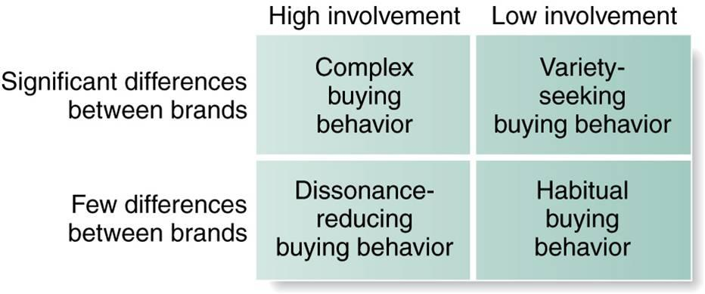

High involvement: the term means when the consumer is highly involved while buying a product. Generally this situation happens in case of expensive or luxuries goods. Like while buying a diamond necklace a consumer is highly involved.
Low involvement: this term means when the consumer is not highly involved while buying a product. It happens in case of low price goods. Like while buying toothpaste a consumer is not highly involved.
Significant differences between brands: it means when there are significant differences between brands.
Few differences between brands: it means when there are very little differences between brands.
- Complex buying power: when the consumer is highly involved in a purchase and perceives significant differences among brands. This may happen when the product is expensive, risky, purchased infrequently. Marketers need to help buyers learn about products class attributes and their relative importance by understanding the information gathering and evaluation behavior of high involvement consumers. They must differentiate their brand’s benefits; motivate sales people to influence the final brand choice.
  - For eg. Consumer while buying a motorcycle is highly involved in the purchase and has the knowledge about significant differences between brands.

- Variety seeking behavior: in this case consumer involvement is low while buying the product but they perceive significant differences between brands. Consumers often do brand switching out of boredom or to simply try something different, not because of dissatisfaction. Market leaders will encourage habitual buying power by dominating shelf-space, keep them fully stocked, and advertisements.

- Dissonance buying behavior: occurs when consumer is highly involved with an expensive, risky or infrequently purchase but see little differences between brands. Marketers after-sale communications should provide evidence and support to help consumers feel good about their brand choice. Consumers respond to good price and purchase for convenience. Like consumer while buying a floor tiles buy them quickly as there are few differences between brands.

- Habitual buying behavior: in this case there is low consumer involvement and few differences between brands. The consumer buys the product quickly.
  - For eg. Toothpaste, salt; a consumer may buy the same brand of salt out of habit rather than having strong brand loyalty. Marketers often use price and sales promotion to promote buying. They can add product features or enhancements to differentiate their brands.

Buyer Decision Process – page 203 F. 6.5
How consumers make decisions
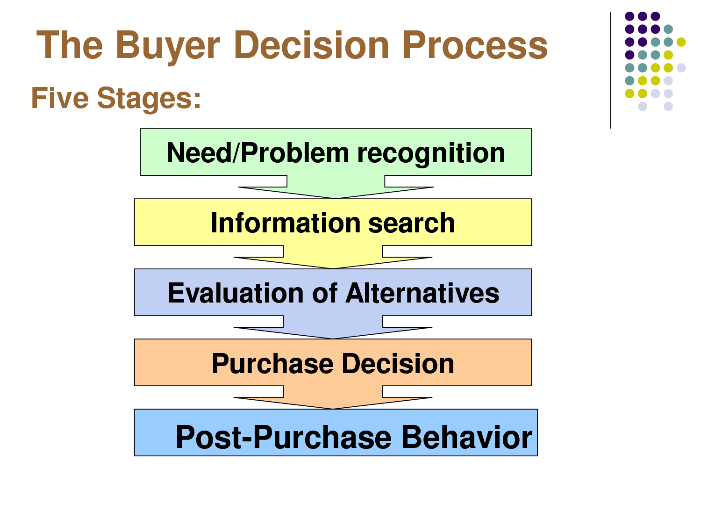
- Need recognition / Problem recognition:
  - The need recognition is the first and most important step in the buying process. If there is no need, there is no purchase. This recognition happens when there is a lag between the consumer’s actual situation and the ideal and desired one.
  - Internal stimuli (hunger, thirst), external stimuli (talk to a friend and suddenly want a new car)

- Information search
  - Once the need is identified, it’s time for the consumer to seek information about possible solutions to the problem. He will search more or less information depending on the complexity of the choices to be made but also his level of involvement. (Buying pasta requires little information and involves fewer consumers than buying a car.)
  - Then the consumer will seek to make his opinion to guide his choice and his decision-making process with: internal and external information.
  - Sources: Personal (friends, family), Commercial (ads, sales people), Public (Mass media), Experiential.

- Alternative evaluation
  - Once the information collected, the consumer will be able to evaluate the different alternatives that offer to him, evaluate the most suitable to his needs and choose the one he think it’s best for him.
  - In order to do so, he will evaluate their attributes on two aspects. The objective characteristics: such as the features and functionality of the product but also subjective (perception and perceived value of the brand by the consumer or its reputation).

- Purchase decision
  - Now that the consumer has evaluated the different solutions and products available for respond to his need, he will be able to choose the product or brand that seems most appropriate to his needs. Then proceed to the actual purchase itself.
  - His decision will depend on the information and the selection made in the previous step based on the perceived value, product’s features and capabilities that are important to him.
  - 2 factors that may influence:
    - Attitudes of others
    - Unexpected situational factors: purchase intention may alter because of crash in economy or competitors price drop

- Post-purchase behavior
  - Once the product is purchased and used, the consumer will evaluate the adequacy with his original needs (those who caused the buying behavior). And whether he has made the right choice in buying this product or not. He will feel either a sense of satisfaction for the product (and the choice) or a disappointment if the product has fallen far short of expectations.
  - Expectation and performance
  - Promise only what your product can deliver.
  - Customer satisfaction Repeat business
  - Ask for feedback; improve buying experience for consumer, change consumer perception for the better.

Major Segmentation Variables for Consumer Markets – page 245 F8.1

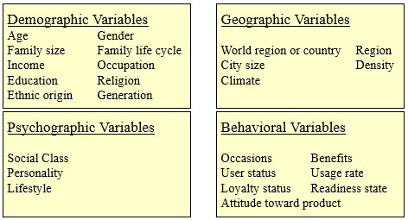

Market Targeting Strategies – page 258 F8.2

Customers can be classified into 4 categories (Segmentation bases or variables)

Demographic, Geographic, Psychographic and Behavioral

Geographic:
- Dividing a market into different geographical unites, such as; nations, regions, provinces, counties, cities or neighborhoods.
  - Region or country:
    - North America
    - Canada
    - Western Europe
    - Middle eats
    - Pacific rim
    - China
    - India
    - Brazil
  - Country region
    - Quebec
    - Ontario
    - Bc
    - Northern territories
  - City size:
    - # of people; under 5000… 5001 - 20 000… 1 000 001 - 4 000 000 ect.
  - Density:
    - Urban
    - Suburban
    - Rural
  - Climate:
    - Northern
    - Southern
    - Prairie
    - Maritime
    - Mountain
    - West coast
Demographic:
- Dividing the market into segments based on variables such as:
  - Age
    - Under 6
    - 6-11
    - 12-19
    - 20-34
    - 35-49
  - Gender
    - Male
    - Female
  - Family size
    - 1-2
    - 3-4
    - 5+
  - Family life cycle
    - Young, single
    - Young, married, no children
    - Young, married, with children
    - Married with children
    - Older, married, no children under 18
    - Older, single
  - Income
    - Under $20 000
    - $20 000 - $29 999
    - $30 000 - $49 999…
    - Over $250 000
  - Occupation
    - Professional and technical
    - Managers
    - Officials
    - Craftspeople
    - Supervisors
    - Farmers
    - Students
    - Homemakers
    - Unemployed
    - Retired
  - Education
    - Primary school
    - Some high school
    - High school graduate
    - Some postsecondary
    - College
    - University
    - Advanced degree
  - Religion
    - Catholic
    - Protestant
    - Muslim
    - Jewish
    - Hindu
  - Ethnic origin
    - Aboriginal
    - British
    - French
    - South Asian
    - Chinese
    - German
    - Ukrainian
  - Generation
    - Baby boomers
    - Generation x
    - Millennial
  - Nationality
    - North American
    - South American
    - British
    - French
    - German
    - Russian
    - Japanese
Psychographic
- Dividing the market based on social class, lifestyle and personality
  - Social class
    - Lower lowers
    - Upper lowers
    - Working class
    - Middle class
    - Upper middles
    - Lower uppers
    - Upper uppers
  - Lifestyle
    - Achievers
    - Strivers
    - Survivors
  - Personality
    - Compulsive
    - Outgoing
    - Authoritarian
    - Ambitious
Behavioral
- Dividing the market based on consumer knowledge, attitudes, uses and responses to a product
  - Occasions
    - Regular occasion
    - Special occasion
    - Holiday
    - Seasonal
  - Benefits
    - Quality
    - Service
    - Economy
    - Convenience
    - Speed
  - User status
    - Nonuser
    - Ex-user
    - Potential user
    - First time user
    - Regular user
  - User rates
    - Light user
    - Medium uder
    - Heavy user
  - Loyalty status
    - None
    - Medium
    - Strong
    - Absolute
  - Readiness stage
    - Unaware
    - Aware
    - Informed
    - Interested
    - Desirous
    - Intending to buy
  - Attitude towards product
    - Enthusiastic
    - Positive
    - Indifferent
    - Negative
    - Hostile

- Age: younger/older. Less than 40 years old and More than 40 years old
- Family size: # of people in the household
- Family life cycle: singlemarriedchildrenretired
- Income: low/high. Less than $100,000 and More than $100,000
- Occupation: professors, lawyers, doctors, etc.
- Generation: baby boomer, X, Y

- Occasions: when or what time of the day do customers consume/use the product
- User status: future, present or past users
- Loyalty: loyal to us, loyal to competitors or brand switchers
- Readiness: unawarenessawarenessknowledgelikedesire to purchase

Market targeting strategies – page 258 F8.2
Finding target market
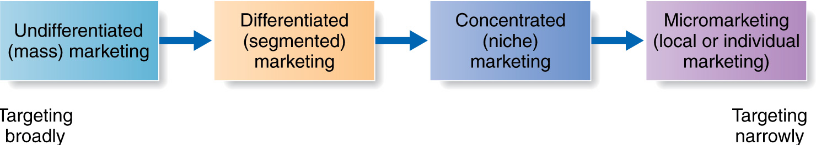

- Undifferentiated (mass) marketing: Market coverage strategy that ignores market segment differences and targets the whole market with one offer. Focus on what is common in the needs rather than difference.homogeneous, so no differences

- Differentiated (segmented) marketing: Market coverage strategy that targets several market segments and designs separate offers for each (more resources). Hoping for higher sales and a stronger position within each market segment. Increased costs = more work.

- Concentrated (niche) marketing: Market coverage strategy in which a company pursues a large share of one or a few submarkets not many resources, so target one segment. Strong position because of greater knowledge of consumer needs in the niche. More effective marketing and more efficient and highly profitable but risky. Smaller company.

- Micromarketing: The practice of tailoring products and marketing programs to the needs/wants of specific individuals and local customer groups each segment has a limited number of customers, expensive products, differentiate each customer in the segment. Local an individual groups.

Marketing managers must choose one of the strategies
- Choosing a Target Marketing Strategy
  - Company resources: Limited Niche
  - Degree of Product Variability: Uniform product Mass
  - Product Life-cycle Stage: From undifferentiated/Concentrated to Differentiated
  - Market Variability: Same tastes Mass
  - Competitors’ marketing strategies:
    - Differentiated Segmented or niche (depends on resources)
    - Undifferentiated Segmented (if possible)

Possible Value Propositions – page 270 F8.4

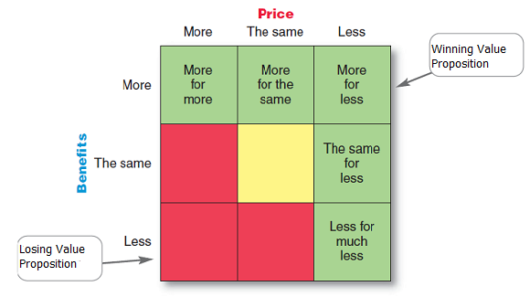

- The full positioning of a brand is called the brands value position – the full mix of benefits on which it is positioned.
- It is the answer to the costumers question (why should I buy your brand)
- Volvo – hinges on safety but also includes reliability, roominess and styling, all for a price that is higher than average, but seems fair for this mix of benefits.

The following 5, are ways in which companies can differentiate and position their products. This represents winning value proportioning that gives the company competitive advantage.

- More for more: This positioning involves providing the most upscale product or service and charging a higher price to cover the higher costs. Not only is the market offering high in quality but it also gives prestige to the buyer. Example: Rolex, four seasons, and Mercedes automobiles claim superior quality, performance and durability and charge a price to match.

- More for the same: companies can attack competitions, more for more positioning by introducing a brand offering comparable quality at a lower price. (Toyota introduces Lexus VS Mercedes).

- Same for less: offering the same for less can be a powerful value proposition / everyone likes a good deal. - Discount stores such a Wal-Mart, BestBuy, winners, don’t claim to offer different or better product, however they offer the same brands at discounted prices based on superior purchasing power and lower cost operations.

- Less for much less: this positioning evolved meeting consumers, lower performance or quality requirements at a much lower price. – Dollar stores offer more affordable goods at very low prices

- More for less: when home depot first opened for business, they had the best product selection, the best service, and the lowest prices compared to local hardware stores and other home improvement chains. However, some companies will find it difficult to sustain such best of both positioning.

Three levels of product – page 281 F 9.1
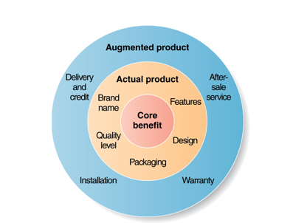

When trying to understand your product, understanding these product levels is important. Each level adds more customer value

- Core customer Value:
  - “What is the buyer really buying?”
  - Ex: Car for transportation.
  - Problem-solving benefit, services consumer seek Marketer’s first goal

- Actual Product:
  - Turn the core benefit into actual product
  - Develop product and service features, design, a quality level, brand name and packaging
  - Ex: Blackberry is the actual product, names, parts, features, packaging are other attributes to deliver core customer value.

- Augmented Product:
  - Build this around the core benefits and actual product by offering additional customer services and benefits.
  - This helps create its customer value and most satisfying customer experience
  - Ex: Blackberry warranty, instructions manual, repair service, toll free number, website, payment terms

Marketing Considerations for consumer products – page 282 F9.1 (table)
Types of Consumer Product
MARKETING CONSIDERATIONS | CONVENIENCE | SHOPPING | SPECIALTY | UNSOUGHT
BUYING BEHAVIOR | Frequent purchase; little planning, little comparison or shopping effort; low customer involvement | Les frequent purchase; much planning and shopping effort; comparison of brands on price, quality and style | Strong brand preference and loyalty; special purchase effort; little comparison of brands; low price sensitivity | Little product awareness, knowledge (or if aware, little or even negative interest)
PRICE | Low price | Higher price | Higher price | Varies
DISTRIBUTION | Widespread distribution; convenient locations | Selective distribution in fewer outlets | Exclusive distribution in only one or a few outlets per market area | Varies
PROMOTION | Mass promotion by the producer | Advertising and personal selling by both the producer and resellers | More carefully targeted promotion by both the producer and resellers | Aggressive advertising and personal selling by the producer and reseller
EXAMPLES | Toothpaste, magazines, and laundry detergent, candy | Major appliances televisions, furniture, clothing, hotel and airline | Luxury goods such as Rolex watches or fine crystal | Life insurance, pre planned funeral service and Canadian Blood Services

Convenience products
- A consumer product or service that costumers usually buy frequently, immediately and with minimal comparison and buying effort

Shopping products
- A consumers product or service that the customer, in the process of selecting and purchasing, usually compares on such attributes as suitably, quality, price and style
- Provide deeper sales support to help customers in their comparison efforts

Specialty products
- A consumer product or service with unique characteristics or brand identification for which a significant group of buyers is willing to make a special purchase effort

Unsought products
- A consumer product, that the consumer either does not know about, or knows about but does not normally consider buying.

Product service Decision has 3 levels: the following is the 1st level:
Individual Product Decisions – page 285 F9.2
The following decisions is the focus to create core customer value
The focus of all of these below decisions is to create customer value
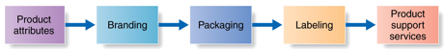
- Product attributes: Benefits through quality, features, style and design
  - Product quality: a competitive necessity, quality level & consistency
  - Features: a competitive tool for differentiation
- Branding
  - The most distinctive skill of professional marketers is the ability to build and manage brands. Most important step!
  - Brand: a name, term, sign, symbol, design or all of them combined, that identifies the product or service of one seller or group of sellers and makes them different from other competitors.
  - Consumers view a brand is a very important part of a product and branding can add value to a product.
- Packaging
  - Packaging involves activities of designing and producing the container of rapper for a product. Wal-Mart has begun to put a lot of emphasis on sustainability, thus packaging is a critical part.
  - Companies are realizing the power of good packaging to attract attention and create immediate consumer recognition of a brand.
  - Many companies have gone green by reducing their packaging and using environmentally responsible packaging materials.
- Labeling
  - Labels range from simple tags attached to products, to complex graphics that are part of the packaging
  - The label identifies the brand, it describes several things about then product (who made it, where it was made, its contents, how its to be used and how to use it safely), and it may help to promote the brand, support its positioning and connection with costumers.
  - Labels and brand logos can support the brands positioning and add personality to the brand.
- Product support services
  - Support services are an important part of the costumers overall brand experience.
  - The first step in designing support services is to survey costumers, periodically to access the value of current services and obtain ideas for new ones, only then can they take steps to fix problems and add new services that will both delight costumers and yield profits to the company (phone, email, fax, internet)

Four service Characteristics – page 294 F9.3
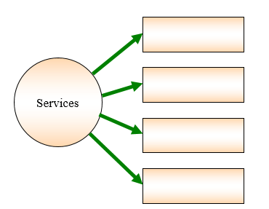
Perishability
Variability
Inseparability
Intangibility

Intangibility:
- Services cannot be seen, touched, smelt, felt, etc.
- Signals for service quality will help marketers identify evidence of capabilities to consumers.
- Example: doctor’s service, cosmetic surgery cannot see results before purchase.

Inseparability:
- Service providers cannot be separated from the consumers of the service. Tangible products can be separated from the manufacturer (water bottle).
- Example: Doctor service; only way to receive this service is to see the doctor; cannot be separated from the patients.

Variability:
- This depends on who provides the service as well as when, where and how they are provided. The quality of the services can be very different and vary.
- Example: Doctor may not give the same personal attention to every patient (busy) or one service provider may be different from another service provider; cannot maintain the same level of quality (waitress). This depends on who provides the service as well as when, where and how they are provided.

Perishability:
- Service cannot be stored for future consumption or later use.(no inventory).
- Firm design strategies for purchasing a better match between demand and supply.
- Example: Doctor cannot get the service back if there are no patients. Hotels charges lower prices in the off-season to attract more guests. Restaurants hire part-time employees to serve during peak periods.

Major Brand strategy decisions – page 303 F9.5
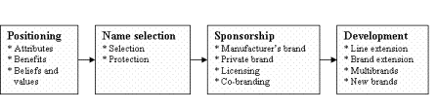
Brands are powerful assets that must be carefully developed and managed. Building strong brands involves many challenging decisions:

- Brand positioning:
Marketers need to position their brands clearly and target costumer’s minds based on 3 levels:

- Attributes:
- Lowest: at the lowest level they can position the brand on product attributes, this is the least desirable level.
- Pampers focused on attributes like; fluid absorption, fit, and disposability.
- Benefits:
- A brand can be better positioned by associating its name with a desirable benefit
- Pampers goes beyond product attributes and talks about the resulting containment and skin health benefits from dryness
- Beliefs and values:
- The strongest brands go beyond attribute or benefit positioning, they are positioned on strong beliefs and values
- Victoria’s secret rely less on products tangible attributes and more on creating surprise, passion and excitement surrounding a brand.
- When positioning a brand the marketer should establish a mission for the brand and a vision of what the brand must be and do.

- Brand name selection:
  - Selection
    - It begins with a careful review of the product and its benefits, the target market, and proposed marketing strategies. Desirable qualities for a brand name include:
- It should suggestion something about the product’s benefits and qualities
- It should be easy to pronounce, recognize and remember
- It should be distinctive
- It should be extendable
- It should translate easily into foreign languages
- It should be capable of registration and legal protection
  - Protection
    - Once chosen, it should be protected. To protect brand names, marketers present them carefully using the world brand and the registered trademark symbol. Example: BAND-AID® Brand Adhesive Bandages.

- Brand sponsorship: (4 options)
  - Manufacturers brand (national brand)
  - Private brand
    - A brand created and owned by a resellers of a product or service.
    - Increasing number of retailers and wholesales have created this.
    - Studies show more consumers buying more private brands (President’s choice is a Wal Mart brand).
  - Licensing
    - Name and character licensing has grown rapidly in recent years
    - It can be highly profitable business for many companies. Example Disney, the world’s biggest licensor, reported more than $30 billion in worldwide merchandise sales last year.
  - Co-branding
    - 2 companies join forces
    - The practice of using the established brand names of two different companies on the same product.
    - This combined brand creates broader consumer appeal and greater brand equity. (Nike and apple cobranded the Nike IPod Sports Kit).

- Brand development:
  - Line extensions
    - Extending an existing brand names to new forms, colors, sizes, ingredients or flavors of an existing product categories
      - Ex. Cheerios cereal extended to – honey nut, frosted, yogurt burst, multi grain and banana nut.
    - Line extension is a low-cost, low-rick way of introducing new products
  - Brand extension
    - Extending and existing brand name to new product categories.
      - Ex. Kellogg’s has extended to the Special K cereal brand into a full line of cereals, plus lines of crackers, fruit crisps, snack and nutrition bars, breakfast shakes, protein waters and so many more health and nutrition products.
    - Brand extension gives a new product instant recognition and faster acceptance, and it saves high advertising costs because the product is already well known on the market.

  - Multi-brands
    - Multi-branding offers a way to establish different features that appeal to different costumer segments.
      - Ex. P&G sells 4 brands of laundry detergent (tide, cheers, gain and ivory), 5 brands of shampoo (Pantene, Head & Shoulders, Aussie, Herbal essence, and Infusium 23), and 2 brands of dishwashing detergent (Dawn and Cascade)
      - P&G’s multi laundry detergent brands; capture almost 50% of the market
    - The only downfall is that there could be some brands that obtain only a small market share, and instead of having 2-3 brands and which are highly profitable, some companies have many brands, which are not as profitable. More effort put into each.
  - New brands
    - Some companies believe that their current brand name is weak, thus when creating a new brand they must come up with a new name. Or they may believe that when entering a new product category, none of their current names are suitable.
      - Ex: Toyota creating the scion (for a different target market)
    - However, too many brands are being created from top brands like; P&G, Kraft and Frito-Lay, not giving smaller brands and smaller companies access to becoming successful.
    - Too many brands without many differences between the products.

Brand Development Strategies – page 309 F9.6

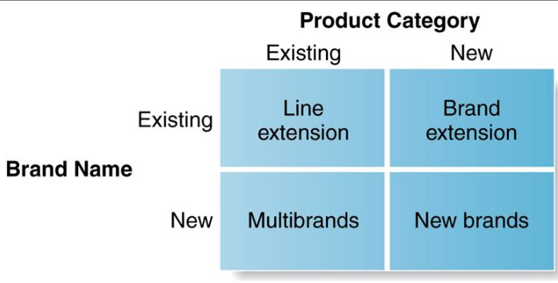

SEE PREVIOUS PAGE: UNDER BRAND DEVELOPMENT
- Line extension
  - Line extensions refers to new sizes, styles, or related products
    - Ex. Coca-cola line extensions; cherry, diet,classic
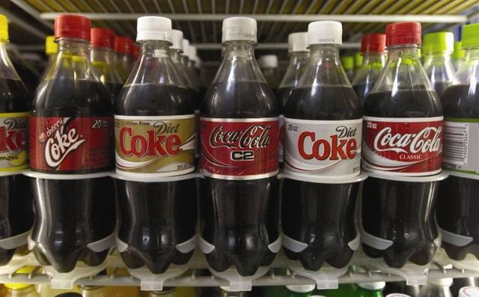

- Brand extension
  - Application of a popular brand name to a new product in an unrelated product category
    - Ex. Duracell’s wireless powermat (expanding to other things than just batteries)
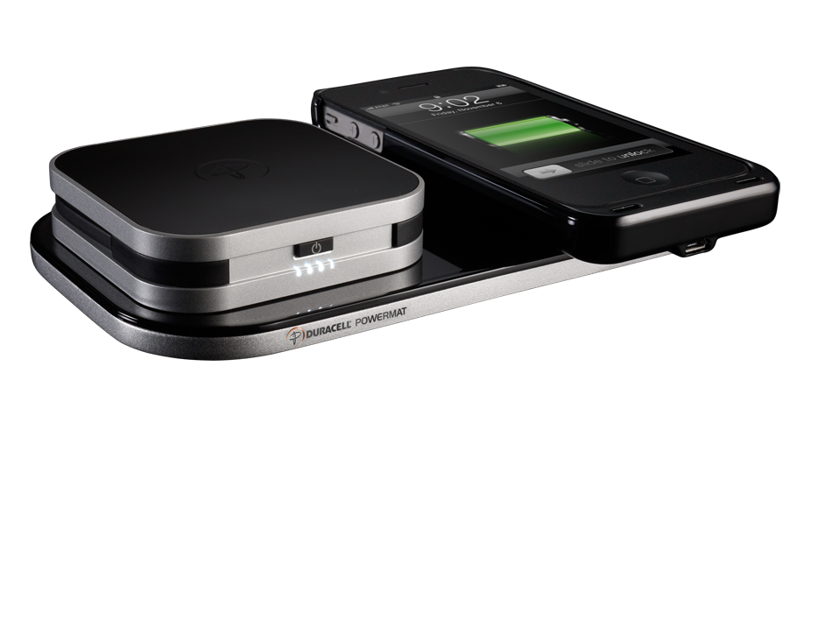

- Multi-brands
  - A way to establish different features that appeal to different costumers
    - Large Companies multi-branding:
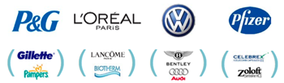

- New brands
  - Coming up with a new brand name for a new product within the same company.
    - Examples of car companies that expanded to new brand names within the same company:

    - Fiat: Alfa Romeo, Chrysler, Dodge, Ferrari, Jeep, Lancia, Maserati, Ram and SRT.
    - Ford: Lincoln
    - General Motors: Buick, Cadillac, Chevrolet, and GMC. GM also owns a lot of car brands in Europe and Asia.
    - Honda: Acura.
    - Hyundai: Kia.
    - Tata Motors (India): Jaguar and Land Rover.
    - Daimler AG: Mercedes-Benz and Smart.
    - Nissan: Infiniti.
    - Toyota: Lexus, Scion, Daihatsu and Hino Motors.
    - Volkswagen: Audi, Bentley, Bugatti, Lamborghini, Porsche.

- There are 8 major steps in New-Product Development. Please explain those steps in detail with examples to illustrate your understanding.
Chapter 10, Page 322, Figure 10.1

- Idea Generation is the systematic search for new-product ideas. 2 major sources of new-product ideas can include internal and external sources.

  - Internal sources may include the company’s Research and Development team, customers, staff/employees and the sales force. For example, Twitter hosts and annual Hack Week which promotes an internal innovation that invites all employees to the opportunity to come up with new-product ideas.

  - External sources may include distributors who are intermediaries for the market and consumers. They can inform the market of any costumer problems or complaints. Suppliers can inform the company about any new ideas, materials and techniques that can be utilized in developing new products. Competitors are an important source because companies pay close attention to the competition adds of new products. They purchase the competing new products to analyze them and decide whether they should develop their own new product to stay ahead of the competition. Others sources; university and commercial laboratories (Bioniche), marketing research firms, government agencies, shows and seminars.

  - Crowdsourcing: inviting broad companies of people into the new-product innovation process. Netflix offered a $1 million prize online to whoever could find the best solution to improve its online movie recommendation system Cinematch.

- Idea Screening is the first idea-reducing stage, which helps spots good ideas and drop poor ones ASAP. Many companies integrate product-screening frameworks to each idea to easily view, which products are worth pursuing. Company should answer yes to each R-W-W three questions: “Is it real”? Is there a need and desire for the product. “Can we win”? Can it withstand the competition, and does the company have the resources to make it a success. “Is it worth doing”? Does the product fit the company’s overall growth strategy, profit potential.

- Concept development and Testing: Once you have an idea, the company must turn that idea into a more detailed version stated in meaningful consumer terms. This is the concept development. Example: promoting a green car to appeal to environmentally conscious people who want practical, low pollution transportation. Concept testing calls for testing new-product concepts with groups of targets consumers to find out of the concepts have strong consumer appeal. Examples can be word or picture descriptions or concept questions to consumers to see which concept has the most appeal.

- Marketing Strategy Development is designing an initial marketing strategy for a new product based on the product concept. The marketing strategy statement consists of three parts:
  - 1st: target market, planned value proposition, sales, market share, profit goals for the first few years. Example of green car page 327.

  - 2nd: product’s planned price, distribution and marketing budget for the first year

  - 3rd: planned long-run sales, profit goals and marketing mix strategy

- Business Analysis involves a review of the sales, costs, and profit projections for a new product to find out whether these factors satisfy the company’s objectives. To estimate the sales forecast, the company can review sales history of similar products sold in the market and conduct market surveys. Next management can estimated the expected costs and profits for the product including marketing, research and development, accounting and finance costs. This will help them analyze the product’s financial attractiveness.

- Product Development helps develop the product concept into a physical product to ensure that the product idea can be turned into a workable market offering. Huge jump in investment when involved research and development and engineers to develop this. First they create prototype to test the product and assess consumer attractiveness.

- Test marketing is the stage of new-product development in which the product and its proposed marketing program are tested in realistic market setting. Evaluation of the company’s targeting and positioning strategy, advertising, distribution, pricing, branding and packaging and budget levels. It takes time to do this and costs are high. When the risks are not high and the production costs are low, test marketing is not necessary. But when competition is high, and introducing the product requires a big investment, this step is required.

- Commercialization: introducing a new product into the market. This brings about high costs; build or rent manufacturing facility, and investment in the first years for advertising, sales and promotion. Must factor in the best time to launch product. Review the economy. Where to launch the new product; single location, region, national or international market.

- The Product Life Cycle Strategies involves 5 distinct stages. Please explain those stages and give examples.
Chapter 10, Page 335, Figure 10.2 + Page 343 for more examples.

After the launching of a new product the company wants to ensure the product life cycle (sales and profits over time) will earn a decent profit to cover all of the effort and risk that went into launching it.
- Product development: company has a new-product idea; sales are 0 but company’s investment costs increase.

- Introduction: period of slow sales growth as the product is introduced in the market. Profits are non-existent in this stage due to the high expenses of product introduction and promotion expenses. Much money needed to attract distributors and build their inventories. Use cost-plus to decide on a product price.

- Growth: rapid market acceptance and increasing profits. Word of mouth advertising leads to new competitors entering the markets, which increases the number of distribution outlets and sales increase to build reseller inventories. Their objective is to maximize market share since they are generating many sales and are popular in the market. Promotion costs are spread over large volume and new product features and models are introduced. Price to penetrate the market.

- Maturity: period of slowdown in sales growth because the product has achieved acceptance by most potential buyers. Profits level off or decline because of increased marketing expenses used to defend product against competition. This stage normally lasts longer. To stay within competition, companies should consider modifying the market, product and marketing mx by finding new users and new market segments for its brands. Modifying the product by changing characteristics such as quality, features, styles or packaging to attract new users. They should price to match or beat competition.

- Decline: sales decrease and profits drop. Cut the price and reduce to minimal level of sales promotion. Phase out unprofitable distribution outlets. Products phases out for many reasons such as technological advances (VHS tapes), shifts in consumer tastes and increased competition. Management should decide to maintain its brand by repositioning or reinvigorating the weak product in hopes of moving back into the growth stage of the PLC. Or management must decide to drop the product from its line by selling it to another firm or liquidating.

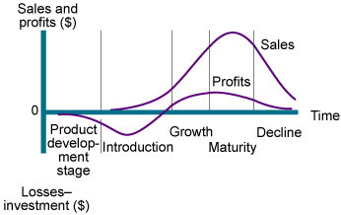

- When a new product is introduced in the market place, companies have the challenge of setting the price. They have a choice between 2 strategies, Skimming or Penetration pricing, what are they and how would they benefit the market?
Chapter 11, Page 371-372

- Market-Skimming Pricing: Setting a high price for a new product to skim maximum revenues layer by layer from the segments willing to pay the high price; the company makes fewer but more profitable sales. Apple first introduced IPhones at high prices $599 per phone. Consumers who were interested in the new gadget and were willing to pay the price bought it. As the demand of the first customers was satisfied, Apple lowered the price of the IPhone to attract other segments of people who are more price-sensitive.

- Market-Penetrating Pricing: Setting a lower price for a new product to attract a large number of buyers and a large market share. With high sales volume, company’s have room to cut their prices even further to attract more market segments. IKEA did this when reaching out to the China demographic by reducing their prices and attracting new costumers. Must be very careful when doing this, be highly price sensitive so that a low price produces more market share. Low price must keep out competition.

- For a company to be competitive, they must adjust and change their prices to account for various customer differences and changing situations. Please present the 7 Price Adjustment Strategies and provide examples.
Chapter 11, Page 376, Figure 11.3

- Discount and allowance pricing: Reducing prices to reward customer responses such as paying early or buying in large volumes

  - Discount: straight reduction in price on purchases during a stated period of time or of larger quantities.
  - Allowance: promotional money paid by manufacturers to retailers in return for an agreement to feature the manufacturers product in some way. Trade-in allowances are price reductions given for example turning in and old car when buying a new one.

- Segmented pricing: Adjusted prices to allow for differences in customers, products, or locations. The company sells a product or service at two or more prices where the difference in the prices is not based on the differences in costs. Example of customer-segment pricing; Museums or movie theatres where the charge a lower prices to students and senior citizens. Product-form pricing; round trip economy from Toronto to London is less expensive than riding in first class. Location-based pricing; different prices for seats in a hockey arena. Time-based pricing; different prices for seeing a movie in the day as opposed to at night, or resorts give seasonal discount.

- Psychological pricing: Adjusting prices for psychological effect. The price says something about the product. Consumers usually perceive higher-priced products as having higher quality. When they don’t have the information or skill to jude the product, price becomes an important quality signal. For example a grocery retailer may position its brand of bran flakes at $2.50 next to Kellogg’s raisin bran at $4.50.

- Promotional pricing: Temporarily reducing prices to increase short-run sales. Offering discounts from normal prices to increase sales and reduce inventories or special event pricing during Christmas to draw more customers. However, it should be done moderately because too often customers might delay a purchase because they expect brands to go on sale frequently. Customers may perceive the quality of the brand as less valuable if they are always on sale.

- Geographical pricing: adjusting prices to account for the geographic location of customers. 3 types of geographical pricing:

  - FOB-origin pricing: goods are placed free on board a carrier; the customer pays the freight from the factory to the destination.
  - Uniform-delivered pricing: opposite of FOB. The company charges the same price plus freight to all customers regardless of their location.
  - Zone Pricing: falls between FOB and Uniform-delivered pricing. The company sets up two or more geographical zones. All customers within a zone pay the same total price; the more distant the zone, the higher the price.

- Dynamic pricing: adjusting prices continually to meet the characteristics and needs of individual customers and situations. Companies now are steering away from fixed prices and are reversing to this. Ebay is an online auction website that allows customers control of pricing by bidding. Amazon can adapt their databases to evaluate a specific shopper’s desires, and tailor products to fit that shopper’s buying behaviour and price products accordingly. Many price comparison sites such as pricenetweork.ca offer instant product and price comparisons from thousands of vendors.

- International pricing adjusting prices for international markets. The price that a company should charge in a specific country should depend on economic conditions, competitive situations, laws and regulations and the development of wholesaling and retailing system. Samsung might introduce a new product to mature markets in highly developed countries to gain mass market share by ursing marketing penetrating pricing whereas in a less developed market they may target smaller and less price sensitive segments by using market skimming pricing. Gucci handbag may be price at 140$ in Italy and in Canada it can be priced at $240. This is the result of higher costs of selling in another country.

- Customers react to any product or service in relation to its value. Please present the 3 Customer Pricing Strategies.
Chapter 11, Page 355, Figure 11.1 + 11.2

The three are 3 major pricing strategies:

Costumer value-based pricing
Cost-based pricing
Competition-based pricing

Costumer value-based pricing:

Pricing is determined by the costumer’s needs and value perceptions. This type of pricing comes after we define the products value, based on costumer’s satisfaction and opinions built on quality. In this strategy “good value” is not the same as “low price”. Therefore, a product’s price can be determined by the costumer’s opinion of its value. (Refer to grid)

Ex: The Steinway grand piano

Their sold anywhere from $40 000 to $165 000, but the most popular one is sold at $75 000. These pianos take about a full year to hand carve and construct. But Steinway’s are not purchased b9ased on price, but based on value and “the Steinway experience”.

- Good-Value pricing: Offering the right combination of quality and good service at a fair price. To accommodate the market throughout difficult economic shifts, different companies have responded by introducing less expensive versions of established, brand-name products. Armani created Armani Exchange, which is a less expensive, and more casual fashion line.

- Value-Added pricing: Attaching value-added features and services to differentiate a company’s offers and charging higher prices. Movie theaters offer more services and amenities now such as paying 15$ as oppose to $9 with amenities and services such as reclining leather seats with subwoofers underneath, online reserved seating, dine in restaurant service and valet parking.

Cost-based pricing:

This form of pricing is determined by the costs of production, distribution and the selling process and not by value of the product. (Refer to grid)

Ex: Ryanair and Walmart

They work to be low cost producers; companies with lower costs can set lower prices with a result in smaller margins but higher sales and profits.

Ex: Steinway, apple and BMW

Higher costing products, and a lot more expensive to make. Steinway would rather go towards the “handcrafted” piano, it takes A LOT more time, effort and is highly expensive to make, however the results in the end show higher quality in a product, this is why Steinway pianos are sold for prices like $75 000.

- Experience curve (learning curve): The drop in average per-unit production cost that comes with accumulated production experience.

- Cost-plus pricing (mark up): Adding a standard mark up to the cost of production.

- Break-even pricing (target return): Setting price to break even on the costs of making and marketing a product or setting price to make a target return. The chart shows the total cost and the total revenue expected at different sales volumes.

Competition-based pricing:

This type of pricing is determined by competitor prices. Instead of a company doing their own price research, they mirror the ideas of a similar company (competitors). Or they take the ideas of larger stores and make them better (focussing more on detail).

Ex: Pete’s (grocery store)

Instead of just having your everyday produce like (Lowballs or Sobeys), Pete’s focussed on detail: outstanding produce, their outstanding on the go deli and costumer service.

Cost-based pricing:

Customer Value-based pricing:

- There are 3 strategies available when companies must determine the number of channel members to use at each level. Please explain the distribution strategies in detail by using examples.
Chapter 12, Page 412

- Intensive distribution: Stocking the product in as many outlets as possible. Typically producers of convenience products and common raw materials such as Kraft and Coca-Cola. Products available where and when consumers wants them. Example: toothpaste, food, sold in millions of outlets. This provides maximum brand exposure.

- Exclusive distribution: Giving a limited number of dealers the exclusive right to distribute the company’s products in their territories. This is typically for luxury brand products, such as Bentley automobiles who only sell their automobiles to a limited number of authorized dealerships. This enhances the brand image and promotes to higher markets while giving the company control over pricing and promotion tactics.

- Selective distribution: The use of more than one but fewer than all of the intermediaries who are willing to carry the company’s products. This gives producers good market coverage with more control and less cost than does intensive distribution. Examples of items are televisions, furniture and home appliance brans are distributed through dealer networks and selected large retailers. This promotes good working relationships.

- A company considers several issues when responding to price changes by a competitor. Please explain how a company might Assess and Respond to Competitor price cut.
Chapter 11, Page 385, Figure 11.7

If a company learns that a competitor has cut its price, it might decide that this price cut is likely to harm its sales and profit. From here if they feel that they will not lose too much market share they can hold their current price and profit margin because reducing their price might equate to a large profit loss. Waiting to see if the competitors change in price will have effects might be detrimental to the company because it gives time for the competition to grow and become more confident as their sales increase. However, if the company decides to take effective action instead of holding their current price, they can consider any of the following four options:

- Reduce price: to match competitors price because the market may be price sensitive. But they should not reduce the product quality or services because it can have damaging long-term market share effects.

- Raise perceived quality: they can maintain the price and advocate their product’s superior value over the competitors. They can do so through improved communications and advertising.

- Improve quality and increase price: This involves moving the brand into a higher price-value position to create greater customer value. This promotes a more prestigious company product status.

- Launch low-price “fighting brand”: To maintain lower level market segments that don’t want to spend money on higher priced products, the company can create a lower-line product to meet their needs. Example: Greyhound partnered with Trailways of New York and created NeOn, offering discount services to various locations in NYC from Toronto and Montreal.

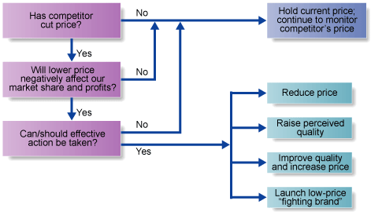

- Companies can design their distribution channels to make products/services available to customers in different ways. Please explain the different types of channels that can be used for both Consumer and Business Marketing Channels.
Chapter 12, Page 401-402, Figure 12.2

- Direct Marketing Channel: It has no intermediary levels. A company sells directly to consumers. Example: Mary Kay, Amway sell their products door to door, through home and office sales parties and on the Internet. GEICO sells automobile insurance direct via the telephone and Internet.

- Indirect Marketing Channel: It contains 1 or more intermediaries. The company uses one or more levels of intermediaries to help bring its products to final buyers. Example is of most of the thing we purchase, clothes, toothpaste, cars, and televisions.

Business marketers can use their sales force to sell directly to customers or it can use various types of intermediaries. Both business and costumer marketing channels find that more levels of intermediaries means less control and more channel complexity.

  - For customer marketing channels:
    - Channel 1: Producer Consumer (direct)
    - Channel 2: Producer Retailer Consumer (indirect)
    - Channel 3: Producer Wholesaler Retailer Consumer (indirect)
  - For Business marketing channels:
    - Channel 1: Producer Business customer (direct)
    - Channel 2: Producer Business distributor Business customer (indirect)
    - Channel 3: Producer Manufacturer’s representatives or sales branch Business distributor business customer (indirect).

- With respect to managing New Product Development in today’s market, companies are required to take a holistic approach to managing the process. Please present the 3 approaches that companies utilize for a successful new product development and provide examples.
Chapter 10, Page 331-335

- Customer-Centered: it focuses on finding new ways to solve customer problems and create more customer-satisfying experiences. A thorough understanding of what costumer’s need and value and involving them in the process. P&Gs new-product success rate is over 50% because they first learn what their customer’s needs are and actually go as far as living with their shoppers to discover product ideas that fit with their needs. They also crowd source by offering customers the opportunity to submit their own ideas and suggestions for new products.

- Team-based: An approach to developing new products in which various company departments work closely together, overlapping the steps in the product development process to save time and increase effectiveness. This helps market products more quickly in fast changing, highly competitive markets. They gather members of every department to form a team (marketing, finance, design, legal, manufacturing) and they stay with the product from the beginning of the new-product development process to the end.

- Systematic effort: Company’s now implement an innovation management system to collect, review, evaluate and manage new-product ideas rather than letting potential ideas disappear and go unnoticed. One member can be appointed as the manager of the innovation system to delegate and create a cross functional team effort that shows top management support and encourage innovation as well as yield a large number of potentially good new-product ideas.

Supply chain management: page 418 – F 12.5

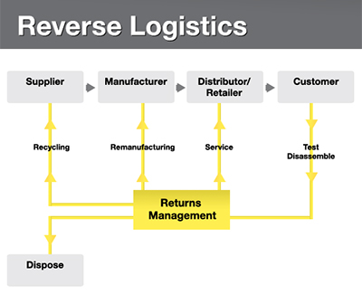

Supply chain management: Managing upstream and downstream value-added flows of materials and goods among the company, suppliers, resellers and final consumers.

Physical distribution: managing the flow of goods from points of origin to points of consumption.

Outbound distribution: moving products from the factory to the reseller, then to the consumers.

Inbound distribution: moving products from the suppliers to the factory.

Reverse distribution: moving broken, unwanted or excess products returned by consumers or resellers.

Distribution center: a large, highly automated warehouse designed to receive goods from various plants and suppliers, take orders, fill them efficiently, and deliver goods to customers as quickly as possible

Intermodal transportation: combining two or more modes of transportation

Retailing: page 436 Table 13.1
Major store retailer types:

Specialty store | - Carries a narrow product lines with a deep assortment, such as apparel stores, sporting good stores, furniture stores, florists and bookstores.  - A clothing store would be a single-line store.  - A men’s custom shirt store would be a super-specialty spore. | - Running rooms  - The body shop  - Williams-Sonoma
Department store | - Carries several product lines  - Typically clothing, home furnishings and household goods.  - Each line operated by a separate department, managed by a specialist or a merchandiser. | - The Bay  - Sears  - Neiman Marcus
Supermarket | - Large, low-cost, low-margin, high-volume, self-service operation designed to serve the consumer’s total needs for grocery and household products | - Loblaw  - Super C  - Metro  - IGA
Convenience store | - Small store located near residential areas; open long hours, seven days a week.  - They carry a limited line of high-turnover convenience products at slightly higher prices. | - 7-eleven  - Couche-Tard  - Circle K
Discount store | - Carries standard merchandise, sold at lower prices with lower margins and higher volumes | - Wal-Mart  - Giant Tiger
Off-price retailer | - Sells merchandise bought at less-than-regular wholesale prices and sold at less than retail: often-leftover goods, overruns, and irregulars obtained at reduced prices from manufacturer or other retailers.  - These include factory outlets owned and operated by the manufacturer  - Independent off-price retailers owned and run by entrepreneurs or by divisions of larger retail corporations and wholesale clubs selling a limited selection of brand-name groceries, appliances, clothing and other goods at deep discounts offered to consumers who pay a membership fee. | - Costco  - Winners  - TJ Max  - Marshals
Superstore | - Large store aimed at meeting consumer’s total needs for routinely purchased food and nonfood items  - This category includes supercenters, combined supermarket and discount stores and category killers, which carry a deep assortment in a particular category and have knowledgeable staff. | Category killers:  - Wal-Mart Supercenter  - Best Buy  - Pet Smart  - Staples

Major types of retail organizations: Page 443 F 13.2

Corporate chain store | - Two or more outlets that are commonly owned and controlled.  - Corporate chains appear in all types of retailing, but they are strongest in department stores, discount stores, food stores, drugstores and restaurants | - Sears (department stores)  - Winners (discount stores)  - Loblaw (grocery store)  - Pharmaprix (drugstores)
Voluntary chain | - Wholesaler-sponsored group of independent retailers engaged in group buying and merchandising | - IGA  - Western auto  - True value (hardware)
Retailer cooperative | - Group of independent retailers that jointly establish a central buying organization and conduct joint promotion efforts. | - Associated Grocers (groceries)  - Desjardin (bank)  - Ace Hardware (Hardware)
Franchise organizations | - Contractual association between a franchisor (a manufacturer, wholesaler, or service organization)  - Franchisees (independent business people who buy the right to own and operate one or more units in the franchise system. | - McDonalds  - Subways  - Pizza hut  - Tim Horton’s

The promotion mix: Page 470

Promotion mix (marketing communications mix): the specific blend of promotion tools that the company uses to persuasively communicate customer value and build customer relationships

Advertising: any paid form of non-personal presentation and promotion of ideas, goods, or services by an identified sponsor

Sales promotion: short-term incentives to encourage the purchase of sale of a product or service

Personal selling: personal presentation by the firm’s sales force for the purpose of making sales and building customer relationships

Public relations: building good relations with the company’s various publics by obtaining favorable publicity. Building up a good corporate image, and handling unfavorable rumors, stories and events

Direct marketing: direct connections with carefully targeted individual consumers to both obtain an immediate response and cultivate lasting customer relationships

New marketing communications model: page 471

Several major factors are changing the face of the way we market our products.

Consumers are changing, in this digital wireless age, they are better formed and more communication empowered, rather than relying on marketer-supplied information, they use the Internet to do their research and learn more about the products before purchasing.

Marketing strategies are changing, rather than jumping into mass markets, marketers are shifting away from this and leaning more towards developing marketing programs designed to build closer personal relationships with consumers in more narrowly defined micro markets.

Advances in Communications technology are causing changes in the way companies and consumers communicate with each other. New digital media, Internet, messages and blogs.

Integrated marketing communications: Page 475 F 14.1

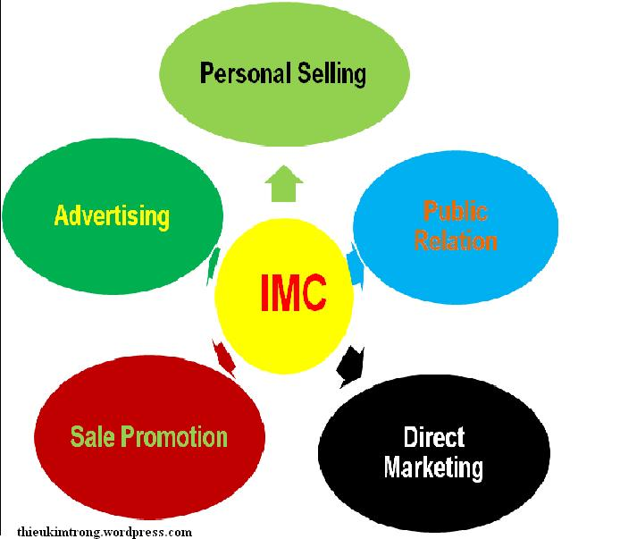

IMC: COSISTENT, CLEAR AND COMPLELLING COMPANY AND BRAND MESSAGES.

- Carefully integrating and coordinating the company’s many communications channels to deliver clear, consistent and compelling message about the organization and its products and connecting it to personal selling, public relations, direct marketing, sales promotion and advertising.

Advertising
    - Reach geographically dispersed masses at a low cost per exposure
    - For companies who want to reach a mass audience – T.V is essential
    - Large scale advertising portrays a certain idea about seller’s success
    - Consumers tend to view advertised products as more legit
    - Helps build a long term, impersonal, image at a high cost
    - One-way communication

Personal selling
- Most effective tool at certain stages of buying process – particularly in building buyer preferences and actions
- Builds customer relationships and solves their problems
- Sales force requires longer term commitment
- Most expensive promotion tool

Sales promotion
- Coupons, contests, deals…(strong incentive to purchase)
- Invite and reward quick response (effects are short lived)
- Not effective in building long term brand preference or customer relationships

Public relations
  - Believable – news stories, features, sponsorships, events…
  - Can reach people who avoid sales people and ads

Direct marketing
  - Direct mail, catalogues, telephone marketing, online marketing …
  - Less public
  - Immediate and customized (interactive)

Push versus pull promotion strategy: Page 489 F 14.4

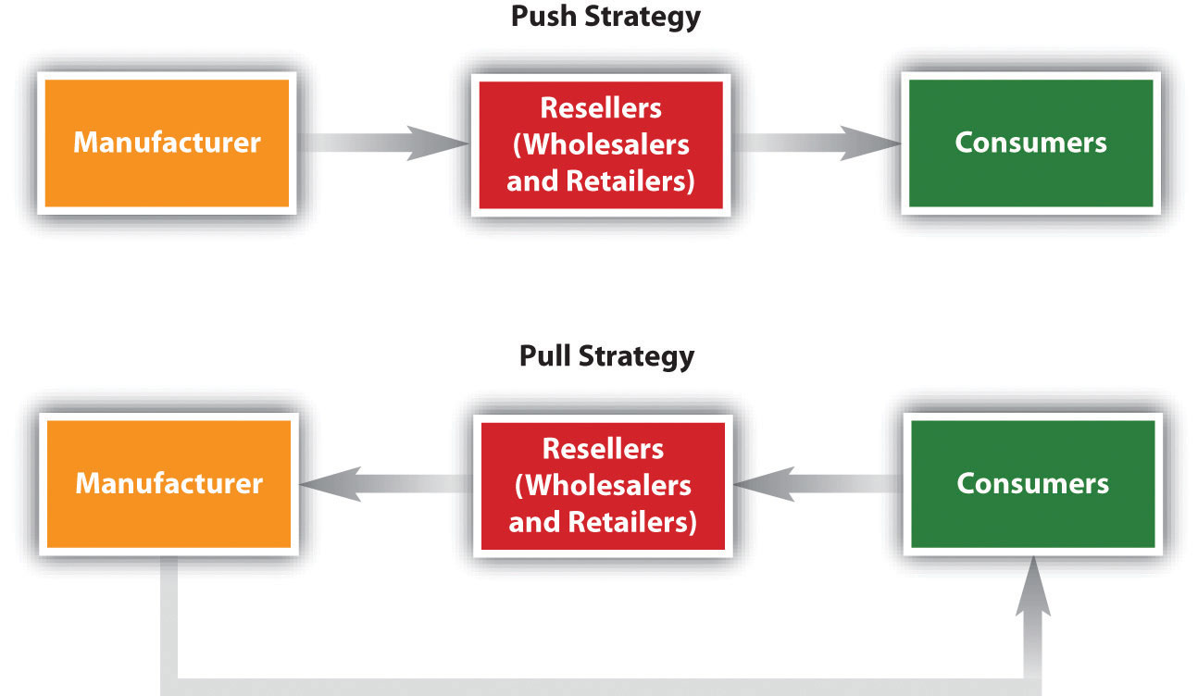

Push strategy: a promotion strategy that calls for using the sales force and trade promotion to push the product through channels. The producer promotes the product to channel members who in turn promote it to final consumers.

Ex: John Deere does very little promoting on its lawn mowers, tractors and other consumer products, instead their sales force works with Lowe’s, Home Depot, and independent dealers who push John Deere products to final consumers

- Manufacturer working with retailer to sell to consumer.

Pull strategy: a promotion strategy that calls for spending a lot on consumer advertising and promotion to induce final consumers to buy the product, creating a demand vacuum that “pulls” the product through the channel.

Ex: Unilever promotes Axe grooming products directly to its young male market using TV and print ads, a brand website, its YouTube channel and other channels. If the pull strategy it then effective the consumers will then demand the brand in large retailers such as; Target, Wal-Mart and Shoppers drug mart, who will be demanding the product from Unilever.

- Consumers demanding from Retailers and Retailers demanding from manufacturer.

Major Advertising Decisions: Page 501 F 15.1

Objectives setting: Communication objectives
Sales objective

Budget Decisions: Affordable approach
Percentage of sales
Competitive parity
Objective and task

Message Decisions: Message strategy
Message execution

Media Decisions: Reach, frequency, impact
Major media types
Specific media Vehicles
Media timing

Advertising evaluation: Communication impact
Sales and profit impact
Return on advertising

Advertising: any paid form of non-personal presentation and promotion of ideas, goods, or services by an identified sponsor

Objective setting: a specific communication task to be accomplished with a specific target audience during a specific period of time
- Informative advertising: used heavily when introducing a new product category
- Persuasive advertising: more important as competition increases
- Reminder advertising: important for mature products to maintain customer relationships and keep reminding customers

Budget decisions: the dollars and other resources allocated to a product or company advertising program. Making decisions based on the amount of money you can spend on advertising.

Message decisions: the strategy by which the company accomplishes its advertising objectives.
- It consists of two major elements: creating advertising messages and selecting advertising media

- Creative concept: the compelling “big idea” that will bring the advertising message strategy to life in a distinctive and memorable way.
- Execution style: the approach, style, tone, words, and format used for executing an advertising message

Media Decisions: The vehicles through which advertising messages are delivered to their intended audiences

Advertising evaluation: how your company benefited on this type of advertising, what came out of it, how it bettered your sales.
Return on advertising investment: the net return on advertising investment divided by the costs of the advertising investment

Profiles of major media types: Page 512 Table 15.2

Television | - Good mass-marketing coverage  - Low-cost per exposure  - Combines sight, sound and motion  - Appealing to the senses | - High absolute cost  - High clutter  - Fleeting exposure  - Less audience selectivity
Newspapers | - Flexibility  - Timeless  - Good local market coverage  - Broad acceptability  - High believability | - Short life  - Poor reproduction quality  - Small pass-along audience
Internet | - High selectivity  - Low cost  - Immediacy  - Interactive capabilities | - Potentially low impact  - Audience controls exposure
Direct mail | - High audience selectivity  - Flexibility  - No ad competition within the same medium  - Allows personalization | - Relatively high cost per exposure  - Junk mail image
Magazines | - High geographic and demographic selectivity  - Credibility and prestige  - High quality reproduction  - Long life and good pass-along readership | - Long ad purchase lead time  - High cost  - No guarantee of position
Radio | - Good local acceptance  - High geographic and demographic selectivity  - Low cost | - Audio only  - Fleeting exposure  - Low attention  - Fragmented audiences
Outdoor | - Flexibility  - High repeat exposure  - Low cost  - Low message competition selectivity | - Little audience selectivity  - Creative limitations

Major steps in Sales force management: Page 534 F 16.1

  - Designing sales force strategy and structure

  - Recruiting and selecting salespeople

  - Training salespeople

  - Compensating salespeople

  - Supervising salespeople

  - Evaluating salespeople

- Designing a Sales force strategy and structure:

Sales force structure:

Territorial sales force structure:
A sales force organization that assigns each salesperson to an exclusive geographic territory in which that sales person sells the company’s full line of products.

Ex: Stanley Black & Decker uses a territorial structure in which each salesperson is responsible for selling all of the company’s products from hand tools to lawn and garden equipment, in assigned territories.

Product sales force structure:
A Sales force organization in which salespeople specialize in selling only a portion of the company’s products or lines.

Ex: GE employs different sales forces within different product and service divisions of its major businesses. Within GE infrastructures, the company has separate sales forces for aviation, energy, transportation and water processing products and technologies.

Costumer sales force structure:
A sales force organization in which salespeople specialize in selling only to certain consumers of industries. (Focusing on the market)

Ex: Stanley Black & Decker has a home depot and Lowe’s sales organization. (Only creating and selling products to these types of stores)

Complex sales force structure:
When a company sells a wide variety of products to many types of consumers over a broad geographic area, it often combines several types of sales force structures.

Ex: Stanley Black & Decker specializes sales force by costumer and by territory.

Sales force size:

Once the company has set its structure, then it must consider sales force size, this can range in size anywhere from a few salespeople to thousands.

Outside sales forces:
Salespeople, who travel to call on customers in the field.

Inside sales forces:
Salespeople, who conduct business from their offices via telephone, the Internet, or visits from prospective buyers.

Team selling:
Using teams of people from sales, marketing, engineering, finance, technical support and even upper management to service large complex accounts.

- Recruiting and selecting salespeople

With every great company comes the recruitment and selection of sales people. The best sales people possess intrinsic motivation, disciplines work style, the ability to close a sale and perhaps most important, the ability to build relationships with consumers.

- Training salespeople

Training salespeople can be a week process or can take up to a year or more depending on the types of training given by that specific company. A lot of companies today have turned to online learning processes, like questionnaires, games or interactive sales calls.

Ex: Bayer Healthcare pharmaceuticals worked with Concentric RX, a health care marketing agency to create a role-playing stimulation video game to train sales force on a new drug-marketing program.

- Compensating salespeople

Compensating salespeople consists of 4 elements:
- A fixed amount
  - Usually a salary gives the salesperson a stable income
- A variable amount
  - Commission or bonuses based on sales performance, rewards salespeople for greater effort and success
- Expenses
- Fringe benefits

- Supervising salespeople
Salespeople need supervision and motivation to realize their full potential.
The goal of supervision: help salespeople “work smart” by doing the right things in the right way.
The goal of motivation: encourage salespeople to “work hard” and reach sales goals.

Page 542… Figure 16.2 how sales people spend their time

Active selling 10%
Prospecting 10%
Problem solving 14%
Administration 31%
Travel time 18%
Personal downtime 17%

- Evaluating salespeople

This process requires good feedback, which is getting regular information about salespeople to evaluate their performance. This information can be obtained from sales reports, call reports and expense reports.

Steps in the Selling Process: Page 546 F 16.3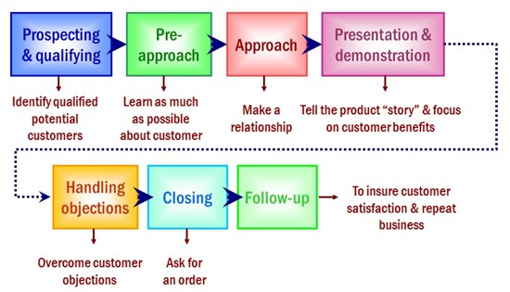

Sales Promotion: Page 549

Sales promotion: incentives to encourage purchase or sale of a product
      - Coupons
      - Cash rebates
      - Contests
      - Discounts
This will generate interest in sales

Consumer promotions: promotion tools used to boost short-term customer buying and involvement or to enhance long-term customer relationships.
- Samples
- Coupons
- Refunds
- Premiums
- Event sponsorships
- Sweepstakes

Event marketing (event sponsorships): creating a brand-marketing event or serving as a sole or participating sponsor of events created by others
- Festivals
- Reunions
- Marathons
- Concerts

Trade promotions: promotion tools used to persuade resellers to carry a brand, give it shelf space, promote it in advertising, and push it to consumers.
- Price-offs
- Allowances
- Buy-back guarantee
- Free goods

Business promotions: sales promotion tools used to generate business leads stimulate purchases, reward customers, and motivate salespeople.
- Conventions & trade shows
- Sales contests

Direct Marketing: Page 564 chapter 17

Direct marketing:

Direct marketing: connecting directly with carefully targeted individual consumers to both obtain an immediate response and cultivate lasting customer relationships
- It can be personalized, and it’s great for one on one marketing methods:
- Catalogue
- Kiosk
- Tele-marketing
- Direct mail
- Face to face selling
- Online marketing
- New digital technologies
- Direct response television marketing

Customer database: an organized collection of comprehensive data about individual customers or prospects, including geographic demographic, psychographic, and behavioral data

Direct-mail marketing: direct marketing by sending an offer, announcement, reminder or other item to a person at a particular physical or virtual address

Catalogue marketing: direct marketing through print, video, or digital catalogues that are mailed to selected customers, or made available in stores

Telephone marketing: using the telephone to sell directly to customers
Direct response television marketing – including direct-response television advertising (infomercials) and home shopping channels

Online Marketing: Page 577 chapter 17

Online marketing:

Online marketing: company efforts to market products and services and build customer relationships over the Internet.

Internet marketing: a public web of computer networks that connects users of all types all around the world to reach other and to a large information repository

Online companies: the so-called dot-coms, which operate only online

Hybrid or click-and-mortar companies: traditional companies that have added online marketing to their operations

Business-to-consumer (B2C) online marketing: businesses selling goods and services online to final customers

Business-to-business (B2B) online marketing: businesses using B2B websites, email, online catalogues, online trading networks, and other online resources to reach new business customers, serve current customers more effectively, and obtain buying efficiencies and better prices

Consumer-to-consumer (C2C) online marketing: online exchanges of goods and information between final consumers

Consumer-to-business (C2B) online marketing: online exchanges in which consumers search out sellers, learn about their offers, and initiate purchases, sometimes even driving transaction terms

Corporate (or brand) website: a website designed to build customer goodwill, collect customer feedback, and supplement other sales channels, rather than to sell the company’s products directly

Marketing website: a website that engages consumers in interactions that will move them closer to a direct purchase or other marketing outcome

Online advertising: advertising that appears while consumers are surfing the web; display ads, search-related ads, online classifieds, and other forms

Viral marketing: internet version of word-of-mouth marketing – websites, videos, email messages or other marketing events that are so infectious that customers will want to pass them along to friends

Online social networks: online social communities – blogs, social networking websites, or even virtual worlds- where people socialize or exchange information and opinions

Spam: unsolicited, unwanted commercial email messages

Major international marketing decisions: Page 628 F 19.1

Global marketing:
Gain competitive advantage, expand, and increase sales & market share. Focus on costs of doing business, info structure (traffic and roads), volume (middle class, can they buy product), is it producible, what’s the risk level.

Looking at the marketing environment: looking at international trade system, when selling to another country a firm may face restrictions on trade between nations: (macro elements)
- Charge tariffs
- Taxes
Economic community: a group of nations organized to work toward common goals in the regulation of international trade. International marketer must study each countries economy:
- Industrial structure
- Its income distribution

Deciding whether to go international: COMMON SENCE

Deciding which market to enter: The firm must take into consideration the demographic, geographic and economic factors of the market, and deciding which is best for the overall company.

Deciding how to enter the market:
Exporting: entering a foreign market by selling goods produced in the company’s home country, often with little modification. Set up an agency there, to see if there’s an interest, export your products and set relationships with freight forward and hire people.

Joint venturing: entering foreign markets by joining with foreign companies to produce or market a product or service
- Licensing: a method of entering a foreign market in which the company is in agreement with a licensee in the foreign market. Giving someone else the right to sell your product. This method gets you into the market quickly. Downfall; if licensing company doesn’t follow your procedures; it can affect the overall quality and service.
- Contract manufacturing: a joint venture in which a company contracts with manufacturers in a foreign market to produce its product or provide its service. Downfall; having a partner decreases the company’s level of control. PLUS: partner has market knowledge in the foreign country.
- Management contracting: a joint venture where the domestic firm supplies the management know-how to a foreign company that supplies the capital; the domestic firm exports management services rather than products (expertise and low risk)
- Joint ownership: a joint venture in which a company joins investors in a foreign market to create a local business in which the company shares joint ownership and control. (Marriage = trust) (Understand each others cultures & can be very profitable)

Direct investment: entering a foreign market by developing foreign-based assembly or manufacturing facilities (low risk).

Deciding on the global marketing program:
Standardized global marketing: an international marketing strategy for using basically the same marketing strategy and mix in all the company’s international markets.
  - Pricing
  - Promotion
  - Distribution channels

Adapted global marketing: an international marketing strategy for adjusting the marketing strategy and mix elements to each international target market, bearing more costs but hoping for a larger market share and return
Product:
- Straight product extension: marketing a product in a foreign market without any change
- Product adaptation: adapting a product to meet local conditions or wants in foreign markets
- Product invention: creating new products for foreign markets
Promotion:
Communication adaptation: a global communication strategy of fully adapting advertising messages to local markets

Distribution channels:
Whole-channel view: designing international channels that take into account the entire global supply chain and marketing channel, forging an effective global value delivery network

Deciding on the global marketing organization: Most companies manage their marketing activities in 3 ways:
- Organize an export department
- Selling the product
- Create an international division
- Marketing
- Manufacturing
- Research
- Finance
- Planning
- Personal specialist

- Become a global organization
- National marketers who sell abroad
  - Trained in worldwide operations

Ethics

Fair trade is a growing movement around the world; it works to make sure that producers in developing countries our paid a fair price for their crops and goods.

