KIN 365

- Your Belief System
- What are your beliefs about young athletes?
  - Are they all the same?
  - All different?
  - Do you like some more than others?
  - Equal treatment for all?
  - Do they have the same potential?
- Don’t discourage any one from becoming what they want to be
- How much realism should you use as a coach?

- What type of coach are you?
- How do you define success?
- How do you treat your athletes?
- How do you treat the opposition?
- How do you treat officials?
- How important is sport in your life?

- What are your beliefs about Spirituality?
- Do you believe in a higher power? In yourself? In anything?
- Will anyone believe in you if you believe in nothing?
- Should we consider the existence of a higher power

- John Wooden - Basketball coach for UCLA in 1970’s
- Pyramid of success/leadership
- Required his players to have faith
- Success is a peace of mind which is a direct result of self satisfaction in knowing you did your best
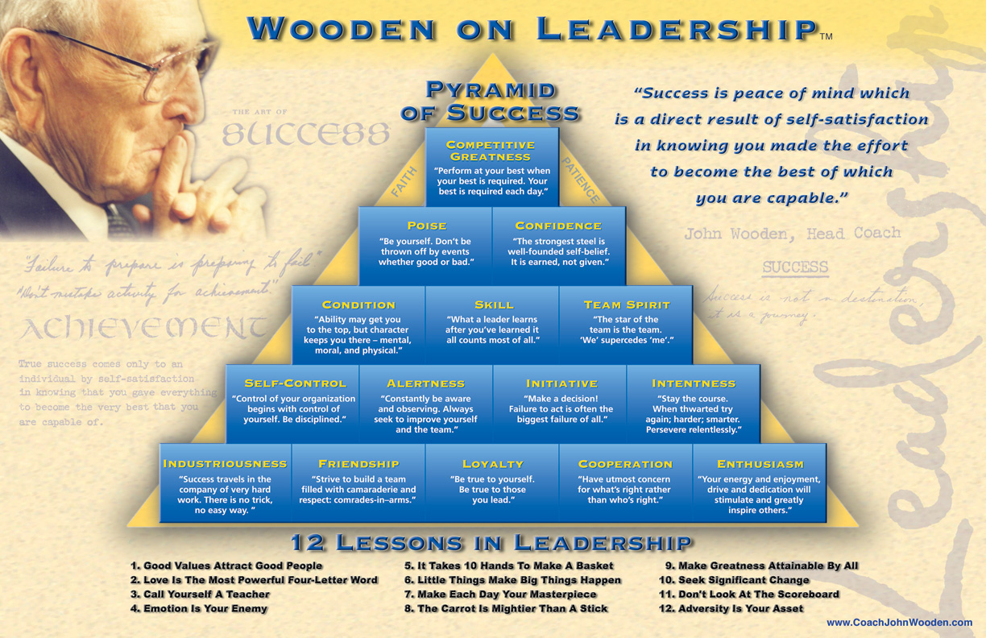
- Don’t confuse fear with respect as a coach

- The EGO in Sport
- Ego refers to someone’s self-confidence
- Construct of the mind
- Begins at a very young age – as soon as people start to tell you what to do/what not to do (punishment vs. reinforcement)
- Ego is constructed by our mind in order to protect us; and forgets nothing
- Tries to ensure that you are not hurt again
- Takes information about the past to protect you in the future
- Gives you a defense mechanism – anger/humor/agreeableness/putting others down before the hurt you
- Ego can sense impending ‘danger’ for your self-confidence
- Operates on fear – we all fear emotional injury and fear
- “The Zone” – being in the moment; living in the very present exact moment they are in – they don’t have to think about anything else; the EGO is not operating

- January 12th, 2015
- We all have our essential self that we are born with
- We all have this purity we are born with – Children
- Life experiences/responsibilities/and societal rules place a heavy burden on children which extinguish their purity and causes the Ego to develop
- Children acting out/outer self is the result of all the ‘injuries’ to their self-esteem from years worth of fear/expectations etc.
- People’s fears center around how the feel emotionally; their efficacy in their jobs, relationships etc.
- The older you get, the bigger role your Ego plays – have dealt with more rejection
- As a coach, you must understand that every single one of your players comes with a different set of fears
- Create a culture where your athlete’s feel completely safe – helps to deal with discipline problems
- A culture where you treat everyone the same, and demand that your players treat everyone with respect
- Being treated differently = being judged = causes athletes to act out and use ‘defense mechanisms’
- The key is to talk about everything you know, and hear everything your players/assistants know in order to assimilate information and move forward as a team

- The Present Now
- The Buddhist concept of ‘being awake’ – living in the present now
- As a coach this means:
  - Being completely aware of your actions and words
  - Conscious – aware of everything during your practice/performance/etc.
  - In order to be conscious of what’s happening with your athletes, you have to be in the present moment
  - You cannot worry about what may happen in the future (i.e. what the game’s end result will be, you can only control what is happening at the present moment)
  - ‘In the Zone’ – you have to be aware of every improvement of every athlete on your team
  - This will allow you to make modifications/advancements in your practices in order to facilitate these improvements

- January 16th, 2015
- Most discipline problems are due to frustration and confusion
- Homogenous grouping – group similarly skilled athletes together
- When doing homogenous grouping, you run the risk of judging, etc.

- As a coach you want absolute focus – it makes it more difficult when your athletes are of varying skill levels
- Want best players working with lesser players – involves team unity and sharing of information; respect within the group

- Anger vs. Being Upset
- Emotionally –anger is an ego trigger
- Physically – one owns the anger; you own it in your body – when you are angry your muscles tense (fight or flight mode)
- Psychically – the anger is an attack
- Anger is based on fear the ego’s tendency is to react; a confrontation occurs
- Anger is always your fault (as it is based on your own fears) – this means you can never blame someone else for your anger
- It is always your choice whether or not to be angry; to deny this is to let others control your life, or, in essence, your life is out of control
- As a coach – these fears usually arise from fear of being undermined, lack of respect from your athletes, fear of failure
- When you let others dictate your anger, you are giving them control over your life

- If someone is angry at you…
- It is never about you
- It is always about that person’s fears
- It is always your choice whether or not to respond with anger, because your ego will be stimulated to defend you

- The Four Agreements – Don Miguel Ruiz
- Be the best you can be (…because that is all there is)
- Never make assumptions
- Never take things too personally
- Be as good as your word

- Stopping Anger
- Step back
- Count to 10
- “I am triggered”
- Recognize it is your ego that is driving the trigger
- Let it go
- Respond in peace

- People’s opinions are based on their perceptions; which have developed over time based on their personal life experiences
- Anger and passion are two very different things; do not confuse the two

- January 19th, 2015
- Coaching Philosophy
- Your style of coaching
- Winning and losing
- Discipline
  - start times
  - uniforms and dress code
  - swearing
  - drugs, and drinking etc.
- Consequences – in terms of disciplining
- What do you want to accomplish?
- What are your priorities
- Defining roles
  - Coaches
  - Players
  - Admin
  - Parents
- Communications
- Dealing with parents:
  - Your availability and accessibility by the parents should be defined at the beginning of the year
- Academics/time management
  - Does school come first?
  - What kind of excuses are acceptable?
  - Is lateness is acceptable

- As a coach, you must abide by the same rules you set our for your athletes – be apart of the ‘we’
- You cannot say one thing and then do another
- Must respect the athletes well being and not put further psychological or physical pressure beyond the expected means

- Parents Expectations for their Children in Sports
- To build self-esteem
- To have fun
- To develop skills
- To increase their fitness
- Meet New friends

- What do parents expect of coaches?
- Make sport enjoyable
- Respect children as individuals
- Be knowledgeable
- Be safety conscious

- Why athletes participate in their favorite sports?
- To have fun
- To improve their skills
- To stay fit
- To participate at something in which they succeed
- To have fun competing with others

- 6 most common reasons for dropping out of sport
- 1. Not getting to play – practiced hard but no game time
- 2. Negative reinforcement – too much criticism
- 3. Mis-matching – “I had to tackle a monster”
- 4. Psychological stress – too much pressure
- 5. Failure – losing repeatedly shattered confidence
- 6. Over-organization – no time for fun
- These factors vary depending on intensity and level of sport

- January 21st, 2015

- Coaching Association of Canada
- Connection between physical abilities and respective age
- Certain aspects of physical development should be emphasized at different points along child development in order to reach peak ability
- Strength and endurance should continually be emphasized

- Volition When you removed the pressure of having to do something, does attendance and commitment increase?
- Does pressure take away from the love of the sport?

- As a coach, how would you like to be remembered?
  - A coach who contributed to the development of young people?
  - A coach for whom players enjoyed playing for
  - A winning coach

- Coaching styles spectrum
- Compliant
  - Put’s athlete’s wants first
  - All about fun
- Cooperative
  - Concerned with building better people
  - Well-organized, still cares about winning and fun
  - Give’s some ownership to the athlete’s themselves
- Commanding
  - “My way or the high way”
  - Associated with the winning model

- For your own philosophy:
- How much say do your athletes have in determining the structure of your team?
- To compliant? Makes it hard to get done, what you as coach believe to be important
- Important to stay on one side of the coaching spectrum for everything you do – flipping around will confuse the athletes, and cause them to lose respect

- For playing time:
- Not equal playing time
- Spares will be played in order to ensure competency
- Playing time at different levels of sport?
- In regular season vs. playoffs?
  - Playoffs – start your best; consistently start the same lineup; belief that if someone is playing bad take them off; give them a break
  - Regular season – more equal playing time in order to determine what works; but consistent starters

- Important to speak, act and present yourself as a role model: no matter what level of play
- Do you believe in fair competition? Intentional penalties?

- Friday, January 23rd
- Intentionally breaking the rules has become a tactic in most sports
- What message is this sending to our athletes?
- Society teaches us that the lessons that we learn in sport are similar to those we learn in life that sport builds character..so if we are teaching cheating/foul play in sports, are athletes going to translate that into their lives?

- Characteristics of a Great Coach

- Dedicated
- Passionate
- High expectations
- Moral/ethical
- Creative
- Honest
- Inspiring
- Organized/prepared
- Empathetic
- Respectful
- Think of the things you need to work on/you excel in

- Coaching the outcome vs. Coaching the process
- Winning vs. competition
  - If you believe in competition, you believe in how well your team plays
  - If you believe in winning, you do whatever it takes to have your team win

- The desire to win = the refusal to quit
- Once you become out of the zone you are becoming reactive as opposed to proactive = must stay in the zone

- Monday, January 26th
- Discipline is number one – team must understand what they are doing
- Fatigue is greatest enemy to young athletes – conditioning requires discipline

- Team must be disciplined and understand exactly what to do with:
  - Start times
  - Uniforms and dress code
  - Swearing
  - Drugs and drinking
- What are the consequences if someone is there on time?
  - Age matters – younger ages are dependent on others for rides
- Base your consequences on a core belief system; be consistent
- What happens if a star player forgets their gear?
  - Do you want to establish a culture or is the result of the single game more important?
- What are your expectations of the night before a practice/game?
- No matter what, do not set every rule into stone unless you plan to 100% follow your rules every single time – other wise you lose respect
- Have some flexibility – reasonably good excuses
- Are the athletes going to be responsible for the consequences? Or will you?

- January, 28th 2015
- What If a player is acting up?
- Do you punish them individually or the team as whole?
- Punishment depends on type of athlete – some punishments might not work on everyone the same

- Defining Roles
- What qualities are you looking for in an assistant coach?
  - Same vs. different ideas (ideally the same philosophy)
  - Similar beliefs but no “another you”
  - Need to respect your position
- Don’t want a Yes Man; need some who commands respect and authority as well

- What will your relationship with your players be?
- Do not try and be their friend – you will have to make difficult decisions
- Treat everyone exactly the same

- Coaches and Parents
- How will you communicate with them?
- Set boundaries

- With regards to players: you cannot change people but you can create environments in which they want to change
- Team culture of changing for the better
- Mistakes? If there are pushing the boundaries, they will make mistakes along the way and as a coach you have to take that into consideration
- Players in individual sports have no one else to hide their mistakes behind

- Your position on playing time of athletes…
  - Based on ability
  - Based on effort
  - Based on equality
  - How will you justify it to parents?
  - How will you allow for change?
- What happens if you have one player who is so far below the ability and level of the rest of the team? Or a group of players?
  - Talking the player about the situation
  - Pair one of the better players with them; and have the work together in order the share skill sets outside of practice?
  - Extra practice for this player?
  - Describe particular role to player? In order to develop skill sets that are lacking

  - Trying players in different positions
  - Split practice into two parts; homogenous grooming?
  - How do we integrate these athletes so they feel valued
- January 30th, 2015

- Leadership
- As a coach you have specific outcomes that you expect of your athletes
  - Do you expect your athletes to perform in the exact way you expect them too
  - Do you abandon the drill if the outcomes aren’t as how you attended it to be
- Absolute focus
- The Great Event theory – during huge times of distress in history; leaders emerge
- The Trait theory – means that certain people are born with leadership traits
  - Their appearance – what does a leader look like?
  - Common traits among leaders
- The Process leadership theory – anyone can become a leader
  - Must have a vision
    - In your mind you have to have an idea of where you want to be; where you are going
  - Pass scrutiny on what you are
  - Have excellent communication skills
    - Athletes need to understand your vision
    - Need to know how they contribute
    - Need to know how they are doing; goal attainment; know what role each person plays
    - Knowing what job/role they have on a team allows players to understand exactly what they need to be doing
  - Are responsible (be as good as your word)
  - Must be trustworthy
- Four Actions of World Class Leaders
- Stretching people – challenging athletes to work to the best of their abilities; constantly setting goals that are harder than the last one
- Empowering athletes – giving athletes ownership to maker their own decisions
- Sharing –the ability to exchange information and know-how; involves the capacity to involve people with respects to objectives
- Coaching – the ability to be a guide and a trainer – coaching is based on the capacity to respect people, to listen attentively, willingly and considerately

- Leadership is the ability to influence other people to act in line with your expectations willingly or otherwise
- Everything or anything the leader does to accomplish the goal of gaining followership merely defines the style of leadership

- February 2, 2015
- Be the Best You
  - Be responsible
  - Be a life time learner
  - Be excellent in everything you do
  - Don’t micro-manage
- Step Forward whenever
  - Be the first too accept responsibility for a job
  - Learn to put yourself on the line
- Work at communications
  - Assigning roles
  - Giving feedback
  - Articulating your plan/vision
- Know your people
  - Treat them all equally
  - Care about them
- Let your passion be obvious, but under control
- Set an example of excellence
  - Demand it of those around you
  - Lead by example

- Your position on playing time of athletes….
  - Based on ability?
  - Based on effort?
  - Based on equality?
  - How will you justify it to the parents?
  - How will you allow for change?
- If you assume everyone should be at every practice – then you cannot base playing time on attendance/effort
- Base playing time on ability – the better you can make the less skilled players, the more the top players have to push themselves to be better
- Attendance is a factor – if best players are consistently not showing up to practices, then they will be sat
- Everyone will get some playing time
- Be prepared for player’s levels of ability changing –
- If an athlete has a bad game/shift – do they get the opportunity to prove themselves? Or are they pulled

- Feedback
- When is the best time for a coach to give feedback?
- For coaches – level of arousal/anxiety is highest after a game and declines as time passes
- For athletes – level of arousal/anxiety is low after a competition (less receptive)
- Best to do it the next practice, in order for athletes to be more receptive and for coaches to formulate

- Wednesday, February 4th 2015
- Some people are just destined to lead – natural leaders
- What kind of energy you bring with you – your athletes will sense
  - What are your energy levels like? Am I carrying the days struggles with you – or are you open and receptive to dedicating your time to your athletes?
  - The energy you bring will have a profound effect on your athletes
  - Don’t allow yourself to focus on anything negative

- General Communications
- Use cue words or key points – limit instructions to essentials
- K.I.S.S principle
  - Keep it short and simple
  - Cue words
- Always express yourself in the affirmative
  - Instinct is always to tell people what they are doing wrong/what not to do
  - Horrible habit of holding on to what people tell you, you are doing wrong
  - Tell them what they are doing right
- Positives in public, negatives in private
  - High-fives, congratulations, etc.
- Ask for feedback on practices
  - Habit of one-on-one feedback about how the athlete is doing overall so they can understand where they stand in your overall vision (their role on the team)
- Talk to three athletes each practice
- Thank your athletes at the end of practice/game
- Make yourself available
- You can’t communicate too much
- Understand learning styles when communicating – visual, tactile, auditory

