Concordia University
Department of Economics

ECON 201 - INTRODUCTION TO MICROECONOMICS Winter 2014

COMMON FINAL EXAMINATION - VERSION 1

FIRST NAME: LAST NAME:

STUDENT NUMBER:

Please, read all instructions carefully:

1. The exam consists of two parts:

(i) Part I: 50 multiple-choice questions (100 marks);
(ii) Part II: Choose 4 out of 5 long questions (100 marks).

2. Write your name, student ID and answers for the multiple-choice questions on the computer scan-sheet with a pencil. Please, also write the version of the exam on the computer
scan-sheet. For Part II, write all your answers on this exam. Do not use additional booklets.

3. You are allowed to use a non-programmable calculator and a paper dictionary, provided that they are approved by the invigilator(s). You may use either pen or pencil to provide your answers for Part II.

4. You are not allowed to tear any pages out of this exam.

Grades:

Part I: Part II:
Problem #1:

Problem #2:

Problem #3:

Problem #4:

Problem #5:

Total:
Part I: Multiple Choice Questions. Write your answers on the computer sheet in
PENCIL.(Total=100 marks)

1. What do good economic models do?

(a) They often leave out important variables, causing serious errors.
(b) They omit many details to allow us to see what is truly important.
(c) They are designed to give a complete picture of a given relationship. (d) They leave economics to be interpreted in many ways by governments.

2. When an economy is operating inside its production possibilities frontier, what do we know?

(a) To produce more of one good, the economy would have to give up some of the other. (b) The economy is operating with efficiency.
(c) Moving to a point on its production possibilities frontier would need a better technology. (d) There are unused resources or inefficiencies in the economy.

3. Suppose the 1999-2000 inflation rate is 10%. Let the base year be 1999. If the real hourly wage in 2000 were to be $15, what must be the value of the nominal hourly wage in 2000?

(a) | $16.
(b) | $15.5.
(c) | $16.5.
(d) | $16.6.
4. Which of the following would be considered as cross-sectional data?

(a) Inflation rates between 1990 and 2010.
(b) The rise in the cost of living over the past five years.
(c) The income and gasoline consumption of 1,000 residents in Montreal in 2012.
(d) The mortgage payments of Anna, Ben and John between 2005 and 2010.
5. Which of the following would definitely result in a higher price for chocolate bars? (a) Demand increases and supply decreases.
(b) Demand and supply both decrease.
(c) Demand decreases and supply increases. (d) Demand and supply both increase.

6. The country of Econoland produces two goods: textbooks and widgets. Last year, it produced
300 textbooks and 600 widgets. This year, it produced 350 textbooks and 700 widgets. Assuming it is on the PPF and given no other information, which of the following could NOT explain the change?

(a) Econoland experienced a reduction in unemployment.
(b) Econoland experienced an improvement in widget-making technology. (c) Econoland acquired more resources.
(d) Econoland experienced a high level of emigration out of the country.

7. Which of the following would cause both the equilibrium price and equilibrium quantity of number two grade potatoes (an inferior good) to increase?

(a) An increase in consumer income.
(b) A decrease in consumer income.
(c) Greater government restrictions on agricultural chemicals, used as input to production. (d) Fewer government restrictions on agricultural chemicals, used as input to production.

8. What will result from an increase in resource costs to firms in a market?

(a) A decrease in equilibrium price and an increase in equilibrium quantity.
(b) An increase in equilibrium price and a decrease in equilibrium quantity.
(c) A decrease in equilibrium price and no change in equilibrium quantity. (d) An increase in equilibrium price and an increase in equilibrium quantity.

9. What might be the reason when quantity demanded has increased at every price?

(a) The number of buyers in the market has decreased.
(b) Income has increased and this good is an inferior good. (c) The consumer prefers another good more than this good. (d) The price of a substitute good has increased.
10. Market demand is given as Qd = 120 − P . Market supply is given as Qs = 4P . What would result if the market price were $35?

(a) A shortage of 85. (b) A surplus of 85.
(c) A surplus of 55.
(d) A shortage of 55.

11. If a per unit tax is imposed and the supply curve is perfectly inelastic, which statement is correct:

(a) Deadweight loss = 0 , Producer burden = 0 , consumer burden = Tax.
(b) Deadweight loss = 0 , Producer burden = Tax , consumer burden = 0.
(c) Deadweight loss is maximum, Producer burden = 0 , consumer burden = Tax. (d) None of the above.

12. If quantity demanded increases from 1,000 to 1,200 units when income rises by 10 percent, using the initial quantity as base, this good could be classified as:
(a) Normal and luxury.
(b) Inferior.
(c) Normal and Necessity.
(d) Cannot be determined from the information provided.

13. Refer to the table below. Using the arc elasticity of demand, the demand for coke is .

 | Price of Jolt | Price of Coke | Income level | Coke Sales
2008  2009  2010  2011 | $1/can  $2/can  $2/can  $2/can | $2/can  $2/can  $3/can  $3/can | $30,000  $30,000  $30,000  $40,000 | 10,000 cases  15,000 cases  10,000 cases  12,000 cases

(a) Unit elastic.
(b) Elastic. (c) Inelastic.
(d) Perfectly inelastic.

14. Assume that John is allocating his budget optimally between two products. If the M U of product X is 10 and its price is $2, the M U of product Y is 5 and its price is $1, then John should:

(a) Increase the consumption of both X and Y. (b) Decrease the consumption of both X and Y.
(c) Increase the consumption of X and decrease the consumption of Y. (d) None of the above.

15. Assume again that John is allocating his budget optimally between soft drinks and hamburg- ers. If the M U of a soft drink is 40 and its price is $4, what must be the price of hamburgers if its M U is 60?

(a) | $6.
(b) | $12.
(c) | $16.
(d) | $40.
16. A demand curve slopes downward due to:

(a) Diminishing marginal productivity. (b) Diminishing marginal utility.
(c) Diminishing marginal rate of substitution. (d) Diminishing return to scale.
Refer to graph below for the next two questions. MSB is the marginal social benefit demand curve, which is parallel to the private benefit demand curve.

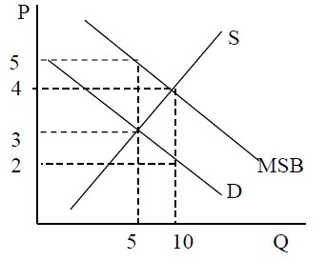

17. Which of the following statements is correct?

(a) The free-market price and quantity are P=3 and Q=5.
(b) The socially optimal price and quantity are P=4 and Q=10. (c) There is a positive externality.
(d) All of the above.

18. To achieve allocative efficiency, the government should use a , which creates a .

(a) Subsidy of $2 per unit, welfare gain of $5.
(b) Tax of $2 per unit, welfare gain of $5.
(c) Subsidy of $2 per unit, deadweight loss of $5. (d) Tax of $2 per unit, deadweight loss of $5.

Use the figure below to answer the following two questions:

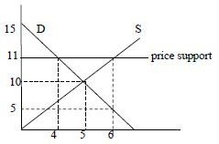

19. Suppose the government sets a price floor at $11 and buys any excess supply. Which of the following statements is correct?

(a) Cost to government = $0, consumer surplus = $8 and producer surplus = $18. (b) Cost to government = $22, consumer surplus = $18 and producer surplus = $8. (c) Cost to government = $22, consumer surplus = $8 and producer surplus = $18. (d) None of the above.

20. Suppose the government provided a subsidy to suppliers, instead of a price floor, with a guaranteed price of $11. This would result in:

(a) Dead weight loss = $3.
(b) Dead weight loss = $2. (c) Deadweight loss = $4. (d) None of the above.

21. Which of the following assumptions is often realistic for a firm in the short run?

(a) The firm can vary both the size of its factory and the number of workers it employs. (b) The firm can vary the size of its factory, but not the number of workers it employs. (c) The firm can vary the number of workers, but not the size of its factory.
(d) The firm can vary neither the size of its factory nor the number of workers it employs.

22. What do we know about fixed costs?

(a) They vary inversely/negatively with production. (b) They vary directly/positively with production.
(c) They are incurred only when production is large enough. (d) They are incurred even if nothing is produced.
23. Why is average total cost very high when a small amount of output is produced?

(a) Average variable cost is low. (b) Average fixed cost is high. (c) Marginal cost is low.
(d) None of the above.

24. Which statement is incorrect: When marginal product exceeds average product,

(a) Average fixed cost must be falling. (b) Average product must be rising.
(c) Average variable cost must be falling. (d) Marginal cost must be increasing.

25. Marginal cost eventually increases as output increases. What property does this reflect?

(a) Increasing fixed cost. (b) Diminishing total cost.
(c) Increasing marginal product.
(d) Diminishing marginal product.

26. A firm’s efficient scale is the quantity of output that

(a) Maximizes marginal product. (b) Maximizes total revenue.
(c) Minimizes average total cost.
(d) Minimizes average variable cost.

27. One explanation of risk aversion is that

(a) The expected utility is bigger than the utility of the expected dollar value with certainty. (b) Individuals do not take any risk.
(c) The marginal utility of an extra dollar decreases as more income is received.
(d) The marginal rate of substitution between winning and risk is constant.

28. Which of the following is not an example of risk pooling?

(a) A car insurance company that insures Canadian drivers. (b) Credit bureau that gives credit cards to different people. (c) An investor that has a diversified portfolio.
(d) Insuring Microsoft against bankruptcy.

29. Why does pooling risk decrease the insurer’s overall risk? (a) Each individual’s risk is very low.
(b) Each individual’s risk is independent of everybody else’s.
(c) Insurance companies never insure risky people. (d) All of the above.

30. How does technological improvement affect the production process?

(a) It causes short-run average costs to increase.
(b) It extends the increasing returns portion of the long run average cost curve.
(c) It causes long-run average costs to increase.
(d) It causes the decreasing returns to scale on long run average cost.

31. All of the statements below describe characteristics of a perfectly competitive market, except

(a) There are many small producers.
(b) All the producers sell identical products. (c) Entry by new producers is free.
(d) Exit by existing producers is not free.

32. Suppose that the equilibrium price in a perfectly competitive market is $20 per unit sold. If a firm in the market decides to charge $25 per unit for its product then

(a) This firm will increase its profits.
(b) This firm will sell units of its product.
(c) This firm will not sell any units if its product.
(d) This firm will increase the demand for its product.
33. Why do firms in perfectly competitive markets make zero economic profit in the long run? (a) Because firms produce differentiated products.
(b) There are no barriers to the entry.
(c) Because firms do not produce at their minimum efficient scale.
(d) Because the total market is not large enough to accommodate so many firms.

34. A perfectly competitive firm’s supply curve is

(a) Zero for all the prices below the shutdown price and for all the prices above the shutdown price is the marginal cost curve above its minimum average total cost.
(b) Zero for all the prices below the shutdown price and is the upward sloping part of the marginal cost curve above the break-even price.
(c) Zero for all the prices below the shutdown price and for all the prices above the shutdown price is the marginal cost curve above its minimum average variable cost.
(d) None of the above.

35. In perfect competition there
(a) Are many sellers who each face a downward-sloping demand curve. (b) Are a few sellers who each face a downward-sloping demand curve. (c) Is only one seller who faces a downward-sloping demand curve.
(d) Are many sellers who each face a perfectly elastic demand curve.
36. Would a firm in a monopolistic market ever produce where Marginal Revenue is negative? (a) No.
(b) Yes.
(c) Only in some cases.
(d) There is not enough information to answer this.

37. For a natural monopoly to exist

(a) A firm must continually buy up its rivals.
(b) A firm’s long-run average cost curve must exhibit continuously diseconomies of scale. (c) A firm’s long-run average cost curve must have continuously economies of
scale.
(d) A firm must have a government-imposed barrier.

38. A monopolist is presently selling 9 units. When it increases the quantity supplied from 9 to
10 units, the price decreases by $1 to $12 per unit. What is the Marginal Revenue received by the monopolist from the 10th unit?

(a) 6. (b) 5. (c) 4. (d) 3.

39. If marginal revenue exceeds marginal cost, a monopolist should:

(a) Increase output.
(b) Decrease output.
(c) Keep output the same. (d) Raise the price.

40. Compared to a perfectly competitive market, a monopoly market will usually generate:

(a) Higher prices and higher output.
(b) Higher prices and lower output.
(c) Lower prices and lower output. (d) Lower prices and higher output.

41. In a duopoly game, what characterizes a dominant-strategy equilibrium?
(a) Both firms choose the same strategy.
(b) Each firm has a unique profit maximizing strategy.
(c) Each firm chooses the strategy of trying to dominate their rival. (d) The firms’ joint profits are maximized.

42. A non-price trade barrier includes which of the following?

(a) Tariffs.
(b) Safety standards.
(c) Minimum pricing laws. (d) Subsidies.

43. Which of the following defines oligopoly behavior?

(a) They produce more and sell at a higher price than a monopolist. (b) They set price equal to marginal cost.
(c) They produce the monopoly output when they are able to collude.
(d) All of the answers are correct.

44. In the table below, which defines the unit cost of producing wine and autos in France and
Germany:

 | France  (euros) | Germany  (euros)
Wine | 10 | 15
Autos | 10,000 | 20,000

(a) France has a comparative advantage in wine and Germany in autos.
(b) Germany has a comparative advantage in wine and France in autos.
(c) Germany has a comparative advantage in both goods. (d) None of the above.

45. In the table below, which shows several points on the production possibilities frontiers for
Canada and the US:

Canada United States

 | A | B | C | D |  | A | B | C | D
Peaches | 0 | 5 | 10 | 15 | Peaches | 0 | 10 | 20 | 30
Apples | 45 | 30 | 15 | 0 | Apples | 45 | 30 | 15 | 0

(a) Canada has an absolute advantage in peaches.
(b) Canada has a comparative advantage in apples.
(c) The US has an absolute advantage in apples.
(d) The US has a comparative advantage in apples.

46. Once a cartel determines the profit-maximizing price:

(a) Changes in the output of any member firms will have no impact on the market price. (b) The temptation to cheat on the agreement may induce some firms to reduce output. (c) Entry into the industry by rival firms will have no impact on the profit of the cartel. (d) All of the above are false.

47. What is true at a Nash equilibrium in a two-firm game?

(a) Output levels are where M C = AT C .
(b) Both players chose the strategy that maximizes their joint payoffs. (c) The players collude on their strategy.
(d) Neither player has an incentive to change strategy.

48. Excess capacity in monopolistically competitive firms is caused by:

(a) The fact that rival firms enter the industry and reduce the demand for the products of the firms already in the industry.
(b) Cost curves being higher than they are under perfect competition.
(c) The waste of many slightly differentiated products serving almost the same purpose. (d) The fact that each firm faces a demand that is not perfectly elastic.

49. Suppose that the typical firm in a monopolistically competitive industry earns an economic/supernormal profit and new firms enter. This causes:

(a) The firm’s demand curve to shift to the right. (b) The industry demand curve to shift to the left.
(c) The firm’s demand curve to shift to the left.
(d) None of the above.

50. The table below describes the profits accruing to each firm in a game. The first figure in any box is firm A’s profit, and the second is firm B’s profit. High and low refer to the strategy of having a high or low advertising budget. Which of the following statements is correct if B and A reach a secret agreement between themselves concerning advertising budgets and this agreement holds because neither cheats?

Firm B strategy

 | Low budget | High budget
Firm A strategy Low budget | 500, 500 | 300, 800
High budget | 800, 300 | 400, 400

(a) One will have a low budget and the other a high budget and total profits will be $1100. (b) Each will have a low budget and joint profits will be $1000.
(c) Each will have a high advertising budget and joint profits will be $800. (d) None of the above.
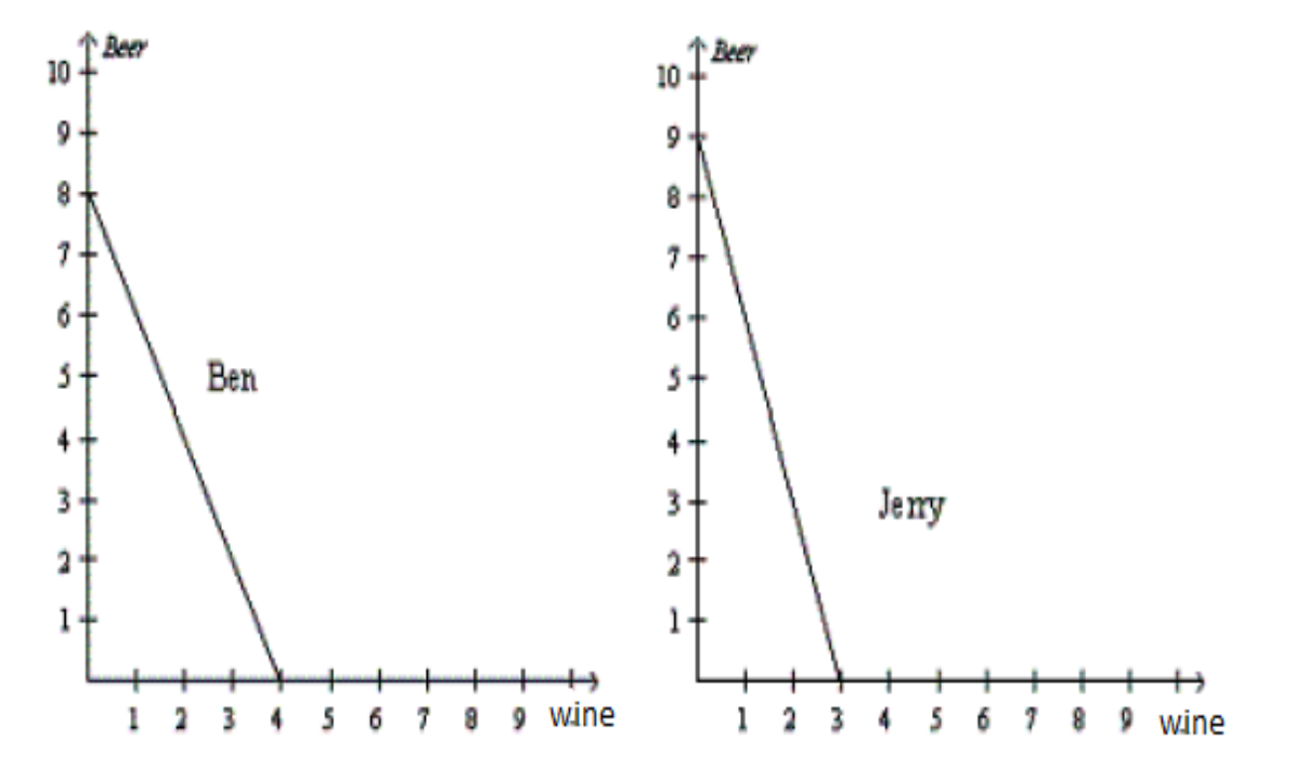Part II: Answer FOUR of the following FIVE questions. If more than four questions are answered, only the first four attempted will be marked.(Total=100 marks)

Question#1 (25 marks) Suppose Ben and Jerry both could produce beer and wine. The figure below presents production possibility frontiers for Ben and Jerry.
(i) For Ben, what is the opportunity cost of one bottle of wine? (3 marks)
2 bottles of beer.
(ii) For Ben, what is the opportunity cost of one bottle of beer? (3 marks)
Half a bottle of wine.
(iii) What does each of the two producers have an absolute advantage in? (4 marks)
Ben has an absolute advantage in wine and Jerry has an absolute advantage in Beer.
(iv) If each person has 40 hours and they devote half of their time (20 hours) to the production of each good, what would the total production be? (5 marks)
Ben will produce 2 wines and 4 beers, Jerry will produce 1.5 wines and 4.5 beers.
(v) If Ben and Jerry specialize in the good in which they have an absolute advantage, what would the total consumption be? (5 marks)
4 wines and 9 beers.
(vi) Plot Jerry’s trading possibilities curve (by plotting at least 2 points on the curve) if the actual terms of the trade are 2.5 beers for 1 wine.(5 marks)
The two intercepts can also serve as 2 points on the PPF.

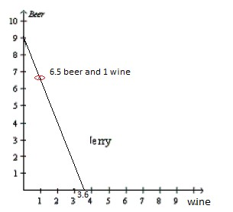
Question#2 (25 marks) Suppose the prices of muffins (M) and coffee (C) are PM = $1 and PC = $2, and we observe the consumer to purchase exactly two muffins and one coffee every day.

(i) Graph the resulting budget constraint on a diagram (muffins on the vertical axis and coffee on the horizontal axis), with intercepts clearly marked, explaining how you arrive at the answers. What is the consumers total income? (6 marks).
Answer: I = 1 ∗ 2 + 2 ∗ 1 = 4, Vertical intercept = I = 4/1 = 4, Horizontal
PM
intercept = I = 4/2 = 2.
P
C
(ii) Calculate the slope of the budget line and explain what it stands for. If the M U from
coffee consumption at the optimal bundle is equal to 20, find the M U obtained from consuming the muffins. (6 marks).
Slope of budget line = − PC
PM
= −2. It means that to get one more extra unit
of coffee the consumer must give up 2 units of muffins. M UM = 20/2 = 10.
(iii) Now suppose the government imposes a $ 1 tax on coffee. Illustrate graphically and explain what happens to the M RS at the new equilibrium. (6 marks).
New PC = 3 , budget line rotates inward and becomes steeper. MRS=new slope of budget line= -3/1=-3.So M RS will increase in absolute value.
(iv) Instead of the tax in (iii), assume now that the consumer experienced a drop in his/her income by 25% per day. Illustrate the new budget constraint and the new optimal bundle on a diagram with clearly labelled intercepts, assuming that the new quantity consumed of muffins is 1 muffin. Specify whether muffins are a normal or an inferior good. (7 marks).
Budget line shifts to the left. Muffins are a normal good.

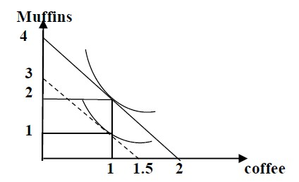
Question#3 (25 marks) Fill in the blanks, given that the wage, W, equals 5040 and is fixed.(Hint: Why is there a total cost of 600 even though nothing is produced?)Each blank equals one mark.

Q | APL | MPL | AVC | AFC | AC | TVC | TFC | TC | MC
0 | – | – | – | – | – |  |  | 600 | –
10 | 504
20 |  |  |  |  |  | 400 |  |  | 30
30 |  | 100.8

Answer:

Q | AP | MP | AVC | AFC | AC | TVC | TFC | TC | MC
0 | – | – | – | – | – | 0 | 600 | 600 | –
10 | 504 | 504 | 10 | 60 | 70 | 100 | 600 | 700 | 10
20 | 252 | 168 | 20 | 30 | 50 | 400 | 600 | 1000 | 30
30 | 168 | 100.8 | 30 | 20 | 50 | 900 | 600 | 1500 | 50

Question#4 (25 marks)A perfectly competitive firm is in a short-run situation in which it is stuck with 5 units of capital. The rental rate is r=$4 per capital unit. The firms marginal cost (MC), fixed cost (FC), variable (VC) and average variables costs (AVC) are displayed in the table below.

Output  (units) | MC  ($/unit) | FC  ($) | VC  ($) | AVC  ($/unit)
0 | - | 20 | 0 | -
1 | 15 | 20 | 15 | 15
2 | 12 | 20 | 27 | 13.5
3 | 9 | 20 | 36 | 12
4 | 7 | 20 | 43 | 10.75
5 | 6 | 20 | 49 | 9.8
6 | 5 | 20 | 54 | 9
7 | 6 | 20 | 60 | 8.57
8 | 7 | 20 | 67 | 8.37
9 | 9 | 20 | 76 | 8.4
10 | 11 | 20 | 87 | 8.7
11 | 14 | 20 | 101 | 9.18
12 | 18 | 20 | 119 | 9.91
13 | 23 | 20 | 142 | 10.92
14 | 30 | 20 | 172 | 12.28

(i) What is the shutdown point?(6 marks)
P = 8.37$/unit, Q=8 units.
(ii) If the price in the market is P=14$/unit what is the profit maximizing quantity?(6 marks)
Q = 11 units because P=14=MC.
(iii) At the price P=14$/unit what is the profit of the firm?(7 marks)
Profit(Q)=[P - ATC(Q)]Q.
ATC(11) = (FC(11)+VC(11))/11 =(20$ + 101$)/11units = 121$/11units=
11$/unit.
Profit(11) = [14 - ATC(11)]11=[14$ - 11$/unit]11units= 33$.
(iv) Using the info in part (iii),draw the demand curve that the firm faces, its MC and ATC curves, and show the area that represents the profit of the firm. Make sure you label everything clearly.(6 marks)
Demand curve is perfectly horizontal at P=14, MC and ATC are as usual U-shaped, MC min=5, ATC=MC at ATCmin, profit maxing quantity is where P=MC, profit is area between P and ATC, up to profit maxing quanitity.
Question#5 (25 marks)The domestic demand in the market for appliances is given by
P = 128 − 1 Q; the market supply of domestic suppliers is given by P = 12 + 1 Q, and the
2 4
world price is $32.

(i) First graph this market and then solve for the equilibrium quantity purchased for a country open to trade.(6 marks)
q=192.
(ii) How much of the quantity traded will be produced domestically and how much will be imported? (6 marks)
80 and 112.
(iii) If a tariff of $6 per unit is imposed on the imported good, illustrate the impact in a diagram and compute the total quantity demanded in the market.(6 marks)
World supply price shifts up to $38 per unit; quantity demanded falls to
180.
(iv) Instead of the tariff, if the domestic government wished to attain the same total quantity demanded as in part (iii), but choose to subsidize supply instead, what would the unit supply subsidy have to be? (7 marks)(Hint: At the quantity in part (iii), what is the dollar difference between the quantity demanded and the price at which domestic suppliers would be willing to supply that amount?)
Subsidy should be $19.

