ANP1106 Topic 1 – Anatomical Terms

Page 11-20

1.1 Describe the anatomical position, the regional and directional terms, as well as the planes and sections

Anatomical Position:
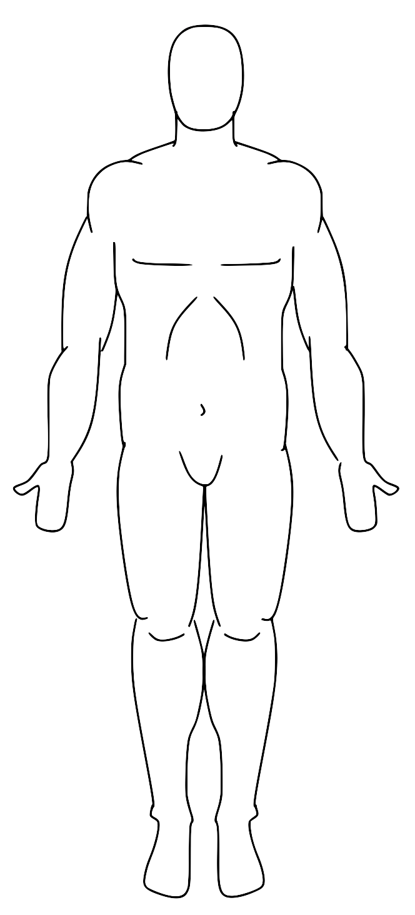
- The anatomical reference point to which body parts are described
- Body is erect with feet slightly apart
- Palms face forward and thumbs point away from the body
- Directional terms refer to the body in this position, regardless of actual body position

Directional Terms:
Allow us to explain where one body structure is in relation to another

Term | Definition | Example
Superior (Cranial) | Towards the head or upper part of a structure or body; above | The head is superior to the abdomen | 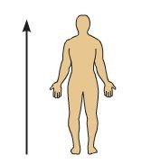
Inferior (Caudal) | Away from the head or towards the lower part of a structure or the body; below | The leg is inferior to the chin | 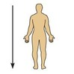
Ventral (Anterior- only in humans) | Towards or at the front end of the body; in front of | The breastbone is anterior to the spine | 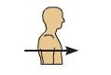
Dorsal (posterior- only in humans) | Towards or at the back end of the body; behind | The heart is posterior to the breastbone | 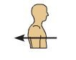
Medial | Towards or at the midline of the body; on the inner side of | The heart is medial to the arm | 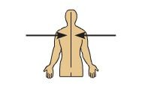
Lateral | Away from the midline of the body; on the outer side of | The arms are lateral to the chest | 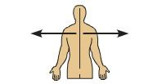
Intermediate | Between a more medial and a more lateral structure | The collarbone is the intermediate between the breastbone and the shoulder | 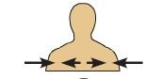
Proximal | Closer to the origin of the body part or the point of attachment of a limb to the body trunk | The elbow is proximal to the wrist | 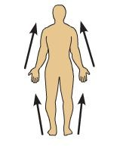
Distal | Farther from the origin of a body part or the point of attachment of limb to the body trunk | The knee is distal to the thigh | 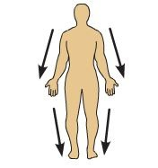
Superficial (external) | Toward or at the body surface | The skin is superficial to the skeletal muscles | 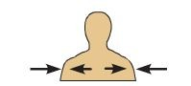
Deep (internal) | Away from the body surface; more internal | The lungs are deep to the skin | 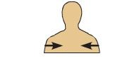

Regional Terms:
There are two fundamental divisions of the body:
- The axial part which makes up the main axis of our body includes the head neck and truck
- The appendicular part consists of the appendages or limbs which are attached to the body’s axis
- Regional terms used to designate specific areas within these major body divisions are indicated in the figure below:

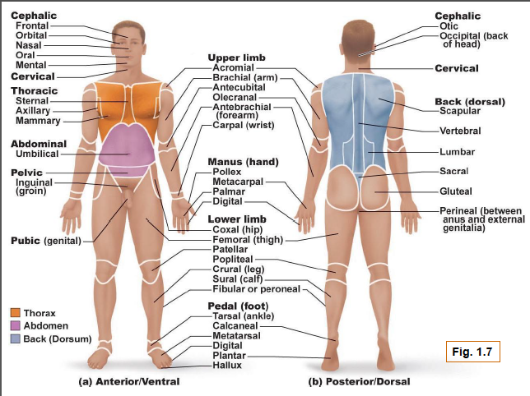

Body Planes and Sections:
For anatomical studies, the body is often cut along planes: sagittal, frontal and transverse. Sections are names after the plane along which it is cut.
- Sagittal planes are vertical planes that divide the body into left and right sections. A sagittal plane that lies directly in the midline is a midsagittal plane (or median plane) All other sagittal planes offset from the midline are parasagittal planes.
- Frontal planes lie vertically and divide the body into anterior and posterior parts. Also called a coronal plane.
- Transverse planes run horizontally from left to right dividing the body into superior and inferior parts. A transverse section is called a cross section.
- Oblique sections are cuts made diagonally but are often confusing and difficult to interpret.

1.2 Describe the body cavities.

Dorsal Body Cavity
- Protects the fragile nervous system
- Has two subdivisions:
  - Cranial cavity, which is in the skull and encases the brain
  - Vertebral or Spinal Cavity which runs within the vertebral column and encloses the spinal cord
- The spinal cord is continuous with the brain, so the cranial and spinal cavities are continuous with each other

Ventral Body Cavity

Thoracic Cavity
The superior subdivision, surrounded by the ribs and the muscles of the chest
Further subdivided into:
- Lateral pleural cavities, each enveloping a lung
The medial mediastinum which contains the pericardial cavity which encloses the heart and surrounds the remaining thoracic organs (esophagus, trachea…)
Abdominopelvic Cavity
Abdominal Cavity | Separated from the thoracic cavity by the diaphragm  The abdominal and pelvic cavities are not physically separated by a muscular or membrane wall  They are not aligned; the bowl shaped pelvic cavity tips away
Contains the stomach, intestines, spleen, liver, and other organs
Walls are formed only by trunk muscles and are not reinforced by bone
Pelvic Cavity
Lies in the bony pelvis
Contains the urinary bladder, some reproductive organs, and the rectum

Membranes in the Ventral Body Cavity:

Serosa (Serous Membrane):
- Thin, double-layered membrane
- Covers the walls of the ventral body cavity and the outer surfaces of the organs within it.
- The parietal serosa lines the cavity walls
- The visceral serosa is where the serosa folds onto itself and covers the organs in the cavity
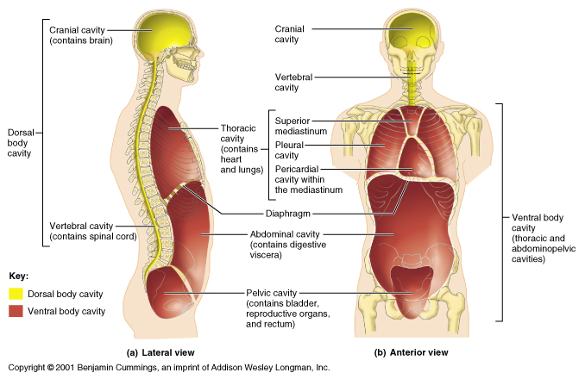
- Serous membranes are separated by a thin layer of serous fluid, a lubricating fluid which is secreted by both membranes

Abdominopelvic Regions and Quadrants:

Because the abdominopelvic cavity is so large and contains so many organs, it is useful to divide it into fur quadrants. A transverse and a medial plane pass through the umbilicus at right angles:

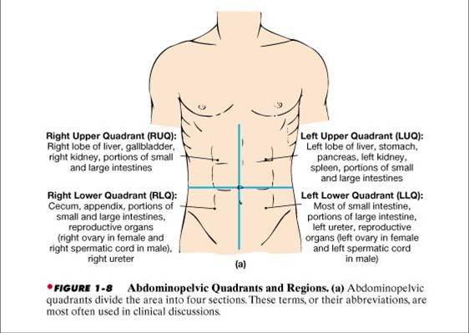

Another division method uses two transverse and two parasagittal planes to divide the cavity into nine regions:



