Muscles:
Muscle Tissue:
- 50% of body mass
- Transforms ATP to directed mechanical energy (exerts force)
- Three types
- Skeletal
- Cardiac
- Smooth
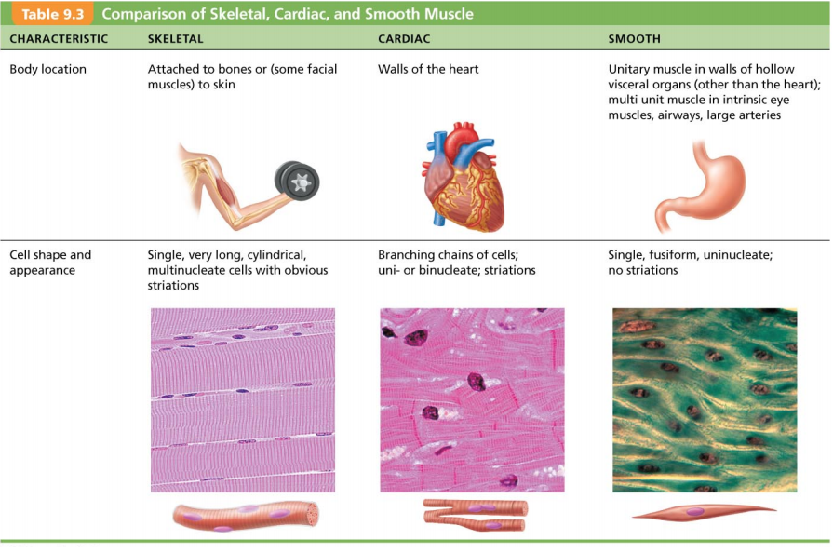
- Myo, mys, and sacro are prefixes for muscle

Skeletal Muscles:
- Attached to bones and skin
- Elongated cells called muscle fibers
- Striated (stripped)
- Voluntary (i.e. Conscious control)
- Contact rapidly; tire easily; powerful
- Require nerve stimulation
- Each muscle is served by one artery, one nerve, and 1+ veins
  - Enter/exit near central part and branch through connective tissue sheaths
  - Every skeletal muscle fiber supplied by nerve ending that controls its activity
  - Huge nutrient and oxygen need; generates large amount of waste
- Connective tissue sheaths muscle
- Support cells; reinforce whole muscle
- External to internal
- Epimysium: dense irregular connective tissue surrounding entire muscle; may blend with fascia
- Perimysium: fibrous connective tissue surrounding fascicles (group of muscle fibers)
- Endomysium: fine areolar connective tissue surrounding each muscle fiber
ADD ON ATTACHEMENTS OF …
Anatomy of a Skeletal Muscle Fiber:
- Long, cylindrical
- 10-100ym in diameter; up to 30cm long
- Multiple peripheral nuclei
- Sarcolemma = plasma membrane
- Modified Structures: myofibrils, sarcoplasmic reticulum, and T tubules
- Sarcoplasm = cytoplasm
  - Glycosomes for glycogen storage (excess of glucose is glycogen), myoglobin for O₂ storage
Note: thin filaments overlap thick filaments
Physiology of Skeletal Muscle:
- For Skeletal muscle to contract
  - Requires Activation
    - stimulation at neuromuscular junction
  - must generate action potential in sarcolemma
  - Excitation-contraction coupling
    - AP propagated along sarcolemma
    - intracellular Ca²⁺ levels must rise briefly
- Skeletal muscles stimulated by motor neurons
- Each axon branches as it enters muscle
- Each axon ending neuromuscular junction with single muscle fiber
  - Usually 1 neuron : 1 muscle fiber
Nerve Impulse with Neuromuscular Junction:
- AP arrives at axon terminal of motor neuron
- Voltage-gated Ca²⁺ channels open. Ca²⁺ enters the axon terminal moving down electrochemical gradient.
- Ca²⁺ entry causes Ach to be released by exocytosis.
- Ach diffuses across the synaptic clef and binds to its receptors on the sarcolemma.
- Ach binding opens ion channels that allow Na⁺ into and K⁺ out of the muscle fiber. This causes local change in membrane potential called the end plate potential. It ignites AP in sarcolemma.
- Ach actions terminated by its breakdown in the synaptic clef by enzyme Acetylcholinesterase and diffuses away from junction.
Note: action potential in muscle at rest is MUCH lower since it starts at -90 instead of a neurons at -17
Note: proteins triggers and opens up the calcium over the muscle therefore the filaments are bathed in calcium.
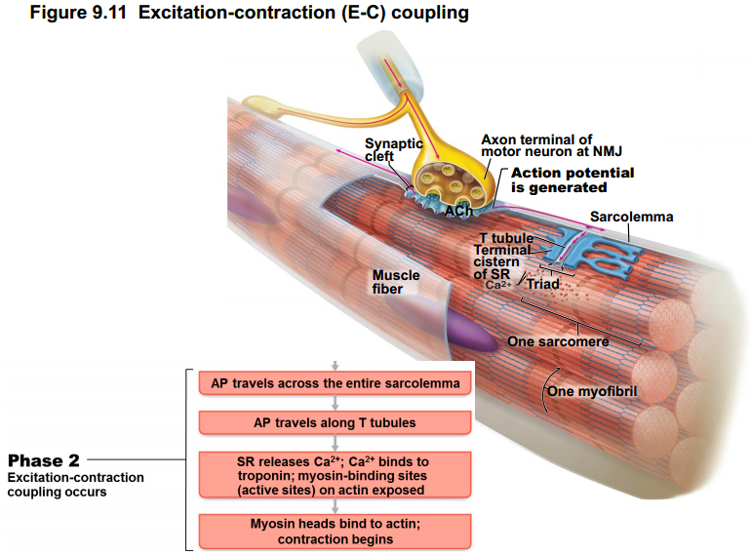
Excitation-Contraction Coupling:
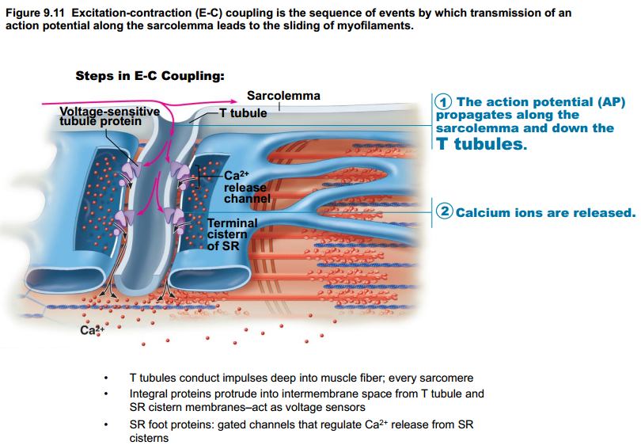
- Actin binding sites for myosin are blocked.
- Tropomyosin blocking the active sites (therefore actin is not recognized by myosin)
- Calcium removes the blocking site, allowing actin to bind with myosin.
- The less the Ca²⁺, the less likely it will be able to bond with myosin.
FIGURE OUT Relationship of the sarcoplasmic reticulum and T tubules to myofibrils of skeletal muscle
- Cross Bridge Formation:
- Calcium binds troponin, removes blocking action of tropomyosin
- Energized myosin head can attach to actin myofilament, forming cross bridge
- The Power (working) Stroke:
- ADP and P_{i} are released.
- Myosin head pivots and bends, changing to its bent low-energy state.
- As a result it pulls the actin filament toward the M line.
What is the M line
- Cross Bridge Detachment:
- After ATP attaches to myosin, the link weakens.
- Myosin head detaches (cross bridge “breaks”).
- Cocking of the Myosin Head
- As ATP is hydrolyzed to ADP and Pi, the myosin head returns to its prestrike high-energy, or “cocked” position.
Note: This cycle will continue as long as ATP is available and Ca²⁺ is bound to troponin.
Speed of Stimulation: Wave Summation & Tetanus
- Rapid rate of stimuli; each contraction builds on the previous one.
- AP refractory period is always honored.
- Tetanus: fused contractions.
  - Inter-stimulus interval too short to allow inter-twitch muscle relaxation.
  - Eventually followed by muscle fatigue.
- Allows smooth, continuous contractions.
Multiple Motor Unit Summation:
- Allows increasing strength of contraction.
- Threshold stimulus: first observable response
- Maxima v vl stimulus: strongest stimulus that produces an increase in contractile force (more motor units recruited).
  - Smallest motor units controlled by most excitable neurons.
  - More intense stimulation recruits larger motor units.
- All units can be recruited simultaneously, but usually staggered
Muscle Tone: even relaxed muscle has a bit of contracted (tone) due to spinal reflexes activated by stretch receptors. Effects on muscles, joints and posture.
Isotonic vs Isometric Contractions:
- Isotonic: change in length & moves load.
  - Concentric vs eccentric isotonic contractions.
    - Eccentric are 50% more forceful, use less ATP/O₂ & fewer muscle fibers but more prone to delayed-onset soreness than concentric contractions.
- Isometric: tension increase but muscle same length.
  - Most body movements are a mix of isotonic – isometric.
  - In isotonic contractions, the thin filaments are sliding
  - In isometric contractions, cross bridges generating force, but do not move thin filaments.
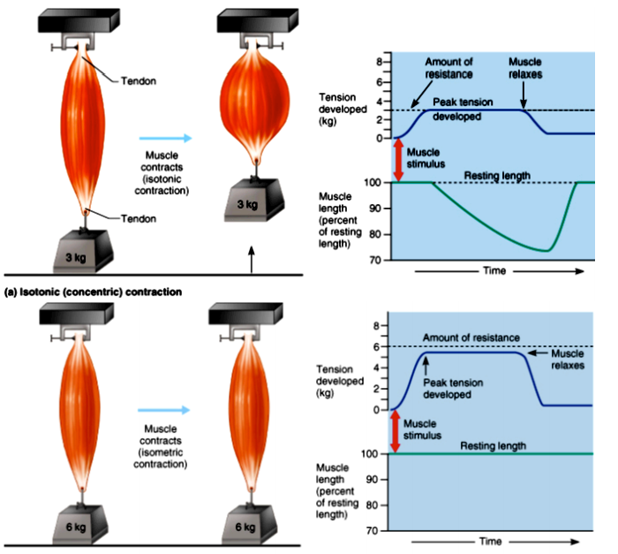
Note: muscle fatigue prevents injury.
Optimal Length-Tension: ideal when the muscle is slightly stretched and is supported by attachment to bones.
Factors that contractile forces (more cross bridges attached):
- Large # of muscle fibers recruited.
- Large muscle fibers.
- High frequency of stimulation (wave summation and tetanus).
- Muscle and sarcomere stretched to slightly over 100% of resting length.
Influence of Load on Velocity & Duration of Skeletal Muscle Contraction:
- Depends on Load. The greater load = longer latent period = slower contraction = slower contraction duration.
Sources of Energy for Muscle Contraction:
- Stored ATP
  - ATP for cross bridge movement & detachment; Ca²⁺ pump
  - Only 4-6 sec stored ATP; regenerated immediately & continuously by (A2-A4)
- Direct Phosphorylation of ADP by Creatine Phosphate
  - CP = unique high-energy molecule stored in muscles.

CP + ADP Creatine + ATP
- Aerobic Respiration
- Most ATP made here.
- Slower.
- Requires continuous supply of O₂ + nutrients.
- Air is required.
- Anaerobic Glycolysis – Vigorous, Sharp, Fast & Powerful Activities
- Only 2 ATP/glucose.
- Fast.
- No O₂ required.
- Not useful because not enough O₂ to be supplied so bad way of getting energy.
- Long term active tissue will be run down.
- Usually pyruvic acid then enters aerobic pathway.
  - If 70% activity for long period, blood vessels compressed by muscles & aerobic respiration too slow.
- Pyruvic acid converted to lactic acid.
- Reconverted back to pyruvic acid post exercise.
- Aerobic respiration replenishes ATP.
  - Anaerobic pathway produces 5% ATP of aerobic, but is 2.5x faster. Important during vigorous muscle activity.
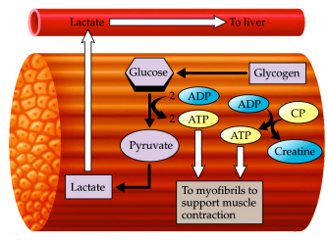
Note:
- Glycose is a critical source for ATP, there is ATP already stored as ATP.
- Glycogen is the storage form for glucose.
- ATP can cause the formation and destruction of the cross bridges.
- Blood brings it there, and takes it away. If there is no blood, the cells will die. Blood is necessary to keep the homeostatic mobility in the energy production.
- Removal of metabolites is through blood.
ADD PICTURE FROM SLIDES 36 AND 37
Energy Systems Used During Sports Activities

Muscle Fatigue: physiological inability to contract
- Results from a relative deflict of ATP (total absence would cause contractures).
- Contributors: build-up of lactic acid, ion imbalance (Na⁺/K⁺ pump requires ATP).
Oxygen Debt
Post exercise:
- Replenish O₂ reserves.
- Convert lactic acid to pyruvic acid.
- Replace glycogen stores.
- Restock ATP & CP.
- Liver converts additional lactic acid to glucose/glycogen (Cori cycle).
- O₂ debt: extra O₂ needed to be taken in to accomplish the above (lactic acid indirectly stimulates respiratory center of brain)
- Controlled in the brainstem – open mouth and get oxygen.
- New term is excess post-exercise oxygen consumption (EPOC)

Heat Production during Muscle Acitivity
ATP driven muscle contraction 20-25% efficient; heat dissipat4ed by body’s cooling mechanisms.

Muscle Fiber Type
- Slow oxidative fibers:
- Thin cells with slow-acting myosin ATPases (enzyme converting and producing ATP).
- Primary energy is fat.
- Contract slowly (red = lots of myoglobin).
  - Myoglobin is a protein equal to hemoglobin, and can bind to oxygen. Not present in blood, but in muscle.
- Fast Glycolytic fibers:
- Large & pale.
- Fast therefore fatigue fast.
- Little myoglobin & diameter 2x that of slow oxidative fibers
- S
- Fatigue resistant.
- Red or pink.
- Intermediate cell size.
Note: you need a combination of all of these to be a good athlete. It is all about GENETICS.
Slide 41: bouton ends.
SR: sarcoplasmic reticulum
Skeletal muscle can only contract, it doesn’t rest.
Smooth muscle can contract or (nitric oxide, ATP, or ____) can be stimulated to rest.
Contraction = depolarization(iron/k). Hyperpolarization = controlled by transmitters.
(Acetyl choline) Contraction behind food, relaxation infront (nitric oxide, ATP, or VIP-VP) – smooth muscle occurs bc controlled by interic nervous system. Controlled by transmitters.

--------
Cell 5 is a mast cell, which produces and secretes inflammation-triggering chemicals such as histamine. Note the secretory granules within the pictured cell.
Most connective tissues (except cartilage) contain blood vessels. A capillary is observed in the figure of areolar connective tissue.
Collagen fibers are extremely tough and provide high tensile strength (that is, the ability to resist being pulled apart) to the matrix. Stress tests show that collagen fibers are stronger than steel fibers of the same size!
Macrophages, which are peppered throughout loose connective tissue, bone marrow, and lymphatic tissue, may be attached to connective tissue fibers (fixed) or may migrate freely through the matrix. They phagocytize a broad variety of foreign materials, ranging from foreign molecules to entire bacteria to dust particles. These "big eaters" also dispose of dead tissue cells, and they are central actors in the immune system.

