Topic 3C- Skeletal system continued
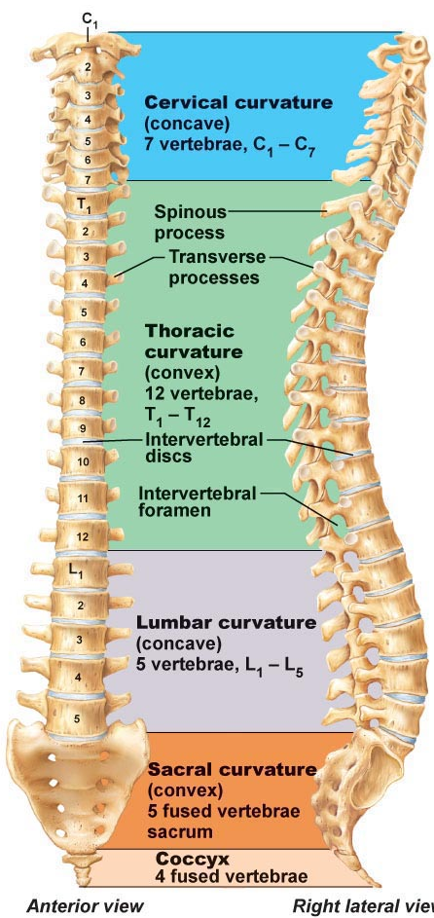
Vertebral column: 33 bones of which 24 remain separate (for flexibility) and the remaining 9 fuse to form 2 composite bones (sacrum and coccyx)- 70 cm long.
- 7 cervical, 12 thoracic, 5 lumbar, 5 sacral, 3/4 coccyx.
- 3 main functions:
  - Weight bearing
  - Anchor for muscles and ligaments
  - Protection of spinal cord
- Curvatures
  - For resilience and flexibility
  - The cervical and lumbar curvatures are concave.
  - The thoracic and sacral are convex.
- Supporting elements of the vertebral column:
- Ligaments
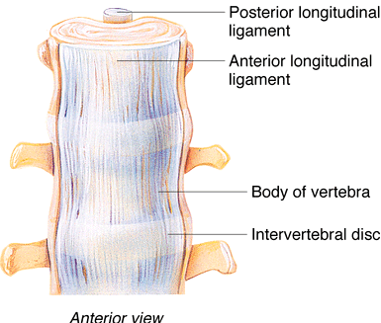
- Strap-like, support column of bones so theyh stay upright.
- Major supporting ligaments= anterior and posterior longitudinal
- Continuous bands down front and back of vertebral bodies from neck to sacrum.
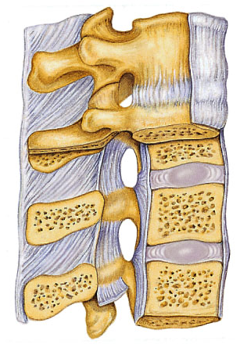
- Broad anterior strongly attached to bony vertebrae and the discs, prevents hyperextension of the spine.
- Posterior is narrow, weaker, and attached only to discs; prevents hyperflexion of the spine.
- Intervertebral discs
- Cushioning between bony vertebral bodies
- Shock absorbers- 25% length of the vertebral column!
- Each is circular with nucleus pulposus in centre and annulus fibrosus around periphery.
- Nucleus pulposus=like a rubber ball= for elasticity and compressibility.
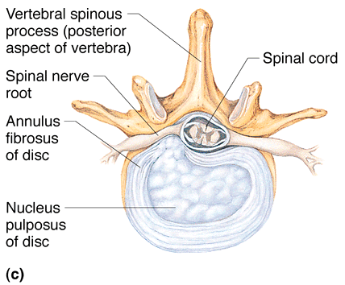
- Annulus fibrosus= holds together successive vertebrae and resists tension in sipne.
- Discs are thickest in lumbar/cervical regions.
- Herniated disc= like in the picture, when you put too much pressure.

- A typical vertebra:
  - Gets larger as one descends the column.
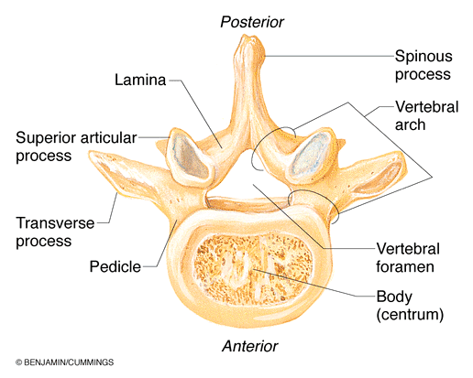
  - Weight-bearing body and vertebral arch
  - Arch and body enclose vertebral foramen
  - A bunch of vertebral foramen on top of one another form the vertebral canal, which the spinal cord passes through.
  - 2 pedicles and 2 laminae make up each vertebral arch
  - Peidcles have notches on superior and inferior surfaces called intervertebral foramina. Spinal nerves from spinal cord pass through here.
- 7 processes from each vertebral arch:
  - 1 spinous process for muscle attachment
  - 2 transverse processes- 1 per side for muscle attachment
  - paired superior and inferior articular processes- link vertebrae above and below; smooth, collagen-coated facets for articulation.

- Cervical Vertebrae: 7 total.
#C1 and C2 have unusual structure= no intervertebral disc
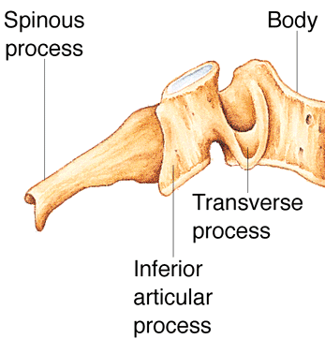
  - C3-C7 are considered typical vertebrae:
    - Body is oval, broader side-to-side than front-to-back
    - Spinous process short and split at end (except for #7)
    - Vertebral foramen is large and triangular
    - Each transverse process contains transverse foramen for passage of vertebral artery to the brain.
  - C1= “Atlas”
    - Specialized structure because the head sits on top of the vertebral column.
    - Brain stem is narrowing to accommodate the spinal column in the skull.
    - No body, no spinous process
    - Posterior and anterior neural arches
    - Lateral masses with superior and inferior articular facets=allows for articulation with brain and with C2
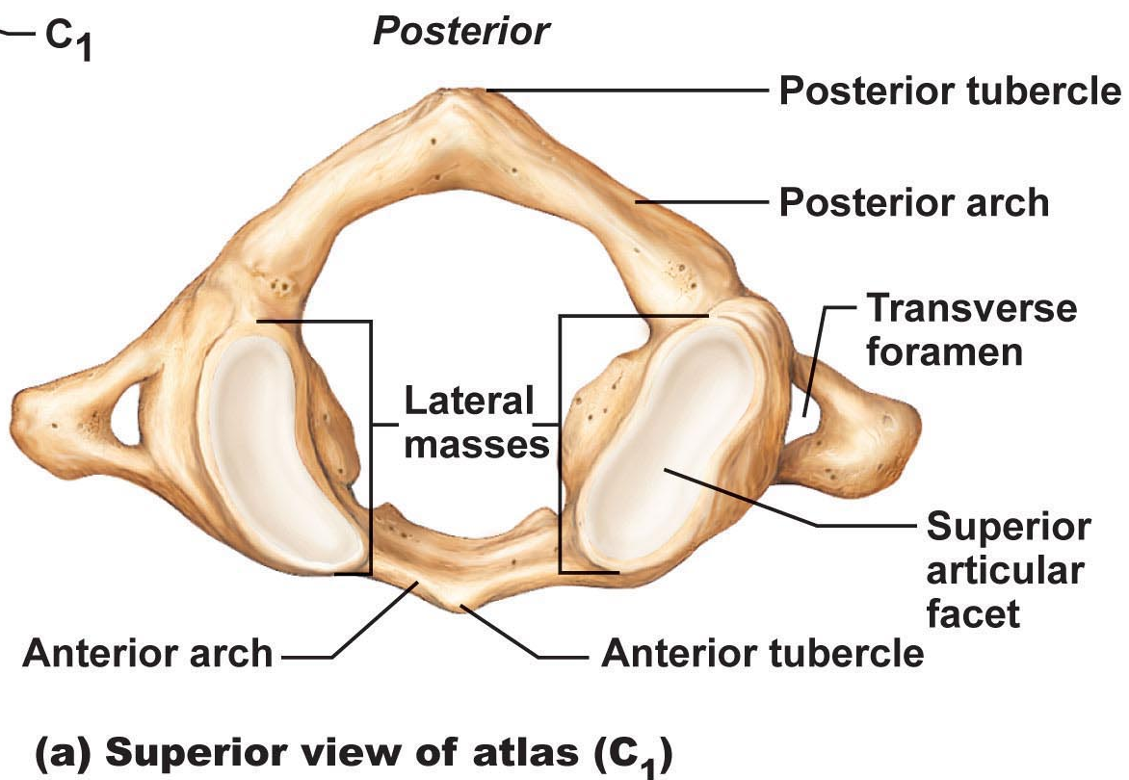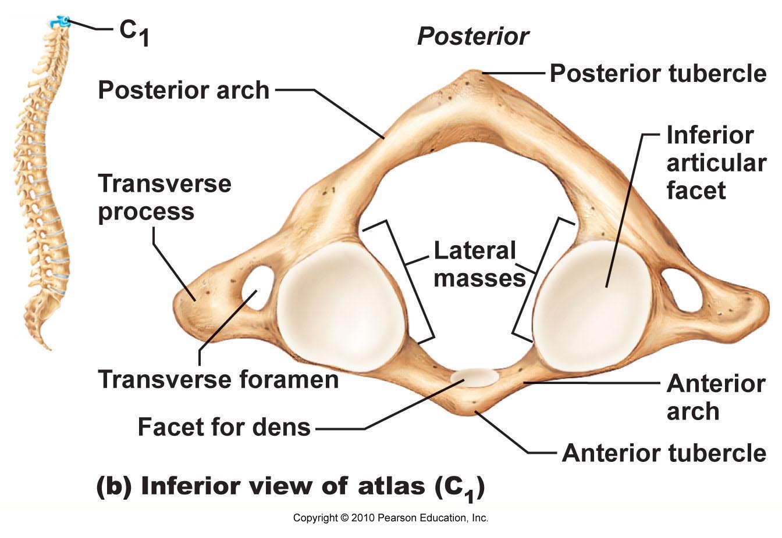

- C2= “Axis”
    - More like others, except for dens/odontoid processes= pivot
    - **We can identify it by the dens.

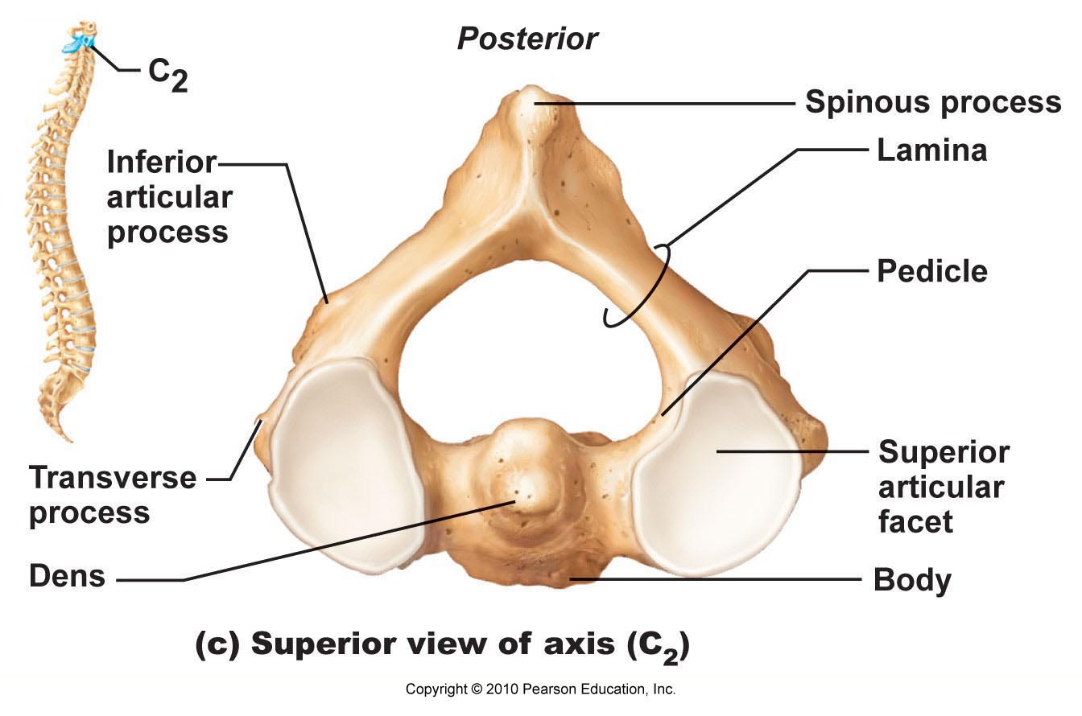
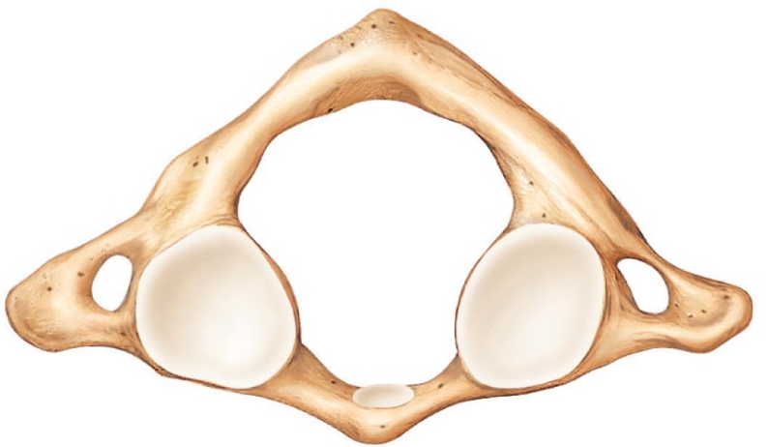

- Thoracic vertebrae- 12 in total, all have ribs attached
  - Increase in size from first to last.
  - Body roughly heart-shaped and bears facets for ribs= paired demi-facets.
  - Main feature is that they only articulate with the ribs!
  - Vertebral foramen is circular
  - Spinous process is long and points downwards.
  - Transverse processes have facets for articulation with tubercles of ribs (except #11 and 12)
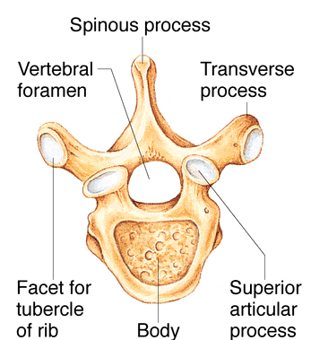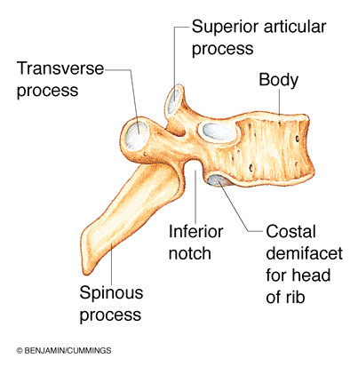

- Lumbar Vertebrae- lower back
  - Major weight-bearing function
  - Bodies are kidney shaped and increase in size from top to bottom.
  - Pedicles and laminae shorter and thicker than those of other vertebrae.
  - Spinous processes are flat and short and project directly back.
  - Vertebral foramen is triangular.
  - Orientation of inferior and superior facets unique- curved
  - Superior faces in and inferior faces out.
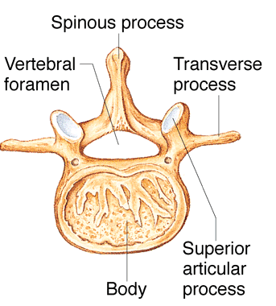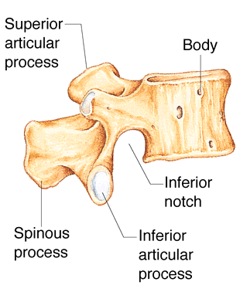

- Sacral Vertebrae
  - Starts as 5 separate vertebrae- fuses in adolescents=sacrum
  - Articulates with 5th lumbar and laterally with hip bones=sacroiliac joint
  - Sacral promontory- marks start of sacrum and close to our center of gravity.
  - Transverse lines- indicates the 4 sites of merging of sacral vertebrae to form the sacrum.
  - Sacral foramina- holes between the bones.
  - Sacral crest- the sacral processes that have fused together in formation of the sacrum.
  - Sacral canal- terminal part of the sacral canal. This is where we’re anchoring outer membranes associated with the spinal cords
  - Spinal hiatus- the 4th and 5th vertebrae may have not fused, and varies between people.
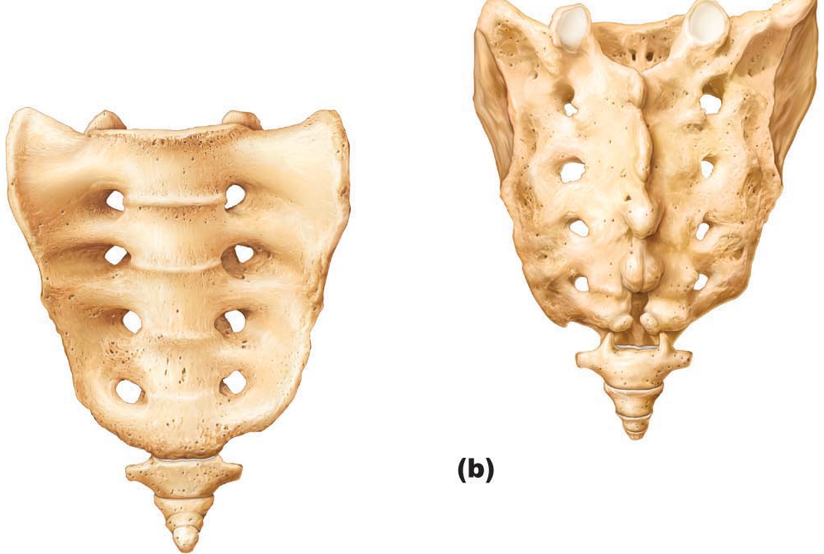
- Coccygeal Vertebrae
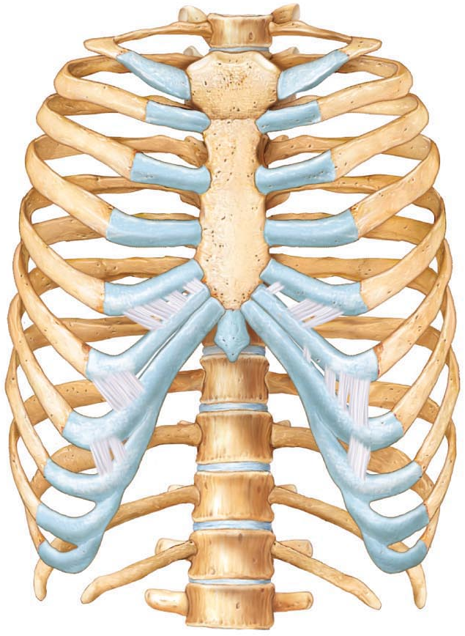
  - Tailbone- 3 or 4 fused coccygeal vertebrae
  - Attachment area for some pelvic ligaments, otherwise useless.

Bony Thorax
- Thoracic vertebrae+ ribs+ costal cartilage+ sternum
- Protective cage around the heart, lungs, and major blood vessels.
- Supports shoulder girdle and upper limbs
- Provides area of muscle attachment for back, chest and shoulders.
- Sternum:
  - Anterior midline of thorax
  - Fusion of 3 bones: manubrium, body, xiphoid process.
  - Manubrium articulates with clavicles via clavicular notches, also with 1st pair of ribs.
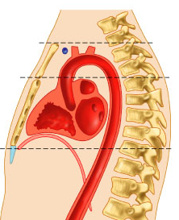
  - Body has notches for articulation with 2nd to 7th ribs.
  - Attachment of some abdominal muscles to xiphoid process.
- Three important anatomical landmarks:
- Jugular notch- indentation in line with disc between T2 and T3. Common carotid artery from aorta.
- Sternal angle- cartilaginous hinge between manubrium and body of sternum.
- Xiphisternal joint- fusion o sternal body and xiphoid process, opposite T9.
- Ribs
  - 12 per side
  - All attach at the back to the vertebral column.
  - Ribs 2-7 attach to body
  - True ribs- ribs 1-7
  - False ribs- 8-12
  - Rib pairs 8,9,10 merge with costal cartilage of rib 7
  - Ribs 11 and 12 don’t attach to the sternum at all, they only come partly around.
  - Typical rib is a bowed, flat bone.
  - Shaft, head, neck, tubercle
  - Main portion is the shaft
  - Costal groove= depression you can see in the cross section image. Nerves and blood vessels follow this pathway.
  - Head with 2 facets- one articulates with the demi-facet on the body of the same-numbered thoracic vertebra, other with that on the body of the superior vertebra.
  - Tubercle articulates with transverse process of the same-numbered thoracic vertebra.
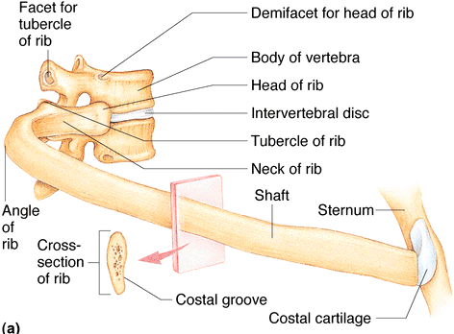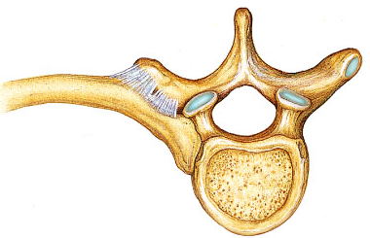

APPENDICULAR SKELETON
Pectoral girdle and pelvic girdle
- Pectoral girdle
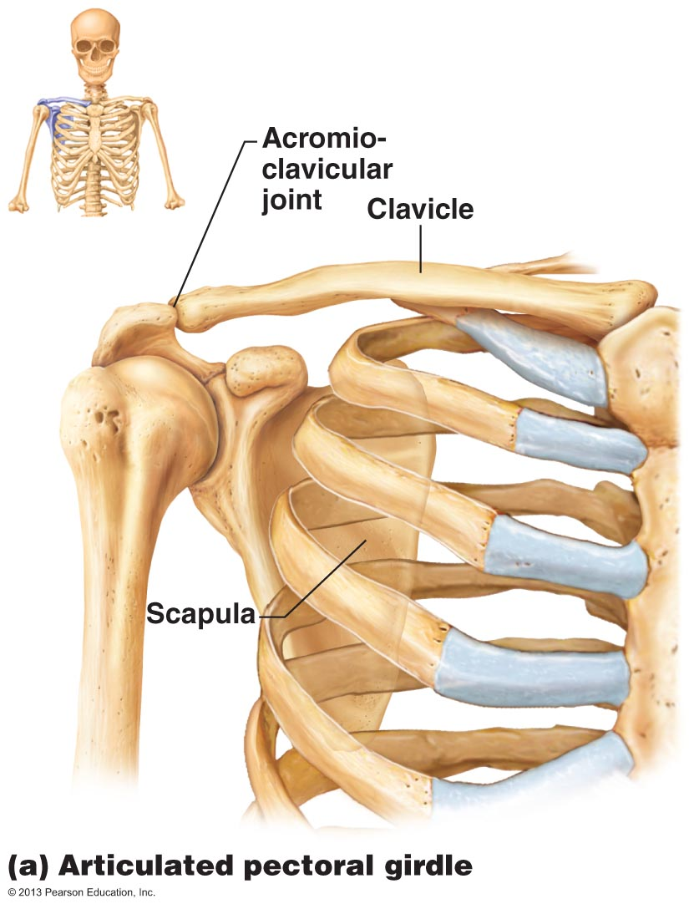
  - 2 pairs of bones: clavicles and scapulae- almost a complete circle around upper trunk to make shoulders

Fig. 7.24
lenoid cavity

  - Clavicles= collarbones, s-shaped
  - Clavicles are insertion points for muscles, and brace to push arms laterally.
  - Curvature ensures outward fracture away from subclavian artery.
  - Anteriorly- the clavicle associates with manubrium
  - Laterally- the clavicle associates with scapula at the acromioclavicular joint.
  - Posteriorly- attached only to muscle=gives us huge range of motion.
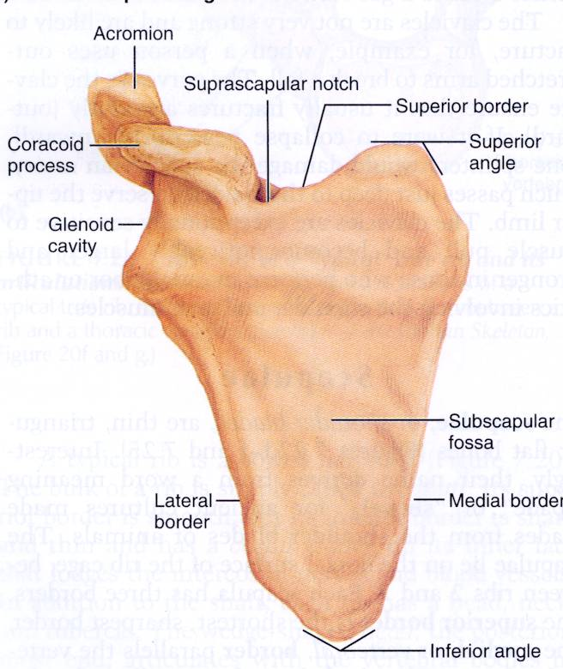
  - Bones are light and movable because scapulae is only attached laterally, and because the socket of the shoulder joint (glenoid cavity) is shallow and poorly reinforced.
- Scapulae= shoulder blades
  - Thin, triangular, flat bones.
  - Dorsally, between ribs 2 and 7
  - **Superior, medial, and lateral borders
  - Spine acromion- articulates with acromial end of clavicle
  - Coracoid process- attaches to biceps muscle.
Upper Limb
30 separate bones: arm, forearm, hand
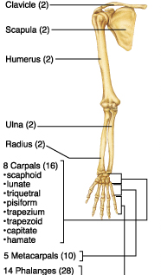

- Humerus
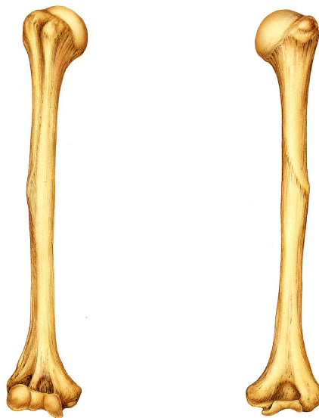
  - Longest bone of upper limb/only bone of “arm”
  - Articulates with scapula, radius, and ulna
  - Head inserts into the glenoid cavity in a way such that when you’re relaxed, your hands are down by your sides.
  - Anatomical neck- marks boundary between the head and the bumps which are tubercles.
  - Greater/lesser tubercles are attachment sites for the rotator cuff muscles.
  - Intertubecular sulcus- groove in between the tubercles
  - Surgical neck- if you break your humerus, this is likely where it will break
  - 2 condyles:
    - Trochlea- articulates with the ulna
    - Capitulum- articulates with radius
  - Ulnar nerve- what you hit when you hit your funny bone.
- Forearm
  - 2 parallel long bones: radius and ulna
  - Articulates with humerous and wrist bones
  - Also articulate with each other at proximal and distal radio-ulnar joints.
  - Intraosseaous membrane in between= actually a ligament. It limits how much movement occurs between the two bones.
  - Ulna= located more medially than the radius.
    - =elbow joint!
    - Olecranon process- locking of olecranon prevents elbow hyperextension
    - Coronoid process- has a radial notch (ulnar notch) where its distal end articulates with the radius.
    - Styloid process- has a ligament to wrist.
  - Radius= on the thumb side.
    - =wrist joint!
    - Head at proximal end
    - Distal end is wider and has medial ulnar notch and lateral styloid process.
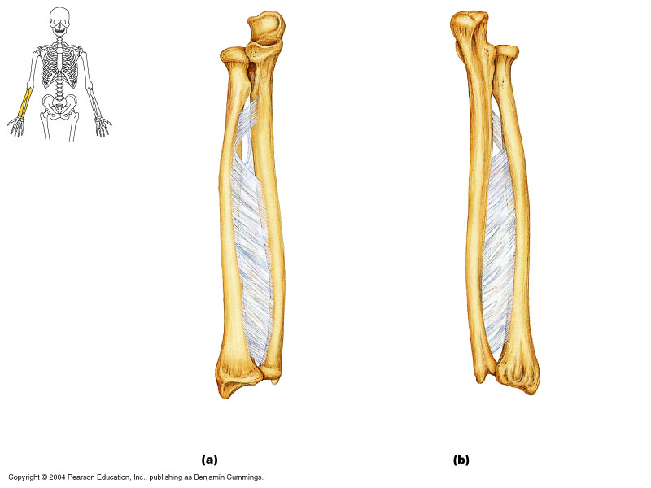

- Elbow joint!
  - Between humerous, radius, and ulna
  - Trochlea and capitulum= condyles.
  - Posterior view shows the olecranon inserting into the olecranon process.
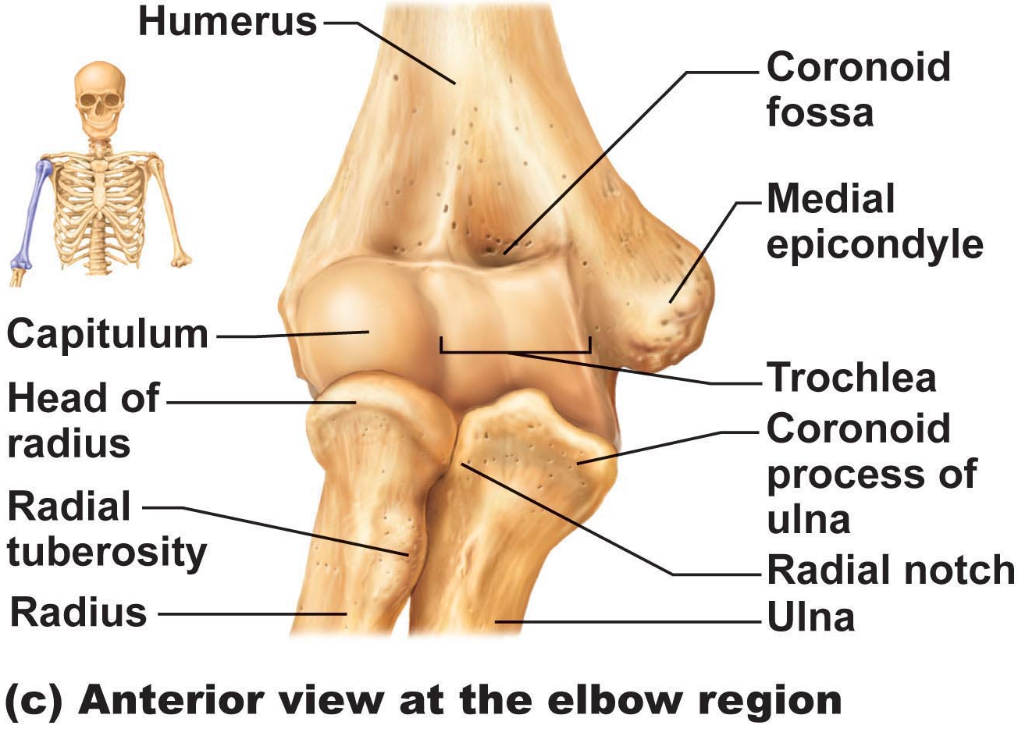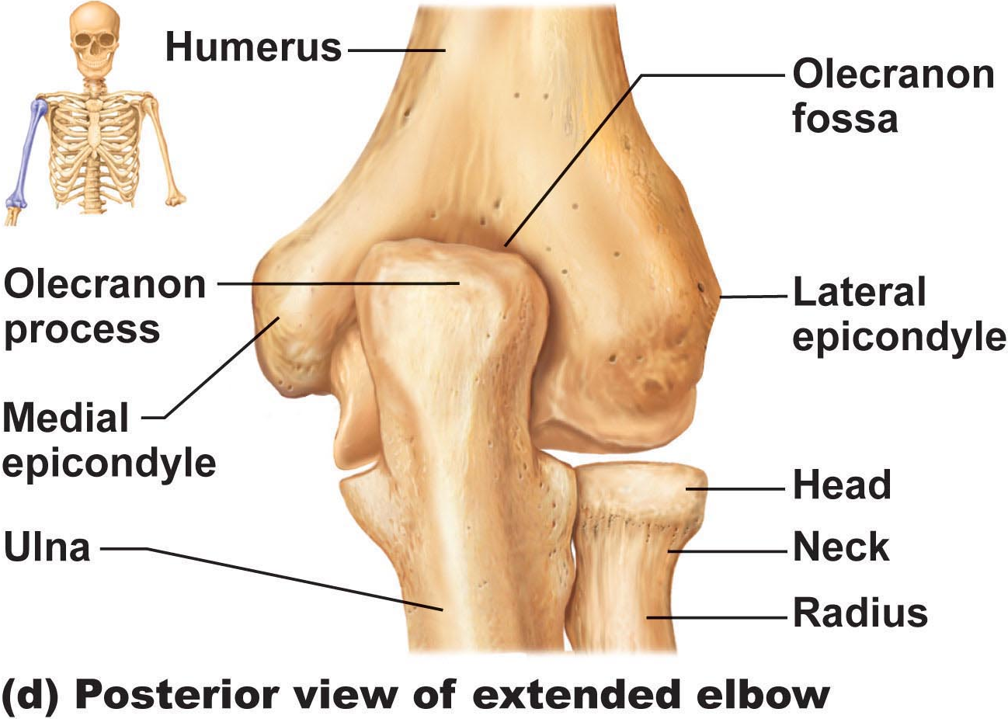
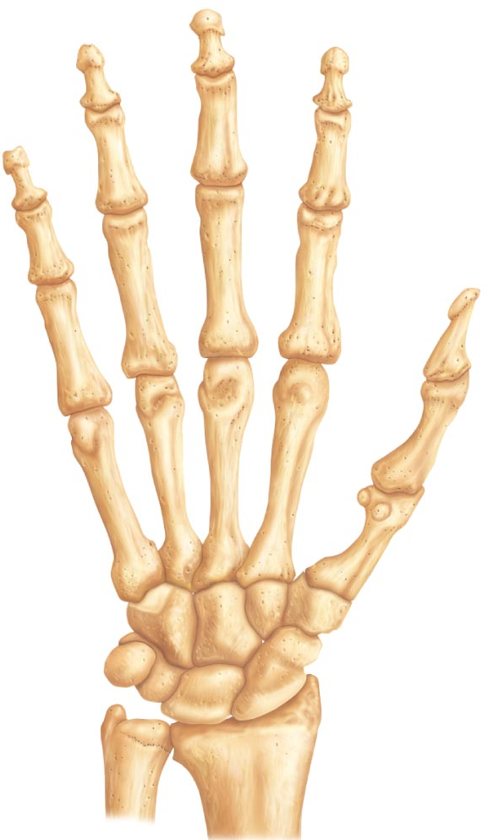
- Hand- 27 bones in total
  - Includes bones of carpus, metacarpus, and phalanges.
  - Carpus (wrist)
    - 8 carpel bones in 2ish rows
    - Only the scaphoid and lunate articulate with the radius.
    - Scaphoid= closest to the thumb side.
    - Carpel bones include: scaphoid, lunate, triquetrum, pisiform, trapezium, trapezoid, capitate, hamate
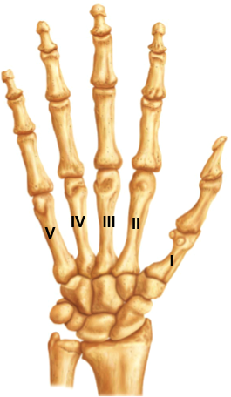
    - “Sally Left The Party To Take Cathy Home”
  - Metacarpus (hand)
    - 5 long bones- distal ends are knuckles
    - Numbered 1-5 in roman numerals
    - Proximal ends are articulated with wrist bones
  - Phalanges (fingers)
    - 3 per finger
    - 2 per thumb (polex)
    - miniature long bones.
    - Numbered 1-5 from thumb to little finger
    - Proximal, middle, distal (except for thumb which only has proximal and distal.
- Pelvic Girdle
  - Attaches lower limbs, transmits weight of upper body to lower limbs, supports visceral organs of pelvis.
  - Forms a complete circle.
  - Left and right hip bones (coxal bones) unite anteriorly with the sacrum at the back.
  - Each os coxa consists of 3 bones that fuse at puberty: ilium, ischium, pubic
  - The acetabulum is the area where all 3 of these bones join= forms the socket of the hip joint.
  - Ischium= part of the hip bone that you sit on
  - Point where the two pubic bones come around= pubic symphysis. This is cartilage and can loosen when giving birth.
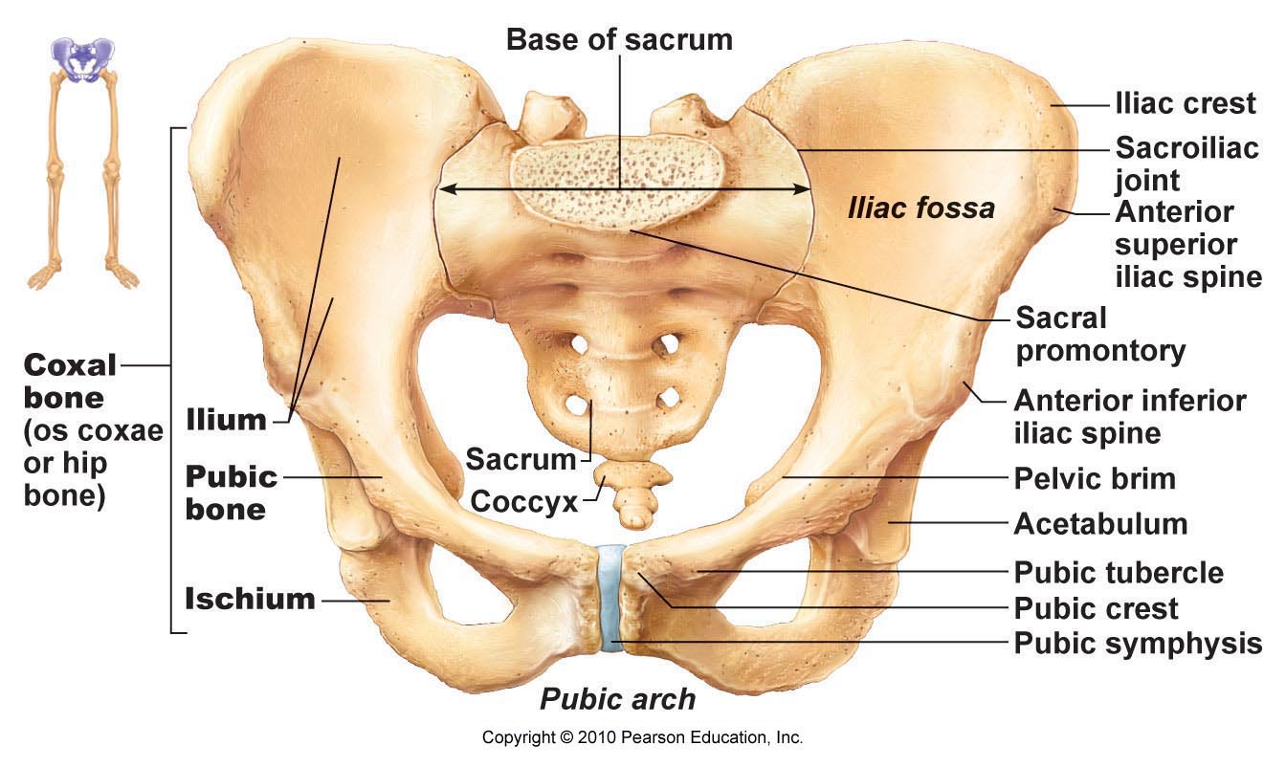
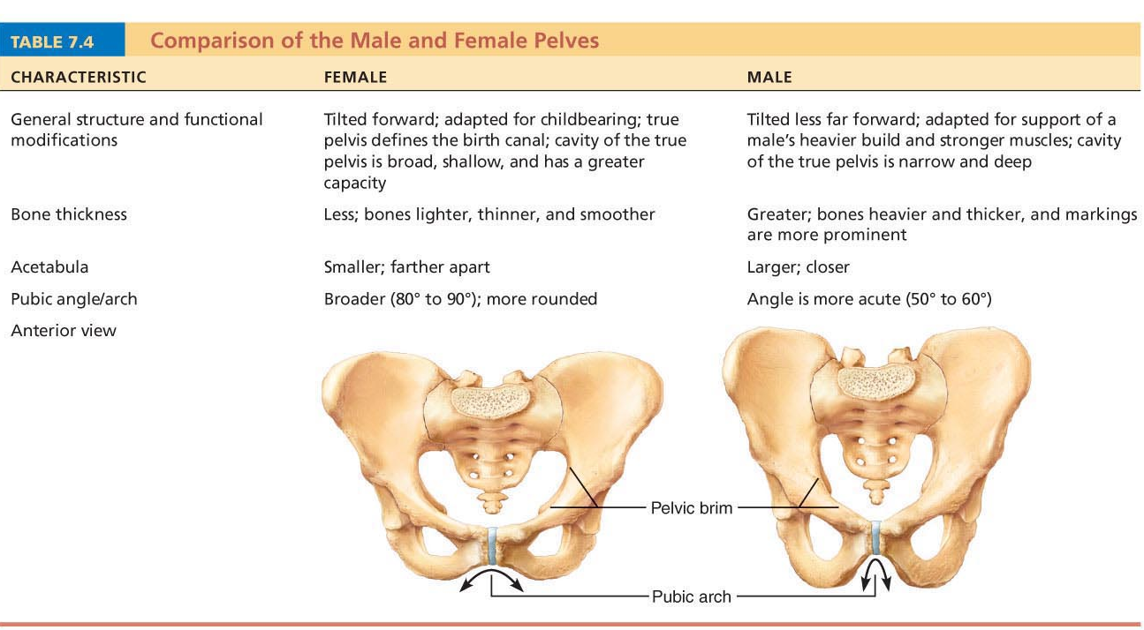
False (greater) pelvis- uses the pelvic brim to distinguish.
True (lesser) pelvis- where the head of the baby is going. This is what an obstetrician looks at.
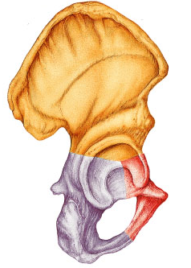
- Ilium
- Iliac crest=superior border (hands on hips)
- Iliac spines= attachment of muscles
- Pelvic brim- superior margin of true pelvis.
- Large flaring bone that forms most of the os coxa
- Anteriorly, the body of the ilium joins the ischium and the pubis.
- Ischium
  - Postero-inferior part of the hip bone
  - Superior body joining the ilium and thinner, inferior ramus
  - Ischial tuberosity- what you’re sitting on!
- Pubis
  - Anterior part of ox coxa
  - 2 pubic bones unite at the pubic synthesis
  - **pubic crest, obdurator foramen (blood vessles and nerves).
- Lower limb: thigh, leg, foot
  - Thigh:
    - Femur= largest, longest, strongest bone.
    - Accounts for about ¼ of your height.
    - Fovia capitis= ligament to acetabulum. Shallow depression on either side of head.
    - Neck- angles laterally to shaft, weak- this is why you usually break your hip at this location.
    - Linea aspera- roughened areas of bone that split into two more distally
    - Lateral and medial condyles- articulate with tibia
    - Lateral and medial epicondyles- muscle attachment
    - Patellar surface- between the condyles.
    - Greater and lesser trochanters- parts that come around the neck.
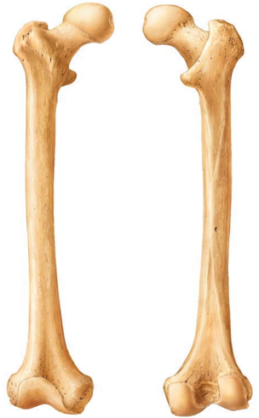
- Leg- 2 parallel bones: tibia and fibula
  - Interosseus membrane + proximal and distal tibiofigbular joints (rigid)
  - Fibula not contributor to knee joint!!
  - Tibia- transfers weight from femur to foot; next largest/strongest bone.
  - The tibia is the only bone to articulate with the femur to form knee joint.
  - Fibula- note head and lateral malleolus.
  - Medial and lateral condyles, anterior crest, tibial tuberosity (patellar ligament) ** be able to label.
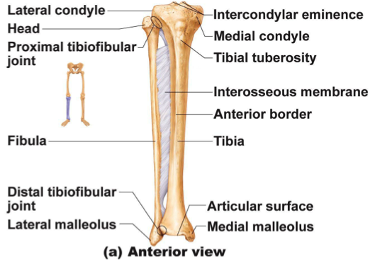
- Foot: 26 bones total: tarsus (ankle bone), metatarsus, and phalanges
  - Tarsus:
    - 7 tarsal bones: largest is the calcaneus (heel bone), and second largest is the talus (park of ankle joint).
    - **Two that need to be labeled= calcaneus and talus
    - The talus articulates with distal regions of fibula and tibita to form ankle joints
    - Medially, the tibia comes down to form the rest of the ankle joint.
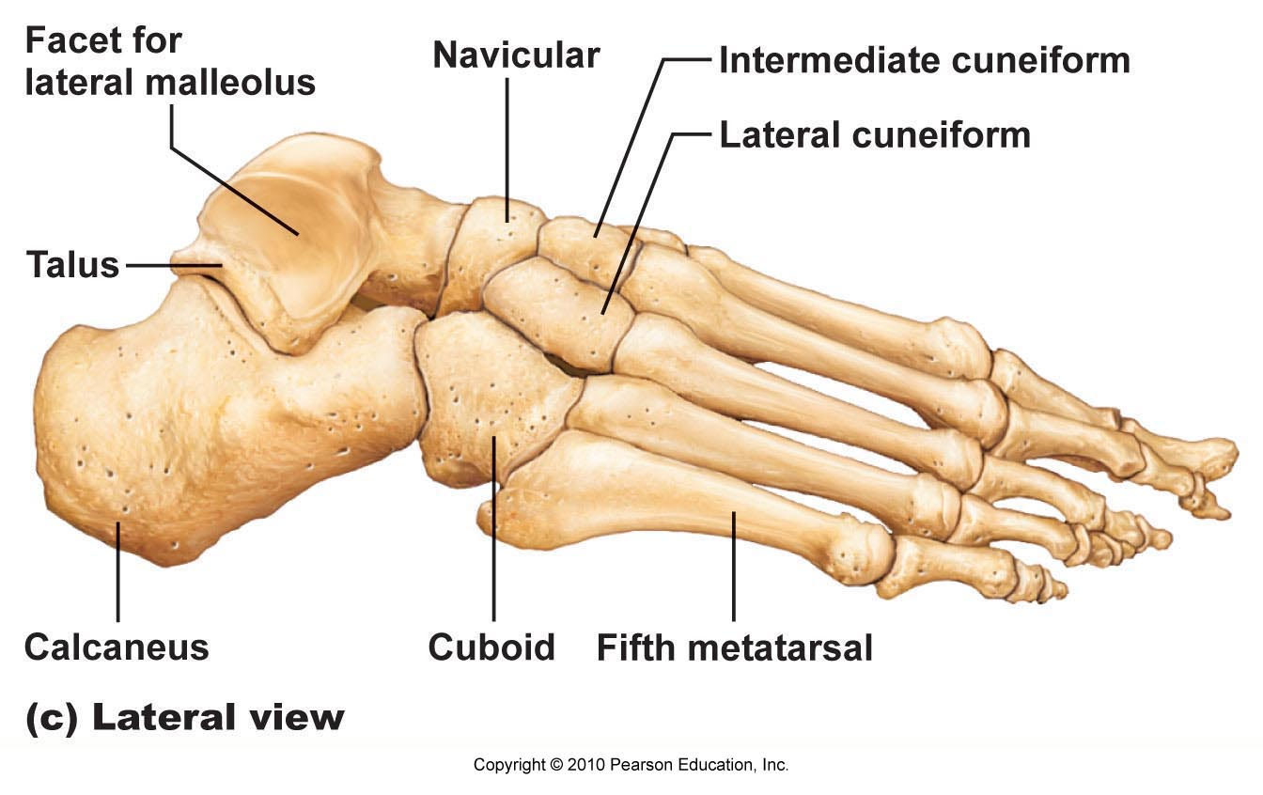
- Metatarsus
- 5 mini long bones numbered 1-5
- Phalanges
- Big toe (hallux) has two phalanges (proximal and distal)
- Remaining toes have 3 phalanges each- proximal, middle, distal
- Calcaneal tendon goes up to muscles of the calf (also called Achilles tendon)
- Talus= bone
- Trochlea= depression on the surface. Here it’s where the tibia articulates.


