BIO2133 LectureTools Questions

Midterm 1:

What are the total number of potential nucleotide sequences (combinations) that can be produced from a polynucleotide of 15 base pairs?
- 100
- 10,000
- 1 million
- 1 billion

The answer is D
$$4^{15}=1,000,000,000$$

In sea urchin DNA, which is double-stranded, 17.5% of the bases were shown to be cytosine. What percentage of adenine would you expect to be present in the DNA?
- 17.5%
- 27.5%
- 32.5%
- 35.0%
- 65.0%
- 82.5%

The answer is C
$$\frac{100-2(17.5)}{2}=32.5$$

For your thesis, you need to amplify a sequence of DNA through PCR. A former grad student’s lab manual suggests 2 possible temperatures (92ºC and 96ºC) for the denaturation temperature. Your sequence is:
5’-CAGTCCCAGGGCGTGCTACGCCGTC-3’
3’-GTCAGGGTCCCGCACGATGCGGCAG-5’
Which temperature would you try first?

- The lower temperature
- The high temperature
- Not enough information

The answer is B
The sequence is rich in C-G, which are more stable than A-T, due to three hydrogen bonds rather than two

How many different chromosomes are in humans?
- 2
- 23
- 46

The answer is B
23 different chromosomes are in homologous pairing

Which of the following describes the cell pictured below?
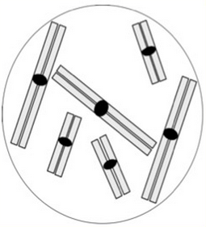
- Haploid
- Diploid
- Triploid
- Tetraploid
- Pentaploid
- Hexaploid

The answer is C
There are two groups of chromosomes based on size, and each group has three homologous pairs

A recent investigation described a new gene called the “drunkenness” gene (DKN1). Results of this investigation demonstrated that a single mutation within exon 2 made people susceptible to alcoholism and reported that approximately 20% of the population is susceptible to alcoholism. If 20% if the population is susceptible, how many possess the DKN1 gene?
- 10%
- 20%
- 50%
- 100%

The answer is D
We all have the DKN1 gene, it is just a question whether this gene is expressed or not. However, possession of the right allele result in alcoholism

A colleague shows you the following karyotypes for two new recently discovered organisms. Which of the following predictions could you make?
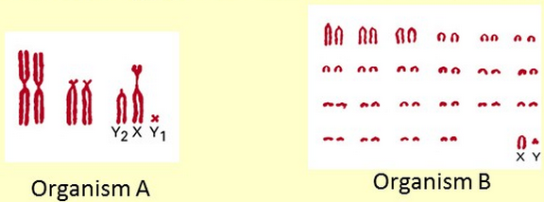
- Organism A’s genome likely encodes many more proteins than that of organism B
- Organism B’s genome likely encodes many more proteins than that of organism A
- Organism B is more complex than organism A
- B and C
- You cannot make any firm predictions about gene content from these karyotypes

The answer is E
The number of chromosomes or the ploidy number does not determine complexity. More DNA does not mean more complex

If you expose cells to ³²P (radioactive) during replication, how would radioactivity be distributed over a pair of homologous chromosomes at metaphase? The radioactivity would be in
- One chromatid of one homolog
- Both chromatids of one homolog
- One chromatid each of both homologs
- Both chromatids of both homologs
- Some other pattern

The answer is D
Each chromosome will unravel into two template strands for replication. Homologous pairs will replicate semiconservatively so each sister chromatids will end up with radioactive ³²P

Which of the following described sister chromatids?
- One is made up of two strands of original DNA, the other newly synthesized DNA
- Each one is made up of one strand original DNA and one strand of newly synthesized DNA
- Each sister chromatid is made up of old DNA. Its homolog is made up of the newly synthesized DNA

The answer is B
DNA replicate via semiconservation

What does this somatic cell look like after DNA replication?
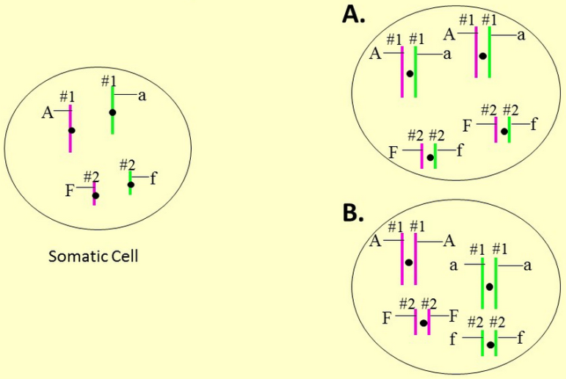

The answer is B
Somatic cells divide by mitosis, resulting in identical sister chromatids

What does a homologous pair look like before DNA replication?
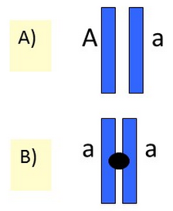

The answer is A
B is incorrect because they are sister chromatids

Refer to the sister chromatids circled in red. Do these have the same set of genes?
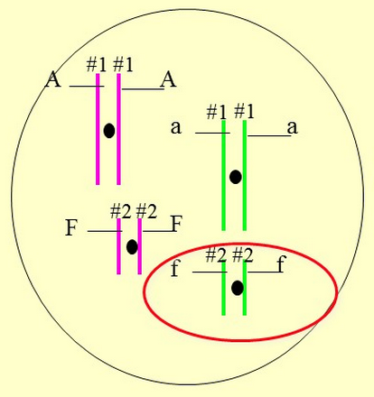
- Yes
- No

The answer is A
Sister chromatids contain identical genes
Refer to the sister chromatids circled in red. Do these have the same set of alleles?
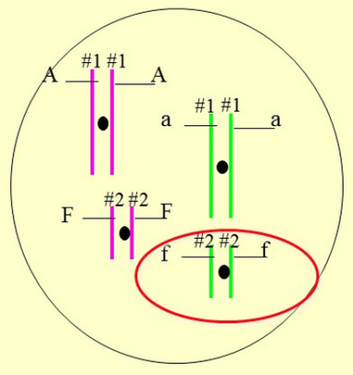
- Yes
- No

The answer is A
Sister chromatids are identical DNA strands. Homologous chromosomes have the same genes, but may have different alleles

Do the homologous chromosomes circled in red have the same set of genes?
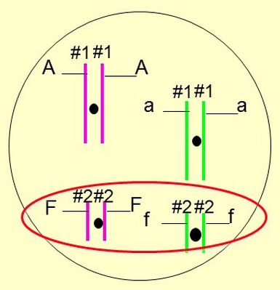
- Yes
- No

The answer is A
Homologous chromosomes contain the same genes

In which of the following cells would you expect to find the gene for liver metabolism?
- Cells in the liver
- Cells in the eye
- Gametes (sperm and egg)
- Cells in the stomach

- Only one of these
- Two of these
- Three of these
- All of them

The answer is D
All cells contain the same chromosomes and genes. The only difference is the activity and inactivity of these genes. Not all cells express the same gene

Which of the male could be the father of the child?
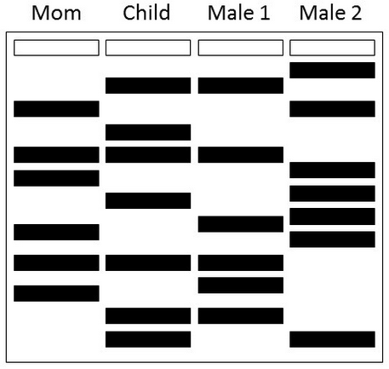
- Male 1
- Male 2
- Both males could be the father
- Neither male could be the father

The answer is D
The 2nd band from the child is absent in both males. Because VNTRs are inherited, neither can be the father

Given the above pedigree, the phenotype of the speech condition is (hint: think about what the pedigree would look like in each of these conditions)
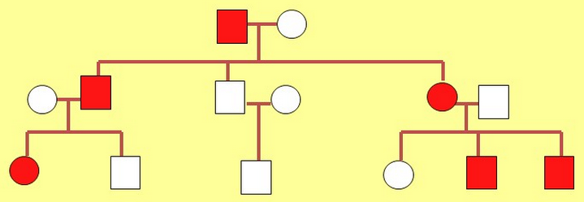
- Autosomal dominant
- Autosomal recessive
- Sex-linked dominant
- Sex-linked recessive
- Autosomal co-dominant

The answer is A
Red is present at every generations, affecting both males and females

According to the KE family speech test results below, on which test(s) did the unaffected group do better than the affected group?
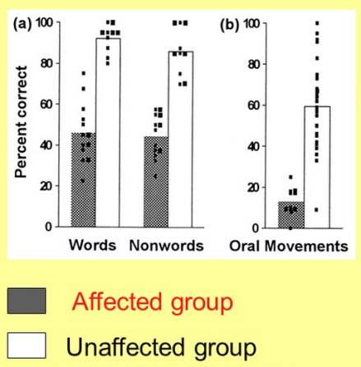
- Words
- Nonwords
- Oral movement

- 1
- 1 and 2
- All 3
- 1 and 3

The answer is C
Phenotypes are not always physical traits; they can be things like speech impediment

For the figure below, which strand is the coding strand?
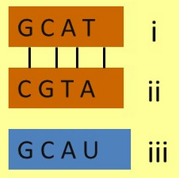
- i
- ii
- iii
- i and ii

The answer is A
A is the sense (coding) strand, B is a template strand, and C is a RNA strand

Consider the following figure. Draw the directions of the DNA strands below. What end is (i) at?
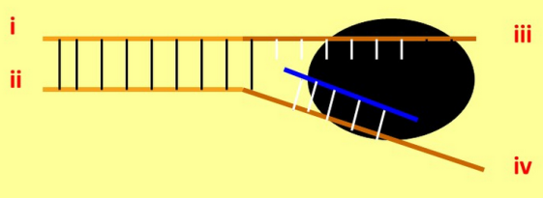
- 5’ of the coding strand
- 3’ of the coding strand
- 5’ of the template strand
- 3’ of the template strand

The answer is A
i is 5’ and iii is 3’. Synthesis of RNA is 5’-3’ direction but the template is read 3’-5’

Which baby is less likely to have severe speech disorder problems? X indicates a mutation
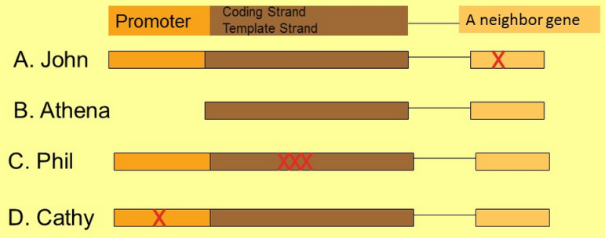

The answer is A
B does not have a promoter region, so the entire gene will not be transcribed. C has a mutated coding strand, leading to mutated mRNA to be transcribed and different protein coded in the end. D has a mutated promoter region, causing problem of RNA polymerase binding and the same problem as B. But D may still get speech impediment; the change in the promoter region may or may not enhance RNA polymerase binding

FOXP2 protein is found in certain but not all brain cells in the same individual. How is this possible?

- Some brain cells do not have chromosome 7
- FOXP2 DNA is only present in some brain cells
- FOXP2 mRNA is only produced in some brain cells
- Some brain cells contain more DNA

The answer is C
All of our cells have it, but only certain cells express it

Identify the players at work
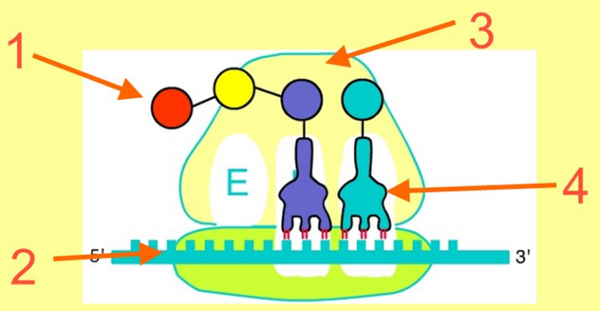

- Methionine
- mRNA
- Large ribosomal subunit
- tRNA

The pictures below show the production of a growing peptide chain. Place the steps in order
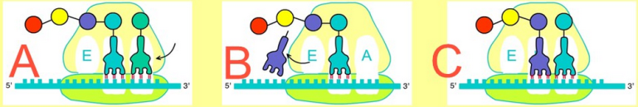
- ABC
- CBA
- BCA
- CAB

The answer is 2
During C, a new teal tRNA enters the A site. During B, the amino acids are bonded and blue tRNA leaves through the E site. During A, a new tRNA enters and the cycle repeats

The first triplet of nucleotides AAU (underlined) is in frame for coding, and encodes asparagine. Which of the following DNA mutations is almost certain to result in a shorter than normal mRNA?
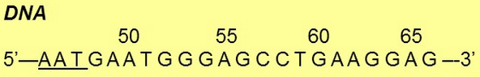
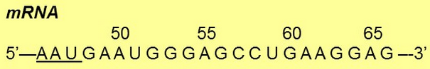
- A replaced G at position 50
- G replaces A at position 53
- C replaces A at position 58
- None of the above

The answer is D
None of these mutations affect the length of normal mRNA. Mutation in the transcription has no impact on mRNA. Such mutation may cause premature termination in translation, but mRNA remains untouched

