Midterm #1 Study Notes : Part 2

1.4 TISSUE:

Describe the different tissues of the human body

Tissue: group of cells that are similar in structure and perform a common or related function

4 Basic Tissues:
1) Epithelial Tissue – covering
forms boundaries between different environments, protects, secretes, absorbs, filters
-lining of GI tract organs and other organs
-skin surface
2) Connective Tissue –support
supports, protects, binds other tissues together
-bones
-tendons
-fat and other soft padding tissue
3) Nervous Tissue – movement
internal communication
-brain
-spinal cord
-nerves
4) Muscle Tissue – control
contracts to cause movement
-muscles attached to bone (skeletal)
-muscle of heart (cardiac)
-muscles of walls of hollow organs (smooth)
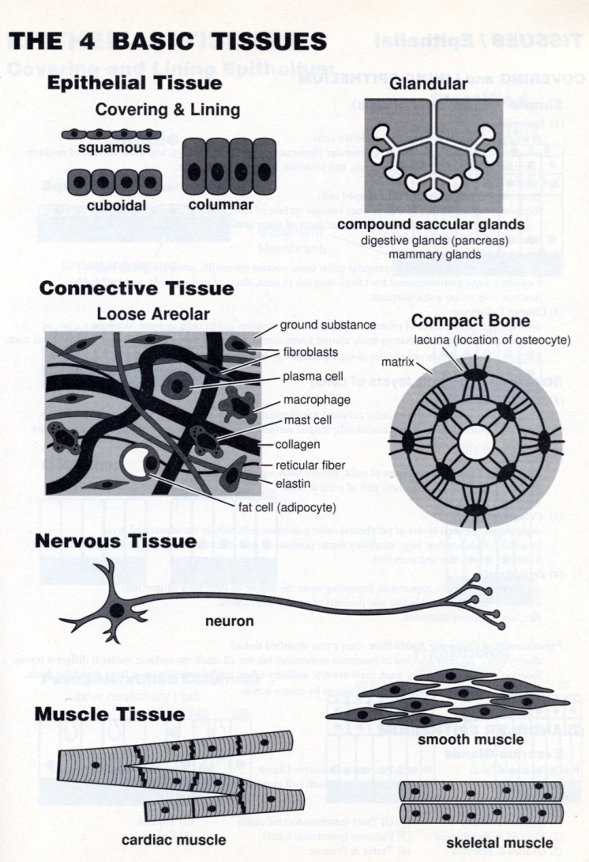

EPITHELIAL TISSUE:

covers a body surface or lines a body cavity
(1) covering and lining epithelium: outer layer of skin, open cavities of digestive and cardio system, walls of organs
(2) glandular epithelium: glands of the body

-forms BOUNDARIES

Functions: protection, filtration, lubrication, secretion, digestions, absorption, transportation, excretion, sensory reception, reproduction

Special Characteristics:

1) POLARITY: apical-basal polarity

i) Apical surface

Microvilli: finger like extension of the plasma membrane –surface area

Cilia: tiny hair like projections – propel substances along their free surface

ii) Basal surface

Basal Lamina: made of glycoproteins + collagen fibers
-selective filter which molecules diffuse from the underlying connective tissue are allowed to enter epithelium

2) SPECIALIZE CONTACTS:
-fit to form continuous sheets
-tight junctions + adherens junctions + desmosomes help keep proteins in the apical region from diffusing into the basal region maintaining epithelial polarity

3) SUPPORTED BY CONNECTIVE TISSUE:
-rest open and are supported by connective tissue

Basal membrane: reticular lamina (collagen fibers) + basal lamina
-together make BASEMENT MEMBRANE
-reinforces epithelial sheet

4) AVASCULAR BUT INNERVATED:
-contains nerves but NO blood
-nourished by blood vessels in connective tissue

5) REGENERATION: high regenerative capacity

6) ARRANGED IN CONTINIOUS SHEETS: (covering and lining epithelium)

Basement membrane: attaches epithelium to underlying connective tissue
-Basal lamina + reticular lamina

Fx:
-anchors down epithelium to loose CT
-mechanical barrier

Classification:
-two names
First: number of cell layers present

1) SIMPLE EPITHELIA: single cell layer
-absorption, secretion, filtration
2) STRATIFIED EPITHEL: two or more cell layers
-high abrasion area, protection
-skin surface, lining mouth

Second: shape of cell
1) SQUAMOUS: flattened, scale like
2) CUBOIDAL: box like, tall as wide
3) COLUMNAR: tall, column

Simple Epithelia:
-absorption, section filtration

(a) Simple Squamous Epithelium

Description: single layer of flattened cells
-disc shaped central nuclei + sparse cytoplasm
-thin permeable

Function: passage of materials diffusion or filtration
-secretes lubricating substances

Location: Kidney, air sacs of lungs, lining of heart, blood vessels lymphatic vessels; lining of ventral body cavity

Two Types: Endothelium + Mesothelium

(b) Simple Cuboidal Epithelium

Description: single layer of cubelike cells with larger spherical central nuclei

Function: secretion and absorption

Location: kidney tubules, ducts and secretory portions of small glands, ovary surface

(c ) Simple Columnar Epithelium

Description: single layer of tall cells with round nuclei; some cells have cilia; layer may contain mucus secreting uni cellular glands

Function: absorption, secretion of mucus, enzymes, and other substances; ciliated type propels mucus (of reproductive cells) by ciliary action
-dense microvilli on the apical surface of absorptive cells
- cells that secrete a protective lubricating mucus

Location: digestive tract, gall balder, excretory ducts of some glands, some uterus

(d) Pseudostratified Columnar Epithelium

Description: single layer of cells of DIFFERING heights
-some reaching surface

Function: secretion, particularly of mucus
-Propulsion of mucus by ciliary action

Location: sperm, glands, upper respiratory tract

Stratified Epithelia:
-durable, protection

(a) Stratified Squamous Epithelium

Description: thick membrane, several layers of cells
-basal cells are cuboidal or columnar
-surface cell are flat squamous
-surface full of keratin and dead

Function: protects underlying tissue area in subjected to abrasion

Location: esophagus, mouth, vagina

(b) Stratified Cuboidal Epithelium:

Description: rare

Location: ducts of larger glands

(c ) Stratified Columnar Epithelium
Description: transition area or junctions between two other types of epithelia

Location: Pharynx, urethra, glandular ducts

(d) Transition Epithelium

Description: resembles both stratified squamous and stratified cuboidal
-basal cells cuboidal or columnar
-surface cells dome shaped or squamous like

Function: stretches readily and permits distension of urinary organ by contained urine

Location: lines the ureters, bladder and part of the urethra

Endocrine Glands/ Exocrine glands

Endocrine glands: produce hormones
-chemicals are secrete directly into extracellular space /blood instead of duct

Exocrine glands: secrete their products onto body surface and body cavities
-mucus, sweat, oil, saliva, pancreatic enzymes

Function:
-protection (mucus, ph)
-thermoregulation (sweat glands)
-excretion (drugs, waste products)

Structure:
1) Unicellular (one celled) glands:
-goblet cells (intestinal and respiratory tracts)
-produce mucin glycoprotein dissolves in water mucus

2) Multicellular Exocrine Glands:
-surrounded by supportive CT which brings blood vessels and nerves

i) Epithelium derived duct

ii) Secretory unit (acinus)

Structural:
i) Simple Glands – unbranched duct
ii) Compound glands – branched duct

Categorized: by secretory units
i) Tubular
ii) Alveolar
iii) Tubuloalveolar

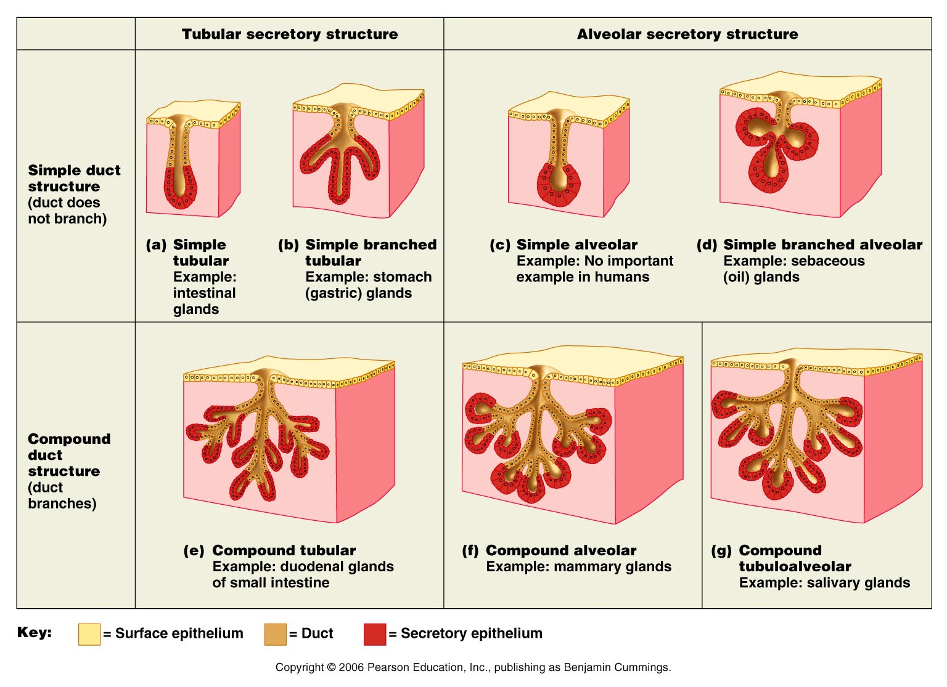

Mode of Secretion:

1) Merocrine/eccrine: exocytosis most common
(pancreas, salivary glands, sweat glands)

2) Holocrine: accumulate their products within them until they reupture
(oil skin glands)

3) Apocrine: cell apex pinches off with secretory product
(humans?)

Exocytosis: durable, energy consuming process
-cells direct the contents of secretory vesciles out of the cell membrane into extracellular space
-proteins, membrane proteins and lipids

CONNETIVE TISSUE:
-highly vascular
-supplied with nerve
-includes bone cartilage and blood
-Mesenchyme: source of CTS

5 Types:
Mesenchyme
Connective Tissue Proper
Cartilage
Bone Tissue
Blood

Fx:
-binding or support
-protection
-insulation
-transportation

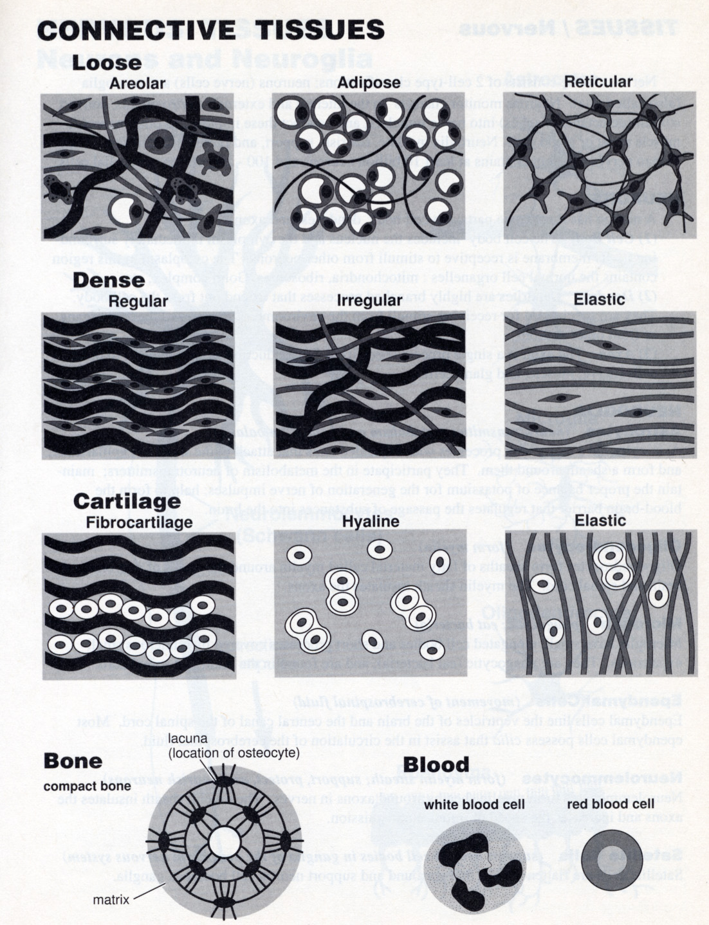

CONNECTIVE TISSUE PROPER:
-fixed and wandering cells

Main Function:
-binds together, supports and strengthens other body tissue
-protects and insulates internal organs
-compartmentalizes structures such as skeletal muscle
-transport (blood) of substances within the body
-storage of fuels (fat)

3 Structural Elements of CT:

1) Cells
-fibroblasts (secrete ground substance and fibes of matrix) F
-macrophasges (phagocytes) F and W
-defensive white blood cells W
-plasma cells (secrete antibodies) W
-mast cells (produce inflammatory mediators) F
-adipocytes (store lipids) F

-blasts are actively dividing/synthesizing cells during growth and repair (immature)
-cytes are primarily provide a level of maintenance (mature forms)

2) Ground substance
-protein based fibers (collagen, elastic, reticular)

Structure:
-interstitial fluid + protein
-adhesion proteins
-proteoglycans (trap water)

Functions:
-supports and binds connective tissue cells
-provides medium for exchange of substances between the cell and blood
-affects tissue development and behavior

3) Fibers:

Collagen fibers: high tensile strength
-protein collagen
-very strong
-resist pulling forces
bone cartilage ligaments tendons

Elastic fibers: elastin has coiled structure to allow stretch + recoil
-protein elastin
-stabilizes elastic fibers
skin blood vessels lungs

Reticular fibers: thin collagenous protein – fine network to support blood vessels, soft tissues
-bundles coated with glycoprotein
-support walls of blood vessels
-network around cell of some tissues
adipose tissue and smooth muscle tissue
-form basement membrane

Two Types of CONNECTIVE TISSUE PROPER

LOOSE Connective Tissue:
-areolar, adipose, reticular

(a) Areolar Connective Tissue

Description: gel like matrix
-all three fibers types – cells fibroblasts macrophages mast cells and some white blood cells

Function: wraps and cushions organs; its macrophages phagocytize bacteria; plays important role in inflammation; holds and conveys tissue fluid
-soft packaging tissue
(1) support and biding other tissue (2) holding body fluids (3) defending against infection (4) storing nutrients

Location: widely distributed under epithelia of body
-mucous membrane
-packages organs
-surrounds capillaries

(b) Adipose

Description: matrix as in areolar,
-closely packed adipocytes or fat cells
-have nucleus pushed to the side by large fat droplet

Function: provides reserve food fuel
-nutrient storing
-insulates against heat loss
-supports and protects organs

Location: under skin, around kidneys and eyeballs, within abdomen, in breasts

White Adipose Tissue: stores nutrients

Brown Adipose Tissue: abundant mitochondria use lipid fuels to heat the bloods stream to warm the body

(c ) Reticular

Description: network of reticular fibers in a typical loose ground substance
-lie on the net work

Function: form soft internal skeleton (stroma) that supports other cells types white blood mast cells and macrophages

Location: lymphoid organs, bone marrow, spleen

DENSE Connective Tissue:
-dense regular, dense irregular, elastic

(a) Dense Regular

Description:
-closely packed bundles of collagen fibers running in same direction
-parallel to the pull
-few elastin fibers
-lots of fibroblasts

Function: attaches to muscle or bones
-muscles to bone
-bone to bone
-great resistance to tension (pulling forces) ONE DIRECTION

Location: tendons, ligaments, aponeuroses

(b) Dense irregular

Description: irregularly arrange collagen fibers
-some elastic fibers
-lots of fibroblast

Function: forms sheets in body areas where tension is exerted from any different direction
-withstand tension in many direction
-structural strength

Location: dermis of the skin, submucosa of digestive tract
-fibrous capsules of organs and joints

(c ) Cartilage: hyaline

Description: -collagen fibers form a imperceptible network

Function: supports and reinforces
-resilient cushioning and properties; resist compressive stress

Location: -form embryonic skeleton
-covers ends of long bone in joint cavities
-forms costal cartilages of the ribs
-cartilages of the nose trachea and larynx

(d) Cartilage: Elastic

Description: similar to hyaline
-more elastic fibers in matrix

Function: maintains the shape of a structure while allowing great flexibility

Location: supports the external ear (pinna) – epiglottis

CARTILAGE:

-features between dense CT and bone: touch but flexible
i) avascular, devoid of nerve fibers
ii) ground substance contains lots of GAGs chondroitin & hyaluronic acid – also chondronectin (adhesive protein)
iii) collagen fibers (can have some elastic fibers)
iv) up to 80% water

(e) Cartilage: fibrocartilage

Description: similar but less firm that hyaline cartilage
-thick collagen fibers predominate

Function: tensile strength with ability to absorb compressive shock

Location: intervertebral discs
-public symphysis
-discs of knee joint

BONE:

-calcium salts give hardness & strength for support/ protection of softer tissues
-cavities for fat storage & synthesis of blood cells

Osteoblasts: bone producing cell, mature into osteocytes
Osteocytess: mature bone cell reside in lacunae (spaces in bone matrix)
Osteoclasts: bone breakers

(f) Others; bone (osseous tissue)

Description: hard calcified matrix containing may collagen fibers
-osteocytes lie in lacunae
-vascular

Function:
-bone supports and protects (by enclosing)
-provides levers for the muscles to act on
-stores calcium and other minerals and fat
-marrow inside bones is the site of blood cell formation (hematopoiesis)

Location: bones

Blood:
-classified as CT cause it consist of cells (red and white) surrounding by nonliving fluid matrix Blood plasma
-“Fiber” components are soluble proteins only visible during clotting

Description: red and white blood cells in a fluid matrix (plasma)

Function: transport of respiratory gases, nutrients, wastes and other substances

Location: within blood vessels

2.2 NEURONS:

Nervous system function:
-sensory input
-integration
-motor output

PNS: consist mainly of nerves (bundles of axons) that extend from the brain and the spinal cord
i) spinal nerves – to and from spinal cord
ii) cranial nerves – to a from brain

Sensory/ afferent: consist of nerve fibers that convey impulses throughout the body

Somatic Afferent Fibers: convey impulses

Visceral Afferent fibers: organs

Motor/ efferent: transmit impulses from the CNS to effector organs which are the muscles and glands
-activate muscles to contract and glands to secrete

i) Somatic Nervous System

ii) Autonomic Nervous System

Neurons:
-specialized cells that conduct electrical impulses
-Amitotic: assume roles and lose their ability to divide
-extreme longevity (over 100 years)
-high metabolic rate and require lots of Oxy + Glucose
-have cell body and one or more slender processes
-plasma membrane of neuron is the site of electrical signaling

Neuron Cell Body: spherical nucleus with a conspicuous nucleolus surrounded by a cytoplasm

Perikaryon/ Soma: the cell body

Nuclei: clusters of cell bodies in the CNS

Ganglia: cluster of cell bodies

Biosynthetic Centre of neuron:
-synthesizes the essential chemistry
-most active and best developed of any cell type

Dendrites: -in motor neurons short branching extensions
-main receptive/input regions of the neuron
-large surface areafor receiging signals
-convey incoming messages toward the cell body

Dendritic Spines: collects info
-bulbous or spiky ends

Graded potentials: short distance signals
-convey incoming messages TOWARD the cell body

Axon: impulse generating, transmitting and conducting region
-arises from the axon hillock
-axon collaterals Axon Terminal End foot
-transmit impulses along axolemma (cell membrane) to the axon terminal
-neurotransmitters released from nerve endings
-exite or inhibit

-lacks rough ER and Golgi apparatus
-cell bodies renews protein
-efficient transport mechanisms
-quickly decay if cut or damaged

Axon hillock: nerve impulses are generated here

Nerve Fibers: long axons

Anterograde movement: movment toward the axons terminals
-travel: mitochondria, cytoskeletal elements membrane components used to renew the axon plasma membrane and enzymes needed for synthesis of certain neurotransmitters

Retro grade movement: movement away from the axon terminals – toward cell body
Travel: organelles to be degraded, signal molecules, viruses and bacterial toxins
-intracellular communication: advising cell body of conditions at axon terminals and for delivery to the cell body vesicle containing signal molecules

-molecules and organelles move along axons by motor proteins and cytoskeletal elements (microtubules)

Myelin Sheath: Myelin – white protein lipoid substances
-protects and electrically insulates fibers and increases the speed of transmission of nerve impulses

Myelinated fibers: segmented sheath around axon

Non-myelinated fibers: conduct impulses slowly

1) Schwann cell envelop an axon
2) The Schwann cell then rotates around the axon, wrapping its plasma membrane loosely around it is layers
(3) the Schwann cell cytoplasm is forced from between the two membrane(end up as a bulge just external to the myelin sheath) tight membrane wrapping around the axon form the myelin sheath

Structural Classified of Neurons:

1) Multipolar: have three or more processes – one axon and the rest dendrites
-most common
-99%
-major neuron type in CNS

2) Bipolar: have two processes – an axon and a dendrite
-rare neurons
-special sense or organs
-retina of eye and olfactory mucosa

3) Unipolar: : single short processes that emerges from the cell body and divides t like into proximal and distal branches
-T-like both branches considered axons
-found mainly in PNS
-common in dorsal root ganglia of the spinal cord and sensory ganglia of cranial nerves

Peripheral (distal) process – associated with sensory receptor

Central (proximal) process – enters CNS

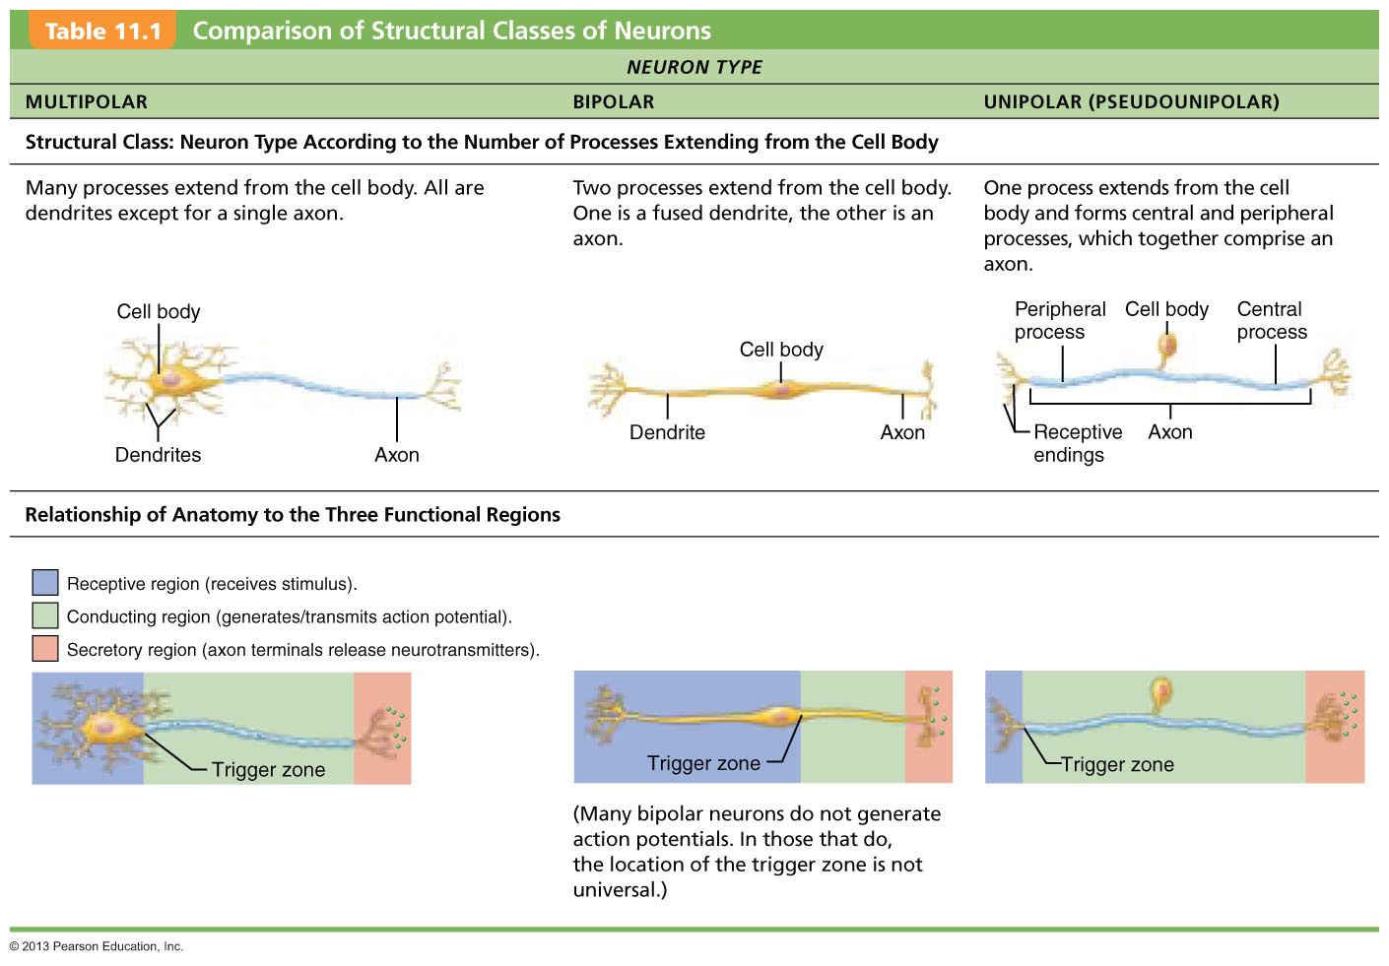

Functional Classification:

Sensory:
-transmit sensory receptors to CNS
-almost all unipolar

Motor:
-transmit from CNS to effectors
-multipolar
-most cell bodies located in CNS
-some located in autonomic nervous system

Interneurons:
-connect motor and sensory neurons
-lie between two neurons in a neural pthawys and shuttle signals through the CNS pathways where integration occurs
-most in CNS
-most multipolar

Synapse:
-neurons functional connect by synapse
-mediates information transfer from one neuron to the next

Axodendritic – between axon terminal of one neuron and dendrites of the other

Axosomatic – between axon terminals of one neuron and soma of other

Less common:
Axoaxonic (axon to axon)
Dendrodenritic (dendrite to dendrite)
Somatodendritic (dendrite to soma)

Presynaptic Neuron: neuron conducting impulses TOWARD the synapse
-information sender

Postsynaptic: neuron conducting impulses AWAY from the synapse
-information receiver

Electrical Synapses:
- * specialized to allow flow of ions between neurons
-lesson common
-Gap junctions connect cytoplasma of adjacent neurons allow ions and small molecules to flow directly from one neuron to the next
-Connexons: protein channels that connect them
-Electrically coupled (they are joined through the gap junction)

-provide a simple means of synchronizing the activity of all interconnecter neurons (local inhibitory networks)
-rapid communication
-uni- or bi-directional
-lots in embryo nervous tissue

*occur in heart and gut

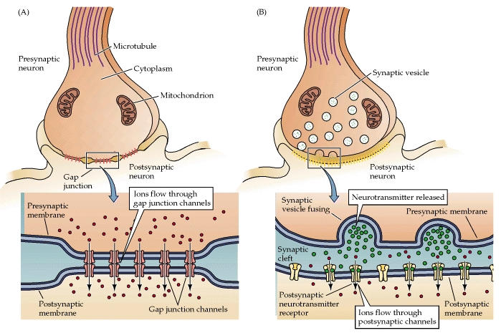

Chemical Synapses:
*specialized for release and reception of chemical neurotransmitters

Two parts:
1) AXON TERIMAL – of the presynaptic neuron which contains tiny membrane bound sacs called SYNAPTIC VESICLES each containing thousands of neurotransmitters
2) a neurotransmitters RECEPTOR REGION on the membrane of a dendrite or the cell body of the post synaptic neuron

-two parts are separated by SYNAPTIC CLEFT

Synaptic clef: a fluid filled space through which transmitters diffuse

-chemical synapses convert the electrical signals to chemical signals (neurotransmitters) that travel across the synapse to the postsynaptic cells converted back into electrical signals

Information Transfer: Chemical Synapses

1) Axon potential arrives at axon terminal

2) Voltage gated Ca channel opens + Ca enters the axon terminal
-action potential depolarizes membrane
-opens Na channels and Ca channels
-Ca floods down its electrochemical gradient into the terminal from the extracellular fluid

3) Ca entry causes neurotransmitters containing vesicles to release their contents by exocytosis:
-Synaptotagmin (sensing protein) binds with Ca and interacts with snare proteins that control membrane fusion
-synaptic vesicles fuse with axon membrane and empty their contents by exocytosis into the synaptic cleft
-Ca then quickly removed
-the more intense the stimulus (frequency) the greater the number of synaptic vesicles that fuse and spill their contents

4) Neurotransmitters diffuses across the synaptic cleft and binds to specific receptors on the post synaptic membrane

5) Binding of neurotransmitters opens ion channels, resulting in graded potentials
-neurotransmittesr bind to receptor protein – causing ion channels to open
-creates graded potential
-either excites or inhibits

6) Neurotransmitters effects are terminated by reuptake through transport proteins, enzymatic degradation or diffusion away from the synapse.
-need to “wipe slate clean”

Reuptake: by astrocytes or presynaptic terminal - where the neurotransmitters is stored or destroyed by enzymes

Degradation: by enzymes associated with the postsynaptic membrane or present in the synapse

Diffusion: away from the synapse

Resting Membrane Potential:

Voltage: potential energy

Potential difference: voltage is always measured between two points
-the greater the difference in charge between the two points the higher the voltage

Charge: voltage and resistance

Resting membrane potential: the potential difference a resting neuron (Vr)
-resting membrane is POLARIED
-value of resting membrane varies from -40mV to -90 mV)

RMP is generated by:
-differences in ionic make up of ICF and ECF
-differential permeability of the plasma membrane

-the resting potential exists only across the membrane *
-bulk outside and inside are neutral

Resting Potential:

-K+ flowing out of the cell causes cell to become more negative inside
-Na coming into the cell makes just slightly more positive
-therefore at resting potential the negative interior of the cell is due to much GREATER diffusionof K out of the cell than Na diffusion into the cell

Sodium Potassium pump:
-ATP driven
-ejects three Na from the cell and then transports two K back into the cell
-pump stabilizes the resting membrane potential by maintain the concentration gradient for sodium and potassium

-ECF has higher concentration of Na balance by Cl –
-ICF has higher K + than ECF balance by the negative charged proteins
-neuron membrane is more permeable to K and Na (leakage channels)
-impermeable to large anionic proteins
-Sodium diffuses into cell down concentration gradient
-Potassium diffuses out of the cell down concentration gradient

Concentration gradient: uneven distribution of substances across border
-moving against CG substance is being forced from area of less concentrated into more concentrated
-moving down from more concentrated into a less concentrated area
energy is used when going AGAINST concentration gradient

Excitatory vs Inhibitory Actions

-neurons use changes in membrane potential as communications signals for receiving integrating and sending information
-changes in membrane potential can produce two types of signals Graded + Action potential

A change in membrane can be produced by:
1) anything that alters ion concentration on the two sides of the membrane
2) anything that changes membrane permeability to any ion

Depolarization:
-decrease in resting membrane potential (toward 0 and above)
-inside becomes less negative than resting membrane potential
-increases probability of producing a nerve impulse

Hyperpolarization:
-increase in membrane potential (away from 0)
-inside of cell more negative than resting membrane potential
-reduces probability of producing a nerve impulse

Membrane potential changes when
-ions across membrane change
-membrane permeability to ions change

1) Graded potentials
-incoming signals operating over short distances

2) Action Potentials
long distance signals of axons

Graded Potentials: are short lived localized changes in membrane potential that can be either depolarization or hyperpolarization
-the stronger the stimulus the more voltage changes and the farther current flows

-GP are triggered by a stimulus that causes gated ions channels to open
Two types of GP:
Receptor potential: sensory neuron is excited by some form of energy
Postsynaptic Potential: neurotransmitter is released by another neuron

Action Potentials: only excitable membranes (neurons and muscle cells) can generate action potentils
-brief reversal of a membrane potential with a total amplitude (change in voltage) of about 100 mV (-70 to +30)
-a depolarization phase is followed by a repolarization phase often a short period of hyperpolarization
-when stimulated neurons will produce a nerve impulse
-stimulus changes the permeability of the neuron’s membrane by OPENING specific voltage gated channels on the axon
-close and open in response to changes in membrane potential and are activated by local currents (graded potenials)

Generation of AP:
-AP is caused by permeability changes in the plasma membrane

Voltage gated Na Channels:
two gates
three different states
-Closed (resting potential)
-Open (by depolarization)
-Inactivated (blocked by inactivation gate)

Voltage gated K Channels
one gate
two different states
-Closed (resting state)
Opened (by depolarization)

Events:
1) Resting State: all gated channels are closed
2) Depolarization: Na+ Channels open
3) Repolarization: Na channels are inactivating and K channels are open
4) Hyperpolarization: some K channels remain open and Na channels reset

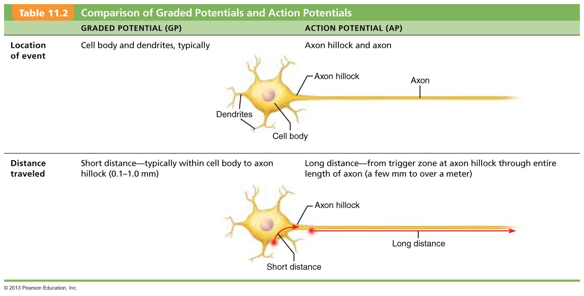

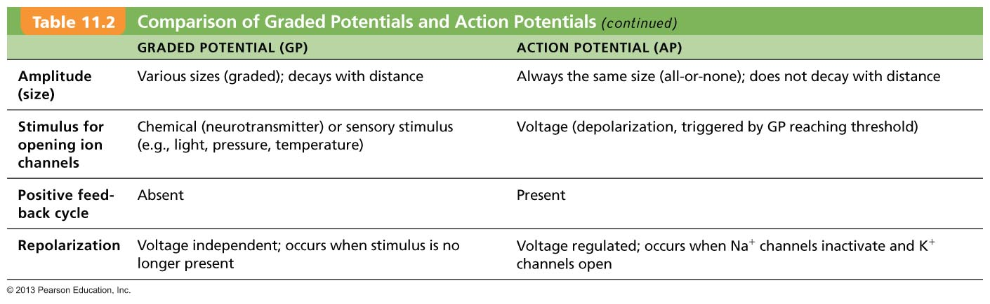
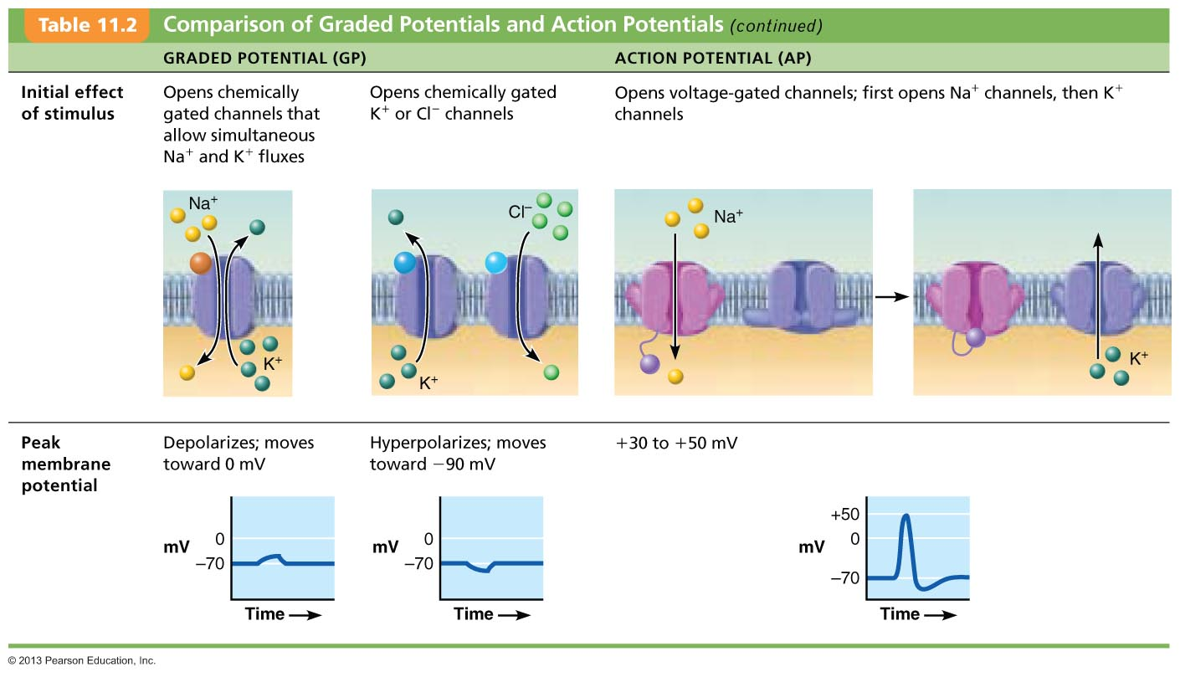
Post Synaptic Potentials:

Types:

1) EPSP – excitatory postsynaptic potentials
*is a local depolarization of the postsynaptic membrane that brings the neuron closer to the AP threshold
-neurotransmitter binding opens chemically gated ion channels allowing Na and K to pass through simultaneously

-neurotransmitter binding opens chemically gated channels
simultaneous flow of Na+ K + in opposite directions
Na influx is greater than K efflux NET depolarization called EPSP
-EPSP occur at excitatory postsynaptic membrane
-EPSP helps triggers AP if EPSP is of threshold strength
can spread to axon hillock, trigger opening of voltage gated channels and cause AP to be generated

2) IPSP - inhibitory postsynaptic potentials
*is a local hyperpolarization of the postsynaptic membrane that drives the neuron away from the AP threshold
-neurotransmitters bidning opens K+ and CL- channels

Synaptic Integration: Summation
-a single EPSP cannot induce an AP
-EPSP and IPSP can SUMMATE (add together)
-Most neurons receive both excitatory and inhibitory inputs from thousands of other neurons
-only EPSP predominate and bring to threshold AP

Types:
1) Temporal Summation
-one or more presynaptic neurons transmit impulses in rapid fire order
-first impulses produces EPSP, then more impulses trigger more EPSP
-produce a much greater depolarization of the postsynaptic membrane

2) Spatial Summation
-postsynaptic neuron stimulated simultaneously by large number of terminals
-postsynaptic neuron is stimulated at the same time by a large number of terminals from same or different neurons
-huge number of receptors bind neurotransmitter and initiate EPSP which summate and change depolarization

Integration: Synaptic Potentiation
-repeated use of synapse increase ability of presynaptic cell to excite postsynaptic neuron SYNAPTIC POTENTIATION
Ca concentration increases in presynaptic terminal and postsynaptic neuron triggers release of more neurotransmitters larger EPSP

-brief high frequency stimulation partially depolarizes postsynaptic neuron
chemically gated channels (NMDA receptors) allow Ca entry
-Ca activates kinase enzymes promote more effective responses to subsequent stimuli

Integration: Presynaptic Inhibition:
-occurs when the release of excitatory neurotransmitters by one neuron is inhibited by the activity of another neuron via an axo-axonic synapse
-less neurotransmitter released
-smaller EPSP formed
-reduces excitatory stimulation of the post synaptic neuron
“pruning” / volume control

Neurotransmitters:
-60 neurotransmitters have been identified
-most neurons make two or more neurotransmitters – neurons can exert several influences
-usually released at different stimulation frequencies
-can promote rapid responses by altering membrane potential (open ion channels)

Classified by:
-chemically structure
-function (excitatory or inhibitory)
-type of receptors
-actions i) direct (ion channels ) ii) indirect (2nd messengers)

Direct Action:
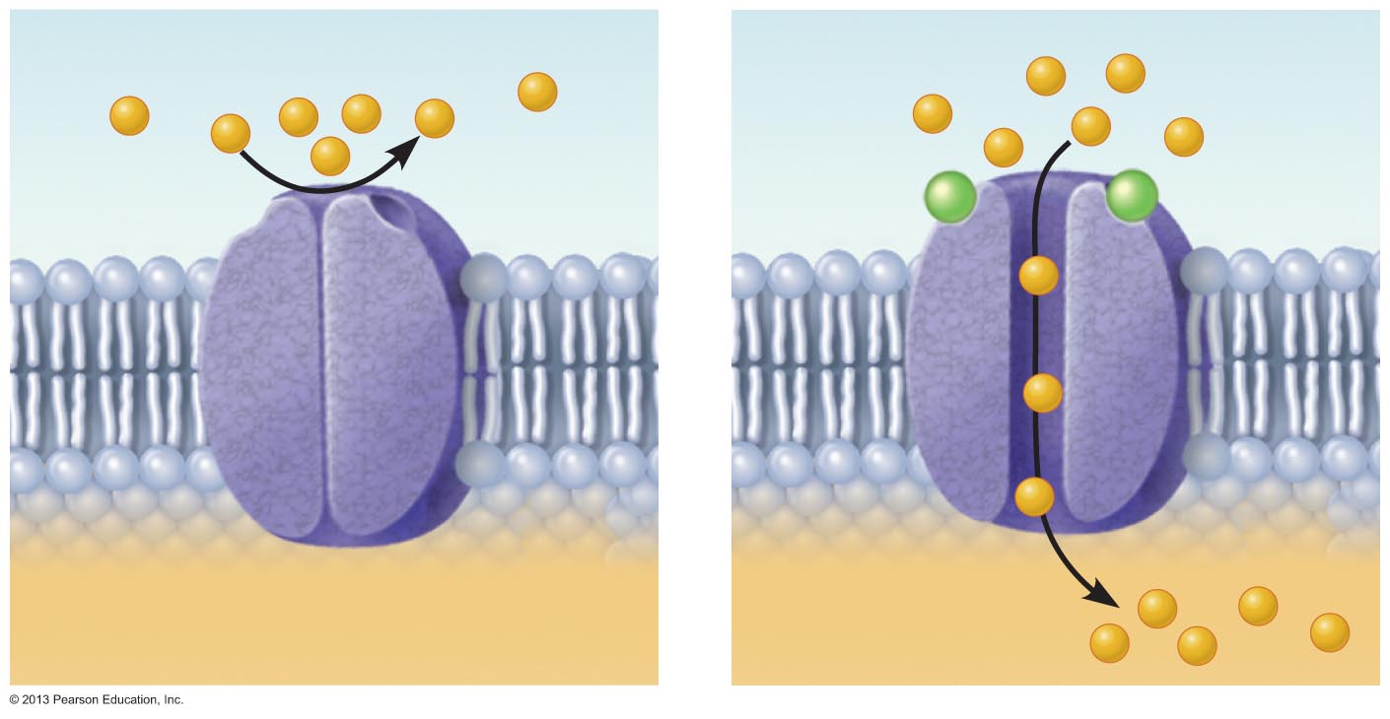
-promotes rapid responses by altering membrane potential

Neurotransmitter: Indirect Actions
-through second messengers, usually G protein pathways
-oversee slow synaptic response
-broader, longer lasting effects similar to hormones
-biogenic amines, neuropeptides and dissolved gases

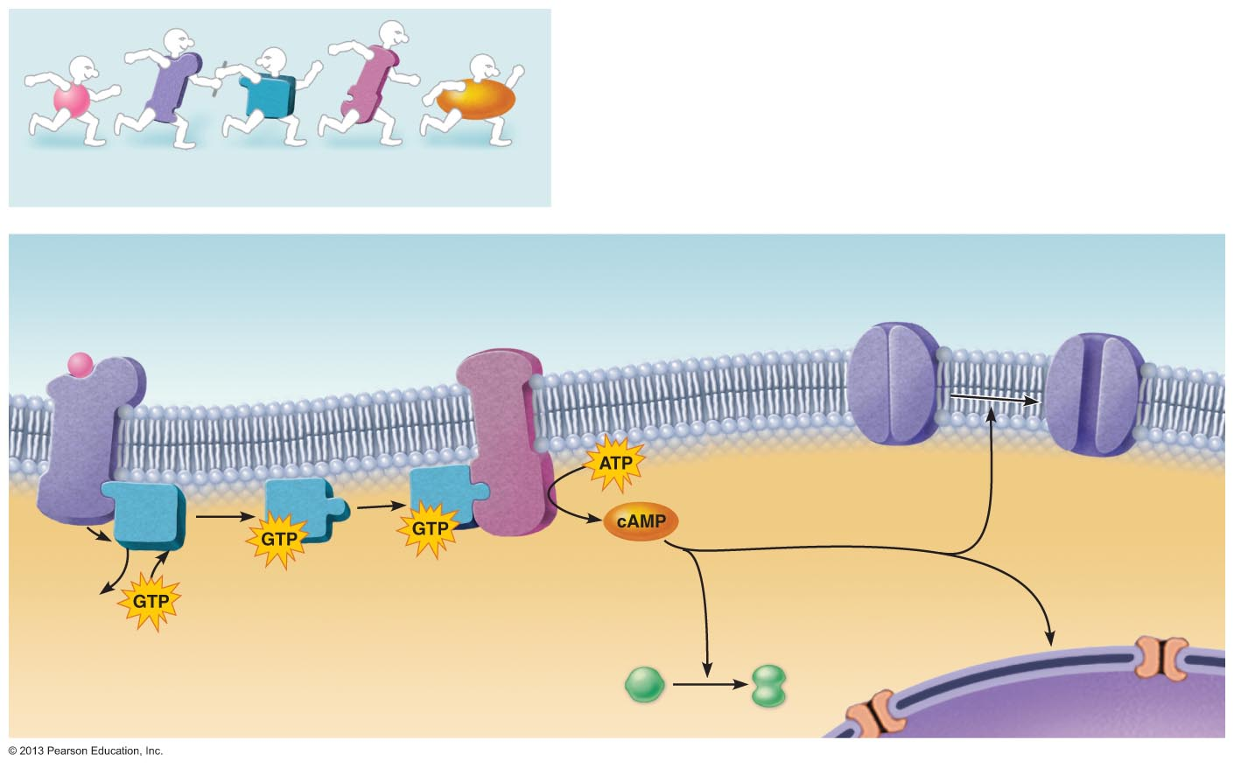

Channel-linked (Ionotropic Receptors)
- Ligand-gated ion channels
- Action is immediate & brief
- Excitatory receptors are channels for small cations
  - Na⁺ influx contributes most to depolarization (Glutamate)
- Inhibitory receptors allow Cl– influx that causes hyperpolarization (GABA)



