Anatomical Terms
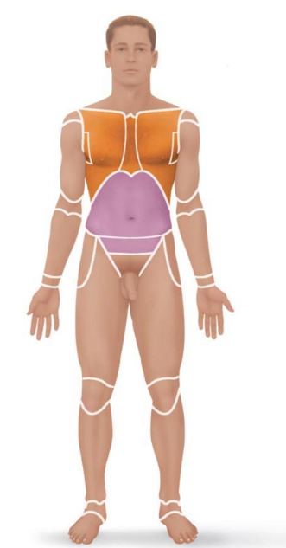
Anatomical Position and Directional Terms
- Anatomical reference point = standard body position called the anatomical position
  - Body erect, feet slightly apart
  - “standing at attention”
  - Palms forward, thumbs point away from the body
Indication of direction – “right” and “left” refer to the patient, NOT the observer
- Directional terms allow us to explain where one body structure is in relation to another
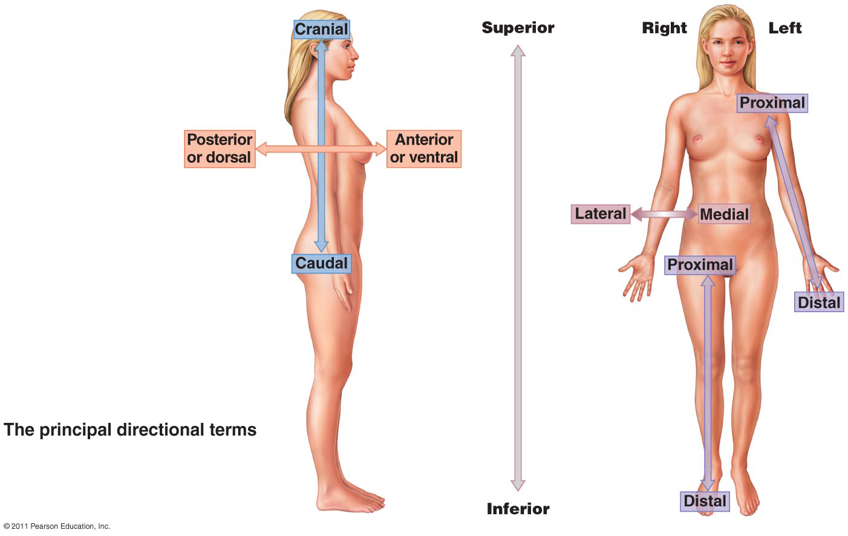
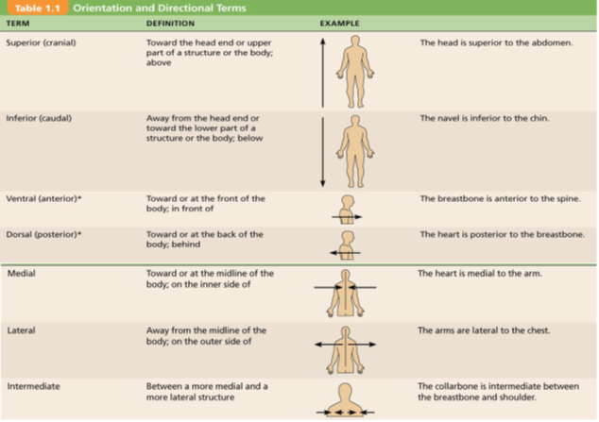
Regional Terms
Two fundamental divisions of the body:
- Axial – head, vertebral column and trunk
- Appendicular – appendages or limbs attached to axis
Regional terms are used to designate specific areas within the axial or appendicular parts of the body
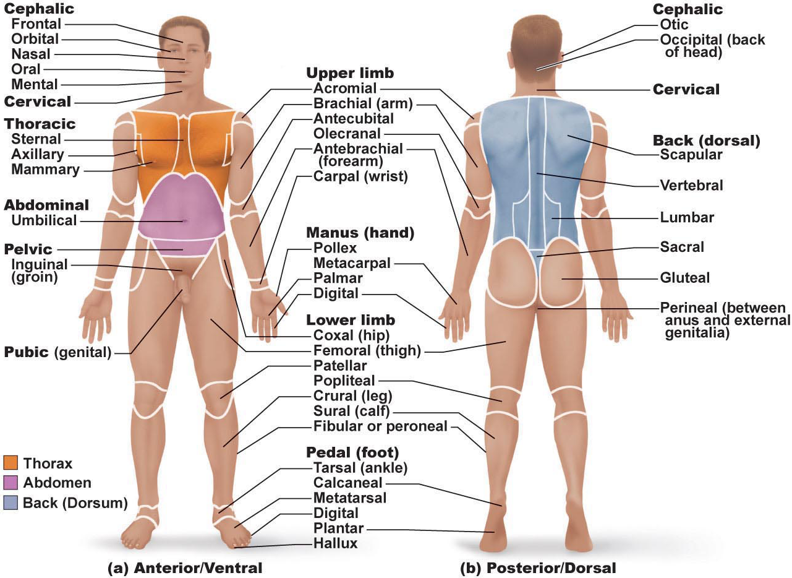
Body Planes and Sections
3 common body planes – 2 vertical and 1 horizontal
- Median (midsagittal) plane
  - Vertical plane that divides body into right and left parts
  - Other sagittal planes offset from the midline are parasagittal planes
- Coronal/Frontal plane
  - Vertical plane that divides the body into anterior and posterior parts
- Transverse/horizontal plane
  - From right to left dividing the body into superior and interior parts
  - Cross-section
Oblique section
- Cuts made diagonally between the horizontal and vertical planes
- Seldom used (confusing)

Body Cavities and Membranes
Dorsal Body Cavity
- Cranial cavity
  - Enclosed by the skull and houses the brain
- Vertebral (spinal) cavity
  - Enclosed by the vertebral column and houses the spinal cord
Both cavities are continuous and well protected
Ventral Body Cavity
Larger and houses the viscera (visceral organs)
- Thoracic cavity
  - Surrounded by the ribs and muscles of the chest
  - Further subdivided into 2 lateral pleural cavities, each enveloping a lung
  - Mediastinum contains the pericardial cavity which encloses the heart and surrounds remaining thoracic organs
- Abdominopelvic cavity
  - Cavities separated by the diaphragm
  - Abdominal cavity contains: stomach, intestines, spleen, liver
  - Pelvic cavity contains: bladder, some reproductive organs, rectum
  - Regions are not physically separated by a muscular or membrane wall

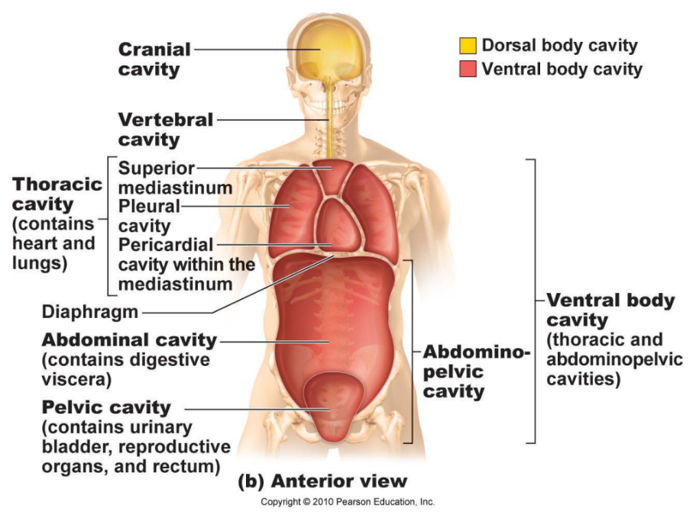
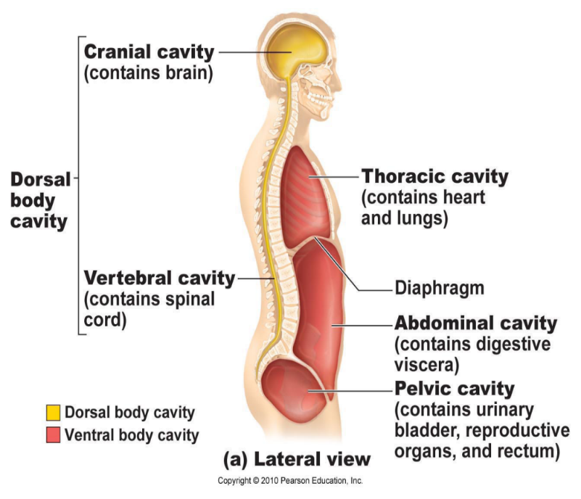

The Integumentary System
Derived from the Latin word “integumentum” which means “a covering”.
Comprised of the:
- Skin
- Accessory structures (skin glands hairs and nails)
The Skin
- Surface area of 1.2-2.2 square meters
- Weighs 4-5 kg (9-11lb)
- 7% total body weight
- Varying thickness from 1.5 to 4.0 millimeters (mm) and composed of 2 distinct regions:
  - Epidermis – outermost layer – epithelial cells, avascular
  - Dermis – thickest layer, leathery, fibrous connective tissue
- Only dermis is vascularized
- Hypodermis – is not part of the skin (subcutaneous)
  - Called superficial fascia because it is superficial to the tough connective tissue wrapping of the skeletal muscles and consists mostly of adipose tissue
  - Anchors skin to the underlying structures (mostly to muscles)
  - Shock absorber/insulator that reduces heat loss
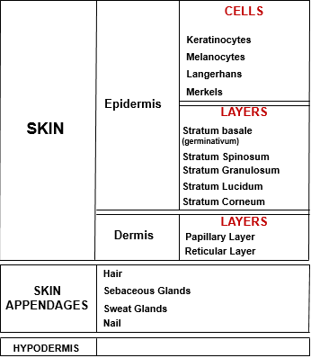
  - Thickens when a person gains weight
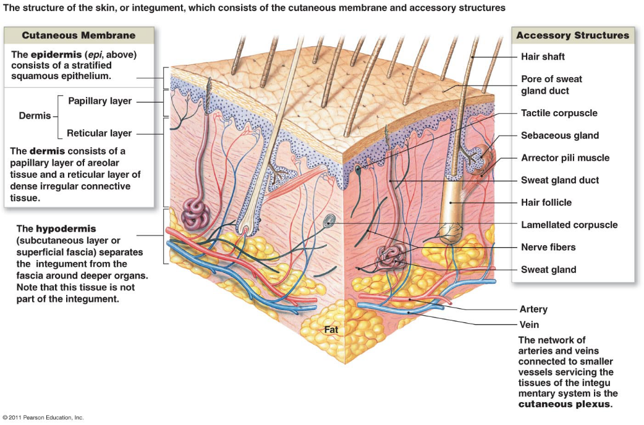

Epidermis
- A keratinized, stratified squamous epithelium consisting of four distinct cell types and five distinct layers
Cells of the epidermis
Keratinocytes
- Produce protein keratin which gives epidermis protective properties
- Majority of epidermal cells
- Tightly connected by desmosomes
- Arise in deepest part of epidermis (stratum basale)
- As they are pushed upward by production of new cells beneath them, they make keratin that eventually dominates their cell contents
- When they reach skin surface they are dead
- Constantly rubbing off, new epidermis every 25-45 days
- Persistent friction causes thickening of epidermis called “callus”
Melanocytes
- Spider-shaped epithelial cells that synthesize the pigment melanin
- Found in deepest layer of epidermis
- Numerous branching processes for melanin transfer to adjacent cells
- Melanin granules accumulate on the superficial “sunny” side of the keratinocyte nucleus, forming a pigment shield that protects the nucleus from the damaging effects of ultraviolet (UV) radiation in sunlight
Langerhans (dendritic) cells
- Star-shaped
- Arise from bone marrow and migrate to the epidermis
- Ingest foreign substances and are key activators of our immune system
Merkel (Tactile) cells
- Present at epidermal-dermal junction
- Each cell is intimately associated with a disc-like sensory nerve ending
- Functions as a sensory receptor for touch
Layers of the Epidermis
Thick skin – covers areas subjected to abrasion (palms, fingertips, soles of the feet), has 5 epidermis layers
- Stratum basale (deepest), stratum spinosum, stratum granulosum, stratum lucidum, stratum corneum (superficial layer)
Thin skin – covers rest of body, stratum lucidum appears to be absent and other layers are thinner

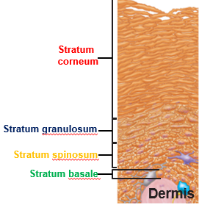
Stratum Basale (Deepest layer, basal layer)
- Attached to underlying dermis along a wavy borderline
- Consists of single row of stem cells – youngest keratinocytes
- Many mitotic nuclei seen in this layer show rapid division of these cells and account for its alternative name (stratum germinativum)
- 10-25% of cells in the stratum basale are melanocytes
  - Branching processes extend among the surrounding cells reaching well into the more superficial stratum spinosum layer
- Occasional tactile cells occur
Stratum Spinosum (Prickly layer)
- Several cell layers thick
- Contain a web-like system of intermediate filaments, mainly tension-resisting bundles of pre-keratin filaments, which span their cytosol to attach to desmosomes
- Keratinocytes look like they have spines = prickle cells
- Scattered among keratinocytes are melanin granules and dendritic cells = most abundant in this layer
Stratum Granulosum (granular layer)
- Thin, consists of 4-6 layers in which keratinocyte appearance changes drastically
- Keratinization begins (cells fill with the protein keratin)
- Cells flatten, nuclei and organelles begin to disintegrate
  - Accumulate granules keratohyaline granules (help form keratin in upper layers) and lamellar granules (contain water-resistant glycolipid that is spewed into the extracellular space and is a major factor in slowing water loss across the epidermis)
- Plasma membranes thicken as cytosol proteins bind to the inner membrane face and lipids released by the lamellar granules coat their external surfaces
- Make cells more resistant to destruction
- Keratinocytes “toughen up” outer skin region
- Layers from above stratum granulosum are too far away from the dermal capillaries and the glycolipids coating their external surfaces cut them off from nutrients, so they die
Stratum Lucidum (Clear layer) – start of no nourishment from capillaries
- Visible only in thick skin
- Translucent band just above the stratum granulosum
- 2-3 rows of clear, flat, dead keratinocytes with indistinct boundaries
- Keratohyaline granules cling to the keratin filaments in the cells causing them to aggregate in large, cable-like, parallel arrays of intermediate filaments called tonofilaments

Stratum Corneum (horny layer)
- Thickest layer, ¾ epidermal thickness
- Keratin and thickened plasma membranes of cells protect skin against abrasion/penetration and glycolipid between cells waterproofs layer
- Apoptosis = nucleus and organelles break down and the plasma membrane thickens
- Average person sheds 50,000 skin cells/min, 40lb of skin cells a life time
The Dermis
- Second major skin region
- Strong, flexible connective tissue
  - Cells are cells that are typically found in CT proper:
    - Fibroblasts, macrophages, some mast cells and WBC’s
- Semi-fluid matrix, embedded with fibers (collagen, elastin and reticular), bind entire body together
- “hide” – similar to animal hide used to make leather
- Rich supply of nerve fibers, blood vessels, and lymphatic vessels
- Hair follicles, oil and sweat glands reside in the dermis
Layers of the dermis
Papillary Layer
- Thin and superficial
- Areolar connective tissue with fine interlacing collagen and elastic fibers forming a loosely woven mat
  - Heavily invested with blood vessels
- Looseness allows phagocytes to wander freely as they patrol the area for bacteria that have breached the skin
- Projections called dermal papillae indent the overlying epidermis
  - Contain capillary loops, pain receptors and touch receptors (tactile/meissner’s corpuscles) – different structures
- Friction ridges in thick skin enhance gripping ability of the fingers and feet
  - Sweat pores along these ridges cause us to leave “fingerprints”
  - Unique to each individual
Reticular Layer
- Deeper to papillary layer
- 80% of dermis thickness
- Irregular connective tissue
  - Collagen fibers give strength and resiliency and maintain skin hydration, elastic fibers provide stretch-recoil
- Cutaneous plexus (source of nourishing blood vessels), lies between this layer and the hypodermis
- Cleavage lines – externally invisible lines run longitudinally in the skin of the head and limbs and in circular patterns around neck and trunk
  - important to surgeons when making an incision, because when incision is parallel to these lines, the skin gapes less and heals more readily
- Flexure lines are dermal folds that occur at/or near joints, where the dermis is tightly secured to deeper structures
  - since the skin cannot slide easily to accommodate joint movement in such regions, the dermis folds and deep skin creases form
  - visible on the wrists, fingers, soles and toes
Homeostatic imbalance
- extreme stretching of the skin, such as during pregnancy, can tear the dermis, leaving silvery white scars called “striae” (stretch marks)
- a blister is a fluid-filled pocket that separates the epidermal and dermal layers
The Hypodermis
- superficial fascia, subcutaneous tissue
- areolar CT and blood vessels and adipose tissue
- anchors skin to underlying structures with ability to slide
- shock absorber and insulation
- stores fat
Skin Colour
- three contributors to skin colour: melanin, carotene and hemoglobin
  - only melanin is made in skin
Melanin
- colour range from reddish yellow to brownish black
- found only in the deeper layers of the epidermis
- difference in skin colouring reflect the kind and amount of melanin made and retained
- melanocytes of black/brown- skinned people produce many more and darker melanosomes than those of fair-skinned individuals and their keratinocytes retain it longer
- freckles/moles are local accumulations of melanin
- when exposed to sun, keratinocytes secrete chemicals that stimulate melanocytes
  - too much sun can cause melanin buildup, protecting the DNA of viable skin cells from UV radiation by absorbing the rays and dissipating the energy as heat
  - causes skin to darken visibly
Carotene
- yellow-orange pigment found in certain plant products e.g. carrots
- accumulates in fatty tissue of hypodermis and stratum corneum
- most obvious in palms and soles (stratum corneum thickest)
Hemoglobin
- pinkish hue of fair skin – reflecting colour of oxygenated pigment hemoglobin
- because Caucasian skin contains only small amounts of melanin, the epidermis is nearly transparent and allows hemoglobin’s colour to show through
Appendages of the skin: Hair
- hair, hair follicles, nails, sweat glands, and sebaceous (oil) glands
Hair and hair follicles
- hard keratin (more durable, doesn’t flake)
- main function is to sense insects on the skin before they bite or sting us
- hair on the scalp guards head against physical trauma, heat loss and sunlight
- eyelashes shield the eyes
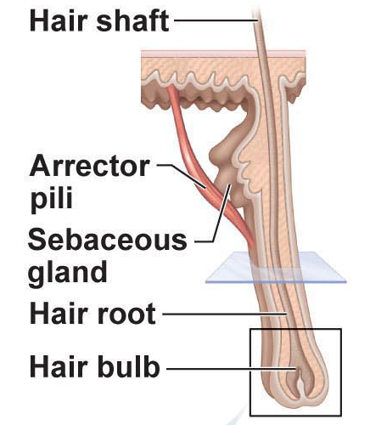
- nose hairs filter large particles like lint and insects from the air we inhale
Structure of a hair (Pili)
- Shaft: keratinization is complete, part that projects from skin
  - Flat and ribbonlike – hair is kinky
  - Oval – hair is silky and wavy
  - Round – straight and coarse
  - 3 layers: medulla, cortex and cuticle
    - Medulla: central core, large cells and air spaces, absent in fine hairs
    - Cortex: bulky layer surrounding the medulla, several layers of flattened keratinocytes; pigment is here
    - Cuticle: single layer of overlapping cells; heavily keratinized, helps provide strength and helps keep the inner layers tightly compacted
      - Subjected to most abrasion, cuticle tends to wear away at the tip of the hair shaft, allowing keratin fibrils in the cortex and medulla to frizz out, creating “split ends”
- Root: keratinization is ongoing, remainder of the hair deep within the follicle
  - Contains within hair follicle
Structure of a hair follicle
- Fold down from epidermal face into the dermis
  - Extend to hypodermis in scalp
- Deep end, 4mm below surface, expands to form a hair bulb
- Sensory nerve endings (root hair plexus) wraps around the bulb, hair acts as sensitive touch receptor
- Wall composed of peripheral connective tissue sheath derived from dermis and inner epithelial root sheath
- Hair matrix (actively dividing area of the hair bulb that produces hair)
- Arrector pili = a muscle that serves each follicle, and causes the hair to stand upright and produce goose bumps in response to cold temperatures/fear
  - Helps animals retain heat and protect themselves
  - For humans, contractions force sebum from the hair follicles to skin surface where it acts as a lubricant
Types and Growth of hair
- Vellus hair – body hair of children and adult females
  - Pale, fine
- Terminal hair – coarse, longer hair of eyebrows and scalp
  - May also be darker
  - Appear in axillary and pubic region during puberty
  - Also on face and chest of men
  - A causation of sex androgens (testosterone)
- Hair growth can be affected by hormones and nutrition
- Rate of hair growth varies from body regions, approx. 2.5mm/week
- Growth cycles
  - Active growth phase: from weeks to years
  - Regressive phase: hair matrix cells die and follicle base and hair bulb shrivel somewhat, dragging hair papilla upward to abut the region of the follicle that does not regress
  - Resting phase: 1-3 months
  - Process begins again, forms a new hair to replace old hair that has fallen out/will be pushed out by the new hair
- Follicles of scalp: active for 6-10 years
- Follicles of eyebrow: active for 3-4 months
Hirsutism = excessive hairiness (on women), with other signs of masculinization may be a result from an adrenal gland or ovarian tumor that secretes abnormally large amounts of androgens
- Tumor can be surgically removed
Hair thinning and Baldness
- Alopecia = hair sheds faster than replaced, leading to hair thinning
  - Coarse terminal hairs replaced by vellus hairs
- Male pattern Baldness = genetically determined, sex influenced condition
  - Thought to be caused by a delayed-action gene
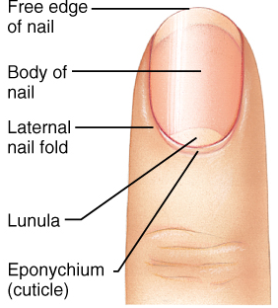
  - Minoxidil (drug to reduce blood pressure) cures this in some people
Nails
- Scale-like modification of the epidermis that forms a protective covering
  - “useful tool”, hooves/claws of animals
    - Pick up small objects, scratch an itch
- Contains hard keratin
- Nail has three regions:
  - Body: portion of the nail that is visible
  - Free edge: visible portion of the nail that extend past the end of the digit
  - Nail folds: 2 lateral and 1 proximal
- Nail matrix: responsible for nail growth
  - As nail cells produced by the matrix become heavily keratinized, the nail body slides distally over the nail bed
- Lunule: region that lies over the thick nail matrix
Sweat glands (sudoriferous)
- Everywhere except nipples and parts of external genitalia
- Approx. 3 million per person
- Myoepithelial cells – specialized cells that contract when stimulated by the nervous system
Eccrine (merocrine) sweat glands
- Numerous/abundant on palms, soles of feet and forehead
- Simple, coiled tubular gland
- Pore at skin surface
- Gland secretion, “sweat”, is a hypotonic filtrate of the blood that passes through the secretory cells of the sweat glands and is released by exocytosis
  - 99% water, with some salts, vitamin C, antibodies, a microbe-killing peptide and traces of metabolic wastes
  - Acidic (pH of 4-6)
- Help with thermoregulation
Apocrine sweat glands
- Approx. 2000 of them, confined to axillary and anogenital areas
- They are the same as merocrine glands, releasing products by exocytosis
  - But larger
- Lie deeper in dermis, sometimes hypodermis
- Ducts empty into hair follicles
- Contain same basic properties as sweat + fatty substances and proteins
  - Viscous or yellow colour
- Odourless until bacteria on skin decomposes it = BO
- Begin functioning at puberty under influence of male sex hormones (androgens)
- Function unknown, not thermoregulation
- May be human equilavent of animal sexual scent glands
Ceruminous glands = modified apocrine gland found in lining of external ear canal. Produce cerumen (earwax) – thought to deter insects and block entry of foreign material
Mammary glands = secrete milk
Sebasceous (oil) glands
- Everywhere except thick skin of palms and soles
- Secrete oily substance called sebum
- Function as holocrine glands
- Typically secrete into hair follicle
- Sebum soften and lubricates hair and skin, prevents hair from becoming brittle and slows water loss from skin when humidity is low
- Kills some bacteria
- Activated by androgens
- Accumulated sebum blocks a sebaceous gland duct, a white-head appears
- If material oxidizes and dries, it darkens to form a blackhead
- Acne is an active inflammation of the sebaceous glands accompanied by “pimples” on the skin
  - Typically caused by staphylococcus
Functions of the Integumentary system
Protection
3 types of barriers:
Chemical
- Skin secretions and melanin (prevents against UV light)
- Low pH of skin surface (acid mantle) retards bacteria multiplication
- Sweat and sebum chemicals kill bacteria
- Defensin, secreted by skin cells, punches holes in bacteria
Physical
- Barrier to trauma and bacterial invasion
- Also limits amount of water loss and VERY minimal water entry
- Alcoholic drinks enhance ski permeability for 24hrs
Biological
- Dendritic cells of the epidermis, macrophages in the dermis and DNA itself
- Electrons in DNA molecules absorb UV radiation and transfer it to the atomic nuclei; which heats up and vibrates vigorously
  - Heat dissipates to surrounding water molecules instantaneously, DNA converts potentially destructive radiation into harmless heat
Skin is not impermeable to: gases, fat-soluble vitamins and steroids, plant oleoresins, organic solvents, salts of heavy metals, penetration enhancers for drug administration
Excretion
- Limited amount of nitrogen-containing wastes (ammonia, urea, uric acid) in sweat
- Excessive sweating is an avenue for water and salt loss
Thermoregulation
- Sweat glands secrete approx. 500mL of sweat a day under regular conditions
  - Unnoticed, insensible perspiration
- Sensible perspiration = noticeable sweating, 12L/day
- Evaporation of sweat from skin surface dissipates body heat and efficiently cools the body, preventing overheating
- External temp. cold = blood vessels constrict
  - Causes warm blood to bypass the skin temp. and allows skin temp. to drop to external temp.
  - Slows heat loss from body
Cutaneous Sensation
- Also called “exteroreceoptors” because they respond to stimuli arising outside the body
- Tactile corpuscles allow us to become aware of a caress or the feel of our clothing against our skin
  - In Dermal papillae
- Lamellar corpuscles alert us to bumps or contacts involving deep pressure
  - In deeper dermis/hypodermis
- Hair follicle receptors report wind blowing
- Free nerve endings in skin sense painful stimuli
Metabolic functions
- When sunlight hits the skin, modified cholesterol molecules are converted to vitamin D precursor, which is transported via the blood to other body areas to be ultimately converted to vitamin D
- Epidermis makes chemical conversions that supplement those of the liver
- Keratinocyte enzymes can:
  - Disarm many cancer-causing chemicals that penetrate epidermis
  - Activate some steroid hormones
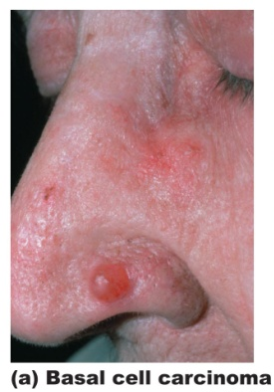
Blood reservoir
- Dermal vascular supply can hold approx. 5% of body’s blood volume
- Blood shunted to muscles from skin when needed
Skin Cancer
Basal Cell Carcinoma
- Least malignant and most common (80% of cases)
- Stratum basale cells proliferate and slowly invade dermis/hypodermis
- Occur most often on sun-exposed areas
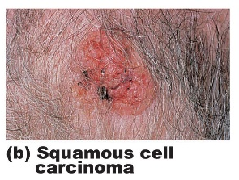
- Slow growing, rarely metastasis (spreads to other areas)
- Cured by surgical excision in 99% of cases
Squamous Cell Carcinoma
- Second most common
- Arises from keratinocytes of stratum spinosum
- Most often on the scalp, ears, hands and lower lip
- Grows rapidly and metastasize if not removed
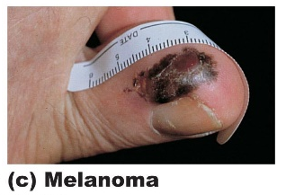
- If caught early and removed surgically or radiation therapy, chances of complete cure are good
Melanoma
- Cancer of melanocytes
- Highly dangerous because its highly metastatic and resistant to chemotherapy
- 2-3% of skin cancers
- Appear spontaneously, 1/3 develop from pre-existing moles
- Early detection is key for survival
- Surgical excision accompanied by immunotherapy
- ABCD rule: Asymmetry, border irregularity, colour, diameter
Burns
- Tissue damage inflicted by intense heat, electricity, radiation or chemicals
  - Denature cell proteins and kill cells in the affected areas
- First concern with burns is excessive loss of body fluids containing proteins and electrolytes
  - This leads to dehydration and electrolyte imbalance
  - Which leads to renal failure and circulatory shock
- After initial concern is passed, infection and sepsis (widespread bacterial infection) become the main threat
First degree burn
- Epidermis only
- Localized redness, swelling and pain
- Heal in 2-3 days
- E.g. sunburn
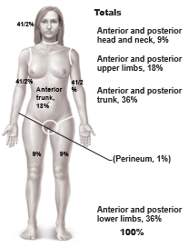
Second degree burn
- Epidermis and upper region of dermis
- Same symptoms as first degree, added blistering
- 3-4 if taken care enough to prevent infections
- “partial thickness burn”
Third degree burn
- “full thickness burn”
- Involves entire thickness of the skin
- Appears gray-white, cheery red, or blackened
- Nerve endings damaged so area is not painful
- Skin grafting is advised
Concern if:
- Over 25% of the body has a second-degree burn
- Over 10% of the body has a third-degree burn
- There are third-degree burns on the face, hands or feet

