- What is Psychology
  - Scientific study of behavior and mental processes-any action that can be observed and recorded
    - Talking, sleeping, running, actions
    - Sensory perceptions, judgments, feelings, memories
  - Utilizing scientific method
    - Method: systematic observations
    - Values: precision, objectivity, open mindedness
  - Aristotle theorized about learning and memory, motivation and emotion, perception and personality
  - Plato assumed that we inherit character and intelligence and that certain ideas are inborn but Aristotle counters that there is nothing in the mind that does not first come in from the external world through the senses
  - Developed from fields of philosophy and biology
- Wilhelm Wundt
  - Was inventing a time lag counter
  - First psychology laboratory
  - University of Leipzig, Germany, Dec 1879
    - Sensory Perception
      - Visual, auditory, tactile
  - Interested in composition of conscious, mental experiences and processes
    - Atoms of the mind
    - How long perceptual processes would take
    - The amount of stimulus needed for reaction
    - Detection response, difference in time it takes to recognize something
- Edward Bradford Titchener
  - Student of Wilhelm Wundt
  - Aimed to discover the minds structure
  - Brought physiological science to North America
  - Termed the school of thought “structuralism”
  - Structuralism
    - Focuses on the basic structural elements of conscious, mental experiences
  - Introspection
    - Observation and reporting of ones mental experiences
      - Feelings, thoughts
    - Report elements of their experience
    - Not reliable
      - Different people reported different experiences
      - Doesn’t have multiple similar outcomes for a conclusion
      - Different stages of intelligence, needed verbal people
- Gestalt Psychology
  - Emphasized peoples experiences are holistic or unified
    - Gestalt=whole, form or pattern
  - The whole is more than just the sum of the parts
    - Perceptions don’t arise just by adding independent sensations
    - Assumes and presumes things
  - Couldn’t provide a whole answer
  - The brain composes still images, makes assumptions to create patterns and show movement such as in a movie
- William James
    - Moment to moment streams of consciousness
    - Stream of consciousness
    - Don’t experience still images
    - Constant change in perceptions
  - Functionalism
    - Focuses on functions of out thoughts, feelings, ideas and behaviors
  - Was influenced by Charles Darwin’s theory on Natural Selection
    - What is the survival advantage of organisms physical attributes and behaviors
    - What is the survival advantage of out mental behavior
    - Sir Francis Galton
      - Genetic inheritance
      - Mental abilities are also inherited
      - Idea of mental capacity that is passed down though generations for survival
      - Behavior is becoming important
  - Textbook contract for psychology that took 12 years Principles of psychology
- Mary Whiton Calkins
  - First woman to be president of American psychological association
  - Outscored all men on exams
  - Denied Harvard degree
- Margret Floy Washburn
  - First Ph.D. in psychology, wrote animal mind
  - Became second APA president
- Structuralism used introspection to define the minds make up, functionalism focused on how mental processes enable us to adapt, survive and flourish
- Psychoanalysis
  - Sigmund Freud
  - Physician, neurological researcher
  - Studied behavior and how it started, studied physiological disorders
  - The unconscious mind
    - Unconscious mental forces were responsible for human nature and behavior
    - Emphasis to say that there are unaware processes mental processes are large an have almost complete control over a person
  - Developed psychoanalysis
    - Theory of personality (human behavior) and treatment of psychological disorders (therapy)
    - Psychodynamic
    - First psychologist that emphasized to think about why it happens
  - Personality theory
    - Mind: ice berg analogy
      - The tip of the ice berg is only a small portions
      - The unconscious mind contains our biological based instincts,
      - Conscious mind is the tip while the unconscious is whats hidden under water
      - Unconscious impulses, thoughts, wishes, memories have larger impact
        - Sexual and aggressive drives and repressed traumatic memories
        - Balanced with other egos
      - No free will
  - People can infer the devaluation of the unconscious mind
  - Considered the first psychological therapy of speaking freely and not thinking to see problems that arise and the need to confront the problems
- Behaviorism
  - *both Watson and Skinner dismissed introspection and redefined psychology as the scientific study of observable behavior
  - John B. Watson
    - Objected to structuralism and functionalism
    - Introspection is not science
    - Consciousness, perceptions , thought ,mental processes
      - Subjective, private experiences
      - Not appropriate for science
  - Psychology must focus on independently observable behavior
    - Should study the factors that influenced learning and behavior
    - Goal is to predict and influence behavior
  - Promoted the idea that behavior is primarily determined by environmental factors
    - Ignore motivation, drives, thoughts (mentalistic concepts)
  - Demonstrated conditioned responses on a baby who became famous as little albert
  - B.F. Skinner
    - Consequences of behavior
      - Operant conditioning
      - Reinforcement and punishment
      - What happens after the behavior
      - Based on effects that weren’t punished tent to repeat
      - If there is a reward it is also repeated
  - Looking at the environment and figure out how it happened
  - Generally before and after the behavior and consider the environment, what caused and what happened after
- Humanistic Psychology
  - Abraham Maslow and Carl Rogers
  - Reaction to behaviorism and psychoanalysis
    - Reject the idea of no free will
    - Reject the idea of unconscious forces controlling behavior
  - Humanistic psychology
    - Emphasized current environmental influences on out growth potential
      - People are innately good, driven towards personal growth
      - Valued person, purpose, family, loved
      - Trying to reach the fullest potential
      - Environmental influences can nurture or limit our growth potential and importance of having out needs for love and acceptance satisfied
    - People make conscious choices
    - People are innately good
      - When needs are not met, maladaptive (not providing adequate or appropriate adjustment to environment of situation) behavior or thinking results
      - Over exaggerate need for love and acceptance
      - Behavior when blocked to full potential or persons
    - Theory of motivation and therapy
    - There was a need for work to suppress desires that will allow society to be stale
    - Therapy was for acceptance for the actions that they preform
- Freudian psychology
  - Unconscious thought processes and our emotional Reponses to childhood experiences affect our behavior
- Cognitive Psychology
  - 1960s cognitive revolution
  - Feelings, cognitive abilities, intelligence, reading, behaviorism doesn’t touch on these topics
  - Focus on how the mind processes and retains information
  - Experimental psychology: sensation, perception, memory, language, reasoning, problem solving
  - Want psychology to tell them about feelings
  - Reject notions of no free will
    - Humans are active thinking machines
    - Not passive reacting machines
  - Modern brain imaging techniques allow researchers to see mental processes
    - Thinking remembering, processing, perceiving
    - Cognitive neuroscience
      - Imaging
      - Doing mental tasks
      - Unconscious mind
  - Memory can be measure with question, through the mental process
  - Every behavior has a though before it
- Other perspectives
  - Neuroscience
  - Anatomy and physiology of the brain
  - Focuses on the functioning of the central nervous system
    - Brain, spinal cord
    - Neurons
    - Neurotransmitters
    - Hormones
  - Evolutionary psychology
    - Focuses on the evolution of behavior and thought
    - How do our behaviors and thoughts benefit survival
      - Aggression
      - Helping
      - Consciousness
  - Behavior genetics
    - Relative influence of genes and environment on individual
  - Social cultural
    - Highlights social and cultural influences on behavior
- Biopsychosocial approach
  - Biological influence
  - Psychological influence
  - Social cultural influence
  - An integrated approach that incorporates biological physiological and social culture levels of analysis
- Neuroscience perspective
  - How the body brain enables emotions memories and sensory experience
- Evolutionary perspective
  - How the natural selection of traits promotes the survival of genes
- Behavior genetics perspective
  - How much our genes and our environments influence out individual differences
- Psychodynamic perspective
  - How behavior springs form unconscious drives and conflicts
- Behavioral perspective
  - How we learn observable responses
- Cognitive perspective
  - How we encode, process, store and retrieve information
- Social cultural perspective
  - How behavior and thinking vary across situations and cultures

- Scientific Method
  - Theory
    - Explain a variety of observations
    - Can originate from casual observations
    - Explain through an organized set or principles (how are things caused)
    - They offer testable predictions which are implied by the theory (hypothesis)
    - Theory: a general principle or set of principles that explains how a number of facts are related to one another and allows for testable predictions
  - Hypothesis
    - Testable prediction that logically flow form principles of theory
  - Observations
    - Descriptive
      - The case study
        - Examine a single individual in depth over a long period of time
        - Problems: individual may not represent a majority of people, cant conclude that caused the behavior
      - Surveys
        - Less in depth
        - Problems: wording effects, inaccurate information
      - Naturalistic observation
        - Unobtrusively observe and record behavior in natural environments
        - Observe natural, spontaneous behavior
        - Problem: no control
    - Correlational
      - Measure the relationships between two attributes or behaviors
      - Uncover naturally occurring relationships
      - Positive Correlation
        - As one increases another increases
        - Range between 0 and +1
        - +1 is perfect positive correlation
      - 0 is no correlation
      - Negative correlation
        - As one increases another decreases
        - Range between -1 and 0
        - -1 is perfect negative correlation
      - Correlation Coefficient
        - Value ranges between -1 to +1
      - Correlation and causation
        - Eg. Length of marriage correlates with hair loss in men
        - Association doesn’t prove causation, correlation indicates the possibility of a cause-effect relationship but does not prove such
        - This principle and you will be wiser as you read and hear scientific studies
    - Experimental
      - 1) manipulating the factors of interest
      - 2) holding constant other factors
      - manipulates a factor to determine its effects
    - Experiments aim to manipulate an independent variable, measure the dependent variable, allow random assignment to control all other variables
- 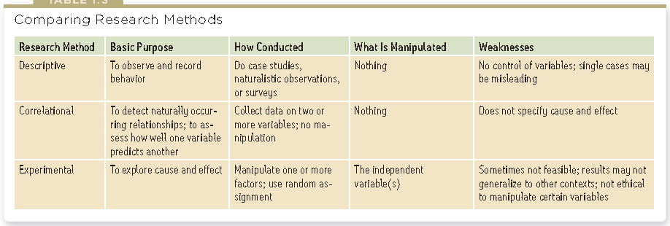
  - Statistical Analysis
- Theory of evolution
  - Variation within any population of organisms
  - Competition for finite resources
  - Certain variations are better than others for acquiring resources, that increase chances for survival and reproduction
  - Next successive generations will have proportionally more offspring from those with more advantageous variations
- Major depressive disorder
  - Observations
    - Worthlessness
    - Inappropriate feelings
    - Feelings of hopelessness
  - Cognitive theory principles
    - Following negative event that self blame and have a low self esteem
    - Over generalization, leads to interpreting events negatively
    - Theory: Low self esteem underlies depression
- Operational definitions
  - 1) protects against experimenter bias
  - 2) Allows for replication
    - Same study with identical procedure but different participants
    - Repeat with slight modification of procedure to extend circumstances
- Hindsight bias
  - Tendency to believe, after learning an outcome, that one would have foreseen
- Over confidence
  - Tend to be more confident than correct
- Perceiving order in random events
  - Random sequences often don’t look random
  - Events can be over interpreted
- Hindsight bias, overconfidence and perceiving patterns in random events can lead to overestimation of a persons intuition
- Scientific attitude that connects to critical thinking
  - Curiosity
    - Passion to explore and understand without misleading or being misled
  - Skeptical
    - What do you mean?
  - Humility
    - An awareness of our own vulnerability to openness to surprises and new perspectives
  - Scientific attitude contributes to critical thinking
    - Curiosity around the world around us
    - Skepticism towards claims and ideas
    - Humility about ones own understanding
- Scientific method- self correcting process for evaluating ideas with observations and analysis
- Critical thinking
  - Examines assumptions, discerns hidden values, evaluates evidence and assess conclusions
- Description
  - Case study
    - Doesn’t allow general principles
    - Don’t know the outlook on a large population but can satisfy a single person
  - Naturalistic observations
    - Doesn’t explain behavior but describes it
    - Cannot control factors that influence behavior
  - Surveys and interviews
    - Wording effect
- Representative sample though the use of random sampling
  - Sampling bias is when a group does not represent the population
- Association doesn’t cause causation
  - Correlation indicates the possibility of a cause-effect relations ship but cant prove it
- Experiment
  - Manipulate factors of interest
  - Hold constant factors
- When is an observed difference reliable?
  - 1) Representative samples are better than biased samples
  - 2) less variable observations are more reliable than those that are more variable
  - 3) More cases are better than fewer
- When averages from two samples are each reliable measures of their respective populations, then their difference is likely to be reliable as well.
- Statistical significance indicates the likelihood that a result will happen by chance but doesn’t say anything about the importance of the result
  - When sample averages are reliable and difference of the two are large, the difference is statistically significant
    - The observed difference is probably not due to chance variation between the samples
- APA code of ethics
  - 1) obtain participants informed consent
  - 2) protect them form harm and discomfort
  - 3) keep information about individual participants confidential
  - 4) fully debrief people

- Franz Gall
  - Phrenology
  - Bumps on skill that could reveal a persons mental abilities and character traits
  - Succeeded in focusing attention on the localization of function
  - Links between biological activity and psychological events
  - Cells conduct electricity and communicate via chemical messages
- Biopsychosocial systems
- Neurons
  - Nerve cell
  - Has a cell body with branching fibers
  - Bushy dendrite fibers receive information and conduct it toward the cell body
  - Cells lengthy axon fiber passes the message through its terminal branches to other neurons
  - Dendrites listen and axons speak
- Myelin sheath
  - Layer of fatty tissue that insulates
  - Speeds impulses
    - If sheath degenerates, multiple sclerosis results and muscle controls are lost
  - A neuron fires an impulse called the action potential

Action potential
    - A brief electrical charge that travels down its axon
  - Ions are exchanged, fluid outside has positive charges and internal is negative
  - Positive outside/ negative inside is called the resting potential
  - Axons surface is selectively permeable
  - 1) Positive sodium’s flood through the cell membrane and depolarizes the axon section and causes another channel to open and so on
    - Refractory period, neuron pumps positive sodium ions back outside to recharge and fire again
  - If inhibitory signals exceed the threshold it triggers action potential
  - Increasing the stimulation will not increase the neural impulses intensity
  - Neurons reaction is an all-or-none response: either fire or not
  - Communicate
    - Sir Charles Sherrington
      - Brief interruption in the transmission of a signal
      - Called the meeting point between neurons a synapse
      - Synaptic gap/cleft
      - Millionth of an inch wide
      - Santiago Cajal
        - Calling them protoplasmic kisses
      - When action potential reached the axon terminal, chemical messengers (neurotransmitters) are released
      - Neurotransmitters cross the synaptic gap and bind to receptor sites
      - like tiny channels at receiving sites and electrically charged atoms flow in
    - Reuptake: the sending neuron reabsorbs excess neurotransmitters
  - Neurotransmitters have designated pathways
  - Neurotransmitters systems don’t operate in isolation, interact and vary with receptors
      - Acetylcholine ACh
        - Learning and memory neurotransmitter
        - Muscle action
    - Messenger at every junction between the motor neurons
    - Causes muscles to contract
    - Candace Pert and Solomon Snyder
      - Attached a radioactive tracer to morphine and shows where it was taken up in the animals brain
  - 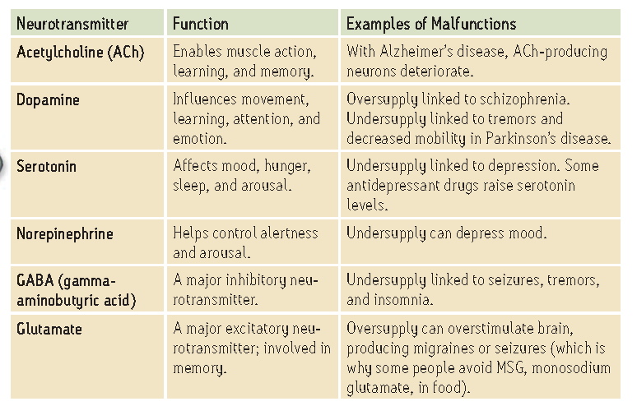
- Brain does indeed produce its own naturally occurring opiates
- Endorphins help explain good feelings
- How drugs affect Neurotransmission
  - Affect the synapses
  - Agonists molecules may be similar enough to a neurotransmitter to bind to its receptor and mimic its biological effects
  - Some opiate drugs are agonists that amplify endorphins
  - Antagonists bind to receptors that block neurotransmitters function
  - Botulin, can cause paralysis by blocking ACh release, Botox
- The Nervous system
  - 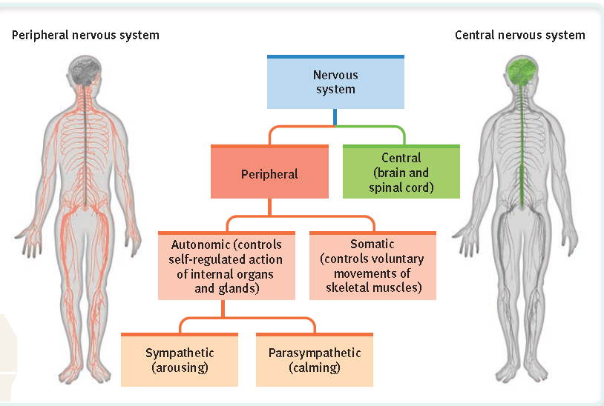
  - CNS is the body’s decision maker
  - PNS is responsible for gathering information and transmitting CNS decisions
  - Sensory neurons: carry messages from body tissue and sensory receptors inward to CNS
  - Motor neurons: carry instructions form CNS to body muscles
  - Interneurons: information processed in the brains internal communication system

Peripheral NS
    - SNS enables voluntary control of skeletal muscles
    - ANS controls self regulated glands and muscles of internal organs
      - Sympathetic nervous system arouses and expends energy
      - Parasympathetic Nervous system conserves energy and calms down the body
      - SNS and ParaNS work together
  - CNS
    - Brains neurons cluster into neural networks
    - Stephen Kosslyn and Olivier Koenig
    - Each layers cells connect with various cells in neural network
    - Spinal cord
      - Two way information highway connecting between peripheral NS and the brain
      - Ascending neural fibers send up sensory information and descending fibers send back motor control information
- Endocrine system
  - Glands secrete chemical messengers called hormones
  - That travel through the blood stream and affect tissues
  - Both endocrine and nervous system produce molecules that act on receptors elsewhere
  - Endocrine messages tend to outlast the effects of neural messages
  - Pituitary gland and adrenal gland
    - Controlled by hypothalamus
    - Releases HGH that stimulates physical development
    - Oxytocin enables contractions for orgasms and birthing
    - Called master gland, releases hormones to trigger other glands
- Brain
  - Brain +body =mind
  - mid is what the brain does
  - right side of body is connected to the left side of the brain
  - brain stimulation to induce effect
- EEG electroencephalogram
  - Amplified read out of waves
  - Brains structure, electrical activity and metabolic activity
  - Study sleep
- PET positron emission tomography
  - Depicts brain activity by showing each brains are consumption of glucose
  - Active neurons consume glucose
  - Radioactive sugar
  - Emits positrons as it decays
- MRI Magnetic resonance imaging
  - Magnetic field
  - Aligns spinning atoms
  - When the atoms return to their original spin, they emit signals and can provide a picture of tissues
  - Wave is particular to each atom and image is based on concentration of hydrogen
- fMRI functional MRI
  - Functioning as well as structure
  - Blood flow
  - Oxygen concentration
- Brain structure
  - Brainstem
    - Begins where spinal cord swells after entering the skill
    - Slight swelling is the medulla
      - Controls heartbeat and breathing
    - Above medulla is pons that help coordinate movements
    - Brainstem crossover point: where nerves to and from each side of the brain connects with the opposite side of the body

Thalamus
    - On top of brainstem
    - Receives information from all the senses except smell and routes it to the higher brain regions
    - Directs replies to medulla and cerebellum: [plays a role in learning, memory, judging time, discriminate sounds and textures]

Reticular Formation
    - Inside brainstem
    - Between ears, lies reticular formation
      - Network of neurons through brainstem
      - Relay of sensory nerves
      - Filter incoming visual and auditory information
    - Extents form spinal cord right up through the thalamus
    - Moruzzi and Magoun discovered electrical stimulation can awake a sleeping cat, enables arousal

Cerebellum
    - Little brain
    - Nonverbal learning and memory that helps to judge time, modulate emotions and discriminate sounds and textures
    - Can affect walking if damages
  - Brain processes most information outside of our awareness

Limbic system
    - Cerebral hemispheres
    - Contains the amygdala, hypothalamus, hippocampus
    - Hippocampus processes conscious memories
    - Amygdala
      - Aggression and fear
      - Emotional memories
    - Stimulating structures other than the amygdala can evoke aggression fear
    - Hypothalamus
      - Below thalamus
      - Controls pituitary
      - Hunger, regulate thirst, body temperature
      - James Olds and Peter Milber found the reward centers
      - Dopamine reacted rewards with pleasures

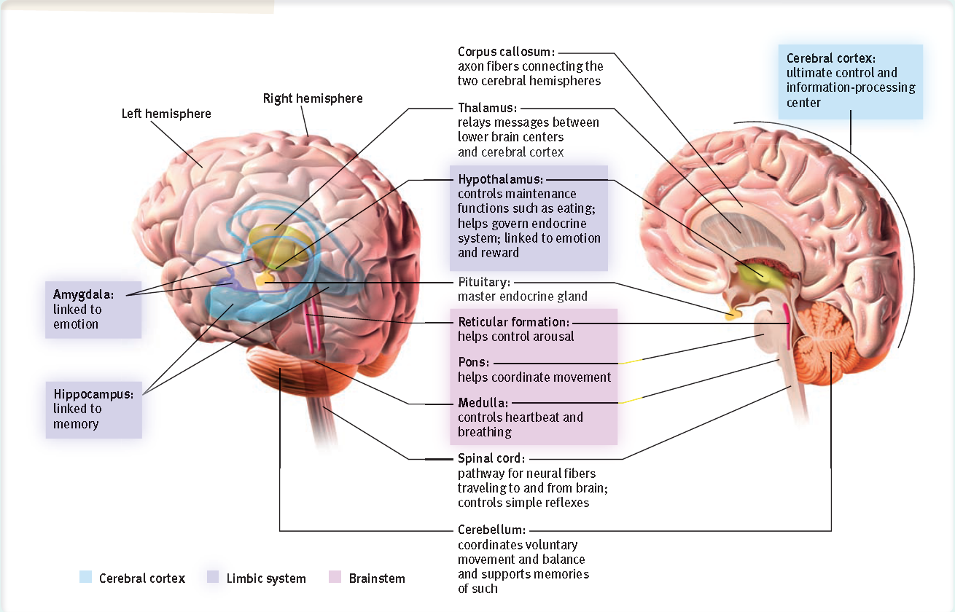
    - Cerebral cortex
      - Cerebrum- hemispheres that is 85% of the brains weight
        - Covers the lower brain areas
        - fissures
        - Contains cerebral cortex, basal ganglia (movement and learning), limbic system
      - Cerebral cortex- thin surface layer of interconnected neural cells, Soma cells
      - Cortex
        - Involved in perception, thinking, language, movement
        - Brains left and right hemispheres are filled with axons connecting the cortex to the brains other regions
        - Supporting the nerve cells are glial cells that provide nutrients and insulating myelin and guide neural connections and mop up ions and neurotransmitters
        - Each hemisphere is divided into 4 lobes and are separated by prominent fissures or folds
        - Frontal lobe
          - Behind forehead
          - Speaking judgment planning
          - Gustatory cortex
        - Parietal lobes
          - At the top and to the rear
          - Touch and body position
          - mathmatical
        - Occipital lobes
          - Back of the head
          - Olfactory cortex
          - Visual Cortex
        - Temporal lobes
          - Above the ears
          - Auditory cortex
          - Facial recognition
      - Functions of cortex
        - Motor functions
          - Fritsch and Hitzig
            - Mild electrical stimulation made the body move
            - Only when applied to arch shaped sections at the back of the frontal lobe
            - Movement to opposite side of where the stimulation was compared to the brain
            - Found motor cortex
            - Rear border of frontal lobe
            - Motor homunculus is the image of the motor cortex labeled with each precise section
          - Mapping
            - Brain has no sensory receptors
            - Able to map motor cortex
          - Sensory functions
            - Penfield identified cortical area to receive information form skin senses
            - Area at the front of the parietal lobes, parallel to and just behind the motor cortex that is called the sensory cortex
          - Association areas
            - Neurons are busy with higher mental functions
            - Donald McBurney
            - Area of cerebral cortex that is not involved in motor, Sensory functions
            - For learning, remembering, thinking, speaking
            - Phineas Gage, frontal lobe damage, only personality change, irretability
            - Super cells clusters
              - Respond to complex patterns constructed from individual features
        - Brains plasticity
          - Ability to modify its self after damage and reorganize to a different environmental stimulation
          - 1) severed neurons unlike cut skin don’t regenerate
          - 2) some brain functions seem pre-assigned to specific areas
          - some neural tissue can recognize in response to damage
          - constantly building new pathways
          - can occur after serious damage
          - constraint induced therapy: rewire brains and improve dexterity
        - Hemispherectomy
          - Taking out half a brain
          - The other half fills up with cerebral spinal fluid
        - Split brain
          - Left hemisphere damage can cause impaired reading, writing, speaking and arithmetic reasoning and understanding
          - Philip Vogel and Joseph Bogen speculated
          - Major epileptic seizures were caused by amplification of abnormal brain activity and thought about separating the corpus callosum
          - Carries messages between the two hemispheres
          - Data received by either hemisphere are quickly transmitted to the other across the corpus callosum
          - Splitting a brain both hemispheres can comprehend and follow instructions to copy simultaneously different figures
          - HE•ART
          - Brain sees art that is the right field and transmits to the left hemisphere
          - Asked to point with left hand but right brain controls left hand and points to HE

    - Basic Principles
      - Perception- the process by which how the brain organizes and interprets sensory input
      - Bottom-up processing: starts at the sensory receptors and works up to higher levels of processing
        - Angles, lines, shapes
      - Top-down processing constructs perceptions form sensory input by drawing on our experience and expectations
        - Senses detect
    - Transduction
      - Sensory system converts energies into another form
        - 1) receive sensory stimulation using specialized receptor cells
        - 2) transform that stimulation into neural impulses
        - 3) deliver the neural information to the brain
      - transduction: converting one form of energy into another that the brain can use
      - psychophysics: physical characteristic of stimuli
    - Thresholds
      - Gustav Fechner
        - Studied awareness of faint stimuli and called them absolute thresholds
        - The minimum stimulation necessary to detect light or sound 50% of the time
      - Signal detection theory predicts when we will detect weak signals
        - Detection is dependent partly on a persons experience, expectations, motivation and alertness
      - Subliminal is when the stimuli cant be detected 50% oft the time
      - We can evaluate a stimulus even when we are not aware of it and even when we are unaware of our evaluation

      - Only when a stimulus triggers synchronized activity in several brain areas to reach consciousness
      - Much of the information processing occurs automatically out of sight and off the radar of the conscious mind
    - Difference Thresholds
      - Difference threshold is the noticeable difference between two stimuli half the time
      - Difference threshold increases with the size of the stimulus
      - Adding 1 ounce to 10 ounce instead of adding o ounce to 100 ounce
      - Ernst Weber
        - Webbers law- for an average person to perceive a difference two stimuli must differ by a constant percentage
        - The exact proportion differs depending on the stimulus
    - Sensory adaptation
      - Constant exposure to stimulus that does not change, becomes less aware of it because it does not change
      - Can reduce sensitivity but offers an important benefit, freedom to focus on informative changes in our environment without being distracted by background noise
      - We perceive the world not exactly as it is but as it is useful for us to perceive it
    - Perceptual set
      - A mental predisposition to perceive one thing and not another
      - Expect certain results but misunderstanding of other perceptions and results
      - Expectations may give perceptual sets
      - A set of mental tendencies and assumptions that greatly affect what we perceive
      - Can influence what we hear, taste, feel and see
      - We determine perceptual set through concepts (schemas) that organize and interpret unfamiliar information
    - Context Effects
      - A stimulus can trigger different perceptions because of differing set but also because of immediate context
      - Richard Warren suggests the brain can work backwards to allow a later stimulus to determine how we perceive an earlier one
      - Top down processing is influenced on perceptions
    - Emotion and Motivation
      - Perceptions are influenced top-down not only by our expectations and by the context but also by our emotions and motivation
      - Motives matter
      - Desired objects will seem closer
    - Vision
      - Eyes receive light energy and transduce into neural messages for brain to process
      - Visible light is but a thin slice of the whole spectrum of electromagnetic energy ranging form imperceptibly short gamma waves to long waves of radio transmission
      - Light wavelength determines hue (color experience)
      - Intensity- the amount of energy in light waves (determined by a waves amplitude) influences brightness
      - Oscillation
        - More= shorter the wavelength
        - Less= longer the wavelength
    - Eye
      - Light enters through the cornea
      - Cornea protects the eye and bends light to focus
      - Light passes through pupil that controls the size of the iris (colored muscle that dilates or constricts to light intensity)
      - Behind pupil is the lens that focuses incoming light rays into an image on the retina
      - Retina is a multilayered tissue on the eyeballs sensitive inner surface
      - The lens focuses the rays by changing its curvature (accommodation)
      - Leonardo da Vinci- thought the watery fluid bends lights rays and inverts the image to the upright position and reaches the retina
      - Johannes Kepler showed that the retina does receive upside down images of the world
        - Retina doesn’t see the whole image but receptor cells use transduction and is perceived as upright image
    - Retina
      - Rods and cones are buried in receptor cells
        - 1) light entering eye triggers photochemical reaction in rods and comes at the back of the retina
        - 2) chemical reaction in turn activates bipolar cells
        - 3) bipolar cells then activate ganglion cells, the axons of which converge to from the optic nerve, this never transmits information to the visual cortex in the brain
- Ganglion Cell | - Bipolar cells | - Cones and rods

      - Axons come together like strands to form the optic nerve
      - Layers of cells, photoreceptors, bipolar cells, Ganglion Cells (axons from the optic nerve) there are only one million ganglion cells
      - Where the optic nerve leaves the eye, there are no receptor cells creates a blind spot
      - Fovea- the retinas area of central focus and there are cone clusters in and around the fovea
      - Each cone transmits to a single bipolar cell that relays the cones individual signal to the visual cortex
        - 6 million cones
        - Mostly in fovea
        - sensitive to detail
      - Rods share bipolar cells with other rods sending combined messages
        - 120 million rods
        - in periphery
      - Cones enable us to perceive color and detail, absorb particular wavelengths
      - Rods enable black and white vision and faint light
      - When entering a dark room, the pupils dilate using the iris to allow for more light to reach your retina
    - Blind spot
      - Axons from ganglion cells converge and leave the eye in the middle of the retina near the fovea
      - Is a hole in the retina where there are no receptors
      - Brain has no info on a part of the visual field
      - But uses indirect information from the other eye to fill in the missing information
    - Visual information processing
      - Entry level, information processes at the retinas neural layers that are brain tissue that has migrated to the eyes during fetal development
      - Also encodes and analyses sensory information
      - Information goes to visual cortex in occipital lobe at the back of the brain
      - Sensitivity enables retinal cells to fire messages that can be misfired
      - Pressure can also trigger retinal cells, but are perceived as light in the brain
    - Feature detection
      - David Hubel and Torsten Wiesel
      - Received a nobel prize for work on feature detectors
      - These specialized neurons in the occipital lobes visual cortex receive information from individual ganglion cells in the retina
      - Feature detector cells derive there name from there ability to specific features
      - Such as lines angles and shapes/movements
      - Feature detection cells pass information to other cortical areas
      - Optic nerve carries information to the visual cortex
        - Thalamus
        - Areas of the visual field corresponding areas of the visual cortex to remember faces
    - Parallel Processing
      - Doing many things at once
      - Brain divides into subdivisions and works on each aspect being perceived simultaneously
      - 30% brain power of cortex for face recognition
    - Color Vision
      - Objects reflect the long wavelengths and therefore is not the color
      - The color of an object is a mental construction
      - Isaac Newton, light rays are not colored, color resides in the theater of the brain by evidence of dreaming in color
      - 1/50 people are color deficient and is usually sex linked male
      - Hermann von Helmholtz, any color can be made through the combination of waves of the 3 primary colors, implied that an eye must have 3 corresponding color receptors
      - Hering surmised that there must be two additional color processes one for red vs green and one for blue vs yellow OPPONENT PROCESS THOERY
      - Proved red-green, yellow-blue, and white-black retinal processes in the retina and in the thalamus
      - Some neurons are turned on by red but turned off by green and some are vice versa
      - 2 colors cant be sent at once so there are certain combinations to see other colors that have hints of different colors
      - color processing occurs in two stages, retinas red, green and blue cones respond in varying degrees t different color stimuli as the young-holtz trichromatic theory
        - Combining light waves of three primary colors
        - Hypothesized that the retina will have 3 different types of sensitive cells
        - Theory that the brain worked the same way that we blend colors
        - problems
          - missing cones but perceive yellow
          - yellow seems pure
      - Signals are processed by nervous systems opponent process cells as hering’s theory proposed
      - Opponent process theory
        - Opposing retinal processes enable color vision
        - Sells stimulated by green inhibit red
        - Others stimulated by red inhibit green
      - Color blindness
        - Missing red, green or both red and green cones
    - Visual Organization
      - A cluster of sensations, people tend to organize them into a gestalt (form/whole)
      - In perception the whole may exceed the sum of it parts
      - Our brain does more than register information about the world
    - Form Perception
      - Separate the ground from the face
      - Figure ground relationship always reverses but will organize the stimulus into a figure seen against a ground
      - Grouping
        - Organize into meaningful forms
        - Proximity
          - Group nearby figures together
        - Continuity
          - We perceive smooth continuous patterns rather than discontinuous one
        - Closure
          - Fill in gaps to create complete whole objects
    - Depth Perception
      - Enable the use to judge an objects distance
      - Eleanor Gibson and Richard Walk, estimate distance and discovered using a visual cliff with a drop off area
      - Tested if a baby would walk across the drop
      - Infants were capable of perceiving depth perception
      - Binocular cues
        - Judging distance of nearby objects
        - The greater the retinal disparity or difference between the two images the closer the object
        - Retinal disparity
          - Objects of focus
            - Greater the disparity between the two objects
          - Other objects
            - Difference between retinal placement of the images
            - More lateral the retinal image the closer the object
      - Relative motion
        - As we move objects appear to move, farther the fixation point the faster it will seem to move
      - Linear Perspective
        - Parallel lines appear to meet in the distance, sharper the angle of convergence, the grater the perceived distance
      - Relative size
        - Monocular cue
        - If two objects are similar in size most people perceive one that casts a smaller retinal image as farther away
      - Relative height
        - Monocular cue
        - We perceive objects higher in our field of vision as farther away
        - Assume lower part of a figure ground illustration is closer, we perceive it as a figure
        - Interposition
          - If an object partially blocks the view of another, it is presumed closer
        - Light and shadow
          - Shading produces a sense of depth consistent with assumptions that light comes form above
          - Nearby objects reflect more light to our eyes
          - Brain assumes that light comes from above and can infer depth based on shading
      - Monocular cues
        - Depth cues available to each eye separately
      - Motion Perception
        - Motion is assumption of shrinking images as retreating and enlarging objects are approaching
        - Continuous movement is a rapid series of slightly varying images stroboscopic movement
        - Phi phenomenon: illusion of movement created when two or more adjacent lights blink on and off quickly
      - Perceptual Constancy
        - Top-down processing
        - Perceiving objects as unchanging even as lighting and images change
        - Color and brightness constancies
          - Color does not reside in an object
          - Experiences of color depends on the objects context
        - Brightness constancy
          - Depends on relative luminance- The amount of light an object reflects relative to it surroundings
          - Comparisons govern our perceptions
        - Shape and size constancies
          - Actual shape cant change seems to change with the angle of view
          - We perceive the form familiar objects such as the door
          - Size constancy, we perceive objects as having constant size even when distance form it varies
          - Moon illusion: moon looks up to 50 percent larger when near the horizon than when high in the sky,
          - Perceptual illusions reinforce a fundamental lesson: perception is not merely a projection of the world onto our brain
          - Sensation is disassembled into bits of information that resembles the functional world
          - Our brain constructs perceptions
        - Visual Interpretation
          - Immanuel Kant
            - Knowledge come from our inborn ways of organizing sensory experiences
            - Equipped to process sensory information
            - John Locke
              - Argues that through our experiences we also learn to perceive the world
    - A man born blind if he can distinguish between a cube and a sphere
      - Locks answer was no
      - Because the man would never have learned to see the difference
      - Could not often recognize visually familiar objects that had to be through touch if the blind had cataract surgery
      - Does the effect of early experience last a life time
      - Answers is clearly yes we retain the imprint of some early sensory experiences far into the future
      - Limitations on animals will not let receptors fully develop
    - Perceptual adaptation
      - Change visual input and is adapted
      - Ability to adapt to displaces or inverted casual field
      - Humans can adapt easily
    - Hearing
      - Hearing is highly adaptive (audition: to hear)
      - Attuned to variations in sound
      - Most sounds are within the range of the human voice
      - 2ND MIDTERM
      - ears can detect air pressure changes
      - amplitude is for loudness
      - wave length is frequency and determines pitch
      - sound measured in decibels
      - when something is 20 decibels its 100 times as loud as a threshold stimulus (10*10=100x)
      - 60 decibels is 40 decibels louder than 20 decibels, 10000x louder than 20 decibels~60 decibels
      - noise canceling headphones
        - speaker creates a sound wave of identical amplitude and frequency with compression and expansion to cancel the wave
    - Ear
      - Transforms vibrating air into neural impulses
      - The ear channels waves through the auditory canal and into the eardrum that causes a vibration
      - Middle ear is made of 3 pistons
        - Hammer
        - Anvil
        - Stirrup
        - Channels to cochlea
      - Cochlea
        - Snail shaped tube in the inner ear
        - Membrane (oval window: against stirrup and pushes against it) vibrates and moves the fluid in the tube
        - Causes ripples in the basilar membrane that also bends the hair cells lining the surface
          - Triggers impulses to adjacent nerve cells
          - Axons where they converge is called the auditory nerve that sends the message to the thalamus and then to the auditory cortex in the temporal lobe
    - 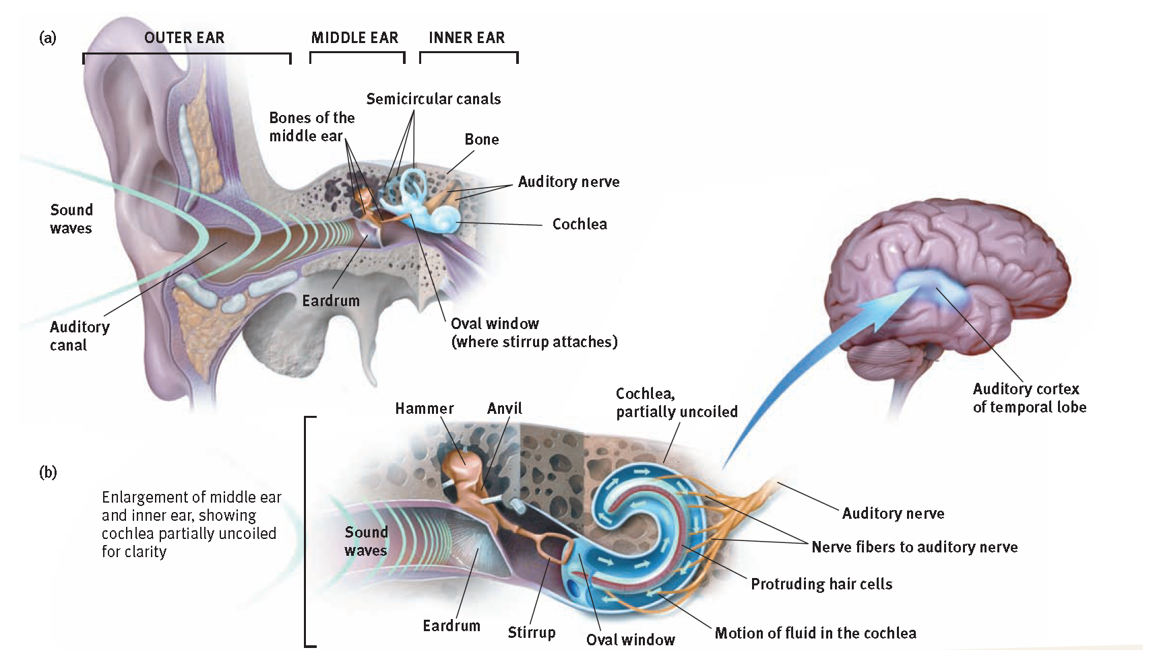
        - Hair cells
          - Basilar membrane
          - Extreme sensitivity and speed
          - Cochlea has 16000
          - Damage
            - Sensorineural hearing loss (nerve deafness)prolonged exposure to loud noises
            - Conduction hearing loss (damage to mechanical system that conducts sound waves to the cochlea such as the eardrum, bones
            - Most common is from disease and biological links to heredity, aging, loud music
          - Analogy to carpet where the mass of an object for prolonged amount of time will not let fibers spring back up
          - Exceeding 100 decibels
          - Normal conversation is 60 decibels
          - Whispering is 20 decibels
        - Restoring hearing
          - Ear implant, cochlear implant
            - Translates sounds into electrical signals
            - Cannot enable hearing if they never learned to hear/ process sound
      - Perceiving loudness
        - Tones active hair cells that are tuned to the same frequency
        - Brain interprets loudness based on the number of hair cells that are activated
        - Hair cells can lose sensitivity to soft sounds but still be affected to loud sounds
        - Compressed harder to hear sounds are amplified more than loud sounds
      - Perceiving Pitch
        - Place theory
          - Herman van Helmholtz
          - We hear different pitches because different sound waves trigger at different places along the cochlea’s basilar membrane
          - Determines sound by specific place
          - High frequencies vibrated near the beginning and low frequencies near the end of the cochlea’s membrane
          - Can only explain high pitched sounds, but cant explain low pitched sounds
        - Frequency theory
          - Brain reads pitch by monitoring the frequency of neural impulses traveling up the auditory nerve
          - Whole basilar membrane vibrates and triggers neural impulses to the brain at the same rate as the sound wave
          - An individual neuron cannot fire faster than 1000 times per a second, how can we sense sounds with a frequency above 1000 waves per a second
          - Cant represent middle frequencies
        - Volley principle
          - Neural cells can alternate firing
          - Firing in rapid succession can attain a combined frequency above 1000 waves per a second
          - Place theory explains high pitches, Frequency theory explains low pitches. Combined can explain middle frequencies
      - Locating sound
        - Two ears are for enjoying stereophonic hearing (three dimensional hearing)
      - Touch
        - Sense of touch is a mixture of skin senses from pressure, warmth, cold and pain
        - Stroking adjacent pressure points creates a tickle
        - Repeated gentle stroking of pain spot creates an itching sensation
        - Adjacent cold and pressure spots can cause a wetness feel
        - Stimulating hot and cold spots creates a sense of hot
        - Warm +cold=hot
      - Pain
        - Women are more pain sensitive
        - Dependent on genes, physiology, experience, attention and surrounding culture
        - Have both bottom up and top down processing
        - Biological influence
          - Different nociceptors that detect harmful temperatures, pressures or chemicals
      - Gate control theory
    - 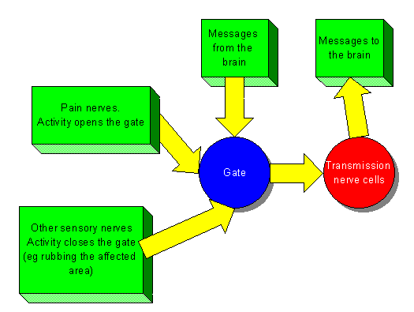
        - Theorized the spinal cord has a neurological gate
        - When tissue is injured, small fibers activate and open the gate to feel pain
        - Large fiber activity closes the gate and blocks pain signal from reaching the brain
        - A way to treat the chronic pain is to stimulate gate closing activities in the large neural fibers
        - Pain is not a physical phenomenon of injured nerves sending impulses to a definable brain area
        - Brain to spinal cord messages can close the gate
        - When we are distracted and endorphins are released to sooth, the pain experience diminished
        - People can carry a gene that boosts the availability of endorphins and becomes less responsive to pain
        - Others can carry a mutated gene that disrupts the pain circuit and only experience small amounts of pain
        - Phantom limb sensations
          - Misinterprets spontaneous CNS activity that occurs in the absence of normal sensory input
          - Pain in nonexistent limbs or sensations from the arm or leg
        - Phantom sounds
          - People with hearing loss and experience the sound of silence with tinnitus
        - Phantom sights
          - Nonthreatening hallucinations
      - Psychological influence
        - Psychological effects of distractions can hide pain
        - Brain records 2 factors of pain
          - the pains peak
          - and how much pain they felt at the end
          - eg. 60sec in cold water and 60+30 seconds in cold water
            - preferred the longer trial with more net pain and less pain at the end
      - Social cultural influences
        - Perceive more pain when others also seem to be experiencing pain
        - When feeling empathy for another’s pain, a persons own brain activity can partly mirror the same pain
        - Placebos can dampen the CNS attention and response to painful experiences like mimicking analgesic drugs
        - Can cause natural opiates to be released by the body
        - Visual reality in a 3D world can reduce brain related pain
          - Visual reality pain control
            - Can distract attention, reduce pain
      - Taste
        - Bumps are called papillae and are not taste buds
        - About 200 taste buds in each papilla

        - Originally thought the 4 flavors were sweet, sour, salty, bitter
        - The fifth was umami, flavor enhancer called monosodium glutamate
        - Most foods before were considered poisons and through repetition was accepted
        - Taste is a chemical sense
        - Each bump on the tongue has 200 taste buds that capture food chemicals
        - 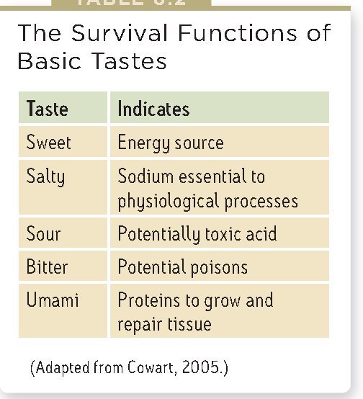
        - Each taste bud pore, 50 to 100 receptor cells project antenna like hairs that sense food molecules
        - Taste receptors reproduce them selves on a reoccurring basis
          - Decreases with age and sensitivity
          - Smoking and alcohol can increase rates
        - Expectations can influence taste
        - Flavor is a combination of taste, smell and texture
        - Taste and smell meet up in the frontal lobe
      - Sensory interaction
        - Cross-modal processing
          - Mode=sensory mode
        - Reaction times are faster with sense combinations
        - For taste you need your nose but smells can change the perceptions on food
        - Sensory interaction- principle of how a sense can influence another
        - McGurk effect
          - Combining 2 opposing sensations but a third is produced
          - Combining visual and audiotry
        - Embodied cognition illustrates how the brain circuits process bodily sensations that are responsible for cognition
        - In detecting events, the brain can combine simultaneous visual and touch sensory information that projects from the somatosensory cortex back to the visual cortex
        - Senses interact, brain blends inputs from seeing, hearing, touching, tasting and smelling channels
        - Synaesthesia: a sensation produces another sensation
      - Smell
        - Breathing comes in pairs except for birth and death
        - Smell is a chemical sense
        - 350 different receptor proteins that recognize particular molecules
        - 5 million olfactory cells
        - respond selectively to smells
      - 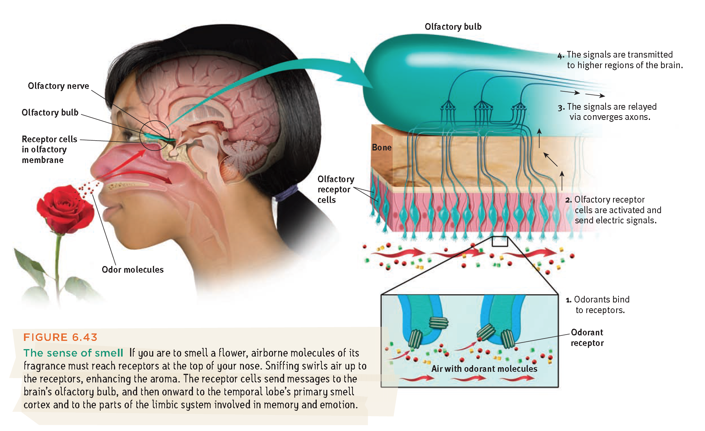
      - a family of genes design a large number of receptors to recognize particular odors
      - Buck and Axel discovered that these receptor proteins are embedded on the surface of the nasal cavity neurons
      - Some odors trigger receptors in combinations to be interpreted by the olfactory cortex
      - Women have a better sense of smell than men
      - Smells are primitive and certainly harder to describe and recall
      - Humans each have their own chemical signature that is identifiable
      - Attractiveness of smells is dependent on learned association
      - Brains are a blank slate and a preface builds
      - Difficult to recall odors by name, can recognize long forgotten odors and associated memories
    - Sense of Touch
      - Pressure, heat, cold, and pain
      - Send to sensory cortex
      - Mechanoreceptors
      - thermoreceptor
    - Body position and movement
      - Vision interacts with kinesthesis
    - 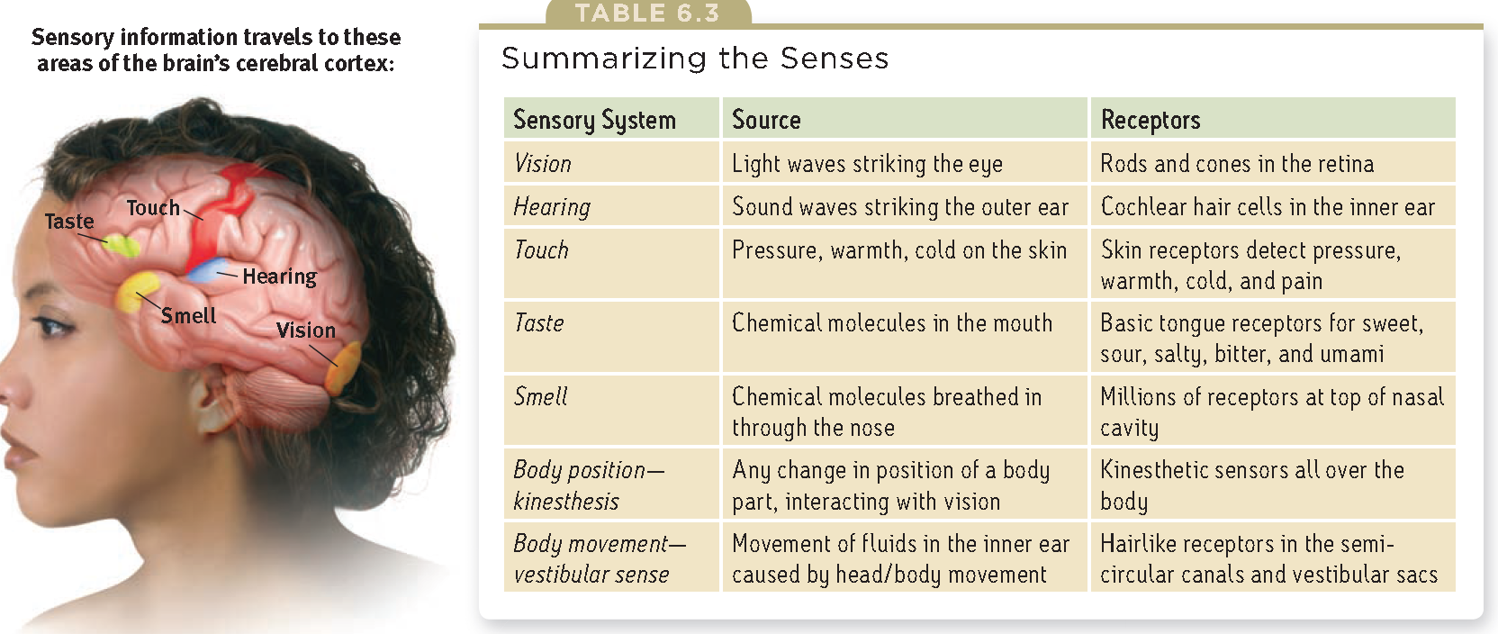
      - Vestibular sense monitors the heads movement and position
      - The semicircular canals and vestibular sacs that connect to the cochlea contain fluid that moves when disturbed and act as a gyroscope
      - Moving the head stimulates hair like receptors that sends messages to the cerebellum to sense body position and maintain balance
      - E.g. when getting dizzy the fluid and receptors do not immediately return to their neutral state
      - Perceptual illusions: mechanisms that normally give an accurate experience of the world under special conditions can fool us
      - Vestibular sense receptors are located in the inner ear
      - Extrasensory Perception: ESP
        - Controversial claim that perception can occur apart from sensory input that includes telepathy, clairvoyance and precognition
        - Telepathy: mind to mind communication
        - Clairvoyance: perceiving remote events
        - Precognition: perceiving future events

- Illusion of conscious will, a will that controls there actions when it isn’t
- Defining consciousness
  - Importance of cognition and mental processes
  - Consciousness is the awareness of ourselves and the environment
  - Awareness allows us to assemble information from sources as we reflect on our past and plan our future
  - Focuses on when we learn a complex concept or behavior
  - There are various stages of consciousness, including sleeping, waking and various altered states
  - Evolutionary psychologist speculate that consciousness must offer a reproductive advantage
- Biology of consciousness
  - Cognitive neuroscience is taking the first small step by relating a specific brain state to conscious experiences
  - Mapping the brains conscious functions allows a limited way to read a mind
- Dual processing: two track mind
  - Humans have 2 minds and each supported with its own neural equipment
  - Unconscious information processing occurs simultaneously on many parallel tracks
  - Brain operates on 2 levels
    - Consciousness
      - Deliberate high road
    - Unconsciousness
      - Automatic low road
  - Dual processing is using a two track mind
  - Blind sight, responding as if she could visually see the stimulus
  - Visual perception track enables us to recognize things and plan for future actions
  - Visual action track guides our movements
  - Two tracks can conflict when confused such as a mask that is inverted that looks like it can be picked up in one way
  - Concentrating on something increases the brains % no more than 5%
  - Consciousness can sometimes arrive late to a decision process
  - Humans function like a point and shoot camera with a manual override (consciousness)
  - Unconscious parallel processing is faster than sequential conscious processing
  - Sequential processing is skilled at solving new problems but require a focused attention
- Selective attention
  - Focusing of conscious awareness on a particular stimulus
  - Blinking less means that there is conscious awareness when focused
  - Don’t text, talk on the phone
- Selective inattention
  - Inattentional blindness is a byproduct of focusing attention on some part of the environment
  - Attention can be powerfully selective and the conscious mind is only at one place at a time
  - Magicians exploit change blindness (slight of hand and misdirection)
- Biological rhythms and sleep
  - Bodies roughly sync with a biological 24h cycle called circadian rhythm
  - In the morning internal temperature rises and decreases at night time
  - Age and experience can alter circadian rhythm
- Sleep stages
  - Sleeping brain has its own biological rhythm
  - Every 90mins we cycle through 4 stages
  - Alpha waves are the waves when were relaxed but awake
  - NREM1 non-REM stage one sleep
  - During NREM1, there can be possible hallucinations
  - NREM2, 20mins, periodic sleep spindles, bursts of rapid rhythmic brain wave activity
  - NREM3, slow wave sleep 30mins, large slow delta waves and is hard to be awaken
- 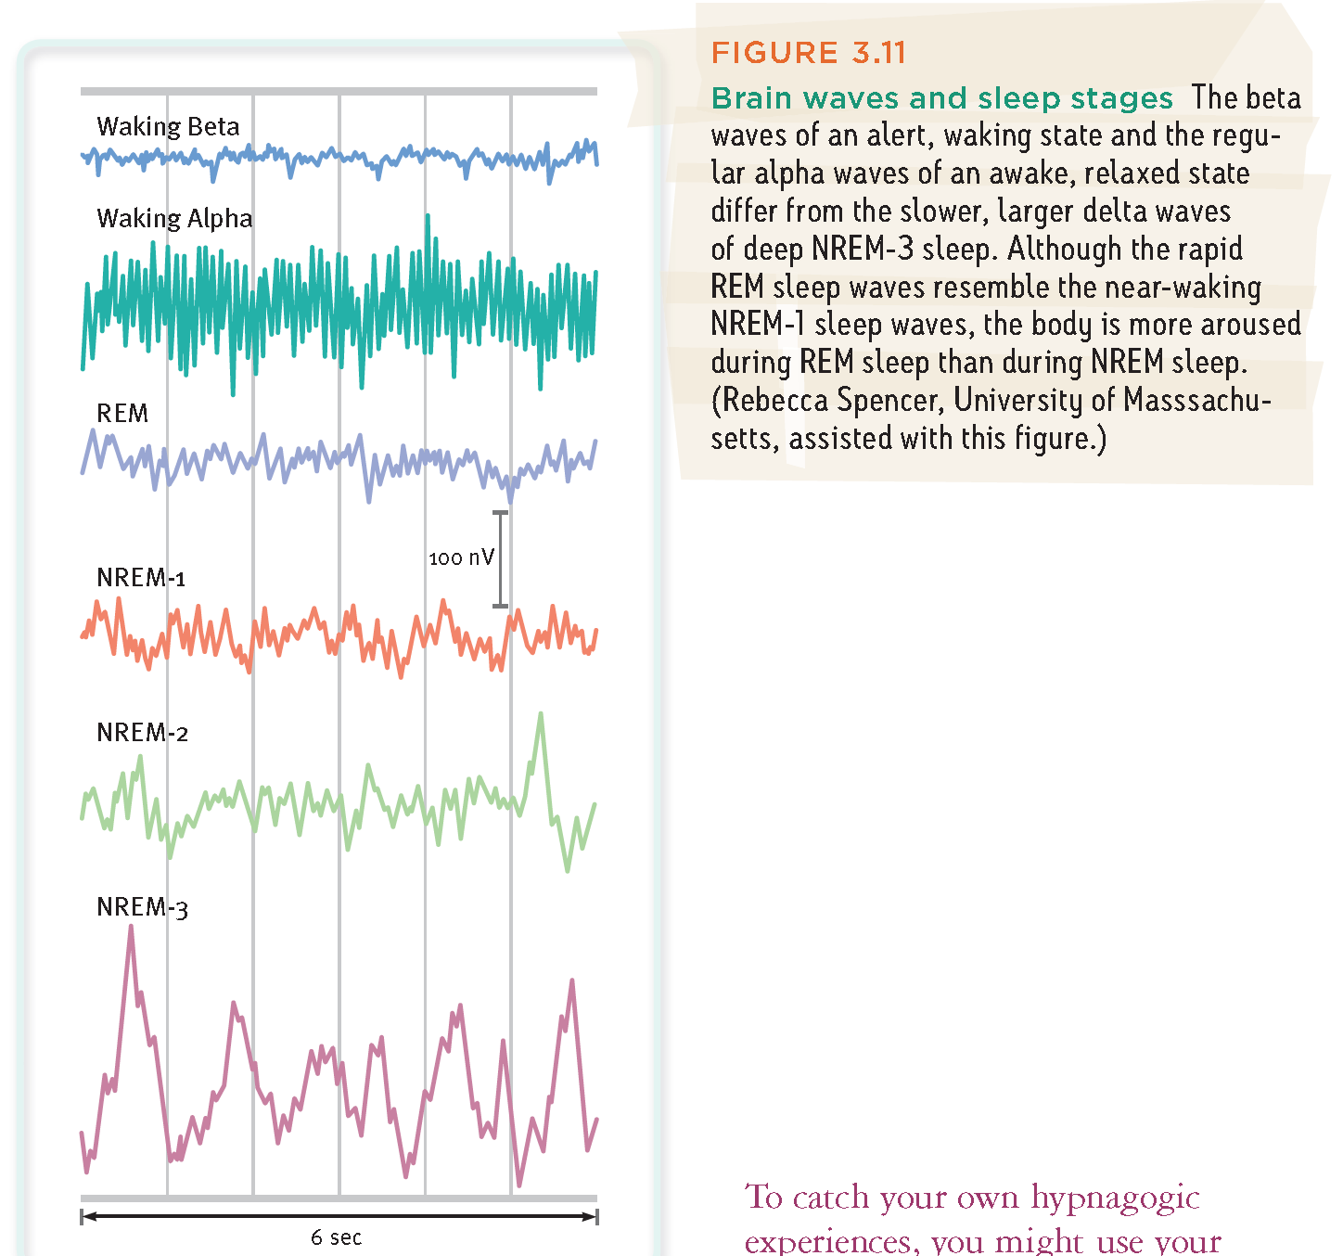
- REM sleep
  - After an hour of sleep, mind ascends from the initial sleep drive returning through NREM2
  - During REM sleep heart rate rises, breathing is rapid and irregular
  - Eyes move every half minute that indicates dreaming
  - During very scary dreams genitals become aroused during REM sleep
  - Motor cortex is active during REM sleep but brain stem blocks messages
  - Can produce sleep paralysis called paradoxical sleep where the internal body is aroused yet externally calm
  - NREM3 grows shorter and disappears gradually
  - REM and NREM2 periods get longer
  - Normally we move through NREM-1, then NREM-2, then NREM-3, then back up through NREM-2 before we experience REM sleep
- What affects our sleep pattern
  - Sleep patterns are influenced culturally
  - Bright morning light affects the circadian clock that activates light sensitive retinal proteins, suprachiasmatic nucleus (SCN) in the hypothalamus
  - SCN causes the brains pineal gland to stop producing melatonin that induces sleeping
- Sleep theory
  - 1.sleep protects
    - A species sleep pattern tends to suit its ecological niche
    - Animals with the most need to graze and the least ability to hide tend to sleep less
  - 2.Sleep helps recuperate
    - Restore and repair brain tissue
    - Animals with high waking metabolism burn a lot of energy and produce a lot of free radicals that are toxic to neurons
  - 3.Sleep helps restore and rebuild fading memories of the days experiences
    - Stabilizes neural memory traces
  - 4.Sleep feed creative thinking
    - Sleep gives to our thinking and learning
    - Spotting connections among literary information
  - 5.Sleep supports growth
    - Pituitary gland releases growth hormones HGH
    - Muscle development
- Effects of sleep loss
  - Accumulated sleep debt cant be repaid with a long sleep to recover
  - Is a predictor of depression
  - REM sleep processing of emotional experiences helps protect against depression
  - Sleep deprivation has consequences
  - Increase weight gain, increases ghrelin that is a hunger arousing hormone and depressed the hunger suppressing hormone leptin
  - Increases cortisol to increase stress and weight gain
  - Can suppress immune cells
  - Sleep deprivation slows reactions and increases error on visual attention tasks
  - Add an hour of sleep each night
- Major sleep disorders
  - Insomnia-persistent problem in falling and staying asleep
    - Insomnia complainers sleep less than others but under estimate the amount of time it takes to get to sleep
    - Sleeping pills and alcohol can aggravate insomnia
    - Aids can lead to a tolerance, increasing a dose to produce an effect
  - Narcolepsy
    - Attacks of overwhelming sleepiness
    - Falls into REM sleep with loss of muscular tension
    - Genes that can cause narcolepsy
    - Orexin a neurotransmitter linked to alertness
  - Sleep apnea
    - Associated with obesity
    - Uses a machine to keep the airway open
  - Night terrors
    - Children
    - Have episodes
    - Aren’t nightmares
    - Usually occur during the first hours of NREM3 sleep
  - Sleep walking
    - NREM3 and so is sleep talking but can occur at any time
- Dream
  - REM dreams are vivid emotional and bizarre, can be confused with reality
  - Common themes are repeatedly failing in an attempt to do something
  - Trauma can produce nightmares
  - The two track mind monitors the environment while we sleep
  - Recordings throughout the night can be remembered
- Why we dream
  - Dream theorists Sigmund Freud , dreams provide a psychic safety valve that discharges unacceptable feelings
  - Manifest content it the remembered story line
  - Latent content is the unconscious drives and wishes that would be threatening if expressed directly
  - William Dornhoff, there was no reason to believe in Sigmunds claims about dreams and their purpose
  - To file away memories
    - Information processing perspective, dreams may be sift sort and fix the days experience in our memory
    - Brain scans confirm the link between REM and memory
  - To develop and preserve neural pathways
    - Maybe brain activity associated with REM sleep serve a psychological function to stimulate the brain
    - When neural networks develop, REM sleep is more common
  - To make sense of neural static
    - Theories propose that dreams erupt from neural activation spreading from the brain stem
    - Sleeping people increased activity in the amygdala during REM sleep
  - To reflect cognitive development
    - See dreams as a apart of brain maturation and cognitive development
  - All theories do agree that we need REM sleep but have different opinions on why we dream
- 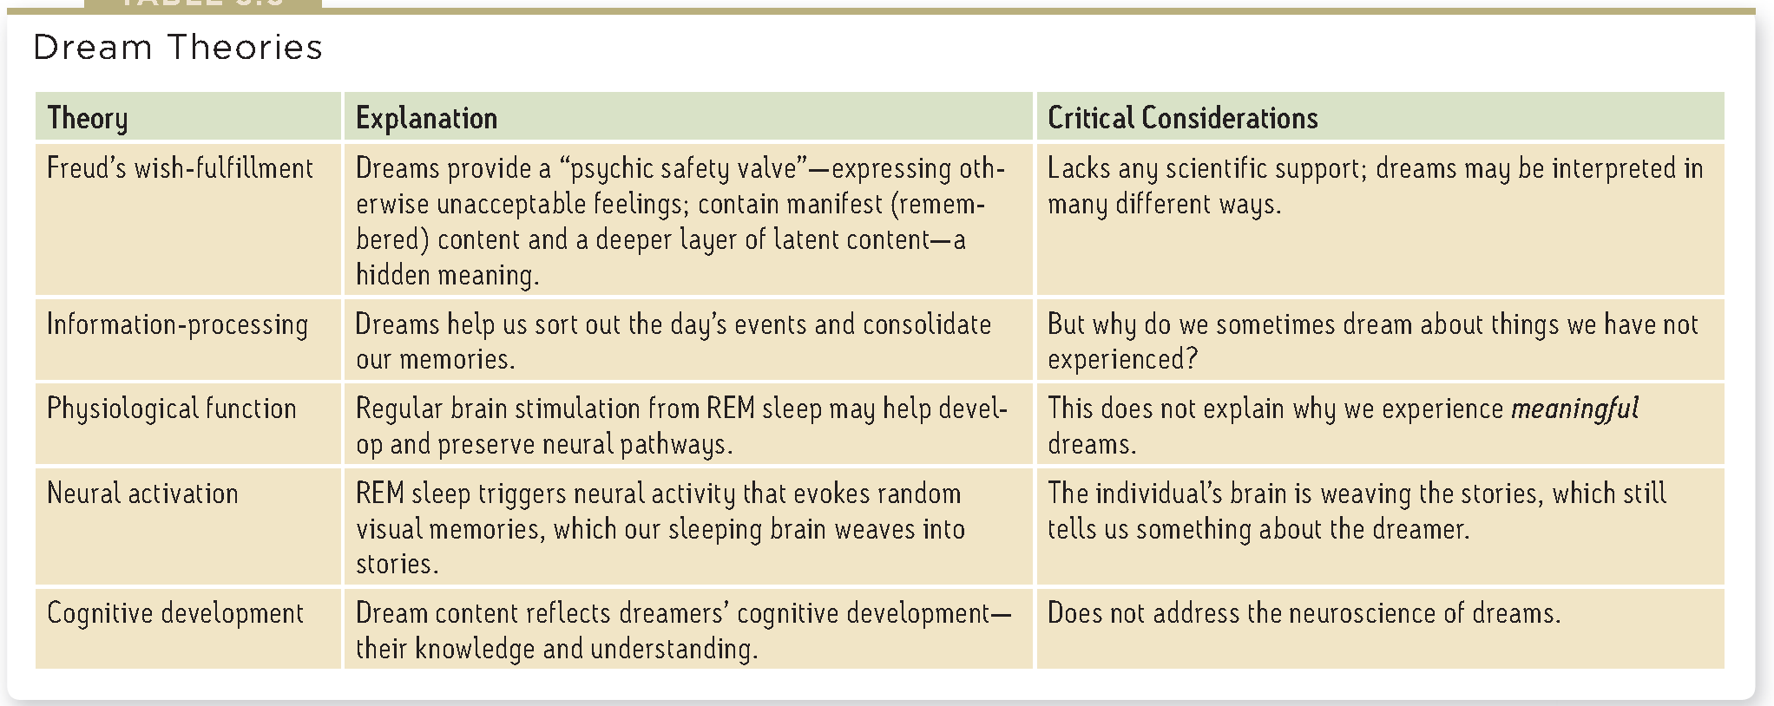
  - Finally being allowed to sleep get back into REM stage and is called Rem Rebound, occurs in mammals
  - Biological and psychological explanations of behavior are partners not competitors
- Hypnosis
  - Hypnotists powers reside in the subjects openness to suggestion, ability to focus on certain images of behavior
  - Postural sway, when we close our eyes and asked to sway we actually do it any ways and respond to hypnosis
  - Hypnotic ability is the ability to focus all attention on one task
- Most believe that experiences can be recalled if we can break through the defense’s but is disputed
- We store memories but cant retrieve some
- Posthypnotic suggestions have helped pain
- Hypnotically refreshing memories can be harmful
- Hypnosis as a social phenomenon
  - The more that someone trust, the more a hypnotist can take over and direct fantasies and attention
  - An authoritative person in a legitimate context can induce people
- Hypnosis as divided consciousness
  - Hypnosis involved social influence and dissociation that is dual processing
  - Dissociation is a split between different levels of consciousness
  - Feel cold but not feel pain
  - Selective attention- can possibly assist in hypnotic pain relief
  - Hypnosis can suppress the area of the brain that induces pain stimuli
  - Hypnosis doesn’t block sensory input but can block out attention to those stimuli
  - There is more unconscious that conscious
  - Information processing starts with selective attention
    - And divided into simultaneous conscious and unconscious realms
- Dugs and consciousness
  - A drugs overall effect depends not only on the biological effects but the psychology of the users expectations
  - That varies with social and cultural context
  - Tolerance includes process of neuroadaptation where the increase of dosage is needed to produce and effect
  - Addiction is when a person craves the use of the substance despite adverse consequences
  - Abrupt stopping of the drug can cause withdrawal
  - Withdrawal can cause pain that is categorized as physical dependence
  - Psychological dependence is when using stress relieving drugs
  - Obtaining the drug can be a days task and focus
  - 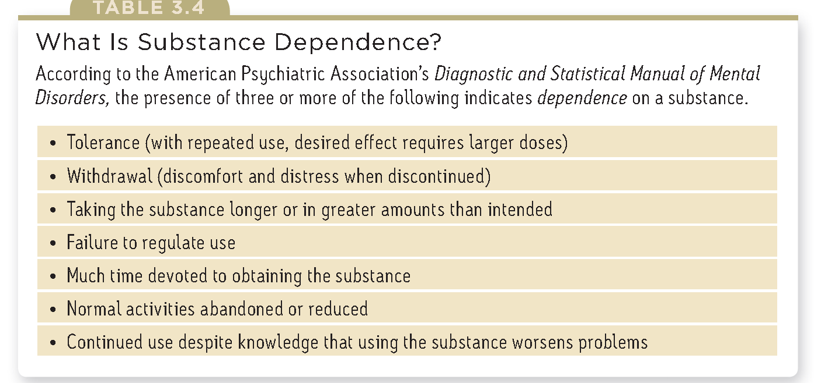
- Psychoactive drugs
  - Depressants
    - Alcohol: equal opportunity drug-increases helpful tendencies
    - Slowed neural processing slowing SP NS
    - Sleep deprivation and alcohol is a sedative
    - Memory disruption
      - Memory formation
      - Alcohol suppresses REM sleep that fixes that days experience into permanent memories
      - Binge drinking contributes to nerve cell death, reduces the formation of nerve cells, impairs growth of synaptic connections
      - Alcohol dependence can shrink the brain
    - Reduced self awareness and self control
      - Reduces self awareness
      - Distracts attention from normal inhibitions and future consequences
      - Suppressing failures
    - Expectancy effects
      - When people believe alcohol affects social behavior in certain ways they will behave accordingly
    - Barbiturates
      - Or tranquilizer will depress nervous system activity
      - Induce sleep or reduce anxiety, larger doses can impair memory and judgment
    - Opiates
      - Opium, morphine, heroin depress neural function
      - Lethargic, artificial opiates replace endorphins and the brain stops producing them and cause a harsh withdrawal
      - Death by overdose
      - Methadone is a synthetic opiate that is a substitute for heroin
  - Stimulants
    - Speeds up body function, pupils dilate
    - Feel alert, lose weight, boost mood or athletic performance
    - Can be addictive
    - Nicotine
      - Eliminating smoking would increase life expectancy
      - Smokers become dependent and develop tolerance
      - Nicotine signals the nervous system to release epinephrine and norepinephrine
      - Diminish appetite, increase alertness and mental efficiency
      - Dopamine and opioids calm anxiety and reduce sensitivity to pain
      - Acute withdrawal dissipates over 6 months
      - Smoking correlates with depression, chronic disability and divorce
    - Cocaine
      - Depletes the brains supply of neurotransmitters
      - Depression follows and drug wears off
      - Situations can trigger aggression
      - Cocaine blocks the reuptake of neurotransmitters and intensifies the affects to produce a euphoric rush
    - Methamphetamine
      - Chemically related to amphetamines
      - Has greater effects and triggers the release of dopamine
      - Stimulates brain cells, mood and energy
      - Can leave the use with depressed functioning
    - Ecstasy
      - MDMA, stimulant and mild hallucinogen
      - Triggers dopamine release
      - Major effect is releasing serotonin and blocking its reuptake
      - Has a dehydrating effect, increase blood pressure and cause death
      - Long term leaching effect of serotonin can decrease production levels can cause depression
      - Suppresses immune system
      - Disrupts serotonin with circadian clock
  - Hallucinogens
    - Distort perceptions, evoke sensory images in the absence of sensory input
    - Both synthetic or natural
    - LSD
      - Emotions can be from euphoria, detachment to panic
      - Brain hallucinates in the same way
      - Starts with geometric forms
      - Next is meaningful images that could tunner or superimpose
      - At the peak, they often feel apart from their body
      - Near death experience, an altered state of consciousness
    - Marijuana
      - Mild hallucinogen, relaxes, disinhibits, can also impair the body
      - THC and byproducts can linger for up to a week, regular users can use less to get a high
      - Can intensify problems
      - More use will cause anxiety and depression
      - Can shrink brain areas that process memories and emotions
- 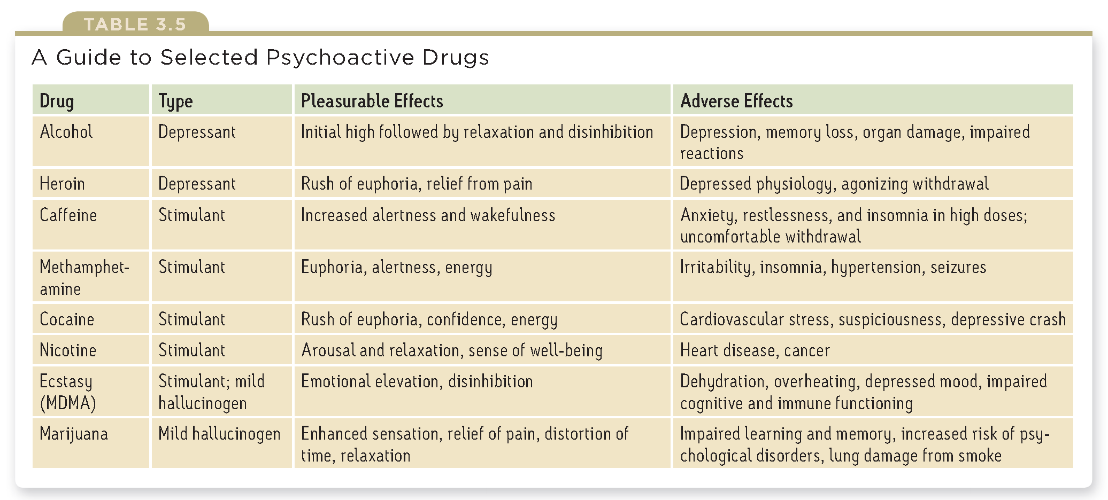
- Influences on Drug use
  - Drug use increase in 1970
  - Occasional drug use represents thrill seeking
  - Biological influences
    - Can be biologically vulnerable to drugs
    - Heredity influence
  - Psychological and social cultural
    - Felling life is meaningless and directionless
    - Experience significant stress or failure and are depressed
    - Drug use can have social roots
    - Drinking dominates social occasions
    - Educate young people about the long term costs of drug use
    - Help find other ways to cope, boost self esteem and purpose in life
    - Modify peer associations against peer pressure by training refusal skills
    - People rarely abuse drugs if they understand the costs

- Adaptability-our capacity to learn new behaviors that help us cope with changing circumstances
- How do we learn
  - Learning is the process of acquiring new and relatively enduring information on behaviors
  - Increases the ability to adapt to environments
  - Operant conditioning, repeat acts that bring reward and avoid unwanted results
  - Classical conditioning, expect and prepare for significant events
  - Cognitive learning, observe events and watching others through language
  - John Locke and David Hume echoed Aristotle’s conclusion that we learn by association, our minds naturally connect events that occur in sequence
  - Takes about 2 months to incorporate a habit that is habitual behavior
  - Linking 2 events that occur close together exhibit associative learning
    - Process of learning associations is conditioning
    - Classical conditioning
      - Associate 2 stimuli and anticipate events
    - Operant conditioning
      - Learn to associate a response and its consequence
  - Cognitive learning
    - Acquiring mental information that guide our behavior
    - Observational learning
      - Learning from another’s experiences
- Classical conditioning
  - Ian Pavlov
  - Explored classical conditioning
  - Objective science based on observable behavior
  - Pavlov’s experiments
    - Conditioned a dog to salivate
    - Used neutral stimuli, stimulus that elicits no response before conditioning
    - Used sights and sounds
    - Used conditioned and unconditioned stimulus and responses
- Acquisition
  - Initial learning of stimulus response relationship
  - Time between NS and US is half a second
  - Classical conditioning is biologically adaptive because it helps humans and other animals prepare for events
  - Conditioning helps an animal to survive and reproduce
  - Through higher order conditioning, a new neutral stimulus can become a new conditioned stimulus but will be weaker that first order conditioning
- Extinction and spontaneous recovery
  - Extinction, the diminished response that occurs when the conditioned stimulus no longer signals an impending unconditioned stimulus
  - Spontaneous recovery, reappearance of a weakened conditioned response after a pause
  - Extinction was suppressing the conditioned response rather than eliminating it
- Generalization
  - Generalization, the tendency to respond likewise to stimuli similar to the conditioned stimulus
  - Can become adaptive to incorporate other stimuli that are not conditioned as an extension
- Discrimination
  - Distinguishing between a conditioned stimulus from a neutral stimulus/irrelevant
  - The ability to recognize differences is adaptive
- Many other responses to many other stimuli can be classically conditioned in many other organisms
- Is one way to that virtually all organisms learn to adapt to their environments
- A process such as learning can be studied objectively
- Pavlov’s methods involved practically no subjective judgments of guesses
- Applications of classical conditioning
  - Keep addicts away from places and people that can cause cravings
  - Little Albert (Douglas Merritte)
    - Feared loud noises but not to a white rat
    - Struck loud noise when presented with a white rat
    - Generalization occurred with other stimuli but not with inanimate objects
    - Died at age 6 for meningitis
- Operant Conditioning
  - Classical conditioning forms associations between stimuli
  - Involves respondent behavior, actions that are automatic response to a stimulus
  - Operant conditioning, associating actions with consequences
  - Behavior that operates on the environment for rewarding or punishing stimuli called operant behavior
  - Skinner used Thorndlike’s work as a starting point on law of effect: rewarded behavior is likely to recur
  - Skinner developed a behavioral technology that revealed principles of behavior control
  - Designed a operant chamber known as the skinner box
  - Reinforcement: any event that strengthens a preceding response
- Shaping behavior
  - Shaping, gradually guiding actions towards the desired behavior
  - Successive approximations, reward responses that are closer to the final desired behavior
  - Shaping complex behaviors
  - Can help what non verbal organisms perceive
- Types of reinforcers
  - Positive reinforcement that strengthens a response by presenting a pleasurable stimulus after a response
  - Negative reinforcement strengthens a response by removing something negative
    - Not punishment but reinforces a negative unproductive response
  - Both can work together
    - Getting a bad exam grade by slacking
      - Negatively reinforced from reduced anxiety
      - Positively reinforced from a better grade
  - Reinforcement is strengthening a behavior
  - Primary and conditioned reinforcers
    - Primary reinforcers are unlearned
    - Conditioned reinforcers get their power through learned association with primary reinforcers
    - Rat pressing down a bar, if the bar turns on a light it is a conditioned reinforcer
    - Immediate or delayed reinforcers
      - To function effectively we must learn to delay gratification
      - Small amount of time before reinforcing an unwanted behavior for being delayed
    - Reinforcement schedules
      - Extinction occurs rapidly
      - Partial reinforcement, sometime reinforced and sometimes not
      - Resistance to extinction is greater than with continuous reinforcement
      - Fixed ratio schedules-reinforce behavior after a set number of responses
      - Variable ratio schedules-reinforce behavior after an unpredictable number of responses
      - Fixed interval schedules-reinforces the first response after a fixed time period
      - Variable interval schedules-reinforce the first response after varying time intervals
      - Rates are higher when reinforcement is linked to the number of responses
      - Responding is more consistent when reinforcement is unpredictable
    - Punishment
      - Punishment is any consequence that decreases the frequency of a preceding behavior
      - 4 major drawbacks to punishment
        - Punished behavior is suppressed not forgotten, only temporary
        - Punishment teaches discriminations among situations, only learns certain responses and not others,
        - Punishment can teach fear, generalization occurs when a response to similar stimuli is also reinforced
        - Physical punishment may increase aggression by modeling aggression as a way to cope with problems
        - More frequent spankings can predict future spankings 9/10 parents spank
      - Skinners legacy
        - Stated that external influences shape behavior
      - Applications of operant conditioning
        - School learning and teaching rates of educating children
        - In sports, make it easy at the start for satisfaction an challenge later on
        - At work, achievable behavior should be reinforced immediately
        - At home
          - State your goals in measurable terms and announce it
          - Monitor how often you engage in your desired behavior
          - Reinforce the desired behavior
          - Reduce the rewards gradually
    - Contrasting Operant and classical conditioning
      - Classical
        - Associate different stimuli we do not control
        - Respond automatically
        - Respondent behavior
      - Operant
        - Associate our own behaviors that act on the environment and produce either rewarding or punishing stimuli
        - Operant behaviors
- 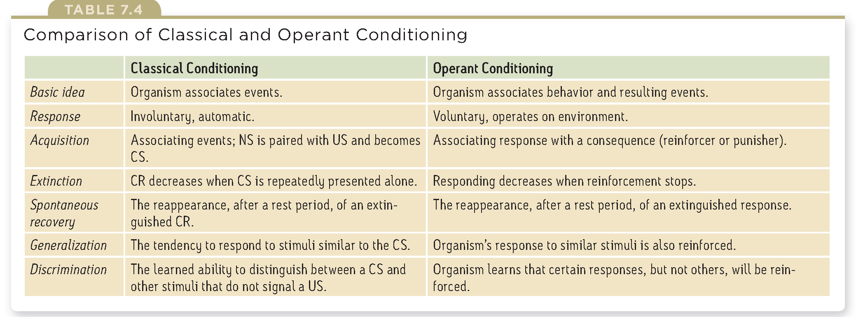
- Biology, cognition and learning
  - Limits on classical conditioning
    - An animals capacity for conditioning is limited by its biology
    - Taste aversion, sickened after eating and will avoid
    - Natural selection was applied to taste aversion
    - Men like red
    - A genetic predisposition to associate a conditioned stimulus with an unconditioned stimulus that follows predictably and immediately is adaptive
    - Causes often immediately precede effects
  - Limits on operant conditioning
    - Biological constraints predispose organisms to learn associations that are naturally adaptive
  - Cognitive process and classical conditioning
    - Importance of not only biological constraints but, effect of cognitive processes
    - An animal can learn the predictability of an event
    - The more predictable the association, the stronger the conditioned response
    - The animal learns an expectancy an awareness of how likely is that the unconditioned stimulus occurs
  - Cognitive process and operant conditioning
    - Skinner resisted the growing belief that cognitive processes have a necessary place in psychology
    - Cognitive map- mental representation of a maze
    - Latent learning-incentive to demonstrate
    - There is more to learning than associating a response with a consequence; there is also cognition
    - Excessive rewards can destroy intrinsic motivation (desire to perform effectively for its own sake)
    - Intrinsic- if marks didn’t matter
    - Extrinsic if the marks matter and if I’m doing well in the course
- 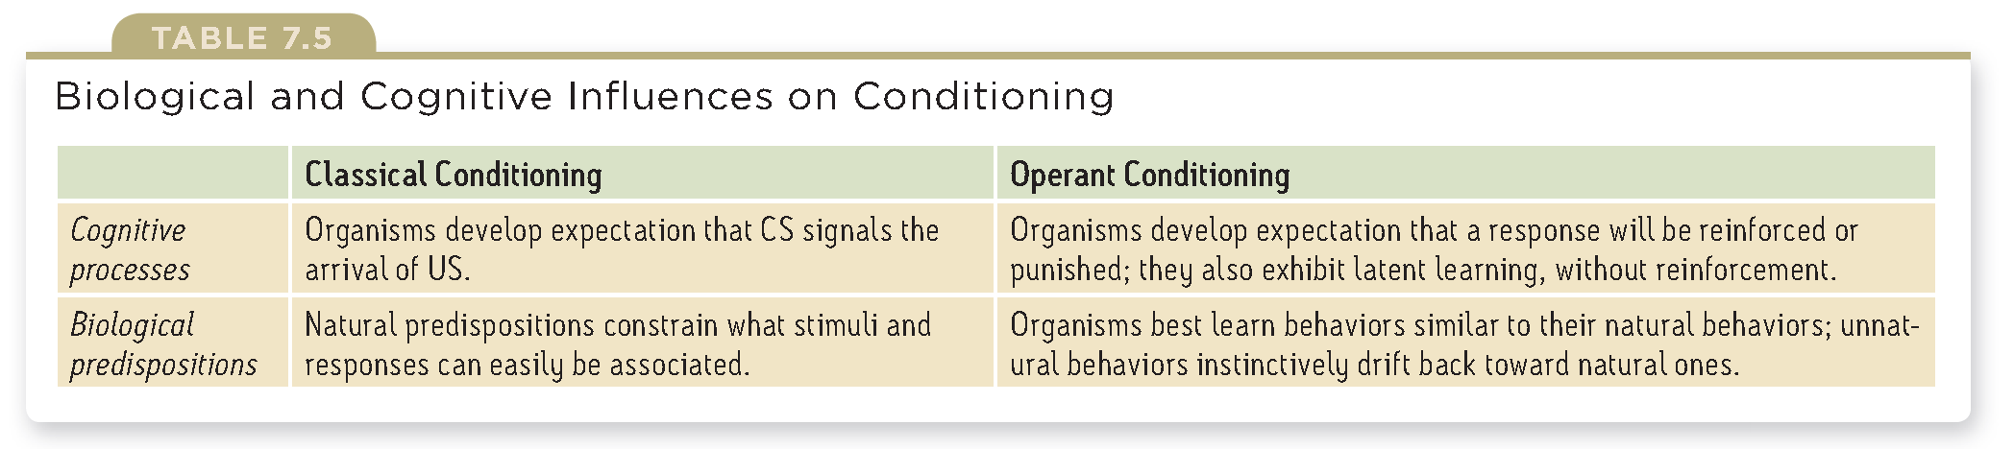
  - Learning by observation
    - Cognition is a factor in observational learning
    - Modeling, learning from others
    - By watching a model we experience vicarious reinforcement or punishment
  - Mirrors and imitation in the brain
    - Mirror neurons can provide a neural basis for everyday imitation and observational learning
    - Children’s brains enable there empathy and their ability to infer another’s mental state (theory of mind)
    - Brain activity underlies our intensely social nature
  - Applications of observational learning
    - Prosocial effects
      - Positive, helpful, constructive behavior modeling
    - Antisocial effects
      - Bad beginnings can cause bad endings
      - Abusive parents having aggressive children
      - Conditions can define the recipe for violence viewing effect

- Is learning that has persisted over time, information stored that can be retrieved, comes in 3 forms
  - Recall: retrieving information not in conscious awareness, that was learned at an earlier time (fill in the blank type of question)
  - Recognition: identifying items previously learned (multiple choice test)
  - Relearning: learning something more quickly than the first time (reviewing)
- Memory models
  - Information processing models are analogies that compare human memory to a computers operations
  - Encode, storage, retrieval
- Computers have their limits, human memories are more fragile than a computers
- Most computers process information sequentially also can alternate on tasks
- Humans have a dual track mind that can use parallel processing
- Information processing mode, Connectionism: views memories as products of interconnected neural networks
- Specific memories arise from particular activation patterns within these networks
- Neural connections change that allow us to interact with an learn from a constantly changing environment
- Richards produced a 3 stage model
  - 1.we first record to remember information as fleeting sensory memory
  - 2.process information into short term memory, encoded through rehearsal
  - 3.information then moves into long term memory for later retrieval, working memory and automatic process
- Working memory
  - 1)Active processing that takes place in the middle stage of auditory and visual information
  - Processing information and linking it to long term memories
  - Automatic processing, Information slipping in and without our consciously attending to it
  - 2)focusing our spot light of attention
- 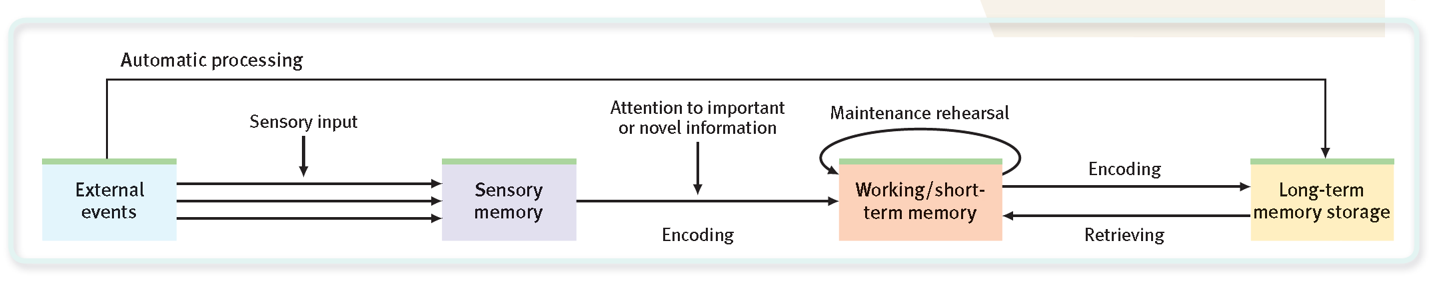
- when integrating memory inputs with long term memory you attention is focused and is called focused processing the central executive
- Without focused attention, information often fades
- 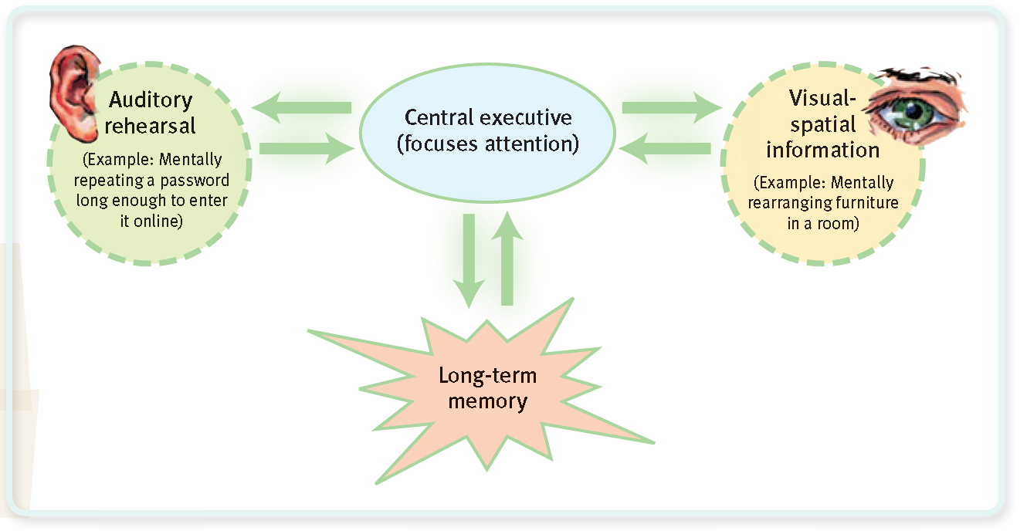
- Alan’s model of working memory auditory and visual rehearsal of new information
- Dual track memory: Effortless versus automatic processing
  - Atkinson and shirffron focused on how we process explicit memories (conscious know and declare facts and experiences)
  - Explicit memories through effortful processing
  - Implicit memories through automatic processing

- What two new concepts update the classic Atkinson-Shiffrin three-stage information-processing model?
- ANSWER: (1) We form some memories (implicit memories) through automatic processing, without our awareness. The
- Atkinson-Shiffrin model focused only on conscious, explicit memories. (2) The newer concept of a working memory
- emphasizes the active processing that we now know takes place in Atkinson-Shiffrin’s short-term memory stage.

- • What are two basic functions of working memory?
- ANSWER: (1) Active processing of incoming visual and auditory information, and (2) focusing our spotlight of
- attention.

- Building memories
  - Automatic processing
    - Implicit memories include procedural memory for automatic skills
    - And classically conditioned association among stimuli
    - Space of encoded processing
    - Time events to retrace a timetable
    - Frequency how many times something has happened
  - Effortful processing
    - Reading and learning
    - Effortful tasks can become automatic
- Sensory memory
  - Effortful processing begins with sensory memory
  - That feeds our working memory
  - Momentary photographic memory
    - Signal applied to remember specific aspects
    - Expressed iconic memory
    - Fleeting sensory memory of visual stimuli
    - Echoic memory, memory fro auditory stimuli
- Capacity of short term working memory
  - Without active processing that we now understand to be a part or working memory concept, short term memories have a limited life
  - Varies depending on age and other factors
  - Takes about 18seconds for the expectancy of a memory in short term to last
  - Working memory capacity can reflect on intelligence
- Effortful processing strategies
  - Chunking, organization into manageable units that is natural and automatic
  - Mnemonics, memory aids using vivid images, acronym
  - Hierarchies, broad concepts divided into narrow concepts and facts
  - Distributed practice, encoding distributed over time, spacing effect and testing effect
- Levels of processing
  - Depth of processing affects our retention
  - Shallow processing encodes on a basic level
  - Deep processing encodes semantically based on the meaning of words
  - Making material personally meaningful
    - A relation makes it easier to process if it can be related to experiences

- What is the difference between automatic and effortful
- processing, and what are some examples of each?
- ANSWER: Automatic processing occurs unconsciously
- (automatically) for such things as the sequence and frequency
- of a day’s events, and reading and comprehending words in
- our own language. Effortful processing requires attention and
- awareness and happens, for example, when we work hard to
- learn new material in class, or new lines for a play.

- • At which of Atkinson-Shiffrin’s three memory stages
- would iconic and echoic memory occur?
- ANSWER: sensory memory

- • Which strategies are better for long-term retention:
- cramming and re-reading material, or spreading out
- learning over time and repeatedly testing yourself?
- ANSWER: Although cramming may lead to short-term gains in
- knowledge, distributed practice and repeated self-testing will
- result in the greatest long-term retention.

- • If you try to make the material you are learning
- personally meaningful, are you processing at a shallow
- or a deep level? Which level leads to greater
- retention?
- ANSWER: Making material personally meaningful involves
- processing at a deep level, because you are processing
- semantically—based on the meaning of the words. Deep
- processing leads to greater retention.

- Memory storage
  - Despite the brains vast storage capacity, we store in many parts of the brain that interact as we encode, store and retrieve information that forms our memories
  - Explicit: frontal lobes and hippocampus
    - Explicit memories are processed in the hippocampus and fed to other brain regions for storage
    - Temporal lobe neural center
    - Save button for explicit memories
    - Damage disrupts the recall of explicit memories
    - Left hippocampus damage messes with verbal information
    - Right hippocampus damage messes with visual information
    - Sub regions can affect both
    - Only temporary hold elements of remembered episodes
    - Sleep supports memory consolidation
  - Implicit: cerebellum and basal ganglia
    - For skills and conditioned associations
    - Cerebellum plays a key role in implicit memories created by classical conditioning
    - Basal ganglia responsible for motor movement, facilitate formation of procedural memories for skills , only receives information input and doesn’t send a response like riding a bike
    - Skills learned during infancy are present in the future
    - Infantile amnesia- first 3 years of life are blank
      - Two influences
      - We index most of our explicit memory using words that non speaking children have yet to learn
      - Hippocampus is the last structure to mature
  - Amygdala
    - Emotions trigger stress hormones that influence memory formation
    - Make more glucose to energize the brain
    - Stress hormones provoke the amygdala to initiate a memory trace in the frontal lobes and basal ganglia to boost memory forming areas
    - Flashbulb memories are clear and concise memory retrievals
  - FINAL EXAM
  - Synaptic changes
    - Sea slug, Aplysia, was classically conditioned with electric stimulation,
    - When learning occurs the slug releases more serotonin onto certain neurons, these cells become more efficient at transmitting signals
    - Increased efficiency of potential neural firing (long term potentiation LTP)
    - Provides a neural basis for learning and remembering associating
    - Evidence of LTP is a physical basis for memory
      - Drugs that block LTP interfere with
      - Mutant mice engineered to lack an enzyme needed for LTP cant get out of a maze
    - After LTP has occurred, passing an electric current through the brain wont disrupt old memories but will wipe out recent memories
    - Electroconvulsive therapy ECT
    - Improving memory focus is a drug that can boost LTP enhancing neurotransmitter glutamate or CREB
  - 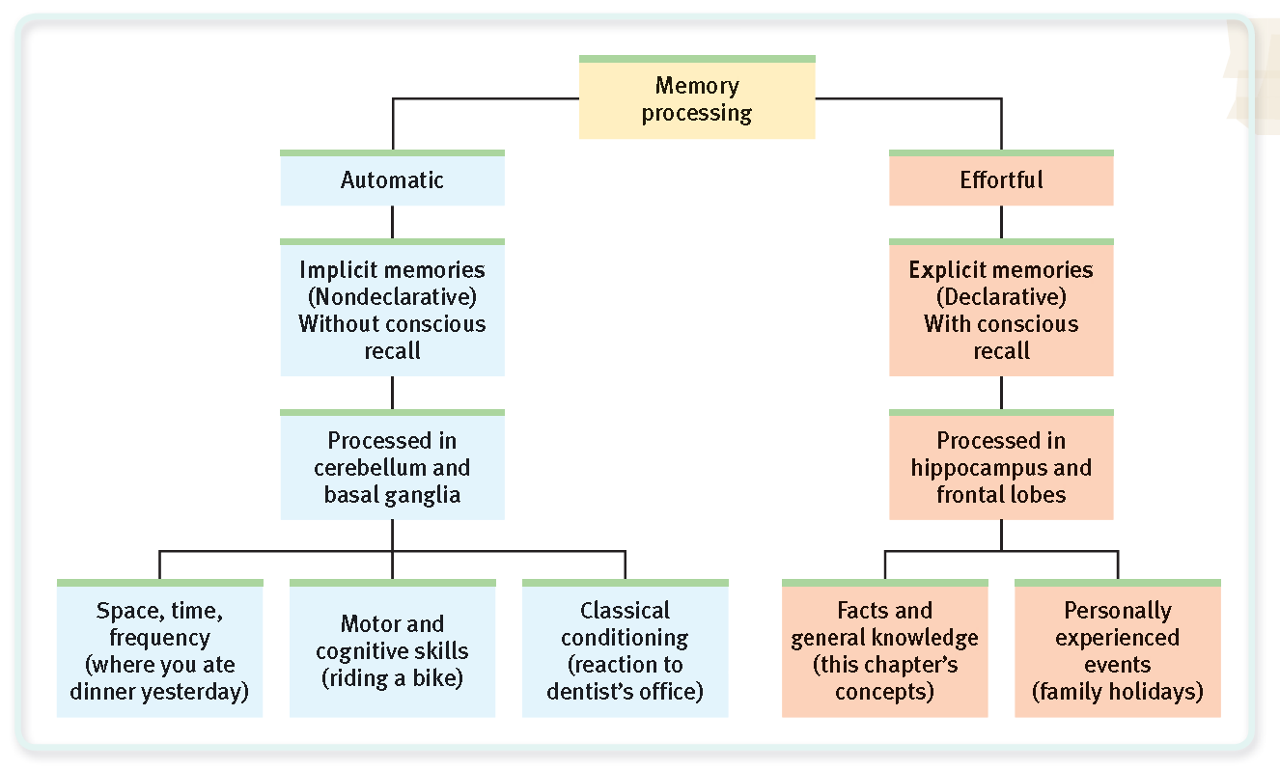
- Retrieval
  - Recall, recognition and relearning speeds are used to measure memory retention
  - Retrieval cues
    - Used later to access information
  - Priming
    - Often associations are activated without our awareness
    - William james called it priming
  - Context dependent memory
    - Putting yourself back into context of the experience can prime your memory retrieval
  - State dependent memory
    - Related to context
    - Mood states, emotions that accompany god or bad events become retrieval cues
    - Moods are somewhat mood congruent
    - Retrieval effect can somewhat explain why our moods persist
  - Serial position effect
    - Why we have large holes in our memories
    - Recency effect when recalling the last items on a list
    - Primacy effect recalling first items on a list
  - Forgetting
    - Anterograde amnesia- could recall the past but couldn’t form new memories
    - Retrograde amnesia- cant recall the past
    - Can learn non verbal tasks
    - Classically conditioned
    - They do all these things without awareness of having learned them
    - Alzheimer’s- loss of explicit memories but can still create implicit memories
  - Encoding failure
    - Age effects encoding efficiency
    - Without effort, potential memories never form
  - Storage decay
    - Forgetting curve
      - Initial course is rapid and later, levels off with time
    - Gradual fading of physical memory trace
  - Retrieval failure
    - Retrieval cues can help retrieve the elusive memory
  - Interference
    - Ability to tune out clutter helps to focus, focusing helps to recall information
    - Proactive interference: prior learning disrupts recall of new information
    - Retroactive interference: new information disrupts the recall of new information
      - Increased forgetting when the subject stayed awake
    - Information presented in the first hour before sleep is protected from retroactive interference
      - Because the opportunity for interfering events is minimized
      - Information during sleep cant be registered
    - Previously learned information can facilitate the learning of new information (positive transfer)
  - Motivated forgetting
    - Memory is unreliable self serving historian
    - Humans repress painful or unacceptable memories to protect our self-concept and to minimize anxiety
    - Repressed memory lingers and can be retrieved by a cue or during therapy
    - Repression is central to Freud’s theory
    - May have intrusive memories of traumatic experiences that we would like to forget
  - Memory construction errors
    - Misinformation effect: exposed to misleading information we tend to misremember
    - So powerful that it can affect behavior and attitude
    - Repeatedly imagining nonexistent actions and events can create false memories
    - Digitally altered photos have produced imagination inflation
    - Imagined events seem more familiar and real
    - The more vivid a memory, the more they can become memories
  - Source amnesia
    - Misattribution
      - At the heart of any false memory
      - Unintentional plagiarism from earlier cue
    - Déjà vu
      - Familiarity with stimulus without a clear idea of how they encountered it before
      - Temporal lobe processing is the experience of feeling familiarity
      - Before we consciously remember details from the hippocampus and frontal lobe processing
  - Discerning true and false memories
    - Memory is a reconstruction and reproduction
    - Memory cant be real by how it feels
    - Unreal memories feel like real memories
    - We tend to remember the gist of things rather than words themselves
  - Children’s eyewitness recall
    - Children’s memories can be easily molded
    - Suggestive interviewing techniques
    - Couldn’t separate real from false memories
    - Memories can be accurate if there is no interference with questioning, using neutral words
  - Repressed or constructed memories of abuse?
    - Adult recollection of child abuse
      - People don’t believe abuse survivors that tell their secret
      - Innocent people are falsely accused
    - Agreed on the following
      - Sexual abuse happens
        - More often than once supposed
        - Problems ranging from sexual dysfunction and depression
        - No characteristic survivor syndrome, no group of symptoms that spot victims of sexual abuse
      - Injustice happens
        - Falsely convicted
        - The guilty escape by casting doubt on truth telling accusers
      - Forgetting happens
        - Very young, may have not understood the meaning of the experience
        - Forgetting is ordinary part of everyday life
      - Recovered memories are common place
        - Cues can recover all memories both un/pleasant
        - Does the unconscious mind forcibly repress painful experiences
        - Can these experiences be retrieved by therapist aided techniques
      - Memories of things before age 3 are unreliable
        - Infantile amnesia
        - Cant form memories for the first 3 year of life
        - There is doubt in recovered memories of abuse during infancy
      - Memories recovered using hypnosis or drugs is especially unreliable
        - Can incorporate suggestions into memories
      - Memories whether real or false can be emotionally upsetting
        - A suggestion that can become a stinging memory that drives bodily stress
    - Victims of most childhood abuse do not repress their abuse
      - Simply stop devoting thought and emotion to it
      - Most likely to happen when
        - The experience was strange, weird and uncomfortable rather than traumatic
        - Abuse only happened once or a few times
        - Victims don’t think about the abuse, because of resilience or no reminders are available
      - Victims do sometimes accurately and spontaneously recall memories of childhood abuse and rarely form false memories
      - The most common response to a traumatic experience isn’t banishment of the experience into the unconscious
        - But experiences are etched into the mind as vivid persistent haunting memories
    - Improving memory
      - SQ3R (read, retrieve, review)
      - Study repeatedly
      - Make material meaningful
      - Activate retrieval cues
      - Mnemonic devices
      - Minimizing interference
      - Sleep more
      - Testing effect

- Motivational concepts
  - Motivation comes from nature (bodily push) and nurture (pulls from our thought process and culture
  - Perspectives of motivated behavior
  - Instinct theory
    - Replaced evolutionary perspective
    - Focuses on genetically predisposed behaviors
  - Drive-reduction theory
    - Inner pushes and external pulls interact
  - Arousal theory
    - Finding the right amount of stimulation
  - Abraham Maslow’s hierarchy of needs
    - Some of our needs take priority over others
- Instincts and evolutionary psychology
  - Before, it was popular to classify behaviors as instincts
  - Rather than explaining human behaviors, it was simply naming them
  - To name a behavior is not explaining it
  - To be an instinct, behavior must have a fixed pattern throughout a species and be unlearned
  - Instinct theory failed to explain most human motives
  - Underlying assumption that genes predispose species-typical behavior remains strong
- Drives and incentives
  - When the original instinct theory of motivation collapsed,
  - It was replaced by drive reduction theory
    - Physiological need creates an aroused state that drives the organism to reduce need through drinking or eating
  - When physiological need increases, so does psychological drive
    - An aroused motivated state
  - Physiological aim of drive reduction is homeostasis
    - Maintenance of a steady internal state
    - We are pushed to reduce drives
    - We are pulled by incentives (+/- stimuli that lure or repel us)
      - One way of how our individual learning histories influence our motives
    - When there is both a need and a incentive, we feel strongly driven
    - Each motive
      - “How is it pushed by our inborn physiological needs and pulled by incentives in the environment?”
  - Optimum arousal
    - Some motivated behaviors increase arousal
    - Human motivation aims not to eliminate arousal but to seek optimum levels of arousal
    - Having out biological needs satisfied, we are driven to experience stimulation and hunger for information
    - When we are bored we look for arousal, too much arousal comes stress
  - A hierarchy of motives
    - Hierarchy of needs
    - 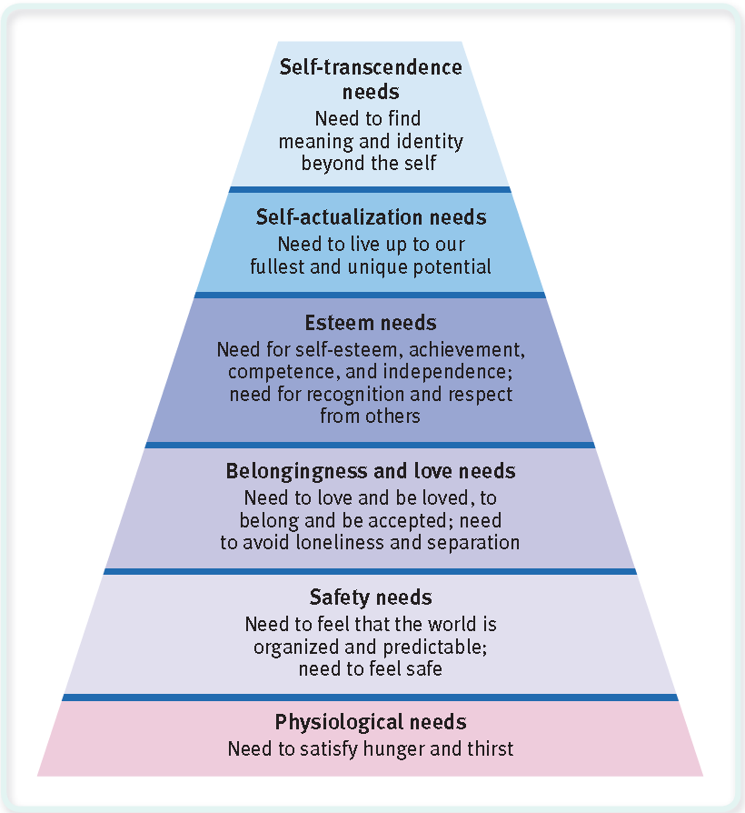
    - First take care of the bottom and then deal with the ones higher above
    - At self actualization, people seek to realize their own potential
    - At self transcendence, people strive for meaning, purpose, and communion that is beyond the self, that is transpersonal
    - Arbitrary, the order of needs is not universally fixed
    - Gaining, retaining mates, parenting offspring, are universal human motives
  - Hunger
    - Preoccupied with unfulfilled basic needs, there is lost interest in other activities
    - Power of activated motives, hijack our consciousness
  - Physiology of hunger
    - Stomach contractions when hungry
  - Body chemistry and the brain
    - Insulin secreted by the pancreas, converts glucose into stored fat
    - Brain monitors blood chemistry to trigger hunger
    - A neural arc called the accurate nucleus releases suppressing or stimulation appetite hormones
    - Electrically stimulating a appetite suppressing area will cause cessation in eating
    - Destroy the area and the animal will become fat
    - Hypothalamus takes care of blood chemistry
    - Ghrelin is secreted by an empty stomach and sends hunger
    - Orexin is secreted by the hypothalamus to trigger hunger
    - Leptin is secreted by fat cells decrease hunger
    - PYY is secreted by the digestive tract and decreases hunger
    - Set point is the stable weight
    - Heredity influences body type and set point
    - Basal metabolic rate, rate of energy expenditure for maintaining body function while the body is at rest
      - Is conversed about being able to be slowly altered
      - Instead use settling point to indicate the level at which a persons weight settles in response to caloric intake and expenditure
  - Psychology of hunger
    - As time passes as we last ate, we anticipate eating again and start feeling hungry
  - Taste preference, biology and culture
    - Carbohydrates boost serotonin levels, that has calming effects
    - Sweet and salty tastes are universal and genetic
    - Other taste preferences are conditioned
    - Neophobia-dislike things that are unfamiliar
    - Culture influences human genetics and affect diet and taste
  - Situational influences on eating
    - People eat more when eating with others
      - Social facilitation
    - Unit bias
      - Occurs with similar mindlessness
    - Food variety stimulates eating
    - Biologically driven to eat, psychological cultural and social affects what, when and how much we eat
  - Obesity and weight control
    - Fat is an ideal form of stored energy
    - High calorie fuel reserve
    - Obesity signals affluence and social status
    - An old rule was if you ever found anything sweet eat it
    - BMI, Body mass index, weight in kilograms/ squared height in meters=BMI
    - Obesity is defined as >30 BMI
    - Obesity increases the risk, increases health care and shortening of life expectancy
  - Social effects of obesity
    - Weight discrimination
    - Weight bias was strong against women
    - Obesity is associated with lower psychological well being and depression
    - Obesity contributes to depression, depression fosters obesity
  - The psychology of obesity
    - You cant lose a pound of fat from 3500 calories of exercise
    - Once we are fat, we need less food to maintain our weight
    - Fat has a lower metabolic rate, it takes less food energy to maintain
    - When a person drops below there set point, hunger increases while metabolism decreases
    - Decreasing food intake by 3500 calories will not lose a pound of weight, but will decrease metabolism
    - Resting metabolism can explain why 2 people with the same height, age and activity level can maintain the same weight if one eats more than the other
  - Genetic factor
    - Adoptive siblings body weights are uncorrelated, peoples body weight resemble there biological parents
    - Identical twins have similar weights
    - With an obese parent
      - Boy is 3x and girl is 6x more likely to become obese
      - Than counter weights with normal parents
    - Many different genes that influence body weight
      - That have small effects
      - Gene FTO, doubles the risk of being obese
    - Food and activity factors
      - Children and adults that suffer from sleep loss are more vulnerable to obesity
      - Levels of leptin fall, and ghrelin rises
      - Social influence, more likely to become obese when a friend became obese
        - If close friends the odds are tripled
      - Environment influences weight come from our fattening world
      - Rations of over weight Mexican has raised from 1 to 7/10
      - Changing food consumption and activity levels are at work
      - Eating more and moving less
      - Changing environment explain expanding obesity problem
      - WHO anti obesity charter
      - Genes mostly determine why one person today is heavier than another
    - Losing weight
      - 2/3 women, ½ men say they want to lose weight
      - only half are serious about trying
      - set point, metabolism, environmental factors are tirelessly conspiring against waist disposal
      - researches have yet to see personality maladjustment causing obesity
      - malnutrition, depression, smoking and side effects
      - it is surely better to accept ones self as a bit heavy that to diet or binge and continually feel out of control and guilty
    - Waist management
      - Begin is self disciplined and motivated
      - Minimize exposure to food cues
      - Exercise
      - Healthy food
      - Don’t starve all day and eat a big meal
      - Binge-stress
      - Connect to a support group
  - Sexual motivation
    - Sexual arousal depends on external and internal stimuli
    - Sexual response cycle
      - 4 stages
      - Initial excitement stage
        - Genital areas become engorged with blood
        - A womans vagina can expand and secrete lubricant
      - Plateau phase
        - Excitement peaks at breathing, pulse, heart rate and as BP continues to rise
        - Penis has sperm at this stage
        - Clitoris retracts and orgasms feel imminent
      - Orgasm
        - Muscle contractions throughout the full orgasm
        - 70-115 BPM for heart rate
        - women facilitate by allowing semen to enter further in for contraception
        - increases retention in deposited sperm
        - pleasurable feeling for both sexes is about the same
        - passionately in love an having an orgasm stimulates the same subcortical brain regions
        - gradually gets to an un-aroused state, release accumulated blood storage
      - Resolution phase
        - Male enters refractory period
          - Few minutes to a day or more, incapable of another orgasm
        - Females have a shorter refractory period that can be re-stimulated to have more orgasms
    - Sexual disorders
      - Consistently impair sexual arousal or function
      - Sexual motivation
        - Lack of energy or arousablity
      - Men
        - Erectile dysfunction
        - Inability to maintain an erection or premature ejaculation
      - Women
        - Pain or orgasmic dysfunction
        - Sexual distress is related to emotional relationships with partner
      - 4/10 is sexual problem
      - 1/8 personal distress
      - identical and fraternal twins
        - womens orgasms are genetically influenced
        - 51% variation in frequency of orgasm via masturbation
        - 31% in intercourse
    - Hormones and sexual behavior
      - Sex hormones have 2 effects
      - Direct physical development of male and female sex characteristics
      - Activate sexual behavior
      - Nature naturally synchronizes sex with fertility
      - Females can be stimulates with IV of estrogen to increase levels
      - Castrated male rates, lose interests in receptive females
        - Can be manipulated with injections of testosterone for male rats
      - Hormones in humans loosely influence sexual behavior
      - On the days near ovulation, intercourse was 24% more frequent
      - Female human sexuality differs by being more responsive to testosterone levels
      - In men, testosterone levels don’t matter much on sexual drive
      - Male hormones fluctuates from sexual stimulation
      - Large hormonal shift over a life span have greater effect
      - Later in life with age, sexual drive decreases
      - Adding more hormones to a normal person wont change the way they interact or be better
      - But hormones and sexual motivation interact
      - Hormones are essential and so are psychological stimuli the start sexual thoughts
    - Psychology of sex
      - Hunger is a need sex isn’t
      - Both depend on internal physiological factors
      - Both reflect the braking and acceleration system
      - Both are influenced by external imagined stimuli and cultural expectation
      - Sexual motivation is less influenced biologically
      - Psychological and social cultural factors play a bigger roles
    - External stimuli
      - With repeated exposure, the emotional response to any erotic stimulus often lessens or habituates
      - Sexual arousal is either pleasurable or disturbing
    - Imagined stimuli
      - Brain is the most significant sex organ
      - Imagination- stimuli inside our head- influences sexual arousal and desire
      - Night time orgasms, nocturnal emissions (wet dreams) are more likely when orgasm hasn’t occurred recently
      - Conscious people are sexually aroused by sexual memories and fantasies
      - 95% of men and women have sexual fantasies
    - Adolescent sexuality
      - Environmental factors accounted for almost ¾ of individual variation in sexual initiation
    - Teen pregnancy
      - American teens are at a higher risk
      - What contributes
        - Minimal communication about birth control
          - Uncomfortable about conversing about it
        - Guilt related sexual activity
          - 72% of teen girls regretted having sex
          - passion can overwhelm intentions and may reduce attempts at birth control
        - Alcohol use
          - Alcohol prior to sex is less likely to use a condom
        - Mass media norms of unprotected promiscuity
          - Media affects our perceptions and actions
          - The more sexual content adolescents view, the more likely to perceive peers being sexually active and experience early intercourse
      - Sexualization of girls
      - Sexualization occurs when girls
      - • Are led to value themselves in terms of their sexual appeal.
      - • Compare themselves to narrowly defined beauty standards.
      - • See themselves as sexual beings for others’ use.
  - Sexually transmitted diseases
    - Unprotected sex
    - STI, STD
    - Teenage girls not yet biologically mature and developed
    - Lower levels of protective antibodies
    - Birth control is 98% effective
    - 2% chance of failure that accumulates to 50% up to 30 uses
    - when drawn to a partner they become motivated to underestimate risks
    - condoms are limited against STI
      - 80% effective against HIV
    - teen abstinence in sex education
    - 49% not participating had sex within 4-6 years
    - Predictors of sexual restraint
      - High intelligence
      - Religious engagement
      - Fathers presence
      - Participation in service learning programs
        - Teens volunteering as tutors
        - Teachers aids
        - Community projects
  - Sexual orientation
    - Motivate is to energize and direct behavior
    - Sexual orientation enduring sexual attraction to either the same or opposite sex or both
    - Most homosexuals report not becoming aware of sexual attraction until puberty or shortly after
    - Statistics
      - 3% of men and 1 or 2% of women
      - 2.5% both in us 2000 census
      - fewer than 1% being bisexual
      - 13% of women, 5% of men have had same sex contact
    - sexual orientation is not a sign of mental health
    - operates subconsciously, neither willfully chosen or changed
    - women’s sexual orientation is more fluid and changing erotic plasticity varying sexuality
    - High sex drive attraction
      - Men towards either men or women
      - Women towards both
  - Origins of sexual orientation
    - 1. Is homosexuality linked with problems in a child’s relationships with parents, such as
    - with a domineering mother and an ineffectual father, or a possessive mother and a
    - hostile father?
    - 2. Does homosexuality involve a fear or hatred of people of the other gender, leading
    - individuals to direct their sexual desires toward members of their own sex?
    - 3. Is sexual orientation linked with levels of sex hormones currently in the blood?
    - 4. As children, were most homosexuals molested, seduced, or otherwise sexually victimized by an adult homosexual?
    - NO
    - Homo and hetero are equally to be smothered by maternal love or father negligence
    - Most children raised by les or gays grow up straight
    - Men that have older brothers are more likely to be gay
    - 2% chance with first sons
    - 3% for 2nd sons
    - 4% with the 3rd
    - fraternal birth order effect
    - defensive maternal immune response when produced by male fetus
    - antibodies may become stronger and prevent brain from developing in a male pattern
    - gay men tend to go through puberty earlier
    - Homosexual behavior doesn’t indicate homosexual orientation
    - If there are environmental factors that influence sexual orientation we don’t know that they are yet
  - Brain and sexual orientation
    - There was a larger cluster in heterosexual men that homosexual men in the hypothalamus
    - Everything psychological is simultaneously biological
    - Hypothalamus is a neural pathway engaged in sexual behavior
    - Scents are also true with sexual orientation when the brain lights up
  - Genes and sexual orientation
    - Homosexuality doesn’t seem to run in families
    - Twin studies prove individual sexual orientations
    - Identical are more likely than fraternal twins to share a homosexual orientation
    - Was able to change one gene in a fruit fly to change the way the sex acts to either be male or female
    - Gay genes cant survive because of reproduction and therefore survive in the human gene pool
    - Fertile female theory, homosexual men have more homosexual relatives on their mothers side than on the fathers side
  - Prenatal hormones and sexual orientation
    - Shared prenatal environment may be a factor
    - When pregnant sheep were injected with testosterone female offspring showed homosexual behavior
    - Hormone levels by female fetuses can predispose the person
    - 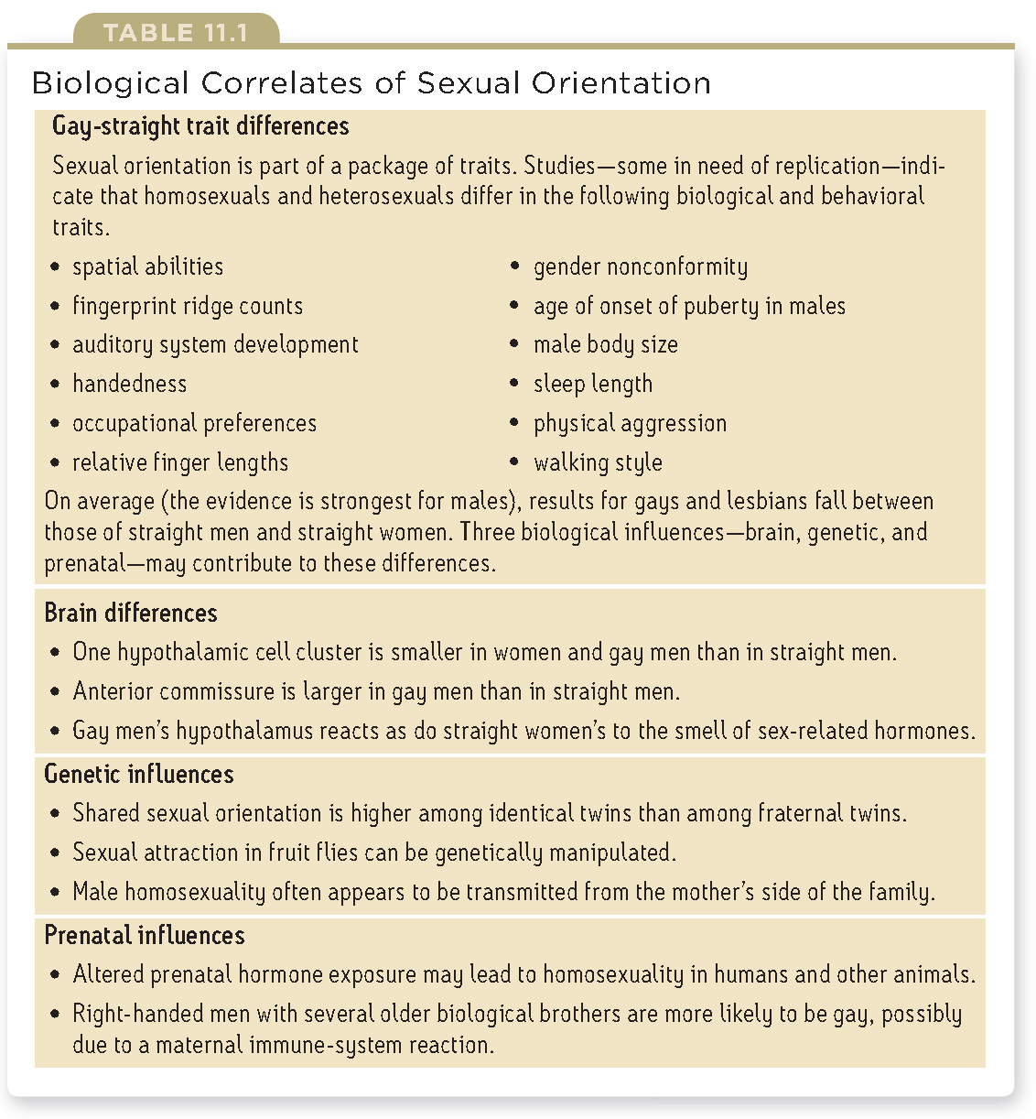
    - straight women and gays out preform others with spatial capabilities
  - Sex and Human Values

  - The need to belong
    - Aristotle called humans a social animal
    - Nichomachean ethics
    - We need to affiliate ourselves with others in close relationships
    - Wretched, without kin nearby
    - Enhanced with cooperation
    - People in every society on earth belongs in groups
  - Wanting to belong
    - Satisfaction of self esteem
    - Relatedness belonging needs
    - Autonomy, sense of personal control
    - Competence, result is a deep sense of well being
    - Ubantu word for human bonds
    - A person is a person through other persons ZULU
    - Seeking love and belonging is motivated by our quest for acceptance
  - Sustaining relationships
    - Fear of being alone worsens the pain or physical abuse, attachments can keep people in abusive relationships
    - Our fear of being alone has some basis in reality
  - Pain of Ostracism
    - Need to belong is denied
    - Social exclusion
    - When they feel bad about themselves being denied 4/5 say its because of relationship difficulty
    - Ostracism is a risk factor
    - Experiencing ostracism is experiencing pain
    - Elicits activity in the brain of the anterior cingulate cortex
    - Acetaminophen lessens social as well as physical pain
    - Opposite is feeling love and activates brain reward system
    - People may eek new friends or gain tress relief from religious faith
    - One that feels ostracism will act in dispersing or aggressive ways against those who excluded them
  - Social networking
    - Mobile and social networking
    - Texting and emailing are displacing talking
    - Social effects of social networking
    - More time online=less time with friends
    - Strengthens with the people we already know
    - When communicating electronically we are less focused on the others reactions
    - More willing to share and be open about worries and vulnerabilities
    - Self esteem gone awry becomes narcissism
    - Narcissistic people are self important, self focused and self promoting
    - High narcissism score is especially active on social networking sites
  - Maintaining balance and focus
    - Monitor your time
    - Monitor your feelings
    - Turn off hand held devices
    - Reduce facebook
    - Nature walk
  - Motivation at work
    - Work can be viewed as being unfulfilling but a need to make money
    - Can be viewed as a career, with an opportunity to advance
    - Viewed as a calling, socially useful activity
      - Highest satisfaction
    - Exhilarating to flow with an activity that fully engages our skills
    - Flow boosts self esteem
- 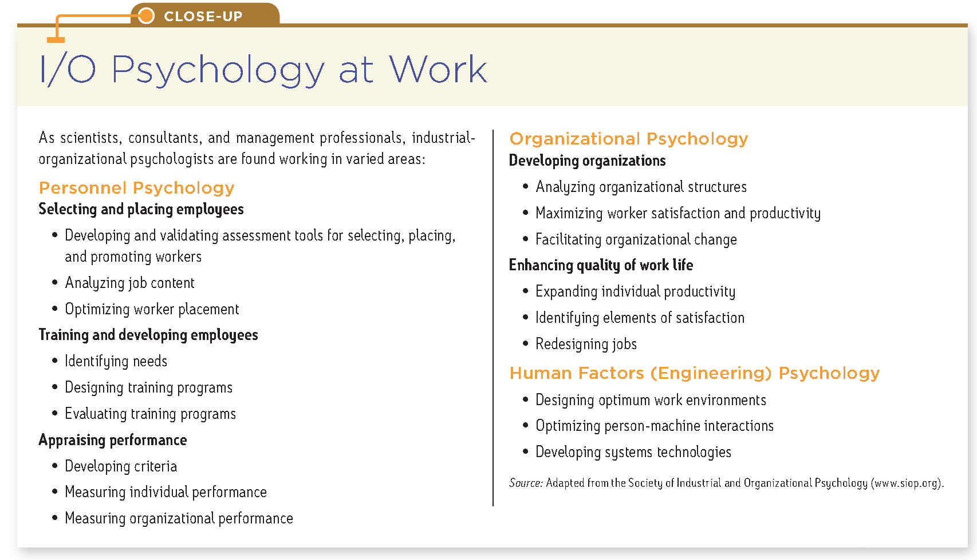

    - industrial organizational psychology
      - applies psychology principles to workplace
    - Personnel psychology
      - Psychology methods and principles when selecting and evaluating workers
    - Organizational psychology
      - Work environments and management styles, modify job and supervision
    - Human factor psychology
      - How machines and environments can be optimal for human abilities
  - Personnel psychology
    - Selecting and accessing employees
    - Identify peoples strengths
    - Interviews are weak predictors
    - Informal interviews are more useful than handwriting analysis
    - Interviews disclose the interviewers good intentions
      - Are less revealing than habitual behaviors
      - Educational attainments predict job performance
    - Interviewers more often follow the successful careers of those they have hired
      - Missing feedback prevents interviewers from getting a reality check on their hiring ability
    - Interviewers presume that people are what they seem to be in the interview situation
      - Behavior doesn’t only reflect enduring traits
    - Interviewers preconceptions and moods color how they perceive interviewees response
      - If they are alike to the interviewer it is better
      - Prescreened are judged more favorable
    - Traditional unstructured interviews do provide a sense of someone’s personality
      - Sadly give the interviewee power and control
      - False impressions to make it towards the interviewer
    - Structure interview
      - Disciplined method of collecting information
      - Have double the predictive accuracy compared to unconstructive
      - One structured is equal to ¾ unstructured interviews
      - If we let our intuitions bias the hiring process based on who impressed you the most
      - Social progress, unless we are careful can mean replacing the obvious arbitrary with the not so obvious arbitrary
    - Appraising performance
      - Serves organizational purpose
      - Reward and pay
      - Serves individual purpose
      - Feed back affirms strengths and helps motivate
      - Performance appraisal methods
        - Checklist for behaviors
        - Graphic rating scale
        - Behavior rating scale, scaled behaviors that describe performance
      - 360 degree feedback is everyone around yourself and vice versa that shows more communication
      - Vulnerable to bias
      - Halo errors occur when an evaluation biases ratings
      - Leniency and severity errors reflect evaluators tendencies to be too easy or too harsh
      - Recency errors, raters only focus on easily remembered recent behavior
    - Organizational psychology: motivating achievement
      - Appraisal of work
      - Matching talents to work matter
    - Grit
      - Strives to exceed by excelling at any task where evaluation is possible
        - Some one that is less driven
        - First person achievement motivation
          - Desire for significant accomplishment
          - Attaining a high standard
      - Gifted children are able learners
      - Accomplished adults are tenacious doers
      - Self disciplines is a better predictor
      - Discipline refines talent
      - 10 year rule: experts that invest 10 years of hard work, 40 hours a week for 50 weeks a year
        - highly motivated and self disciplined
        - they are distinguished not by natural talent but by there discipline
      - intelligence is distributed like a bell curve, achievements are not
      - achievements involve more than raw ability
    - Satisfaction and engagement
      - Study employee satisfaction
      - Satisfaction with work feeds satisfaction with life
      - Positive moods enhance creativity and helpfulness
      - Evidence of satisfaction benefits are positive correlations with performance
      - Satisfaction and performance correlate because both reflect job self esteem and a sense that efforts control rewards
      - Employee engagement-extent of involvement, enthusiasm and identification with organization
      - Engaged workers know what is expected of them
      - Engaged employees have customers that are loyal
      - Employee attitude predicts future business success
      - Three types of employees
        - Engaged
          - Work with passion and feeling, having a connection to the company
        - Not engaged
          - Putting in time but investing little passion into their work
        - Actively disengaged
          - Unhappy workers undermining colleagues achievements
    - Managing well
      - Leaders dream to enhance satisfaction, engagement and productivity of an organizations success
      - Harnessing job relevant strengths
        - Select the right people
        - Discern natural talents
        - Adjust work roles to suite talents
        - Develop talents into strengths
      - Effective managers
        - Help identify strengths and measure talents
        - Match tasks to talents
        - Care how people feel about their work
        - Reinforce positive behaviors through recognition and reward
      - Good managers focus training time on educating people about their strengths and building upon them
    - Setting specific, challenging goals
      - Achievement goals sometimes involve approaching high levels of mastery or performance
      - Sometimes involve avoiding failure
      - Specific challenging goals motivate achievement when combined with reports
      - State goals together with sub goals and implementation intentions
        - Action plan to achieve goals
        - More focused and completion is more likely
      - People sustain there mood and motivation when they focus on immediate goals rather than distant goals
      - To motivate high productivity
        - Effective leaders work with people to define explicit goals, sub goals and implementation plans and provide feedback on progress
    - Choosing an appropriate leadership style
      - Task leadership
        - Setting standards, organizing work and focusing attention on goals
        - Directive style: give orders
      - Social leadership
        - Explaining decisions, mediating conflicts and building high achieving teams
        - Democratic style: delegate authority and welcome participation of team members
        - Good for morale
        - Subordinates fell more satisfied and motivated
        - Groups solve problems with a greater collective intelligence
      - Great person theory of leadership
        - All great leaders share certain traits but is overstated
        - Leaders personality matters
        - Effective leaders are neither extremely assertive or unassertive
        - Effective leaders of laboratories, exude charisma
          - Charisma blends a goal based vision that inspires other to follow
      - Transformational leadership
        - Motivates others to identify with and commit themselves to the groups mission
        - Transformational leaders are natural extraverts, high standards, offer people attention
        - Able to inspire others, share a vision and commit to group missions

      - Effective managers exhibit both task and social leadership
        - Care about how well the work is and the needs of the subordinates
        - Having a best friend at work increases 30% to be engaged in work
        - Voice effect
          - A chance to voice opinion during a decision making process, will respond more positively and feel empowered to be more creative
      - Ultimate in employee participation is employee owned company
        - ESOP employee stock ownership plan
        - Every employee owns part of the company
        - No one owns more than 5%
    - The human factor
      - Psychologists help to design appliances, machines and work settings, that fit our natural perceptions and inclinations
      - Makes this easier for humans to operate
      - Can help prevent accidents
      - mostly caused by human error
    - assistive listening
      - in ear speakers for hearing difficulty
      - broadcast the sound and apply to a hearing aid
        - loop systems
    - when you know something, its hard to mentally simulate
      - what its like not to know
      - curse of knowledge
    - designers and engineers should consider human abilities and behaviors be designing things to fit people, user testing inventions before production and distribution
    - identifiable psychological mechanisms drive motives
    - common effect: energizing and direction of behavior

- Cognition and emotion
  - Emotions are a mix of bodily arousal
  - Expressive behaviors and conscious experience including thoughts and feelings
  - Does bodily arousal come before or after emotional feelings
  - Does cognition always come before emotion
- Does bodily arousal come before or after emotional feelings
- Arousal comes before emotion
  - James-Lang theory
  - First comes conscious awareness then the feeling
- Arousal and emotion occur simultaneously
  - Cannon-Bard theory
  - Body’s responses are too similar and too slow to cause different emotions
  - Bodily responses and experienced emotions occur separately but simultaneously
  - Emotion-triggering stimulus travels to PSNS, causing arousal
  - Also traveled to the brains cortex to be aware of the emotion
  - Challenged with spinal cord injuries, emotions felt above the neck were felt more intense
- Cognition can define emotion: Schachter and Singer
  - Emotional experience requires a conscious interpretation of arousal
  - Physical reactions and thoughts together create emotion
  - Two factor theory: emotions are made of physical arousal and cognitive appraisal
  - Spillover effect: arousal that causes an effect (byproduct)
  - Arousal fuels emotion and cognition channels it
- Cognition may not precede emotion
  - We actually have many emotional reactions apart from or even before our interpretation of a situation
  - We have an acute sensitive automatic radar for emotionally significant information
  - Sublimely flashed stimuli can prime us
  - Emotional responses can travel 2 pathways
    - The high road is through the brains thalamus and to the brains cortex
      - Then analyzed and labeled, then sent out via the amygdala
    - Low road is the bad stuff
      - Joseph LeDoux
      - Neural shortcut that passes the cortex
      - Fear stimuli travel from a sensory part to the thalamus and straight to the amygdala
      - Bypassing enables a fast emotional response before our intellect intervenes
      - Only fears can trigger the amygdala activity through being flashed very quickly that it is unconscious
- 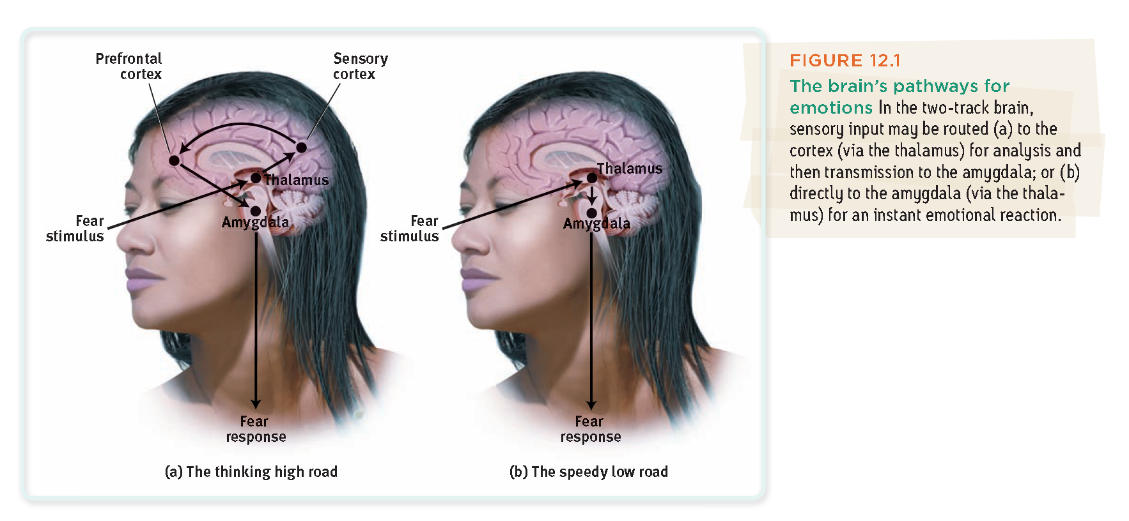
  - amygdala sends more neural projections up to the cortex than it receives back that makes it easier to hijack our thinking than for our thinking to rule our feelings
  - some of our emotional reactions involve no deliberate thinking
  - emotions arise when we appraise an event as harmless or dangerous whether we truly know it or not
  - 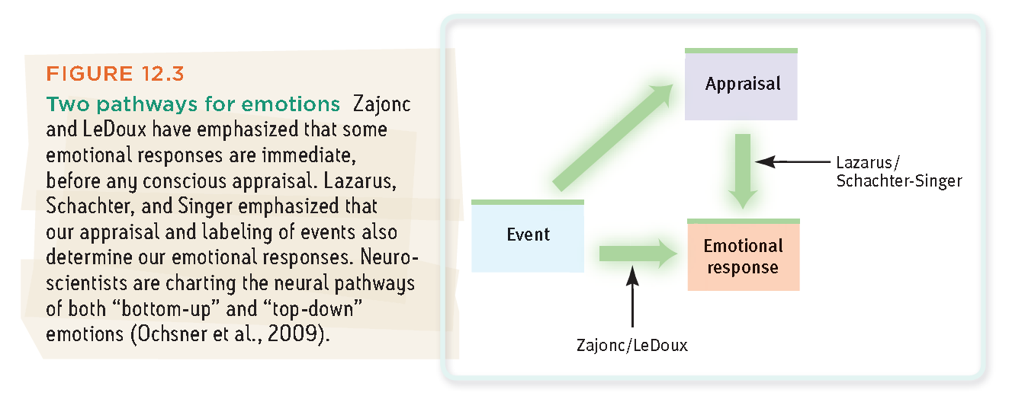
  - highly emotional people are intense because of interpretations
    - personalize events
    - generalize experiences by overreacting to a single event
  - Learning to think more positively can help people feel better
  - Thinking the highroad allows us to take some control over our emotional life
  - Automatic emotions and conscious thinking weave the fabric of our emotional lives
  - 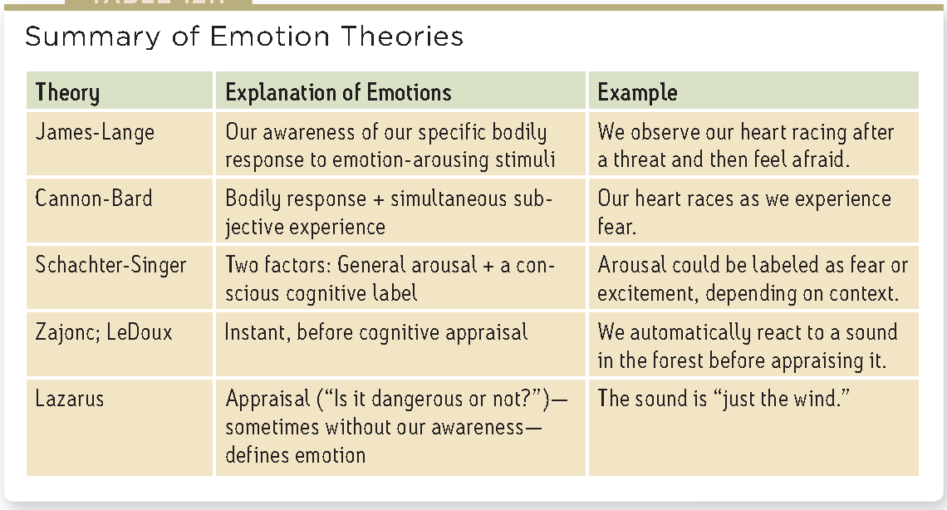
- Embodied emotion
  - Automatic nervous system
  - Sympathetic division of ANS
  - Epi and nor-epi
  - Adrenaline and noradrenaline
  - Liver pours out more sugar into blood stream
  - Heart, BP, muscles, pupils dilate for more light
  - Too little arousal can be disruptive, prolonged arousal can tax the body
  - PNS calms
  - Performance peaks at lower levels of arousal for difficult tasks
    - At higher levels for easy tasks
  - Psychology of emotions
    - Different emotions do not have sharp distinct biological signatures or brain regions
    - Emotional portfolio of the insula, a neural center deep inside the brain
      - Its activated when we experience various social emotions lust, pride, disgust, eating something disgusting
    - Facial muscles, hormones, temperature
    - Negative emotions cause prefrontal activity in the right more than the left
    - Positive moods tend to trigger left frontal lobe activity
    - Facial expression and brain activity vary with emotion
  - Expressed emotion
    - Expressive behavior implies emotion
    - Gazing into someone’s eyes can cause an attraction and affection
    - We are good at detecting nonverbal threats
    - Subliminally flashed words are sensed when the words are more negative
    - Experience can sensitize us to particular emotions
    - Most physically abused children can see angry faces over fearful faces
    - Behavior between truth and lies are too minute
    - Easier to detect if its 2 seconds of visual information
    - Introverts are great at reading other emotions
    - Extroverts are generally easier to read
  - Lie detection
    - Polygraph
    - Measure emotion, linked changes in breathing, cardiovascular activity and perspiration
    - There are control questions to make you nervous
      - Create a base line of being nervous
    - Of 100 people, 50 guilty and 50 innocent
      - 1/3 guilty
      - ¼ innocent
      - Through the use of a polygraph
    - Guilty knowledge test
      - Psychological responses to crime scene details
    - When the brain is telling the truth, the left frontal lobe and anterior cingulate cortex has activity
    - Left prefrontal cortex and anterior cingulate cortex when lying
  - Gender, Emotion, and nonverbal behavior
    - Women generally read thin slices of behavioral cues than men
      - Also the assessment of emotional cues
    - Women’s nonverbal sensitivity helps explain their greater emotional literacy
    - Women’s skills at decoding emotions can contribute to greater emotional responsiveness
    - Anger strikes most people as a masculine emotion
    - Women are more likely than men to describe themselves as empathetic
      - Empathy, you identify with others and imagine what it must be like to walk in their shoes
    - Women share more emotions than men and express them
    - Females are more likely to express empathy, to cry and report distress
    - Women also experience more emotional events
  - Culture and emotional expression
    - Importance of cultural definitions of gestures
    - Facial expressions do convey some nonverbal accents that provides clues to ones culture
    - People judge a fearful face set in a painful situation as pained
    - Gestures tend to differ rather that expressions through cultural aspects
    - Emotions is best understood as a biological, cognitive, and social cultural phenomenon
  - Effect of facial expressions
    - William james
    - Expressions not only communicate emotion but they amplify regulate it
    - Facial feed back effect: tendency of facial muscles states to trigger corresponding feelings
    - When smiling we quickly understand pleasant effects
    - Botox stops people from frowning and being depressed
  - Experienced emotion
    - 10 emotions isolated in infancy where all were present
    - emotions can be combinations of the 10 isolated
  - 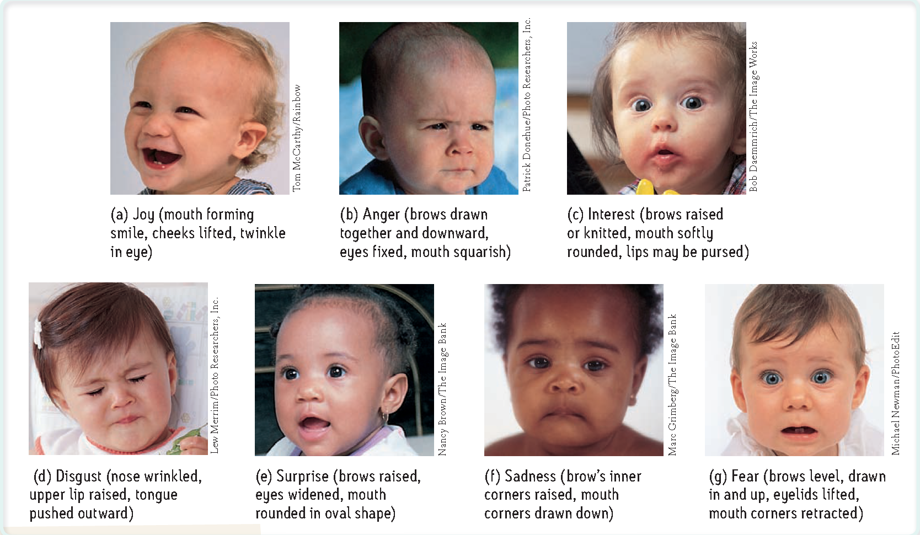
    - emotions are a variation of 2 dimensions
    - arousal and valence
    - 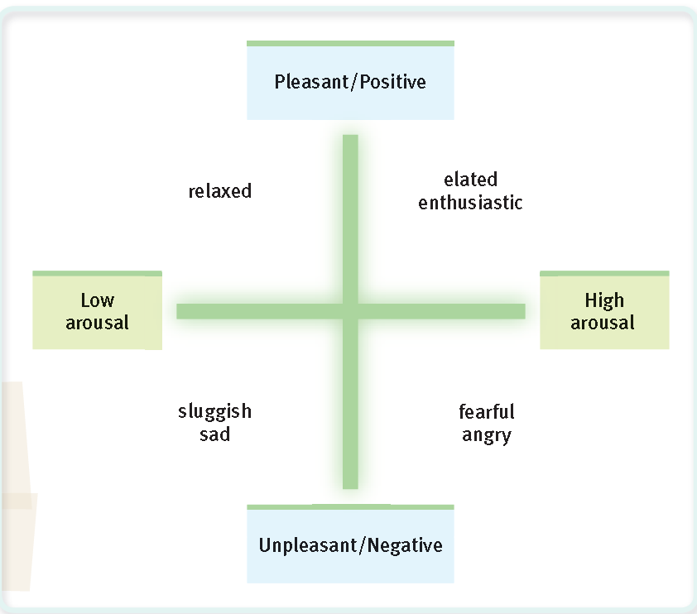
  - Anger
    - Fear triggers flight but anger triggers fight
      - Being an adaptive behavior
    - Anger can be a response to some ones perceived misdeeds when unjustified or avoidable
    - Chronic hostility is linked to heart disease
    - Releasing anger can be better than internalizing them
    - Achieving emotional release, Catharsis
      - Through aggressive action or fantasy
    - Works but only if direct counterattack is towards the provoker
    - Expressing anger is temporary calming if it doesn’t leave us feeling guilty or anxious
    - Feed back effect, expressing anger and magnify anger
    - Pleasurable actions to relieve anger can reoccur
    - Anger primes prejudice
    - Emotional arousal will die down eventually
    - Deal with anger that involves being neither chronically angry or sulking and rehearsing grievances
    - Anger isn’t always wrong can communicate strength and competence
    - Can benefit a relationship, expresses a grievance and promote reconciliation rather than retaliation
    - Talking to an offender can lessen aggravation
    - Forgiveness releases anger and calms the body
  - Happiness
    - Can perceive the world as safer and feeling more confident
    - When happy young, can foretell a happy life
    - Feel good do good phenomenon
    - With positive psychology, came subjective well being
      - Feelings of happiness or sense of satisfaction with life
    - Short life of emotional ups and downs
      - A stress full event can trigger a bad mood
        - Usually the next day it lifts and goes away
      - Tragedy isn’t permanently depressing
      - People coping with permanent disabilities may not rebound from former emotions
      - Paraplegic, thinking about others things and gradually feeling less miserable
      - We over estimate the duration of our emotions and underestimate our resiliency and capacity to adapt
    - Wealth and well being
      - In poor countries people with more money feel happier than those who struggle
      - People in rich countries experience greater well being than those in poor countries
      - One there is enough money to fulfill basic needs and over flows to being too much, it does less to increase feelings of happiness
        - Diminishing returns phenomenon
      - Experiencing luxury diminishes our savoring of life’s simple pleasures
      - Economic growth in affluent countries has provided no apparent boost to morale or social well being
    - Adaptation and comparison
      - Psychological principles that explain
      - For those who are not poor, more money buys surges of happiness that is temporary and emotions act like elastic bands
      - Happiness is relative to our own experience
        - Adaptation-level phenomenon
        - Tendency to judge various stimuli in comparison to past experiences
        - Harry Helson explains neutral levels, analyzing differences and how something is balanced based on our experience
          - Variations in being up or down
        - Feeling gratified and deprived
        - Satisfaction and dissatisfaction success and failure are judgments we make based on prior experiences
        - Increasing the neutral level and needing something more like a surge to increase pleasure
      - Happiness is relative to others success
        - We are worse off than others with whom we compare ourselves is the concept of relative deprivation
        - When expectations soar above attainments, the result is disappointment
        - Comparing ourselves with those who are better off creates envy
        - Comparing ourselves with those worse off boosts our contentment
      - Predictors of happiness
        - Nature and nurture
        - Happiness ratings are heritable
        - Personal level, emotions tend to balance around a level defined by our experiences
        - Cultural level, groups vary in the traits they value
        - Our satisfaction with life is not fixed
        - Influenced by factors that are under our control
        - Relationship quality matters
  - 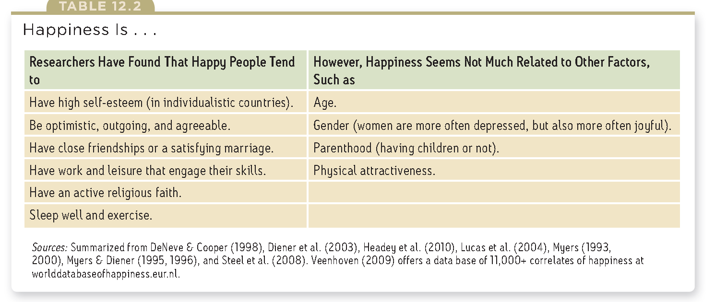
    - Gallup surveys
    - National well being assessment
    - Has a predictive power
  - Self reported happiness
    - Yes
      - Personality traits
      - Close relationships
      - Flow
      - Religious faith
    - NO
      - Age
      - gender
  - Stress and health

Absolute threshold-the minimum stimulation needed to detect a particular stimulus 50% of the time
Accommodation-the process by which the eyes lens changes shape to focus near or far objects on the retina
Action potential-a neural impulse a brief electrical charge that travels down an axon
Adrenal glands-a pair of endocrine glands that sit just above the kidneys and secrete hormones that help arouse the body in times of stress
Amygdala-two lima bean sized neural clusters in the limbic system, linked to emotion
Applied research-scientific study that aims to solve practical problems
Association areas-areas of the cerebral cortex that are not involved in primary motor or sensory functions rather they are involved in higher mental functions such as learning remembering thinking and speaking
Audition-the sense or act of hearing
Autonomic nervous system-part of PNS that controls the glands and muscles of the internal organs, sympathetic division arouses; its parasympathetic division calms
Axon-the neuron extension that passes messages through its branches to other neurons or to muscles or glands
Basic research-pure science that aims to increase the scientific knowledge base
Behavior genetics perspective-how our genes and our environment influence our individual differences
Behavioral perspective-how we learn observable responses
Behaviorism-the view that psychology 1) should be an objective science that 2) studies behavior without reference to mental processes. Most research psychologists today agree with 1 but not with 2. OBSERVABLE BEHAVIOR
Binocular cues-depth cues such as retinal disparity that depend on the use of two eyes
Biological perspective-concerned with the links between biology and behavior. Includes psychologists working in neuroscience, behavior genetics, and evolutionary psychology. These researchers may call themselves behavioral neuroscientists, neuropsychologists etc
Biopsychosocial approach-an integrated approach that incorporates biological physiological and social culture levels of analysis
Blind spot-the point at which the optic nerve leaves the eye, creating a "blind" spot because no receptor cells are located there
Bottom up processing-analysis that begins with sensory receptors and works way up to the brains integration of sensory information
Brainstem-central core of the brain, beginning where the spinal cord swells as it enters the skull, responsible for automatic survival functions
Case study-an observation technique in which one person is studied in depth in the hope of revealing universal principles
Central nervous system-the brain and spinal cord
Cerebellum-little brain, at the rear of the brainstem, function include processing sensory input and coordinating movement output and balance
Cerebral cortex-the intricate fabric of interconnected neural cells covering the cerebral hemispheres, the body's ultimate control and information processing center
Clinical Psychology-a branch of psychology that studies, asses, and treats people with psychological disorders
Cognitive Neuroscience-the inter disciplinary study of the brain activity linked with cognition
Cognitive perspective-how we encode process, store, and retrieve information
Color constancy-perceiving familiar objects as having consistent color, even is changing illumination alters the wave lengths reflected by the object
Community psychology-a branch of psychology that studies how people interact with their social environments and how social institutions affect individuals and groups
Cones-retinal receptor cells that are concentrated near the center of the retina and that function in daylight or in well lit conditions. The cones detect fine dtail and give rise to color sensations
Confounding variable-a factor other than the independent variable that might produce an effect in an experiment
Control group-in an experiment the group that is not exposed to treatment and contrasts with the experimental group and serves as a comparison for evaluation
Corpus callosum-the large band of neutral fibers connecting the two brain hemispheres and carrying messages between them
Correlation coefficient-a statistical index of the relationship between two things from -1 to +1
Correlation-a measure of the extent to which two factors vary together and thus of how well either factor predicts the other
Counseling psychology-a branch of psychology that assists people with problems in living and in achieving greater well being
Critical thinking-thinking that does not blindly accept arguments and conclusions rather it examines assumptions, discerns hidden values, evaluate evidence and assess conclusions
Debriefing-the post experimental explanation of a study, including its purpose and any deceptions to its participants
Dendrites-a neurons busy branching extensions that receive messages and conduct impulses toward the cell body
Dependent variable-the outcome factor, the variable that may change in response to manipulations of the independent variable
Depth Perception-the ability to see objects in 3D although images that strike the retina are 2D that allows for the judgment of distance
Difference threshold-the minimum difference between two stimuli required for detection 50% of the time (noticeable differences)
Double blind procedure-an experimental procedure in which both the research participants and the research staff are ignorant (blind) about whether the research participants have received the treatment or placebo
Electroencephalogram-amplified recording of waves of electrical activity that weeps across the brains surface, measured by electrodes placed on the scalp
Endocrine system-the body's slow chemical communication system, glands that secrete hormones into the blood stream
Endorphins-morphine within, natural opiate like neurotransmitters linked to pain control and to pleasure
Evolutionary perspective-how the natural selection of traits has promoted the survival of genes
Experiment-a research method in which an investigator manipulates one or more factors (independent variables) to observe the effect on some behavior or mental process (the dependent variable). Done by random assignment of participants
Experimental group-in an experiment, the group that is exposed to the treatment that is to one version of the independent variable
Feature detectors-nerve cells in the brain that respond to specific features of the stimulus such as shape/angle/movement
Figure ground-the organization of visual field into objects that stand out from their surroundings
fMRI-functional MRI, technique for revealing blood flow and brain activity by comparing successive MRI scans, fMRI scans show brain function
Fovea-the central focal point in the retina around which the eyes cones cluster
Frontal lobes-portion of the cerebral cortex lying just behind the forehead involved in speaking and muscle movement and in making plans and judgments
Gestalt-organized whole, emphasized tendency to integrate pieces of information into meaningful wholes
Glial cells-cells that support, nourish and protect neurons in the nervous system
Grouping-the perceptual tendency to organize stimuli into coherent groups
Hindsight bias-the tendency to believe after learning an outcome, that one would have foreseen it (I-knew-it-all-along phenomenon)
Hormones-chemical messengers that are manufactured by the endocrine glands that travel through the blood stream and affect other tissues
Hue-the dimension of color that is determined by the wavelength of light: what we know as the color names blue green and so forth
Humanistic psychology-historically significant perspective that emphasized the growth potential of healthy people and the individuals potential for personal growth
Hypothalamus-a neural structure lying below the thalamus, directs several maintenance activities, helps govern the endocrine system via the pituitary gland and is linked to emotion and reward
Hypothesis-a testable prediction often implied by a theory
Independent variable-the experimental factor that is manipulated, effects being studied
Informed consent-an ethical principle that research participants be told enough to enable them to choose whether they with to participate
Intensity-the amount of energy in a light or sound wave, which we perceive as brightness or loudness as determined by the waves amplitude
Interneurons-neurons within the brain and spinal cord that communicate internally and intervene between the sensory inputs and motor outputs
Iris-a ring of muscle tissue that forms the colored portion of the eye around the pupil that changes shape to help focus images on the retina
Lesion-tissue destruction, a brain lesion is a naturally or experimentally caused destruction of brain tissue
Levels of analysis-the differing complementary views, form biological to psychological to social culture for analyzing any given phenomenon/factors
Limbic system-neural system (hippocampus, amygdala, hypothalamus) located below the cerebral hemispheres associated with emotions and drves
Mean-the arithmetic average of a distribution obtained by adding the scores and dividing by the number of scores
Median-the middle score in a distribution, half the scores are above and below it
Medulla-the base of the brainstem, controls heartbeat and breathing
Mode-the most frequent occurring scores in a distribution
Monocular cues-depth cues such as interposition and linear perspective available to either eye alone
Motor cortex-an area at the rear of the frontal lobes that controls voluntary movements
Motor neurons-neurons that carry outgoing information form brain and spinal cord to the muscles and glands
Myelin sheath-a fatty tissue layer segmentally encasing the axons of some neurons, enables vastly greater transmission speed as neural impulses hop from one node to the next
Natural Selection-principle among the range of inherited trait variations, those contributing to reproduction and survival will most likely be passed on to succeeding generations
Naturalistic Observation-observing and recording behavior in naturally occurring situations without trying to manipulate and control the situation
Nature Nurture issue-controversy over the relative contributions that genes and experience make to the development of psychological traits and behaviors, todays science sees traits and behaviors arising form the interaction of nature and nurture
Nerves-bundled axons that form neural connections with the central nervous system and with muscles glands and organs
Nervous system-the body's speedy electrochemical communication network consisting of all the nerve cells of the peripheral and central nervous systems
Neurogenesis-formation of new neurons
Neuron-a nerve cell, the basic building block of the nervous system
Neuroscience perspective-how the body and brain enable emotions, memories and sensory experiences
Neurotransmitters-chemical messengers that cross the synaptic gaps between neurons. When released by sending neuron, neurotransmitters travel across the synapse and bind to receptor sites on the receiving neuron thereby influencing whether that neuron will generate a neural impulse
Normal Curve-a symmetrical bell shaped curve that describes distribution of many types of data, most scores fall near the mean (roughly 68% fall within one standard deviation) and fewer and fewer near the extremes
Occipital lobes-portion of the cerebral cortex lying at the back of the head includes areas that receive information from the visual fields
Operational definition-a statement of the procedures used to define research variables
Opponent process theory-the theory that opposing retinal processes enable color vision, some cells are stimulated by green and inhibited by red others are stimulated by red and inhibit green
Optic nerve-the nerve that carries neural impulses from the eye to the brain
Parallel processing-the processing of many aspects of a problem simultaneously: the brains natural mode of information processing for many functions including vision. Contrasts with the step by step processing of most computers and conscious problem solving
Parasympathetic nervous system-the division of the autonomic nervous system that calms the body conserving its energy
Parietal lobes-portion of the cerebral cortex lying at the top of the head and toward the rear receives sensory input for touch and body position
Perception-the process of organizing and interpreting sensory information enabling us to recognize meaningful objects and events
Perceptual adaptation-in vision, the ability to adjust to an artificially displaced or even inverted visual field
Perceptual constancy-perceiving objects as unchanging even as illumination and retinal images change
Perceptual set-a mental predisposition to perceive one thing and not another
Peripheral nervous system-the sensory and motor neurons that connect the central nervous system to the rest of the body
PET-positron emission tomography scan, visual display of brain activity that detects where a radioactive form of glucose while the brain is functioning
Phi phenomenon-an illusion of movement created when two or more adjacent lights blink on and off in quick succession
Pituitary gland-the endocrine systems more influential gland, under the influence of the hypothalamus, the pituitary regulates growth and controls other endocrine glands
Placebo effect-experimental results caused by expectations alone, any effect on behavior caused by administration of an inert substance or condition which the recipient assumes is an active agent
Plasticity-the brains ability to change especially during childhood, by reorganizing after damage or by building new pathways based on experience
Population-all the cases in a group being studied from which samples may be drawn (does not apply to national studies)
Positive psychology-the scientific study of human functioning with the goals of discovering and promoting strengths and virtues that help individuals and communities to thrive
Priming-the activation often unconsciously of certain associations thus predisposing ones perception memory or response, leading to a secondary stimulus later on
Psychiatry-a branch of medicine dealing with psychological disorders practiced by physicians who sometimes provide medical treatments as well as psychological therapy
Psychodynamic perspective-how behavior springs from unconscious drives and conflicts
Psychology-the science of behavior and mental processes
Psychophysics-the study of relationships between the physical characteristics of stimuli such as intensity and psychological experience
Pupil-the adjustable opening in the center of the eye through which light enters
Random assignment-assigning participants to experimental and control groups by chance and minimizing preexisting differences between those assigned to the different groups
Range-the difference between the highest and lowest scores in a distribution
Reflex-a simple automatic response to a sensory stimulus such as the knee jerk response
Replication-repeating the essence of a research study, usually with different participants in different situations to see whether the basic finding extends to other participants and circumstances
Reticular formation-a nerve network that travels through the brainstem and plays an important role in controlling arousal
Retina-the light sensitive inner surface of the eye containing the receptor rods and cones plus layers of neurons that begin the processing of visual information
Retinal disparity-binocular cue for perceiving depth, comparing images from retinas of 2 eyes, the brain computes distance, the greater the disparity between the 2 images, the closer the object
Reuptake-a neurotransmitters reabsorption by the sending neuron
Rods-retinal receptors that detect black, white and gray: necessary for peripheral and twilight vision when cones don't respond
Scatterplot-a graphed cluster of dot, each of which represent values of two variable. Slope of points suggests the direction of the relationship. The amount of scatter suggests the strength of the correlation. Little scatter indicates a high correlation
Sensation-the process by which our sensory receptors and nervous system receive and represent stimulus energies from our environment
Sensory adaptation-diminished sensitivity as a consequence of constant stimulation
Sensory cortex-area at the front of the parietal lobes that registers and processes body touch and movement sensations
Sensory neurons-neurons that carry incoming information from the brain and spinal cord
Signal detection theory-a theory predicting how and when we detect the presence of a faint stimulus amid background stimulation
Social cultural perspective-how behavior and thinking vary across situations and cultures
Somatic nervous system-the division of the PNS that controls the body's skeletal muscles skeletal nervous system
Split brain-a condition resulting from surgery that isolates the brains two hemispheres by cutting fibers (mainly those of the corpus callosum connecting them)
SQ3R-A study method incorporating survey, question, read, retrieve, review
Standard deviation-a computed measure of how much scores vary around the mean score
Statistical significance-a statistical statement of how likely it is that an obtained result occurred by chance
Subliminal-below ones absolute threshold for conscious awareness
Survey-a technique for ascertaining the self reported attitudes of behaviors of a particular group usually by questioning a representative, random sample of the group
Sympathetic nervous system-the division of the autonomic nervous system that arouses the body, mobilizing its energy in stressful situations
Synapse-the junction between the axon tip of the sending neuron and the dendrite or cell body of a receiving neuron. Tiny gap is called the synaptic cleft
Temporal lobes-portion of the cerebral cortex lying roughly above the ears, includes the auditory areas each receiving information primarily from the opposite ear
Testing effect-enhanced memory after repeated retrieving rather than simply reading information once. Also sometimes referred to as a retrieval practice effect or test-enhanced learning
Thalamus-the brains sensory switchboard, located on top of the brainstem, directs messages to the sensory receiving areas in the cortex and transmits replies to the cerebellum and medulla
Theory-an explanation using an integrated set of principles that organizes observations and predicts behaviors or events
Threshold-the level of stimulation required to trigger a neural impulse
Top down processing-information processing guided by higher level mental processes as when we construct perceptions drawing on out experience and expectations
Transduction-conversion of one form of energy into another. In sensation, the transforming stimulus energies such as sight, sounds and smells into neural impulses our brain can interpret
Transduction-o 1) receive sensory stimulation using specialized receptor cells
o 2) transform that stimulation into neural impulses
o 3) deliver the neural information to the brain
Visual Cliff-a laboratory device fro testing depth perception in infants and young animals
Wavelength-the distance from the peak of one light or sound wave to the peak of the next. Electromagnetic wavelengths vary from the short blips of cosmic rays to the long pulses of radio transmission
Weber's Law-the principle that, to be perceived as different, two stimuli must differ by a constant minimum percentage rather than a constant amount
Young Helmholtz trichromatic theory-three color theory, theory that retina contains three different color receptors (one most sensitive to red/green/blue) when stimulated in combination can produce the perception of any color
Frequency-the number of complete wavelengths that pass through a given point for a duration of time
Pitch-a tones experienced highness or lowness that depends on frequency
Middle ear-the chamber between the eardrum and cochlea, contains 3 tiny bones (hammer, anvil, stirrup) that concentrate vibrations the eardrum on the cochlea’s oval window
Cochlea-coiled, bony, fluid filled tube in the inner ear, sound waves travelling through will trigger nerve impulses
Inner ear-inner most part of the ear, containing the cochlea, semicircular canals and vestibular sacs
Sensorineural hearing loss-hearing loss caused by damage to the cochlea’s captor cells or the auditory nerves (nerve deafness)
Conduction hearing loss-hearing loss caused by damage to the mechanical system that conducts vibrations to the cochlea
Cochlear implant-a device for converting sounds into electrical signals and stimulate the auditory nerve through electrodes threaded through the cochlea
Place theory-in hearing the theory that links the pitch we hear with the place where the cochlea’s membrane is stimulated
Frequency theory-in hearing the theory that the rate of which a nerve impulse travel up the auditory nerve matches the frequency of the tone and enable the possibility of sensing pitch
Sensory interaction-principle that one sense may influence another such as smell and taste
Kinesthesis-system for sensing the position and movement of individual body parts
Vestibular sense-sense of body movement and position, including the sense of balance
Extrasensory perception-the controversial claim that perception can occur apart from sensory input that includes telepathy, clairvoyance and precognition
Parapsychology-study of paranormal phenomena including ESP and psychokinesis
Consciousness-our awareness of ourselves and our environment
Dual processing-principle of information being simultaneously processed on separate conscious and unconscious tracks
Blind sight-a condition in which a person can respond to a visual stimulus without consciously experiencing it
Selective attention-focusing of conscious awareness on a particular stimulus
Inattentional blindness-failing to see visible objects when our attention is directed elsewhere
Change blindness-failing to notice changes in the environment
Circadian Rhythm-biological clock that occur on a 24h cycle
REM Sleep-rapid eye movement sleep, reoccurring sleep stage where vivid dreams commonly occur (twitching)
Alpha waves-slow brain waves of a relaxed awake state
Sleep-periodic, natural, reversible loss of consciousness
Hallucinations-false sensory experiences such as seeing something in the absence of an external stimulus
Delta waves-large slow brain waves associated with deep sleep
Insomnia-recurring problems in falling or staying asleep
Narcolepsy-sleep disorder characterized by uncontrollable sleep attacks, sufferer can lapse into REM sleep
Sleep apnea-a sleep disorder characterized by temporary cessations of breathing during sleep and repeated momentary awakenings
Night terrors-sleep disorder characterized with high arousal and appearance of being terrified unlike nightmares and occur during NREM3
Dream-sequence of images, emotions and thought passing through a persons mind, hallucinatory imagery, delusional acceptance afterwards and is difficult to remember
Manifest content-according to Freud, the remembered story line to a story
Latent content-according to Freud, the underlying meaning to a dream
REM Rebound-tendency for REM sleep to increase following REM sleep deprivation
Hypnosis-social interaction in which a hypnotist suggests to a subject that certain perceptions, feelings, thoughts, or behaviors will spontaneously occur
Posthypnotic suggestion-suggestion made during a hypnosis session to be carried out after the subject is no longer hypnotized
Dissociation-split in consciousness that allows some thoughts and behaviors to occur simultaneously with others
Psychoactive drug-a chemical substance that alters perceptions and moods
Tolerance-the diminishing effect with regular use of the same dose drug, requiring the user to use a larger amount as time passes until the drug takes effect
Addiction-compulsive drug craving and use despite adverse consequences
Withdrawal-discomfort and distress that follows the discontinuing of an addictive drug
Psychical dependence-psychological need for a drug marked with an unpleasant withdrawal when the drug is discontinued
Psychological dependence-a psychological need to use a drug such as reliving negative emotions
Depressants-drugs that reduce neural activity and slow body functions
Alcohol dependence-alcohol use marked by tolerance, drive to continue use and withdrawal if suspended
Barbiturates-drugs that depress CNS activity, reduce anxiety but impair memory and judgment
Opiates-opium and its derivatives, depress neural activity, temporary pain and anxiety relief
Stimulants-drugs that excite neural activity and speed up body function
Amphetamines-drugs that stimulate neural activity, that speed up body function and mood changes
Nicotine-stimulating and highly addictive psychoactive drug in tobacco
Methamphetamine-powerfully addictive drug that stimulates the CNS, speeds up body function, reduces baseline dopamine levels
Ecstasy-synthetic stimulant and mild hallucinogen, long term harm to serotonin producing neurons
Hallucinogens-psychedelic drugs such as LSD that distorts perception,
LSD-powerful hallucinogenic drug known as acid
Near death experience-altered state of consciousness reported after a close brush with death, similar to drug induced hallucinogens
THC-major active drug in marijuana that triggers hallucinations
Learning-the process of acquiring new and relative enduring information or behaviors
Associative learning-learning that certain events occur together, events can be 2 stimuli (classical conditioning) or response and its consequences (operant conditioning)
Stimulus-any event or situation that evokes a response
Cognitive learning-the acquisition of mental information whether by observing events, watching others or through language
Classical conditioning-a type of learning in which one learns to link 2 or more stimuli and anticipate events
Behaviorism-View that psychology 1) should be an objective science 2) study behavior without reference to mental processes most don’t agree with 2 only agree with 1
Neutral stimulus-in classical conditioning, a stimulus that elicits no response before conditioning (sound or image)
Unconditioned response-in classical conditioning, an unlearned, naturally occurring response to an unconditioned stimulus (food in mouth)
Unconditional stimulus-in classical conditioning, a stimulus that unconditionally naturally and automatic triggers a response (food)
Conditioned response-in classical conditioning, a learned response to a previous neutral stimulus
Conditioned stimulus-in classical conditioning, an originally irrelevant stimulus that after association with an unconditioned stimulus come to trigger a conditioned response
Acquisition-in classical conditioning, the initial stage, when one links a neutral stimulus and a unconditioned stimulus begins triggering the conditioned response, in operant conditioning it is the strengthening of a reinforced response
High order conditioning-procedure where the conditioned stimulus in one conditioning experience is paired with a new neutral stimulus, creating a second weaker conditioned stimulus (also called second order conditioning)
Extinction-diminishing of a conditioned response, occurs in classical conditioning when an unconditioned stimulus does not follow a conditioned stimulus, occurs in operant conditioning when a response is no longer reinforced
Spontaneous recovery-the reappearance, after a pause, of an extinguished conditioned response
Generalization-tendency once a response has been conditioned for stimuli similar to the conditioned stimulus to elicit similar responses
Discrimination-in classical conditioning, the learned ability to distinguish between conditioned stimulus and stimuli that do not signal and unconditioned stimulus
Operant conditioning-type of learning where behavior is strengthened if followed by a reinforce or diminished if followed by a punisher
Law of effect-Thorndike’s principle that behaviors followed by favorable consequences become more likely and vice versa with unfavorable consequences
Operant chamber-operant conditioning, a chamber containing a bar or key that an animal manipulates for a reward, rate is calculated
Reinforcement-in operant conditioning, any event that strengthens the behavior it follows
Shaping-an operant conditioning procedure in which reinforcers guide behavior toward closer approximations of desired behavior
Positive reinforcement-increasing behaviors by presenting positive reinforcers, a positive reinforcer is any stimulus that when presented strengthens a response
Negative reinforcement-increasing behavior by stopping and reducing a negative stimulus, a negative reinforcer is a stimulus when removed after a response strengthens the response (not a punishment)
Primary reinforcer-innately reinforcing stimulus such as one that satisfies a biological need
Conditioned reinforcer-a stimulus that gains its reinforcing power through its associations with the primary reinforcer (secondary reinforcer)
Reinforcement schedule-a pattern that defines how often a desired response will be reinforced
Continuous reinforcement-reinforcing the desired response every time it happens
Partial (intermittent) reinforcement-reinforcing a response only part of the time, results in slower acquisition of response but is much greater resistance to extinction than does continuous reinforcement
Fixed ratio schedule-in operant conditioning, a reinforcement schedule that reinforces a response only after a specific number of responses
Variable ratio schedule-in operant conditioning, reinforces responses after an unpredictable number of responses
Fixed interval schedule-in operant conditioning, reinforces a response after a specified time has elapsed
Variable interval schedule-in operant conditioning, reinforces a response after unpredictable time intervals
Punishment-an event that tends to decrease the behavior that it follows
Respondent behavior-behavior that occurs as an automatic response to some stimulus
Operant behavior-behavior that operates on the environment producing consequence
Cognitive map-mental representation of the layout of ones environment (the map of a maze in the mind)
Latent learning-learning that occurs but is not apparent until there is an incentive to demonstrate it
Intrinsic motivation-a desire to preform a behavior effectively for its own sake
Extrinsic motivation-a desire to perform a behavior to receive promised rewards or avoid threatened punishment
Observational learning-learning by observing others
Modeling-the process of observing and imitating a specific behavior
Mirror neurons-frontal lobe neurons that some scientists believe fire when performing certain actions or observe others doing so, the brains mirroring of another’s action may enable imitation and empathy
Proscocial behavior-positive, constructive, helpful behavior opposite of antisocial
Memory-the persistence of learning over time through the storage and retrieval of information
Recall-a measure of memory in which the person must retrieve information learned earlier (fill in the blank)
Recognition-a measure of memory in which the person need only identify items previously learned (multiple choice)
Relearning-a measure of memory that assess the amount of time saved when learning material again
Encoding-the processing of information into the memory system for example by extracting meaning
Storage-the retention of encoded information over time
Retrieval-the process of getting information out of memory storage
Sensory memory-the immediate, very brief recording of sensory information in the memory system
Short term memory-activated memory that holds a few items briefly
Long term memory-the relatively permanent and limitless storehouse of the memory system
Working memory-a newer understanding of short term memory that focuses on conscious active processing of incoming information retrieved from long term memory
Explicit memory-memory of facts and experiences that one can consciously know and declare
Effortful processing-encoding that requires attention and conscious effort
Automatic processing-unconscious encoding of incidental information such as space, time meaning of words
Implicit memory-retention independent of conscious collection (non declarative memory)
Iconic memory-a momentary sensory memory of visual stimuli
Echoic memory-a momentary sensory memory of auditory stimuli
Chunking-organizing items into familiar, manageable units automatically
Mnemonics-memory aids, use vivid imagery and organizational devices
Spacing effect-tendency for distributed study or practice to yield better long term retention
Testing effect-enhanced memory after retrieving
Shallow processing-encoding on a basic level such as the structure or appearance
Deep processing-encoding semantically meaning of words
Hippocampus-neural center located in the limbic system, helps process explicit memories
Flashbulb memory-a clear memory of an emotionally significant moment or event

- Long term potentiation LTP-an increase in a cells firing potential after a brief rapid stimulation, neural basis for learning and memory.
- Priming-the activation often consciously of particular associations in memory
- Mood congruent memory-the tendency to recall experiences that are consistent with ones current mood
- Serial position effect-our tendency to recall best the first and last items in a list
- Anterograde amnesia-an inability to form new memories
- Retrograde amnesia-an inability to retrieve information from ones past
- Proactive interference-the disruptive effect of prior learning on the recall of new information
- Retroactive interference-the disruptive effect of new learning of the recall of old information
- Repression-psychoanalytical theory, basic defense mechanism that banishes from consciousness anxiety arousing thoughts, feelings and memories
- Misinformation effect- incorporating misleading information into ones memory of an event
- Source amnesia-attributing to the wrong source an event we have experienced, along with misinformation is the center of false memories
- Deja vu- eerie sense that you have experienced this before, cues can trigger retrieval of an earlier experience
- Motivation-a need or desire that energizes and directs behavior
- Instinct-a complex behavior that is rigidly patterned throughout a species and is unlearned
- Drive reduction theory-the idea that a physiological need creates an aroused tension state (a drive) that motivates an organism to satisfy the need
- Homeostasis-tendency to maintain a balanced or constant internal state
- Incentive-positive or negative environmental stimulus that motivates behavior
- Hierarchy of needs-Maslow’s pyramid of human needs, bottom is physiological that must be first satisfied before moving onto psychological needs
- Glucose-form of sugar that circulates in the blood and provides energy, when its low we feel hungry
- Set point-the point at which a persons weight thermostat is set, increase in hunger and decrease in metabolic rate
- Basal metabolic rate-the body resting rate of energy expenditure
- Sexual response cycle-4 stages of sexual response, Excitement, plateau, orgasm, resolution
- Refractory period-resting period after orgasm during which a man cannot reach another orgasm
- Sexual disorder-a problem that consistently impairs sexual arousal or impairment
- Estrogen-female sex hormone, contributes to female sex characteristics, in non human female mammals estrogen levels peak during ovulation to promote sexual receptivity
- Testosterone-most important male sex hormone, both males and females have it, extra testosterone can stimulate the growth of male sex organs in the fetus and characteristics during puberty
- Sexual orientation-sexual attraction for either the same or opposite sex
- Flow-completely involved focused state of consciousness with diminished awareness of self and time, optimal engagement of ones skills
- Industrial organizational psychology-application of psychology concepts and methods to optimize human behavior in workplaces
- Personnel psychology-subfield of IO psychology, focuses on employee recruitment, selection, placement, training and development
- Organizational psychology-subfield of IO psychology examines organizational
- Human factor psychology-sub field of IO psychology explores how people and machines interact and how machines and physical environments can be made safe and easy to use
- Structured interview-interview process that asks the same job relevant questions of all applicants, each of who is rated and scaled
- Achievement motivation-a desire for significant accomplishment for mastery of skills or idea, to rapidly attain high standards
- Emotion-a response of the whole organism involving 1) psychological arousal 2) expressive behavior 3) conscious experience
- James Lange theory-our experience of emotion is our awareness of our psychological responses to emotion arousing stimuli
- Cannon Bard theory-theory that an emotion arousing stimulus simultaneously triggers a psychological response and a subjective experience of emotion
- Two factor theory-Schachter Singer theory that to experience emotion one must be physically aroused and cognitively label the arousal
- Polygraph-a machine commonly used to detect lies by measuring physiological responses that accompany emotion
- Facial feed back effect-tendency of facial muscles states to trigger corresponding feelings
- Feel good do good phenomenon-tendency to be helpful when in a good mood
- Subjective well being-self perceived happiness or satisfaction with life. used along with measure of objective well being to evaluate quality of life
- Adaptation level phenomenon- tendency to form judgments relative to a neutral level defined by prior experiences
- Relative deprivation-perception that one is worse off relative to those who compares oneself
- Health psychology-subfield of psychology, hat provides psychology’s contribution to behavioral medicine

