Chapter 5: NUTRITION
Nutrients in Foods:
- MACRO Carbohydrates, amino acids, lipids
- MICRO water, vitamins, minerals
Calorie Values of Energy Nutrients
NUTRIENT ENERGY
- Carbohydrate (sugars) 4 Cal/g
- Fat (lipids) 9 Cal/g
- Protein (amino acids) 4 Cal/g
- *Alcohol 7 Cal/g
Digestive Process Summary: APPROXIMATELY 24 hours
- Mouth: mechanical digestion, saliva (amylase)
- Esophagus: peristalsis
- Stomach: chemical digestion, HCL
- Small intestine: absorption
  - Liver: filters, distributes nutrients; bile
  - Pancreas: insulin, glucagon
- Large intestine: digestive waste, some absorption
Obtaining Essential Nutrients
- Carbohydrates (sugars)
  - Simple carbohydrates (fruits)
    - Monosaccharide: glucose, galactose, fructose
    - Disaccharide: (2 simple sugars) maltose, lactose, sucrose
  - Complex carbohydrates
    - Grains, cereals, breads, pastas, legumes (beans)
    - Polysaccharide: fibre, starch, glycogen
    - Fibre: 25g/day women, 38g/day men
  - Athletes:
    - Consuming concentrated sugary foods/drinks: diarrhea b/c food will move more rapidly and unabsorbed sugars will reach colon
    - Carb loading, glycogen loading, glycogen supercompensation
      - Train hard for a week with only small amount of carbs, then day of dramatically increase intake of carbs (builds energy reserves for last few km)
- Fats (lipids)
  - Triglycerides: ~95% of lipid family, 5% sterols (cholesterol)
  - Saturated (fats) vs Unsaturated (oils)
  - Lipoproteins: HDL/LDL
  - Transport vitamins: A, D, E, K
- Proteins (amino acids)
  - 8 Essential (body can’t make, from food) & Non-Essential a.a.
    - Synthesis dependent on quality and digestible form
  - Complete (20: meat, meat derived products)
  - Incomplete (>20: plant-based products)
  - Plant sources: legumes, grains, nuts & seeds
  - Recommendation: ~0.8g/kg bodyweight
- Water
  - ~50-60% body composition
  - Minimum 6 glasses a day (ideally water)
- Vitamins
  - Fat soluble: absorb through intestinal tract with help of fat (A, D,E, K)
  - Water soluble: dissolves easily in water (B complex, C)
- Minerals: inorganic, indestructible
  - Growth & Metabolism
  - Macrominerals (>5g in the body)
    - (7) calcium, phosphorus, potassium, sulphur sodium, chloride, magnesium
- Trace minerals (>5g in body)
  - (15) iron, zinc, iodine, selenium, fluoride
- Calcium
  - Milk products, green vegetables
  - Carbonated drinks may cause excretion
  - Vitamin D increases absorption
  - Osteoporosis
- Iron
  - Vitamin C will increase absorption
  - Caffeine prevents absorption
  - Anemia
- Changing the Meat & Potatoes Person
  - Eating red meat, main dish, 5x/week 4 times risk of colon cancer (vs people eating red meat 1x/month)
  - Fruits and vegetables (phytochemicals): antioxidants
  - Organic grown foods?
  - ~4% of Canadians are vegetarians
      - Legumes are important
      - Many types of vegetarians
Food Safety: A Growing Concern
- Food Allergies
  - Reactions: hives, rash, swelling, itchiness, vomiting, irregularity in breathing, shock, etc.
  - Common: legumes (soy), nuts, shellfish, eggs, wheat and milk
- Food Intolerances
  - DO NOT involve immune system
- Minimizing Food-borne Illness
  - Eat red meat, seafood and poultry within 1-2 days; leftovers within 3 days
  - Hot foods hot, cold foods cold
  - Refrigerate cooked food within 2 hours
  - Thaw food in the refrigerator
  - Avoid cross-contamination (soap, hot water)
- Additives
  - Substances added to food to reduce risk of food-borne illness, prevent spoilage, enhance look, taste and nutrient value
  - Fewer chemicals, colorants and preservatives = better
    - Antimicrobial agents: salt, sugar, nitrites (reduce microbes)
    - Antioxidants: preserve color, flavour (reduces oxygen exposure)
    - Artificial colours, nutrient additions, flavour enhancers (MSG, monosodium glutamate)
    - Sulfites: used to preserve vegetable colour
    - Dioxins: found in coffee filters, milk containers, frozen foods
    - Methylene chloride: decaffeinated coffee
    - Hormones: bovine growth hormone found in animal meet and milk
Eating Well as a Uni/College Student
- When Funds are Short
  - Fruits and vegetables, canned or frozen
  - Sales, discount/bulk food chains
  - Buy in volume, freeze; cook large meals and freeze/store smaller portions
- Healthy Eating in the Dorm (“Freshman 15”)
  - Eat small and frequent meals (DO NOT skip meals)
  - Avoid emotional eating (ex. During exams)
  - Social events (alcohol, high fatty foods)
- Fast Foods: Eating on the Run
  - Nutritional analyses
  - Skinless, non-fried meats
  - Minimize fried foods
  - Minimize mayo, sauces, salad dressings, etc.
  - Less processed food, more unprocessed foods
  - High fibre, lots of liquids = satiation
Healthy Eating
- Hunger vs. Appetite
- Balanced diet
  - 55-60% carbs
  - 30% fats
  - 10-15% protein
- A, B, C, M, V
Nutritional Facts Panel
- Servings per container
- Macronutrients
- Vitamin A, C
- Calcium, iron
- Daily Values
- Ingredients list
The trend in North America has been toward consuming larger food portions
Keep in Mind
- Frequency
  - 6 feedings vs 3 feedings per day
- Quantity
  - 2 white egg omelette and water vs. 5 strips of bacon, 2 sausage links and 2 slices of buttered white toast
- Quality
  - Grilled sliced zucchini vs deep-fried zucchini sticks dipped in sour cream
Chapter 4: PERSONAL FITNESS
Introduction
- Canada’s Physical Activity Guide to Healthy Active Living: PHAC & CSEP
  - 60+ minutes of moderate intense activity, daily!
  - Participaction Canadahealth promotion
- ~50% Canadians are physically inactive
- ~20% of teens sufficiently active for optimal growth and development
Health and performance components
- Performance (functional components):
  - agility, power, coordination, balance, speed reaction time
- Muscle contractions
  - Isometric: force produced without muscle movement
  - Concentric: force produced while shortening the muscle
  - Eccentric: force produced while lengthening the muscle
- Stretching: flexibility and Range of Motion (ROM)
  - Static (isometric)
  - Ballistic (dynamic/sports-specific)
  - PNF (contract-relax)
Energy Pathways
High Intensity ATP- CP (alactic system: ANAEROBIC) Short Duration
up to first 15 seconds
GLYCOLYSIS (lactic system: ANAEROBIC)
90-180 seconds
OXIDATIVE (bet oxidation: AEROBIC)
180+ seconds

Low Intensity Long duration
Types of Exercise
- “Cardio” training (AEROBIC THRESHOLD):
  - Speed walking, light running, x-country skiing, jogging, swimming, interval training
- “Resistance” training (ANAEROBIC THRESHOLD):
  - Circuit-training, calisthenics, weightlifting, plyometric, bodybuilding, powerlifting
Improving Cardiorespiratory Endurance
- Cardiorespiratory Endurance:
  - MAX HR: [target heart rate (220 male or 226 female) ⎯ age]
  - [target heart rate (220 male or 226 female) ⎯ age] x % intensity (~70-90%)
- Aerobic Power:
  - VO2%: lactate threshold 55-85%, volume of oxygen consumed by muscles during exercise
- Graded Exercise Test:
  - Aerobic capacity: sustaining maximum work load
- Optimal training range: 50-80% maximal
Improving Muscular Strength and Endurance
- Muscular Strength and Endurance
  - Strength: one repetition maximum (1RM)
  - Power: strength/time
  - Endurance: duration of work, given fixed load
- Principles of Strength Development:
  - The Overload Principle: hypertrophy
  - The Specific of Training Principle
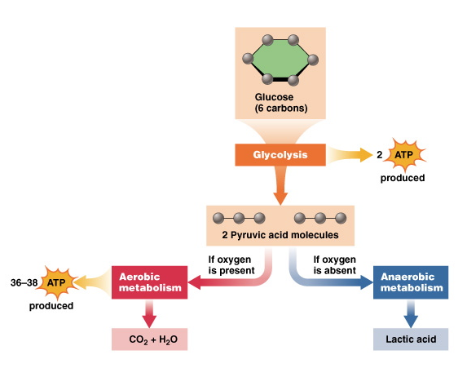
Fuel for Physical Activity

- Carbohydrates: increase in % contribution of energy source as exercise intensity increases (initially has a lower % contribution compared to fats)
- Fats: decrease in % contribution of energy source as exercise intensity increases (initially has a higher % contribution at the beginning)
Fuel for Physical Activity
- Scenario 1: brisk walking, 30 mins @ 40% VO2 MAX
  - Higher oxidative efficiency
  - % of calories derived from lipids: 80%
  - 100 calories utilized
  - Absolute calories from lipids: 80 calories
- Scenario 2: running, 30 mins @ 80% VO2 MAX
  - Lower oxidative efficiency
  - % of calories derived from lipids: 40%
  - 200 calories utilized
  - Absolute calories from lipids: 80 calories

Sound Fitness Program
- 3 Variables:
1. Frequency (30 mins moderate x3 days, 60 mins light x7 days)
2. Intensity (increase from 70% to 90% eventually)
3. Duration (expend 300-500 calories/day)
- Recall:
1. MACRO plan
2. MICRO plan
- Recall: For healthy weight management & shift in body composition: ANAEROBIC training is the priority
MACRO PLAN
- Less detailed, general aerobic fitness, one day of exercise would be : cardio (running, biking, swimming), upper or lower body, stretching, 2 rest days/week
MICRO PLAN (e.g. gym)
- More detail, anaerobic, upper/lower, divided into sets and reps
  - Higher intensityless reps
  - More value in less intensitylonger duration (making is aerobic)
CROSS-TRAINING PLAN
- Variety of activities that require use of different systems/muscles (basketball, swimming, running, martial arts,core)
  - More ORGANIC movements vs. micro (gym)
  - mix of aerobic and anaerobic
FLEXIBILITY
- enhanced by controlled stretching of muscles
- decrease resistance to stretch for increased ROM
- static stretching: 10-30 seconds (yoga, tai chi, pilates)

Fitness injuries
- Causes
  - Overuse (cumulative effects) injuries vs. traumatic injuries (accidental)
- Common overuse injuries:
- Plantar fasciitis inflammation, heel to toe, protects foot
- “runner’s knee”lateral tilting, stress on knee joint area
(Movement in patella ligament/erosion behind the knee capOA)
- Treatment:
  - Rest
  - Ice
  - Compression
  - Elevation
- Exercising in the Heat
  - Avoid dehydration; wear appropriate clothing
  - 3 heat stress illnesses
1. Cramps
2. Exhaustion
3. Heat stroke
- Exercising in the Cold
  - Wear appropriate clothing, hydration
  - cream
Chapter 6: MANAGING YOUR WEIGHT (Finding a Healthy Balance)
The Body’s Energy Balance
- 50-65% BMR
- 25-50% physical activity
- 5-10% thermic effect of food
  - Amino Acid thermo effect is HIGHER than carbs and lipids
  - Fitness level increasesBMR increases
Overweight and Obesity
- BMI = (weight in kg)/(height in m²)
- BMI = [(weight in lb)/(height in m²) x 705]
  - 18.5-24.9 = healthy weight
  - 25-29.9 = overweight
  - 30-34.9 = obese class 1
  - 35-39.9 = obese class 2
  - 40+ = obese class 3 (morbid obesity)
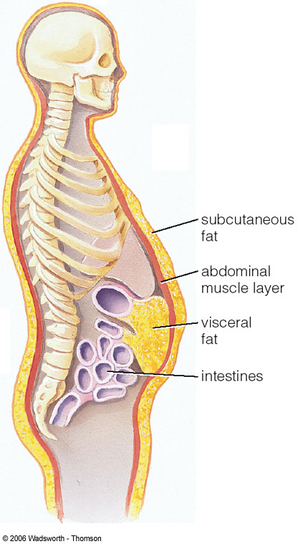
- *MORE than 50% of adult Canadians are overweight
Body Weight & Composition
CENTRAL OBESITY

- Fatfold measures: can yield accurate results when a trained technician meausures body fat
  - Using a caliper to gauge the thickness of a fold of skin
  - Measurements are taken on:
    - Back of arm (over the triceps)
    - Below the shoulder blade (subscapular)
    - Lower body sites
- Dual energy X-ray absorptiometry (DEXA): employs two low-dose X-rays that differentiate among:
    - fat-free soft tissue (lean body mass)
    - fat tissue
    - bone tissue
  - provides precise measurement of total fat and its distribution in all but extremely obese subjects
- Bioelectrical impedance: simple, painless, accurate
  - Determines body fatness by measuring conductivity
    - Lean tissueconducts mild electric current
    - Fat tissue does not
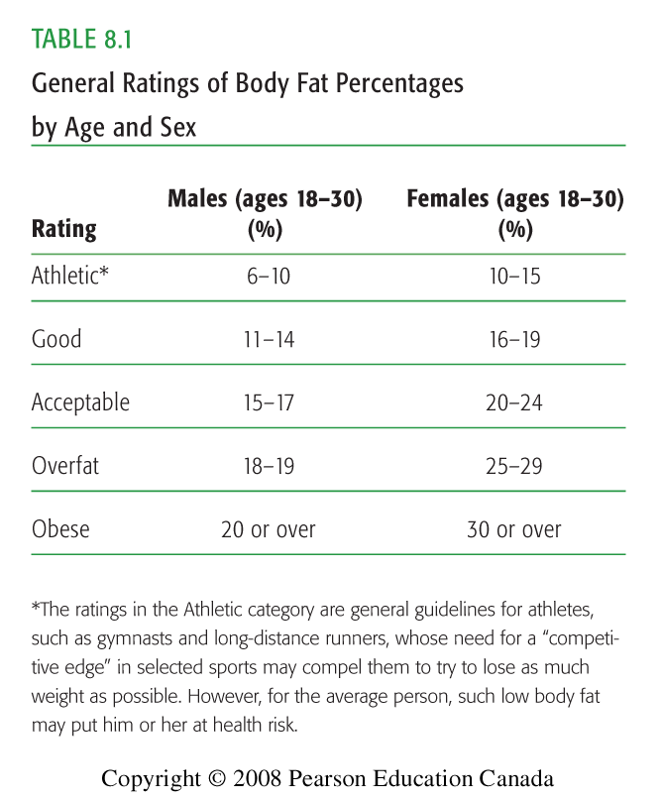

Risk Factors for Obesity
- Heredity and Genetic Factors
  - Body type:
    - Endomorph
    - Mesomorph
    - Ectomorph
  - Children of obese parents = increased risk
  - “Set-point” theory
- Endocrine influences
  - <2% of obesity cases endocrine related
Managing Your Weight
- Avoid quick weight-loss programs
  - Very low-calorie diets (VLCD), starvation
- >50% Canadians sedentary during leisure time
- Labour-saving devices reduce activity
- Food = major part of socialization

Eating Disorders
- Eating Disorders
  - Abnormal attitudes toward one’s body weight and shape
  - Severe disturbances in eating behaviours
  - Unhealthy efforts to control weight
- Anorexia Nervosa
  - 0.5% to 1% of adolescent females are anorexic
  - Medical problems (e.g. damage to bones, muscles)
- Bulimia Nervosa
  - 1-3% of adolescent and young females
  - Cycles of binge eating then purging to prevent calorie absorption
- Treating Eating Disorders
  - Early diagnosis and recognition are best predictors of success
  - Multidimensional approach usually involving family & friends, medical personnel
  - Hospitalization, psychotherapy
Body Composition:
- Weight, muscle, fat, volume and density



